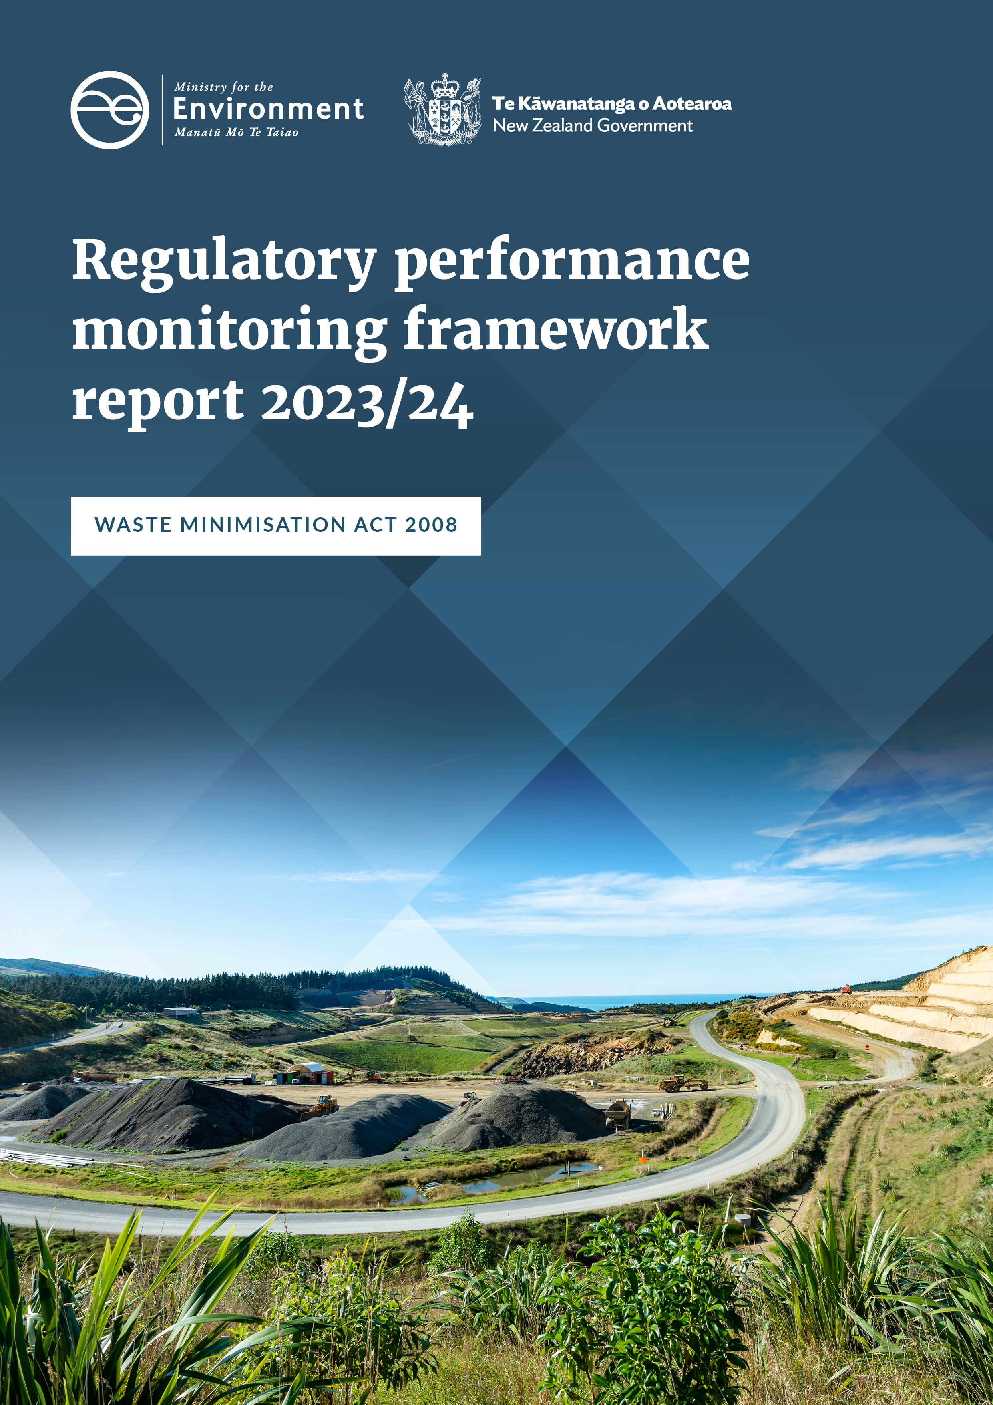

**Disclaimer**

The information in this publication is, according to the Ministry for the Environment’s best efforts, accurate at the time of publication. The Ministry will make every reasonable effort to keep it current and accurate. However, users of this publication are advised that:

* the information does not alter the laws of New Zealand, other official guidelines, or requirements
* it does not constitute legal advice, and users should take specific advice from qualified professionals before taking any action based on information in this publication
* the Ministry does not accept any responsibility or liability whatsoever whether in contract, tort, equity, or otherwise for any action taken as a result of reading, or reliance placed on this publication because of having read any part, or all, of the information in this publication or for any error, or inadequacy, deficiency, flaw in, or omission from the information in this publication
* all references to websites, organisations or people not within the Ministry are for convenience only and should not be taken as endorsement of those websites or information contained in those websites nor of organisations or people referred to.

This document may be cited as: Ministry for the Environment. 2025. *Waste Minimisation Act 2008: Regulatory performance monitoring framework report 2023/24*. Wellington: Ministry for the Environment.

Published in June 2025 by the  
Ministry for the Environment   
Manatū mō te Taiao  
PO Box 10362, Wellington 6143, New Zealand  
[environment.govt.nz](http://www.environment.govt.nz)

ISBN: 978-1-991140-91-3  
Publication number: ME 1900

© Crown copyright New Zealand 2025

# Contents

Executive summary 5

Part 1: Our work programmes 6

Levy administration | Whakarite Utu 7

Facility compliance | Tautukunga wāhi para 10

Territorial authority compliance | Tautukunga mana wāhi 13

Fund compliance | Tautukunga tahua 18

Product compliance |Tautukunga hangana 20

Regulatory compliance | Tautukunga whakahaere 23

Part 2: Performance assessment and monitoring 26

Overview 26

Modern Regulator Improvement Tool (MRIT) assessment 26

Appendix: Modern Regulator Improvement Tool framework and explanations 28

References 31

# Tables

Table 1: Key dates for the increase and expansion of the waste levy and reporting obligations 7

Table 2: Number of registered facilities 8

Table 3: Applications received by the Ministry under the Waste Minimisation Act 2008 8

Table 4: Compliance observation outcomes for facilities inspections against key areas 11

Table 5: Compliance scores over the reporting years for full audits 12

Table 6: Outcome of territorial authority compliance audits 15

Table 7: Waste levy distributed to, or withheld from, territorial authorities 16

Table 8: Territorial authority waste levy spend areas 16

Table 9: Audit activity for Waste Minimisation Fund projects 19

Table 10: Number of reports received from the public 21

Table 11: Compliance rates for businesses visited in 2023/24 22

Table 12: Referrals and proactive investigations conducted 24

Table 13: Enforcement tools used 25

Table 14: Formal investigation processes undertaken 25

Table A1: Description of MRIT attributes 28

Table A2: Levels of organisational maturity 29

Table A3: Waste operations MRIT scores 30

# Figures

Figure 1: The Waste Operations work programmes 6

Figure 2: Waste levy money paid to territorial authorities 13

Figure 3: Waste Operations MRIT assessment results 27

## **Executive summary**

**This 2023/24 regulatory performance monitoring framework report tracks implementation of the compliance functions of the Waste Minimisation Act 2008 (WMA) by the Ministry for the Environment | Manatū Mō Te Taiao (the Ministry). The purpose of the report is to increase the transparency of our function and to drive continuous improvement of processes and outcomes.**

The WMA is the primary legal instrument to address waste and resource recovery in Aotearoa New Zealand. Its purpose is to encourage waste minimisation and a decrease in waste disposal to protect the environment from harm and to provide environmental, social, economic and cultural benefits.

The 2023/24 reporting year, from 1 July 2023 to 30 June 2024,marked the continued expansion of the waste levy for existing facilities and the roll-out of the new facilities inspection programme. Additional bans were imposed on more single-use plastic products and an Order in Council came into effect to help disposal facility operators (DFOs) with accepting waste generated as a result of the severe weather events of 2023: Cyclone Hale, the Auckland Anniversary weekend floods and Cyclone Gabrielle.

Highlights from the 2023/24 reporting year include the following initiatives.

* Class 3 and 4 (managed or controlled fill) facilities became levy liable at $10 per tonne, and Class 1 (municipal landfills) saw an increase to the waste levy from $40 to $50 per tonne.
* The amount of levy distributed to territorial authorities (TAs) and to Te Pūtea Whakamauru Para – the Waste Minimisation Fund (WMF) was increased.
* The facilities compliance inspection programme (complementing the existing audit programme) for disposal facilities was implemented.
* The Waste Minimisation (Tyres) Regulations 2023 came into effect on 1 March 2024.
* Single-use plastic straws, single-use plastic tableware and cutlery, and single-use plastic produce bags were phased out or banned.
* The Standard Materials for Kerbside Collection came into effect on 1 February 2024. This standard requires services managed directly by TAs, or via contracts, to comply with the collection of dry recycling, food organics, and combined food organics and garden organics (FOGO).
* The Severe Weather Emergency Recovery (Waste Minimisation) Order 2023 (the SWERLA order) came into effect on 25 July 2023. This order provides temporary relief to disposal facility operators and TAs by extending reporting timeframes (for waste management and minimisation plans (WMMPs) and waste returns) and correction of waste levy data. It also introduces the first exemption from the waste levy for cyclone- and flood-related waste to support recovery efforts after the severe weather events of 2023.

Note this report does not repeat introductory information, such as roles and objectives, that was included in our reports from previous years. For this information please refer to the earlier reports on our website:

* [inaugural report 2020/21](https://environment.govt.nz/publications/wma-regulatory-pmf-2020-21/)
* [2021/22 report](https://environment.govt.nz/publications/waste-minimisation-act-2008-regulatory-performance-monitoring-framework-report-20212022/)
* [2022/23 report](https://environment.govt.nz/publications/regulatory-performance-monitoring-framework-report-2022-23/).

# **Part 1: Our work programmes**

Figure 1: The Waste Operations work programmes

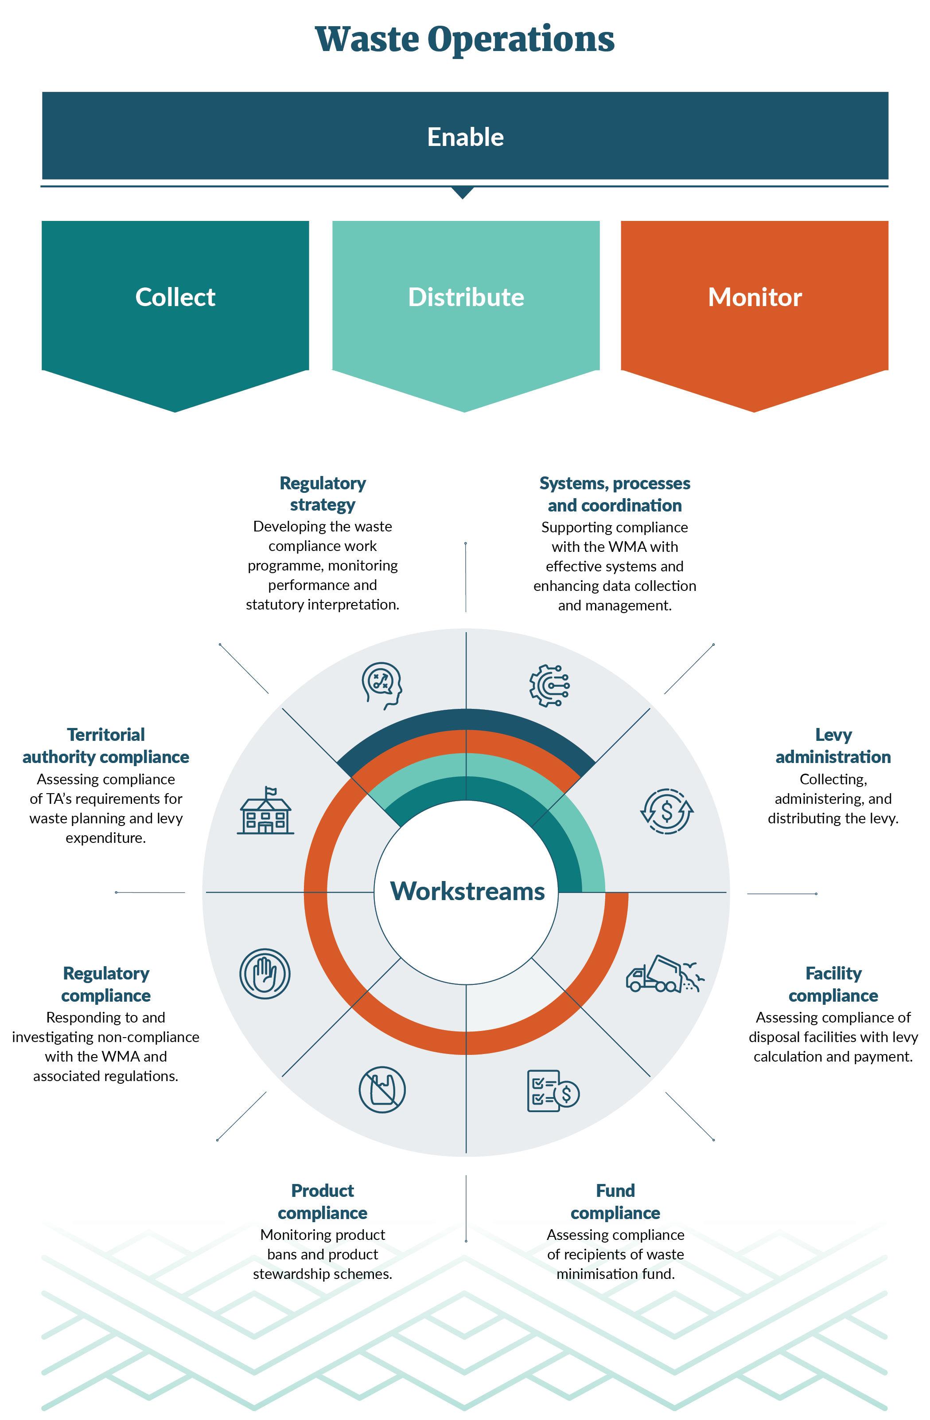

## Levy administration | Whakarite Utu

### Overview

From 1 July 2023, the waste levy expanded to include the charging of a levy for Class 3 and 4 facilities (managed or controlled fill) at a rate of $10 per tonne. The levy was increased for Class 1 (municipal landfill) from $40 to $50 per tonne and the levy for Class 2 (construction and demolition fill) remained at $20 per tonne. Facilities not subject to the levy – such as Class 5 (cleanfills), industrial monofills and transfer stations – are still required to submit quarterly waste tonnage data.

The levy administration team continues to work with the sector not only in the operational management of the levy but through ongoing education, stakeholder engagement, providing updates on upcoming regulatory requirements and responding to sector enquiries. We continue to receive enquiries about obligations under the WMA as new participants in the waste sector register. We welcome these interactions, as addressing questions and clarifying requirements early on helps mitigate potential compliance issues in the future.

Table 1: Key dates for the increase and expansion of the waste levy and reporting obligations

|  |  |  |
| --- | --- | --- |
| Facility class | Levy obligations[1] | Reporting obligations |
| Class 1 – Municipal disposal facilities | Levy from 1 July 2023 increases to $50 per tonne | Monthly returns on waste |
| Class 2 – Construction and demolition disposal facilities | Levy from 1 July 2023 remains at $20 per tonne | Monthly returns on waste |
| Classes 3 and 4 – Managed or controlled fill disposal facilities | Levy from 1 July 2023 increases to $10 per tonne | Monthly returns on waste |
| Class 5 – Cleanfills | Levy does not apply | Quarterly returns on waste |
| Industrial monofills | Levy does not apply | Quarterly returns on waste |
| Transfer stations | Levy does not apply | Quarterly returns on waste |

The 2023/24 reporting period had an overall increase in the number of facilities registering in the Online Waste Levy System (OWLS). Notably, growth was observed across Class 3 and 4 facilities who became levy liable, Class 5 facilities and transfer stations as shown in table 2. In contrast, there was little change in the number of Class 1 and Class 2 facilities, with only two newly registered construction and demolition fill disposal facilities.

Some of the new registrations included facilities applying to change their class type. If a facility had registered as a class type accepting a range of waste materials but later found they only disposed of one or two waste streams that are subject to a lower or no levy, they can discuss changing their class type with the levy administration team.

This can happen either when a facility has registered to meet the market demands of a particular region or when a compliance officer has advised the facility after an inspection or audit that a change of class type would better fit the actual waste they are disposing.

### New facilities

Table 2: Number of registered facilities

| **Class** | **2020/21** | | **2021/22** | **2022/23** | **2023/24** |
| --- | --- | --- | --- | --- | --- |
| Class 1 – Municipal disposal facility | | 36 | 42 | 40 | 40 |
| Class 2 – Construction and demolition disposal facility | |  | 9 | 11 | 13 |
| Class 3 and 4 – Managed or controlled fill  facility | |  | 29 | 108 | 122 |
| Class 5 – Cleanfill facility | |  | 28 | 93 | 110 |
| Industrial monofill | |  | 9 | 22 | 24 |
| Transfer stations | |  | 231 | 240 | 251 |
| **TOTAL** | | **36** | **348** | **514** | **560** |

#### Applications received and processed

Facility operators may submit a range of applications to the Ministry under the WMA using the OWLS. The 2023/24 reporting year has seen an increase in the number of applications relating to levy waivers and estimations. This is shown in table 3.

The levy administration team played a key role in implementing the emergency legislation measures (the SWERLA order) after the severe weather events of 2023. These measures aimed to reduce cleanup costs and streamline the waste levy exemption and waiver process for affected facilities, thereby minimising administrative burden.

Table 3: Applications received by the Ministry under the Waste Minimisation Act 2008

| **Application and process** | **Received | approved 2009 to 2020** | **Received | approved 2020/21** | **Received | approved 2021/22** | **Received | approved 2022/23** | **Received | approved 2023/24** |
| --- | --- | --- | --- | --- | --- |
| Application to file an annual return *Reg 9* | 105 | *104 (1 withdrawn)* | 6 | 6 | 4 | 4 | 2 | 1 *(1 withdrawn)* | 0 | 0 |
| Application to use an average tonnage methodology *Reg 15* | 33 | 26 *(7 declined)* | 3 | 3 | 1 | 0 | 2 | 0 (*2 declined)* | 0 | 0 |
| Application for a levy refund *Reg 33* | 0 | 0 | 0 | 0 | 0 | 0 |
| Application for a payment extension *Reg 30* | 0 | 0 | 1 | 0 | 0 | 2 | 1 (1 *declined)* |
| Application for a return extension *Reg 10* | 0 | 0 | 4 | 0 | 9 | 0 *(9 declined)* | 0 | 0 |
| Application for a storage time extension *Reg 11* | 56 | 9 *(42 declined, 5 withdrawn)* | 0 | 1 | 0 | 0 | 1 | 1 *1 declined)* |
| Application for a waiver *Sec 29* | 21 | 16  *(4 declined, 1 withdrawn)* | 2 | 2 | 2 | 2 | 9 | 7 *(2 withdrawn)* | 15 | 2 *(1 declined, 1 withdrawn)* |
| **TOTAL (applications)** | **215** | **11 | 11** | **13 | 6 *(6 withdrawn, 1 processing)*** | **22 | 8** | **18 | 4 *(2 declined, 1 withdrawn)*** |

#### Issuing a return estimation

Registered facilities liable to pay the levy are required to submit a return by the 20th of each month. Section 34 of the WMA enables the Ministry to estimate the amount of levy payable if the operator has not provided records or information, or where that information is incomplete or incorrect.

For the 2023/24 period, we made a total of 38 estimations. Most of these related to Class 3 and 4 facilities who are new to the regulatory requirements and statutory timeframes. Another reason provided by disposal facility operators for their late returns was because new data entry staff and data verifiers who submitted the returns did not understand the statutory obligations or timeframes.

#### Application for a levy waiver

Section 29 of the WMA enables the Ministry to waive, in writing, the requirements for an operator to pay any amount of levy if satisfied that exceptional circumstances justify the waiver. We assess any applications we receive on a case-by-case basis against key considerations.

Over this reporting period, we received 15 waiver applications. This increase in applications can be directly attributed to levied disposal facilities who were impacted by the severe weather events of Cyclone Gabrielle.

### Comments

The levy administration team continues to see an increase in the number of new facilities registering within the OWLS and through enquiries to the dedicated levy administration inbox and 0800 WDLEVY (0800 835 389) number.

To support the sector, we provide updates on upcoming regulatory changes through targeted communications and system notifications. These updates include the release of new factsheets or guidance materials addressing regulatory changes or clarifications, along with enhancements to OWLS designed to improve usability and streamline sector interactions.

## Facility compliance | Tautukunga wāhi para

### Overview

The 2023/24 period saw an increase of 121 Class 3 and 4 (managed or controlled fill) facilities registered in OWLS, alongside increases across other classes of facilities. This growth in newly registered disposal facilities, each requiring regulatory oversight, prompted a strategic review and redesign of our existing auditing programme.

Recognising the expectation that the Ministry as a regulator would inspect all newly registered levy-liable facilities in a timely manner, we developed an approach that enabled better use of our resources while mitigating the potential for non-compliance.

This resulted in our team implementing the ‘facilities inspections’ programme. This involves our compliance officers conducting on-site meetings with staff at each facility to review operational processes, observe practices and deliver feedback and recommendations to support and promote compliance with the WMA and associated regulations.[2]

Where our on-site inspections identify areas of concern, we escalate these to the regulatory compliance team so a full site audit can be carried out.

### What we found

#### Facility compliance inspections

During the 2023/24 reporting period, we inspected 68 facilities. Our inspections focus on eight key areas of compliance. We found that most facilities were compliant as shown in table 4. The two areas that we deemed medium to high non-compliance related to the use of incorrect measurement methodologies or the levy being calculated incorrectly.

An example of where a levy may be incorrectly calculated is when the facility operator applies a conversion factor against a waste type that is not in accordance with the requirements prescribed under schedule 1 of the Waste Minimisation (Calculation and Payment of Waste Disposal Levy) Regulations 2009.

Another example of non-compliance arises when a facility registers in OWLS as a Class 3 and 4 (managed or controlled fill), but accepts material classified under Class 2 (construction and demolition). In such cases, the facility is incorrectly receiving waste outside its approved classification and should therefore be paying the higher levy rate applicable to Class 2 waste.

Facility compliance inspections are a deterrent to facilities that receive waste outside of their classification including waste incurring a higher levy. This can also result in a facility being liable for recovery of unpaid levies and potential for the facility to be registered at a higher Class.

Table 4: Compliance observation outcomes for facilities inspections against key areas

|  |  |  |  |  |  |
| --- | --- | --- | --- | --- | --- |
| **Inspection areas** | **Compliant** | **Non-compliant low** | **Non-compliant medium** | **Non-compliant high** | **Not applicable[3]** |
| Waste matches regulations | 87% | – | 12% | – | 1% |
| Waste return | 30% | 4% | – | – | 66% |
| Levy return | 67% | 19% | 1% | – | 12% |
| Levy payments | 57% | 6% | 1% | – | 36% |
| Measurement method | 51% | 24% | 25% | – | – |
| Stockpile | 43% | 9% | – | – | 49% |
| Levy calculation | 46% | – | 13% | 13% | 28% |
| Recordkeeping | 93% | 6% | – | – | 1% |

### Full compliance audits

A full audit includes an on-site inspection that goes beyond the facility compliance inspection. It enables auditors to request more information such as weighbridge data to review against the data submitted through OWLS. This process ends with an assessment of the facility’s level of compliance and non-compliance so that appropriate remedies can be applied. An audit period can encompass, but is not limited to, the previous 12 months, and timeframes can be adjusted at our discretion.

The areas where disposal facilities scored low non-compliance relate to, but are not limited to, late invoice payment, a late waste return or stockpiling concerns. We usually address these low non-compliance scores through a corrective action request made to the facility. We record any corrective actions and the timeframe within which the facility must implement them in the facility’s inspection report.

Facilities that received a medium or high non-compliance score mainly had issues that could lead to a levy miscalculation. Examples include accepting out-of-class waste, using a lower conversion factor than the regulations prescribe or omitting waste types from their waste return. In such cases, we escalate the matter to the regulatory compliance team for further assessment and potential investigation.

A ‘not determined’ score indicates there was not enough evidence to assess compliance within the scope of the audit, for example insufficient information for the period covered by the audit.

A ‘not applicable’ score signifies that the criteria were either no longer relevant due to changed circumstances or that a triggering element in the criteria was not activated within the scope of the audit.

Table 5: Compliance scores[4] over the reporting years for full audits

|  |  |  |  |  |
| --- | --- | --- | --- | --- |
| **Compliance grade** | **2020/21** | **2021/22** | **2022/23** | **2023/24** |
| Compliant | 57% | 60% | 53% | 59% |
| Compliant – area for improvement | 4% | 4% | 4% | 6% |
| Non-compliant – low | 13% | 17% | 19% | 15% |
| Non-compliant – medium | 13% | 4% | 5% | 5% |
| Non-compliant – high | 6% | 4% | 2% | 3% |
| Not determined | 3% | 9% | 7% | 1% |
| Not applicable | 3% | 3% | 11% | 11% |

### Responding to non-compliance

Our auditors continue to identify areas of predictable non-compliance such as the incorrect conversion factor being used or the levy being miscalculated through incorrect recording of gross and diverted tonnages. Many of these issues are addressed effectively through education and engagement with regulated parties. This ensures facilities will have a better understanding of the Ministry’s compliance expectations as the auditing and facilities inspection programme continues to evolve.

Where our auditors identify non-compliance, they have two options.

* Issue a request for corrective action and ensure the facility returns to compliance.
* Escalate the facility to our regulatory compliance team for further assessment.

The regulatory compliance team has a range of enforcement tools to address non-compliance. These include issuing a warning letter and recovering unpaid levies. Where these tools cannot resolve non-compliance or they find more breaches, they refer the matter for an investigation which may lead to prosecution.

### Comments

During this reporting period, in which Class 3 and 4 facilities became subject to the waste levy, we identified areas where operators lacked a full understanding of their regulatory obligations. This was particularly in relation to measuring waste where there was no onsite weighbridge. The regulation clearly states that in the absence of an onsite compliant weighbridge, operators must either use a compliant offsite weighbridge, apply the conversion factors for volume-to-weight calculations, or seek approval for the use of an average tonnage system.

A commonly identified risk is when a facility accepts waste from a different class (usually a class subject to a higher waste levy) and this non-compliance is only identified during a facilities inspection or full audit. When we find this type of non-compliance, the facility must either stop accepting the non-permitted waste or change their OWLS registration class and start paying the higher levy rate. In some cases, when we refer the matter to the regulatory compliance team, they may take steps to recover the unpaid levy.

## Territorial authority compliance | Tautukunga mana wāhi

### Overview

The purpose of the waste levy is to raise revenue for promoting and achieving waste minimisation and increasing the cost of waste disposal to recognise that disposal imposes costs on the environment, society and the economy. The Ministry continues to provide waste disposal levy assurance via guidance and support to TAs, with the delivery of compliance audits in accordance with the regulatory requirements under the WMA and associated regulations.

As the levy expands, the amount of money able to be distributed to TAs has increased significantly (see figure 2). This underlines the importance of ensuring that TAs comply with their legal requirements under the WMA.

Figure 2: Waste levy money paid to territorial authorities

As outlined in the WMA, each TA receives a share of 50 per cent of the waste levy, based on its district’s population. It must spend this money on activities to promote or achieve waste minimisation in accordance with its waste management and minimisation plan (WMMP). These payments are made quarterly.

The WMMP is intended to be the guiding document for TAs to promote and achieve effective and efficient waste management and minimisation within their districts.

A TA **will not** receive its share of the levy if at the time the levy is due to be paid, the TA has not either:

* adopted a WMMP or
* reviewed its WMMP if that was required before payment.

A TA **may not** receive[5] its share of the levy if at the time the levy is due to be paid, it has not:

* spent its previous payment in accordance with section 32 of the WMA, or
* complied with a performance standard set by the Minister for the Environment, or
* provided records or information as prescribed.

From 1 February 2024, the Standard Materials for Kerbside Collections performance standard came into force. The standard requires TAs to standardise the materials they accept in council-managed kerbside recycling and in collections of food scraps and food organics and garden organics (FOGO).

In response to the severe weather events of 2023, the SWERLA order was developed and came into effect on 25 July 2023. The SWERLA order specified TAs impacted by these events who could apply for extensions to the due dates for WMMP reviews. It ensured affected TAs could continue to receive their quarterly levy payments or receive backdated payments in cases where payments were withheld for overdue WMMP reviews.

In the 2023/24 reporting period, the TA compliance team carried out a range of audits and monitoring. These included full audits and checking that TAs had reviewed their WMMP and are complying with the Standard Materials for Kerbside Collections performance standard.

### What we found through auditing

#### Outcomes of full audits

Our TA compliance team conducted seven full audits during the 2023/24 financial year.These full audits included assessing how TAs had spent their levy money and whether they are meeting their WMMP requirements listed in table 6. There were delays in finalising some of these reports due to challenges getting supporting financial documentation, as well as the audit team being focused on sector engagement at that time. This engagement included developing factsheets and delivering webinars to help TAs understand and prepare for their new regulatory reporting obligations under the Waste Minimisation (Information Requirements) Amendment Regulations 2023, which come into effect on 1 July 2024.

Of the seven TAs audited, four were fully compliant with all legislative requirements in table 6. Although the TAs audited were fully compliant with WMMP content requirements, the audits showed a decline in compliance with the three levy expenditure provisions. This decline highlighted the need for continued clarity around levy spend requirements. Several initiatives to provide this clarity are covered in the comments section at the end of this chapter.

The main causes of non-compliance were:

* **funds allocated to non-compliant initiatives:** Some funds were allocated to initiatives that did not meet legislative criteria. This issue was found in only one TA audited, where $23,581.38 had been misallocated. As a corrective action, the TA had to pay back the full amount into the levy reserve, which has now been completed
* **unrecorded initiatives in WMMP**: One TA had not recorded certain initiatives in its WMMP. The TA has since addressed the issue in its latest WMMP, which has been completed and updated accordingly.

Table 6: Outcome of territorial authority compliance audits

|  |  |  |  |  |
| --- | --- | --- | --- | --- |
| **Areas of compliance assessed during TA audits** | **2020/21** | **2021/22** | **2022/23** | **2023/24** |
| Levy expenditure limited to matters to promote or achieve waste minimisation – section 32(1)(a) | 89% | 96% | 94% | 83% |
| Levy expenditure in accordance with WMMP – section 32(1)(b) | 78% | 100% | 94% | 66% |
| WMMP compliance with sections 43, 50 and 51 | 90% | 95% | 95% | 100% |
| Adherence to Ministry guidelines for levy spend (refer to [Good practice levy spend guidelines for TAs](https://environment.govt.nz/publications/waste-levy-spending-guidelines-for-territorial-authorities/)) | 92% | 86% | 79% | 60% |

#### Outcomes of WMMP reviews

TAs are required to review the content of their WMMPs at least every six years. In the 2023/24 reporting period, 24 WMMPs were due for review. Eighteen TAs met the requirements of carrying out their WMMP review and were eligible for levy quarterly payments. The remaining six TAs were all impacted by the severe weather events of 2023 and received WMMP review extensions.

#### Outcome of kerbside compliance standard monitoring

Over the 2023/24 reporting year, the Ministry developed a monitoring programme for the new kerbside recycling performance standard that began on 1 February 2024. To assess compliance with the standard, we reviewed all TAs’ websites and public communications. Where we identified non-compliance, we engaged directly with the relevant TAs to address areas for improvement.

In this first round of monitoring, we assessed all 67 TAs. Seven of these did not operate a kerbside collection for recycling, food scraps or FOGO and so were not required to comply with the standard. Of the remaining 60, 58 (97 per cent) were either compliant or achieved compliance following engagement by our staff. This was a strong outcome for the first audit cycle. Ongoing annual monitoring will continue to support full compliance across all applicable TAs.

We consider the two TAs that remain non-compliant low risk. We required them to make changes to their public communications to fully align with the new standard. This level of non-compliance did not meet the threshold for withholding levy payments.

#### Levy distribution

The TA compliance team oversees distribution of the levy to all 67 TAs each quarter. Figure 2 and table 7 show how levy payments have significantly increased throughout the period of levy expansion.

All TAs received their levy payments during the 2023/24 reporting period, with none reaching the threshold of non-compliance that would require payments to be withheld. An example of non-compliance that meets this threshold would be a TA spending money on litter campaigns which did not directly reduce waste to landfill.

Table 7: Waste levy distributed to, or withheld from, territorial authorities

|  |  |  |  |  |
| --- | --- | --- | --- | --- |
| **Quarter** | **Distributed  *(withheld)***  **2020/21** | **Distributed *(withheld)***  **2021/22** | **Distributed *(withheld)***  **2022/23** | **Distributed *(withheld)***  **2023/24** |
| Q1 (July) | $3,959,800  *($3,858)* | $4,327,704  *($611)* | $8,958,834  *($0)* | $14,006,648.84  *($0)* |
| Q2 (October) | $3,988,832  *($4,470)* | $4,343,880  *($613)* | $8,944,223  *($0)* | $14,633,886.50  *($0)* |
| Q3 (January) | $4,376,476  *($4,264)* | $7,969,424  *($1,124)* | $13,871,356  *($0)* | $26,670,920.17  *($0)* |
| Q4 (April) | $4,443,271  *($627)* | $9,340,005  *($1,318)* | $15,106,609  *($0)* | $24,353,456.42  *($0)* |
| **TOTAL** | **$16,768,378**  ***($13,220)*** | **$25,981,013**  ***($3,665)*** | **$46,881,022**  ***($0)*** | **$79,664,911.93**  ***($0)*** |

### Voluntary reporting of TA spending

We ask TAs to submit a report on their annual levy spend. The report must provide details of how they used their share of levy funds during the previous financial year. Until July 2022, this information was provided by a manual spreadsheet-based process. To streamline reporting and enhance oversight, the Ministry launched the Territorial Authority Waste Levy Expenditure System (TAWLES), a modern online system for compliance, monitoring and enforcement activities. It provides a centralised database of levy expenditure and waste data.

Currently, this reporting is voluntary for TAs. Therefore, the values in table 8 below underestimate the total levy spend, and it is likely the percentages for different spending areas are more varied. This will change when it becomes compulsory for TAs to report this information to the Ministry annually, with first reports due by 30 September 2025.

Table 8: Territorial authority waste levy spend areas[6]

|  |  |  |  |  |
| --- | --- | --- | --- | --- |
| **Spending area** | **2020/21** | **2021/22** | **2022/23** | **2023/24** |
| Services | 50% | 45% | 93% | 57% |
| Education and communication | 25% | 33% | 4% | 15% |
| Infrastructure | 10% | 8% | 1% | 15% |
| Research and reporting | 3% | 4% | 1% | 3% |
| Other initiatives | 13% | 10% | 1% | 10% |
| **Total spend** | **$20,359,971** | **$17,451,661** | **$56,718,057** | **$16,957,621** |

### Comments

Historically, TAs have mainly used levy funding to support services such as kerbside recycling, education and public engagement. The pattern of expenditure in 2023/24 is consistent with previous years. However, the increased levy funding is expected to influence both the scale and nature of future spending.

Audit findings and our enquiries during the 2023/24 financial year have highlighted the need for greater clarity around levy spending requirements. In response, we will release more guidance ahead of the first mandatory reporting deadline. This will include video tutorials covering both levy spend reporting and the new reporting regulation requirements.

## Fund compliance | Tautukunga tahua

### Overview

Distributing the waste levy is a key statutory role for the Ministry. TAs receive 50 per cent of the levy, and once administration costs are accounted for, the remainder of the levy is distributed to waste minimisation initiatives. Most of the funds are distributed through the WMF that is administered by the waste investments team. Other funding may go to projects initiated by the Minister for the Environment.

The fund compliance team is responsible for assessing and validating this expenditure and ensuring that the funding purpose aligns with its distribution and that it is used to minimise waste. Audits of funded projects are either initiated proactively or in response to referrals from the waste investments team who are responsible for processing and managing funding applications. In the absence of a referral, audit recipients are selected based on the auditors’ risk assessments using all available and relevant information.

Fund compliance can conduct two types of audits:

* A full audit – this engages with the WMF recipient to ensure the funds have been spent in accordance with the Deed of Funding (the deed).
* A third-party payment audit – this involves directly contacting the supplier who provided the services to the WMF recipient on the project. This is to ensure that where the Ministry has paid the WMF recipient, they have then paid the supplier. If significant issues are identified, this will warrant a full audit of the recipient.

A WMF audit could include assessing:

* whether the funding expenditure is appropriate and in accordance with the deed[7]
* whether reported results are accurate, and project deliverables have been met in accordance with the deed
* the effectiveness of the project’s processes to minimise the risk of misreporting and fraud.

If audit findings raise concerns, the fund compliance team will recommend actions in its report to the fund recipient and waste investments team to address these. The waste investments team will work with the recipient to fairly address the matter(s) in accordance with the Ministry’s compliance strategy. Possible courses of action include:

* providing education to promote voluntary compliance
* requiring potential retainment or repayment of funds in accordance with the deed
* requiring any recourse available to the Ministry in accordance with the deed
* monitoring, including follow-up on our recommendations, and increased audit frequency
* investigating alleged breaches
* prosecuting in accordance with section 65 of the WMA.

### What we found

In 2023/24, audits were initiated on four funding projects as shown in table 9. An audit risk assessment was carried out for each, and it was determined that full audits were not required as two of these projects were classified as low risk.

The remaining two projects were fully audited, which identified instances of non-compliance in relation to:

* milestones as required by the deed being delayed, with no requests to apply for due dates to be extended
* a lack of procurement procedures or not complying with the procedures in place, both of which are requirements of the deed.

As non-compliance was found, the audit report also included recommendations for possible actions for the recipient and waste investment team. This process has been discussed in the chapter overview.

Table 9: Audit activity for Waste Minimisation Fund projects

|  |  |  |  |  |
| --- | --- | --- | --- | --- |
| **Audit activity** | **2020/21 (pilot)** | **2021/22** | **2022/23** | **2023/24** |
| Number of referrals | 3 | 5 | 0 | 0 |
| Audits initiated due to referrals | 1 | 5 | 0 | 0 |
| Proactive audits initiated | 3 | 2 | 3 | 4 |
| Audits in progress (30 June) | 1 | 3 | 2 | 1 |
| Audits finalised | 3 | 5 | 4 | 3 |

### Comments

The auditing function provides a critical role in ensuring transparency and maintaining public confidence in the administration and distribution of the waste levy. The audit and WMF teams have worked collaboratively to develop the audit programme, while preserving the independence and integrity of the audit process.

As the range of projects that can be funded through the waste levy increases, the audit function will face increasing complexity in ensuring compliance and accountability.

## Product compliance | Tautukunga hangana

### Overview

Product compliance covers education and compliance related to product stewardship schemes (PSS) and the prohibition of the use, import and manufacture of specific materials and products.

#### Product stewardship schemes

Product stewardship schemes (PSS) were established to manage priority products declared by the Minister for the Environment. These products will or may cause significant environmental harm when disposed of as waste, or offer significant benefits from reduction, reuse, recycling, recovery or treatment of the product. Currently, there is one declared priority product under the Waste Minimisation (Tyres) Regulations 2023. This regulation applies to both pneumatic (that is tyres containing pressurised gas or air) or solid tyres that are used, or intended for use, on motor vehicles or an aircraft.

The regulations include two tranches.

* The first came into effect on 1 March 2024 and requires that tyres must be sold in accordance with the accredited tyre scheme.
* The second came into effect on 1 September 2024 and requires the accredited tyre scheme to begin full operations.

#### Product and material bans

The Minister for the Environment has the authority to ban materials or products:

* that pose a risk to the environment, or
* where there are considerable benefits to be gained through their reduction, reuse, recycling, recovery or treatment, and
* where a PSS is not deemed appropriate.

Several plastic items have been prohibited, starting with microbeads[8] in 2018 and plastic shopping bags[9] in 2019. More recently the first two stages of a three-tranche[10] product ban have been rolled out for a range of plastic materials and products.[11]

* **Tranche 1** (October 2022) prohibited the sale and manufacture of single-use plastic drink stirrers and cotton buds, plastics with pro-degradant additives, certain PVC food trays and containers, and polystyrene takeaway food and beverage packaging.
* **Tranche 2** (1 July 2023) prohibited the sale and manufacture of single-use plastic cutlery, produce bags and tableware. Plastic straws are also banned unless they are for use by a person who has a health condition or disability that requires them to use a plastic drinking straw. Plastic produce labels are banned unless they are used or intended for use on fruit and vegetables for export or are home compostable. The adhesive (glue) associated with the labels must be home compostable by 1 July 2025[12] (now extended until 1 July 2028).

Since the three-stage product ban was established, the Ministry has received reports from the public about suspected non-compliance with the regulations as shown in table 10.

In 2023/24, the Ministry began a compliance monitoring programme which targeted businesses in Auckland, Waikato and Canterbury. Our staff visited the businesses where alleged non-compliance had been reported and other businesses of interest.

Table 10: Number of reports received from the public

|  |  |  |  |
| --- | --- | --- | --- |
| **Banned plastic product type** | | **Number of  reports received 2022/23** | **Number of reports received 2023/24** |
| Tranche 1 | Single-use plastic shopping bags | 22 | 27 |
| PVC food trays and containers | 0 | 6 |
| Polystyrene and expanded polystyrene takeaway food and beverage packaging (plastic type 6) | 3 | 0 |
| Plastics with pro-degradant additives | 0 | 0 |
| Drink stirrers | 0 | 0 |
| Cotton buds with plastic stems or synthetic buds | 0 | 0 |
| Tranche 2 | Single-use plastic produce bags | NA | 30 |
| Single-use plastic plates, bowls and cutlery | NA | 17 |
| Single-use plastic drinking straws (some medical exemptions apply) | NA | 20 |
| **Total** | | **25** | **100** |

### What we found

Ministry staff visited a total of 288 businesses across 3 regions, with the average compliance rate being 84 per cent.

Single-use plastic cutlery, drinking straws and produce bags comprised most of the banned products identified as still being sold or supplied. These items were mainly found in takeaway restaurants, cafes, discount partyware stores, small independent grocery stores, and fresh produce and convenience stores.

Table 11: Compliance rates for businesses visited in 2023/24

|  |  |  |
| --- | --- | --- |
| **Region** | **Number of businesses visited** | **Compliance rate** |
| Auckland | 173 | 81% |
| Waikato | 36 | 72% |
| Canterbury | 79 | 99% |

### Responding to non-compliance

The main causes of non-compliance were misunderstanding and a lack of awareness of the product bans. Specific feedback included:

* confusion about the extent of the ban (ie, bioplastics – that compostable and plant-based alternatives are included in the ban)
* uncertainty around what is and isn’t banned (ie, single-use versus reusable)
* many English as a second language members of the regulated community being unaware of the ban
* guidance on what is included in the ban and the technical aspects being hard to understand
* misinformation – suppliers and some distribution chains telling employees to keep selling banned products, creating very little incentive for retailers to reach compliance quickly
* some suppliers offloading large quantities of banned products onto the retailer just before the ban via large discounts
* financial insecurity due to loss of product.

We addressed these issues through education (including the use of multi-language materials and translation assistance) and sending out formal compliance enforcement letters.

### Comments

One of the biggest challenges in achieving full compliance with current and future bans is effectively communicating these regulations to all businesses, particularly smaller independent operators. Although it is relatively straightforward to reach larger businesses and chain-store brands via their central offices and ask them to distribute information through their networks, smaller businesses often lack these communication channels.

To address this, our future compliance efforts will focus on smaller independent businesses. This will include targeted compliance visits, ongoing education through verbal guidance and distributing multilingual education materials, to ensure businesses are well-informed and supported.

## Regulatory compliance | Tautukunga whakahaere

### Overview

The regulatory compliance team receives referrals for escalation from the teams within Waste Operations. This team also undertakes any formal investigations resulting from compliance referrals.

During the 2023/24 reporting period, we continued to conduct a wide range of compliance assessments in direct response to notifications or incidents. Most referrals originated from levy administration and disposal facility auditing teams and related to non-compliance at disposal facilities. We received other referrals from the public through the [online alleged breach reporting](https://environment.govt.nz/news/a-new-online-tool-to-report-waste-facilities-compliance/) (ABN) tool.

We assess all referrals to determine if enough information is available to progress to a compliance response. We may close referrals if there is not enough information or if the non-compliance falls under legislation administered by another agency.

### The alleged breach notification (ABN) tool

The ABN was developed to give members of the public and the waste sector a direct, secure way to report disposal facilities suspected of operating in breach of the WMA and regulations. For example, this could be disposal facilities being open to the public but not being registered with the Ministry and therefore not reporting tonnages or paying the required waste levy. It could also be, for example, a facility that is accepting waste outside of its registered class type.

### What we found

In total for the reporting period, 51 reports of non-compliance were referred to the regulatory compliance team. Forty of these came from levy administration and three from the facilities compliance team. The type of referrals ranged from lower-risk breaches, such as a non-levy liable facility failing to provide its quarterly waste return, to more significant or higher-risk referrals, such as a levy-liable facility failing to pay its waste levy invoice.

Eight reports of alleged non-compliance came from the public using the ABN reporting tool.

### Responding to non-compliance

When we identify a non-compliance, we undertake a comprehensive assessment to determine the most effective intervention proportional to the level of risk. We have a range of regulatory tools available. These include education to encourage voluntary compliance, referral to another agency, or further investigation where a prosecution could be initiated. Any prosecution would need to be in accordance with the Solicitor-General’s Prosecution Guidelines 2013 including meeting the evidential and public interest tests.

The enforcement tool used most frequently during the reporting period was education and/or issuing advice letters. This approach is effective for lower-level non-compliance as it informs and educates by removing barriers to compliance and provides the referred party an opportunity to improve their current practice.

In some situations, an escalation can result in another enforcement tool being applied, such as a formal warning letter or the recovery of unpaid levies. A warning letter informs an individual or company they have breached the WMA. This can form part of the history of non-compliance and can be used to inform future enforcement actions.

The Ministry may also determine that unpaid levies may need to be recovered. In such cases, an invoice is issued to a disposal facility for any levy which had not been correctly calculated or initially invoiced. This ensures accurate levy collection and reinforces compliance with regulatory requirements.

Some instances of non-compliance include the following.

* Facility operators failing to submit their monthly or quarterly returns by the due date on consecutive occasions. This results in the Ministry undertaking a levy estimation for levy-liable facilities, and the matter is also often referred for a compliance assessment.
* A site operating as a disposal facility which has not registered in OWLS, or which is not paying the required levy for the waste it disposes. In these situations, we will ask the facility to either register in OWLS or tell them to cease all disposal operations in contravention of the WMA.
* When a disposal facility operator is registered in OWLS as a particular class of facility, it can only accept waste for disposal that is permitted by its class type. If it accepts waste from a class with a higher levy, it is in breach of the WMA and must either cease accepting the out-of-class waste or change its classification.

Table 12: Referrals and proactive investigations conducted

|  | **Referrals 2021/22** | **Investigations 2021/22** | **Referrals  2022/23** | **Investigations 2022/23** | **Referrals  2023/24** | **Investigations 2023/24** |
| --- | --- | --- | --- | --- | --- | --- |
| Territorial authority | 0 | 0 | 0 | 0 | 0 |  |
| Disposal facility compliance | 3 | 3 | 7 | 2 | 3 | 0 |
| Fund compliance | 0 | 0 | 0 | 0 | 0 | 0 |
| Product compliance | 0 | 0 | 0 | 0 | 0 | 0 |
| Levy administration | 4 | 0 | 7 | 0 | 40 | 0 |
| Alleged Breach Notification tool | 11 | 0 | 13 | 0 | 8 | 0 |
| **Total** | **18** | **3** | **27** | **2** | **51** | **0** |

Table 13: Enforcement tools used

|  |  |  |  |  |
| --- | --- | --- | --- | --- |
| **Tool** | **2020/21** | **2021/22** | **2022/23** | **2023/24** |
| Education and/or advice letter | 2 | 2 | 15 | 39 |
| Prosecution | 0 | 0 | 0 | 0 |
| Recovery of unpaid levy | 0 | 5 | 2[13] | 4[14] |
| Warning letter | 0 | 0 | 0 | 2 |
| Court order for commercial gain | 0 | 0 | 0 | 0 |
| Ministerial direction to retain levy money | 0 | 0 | 0 | 0 |
| Revocation of scheme accreditation | 0 | NA | NA | 0 |

Table 14: Formal investigation processes undertaken

|  |  |  |  |  |
| --- | --- | --- | --- | --- |
| **Process** | **2020/21** | **2021/22** | **2022/23** | **2023/24** |
| Request for information | 10 | 4 | 3 | 0 |
| Application for a production order | 0 | 0 | 0 | 0 |
| Interviews completed | 0 | 0 | 0 | 0 |

### Comments

For the 2023/24 reporting period, the regulatory compliance team observed an increase in referrals involving Class 3 and 4 (managed or controlled fill). These facilities were relatively new to the regulatory framework, having been required to start providing monthly waste returns from 1 January 2023 and becoming subject to the waste levy from the 1 July 2023.

The areas of non-compliance included not recording the correct gross and diverted tonnages or not submitting monthly returns on time, which occurred in several instances. These examples of non-compliance were also observed in other facility classes.

We continue to take a fair, reasonable and proportionate approach when dealing with breaches of the WMA and its associated regulations.

# **Part 2: Performance assessment and monitoring**

## Overview

This report captures our main outputs, including a benchmarking exercise using the Modern Regulator Improvement Tool (MRIT). The tool was developed by the Australasian Environmental Law Enforcement and Regulators network (AELERT), an internationally recognised professional network for environmental regulators.

MRIT helps the Ministry, other government departments, our regulated communities and stakeholders understand whether regulatory programmes are achieving their objectives and making the best possible use of resources.

The value of good data increases over time, and the MRIT framework is designed to work through changes in legislation, institutional arrangements and personnel.

## Modern Regulator Improvement Tool assessment

The MRIT is a qualitative assessment framework that helps regulators understand their progress, areas of strength and areas needing development. It sets out 12 key attributes for regulatory agencies to assess themselves against and to rate their level of maturity in conducting their roles (figure 3). Organisational maturity can range from ‘absent’ through to ‘leading’, and the MRIT assessment should be done repeatedly to track improvements and prioritise areas where more work or investment is needed. Further details are provided in the appendix.

This is our fourth annual MRIT assessment. In 2020/21, our overall maturity level was graded   
as ‘developing’. This increased in 2021/22 to ‘maturing’ which we have continued to maintain. The 2023/24 assessment, together with the previous three assessments, is presented in   
table A3.

In 2023/24, our overall organisational maturity score remained as ‘maturing’ which is reflective of 10 of the 12 attributes not changing. However, there was a decline in two attribute levels:

* **Governance and delivery – performance reporting** (maturing to developing)

The performance reporting attribute refers to how effectively a regulatory agency collects, analyses and distributes data to the public, and how this data shapes organisational decision-making.

* **Leadership and culture – regulatory philosophy and approach** (well-established to maturing)

The regulatory philosophy and approach attribute covers the regulator’s ability to clearly articulate and apply the guiding principles for the way it regulates.

The scoring of these two attributes reflects a period of change resulting from reorganisation and reprioritisation. In 2023/24, despite wider Ministry funding cuts and an organisation restructure, our regulatory responsibilities continued to grow. In response, we had to change the way we worked in certain key work programmes. This reporting period (2023/24) also saw the Ministry embed a new culture that had to prioritise and use resources more efficiently to cope with the growing expectations of an expanding sector.

The past four years have seen significant growth in the Ministry’s waste regulation responsibilities. For the first three years of the reporting period, there were corresponding increases in funding and staffing levels which enabled us to focus on continual improvement and performance. This is reflected in the MRIT scores for 1 July 2020 to 30 June 2022.

We have plateaued in some areas with no change for the last two to three years. We will consider these areas when developing our strategic priorities and focus areas for future reporting.

Figure 3: Waste Operations MRIT assessment results

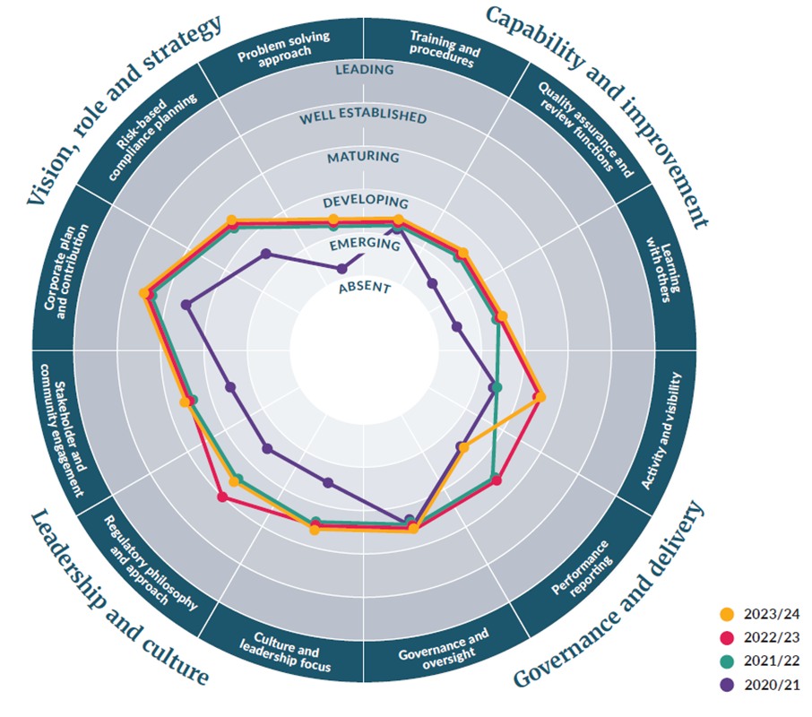

# Appendix: Modern Regulator Improvement Tool framework and explanations

The Modern Regulatory Improvement Tool (MRIT) framework consists of 12 attributes across 4 themes (see table A1). They are based on the AELERT Statement of Better Regulatory Practice. Each attribute represents a level the regulator may occupy which equates to a measurement of maturity.

Assessment against the attributes is based on six levels of organisational maturity. Each attribute has a specific description for each level, but a general description is provided in table A2.

Table A1: Description of MRIT attributes

| **Theme** | **Attribute** | **Description** |
| --- | --- | --- |
| Vision, role and strategy | Corporate plan and contribution | A corporate plan that articulates the organisation’s goals, objectives and future work activities. ‘Contribution’ describes the regulator’s ability to link its goals, objectives and activities with the Government’s agenda. |
| Risk-based compliance planning | Mechanisms to allocate regulatory effort and response, based on an assessment of the regulator’s risk appetite, characteristics of the regulated community and so on. This may include annual planning mechanisms, assessment frameworks or other systems to apportion and track effort. |
| Problem-solving approach | A way of resolving specific or complex problems by rearranging effort, skills and resources around the problem itself, rather than through traditional functional structures. It is often associated with agile project management styles and concepts of double-loop learning. |
| Capability and improvement | Training and procedures | How the regulator ensures it has the requisite combination of skills and competencies to achieve its regulatory role and organisational priorities (training). The procedures and policies used to reinforce expected behaviours and to support staff to achieve the organisation’s objectives (procedures). |
| Quality assurance and review functions | Initiatives that support operational consistency, fair and unbiased decision-making, and continuous improvement. These include internal and external mechanisms such as structured assessments and reviews, and multiple avenues within and outside the regulator for duty holders to review decisions or lodge complaints. |
| Learning with others | The regulator’s role in learning from, and sharing information and experiences with, other regulators as part of the broader regulatory profession. |
| Governance and delivery | Activity and visibility | How active the regulator is in administering its legislation and regulatory scheme, including whether it is proactive or mostly reactive, and whether it uses all measures available to it (activity). How much the regulated and wider community are aware of the regulator’s role, function and achievements. |
| Performance reporting | The collection and use of information to determine whether the regulator is effective in its regulatory mission and to inform organisational decisions, and to inform the public and stakeholders about the regulator’s effectiveness. |
| Governance and oversight | The systems and institutions for ensuring that the regulator is well-managed, accountable, ethical and transparent. |
| Leadership and culture | Stakeholder and community engagement | The regulator’s ability to bring stakeholder and community voices into decisions that affect or interest them. This can involve different levels of engagement. The types of engagement can include inform, consult, involve, collaborate and empower. |
| Regulatory philosophy and approach | The regulator’s ability to clearly articulate and apply the theory that acts as a guiding principle for the way it regulates; how it will approach its role as a regulator and use its powers to regulate; and the factors that the regulator takes into consideration when responding to any identified non-compliance or harm. |
|
| Culture and leadership | The regulator’s expectations, experiences, philosophy and values that hold it together (culture) and its ability to establish a clear vision, share that vision with others, and coordinate and balance the conflicting interests of all members and stakeholders (leadership). |

Table A2: Levels of organisational maturity

|  |  |
| --- | --- |
| **Level** | **Description** |
| **Leading** | It is not expected that many agencies will reach this level of maturity without a conscious investment of resources in the attribute. A leading agency will be recognised as such across the AELERT network, and quite likely overseas. It will have a strong theoretical understanding of the attribute, as well as a best-practice approach that achieves consistently strong results in matters related to the attribute. |
| **Well-established** | The attribute is now embedded in the agency and will likely continue at this level despite organisational changes. The agency will be recognised by its peers as being at a high level of development in this attribute, and the agency will achieve strong results as a consequence of its level of maturity. |
| **Maturing** | An agency’s confidence or proficiency is growing, and it may be recognised within its regulatory community or jurisdiction as performing well in the attribute. The attribute may not be fully embedded in the agency though. A change of leadership or change in the external environment could impact on the attribute. |
| **Developing** | The agency will have recognised the importance of the attribute and progressed down the path of embedding it into the systems, processes or culture of the agency. Agencies at the ‘developing’ level will have a growing degree of confidence with the attribute, but its presence may not be at a consistently high level across the whole agency. |
| **Emerging** | The attribute is present but is at an early stage of its development. The agency may have recognised the importance of the attribute and begun developing its capability, or it may not have formally developed it, but parts of the agency may be displaying the attribute in an ad hoc or unstructured way. |
| **Absent** | The attribute is not present in the agency or is present only in a rudimentary form. No judgement is associated with an agency identifying itself as ‘absent’ for a particular attribute, because many legitimate reasons exist as to why an attribute might not be present. For example, this might apply to a newly formed agency that has yet to develop some of the attributes or to a more established agency that has not branched out into a particular area (such as compliance planning). |

Table A3: Waste operations MRIT scores

| **Theme** | **Attribute** | **2020/21** | **2021/22** | **2022/23** | **2023/24** |
| --- | --- | --- | --- | --- | --- |
| Vision, role and strategy | Corporate plan and contribution | Maturing | Well-established | Well-established | Well-established |
| Risk-based compliance planning | Developing | Maturing | Maturing | Maturing |
| Problem-solving approach | Emerging | Developing | Developing | Developing |
| Capability and improvement | Training and procedures | Developing | Developing | Developing | Developing |
| Quality assurance and review functions | Emerging | Developing | Developing | Developing |
| Learning with others | Emerging | Developing | Developing | Developing |
| Governance and delivery | Activity and visibility | Developing | Developing | Maturing | Maturing |
| Performance reporting | Developing | Maturing | Maturing | Developing |
| Governance and oversight | Maturing | Maturing | Maturing | Maturing |
| Leadership and culture | Stakeholder and community engagement | Developing | Maturing | Maturing | Maturing |
| Regulatory philosophy and approach | Developing | Maturing | Maturing | Maturing |
| Well-established |
| Culture and leadership | Developing | Maturing | Maturing | Maturing |

# References

[Ministry for the Environment. 2021. *Waste Minimisation Act regulatory performance monitoring framework: Inaugural report 2020/21.* Wellington: Ministry for the Environment.](https://environment.govt.nz/publications/waste-minimisation-act-2008-regulatory-performance-monitoring-framework-report-20212022/)

[Ministry for the Environment. 2022. *Waste Minimisation Act 2008 regulatory performance monitoring framework report 2021/2022.* Wellington: Ministry for the Environment.](https://environment.govt.nz/publications/waste-minimisation-act-2008-regulatory-performance-monitoring-framework-report-20212022/)

Ministry for the Environment. 2025. *Waste Minimisation Act 2008 regulatory performance monitoring framework report 2022/2023.* Wellington: Ministry for the Environment.

Severe Weather Emergency Recovery (Waste Minimisation) Order 2023. Available at https://www.legislation.govt.nz/regulation/public/2023/0175/latest/whole.html#LMS869894 (Accessed: 28 April 2024).

Standard Materials for Kerbside Collections Notice 2023 (Notice No 1) Available at: https://gazette.govt.nz/notice/id/2023-go4222(Accessed: 28 April 2028).

Waste Minimisation Act 2008. Available at https://www.legislation.govt.nz/act/public/2008/0089/latest/whole.html#dlm999802 (Accessed: 28 April 2025).

Waste Minimisation (Calculation and Payment of Waste Disposal Levy) Regulations 2009. Available at https://www.legislation.govt.nz/regulation/public/2009/0144/latest/whole.html#DLM2055712 (Accessed: 28 April 2024).

Waste Minimisation (Information Requirements) Regulations 2021. Available at https://www.legislation.govt.nz/regulation/public/2021/0069/latest/whole.html#LMS474645 (Accessed: 28 April 2025).

Waste Minimisation (Microbeads) Regulations 2017. Available at https://www.legislation.govt.nz/regulation/public/2017/0291/latest/whole.html#DLM7490715 (Accessed: 28 April 2025).

Waste Minimisation (Plastic Shopping Bags) Regulations 2018. Available at https://www.legislation.govt.nz/regulation/public/2018/0270/6.0/whole.html (Accessed: 28 April 2025).

Waste Minimisation (Plastic and Related Products) Amendment Regulations 2022. Available at https://www.legislation.govt.nz/regulation/public/2022/0312/latest/whole.html#whole (Accessed: 28 April 2025).

Waste Minimisation (Plastic and Related Products) Regulations 2022. Available at https://legislation.govt.nz/regulation/public/2022/0069/13.0/whole.html (Accessed: 28 April 2028).

1. A number of increases in the waste levy are scheduled for classes 1 to 4 through until 1 July 2027.
2. Regulation relating to levy-liable facilities – Waste Minimisation (Calculation and Payment of Waste Disposal Levy) Regulations 2009 and Regulation relating to non-levy liable facilities – Waste Minimisation (Information Requirements) Regulations 2021.
3. An example of a ‘not applicable’ score is where a facility is not subject to the regulations related to the audit criteria, such as a cleanfill and industrial monofill not subject to the levy, and therefore it does not receive invoices. Another example is where the facility was not active at the time of the audit inspection, so the audit criteria could not be assessed.
4. In the 2020/21 and 2021/22 reporting years only Class 1 facilities were audited. In 2022/23, both Class 1 and 2 facilities were audited. In 2023/24 Classes 1 to 4 were audited.
5. This is at the discretion of the Minister for the Environment who will direct the Ministry to withhold payment in some cases where these requirements have not been met.
6. As reported voluntarily in TAWLES.
7. Legal agreement outlining terms and conditions of funding for a specific purpose.
8. Waste Minimisation (Microbeads) Regulations 2017.
9. Waste Minimisation (Plastic Shopping Bags) Regulations 2018.
10. Cabinet removed the deadline for a third tranche of phase-outs in 2024 and we are currently working with stakeholders to provide further advice to the Minister around next steps for these products.
11. Waste Minimisation (Plastic and Related Products) Regulations 2022 and Waste Minimisation (Plastic and Related Products) Amendment Regulations 2022.
12. Cabinet agreed in 2024 to amend the regulations to extend the 2025 requirements to 1 July 2028. If approved, labels on all produce sold domestically, including the adhesive, must be certified home-compostable by 1 July 2028.
13. Invoices totalling $130,449.90 (including GST) were issued in the 2022/23 period (July 2022 to June 2023).
14. Invoices totalling $23,769.58 (including GST) were issued in the 2023/24 period (July 2023 to June 2024).