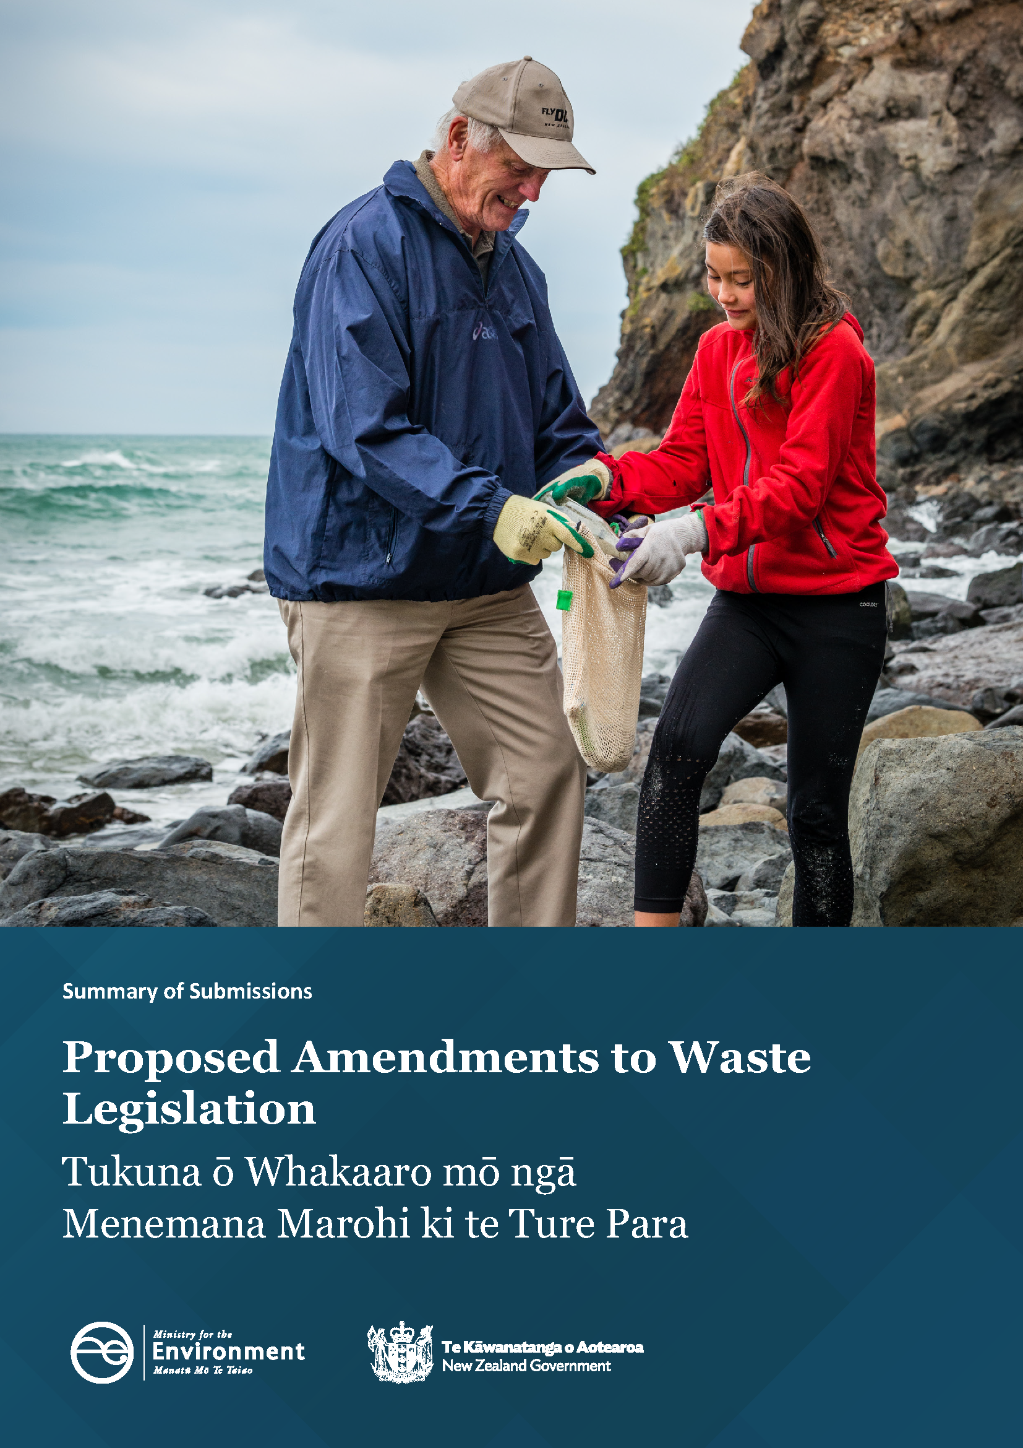
Disclaimer
The information in this publication is, according to the Ministry for the Environment’s best efforts, accurate at the time of publication. The Ministry will make every reasonable effort to keep it current and accurate. However, users of this publication are advised that:
- the information does not alter the laws of New Zealand, other official guidelines, or requirements
- it does not constitute legal advice, and users should take specific advice from qualified professionals before taking any action based on information in this publication
- the Ministry does not accept any responsibility or liability whatsoever whether in contract, tort, equity, or otherwise for any action taken as a result of reading, or reliance placed on this publication because of having read any part, or all, of the information in this publication or for any error, or inadequacy, deficiency, flaw in, or omission from the information in this publication
- all references to websites, organisations or people not within the Ministry are for convenience only and should not be taken as endorsement of those websites or information contained in those websites nor of organisations or people referred to.

This document may be cited as: Ministry for the Environment. 2025. Proposed amendments to waste legislation: Summary of submissions. Wellington: Ministry for the Environment.

Published in December 2025 by the
Ministry for the Environment
Manatū mō te Taiao
PO Box 10362, Wellington 6143, New Zealand
environment.govt.nz
ISBN: 978-1-991404-07-7
Publication number: ME 1918
© Crown copyright New Zealand 2025

Contents
Consultation overview and main themes 7
What we consulted on and why 7
Overview: what submitters said 7
How we consulted 9
Consultation tools 9
Who responded? 9
Next steps 12
What we heard 13
Creating a framework for extended producer responsibility 13
Improving the waste disposal levy system through changes to levy allocation, distribution and use 21
Clarifying roles and responsibilities in waste legislation 34
Creating a modern, effective compliance regime 38
Enabling efficient and effective controls for littering and other types of mismanaged waste 44
Appendix: Summary of proposals and consultation questions 55

Tables
Table 1: Overview of main themes heard across topic areas 7
Table 2: Submitter responses across consultation topics 11
Table 3: Descriptive quantification of submitters 11
Table 4: Summary of proposals and consultation questions 55

Figures
Figure 1: Overview of groups and sectors that made written submissions 10
Figure 2: Number of submitters per region, as well as from outside New Zealand 10
Figure 3: Summary of support for the proposed extended producer responsibility framework 13
Figure 4: Support for discontinuing the Government accreditation of voluntary product stewardship schemes 19
Figure 5: Support for changing the distribution of levy funds to territorial authorities from a population-based calculation to a combination of a base flat rate (20 per cent) and a population-based calculation (80 per cent) 21
Figure 6: Support for activities that promote or achieve waste minimisation, in accordance with and as set out in the territorial authorities’ Waste Management and Minimisation Plan 22
Figure 7: Support for costs associated with managing emergency waste 23
Figure 8: Support for costs associated with activities that provide for the remediation of contaminated sites and vulnerable landfills 23
Figure 9: Support for costs associated with compliance, monitoring and enforcement of mismanaged waste 24
Figure 10: Support for costs associated with activities that reduce environmental harm or increase environmental benefits 24
Figure 11: Support for the removal of the current blanket exclusion from the levy for waste-to-energy facilities 25
Figure 12: Support for the Minister’s considerations for a review of the effectiveness of the waste levy should mirror the scope of the purpose of the WMA and the parameters for levy spend (once these are decided) 26
Figure 13: Support for changing the timeframe for review of the effectiveness of the waste levy from every three years to at least every five years 26
Figure 14: Support for replacing the current levy-waiver requirement of ‘exceptional circumstances’, instead enabling the Secretary to waive the requirement for an operator to pay any amount of levy in specified circumstances 27
Figure 15: Support for limiting the waiver requirement to emergency event situations as per the Civil Defence Emergency Management Act 2002, and biosecurity responses have been undertaken under Part 7 of the Biosecurity Act 1993 27
Figure 16: Support for the waiver requirement for waste from the remediation of a contaminated site should specify any eligibility criteria that an application must meet 28
Figure 17: Support for requiring a Minister to consider specific criteria before recommending levy exemption regulations are made (instead of the current requirement that the Minister is satisfied ‘exceptional circumstances’ exist) 28
Figure 18: Support for applying a timeframe of a maximum of five years before levy exemptions via regulations must be reviewed or allowed to expire 29
Figure 19: Support for the Minister being able to impose conditions on levy exemptions 29
Figure 20: Support for clarifying in legislation when the levy should be imposed on waste disposed of at a disposal facility, so that waste reuse on-site is operationally necessary and reasonable 30
Figure 21: Support for an approval system with limits and conditions 31
Figure 22: Support for changes to the stockpile calculation process to track the throughput of materials 31
Figure 23: Support for a stockpile volume threshold limit 31
Figure 24: Support for improved data collection, record-keeping and reporting provisions, to increase transparency and traceability of material entering and leaving a site 32
Figure 25: Support for defining/amending the terms ‘diverted material’, ‘accumulation’ and ‘stockpiling’ in the legislation 32
Figure 26: Support for the proposed changes to the roles and responsibilities for the Ministry for the Environment 34
Figure 27: Support for the proposed changes to the roles and responsibilities for the New Zealand Customs Service 35
Figure 28: Support for the proposed changes to the roles and responsibilities for territorial authorities 35
Figure 29: Support for the change in the Secretary for the Environment’s ability to retain levy payments to a territorial authority, from mandatory to discretionary 36
Figure 30: Support for enabling the Waste Advisory Board to provide advice at its discretion 36
Figure 31: Support for the regulator having greater powers to receive data, including the ability share with other regulators and the Ministry 38
Figure 32: Support for a tiered approach to the compliance tools and sanctions 42
Figure 33: Support for integrating littering and other types of mismanaged waste into the same regulatory framework for waste management and minimisation 44
Figure 34: Support for enabling regulation for the collection of data on littering and dumping 45
Figure 35: Support for expanding the purpose of the Waste Minimisation Act to include littering and other mismanaged waste in the new waste legislation 45
Figure 36: Support for limiting the definition of ‘public authority’ as proposed 46
Figure 37: Support for enabling public authorities (amended as proposed) to warrant litter control officers or appoint litter wardens to manage and enforce littering and other mismanaged waste offences 46
Figure 38: Support removing the assignment of a statutory role for the promotion of litter control to any specific agency or organisation 46
Figure 39: Support for public authorities having a discretion whether they provide waste receptacles in public places but an obligation to empty those receptacles if they provide them 47
Figure 40: Support for removing the requirement for the Medical Officer of Health to be satisfied that litter receptacles are emptied promptly, efficiently and at regular and prescribed intervals 48
Figure 41: Support for a local or public authority retaining the ability to make grants to any organisation for the abatement or prevention of litter 48
Figure 42: Support for a local or public authority being able to spend such sums of money as it thinks fit on any scheme or campaign for the abatement or prevention of litter 48
Figure 43: Support for a local or public authority retaining the ability to make bylaws to help reduce littering and dumping, if they are not inconsistent with the provisions of the new legislation 49
Figure 44: Support for a local or public authority retaining the ability to deter, prevent, require timely clean-up and enforce waste escaping/being carried on to public or private land 49
Figure 45: Support for enabling all types of litter control officers to apply different tiers of compliance tools, where they are authorised to act 50
Figure 46: Support for Litter Control Officers being able to use vehicle registration and ownership details when enforcing offences 50
Figure 47: Support for litter control officers being able to use appropriate evidence-gathering, search and surveillance powers for vehicles that are implicated in serious dumping offences 51
Figure 48: Support for the proposed amendments to the compliance monitoring and enforcement framework for littering and other mismanaged waste offences 51
Figure 49: Support for lowering the threshold for evidence of a mismanaged waste offence, to allow for effective compliance monitoring and enforcement by litter control officers 52
Figure 50: Support for public authorities being able to be compensated by the offender if the mismanaged waste offence has caused significant environmental harm 52
Figure 51: Support for public authorities, regulators, or occupiers of private land where a littering offence is committed should be able to recover reasonable costs associated with the removal of the litter/waste and/or the environmental harm caused from the offender 53
Figure 52: Responses to the question are the current provisions efficient or effective for addressing this type of mismanaged waste issue in your area? 53

Consultation overview and main themes

What we consulted on and why
From 22 April to 1 June 2025, the Government consulted on proposals to amend the Waste Minimisation Act 2008 (WMA) and Litter Act 1979 (the Litter Act). The amendments aim to create fit-for-purpose, modern waste legislation that provides more options and flexibility to reduce and manage waste effectively and efficiently. The Ministry for the Environment (the Ministry) sought feedback on the following proposals for amending the waste legislation:
- creating a framework for extended producer responsibility
- improving the levy system through changes to waste levy allocation, distribution and use
- clarifying roles and responsibilities in the waste legislation
- creating a modern, effective compliance regime
- enabling efficient and effective controls for littering and other types of mismanaged waste.
To inform the consultation, the consultation document Have your say on proposed amendments to waste legislation, along with a Summary of proposals and consultation questions, was published on the Ministry website.
This document summarises the views expressed by the submitters. It does not analyse those views or make recommendations in response to them. Any recommendations will be included in advice to the Government to help with further policy decisions.

Overview: what submitters said
Main themes from the consultation across topic areas are summarised below.
Table 1: Overview of main themes heard across topic areas
Overview of themes across consultation topic areas
Creating a framework for extended producer responsibility (EPR) and discontinuing government accreditation of voluntary product stewardship (VPS) schemes | - Most submitters (95 per cent) supported a modern EPR framework because it would help reduce waste by making producers responsible for the full life cycle of their products. They also shared helpful suggestions for how the framework could be designed, including ideas specific to certain products or materials.  - Views were mixed on ending government accreditation of VPS schemes. Supporters of ending this as a legislative function (69 per cent) believed VPS schemes have not delivered expected outcomes and saw the process as ineffective. Others (21 per cent) considered VPS schemes to be an important pathway to regulated priority product stewardship. They were concerned that the absence of government accreditation of VPS schemes could lead to greenwashing and hinder industry growth and innovation.
Improving the waste disposal levy system through changes to the waste levy allocation, distribution and use | - Most submitters (86 per cent) agreed with the proposal to change the waste levy distribution for territorial authorities’ calculation to a combination of a base flat rate (20 per cent) and a population-based calculation (80 per cent).  - Many submitters (61 per cent) were opposed to broadening the scope of the levy to include activities that reduce environmental harm or increase environmental benefits.  - Most submitters (95 per cent) agreed that the waste levy should be spent on activities that promote or achieve waste minimisation, in accordance with and as set out in the territorial authorities’ Waste Management and Minimisation Plan.  - Many submitters (70 per cent) agreed with the proposal to remove the blanket exclusion from the waste levy for waste-to-energy facilities.  - Of the three levy waiver proposals, submitters were split in their opinions. Although over 50 per cent of submitters were in favour of all the proposals, around 25 per cent of submitters were unsure.  - Most submitters (76 per cent) supported clarifying when the levy should be imposed on waste disposed of at disposal facilities, so that waste reused on-site is operationally necessary and reasonable.  - Strong support was expressed by submitters for the proposed changes to improve the stockpiling controls through the introduction of new tools. Each of the five proposals received support from over 70 per cent of submitters.
Clarifying roles and responsibilities in the waste legislation | - Most submitters supported proposed changes to the roles and responsibilities for the Ministry for the Environment (87 per cent), New Zealand Customs Service (88 per cent) and territorial authorities (76 per cent).  - Submitters expressed general support for inter-agency data sharing.  - Many submitters (56 per cent) supported the proposal that the Secretary for the Environment’s ability to retain levy payments should change from mandatory to discretionary. However, some submitters supported the proposal conditionally, cautioning that criteria should guide discretion.  - Concerns were raised regarding increased financial uncertainty for councils, which they considered could undermine local waste minimisation efforts.  - Many submitters (74 per cent) supported enabling the Waste Advisory Board (the Board) to provide advice towards improved policy outcomes, and strategic collaboration between the Minister for the Environment and Board throughout the policy development process.
Creating a modern, effective compliance monitoring and enforcement (CME) regime | - Most submitters (93 per cent) supported the proposal that the regulator has greater powers to receive and share data. Most submitters (87 per cent) also supported the proposal for a tiered approach to compliance tools and sanctions.  - A few submitters raised concerns about sharing data containing commercially sensitive information and requested that this be addressed.  - There were recommendations from submitters regarding how to improve the proposed tiered approach to the CME framework. This included suggestions to adequately resource councils and provide clear guidance on how to apply each tier of the CME framework.
Enabling efficient and effective controls for littering and other types of mismanaged waste | - A range of questions were included in the consultation document on the littering and mismanaged waste proposals. Generally, broad support was received for the proposals.  - The proposal to change the current mandatory requirement for public authorities to provide waste receptacles was the least supported proposal (19 per cent disagreed with the proposal). This level of opposition was due to the view that this was an expected core responsibility of councils, and that the removal of bins could lead to an increase in littering. It is noted, however, that 81 per cent of submitters were in support of the proposal.

How we consulted

Consultation tools
Submitters were invited to submit their views using the Ministry’s online public engagement and survey platform, Citizen Space (Have your Say), or by email to its consultation inbox (wasteamendment@mfe.govt.nz).
Submitters choosing to submit via Citizen Space could respond to the consultation document questions provided on the platform. They could also choose not to provide an answer to any particular question. Submitters could also add written feedback through the online platform and provide additional supporting information. Submitters who provided their submission to the email address could choose the structure of their content and provide this as a Word document or PDF.
During the consultation period, two online webinars were held in partnership with WasteMINZ, and an additional webinar was held in partnership with the New Zealand Food and Grocery Council. Over 500 participants attended these webinars. Recordings of the webinar were made available on the Ministry website. The recordings did not include the question-and-answer portion of the webinars. Those in attendance were able to ask questions of the presenters and were encouraged to email the consultation inbox with their questions if there was insufficient time to address it at the webinars.
The commonly asked questions received at webinars and through the consultation inbox were answered after the webinars by Ministry officials and posted on the Ministry website.

Who responded?
The Ministry received 267 submissions. These came from individuals, organisations and groups across all regions of New Zealand as well as internationally, from a range of sectors, including local government, businesses, industry bodies, iwi and hapū, registered charities and individuals. Most responses were submitted via Citizen Space.
Figure 1 below shows the proportions of submitters from each group. Submitters could identify with as many different groups as they wanted to. This means the groups are not directly comparable with each other.
Figure 2 shows the number of submitters per region, as well as from outside New Zealand.
Table 2 shows how submitters responded across the consultation topics.
Figure 1: Overview of groups of people and sectors that made written submissions
267  total written submissions | 42  Waste and resource recovery sector – waste management | 66  Waste and resource recovery sector – waste minimisation | 11  Waste and resource recovery sector – disposal facility operators
26  Business – goods-producing industry | 6  Business – primary  industry | 29  Business – service  industry | 22  Industry body or association
3  Iwi, hapū | 73  Non-governmental organisation, charity or trust | 74  Individual | 8  Outside of  New Zealand
1  Central government organisation | 40  Local government or  board – territorial authority | 6  Local government or  board – regional council | 33  Other

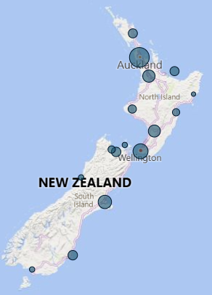
Figure 2: Number of submitters per region, as well as from outside New Zealand
Submissions per region
Northland | Te Tai Tokerau | 9
Auckland | Tāmaki Makaurau | 56
Waikato | 19
Bay of Plenty | Te Moana-a-Toi | 9
Gisborne | Te Tairāwhiti | 1
Taranaki | 7
Hawke’s Bay | Te Matau-a-Māui | 5
Manawatū-Whanganui | 18
Wellington | Te Whanganui-a-Tara | 30
Marlborough | Te Tauihu-o-te-waka | 2
Tasman | Te Tai-o-Aorere | 5
Nelson | Whakatū | 10
West Coast | Te Tai Poutini | 2
Canterbury | Waitaha | 23
Otago | Ōtākou | 10
Southland | Murihiku | 2
National organisation | 51
International | 8

Table 2: Submitter responses across consultation topics
Consultation topic area | Number of submitters who answered one or more questions
Creating a framework for extended producer responsibility and discontinuing government accreditation of voluntary product stewardship schemes | 235
Improving the waste levy system through changes to waste levy allocation, distribution and use | 238
Clarifying roles and responsibilities in the waste legislation | 174
Creating a modern, effective compliance regime | 167
Enabling efficient and effective controls for littering and other types of mismanaged waste | 199

Submitter comments
Comments from submitters are included and described throughout this summary. Submitters who gave consent for their submission and name to be published are referenced with the quote. Some comments are not attributed to a particular submitter because they are not direct quotes or because the submitter chose to remain anonymous.
When referring to submitters, the report quantifies support for positions based on the classifications in table 3. These classifications relate to the number of responses received and are used relative to the proportion of responses to that question.
Table 3: Descriptive quantification of submitters
Descriptive classification | Definition and/or range
None | 0% of submitters on this topic
Few | 1–25% of submitters on this topic
Some | 26–50% of submitters on this topic
Many | 51–75% of submitters on this topic
Most | 76–99% of submitters on this topic
All | 100% of submitters on this topic

Next steps

Publishing submissions
Alongside the release and publication of this document, we will also publish and release submissions from those who provided consent to publication of their individual submission. These will be available on the Ministry’s website.

Policy decisions
In addition to the Minister for the Environment receiving a summary of the submissions, the information provided as part of the consultation phase will inform subsequent policy development for the waste legislation. The Ministry will provide advice to Ministers and Cabinet on the submissions received and the next steps for waste legislative amendments.

Stay up to date
To stay up to date on any decisions and announcements, visit the Ministry’s website or go to our Facebook or Instagram page.

What we heard

Creating a framework for extended producer responsibility

Summary
- Most submitters (95 per cent) supported a modern extended producer responsibility framework because they considered it would prevent and reduce waste by requiring producers to be held accountable for the full life-cycle impacts of their products.
- Some submitters offered suggestions for improvements to the process for prioritising products, designing schemes, financial controls, performance monitoring and enforcement. Others provided detailed design considerations specific to a certain product or material.
- There were mixed views about ending government accreditation of voluntary product stewardship (VPS) schemes. Many submitters (69 per cent) supported this proposal because they considered these schemes have not delivered the expected outcomes and viewed the accreditation process as ineffective in its current form.
- Some submitters (21 per cent) considered VPS schemes to be an important pathway to regulated priority product stewardship. There were concerns that ending government accreditation of VPS schemes would increase the risk of greenwashing and potentially stifle industry growth and innovation.

What submitters were asked and what they said

Do you support the proposal for a modern EPR framework?
A total of 235, or 88 per cent of submitters responded to this question, with most (95 per cent) supporting the proposals for a modern EPR framework. The support came from all submitter types. Five per cent were unsure or did not support the proposal.
Figure 3: Summary of support for the proposed extended producer responsibility framework
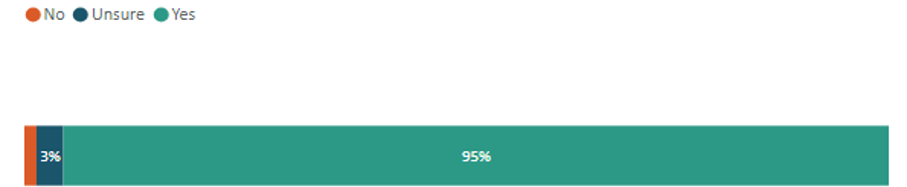
This section summarises responses to the question on whether submitters support the proposed EPR framework, as well as feedback on Appendix 1: Summary of proposed extended producer responsibility framework of the consultation document.

Benefits of an extended producer responsibility (EPR) framework
Submitters considered EPR to be a powerful tool to prevent and reduce waste, enabling a shift toward a more resource efficient, low waste and low emissions (more circular) economy. These submitters considered that EPR encourages reuse, repair and recycling, reducing reliance on raw materials and mitigating environmental impacts while also creating jobs and providing for growth. Submitters noted that EPR can drive meaningful change by making producers accountable for the full life-cycle impact of their products, aligning with user pays and polluter pays principles.
Submitters also considered that EPR would shift the financial burden of waste management from ratepayers and councils to producers, making the system more equitable. EPR was viewed as a way to internalise the true costs of products and packaging. It would also:
- incentivise better product design, including durability, repairability and recyclability
- enable the implementation of container return schemes, which have proven successful in over 70 international jurisdictions. All Australian states either have or will have these schemes in place by the end of 2027. Container return schemes deliver benefits such as reduced litter and increased recycling rates.
Submissions from industry respondents provided useful feedback on detailed design considerations specific to a particular product or material. This feedback will be taken into consideration by the Ministry with respect to scheme design and used to inform subsequent policy development for the legislation.
This summary focuses on submission feedback relating to the overall EPR framework and the enabling legislation, as opposed to scheme-specific design considerations.
One submitter noted that:
Strengthening the product policy toolkit, which includes the extended producer responsibility framework, is critical if we are serious about waste prevention and reduction in Aotearoa NZ. – Sarah Meads
Another submitter noted:
For island communities like Waiheke in the Hauraki Gulf, strengthening the producer responsibility framework is essential to reducing waste and protecting our sensitive environment. As a small, ecologically significant island with limited landfill capacity and high transport costs, we experience the consequences of poorly managed product and packaging lifecycles more acutely than urban centres. – Waiheke Resources Trust

Identifying products of interest and priority products
Strong interest was expressed from submitters about how priority products are identified and what matters should be considered. Feedback included the following.
- The need for a robust investigative process to ensure product(s) would benefit from a regulated approach.
- On the proposed shift to a non-statutory process for declaring priority products, submitters provided pros and cons, including:
- concern this would reduce the pressure on producers to take responsibility and weaken the incentive to establish schemes
- support if the change would allow for faster implementation
- a suggestion that there could be a mandatory regular review process so new products could be included in the EPR priority list.
- Submitters also suggested additions to the priority product list, such as beverage containers, textiles and packaging made from various materials, including glass, fibre and metal.

Process for designing schemes
The co-design process for designing schemes is a non-statutory component of the existing framework. Submitters provided feedback on how they thought co-design could be improved, including the following.
- The focus of EPR should shift away from end-of-life waste management – such as recycling – and focus on designing out waste. Submitters also cautioned against relying on recycling as a default solution, because the current dependence on recycling markets, which often face limited demand for recycled materials, is unsustainable and increases the risk of future market failures.
- The consultation document lacks clarity on who gets to design EPR schemes and how. Where industry takes the lead, this can result in industry capture and scheme designs that do not make producers fully responsible for their products and the impacts of them. The submitters suggested more government control on scheme design, such as establishing an independent agency to oversee product stewardship.
- Support was expressed for proactively enabling coordination between EPR schemes. There is no clear way for schemes to work together, so each scheme focuses on its own products and objectives. As more schemes appear, this could lead to duplicated services, inefficiency and public confusion about different rules and systems.
- Support was expressed for measures that increase equity, inclusion and community engagement. Submitters recognised the importance of ongoing consultation with all stakeholders, particularly iwi, rural communities and local stakeholders, during scheme design.
- There were calls for equity in access to services, and recognition for Māori values in waste management.

Roles and responsibilities
Submitters considered that roles and responsibilities need to be clearly defined, particularly for government and producers, and robust governance is needed alongside government oversight. Other submitter feedback included the following.
- The term Producer Responsibility Organisation (PRO) may be too narrow and could exclude models like non-governmental organisation-led or multi-stakeholder schemes. Submitters recommended broader eligibility and inclusive co-design to allow all options.
- Robust governance is needed alongside government oversight and intervention, providing schemes with the necessary autonomy to act like commercial entities and respond to changing market conditions.
- Support was expressed for the inclusion of online and offshore producers, to ensure they face the same rules as onshore producers.
- Support was expressed for the inclusion of duty of care, standards and licensing provisions in the legislative toolkit, because this would strengthen the overall framework and help shift responsibility upstream to producers rather than focus on ‘end-of-pipe’ solutions.

Regulating for high performing schemes
Submitter feedback included providing stronger scheme and product control provisions within the EPR toolkit, including:
- ensuring a robust and adaptable regulatory framework is provided for, to allow for an effective response to changing circumstances, such as through innovation and markets
- that section 23 of WMA provisions has been underutilised and could be strengthened with clearer descriptions, expansion and modernisation. Product passports (based on the European Union model) could also be added
- establishing stronger regulations to drive better product design and reduce waste at the source, rather than focusing on end-of-life product management
- supporting mandatory return and/or recycling rate targets for schemes and requiring public reporting on performance targets
- providing for certain automatic interventions if scheme targets are not met (such as automatic increases in deposit rates for schemes involving a refundable deposit)
- building scheme expectations into the WMA provisions rather than leaving this to the Minister’s discretion to set via a Gazette notice, and ensuring expected outcomes include adherence to the waste hierarchy and a focus on the full product life cycle
- having central government set performance targets (with consultation) rather than the industry. This approach would avoid the incentive to opt for the lowest-cost option that results in lower targets
- a view that enforcement and framework design needs to incentivise the PRO to maximise performance.
One submitter noted that:
The Waste Minimisation Act in its current form lacks enforceable mechanisms to hold producers accountable for end-of-life products. By mandating producer responsibility for design, collection, recycling, and disposal, the proposed EPR framework remedies this gap in the current WMA. – Manawatu District Council

Financial controls
Submitters supported regulated fees (or charges) that enable cost recovery, while also maintaining the not-for-profit model and providing for some flexibility to respond to changing market conditions. In addition, support was expressed for:
- being able to delegate the collection of fees and/or charges (and refunds where necessary) to the appropriate authority or organisation, supported by a strong enforcement capability
- establishing eco-modulated fees, which adjust the scheme charges producers pay based on the environmental performance (such as reusability, recyclability, repairability) of their products
- funding reuse and repair initiatives, as well as providing incentives for better product design and innovation
- funding for research, development and innovative solutions to reduce the product’s environmental impact (particularly where recyclability and end markets are problematic)
- providing adequate financial controls to mitigate the financial risks, including underfunding, if financial mechanisms are not based on actual operational costs
- fairly compensating scheme service providers, including handling and recycling facility operators, for their services.

Compliance monitoring and enforcement (CME)
Submitters provided the following comments on the CME of EPR schemes:
- The effective roll-out of EPR will be reliant on properly funded compliance and enforcement being established in advance of schemes.
- Submitters wanted greater clarity on enforcement roles, especially the respective roles for the regulator and PRO. A view was expressed that the scheme manager should have a role in enforcement operationally, and there should be tiered responses and suitable penalties for non-compliance.
- A comprehensive compliance scheme is needed to ensure that scheme outcomes and targets are set, delivered and consistently improved upon.
One submitter noted that:
The EPR Framework needs to include … A compliance, monitoring and enforcement regime that reflects the real risks of non-compliance, with clear roles for the regulator, PROs and scheme management, as well as suitable penalties for non-compliance that will drive change. – 3R Group Limited

General comments
Additional comments submitters made about EPR schemes included:
- Encouragement is needed to learn from global best practice to avoid known pitfalls. Suggestions were made for New Zealand to adopt international best practices to drive meaningful change.
- Concern was expressed that the proposals contained in the consultation document lacked detail, ambition and urgency, particularly in addressing high-impact waste streams, such as e-waste, packaging and textiles.
- EPR should be used to complement other tools, such as landfill bans, product taxes, labelling requirements, licensing and duty of care provisions.
- Faster implementation of mandatory EPR schemes is urgently needed. Submitters were concerned about slow progress on the existing six priority products. They saw EPR as a way to speed things up and improve oversight, but worried that momentum on current products could be lost during the transition.
- Uncertainty about how business would be affected by the EPR framework. Submitters expressed that businesses need stability to support long-term investment and recommended ongoing stakeholder consultation to improve the EPR framework.
- That schemes should be easy to use, be accessible and convenient and leverage existing collection networks and infrastructure (not substitute existing services).
- There was strong support for implementing a container return scheme for beverage containers. A range of views were shared on a possible scheme design and operations.
One submitter noted that:
We also wish to emphasise the need to ensure that momentum is not lost on existing priority products such as batteries, agrichemicals and plastics. – Tasman District Council

Reasons against or unsure
Less than 5 per cent of submitters were unsure or did not support modernising the EPR framework. The two submitters – one organisation and one individual – who did not support the proposal provided no further comment.
Submitters who were unsure about the proposal expressed a range of concerns. Their views are summarised below.
- Submitters cited a lack of information to make informed decisions, particularly on the potential impacts and how the EPR framework would lead to more product stewardship schemes.
- Suggested alternatives included making the polluter pays principle compulsory for all products by 2030, focusing on circular design and banning unnecessary packaging rather than managing it through a scheme.
Submitters who were unsure but offered conditional support highlighted several areas for improvement in the proposed EPR framework, including the need for:
- stronger legal mechanisms to ensure the priority product list is regularly updated
- a broader definition of eligible scheme managers (PROs) to include local governments and community organisations
- better integration of existing regulatory tools to enhance the effectiveness of EPR
- financial protection for territorial authorities in case schemes fail
- a framework that supports circular economy models rather than encouraging lowest-cost compliance
- ensuring equitable service delivery, especially for small communities and avoiding dominance by large commercial players
- encouragement to address the lack of coordination in the current co-design model, which risks duplication, inefficiency and public confusion as more schemes are introduced
- clarification on how performance targets will be set and enforced to ensure accountability and effectiveness.

Do you support discontinuing the Government accreditation of voluntary product stewardship schemes?
A total of 225 submitters, representing 84 per cent of all respondents, answered this question. Of those who responded, most (69 per cent) supported discontinuing government accreditation of voluntary product stewardship (VPS) schemes.
Figure 4: Support for discontinuing the Government accreditation of voluntary product stewardship schemes
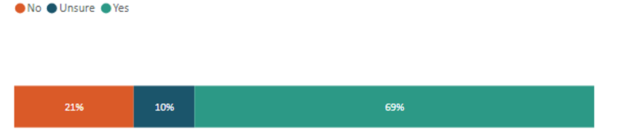
There was a varied degree of support for ending government accreditation of VPS schemes across sector groups. Among business respondents, only some (44 per cent) supported the proposal. In contrast, support was higher among submitters from the waste and resource recovery sector (67 per cent), local government (71 per cent), non-governmental organisations, charities or trusts (94 per cent), and iwi and hapū (100 per cent).
Submitters, in support of withdrawing a legislative function, commented that VPS schemes have not delivered the expected outcomes and the current government accreditation process is ineffective. Others viewed it as a form of greenwashing. One submitter commented:
Voluntary efforts and schemes have not worked in competition with the economics of wasteful practices. Nothing will change unless it is regulated. Get going. – Again Again Limited
Another submitter noted:
In some cases [VPS schemes] have been a useful stepping stone … to progress towards mandatory EPR. In other cases, they have been a way for organisations to use them as a form of greenwash … It would be better for the Government to apply the scarce resources it has available to develop high performing schemes for key product and material streams ... Accreditation [criteria] … in the current WMA 2008 do not determine whether the scheme is addressing environmental impacts in any real way. – Zero Waste Network Aotearoa
Submitters who opposed or were unsure commented that removing government accreditation could increase the risk of greenwashing and potentially stifle industry growth and innovation. One submitter commented:
While we agree that mandatory regulation is the most effective mechanism to ensure coverage, equity, and environmental integrity, voluntary schemes still have an important role to play in areas not yet declared Priority Products … Without Ministry oversight there is a risk of proliferation of schemes that dilute trust and confuse stakeholders. – Agrecovery Foundation
Submitters who opposed the proposal or were unsure suggested alternatives such as modernising the existing limited VPS framework or appointing an independent third party to maintain a VPS accreditation function.

Improving the waste disposal levy system through changes to levy allocation, distribution and use

Summary
- Most submitters (86 per cent) agreed with the proposal to change the waste levy distribution to territorial authorities to a combination of a base flat rate (20 per cent) and a population-based calculation (80 per cent).
- 61 per cent of submitters were opposed to broadening the scope of the levy to include activities that reduce environmental harm or increase environmental benefits.
- Most submitters (95 per cent) agreed that the waste levy should be spent on activities that promote or achieve waste minimisation, in accordance with and as set out in the Waste Management and Minimisation Plan of territorial authorities.
- Many submitters (70 per cent) agreed with the proposal to remove the blanket exclusion from the waste levy for waste-to-energy facilities.
- Of the three levy waiver proposals, submitters were divided on their opinions. Though over 50 per cent were in favour of all proposals, around 25 per cent were unsure.
- Most submitters (76 per cent) supported clarifying when the levy should be imposed on waste disposed of at disposal facilities, so that waste reused on-site is operationally necessary and reasonable.
- Strong support was expressed by submitters for the proposed changes to improve the stockpiling controls through the introduction of new tools. Each of the five proposals received support from over 70 per cent of submitters.

What submitters were asked and what they said

Waste levy distribution
Do you support changing the distribution of levy funds to territorial authorities from a population-based calculation to a combination of a base flat rate (20 per cent) and a population-based calculation (80 per cent)?
Figure 5: Support for changing the distribution of levy funds to territorial authorities from a population-based calculation to a combination of a base flat rate (20 per cent) and a population-based calculation (80 per cent)
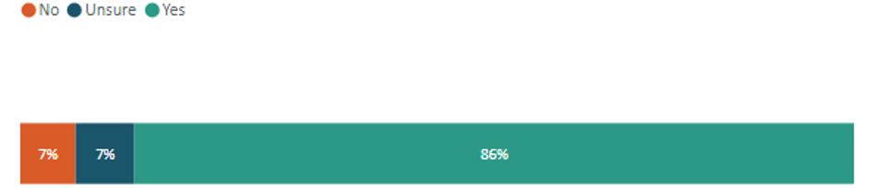
Most submitters (86 per cent) agreed with the proposal to change the distribution of levy funds from a population-based calculation to a combination of a base and flat rate and a population-based calculation. Most territorial authorities (94 per cent) were in favour of this change, commenting that it will be a fairer way to distribute the levy. However, some of the larger territorial authorities were either unsure or unsupportive of the proposal because it would result in less levy funding for them, compared with the status quo calculation.
Others in favour of the changes commented that it would, overall, be a fairer way to distribute the levy, especially for smaller territorial authorities and those that have seasonal population spikes.
The proposed new calculation method would reduce the amount of waste levy funding the Auckland Council receives annually (compared to the current distribution method) and introduces a disadvantage to large unitary authorities. – Auckland Council
The inclusion of a 20% base rate to the levy will reduce the funding disparities among Councils and will support smaller Councils, especially those with high tourism numbers. – Waimakariri District Council

Broadening the scope of the waste levy
Do you support changes that would permit territorial authorities to use the levy for:
Activities that promote or achieve waste minimisation, in accordance with and as set out in the territorial authorities’ Waste Management and Minimisation Plan
Figure 6: Support for activities that promote or achieve waste minimisation, in accordance with and as set out in the territorial authorities’ Waste Management and Minimisation Plan
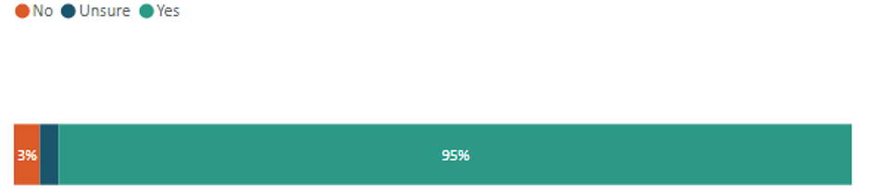
Most submitters (95 per cent) agreed that the waste levy should be spent on activities that promote or achieve waste minimisation, in accordance with and as set out in the Waste Management and Minimisation Plan of territorial authorities (ie, the status quo scenario). Submitters commented that the waste levy should be spent on activities that minimise waste, as is the intended purpose of the levy as outlined in section 3 of the WMA.

Costs associated with managing emergency waste
Figure 7: Support for costs associated with managing emergency waste
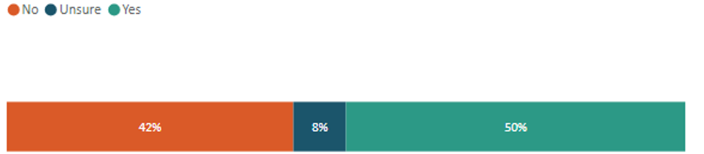
Submitters were split, with slightly more in support, on whether the waste levy should be spent on costs associated with the management of emergency waste. Those in favour of the proposal commented that, due to the increase in severe weather events over the past few years, having the levy funds open to helping with the clean-up operations would be helpful.
Those opposed to the proposal had the opposite view, with some believing that, by broadening the levy in this way, it would deplete the funds needed for waste minimisation, and that it should be up to central government to help cover the costs incurred for management of emergency waste.
Activities that provide for the remediation of contaminated sites and vulnerable landfills
Figure 8: Support for costs associated with activities that provide for the remediation of contaminated sites and vulnerable landfills
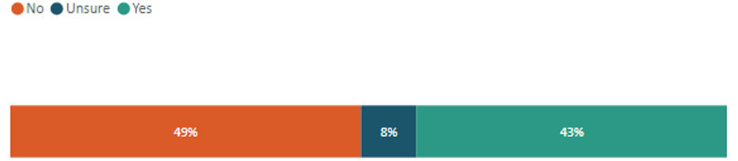
Submitters were split, with slightly more in opposition to the waste levy being spent on activities that provide for the remediation of contaminated sites and vulnerable landfills. Those opposed commented that the costs were too significant to be covered by the levy and that private land owners should be responsible for covering the costs.
Those in favour believed that territorial authorities should have the option to use the funds to remediate the sites. Some submitters agreed to the proposal but with a range of caveats, including not having to cover historical sites and central government helping with costs as required.

Compliance, monitoring and enforcement of mismanaged waste
Figure 9: Support for costs associated with compliance, monitoring and enforcement of mismanaged waste
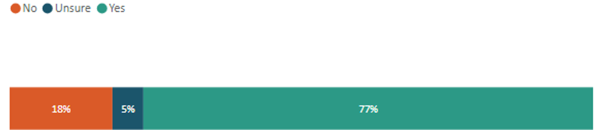
Most submitters (77 per cent) agreed that the waste levy should be broadened to include compliance monitoring and enforcement costs related to mismanaged waste. Those in favour commented that councils would welcome the extra resourcing to an area that some stated is hard to find funding for. Submitters also welcomed any additional tools that would help them improve their CME practices.
Those opposed believed it should be up to territorial authorities to find the funding for CME from their overall budget and not from the levy funds. Others commented that the costs for mismanaged waste should be borne by those who are responsible for the waste.
Comments were expressed from both sides seeking further clarification on what the proposal in the consultation document defined as ‘mismanaged waste’.
Activities that reduce environmental harm or increase environmental benefits
Figure 10: Support for costs associated with activities that reduce environmental harm or increase environmental benefits
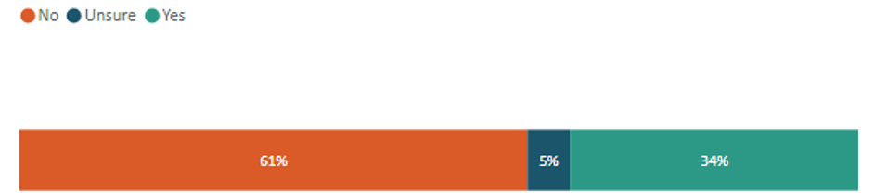
Many submitters (61 per cent) opposed the proposal to broaden the levy to activities that reduce environmental harm or increase environmental benefits. Some believed that territorial authorities should have more control over where they spend their portion of the levy distribution. Others believed the levy spend needs to stay ring-fenced to its purpose of waste minimisation. Of the territorial authorities that provided feedback, approximately 66 per cent were opposed to the proposal. Some submitters also noted the dynamic of changing the way the levy is distributed, to help smaller territorial authorities, while also broadening the scope of levy-funded activities, which would introduce competing needs for that funding.
Overall, territorial authorities were concerned that broadening the scope of the levy spend would reduce the amount of levy that would be spent on waste minimisation in practice. Concern was also expressed that the proposed changes would result in central government contributing less financial support for these areas. Many submitters believed that the purpose of the levy is waste minimisation and the levy spend criteria should reflect this.
There were 34 per cent of submitters that were supportive of this proposal, with comments stating that territorial authorities should have more flexibility in where they can allocate their levy distribution. Further support was provided for the proposal stating that broadening the scope of the levy will result in more tangible environmental outcomes.
This submission expresses concern that expanding the waste levy’s use in this way could dilute its core purpose – encourage waste minimisation and decrease waste disposal. We believe that waste minimisation should be maintained as the core outcome for TAs in line with the waste hierarchy. – Dunedin City Council
My main concern is the very broad range of purposes to which waste levy funds could potentially be put. In the context of territorial authorities, this could include everything from increased staffing for resource consent processing and monitoring to helping maintain local storm water infrastructure. Councils already have well established (and more appropriate) means of funding these sorts of activities. The risk of adding the waste levy to the list is that public acceptability of the scheme itself is undermined. – Parliamentary Commissioner for the Environment
What are suggestions for criteria that could form a decision-making framework for possible spending of the waste levy on environmental benefits and/or reduction of environmental harm?
A common theme from submitters was to reference the waste hierarchy within any decision-making framework for the waste levy spend. Their view was that this would help keep the criteria simple and prioritise activities that reduce, reuse, recycle, repurpose and prevent waste. Another common theme was to align levy spend with activities and projects that align with national waste-related priorities (such as the waste strategy or emissions reduction plan). Comments in this section also echoed support for more EPR schemes to help recover the costs of managing specific products at their end of life.
Submitters were opposed to this change (ie, allowing levy funds to support a wider range of environmental activities) and further commented that the levy needs to be focused on waste and waste minimisation only. They argued that the proposals to broaden the scope of the levy are too wide and could reduce funds for initiatives targeted specifically to waste minimisation.

Further levy effectiveness considerations
Do you support removal of the current blanket exclusion from the levy for waste-to-energy facilities?
Figure 11: Support for the removal of the current blanket exclusion from the levy for
waste-to-energy facilities
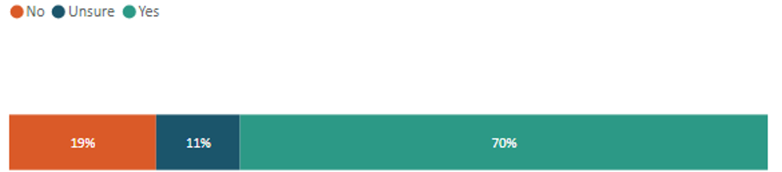
Many submitters (70 per cent) supported the proposal to remove the blanket exclusion from the waste levy for waste-to-energy facilities. Submitters commented that removing the exclusion promotes fairness within the waste system.
However, others were opposed to this proposal and suggested retaining the status quo. Suggestions were also made that there should instead be levy exclusions on a case-by-case basis, ensuring that facilities that are helping with waste minimisation are not being disadvantaged. Calls were made for a clear definition of waste-to-energy to be put in the legislation and to make it clear what types of waste-to-energy technologies ought to be subject to the levy.
Removing the blanket exclusion for waste-to-energy facilities is also essential, as these facilities can have significant environmental impacts and should not be exempt from contributing to waste minimisation efforts. – Riverlution
Retaining the blanket levy exclusion for WtE [waste-to-energy] facilities supports landfill diversion, simplifies policy, and encourages investment in diverse WtE technologies critical for New Zealand’s waste and climate goals. – DeCarbonate Energy
Do you agree that the Minister’s considerations for a review of the effectiveness of the waste levy should mirror the scope of the purpose of the WMA and the parameters for levy spend (once these are decided)?
Figure 12: Support for the Minister’s considerations for a review of the effectiveness of the waste levy should mirror the scope of the purpose of the WMA and the parameters for levy spend (once these are decided)
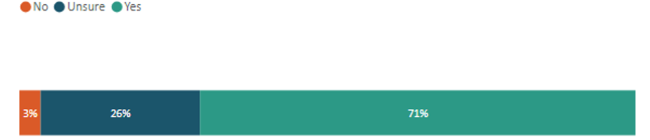
Many submitters (71 per cent) agreed that the Minister’s review of the effectiveness of the levy should mirror the purpose of the WMA. Submitters were supportive overall of the proposal, but wanted to know more details regarding the parameters of the levy spend.
Do you support changing the timeframe for review of the effectiveness of the waste levy from every three years to at least every five years?
Figure 13: Support for changing the timeframe for review of the effectiveness of the waste levy from every three years to at least every five years
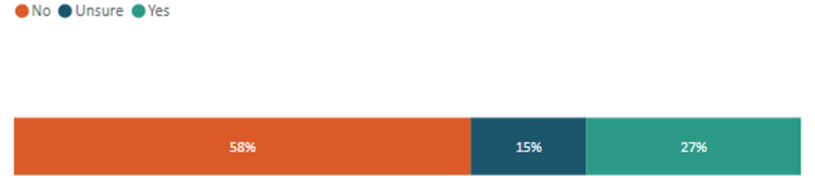
Many submitters (58 per cent) were opposed to changing the timeframe for the statutory review of the effectiveness of the waste levy from three years to five years. Those opposed commented that the proposal could reduce transparency and accountability, and the three-yearly checks ensure the programmes are moving in the right direction. Further comment was made that a five-yearly review timeframe is out of step with many government review cycles.
Those supporting the proposal commented that the extra time between reviews would help reduce the administrative costs of the review. Others commented that the extended timeframe would allow programmes to become fully established and have a chance to start returning positive outputs before being subject to a review.

Use of waivers
Do you support replacing the current levy-waiver requirement of ‘exceptional circumstances’, instead enabling the Secretary to waive the requirement for an operator to pay any amount of levy in specified circumstances?
Figure 14: Support for replacing the current levy-waiver requirement of ‘exceptional circumstances’, instead enabling the Secretary to waive the requirement for an operator to pay any amount of levy in specified circumstances
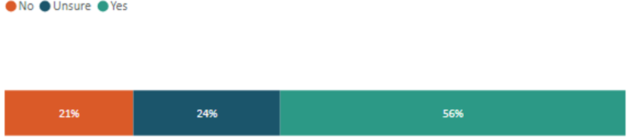
Many of the submitters (56 per cent) in favour of replacing the ‘exceptional circumstances’ waiver requirement noted that clear criteria would reduce uncertainty for councils and waste operators dealing with complex waste situations. Additionally, several submitters noted the importance of incorporating safeguards within revised ‘specified circumstances’ and that the Secretary for the Environment should be empowered to assess applications on a case-by-case basis, prioritising those that demonstrate a strong commitment to positive environmental outcomes.
Clearer criteria would improve transparency and ensure waivers are only granted in genuinely necessary situations, e.g. in times of a natural disaster. Criteria must be tightly defined to prevent overuse. – Tauranga City Council
Do you support limiting the waiver requirement to emergency event situations for which a state of national or local emergency has been declared under the Civil Defence Emergency Management Act 2002 and biosecurity responses have been undertaken under Part 7 of the Biosecurity Act 1993?
Figure 15: Support for limiting the waiver requirement to emergency event situations as per the Civil Defence Emergency Management Act 2002, and biosecurity responses have been undertaken under Part 7 of the Biosecurity Act 1993
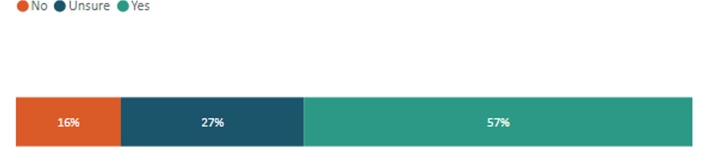
Many submitters (57 per cent) were in favour of limiting waiver requirements in emergency situations, noting the importance of clearly setting out the circumstances where the Secretary for the Environment has the power to waive fees rather than solely relying on separate legislation to meet the purpose of the WMA.
Some submitters who opposed the changes believed that the current process allows flexibility for the applications of waivers and the proposal is too restrictive.
Do you agree the waiver requirement for waste from the remediation of a contaminated site should specify any eligibility criteria that an application must meet? If so, please share any suggestions for eligibility criteria.
Figure 16: Support for the waiver requirement for waste from the remediation of a contaminated site should specify any eligibility criteria that an application must meet
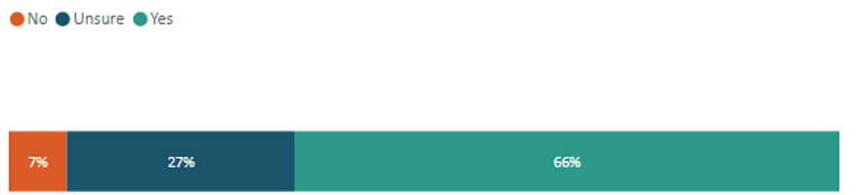
Submitters who supported incorporating eligibility criteria noted that approvals should be limited to cases where developers do not stand to gain financially from the outcome of the remedial works. The suggestion was that waivers should be reserved for legacy sites where remediation delivers clear and measurable benefits to the broader community and environment.
Submitters pointed out that the waste levy often contributes to site remediation through the Vulnerable Sites and Contaminated Landfills Fund. Allowing additional financial relief in such cases could be seen as ‘double dipping’ and may undermine the integrity of the funding framework.

Conditions and exemptions
Do you support requiring a Minister to consider specific criteria before recommending levy exemption regulations are made (instead of the current requirement that the Minister is satisfied ‘exceptional circumstances’ exist)?
Figure 17: Support for requiring a Minister to consider specific criteria before recommending levy exemption regulations are made (instead of the current requirement that the Minister is satisfied ‘exceptional circumstances’ exist)
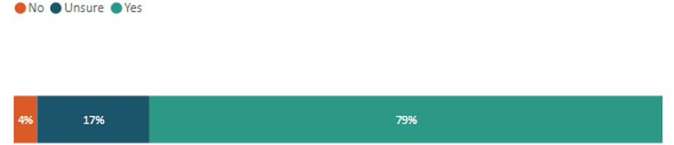
Submitters in favour of this amendment noted that published criteria increase transparency and accountability in decision-making, leading to more equitable outcomes for all.
Suggestions for criteria included:
- requiring increased transparency and accountability measures
- considering potential regional and/or national implications of an exemption
- prioritising alternatives at the top of the waste hierarchy before landfill.
Some responses sought further clarification about the differences between a waiver and exemption (including when each provision was applicable and the process requirements).
Without specific criteria for determining exemptions, there is a risk that Ministerial decision-making could be ad hoc with the potential for inconsistent decision-making over time. – Business New Zealand
Do you support applying a timeframe of a maximum of five years before levy exemptions via regulations must be reviewed or allowed to expire?
Figure 18: Support for applying a timeframe of a maximum of five years before levy exemptions via regulations must be reviewed or allowed to expire
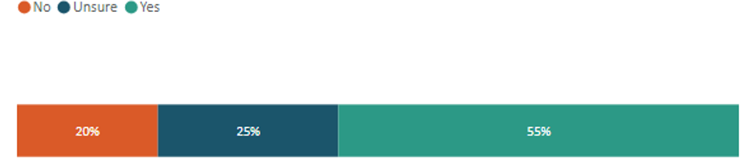
Many submitters (55 per cent) were in favour of applying a maximum five-year review timeframe. They described the amendment as a sensible control measure that would prevent unnecessary exemptions from persisting indefinitely while ensuring new waste disposal technologies can be implemented as required. In agreement, one submitter suggested incorporating the ability for the Minister to review at an earlier stage if significant new information or technological advances come to light that violate exemption terms.
Some of those opposed to the change noted that extending the timeframe to five years would increase the risk of oversight and slips in best practice being followed.
Do you agree that the Minister should be able to impose conditions on levy exemptions?
Figure 19: Support for the Minister being able to impose conditions on levy exemptions
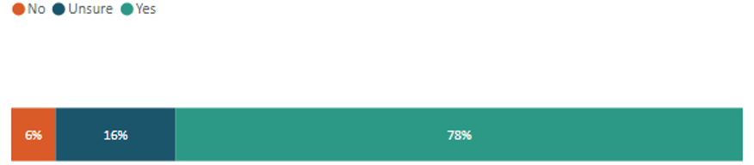
Most submitters (78 per cent) who were in support of enabling the Minister to impose conditions highlighted enhanced abilities to effectively manage risk and monitor appropriate implementation. Additional submitters identified that benefits included reduced rates of stockpiling, reduced levy avoidance and the introduction of clear criteria associated with equitable outcomes for producers and councils. The ability to impose conditions on levy exemptions was regarded by submitters as an appropriate control mechanism to reduce unforeseen environmental and operational risks and maintain levy integrity.
A few submitters cautioned potential perverse consequences of blanket exemptions and whether this may contribute to non-desirable waste outcomes.

Reuse of waste on-site
Do we need to clarify in legislation when the levy should be imposed on waste disposed of at a disposal facility, so that waste reuse on-site is operationally necessary and reasonable?
Figure 20: Support for clarifying in legislation when the levy should be imposed on waste disposed of at a disposal facility, so that waste reuse on-site is operationally necessary and reasonable
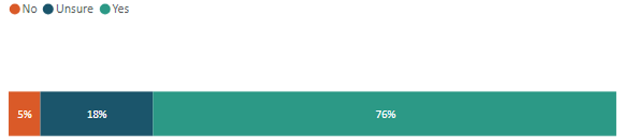
Many submitters (64.8 per cent) responded to this question. A common theme from those in support was for clarity in legislation that ensures waste reused on-site at disposal facilities is ‘operationally necessary’ and ‘reasonable’. Their view was that this clarity would support a fairer system that limits levy avoidance, reduces negative environmental outcomes through excessive reuse and reduces uncertainty amongst landfill operators.
Five per cent of submitters expressed concern on how further clarity around reuse on-site could limit the commercial operations of landfill operators and that materials reused and for what purpose should be at the discretion of the site and operator.
A few submitters unsure about their support for this proposal expressed concern about the potential ambiguity of the terms ‘operationally necessary’ and ‘reasonable’ and requested further information on definitions and/or criteria around these terms.
We strongly agree that clarity is needed in this space. When there is uncertainty, different companies with different risk appetites apply the regulations in different ways. This sees companies like ours disadvantaged as we try to follow the intent of the rules, while other players push the boundaries of the rules to avoid the Waste Levy. – Anonymous business
Clarification would help prevent potential misuse and ensure that levy obligations are applied fairly. Restrictions should be in place to avoid unjustified exemptions under the guise of operational reuse. – Anonymous business

Stockpiling controls
Do you support improvements to stockpiling controls by introducing tools such as: a) an approval system with limits and conditions?
Figure 18: Support for an approval system with limits and conditions
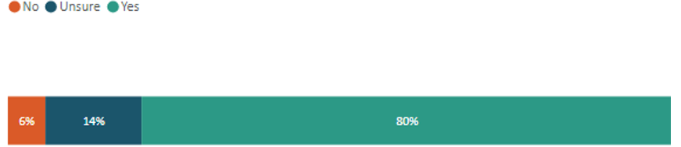
An average number (57.3 per cent) of submitters provided a response across the five stockpiling questions. Most submitters, 80 per cent, supported improvements to an approval system with limits and conditions, noting that an approval system should be flexible, risk-based and provide for the different needs and operational realities of different sites. Submitters expressed the need to monitor and enforce inappropriate long-term stockpiling, while allowing for legitimate storage of materials for operational needs or beneficial recovering and recycling. Their view was for stockpiling controls to differentiate between high-risk materials (such as tyres) and other low-risk stockpiled material (such as topsoil).
Any approval system should include clear guidance, streamlined processes for low-risk scenarios, and allow for case-by-case discretion to reflect the varying conditions and needs for different facilities. – Northland Waste Limited
b) changes to the stockpile calculation process to track the throughput of materials?
Figure 19: Support for changes to the stockpile calculation process to track the throughput of materials
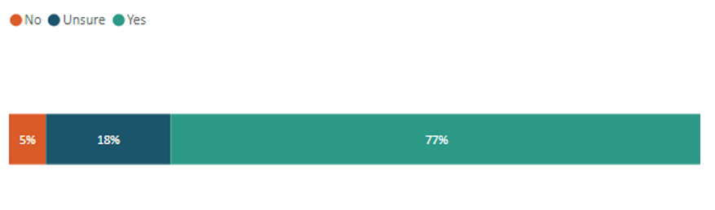
Most submitters (77 per cent) were in favour of changes to the stockpile calculation process to track the throughput of materials at a disposal facility, noting it would improve traceability and tracking of waste on- and off-site. A few submitters (18 per cent) were unsure, with some expressing concern about the practicality of changing the stockpiling calculation process, because most stockpiles are rolling, dynamic entities.
c) a stockpile volume threshold limit?
Figure 20: Support for a stockpile volume threshold limit
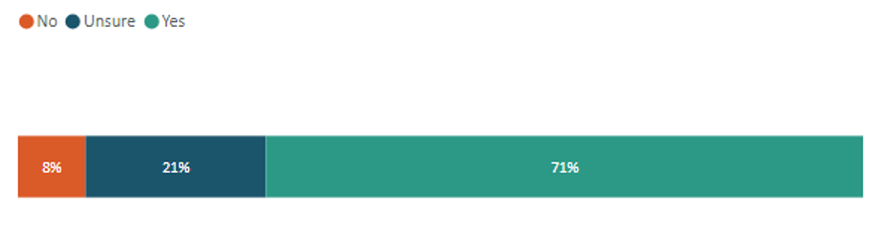
Many submitters (71 per cent) agreed with using stockpile volume threshold limits as a form of stockpiling control. They noted that a threshold limit should be dynamic and based on stockpile type, size and operation and with consideration for the macro landscape. A few submitters expressed concern with using stockpiling volume thresholds because different types of disposal facilities require different volumes of stockpiles depending on the nature of their operations.
Different material types have different behaviours and risk profiles when stock-piled. Some, such as inert and uncontaminated soils will have minimal risk of environmental harm when stockpiled, meaning that a volumetric limit is not required. However, contaminated waste, or waste with a flammability risk will likely have a scale when the risk outweighs the benefit of storage (e.g. e-waste leachate, tyre mountain fires). It is likely therefore that different materials and/or products will require different volume thresholds. – Plastics New Zealand Incorporated
d) improved data collection, record-keeping and reporting provisions, to increase transparency and traceability of material entering and leaving a site?
Figure 21: Support for improved data collection, record-keeping and reporting provisions, to increase transparency and traceability of material entering and leaving a site
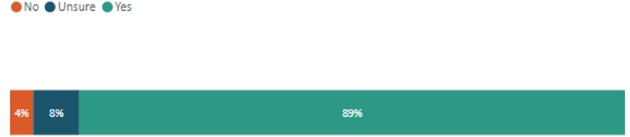
Most submitters (89 per cent) supported improved data collection, record-keeping and reporting provisions, expressing that data systems would better enable a risk-based system that aligns with existing levy data reporting requirements. Those submitters who were supportive also expressed the need for protection of commercially sensitive information as well as accessibility for end users where necessary. A few submitters were unsure about the impacts of these provisions and requested more information.
Should be digitised and centralised where possible, allowing real-time access for regulators and public summaries to ensure transparency. – Riverlution
e) defining/amending the terms ‘diverted material’, ‘accumulation’ and ‘stockpiling’ in the legislation?
Figure 22: Support for defining/amending the terms ‘diverted material’, ‘accumulation’ and ‘stockpiling’ in the legislation
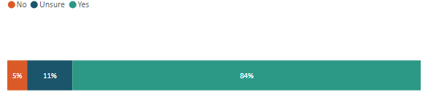
Most submitters (84 per cent) were in favour of amending and/or defining the terms ‘diverted material’, ‘accumulation’ and ‘stockpiling’ in the legislation, noting that improving definitions is essential for both regulatory clarity and environmental outcomes. Clearer definitions were also mentioned as beneficial for CME and to promote effective waste minimisation.
Definitions that are legally defined will ensure that all organisations/producers/ processors etc are operating within the same boundaries and will allow for accurate compliance, monitoring and enforcement actions. – Selwyn District Council
We believe there are a number of terms and definitions in both Acts that need review and clarification. The term ‘diverted material’ is a particularly problematic one and can be interpreted in ways that reduce the effectiveness of waste management and minimisation initiatives. – Eunomia Research & Consulting

Clarifying roles and responsibilities in waste legislation

Summary
- Most submitters supported proposed changes to the roles and responsibilities for the Ministry for the Environment (87 per cent), New Zealand Customs Service (88 per cent), territorial authorities (76 per cent), along with support for inter-agency data sharing.
- Many submitters (56 per cent) supported the proposed change in the Secretary for the Environment’s ability to retain levy payments from mandatory to discretionary, with several submitters supporting conditionally, cautioning that criteria should guide discretion.
- Concerns were raised regarding increased financial uncertainty for councils, which submitters considered could undermine local waste minimisation efforts.
- Many submitters (74 per cent) supported enabling the Waste Advisory Board to provide advice on improved policy outcomes, and strategic collaboration between the Minister for the Environment and Waste Advisory Board throughout the policy development process.

What submitters were asked and what they said

Changes to roles and responsibilities for the
Ministry for the Environment
Do you support the proposed changes to the roles and responsibilities for the Ministry for the Environment?
Figure 23: Support for the proposed changes to the roles and responsibilities for the Ministry for the Environment
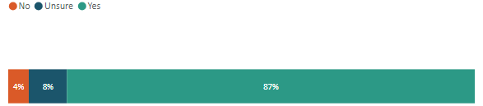
Most submitters (87 per cent) supported proposed changes to the roles and responsibilities for the Ministry for the Environment. Comments in favour of the amendment emphasised a need for the Ministry to take a proactive leadership role, guiding the design, roll-out and implementation of future EPR schemes.
We support strengthening the Ministries leadership role, especially around EPR, strategy, data, and enforcement, as these functions are crucial to driving systemic change. – Riverlution

Changes to roles and responsibilities for the New Zealand Customs Service
Do you support the proposed changes to the roles and responsibilities for the New Zealand Customs Service?
Figure 24: Support for the proposed changes to the roles and responsibilities for the
New Zealand Customs Service

Most submitters (88 per cent) supported the proposed changes to the roles and responsibilities for the New Zealand Customs Service (Customs). A common theme amongst submitters in favour of the proposal was the support for Customs monitoring product stewardship schemes and supporting EPR compliance at the border. Additionally, submitters supported inter-agency data sharing, noting the opportunity for Customs to support regulating product imports from online marketplaces.
We support NZ Customs sharing data and potentially collecting EPR charges at the border. This role is appropriate, given their existing systems for tracking imports, and will help identify and charge the first responsible supplier. This ensures imported products such as tyres, electronics, and packaging are fairly captured in any future producer-funded scheme, reducing cost pressures on councils. – Tauranga City Council

Changes to roles and responsibilities for territorial authorities
Do you support the proposed changes to the roles and responsibilities for territorial authorities?
Figure 25: Support for the proposed changes to the roles and responsibilities for territorial authorities
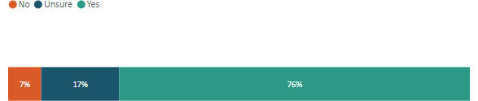
Most submitters (76 per cent) supported changes to territorial authority roles and responsibilities with caveats that legislative amendments should refer to the role of councils within an EPR framework. Broad support was expressed for further clarity within the legislation to better specify the minimum obligations on territorial authorities, conditional on access to adequate funding. More generally, further clarity was requested on how proposed activities and amendments to council responsibilities would be funded.
A small number of submitters expressed concerns about the proposed changes causing an increase in the financial and operational burden placed on local authorities.

Secretary for the Environment’s ability to retain levy payments to a territorial authority
Do you support a change in the Secretary for the Environment’s ability to retain levy payments to a territorial authority, from mandatory to discretionary?
Figure 26: Support for the change in the Secretary for the Environment’s ability to retain levy payments to a territorial authority, from mandatory to discretionary
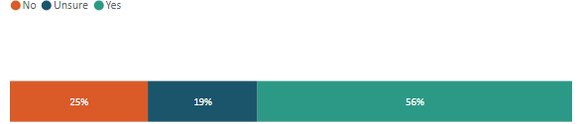
Many submitters (56 per cent) supported a change in the Secretary for the Environment’s ability to retain levy payments from mandatory to discretionary. However, offers of conditional support were expressed with caution that criteria should guide discretion to minimise subjectivity.
Submitters in favour of the amendment acknowledged the flexibility benefits of allowing the Secretary for the Environment to consider unique circumstances on a case-by-case basis while noting the expansion of discretion should not be limitless but guided with clear criteria.
...discretionary retention of levy payments could create uncertainty for councils and may create equity and transparency issues. – Manawatu District Council

Enabling the Waste Advisory Board to provide advice at its discretion
Do you support enabling the Waste Advisory Board to provide advice at its discretion?
Figure 27: Support for enabling the Waste Advisory Board to provide advice at its discretion
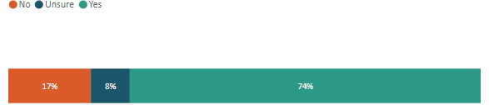
Many submitters (74 per cent) supported enabling the Waste Advisory Board (Board) to provide advice at its discretion rather than on the request of the Minister for the Environment, citing the opportunity to offer guidance efficiently in response to relevant issues pertaining to waste. Enabling the Board to provide advice at its discretion was correlated with improved policy outcomes through enhanced strategic collaboration between the Minister and the Board throughout the policy development process, rather than at the end.
The Board is more in-tune with changes and advancements in the waste sector and this change would allow the Board to proactively address emerging issues, provide timely input on overarching waste challenges, and contribute to long-term planning. – New Plymouth District Council
Submissions against the proposed change typically originated from industry stakeholders, highlighting that discretionary advice increases subjectivity and opens the door to potential corruption. Those opposed also commented that the Board should only provide advice if it is relevant to the Board’s strategy or if advice is requested by the Minister.

Creating a modern, effective compliance regime

Summary
- Most submitters (93 per cent) supported the regulator having greater powers to receive and share data. Reasons submitters gave for supporting the proposal included that it would increase transparency and support evidence-based decision-making and enhance compliance, enforcement and policy effectiveness.
- Many submitters raised concerns about protection of commercially sensitive information and requested this be addressed.
- Most submitters (87 per cent) supported a tiered approach to the compliance tools and sanctions. Reasons submitters gave for supporting the proposal included that there would be proportional penalties based on the severity of offences and the framework would ensure consistency across territories.
- Eleven per cent of submitters were unsure about the proposal and 3 per cent were against the tiered approach. Reasons cited included that low-level penalties, such as fines, may not deter serious offences and may reduce accountability because offences might be inappropriately grouped into lower tiers.
- Many submitters have made recommendations about how to improve the proposed tiered approach. These include ensuring adequate resourcing for councils, providing clear guidance on how to apply each tier, and penalties that should correspond to the level of harm caused.

What submitters were asked and what they said

Greater data powers for the regulator to receive and share data
Do you agree the regulator should have greater powers to receive data, including the ability to share with other regulators and the Ministry?
Sixty-seven per cent of submitters responded to this question, with most (93 per cent) supporting the proposal for greater powers for the regulator to receive and share data. This support was across all submitter types. Only 3 per cent of submitters did not support the proposal and they were individuals, territorial authorities, and waste and resource recovery sectors associated with both waste minimisation and waste management.
Figure 28: Support for the regulator having greater powers to receive data, including the ability share with other regulators and the Ministry
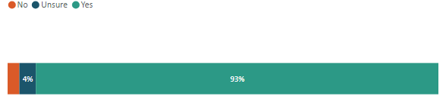

Benefits of greater powers for the regulator to receive and share data
Most submitters (93 per cent) agreed that the regulator should have greater powers to receive data, including the ability to share with other regulators and the Ministry. Comments on this topic included the following.
- Modern data systems and technology are needed. Submitters from the heating, ventilation and air conditioning industry noted the lack of supply chain visibility in relation to refrigerants. A modern data system would enable PROs to implement effective schemes. One submitter commented that this technology could include artificial intelligence for analysing large volumes of real-time data, leading to effective compliance measures.
- There is an interest in increased visibility of non-compliance. A few submitters considered that a modern data system, including emerging technologies, would provide greater visibility of non-compliance, which would enable a more targeted compliance toolkit.
…local authorities could benefit from access to compliance data from other regulators when investigating issues like unlicensed dumping or improper disposal of hazardous materials. – Tauranga City Council
- Support was expressed for enhanced compliance, enforcement and policy effectiveness. Submitters considered that improved data sharing may enhance compliance, monitoring and enforcement, and policy effectiveness. There was a view that it also supports a more integrated approach to waste management by reducing duplication of effort and allowing efficiencies to be more easily uncovered.
- Data from private operators would allow a more complete picture. A few council submitters noted the difficulties they have in obtaining data from private operators, which has made understanding the full scale of the waste problem and making data-driven decisions and reporting difficult. Requiring data from private operators will bring them into line with the existing reporting requirements of territorial authorities. Another submitter also commented that:
Neither councils, regulators or MfE have a good understanding of volumes managed or recycling diverted by private operators. Requiring both private companies and council operators to report landfill weigh bridge volumes and types of performance annually will provide a picture of waste disposal, recycling and diversion performance across districts, regions and the country. Holistic reporting will allow MfE to understand whether the intent of the national Waste Strategy is being realised. – Water New Zealand
- Support was expressed for an increase in transparency and for evidence-based decision-making. A submitter noted that a more consistent and centralised data collection and sharing regime will:
…enhance transparency, support evidence-based decision-making, and allow both central and local government to identify trends, target interventions, and track progress against national goals. – Tauranga City Council
- It would be beneficial to track waste across boundaries. One submitter noted:
Waste and environmental harm often cross administrative boundaries, so seamless data-sharing between agencies (including for EPR schemes) is essential for coherent enforcement and tracking materials across their lifecycle. – Riverlution

Disadvantages of greater powers for the regulator to receive and share data
One submitter who was in opposition to the proposal raised the following concerns:
Data collection is a necessary process, however the need for data to support knowledge and understanding about our waste and recycling streams, does not give way to then using this data for a multitude of purposes, especially for sharing across regulators. Requirements for data collection at government owned facilities should not be applied as a mandatory requirement in the private sector. – New Zealand Association of Metal Recyclers

Recommendations from submitters to improve the proposal
Submissions from respondents, both for and against the proposal, provided the following feedback.
- Commercially sensitive data must be protected and only used for the intended purpose. A common request from submitters who provided recommendations was that commercially sensitive data must not be released, with data from landfill operators cited as an example. Another request from submitters was that data should only be used for the purpose it was collected. One submitter went further, suggesting that data should be managed by a third party to maintain commercial sensitivity:
Eunomia Research and Consulting NZ has completed a number of different reports and in the Waikato District we have completed a pilot project that is yet to be implemented. All data should be managed by a 3rd party to maintain commercial sensitivity and the results published annually. Data should be gathered regionally for reporting to a national level and be managed to maintain commercial sensitivity. The Australian Department of Climate Change, Energy, the Environment and Water have regulations that capture this data at a state level, and on a far wider range of facilities, other than disposal facilities. Aggregated at a country level this allows for better decision making and investment. We should follow this example as once again NZ continues to lag behind. – Matamata Piako District Council
- Data sharing should be encouraged across agencies, councils and organisations. A few submitters considered that data sharing should occur between organisations other than just regulators. Benefits of sharing this data were noted as facilitating better national reporting, minimising waste and having greater visibility of data, which would support such activities without duplicating data collection and monitoring. Submitters recommended that data sharing should extend to:
- research and scientific organisations to help inform their work and enable them to assist government
- territorial authorities to help with assessing and reporting on national or regional goals, targets or key outcomes, supporting with their waste assessment and programmes under their Waste Management and Minimisation Plans, and to avoid duplicating efforts to collect and monitor data
- EPR schemes, PROs and scheme managers:
It’s essential that EPR schemes have access to the data made possible by recent amendments to regulations made under the WMA. The proposal to ‘clarify data-sharing provisions, to enable data to be shared between regulators for CME and EPR purposes,’ should include PROs and scheme managers. – 3R Group Limited
- Ensure councils are adequately resourced. A few submitters requested that territorial authorities be adequately financially resourced to carry out the new data collecting and reporting requirements. Other submitters also requested clear guidance and training for compliance staff.
- Information and reporting should be publicly available to help build public trust and ensure accountability. A few submitters suggested that data and reports should be made publicly available. Those with concerns expressed a need to maintain commercial confidentiality of data.
- Address organic waste gaps. A few submitters requested that more data on organic waste should be collected and shared.
There is a great need for collection and availability of data on organic wastes. Investors are constrained in their feasibility investigations because of the lack of publicly available data. The data should be collected regionally and include all sources of organic waste excluding commercially sensitive data but including from commercial waste collections. – Bioenergy Association
- Use Customs for EPR data and collection. Some support was expressed by submitters for Customs to play a role in the collection of EPR data in particular.
Customs NZ should have a role in tracking both outward and inward goods and waste materials, including refrigerant gases. Given that most refrigerants are imported, Customs’ data and collection role could support both compliance and efficient cost recovery under some EPR scheme designs. While this is not relevant to the Trust at present because the Cool-Safe scheme is funded through NZUs [New Zealand emission units] obtained through the destruction of a limited number of refrigerants, it could become relevant if there are changes to the NZ ETS [New Zealand Emissions Trading Scheme], or other circumstances which required the use of other tools such as an advanced destruction fee or similar levy. This would require close coordination between agencies and clear protocols for data sharing and charge setting. – The Trust for the Destruction of Synthetic Refrigerants (Cool-Safe)
- Use digital tools. A submitter requested that modern digital tools be used:
Leverage modern technology to track waste flows and stockpiles in real time via digital reporting. Make compliance more accessible through simple online portals and smart data systems that reduce admin burden. – Repost

Tiered approach to the compliance tools and sanctions
Do you support the proposed tiered approach to the compliance tools and sanctions?
Sixty per cent of submitters responded to this question, with most (87 per cent) supporting the proposal for a tiered approach to compliance tools and sanctions. However, 11 per cent were unsure if they supported the proposal. Only 3 per cent of submitters did not support the proposal for a tiered approach to compliance tools and sanctions. Those who did not support the proposal were listed as individuals, territorial authorities, and waste and resource recovery sectors associated with waste minimisation, waste management and disposal facility operators. Ten per cent of submitters disagreed with the proposal, with most of these being disposal facility operators. However, in general, the disposal facility operator sector overwhelmingly supported the proposal.
Figure 29: Support for a tiered approach to the compliance tools and sanctions
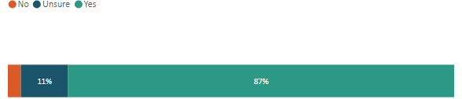

Benefits of a tiered approach to compliance tools and sanctions
Most submitters (87 per cent) agreed with the proposed tiered approach to compliance tools and sanctions. The main reasons for their support were as follows.
- A few submitters supported the proposal, noting it would provide proportional penalties based on the severity of offences. Others noted it would give regulators more tools to address minor offences without having to default to prosecution, which can be resource intensive and slow. It was also noted that prosecution was too severe for minor offences, and the tiered system enables minor issues to be addressed early before they can escalate and may result in behaviour change for regulated communities.
- A few submitters advised that they support the proposal because the framework will ensure consistency and be aligned nationally, with one submitter noting it may raise standards across the industry. Another noted that regulatory consistency would improve across the regions.
- Data sharing will support better oversight and accountability. It was noted that enabling regulators to share information and set input methodologies for CME purposes would bring the waste sector into line with good practice already in use in other legislation. Another submitter noted that regulators sharing information and aligning information and reporting requirements, requests and timeframes may reduce the burden on water service and waste providers.
NZFGC supports a tiered compliance and enforcement framework that applies to both EPR and levy obligations. We wish to emphasise the importance of comprehensive data capture and transparency across the waste and recycling system. NZFGC supports enhanced powers for regulators to collect and share data, and for the Ministry to intervene where schemes fail to meet performance targets. We support regular audits and independent oversight of PROs to ensure accountability and public trust. – New Zealand Food and Grocery Council
- Improve compliance and enforcement. Two submitters expressed that strengthening of regulatory roles may help with discouraging non-compliance. One submitter noted that enforcement of mismanaged waste issues and the obligations organisations have may lead to better environmental outcomes.

Disadvantages of a tiered approach to compliance tools and sanctions
Three per cent of respondents did not support the proposal, giving the following main reasons for their disagreement.
- A submitter considering that a tiered system may allow defences to downplay offences during prosecutions.
- A submitter noted that there may be reduced accountability because offences might be inappropriately grouped into lower tiers.
- Another submitter also noted that low-level penalties, such as fines, may not deter serious offences.

Recommendations from submitters to improve the proposed tiered approach
Submitters provided recommendations including the following.
- There is a need for clear guidance on applying each tier and the level of discretion that can be applied to enforcement action. Collectively, these recommendations were for clear guidance on defining thresholds, penalties, escalation criteria and how the regime applies to different stakeholders, along with providing consistent national guidance and support materials.
- Penalties should correspond to the level of harm caused. Submitters have requested use of penalties for different areas of offending and a level of discretion to apply tools to specific situations. Specific recommendations included the ability to move up tiers or fine for repeat offending. A submitter also suggested that penalties could align with cost recovery.
A tiered system creates an environment where minor issues can be addressed early (with a warning or infringement notice) before they escalate, while also ensuring stronger penalties are available for more serious or repeated breaches. – Waste Management New Zealand Limited
- There is a need to ensure councils are adequately resourced, and enforcement officers need to be appropriately trained for the compliance, monitoring and enforcement to be effective. One submitter requested specific resourcing for rural and remote compliance:
Many of the worst waste issues – from illegal dumping to mismanaged stockpiles – occur in under-resourced rural areas. The compliance regime should:
Ensure resourcing for rural inspections and support. Allow flexible implementation tools tailored to non-urban contexts where infrastructure is limited. – Repost
- The framework should include an appeal process and regular reviews. Three submitters made recommendations for improving transparency and oversight of the new framework. This included the ability to review investigative powers, ensuring natural justice through review and appeal processes. One submitter considered that checks and balances are needed, in case an enforcement body that issues the fines and receives them develops an incentive to issue fines that could be misused.
- Education and incentives. A submitter requested that enforcement be combined with education and rewards for compliant behaviour to build trust and encourage innovation.

Enabling efficient and effective controls for littering and other types of mismanaged waste

Summary
- Broad support was expressed for all of the proposals, ranging from 86 per cent to 96 per cent of those who answered the question.
- The proposal to limit the definition of public authority had 66 per cent support, with nearly a third of submitters unsure. Only seven submitters who answered this question did not support the proposal.
- The proposal to remove the assignment of a statutory role for the promotion of litter control to any specific agency or organisation was opposed by 12 per cent of submitters who answered this question. Those who did not support it were concerned it would leave a gap in the delivery of this function or increase the burden on territorial authorities.
- The proposal to change the current mandatory requirement for public authorities to provide waste receptacles received the least support. However, only 19 per cent were in opposition to the proposal, and a much larger majority (72 per cent) supported it. Those in opposition expressed that this was a core responsibility of councils and were concerned that the removal of rubbish bins could lead to an increase in littering.

What submitters were asked and what they said

Scope of the legislation
Do you support integrating littering and other types of mismanaged waste into the same regulatory framework for waste management and minimisation?
Figure 30: Support for integrating littering and other types of mismanaged waste into the same regulatory framework for waste management and minimisation
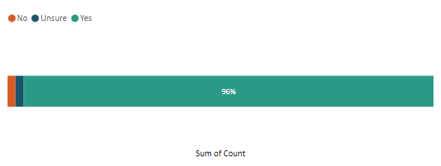
This question received 214 responses, with most submitters (96 per cent) supporting the integration of littering and other types of mismanaged waste into the same regulatory framework for waste management and minimisation.
Submitters who commented on this proposal referred to the benefits of having unified legislation to ensure consistency and prevent enforcement gaps.
We support the integration of littering and other types of mismanaged waste into the same regulatory framework for waste management and minimisation. A comprehensive approach is essential to address the full spectrum of waste issues, from land-based litter to mismanaged waste, ensuring a unified strategy for waste reduction and environmental protection. – Tasman District Council
Do you support enabling regulations for the collection of data on littering and dumping?
Figure 31: Support for enabling regulation for the collection of data on littering and dumping
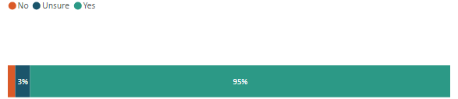
This question received 179 responses, with most submitters (95 per cent) supporting enabling regulations for the collection of data on littering and dumping.
Some confusion was expressed amongst submitters that the proposal would include the introduction of new data-reporting requirements immediately when the legislation came into effect. The intention was that the legislation would create an enabling tool to regulate for mismanaged waste, if required, in the future. However, submitters commented on the positive benefits of collecting and reporting on mismanaged waste data. For example, providing a more accurate picture of waste management and minimisation challenges, having data to inform policy decisions (particularly to inform priority products for EPR-regulation) and using the data to better target problem areas and the allocation of resources. Submitters requested guidance, a national tool and a consistent standardised approach to collecting mismanaged waste data.
Do you support expanding the purpose of the Waste Minimisation Act to include littering and other mismanaged waste in the new waste legislation?
Figure 32: Support for expanding the purpose of the Waste Minimisation Act to include littering and other mismanaged waste in the new waste legislation
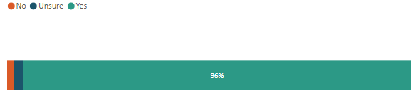
This question received 179 responses, with most submitters (96 per cent) supporting the expansion of the purpose in section 3 of the WMA to include littering and other mismanaged waste in the new waste legislation.
The three submitters who did not support the proposal were concerned the positive aspects of the Litter Act would be lost if the Acts were consolidated or the focus on waste minimisation in the WMA would be compromised by expanding the purpose to include waste management (mismanaged waste enforcement) in the same legislation.
Staff do not support expanding the purpose of the WMA to include littering and other mismanaged waste as minimisation is very different to enforcement and there should be a clear distinction between the two. – Hamilton City Council

Roles and responsibilities
Regarding public authorities, do you support:
  - limiting the definition of ‘public authority’ as proposed?
Figure 33: Support for limiting the definition of ‘public authority’ as proposed
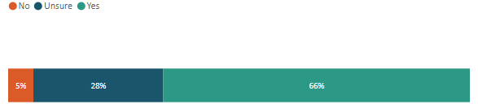
Of the 128 submitters who answered this question, many (66 per cent) supported limiting the definition of ‘public authority’ as proposed. Those who were unsure or did not support the proposal were concerned that regional councils were not explicitly included.
  - enabling public authorities (amended as proposed) to warrant Litter Control Officers or appoint Litter Wardens, to manage and enforce littering and other mismanaged waste offences?
Figure 34: Support for enabling public authorities (amended as proposed) to warrant litter control officers or appoint litter wardens to manage and enforce littering and other mismanaged waste offences
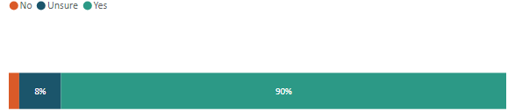
Most of the 143 submitters who answered this question supported the proposal (90 per cent). Two submitters (an individual and a local government submitter) suggested that other organisations could be given the ability to warrant litter control officers or appoint litter wardens, such as iwi authorities and voluntary or non-public organisations.
Do you support removing the assignment of a statutory role for the promotion of litter control to any specific agency or organisation?
Figure 35: Support removing the assignment of a statutory role for the promotion of litter control to any specific agency or organisation
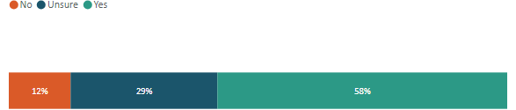
This question received 129 responses, with many submitters supporting the proposal to remove the statutory responsibility allocated to Keep New Zealand Beautiful (KNZB) for promotion of litter control (58 per cent). Of those who did not support the proposal or were unsure, issues raised included a concern that the removal of the statutory role for litter promotion from KNZB would leave a gap in the delivery of this function, or it would increase the burden on territorial authorities. Other submitters suggested that central government provide funding to KNZB to continue to fulfil this role.
Do you support public authorities having a discretion whether they provide waste receptacles in public places but an obligation to empty those receptacles if they provide them?
Figure 36: Support for public authorities having a discretion whether they provide waste receptacles in public places but an obligation to empty those receptacles if they provide them
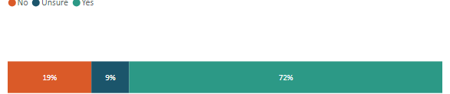
This question received 162 responses. Many submitters (72 per cent) supported the proposal to change the current mandatory requirement for public authorities to provide waste receptacles. The full provision in section 9(1) of the Litter Act 1979 is for:
…every person, public authority, and department of State shall at all times provide and maintain in every public place under his or its control or management where litter is likely to be deposited, such number of litter receptacles of suitable construction and design for the temporary deposit of litter as may reasonably be necessary to keep the place free from litter.
Of those submitters who did not support this proposal, most were from businesses that felt the provision of public waste receptacles was a core responsibility of councils, and a community expectation exists that they are provided.
Removing the obligation to provide litter bins risks an increase in illegal dumping and public litter, particularly in areas without the resources or inclination to install and maintain adequate infrastructure. While we support councils having flexibility to tailor services, litter receptacles are a basic public service that should not be optional. Inconsistent bin provision across districts undermines community expectations and shifts the burden onto clean-up crews, often at greater cost. If bins are discretionary, we risk normalising litter in the public spaces we aim to protect. Removing the requirement outright sends the wrong message and could backfire environmentally and socially. – Waste Management NZ Limited
Those who supported the proposal said this would allow for flexibility to place bins based on local needs and capacity. Most submitters agreed, however, that the requirement for public authorities to empty litter receptacles in public places under their control should remain.

Do you support removing the requirement for the Medical Officer of Health to be satisfied that litter receptacles are emptied promptly, efficiently and at regular and prescribed intervals?
Figure 37: Support for removing the requirement for the Medical Officer of Health to be satisfied that litter receptacles are emptied promptly, efficiently and at regular and prescribed intervals
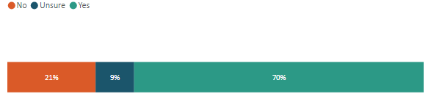
This question received 151 responses, of which many submitters (70 per cent) supported the proposal on the basis that the function was unnecessary and had no clear benefit. Of the few who did not support the proposal, they said having an independent agency with additional powers to step in if required was beneficial.
Do you agree that a local or public authority should:
- retain the ability to make grants to any organisation for the abatement or prevention of litter?
Figure 38: Support for a local or public authority retaining the ability to make grants to any organisation for the abatement or prevention of litter
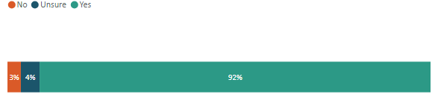
Of the 158 submitters who responded to this question, most (92 per cent) supported this proposal. As pointed out by two submitters, the WMA has a corresponding power in section 47 that gives councils the ability to make grants to promote or achieve waste minimisation, and the Local Government Act 2002 gives councils a general ability to make grants.
- be able to spend such sums of money as it thinks fit on any scheme or campaign for the abatement or prevention of litter?
Figure 39: Support for a local or public authority being able to spend such sums of money as it thinks fit on any scheme or campaign for the abatement or prevention of litter
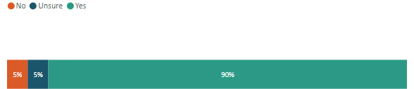
Of the 155 submitters who answered this question, most (90 per cent) supported the proposal. The minority of submitters who did not support this proposal did not provide a rationale for their position.
- retain the ability to make bylaws to help reduce littering and dumping, if they are not inconsistent with the provisions of the new legislation?
Figure 40: Support for a local or public authority retaining the ability to make bylaws to help reduce littering and dumping, if they are not inconsistent with the provisions of the new legislation
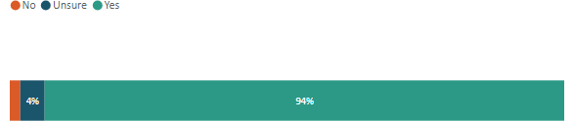
This question received 159 responses, of these, 94 per cent supported the proposal, stating the need to retain bylaw-making powers to address local litter and dumping issues.
While retaining the ability to make bylaws is preferred to ensure councils can address localised issues, a better and more efficient long-term solution would be to draft the national legislation in a way that reduces or removes the need for bylaws altogether. There is currently a high degree of duplicated effort across councils in developing, consulting on, and enforcing similar bylaws. This fragmented approach can create inconsistency for businesses and the public and consumes significant local government resources. – Tasman District Council
Of the three submitters who did not support this proposal, a similar point was raised that the regulatory settings should be nationally consistent and enforced centrally.
- retain the ability to deter, prevent, require timely clean-up and enforce waste escaping/being carried on to public or private land?
Figure 41: Support for a local or public authority retaining the ability to deter, prevent, require timely clean-up and enforce waste escaping/being carried on to public or private land
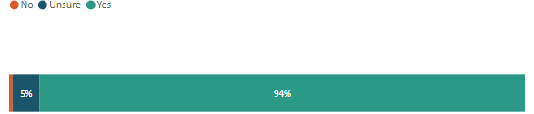
This question received 152 responses, of these submitters, most (94 per cent) supported the proposal. The one submitter who did not support the proposal stated that further detail was required because they were concerned about unintended consequences of the proposal.
Do you support enabling all types of Litter Control Officers to apply different tiers of compliance tools, where they are authorised to act?
Figure 42: Support for enabling all types of litter control officers to apply different tiers of compliance tools, where they are authorised to act
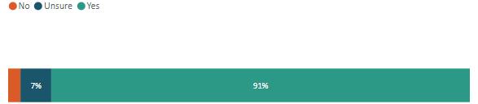
This question received 150 responses, of these submitters, most (91 per cent) supported the proposal. Those who supported the proposal referred to this approach as being consistent with other modern legislation, enabling more flexible enforcement and the ability to apply a compliance tool proportionate to the severity of the offence. Submitters also referred to the current framework as being challenging to use, with offences often having no consequences. Several submitters also raised the need to know more about the proposed infringement values because they could not comment on whether the levels were adequate. The few submitters who did not support this proposal did not provide a rationale for their position.
Do you agree that, in enforcing offences, Litter Control Officers should be able to:
a) use vehicle registration and ownership details?
Figure 43: Support for Litter Control Officers being able to use vehicle registration and ownership details when enforcing offences
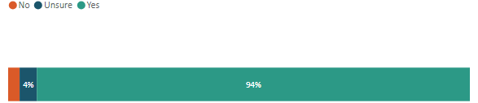
This question received 161 responses, and most submitters (94 per cent) supported the proposal. The rationale for supporting the proposal is summarised by the quote below:
Currently, the most significant barrier to effective enforcement has been the difficulty in collecting sufficient evidence to identify and prosecute offenders, particularly in cases involving illegal dumping from vehicles. Allowing LCOs [Litter Control Officers] to use vehicle registration data and appropriate surveillance tools would significantly enhance their ability to investigate and respond. – New Plymouth District Council
- use appropriate evidence-gathering, search and surveillance powers for vehicles that are implicated in serious dumping offences?
Figure 44: Support for litter control officers being able to use appropriate evidence-gathering, search and surveillance powers for vehicles that are implicated in serious dumping offences
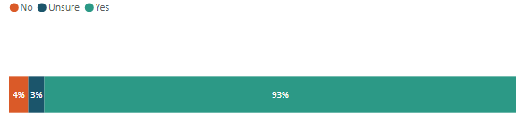
This question received 158 responses, of these, most submitters (93 per cent) supported the proposal. The following quote articulates the reasons for supporting the proposal and touches on the areas of concern raised by some submitters.
Enabling LCOs [Litter Control Officers] to access vehicle registration details and use reasonable evidence-gathering and surveillance powers would help identify offenders and support stronger deterrence. These powers are consistent with existing provisions under section 235 of the Land Transport Act 1998, which allows enforcement officers to obtain vehicle owner information for investigation purposes. However, to maintain public trust, it is important that the use of these powers is clearly defined, proportionate, and subject to appropriate oversight, with guidance and training to ensure their lawful and consistent application. – Tasman District Council

Compliance monitoring and enforcement framework
Do you support the proposed amendments to the compliance monitoring and enforcement framework for littering and other mismanaged waste offences?
Figure 45: Support for the proposed amendments to the compliance monitoring and enforcement framework for littering and other mismanaged waste offences
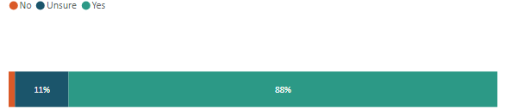
This question received 155 responses, with most submitters (88 per cent) supporting the proposal on the basis that they considered it would provide public authorities with better tools to address persistent and emerging mismanaged waste issues.
Do you support lowering the threshold for evidence of a mismanaged waste offence, to allow for effective compliance monitoring and enforcement by Litter Control Officers?
Figure 46: Support for lowering the threshold for evidence of a mismanaged waste offence, to allow for effective compliance monitoring and enforcement by litter control officers
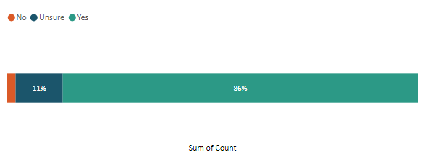
This question received 148 responses, with most submitters (86 per cent) supporting the proposal. Supporters referred to the enforcement ability being constrained by the current threshold and making successful prosecution of offences very difficult.
Low prosecution rates under current regulations, given evidence standards are impractical and disproportionate to the offence severity, and there are limited powers relating to litter from construction sites and illegal dumping on private land. – Auckland Council
Do you agree that public authorities should be able to be compensated by the offender if the mismanaged waste offence has caused significant environmental harm?
Figure 47: Support for public authorities being able to be compensated by the offender if the mismanaged waste offence has caused significant environmental harm
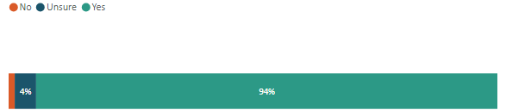
This question received 160 responses, with 94 per cent of submitters supporting the proposal. One of the main reasons expressed for supporting the proposal was that mismanaged waste can cause significant environmental harm, costs more to clean up and dispose of than the fine, and the financial burden falls on public authorities and their communities.

Cost recovery for removal of waste and correction of damage
Do you agree that public authorities, regulators, or occupiers of private land where a littering offence is committed, should be able to recover reasonable costs associated with the removal of the litter/waste and/or the environmental harm caused from the offender? If not, please explain why and provide any suggested alternatives for covering these costs
Figure 48: Support for public authorities, regulators, or occupiers of private land where a littering offence is committed should be able to recover reasonable costs associated with the removal of the litter/waste and/or the environmental harm caused from the offender
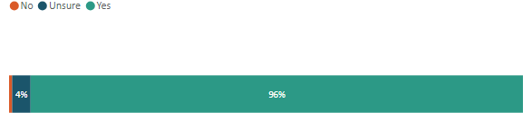
This question received 167 responses, with 96 per cent of submitters supporting the proposal. A few submitters, although supportive, questioned how the occupiers of private land would recover any costs they incurred to clean up waste dumped on private land.

Feedback requested from litter control officers
If you are a Litter Control Officer who has used the existing section 9(2)–(4) of the Litter Act (to require an occupier of land or premises to take all reasonable steps to prevent litter being carried or escaping onto the public place), please answer the following.
  - Are the current provisions efficient or effective for addressing this type of mismanaged waste issue in your area?
  - If not, please provide more information about the limitations of the provisions.
Please provide your feedback on the draft infringement levels for the proposed mismanaged waste compliance framework.
Figure 49: Responses to the question are the current provisions efficient or effective for addressing this type of mismanaged waste issue in your area?
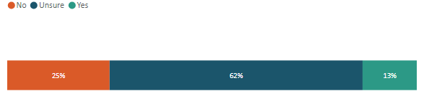
This question received 68 responses. Many submitters were unsure (62 per cent). Of the 25 per cent who said ‘no’, they indicated that the current provisions for addressing escaped and mismanaged waste were not efficient or effective in their area. A few local government submitters said they did not use or infrequently used these provisions in the Litter Act. One local government submitter, Kapiti Coast District Council, which was unsure about the statement, said it is often challenging to determine the liability of offending for escaped waste and therefore to recover costs.
One submitter, Tasman District Council, clarified that it is limited when using the current escaped waste provisions in the Litter Act because action can only be taken after the waste has escaped and only requires ‘reasonable steps’ with no specific requirement for providing receptacles to contain the waste. The Council suggested it would be more effective if contractors, recycling providers and waste management services were required to take proactive steps to prevent waste from escaping, such as at building sites with loose plastics.
Other litter and mismanaged waste-related feedback received includes the following.
- A submitter commented on the uncertainty as to when a waste is also considered a discharge under the Resource Management Act 1991, for example, plastics that break down into microplastics.
- A few business submitters supported the proposals but recommended a provision be added to exclude from enforcement any unintentional littering caused by a significant weather event outside of an individual’s control, such as a storm or flood.
- A few local government submitters suggested having strict liability for mismanaged waste offences, so focusing on the harm caused by the waste regardless of whether the person intended to cause harm or were negligent.
Comments from Auckland Council summed up the overall issue with the current Litter Act:
Over the last few years using regulations under the Litter Act 1979, Auckland Council has been successful in achieving only two prosecutions per year, on average. A high level of investigative work is required to take significant offences to court, to identify the offender, gather robust evidence and to secure witnesses. This process uses significant staff resources, especially as cases must be taken to court within a 6-month timeframe of the offence date. Infringement notices and fines are instead more commonly used. – Auckland Council

Appendix: Summary of proposals and consultation questions
Table 4 provides a summary of the proposals and consultation questions, as provided in support of this consultation at <Have your say on proposed amendments to waste legislation - Ministry for the Environment - Citizen Space>.
Table 4: Summary of proposals and consultation questions
Relevant provisions in legislation and proposals for amendment | Consultation questions
Waste Minimisation Act Part 2: Product stewardship  Amend the product stewardship provisions in the Waste Minimisation Act (WMA) to replace them with an extended producer responsibility (EPR) framework.  Discontinue the role of central government in accrediting voluntary product stewardship schemes – organisations can still develop voluntary schemes if they wish to. | We are interested in your views on an EPR framework.
- Do you support the proposal for a modern EPR framework?
Yes | No | Unsure
- Do you support discontinuing the government accreditation of voluntary product stewardship schemes? Yes | No | Unsure
Please share any further thoughts or ideas on these proposals.
Waste Minimisation Act Part 3: Waste disposal levy  Adjust the method for allocating funds from the waste disposal levy (the levy) to territorial authorities, to reduce the extremity of funding between very large and very small councils. The current population-based allocation approach would change to a combination of a base flat rate (20 per cent) and a population-based calculation (80 per cent).  Widen the use of the levy money for territorial authorities to support a broader range of waste and environmental outcomes.  Provide central government and territorial authorities with a decision-making framework for spending levy funds on environmental benefits and/or reduction of environmental harm.  Remove the blanket levy exclusion for waste-to-energy technology and facilities, to ensure a level playing field for all types of final waste disposal.  Amend the Minister’s required considerations and timeframe when reviewing the effectiveness of the levy.  Improve the efficiency and effectiveness of the existing levy provisions for:  - levy waivers  - levy exemptions  - reuse of material at disposal facilities  - stockpiling. | We are interested in your views on the following proposed changes to the waste disposal levy.
Distribution of levy funds
- Do you support changing the distribution of levy funds to territorial authorities from a population-based calculation to a combination of a base flat rate (20 per cent) and a population-based calculation (80 per cent)? Yes | No | Unsure
Please share any further thoughts or ideas on this proposal.
Scope of use of levy funds
- Please indicate your support for changes that would permit territorial authorities to use the levy for:
- activities that promote or achieve waste minimisation, in accordance with and as set out in the territorial authorities’ Waste Management and Minimisation Plan.
Yes | No | Unsure
- costs associated with managing emergency waste.
Yes | No | Unsure
- activities that provide for the remediation of contaminated sites and vulnerable landfills.
Yes | No | Unsure
- compliance, monitoring and enforcement of mismanaged waste. Yes | No | Unsure
- activities that reduce environmental harm or increase environmental benefits. Yes | No | Unsure
Please share any further thoughts or ideas on this proposal.
- Please share any suggestions for criteria that could form a decision-making framework for possible spending of the waste levy on environmental benefits and/or reduction of environmental harm.
Further levy effectiveness considerations
- Do you support removal of the current blanket exclusion from the levy for waste-to-energy facilities?
Yes | No | Unsure
- Do you agree that the Minister’s considerations for a review of the effectiveness of the waste levy should mirror the scope of the purpose of the WMA and the parameters for levy spend (once these are decided)? Yes | No | Unsure
- Do you support changing the timeframe for review of the effectiveness of the waste levy from every three years to at least every five years? Yes | No | Unsure
Please share any further thoughts or ideas on these proposals.
Use of waivers
- Do you support replacing the current levy-waiver requirement of ‘exceptional circumstances’, instead enabling the Secretary to waive the requirement for an operator to pay any amount of levy in specified circumstances? Yes | No | Unsure
- Do you support limiting the waiver requirement to emergency event situations for which a state of national or local emergency has been declared under the Civil Defence Emergency Management Act 2002 and biosecurity responses have been undertaken under Part 7 of the Biosecurity Act 1993? Yes | No | Unsure
- Do you agree the waiver requirement for waste from the remediation of a contaminated site should specify any eligibility criteria that an application must meet? If so, please share any suggestions for eligibility criteria.
Yes | No | Unsure
Please share any further thoughts or ideas on these proposals.
Conditions and exemptions
- Do you support requiring a Minister to consider specific criteria before recommending levy exemption regulations are made (instead of the current requirement that the Minister is satisfied ‘exceptional circumstances’ exist)?
Yes | No | Unsure
- Do you support applying a timeframe of a maximum of five years before levy exemptions via regulations must be reviewed or allowed to expire? Yes | No | Unsure
- Do you agree that the Minister should be able to impose conditions on levy exemptions? Yes | No | Unsure
Please share any further thoughts or ideas on these proposals.
Reuse of material at disposal facilities
- Do we need to clarify in legislation when the levy should be imposed on waste disposed of at a disposal facility, so that waste reuse on-site is operationally necessary and reasonable? Yes | No | Unsure
Please share any further thoughts or ideas on this proposal.
Stockpiling controls
- Do you support improvements to stockpiling controls by introducing tools such as:
- an approval system with limits and conditions?
Yes | No | Unsure
- changes to the stockpile calculation process to track the throughput of materials? Yes | No | Unsure
- a stockpile volume threshold limit? Yes | No | Unsure
- improved data collection, record-keeping and reporting provisions, to increase transparency and traceability of material entering and leaving a site? Yes | No | Unsure
- defining/amending the terms ‘diverted material’, ‘accumulation’ and ‘stockpiling’ in the legislation?
Yes | No | Unsure
Please share any further thoughts or ideas on these proposals.
Various Parts of the Waste Minimisation Act: Clarifying the roles and responsibilities in the waste legislation  Retain the current core role of the Ministry but add new responsibilities related to the proposed EPR framework.  Improve the role of the New Zealand Customs Service (NZ Customs) to support existing regulated product stewardship and an EPR framework.  For territorial authorities, clarify the minimum obligations for waste minimisation and improve the regulatory tools to ensure these are delivered.  Enable the Waste Advisory Board to provide advice to the Minister or Ministry on its own initiative – consistent with an agreed strategic plan – and focus the Board’s mandate on strategic and/or overarching waste issues. | We are interested in your views on clarifying the role of central government and territorial authorities in the waste legislation.
- Do you support the proposed changes to the roles and responsibilities for:
- the Ministry for the Environment. Yes | No | Unsure
- the New Zealand Customs Service. Yes | No | Unsure
- territorial authorities? Yes | No | Unsure
- Do you support a change in the Secretary for the Environment’s ability to retain levy payments to a territorial authority, from mandatory to discretionary?
Yes | No | Unsure
- Do you support enabling the Waste Advisory Board to provide advice at its discretion? Yes | No | Unsure
Please share any further thoughts or ideas on these proposals.
Waste Minimisation Act Part 5: Modernising the compliance and data regime  Introduce a fit-for-purpose compliance regime for the waste regulatory system to bring it into line with good practice already in use in other legislation. This will define the regulators’ and other organisations’ legislative obligations for monitoring and compliance activities.  Implement an amended compliance monitoring and enforcement (CME) framework to improve on the littering and other mismanaged waste compliance currently provided for under the Litter Act.  Enable regulators to share information for CME purposes. | We are interested in your views on modernising the existing compliance regime.
- Do you agree the regulator should have greater powers to receive data, including the ability to share with other regulators and the Ministry? Yes | No | Unsure
- Do you support the proposed tiered approach to the compliance tools and sanctions? Yes | No | Unsure
Please share any further thoughts or ideas on these proposals.
Litter Act: The effective enforcement and cost recovery of littering and other types of mismanaged waste  Improve the existing regulatory framework to enable public authorities to better deter and address littering and other types of mismanaged waste.  Integrate littering and other mismanaged waste into the broader waste management and minimisation regulatory system so the whole waste system is managed under one cohesive piece of legislation (including changes to the purpose of the legislation). | We are interested in your views on changes to the Litter Act.
Scope of the legislation
- Do you support integrating littering and other types of mismanaged waste into the same regulatory framework for waste management and minimisation? Yes | No | Unsure
- Do you support enabling regulations for the collection of data on littering and dumping? Yes | No | Unsure
- Do you support expanding the purpose of the WMA to include littering and other mismanaged waste in the new waste legislation? Yes | No | Unsure
Please share any further thoughts or ideas on these proposals.
Roles and responsibilities
- Regarding public authorities, do you support:
- limiting the definition of ‘public authority’ as proposed?
Yes | No | Unsure
- enabling public authorities (amended as proposed) to warrant Litter Control Officers or appoint Litter Wardens, to manage and enforce littering and other mismanaged waste offences? Yes | No | Unsure
- Do you support removing the assignment of a statutory role for the promotion of litter control to any specific agency or organisation? Yes | No | Unsure
- Do you support public authorities having a discretion whether they provide waste receptacles in public places but an obligation to empty those receptacles if they provide them?
Yes | No | Unsure
- Do you support removing the requirement for the Medical Officer of Health to be satisfied that litter receptacles are emptied promptly, efficiently and at regular and prescribed intervals? Yes | No | Unsure
- Do you agree that a local or public authority should:
- retain the ability to make grants to any organisation for the abatement or prevention of litter? Yes | No | Unsure
- be able to spend such sums of money as it thinks fit on any scheme or campaign for the abatement or prevention of litter? Yes | No | Unsure
- retain the ability to make bylaws to help reduce littering and dumping, if they are not inconsistent with the provisions of the new legislation? Yes | No | Unsure
- retain the ability to deter, prevent, require timely clean-up and enforce waste escaping/being carried on to public or private land? Yes | No | Unsure
- Do you support enabling all types of Litter Control Officers to apply different tiers of compliance tools, where they are authorised to act? Yes | No | Unsure
- Do you agree that, in enforcing offences, Litter Control Officers should be able to:
- use vehicle registration and ownership details?
Yes | No | Unsure
- use appropriate evidence-gathering, search and surveillance powers for vehicles that are implicated in serious dumping offences? Yes | No | Unsure
Please share any further thoughts or ideas on these proposals.
Compliance monitoring and enforcement framework
- Do you support the proposed amendments to the compliance monitoring and enforcement framework for littering and other mismanaged waste offences? Yes | No | Unsure
- Do you support lowering the threshold for evidence of a mismanaged waste offence, to allow for effective compliance monitoring and enforcement by Litter Control Officers?
Yes | No | Unsure
- Do you agree that public authorities should be able to be compensated by the offender if the mismanaged waste offence has caused significant environmental harm? Yes | No | Unsure
Please share any further thoughts or ideas on these proposals.
Cost recovery for removal of waste and correction of damage
- Do you agree that public authorities, regulators, or occupiers of private land where a littering offence is committed, should be able to recover reasonable costs associated with the removal of the litter/waste and/or the environmental harm caused from the offender? If not, please explain why and provide any suggested alternatives for covering these costs.
Yes | No | Unsure
Please share any further thoughts or ideas on these proposals.
Feedback requested from Litter Control Officers
- If you are a Litter Control Officer who has used the existing section 9(2)–(4) of the Litter Act (to require an occupier of land or premises to take all reasonable steps to prevent litter being carried or escaping onto the public place), please answer the following.
- Are the current provisions efficient or effective for addressing this type of mismanaged waste issue in your area? Yes | No | Unsure
- If not, please provide more information about the limitations of the provisions.
- Please provide your feedback on the draft infringement levels for the proposed mismanaged waste compliance framework.
Please share any further thoughts or ideas on this proposal.
 | If you have any further comments or thoughts on the proposed amendments that have not been captured in the previous questions, please share them here.

Links to webinars can be found on the Ministry’s website.
New Zealand Gazette. Declaration of priority products notice 2020. Retrieved 22 July 2025.
Section 23 of the Waste Minimisation Act 2008 refers to the regulations that can be made by government for products, materials and waste.
Ministry for the Environment. Priority product stewardship. Retrieved 22 July 2025.
The polluter pays principle means that people or businesses who cause pollution pay for cleaning it up and preventing further damage.
New Zealand Legislation. Waste Minimisation Act 2008, section 3. Retrieved 22 July 2025.
This covers the Waste Minimisation Act 2008 and Litter Act 1979.

