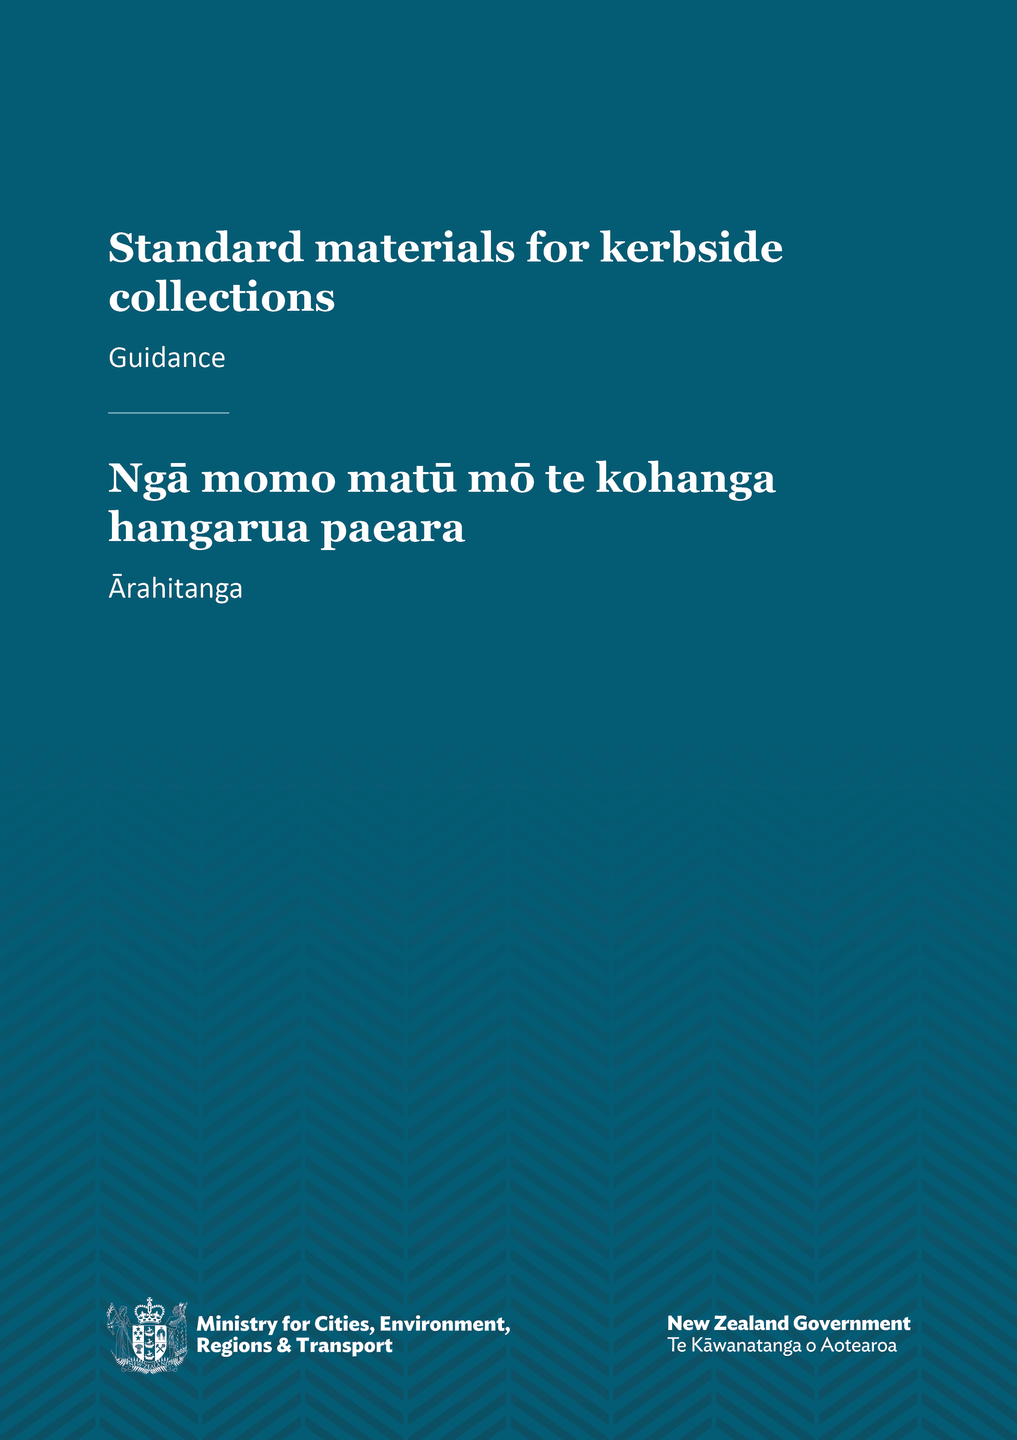
Ngā momo matū mō te kohanga hangarua paeara
Standard materials for kerbside collections
Guidance

Disclaimer
The information in this publication is, according to the Ministry for Cities, Environment, Regions and Transport’s best efforts, accurate at the time of publication. The Ministry will make every reasonable effort to keep it current and accurate. However, users of this publication are advised that:
- the information does not alter the laws of New Zealand, other official guidelines, or requirements
- it does not constitute legal advice, and users should take specific advice from qualified professionals before taking any action based on information in this publication
- the Ministry does not accept any responsibility or liability whatsoever whether in contract, tort, equity, or otherwise for any action taken as a result of reading, or reliance placed on this publication because of having read any part, or all, of the information in this publication or for any error, or inadequacy, deficiency, flaw in, or omission from the information in this publication
- all references to websites, organisations or people not within the Ministry are for convenience only and should not be taken as endorsement of those websites or information contained in those websites nor of organisations or people referred to.

This document may be cited as: Ministry for Cities, Environment, Regions and Transport. 2026. Standard materials for kerbside collections: Guidance. Wellington: Ministry for Cities, Environment, Regions and Transport.

First published in September 2023 by the
Ministry for the Environment
Manatū mō te Taiao
PO Box 10362, Wellington 6143, New Zealand
environment.govt.nz
Updated in June 2026 by the Ministry for the Environment and September 2026 by the Ministry for Cities, Environment, Regions and Transport
ISBN: 978-1-991404-52-7
Publication number: ME 1978
© Crown copyright New Zealand 2026

Contents
Introduction 5
Why standardising materials is important 6
Who the Standard Materials Gazette Notice affects 7
When the Notice must be implemented 8
Extended timeline for some TAs 8
Standard set of materials: Recycling 9
Recycling: Excluded materials 10
Standard set of materials: Food scraps and FOGO 13
Food scraps and FOGO: Excluded materials 13
Food scraps and FOGO: Discretionary materials 14
What the changes will mean in practice 16
Collecting and processing materials 16
Communicating the changes 16
WMMPs and waste bylaws 17
Process for updating the standard materials 18
Exemptions for TAs where costs exceed public interest 20
Guidance for trialling collection of non-standard materials 21
Purpose of trials 21
Trial criteria 21
Promoting trials 22
Trial scale and duration 22
Compliance, monitoring and enforcement 23

Tables
Table 1: Summary of standard materials accepted in household kerbside recycling 9
Table 2: Summary of excluded materials in kerbside recycling 10
Table 3: Summary of excluded materials in kerbside food scraps and FOGO collections 13
Table 4: Summary of discretionary materials for food scraps and FOGO collections 14

Figures
Figure 1: Standard materials list for household kerbside recycling 9
Figure 2: Process for updating the standard materials list 18

Introduction
This document provides guidance to support the implementation of the Standard Materials for Kerbside Collections Gazette Notice (the Notice) under the Waste Minimisation Act 2008.
The guidance will help territorial authorities (TAs) to implement and communicate the standard materials accepted in TA recycling, food organics (food scraps), and food organics and garden organics (FOGO) collections from 1 February 2024.
The guide provides further information to the Notice to explain:
- why some materials are, or are not, accepted
- when TAs have discretion over accepting certain materials
- what practical changes will need to be made
- how the list of standard materials can be updated over time
- exemptions for TAs where costs exceed public interest
- trial collections of non-standard materials.

Why standardising materials is important
Accepting the same set of materials nationally in collections of household kerbside recycling, food scraps and FOGO makes it easier for households to know what materials can be accepted wherever they are in Aotearoa New Zealand.
Clarity on what can be recycled at the kerbside will mean fewer contaminants in recycling bins, less waste going to landfill and more material being recycled overall. Confidence about what can be recycled will support businesses to choose and design recyclable packaging and improve the market for recyclable materials.
For organics collections, the nutrients in food and garden organics are recycled back to the soil and the food chain through compost or digestate (an end product of anaerobic digestion). Accepting a standard set of materials in organics collections helps reduce the risk of contamination in any compost or digestate that is produced.
Standardising kerbside recycling will help New Zealand become a resource efficient economy, where materials are re-used as much as possible.

Who the Standard Materials Gazette Notice affects
The Standard Materials for Kerbside Collections Gazette Notice applies to all TAs that collect kerbside recycling, food scraps or FOGO receptacles from households in urban areas and that include such services in their Waste Minimisation and Management Plans (WMMPs). The Notice will also apply to private waste companies that collect household kerbside recycling or organic waste on behalf of TAs.
Collections made directly from the kerbside, as well as on-site collections that use standard kerbside collection receptacles (eg, wheeled bins, crates, food scrap bins or caddies, bags or similar) must meet the standard materials requirements. For example, apartment blocks sometimes use a central on-site collection point. Such collections are considered a kerbside service subject to this Notice if the apartment block collection is managed by a TA and the receptacles used are the same or similar to others collected directly from the kerbside.
The Notice does not apply to transfer stations, community recycling centres, resource recovery centres, other drop-off recycling schemes or extended producer responsibility programmes. Private waste companies and social enterprises that operate collections independently of TAs are not subject to the Notice.
From 3 September 2026 the Notice no longer applies to kerbside services delivered to rural communities. This reflects that it may be more difficult to cost-effectively deliver a full range of services to rural areas. The Notice only applies to services delivered to urban areas with a population of 1,000 or more. Urban areas are as identified in the StatsNZ Urban Rural classification.
The Notice does not require TAs to provide kerbside services to any particular area. TAs retain discretion as to whether to provide services, the extent of collection routes, and which dwellings are served. However, if a kerbside service is provided to an urban area the service must comply with the Notice and accept the standard materials.
When the Urban Rural classification is updated, the relevant Urban Rural classification is the one in place when the TA most recently started or renewed the service. If any area changes classification, the Notice will apply, or cease to apply, to that area from the next review, redesign or procurement of the service (eg, through a waste management and minimisation plan review).
The Urban Rural classification can also be usefully viewed as a map via StatsNZ Geographic Boundary Viewer. Use the ‘Layers’ menu on the right to turn on ‘Urban Rural’ and select the appropriate year. Selecting ‘Legend’ will show which of the marked areas are small, medium, large and major urban areas and which are rural settlements.

When the Notice must be implemented
All TAs that provide a kerbside recycling, food scraps or FOGO service (as specified in their WMMPs) must comply with the Notice from 1 February 2024.

Extended timeline for some TAs
Some TAs will have until 2027 to implement the requirements, due to new infrastructure or services needing to be established.
- Hurunui District Council and Westland District Council have until 1 January 2027 to add glass to their existing recycling collections in urban areas.
- Clutha District Council will have until 1 July 2027 to add glass to their existing recycling collections in urban areas.
- Gore District Council will have until 1 January 2027 to add paper and cardboard; plastic bottles, trays and containers of resin identification codes 1, 2 and 5; and aluminium and steel tins and cans to its existing recycling collection in urban areas.

Standard set of materials: Recycling
From 1 February 2024, the only materials that can be accepted in household kerbside recycling are shown in figure 1. Materials must be clean. For containers that previously held liquids, pastes, ointments or similar, this means empty and rinsed.
Figure 1: Standard materials list for household kerbside recycling
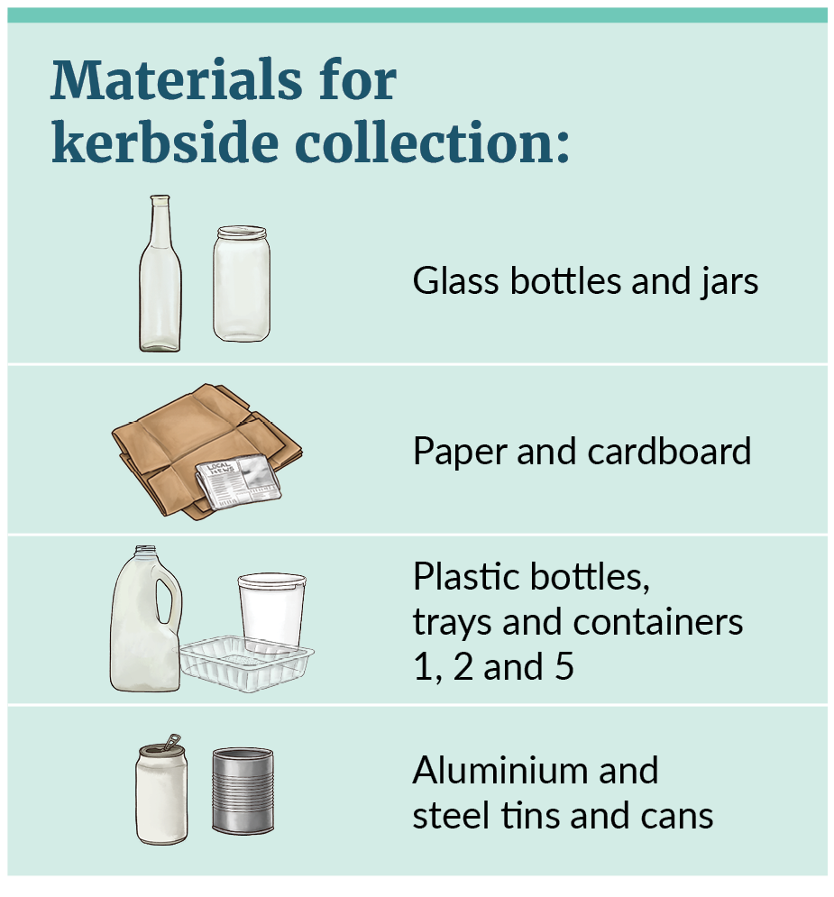
The materials included are able to be processed and sorted effectively, are unlikely to contaminate recycling or affect health and safety, have strong and sustainable end markets, and support a circular economy (that is, by being able to be recycled multiple times). Table 1 provides further details on the standard set of materials.
Table 1: Summary of standard materials accepted in household kerbside recycling
Material | Further details
Glass bottles and jars | - Only includes empty, clean, and unbroken glass bottles and jars made from container glass (a type of glass used in the production of containers).  - Does not include broken glass or glass with other materials attached.  - Does not include glass medicine bottles or laboratory glass containers.  - Does not include non-container glass, such as light bulbs, heat-resistant glass, crockery, opal glass, screens, vases or ornamental glass items, cosmetic glass, drinking glasses, mirror glass or window glass.
Paper and cardboard | - Includes clean paper and cardboard including pizza boxes (food scraps should be removed although grease stains are okay).  - Does not include shredded paper.  - Does not include paper or cardboard that is plastic lined (such as receipts and boarding passes), foil lined or that has compostable elements (eg, coatings or linings) that could contaminate the recycling process.
Plastic bottles, trays and containers with resin identification codes 1, 2 and 5 | - Includes empty and clean, clear and coloured polyethylene terephthalate (PET), high density polyethylene (HDPE), and polypropylene (PP).  - Includes empty and clean meat trays or other trays and containers, such as margarine tubs, fruit punnets or appropriately sized yogurt pottles, provided they are made from and marked as plastics 1, 2 and 5.  - Does not include materials that are likely to be contaminated, such as paint containers, hazardous substance containers and plant pots (see table 2).  - Does not include products made of plastics 1, 2 and 5 that are not bottles, trays or containers (such as toys), because these are often made of multiple materials that are difficult to separate.  - With some containers, the shape and function of a lid and base are reversed. For example, with a domed plastic cake container the upper part of the packaging acts like a container while the lower part is like a large flat lid. In these cases, the upper part would be accepted as it can be mechanically sorted like a container, while the lower part is excluded for the same reasons as large flat lids (see Lids, caps and tops in table 2).
Aluminium and steel tins and cans | - Does not include other types of aluminium such as foil (foil on a roll or foiled trays) and does not include aerosols (see table 2).
The Standard Materials for Kerbside Collections Gazette Notice does not specify requirements for the size and composition of labels attached to accepted materials.

Recycling: Excluded materials
TAs will be required to stop accepting materials that are not listed in table 1. For clarity, table 2 outlines the main materials that have been excluded from the recycling standard materials and the rationale for their exclusion. Alternative recycling schemes may be available for excluded items, such as the options listed in table 2.
Table 2: Summary of excluded materials in kerbside recycling
Excluded material | Rationale | Alternative recycling options
Undersized items  (three-dimensional items smaller than 50 mm at their widest point and two-dimensional items smaller than 100 mm by 140 mm) | Three-dimensional items smaller than 50 mm at their widest point (length, height or width) and two-dimensional items smaller than 100 mm x 140 mm are screened out during initial sorting at recycling plants. Examples of items that are likely to be undersize include: lids/caps, some cosmetics containers, some spice/flavouring containers, small takeaway sauce pottles, and other materials that have been broken down into small pieces.  These items, which are too small to sort effectively, are sent to the landfill. | - Some smaller items can be recycled through product take-back schemes or dropped off at transfer stations or community resource recovery centres.
Oversized items  (glass, plastic, steel and aluminium containers more than 4 litres) | Oversized plastic, metal and glass items larger than 4 litres are too big to be processed on automated sorting lines. | - Some transfer stations and community resource recovery centres will accept bulky plastic, metal and glass for recycling.  - Scrap metal yards will also often accept large metal materials.  - If bulky multi-component items, such as homeware, are still in usable condition they may be accepted by op shops.
Lids, caps and tops (except for tethered lids, caps and tops) | Several reasons exist for excluding lids and caps.  - Small loose lids and caps are too small for recycling plants to sort successfully.  - Large flat lids, like those from ice-cream containers, act like paper and cardboard during mechanical sorting and often end up contaminating collected paper and cardboard.  - When lids are left on closed bottles or containers, liquid or food is more likely to remain inside and the container will be discarded to landfill.  - Detachable lids, caps and tops are often a different grade of plastic from the base bottle or container.  - Pumps and triggers, such as those found on household cleaners, are made of multiple materials which are difficult to separate for recycling. They are considered a type of lid and are excluded.  An exception is lids, caps, or tops that are tethered to a recyclable container that is accepted in kerbside recycling. Tethered means that it stays attached to the bottle or container when open and cannot be easily removed. Tethered lids should be left open and attached for recycling. Tethered lids include steel-can lids (ends) that have not been fully removed from the empty can. | - The Packaging Forum Caps and Lids Scheme accepts plastic and metal caps and lids at participating drop‑off locations.  - In some instances, transfer stations and community resource recovery centres may also have lid recycling schemes.  - Some Lions Clubs around the country collect metal rip tabs from beer cans (a small piece of metal designed for opening the top of a can) and metal lids from wine bottles.
Aerosols (steel and aluminium) | Most recycling plants in New Zealand do not have the safety equipment needed to compact aerosols in a way that prevents fires and ducts any fumes outside of the building.  As well, aluminium aerosols are typically grouped with used aluminium beverage containers, for on-selling, and their inclusion can lower the overall value of an aluminium collection.
Liquid paperboard (LPB) | LPB (carton packaging made of a composite material) is hard to recycle multiple times because the packaging is a composite of different materials (commonly cardboard, plastic and aluminium) that are not easily separated.  Sorting LPB cartons at recycling facilities is also challenging, often requiring hand sorting or upgraded equipment. | LPB drop-off points can overcome challenges of sorting and are being established across the country. Drop-off points include some transfer stations and community resource recovery centres.
Aluminium foils and trays | At most recycling facilities, aluminium foils and trays are a source of contamination. Because of their light weight, size and shape, aluminium foil and trays are often unable to be sorted by machinery. Food residues left on these materials can also contaminate recycling.
Plastics with resin identification number  3, 4, 6 or 7 | Low volumes of these types of plastic are in the kerbside waste stream, meaning they have limited recycling markets and can contaminate the recycling of high-value plastics like plastic 1 (PET). The Government is phasing out many types of food and beverage packaging made from plastic 3 (polyvinyl chloride, PVC) and plastic 6 (polystyrene, PS) by mid-2025. | EXPOL collects household volumes of expanded polystyrene (a type of plastic 6) at selected hardware stores across the country.  For information on soft plastic drop-off collections (including plastic 4), see the soft plastics row below.
Soft plastics | All types of soft plastic (eg, bags and wrap) are excluded because they can cause problems in recycling plants by catching on sorting equipment and getting tangled. | The Packaging Forum collects plastics through drop-off points in supermarkets and other locations.
Plant pots (including those made of plastic 5) | Many plant pots are black or dark colours that are difficult for optical sorting technology at recycling plants to correctly sort. Plant pots are also often not clean and have the potential to contaminate recycling. | Many garden stores (including Mitre 10, Bunnings and Kings Plant Barn) operate drop-off recycling schemes for plant pots.
Paint containers | Paint containers are hard to clean and are likely to contaminate recycling streams. | Many paint brands, such as Resene and Dulux, accept unwanted paint and paint containers for reuse or recycling.  Some TAs accept empty and dry paint containers at transfer stations or community resource recovery centres.
Hazardous substance containers | Hazardous substance containers (eg, those containing pesticides, motor coolant or automotive oil) are a health and safety risk. | Many transfer stations and community resource recovery centres accept hazardous substance containers commonly used by householders.  Agrecovery accepts many types of used agrichemical containers, including some home gardening containers.  Some automotive stores accept used automotive oil containers.

Standard set of materials: Food scraps and FOGO
Only food scraps and garden organics are accepted materials in food scraps and FOGO bins. TAs can choose whether they collect food scraps only or offer a FOGO collection.

Food scraps and FOGO: Excluded materials
The accepted materials for food scraps and FOGO collections are limited, to ensure the materials being collected do not contain additives, inks or chemicals that could contaminate soil or be dangerous to human health. The materials being collected must not undermine the final products, such as compost or digestate.
TAs will have discretion over some materials accepted in organics collections, mainly the use of compostable bin liners and potentially problematic garden materials within FOGO collections. See the Food scraps and FOGO: Discretionary materials section for more information.
All other materials in food scraps and FOGO collections must no longer be accepted. The main materials that are excluded and reasons for doing so are listed in table 3.
Table 3: Summary of excluded materials in kerbside food scraps and FOGO collections
Excluded materials | Rationale
Paper and cardboard, including:  - kitchen paper towels, hand towels and serviettes  - newspaper and shredded paper  - food-soiled cardboard containers (eg, pizza boxes)  - cardboard (including egg cartons). | Per- and polyfluoroalkyl substances (PFAS, including PFOA, PFOS) can be found in fibre-based products as well as in recycled paper and cardboard. Fibre-based products means products primarily made from wood fibre (paper or cardboard) or other types of biomass (bamboo, rice, sugarcane, potato starch, etc).  These PFAS can then accumulate in the soil, plants and consequently the food chain.  Newspaper and cardboard can also introduce contaminants such as inks that include heavy metals and/or microplastics.  Some paper and cardboard items can still be diverted from landfill through kerbside recycling. This includes: pizza boxes with food scraps removed, cardboard (including egg cartons) and newspaper.
Compostable packaging including:  - compostable plastic products or packaging  - compostable fibre products or packaging  - compostable labels. | Some compostable materials don’t break down within the specified timeframes, don’t break down completely, or contain substances of concern (such as PFAS). New Zealand currently has no standard for what can be labelled as compostable packaging.  Compostable packaging can leave microplastics or other contaminants to accumulate in compost, soil, plants and animals, in some cases negatively affecting their growth.  Compostable packaging can also look almost identical to non-compostable packaging, causing further contamination challenges. The Ministry for the Environment’s position statement on compostable products provides further information.
This exclusion has one exception. TAs can choose whether they want to accept compostable bin liners in food scraps and FOGO bins. This exception recognises the potential for bin liners to increase the usage rates of food scraps collections.
Excluding all other types of compostable packaging and fibre strikes a balance between maximising diversion and minimising contamination.
Tea bags | Most tea bags currently sold in New Zealand are partially or wholly made of plastic, including plastic adhesives. Excluding tea bags from food scraps and FOGO collections minimises the risk of introducing microplastics into composts, soils and the environment.
Sawdust from treated timber | Sawdust made from treated timber products can contain toxic chemicals, such as arsenic, boron, chromium and copper. Excluding treated sawdust from FOGO collections minimises the risk of introducing toxic chemicals into composts, soils and the environment.
Animal waste | Animal waste can pose health and safety risks in organics processing facilities because it can be a vector for pathogens. Additionally, animal waste (from dogs in particular) is often collected in bags made from traditional or compostable plastics. Excluding animal waste minimises the risks of these bags entering organic processing facilities and introducing potential contaminants.
Ash | Ash, such as from fireplaces, can cause health and safety risks in organics processing facilities and introduce contaminants. Excluding ash minimises the risk of introducing unknown contaminants into composts, soils and the environment.

Food scraps and FOGO:
Discretionary materials
TAs can choose whether to accept some specific organic materials, including compostable bin liners. These discretionary materials are summarised in table 4.
Table 4: Summary of discretionary materials for food scraps and FOGO collections
Discretionary material | Considerations
Compostable plastic or fibre bin liners (for food scraps and FOGO collections) | Compostable bin liners include compostable plastic bin liners and fibre-based bin liners, such as newspaper, cardboard or paper bags.  Compostable bin liners can help divert food scraps from landfill by helping to reduce the ‘ick’ factor associated with separating out food scraps. They can also improve cleanliness when handling food scraps.  However, bin liners must be selected carefully. Some contain contaminants that can affect the quality of the compost or digestate made by the processing facilities. See further guidance below on selecting bin liners.
Seashells (for food scraps and FOGO collections) | This includes hard seashells, such as mussels and pipi. Seashells can interfere with processing equipment and also do not break down well, sometimes leaving shards in the final product.
Small amounts of garden organics (for food scraps collections) | TAs can choose to accept small amounts of garden organics (eg, cut flowers) in their food scraps bins. TAs can specify which types of garden organics to accept.
Fibrous or woody plants (for FOGO collections) | Fibrous or woody plants include flax, bamboo, large branches and tree stumps. Fibrous or woody plants do compost but take more time, compared with other types of organic material. These materials can also cause issues with some types of processing machinery, for example, jamming chippers and shredders. TAs should check whether the organics processors available in their region can process fibrous and woody plants and, if so, what maximum size of branches and/or logs they will accept.
Noxious weeds (for FOGO collections) | TAs should choose which weeds to accept or exclude based on which weeds are problematic in the region. Some organics processing technologies can process noxious weeds at high temperatures, while other technologies may not. TAs should check with local organics processing facilities.
Garden material likely to contain chemical spray residue (for FOGO collections) | Herbicides and other chemical sprays can persist in garden materials and may negatively affect compost production, killing plants that are planted in that compost.  We encourage TAs to check with local organics processing facilities about their requirements regarding garden waste sprayed with chemical sprays.
Additional topics are listed below for TAs to consider when deciding whether to allow compostable bin liners in their food scraps collections.
- The type of organics processing technology available: Some organics processing technologies can process compostable bin liners, but others can’t. We encourage TAs to check with their local organics processing facilities to understand whether they can process compostable bin liners.
- The type of compost or other product being produced: Some organics processing facilities produce organic certified compost products. Such facilities may not accept compostable bin liners, to maintain their certifications. We recommend TAs check with their local organics processing facilities to understand their product and certification needs.
- Whether bin liners are certified compostable: To improve certainty around whether bin liners will effectively break down, TAs and/or householders should choose bin liners that are certified compostable. Composting certifications are often measured to either ‘industrial’ or ‘home compost’ standards. TAs should consult with their local organic processing facilities to see what type of compostable bin liners could work for their service. The most common compostable certifications used in New Zealand include:
- industrial compost certifications: AS 4736 (Australian seedling industrial composting), EN 13432 (Seedling industrial composting), EN 13432 (OK compost industrial composting), EN 13432 (Din industrial) and ASTM D 6400 or 6868 (Biodegradable Products Institute and US Composing Council)
- home compost certifications: AS 5810 (Australian seedling home composting), variation of EN 13432 (OK compost home composting) and AS 5810 / NF T 51-800 (Din home).
- How existing collections are performing: Ideally, food scraps are collected without compostable bin liners. Therefore, if a TA’s food scraps collection service excludes bin liners and is not performing well, the TA should first consider other ways to increase participation, such as ensuring the bins or caddies being used are fit for purpose or increasing community outreach and education. The Ministry for the Environment funded research in 2023 to understand the barriers to participation in kerbside food scraps collections. Reviewing this research can be a helpful place to start.

What the changes will mean in practice

Collecting and processing materials
TAs will need to decide:
- whether recycling materials are collected together (co-mingled) or separately
- where and how the collected materials are processed.

Collecting glass as a separate stream
While TAs must collect glass bottles and jars, there is no requirement for glass to be collected in a separate glass bin or crate.
However, we encourage TAs to collect glass separately as a best practice because it increases the recovery and value of both the glass and the other recycled materials. When glass is collected, fine shards of glass are created during transport. In collections where glass is co-mingled with other dry recyclables, these fine shards can easily contaminate other recyclables, particularly fibre (paper/cardboard).

Collecting and processing options for food scraps and FOGO
TAs can choose whether they collect food scraps only or offer a FOGO collection. TAs should consult the organics processing facility they intend to use to process any new organic collections. Depending on the processing technology being used, some facilities may prefer either a food scraps only collection or a combined FOGO collection.
TAs will also need to choose where food and garden waste is processed. This resource from the Office of the Prime Minister’s Chief Science Advisor gives an overview of options for processing food and garden waste.

Funding support
Funding is available for TAs and the private sector to invest in diverting food and other organic wastes from landfill in their regions. Please see the Waste Minimisation Fund for details.

Communicating the changes
Standardising the materials accepted at kerbside will allow consistent messaging around which materials can be recycled across the country. To comply with the standard materials requirements, we expect TAs to update their public-facing communications materials (eg, websites, waste collection guidance booklets) to clearly list the accepted standard materials.
In early 2024, the Ministry for the Environment supported a national communications campaign to promote the kerbside standard materials. TAs had access to campaign materials they could adapt and use for their own communities.
Standardising kerbside recycling will help improve the effectiveness of on-pack recycling labelling. The Recycling Leadership Forum is leading and coordinating input into the way the Australasian Recycling Label works in Aotearoa. An important focus for the Recycling Leadership Forum is ensuring the label is fit for purpose in the New Zealand market, including aligning with the kerbside changes.

WMMPs and waste bylaws
For TAs that already offer a kerbside collection service, and include this service in their WMMP, the standard materials requirement will apply from 1 February 2024 and no WMMP updates will be needed.
TAs establishing new kerbside services will need to update their WMMPs accordingly. Once new kerbside services are in place and are detailed in a TA’s WMMP, the services will need to comply with the standard materials requirements.
TAs with a waste bylaw that specifically lists materials that can be accepted for recycling at the kerbside within their area may need to update that bylaw to align with the new standard materials. A TA will need to consider this change in relation to its obligations under the Local Government Act 2002 and the process for bylaw amendments under that Act.

Process for updating the standard materials
The list of materials for kerbside recycling, food scraps and FOGO bins managed by TAs will need to remain current and relevant as changes in the market occur and processing technologies improve.
The Minister for the Environment is responsible for updating the list of standard materials. If the Minister decides to update the standard materials, this will require a further gazette notice under section 49 of the Waste Minimisation Act 2008.
The Minister for the Environment will consider updates to the standard materials:
- by application to the Ministry for the Cities, Regions, Environment, and Transport
- through the design of an extended producer responsibility scheme
- as initiated by the Minister.
An overview of the application process is shown in figure 2.
Figure 2: Process for updating the standard materials list
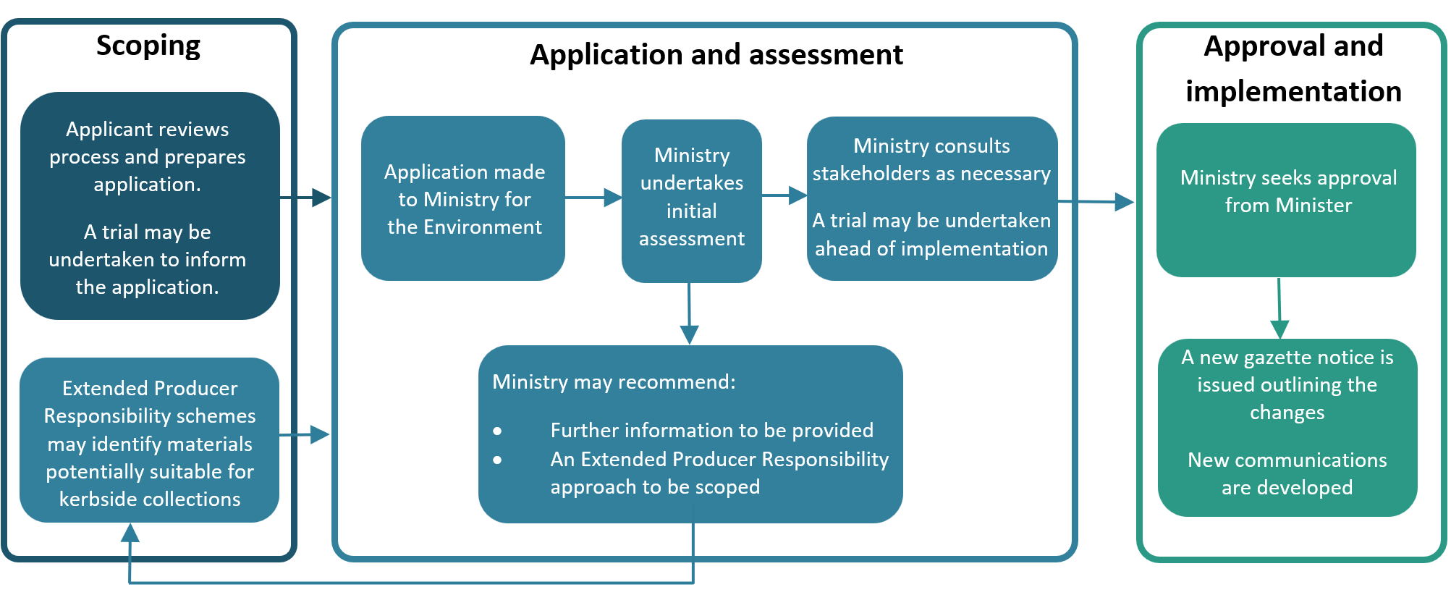
Updates made to the standard materials list will be assessed based on the following non-exhaustive list of criteria.
- Environmental benefits: Do the proposed end-market solutions support a circular economy and minimise environmental harm (eg, greenhouse gas emissions, discharge to air and/or land and resource extraction)?
- Economic viability: Does the material being considered have markets that are sufficiently large and have longevity? Is collecting and processing the proposed material economically viable? What are the total costs associated with the proposed collection and who will cover such costs?
- Technology availability: Is the technology required to collect and process the proposed material a proven technology that is readily available in Aotearoa?
- Distribution: Can all parts of the country viably collect and process the proposed material?
- Contamination: Does processing the proposed material have the potential to contaminate other recycling streams?
- Health and safety: Can the proposed material be processed in a way that ensures a high level of health and safety for all workers involved?
- Additional considerations: Other considerations the Minister for the Environment deems appropriate.
If the information is insufficient to have confidence that the proposed material can be collected or processed effectively, or if there are concerns about costs and impacts on the wider industry, the Ministry may:
- ask for further evidence or research
- recommend the applicant review its scope, taking into consideration an extended producer responsibility approach
- decline the application.
Applicants will need to show they have undertaken market research, understand the costs associated with their proposed collection, and have put a viable plan in place for covering such costs. If an application is made without having completed such an assessment, the design of an extended producer responsibility scheme may be recommended as a next step.
In working towards submitting an application to the Ministry, TA’s, industry and NGOs may decide it is necessary to test collection of a new material. Trials may take place during the scoping phase (before applying) or during the assessment phase to provide additional evidence and research to the Ministry. See the Guidance for trial collections of non-standard materials section below.
Once any further information is assessed, and the application is approved by the Minister for the Environment, the standard materials list will be updated via a new gazette notice specifying the change(s). Where multiple changes have been approved, they may be grouped together and published in a single gazette notice. Grouping changes together will allow public messaging to remain consistent and reduce administrative costs for affected groups.

Exemptions for TAs where costs exceed public interest
September 2026 changes to the Standard Materials for Kerbside Collections Notice include a new section 7a. Exemptions to collecting an accepted material. This section sets out a process for a TA to apply for, and the Minister for the Environment to consider, an exemption from the requirement to accept a material, or class of material, in a kerbside service.
An exemption is only expected to be used in circumstances where the cost of collecting the accepted material exceeds the public interest in collecting the material and the material can be cost-effectively recovered another way.
Specifically, in granting any exemption the Minister must be satisfied that:
- Accepting the material in the kerbside service would impose costs on the Territorial Authority that significantly exceed the public interest and benefit of collecting the material; and
- The material can be recovered more cost-effectively through an alternative recovery method, while maintaining a reasonable rate of recovery.
The Minister must further consider the impact of the exemption on the national effectiveness of standard materials for kerbside collections and may consider other relevant factors.
To apply, a TA must write to the Minister and provide costs and recovery rates for kerbside collection and the alternative recovery method. The TA must also specify when the service will next be reviewed (at which point the need for an exemption can be re-examined).
An exemption will take effect when it is published in the New Zealand Gazette. An exemption notice will state the TA to which it applies, the relevant material, the expiry date of the exemption, and the reasons for granting the exemption.
Exemptions are only envisaged to be used very occasionally and in narrow circumstances to preserve the overall benefits gained from accepting a nationally consistent set of standard materials.

Guidance for trialling collection of non-standard materials
The Standard Materials for Kerbside Collections Notice 2023 does not provide guidance for trials. However, it has always been intended that the standard materials list could be added to over time, with trials informing this process where necessary.
Trials may be used to test whether a material can be collected and sorted effectively. For example, looking at the quality and quantity of the material collected, or how the collection impacts other materials or existing systems.
This guidance allows TAs, industry or NGOs to run trials for collecting, sorting or processing materials that could be suitable for kerbside collection.

Purpose of trials
The Ministry expects trials to provide evidence for possible updates to the Standard Materials for Kerbside Collections Notice.
Trials should be based on a credible case that the material could meet the criteria for standardisation. Key factors to consider include:
- the material’s ability to be recovered
- market demand for the material
- environmental benefits
- compatibility with existing collection and processing systems.
Trials should be designed with these outcomes in mind so that results can meaningfully contribute to the evidence base for potential inclusion in the standard materials list.

Trial criteria
The Ministry expects trials to:
- have clear objectives
- be time limited (with start and end dates)
- clearly state in all communications and promotions that the collection is a trial
- not undermine public trust in the kerbside recycling system or outcomes
- be notified to the Ministry before starting
- share results and findings with the Ministry.
A trial planning template is available on the Ministry’s website to support best practice trial design.
You are encouraged to share your completed template with the Ministry. Notification helps the Ministry’s Compliance team stay informed and prevents misunderstandings.

Promoting trials
All promotional material (eg, websites, social media, bags or receptacles, flyers) should clearly show:
- that the collection is a trial
- start and end dates of the trial
- who is running the trial, including organisation name and contact details.

Trial scale and duration
Trials can differ in size and length depending on what is being tested. Below are examples of different testing scales and when they might be suitable.
Trials may start small and expand or begin at a later stage if early testing is unnecessary. This may apply when a similar material has already been tested or overseas evidence supports wider testing.
Expanding scale or duration are changes that should be notified to the Ministry. For example, if another district is included in the trial, or the length is extended beyond original dates provided to the Ministry. This aligns with the trial criteria and ensures the Ministry’s Compliance team is informed.

Local trial
- Tests collection methods, quantities and quality (including secondary impacts on existing collections/materials).
- Limited area or number of households.
- Short duration (around 6 months, may run for longer if specific needs are identified ie, testing expected seasonal effects).

Wider testing
- Testing preferred methods in different conditions (eg, urban areas of different sizes, distance from processors, different material recovery facility set ups).
- May involve multiple districts, larger areas, and integration with TA managed services.
- Short to medium duration (6–12 months or more).

Successful trial extension
A successful trial may want to continue until a final decision is made on the material becoming a standard material. This would be to maintain confidence in the recycling system and avoid households starting and stopping recycling behaviour.
To move into an extension phase, trials should have:
- an application in place to become an accepted material
- evidence on costs and benefits supporting inclusion
- broad consensus that the material can be safely and effectively collected through kerbside
- an available end market for the material.

Compliance, monitoring and enforcement
The Ministry for Cities, Regions, Environment, and Transport is the primary regulator under the Waste Minimisation Act 2008. We will work with TAs in the lead up to the requirements coming into force, to support their implementation. Our compliance team will work with TAs to ensure they understand their responsibilities regarding standard materials. The way we work is guided by our Compliance, monitoring and enforcement strategy.
This notice will be enforced under section 37 of the Waste Minimisation Act 2008. Once the requirements come into force, our auditing programme will expand to include these new requirements, and our auditors will contact TAs to assess their compliance. Where we find any non-compliance, we may take enforcement action. If TAs fail to comply with the standard materials gazette notice, one or more payments of the waste levy can be retained.

At publication, the latest version of the Urban Rural classification was Urban Rural 2026V1.0.0.
Pritchett S, Yates S. 2020. Recommendations for standardisation of kerbside collections in Aotearoa. Prepared for the Ministry for the Environment by WasteMINZ. Wellington: Ministry for the Environment.
Trials that are independent from territorial authority managed kerbside services are unaffected by the standard materials regulation. However, all trials should follow the guidance for trialling non-standard materials to inform any later assessment on changes to the standard materials.

