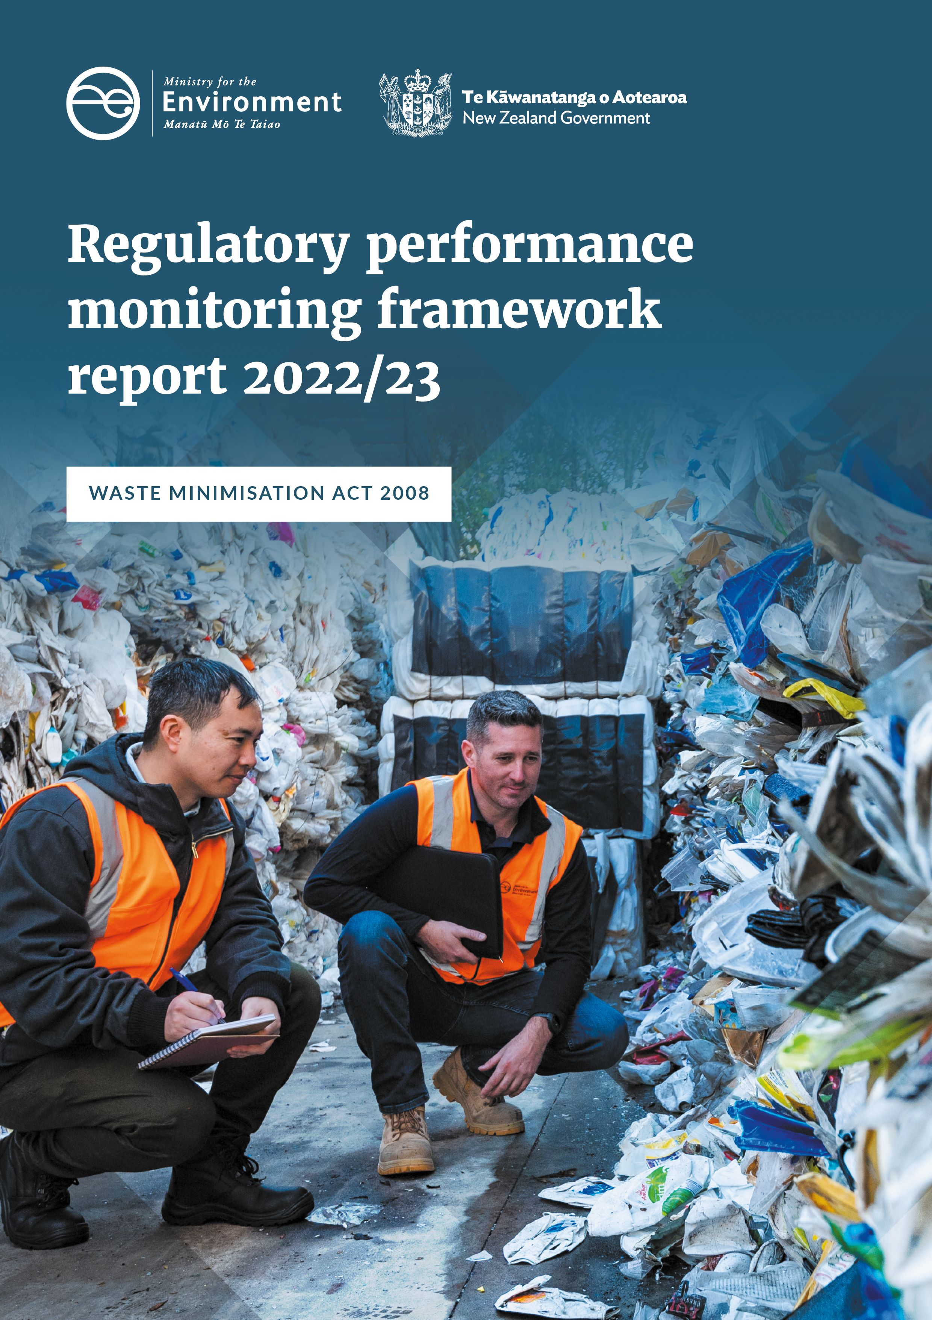

**Disclaimer**

The information in this publication is, according to the Ministry for the Environment's best efforts, accurate at the time of publication. The Ministry will make every reasonable effort to keep it current and accurate.

However, users of this publication are advised that:

* The information does not alter the laws of New Zealand, other official guidelines, or requirements.
* It does not constitute legal advice, and users should take specific advice from qualified professionals before taking any action based on information in this publication.
* The Ministry does not accept any responsibility or liability whatsoever whether in contract, tort, equity, or otherwise for any action taken as a result of reading, or reliance placed on this publication because of having read any part, or all, of the information in this publication or for any error, or inadequacy, deficiency, flaw in, or omission from the information in this publication.
* All references to websites, organisations, or people not within the Ministry are for convenience only and should not be taken as endorsement of those websites or information contained in those websites nor of organisations or people referred to.

This document may be cited as: Ministry for the Environment. 2025. *Waste Minimisation Act 2008: Regulatory performance monitoring framework report 2022/23*. Wellington: Ministry for the Environment.

Published in March 2025 by the  
Ministry for the Environment   
Manatū mō te Taiao  
PO Box 10362, Wellington 6143, New Zealand  
[environment.govt.nz](http://www.environment.govt.nz)

ISBN: 978-1-991140-75-3

Publication number: ME 1883

© Crown copyright New Zealand 2025

**Contents**

Part 1: Our work programmes 6

Levy administration | Whakarite utu 7

Facility compliance | Tautukunga wāhi para 11

Territorial authority compliance | Tautukunga mana wāhi 14

Fund compliance | Tautukunga tahua 17

Product compliance | Tautukunga hanganga 19

Regulatory compliance | Tautukunga whakahaere 20

Part 2: Performance assessment and monitoring 22

Overview 22

Modern Regulator Improvement Tool (MRIT) assessment 22

Appendix: Modern Regulator Improvement Tool framework and explanations 24

**Tables**

Please note all reporting periods in these tables are from 1 July to 30 June.

Table 1: Key dates for the increase and expansion of the waste levy and reporting obligations 7

Table 2: Number of registered facilities 7

Table 3: Applications received by the Ministry under the Waste Minimisation Act 2008 8

Table 4: Waste levy distributed to, or withheld from, territorial authorities 9

Table 5: Compliance scores over the reporting years 12

Table 6: Results of referrals and corrective actions on non-compliance matters 13

Table 7: Outcome of territorial authority compliance audits 14

Table 8: Territorial authority waste levy spend 15

Table 9: Audit activity for Waste Minimisation Fund projects 18

Table 10: Number of non-compliance reports received 19

Table 11: Referrals and proactive investigations conducted 20

Table 12: Enforcement tools used 21

Table 13: Formal investigation processes undertaken 21

Table A1: Levels of organisational maturity 24

Table A2: Description of MRIT attributes 25

Table A3: Waste operations MRIT scores 26

**Figures**

Figure 1: The Waste Operations work programmes 6

Figure 2: Levy money paid to territorial authorities 10

Figure 3: Waste Operations MRIT assessment results 23

**Executive summary**

**This 2022/23 Regulatory performance monitoring framework (RPMF) report tracks implementation of the compliance functions of the Waste Minimisation Act 2008 (WMA) by the Ministry for the Environment | Manatū Mō Te Taiao (the Ministry). The purpose of the report is to increase the transparency of our function and to drive continuous improvement of processes and outcomes.**

The WMA is the primary legal instrument to address waste and resource recovery in Aotearoa New Zealand. Its purpose is to encourage waste minimisation and a decrease in waste disposal to:

1. protect the environment from harm
2. provide environmental, social, economic and cultural benefits.

[Our first RPMF report](https://environment.govt.nz/assets/publications/WMA-regulatory-performance-monitoring-framework-2020-21-final.pdf) in the series was for the 2020/21 year, which was the year before the waste levy programme was expanded, as later detailed in this report. This gave us a year of data on the state of the levy before expansion. We planned to deliver three annual reports that would form a baseline data period to demonstrate how both the Ministry and the waste industry were adapting to and complying with the WMA.

We used the 2020/21 pre-levy expansion data to shift our monitoring programme towards a more intelligence-led, risk-based model in 2021/22. This ensured our available resources were first deployed to areas of greatest risk or concern.

This report presents the data from 2022/23, a discussion of this data, and the trends over the baseline period. It sets out what we have achieved and where there is room for improvement. This information will inform the compliance monitoring programme for the subsequent years.

Key findings for the 2022/23 period saw an increase in non-compliance. This was due to new facilities entering the levy system not fully understanding their obligations under the WMA. This was to be expected, as with the implementation of any new regulations, and we continue to engage with and educate the waste sector.

Highlights from the 2022/23 reporting year include:

* continuing to expand the waste levy to cover additional facility classes, and increasing the waste levy for all levy-liable disposal facilities, as well as reporting obligations for non-levied facilities
* starting the first tranche of the plastic phase-outs, after the 1 October 2022 ban on specified plastic types and products. More phase-outs are planned over the next few years for hard to recycle plastics
* developing a risk-based approach to compliance using available data and information about the sector. We increased our focus on collating and improving information needed for robust risk assessment
* collaborating with policy teams undertaking legislative reform on the WMA and Litter Act 1979.

Note that this report does not repeat introductory information, such as about roles and objectives, that was included in the reports from previous years. For this information, please refer to the [2020/21 RPMF Report](https://environment.govt.nz/assets/publications/WMA-regulatory-performance-monitoring-framework-2020-21-final.pdf) and [2021/22 RPMF Report](https://environment.govt.nz/assets/publications/WMA-2008-regulatory-performance-monitoring-framework-report-2021-2022-v5.pdf) on our website.

# Part 1: Our work programmes

Figure 1: The Waste Operations work programmes

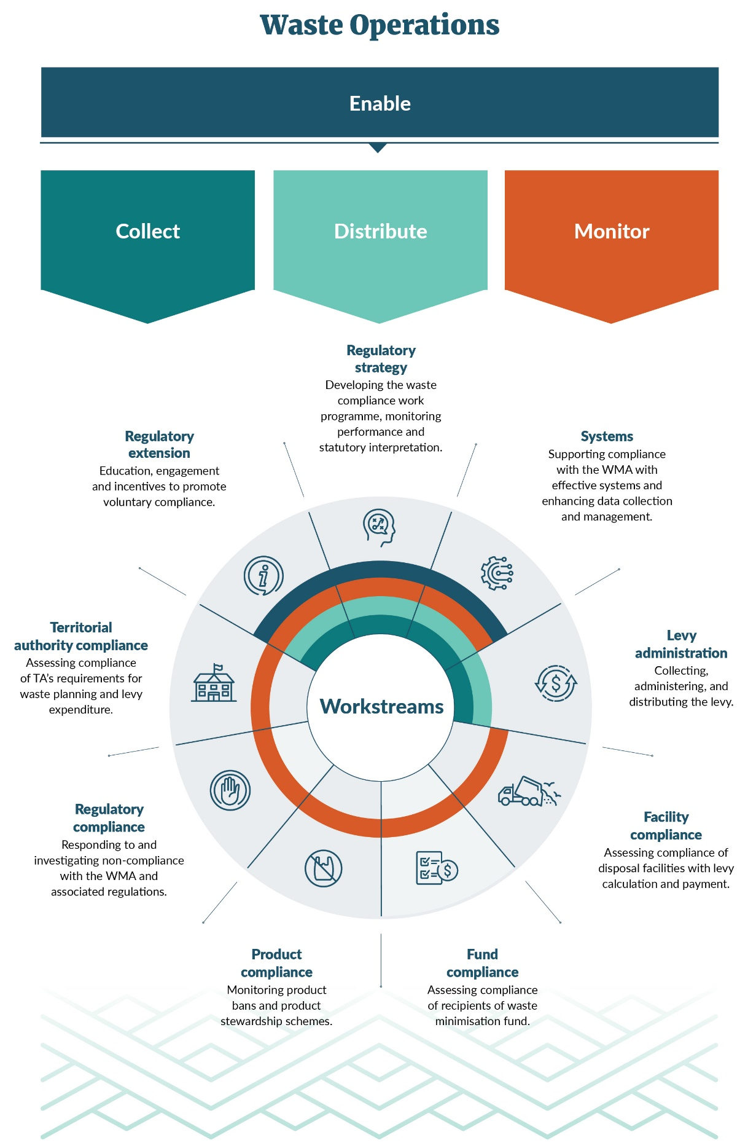

## Levy administration | Whakarite utu

### Overview

From 1 July 2022, the waste levy programme expanded to include the charging of a levy for Class 2 facilities (construction and demolition fill), and for information to start being collected and reported to the Ministry by Class 3 and 4 facilities (managed or controlled fill) and transfer stations. The levy also increased for Class 1 facilities (municipal disposal). These changes are shown in table 1.

The levy administration team continues to work with the sector not just in administering the levy but also to educate, engage and provide key updates as well as to respond to enquiries.

From 1 July 2023, Class 3 and 4 facilities will be required to start paying the levy, and Class 5 facilities (cleanfills) and industrial monofill facilities will be required to start collecting and reporting information to the Ministry.

Table 1: Key dates for the increase and expansion of the waste levy and reporting obligations

|  |  |  |
| --- | --- | --- |
| Facility class | Levy obligations[1] | Reporting obligations |
| Class 1 – Municipal disposal facilities | Levied from 1 July 2022 ($30 per tonne) | Are already reporting monthly returns on waste |
| Class 2 – Construction and demolition disposal facilities | Levied from 1 July 2022 ($20 per tonne) | Must start reporting on waste from  1 January 2022 |
| Classes 3 and 4 – Managed or controlled fill disposal facilities | Levied from 1 July 2023 ($10 per tonne) | Must start reporting on waste from  1 January 2023 |
| Class 5 – Cleanfills | Levy does not apply | Must start reporting quarterly on waste from 1 January 2023 |
| Industrial monofills | Levy does not apply | Must start reporting quarterly on waste from 1 January 2023 |
| Transfer stations | Levy does not apply | Must start reporting quarterly on waste from 1 January 2022 |

### New facilities

Table 2: Number of registered facilities

| Class | 2020/21 | 2021/22 | 2022/23 |
| --- | --- | --- | --- |
| Class 1 – Municipal disposal facility | 36 | 42 | 40 |
| Class 2 – Construction and demolition disposal facility |  | 9 | 11 |
| Class 3 and 4 – Managed or controlled fill  facility |  | 29 | 108 |
| Class 5 – Cleanfill facility |  | 28 | 93 |
| Industrial monofill |  | 9 | 22 |
| Transfer stations |  | 231 | 240 |
| **TOTAL** | **36** | **348** | **514** |

Overall, there were **166** new facilities registered with the Ministry since the last reporting period, which equates to a growth of **48 per cent.** During this period, the highest increase in registered levy-liable facilities were in Class 3 and 4 – Managed or Controlled fill facilities, as their obligations to start reporting began on 1 July 2022 and were not subject to the levy until 1 July 2023.

The highest increase in non-levy liable facilities were in Class 5 – Cleanfill sites, as their obligation to start reporting on from 1 January 2023. We saw a steady increase in the number of other non-liable facilities including industrial monofills and transfer stations.

### What we do

#### Documentation received and processed

Facility operators can lodge various applications with the Ministry under the WMA (see table 3 below). The 2022/23 reporting year has seen the number of applications double, with an increase in applications for a return extension[2] and levy waiver.[3]

Table 3: Applications received by the Ministry under the Waste Minimisation Act 2008

| Application and process | Received | approved 2009 to 2020 | Received | Approved 2020/21 | Received | Approved 2021/22 | Received | Approved 2022/23 |
| --- | --- | --- | --- | --- |
| Application to file an annual return *Reg 9* | 105 | *104 (1 withdrawn)* | 6 | 6 | 4 | 4 | 2 | 1 *(1 withdrawn)* |
| Application to use an average tonnage methodology *Reg 15* | 33 | 26 *(7 declined)* | 3 | 3 | 1 | 0 | 2 | 0 (*2 declined)* |
| Application for a levy refund *Reg 33* | 0 | 0 | 0 | 0 |
| Application for a payment extension *Reg 30* | 0 | 0 | 1 | 0 | 0 |
| Application for a return extension *Reg 10* | 0 | 0 | 4 | 0 | 9 | 0 *(9 declined)* |
| Application for a storage time extension *Reg 11* | 56 | 9 *(42 declined, 5 withdrawn)* | 0 | 1 | 0 | 0 |
| Application for a waiver *Sec 29* | 21 | 16  *(4 declined, 1 withdrawn)* | 2 | 2 | 2 | 2 | 9 | 7 *(2 withdrawn)* |
| **TOTAL (applications)** | **215** | **11 | 11** | **13 | 6 *(6 withdrawn, 1 processing)*** | **24 | 8** |

Section 34 of the WMA provides for the Ministry to estimate the amount of levy payable if the operator has not provided records or information, or that information is incomplete or incorrect. Between 2009 and 2020, we issued four estimations. During the 2022/23 period, a total of 15 estimations were made. We attribute this significant increase to new regulations affecting other types of facilities who had previously not been captured by the legislation, and operators not fully understanding their legal obligations.

### Distribution of the levy

We have a statutory role in managing the proportional distribution of the levy to territorial authorities (TAs). How each share is calculated is prescribed in section 31 of the WMA. Each quarterly payment requires non-complying TAs to have their levy funds withheld. There is no discretion under the WMA; if TAs do not meet their core obligations, we must withhold funds.

Table 4: Waste levy distributed to, or withheld from, territorial authorities

|  |  |  |  |
| --- | --- | --- | --- |
| **Quarter** | **Distributed *(withheld)***  **2020/21** | **Distributed *(withheld)***  **2021/22** | **Distributed *(withheld)***  **2022/23** |
| Q1 (July) | $3,959,800  *($3,858)* | $4,327,704  *($611)* | $8,958,834  *($0)* |
| Q2 (October) | $3,988,832  *($4,470)* | $4,343,880  *($613)* | $8,944,223  *($0)* |
| Q3 (January) | $4,376,476  *($4,264)* | $7,969,424  *($1,124)* | $13,871,356  *($0)* |
| Q4 (April) | $4,443,271  *($627)* | $9,340,005  *($1,318)* | $15,106,609  *($0)* |
| **TOTAL** | **$16,768,378**  ***($13,220)*** | **$25,981,013**  ***($3,665)*** | **$46,881,022**  ***($0)*** |

In the 2022/23 period, we distributed a total of **$46,881,021.80** of waste levies to territorial authorities and we did not need to retain levies from any of the 67 TAs. Waste Operations worked closely with all councils, particularly those who had previously had the levy withheld, to support them to meet their obligations under section 30 of the WMA.

Figure 2: Levy money paid to territorial authorities

### 

### Comments

As the levy expands to encompass other classes, we anticipate an increase in the number of estimations required for levy liable returns. The estimation process may be enacted by the levy collector (under section 34 of the WMA) when a facility fails to meet the statutory deadline for filing a return.

## Facility compliance | Tautukunga wāhi para

### Overview

Our disposal facility audit programme ran a risk-based audit programme in 2022/23. All audits to 30 June 2023 were carried out by both internal and external auditors and included Class 1 and Class 2 facilities.

Each facility audited receives a compliance score against each of the following key audit areas:

* waste acceptance matches class
* levy returns
* invoice payment
* measurement method and tonnage observations
* stockpile timeframes
* levy calculations
* record keeping and retention.

Audit results form the basis of our risk-based planning for subsequent audit years. Facilities undergoing their first audit can expect a structured assessment of their compliance with regulatory requirements, in addition to support and guidance as they work to meet their obligations.

With the significant growth in levy-liable Class 3 and 4 facilities, we plan to develop new compliance products in 2023/24 to help these facilities understand and comply with the regulations.

The level of non-compliance corresponds to the degree of associated risk. A low-level non-compliance score against any of the key audit areas is typically minor and easily resolved, while high and medium non-compliance reflects concerning practices that are likely to need further investigation. Nuance in presenting degrees of non-compliance gives both the Ministry and stakeholders more information about the nature and extent of issues in the sector and helps us focus on the matters constituting greatest risk.

### What we found

About 57 per cent of all audit areas were scored compliant or had only minor areas for improvement.

Of the Class 1 facilities, 65 per cent of the audit areas were scored as compliant, slightly up from 64 per cent for the 2021/22 reporting year. There was a small decrease in the number of areas scored with medium and high non-compliance, 8 per cent down to 5 per cent. The number of areas with low level non-compliance also decreased slightly, from 17 per cent to 16 per cent in the 2022/23 reporting year.

The 2022/23 reporting year was the first time Class 2 facilities were audited. For this first initial audit, 41 per cent of audit areas were scored compliant with 25 per cent having low non-compliance and 9 per cent scored with medium or high non-compliance. See table 5 for more information.

The addition of the Class 2 facilities has resulted in an overall decline in compliance and a rise in low-risk non-compliance. This is to be expected as new participants learn their requirements under the expanded levy obligations.

### Compliance rates

Rates of non-compliance against audit areas were highest amongst Class 2 facilities as their obligations had changed. On the other hand, Class 1 facilities have shown an overall increase in compliance year on year, which is evidence that as the waste industry adapts to the reporting system, compliance becomes the predominant standard.

Table 5: Compliance scores over the reporting years

|  |  |  |  |  |
| --- | --- | --- | --- | --- |
| Compliance grade | 2020/21 Class 1[4] | 2021/22 Class 1[5] | 2022/23 Class 1 | 2022/23 Class 2 |
| Compliant | 57% | 60% | 63% | 32% |
| Compliant – area for improvement | 4% | 4% | 2% | 9% |
| Non-compliant – low | 13% | 17% | 16% | 25% |
| Non-compliant – medium | 13% | 4% | 5% | 4% |
| Non-compliant – high | 6% | 4% | 0% | 5% |
| Not determined | 3% | 9% | 6% | 7% |
| Not applicable | 3% | 3% | 7% | 18% |

### Responding to non-compliance

Our auditors continue to identify some areas of predictable non-compliance. Many of these issues are addressed effectively through educating and engaging with the regulated parties so they better understand expectations as the monitoring programme evolves. Where our auditors identify non-compliance, they have two options: issue a request for corrective action or refer the facility to our regulatory compliance team for further assessment.

Corrective action requests are typically for minor matters that can be easily resolved with extra support and engagement. An example of a minor matter is where a disposal facility operator (DFO) is scored low level non-compliance against the ‘levy return’ audit area as they have failed to submit a return on time. They are then issued a corrective action to review and amend their processes where possible to ensure that waste returns are submitted on time in the future. Subsequent audits will review any previous corrective action requests, with some requests needing to be rectified through short-term actions. We maintain a register with timeframes for each request (see table 6).

Matters relating to audit areas scored medium to high non-compliance are referred directly to the regulatory compliance team for further assessment. The team has a range of enforcement tools to address non-compliance including education, recovery of unpaid levy or prosecution. Where these tools cannot resolve non-compliance, the case is referred for further investigation.

Table 6: Results of referrals and corrective actions on non-compliance matters

|  |  |  |  |  |
| --- | --- | --- | --- | --- |
| **Non-compliance score** | **Regulatory outcome** | **2020/21** | **2021/22** | **2022/23** |
| Low[6] | Number of corrective action requests | 28 | 58 | 24 |
| Number of corrective action requests resolved | 25 | 45 | 17 |
| Number of unresolved corrective action requests escalated to regulatory compliance team | 3 | 13 | 7 |
| Medium and high[7] | Number of medium and high non-compliance matters | 9 | 6 | 3 |
| Number of medium and high  non-compliance matters resolved | 6 | 5 | 3 |
| Number of medium and high non-compliance matters unresolved (referred for investigation) | 3 | 1 | 0 |

### Comments

What we learn in the field is directly applied to our planning and risk assessment for future years. This knowledge is also useful for other parts of our organisation. The key insights from our auditing programme this year are set out below and identify opportunities to improve policy settings:

* The regime for managing disposal facilities is changing considerably as the levy continues to expand. Our audit programme has been operating with considerable ambiguity and an Act and regulations that have limitations. We must be more proactive in our regulatory stewardship to support an effective compliance regime.
* An increasing levy has the potential to increase non-compliant behaviour, such as disposing waste to an unapproved facility or to non-levied sites. To meet this challenge, Waste Operations is extending our compliance function but are aware of the considerable demand this will have on our capacity.
* Diversion[8] is limited amongst Class 2 to 5 facilities compared with Class 1 municipal waste facilities, which receive higher quantities of commercially viable, recyclable commodities. As more facilities come on board with the levy’s expansion, the Ministry will need to support facilities with information on what waste can and cannot be diverted and how to calculate diversion factors.

## Territorial authority compliance | Tautukunga mana wāhi

### Overview

We conducted audits of 24 territorial authorities (TAs) throughout New Zealand in 2022/23. This compares with 48 in 2020/21 and 24 in 2021/22.

The scope of TA audits includes:

* a compliance assessment of levy expenditure practices against the obligations in the Act and compliance with the standards in the Ministry’s written guidance
* a review of key documentation, such as the TA’s waste assessment and Waste Minimisation and Minimisation Plan (WMMP), any applicable bylaw, and/or solid waste policy and reporting.

Audit results will continue to form the basis of our risk-based planning for future audit years and we will use aggregated compliance data to inform our policy development.

### What we found through auditing

The TA auditing programme has shown a relatively high level of compliance by local government with their WMA obligations.

Table 7: Outcome of territorial authority compliance audits

|  |  |  |  |
| --- | --- | --- | --- |
| Areas of compliance assessed during TA audits | 2020/21 | 2021/22 | 2022/23 |
| Levy expenditure limited to matters to promote or achieve waste minimisation – section 32(1)(a) | 89% | 96% | 94% |
| Levy expenditure in accordance with WMMP – section 32(1)(b) | 78% | 100% | 94% |
| WMMP compliance with sections 43, 50 and 51 | 90% | 95% | 95% |
| Adherence to Ministry guidelines for levy spend (refer to [Good practice levy spend guidelines for TAs](https://environment.govt.nz/publications/waste-levy-spending-guidelines-for-territorial-authorities/)) | 92% | 86% | 79% |

Levy expenditure compliance rates under s32(1)(b) (spending of levy in accordance with Ministry guidelines) has declined in the 2022/23 year. We have addressed areas of non-compliance through education and engagement with TAs in relation to WMMP review and good practice financial processes. No TA non-compliance has been referred for investigation as of 1 July 2023.

The remaining regulatory obligations in table 8 showed similar compliance rates to 2021/22.

### Levy spend reporting

We ask territorial authorities to submit an annual report to us through the Territorial Authority Waste Levy Expenditure System (TAWLES). Their annual report needs to outline how they have spent their share of levy funds for the previous financial year.

Currently, this reporting is voluntary. Therefore, the values in table 8 underestimate the total levy spend, and it is likely the percentages for different spending areas are more varied. This will change in future when it becomes compulsory for TAs to report this information to us annually, with first reports due 30 September 2025.

Table 8: Territorial authority waste levy spend[9]

|  |  |  |  |
| --- | --- | --- | --- |
| Spending area | 2020/21 | 2021/22 | 2022/23 |
| Services | 50% | 45% | 93% |
| Education and communication | 25% | 33% | 4% |
| Infrastructure | 10% | 8% | 1% |
| Research and reporting | 3% | 4% | 1% |
| Other initiatives | 13% | 10% | 1% |
| **Total spend** | $20,359,971 | $17,451,661 | $56,718,057 |

### Responding to non-compliance

Areas where we have identified non-compliances include:

* one TA spent the waste levy money on disposal activities rather than on waste minimisation and was asked to refund the levy money within their levy fund
* two TAs had not conducted their WMMP review within the six-year timeframe required by section 50 of the WMA and were therefore marked ‘non-compliant’ in the audit report. As their reviews were completed by the time of the audit (although late), we considered this matter resolved and the two TAs received their levy payment.

We have provided education, corrective actions and monitoring where necessary for these instances of low-level non-compliance. Subsequent audits show improvement across all of these areas, indicating that additional education and support is an effective intervention.

This reporting period is the first full year using the Territorial Authority Waste Levy Expenditure System (TAWLES), and we expect that future years will show the shift to online-based reporting results in more consistent record keeping.

### Comments

From 1 July 2024, new regulations will come into effect requiring TAs to report on how they have spent the waste levy money they received (with first reports due on 30 September 2025 for the preceding year). This will change the above dataset, making more information available and ensuring it is provided to us within a required timeframe.

TAs mainly spent the levy money on services like kerbside recycling, education and communication. This reflects a typical spread of spending, based on historical data. The increased amount of the levy is also likely to change the profile and types of levy expenditure.

## Fund compliance | Tautukunga tahua

### Overview

Distribution of the waste levy is a key statutory role for the Ministry. TAs receive 50 per cent of the levy, and once our administration costs are covered, the remainder is distributed to waste minimisation initiatives. Most of the funds are distributed through the Te Pūtea Whakamauru Para Waste Minimisation Fund (WMF), with other funding going to projects initiated by the Minister for the Environment.

The WMA sets out the levy’s distribution model. Assessing and validating this expenditure is critical to ensure the funding purpose aligns with its distribution and is used to minimise waste.

All audits of funded projects are either initiated proactively or in response to referrals from the Ministry team in charge of processing and managing funding applications. Otherwise, audit recipients are selected based on the auditors’ risk assessments using all available and relevant information. Depending on available resourcing, we aim to audit at least 10 per cent of recipients approved for funding.

Waste operations can conduct two types of audits:

* A full audit – this engages with the WMF recipient to ensure the funds have been spent in accordance with the Deed of Funding.
* A third party payment audit – this involves directly contacting the supplier who provided the services to the WMF recipient on the project. This is to ensure that where we have paid the WMF recipient, they have then paid the supplier. If we identify significant issues, this will warrant a full audit of the recipient.

A WMF audit could include assessing:

* whether the funding expenditure is appropriate and in accordance with the funding deed and the WMA
* whether reported results are accurate and project deliverables have been met in accordance with the funding deed
* the effectiveness of the project processes to minimise the risk of misreporting and fraud.

If audit findings demonstrate cause for concern, Waste Operations will work with the fund recipient to address the matter fairly in accordance with our compliance strategy. Possible courses of action include:

* providing education to promote voluntary compliance
* requiring potential retainment or repayment of funds
* monitoring, including follow-up on our recommendations, and increased audit frequency
* investigating alleged breaches
* prosecuting and/or fining in accordance with section 65 of the WMA.

### What we found

No referrals were made in the 2022/23 reporting year, while the number of proactive audits that were initiated, progressed and then finalised, remained relatively stable.

Historically, the rate of audit has been low due to the limited number of available audit staff. In future, the frequency and depth of audits is likely to increase to maintain public confidence in administration of the waste levy.

Table 9: Audit activity for Waste Minimisation Fund projects

|  |  |  |  |
| --- | --- | --- | --- |
| Audit activity | 2020/21 (pilot) | 2021/22 | 2022/23 |
| Number of referrals | 3 | 5 | 0 |
| Audits initiated due to referrals | 1 | 5 | 0 |
| Proactive audits initiated | 3 | 2 | 3 |
| Audits in progress (30 June) | 1 | 3 | 2 |
| Audits finalised | 3 | 5 | 4 |

### Comments

Establishing a new auditing function has been challenging. The new auditing function provides important transparency when it comes to maintaining public confidence in administration of the waste levy. The audit and WMF teams have collaborated on the development of the audit programme, while maintaining the independency of the audits themselves.

As the range of projects that can be funded through the waste levy increases, this will create greater complexity for the audit function.

## Product compliance | Tautukunga hanganga

### Overview

The first of a three-stage plastics product ban took place in October 2022. Stage 1 banned the sale or manufacture of single-use plastic items: drink stirrers, cotton buds, any product with pro-degradants, PVC food trays and specific polystyrene packaging.

### Responding to non-compliance

#### Stage 1 ban compliance

The first ban, from 1 October 2022, mainly affected importers and manufacturers. As such, reports of non-compliance have been low. This is due to the ban working, as the banned products are no longer being brought into the country and therefore no longer available for purchase by the public.

Table 10: Number of non-compliance reports received

|  |  |
| --- | --- |
| Banned plastic product type | Number of reports received 2022/23 |
| Single-use plastic shopping bags | 22 |
| PVC food trays and containers | 0 |
| Polystyrene and expanded polystyrene takeaway food and  beverage packaging (plastic type 6) | 3 |
| Plastics with pro-degradant additives | 0 |
| Drink stirrers | 0 |
| Cotton buds with plastic stems or synthetic buds | 0 |
| **Total** | **25** |

### What we found

We received 25 breach reports relating to the plastics ban and 34 enquiries from industry asking for support to meet compliance requirements. We took a pragmatic approach to assess each enquiry on a case-by-case basis. We asked a set of questions and assessed each response against the ban’s requirements.

### Comments

Many importers of food products with integrated cutlery were unaware that the ban included their products.

Requests for a time extension came from companies with excess stock. Where we granted extensions, we will closely monitor to ensure the banned stock are not continuing to be used or supplied after the extended deadline. Ensuring we made widely available posters and information sheets relating to the banned products, in several languages and with clear pictures and infographics.

The second stage of the ban came into force on 1 July 2023. It banned the sale or manufacture of single-use plastic cutlery, plates and bowls, produce bags and non-compostable produce labels.

## Regulatory compliance | Tautukunga whakahaere

### Overview

During 2022/23 we initiated no new investigations, however two investigations from the 2021/22 period were continued. These investigations included the under-reporting of net tonnages of waste due to incorrect recording, and reporting of waste received at disposal facilities. Under-reporting of waste can have serious implications for levy payments which help fund waste management and minimisation initiatives throughout Aotearoa.

### What we found

Twenty-seven reports of non-compliance were referred to the regulatory compliance team for further assessment. These referrals covered a range of breaches against the WMA and associated regulations. Referrals can either come from internal Ministry teams or from members of the public through our online reporting tool: ‘Alleged Breach Notification’ (ABN).

### Responding to non-compliance

The 2022/23 period highlighted common non-compliance behaviours by disposal facility operators. These included a lack of understanding with how to comply with certain key aspects of the WMA and associated regulations, specifically:

* Not submitting monthly returns on time. This has resulted in the Ministry issuing 15 compliance letters requesting waste returns that were not submitted by the due date.
* Incorrect use of conversion factors to convert the volume of waste or diverted material into weight (at facilities where there is no weighbridge available). This has resulted in an under-reporting of net waste and associated waste levy, which we have later recovered.
* Incorrectly recording and reporting material deemed to be diverted onsite. This has led to the Ministry publishing a new factsheet, [*Managing diversion at levied disposal facilities*](https://environment.govt.nz/publications/managing-diversion-at-levied-disposal-facilities/)*,* to provide guidance to the regulated community.

Table 11: Referrals and proactive investigations conducted

|  | Referrals 2021/22 | Investigations 2021/22 | Referrals  2022/23 | Investigations 2022/23 |
| --- | --- | --- | --- | --- |
| Territorial authority | 0 | 0 | 0 | 0 |
| Disposal facility compliance | 3 | 3 | 7 | 2 |
| Fund compliance | 0 | 0 | 0 | 0 |
| Product compliance | 0 | 0 | 0 | 0 |
| Levy administration | 4 | 0 | 7 | 0 |
| Alleged Breach Notification tool | 11 | 0 | 13 | 0 |
| **Total** | 18 | 3 | 27 | 2 |

Table 12: Enforcement tools used

|  |  |  |  |
| --- | --- | --- | --- |
| Tool | 2020/21 | 2021/22 | 2022/23 |
| Education and/or advice letter | 2 | 2 | 15 |
| Prosecution | 0 | 0 | 0 |
| Recovery of unpaid levy | 0 | 5 | 2[10] |
| Court order for commercial gain | 0 | 0 | 0 |
| Ministerial direction to retain levy money | 0 | 0 | 0 |
| Revocation of scheme accreditation | 0 | NA | NA |

Table 13: Formal investigation processes undertaken

|  |  |  |  |
| --- | --- | --- | --- |
| Process | 2020/21 | 2021/22 | 2022/23 |
| Request for information | 10 | 4 | 3 |
| Application for a production order | 0 | 0 | 0 |
| Interviews completed | 0 | 0 | 0 |

### Comments

The regulatory compliance team anticipates an increase in the volume of referrals of non-compliance for the 2023/24 period, following the scheduling of Class 3/4 – Managed or Controlled fill disposal facilities into the Ministry’s annual audit programme.

This reporting period revealed a lack of understanding of the WMA’s regulatory requirements, especially from new members of the regulated community (ie, Class 2 and Class 3/4 disposal facility operators).

Several instances arose in this reporting period where operators either did not consider the WMA applied to them (due to the lack of clarity and/or certainty in the regulations), or did not see themselves as traditional disposal facilities.

# Part 2: Performance assessment and monitoring

## Overview

This RPMF report captures our main outputs, including a benchmarking exercise using the Modern Regulator Improvement Tool (MRIT). The tool was developed by the Australasian Environmental Law Enforcement and Regulators network (AELERT), an internationally recognised professional network for environmental regulators.

MRIT helps the Ministry, other government departments, our regulated communities and stakeholders understand whether regulatory programmes are achieving their objectives and making the best possible use of resources.

The value of good data increases over time, and the MRIT framework is designed to work through changes in legislation, institutional arrangements and personnel.

## Modern Regulator Improvement Tool (MRIT) assessment

The MRIT is a qualitative assessment framework that helps regulators understand their progress, areas of strength and areas needing development. It sets out 12 key attributes for regulatory agencies to assess themselves against and to rate their level of maturity in conducting their roles (figure 3). Organisational maturity can range from ‘absent’ through to ‘leading’, and the MRIT assessment can be done repeatedly to track improvements and prioritise areas where more work or investment is needed. Further details are provided in the appendix.

This is the third year Waste Operations has undertaken the assessment. As with last year, we will apply the learnings to define our strategic priorities and identify appropriate focus areas for the future. The 2022/23 assessment, together with the 2020/21 and 2021/22 assessments, is presented in table A2.

In the 2022/23 reporting year, two of our attributes showed positive improvement in maturity level:

* governance and delivery: activity and visibility increased from the level of ‘developing’ to ‘maturing’
* leadership and culture: regulatory philosophy and approach increased from maturing to the midway point between ‘maturing and well-established’ levels.

Over the three-year baseline period, a number of attributes have shown positive movement into maturing or well-established.

The MRIT has identified a number of attributes that have remained static in the ‘developing’ level for two or more years and thus where we need to focus our improvement effort. These are:

* vision, role and strategy: problem-solving approach
* capability and improvement: training and procedures, quality assurance and review functions, and learning with others.

Figure 3: Waste Operations MRIT assessment results

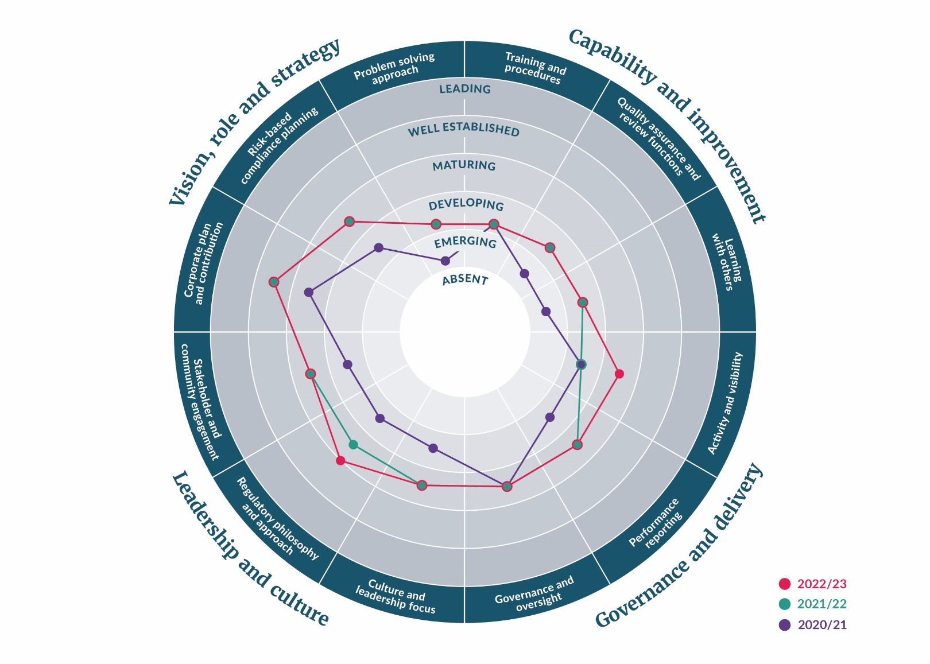

# Appendix: Modern Regulator Improvement Tool framework and explanations

The Modern Regulatory Improvement Tool (MRIT) framework consists of 12 attributes across 4 themes (see table A2). They are based on the AELERT Statement of Better Regulatory Practice. Each attribute represents a level the regulator may occupy which equates to a measurement of maturity.

Assessment against the attributes is based on six levels of organisational maturity. Each attribute has a specific description for each level, but a general description is provided in table A1.

Table A1: Levels of organisational maturity

|  |  |
| --- | --- |
| Level | Description |
| **Leading** | It is not expected that many agencies will reach this level of maturity without a conscious investment of resources in the attribute. A leading agency will be recognised as such across the AELERT network, and quite likely overseas. It will have a strong theoretical understanding of the attribute, as well as a best-practice approach that achieves consistently strong results in matters related to the attribute. |
| **Well-established** | The attribute is now embedded in the agency and will likely continue at this level despite organisational changes. The agency will be recognised by its peers as being at a high level of development in this attribute, and the agency will achieve strong results as a consequence of its level of maturity. |
| **Maturing** | An agency’s confidence or proficiency is growing, and it may be recognised within its regulatory community or jurisdiction as performing well in the attribute. The attribute may not be fully embedded in the agency though. A change of leadership or change in the external environment could impact on the attribute. |
| **Developing** | The agency will have recognised the importance of the attribute and progressed down the path of embedding it into the systems, processes or culture of the agency. Agencies at the ‘developing’ level will have a growing degree of confidence with the attribute, but its presence may not be at a consistently high level across the whole agency. |
| **Emerging** | The attribute is present but is at an early stage of its development. The agency may have recognised the importance of the attribute and begun developing its capability, or it may not have formally developed it, but parts of the agency may be displaying the attribute in an  ad hoc or unstructured way. |
| **Absent** | The attribute is not present in the agency or is present only in a rudimentary form. No judgement is associated with an agency identifying itself as ‘absent’ for a particular attribute, because many legitimate reasons exist as to why an attribute might not be present. For example, this might apply to a newly formed agency that has yet to develop some of the attributes or to a more established agency that has not branched out into a particular area (such as compliance planning). |

Table A2: Description of MRIT attributes

| Theme | Attribute | Description |
| --- | --- | --- |
| Vision, role and strategy | Corporate plan and contribution | A corporate plan that articulates the organisation’s goals, objectives and future work activities. ‘Contribution’ describes the regulator’s ability to link its goals, objectives and activities with the Government’s agenda. |
| Risk-based compliance planning | Mechanisms to allocate regulatory effort and response, based on an assessment of the regulator’s risk appetite, characteristics of the regulated community and so on. This may include annual planning mechanisms, assessment frameworks or other systems to apportion and track effort. |
| Problem-solving approach | A way of resolving specific or complex problems by rearranging effort, skills and resources around the problem itself, rather than through traditional functional structures. It is often associated with agile project management styles and concepts of double-loop learning. |
| Capability and improvement | Training and procedures | How the regulator ensures it has the requisite combination of skills and competencies to achieve its regulatory role and organisational priorities (training). The procedures and policies used to reinforce expected behaviours and to support staff to achieve the organisation’s objectives (procedures). |
| Quality assurance and review functions | Initiatives that support operational consistency, fair and unbiased decision-making, and continuous improvement. These include internal and external mechanisms such as structured assessments and reviews, and multiple avenues within and outside the regulator for duty holders to review decisions or lodge complaints. |
| Learning with others | The regulator’s role in learning from, and sharing information and experiences with, other regulators as part of the broader regulatory profession. |
| Governance and delivery | Activity and visibility | How active the regulator is in administering its legislation and regulatory scheme, including whether it is proactive or mostly reactive, and whether it uses all measures available to it (activity). How much the regulated and wider community are aware of the regulator’s role, function and achievements. |
| Performance reporting | The collection and use of information to determine whether the regulator is effective in its regulatory mission and to inform organisational decisions, and to inform the public and stakeholders about the regulator’s effectiveness. |
| Governance and oversight | The systems and institutions for ensuring that the regulator is well-managed, accountable, ethical and transparent. |
| Leadership and culture | Stakeholder and community engagement | The regulator’s ability to bring stakeholder and community voices into decisions that affect or interest them. This can involve different levels of engagement. The types of engagement can include inform, consult, involve, collaborate and empower. |
| Regulatory philosophy and approach | The regulator’s ability to clearly articulate and apply the theory that acts as a guiding principle for the way it regulates; how it will approach its role as a regulator and use its powers to regulate; and the factors that the regulator takes into consideration when responding to any identified non-compliance or harm. |
|
| Culture and leadership | The regulator’s expectations, experiences, philosophy and values that hold it together (culture) and its ability to establish a clear vision, share that vision with others, and coordinate and balance the conflicting interests of all members and stakeholders (leadership). |

Table A3: Waste operations MRIT scores

| Theme | Attribute | 2020/21 | 2021/22 | 2022/23 |
| --- | --- | --- | --- | --- |
| Vision, role and strategy | Corporate plan and contribution | Maturing | Well established | Well established |
| Risk-based compliance planning | Developing | Maturing | Maturing |
| Problem-solving approach | Emerging | Developing | Developing |
| Capability and improvement | Training and procedures | Developing | Developing | Developing |
| Quality assurance and review functions | Emerging | Developing | Developing |
| Learning with others | Emerging | Developing | Developing |
| Governance and delivery | Activity and visibility | Developing | Developing | Maturing |
| Performance reporting | Developing | Maturing | Maturing |
| Governance and oversight | Maturing | Maturing | Maturing |
| Leadership and culture | Stakeholder and community engagement | Developing | Maturing | Maturing |
| Regulatory philosophy and approach | Developing | Maturing | Maturing |
| Well established |
| Culture and leadership | Developing | Maturing | Maturing |

1. A number of increases in the waste levy are scheduled for Classes 1 to 4 through until 1 July 2027.
2. Regulation 10 of the [Waste Minimisation (Calculation and Payment of Waste Disposal Levy) Regulations 2009](https://www.legislation.govt.nz/regulation/public/2009/0144/latest/whole.html#DLM2055749) provides for the operator of a disposal facility to request in writing to the levy collector more time to provide the return.
3. Section 29 of the [Waste Minimisation Act 2008](https://www.legislation.govt.nz/act/public/2008/0089/40.0/DLM999802.html) provides that the Secretary may waive, in writing, the requirement for an operator to pay any amount of levy, if the Secretary is satisfied that exceptional circumstances justify the waiver.
4. Only Class 1 facilities monitored in 2020/21.
5. Only Class 1 facilities monitored in 2021/22.
6. All low non-compliance matters are managed by the auditor who issues the DFO with a corrective action request.
7. All medium and high non-compliance matters are managed by the regulatory compliance team. These figures exclude low non-compliance matters referred to regulatory compliance.
8. Diversion means not sending unwanted materials to disposal facilities. Instead, materials are repurposed through the process of reuse, recycling or recovery.
9. As reported voluntarily in the TAWLES.
10. Invoices totalling $130,449.90 (including GST) were issued in the 2022/23 period (July 2022 to June 2023).