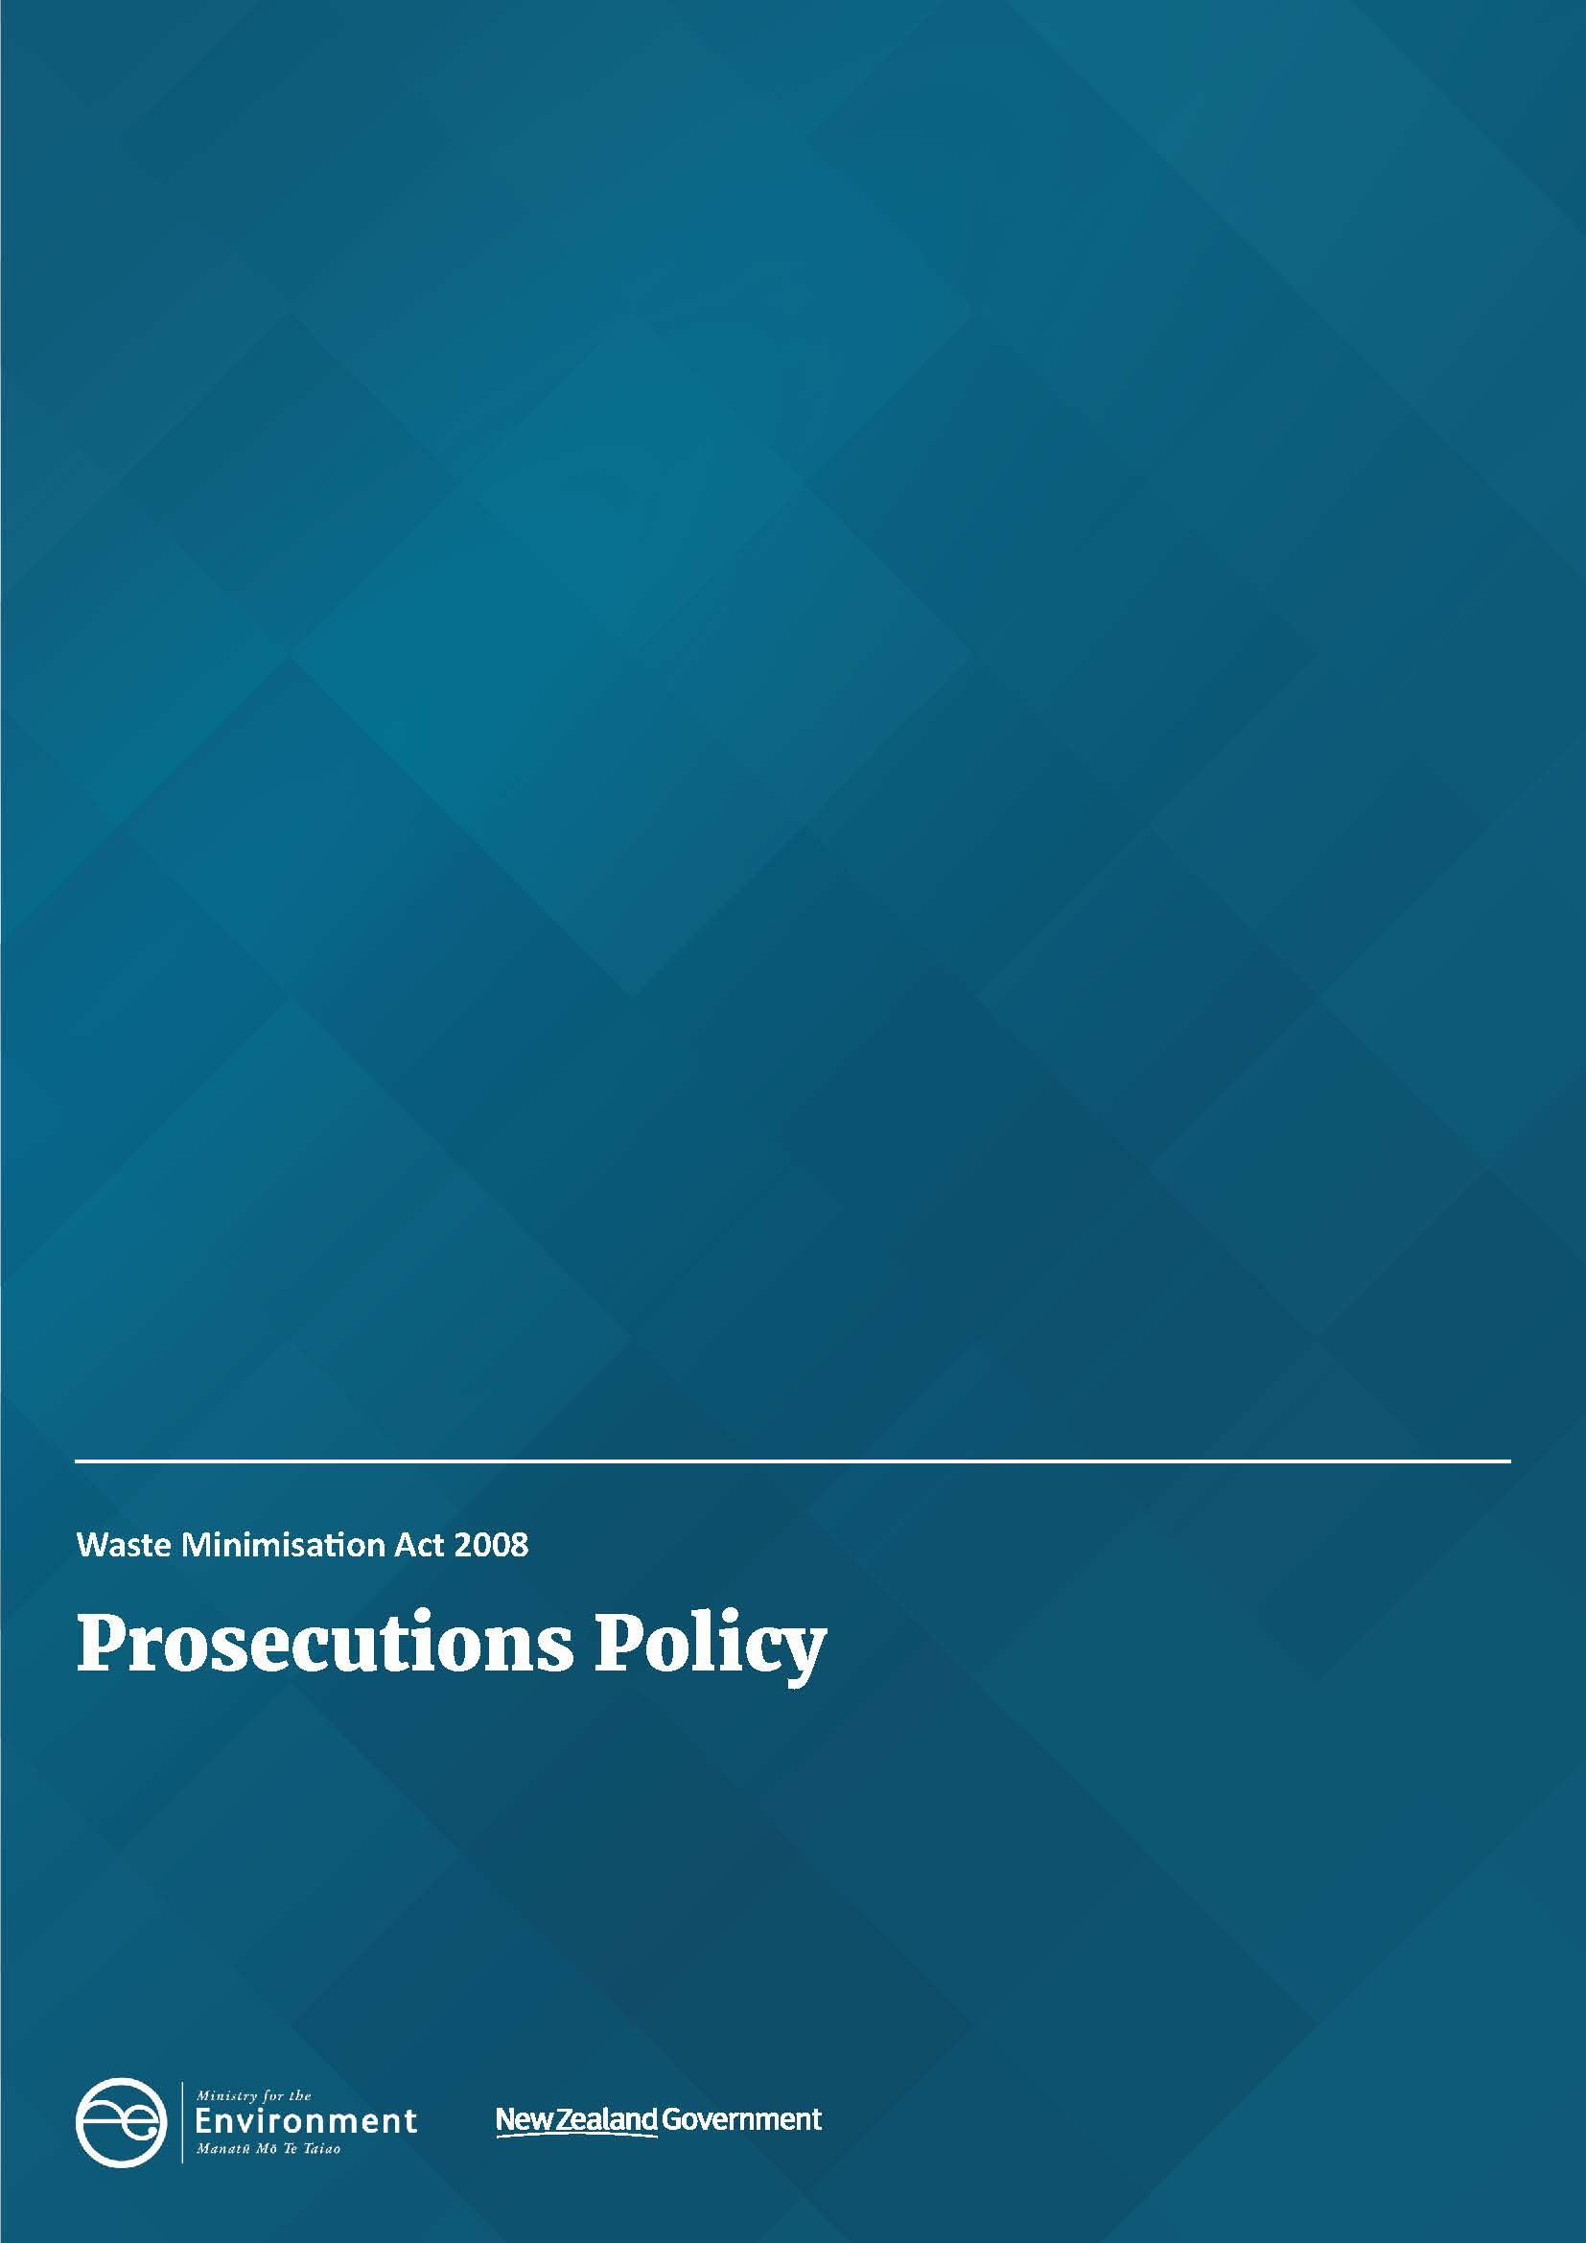

Disclaimer
The information in this publication is, according to the Ministry for the Environment’s best efforts, accurate at the time of publication. The Ministry will make every reasonable effort to keep it current and accurate. However, users of this publication are advised that:
- the information does not alter the laws of New Zealand, other official guidelines, or requirements
- it does not constitute legal advice, and users should take specific advice from qualified professionals before taking any action based on information in this publication
- the Ministry does not accept any responsibility or liability whatsoever whether in contract, tort, equity, or otherwise for any action taken as a result of reading, or reliance placed on this publication because of having read any part, or all, of the information in this publication or for any error, or inadequacy, deficiency, flaw in, or omission from the information in this publication
- all references to websites, organisations or people not within the Ministry are for convenience only and should not be taken as endorsement of those websites or information contained in those websites nor of organisations or people referred to.

This document may be cited as: Ministry for the Environment. 2021. Waste Minimisation Act 2008: Prosecutions Policy. Wellington: Ministry for the Environment.

Published in June 2021 by the
Ministry for the Environment
Manatū mō te Taiao
PO Box 10362, Wellington 6143, New Zealand
environment.govt.nz
Updated April 2026
ISBN: 978-1-99-003349-0
Publication number: ME 1577
© Crown copyright New Zealand 2026

Contents
Introduction 4
Function and scope of a prosecution policy 5
Roles and responsibilities 6
Tests for prosecution 8
More information 8
Deciding who to charge 9
Obligations under the Criminal Disclosure Act 2008 9
Responsibilities for carrying out prosecution 9
Seeking further orders 9
Appealing court decisions 9
Parallel prosecution 10
Media and communications 11

Introduction
The purpose of the Waste Minimisation Act 2008 (the WMA) is to “encourage waste minimisation and a decrease in waste disposal in order to:
- protect the environment from harm; and
- provide environmental, social, economic, and cultural benefits”.
A range of compliance interventions are possible under the WMA. This policy relates specifically to prosecutions. Prosecution is also possible under related Acts, and these are set out for reference.

Function and scope of a prosecution policy
The Ministry for the Environment (the Ministry) is a public prosecuting agency and is obliged to maintain a prosecutions policy. This policy applies to all Ministry staff and contractors carrying out investigations that might result in taking proceedings under the WMA or other relevant Acts.
This policy sets a framework for making decisions about the use of prosecutions under the WMA. It is not intended to guide enforcement decisions beyond prosecution, or decisions on investigations. Its purpose is intentionally narrow. Matters outside prosecutions are addressed in the following documents:
- WMA Compliance, Monitoring and Enforcement Strategy
- WMA Enforcement Decision-making Policy
- WMA Investigations Manual 2020
- WMA Communications and Engagement Strategy 2020.
The purpose of the Prosecutions Policy is to:
- formally adopt the guidance set out in the Solicitor General’s Prosecution Guidelines 2025
- provide additional context to aid the Ministry’s decisions under the WMA.
This policy should be read in conjunction with the WMA Enforcement Decision-Making Policy.

Roles and responsibilities
Decisions on prosecutions under the WMA are made by an Enforcement Decision Group, chaired by the General Manager, Waste Systems and Operations in the Resource Efficiency Team.
The WMA Enforcement Decision-Making Policy guides this process. Any decision will also be subject to final discussion and determination with the prosecutor.

Conflicts of interest
Conflicts of interest can arise in prosecutorial processes. All staff involved in actual or potential prosecutions must act lawfully, fairly, promptly and free of any actual, potential or perceived conflict of interest.
Any conflict of interest (actual, potential or perceived) must be disclosed immediately to the Manager of Waste Operations and the General Manager of Legal and Risk. Where there may be any disagreement as to whether a conflict of interest exists, the decision of the General Manager of Legal and Risk shall be final. Disclosures of actual, potential or perceived conflicts must be recorded through the Ministry’s internal procedures.

Tests for prosecution
The Solicitor-General’s Prosecution Guidelines 2025 contain two critical tests: the evidential sufficiency test and the public interest test.
Evidential sufficiency: there is enough evidence to prove the proposed charge beyond a reasonable doubt.
Public interest: prosecution is required in the public interest.
For guidance on elements of these tests that are relevant to prosecution decisions under the WMA, see the WMA Enforcement Decision-Making Policy.
Considering a decision to prosecute includes the consideration of what charges to bring in court. Charges are possible under these statutes:
- Waste Minimisation Act 2008
- Crimes Act 1961
- Criminal Procedure Act 2011.
The limitation period for filing a charge under the WMA is 12 months after the date on which the matter giving rise to the charge became (or should have become) known.
The limit for filing a charge under the Crimes Act 1961 and Criminal Procedure Act 2011 depends on the category of the offence.

More information
- Ministry of Justice charging documents.
- The WMA Enforcement Decision-Making Policy sets out the tools and procedures available under this legislation.

Managing a prosecution

Deciding who to charge
Certain situations may require a decision on whether to prosecute an individual or a company or another liable entity, or a combination. There may be an option to hold to account public entities (eg, local councils) via prosecution.
The WMA provides for the liability of principals for the acts of their agents, and for considering who is appropriate to charge in these scenarios.2 The Enforcement Decisions Group will determine liability.
The type and number of charges should reflect the criminality of the defendant’s conduct as detailed in the facts to be used in trial. The charges may be representative of the offending if the criteria in section 20 of the Criminal Procedure Act 2011 are met.

Obligations under the Criminal Disclosure Act 2008
The Ministry as a prosecuting agency has certain responsibilities under the Criminal Disclosure Act 2008. Disclosure in prosecutions is covered by this Act, and responsibility for disclosure (including ensuring it occurs within statutory timeframes) lies with the prosecutor for each case.

Responsibilities for carrying out prosecution
When the Ministry decides to initiate a prosecution, the Legal and Risk Team will be responsible for instructing a Crown prosecutor. The investigator will also be involved in the briefing.

Seeking further orders
Under the WMA, further orders may be sought as part of or following a prosecution. Under the WMA, section 67 provides for applying to the court to order a “person to pay an amount not exceeding the value of any commercial gain resulting from the contravention, if the court is satisfied that the contravention occurred in the course of producing a commercial gain”.

Appealing court decisions
The Ministry may from time to time seek to appeal a decision of a court – for example:
- a pre-trial ruling (with leave of the court)
- a sentence imposed
- a ruling by the trial court (on a question of law, with leave of the court).
Any appeal must be referred by the instructed Crown solicitor to the Solicitor-General for consideration and approval, in accordance with the Criminal Procedure Act 2011.

Parallel prosecution
In certain situations, prosecution of a party may involve collaboration with other agencies, including councils and the Environmental Protection Authority.
Coordinating with other agencies may mean varying the timing and structure of WMA prosecutions. The particulars will be addressed via the Ministry’s Manager of Waste Operations and the Ministry’s Legal and Risk Team in association with Crown prosecutors.

Media and communications
In communicating with the public through the media about a prosecution, Ministry staff will follow the Crown Law Media Protocol for Prosecutors, and will:
- act in a way that does not prejudice the right to a fair trial
- support the administration of justice and the integrity of the criminal justice system
- respect the principle of open justice
- treat victims of crime with courtesy and compassion and respect their dignity and privacy.
The Ministry will publicise the outcome of a prosecution where appropriate. This will be managed by the Manager, Waste Operations, with the Communications Team.

Section 71 of the WMA.
Section 71 of the WMA.

