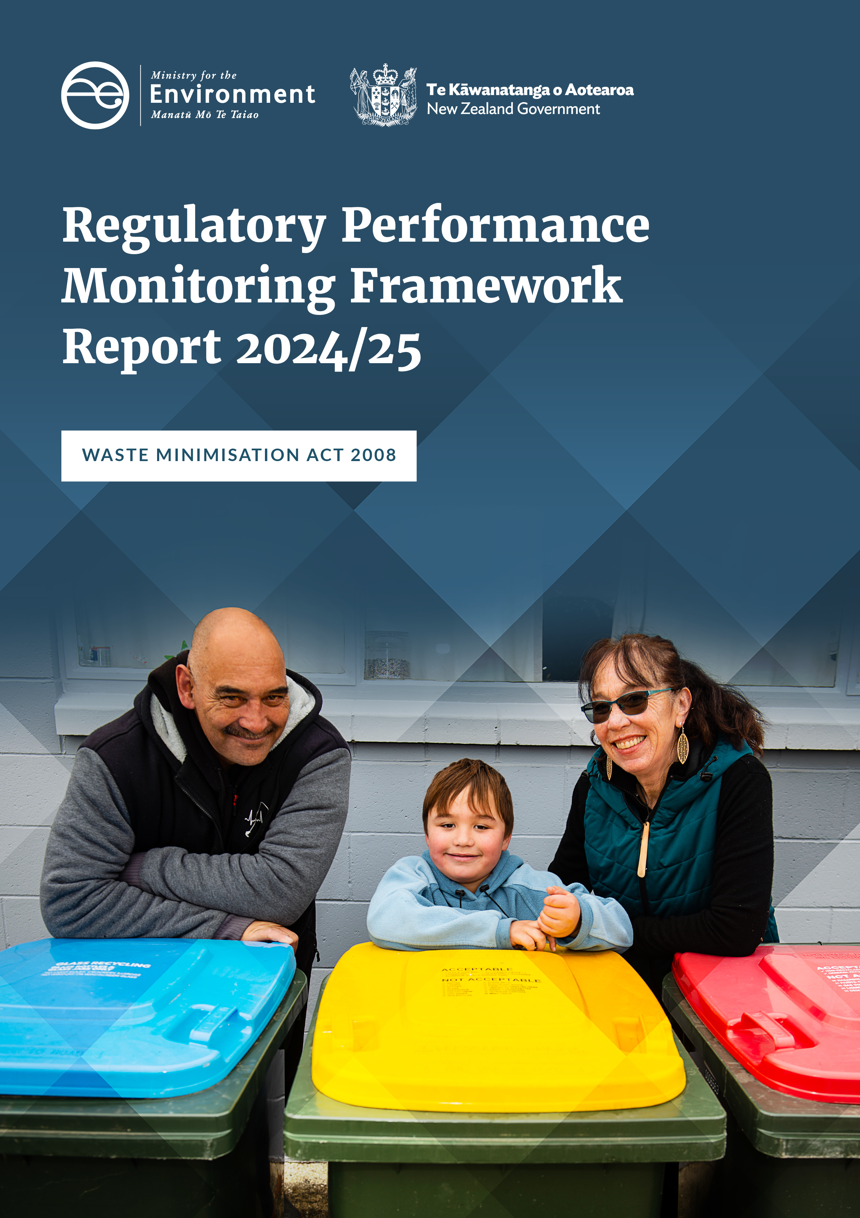

Disclaimer
The information in this publication is, according to the Ministry for the Environment’s best efforts, accurate at the time of publication. The Ministry will make every reasonable effort to keep it current and accurate. However, users of this publication are advised that:
- the information does not alter the laws of New Zealand, other official guidelines, or requirements
- it does not constitute legal advice, and users should take specific advice from qualified professionals before taking any action based on information in this publication
- the Ministry does not accept any responsibility or liability whatsoever whether in contract, tort, equity, or otherwise for any action taken as a result of reading, or reliance placed on this publication because of having read any part, or all, of the information in this publication or for any error, or inadequacy, deficiency, flaw in, or omission from the information in this publication
- all references to websites, organisations or people not within the Ministry are for convenience only and should not be taken as endorsement of those websites or information contained in those websites nor of organisations or people referred to.

This document may be cited as: Ministry for the Environment. 2025. Waste Minimisation Act 2008: Regulatory Performance Monitoring Framework Report 2024/25. Wellington: Ministry for the Environment.

Published in November 2025 by the
Ministry for the Environment
Manatū mō te Taiao
PO Box 10362, Wellington 6143, New Zealand
environment.govt.nz
ISBN: 978-1-991404-15-2
Publication number: ME 1928
© Crown copyright New Zealand 2025

Contents
Executive summary 5
Part 1: Our work programmes 6
Levy administration | Whakarite utu 7
Facility compliance | Tautukunga wāhi para 11
Territorial authority compliance | Tautukunga mana wāhi 14
Fund compliance | Tautukunga tahua 18
Product compliance | Tautukunga hangana 20
Regulatory compliance | Tautukunga whakahaere 24
Part 2: Performance assessment and monitoring 28
Overview 28
Modern Regulator Improvement Tool framework 28
Modern Regulator Improvement Tool assessment 30

Tables
Table 1: Important 2024/25 dates for the increase and expansion of the waste levy and reporting obligations 8
Table 2: Number of registered facilities 8
Table 3: Applications received by the Ministry under the Waste Minimisation Act 2008 9
Table 4: Compliance observation outcomes for facilities inspections against main areas for 2024/25 12
Table 5: Compliance scores over the reporting years for full audits 13
Table 6: Waste levy distributed to, or withheld from, territorial authorities 16
Table 7: Territorial authority compliance with kerbside compliance standard over the reporting years 16
Table 8: Audit activity for Waste Minimisation Fund projects 19
Table 9: Number of reports received from the public 21
Table 10: Compliance rates for businesses visited in 2024/25 22
Table 11: Referrals and investigations conducted 25
Table 12: Enforcement tools used 26
Table 13: Formal investigation processes undertaken 26
Table 14: Description of Modern Regulator Improvement Tool attributes 28
Table 15: Levels of organisational maturity 29
Table 16: Ministry for the Environment waste operations Modern Regulator Improvement Tool scores 32

Figures
Figure 1: Waste operations work programmes 6
Figure 2: Waste levy money paid to territorial authorities 14
Figure 3: Waste operations Modern Regulator Improvement Tool assessment results 31

Executive summary
This 2024/25 regulatory performance monitoring framework report tracks implementation of the compliance functions of the Waste Minimisation Act 2008 (WMA) by the Ministry for the Environment | Manatū Mō Te Taiao (the Ministry). The purpose of the report is to increase the transparency of our function and to drive continuous improvement of processes and outcomes.
The WMA is the primary legal instrument to address waste and resource recovery in Aotearoa New Zealand. Its purpose is to encourage waste minimisation and decreased waste disposal, to protect the environment from harm and to provide environmental, social, economic and cultural benefits.
The 2024/25 reporting year, from 1 July 2024 to 30 June 2025, saw changes to existing regulations to improve the quality and availability of waste data and to inform future waste minimisation policies.
Tranche 2 of the Waste Minimisation (Tyres) Regulations 2023 and scheme began full operations. Scheme participants receive payments for the services they provide that involve end-of-life tyres, and incentive payments are available to support the recovery of raw materials found in end-of-life tyres. The waste levy increased for Class 1 and Class 2 disposal facilities, and the existing levy obligations remained for Class 3 and 4 disposal facilities.
Significant changes from this reporting year include the following initiatives.
- The Waste Minimisation (Calculation and Payment of Waste Disposal Levy) Amendment Regulations 2023 and the Waste Minimisation (Information Requirements) Amendment Regulations 2023 came into effect on 1 July 2024, and govern reporting and record-keeping obligations. Under these regulations, disposal facilities, transfer stations and industrial monofills are required to report on the activity category (or source) that generated the waste.
- The Waste Minimisation (Information Requirements) Amendment Regulations 2023 also introduced requirements for territorial authorities to gather data and report (annually to the Ministry) on all waste managed through their services or facilities. Additionally, territorial authorities are required to report annually on their levy spending (previously, this reporting was voluntary).
- The Waste Minimisation (Waste Disposal Levy) Amendment Act 2024 introduced a new provision enabling waste levy waivers to be granted for the remediation of contaminated sites.
- The first regulated product stewardship scheme, Tyrewise, became fully operational to fund services provided under the scheme. These services include the collection of end-of-life tyres from registered retailers, generators and collectors, with tyres transported to authorised processors.
- The waste levy for Class 1 disposal facilities (municipal landfills) increased from $50 to $60 per tonne.
- The waste levy for Class 2 (construction and demolition) disposal facilities increased from $20 to $30 per tonne.
This report and all previous regulatory performance monitoring reports can be viewed on the Ministry’s webpage: Compliance, monitoring and enforcement of the Waste Minimisation Act.

Part 1: Our work programmes
Figure 1: Waste operations work programmes
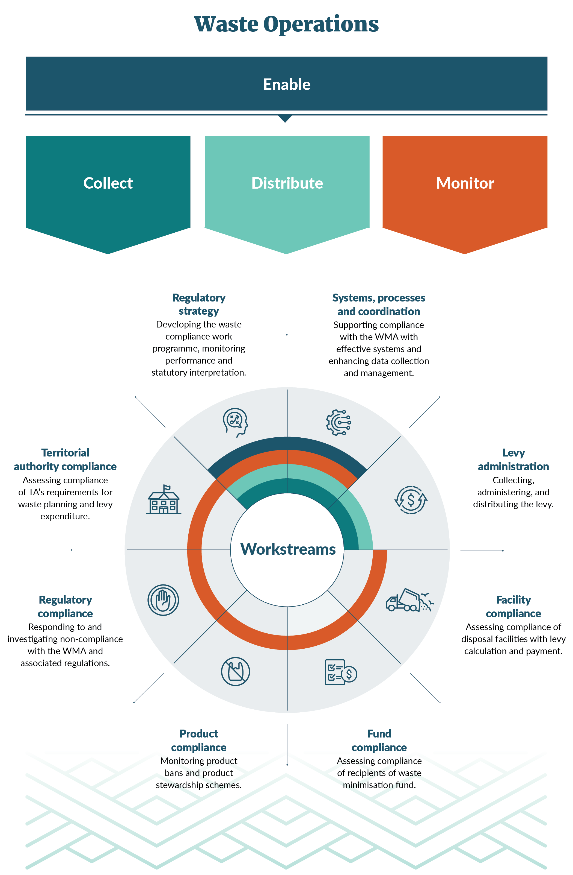
Note: TA = territorial authority; WMA = Waste Minimisation Act 2008.

Levy administration | Whakarite utu

Overview
During the 2024/25 reporting period, three legislative amendments came into effect – requiring activity category reporting for facility operators, and adding a new provision to allow a waste levy waiver for contaminated sites.
Additionally, the waste levy was increased for Class 1 (municipal landfill) and Class 2 (construction and demolition) disposal facilities, with further increases to the waste levy confirmed for the following three years.
The number of new facilities registering in the Online Waste Levy System (OWLS) also trended upwards over 2024/25.

New regulations

Activity category reporting
From 1 July 2024, the Waste Minimisation (Calculation and Payment of Waste Disposal Levy) Amendment Regulations 2023 and the Waste Minimisation (Information Requirements) Amendment Regulations 2023 brought in new reporting obligations. Every disposal facility operator must now provide an activity category report (ACR) identifying the source of the waste material. The ACR information collected will give the Ministry better insight into the regional and national flow of waste materials and help shape future thinking on ways to minimise and manage waste.

Remediation of a contaminated site – section 29(1)(b)
From 1 July 2024, the Waste Minimisation (Waste Disposal Levy) Amendment Act 2024 introduced a new provision to enable the levy to be waived for waste associated with the remediation of contaminated sites. The Ministry has developed guidance to help disposal facility operators and those undertaking remediation projects; the guidance also sets out relevant criteria.

Waste levy
The Government agreed in May 2024 to a second phase of waste disposal levy rate increases. The increases are incremental, phased over a three-year period from 1 July 2025 to 1 July 2027. More information can be found on the Ministry’s webpage: Waste disposal levy expansion.
Table 1 outlines levy and reporting obligations during the 2024/25 reporting period.
Table 1: Important 2024/25 dates for the increase and expansion of the waste levy and reporting obligations
Facility class | Levy obligations | Reporting obligations
Class 1 – Municipal disposal facilities | Levy from 1 July 2024 increased to $60 per tonne | Monthly returns on waste
Class 2 – Construction and demolition disposal facilities | Levy from 1 July 2024 increased to $30 per tonne | Monthly returns on waste
Class 3 and 4 – Managed or controlled fill disposal facilities | Levy from 1 July 2023 remains at $10 per tonne | Monthly returns on waste
Class 5 – Cleanfill facility | Levy does not apply | Quarterly returns on waste
Industrial monofills | Levy does not apply | Quarterly returns on waste
Transfer stations | Levy does not apply | Quarterly returns on waste
The Ministry continues to work with the sector, not only in the operational management of the levy, but through ongoing education, stakeholder engagement, providing updates on upcoming regulatory requirements, and responding to sector enquiries. We welcome these interactions because addressing questions and clarifying requirements early on helps mitigate potential compliance issues.

Facility and registration changes
The reporting period saw an overall increase in registered facilities in the OWLS, as detailed in table 2. The 28 new facility registrations and 11 facility closures mean the number of open registered facilities has increased from 560 in 2023/24 to 577 in 2024/25.
Coincidentally, new facility registrations also amount to 17. Although 28 new facilities were registered in 2024/25, 11 of these were existing operators registering an additional facility.
The Ministry continues to work with facility operators to ensure they understand their obligations under the WMA and its associated regulations. This includes initial registration in OWLS, and if they subsequently choose to change, expand or close their facilities. We continue to provide support to facility operators and advise if any changes do not meet the regulatory requirements under the WMA.
Table 2: Number of registered facilities
Class | 2020/21 | 2021/22 | 2022/23 | 2023/24 | 2024/25
Class 1 – Municipal disposal facility | 36 | 42 | 40 | 40 | 41
Class 2 – Construction and demolition disposal facility |  | 9 | 11 | 13 | 15
Class 3 and 4 – Managed or controlled fill disposal facility |  | 29 | 108 | 122 | 131
Class 5 – Cleanfill facility |  | 28 | 93 | 110 | 121
Industrial monofills |  | 9 | 22 | 24 | 25
Transfer stations |  | 231 | 240 | 251 | 244
TOTAL | 36 | 348 | 514 | 560 | 577

Applications received and processed
Using the OWLS, facility operators may submit a range of applications to the Ministry for approval under the WMA. A steady number of applications in the 2024/25 reporting year related to levy waivers, as shown in table 3.
Table 3: Applications received by the Ministry under the Waste Minimisation Act 2008
Application and process | Received | approved  2020/21 | Received | approved  2021/22 | Received | approved  2022/23 | Received | approved  2023/24 | Received | approved  2024/25
Application to file an annual return  reg 9 | 6 | 6 | 4 | 4 | 2 | 1  (1 withdrawn) | 0 | 0 | 0 | 0
Application to use an average tonnage methodology  reg 15 | 3 | 3 | 1 | 0 | 2 | 0  (2 declined) | 0 | 0 | 0 | 0
Application for a levy refund  reg 33 | 0 | 0 | 0 | 0 | 0 | 0 | 0 | 0 | 0 | 0
Application for a payment extension  reg 30 | 0 | 0 | 1 | 0 | 0 | 0 | 2 | 1  (1 declined) | 2 | 2
Application for a return extension  reg 10 | 0 | 0 | 4 | 0 | 9 | 0  (9 declined) | 0 | 0 | 3 | 2  (1 not applicable)
Application for a storage time extension  reg 11 | 0 | 0 | 1 | 0 | 0 | 0 | 2 | 1  (1 declined) | 3 | 4  (1 approved from previous year)
Application for a waiver – exceptional circumstances  s29 | 2 | 2 | 2 | 2 | 9 | 7  (2 withdrawn) | 15 | 2  (1 declined, 1 withdrawn) | 4 | 2  (2 withdrawn)
Application for a waiver – contaminated site  s29(1)(b) | – | – | – | – | 7 | 2  (1 declined, 1 returned, 3 under assessment)
TOTAL (applications) | 11 | 11 | 13 | 6 | 22 | 8 | 19| 4 | 19 | 12

Levy waivers
Section 29 of the WMA enables the Ministry to waive, in writing, the requirements for an operator to pay any amount of levy if satisfied that the application meets the required criteria. All applications received are assessed on a case-by-case basis against key criteria considerations.

Application for a levy waiver – exceptional circumstances (section 29(1)(a))
During this reporting period, the Ministry received four waiver applications for exceptional circumstances under section 29(1)(a) of the WMA. Two of these waivers were incorrectly submitted and subsequently withdrawn. The remaining two applications were in response to disposal facilities affected by the severe weather events of Cyclone Gabrielle.

Application for a levy waiver – remediation of a contaminated site (section 29(1)(b))
During this reporting period, the Ministry received seven waiver applications for the remediation of a contaminated site under section 29(1)(b) of the WMA. Of these:
- two applications were approved
- three applications remain under assessment
- one application was declined due to the facility no longer receiving the waste
- one application has been returned to the applicant for further information.

Issuing a return estimation
Registered facilities liable to pay the levy are required to submit a return by the 20th of each month. Section 34 of the WMA enables the Ministry to estimate the amount of levy payable if the operator has not provided records or information, or where information provided is incomplete or incorrect.
For the 2024/25 period, 11 estimations were calculated. Most related to Class 3 and 4 facilities that did not have processes in place for when staff were on leave and did not fully understand their statutory obligations and timeframes. The Ministry has seen a steady downward trend of estimations over the past two reporting years, which indicates that disposal facility operators are becoming more aware of their statutory obligations and consequences.

Comments
New regulations coming into force over this reporting period have required system modifications and enhancements to the reporting pages in the OWLS. These changes enable further information collection and submission, including for contaminated site waiver applications. To support the system enhancements, the Ministry has developed targeted guidance materials to help the sector meet the new compliance requirements.
To further support the sector, we provide updates on upcoming regulatory changes through targeted communications and system notifications. These updates address regulatory changes or clarifications, as well as enhancements to the OWLS designed to improve usability and streamline sector interactions.
The Ministry continues to see a steady increase in the number of new facility registrations, both through the OWLS and through enquiries to the dedicated levy administration inbox and 0800 WDLEVY (0800 835 389) number.

Facility compliance | Tautukunga wāhi para

Overview
Over the 2024/25 reporting period, the facility inspections programme has been refined, with a greater emphasis on capturing site information and data. This follows good regulatory practice and enables the team to provide greater intelligence to the Ministry about the sector.
Facility operators are responding positively to the compliance and monitoring programme, engaging with the Ministry throughout the entire inspection and audit process. Most operators engaged in good faith and were willing to comply and remedy any non-compliance identified. This can be attributed to effective relationships built between individual operators and the wider sector.
Highlights for the reporting period are the high compliance rates observed for the new activity category reporting obligations, as well as data being submitted on time. This can be attributed to the targeted education and engagement efforts with facility operators, leading up to and during the implementation of these regulations.

What we found

Facility compliance inspections
During the 2024/25 reporting period, as part of the facilities inspections programme, the Ministry inspected 79 facilities, focusing on 8 main areas of compliance. Inspections help the Ministry understand compliance levels across the sector and inform us if a facility may require a full compliance audit. The inspections found that most facilities were compliant, as shown in table 4. The two areas of non-compliance related to the use of incorrect measurement methodologies or the levy being calculated incorrectly.
Facilities without a weighbridge are required to use conversion factors prescribed under Schedule 1 of the Waste Minimisation (Calculation and Payment of Waste Disposal Levy) Regulations 2009. Incorrect application of conversion factors can lead to errors in calculation of the levy; we have focused on correcting this area of non-compliance and providing advice to support correct use of conversion factors.
The inspections also found that most Class 3 and 4 facilities had registered correctly and were accepting waste applicable to their class type. Class 5 facilities displayed slightly less compliance in this area; these operators were observed incorrectly accepting waste materials such as waste concrete and other hard fills. This waste may be acceptable under the facilities’ resource consent issued under the Resource Management Act 1991, but, under the WMA, this type of waste can only be accepted by facilities that are Class 3 and 4 facilities or higher.
Because we have observed this non-compliant behaviour over the past couple of years, the auditors have been engaging with cleanfill operators to explain the difference between the legislation. This has involved providing education on which materials can only be accepted to cleanfill facilities under the WMA and helping operators to re-register into the correct class type.
Table 4: Compliance observation outcomes for facilities inspections against main areas for 2024/25
Inspection areas | Compliant (%) | Non-compliant low (%) | Non-compliant medium (%) | Non-compliant high (%) | Not applicable* (%)
Waste matches regulations | 84 | 1 | 11 | – | 4
Waste returns | 84 | 11 | 5 | – | –
Levy payments | 38 | 11 | 3 | – | 48
Measurement method | 70 | 11 | 10 | 5 | 4
Stockpile | 37 | 5 | 4 | – | 54
Levy calculation | 43 | – | 10 | 1 | 46
Activity category reporting | 72 | 4 | – | – | 24
* An example of a ‘not applicable’ score is where a facility is not subject to the regulations related to the audit criteria (such as a cleanfill and industrial monofill not subject to the levy), so does not receive invoices. Another example is a facility that was not active at the time of the audit inspection, so the audit criteria could not be assessed.

Full compliance audits
A full compliance audit includes activities that go beyond the facility compliance inspection. It enables auditors to request more information, such as weighbridge data, to review against the data submitted through the OWLS. This process ends with an assessment of the facility’s level of compliance and non-compliance, so that appropriate remedies can be applied. An audit period can encompass, but is not limited to, the previous 12 months, and timeframes can be adjusted at the auditor’s discretion.
Over the 2024/25 reporting period, 14 disposal facilities were audited across classes 1 to 4. Because Class 3 and 4 facilities are still new to the waste levy regime, this reporting period involved an increased compliance focus. Auditors observed high compliance with the requirement to submit waste tonnage and report on activity categories.
Low-level non-compliance by disposal facilities was primarily associated with the late payment of levy invoices, specifically, disposal facility operators not meeting payment deadlines stipulated in the regulations. These non-compliances are addressed through a corrective action request made to the operator. Corrective actions are documented in the audit report, along with a specified timeframe within which the facility must implement the correction.
Common examples of actions that meant facilities received a medium or high non-compliance score include:
- accepting out-of-class waste
- applying a lower conversion factor than those prescribed in the regulations
- omitting waste types from a waste return.
In such cases, the matter is escalated for further assessment and, where appropriate, an investigation. Table 5 gives the compliance scores over the reporting years (2020/21 to 2024/25) for full audits.
Table 5: Compliance scores over the reporting years for full audits
Compliance grade | 2020/21 (%) | 2021/22 (%) | 2022/23 (%) | 2023/24 (%) | 2024/25 (%)
Compliant | 57 | 60 | 53 | 59 | 59
Compliant – area for improvement | 4 | 4 | 4 | 6 | 5
Non-compliant – low | 13 | 17 | 19 | 15 | 19
Non-compliant – medium | 13 | 4 | 5 | 5 | 5
Non-compliant – high | 6 | 4 | 2 | 3 | 5
Not determined* | 3 | 9 | 7 | 1 | <1
Not applicable** | 3 | 3 | 11 | 11 | 7
* Unable to be determined within the scope of the audit.
** Not within scope of the audit.

Responding to non-compliance
The Ministry responds to low-level non-compliance through engagement with and education of regulated parties. This ensures facilities will have a better understanding of the compliance expectations as the auditing and facilities inspection programme continues to evolve.
When auditors identify higher risk non-compliances, two pathways of response are available.
- Issue a request for corrective action and ensure the facility returns to compliance.
- Escalate for further assessment or investigation of the facility.
The Ministry has various enforcement tools to address non-compliance, which include issuing a warning letter and recovering unpaid levies. Where these tools cannot resolve non-compliance, or additional breaches are found, the matter is escalated for an investigation that may lead to prosecution.

Comments
A highlight of the reporting period was the high compliance rates observed during facility inspections and full audits. Facility operators generally responded positively and cooperatively to inspections and audits, reflecting a strong commitment to their regulatory obligations. The Ministry continues to engage with operators to support sector-wide understanding of compliance requirements. Early identification and resolution of concerns typically result in enhanced compliance outcomes.
The Ministry will continue to aim for a fair and consistent approach in applying the regulations, and will ensure its online guidance remains fit for purpose.

Territorial authority compliance | Tautukunga mana wāhi

Overview
From 1 July 2024, it became mandatory for territorial authorities (TAs) to report on how they spend the waste levy money they receive; such reporting had previously been voluntary. Over this reporting period, to ensure a smooth transition into mandatory obligations, the Ministry prioritised detailed reconciliations of historic TA financial records (provided voluntarily).
The purpose of the waste levy is to raise revenue for promoting and achieving waste minimisation, and to increase the cost of waste disposal in recognition of its effect on the environment, society and the economy.
As outlined in the WMA, each TA receives a share of 50 per cent of the waste levy, based on its district’s population. The TA must spend this money on activities to promote or achieve waste minimisation, in accordance with its waste management and minimisation plan (WMMP). These payments are made quarterly.
The WMMP for each TA is its guiding document to promote and achieve effective and efficient waste management and minimisation within its district.
As the levy expands, the amount of money available for distribution to TAs has increased (figure 2), so it is important for TAs to comply with their legal requirements under the WMA.
Figure 2: Waste levy money paid to territorial authorities

A TA will not receive its share of the levy if, at the time the levy payment is due, it has not adopted or reviewed its WMMP.
A TA may not receive its share of the levy if, at the time the levy payment is due, it has not:
- spent payments in accordance with section 32 of the WMA
- complied with a performance standard set by the Minister for the Environment (the Minister)
- provided records or information as prescribed.

New Standard and regulations
From 1 February 2024, the Standard Materials for Kerbside Collections Notice 2023 performance standard (the Standard) came into force. The Standard requires TAs to standardise the materials they accept in council-managed kerbside recycling, food scraps and food organics and garden organics collections.
The Waste Minimisation (Information Requirements) Amendment Regulations 2023 came into force on 1 July 2024. The regulations require TAs to keep records for all waste managed through their respective services, including how levy funds have been spent. From 1 July 2024, TAs are required to keep these records and report back to the Ministry, with the first report due by 30 September 2025.
Before 1 July 2024, TAs voluntarily provided the Ministry with information on how they spent the levy.

What we found

Levy distribution
The Ministry monitors the compliance of 67 TAs with the WMA, the Waste Minimisation (Information Requirements) Regulations 2021, and the Standard, and makes a determination to distribute or withhold the payment of the levy each quarter of the financial year.
The WMA requires TAs to review the content of their WMMPs every six years. In the 2024/25 reporting period, 12 WMMPs were due for review, all of which were completed.
The WMA specifies circumstances in which the Ministry can retain levy money payable to a TA.
- Section 33 provides that the Ministry must retain levy payments if a TA has not adopted its WMMP or has not reviewed it within the prescribed timeframe.
- Section 37 provides that the Ministry may withhold levy payments when a TA has not met a standard requirement or a performance standard.
All TAs received their levy payments during the 2024/25 reporting period, with none reaching the threshold of non-compliance that would require payments to be withheld. Non-compliance that could trigger this threshold could be, for example, a TA spending money on litter campaigns that did not directly reduce waste to landfill.
Figure 2 and table 6 show how levy payments have increased throughout the period of levy expansion.
Table 6: Waste levy distributed to, or withheld from, territorial authorities
Quarter | Distributed  (withheld)  2020/21 | Distributed (withheld)  2021/22 | Distributed (withheld)  2022/23 | Distributed (withheld)  2023/24 | Distributed (withheld)  2024/25
Q1 (July) | $3,959,800  ($3,858) | $4,327,704  ($611) | $8,958,834  ($0) | $14,006,649  ($0) | $23,759,401  ($0)
Q2 (October) | $3,988,832  ($4,470) | $4,343,880  ($613) | $8,944,223  ($0) | $14,633,887  ($0) | $22,397,725  ($0)
Q3 (January) | $4,376,476  ($4,264) | $7,969,424  ($1,124) | $13,871,356  ($0) | $26,670,920  ($0) | $25,107,487  ($0)
Q4 (April) | $4,443,271  ($627) | $9,340,005  ($1,318) | $15,106,609  ($0) | $24,353,456  ($0) | $25,080,840  ($0)
TOTAL | $16,768,379  ($13,219) | $25,981,013  ($3,666) | $46,881,022  ($0) | $79,664,912  ($0) | $96,345,453  ($0)

Outcome of kerbside compliance standard monitoring
Over the previous reporting year (2023/24), the Ministry developed a monitoring programme for the new kerbside recycling performance standard, which began on 1 February 2024. To assess compliance with the Standard, we applied a broad audit compliance approach and reviewed all the websites and public communications of all TAs.
The first round of monitoring involved assessing all 67 TAs. Seven did not operate a kerbside collection for recycling, food scraps, or food organics and garden organics, so were not required to comply with the Standard. Of the 60 remaining TAs, 57 (95 per cent) achieved compliance.
For the 2024/25 reporting year, the Ministry applied an in-depth audit compliance approach. Under the enhanced model, some TAs were non-compliant that had previously been found to be compliant in 2023/24. Of the 60 TAs reviewed, 14 were now found to be non-compliant, although the level of non-compliance did not meet the threshold for withholding levy payments. At the conclusion of the 2024/25 reporting year, we have been engaging with the 14 non-compliant TAs, and, at the time of writing, only 2 remain non-compliant.
The outcomes of both rounds of monitoring are outlined in table 7.
Table 7: Territorial authority compliance with kerbside compliance standard over the reporting years
Compliance outcomes as reported | 2023/24 (broad) | 2024/25 (in-depth)
Compliant | 57 (95%) | 46 (77%)
Non-compliant | 3 (5%) | 14 (23%)
TOTAL | 60 | 60

Comments
Historically, TAs have mainly used levy funding to support services such as kerbside recycling, education and public engagement. However, the increased levy funding is expected to influence both the scale and nature of future spending, which would be reflected in WMMPs as they are reviewed.
From 1 July 2024, TAs started to compile and record the data required under the regulation amendments, which were due on 30 September 2025. To ensure that data collection is consistent, the Ministry has released templated spreadsheets and a ‘how-to’ video to help TAs in providing the required data and information. We also released guidance on reporting on resource-recovery facilities and how to measure contamination in kerbside collection.
The in-depth kerbside compliance audit highlighted previously undetected TA non-compliance. However, further engagement, which continued beyond the reporting period, has achieved high compliance outcomes.

Fund compliance | Tautukunga tahua

Overview
Distributing the waste levy is an important statutory role for the Ministry. TAs receive 50 per cent of the levy and, once administration costs are accounted for, the Ministry distributes the remainder of the levy to initiatives that minimise waste or reduce environmental harm. Most of the funds are distributed through the Waste Minimisation Fund, and the levy also finances the Contaminated Sites and Vulnerable Landfills Fund and funding emergency waste. Funding may also go to projects initiated by the Minister.
The Ministry is responsible for assessing and validating this expenditure and ensuring that the funding purpose aligns with its distribution. A fund recipient may be internally referred within the Ministry for a full audit. Full audits may also be proactively initiated, with audit recipients being selected based on the auditors’ risk assessments using all available and relevant information. Different teams across the Ministry carry out separate functions to provide for independence and integrity of the audit process.
Towards the end of the 2024/25 reporting period, the Ministry began using a pre-audit to replace proactive initiation of audits. This involves the audit of the Ministry’s internal processes, primarily the fund application stage and the review of relevant information, such as data available on the Fund Management System (IT platform), due diligence and Deed of Funding (the Deed). If significant risks are identified that may result in the recipient being non-compliant with the Deed, a full audit of the recipient is recommended and undertaken.
A full audit engages with the Waste Minimisation Fund recipient to determine whether the funds have been spent in accordance with the Deed.
If the full audit findings raise concerns, the Ministry will recommend actions in its report to the fund recipient. The Ministry will work with the recipient to fairly address the matter(s) in accordance with its enforcement decision-making policy. Possible courses of action include:
- providing education to promote voluntary compliance
- requiring potential retainment or repayment of funds in accordance with the Deed
- requiring any recourse available to the Ministry in accordance with the Deed
- monitoring, including follow-up on recommendations, and increased audit frequency
- investigating alleged breaches
- prosecution in accordance with section 65 of the WMA.

What we found
In 2024/25, full audits were initiated on three funding projects, with one full audit in progress from the previous reporting year. One audit was completed and three are still in progress (to be completed in 2025/26), as shown in table 8.
The completed full audit identified non-compliance in relation to:
- delay in milestones, as required by the Deed, with no requests for due dates to be extended
- a lack of procurement procedures or not complying with the procedures in place (both being required by the Deed).
Because non-compliance was found, the audit report also included recommended actions for the recipient and the Ministry.
Table 8: Audit activity for Waste Minimisation Fund projects
Audit activity | 2020/21 (pilot) | 2021/22 | 2022/23 | 2023/24 | 2024/25
Number of referrals | 3 | 5 | 0 | 0 | 0
Audits initiated due to referrals | 1 | 5 | 0 | 0 | 0
Proactive audits initiated | 3 | 2 | 3 | 4 | 3
Audits in progress (30 June) | 1 | 3 | 2 | 1 | 3
Audits finalised | 3 | 5 | 4 | 3 | 1

Comments
The auditing function has a critical role in ensuring transparency and maintaining public confidence in the administration and distribution of the waste levy. The teams across the Ministry have worked collaboratively to develop the audit programme, while preserving the independence and integrity of the audit process.
Following amendments to the WMA in 2024, an increased range of projects can be funded through the waste levy. As such, the audit function is expected to encounter increasing complexity in ensuring compliance and accountability. The implementation of the new pre-audit process will support more effective targeting of full audits, enabling appropriate allocation of resources according to risk.

Product compliance | Tautukunga hangana

Overview
Product compliance covers education and compliance related to product stewardship schemes and the prohibition of the use, import and manufacture of specific materials and products.

Product stewardship schemes
Product stewardship schemes were established to manage priority products declared by the Minister, which are products that:
- will or may cause significant environmental harm when disposed of as waste, or
- offer significant benefits from their reduction, reuse, recycling, recovery or treatment.
Currently, six declared priority products are in place, with tyres being the first one covered by regulations made under the WMA. The Waste Minimisation (Tyres) Regulations 2023 (Tyres Regulations) apply to pneumatic or solid tyres that are used, or intended for use, on motor vehicles or an aircraft.
The Ministry has a direct regulatory role to monitor and enforce compliance across the regulated tyre sector. This includes ensuring that all regulated parties, including importers and retailers, are registered with and adhere to the accredited product stewardship scheme, Tyrewise.
Tyrewise is administered by Auto Stewardship New Zealand, which is the scheme manager. Where Auto Stewardship New Zealand detects non-compliance, it refers this to the Ministry. The Ministry follows up with potential regulated participants to ensure they:
- complete their registration with Tyrewise
- where applicable, pay the tyre stewardship fee
- confirm that tyres are only sold in accordance with the accredited scheme
- adhere to all aspects of the Tyrewise Code of Participation.
The tyre stewardship fee enables tyres to be collected and transported, then recycled and repurposed into other useful products, such as rubber surfacing on playgrounds. The use of the fee protects the health of the natural environment and communities by preventing millions of tyres from ending up in landfill or being illegally dumped or stockpiled.

Product and material bans
The Minister has the authority to ban materials or products:
- that pose a risk to the environment or that can provide considerable benefits through their reduction, reuse, recycling, recovery or treatment, and
- for which a product stewardship scheme is not deemed appropriate.
Several plastic items have been prohibited, starting with microbeads in 2018 and plastic shopping bags in 2019. More recently, the first two tranches of a product ban have been implemented for a range of plastic materials and products.
- Tranche 1 (October 2022) prohibited the sale and manufacture of single-use plastic drink stirrers and cotton buds, plastics with pro-degradant additives, certain PVC food trays and containers, and polystyrene takeaway food and beverage packaging.
- Tranche 2 (July 2023) prohibited the sale and manufacture of single-use plastic cutlery, produce bags and tableware. Plastic straws are also banned, unless they are for use by a person who has a health condition or disability that requires them to use a plastic drinking straw. Plastic produce labels are banned, unless they are used or intended for use on fruit and vegetables for export or are home compostable. The adhesive used on the labels must be home compostable by 1 July 2028.
Since the product ban was established, the Ministry has received reports from the public about suspected non-compliance with the regulations, as shown in table 9.
In 2023/24, the Ministry began a compliance monitoring programme that continued until 2024/25, targeting businesses in Wellington, Whanganui-Manawatū, Nelson-Tasman, Taranaki, Otago and Bay of Plenty. The Ministry’s compliance officers visited the businesses where alleged non-compliance had been reported, as well as other businesses of interest.
Table 9: Number of reports received from the public
Banned plastic product type |  | Number of  reports received 2022/23 | Number of reports received 2023/24 | Number of reports received 2024/25
Tranche 1 | Single-use plastic shopping bags | 22 | 27 | 10
Tranche 1 | PVC food trays and containers | 0 | 6 | 1
Tranche 1 | Polystyrene and expanded polystyrene takeaway food and beverage packaging (plastic type 6) | 3 | 0 | 4
Tranche 1 | Plastics with pro-degradant additives | 0 | 0 | 0
Tranche 1 | Drink stirrers | 0 | 0 | 0
Tranche 1 | Cotton buds with plastic stems or synthetic buds | 0 | 0 | 0
Tranche 2 | Single-use plastic produce bags | NA | 30 | 16
Tranche 2 | Single-use plastic plates, bowls and cutlery | NA | 17 | 7
Tranche 2 | Single-use plastic drinking straws (some medical exemptions apply) | NA | 20 | 9
TOTAL |  | 25 | 100 | 47

What we found

Product stewardship schemes
In alignment with the Ministry’s enforcement decision-making policy, we apply a staged approach to addressing non-compliance with regulations. This approach prioritises education and engagement in the first instance, providing potential participants with clear guidance on their regulatory obligations and potential consequences of non-compliance. This has proven effective in achieving voluntary compliance and an understanding of the Tyrewise scheme requirements. Where education is insufficient, the Ministry has other enforcement tools available to ensure regulated parties become compliant.
Over the 2024/25 reporting period, the Ministry has been able to collect most (99.5 per cent) of the tyre stewardship fees issued to importers of regulated tyres. For unpaid fees, we have used compliance letters outlining outstanding amounts owed and consequences of non-payment, which include referral for an investigation or prosecution, or both.
In 2024/25, the Ministry received 55 referrals of non-compliance from Tyrewise. All of these referrals have undergone a compliance assessment and have been closed, with each participant becoming compliant with the Tyres Regulations and the Tyrewise Code of Participation.

Product and material bans
In 2024/25, Ministry compliance officers visited 317 businesses across 6 regions, with the compliance rate being 91 per cent across the country (see table 10).
As with the previous reporting year, single-use plastic cutlery, drinking straws and produce bags comprised most of the banned products identified as still being sold or supplied. These items were mainly found in takeaway restaurants, cafes, discount partyware stores, small independent grocery stores, and fresh produce and convenience stores.
Table 10: Compliance rates for businesses visited in 2024/25
Region | Number of businesses visited | Number of compliant businesses
Wellington | 125 | 113 (90%)
Whanganui-Manawatū | 11 | 9 (82%)
Otago | 30 | 27 (90%)
Nelson-Tasman | 67 | 62 (93%)
Bay of Plenty | 41 | 36 (87%)
Taranaki | 43 | 42 (98%)
TOTAL | 317 | 289 (91%)
As with the 2023/24 reporting year, the main causes of non-compliance were a general misunderstanding of the specifics of the ban and a lack of awareness of the product bans as a whole.
Cutlery was one of the most common banned plastic products that our compliance officers found during spot checks of shops. It was noted that most of the cutlery encountered was bio/plant based, which still contains plastic material. Those businesses appear to have made an effort to shift the sale of their products in the right direction, but bio/plant-based cutlery is contrary to the ban.
The public also reported to the Ministry about the use of straws and produce bags. The Ministry’s compliance officers found these items during follow-up spot checks. Any plastic produce bags found in produce sections were addressed immediately on site and removed. It is important to note that these bags have legal uses as pre-packaging for fruit and vegetables or in other parts of a store (eg, dried goods, meats or bakery). The specificity of the ban on produce bags leads to confusion amongst the public on when and where they are banned, resulting in reports to the Ministry in situations that are legal. Straws are allowed in small quantities through a medical exemption, so we expect continued reports from the public on this product under legal circumstances.

Comments
The Ministry has established an effective working relationship and maintained regular engagement with Tyrewise, including discussing non-compliance referrals and sharing insights. This collaborative approach has enhanced the efficiency and responsiveness of compliance efforts. A significant achievement of the monitoring period has been that the participants in all 55 referred reports returned to compliance following the Ministry’s staged enforcement approach. Further, a 99.5 per cent compliance rate has been achieved for payment of the tyre product stewardship fee.
High levels of compliance with the product and materials ban continue to be observed across most regions of the country. In areas where issues have arisen, we have addressed these through targeted educational outreach and repeated interactions. The public continues to add pressure to businesses to comply by reporting non-compliance to the Ministry. Although communication with some small businesses remains a challenge, behavioural trends indicate a positive shift. This is expected to continue as banned plastic items become harder to source over time, reinforcing the effectiveness of the ban.

Regulatory compliance | Tautukunga whakahaere

Overview
The Ministry receives referrals for escalation from teams within the Ministry (facility compliance auditors or levy administration), as well as from members of the public and the waste sector. The referrals include any formal investigations resulting from compliance referrals, such as those related to disposal facility audits, non-payment of levy or failure to submit waste returns.
During the 2024/25 reporting period, the Ministry also ensured sector compliance with the Waste Minimisation (Tyres) Regulations 2023. As part of the Ministry’s compliance, monitoring and enforcement responsibilities under the WMA, all regulated parties – including importers and retailers of regulated tyres – are required to be registered with and adhere to the accredited product stewardship scheme, Tyrewise.

What we found
Referrals included lower-risk breaches, such as parties selling or importing regulated tyres who had not registered with Tyrewise. We also received higher-risk referrals related to importers of regulated tyres or disposal facility operators failing to meet their statutory obligations under the associated regulations, including paying the tyre stewardship fee or waste levy.

Disposal facility referrals
The Ministry received seven disposal facility referrals for the reporting period, of which:
- one was escalated for formal investigation
- three were referred as a result of formal audit findings that waste tonnage had not been correctly reported to the Ministry, resulting in the waste levy being recovered
- one was closed, because it was outside of the statute of limitations
- two are still the subject of active compliance assessments.

Regulated product stewardship – Tyres Regulations referrals
During the reporting period, the Ministry received 89 referrals of reported non-compliance. As noted in the section Product stewardship schemes above, 55 of these referrals came from the newly regulated sector under the Tyres Regulations. The referrals came either from Tyrewise or from the Ministry team that oversees the implementation and operations of the regulated product stewardship scheme.

Levy administration referrals
The Ministry received ten levy administration referrals for the reporting period, of which:
- one was escalated for formal investigation
- two were referred specifically for not submitting the newly prescribed waste ACR in the OWLS alongside their normal waste data return
- four were specifically for facilities that had not submitted their normal waste data returns
- three were for facilities that had not submitted their waste data returns and their ACR.

Alleged breach notifications
The Ministry developed an Alleged Breach Notification form to give members of the public and the waste sector a direct, secure way to report disposal facilities suspected of operating in breach of the WMA and regulations. An example of a breach could be a disposal facility being open to the public but not registered with the Ministry, so not reporting tonnages or paying the required waste levy. Another example of a breach would be a facility that is accepting waste outside of its registered class type.
Through the Alleged Breach Notification form, we received 17 referrals for the reporting period, of which 15 related to operation of a disposal facility not registered with the Ministry. Of these:
- seven were registered and brought into the WMA compliance regime
- seven were found not to be disposal facilities (instead being, for example, earthworks or land development, or recycling/composting facilities), and the files were closed
- one was not found to be operational (receiving waste), and the referral was closed.
The two remaining referrals were for facilities alleged to be accepting waste material beyond their facility class type. For one of these, no breach was identified. For the other, we identified a minor non-compliance and worked with the facility operator to ensure ongoing compliance.
Table 11 shows the number of referrals from other regulated areas under the WMA.
Table 11: Referrals and investigations conducted
 | Referral  2022/23 | Investigation  2022/23 | Referral  2023/24 | Investigation  2023/24 | Referral  2024/25 | Investigation  2024/25
Territorial authority | 0 | 0 | 0 | 0 | 0 | 0
Disposal facility compliance | 7 | 2 | 3 | 0 | 7 | 2
Fund compliance | 0 | 0 | 0 | 0 | 0 | 0
Product compliance | 0 | 0 | 0 | 0 | 0 | 0
Levy administration | 7 | 0 | 40 | 0 | 10 | 1
Alleged Breach Notification tool | 13 | 0 | 8 | 0 | 17 | 0
Regulated product stewardship – tyres | – | – | – | – | 55 | 0
TOTAL | 27 | 2 | 51 | 0 | 89 | 3

Responding to non-compliance
When the Ministry identifies non-compliance, it makes a comprehensive assessment to determine the most effective intervention proportional to the level of risk. Various regulatory tools are available, including:
- education to encourage voluntary compliance
- referral to another agency
- further investigation where a prosecution could be initiated.
Any prosecution would need to be in accordance with the Solicitor-General’s Prosecution Guidelines, including meeting the evidential and public interest tests.
The enforcement tools used most frequently during the 2024/25 reporting period were education and/or issuing compliance letters. This approach is effective for lower-level non-compliance because it informs and educates by removing barriers to compliance, helping the referred party to improve their current practice or better understand their new obligations.
In some situations, the response can escalate to applying other enforcement tools, such as a formal warning letter or the recovery of unpaid levies. A warning letter informs a person or company they have breached the WMA. This can form part of the history of non-compliance and can be used to inform future enforcement actions. The Ministry may also determine that unpaid levies need to be recovered.
Table 12 gives a breakdown of the various enforcement tools used over reporting years, and table 13 details the formal investigation processes for non-compliance over the same periods.
Table 12: Enforcement tools used
Tool | 2020/21 | 2021/22 | 2022/23 | 2023/24 | 2024/25
Education and/or advice letter | 2 | 2 | 15 | 39 | 19
Prosecution | 0 | 0 | 0 | 0 | 0
Recovery of unpaid levy | 0 | 5 | 2 | 4 | 2
Warning letter | 0 | 0 | 0 | 2 | 0
Court order for commercial gain | 0 | 0 | 0 | 0 | 0
Ministerial direction to retain levy money | 0 | 0 | 0 | 0 | 0
Revocation of scheme accreditation | 0 | N/A | N/A | 0 | 0
Table 13: Formal investigation processes undertaken
Process | 2020/21 | 2021/22 | 2022/23 | 2023/24 | 2024/25
Request for information | 10 | 4 | 3 | 0 | 5
Application for a production order | 0 | 0 | 0 | 0 | 0
Interviews completed | 0 | 0 | 0 | 0 | 0

Comments
For the 2024/25 reporting period, the Ministry undertook new regulatory responsibilities under the Tyres Regulations, with a focus on sector engagement. Efforts were directed towards retailers or importers of regulated tyres to ensure they were meeting their obligations by registering with Tyrewise. We worked closely with Tyrewise and its internal implementation team to assess all referrals for non-compliance. We used targeted phone calls or compliance letters to support businesses in returning to compliance.
To help improve and refine the Ministry’s regulatory role under the WMA, we have updated our compliance, monitoring and enforcement strategy, as well as our warning policy.
The Ministry continues to take a fair, reasonable and proportionate approach when dealing with breaches of the WMA and its associated regulations, including any new regulations coming into force.

Part 2: Performance assessment and monitoring

Overview
This report captures the Ministry’s main outputs, including a benchmarking exercise using the Modern Regulator Improvement Tool (MRIT). The tool was developed by the Australasian Environmental Law Enforcement and Regulators network, an internationally recognised professional network for environmental regulators.
The MRIT helps the Ministry, other government departments, regulated communities and stakeholders understand whether regulatory programmes are achieving their objectives and making the best possible use of resources.
The value of good data increases over time, and the MRIT framework is designed to function regardless of changes in legislation, institutional arrangements and personnel.

Modern Regulator Improvement Tool framework
The MRIT is a qualitative assessment framework that helps regulators understand their progress, areas of strength, and areas needing development. It sets out 12 main attributes across 4 themes, for regulatory agencies to assess themselves against and to rate their level of maturity in conducting their roles (table 14).
Table 14: Description of Modern Regulator Improvement Tool attributes
Theme | Attribute | Description
Vision, role and strategy | Corporate plan and contribution | A corporate plan that articulates the organisation’s goals, objectives and future work activities. ‘Contribution’ describes the regulator’s ability to link its goals, objectives and activities with the Government’s agenda.
Vision, role and strategy | Risk-based compliance planning | Mechanisms to allocate regulatory effort and response, based on an assessment of the regulator’s risk appetite, characteristics of the regulated community and so on. This may include annual planning mechanisms, assessment frameworks or other systems to apportion and track effort.
Vision, role and strategy | Problem-solving approach | A way of resolving specific or complex problems by rearranging effort, skills and resources around the problem itself, rather than through traditional functional structures. It is often associated with agile project management styles and concepts of double-loop learning.
Capability and improvement | Training and procedures | How the regulator ensures it has the requisite combination of skills and competencies to achieve its regulatory role and organisational priorities (training). The procedures and policies used to reinforce expected behaviours and to support staff to achieve the organisation’s objectives (procedures).
Capability and improvement | Quality assurance and review functions | Initiatives that support operational consistency, fair and unbiased decision-making, and continuous improvement. These include internal and external mechanisms, such as structured assessments and reviews, and multiple avenues within and outside the regulator for duty-holders to review decisions or lodge complaints.
Capability and improvement | Learning with others | The regulator’s role in learning from, and sharing information and experiences with, other regulators as part of the broader regulatory profession.
Governance and delivery | Activity and visibility | How active the regulator is in administering its legislation and regulatory scheme, including whether it is proactive or mostly reactive, and whether it uses all measures available to it (activity). How much the regulated and wider community are aware of the regulator’s role, function and achievements.
Governance and delivery | Performance reporting | The collection and use of information to determine whether the regulator is effective in its regulatory mission, to inform organisational decisions, and to inform the public and stakeholders about the regulator’s effectiveness.
Governance and delivery | Governance and oversight | The systems and institutions for ensuring that the regulator is well managed, accountable, ethical and transparent.
Leadership and culture | Stakeholder and community engagement | The regulator’s ability to bring stakeholder and community voices into decisions that affect or interest them. This can involve different levels of engagement of different types, including engagement to inform, consult, involve, collaborate or empower.
Leadership and culture | Regulatory philosophy and approach | The regulator’s ability to clearly articulate and apply the theory that acts as a guiding principle for the way it regulates, how it will approach its role as a regulator and use its powers to regulate, and the factors it takes into consideration when responding to any identified non-compliance or harm.
Leadership and culture | Culture and leadership | The regulator’s expectations, experiences, philosophy and values that hold it together (culture), and its ability to establish a clear vision, share that vision with others, and coordinate and balance the conflicting interests of all members and stakeholders (leadership).
Within the MRIT framework, each attribute represents a level the regulator may occupy, which equates to a measurement of maturity. Table 15 contains a general description of each level. Organisational maturity can range from ‘absent’ through to ‘leading’, and the MRIT assessment should be done repeatedly, to track improvements and prioritise areas where more work or investment is needed.
Table 15: Levels of organisational maturity
Level | Description
Leading | It is not expected that many agencies will reach this level of maturity without a conscious investment of resources in the attribute. A leading agency will be recognised as such across the Australasian Environmental Law Enforcement and Regulators network, and quite likely overseas. It will have a strong theoretical understanding of the attribute, as well as a best-practice approach that achieves consistently strong results in matters related to the attribute.
Well established | The attribute is now embedded in the agency and will likely continue at this level despite organisational changes. The agency will be recognised by its peers as being at a high level of development in this attribute, and the agency will achieve strong results as a consequence of its level of maturity.
Maturing | An agency’s confidence or proficiency is growing, and it may be recognised within its regulatory community or jurisdiction as performing well in the attribute. The attribute may not be fully embedded in the agency, though. A change of leadership or change in the external environment could affect the attribute.
Developing | The agency will have recognised the importance of the attribute and progressed down the path of embedding it into the systems, processes or culture of the agency. Agencies at the ‘developing’ level will have a growing degree of confidence with the attribute, but it may not be present at a consistently high level across the whole agency.
Emerging | The attribute is present but is at an early stage of its development. The agency may have recognised the importance of the attribute and begun developing its capability. Alternatively, the agency may not have formally developed the attribute, but parts of the agency may display the attribute in an ad hoc or unstructured way.
Absent | The attribute is not present in the agency, or is present only in a rudimentary form. No judgement is associated with an agency identifying itself as ‘absent’ for a particular attribute, because many legitimate reasons exist as to why an attribute might not be present. For example, this level might apply to a newly formed agency that has yet to develop some of the attributes, or to a more established agency that has not branched out into a particular area (such as compliance planning).

Modern Regulator Improvement Tool assessment
This is our fifth annual MRIT assessment. In 2020/21, the overall maturity level for the Ministry’s waste operations was graded as ‘developing’. In 2021/22, our overall organisational maturity score increased to ‘maturing’, where it has remained.
In 2023/24, our overall scores declined for ‘Governance and delivery – Performance reporting’ and ‘Leadership and culture – Regulatory philosophy and approach’, which was attributed to a period of change resulting from reorganisation and reprioritisation. This resulted in reduced resourcing levels, while the responsibilities of the Ministry’s regulatory functions continued to grow. In response, we reprioritised some compliance work programmes.
Throughout the 2024/25 period, waste operations have shifted into a settling period, with work programmes adjusting to new funding levels and priorities. This is reflected in the MRIT scores for this period remaining unchanged from 2023/24.
The 2024/25 assessment and the assessments from previous years are presented in figure 3 and table 16.
Figure 3: Waste operations Modern Regulator Improvement Tool assessment results
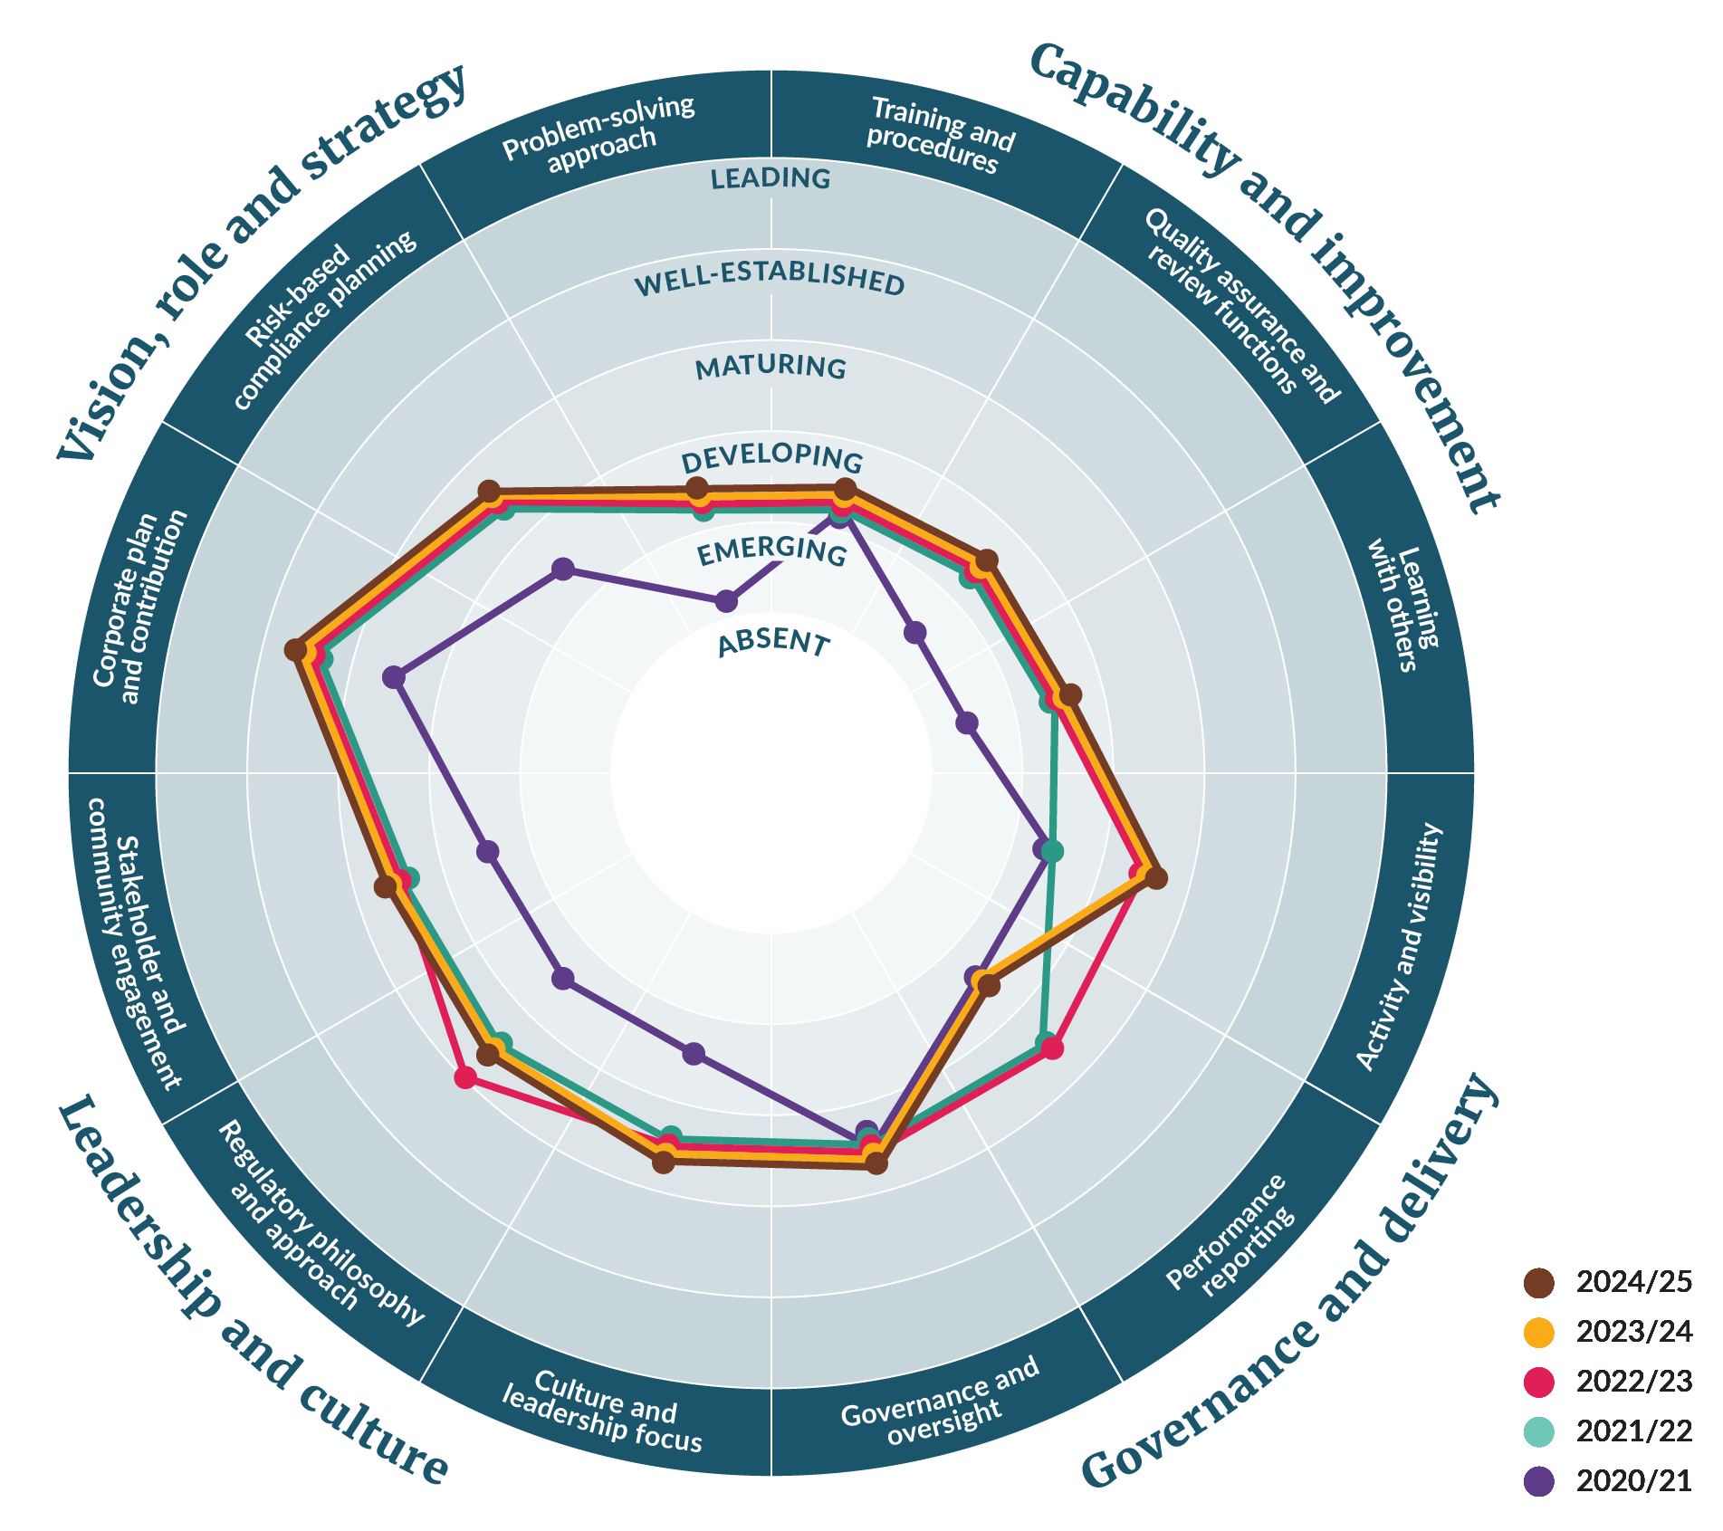

Table 16: Ministry for the Environment waste operations Modern Regulator Improvement Tool scores
Theme | Attribute | 2020/21 | 2021/22 | 2022/23 | 2023/24 | 2024/25
Vision, role and strategy | Corporate plan and contribution | Maturing | Well established | Well established | Well established | Well established
Vision, role and strategy | Risk-based compliance planning | Developing | Maturing | Maturing | Maturing | Maturing
Vision, role and strategy | Problem-solving approach | Emerging | Developing | Developing | Developing | Developing
Capability and improvement | Training and procedures | Developing | Developing | Developing | Developing | Developing
Capability and improvement | Quality assurance and review functions | Emerging | Developing | Developing | Developing | Developing
Capability and improvement | Learning with others | Emerging | Developing | Developing | Developing | Developing
Governance and delivery | Activity and visibility | Developing | Developing | Maturing | Maturing | Maturing
Governance and delivery | Performance reporting | Developing | Maturing | Maturing | Developing | Developing
Governance and delivery | Governance and oversight | Maturing | Maturing | Maturing | Maturing | Maturing
Leadership and culture | Stakeholder and community engagement | Developing | Maturing | Maturing | Maturing | Maturing
Leadership and culture | Regulatory philosophy and approach | Developing | Maturing | Maturing / well established | Maturing | Maturing
Leadership and culture | Culture and leadership | Developing | Maturing | Maturing | Maturing | Maturing

Ministry for the Environment. 2025. Remediation of contaminated sites: A guide to applying for a waste levy waiver under section 29(1)(b) of the Waste Minimisation Act 2008 | Te whakatika wāhi tāhawahawa: He aratohu mō te tono whakaore utu para i raro i te wāhanga 29(1)(b) o te Ture Whakaiti Para 2008. Wellington: Ministry for the Environment.
When an existing operator in the OWLS registers an additional facility, it could be an additional facility at an existing site or a new site under that operator’s control.
The Government also supported waste management through funding to local councils and the primary sector, and by making legislative changes to streamline the recovery process.
The Minister for the Environment has discretion to direct the Ministry to withhold payment in some cases if these requirements have not been met.
Ministry for the Environment. 2025. Waste Minimisation Act 2008: Enforcement Decision-Making Policy. Wellington: Ministry for the Environment.
The Ministry’s Waste Investments team determines projects’ funding eligibility.
Tyrewise. 2024. Code of Participation. Auto Stewardship New Zealand.
Waste Minimisation (Microbeads) Regulations 2017.
Waste Minimisation (Plastic Shopping Bags) Regulations 2018.
Waste Minimisation (Plastic and Related Products) Regulations 2022 and Waste Minimisation (Plastic and Related Products) Amendment Regulations 2022.
Cabinet agreed in 2024 to amend the regulations to extend the 2025 requirements to 1 July 2028. If approved, labels on all produce sold domestically, including the adhesive, must be certified home-compostable by 1 July 2028.
Ministry for the Environment. 2025. Waste Minimisation Act 2008: Enforcement Decision-Making Policy. Wellington: Ministry for the Environment.
Section 71 of the WMA specifies that a charge must be filed within 12 months of the date on which the matter giving rise to the charge first became known, or should have been known, to the person who commences the proceedings.
Crown Law. 2025. The Solicitor-General’s Prosecution Guidelines. Wellington: Crown Law.
Invoices totalling $130,449.90 (including GST) were issued in the period July 2022 to June 2023.
Invoices totalling $23,769.58 (including GST) were issued in the period July 2023 to June 2024.
Invoices totalling $6,453.68 (including GST) were issued in the period July 2024 to June 2025.
Ministry for the Environment. 2021. Waste Minimisation Act 2008: Compliance, Monitoring and Enforcement Strategy. Wellington: Ministry for the Environment.
Ministry for the Environment. 2025. Waste Minimisation Act 2008: Warning Policy. Wellington: Ministry for the Environment.

