

Inputs into a review of the effectiveness of the waste disposal levy
For the Ministry for Cities, Environment, Regions and Transport
Prepared August 2026

Report For
Ministry for Cities, Environment, Regions and Transport (MCERT)
Project Team
David Lerpiniere
Lisa Eve
Tanzir Chowdhury
Sunshine Yates
Rachel Stoner
Molly Coombes
Approved By

David Lerpiniere, Project Director
Eunomia Research & Consulting Ltd
35 Gilfillan Street
Blockhouse Bay
Auckland 0600
New Zealand
Tel +64 9 376 1909
Web www.eunomia.co.nz

Executive Summary
This review was conducted to input into the Ministry’s formal review to support the Minister in their obligatory review of the effectiveness of the waste disposal levy (levy) every three years as required by section 39 of the Waste Minimisation Act 2008 (WMA). The levy is set under the WMA and acts as a financial incentive to minimise waste sent to landfill and promote resource recovery. The revenue generated from the levy is used to support waste minimisation and recovery initiatives, projects, and infrastructure development. Since July 2024, it has also supported a wider range of environmental priorities.
Eunomia’s contribution to the review through this report considers information over the period of three financial years (1 July 2022 to 30 June 2025). This report presents findings from stakeholder engagement, quantitative analysis of waste disposal volumes, a review of resource recovery trends, and desk-based research into disposal levy regimes applied in other countries.
The Ministry’s review will draw on Eunomia’s work to support the Minister’s analysis of whether waste to landfill has decreased and whether waste recovery has increased in Aotearoa New Zealand over the review period, alongside other matters the Minister considers relevant.
Stakeholder engagement
Stakeholder engagement was carried out across numerous sectors that are involved with, and affected by, the levy. The sectors included - but were not limited to - local government, waste operators, resource recovery, recycling, and construction and demolition. Many opinions were raised and were often shared across the sectors.
Stakeholders broadly supported the waste disposal levy and were appreciative of its role in generating funding at the local and national level for investment into waste minimisation initiatives, infrastructure and programmes. Concerns were raised, however, around the design and implementation of the levy. Common themes included a lack of clarity around the long-term strategy for the levy, a need for improved data and monitoring, and potential unintended consequences of the current differential levy rates between landfill classes.
Stakeholders had mixed views regarding whether the current levy rates are set at an appropriate level, and as to future possible changes. While some stakeholders considered the current rates too low to drive behaviour change, others noted the impact of increased disposal costs on small businesses and rural and low-income communities.
Waste disposal data analysis
An analysis was conducted of the quantity of waste disposal at each landfill class. This was limited to a certain extent by data availability; for Classes 2-5, data has only been collected since the introduction of their levies and reporting requirements in more recent years.
Statistical analysis found a strong statistically significant negative relationship between the Class 1 levy rate and disposal quantities, suggesting that increases to the levy do correlate to reductions in quantities disposed at Class 1 landfills.
The analysis also investigated concerns raised by stakeholders around movement of unsuitable waste between landfill classes and increasing instances of co-located landfill sites. The available data is not considered sufficient to determine the existence or scale of such behaviours, although they cannot be entirely ruled out – although changes in quantities to each type of facility are noted, it is not possible to say for certain that this is a consequence of certain waste types being ‘transferred’ between classes, or the extent to which they are caused by the levy.
Resource recovery trends
A desktop review was conducted of potential factors affecting resource recovery in New Zealand. This included trends in international policies and recycling markets, domestic recycling infrastructure, increasing standardisation of domestic recycling, public attitudes and beliefs, the waste reduction work programme and emissions reduction plan initiatives. The review considered major developments and changes that have occurred during the review period and a qualitative assessment of their potential impact on recycling quantities in New Zealand.
Domestically, several positive developments occurred during the review period, including major investment into local resource recovery infrastructure, particularly for C&D waste, and the launch of the Tyrewise product stewardship scheme. This contrasts with some major closures of domestic processing facilities particularly for paper and cardboard recycling, which has increased New Zealand’s reliance on export of these materials to international markets.
This is set within a changing international environment, with several key export markets introducing restrictions on the international trade of waste (particularly plastic), and continued shifts in policy and regulation, often driven by the European market but seen globally.
International review
A comparative assessment of waste levies across Europe and Australia investigated the differences in levy rates, structure and scope, regulatory frameworks and use of revenue compared to New Zealand. The review found that New Zealand’s levy rates remain amongst the lowest. It also showcased many broader international policy measures that operate alongside levies. These policies, such as product stewardship schemes and the implementation of the waste hierarchy, encourage alternatives to landfill disposal.
Approaches to the allocation of levy funding vary considerably across the regions reviewed. Some dedicate a portion or all levy funding specifically to waste minimisation initiatives, while others do not hypothecate the funding at all.
Concluding remarks
The study was conducted in close collaboration with MCERT to ensure that the approach could be adapted iteratively to focus upon MCERT’s key priorities. The main body of this report presents the detailed findings of the desk-based analysis and stakeholder engagement exercise. Key supporting information can be found in appendices.

Table of Contents
0.0 Executive Summary 2
1.0 Introduction 7
2.0 Methodology 8
2.1 Stakeholder Engagement 8
2.2 Waste Disposal Data Analysis 11
2.3 Resource Recovery Trends 12
2.4 International Disposal Levy Regimes 12
3.0 Findings 13
3.1 Stakeholder Engagement 13
3.1.1 Survey 13
3.1.2 Interviews and workshops 17
3.1.3 Themes 22
3.1.4 Key stakeholder concerns and recommendations 30
3.2 Waste Disposal Data Analysis 32
3.2.1 Assessing a relationship between waste quantities and the levy 32
3.2.2 Comparison with GDP and population 35
3.2.3 Statistical Analysis 37
3.2.4 Number of registered sites 40
3.2.5 Co-location of sites 42
3.2.6 Diverted waste 44
3.3 Resource Recovery Trends 47
3.3.1 Trends in international policies and recycling markets 47
3.3.2 Domestic recycling infrastructure 49
3.3.3 Increasing standardisation of domestic recycling 50
3.3.4 Public attitudes and beliefs 51
3.3.5 Waste reduction work programme and emissions reduction plan initiatives 52
3.4 International Research 55
3.4.1 Waste Levy Rates 55
3.4.2 Structure of the Levy 61
3.4.3 Regulatory Regime 62
3.4.4 Use of Revenue 64
3.4.5 Length of Operation 67
4.0 Conclusion 69
Appendix 71
A.1.0 Survey results 72
A.2.0 Statistical analysis results 81

Introduction
Eunomia was commissioned in March 2026 by the Ministry for Cities, Environment, Regions and Transport (MCERT, formerly several foundation agencies including the Ministry for the Environment) to support its review of the effectiveness of the waste disposal levy. The review is a requirement of the Waste Minimisation Act (section 39).
The New Zealand waste disposal levy is an economic tool designed with two key purposes:
- To raise revenue to fund a range of waste and wider environmental objectives; and
- To increase the cost of waste disposal to recognise the impact of disposal on the environment, society and the economy.
In turn, this seeks to encourage more sustainable approaches to the production, use, recovery, and end-of-life management of materials and products. By increasing the cost of disposal, the levy is intended to create an incentive for businesses, households, and local authorities to reduce waste generation, improve recycling and resource recovery, and adopt more circular economy practices.
A levy has been in place since 2009 for landfills that accept waste from households (municipal). Changes were introduced in 2021 such as including other landfill types, increasing the cost of the levy, and introducing reporting requirements. Three landfill Classes have since been introduced to the levy, Class 2 in 2022 and Classes 3 and 4 in 2023. The rate of the levy has also incrementally increased by between $5 and $10/tonne per year for different disposal facility classes.
Table 1-1: Expansions and increases to the levy over time
Disposal Facility Class | July 2021 | July 2022 | July 2023 | July 2024 | July 2025 | July 2026 | July 2027
Class 1  Municipal landfill | $20 | $30 | $50 | $60 | $65 | $70 | $75
Class 2  Construction and demolition fill |  | $20 | $20 | $30 | $35 | $40 | $45
Class 3 and 4  Managed and controlled fills |  |  | $10 | $10 | $15 | $15 | $20
Reviewing the levy is important because significant changes have been introduced since 2021, including expanded coverage to additional landfill classes, higher levy rates, and new reporting requirements as shown in Table 1-1. These reforms were implemented progressively, meaning their full impacts were not captured in the previous review, which covered the period from 2019/20 to 2021/22. In addition, further legislative changes introduced in 2024 expanded the range of activities that can be funded through levy revenue. The current review, covering 2022/23 to 2024/25, provides an opportunity to assess how effectively these changes are influencing waste disposal behaviour, improving resource recovery, and supporting waste minimisation outcomes.
This report presents the findings of a desk-based analysis of secondary data and a stakeholder engagement exercise. The study was conducted in close collaboration with MCERT to ensure that the approach focused upon MCERT’s key priorities and information needs. The findings of this study are to be used to inform the formal review, which will be authored by MCERT.

Methodology
The study methodology comprised four parts:
- Stakeholder surveys, interviews, and workshops
- Analysis of waste disposal data
- Consideration of resource recovery trends
- Review of international disposal levy regimes
The methodology for each part is outlined in the following Sections 2.1 to 2.4

Stakeholder Engagement
Stakeholder engagement was undertaken to gather insights from various sectors to support and complement the quantitative data. A Stakeholder Engagement Plan and Database identified stakeholders that the engagement planned to reach and the best way to engage them. Three engagement methods were undertaken as shown in Table 2-1. It should be noted that stakeholders were not identified as to provide a representative sample, but to capture a range of views and perspectives.
Once stakeholder engagement was completed, the responses were analysed and are presented in Section 3.1. An overview of the analysis approach is shown in Table 2-2. Full survey results are included in Appendix A.1.0.

Table 2-1: Engagement Methods
Type | Reach | Audience | Date
Survey | A banner with the survey link was posted on the online waste levy (OWLS) reporting system.  Sector organisation WasteMINZ emailed members of the Territorial Authorities’ Officers (TAO) Forum, Disposal to Land, and Recycling & Resource Recovery Sector Groups on behalf of Eunomia.  Umbrella organisations Waste and Recycling Industry Association (WRIA), Zero Waste Aotearoa (ZWA) were asked to pass on the survey to members.  The Packaging Forum, Business NZ, Food and Grocery Council, Localised, Consumer NZ, Sustainable Business Network (SBN) and 3R were asked to respond to the survey. | 101 survey respondents who identified as belonging to the following groups:  - industry body (6),  - territorial authorities (TAs) (41),  - landfill operator (12),  - other waste facility operator (9),  - other (5),  - community group (5),  - regional council (2),  - consultancy (9),  - regulator or government agency (1),  - consumer or business (8). | 14 May to 20 June
Interviews | Survey respondents who indicated they would like to participate in an interview were contacted individually. | Seven attendees were interviewed from five sectors (waste operator, resource recovery operator, business, industry body, consultancy) across five interviews | Hosted from 18 June to 6 July
Workshops | Survey respondents who indicated they would like to participate in an interview were invited to group workshops where suitable groups could be identified to ensure more people could be included. | 27 attendees across the workshop groups:  - WRIA (2),  - metal/e-waste (4),  - construction and demolition (C&D) (10), and  - TAs (11). | Hosted from 22 May to 2 July

Table 2-2: Engagement Analysis
Type | Description of Analysis
Survey | Response dataset was reviewed to remove incomplete responses. Quantitative responses were represented as numbers and percentages and free-form responses were grouped into themes and subsequently represented as numbers and percentages.
Interviews and workshops | Minutes from interviews were taken by the project team and transcribed by Microsoft Teams. Discussions were grouped into themes and stakeholder groups were mapped to the themes.

Waste Disposal Data Analysis
The Ministry publishes various datasets regarding waste management facilities across New Zealand. Eunomia utilised this publicly available data for much of the analysis presented, alongside some additional data provided by the Ministry with more granular detail.
Eunomia accessed the dataset “tonnage_class_month”, which summarises the total quantity of waste processed through each class of landfill (as well as at transfer stations) each month, sourced from the Online Waste Levy System (OWLS).
The data was reformatted into a time series, showing the quantities of waste between 2009 and the present day, presented either monthly, quarterly or annually, for both gross and net tonnage. The net tonnage data was then used for any further analysis, as this represents the final quantity disposed of at landfill. The difference between the gross and net tonnage is considered “diverted” tonnage, which is either reused or recycled within the facility, or removed from the landfill for reuse, recycling, recovery, or otherwise removed (i.e. the destination of this waste is not captured).
Alongside the previously presented data, in addition, the dataset “resident-population_monthly_interpolation” was accessed, which uses census population data and estimates the population in between census years, from Stats New Zealand.
Additionally, data on New Zealand’s GDP was accessed from the Reserve Bank of New Zealand. This was used to compare the trend of GDP against the quantity of waste disposed. For this purpose, both waste quantities and GDP were totalled to be presented annually.
An initial assessment was conducted, presenting the summary of quantities of waste disposed at each type of facility as a time series alongside instances of key changes to the levy rates for each landfill class. The quantities of waste were also compared to wider contextual factors, including economic influences (gross domestic product - GDP) and population growth.
This was paired with a robust statistical analysis that provided an assessment of the correlation between these variables. The purpose of this analysis was to determine whether a relationship exists between waste levy rates and Class 1 landfill tonnage. The assessment also accounts for broader factors including economic conditions and the Covid-19 pandemic. Some additional factors were considered but not pursued for inclusion in the statistical analysis – for example, the level of C&D activity could influence waste generation but there were no suitable indicators that could be used.
Initially, a simple linear regression was conducted, the results of which are presented in Appendix A.2.1. However, diagnostic analysis of this regression model indicated the presence of serial correlation in the dependent variable and error terms, meaning that the observations were not independent over time, violating a key requirement of linear regression analysis. In this case, standard regression methods are therefore not the most appropriate approach.
To address this, a time-series modelling framework (ARIMAX) was applied, which accounts for temporal dependence while still including external economic factors in the analysis.
The ARIMAX model was fitted with both monthly and quarterly data. The monthly data is preferred due to the larger sample size which would generally produce more accurate results. As data on GDP is only available quarterly, this was interpolated using Denton’s method to disaggregate to a monthly frequency.
Further areas of interest were investigated, particularly relating to topics raised during the stakeholder engagement. The assessment considered a time series of the number of registered sites across each facility type, noting instances of levy changes or the introduction of reporting requirements, an investigation into the potential increase in cases of co-location of sites, and a review of diverted waste quantities.
The findings are presented in Section 3.2.

Resource Recovery Trends
A review was conducted of various factors that may have had an impact on New Zealand’s resource recovery quantities, along with a high level, qualitative assessment of what that impact is likely to be. There is limited data available to quantitatively consider the amount of resource recovery in New Zealand and assess its trend across the review period. The factors considered include:
- Trends in international recycling markets
- Domestic recycling infrastructure
- Increasing standardisation of domestic recycling
- Public attitudes and beliefs
- Waste reduction work programme and emissions reduction plan initiatives
Desk-based research was conducted to provide a summary of the context, and key changes that have occurred, during the review period. While the assessment of the likely impact of each factor on recycling quantities was kept qualitative, some available datasets were reviewed to inform this assessment.
The findings are presented in Section 3.3.

International Disposal Levy Regimes
The international disposal levy review involved the desktop analysis of disposal levies in New Zealand, Australia, countries within the EU, and the UK. For each country the rate of the levy and its structure was investigated, as well as the regulatory regimes they comply to and how the revenue is used. Findings are presented in Section 3.4.

Findings
This section presents the findings of the levy review. It opens with stakeholder engagement in Section 3.1, bringing together insights from various sectors provided in a survey, as well as interviews and workshops, and identifying common themes, concerns, and suggested recommendations.
Following this, waste disposal data analysis is presented in Section 3.2. It presents an overview of quantities of waste at each class of landfill over time, paired with a statistical analysis of the relationship between these quantities and the levy rate.
Section 3.3 presents a summary of resource recovery trends that are likely to impact the quantity of resource recovery in New Zealand. This includes trends in international policies and recycling markets, domestic recycling infrastructure, increasing standardisation of domestic recycling, public attitudes and beliefs, and the waste reduction work programme and emissions reduction plan initiatives. The review considers major developments and changes that have occurred during the review period and a qualitative assessment of their potential impact on recycling quantities in New Zealand.
A summary of research into international waste levies and related policies is presented in Section 3.4, providing a comparative assessment to New Zealand’s levy. This considers levy rates, structure and scope, regulatory frameworks, and use of revenue.

Stakeholder Engagement
This section presents the findings from surveys, workshops, and interviews. It begins with a summary of survey results that presents findings for seven questions at a high-level in Section 3.1.1. Granular results can be found in the appendix. A summary of points raised at interviews and workshops across the six sectors follows in Section 3.1.2, which are then grouped into six themes in Section 3.1.3 and supported by survey results. To conclude the section, key concerns across surveys, interviews, and workshop are presented alongside recommendations identified by stakeholders in Section 3.1.4.
It is important to note that the stakeholder engagement involved self-selection and that opinions often differ within sectors.

Survey
As mentioned in the methodology section (Section 2.1), the survey was promoted through OWLS, WasteMINZ sector groups, and direct contact with groups and associations. Respondents were self-selected and identified the organisation type that they identify most closely with as listed in Table 3-1 (only one option could be selected). Local government (TAs, regional councils) were the largest group of respondents (43%) and waste industry (landfill and other facility operators) were the second largest group (21%).
This summary summarises survey results across the following questions, noting highest response for mandatory and multi choice questions, and lower responses for free-response questions. Full results can be found in Appendix A.1.0.

Table 3-1 Survey Participation Across Organisation Types
Organisation | Count | Percentage
Community group | 5 | 5%
Consultancy | 9 | 9%
Consumer or business | 8 | 8%
Industry body | 6 | 6%
Landfill operator | 12 | 12%
Other | 8 | 8%
Other waste facility operator | 9 | 9%
Regional council | 2 | 2%
Regulator or Government agency | 1 | 1%
Territorial authority | 41 | 41%
Total | 101 | 100%

Impacts following levy changes
Respondents were asked to indicate impacts that they have observed that they think could be caused by the levy changes that have occurred since 2021. The question provided a list of impacts for respondents to select as many as they found relevant. The question was mandatory for survey completion and found the most observed impacts indicated to be:
- Funding of diversion and infrastructure programmes (47%)
- Moving waste from one landfill type to another, which could include redirection of suitable wastes which could ‘free up’ space in higher landfill classes, or could include the transfer of unsuitable wastes to lower landfill classes in order to avoid higher fees (45%)
- Generating revenue for waste minimisation (43%)
- Increased resource recovery and diversion rates (40%)
From responses, it is clear that, while respondents appeared to recognise several positive outcomes of the levy such as generating revenue, funding programmes, and reducing disposal, there were also prevalent concerns around waste moving from higher to lower landfill Classes – although this is not necessarily an outright negative outcome.
When asked for reasoning and evidence much was anecdotal (48%), some referred to publicly available data (4%), and some referred to unpublished datasets (5%).
Survey results for this question can be found in Appendix A.1.1.1.

Negative impacts
Another mandatory question provided respondents with three negative impacts and the option to provide other negative impacts that they had observed. Respondents could select multiple options. The provided impacts were observed across respondents as follows:
- Disposing of waste to an inappropriate landfill class (36%)
- Illegal dumping (39%)
- Misreporting (12%)
- Other (43%)
The most commonly observed was illegal dumping, then inappropriate disposal, and finally misreporting. Of those that selected other, the vast majority observed no changes in behaviour (35 respondents, 81% of those that responded ‘other’).
The smaller percentage of respondents that indicated the item ‘Disposing of waste to an inappropriate landfill class’ (36%) from this question than the previous ‘Moving waste from one landfill type to another’ (45%) may be due to the use of the word “inappropriate”. The previous question gave the example of movement from Class 1 to Class 2, and while the Classes have different acceptance criteria and limits the movement of waste may be viewed as “appropriate” by those that did not indicate the similar options in each question.
Survey results for this question can be found in Appendix A.1.1.2.

Levy rates
The next question provided the levy rate for each Class of facility for the next financial year. Respondents were required to respond to each rate with whether it is too low, about right, too high, or don’t know.
Class 1 had a consistent distribution across the options; just under a third said the rate was too low (32%) or about right (32%), and a fairly similar proportion believed it was too high (26%). Only 10% responded ‘I don’t know’.
When asked about Classes 2, 3 and 4, across all classes the majority indicated that they found the rates too low (47%, 43%, 40% respectively). In all cases, this was followed by those who believed the rates to be ‘about right’ (29%, 25%, 28% respectively), with the lowest proportion believing rates to be ‘too high’ (10%, 11%, 12% respectively). The proportion that responded ‘I don’t know’ was also higher than for Class 1 in all cases (14%, 21%, 21% respectively).
While respondents weren’t required to add further comments, 31 did so. Of these, 19% suggested determining levy rate by material rather than destination, and 16% suggested setting rates that are in line with Australia’s rates.
Survey results for this question can be found in Appendix A.1.1.3.

Disproportionate effects
This was not a mandatory survey question and had a total of 84 responses; 35 (42%) had observed disproportionate effects from the levy on specific groups, and 49 (58%) had not.
29 respondents chose to provide further details. These comments noted disproportionate effects on low-income families (31%), illegal dumping (24%), and rural communities either experiencing increased traffic from waste movements (10%) and/or cost of having to transport waste further (10%).
Survey results for this question can be found in Appendix A.1.1.4.

Future levy rate settings
This was not a mandatory survey question and received responses from 88 respondents about what levy settings should be in future years.
The question had three suggestions and an option to specify other options. The majority of respondents (36%) chose other, followed by ‘higher increases that are in line with international examples’ (30%), ‘small increases that are in line with inflation or similar’ (22%), and fewer respondents preferred to remain at current rates (13%).
30 respondents provided further comment after selecting ‘other’ and had quite varied feedback. The point raised most was that changes need to be based on evidence and data (noted by 20% of respondents to this question). The next most common point (17%) was to have the same levy rate for all Classes, which may reflect concerns that the differential in levy rates contributes to unsuitable waste transferring between Classes, and that waste is disposed of no matter which facility it ends up at.
Survey results for this question can be found in Appendix A.1.1.5.

Levy coverage
This question asked respondents whether there were any waste streams and/or facilities that should be subject to the levy; it was not mandatory and received 75 responses. It was split very closely between those that responded, with 49% of respondents choosing yes, there should be additional streams/facilities and 51% choosing no, that there shouldn’t be.
When prompted for additional details, 32 respondents gave further comment. A significant proportion of these (47%) suggested waste to energy (W2E)/incineration, with all other suggestions, mentioned by less than 10% of these respondents, including anaerobic digestion (AD), all types of disposal, industrial monofils, and farm dumps. A small proportion (6%) commented that certain materials should not be subject to a levy, such as byproduct from recycling processes that is disposed of at landfill.
Survey results for this question can be found in Appendix A.1.1.6.

Suggested improvements
Another non-mandatory question asked for suggestions to improve levy effectiveness in terms of waste reduction and increased resource recovery; 56 respondents provided comment. Responses were again varied; 23 separate suggestions were mentioned, although only 3 of these were mentioned by more than 10% of respondents. The most common response (30%) suggested limiting levy spending to waste minimisation only. 16% suggested levy funds should be used to invest in onshore infrastructure to drive recovery. Other responses included having the same rate for all landfill Classes (11%), monitoring and data in terms of funding and spend, waste diversion, and perverse behaviours (9%), and implementing or expanding complementary policies to approach diversion more holistically (9%).
Survey results for this question can be found in Appendix A.1.1.7.

Interviews and workshops
At the end of the survey, respondents were asked if they would like the opportunity to discuss their responses in further detail, which 88 people indicated yes to. Section 2.1 outlines the workshops and interviews conducted. This section provides a summary of the key views raised at interviews and workshops across six sectors. There are sometimes contradictions due to the wide-ranging views held by individuals within each sector.

Waste operators
Many stakeholders within the waste sector pointed to the need for a strategic framework for the levy. They believed that there are no clear objectives, reporting mechanisms, or investment prioritisation. According to waste sector stakeholders, the missing framework does not allow for actual analysis of levy effectiveness. There is clear interest in collaborating closely with the Ministry to build a workable framework.
Some stakeholders raised that the reallocation of levy to areas beyond waste minimisation threatens to undermine the credibility of the levy.
They also talked to perceived misalignment between facility classifications (set in regulation under the Waste Minimisation Act) and acceptance criteria (set by regional councils under the Resource Management Act) and request national acceptance criteria standards as well as a national regulator and enforcer.
Some waste sector stakeholders raised that there needs to be a link between who pays the levy and who receives levy funding. The belief was that this would improve investment into diversion pathways and infrastructure. Some concerns perceived by waste sector stakeholders included duplication between the public and private sector, putting the private sector at a perceived financial disadvantage, and a perception that fund recipients are not held accountable for sound and strategic investment decisions.
There was a call to allocate levy funding based on need that would be determined via contestable funds. This would support communities that are small or remote to access infrastructure and services. There was also a suggestion to expand the scope beyond waste minimisation to include reduction of harm from waste. It was raised that the current Waste Minimisation Fund (WMF) investment signals are too narrow (organic waste minimisation) and that they should be expanded (or removed) to enable projects like kerbside collection education, waste data, and research into large scale strategic infrastructure investment.
In terms of levy effectiveness, waste sector representatives raised that waste is moving from Class 1 landfills to lower classes, which is not a reduction in tonnes but diversion from one landfill Class to others. Other unfavourable outcomes that they have noticed include contaminated soils being mixed (diluting contamination, enabling inappropriate disposal at lower Class landfills to avoid higher fees) and waste travelling longer distances to lower landfill Classes, as well as new lower Class facilities being built (investigated in Section 3.2.4). Waste sector stakeholders raised that the movement of waste to lower landfill classes means that the emissions trading scheme (ETS) receives less money and that the waste is being disposed of at facilities that have less environmental controls. A common belief was that these outcomes are due to the differential levy rate between landfill Classes.
They did, however, recognise that they have been recovering more timber which could be a positive outcome of the levy. Some questioned the lack of regulation on incoming materials such as CCA treated timber (i.e. timber treated with copper, chromium and arsenic) and packaging types.
In terms of levy facilities and differential rates, some members of the waste sector preferred having one levy for all sites, applying a levy by waste type rather than facility, and others that AD and incineration should have the same levy as Class 1 as it is the same waste being disposed of, just different processing methods.

Territorial authorities
Stakeholders representing territorial authorities (TA) shared their gratitude for waste levy funding and believed it is a positive mechanism. They requested clarification of purpose and outcomes as well as definitions, in particular inert waste, C&D, and Class 2 facilities.
Since the expansion of the levy (increasing rates and covering additional landfill types) and the amendment that allows for central government spending on a broader range of environmental outcomes, TA officers find it more difficult to see the effectiveness of the levy, and some requested that the allocation of the funds is again limited to waste minimisation activities. Some believed that this expansion has encouraged an unhelpful public and political perception that levy money is free and to be used however councils wish, despite TA obligations to the WMA and their waste management and minimisation plans (WMMPs).
TA officers recognised the absence of a national or cross-regional approach for the investment of levy funds, which limits infrastructure and better opportunities for collaboration.
Many stakeholders deemed the levy too low to drive behaviour change and recognised that the rate is much lower than some overseas rates, some pointing to Australia in particular, and others requesting international evidence that waste levies work. Stakeholders presented the tension between keeping costs manageable and raising them enough to drive and fund diversion.
Stakeholders requested forecasting of the levy rate (20 years) to enable them to better plan gate fees and appropriate infrastructure investment. Stakeholders that run facilities raised that levy and ETS charges are the majority of the gate fee.
Concerns were raised about the levy differential between Class 1 and 2 facilities driving undesirable behaviour (such as waste moving to lower Classes and waste blending) rather than positive diversion. It was raised that the composition of waste received at Class 2 facilities is not well known, so it is difficult to determine what the environmental impact of the Class 1 waste moving to Class 2 facilities is. Some stakeholders recommended substituting the ETS for Class 1 facilities with a waste levy that is carbon-based to ease the differential and its perceived impacts.
Some TA officers indicated the need to include a levy for all waste facilities including W2E facilities (including AD). They noted that different technologies have different impacts and some have perverse outcomes. By not covering W2E facilities the playing field is uneven and risks W2E absorbing waste streams that have more beneficial recovery options that are more expensive.
Stakeholders talked to small and rural councils being disadvantaged by lack of access and higher cost of recovery and disposal per capita and wonder whether council amalgamation may improve the economies of scale needed to have efficient and relatively affordable waste services and infrastructure. Some stakeholders suggested implementing additional localised levy according to waste service and infrastructure access.
They also recognised individuals in financial hardship where extra costs of waste disposal are piled on top of the increasing cost of everything else.
Some stakeholders also raised concerns that the limit for soil contamination is too low, especially for naturally occurring elements, and that soils take up large amounts of space in landfill when they could be deposited elsewhere – although contamination limits are not a matter covered by the waste disposal levy, it does link to the levy rates when soils must be disposed at Class 1 landfills.
While exemption pathways exist (e.g. emergency waste, historic site remediation) they were viewed as tedious by stakeholders, especially for facilities that are not owned by councils. It was recommended that this process be simplified to relieve administrative burden, especially during emergency events.

Construction and demolition (C&D)
C&D stakeholders identified a disconnection with various interpretations of the WMA and RMA (and associated regulations) by different regions and clients. Stakeholders from the C&D sector raised that there can be a mismatch between facility classification and their consent, and how they operate on the ground. They perceived inconsistent enforcement and believed that there are unconsented Class 3 and 4 facilities in operation, which disadvantages operators who are acting in accordance with classifications and consents.
These stakeholders perceived the levy to drive waste reclassification rather than genuine diversion, particularly due to the price differential between Class 1 and 2 landfills, and the ETS charges that apply to Class 1 landfills. Instances of this cost differential impact brought up discussions such as movement of waste to lower landfill Classes and installation of Class 2 cells within Class 1 sites.
Soils were a repeated concern across stakeholders in the C&D sector. They discussed that soil can be contaminated to the extent that it has no diversion pathways, including soil that has naturally occurring contamination like iron and arsenic. Assuming that the levy will continue to increase, C&D stakeholders are concerned that this will be detrimental to the cost of development and affect housing affordability and viability. Stakeholders suggest that the levy targets materials that could plausibly be diverted from landfill, excluding soils.
In the same vein, these stakeholders suggested setting levy costs based on existing solutions – for example, charging the levy on materials for which diversion routes exist, and not on materials that cannot be recovered at all (such as contaminated soils). Funding could be reinvested in finding solutions for problematic material streams like contaminated soil.
Some stakeholders discussed inequalities experienced by different locations and geographies. For example, accessibility to waste and recovery infrastructure, local industry (disposal of contaminated soil is highly regulated in agricultural areas to avoid contamination into food or water systems), and landscapes (e.g. hard rock vs. alluvial) impact the amount of levy paid. For these reasons, stakeholders recommended local levies based on unique circumstances of different regions.

Resource recovery and recycling
Stakeholders within the resource recovery and recycling sector recognised that the levy is a tool that should not be used in isolation. They considered revenue from the levy should be invested into infrastructure that provides recovery options in order to actively drive waste diversion. Some stakeholders raised that if the levy were working perfectly, the implementation and management of diversion programmes would be sufficient, and that confidence in the system needs to be built.
Members of this sector raised that spending needs to be more transparent as funding into programmes appears to be very dependent on needs and priorities determined by central government and TAs without consultation with other groups involved in waste minimisation and management. Stakeholders want to see what money is spent on and how it is connected to the levy’s purpose.
Stakeholders have observed the levy differential causing perverse outcomes as listed in previous stakeholder group sections.
A positive observation was increased food rescue since changes to the levy, which was seen to possibly be driven by the expense of disposal to Class 1 landfills.
Stakeholders hoped that the levy increases opportunities for C&D recovery infrastructure and more food rescue to minimise organic waste to landfill.
A recommendation was made to apply levy rates according to the environmental impacts made by waste streams.
Anecdotes were shared about customers at facilities who find the cost of disposal to be difficult to manage, exacerbated by the cost-of-living crisis. The increasing levy cost may be seen to disproportionately affect people experiencing financial hardship, as the items they can afford may be more likely to be replaced more frequently than higher cost items.
Members of the resource recovery and recycling sector considered that the levy penalises recycling that generates byproducts. Some stakeholders believe that in cases where an activity exists specifically to divert waste to landfill, residual waste should not incur a levy charge. Some stakeholders believed that this impacts their ability to finance onshore recovery options as it is cheaper to pay for disposal within New Zealand or export for processing overseas, and there was a perception that in some cases this results in breaches of the Basel Convention.
Further, stakeholders noted that the lack of charge (e.g. tax or EPR mechanisms) at earlier stages of products’ lifecycles does not align with encouraging waste minimisation or diversion activity.

Sustainability
Stakeholders from the sustainability sector said that, fundamentally, if diversion opportunities don’t exist or are too expensive, waste will move to facilities that are not designed to manage it, processes that are less environmentally beneficial, or somewhere illegal.
They spoke to disconnections between landfill classification guidelines, technical guidelines for disposal to land, activity categories, and consenting requirements, as well as the difference between regions and interpretations by waste operators and their clients.
Sustainability representatives talked about the cost differential having negative environmental consequences including movement of waste to lower Classes and to other regions, as well as waste shredding (i.e. to disguise wastes being inappropriately disposed at unsuitable landfill Classes). A further concern mentioned was cases of timber is entering Class 2 facilities that are not designed to handle organic materials.
They believed that operators disposing to Class 1 sites are disproportionately impacted by the levy due to the higher rate, as well as the ETS charges. This is compounded for waste operators in remote rural areas due to the additional transport costs. And as aforementioned risks moving waste and revenue away from Class 1 facilities.
There was also mention that the compliance system is not strong enough to monitor what is happening on the ground in terms of noncompliance with resource consents (councils) and regulatory waste facility categorisation (MCERT), or detrimental environmental impacts of waste being redirected from Class 1 to lower landfill Classes. Further, it was raised that composition of waste at Class 2 (and lower Class facilities) is not well known or monitored posing a risk to responsible waste management.
In terms of levy scope and structure, one stakeholder within the sustainability sector pointed to the key messages on page 52 of Eunomia’s report The New Zealand Waste Disposal Levy around differentiated rates between inert and other materials. The representatives raised other messages such as including all facilities in the levy and improving management of farm dumps given their likelihood of pollution.
Stakeholders in the sustainability space also called for more comprehensive data – providing a mass balance of all wastes, rather than only tonnages through registered landfills – to better understand the materials moving through the system, and thus enable sound planning and investment as well identify wastes that are unaccounted for at registered disposal sites.

Business
Stakeholders from the business sector who participated in the survey believed that the legislation and regulation about waste management is not clear as there are various sets of rules to interpret and follow (waste levy, RMA and regulations, individual council consents).
These respondents also believed there is no problem definition for the objective of the levy, and recommended it to be minimisation of harm to the environment and people. They perceived that the levy is simply more cost placed on operators and it does not solve a defined problem.
Business respondents believed that the rate of the levy should reflect the risk that the material poses in facilities, in particular it should not apply to inert materials (concrete, tyres and soil were examples of materials perceived to be inert) but to hazardous materials only. This excludes organic waste as they believe Class 1 landfill gas capture (LFG) to be sufficient and subject to the ETS.
They believed that the increasing levy has driven inefficient transboundary transport, illegal dumping of household waste and soil, and resource consent noncompliance.

Themes
The opinions expressed in the interviews and workshops are gathered in the following sections under key themes. The findings from the survey are also included where they provide additional context.
Many different viewpoints were expressed during the stakeholder engagement, and not every view expressed has necessarily been captured below. Where possible, the sectors that raised specific issues have been identified. Occasionally this identification has been omitted to ensure confidentiality.

Strategic direction
Most stakeholders across groups called for a strategic levy framework that:
- Clarifies purpose and objectives
Multiple groups (operators, TAs) talked to the purpose of the levy and how its objectives are becoming less clear. This lack of clarity was viewed as impacting the ability to evaluate its effectiveness, and to comment on the appropriateness of the current levy rates.
- Links outcomes to KPIs and reporting
To increase the legitimacy of the levy, members from the waste operator and business sectors suggested that a framework is required to set objectives, KPIs, and sufficient reporting mechanisms, and that the levy rate could then be set according to the objectives. It was recommended by waste operator stakeholders that this framework be built in close collaboration with the waste sector.
- Clarifies levy fund allocation
It was also recommended that additional clarity is required around how the levy funds are allocated, what outcomes the funding is intended to deliver, and how performance of outcomes are measured.
Attendees of the waste operator workshop considered that there is a disconnect between the purpose of the levy (i.e. waste minimisation) and what it funds, and that this disconnect reduces the willingness of people disposing of waste to pay the levy.
- And is based on existing diversion pathways and current end-markets
Members from the waste operator and C&D sectors believed that levy design needs to be based on the existence of diversion pathways and end markets, and not penalise materials where no viable alternative routes to disposal are available. TA representatives also expressed the importance of ensuring that materials have secure recovery pathways before subjecting them to a levy at landfill. One representative from the resource recovery sector further indicated that the levy cannot work in isolation and that levy funds need to be funding infrastructure to provide recovery pathways.
Some stakeholders believed that recent scope extension weakened the link between levy purpose and outcomes.
Attendees from TA workshops believed that the extended scope of activities that the central government can spend levy funds on (made as part of changes to the legislation in 2024) not only distances the levy from its original intended purpose but has also increased the perception that levy funds are a ‘slush fund’. TAs considered that this perception is likely to become more widespread as rates-capping puts further pressure on council budgets (if proposed changes to what TAs can spend the levy on proceed).

Survey results on strategic direction
Respondents indicated positive impacts that may have been caused by levy changes since 2021. The most notable are funding of diversion infrastructure and programmes (47 respondents, 47%), revenue generation (43, 43%), increased resource recovery and diversion rates (40, 40%), increased recovery pathways for waste streams (36, 36%), and decreased waste to landfill (25, 25%).
The most notable negative impacts include waste transfer from Class 1 to lower classes (45, 45%) and increased illegal dumping (32, 32%).
When asked how the levy could be more effective at reducing waste or increasing resource recovery, the most common answer was to limit the scope of levy spending to waste minimisation activities (17 respondents, 30%). The next most common answer was investment of levy funds into local infrastructure (9, 16%). Responses specific to strategic direction include reevaluating the funding model (2), develop a comprehensive strategy (2), justifying the link between waste levied and levy funding (2), shifting cost of disposal to start of life (2), and improving definitions, clarity, and enforcement (1).

Regulation and monitoring
Most stakeholders found that current definitions and classifications lead to misinterpretation.
One TA representative added the need to have flexibility in definitions and processes to update them as if and when perverse outcomes emerge. This specific mention was brought up when discussing W2E type waste processing methods and related to the need to update legislation or publish gazette notices in the instance that a waste process has unplanned detrimental outcomes. This would allow for these types of consequences to be brought to an end more quickly than the current process.
Representatives from the C&D sector and TAs reported inconsistent interpretation of acceptance criteria for facility Classes, as well as the need for clear definitions for inert and C&D material.
Interview attendees from waste operator, sustainability consultancy, and business sectors noted that there are different consenting and waste acceptance criteria across the country, making it more difficult for operators to follow, and potentially incentivising perverse outcomes. They also identified a disconnect between landfill classification guidelines, technical guidelines for disposal to land, levy categories, and consenting requirements. One waste operator recommended having a single regulator and enforcer, namely the EPA, for the country.
Many stakeholders emphasised the importance sufficient compliance controls.
Waste and resource recovery operators stressed the need to build confidence in the system. Sustainability consultants added that compliance requires bolstering, to better understand what is happening on-the-ground at disposal sites.
Most stakeholders requested better data to monitor levy effectiveness.
Multiple groups (waste operators, C&D, TAs, sustainability consultants) called for better data to improve the ability to monitor levy effectiveness. Members of the waste operator workshop believed that all facilities should have reporting obligations to provide a full picture of waste flows in New Zealand. This would assist both the public and private sector to plan and invest in appropriate waste infrastructure. They also considered that not much is known about the composition of Class 2 landfills.
Members of the TA workshop raised concerns that it is difficult for them to demonstrate the effectiveness of their investment of levy funds (for example, because it may be difficult to isolate the impact of education initiatives from other factors). In turn, this led to some concern that future changes may be made to the allocation of levy funds to TAs.
Some raised potential complementary levers to the levy, such as EPR or regulation of import and use of materials.
Representatives from e-waste and metal recycling sectors pointed to the disparity between having a levy charged at disposal, but no tax or extended producer responsibility (EPR)-type levy on importers when material enters the country.
Representatives from the waste operator sector supported regulation for materials entering New Zealand, and the use of certain materials within the country. Examples given related to types of packaging and chromated copper arsenate (CCA)-treated timber.

Survey results on regulation and monitoring
Across several questions throughout the survey, respondents raised points related to wider regulation as well as monitoring of the levy. When asked about the current levy rates, 10% of those who provided further comment suggested that complementary policies should be implemented if the levy rates were to be increased.
When respondents were asked for any other ideas on making the levy more effective, 9% noted requested further monitoring of data points including on funding spend, waste diversion, and perverse behaviours / unintended effects.9% of respondents also noted that complementary policies should be implemented or expanded, with an additional 7% suggesting levy funds could be used specifically to develop product stewardship or container deposit policies.

Unintended outcomes
Most stakeholders believe that waste is moving from Class 1 landfills to lower classes of landfills.
Workshop attendees across waste operator, C&D, TAs, sustainability consultants, and business sectors considered that the differential cost drives waste to be disposed of to landfill classes with lower management standards rather than genuine waste minimisation or diversion. This was echoed by representatives from waste, resource recovery, business, and sustainability sectors during workshops and interviews. Almost half (45%) of survey respondents also stated that they had observed waste transferred from one landfill class to another since 2021.
Attendees considered that the movement of waste from Class 1 facilities to landfill classes with lower management standards increases environmental risk at these sites. There was anecdotal reporting from the waste operator sector of waste being transported over longer distances to dispose of it at a different landfill class, in their view causing further detrimental environmental effects.
Specific concern over the quantities of timber being disposed of at Class 2 landfills was expressed by several workshop attendees.
The cost differential between landfill classes was also identified as a reason for a perceived increase in new Class 2 sites, Class 2 sites on land consented for Class 1 sites, and Class 2 cells within Class 1 landfills, as well as waste blending. A quantitative review of the number of registered sites is presented in Section 3.2.4, and shows some slight fluctuations in the number of Class 2 sites registered during the review period, with an overall minor increase from 12 to 14 sites.
Waste operators reported anecdotal instances where operators apply for Class 2 landfill consents and then attempt to upgrade them to Class 1 without consenting; similarly with Class 3 to Class 2. An example of an anecdotal case was of an RMA consented facility approved to accept certain wastes that are not accepted under the WMA (Class 2 approved to accept industrial waste).

Some stakeholders pointed to increases in illegal dumping because of levy increases.
Members of the workshops representing metal recyclers, e-waste, and TAs identified illegal dumping as a further perverse effect of the levy, although there is limited data supporting this as yet.
There were mixed views about whether illegal dumping was due to lack of access to diversion pathways, cost of correct management, or behavioural issues.
TA members mentioned that they are grateful for levy funding for illegal dumping enforcement to reduce the financial burden.

Survey results on unintended outcomes
Survey respondents identified the main negative changes to be waste moving to lower landfill classes (36%), illegal dumping (39%), and misreporting (12%). ‘Other’ was indicated by 43% of respondents of which the most frequent response was that no changes in behaviour were observed; all other responses were indicated by two or less respondents.

Levy coverage
Some stakeholders believed that W2E facilities should be subject to the levy.
Attendees within the waste operators and TA workshops raised the need to consider waste to energy (W2E) facilities (including pyrolysis, incineration, kilns, and anaerobic digestion (AD)) for the levy. Without being covered by the levy, these attendees considered these facilities may become lower-cost alternatives for materials that could be diverted to more beneficial recovery pathways. In the view of these attendees, the levy’s purpose is to minimise waste, rather than use it for fuel.
Some stakeholders believed that all facility Classes should be subject to the levy.
Workshop attendees across waste operators and TAs, and interviewees questioned why lower classes of facilities, including monofils and farm dumps were exempt from the levy, given perceived associated threats to environmental and public health.
One stakeholder believed Class 1 should be exempt from the levy.
One representative from the business sector believed that Class 1 landfills should be exempt from the levy as they are modern and, in their view, don’t pose risks to public health.

Survey results on facility coverage
When asked whether there are waste facilities that should be subject to the levy, 49% of respondents agreed and 51% disagreed. The most frequent facility mentioned was W2E/incineration (47%).

Waste streams
Most stakeholders put forward the idea of applying a levy to waste streams based on their potential to cause environmental harm.
A sustainability consultant mentioned recommendations from a 2017 Eunomia report that there could be different levy rates for active waste (waste that generates emissions and leachate) and inert waste (waste that is stable). International examples of this are presented in Section 3.4.2.1.
Attendees from the waste operator and C&D groups raised the view that disposal of contaminated soil should be governed by the RMA and related amendments and bills. They believed that soils should not have Class-based levy rates applied and be solely based on the RMA acceptance criteria with site-specific outcomes. The attendees talked to contradictions between the levy and RMA-type documents that in some cases can result in poor outcomes for soil as the levy is more restrictive about where soils can go.
These stakeholders considered that, as soils have poor recovery pathways, levying them does not encourage their diversion, unless new pathways are provided.
Some stakeholders believed waste generated as a byproduct of recycling should be exempt from the levy.
Members of the metal recyclers and e-waste workshop argued that residual waste from recycling activity should be exempt from the levy as they consider it undermines waste diversion.
Stakeholders had mixed views on introducing a landfill ban for organic material.
There was disagreement in a TA workshop over the potential banning of organics from landfill. Some attendees believed that this would reduce leachate and gas production and increase diversion and reuse pathways; and in the case of food scraps and garden waste, potentially produce products to regenerate soils (if they were instead diverted to composting or AD). One attendee noted that in their view organics in landfill is positive for gas generation as a revenue source (e.g. sales of electricity, carbon credits under the ETS), and that removing them could have unexpected impacts on the structural integrity of the landfill.

Survey results on waste streams
When asked whether there were any waste streams that are not currently subject to the levy, several specific streams were indicated by less than two responses each. They include all waste streams (including emissions and wastewater), recycling sent for export, and recycled materials (including single use plastics (e.g. soft plastics scheme), end of life vehicles, oil, and textiles). Recommendations also included exempting recycling byproducts and taxing importers of raw plastic and resin.
Under a separate question about the levy rates set for this financial year, six respondents indicated that levy rate should be determined by material rather than destination. Another question about future levy settings received three responses that specific materials (contaminated soils, recycling byproducts) should be exempt from or have a reduced levy charge.

Levy rates
Stakeholders expressed a wide range of contrasting opinions on the levy rates, with no clearly dominant view prevailing. Some stakeholders believed that:
- The levy rate is too low to achieve its purpose.
Members of the TA workshop argued that the levy rate is below rates of high-performing overseas countries (comparisons to international levy rates are presented in Section 3.4.1). At its current rate, they considered it costs less to dispose of material than to divert it, and the financial tipping point needed to drive diversion has not been reached.
- The low rate disincentives new diversion pathways.
Members of the waste operator workshop shared stories of investing in diversion infrastructure that was unsuccessful as it was too difficult to be financially competitive with disposal sites.
Some believed that Class 1 and 2 landfills should share the same levy rate.
As mentioned in sections 3.1.1.3, anecdotal reports suggest that the differential rates across facility types may have led to unintended impacts. Waste operators and members of C&D sectors believe that the levy rates for Class 1 and 2 landfills should be the same, and some believe that the same rate should apply to all landfill classes. This would be anticipated to relieve cost pressures on Class 1 landfills and prevent waste going to lower classes of facilities.
Others believed that the rate:
- Should align with end-markets
Some members of the waste operator and C&D sectors believed that the levy should be relevant to markets (i.e. materials with strong diversion pathways would have a higher levy cost).
- And/or be applied to waste stream rather than facility Class
As mentioned in Section 3.1.3.5, various workshop participants raised the view that waste streams should be levied relative to their characteristics in terms of leachate and LFG production potential.
Some believed that the financial burden placed on TAs in small or rural areas could be lessened by having variable levies based on access.
Members from the waste operator and TA workshops shared that small and rural councils and communities face high transport costs to reach infrastructure but pay the same levy as larger, central councils and communities with better access. A TA representative suggested that TA amalgamation may relieve some of these pressures, and another suggested lowering levy cost for areas with less access.
Some raised that Class 1 facilities pay the highest levy rate as well as ETS charges which furthers the price differential between Classes.
Members from the waste operator workshop and a sustainability consultant talked about the perceived disadvantage Class 1 operators have due to the differential levy on top of emissions trading scheme (ETS) charges. They considered that these costs encourage disposers to move waste elsewhere, even though there is significant investment at Class 1 landfills to reduce environmental impacts.
Several stakeholders shared that the cost is also impacting individuals that are experiencing financial hardship.
Some participants observed that the increasing rate of the levy, and associated increase in gate fees has placed extra stress on those experiencing financial hardship, especially during the cost-of-living crisis. Waste and resource recovery operators reported having experienced hostile public behaviour onsite, however they recognised the numerous factors leading to these events, including low household budgets resulting in the purchase of low-quality items that then require more frequent disposal.

Survey results on levy rates
Survey results showed a large variation on how stakeholders think that the rate should be set. For Class 1 landfills 32% thought the rate was too low, 32% that it is just right, and 26% that it is too high, while 10% didn’t know. The rates for the other Classes, however, tended to be seen as too low rather than too high.
For future levy settings, 30% of respondents believed that increases should be steeper and in line with international rates, 22% thought that the increases should be smaller and in line with inflation or similar, and 13% said it should stay the same. This question also allowed respondents to choose ‘Other’, in which the highest frequency of responses indicated that further evidence is needed (6).
In terms of the levy having disproportionate impacts on groups, 42% of respondents had observed some and 58% had not. The most common group identified was low-income families (9).

Levy Allocation and Spending
Some stakeholders raised the need to clearly align levy outcomes to levy allocations.
As outlined in 3.1, support for a clear strategy for the levy and levy funds was expressed by several sectors, as well as the need to ensure that levy funds are invested into projects that support the levy vision. Several sectors expressed the view that levy spending needs to focus on local diversion pathways, so that there are opportunities to divert materials from landfill.
A request was made to extend the scope of WMF funding to other areas that align with the levy’s purpose.
The waste and resource recovery operator sectors requested that a broader range of projects be considered through the WMF, including education for kerbside collection changes, waste data, large-scale strategic research to help inform investment decisions both by TA and private sector.
TAs were grateful for levy funding, and requested support to understand levy spend rules and prove value for money.
At each TA workshop, officers expressed gratitude for levy funding as it allows them to respond to their obligations for waste management and minimisation within the WMA.
During TA workshops, participants expressed that councillors and the public want evidence of the outcomes from spending of rates and levy-funds. They raised that the relationships between levy spend and outcomes in terms of value for money are hard to evidence.
Participants in the TA workshop considered that the levy spending rules were difficult to follow, with spend determined by WMMPs, which can limit their response to changing circumstances.
Some stakeholders perceived that levy allocation builds reliance on public funding and undermines operations of private sector.
Some waste operators raised concern that a lack of strategy around levy use (by TAs, central government, and WMF recipients) and a perceived lack of accountability for levy spending deters private investment and slows innovation. They believed it could also create long-term reliance on public funding to sustain services that could otherwise be delivered by the private sector.
Members of the waste and resource recovery operator sectors also expressed concern at TAs using levy funds to invest in projects that they believed to directly compete with private industry, and in their view were not necessarily part of TAs’ core responsibilities. They also suggested that allocation of levy funds to TAs should be through a contestable fund and based first and foremost on need.
A representative from the resource recovery sector questioned the transparency of the levy spend, and waste operators expressed a desire for better reporting on how levy revenue is invested and the outcomes of levy funded TA and WMA projects.

Survey results on levy allocation and spending
Two responses mentioned expanding the scope of funds to cover CAPEX and OPEX costs for waste services, another two suggested more clear guidance on spending for TAs.

Key stakeholder concerns and recommendations
Six key concerns were raised during stakeholder engagement, each with corresponding recommendations, as listed below. Recommendations in this list are those that were raised most frequently and are not presented in a set order.

1) Lack of clear levy strategy
Stakeholders felt that the purpose, objectives, functions, and revenue allocations of the levy are unclear. This results in difficulties to assess levy effectiveness, justify rates, and maintain confidence in the system.
- Develop a clear levy strategy with defined objectives, performance measures, and reporting requirements.
- Improve transparency around how levy funds are allocated, the outcomes they are expected to achieve, and their actual outcomes.
- Ensure a levy strategy encourages investment in recovery infrastructure and supports diversion pathways and end markets.
- Design a strategy for levy spending that encourages collaboration across the country as well as private and public sectors.

2) Insufficient data and monitoring
Stakeholders identified significant data gaps that limit the understanding of waste flows, levy effectiveness, and disposal behaviour and prevent informed planning for waste management for both private and public sectors. This would also allow TAs to better meet obligations to minimise and manage waste under the WMA and respective WMMPs.
- Release regionally amalgamated tonnage data and activity categories by facility type. To better improve waste flows this would include geographic source.
- Improve compositional data across all facility Classes.
- Strengthen monitoring and compliance systems.

3) Inconsistent definitions, classifications, and acceptance criteria
Stakeholders identified a disconnect between landfill classification guidelines, technical guidelines for disposal to land, levy categories, and consenting requirements.
- Develop nationally consistent, standardised framework to ensure that landfill classification guidelines, technical guidelines for disposal to land, levy categories, and consenting requirements align.

4) Levy not effectively driving waste minimisation or reduced environmental harm
Many stakeholders raised the issue that differential levy rates encourage disposal at lower-class landfills rather than genuine waste minimisation and reduced environmental harm.
- Review levy rate differentials between landfill classes.
- Consider harmonising levy rates across landfill classes or aligning rates more closely.
- Consider applying levy to waste streams (i.e. inert versus active).

5) Misalignment between levy charging and levy spending
Stakeholders wanted spending to be more strategic and transparent to improve diversion opportunities and meet needs of the WMA.
- Refer to recommendations 1)b and 1)d.
- Focus spending on projects that support waste diversion pathways.
- Improve accountability and outcome reporting for levy-funded projects.

6) Limitations to facilities subject to the levy
Stakeholders questioned why some facility types, including waste-to-energy facilities, monofills, and farm dumps, are exempt from the levy despite potential risk to the environment.
- Consider including waste-to-energy facilities and monofils where appropriate.
- Ensure levy coverage reflects environmental risks and waste minimisation objectives.

Waste Disposal Data Analysis

Assessing a relationship between waste quantities and the levy
The Ministry has collected monthly data on the quantity of waste received to landfills as part of the National Waste Data Reporting Programme since 2009 for Class 1 landfills, 2022 for Class 2, and 2023 for Class 3 & 4. Quarterly data is also reported for Class 5 landfills (cleanfills) as well as industrial monofills and transfer stations.
The waste disposal levy (waste levy) rate for Class 1 landfills was kept constant from 2009 to 2021, when incremental increases began to take effect (see Table 1-1). Given that data has now been collected for this landfill Class for 17 years, it may be possible to observe any potential effects of the levy increases on the tonnage data.
Data on Class 2, 3 & 4 landfills, however, only began to be collected more recently, over the period since their levies were introduced and have been incrementally increased. There is, therefore, no ‘control’ period so to speak, to compare the long-term trends in waste quantities to any changes that may have occurred as a result of levy increases.

All facilities
Figure 3-1 shows the net quantity of waste through each type of facility annually, along with markers noting dates of changes to the waste disposal levy, as detailed in Table 1-1. It should be noted that the significant variation in quantities at Class 5 facilities is primarily driven by one site, but this level of fluctuation is expected.
Data on quantities received at transfer stations is included in these charts, but it should be noted that this should not be considered cumulatively with quantities through other facilities, as the material received at transfer stations is consolidated and then sent to other facilities, where the quantity will also be captured in the data presented.
Figure 3-1: Annual net quantity of waste at all facilities
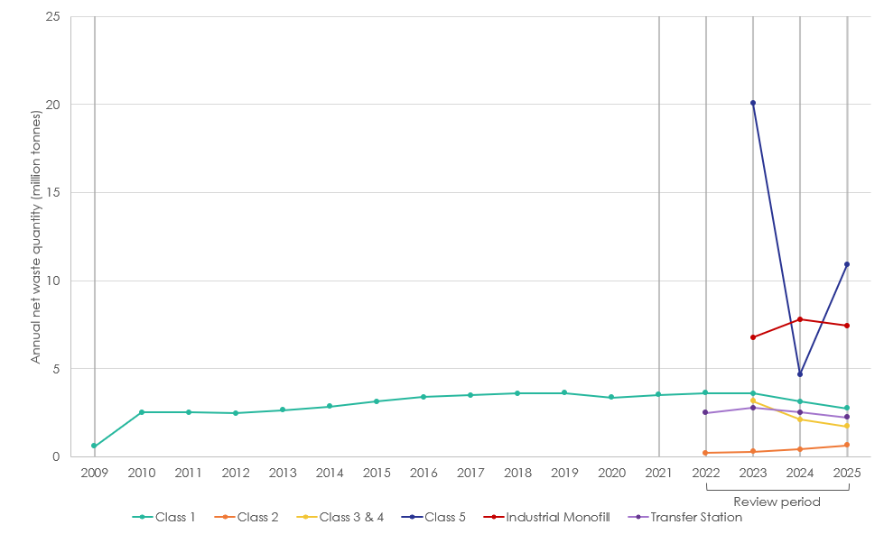

Class 1 and 2 landfills
Figure 3-2 presents a focused view of annual net quantity of waste disposed of at Class 1 and Class 2 landfills, noting dates of waste disposal levy changes in line with Table 1-1.
The annual quantity of waste received at Class 1 landfills began to gradually increase from around 2.5 million tonnes/year in 2012 to 3.5 million tonnes in 2016. The quantity oscillates around 3.5 million tonnes/year between 2016 and 2023. A small decrease is apparent in 2020, which may be attributable to reduced economic activity during the early stages of the COVID-19 pandemic.
A decrease then occurred in 2024 and 2025 (calendar years). These decreases coincide with the Class 1 levy increasing to $50/tonne in July 2023, $60/tonne in July 2024, and $65/tonne in July 2025. It is notable, however, that the earlier changes to the levy, incrementally increasing from $10/tonne to $30/tonne between 2021 and 2023, had no apparent or coincidental impact on the quantities of Class 1 landfill waste in the available data.

Figure 3-2: Annual quantity of waste at Class 1 and 2 landfills
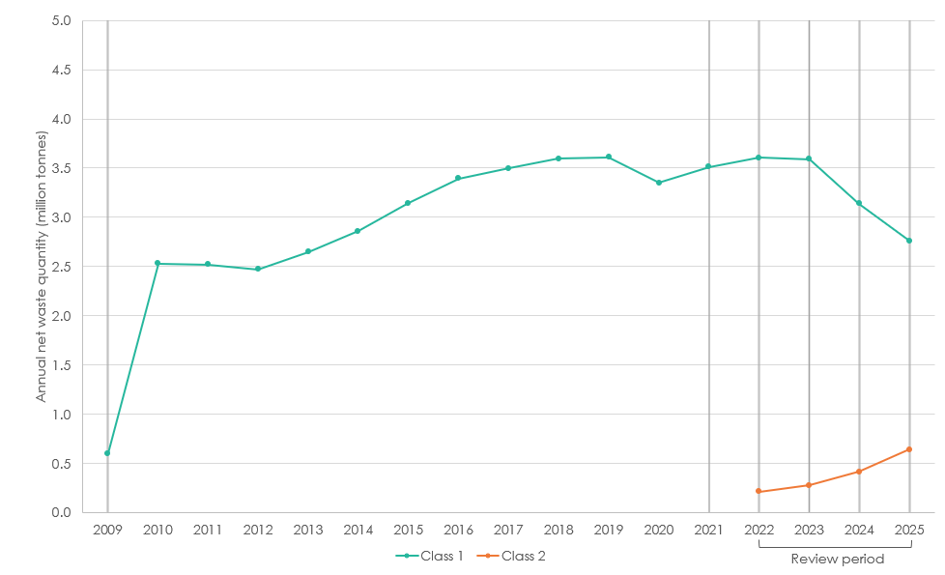
The data for the quantity of waste at Class 2 landfills appears to show a slight rise from 2022 to present, reaching just over 600,000 tonnes/year. However, due to the lack of extended data, it is difficult to say whether this increase is a long-term trend, an anomaly, or simply a result of improving data collection since reporting requirements were introduced. The gradual increase does appear to coincide with the decrease in quantities of waste at Class 1, however it is not possible to definitively link the two (i.e. suggesting that waste has simply been transferred from Class 1 to Class 2). Furthermore, the quantities do not entirely align:
- Between 2023 and 2025, Class 1 tonnage decreased from 3,510,255 tonnes to 2,746,600 tonnes; a decrease of 763,654 tonnes (22%)
- Over the same period, Class 2 tonnage increased from 300,564 tonnes to 642,660 tonnes; an increase of 342,095 tonnes (114%)
- This suggests that, at most, less than half (45%) of the tonnage no longer present at Class 1 landfills could be being diverted to Class 2

Class 3 and 4 landfills
The data for Classes 3 & 4 is even more limited, having only first been recorded in 2023. This first year of data corresponds to the introduction of the Class 3 & 4 levy at $10/tonne. This was increased in 2025 to $15/tonne. Across these years, the quantities seem to follow a similar pattern to Class 1 landfills, showing a year-on-year decrease that totals to an 18% reduction between 2023 and 2025.

Figure 3-3 shows the distribution of the net waste quantities between each facility type. It can be seen that the proportion of waste destined for Class 1 landfills has remained somewhat consistent, while Class 2 proportions have increased, corresponding to a decrease to Class 3 & 4.
Figure 3-3: Distribution of net waste quantities across facility types
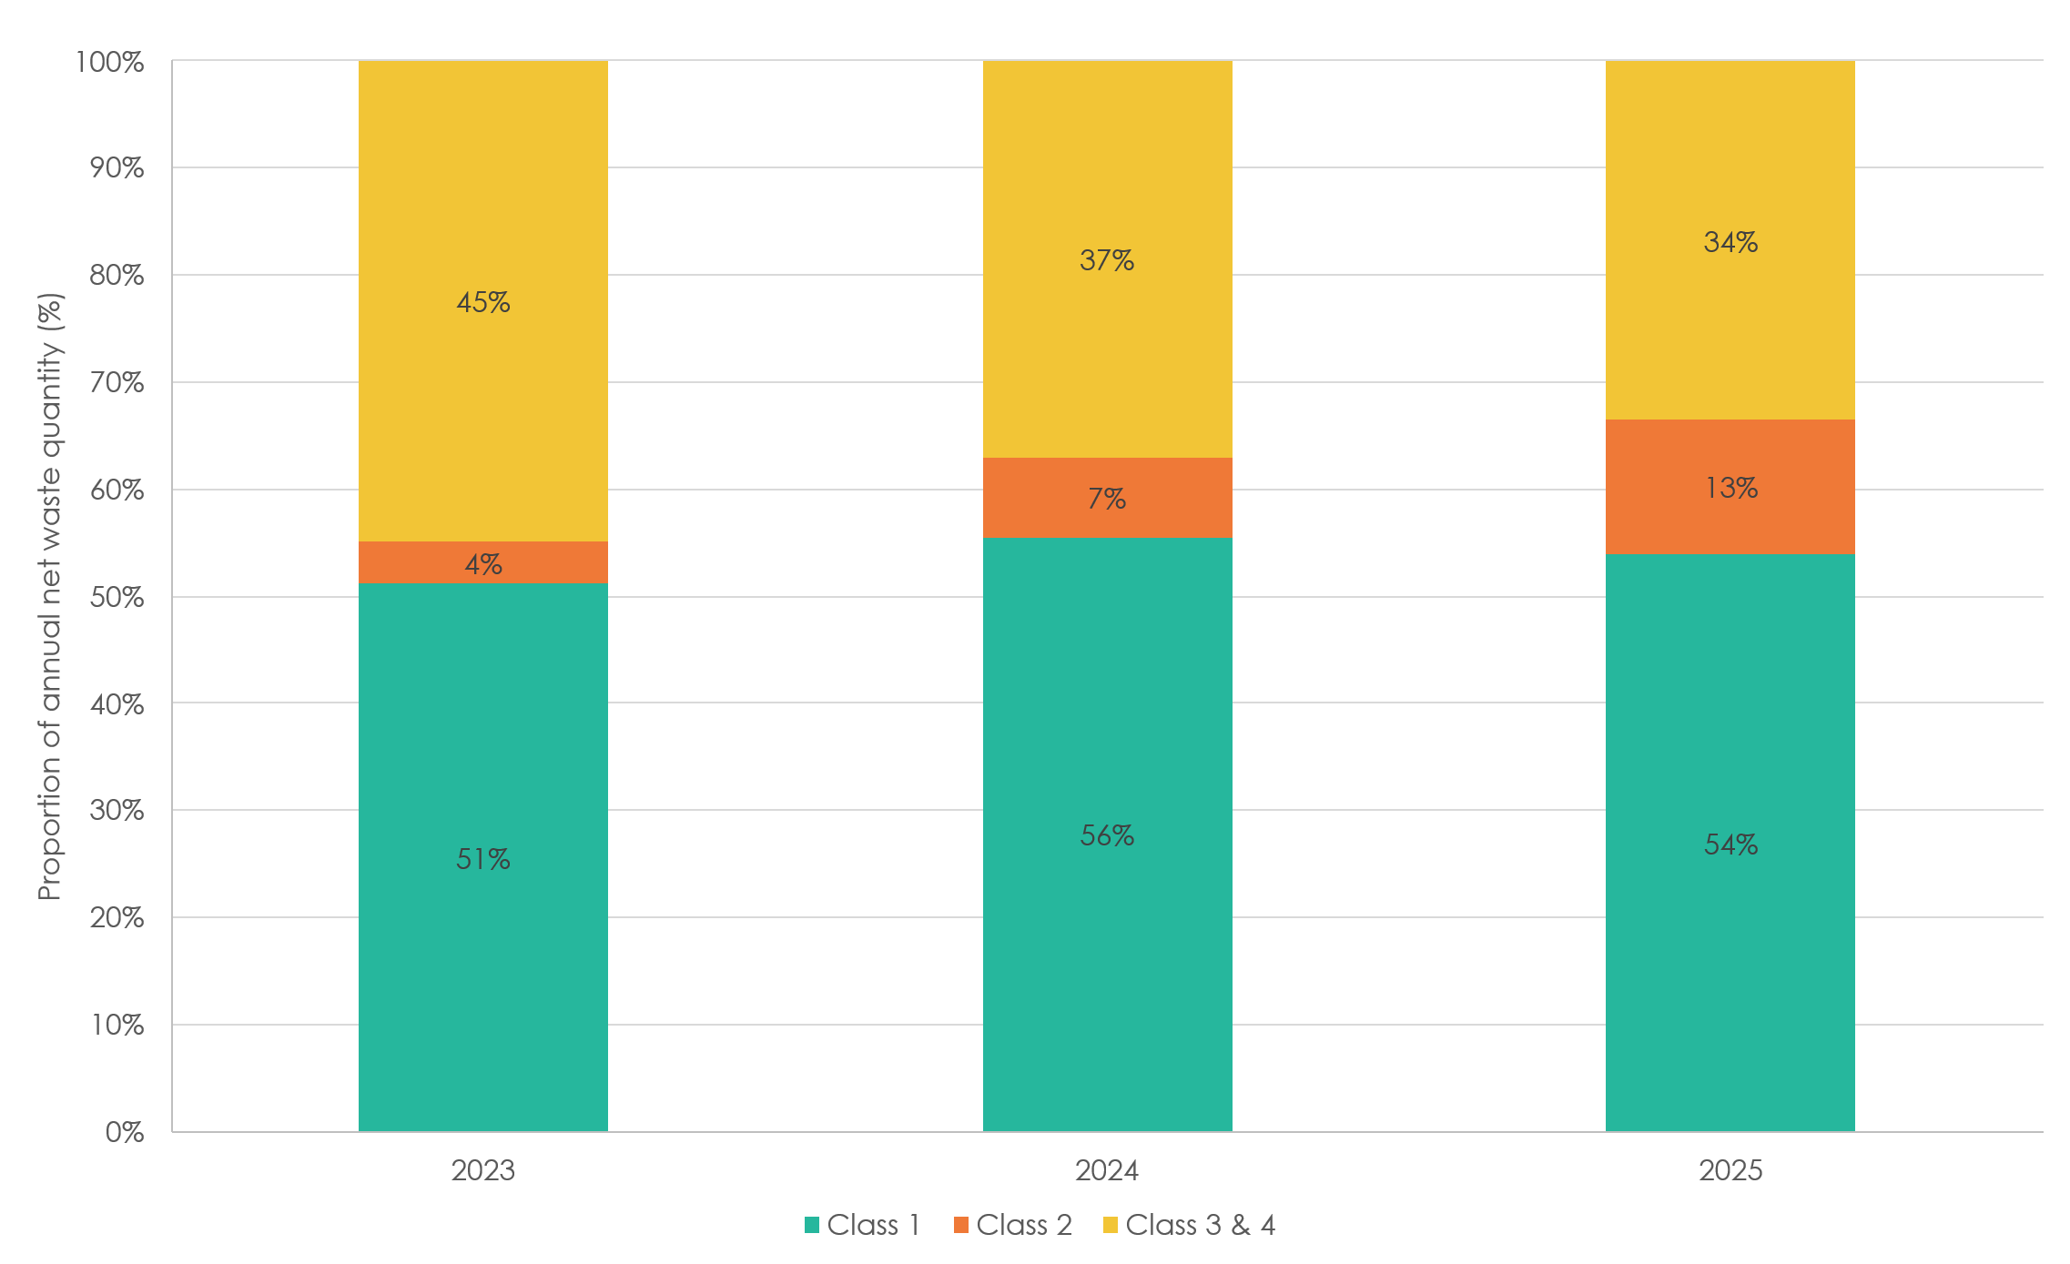

Comparison with GDP and population
Figure 3-4 shows the quarterly quantity of waste at both Class 1 and 2 landfills, plotted alongside New Zealand’s GDP (which is reported quarterly but shown in annual terms). There appears to be a correlation between the waste quantities at Class 1 landfills and the country’s GDP; it is widely recognised that solid waste generation is closely linked to the country’s economic performance. The chart shows, however, that from around 2020-21, the quantity of waste at Class 1 landfills appears to become decoupled from the rising GDP.
For Class 2 landfills, however, this pattern does not appear to be seen. The data is much more limited, in that it only began being recorded in 2022, so it is not possible to identify long term trends, or to identify whether the increasing quantities seen in recent years is in line with expected patterns or not. There is a possibility that, as waste quantities at Class 1 landfills have been decreasing, some of this waste may simply have been transferred to Class 2 landfills, which have seen increases during this period; however, this would not account for all of the decrease seen in Class 1, and it is not possible to conclusively draw this conclusion from the data available.
Figure 3-4: Waste quantities at Class 1 and 2 landfills compared with GDP
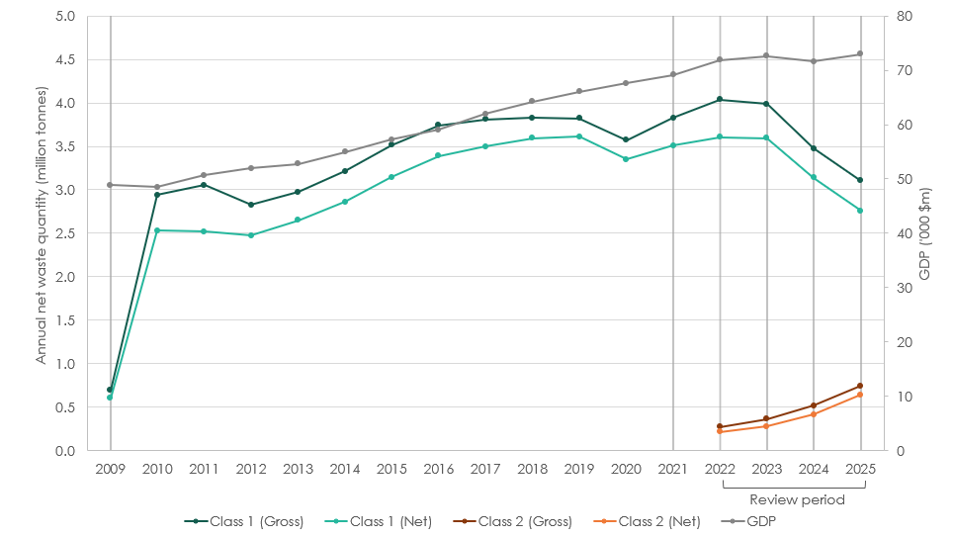
A similar apparent decoupling from population of waste to class 1 facilities but not to class 2 facilities can be seen in Figure 3-5.
Figure 3-5: Waste quantities at Class 1 and 2 landfills compared with population
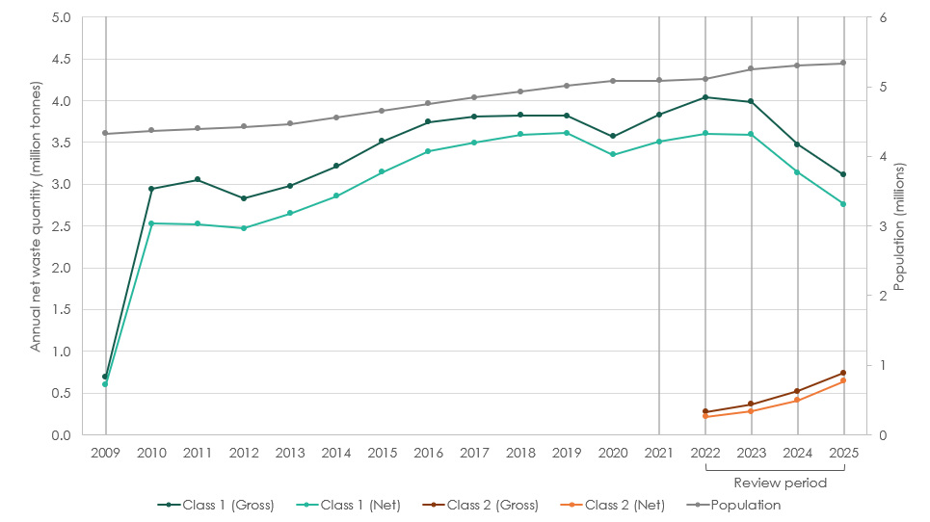

Statistical Analysis
ARIMAX Model Results
A summary of the key outputs from this analysis are presented in Table 3-2 as well as Figure 3-6. Additional details of the full results can be found in Appendix A.2.2.
Table 3-2: Key results of time-series analysis
Variable | Unit | Coefficient | p-value
ma1 |  | -0.7826 | 0.00000
Seasonal_ma1 |  | 0.2654 | 0.00004
tonnage_2 | tonnes/year | 0.3462 | 0.2631
tonnage_34 | tonnes/year | 0.0395 | 0.1259
levy_1 | $/tonne | -1,793.1422 | 0.0345
levy_2 | $/tonne | 857.6472 | 0.1725
levy_34 | $/tonnes | 820.6485 | 0.6206
Gdp | $m | 6.9318 | 0.0003
Pop | no. people | 0.0179 | 0.7663
Covid |  | -107,107.97 | 0.0000

Key findings
Factor | Impact on Class 1 tonnage
Class 1 waste levy | Statistically significant at <5% and a negative relationship with Class 1 landfill tonnage; increases to the Class 1 levy are associated with reductions in Class 1 tonnage, after controlling for other economic factors. The relationship suggests that a $1/tonne increase to the levy results in a reduction of 1,793 tonnes/year.
GDP | Significant at <1% and positive, suggesting a correlation between GDP and waste generation. The relationship suggests that a $1m increase in GDP results in an increase of 6.93 tonnes/year. This relationship is consistent with expectations.
Covid | The impact of Covid-19 was included as a dummy variable in order to control for the sharp decrease in landfill tonnage in April 2020, improving model fit and preventing distortion of estimates of the levy effect.

Figure 3-6: ARIMAX Model Results
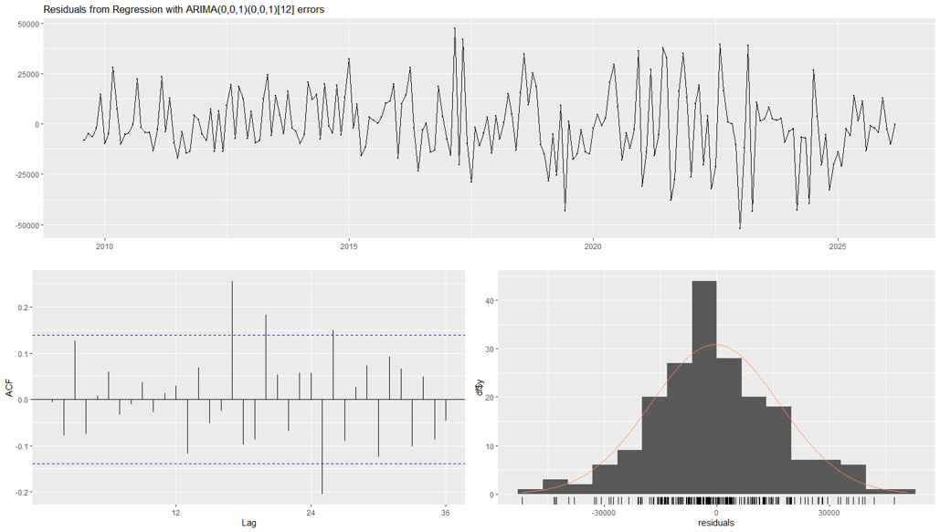

Based on the regression design, all relationships imply causation, except for Class 2 tonnage and Class 3&4 tonnage. Class 1 tonnage is affected by the Class 1, 2, and 3&4 waste levies, GDP, and population; not vice versa.
In the case of Class 2, 3 & 4 tonnages, there could be some reverse causation (i.e. increase in Class 1 tonnage could reduce Class 2, 3 and 4 tonnages), but these are considered insignificant and not used to interpret causation.
We therefore believe it is possible to say with some degree of confidence that increases to the Class 1 waste levy have led to reductions in Class 1 tonnages, while the positive coefficients for the Class 2 waste levy and Class 3 & 4 waste levy are not considered statistically significant, and thus increases to these levies would not be expected to have a significant impact on Class 1 tonnage or diversion of waste between different landfill classes.

Assessment of model fit
A diagnostic plot was generated to provide an assessment of the model fit, shown in Figure 3-7. Overall, the regression fit is good, and it is believed that no additional factors could likely be considered in the model to improve the fit much further. Alternate specifications, such as a log transformation, were tested but did not produce a good fit (primarily due to a significant presence of zero values in the data).
Figure 3-7: In-Sample Forecast against Actual Data
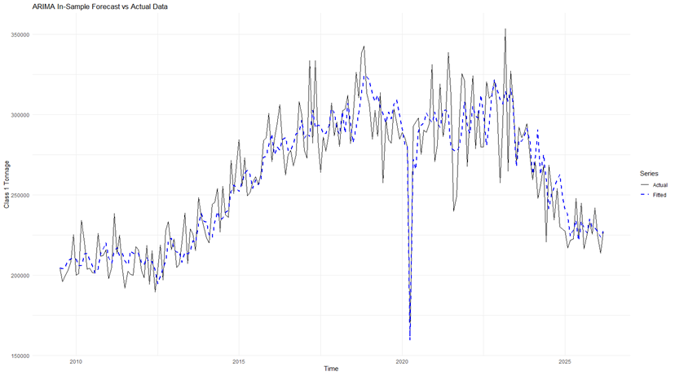

Number of registered sites
Figure 3-8 shows the total number of each type of landfill class since 2009.
This shows that the number of Class 1 and 2 sites and industrial monofills registered has remained either relatively constant or has slightly decreased, in contrast with the consistently increasing number of Class 3, 4 and 5 sites and transfer station registrations. There are two particularly notable spikes – both of which fall outside of this levy review period:
- January 2022: the number of transfer station registrations increases from 103 to 243 (136% increase). This aligns with the introduction of mandatory reporting requirements for transfer stations
- December 2025: the number of Class 5 landfill registrations increases from 127 to 180 (42% increase)
Figure 3-8: Number of registered sites from 2009
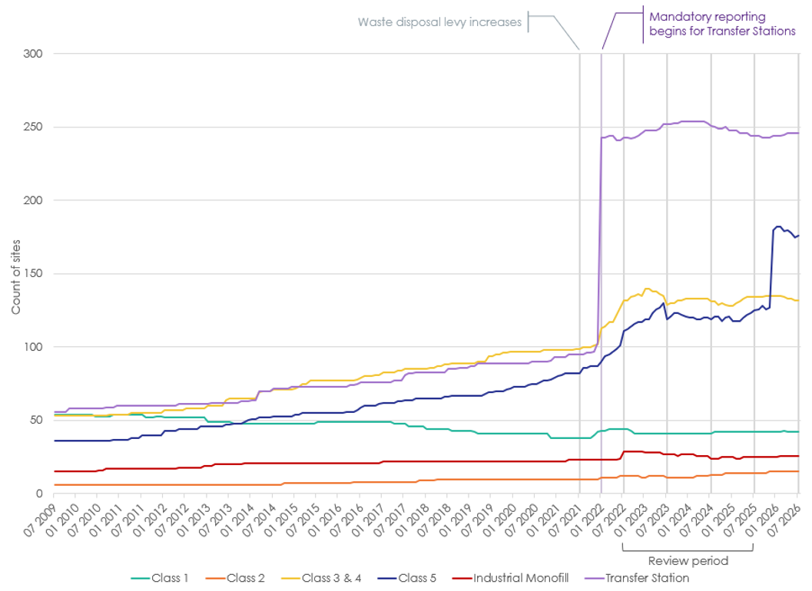
*Note that records of facilities’ “start dates” were used to create this time series. It appears that in some cases, this has been inputted as the actual opening date of the facility, even if this pre-dates reporting for such facility types. In other cases, it has been recorded as the date when reporting began. This causes the presence of registered sites prior to reporting, as well as the spikes that may occur when reporting is introduced.

For the review period in question, between July 2022 and June 2025, the number of sites is predominantly stable across all facility categories, shown in Figure 3-9. The only instances where site numbers (by category) changed by more than a 5% increase or decrease are:
- Class 2 sites: minor fluctuations between December 2022 and March 2024 (between 11 and 12) followed by increases to 13 (July 2024) and then 14 (November 2024)
- Class 5 sites: 8% decrease in July 2023 (from 130 to 119 respectively)
- Industrial Monofills: 8% decrease in July 2024 (from 26 to 24)
Figure 3-9: Number of registered sites during review period
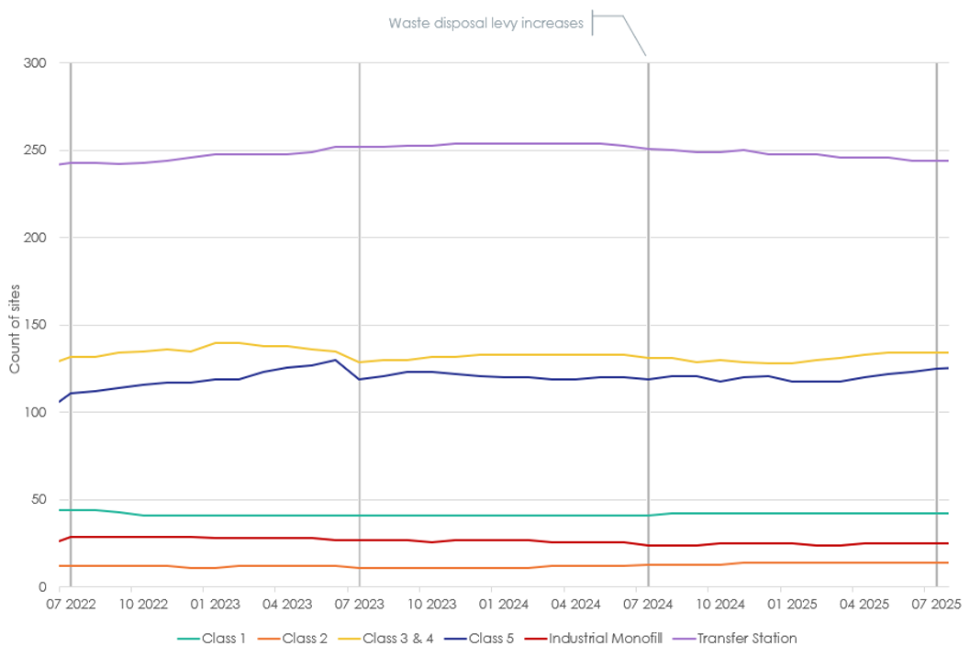

Co-location of sites
During the stakeholder engagement (Section 3.1), it was anecdotally reported by industry players that there has been an increasing trend of ‘co-location’ of landfill sites. This particularly refers to sites that originally homed a Class 1 landfill, and when the levy began or was increased, opened further classes of landfills on the site, which could allow certain materials to be disposed of at a lower levy rate.
The Ministry holds data on all registered landfill sites, both active and closed, which was investigated to assess whether any cases of co-location could be identified. Each site is registered to a specific latitude and longitude, which in many cases is reported to great specificity (e.g. to 6 decimal places, which gives a precision of approximately 0.1m). The latitudes and longitudes of each site were rounded to 2 decimal places (precision of approximately 1km), and any registered sites where both the latitude AND the longitude matched were identified. This produced a shortlist of 106 locations that potentially hosted multiple facilities.
In most cases, there were two facilities in one location. The sites were investigated to identify any locations that hosted a Class 1 landfill (whether it was still active or not), and of those, which hosted additional classes of landfills (in some cases the Class 1 landfill was accompanied by a transfer station, but no additional landfills; these cases were considered out of scope). The sites that were found to have co-located facilities are shown in Table 3-3. Some instances were excluded because they related to sites located close together but known to have different operators, or because the site was no longer active.
Table 3-3: Instances of co-location
Name | Class | Years Active* | Quantities (through each facility on site)
A | Class 1  Class 3 & 4  Class 5 | 2015 – active  2022 – active  2022 – active | < 10k tonnes/quarter  < 1k tonnes/quarter  < 1k tonnes/quarter
B | Class 1  Class 3 & 4 | 2021 – active  2008 – active | < 10k tonnes/quarter  < 1k tonnes/quarter
C | Class 1  Class 2 | 2021 – active  2024 – active | <10k tonnes/quarter  1k – 5k tonnes/quarter
D | Class 1  Class 2 | 2009 – active  2024 – active | > 100k tonnes/quarter  > 5k tonnes/quarter
E | Class 1  Class 2 | 2009 – active  2024 – active | 10k – 100k tonnes/quarter  1k – 5k tonnes/quarter
F | Class 1  Class 2 | 2009 – active  2009 – active | > 100k tonnes/quarter  > 5k tonnes/quarter
G | Class 1  Class 5 | 2022 – active  2001 – active | < 10k tonnes/quarter  < 1k tonnes/quarter
H | Class 1  Class 2 | 2009 – active  2025 – active | 10k – 100k tonnes/quarter  1k – 5k tonnes/quarter
*Note the ‘years active’ are as listed in the Ministry’s database. In some cases, the starting year of the facility is not recorded correctly. If it has been operational since before the levy and reporting requirements began, the start date may have simply been noted as when those began i.e. 2009.
It appears that four Class 2 landfills have been opened at the same site as a Class 1 landfill since 2024. Two Class 5 landfills have opened at Class 1 landfill sites since 2022, and one Class 3&4 landfill in 2022.
Four key sites process 97% of the waste handled through these ‘co-located’ sites. The proportion of waste that is handled through the ‘secondary’ facility on site (i.e. in all of these cases, Class 2) ranges between 5% and 25%.
Alongside the clearer, outright co-location, which can for the most part be identified through the investigation of sites’ precise locations, stakeholders suggested that in some cases, as the levy increased on Class 1 landfills, smaller Class 2-5 facilities begin to open in the surrounding areas.
In an attempt to investigate occurrences of this, a case study was conducted on a site that is known to have had a Class 1 landfill in operation since before the levy was introduced in 2009, and a collocated Class 2 landfill that began operating more recently, in 2025.

Case study: Kate Valley and surroundings
The Kate Valley landfills are located in Canterbury, close to Waipara, around 60km north of Christchurch. The landfill operates as a joint venture agreement between Transwaste Canterbury and WM (formerly Waste Management).
The Class 1 landfill opened in 2005 and thus has been reporting data and subject to the levy since its introduction in 2009. The Ministry’s data records show that a Class 2 facility has been operating at Kate Valley since November 2025.
Local stakeholders reported that smaller facilities closed when the Class 1 Kate Valley site opened, as material began to be diverted there, but now as levy rates have risen, the smaller Class 2 – 5 sites are reopening. The Ministry’s site information was investigated to identify any cases that may back up this anecdotal reporting.
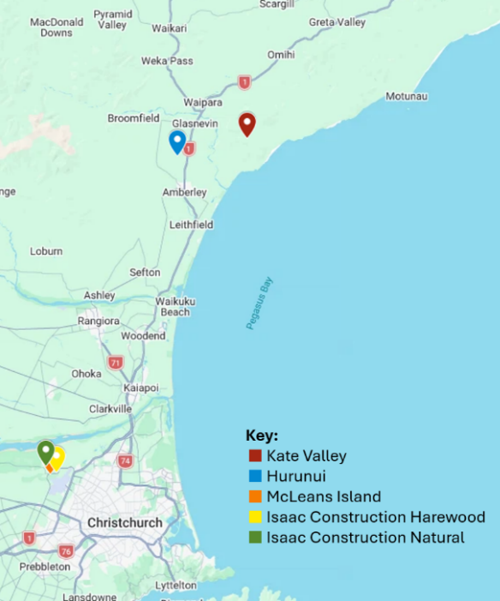
Only one site was found to have opened within arm’s reach of Kate Valley, and this has been operational since 2009 – the Hurunui Class 3 & 4 Managed Fill.
A number of sites have opened in more recent years, closer to Christchurch:
- 2022: McLeans Island, Class 3 & 4
- 2022: Isaac Construction Harewood, Class 5
- 2022: Isaac Construction Natural, Class 3 & 4
The three facilities process a combined quantity of over 30,000 tonnes per quarter.
All three of these sites opened in 2022, alongside the introduction of the Class 2 levy and an increase to the Class 1 rate.

Diverted waste
Diverted tonnage is material that enters a facility but is reused, recycled, or recovered (including waste-to-energy) either within or from the facility within 6 months. It is not possible to identify from the data whether the material has subsequently left the site, or has been reused on-site. Figure 3-10 shows the total quantity diverted from each category of facility, while Figure 3-11 shows this as a proportion of the gross tonnage entering facilities.
Figure 3-10: Annual quantity of waste reported as ‘diverted’ by facilities
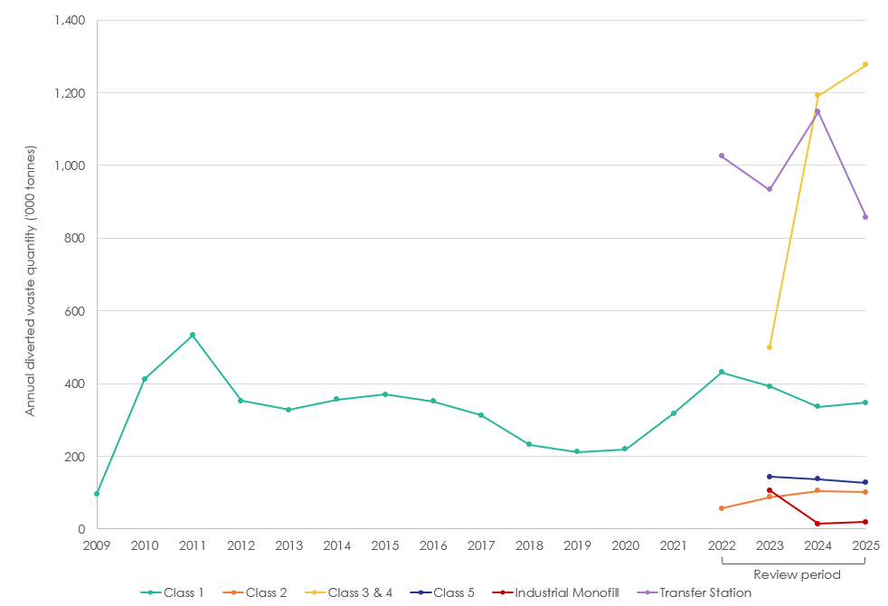

For Class 1 facilities, a decreasing trend in the total quantity of ‘diverted’ waste can be seen since 2022, although with a slight uptick in 2025. As a proportion of the gross tonnage, however, this has remained relatively constant until the slight increase in 2025.
For Class 2, this contrast is even more pronounced, as the quantity has increased year on year between 2022 and 2025, but as a proportion has consistently decreased since 2023
For Class 3 & 4 facilities, both the quantity and proportion have followed an increasing trend since data reporting began in 2023.
Figure 3-11: Annual proportion of waste diverted from facilities
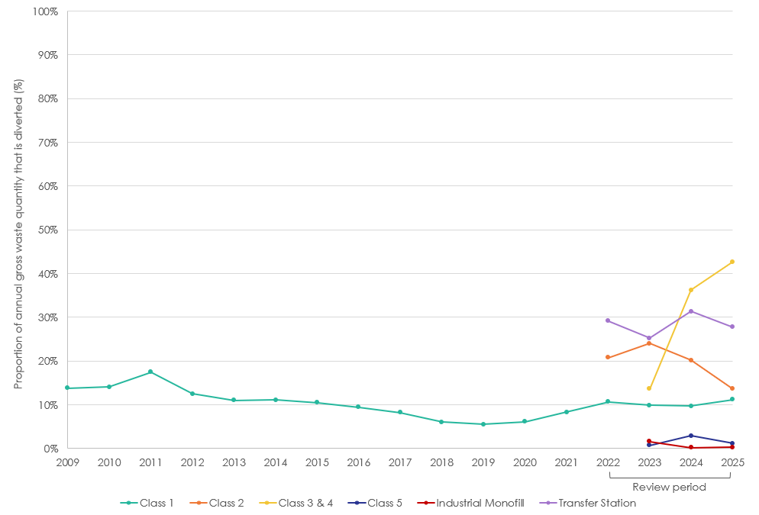

Figure 3-12 shows a box-and-whisker plot depicting the variation of diverted tonnage across sites of each category of facility (excluding outliers). For all categories, the median values are skewed towards the lower end, driven by a number of sites with no reported diversion, while a smaller number of sites report a significant amount of diverted tonnage.

Figure 3-12: Variation of reported diverted tonnage across sites
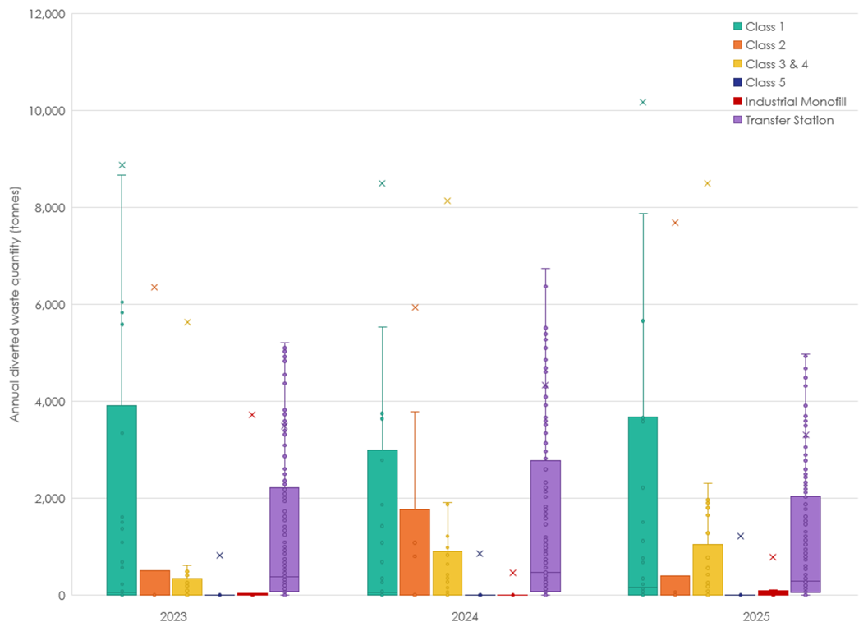

Resource Recovery Trends

Trends in international policies and recycling markets
In the previous review it was noted that, since China’s ban on importing waste was introduced, much recyclable waste was then exported to other south-east Asian countries, including Vietnam, Indonesia, Thailand and Malaysia. In the period since, many of these countries have now also banned or restricted waste imports:
- Thailand,: three-phase restrictions on plastic waste imports announced in 2022; limiting imports in 2023 to only that which could be used in production by specific plants; reducing allowed imports by 50% in 2024; and extensive restrictions in 2025.
- Vietnam,: in 2020 a ban on plastic scrap imports was announced, to be in place by 2025, but appears to have been replaced by the introduction of a regulated import system.
- Malaysia: restrictions on plastic waste imports announced in 2018, tightened in 2022 and, as of 2025, plastic scrap imports are now heavily restricted unless with prior approval upon meeting certain quality standards.
- Indonesia: Restrictions on plastic waste imports was announced in late 2024, to be implemented in 2025.
Even with the introduction of regulations in 2018 and tightening of regulations in 2022, Malaysia consistently remained the single largest destination for New Zealand’s plastic scrap exports from 2019 until 2024. Despite the heavy restrictions introduced in 2025, a significant quantity was still exported to Malaysia in 2025, although this was approximately halved compared to the previous year. Increasingly heavy quality requirements demanded by export markets is likely to be placing heavier pressure on MRF operators to control the waste materials they accept.
Figure 3-13 shows the total quantity of plastic scrap exports from New Zealand, alongside the quantities exported to the countries noted above (using overseas merchandise trade data, assessing the custom codes 3915 including “Ethylene polymers; waste, pairings and scrap”, “Plastics n.e.c.; waste, pairings and scrap” and “Styrene polymers; waste, pairings and scrap”).
After an initial drop in plastic scrap exports between 2019 and 2020 (which could also be linked to the Covid-19 pandemic), the quantity has risen again and remained fairly stable between 2023 and 2025. Any decrease in quantities exported to Malaysia appears to have been compensated for through increases in exports to other countries – including Indonesia; despite the announcement of further restrictions in 2025, exports rose by 62% between 2024 and 2025 (from 5.56 million kg to 8.98 million kg). It is likely that controls are in place in Indonesia that still allow exports to specific plants, as per other countries in the region.
Figure 3-13: Quantity of New Zealand's plastic scrap exports to key countries
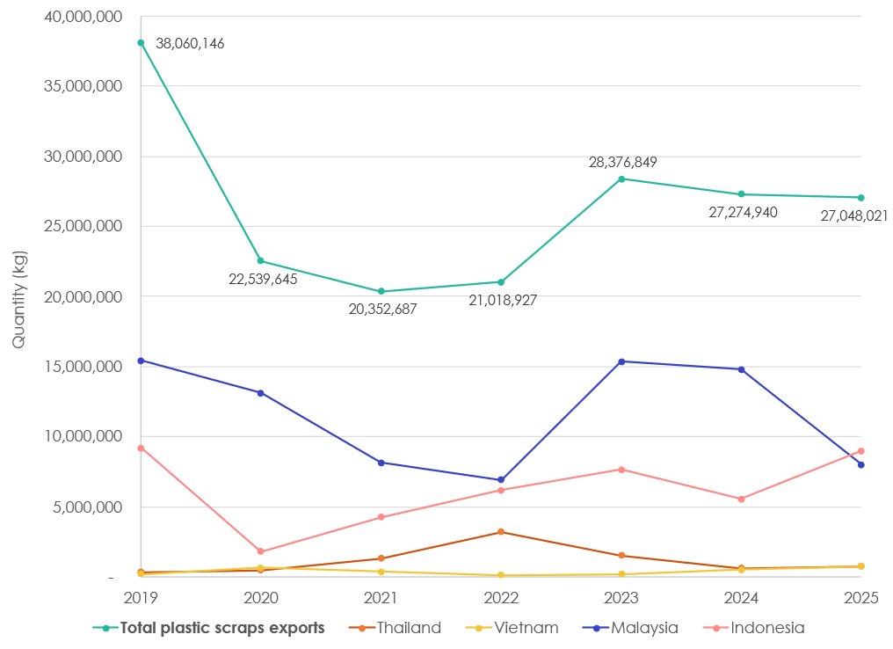
This is all part of a continuing trend towards tighter controls on exports of recycling commodities, making it harder for New Zealand exporters to find suitable markets abroad. The Basel Convention is a key factor, the aim of which (since 1989) has been to prevent the dumping of hazardous waste from developed and industrialised (notably OECD and EU) countries, including New Zealand, on less developed countries without the means to treat that waste safely and effectively. Controls include notification, prior informed consent and movement tracking. Restricting what and where plastics can be exported became part of the Basel Convention in 2021, imposing restrictions on hazardous plastics, for example those from e-waste that contain brominated flame retardants (BFRs), and (importantly) unsorted plastics, which are considered hazardous. The Imports and Exports (Restrictions) Act 1988 (Imports and Exports Act) places permitting requirements on the export of mixed or contaminated plastic waste from New Zealand, as required under the Basel Convention. The regulatory framework relies on the exporter to identify if a permit is required.
The 2021 changes to the Basel Convention are likely to be contributing to a redirection of waste to other countries. Between 2023 and 2025, exports of plastic scraps to the US have increased 1925% (from 100 tonnes to 2,000 tonnes) and to Australia 392% (from 705 tonnes to 3,471 tonnes). The US is not a party to the Basel Convention, meaning Basel Parties are unable to trade controlled plastic scrap without a separate agreement; this could be the reason why no plastic scrap was exported from New Zealand to the US in 2021, but has increased since. Exports of controlled waste to the United States of America, and other non-Basel parties, still requires a special Article 11 agreement under Basel, or are deemed illegal.
Additionally, in January 2023, revisions were made to the EU Waste Shipment Regulations. Key elements of these changes include the following, although many are not yet operational:
- Banning the export of plastic waste to non-OECD countries, and phasing out exports to OECD countries within four years
- Banning shipments of all waste destined for disposal within the EU
- Requiring demonstration that waste shipped outside the EU be managed in an environmentally sound manner
- Where waste is exported to non-OECD countries for recovery, requiring consent from the receiving country and demonstration of their ability to sustainably manage the waste
These policy shifts have all taken place against the backdrop of ongoing international (United Nations) discussions around moving towards a legally binding Global Plastics Treaty, which could include measures around plastic products, plastic design and the role of trade in managing plastic waste.

Likely impact on quantities
While the distribution of materials exported to each country has shifted in response to these policies, the total quantity of recyclable waste exported does not appear have been affected overall. Furthermore, changes in international markets are not thought to have had a large effect on resource recovery rates.

Domestic recycling infrastructure
New Zealand’s recycling infrastructure and access continues to be fragmented; materials that can be economically processed onshore are limited and the rest must be exported for recycling. The recycling industry therefore operates within the global context of commodity markets and prices.
New Zealand has historically had a deficit in resource recovery infrastructure. Despite investment through the Waste Minimisation Fund (WMF) and other sources over the review period, this remains the case. Information on WMF investments is available on an interactive dashboard on the Ministry’s website.
Difficult operating conditions and insecure feedstock supply can make financial viability challenging for onshore processing. In addition to historic deficits, some onshore processing capacity reduced over the review period. By way of examples in the fibre recycling sector, Oji Fibre Solutions closed its Penrose fibre mill (78,000 tonnes/year capacity) in December 2024, its Kinleith Mill facility in June 2025 (90,000 tonnes/year capacity), and also announced in March 2026 the decision to cease manufacturing Specialty Boards at their Hamilton facility later in 2026.

Likely impact on quantities
The closure of the fibre facilities appears to have redirected cardboard and paper to offshore facilities. There has been a slight decrease to total quantities recycled, but not significantly different than trends seen in previous years.
Despite the launch of multiple C&D facilities,,, , the quantity recovered by WRIA members has decreased between 2022 to 2025.

Increasing standardisation of domestic recycling
The standardisation of kerbside collections was announced in September 2023 and in place from February 2024. The policy standardises the materials that must be collected within recycling and food scraps services across the country (however, it does not mandate that councils must have these services in place).
- Materials that must be accepted in kerbside recycling: glass bottles and jars; paper and cardboard; PET, HDPE and PP bottles, trays and containers; aluminium and steel tins and cans
- Materials that must not be accepted in kerbside recycling: undersized or oversized items; lids, caps and tops (except where tethered); aerosols; liquid paperboard; aluminium foil and trays; other plastics (PVC, LDPE, PS, EPS, other); soft plastics; plant pots; paint containers; hazardous substance containers
- Materials that must not be accepted in food scraps services: paper and cardboard; compostable packaging; tea bags; sawdust; animal waste; ash

Likely impact on quantities
The standardisation could have varying impacts; for some councils, it may have led to a reduction in the range of materials collected at kerbside. However, it may also have led to an improvement in contamination levels, which could increase the overall quantity that is recycled. The quantity of recyclable waste collected at the kerbside is relatively low in comparison to commercial or industrial sources, so has a smaller impact overall.

Public attitudes and beliefs
In 2023, the Ministry funded research to understand and track changes in people’s attitudes, awareness and behaviours around waste minimisation. The research was repeated over three years: 2023, 2045 and 2025. The latest report found the following key findings:
- Recycling remained widespread: 97% reported they recycle in 2025 (96% in 2024)
  - Data from the Waste & Recycling Industry Association (whose members together handle 90% of the industry’s material flow), which shows that residential collections have seen an increasing quantity of general waste but a decreasing quantity of recycling since 2023.
- When uncertain about whether an item was recyclable, most people opted to put it in the rubbish rather than contaminating recycling (87% in 2025; 90% in 2024; 88% in 2023)
  - This stated behaviour does not necessarily align with people’s actual practices. For example, in Auckland specifically, it has been reported that around 30% of kerbside recycling is destined for landfill due to contamination, with the public incorrectly disposing of general waste items in their recycling bins. This is stated to be an upward trend since 2020.
- An increasing number of people taking items to separate drop-off locations (63% in 2025; 48% in 2024; 59% in 2023)
- A majority of people practice good recycling habits, with this mostly staying stable:
  - Rinsing/cleaning recycling (75%; 77%; 83%)
  - Removing non-recyclable parts (71%; 68%; 69%)
  - Removing plastic wrap from meat trays (70%; 67%; 73%)
  - Removing lids (67%; 67%; 65%)

In addition, Rabobank has conducted a survey on attitudes to food waste over the last five years (2021, 2022, 234 and 2025). Some key observations include:
- A consistent majority of people claim to care about reducing food waste (82% in 2025; 81% in 2023; 80% in 2022; 79% in 2021)
- A similar number care about reducing waste (in general, e.g. single use plastic, recycling) (78%; 78%; 78%; 79%)
- The self-reported estimated rate of food waste, as a proportion of household spend on food, has decreased since 2022 (10,9%; 12.2%; 13.4%; 8.6%)
- A significant majority of people engage in practices that likely lead to reduced food waste (the figure shown is the proportion that ‘always’ or ‘sometimes’ do this in 2025):
  - Using a shopping list for buying groceries (95%; always: 64%, sometimes: 31%)
  - Thinking about portion size when preparing food / cooking (94%; always: 53%, sometimes: 41%)
  - Eating leftovers from a previous meal (98%; always: 48%, sometimes: 49%)
  - Using leftovers to make a new meal the next day (92%; always: 33%, sometimes: 59%)
  - Planning meals in advance (93%; always: 39%, sometimes: 54%)
  - Freezing food that doesn’t get eaten (88%; always: 30%, sometimes: 58%)
  - Eating food that is past its ‘best before’ date (89%; always: 15%, sometimes: 74%)
- There is a slight preference for less expensive, imperfect fruits and vegetables (45%) compared to more expensive, visually perfect ones (39%), although a significant amount have no preference (17%)

Likely impact on quantities
Increasing awareness of recycling and improving behaviours could lead to an increase of materials for recycling and reduction in non-recyclable waste. Behaviour change activities focused on waste minimisation could reduce overall quantities. However, overall, quantities of recyclable materials stemming from public behaviour is relatively small in comparison to industrial and commercial sources.

Waste reduction work programme and emissions reduction plan initiatives
Household / kerbside waste management policies
In November 2022, the Government announced five policies to address household recycling. In December 2024, however, the government halted four of these – all except the standard materials policy, which had already come into effect.

Single use plastic policies
In 2021, a plan to phase-out certain single-use and non-recyclable plastics was announced, with three phases. The first two phases were completed in 2022 and 2023, before the third phase, intended for 2025, was halted by the Government in November 2024:
- Phase 1, October 2022, in place: ban on single-use plastic drink stirrers and cotton buds, PS takeaway food and drink packaging, all EPS food and drink packaging, and some PVC food trays and plastics.
- Phase 2, July 2023, in place: ban on single-use plastic tableware and plastic produce bags, restrictions on the use of plastic straws, and beginning of a transition from plastic to compostable produce labels.
- Phase 3, July 2025, pending decision: ban on all other PVC and PS food and drink packaging.
The deadline for the transition from plastic to compostable produce labels was also extended, from July 2025 to July 2028 in order to align with the timing of overseas regulatory changes.

Product Stewardship
In New Zealand, the 2008 Waste Minimisation Act allows for both mandated and voluntary product stewardship schemes to be created. The Government can declare ‘priority products’, for which product stewardship schemes must then be developed and accredited. In 2020, the following priority products were declared: tyres; electrical and electronic products; agrichemicals and their containers; refrigerants and other synthetic greenhouse gases; farm plastics; plastic packaging. The Ministry works with industry to co-design the schemes for these products.
As yet, only the scheme for tyres (‘Tyrewise’) is operational and regulated. The scheme launched in March 2024, with collections of tyres beginning in September that year. In the 7 months between September 2024 and March 2025, the scheme collected 36,801 tonnes of tyres, equivalent to around 4.6 million passenger car tyres. Tyrewise estimates that over 5.5 million tyres are imported into New Zealand each year, either loose or fitted on imported vehicles.
The schemes for refrigerants and other synthetic greenhouse gases(‘Cool-Safe’) and for farm plastics, agrichemicals and their containers (‘Agrecovery’) are both operational on a voluntary basis, with regulations in development.
The design projects for large batteries, other e-waste, and plastic packaging have all been completed.

Voluntary commitments
A number of major brands and producers of packaging products signed up to the ANZPAC Plastics Pact. This comprised commitment to a number of targets including ensuring that, by 2025, 100% of plastic package they produce is reusable, recyclable or compostable.

Wider waste minimisation policies and work programme
In March 2025, the Ministry’s updated waste and resource efficiency work programme for 2024 to 2026 was published. Policies that may affect the quantity of recycling and resource recovery include:
- Continued investment of the waste disposal levy, prioritising: contaminated sites; infrastructure; innovation, community solutions and education; and system design (e.g. development of product stewardship schemes)
- Targeted investment in resource recovery infrastructure and systems in order to reduce waste emissions
- Ensuring plastic packaging is recyclable and high value
- Further development of product stewardship schemes, including for: tyres; synthetic refrigerant gases; farm plastics, agrichemicals and their containers; electrical and electronic products including batteries; plastic packaging
- Developing a framework for a potential beverage container return scheme as part of waste legislation amendments
- Enabling the reduction of C&D waste, prioritising investment in C&D separation and recovery infrastructure
The Recycling Leadership Forum, established in May 2024 contributes advice and information to the Ministry from a range of representatives of the retail, packaging, food & grocery, recycling and local government sectors, focusing on improving recyclability of key materials that are not included in kerbside recycling.

Likely impact on quantities
The phasing out of hard-to-recycle single use plastics could have led to a shift towards more recyclable packaging types and a reduction in contamination of recycling streams, thus increasing the overall amount of recyclable material.
The launch of the Tyrewise product stewardship scheme has contributed to an increasing quantity of tyres destined for recycling.

International Research
This review provides a comparative analysis of waste disposal levies in New Zealand, Australia, and selected European countries. The European countries include Austria, Denmark, Finland, Belgium (Flanders), France, Ireland, Italy, the Netherlands, Sweden, Norway, Slovakia, Spain, Switzerland and the United Kingdom (UK), chosen to reflect a diverse range of policy designs and implementation approaches.
The analysis examines several key dimensions of waste disposal levy systems, including:
- Levy rates and their variation across jurisdictions;
- The structure and scope of levies, including distinctions such as active versus inert waste and metropolitan versus regional applications;
- The regulatory frameworks underpinning waste disposal levies in New Zealand, Australia, the European Union, and the UK;
- The allocation and use of levy revenues across different jurisdictions; and
- The timing of policy adoption, specifically the years in which waste disposal levies were first introduced in each jurisdiction.

Waste Levy Rates

Levy Rates in Australia
All states and territories in Australia, except for the Northern Territory, have implemented a waste levy of some sort. The structure and scope of each levy vary greatly between the states and territories.
Key information for waste levies across Australia is presented in Table 3-4. In all cases, the levy rate quoted is expressed per tonne of waste landfilled. The 2026/27 rates for Australia and New Zealand apply from 1st July 2026. All levy rates were originally collected in their respective domestic currencies and subsequently converted into NZ$ using spot exchange rates. Please note that, due to fluctuations in exchange rates, levy levels reported in New Zealand dollars (NZ$) are indicative only. New Zealand’s waste levy has also been included for the purposes of comparison.
It is notable that the majority of Australian state levies are applied on the basis of the type of material (e.g. household/municipal, industrial) or location of the site (e.g. rural, metropolitan), rather than explicitly on the basis of the Class of the landfill. The figures presented in the table are indicative, and some states may have additional levies or rates apply.
Table 3-4: Waste Levies across Australia and New Zealand
State | Levy rate ($/tonne)
Australian Capital Territory | 2025/26  Household waste: A$117.50 (NZ$141.96)
Northern Territory | A waste disposal levy does not exist
New South Wales | 2026/27  Standard waste (Metropolitan Area): A$180.20 (NZ$217.72)  Standard waste (Regional Area): A$103.80 (NZ$125.41)  Virgin excavated natural material (Metropolitan Area): A$162.20 (NZ$195.97)  Virgin excavated natural material (Regional Area): A$93.40 (NZ$112.84)
Queensland | 2025/2026  Standard waste (metropolitan areas): A$125.00 (NZ$151.02)  Standard waste (regional areas): A$97.00 (NZ$117.19)  2026/2027  Standard waste (metropolitan areas): A$135.00 (NZ$163.11)  Rate for regional areas will increase with annual indexation rate.
South Australia | 2026/27  Solid waste (metropolitan Adelaide): A$171.00 (NZ$206.60)  Solid waste (non-metropolitan Adelaide): A$85.50 (NZ$103.30)
Tasmania, | 2026/27  A$70.56 (NZ$82.25)
Victoria | 2026/27  Municipal and industrial waste (metro and provincial areas): A$177.19 (NZ$214.08)  Municipal waste (rural areas): A$88.42 (NZ$106.83)  Industrial waste (rural areas): A$155.95 (NZ$188.42)
Western Australia | 2026/27  A$90.00 (NZ$108.74)
New Zealand | 2026/27  Municipal landfill (class 1): $70.00  Construction and demolition fill (class 2): $40.00  Managed or controlled fill facility (class 3 and 4): $15.00
Figure 3-14: Levy rates in New Zealand and Australian states and territories
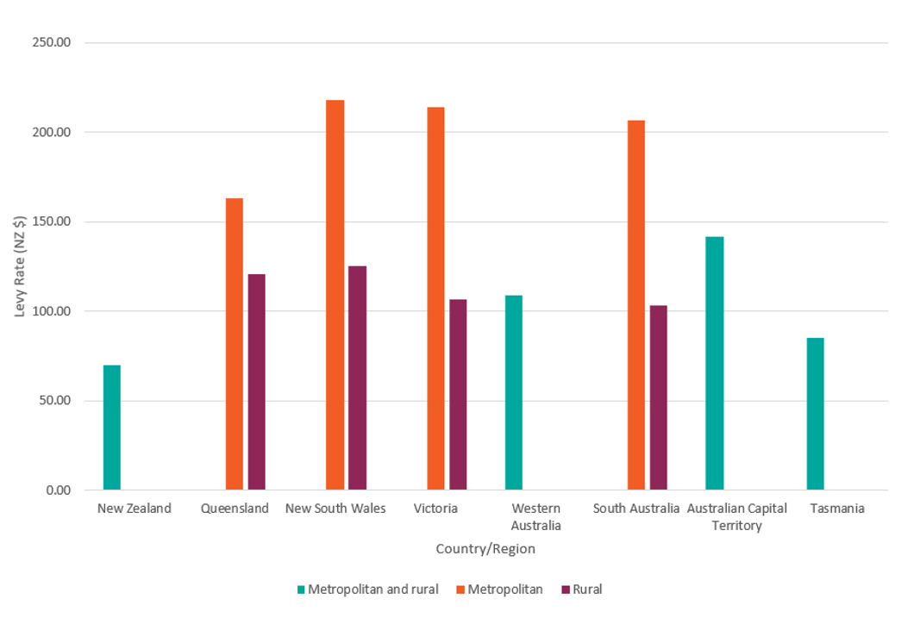
Figure 3-14 compares waste disposal levy rates (NZ$) between New Zealand and Australian states and territories. New Zealand applies a single national rate of NZ$70 for Class 1 landfills, whereas Australian rates vary by state or territory. In some Australian regions, levy rates are further differentiated between metropolitan and rural areas; where this occurs, metropolitan rates are consistently higher than rural rates. Metropolitan levies range from about NZ$160 to NZ$220, while rural rates are lower, ranging from about NZ$100 to NZ$125. Western Australia, the Australian Capital Territory, and Tasmania each report only one rate, which is generally closer in value to rural rates. Overall, waste disposal levy rates across all Australian states and territories shown are higher than the national rate for Class 1 landfills in New Zealand.

Levy Rates in Selected European Countries
Since the introduction of the Waste Hierarchy in the Waste Framework Directive, landfilling has transitioned from being the default disposal method to the last resort for EU Member States. Based on the Waste Hierarchy, EU Member States must either recycle it or recover its energy by incinerating the waste. Moreover, the Landfill Directive mandates EU Member States to pre-treat municipal waste before sending it to landfill, along with a maximum 10% target for landfilling of municipal waste. As a result, many of these European countries have been using the landfill tax as an economic incentive mechanism for diverting waste from landfill to other treatment or disposal methods.
The review in this section of the report focuses on key EU Member States and the United Kingdom. The following countries are covered:
- Austria;
- Denmark;
- Finland;
- Belgium (Flanders);
- France;
- Ireland;
- Italy;
- The Netherlands;
- Sweden;
- Norway;
- Slovakia;
- Spain;
- Switzerland; and
- United Kingdom
Key information for waste levy rates across a broad selection of EU Member States is presented in Table 3-5. The levy rates represent the most recently available data in the public domain. Consequently, the applicable years vary across countries in accordance with the timing of updates or publications.
Table 3-5: Waste Disposal Levies across selected European Countries and Regions
Country | Levy rate (local currency / tonne)
Austria | 2025/26  Range from €23.70 to €100.10 for disposal of waste to landfill. (NZ$47.27 to NZ$199.65)
Belgium (Flanders) | 2025/26  €134.22 for standard active municipal solid waste (NZ$267.70)  €73.82 for inert waste (NZ$147.23)
Belgium (Wallonia) | 2021/22  €120.52 for general waste (NZ$240.37)
Denmark | 2023/24  475.00 kr. for all waste unless exempted (NZ$126.88)  The exemptions primarily cover low-risk, inert, or reusable materials, such as clean soils, certain construction debris, specific combustion residues, and qualifying compost or recovered waste.
Finland | 2023/24  €80.00 (NZ$159.56)
France, | 2025/26  €65.00 (NZ$129.64)
Italy | 2025/26  Levy rates vary by region:  Lower estimate – €5.17 (NZ$10.31)  Upper estimate – €25.82 (NZ$51.50)  Average – €15.50 (NZ$30.90)
Ireland | 2023/24  €85.00 (NZ$169.53)
The Netherlands | 2026/27  €40.85 (NZ$81.47)
Norway | A waste disposal levy does not exist.
Slovakia | 2021/22  Levy varies by region dependant on level of municipal waste separation  €11.00 for less than or equal to 10% separation (NZ$21.94)  €33.00 for more than 60% separation (NZ$65.82)  Average – €22.00 (NZ$43.88)
Spain | 2026/27  €40.00 for municipal waste (NZ$79.78)
Sweden | 2025/26  750.00 kr for all waste ($NZ135.95)
Switzerland | 2024/25  Fr. 16.00 for landfill types C, D and E (NZ$34.61)  Fr. 5.00 for landfill type B (mainly inert) (NZ$10.82)
United Kingdom | 2026/27  £130.75 for active waste (NZ$302.00)  £8.65 for inert waste (NZ$19.98)

Figure 3-15: Levy rates in New Zealand, Australia and selected European countries
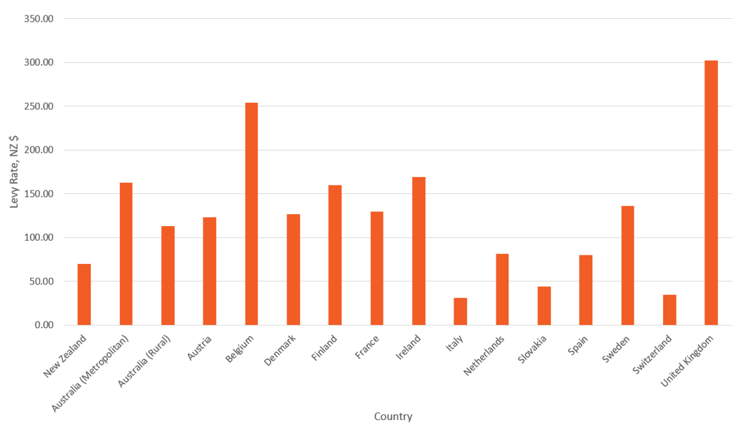
*Averages have been calculated for this figure in instances where countries have different rates for different areas and waste types (i.e. for Australia, Austria, Belgium, Italy, and Slovakia).
Figure 3-15 compares waste disposal levy rates across New Zealand, Australia, and a range of European countries. New Zealand has one of the lowest rates at NZ$70, which is below most European rates shown. The United Kingdom has the highest levy, at just over NZ$300, while countries such as Belgium (around NZ$220), Ireland (around NZ$170), Finland (around NZ$160), and metropolitan Australia (around NZ$160) also have substantially higher rates than New Zealand. A number of European countries, along with rural Australia, fall into a moderate range, including Austria, Denmark, France, Sweden, Spain, and the Netherlands, with rates generally between NZ$80 and NZ$135. In contrast, Italy, Slovakia, and Switzerland have lower rates than New Zealand, ranging from approximately NZ$30 to NZ$45. Overall, Australian rates sit between New Zealand and the higher European values, with metropolitan rates notably higher than rural rates. The graph highlights that New Zealand’s waste disposal levy is relatively low compared with most European countries.

Structure of the Levy
The categorisation of waste varies across EU countries and between states and territories in Australia. Nevertheless, in most cases waste disposal levies apply to the primary waste streams, including mixed household and commercial waste, as well as certain industrial and construction wastes, thereby covering a significant proportion of total waste generated.
This section provides a brief summary of the main waste disposal levy pricing structures found in our review. As shown in Table 3-4 and Table 3-5, these range from a simple, one rate approach, to complex approaches involving many different rates for different waste types.

Active/Inert
A common structure for waste disposal levies in the EU is to have one rate for active waste and another for construction and demolition (C&D) or inert waste. The exact way in which this is specified in regard to waste type varies across countries, as indicated in Table 3-5. For example, some differentiate the inert fraction, and several do not indicate any specifics at all. The general argument for setting inert levy rates at a much lower level than active rate wastes is because the environmental damages from landfilling are much lower. Moreover, the large quantities and low disposal costs result in significant marginal changes, even at low levy rates.
The UK and Austria are examples of waste disposal levies with two rates. In the UK, a ‘standard’ and ‘lower’ rate is applied. The lower rate of levy can only be applied to waste that meets the following criteria:
- Non-hazardous;
- Low potential for greenhouse gas emissions (i.e. waste which are not biodegradable with little or no organic content); and
- Low polluting potential in the landfill environment. ,
The lower rate is therefore applied mainly to what is commonly termed ‘inert’ waste, however, the guidance, which also includes a full list of qualifying materials for the lower rate, ensures that the lower rate is applied only to waste which meet certain criteria in terms of their environmental impact.
Some countries, such as Denmark, apply a single waste disposal levy rate, with exemptions for certain waste streams, primarily inert or low-risk materials, that are not subject to the levy.

Metropolitan/Rural
Another approach taken to differential pricing for a waste disposal levy is to set a higher rate for metropolitan waste (i.e. waste generated closer to major urban centres) and a lower rate for waste from rural areas. This pricing structure, which is employed in most Australian states and territories, aims to address the different financial and operational considerations for rural and metropolitan areas, such as:
- Lower population densities in rural areas increases the costs of waste transportation relative to metropolitan regions. The imposition of a waste levy compounds these waste transport costs, increasing the relative costs of regional landfills;
- Access to recycling services is reduced for rural populations, for example, there is much more limited implementation of kerbside recycling due to the higher costs associated with population spread.
- Metropolitan areas are in a better position to reduce waste disposal and increase reuse and recycling compared to rural areas
Australia’s population is highly urbanised, and rural areas are very sparsely populated. This pricing structure addresses the particular requirements presented by this population distribution; hence it is more prominent in Australia. It can, however, lead to the transport of waste across large distances in order to take advantage of lower fees in other areas.
In New Zealand, distances between locations of waste generation and treatment or disposal are generally shorter than in Australia, although regional exceptions exist. Transport costs can form a significant component of overall costs for recovering or disposing of waste in some areas, such as the West Coast of the South Island. Therefore, there may be instances where a case does exist for a lower rate. S41 (1)(d) of New Zealand’s Waste Minimisation Act 2008 allows different rates to be applied to individual facilities. Therefore, any issues in respect of distances to markets could be examined on a case-by-case basis without needing to consider an overall urban/rural split. In general, an alternative approach could be to first consider using levy income to support remote communities through investment in infrastructure and/or subsidy of appropriate services.

Regulatory Regime

European Union
The Waste Framework Directive (2008/98/EC) provides the overarching legal framework for waste policy across EU Member States. It establishes the waste hierarchy, which prioritises prevention as the most preferred option, followed by preparing for re-use, recycling, and other forms of recovery, with disposal (such as landfilling) considered the least preferred option. The Waste Framework Directive (WFD) also embeds the “polluter pays” principle, requiring waste producers to bear the costs of waste management. Within this regulatory framework, Member States are able to determine the scope and rates of waste disposal levies.
First introduced in 1999 and subsequently amended in 2018, Directive 1999/31/EC on the landfill of waste (as amended by Directive (EU) 2018/850) constitutes the primary legislative framework governing landfills in the EU. Primarily, the Landfill Directive:
- establishes key technical and operational requirements for landfill sites;
- classifies landfills into three categories (hazardous, non-hazardous, and inert);
- and requires Member States to reduce the amount of biodegradable waste sent to landfill.
The 2018 amendments further strengthen these provisions by:
- introducing restrictions, from 2030, on the landfilling of waste suitable for recycling or other forms of material or energy recovery;
- setting a target to limit municipal waste landfilled to 10% by 2035;
- and enabling Member States to apply economic instruments and other measures to support the implementation of the waste hierarchy.

United Kingdom
The United Kingdom was a member of the European Union at the time the Landfill Directive was introduced and was therefore, like all Member States, required to transpose it into domestic law. Following the UK’s withdrawal from the EU, the Directive’s provisions were retained in domestic law under the European Union (Withdrawal) Act 2018. As of 2026, no replacement legislation has been introduced, and the existing regulatory framework remains in force and continues to be actively enforced by the Environment Agency.
The UK Landfill Tax was introduced in 1996 in order to better reflect the environmental costs of landfilling. The aim was therefore both to reduce the overall levels of waste produced and to send less waste to landfill.
The UK landfill tax has two bandings: inert waste and non-inert waste. The current structure of the New Zealand Waste Disposal Levy is similar to the structure of the UK landfill tax, with lower rates for inert waste sent to Class 2, 3, and 4 landfills, and a higher rate for the non-inert waste sent to Class 1 landfills.
The UK landfill tax started with initial low rates in 1996, which were then subsequently increased using a tax escalator. The initial standard rate for non-inert waste was GBP 7 per tonne, while the lower rate for inert waste was GBP 2 per tonne. In 1999, the rates were increased to GBP 10 per tonne, then to be increased using a tax escalator of GBP 1 per tonne each year. The escalator was increased to GBP 3 per tonne in 2005, and then to GBP 8 per tonne in 2007. From April 2015, both the standard and the lower rates were set to increase in line with inflation based on the Retail Price Index (RPI). In 1996, the tax was charged at a standard rate of GBP 84.40/tonne and the lower rate of GBP 2.65/tonne, while the current rate in 2026 is GBP 130.75/tonne for non-inert waste and GBP 8.65/tonne for inert waste. The New Zealand Waste Disposal Levy, on the other hand, currently increases in fixed increments, rather than being tracked to the inflation rate, as set out in a schedule to the levy regulations. Further changes beyond the current schedule will require another regulatory process.

Australia
In Australia, waste legislation, policy and regulation are the responsibility of state and territory governments. While the policy frameworks differ between states and territories, common themes include commitments to the safe management of waste, implementing the waste hierarchy, delivering the National Waste Policy Action Plan (including achieving its targets), and transitioning towards a more circular economy. Most states and territories require landfill operators to pay a waste disposal levy to their government i.e. some amount for each tonne of waste deposited in landfill. This additional fee increases the cost of landfill disposal, thereby encouraging recycling, and is often used in part to fund recycling infrastructure, programmes or governance organisations.

Use of Revenue

The European Union and United Kingdom
Publicly available information on the Landfill Tax in Denmark, Finland, the Netherlands, and Sweden does not indicate that the tax is hypothecated to specific spending programmes. While it is not possible to state this with certainty based solely on publicly available information, it is likely that for these countries landfill tax revenues are paid into the general government budget and used alongside other tax revenues to fund public expenditure. This practice is commonplace with national taxes in the UK and EU.
Revenue usage is more closely tied to the source of revenue in Austria, where funds are used to remediate contaminated land. In fact, Austria is the only European country where revenues from a waste disposal levy are exclusively used for this purpose.
In the Flanders region of Belgium, landfill levy revenues contribute to the MINA Fund (Minafonds), the Fund for the Prevention and Remediation of the Environment and Nature. However, publicly available sources do not clearly indicate what proportion of revenue is allocated to the fund. In the Walloon Region of Belgium, all landfill levy revenues are allocated to a dedicated Waste Management Fund.,
The French government explicitly states that revenues generated from the landfill levy are allocated to the general state budget.
In Ireland, revenues from the landfill levy are ring-fenced within the Circular Economy Fund, which finances a range of initiatives established under the Circular Economy and Miscellaneous Provisions Act 2022.
Landfill tax revenues in Italy are collected by the regions. Ten per cent is distributed to the province, while 20% of the remaining revenue is earmarked for a regional environmental fund.
Slovakia directs all landfill levy revenue to the Environmental Fund, which subsequently redistributes the funds to municipalities and environmental initiatives.
In Spain, revenues generated from the landfill levy are transferred to the Autonomous Communities (regional governments), meaning that their use varies across regions. Catalonia offers a notable example of revenue earmarking, with landfill tax revenues funding waste collection systems, waste management infrastructure, and measures to support waste prevention and recycling.
In Switzerland, the Federal Statistical Office reports data on the allocation of environmentally related tax revenues separately. In 2025 approximately 65% of these revenues were allocated to other purposes, 15% were transferred to the state budget, 13% were directed towards environmental initiatives, and the remaining 7% were redistributed.
In the UK, a notable exception to the general allocation of landfill levy revenues to the public budget is the Landfill Communities Fund (LCF). Under this scheme, landfill operators can make contributions to approved community and environmental projects and claim tax credits equal to 90% of the value of their contribution. In most cases, the communities receiving funding are expected to provide the remaining 10% of project costs. Between 1996 and 2015, approximately 10% of landfill tax revenues were allocated to the LCF, with the remaining 90% directed to the general budget.,
Table 3-6: Allocation of landfill levy revenues in selected European countries
Country | General Budget | Fund Waste Management Schemes etc. | Clean up contaminated sites | Other
Austria |  |  | ü  100%
Belgium (Flanders) | ü  % unknown | ü  % unknown
Belgium (Wallonia) |  | ü  % unknown
Denmark | ü  100%
Finland | ü  100%
France | ü  100%
Ireland |  | ü  100%
Italy |  | ü  18% |  | ü  82%
Netherlands | ü  100%
Slovakia |  | ü  100%
Spain | ü  % unknown | ü  % unknown
Sweden | ü  100%
Switzerland | ü  15% | ü  13% |  | ü  72%
UK | ü  90% | ü  10% (ENTRUST Landfill Communities Fund)

Australia
The Australian Capital Territory (ACT) does not operate a landfill levy scheme comparable to those in other Australian jurisdictions. Instead, waste disposal charges (gate fees) are paid directly to the ACT Government at the government-owned landfill facility, with the resulting revenues accruing to the Territory Government.
In New South Wales (NSW), all waste disposal levy revenue is collected by the State Government, which determines how the funds are allocated and spent.
In Queensland, 70% of landfill levy revenues are committed to reinvestment in programmes and initiatives that support the achievement of the state's waste strategy targets. The destination of the remaining funds is less transparent. Based on practices in some other Australian jurisdictions, the remaining revenue may be retained within the broader state budget.,
South Australia's landfill levy revenues are split equally between the Green Industry Fund and the Environment Protection Authority, with 50% allocated to fund circular economy programmes through Green Industries SA.
In Tasmania, 100% of waste disposal levy revenues are legally ringfenced and reinvested into projects and initiatives that support waste and resource recovery. For example, resource recovery and recycling infrastructure upgrades across regional councils.
In Victoria, landfill levy revenues are deposited into the Municipal and Industrial Waste Levy Trust. After funding core environmental activities undertaken by government agencies, the remaining revenue is transferred to the Sustainability Fund to support waste reduction and climate action programmes. However, publicly available sources do not clearly indicate how revenues are apportioned between these two funding streams.
In Western Australia, at least 25% of forecast waste disposal levy revenue must be allocated to the Waste Avoidance and Resource Recovery (WARR) Account. The treatment of the remaining revenue is less clear from publicly available sources, although it may be retained within broader state government finances, consistent with arrangements in some other Australian jurisdictions.
Table 3-7: Allocation of landfill levy revenues in Australia
State/Territory | General Budget | Fund Waste Management Schemes etc.
Australian Capital Territory | ü  100%
New South Wales | ü  100%
Queensland | ü  30% | ü  70%
South Australia | ü  50% | ü  50%
Tasmania |  | ü  100%
Victoria | ü  % unknown | ü  % unknown
Western Australia | ü  75% | ü  25%

Length of Operation
Table 3-8 compares the introduction dates of waste levies across New Zealand, Australian states and territories, and selected European countries.
Table 3-8: Waste Levy Year of Implementation
Country | Year of Implementation
New Zealand | 2009
Queensland (Australia) | 2019
New South Wales (Australia) | 1971
Victoria (Australia) | 1992
Western Australia (Australia) | 2008
South Australia (Australia) | 1994
Australian Capital Territory (Australia) | Unclear
Tasmania (Australia) | 2022
Austria | 1989
Denmark | 1987
Italy | 1996
Sweden | 2000
United Kingdom | 1996

The implementation of waste disposal levies varies across the countries and Australian states included in this study, with the first waste disposal levy introduced in New South Wales in 1971.

Conclusion
This review has considered several key themes in order to inform an assessment of the effectiveness of New Zealand’s waste disposal levy: quantitative waste disposal data, resource recovery trends, international comparisons, and stakeholder perspectives.
Overall, the report suggests that, over the review period of July 2022 – June 2025, the waste disposal levy has contributed to the achievement of a reduction of waste to Class 1 landfills as well as successfully generating funding for waste minimisation activities at both regional and national levels. The findings also identified, however, several areas where stakeholders’ perceptions of the levy’s design and impacts may not align with existing data and evidence, as well as areas where improvements could be made.
Evidence of reduced disposal to Class 1 landfills
Statistical analysis of waste disposal data shows that the quantity of waste disposed of at Class 1 landfills has decreased at a rate that correlates with the increases to the Class 1 waste disposal levy. The time-series modelling identified a strong statistically significant negative relationship between the Class 1 levy rate and disposal quantities, after accounting for other contextual factors including GDP, population growth, and the impact of Covid-19.
Stakeholder concerns around levy design
Across all stakeholder groups, there was broad support for the waste disposal levy, particularly highlighting the benefits of the levy funding in enabling waste minimisation activities at a TA level as well as investment in infrastructure at a national level. Stakeholders did, however, raise concerns around the design and implementation of the levy. Key concerns included:
- Lack of clear, long-term levy strategy regarding the purpose, functions and revenue allocations of the levy, eroding confidence in the system
- Insufficient data and monitoring, limiting the understanding of waste flows, levy effectiveness, and disposal behaviours and preventing informed long-term planning within the industry
- Debate around differential levy rates and the potential to encourage perverse behaviours such as the transfer of waste to lower landfill classes
- Misalignment between levy charging and the expansion of the use of levy funding for a wider scope of activities aside from waste minimisation purposes
Many of these themes were consistent across different stakeholder groups, suggesting that confidence in the levy could be strengthened through greater transparency, clearer strategic direction, and improved evidence.
Perceived perverse behaviours require further investigation
Stakeholder engagement unearthed recurring themes around concerns that the current structure of the levy contributes to unintended consequences via attempts to avoid higher levy rates, which stakeholders believe presents in a number of ways, such as reports of:
- Redirection of material from Class 1 landfills to lower classes, which may be achieved through, for example shredding and blending of materials so that waste composition is harder to detect
- An increasing number of ‘co-located’ sites, where Class 1 landfills exist at the same location as other, lower classes, potentially allowing for easier transfer of – potentially unsuitable – material between classes
- Increasing occurrences of illegal dumping, particularly in rural or low-income areas
While several stakeholders expressed these concerns, the available evidence assessed during this review is insufficient to determine the existence or scale of these behaviours, or the extent to which they could be attributed to the levy. Some observations may warrant further monitoring or investigation.
Drawing on international experiences
The review of international levy policies found that New Zealand’s levy rates remain relatively low compared with many Australian and European countries and territories, and stand alone in being applied by landfill category rather than material type or location of the site. In many international examples, the levy sits within a broader package of related policies, such as commitments to the waste hierarchy and implementation of product stewardship schemes and the ‘polluter pays’ principle.
This reflects a common theme expressed by stakeholders that the levy should encourage waste minimisation as part of a wider packaging of regulatory tools, and would be most effective with viable alternatives to disposal in place.

Appendix

- Survey results
There were 101 respondents to the survey, and their organisations’ reach was as follows:
Geographical reach | Number of respondents | % of respondents
National | 31 | 31%
Upper North Island only | 26 | 26%
Lower North Island only | 20 | 20%
Upper and Lower North Island | 3 | 3%
South Island only | 18 | 18%
No response | 3 | 3%
Total respondents | 101

    - From the perspective of your organisation, have you observed any of the following impacts that you think could be caused by the levy changes that have occurred since 2021?
Table 4-1: Responses (respondents could select all options that replied so responses do not sum to 100%)
Impact | Number of respondents | % of respondents
Decreased waste generated | 7 | 7%
Decreased waste to landfill | 25 | 25%
Decreased specific or problematic waste streams (e.g. C&D, organics) to landfill | 20 | 20%
Transferred waste from one landfill type to another (e.g. from Class 1 (municipal) to other classes or types of landfills with lower or no levy rates) | 45 | 45%
Increased resource recovery and diversion rates | 40 | 40%
Increased recovery options for specific/problematic waste streams (e.g. C&D, organics) | 36 | 36%
Increased illegal dumping | 32 | 32%
Prompted misreporting to avoid increased disposal costs through payment of the levy | 10 | 10%
Generated revenue to use for waste minimisation | 43 | 43%
Funded diversion infrastructure and programmes | 47 | 47%
Changed the way services, supplies, machinery, infrastructure, etc. are procured | 9 | 9%
None | 9 | 9%
Other | 16 | 16%
Total respondents to this question | 101

Of the ‘other’ responses, the impacts noted included:
- Waste types sorted at transfer station into streams that result in lower fees (5; 33%)
- Increased quantity of high-levy materials in shredder feed (4; 27%)
- Financial burden (4; 27%)
- Increased illegal dumping / fly tipping (2; 13%)
- Revenue generated by levy used for broader activities (not solely waste minimisation) (2; 13%)
- Other negative impacts, not specified (2; 13%)
- Increased awareness of levy (1; 7%)
- Not possible to quantify impacts or definitively correlate impacts with the levy (1; 7%)

Respondents were asked to provide their reasoning or evidence for the impacts they reported observing. 75 respondents provided a response:
- 36 (48%) relied on anecdotal evidence
- 21 (28%) had observed an increased number of waste reduction initiatives funded by the levy
- 19 (25%) had observed an increased amount of infrastructure funded by the levy
- 18 (24%) did not provide any reasoning or evidence
- 8 (11%) referred to unspecified data on waste quantities
- 6 (8%) noted that it was not possible to definitively correlate the impacts they noted with the levy
- 4 (5%) referred to specified data on waste quantities, other than that published by MfE
- 3 (4%) referred to the MfE data on waste quantities
- 1 (1%) referred to data on council funding received from the levy

    - From the perspective of your organisation, are you aware of any negative changes in behaviour that may be affected by the levy?
Table 4-2: Responses (respondents could select multiple options, so responses may not sum to 100%)
Impact | Number of respondents | % of respondents
Disposing of waste to an inappropriate landfill class | 36 | 36%
Illegal dumping | 39 | 39%
Misreporting | 12 | 12%
Other | 43 | 43%
Total respondents to this question | 101

Of the ‘other’ responses, the behaviours noted include:
- No changes in behaviour observed (35, 81%)
- Inappropriate methods of disposal (e.g. uncontrolled incineration, unregistered landfills) (2, 5%)
- Dissatisfaction with levy allocation (1, 2%)
- Operators refusing to accept low value materials (1, 2%)
- Incentivisation of low quality investment (1, 2%)
- Confusion regarding contaminants (1, 2%)
- Creating operator monopoly (1, 2%)
- Customer dissatisfaction (1, 2%)

Respondents were asked to provide their reasoning or evidence for the behaviour changes they noted. 42 respondents provided a response:
- 29 (69%) relied on anecdotal evidence
- 11 (26%) did not provide any reasoning or evidence
- 3 (7%) noted that it was not possible to definitively correlate the impacts they noted with the levy
- 1 (2%) referred to specified data on waste quantities, other than that published by MfE
- 1 (2%) referred to media reporting
- 1 (2%) referred to photographic evidence (not provided)

    - The levy rates for Class 1 and 2 landfills are going to increase by $5/tonne in July this year. Indicate whether you think that the rates for the next financial year are appropriate for each landfill Class.
Table 4-3: Responses (optional question, so not all participants responded)
 | Too low | About right | Too high | Don’t know | Total respondents to this question
Class 1 $70/tonne | 28  (32%) | 28  (32%) | 23  (26%) | 9  (10%) | 88
Class 2 $40/tonne | 41  (47%) | 25  (29%) | 9  (10%) | 12  (14%) | 87
Class 3 $15/tonne | 37  (43%) | 22  (25%) | 10  (11%) | 18  (21%) | 87
Class 4 $15/tonne | 34  (40%) | 24  (28%) | 10  (12%) | 18  (21%) | 86

Further comments on the levy rates included:
- Levy rate should be determined by the material rather than the destination (6, 19%)
- Some specific levy rates should be increased (5, 16%)
- The levy rates should emulate those in Australia (5, 16%)
- All Classes should have the same levy rate (4, 13%)
- Class 1 and Class 2 should have the same levy rate (3, 10%)
- Some specific levy rates should be decreased (3, 10%)
- Complementary policies are required if the levy rate is increased (3, 10%)
- It depends what the fee is used for, and if it is hypothecated for waste minimisation (2, 6%)
- Suggestion to change to classes / material classifications (1, 3%)
- Current rates provide councils adequate funding (1, 3%)
- Levy rate should be balanced to incentivise diversion but avoid financial pressure (1, 3%)
- Definitions, compliance and regulations are unclear / subjective / limited (1, 3%)
- The levy is having different effects on different materials (1, 3%)
- The total cost of disposal can still vary (e.g. depending on geography) (1, 3%)
- There should be a bigger differential between Class 1 and Class 2 (1, 3%)

    - Have you observed any disproportionate effects on any groups (e.g. rural or low-income communities, small businesses)?
Responses (optional question, so not all participants responded):
- Total respondents to this question: 84
- Yes: 35, 42%
- No: 49, 58%

Further details:
- Low-income families struggle with the rising costs of disposal (9, 31%)
- Increasing frequency of illegal dumping, particularly in rural or low-income areas (7, 24%)
- Rural and remote communities are impacted by increasing traffic to Class 2 and 3 landfills (3, 10%)
- Rural communities are impacted by rising costs of having to send waste further away (3, 10%)
- Increasing cost to industry (3, 10%)
- Charities are impacted (e.g. Salvation Army) despite their overall benefit to waste minimisation (2, 7%)
- The levy is paid with the understanding that it is hypothecated; this is at risk (1, 3%)
- There has been no impact on circular building practices (1, 3%)
- Small waste management businesses are affected by costs and shifting materials (1, 3%)
- Cost of disposal should be shifted to the start of the lifecycle when purchasing a product (1, 3%)

    - How do you think the levy rate should be set in future years?
Table 4-4: Responses (optional question, so not all participants responded)
 | Number of respondents | % of respondents
Higher increases (e.g. in line with higher rates in some countries internationally) | 26 | 30%
Increase in smaller increments (e.g. in line with inflation) | 19 | 22%
Remain at current rates | 11 | 13%
Other | 32 | 36%
Total respondents to this question | 88

Other:
- Further evidence and data should be gathered before making changes (6, 20%)
- All Classes should have the same levy rate (5, 17%)
- Other complementary policies should be implemented / expanded (e.g. ETS, infrastructure, education) (4, 13%)
- Levy rates should be increased (4, 13%)
- The levy and use of funds needs to be justified, transparent and relevant to the waste being levied (4, 13%)
- Specific materials should be exempt from or differentiated in the levy (e.g. contaminated soils, byproducts of recycling processes) (3, 10%)
- Class 1 and Class 2 should have the same levy rate (2, 7%)
- Increase in smaller increments until economy improves (1, 3%)
- Waste streams should be investigated further upon receipt at landfills to identify opportunities for diversion to recovery/recycling (1, 3%)
- Some specific levy rates should be increased (1, 3%)
- Continue with current planned rate of increase (1, 3%)
- Levy rate should be determined by the material rather than destination (1, 3%)
- Levy rates should be decreased (1, 3%)
- Levy rates should only be increased for materials where there are viable alternatives (1, 3%)

    - Are there any waste streams and/or facilities that are not subject to the levy that you think should be?
Responses (optional question, so not all participants responded):
- Total respondents to this question: 75
- Yes: 37 (49%)
- No: 38 (51%)

32 respondents provided further comment:
- Waste-to-energy / incineration (15, 47%)
- Anaerobic digestion (3, 9%)
- All disposal activities (3, 9%)
- Industrial monofills (2, 6%)
- Farm dumps (2, 6%)
- All waste streams (e.g. including emissions, wastewater) (2, 6%)
- Some materials should be exempted from the levy (e.g. recycling byproducts) (2, 6%)
- Contaminated land / land remediation (2, 6%)
- Waste exported for recycling (1, 3%)
- Textile waste (1, 3%)
- Importers of raw plastic and resin (1, 3%)
- Recyclers of single use plastics (e.g. soft plastics scheme) (1, 3%)
- EOL vehicles (1, 3%)
- Oil (1, 3%)

    - Do you have any ideas about how the levy can be made more effective at reducing waste or increasing resource recovery?
Responses (optional question, so not all participants responded):
- Total respondents to this question: 56
- Limit the scope of the use of funds (i.e. to only waste minimisation activities) (17, 30%)
- Funds should be used to invest in onshore infrastructure (9, 16%)
- All Classes should have the same levy rate (6, 11%)
- Further monitoring of data – funding spend, waste diversion, perverse behaviours etc. (5, 9%)
- Other complementary policies should be implemented / expanded to provide a holistic approach to diversion (5, 9%)
- Allocate funds to the development of a product stewardship scheme and/or container deposit scheme (4, 7%)
- Increase public awareness (4, 7%)
- Allocate funds for small-medium scale projects, initiatives and organisations (3, 5%)
- Class 1 and Class 2 should have the same levy rate (3, 5%)
- Specific materials should be exempt from of differentiated in the levy (e.g. contaminated soils, byproducts of recycling) (3, 5%)
- Remove levy on and/or invest in contaminated soils (3, 5%)
- Expand scope of use of funds to cover operational and capital costs of services (e.g. kerbside, monitoring and enforcement, illegal dumping) (2, 4%)
- Provide further guidance to TAs on spending and to applicants on how to apply for funding (2, 4%)
- Reevaluate the funding model – how the rate is calculated, how the funding is distributed (2, 4%)
- Develop a comprehensive strategy for waste levy rates and investment (2, 4%)
- The levy and use of funds needs to be justified, transparent and relevant to the waste being levied (2, 4%)
- Provide a rebate on diverted material (2, 4%)
- Cost of disposal should be shifted to the start of the lifecycle when purchasing a product (2, 4%)
- Increase proportion of levy spent on prevention, reuse and repair (1, 2%)
- Improve definitions, clarity and enforcement of the levy (1, 2%)
- Levy should encourage further sorting of materials e.g. C&D, residual waste (1, 2%)
- Nationalise the sector (1, 2%)
- Increase levy rates (1, 2%)

    - Is there anything else you would like to share about the levy that you think has not been captured in this survey?
Responses (optional question, so not all participants responded):
- Total responses to this question: 18
- Landfills that receive organic waste should be required to register with the ETS (3, 17%)
- The use of the levy funding should be hypothecated (2, 11%)
- The levy should be part of an effective package of complementary policies and implementation plan (2, 11%)
- The levy creates an important revenue stream for councils to support waste minimisation (2, 11%)
- An increased proportion of the levy funding should be used for waste prevention and reduction e.g. focus on product packaging and design (1, 6%)
- The levy should be applied to WtE facilities (1, 6%)
- Further data collection and monitoring is important (1, 6%)
- This work should consider the ETS at Class 2 facilities (1, 6%)
- The use of funding should be expanded beyond the current focus on organic and construction waste (1, 6%)
- Long term information on future levy changes is important for planning and investment decisions (1, 6%)
- The levy should be charged based on a factor that accounts for both weight and volume (1, 6%)
- The levy should be applied to soil that is imported to a site for daily cover (1, 6%)
- Consultation should engage further with infrastructure construction industry (1, 6%)
- The distribution of funds should be reevaluated e.g. smaller councils should receive more (1, 6%)
- More focus on producer responsibility is needed (1, 6%)
- Funding should be more accessible to small organisations (1, 6%)
- The current system has damaged small waste management businesses (1, 6%)

- Statistical analysis results
  - Linear regression results
A summary of the key outputs from this analysis are presented in Table 4-5.
Table 4-5: Key results of linear regression analysis
Variable | Unit | Coefficient | p-value
(Intercept) |  | -113,600 | 0.139257
levy_1 | $/tonne | -2,347 | 0.000577
levy_2 | $/tonne | 521.1 | 0.409273
levy_34 | $/tonne | 112.4 | 0.935024
tonnage_2 | tonnes | -0.1948 | 0.537935
tonnage_34 | tonnes | 0.04174 | 0.100507
gdp_sa_m | $m | 12.89 | 0.000380
Pop | no. people | 0.03198 | 0.293604
Covid |  | -116,600 | 1.31e-06

The results from this initial regression achieved a relatively high R² value of ~0.74, and suggest that the levy rate for Class 1 is significant and negative, GDP is significant and positive, and the dummy variable for COVID is significant and negative. However, the Breusch-Godfrey test for serial correlation in error terms indicates presence of serial correlation in linear regression residuals (p-value < 0.005, rejecting the null hypothesis of no serial correlation), and as such, the linear regression coefficient estimates are likely to be biased and inconsistent. The plot of residuals against time displays a non-random cyclical pattern over time (Figure 4-1), and the ACF plot of residuals also confirms significant correlation between different lags of the residual terms (Figure 4-2).

Figure 4-1: Time Series Plot of Linear Regression Residuals
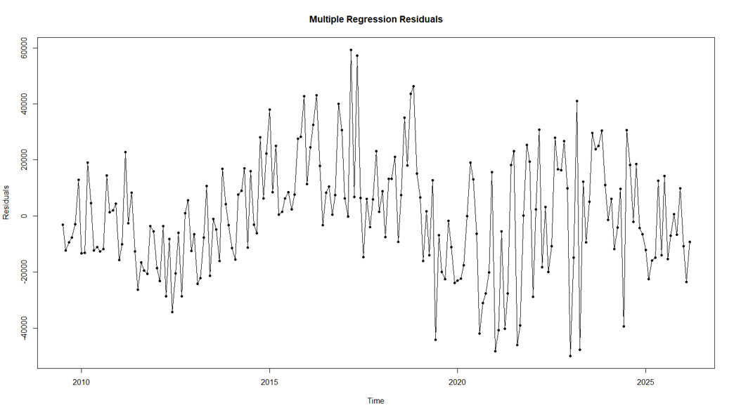

Figure 4-2: Autocorrelation Function Plot of Linear Regression Residuals
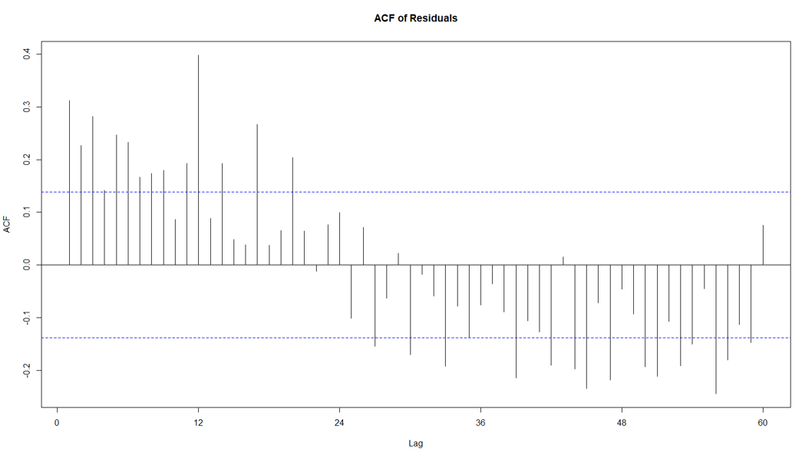

Call: lm(formula = tonnage_1 ~ levy_1 + levy_2 + levy_34 + tonnage_2 + tonnage_34 + gdp_sa_m + pop + covid, data = monthly)
Residuals:
Min | 1Q | Median | 3Q | Max
-49936 | -13101 | -286 | 13118 | 59272
Coefficients:
Variable | Coefficient | Standard Error | t-value | p-value
(Intercept) | -1.136e+05 | 7.648e+04 | -1.485 | 0.139257
levy_1 | -2.347e+03 | 6.704e+02 | -3.501 | 0.000577 ***
levy_2 | 5.211e+02 | 6.301e+02 | 0.827 | 0.409273
levy_34 | 1.124e+02 | 1.377e+03 | 0.082 | 0.935024
tonnage_2 | -1.948e-01 | 3.157e-01 | -0.617 | 0.537935
tonnage_34 | 4.174e-02 | 2.529e+02 | 1.650 | 0.100507
gdp_sa_m | 1.289e+01 | 3.563e+00 | 3.618 | 0.000380 ***
pop | 3.198e-02 | 3.037e-02 | 1.053 | 0.293604
covid | -1.166e+05 | 2.334e+04 | -4.996 | 1.31e-06 ***
Signif. codes: 0 ‘***’ 0.001 ‘**’ 0.01 ‘*’ 0.05 ‘.’ 0.1 ‘ ‘ 1

Residual standard error: 21020 on 192 degrees of freedom
Multiple R-squared: 0.7422
Adjusted R-squared: 0.7314
F-statistic: 69.09 on 8 and 192 DF
p-value: < 2.2e-16

  - ARIMAX model full results
Series: tonnage_1_m_d1
Regression with ARIMA(0,0,1)(0,0,1)[12] errors

Coefficients:
Variable | Coefficient | Standard Error
ma1 | -0.7826 | 0.0514
sma1 | 0.2654 | 0.0644
tonnage_2 | 0.3462 | 0.3093
tonnage_34 | 0.0395 | 0.0258
levy_1 | -1793.1422 | 848.3666
levy_2 | 857.6472 | 628.7092
levy_34 | 820.6485 | 1657.8299
gdp | 6.9318 | 1.9130
pop | 0.0179 | 0.0604
covid | -107107.97 | 16215.08

sigma^2: 306827568
log likelihood: -2233.74
AIC: 4489.47
AICc: 4490.88
BIC: 4525.75

Training set error measures:
 | ME | RMSE | MAE | MPE | MAPE | MASE | ACF1
Training set | -442.02 | 17072.97 | 13044.3 | -82.28 | 314.32 | 0.56 | -0.0061

Ljung-Box test
Data: Residuals from Regression with ARIMA(0,0,1)(0,0,1([12] errors
Q*: 41.19
df: 22
p-value: 0.007823
Model df: 2
Total lags used: 24

Coefficients:
Variable | Coefficient | Standard Error | t-value | p-value
ma1 | -0.7826 | 0.0514 | -15.2279 | 0.00000
sma1 | 0.2654 | 0.0644 | 4.1203 | 0.00004
tonnage_2 | 0.3462 | 0.3093 | 1.1190 | 0.2631
tonnage_34 | 0.0395 | 0.0258 | 1.5304 | 0.1259
levy_1 | -1793.1422 | 848.3666 | -2.1136 | 0.0345
levy_2 | 857.6472 | 628.7092 | 1.3641 | 0.1725
levy_34 | 820.6485 | 1657.8299 | 0.4950 | 0.6206
gdp | 6.9318 | 1.9130 | 3.6236 | 0.0003
pop | 0.0179 | 0.0604 | 0.2972 | 0.7663
covid | -107107.9686 | 16215.0806 | -6.6055 | 0.0000


www.eunomia.eco k

Prior to July 2024, revenue was raised for the purpose of promoting and achieving waste minimisation. Since 1 July 2024, a wider range of matters may be funded by the levy, as outlined in section 3 of the WMA.
https://environment.govt.nz/facts-and-science/waste/download-waste-data/
https://www.stats.govt.nz/topics/population/
https://www.rbnz.govt.nz/statistics/series/economic-indicators/gross-domestic-product
Austria, Denmark, Finland, Belgium (Flanders), France, Ireland, Italy, the Netherlands, Sweden, Norway, Slovakia, Spain, Switzerland, and the United Kingdom.
Although the spending of the central government portion of the fund has been expanded, TAs are still required to spend their portion on matters to promote or achieve waste minimisation, or in line with their Waste Management and Minimisation Plans. Although proposals have been made to widen this, they have not yet been actioned.
This instance of waste blending refers to the inclusion of waste with potential for reuse to W2E facilities to become process engineered fuel (PEF) as it is cheaper than disposal.
This includes stakeholders who participated in the metal / e-waste workshop as well as individual interviews.
Examples of byproducts can include shredder floc from vehicle or e-waste recycling processes.
The Basel Convention restricts the international trade of hazardous wastes, its intention being to prevent the transfer of wastes to jurisdictions which cannot manage hazardous waste in an environmentally sound manner.
A number of stakeholders were interviewed individually, spanning private sector (e.g. consultants) and NGOs, who work in the sustainability space.
Eunomia. The New Zealand Waste Disposal Levy. 2017. https://eunomia.nz/wp-content/uploads/2017/06/WDL-Final-Report-30-05-17.pdf.
Current reporting requirements do extend to sites that are not subject to the levy. Details can be found at: https://environment.govt.nz/what-government-is-doing/areas-of-work/waste/waste-disposal-levy/waste-disposal-levy-information-for-site-operators/#reuse-of-materials-on-site
Waste blending is a process of mixing different waste types. It is assumed in this context to involve wastes that are accepted by different Classes of landfills depending on material type and contamination levels to avoid paying higher levy rates.
Eunomia. The New Zealand Waste Disposal Levy. 2017. https://eunomia.nz/wp-content/uploads/2017/06/WDL-Final-Report-30-05-17.pdf.
Ministry for the Environment. “Role of Territorial Authorities in Managing and Minimising Waste.” 2025. https://environment.govt.nz/acts-and-regulations/acts/waste-minimisation-act-2008/role-of-territorial-authorities-in-managing-and-minimising-waste/.
https://www.mdpi.com/2071-1050/15/21/15193
China’s National Sword Policy, announced in February 2019, included bans on certain types of recyclable waste and a strict maximum contamination standard of 0 per cent. The policy led to the removal of the largest recycling market in the world for low-value mixed plastics (e.g. resin types 3 (PVC), 4 (LDPE), 6 (PS) and 7 (other)).
https://earth.org/thailand-ban-plastic-imports/
https://www.aljazeera.com/news/2025/1/14/what-is-waste-colonialism-and-why-has-thailand-banned-imports-of-plastic
https://www.recycleinme.com/scrap-news/newsdetails-353
https://en.mae.gov.vn/Pages/chi-tiet-tin-Eng.aspx?ItemID=8728
https://eia-international.org/news/malaysia-strengthens-plastic-waste-controls-to-close-the-door-on-waste-colonialism-from-other-countries/
https://en.antaranews.com/news/332021/indonesia-to-end-plastic-waste-imports-by-2025-minister
https://www.stats.govt.nz/large-datasets/csv-files-for-download/overseas-merchandise-trade-datasets/
https://www.epa.gov/hwgenerators/new-international-requirements-export-and-import-plastic-recyclables-and-waste
https://www.amcsgroup.com/resources/blogs/what-do-tightening-eu-export-and-asian-import-restrictions-mean-for-the-global-recycling-industry/
See for example: https://environment.govt.nz/assets/publications/waste-levy-investment-options.pdf.
https://mfenz.shinyapps.io/waste_wmf_app/.
https://www.paperage.com/2024news/12-09-2024oji-fibre-solutions-to-close-pm6-at-kinleith-mill.html
https://www.hitechpackaging.co.nz/oji-fibre-solutions-penrose-closure-impact/
https://www.nzherald.co.nz/waikato-news/news/cambridge-site-for-64m-resource-co-limited-construction-and-demolition-recycling-plant/DYAKTLBE25E5LL3ZHY53MBMA2U/
https://www.greengorilla.co.nz/waikato-resource-recover-facility/
https://www.greengorilla.co.nz/green-gorilla-opens-16m-fully-electric-resource-recovery-facility-in-waikato/
https://environment.govt.nz/publications/waste-and-resource-efficiency-behavioural-trend-monitoring-survey-2025/
WRIA National Waste and Recycling Snapshot 2025
https://www.rnz.co.nz/news/environment/592297/what-auckland-is-doing-wrong-when-it-comes-to-recycling-and-how-it-can-change
https://wria.org.nz/wp-content/uploads/2026/05/260407-Waste-Matters-Issue1.pdf.
https://www.rabobank.co.nz/community/food-waste
https://environment.govt.nz/news/update-on-waste-policies/
https://www.tyrewise.co.nz/wp-content/uploads/2025/11/Tyrewise_Annual-Report-2025_RGB_web_final.pdf
An Equivalent Passenger Unit (EPU) is the industry measure equivalent to one standard passenger tyre, which weighs 9.5kg new and 8kg at end-of-life.
BUILDING A CIRCULAR ECONOMY FOR PLASTICS, WHERE IT NEVER BECOMES WASTE OR POLLUTION -
https://environment.govt.nz/assets/publications/waste-and-resource-efficiency-work-programme-2024-26.pdf?v=0fc6a5120c7103e076adb99c261dbb4b0fb3d6cd
https://environment.govt.nz/what-government-is-doing/areas-of-work/waste/improving-household-recycling-and-food-scrap-collections/recycling-leadership-forum/
https://www.xe.com/ accessed 11/06/2026 and 12/06/2026.
https://www.cityservices.act.gov.au/recycling-and-waste?a=2119113 It should be noted that the rate provided for ACT is a gate fee price for sending waste to the landfill site, which is owned by the ACT, rather than a waste levy.
https://www.epa.nsw.gov.au/Your-environment/Waste/waste-levy/levy-regulated-area-and-levy-rates
https://www.qld.gov.au/environment/waste-reduction-recycling/disposal-levy/about/levy-rates
https://www.epa.sa.gov.au/business_and_industry/waste-levy
https://nre.tas.gov.au/environment/waste-and-resource-recovery/landfill-levy
https://www.treasury.tas.gov.au/economy/economic-policy-and-reform/fee-units
https://www.epa.vic.gov.au/waste-levy
https://www.wa.gov.au/service/environment/environment-information-services/waste-levy-rate-schedule
https://environment.govt.nz/what-government-is-doing/areas-of-work/waste/waste-disposal-levy/expansion/
It should be noted that, despite the intentions behind a landfill tax, it does not always lead to diversion to reuse/recycling; it can contribute to unintended consequences or perverse outcomes such as waste crime, export (e.g. to developing countries that may not have suitable facilities), or waste-to-energy.
https://www.altlasten.gv.at/finanzierung/altlastenbeitrag.html
There is ambiguity around what the Austrian levy rates refer to. The rate presented in Figure 2 is an average of the upper and lower values within the range.
https://ovam.vlaanderen.be/documents/d/nl/tarieven-milieuheffingen-2026-4
The source classifies standard active municipal solid waste as combustible waste and inert waste as non-combustible waste.
https://www.cewep.eu/wp-content/uploads/2021/10/Landfill-taxes-and-restrictions-overview.pdf
https://leap.unep.org/en/countries/dk/national-legislation/waste-and-raw-materials-tax-act-no-14-2023
https://www.finlex.fi/fi/lainsaadanto/saadoskokoelma/2022/962
https://bofip.impots.gouv.fr/bofip/12765-PGP.html/identifiant=BOI-BAREME-000039-20241218
https://www.legifrance.gouv.fr/codes/article_lc/LEGIARTI000051251729/2025-04-23
https://www.eea.europa.eu/en/topics/in-depth/waste-and-recycling/municipal-and-packaging-waste-management-country-profiles-2025/it-municipal-waste-factsheet.pdf/@@download/file
https://www.gov.ie/en/department-of-climate-energy-and-the-environment/press-releases/introduction-of-new-environment-levies-will-incentivise-recycling-and-help-ireland-meet-our-eu-waste-targets/
https://www.belastingdienst.nl/wps/wcm/connect/bldcontentnl/belastingdienst/zakelijk/overige_belastingen/belastingen_op_milieugrondslag/afvalstoffenbelasting/tarief_afvalstoffenbelasting
https://www.cewep.eu/wp-content/uploads/2021/10/Landfill-taxes-and-restrictions-overview.pdf
https://sede.agenciatributaria.gob.es/Sede/en_gb/impuestos-especiales-medioambientales/impuesto-sobre-deposito-residuos-vertederos/base-imponible-tipo-impositivo-cuota-tributaria.html
https://www.skatteverket.se/foretag/skatterochavdrag/punktskatter/avfallsskatt.4.18e1b10334ebe8bc80002886.html
https://www.bafu.admin.ch/en/levying-the-ocrcs-charge
https://www.fedlex.admin.ch/eli/cc/2008/670/en The legislation setting out the levy rates in Switzerland appears not to have been revised since January 2016. As a result, the levy rates in 2026 remain unchanged from those in effect in 2016.
https://www.gov.uk/government/publications/landfill-tax-rates-for-2026-to-2027/landfill-tax-increase-in-rates-from-1-april-2026
The UK has recently consulted on moving to a single rate to address concerns regarding waste crime (e.g. an incentive to misreport waste in order to pay the lower fee). It was decided to continue with a dual-rate system, but to increase the ‘lower’ rate and prevent the gap from widening in the future https://www.gov.uk/government/consultations/consultation-on-reform-of-landfill-tax/consultation-on-reform-of-landfill-tax-in-england-and-northern-ireland https://www.gov.uk/government/consultations/consultation-on-reform-of-landfill-tax/outcome/consultation-on-reform-of-landfill-tax-in-england-and-northern-ireland-summary-of-responses#government-decisions-and-response-to-the-consultation
https://www.gov.uk/government/publications/landfill-tax-rates-for-2026-to-2027/landfill-tax-increase-in-rates-from-1-april-2026
https://www.gov.uk/government/publications/excise-notice-lft1-a-general-guide-to-landfill-tax/excise-notice-lft1-a-general-guide-to-landfill-tax#qualifying-material
https://www.aph.gov.au/Parliamentary_Business/Committees/Senate/Environment_and_Communications/WasteandRecycling/Report/c04
https://legislation.govt.nz/act/public/2008/89/en/latest/#DLM999802
https://environment.ec.europa.eu/topics/waste-and-recycling/waste-framework-directive_en
https://eur-lex.europa.eu/EN/legal-content/summary/landfill-of-waste.html
https://www.countrystylerecycling.co.uk/legislation/landfill-directive/
https://www.dcceew.gov.au/environment/protection/waste/publications/national-waste-resource-recovery-reporting/states-territories-local-government-2024
https://ieep.eu/wp-content/uploads/2022/12/AT-Landfill-Tax-final.pdf
https://ovam.vlaanderen.be/milieuheffingen-voor-afvalstoffen#
https://www.wallonie.be/fr/demarches/regler-la-taxe-sur-les-dechets-en-region-wallonne
https://bofip.impots.gouv.fr/bofip/12894-PGP.html/identifiant=BOI-TCA-POLL-40-20250723
https://lasntg.ie/wp-content/uploads/2025/10/Waste-recovery-and-landfill-levy-Ellen-Holloway-DCEE.pdf
https://www.normattiva.it/atto/caricaDettaglioAtto?atto.dataPubblicazioneGazzetta=1995-12-29&atto.codiceRedazionale=095G0612&tipoDettaglio=originario
https://www.naturpack.sk/en/news/the-slovak-parliament-adopted-the-modifications-of-the-waste-act/
https://bestpractices-waste-med.net/landfill-and-incineration-tax-with-a-refund-criterion-to-boost-source-separation-of-biowaste/
https://www.bfs.admin.ch/bfs/en/home/statistics/territory-environment/environmental-accounting/environmental-taxes.assetdetail.36513831.html
https://www.entrust.org.uk/resources/what-is-the-lcf/
https://ieep.eu/wp-content/uploads/2022/12/UK-Landfill-Tax-final.pdf
https://resourcehub.com.au/wp-content/uploads/2026/01/Resource-Hub-ACT-Levy-Factsheet.pdf
https://www.bmcc.nsw.gov.au/sites/default/files/docs/FORM_NSWGovWasteLevy_FactSheet_2025-26.pdf
https://www.qld.gov.au/environment/waste-reduction-recycling/disposal-levy/about/overview
https://www.stateoftheenvironment.detsi.qld.gov.au/pollution/management-responses/policy-and-programs/waste-disposal-levy
https://www.greenindustries.sa.gov.au/wastelevy
https://nre.tas.gov.au/environment/waste-and-resource-recovery/landfill-levy
https://www.environment.vic.gov.au/sustainability/sustainability-fund
https://www.wasteauthority.wa.gov.au/about/view/About-the-Waste-Authority-Levy
https://environment.govt.nz/what-government-is-doing/areas-of-work/waste/waste-disposal-levy/overview/
https://www.qld.gov.au/__data/assets/pdf_file/0028/99307/queensland-waste-levy-fact-sheet.pdf
https://wastemanagementreview.com.au/levy-reform-urgently-needed/
https://www.wasteauthority.wa.gov.au/about/view/About-the-Waste-Authority-Levy
https://faolex.fao.org/docs/pdf/sa44174.pdf
https://nre.tas.gov.au/environment/waste-and-resource-recovery/landfill-levy/landfill-levy-faqs
https://www.cewep.eu/wp-content/uploads/2021/10/Landfill-taxes-and-restrictions-overview.pdf
https://www.cewep.eu/wp-content/uploads/2021/10/Landfill-taxes-and-restrictions-overview.pdf
https://www.sardegnaentrate.it/entrate/tributiregionali/tributiminori/impostaspecialedepositoindiscaricarifiutisolidi/
https://www.eea.europa.eu/en/analysis/publications/managing-municipal-solid-waste/sweden-municipal-waste-management/@@download/file
https://commonslibrary.parliament.uk/research-briefings/sn00237/
Some respondents noted multiple impacts, so sum totals to more than 100%

