Te whakapai i te kohinga hangarua me te para kai-ā-kāinga

Improving household recycling and food scraps collections
Information for councils and the waste sector

We’re making it easier for people to recycle and divert food scraps from landfills
In Aotearoa New Zealand, only about one-third of household waste is recycled and composted. The rest goes to landfills. People, businesses and manufacturers are confused about what can and can’t be recycled, and too many items go in the wrong bin.
More than 300,000 tonnes of food scraps are sent to our landfills every year, rotting and producing methane, a powerful greenhouse gas. If we are to meet our emissions reduction target of reducing biogenic methane from waste by 40 per cent by 2035, we need to stop sending so much food to landfill.
To support a low-emissions, low-waste circular economy, we are introducing three big changes:
- Councils across Aotearoa will accept the same materials in their household collections
- Recycling collections will be available to households in all urban areas
- Food scraps collections will be available to households in all urban areas
The government is also introducing minimum standards for councils to divert waste from landfill, and requiring waste companies, operators and councils to collect and report more of their waste data. Revenue from the expanded waste levy will support the roll out of these changes.
This fact sheet summarises the key changes and what they mean for councils and the waste sector. We will provide more information when regulations are finalised.

Overview of the changes

Change | Action for councils and waste companies
- Accept the same standard set of materials | From 1 February 2024, all district and city councils accept only these materials in their recycling collections:  • glass bottles and jars*  • paper and cardboard (including pizza boxes)  • plastic bottles, trays and containers marked with recycling symbols 1, 2, and 5  • aluminium and steel tins and cans.  Once councils are collecting food scraps (or food and garden waste), these services must only collect food scraps and garden waste (ie, not paper or compostable packaging).
- Recycling collections for urban households | By 1 January 2027, all district and city councils provide recycling collections to households in urban areas of 1,000 people or more (read more about recycling collections).
- Food scraps collections for urban households | By 1 January 2030, all district and city councils provide food scraps (or food and garden waste) collections to households in urban areas of 1,000 people or more.  Councils with organics processing facilities nearby provide a food scraps service by 1 January 2027 (read more about food scraps collections).
- Minimum standards for diverting waste from landfill | All district and city councils meet a performance standard for the amount of household kerbside waste diverted from landfill.  The performance standard will increase over time:  - 30 per cent by July 2026  - 40 per cent by July 2028  - 50 per cent by July 2030
- Reporting requirements | From July 2024, all private waste companies that provide regular household waste collections (eg, weekly or fortnightly) record tonnes of rubbish, recycling, food and garden waste collected, and contamination rates.  From late 2025, they report these figures to the Ministry for the Environment.  Note: this will complement reporting requirements for district and city councils and waste operators that are expected to be introduced by 2024.
* The three councils that don’t currently collect glass will have until 1 January 2027 to do so.

When the changes are happening
We will stagger the roll-out of the changes to allow time for infrastructure to be put in place.
Figure 1: Timeline for implementing the changes to recycling and food scraps collections
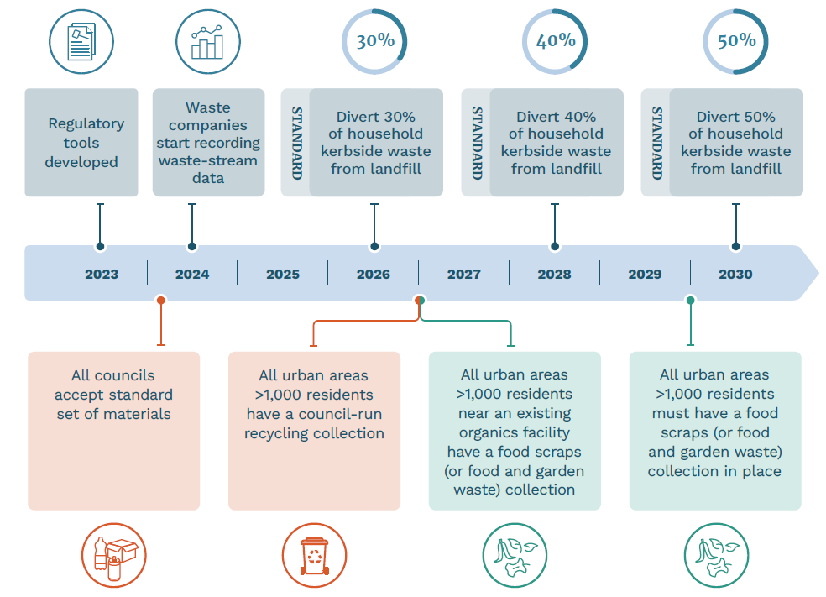
The first change for councils and households will be accepting the same set of materials in collections around the country from 1 February 2024. Food scraps collection will be phased so councils that are near organics processing infrastructure start collecting food scraps earlier than those that aren’t.

What the changes mean for Waste Minimisation and Management Plans
We will use different regulatory tools under the Waste Minimisation Act 2008 (WMA) to give effect to the changes. Once in place, some of the tools will require councils to amend their Waste Minimisation and Management Plans (WMMPs) or set performance standards for how WMMPs are implemented.
The first change, accepting standard materials, will be a performance standard that will not require councils to immediately amend their WMMP before it comes into effect.
The main impact on WMMPs will be the changes to make household recycling and food scraps collections available in urban areas. Councils will need to update WMMPs before the changes come into effect in 2027 but will not need to consult, as is the usual process for updating WMMPs.
We will provide more guidance on what the changes will mean for WMMPs once we have finalised the regulatory tools.
Councils will still need to review their WMMPs every six years. If timing aligns, the review and above changes could be made together.

What the changes mean for councils
The changes mean different things for different councils depending on what services are currently offered and which materials are currently collected. The changes that affect the highest number of councils, the soonest are:
- accepting a standard set of materials
- food scraps collections

Recycling services
From 1 February 2024, all council household recycling services must accept the same standard set of materials. This means some councils will need to stop collecting some types of materials or start collecting new ones.
- Some councils will need to stop collecting liquid paperboard, foil, aerosols, soft plastics, polystyrene and plastics 3, 4, 6 and 7 in their household kerbside recycling collection. These materials are problematic to sort and recycle, and often end up in landfill.
- Some councils will need to collect new materials, such as plastic #5, glass and pizza boxes.
- Councils that need to start collecting glass will have until 1 January 2027 to do so.
All councils in urban areas (more than 1,000 residents) must have their recycling service in place by 2027. To check whether your towns meet this threshold use the Stats NZ Geographic Boundary Viewer (for the 2022 year). The smallest urban areas (those with between 1,000 and 2,000 people) will be included in the regulation for clarity.

Support available
In 2024, the government will run a national communications campaign on what materials will be accepted in kerbside collections. Councils will be able to adapt and use these campaign materials.
Councils that need to start collecting glass or introduce a new recycling service can apply for funding through the Waste Minimisation Fund.
Things to do now:
- Understand what these changes mean for you (eg, whether you will need to start a recycling collection, collect new materials or expand to new areas).
- Understand what services your suppliers provide or what changes in contracts may be needed, and how soon these can happen.
- Consider what you need to tell your communities.
- Get in touch with us about funding here Waste Minimisation Fund (WMF) - Ministry for the Environment - Citizen Space).
- Contact transformingrecycling@mfe.govt.nz if you have any questions.

Food scraps collections
For many councils, collecting household food scraps (or food and garden waste) will be the biggest change. We will need a national network of organics processing facilities to support the change.
Councils with main centres within 150 kilometres of an organics processing facility will need to collect food scraps by 1 January 2027. Figure 2 shows these councils.
For other councils, organics processing infrastructure will likely need to be built before your collections get underway in 2030. We can help you plan and implement these services.
Through the new collections, councils can only accept food scraps or food and garden waste – not paper, cardboard, compostable packaging, or other materials that can contaminate soils and the food chain. Councils will have some discretion over a few materials, such as compostable bin liners.

Support available
We will support the roll out of food scraps collections with:
- guidance on food and garden waste services, including where some local discretion in the materials accepted (eg, flax leaves or compostable bin liners) may be allowed
- communications materials that can be adapted for individual council needs.
Also, $120 million of contestable funding is available until June 2024 from the Waste Minimisation Fund and Climate Emergency Response Fund to help councils and the private sector invest in diverting food and other organic wastes from landfill. This funding covers:
- planning the transition to food scraps collections
- rolling out food scraps collections, including new bin infrastructure and drop-off facilities, and upgrading transfer stations.
The waste levy increase, which is progressively rising to $60 per tonne by July 2024 and expanding to cover all types of landfills, will help councils fund these changes.
Things to do now:
- Understand what organics processing facilities are near you (or underway), and when you will need to roll out a collection by.
- Find out what other councils in your region are doing and how you can work together.
- Get in touch with the Ministry for funding here Waste Minimisation Fund (WMF) - Ministry for the Environment - Citizen Space).
- Contact transformingrecycling@mfe.govt.nz if you have any questions.

Figure 2: Map of councils with main centres within 150 kilometres of an organics processing facility
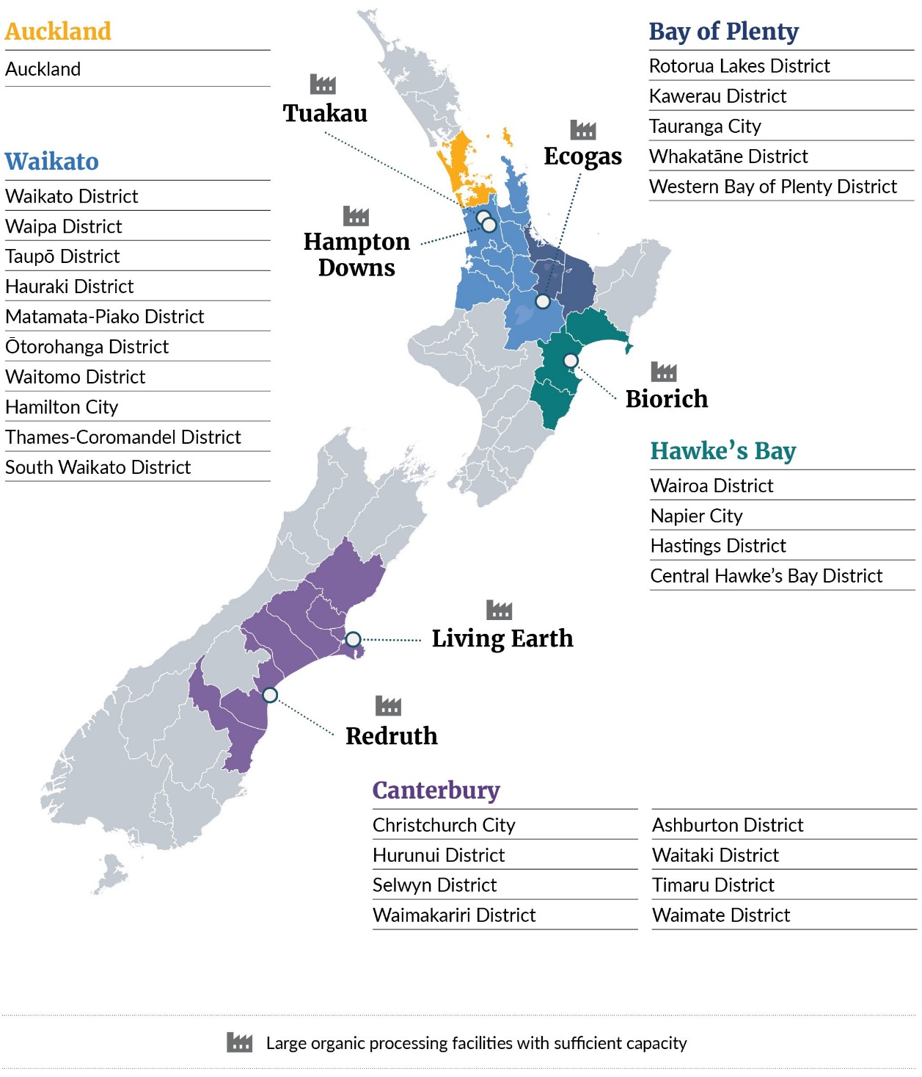
While the Hawke's Bay councils have been included in the 2027 food scraps deadline, we will work with these councils to consider the local impacts of the recent severe weather events and whether there will be sufficient access in this region to a food waste processing facility.

How the Ministry will ensure compliance
The Ministry for the Environment is the primary regulator under the Waste Minimisation Act 2008.
Once the requirements are in place, our compliance team will work with you to ensure you understand the obligations and responsibilities. The way we work is guided by our Compliance, monitoring and enforcement strategy.
Our auditing programme will expand to include the new requirements and our auditors may contact you to check on progress.
Where we find non-compliance with the new obligations, we may take enforcement action. This can include warnings, retaining waste levy allocation or prosecution, depending on the nature of the non-compliance.

Next steps
During 2023 and 2024 we will develop the regulatory tools to make these changes come into force.
Once the tools are in place, councils may need to update their WMMPs to implement new kerbside collections for recycling and food waste.
When the tools are finalised, we will provide more information on:
- what changes may be required in your WMMPs
- the new data collection requirements and what they will mean for councils and the waste sector
- how we will monitor and calculate performance standards.

Published in March 2023 by the  Ministry for the Environment – Manatū Mō Te Taiao  Publication number: INFO 1147 | 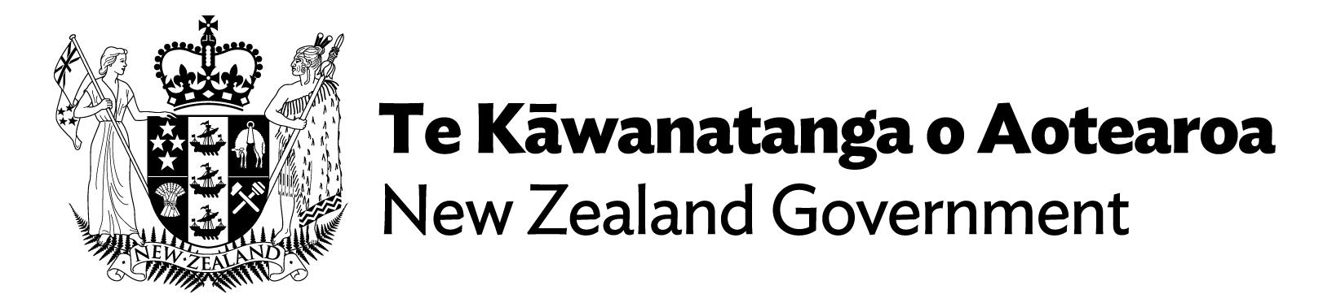

Once the new waste legislation comes into force, these requirements will carry over.

Contact transformingrecycling@mfe.govt.nz if you have any questions.

The following tools will be used to give effect to these changes: - Change 1 and 2 (household recycling and food scraps collections) will be set out in regulations (an order in council) under section 48 of the WMA. - Change 3 and 4 (standardising materials and the minimum standards for diverting waste from landfill will be set out in performance standards (via a notice in the gazette) under section 49 of the WMA for the implementation of WMMPs. - Change 5 (reporting requirements) will be set out in regulations (an order in council) under section 86 of the WMA.
See section 48 (4) of the WMA
Any updates to WMMPs, in order to implement the kerbside changes, will not automatically satisfy councils' obligations to review their WMMPs every six years and consult on any changes they make.
Note councils may be able to suggest other services for materials not accepted in kerbside collections by supporting alternative recycling initiatives such as the soft-plastic drop-off recycling scheme.
In the Layer List, tick ‘Urban Rural’, untick the layer ‘Urban-Rural areas 2023’ and tick the 2022 layer instead. Turn on the legend to see the colours for types of areas. Rural settlements are not considered urban areas.

