Ngā tikanga ngaronga kai me te para mō Aotearoa
Food loss and waste definition for Aotearoa New Zealand

Disclaimer
The information in this publication is, according to the Ministry for the Environment’s best efforts, accurate at the time of publication. The Ministry will make every reasonable effort to keep it current and accurate. However, users of this publication are advised that:
- the information does not alter the laws of New Zealand, other official guidelines, or requirements
- it does not constitute legal advice, and users should take specific advice from qualified professionals before taking any action based on information in this publication
- the Ministry does not accept any responsibility or liability whatsoever whether in contract, tort, equity, or otherwise for any action taken as a result of reading, or reliance placed on this publication because of having read any part, or all, of the information in this publication or for any error, or inadequacy, deficiency, flaw in, or omission from the information in this publication
- all references to websites, organisations or people not within the Ministry are for convenience only and should not be taken as endorsement of those websites or information contained in those websites nor of organisations or people referred to.

Ngā mihi
The Ministry for the Environment would like to thank everyone who has been involved in the creation of the food loss and waste definition for Aotearoa New Zealand and this document.
Ngā mihi nui ki a koutou.

This document may be cited as: Ministry for the Environment. 2023. Food loss and waste definition for Aotearoa New Zealand. Wellington: Ministry for the Environment.

Published in October 2023 by the
Ministry for the Environment
Manatū mō te Taiao
PO Box 10362, Wellington 6143, New Zealand
environment.govt.nz
ISBN: 978-1-991077-88-2 (online)
Publication number: ME 1796
© Crown copyright New Zealand 2023

Contents
Purpose 4
How to use this document 4
Background 4
Is food loss and waste a problem? 4
Why do we need a definition for food loss and waste? 5
Consultation on the definition 5
Food loss vs food waste 5
Definition 6
Waste hierarchy 7
Waste and non-waste destinations 8
Key elements of the definition 11
Ready for harvest 11
Inedible food and drink 11
Definition of ‘food’ in the Food Act 2014 12
Next steps 12
Baseline measurement 12
Relevant work 12
Emissions reduction plan 12
Improving household food scraps collections 13
National food waste reduction partnerships 13
Food waste research project reports 13
Appendix 1 14

Tables
Table 1: Reuse destinations (non-waste) 9
Table 2: Recycle and recovery destinations (waste) 10
Table 3: Disposal destinations (waste) 10
Figures
Figure 1: Food loss vs food waste within the food supply chain 6
Figure 2: Waste hierarchy 8

Purpose
This document outlines the New Zealand Government’s definition for food loss and waste in Aotearoa New Zealand (the definition). The definition supports government initiatives including measuring food loss and waste, improving household kerbside recycling collections and the emissions reduction plan.
The Government intends for the definition to provide clarity on how to consider and measure food loss and waste. The definition is intended to be an informational tool rather than government policy.

How to use this document
This document provides context on the formation of the definition and the specific terms used in
the definition.
The Government encourages anyone planning to measure food loss and waste to consider using this definition, so that measurements of food loss and waste are conducted consistently across Aotearoa.
If you have any questions about the definition, or related work programmes, you can contact the Ministry for the Environment (the Ministry) at info@mfe.govt.nz.
For the purposes of this document when we refer to ‘food’ this means ‘food and drink’.

Background

Is food loss and waste a problem?
The Food and Agriculture Organization of the United Nations (FAO) estimates that one-third of all food produced globally is lost or wasted. In Aotearoa, food loss and waste is an economic, environmental and social problem.
- Economic: Households throw out NZ$3.1 billion of avoidable food waste in Aotearoa each year.
- Environmental: In 2019, waste was responsible for 4 per cent of our national gross emissions.
Of these waste emissions, 94 per cent are biogenic methane, largely generated by the decomposition of food and other types of organic waste. Biogenic methane has a warming effect 28 times greater than carbon dioxide.
- Social: Almost one in five children in Aotearoa experience severe-to-moderate food insecurity. There are opportunities to improve food security through the redistribution of surplus food.

Why do we need a definition for food loss
and waste?
The Government has committed to reducing food waste in Aotearoa. Following the Environment Committee’s investigation into food waste in 2020, the Government agreed to adopt a national definition and baseline measure of food waste and to consider food waste reduction targets. As part of the emissions reduction plan, the Government has also agreed to undertake actions to enable households and businesses to reduce organic waste.
To meet these commitments, we need to define food loss and waste and use the definition to create a baseline measurement for Aotearoa. Once a baseline has been established, we can evaluate the state of food loss and waste in Aotearoa and track changes over time.

Consultation on the definition
In October 2022, on behalf of the Ministry, the New Zealand Food Waste Champions 12.3 Trust undertook targeted consultation on a draft definition for food loss and waste. The draft definition was informed by international best practice and shared with key stakeholders for review. This targeted consultation process aimed to ensure the definition is fit for purpose in Aotearoa and reflects our national food system.
Consultation was open to key stakeholders in the food industry. This included reaching out to food rescue organisations, relevant government agencies, local government, academic institutions, food sector businesses, Māori organisations and environmental non-governmental organisations. The final definition has been shaped using feedback from the consultation.

Food loss vs food waste
Within the wider food system, the human food supply chain is the series of activities that go into producing, processing, distributing and consuming of food. It starts at the beginning of food production (eg, freshly planted seedlings) and continues through to the food being consumed (at home or away from home). Food loss and waste occur when food leaves the food supply chain and is not consumed by people or animals.

The difference between food loss and food waste depends on the stage at which food leaves the supply chain, as described below (and further illustrated in figure 1).
• ‘Food loss’ refers to food that leaves the supply chain from the time when the food is ready for harvest (or slaughter), through to the processing and manufacturing stage.
• ‘Food waste’ is food that leaves the supply chain from the wholesale, retail and marketing stage onwards. This includes waste that occurs at the consumption stage (at home or away from home).
Food that leaves the food supply chain before it is ready for harvest (pre-harvest) is out of scope of the definition.
Figure 1: Food loss vs food waste within the food supply chain
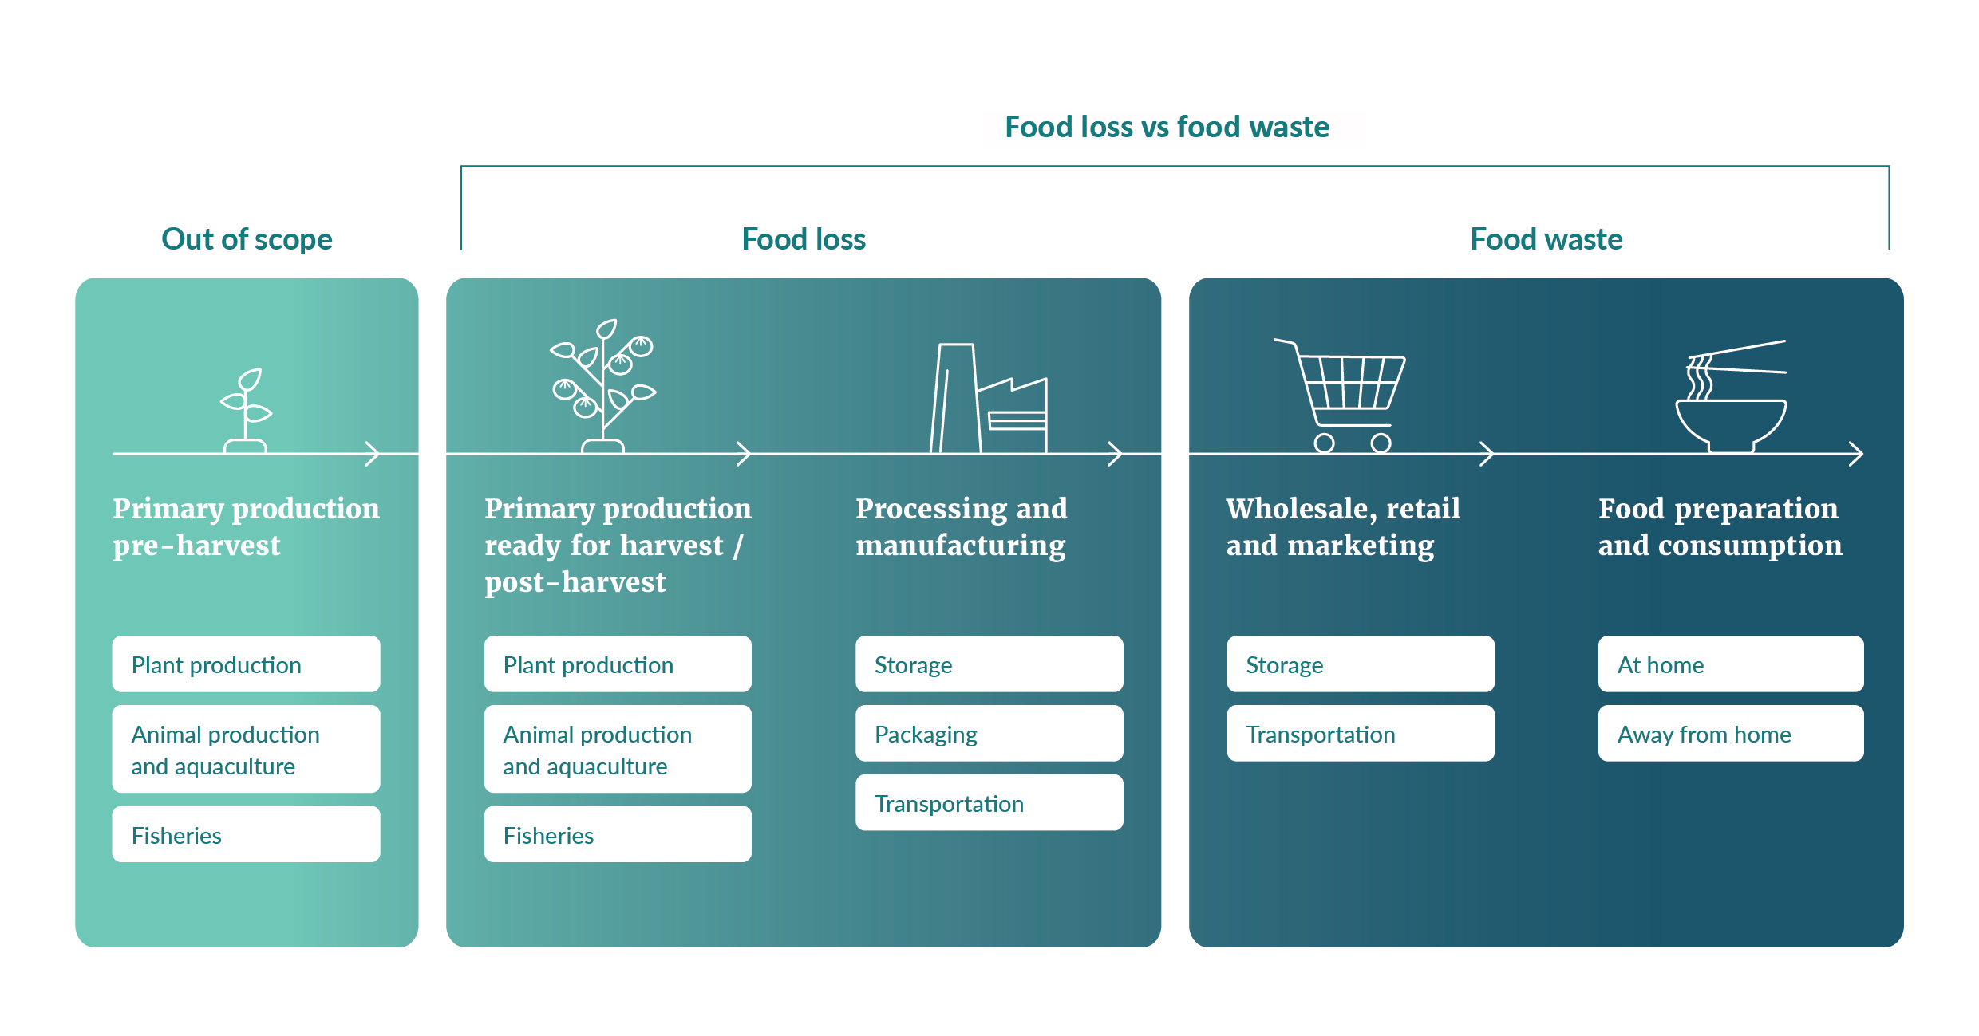

Definition
The definition of food loss and waste is below. This overarching definition will be used in measuring the national baseline for food loss and waste in Aotearoa. The subsequent sections of this document explain the key elements of the definition.
Food loss and waste
Imported or domestically produced food and drink, including inedible parts, which leave the food supply chain from the point that crops and livestock are ready for harvest or slaughter onwards to the point of consumption, to be recycled, recovered or disposed of in Aotearoa New Zealand.

The overarching definition encompasses two constituent components: food loss and food waste. To allow food loss and food waste to be analysed separately, these terms are individually defined below.
Food loss
Imported or domestically produced food and drink, including inedible parts, which leave the food supply chain from the point that crops and livestock are ready for harvest or slaughter through to the processing and manufacturing stage (including transportation and storage) to be recycled, recovered or disposed of in Aotearoa New Zealand.

Food waste
Imported or domestically produced food and drink, including inedible parts, which leave the food supply chain from the wholesale, retail and marketing sectors onwards to the point of consumption, to be recycled, recovered or disposed of in Aotearoa New Zealand.

Waste hierarchy
A waste hierarchy is a tool used to illustrate the best and the least favoured options to reduce and manage waste. Waste hierarchies can be designed to focus on a particular type of waste, or to cover waste management issues more broadly.
The Ministry has not developed a waste hierarchy specific to food waste. However, the Government’s waste strategy presents a general waste hierarchy, setting out an order of preference for managing and disposing of materials (figure 2). The waste hierarchy is best regarded as an indication of preference, rather than a prescriptive tool.
This hierarchy has provided the basis for developing the waste and non-waste destinations that food loss and waste can be categorised into. These are discussed in the next section.
Figure 2: Waste hierarchy
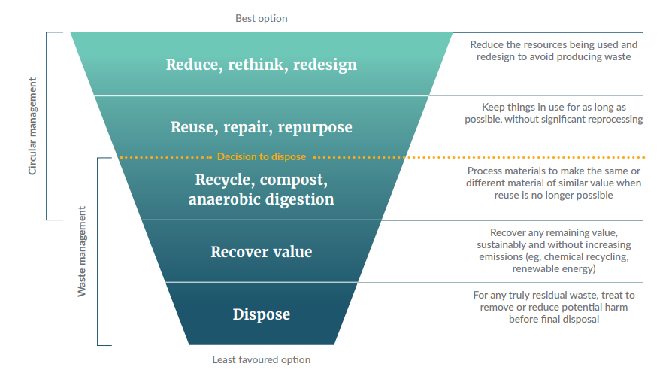
Source: Ministry for the Environment. 2023. Te rautaki para | Waste strategy. Wellington: Ministry for the Environment. p 15.

Waste and non-waste destinations
In addition to defining food loss and food waste, we need to specify the final destination of lost
and wasted food. To do this, we have to classify the different destinations as either ‘waste’ or
‘non-waste’.
For the sake of this definition, any destination where the food is not consumed by humans or animals is deemed a waste destination (as shown below). This recognises that even when waste destinations could deliver high-value benefits (eg, composting), the food has still not been used for its original purpose. This can represent an inefficient use of the resources and resulting emissions used to produce the food. This approach aligns with the Government’s waste hierarchy, which encourages action to reduce waste first and foremost.
The destinations have been classified into destination groupings. These destination groupings (and their relevant classification) are Reuse (non-waste), Recycle and recovery (waste) and Disposal (waste). The purpose of presenting destination groupings is to provide a useful structure for data capture and analysis.

In addition to considering the Government’s waste hierarchy, we have researched and reviewed international documentation and adapted their relevant food waste hierarchies to develop the following destination groupings.

Reuse destinations (non-waste)
This destination grouping is for food that is not consumed as originally intended and instead is redistributed, upcycled or fed to animals. This is the most preferred destination grouping.
We understand that not all food redistributed or upcycled will end up being consumed by people
or animals. If this food eventually ends up in a waste destination, then it will be counted as loss
or waste.
Animal feed is categorised as a non-waste destination following international best practice. It also supports a sustainable food systems approach, because it is assumed that animal feed keeps the food in the human food supply chain.
In the first instance, it is preferable for food to be consumed by humans rather than converted into animal feed. Food redistribution is the most preferred in the destination grouping because the food is consumed by humans without requiring additional processing. This is followed by upcycling to other food products and finally animal feed.
Table 1: Reuse destinations (non-waste)
Food redistribution | Donation, rescuing, gleaning or sale of surplus food for consumption.
Upcycling to other food products | Processing of food by-products or surplus food (that would have otherwise gone to a waste destination) into new food products.
Animal feed | Diverting material from the food supply chain to animals.

Recycle and recovery destinations (waste)
Recycle and recovery destinations are classified as waste destinations. However, we acknowledge that many of these can provide significant social, economic or environmental value. For example, composting brings valuable nutrients back into the whenua (land), and farming practices such as ploughing crops back into the field can help to improve soil health. Similarly, bioprocessing can result in value-added products that extend the useable life of the food.
Determining a preference of the recycle and recovery destinations within the grouping is challenging because there is significant variance in the costs and benefits associated with each one. For this reason, the destinations in table 2 below are ordered alphabetically and do not indicate any ranking
of preference.
Table 2: Recycle and recovery destinations (waste)
Aerobic digestion/compost | Processing with oxygen to produce organic material for soil application without energy recovery.
Anaerobic digestion | Processing without oxygen to produce organic material for soil application with energy recovery (eg, biogas).
Land application | Spreading, spraying, injecting or incorporating organic material onto land to improve soil quality.
Not-harvested/ploughed-in | Leaving crops that were ready for harvest in the field, or tilling  them in.
Other | Any other destination that involves recycling and/or recovery rather than reuse or disposal. This includes using food for biodiesel or other biofuel products.
Processing into non-food items (bioprocessing) | Turning food into value-added, non-food products such as packaging, bioplastics and cosmetic products.

Disposal destinations (waste)
Disposal destinations are classified as waste destinations. This is the least preferred group of destinations. We want to decrease the volume of food that ends up here as much as possible,
in line with the Government’s waste hierarchy.
Determining a preference of the disposal destinations within the grouping is challenging because
there is significant variance in the costs and benefits associated with each one. For this reason,
the destinations in table 3 below are ordered alphabetically and do not indicate any ranking
of preference.
Table 3: Disposal destinations (waste)
Combustion | Burning of food without nutrient recovery (with or without energy recovery).
Landfill | Sending food to an area of land or excavated site specifically designed to receive waste.
Refuse/discard | Abandoning food on land or in the sea. This includes open dumps, open burns and fish discards.
Sewer/wastewater | Sending food down the sewer, including through food waste disposal units.

Key elements of the definition

Ready for harvest
The primary production of food within the food supply chain can be categorised into the following three stages: pre-harvest, ready for harvest and post-harvest.
The definition captures food loss and waste when food leaves the food supply chain from when the food is ready for harvest (or slaughter). The definition does not capture food that is lost when it is still in the pre-harvest stage (ie, not ready to be harvested or slaughtered).
During consultation, most respondents (77 per cent) agreed with beginning the scope of the definition from ready for harvest. Starting from this point aligns with international best practice, including the strategies outlined by the Australian Government, the Global Food Waste Champions 12.3, and the FAO.
Starting from ready for harvest will provide a better picture of on-farm food losses and will help us understand the impact of external pressures such as retail standards. This starting point also recognises the practical challenges of gaining data earlier in the production process during
pre-harvest. We understand that this approach of not including pre-harvest in the measurement
may result in some losses not being quantified (eg, crops lost to weather events or climate change).
We are aware that there is a lack of guidance around when food is ready for harvest, and we are investigating potential further research in this area. You can contact the Ministry at info@mfe.govt.nz if you have information on these topics or would like to engage.

Inedible food
We have included inedible food in the scope of the definition. This inclusion provides greater data granularity and more opportunity to develop effective waste reduction strategies.
The classification of inedible food is subjective and varies between cultures. Therefore, excluding inedible food from the definition would make collecting and comparing data difficult within Aotearoa and against other countries. Including inedible food also aligns with international best practice.
When reviewing the amount of food lost and wasted within Aotearoa, it is important to acknowledge that there will always be a portion that is inedible. If we focus only on the edible elements of food, we risk overlooking the most beneficial solutions.

Definition of ‘food’ in the Food Act 2014
Section 9 of the Food Act 2014 contains a specific definition of food for human consumption (see Appendix 1). The key aim of this legislation is to maintain food safety and suitability.
The Government’s definition for food loss and waste is broader than the Act’s definition of food.
This is because all types of food can be lost or wasted – including inedible food such as bones, pits
or rinds, and spoiled food that is unsuitable for human consumption. This lost or wasted food is relevant to this definition but is not covered by the definition of food in the Act.

Next steps

Baseline measurement
The Government is establishing a baseline measurement of food loss and waste across Aotearoa.
The baseline initiative is in response to a recommendation by the Environment Committee. The research is being carried out by the University of Otago and will measure food loss and waste throughout the food supply chain, as well as identifying the final destinations (eg, landfill, compost, animal feed). The baseline measurement findings are expected to be published in early 2024. The definition of food loss and waste is fundamental to the scope of this measurement.

Relevant work

Emissions reduction plan
There are a number of initiatives in the emissions reduction plan that focus on food waste reduction and diversion from landfill.
- Action 15.1.1: Encourage behaviour to prevent waste at home
- Action 15.1.2: Enable businesses to reduce food waste
- Action 15.1.3: Support participation in improved kerbside collections
- Action 15.2.1: Improve household kerbside collection of food and garden waste
- Action 15.2.2: Invest in organic waste processing and resource recovery infrastructure
(ie, projects that divert food waste from landfill)
- Action 15.2.3: Require the separation of organic waste.
Finalising the definition for Aotearoa will help us monitor the impacts of initiatives, which can then be factored into emissions calculations.

Improving household food scraps collections
The Government is making it easier for people to divert food from landfill, by making food scraps collection services available to households in all urban areas by 2030.
As well as providing households with food scraps collections, the Government is looking to get businesses ready to separate food scraps from general waste by 2030.

National food waste reduction partnerships
The Government is contributing funding over the next three years from the Climate Emergency Response Fund to new national food waste reduction projects. These are to be delivered by
non-governmental organisations working in partnership with the Government. So far, four organisations have been announced to receive this funding.
Aligning with our need for better and more robust data in the waste sector, the projects will take a scientific approach to using and developing evidence on what works and what doesn’t when it comes to reducing food waste in business, household and Māori-led settings.
Each project has its own specific objectives, but all will contribute towards the same three common goals within their sector:
- reducing food waste by 10 per cent
- increasing our knowledge and understanding of the quantity and causes of food waste in Aotearoa
- increasing our knowledge and understanding of the effectiveness of different interventions to reduce food waste.
The definition will support the analysis of these projects to measure the impact that they achieve.

Food waste research project reports
The Office of the Prime Minister’s Chief Science Advisor (OPMCSA) is currently undertaking a research project on food rescue, food loss and food waste in Aotearoa. The definition supports
this work.

Appendix 1

Meaning of food according to the Food Act 2014
Meaning of food
9 Meaning of food
- In this Act, unless the context otherwise requires, food—
  - means anything that is used, capable of being used, or represented as being for use, for human consumption (whether raw, prepared, or partly prepared); and
  - includes—
    - seeds, plants, or plant material intended for human consumption, including seeds that are intended to be sprouted and consumed as sprouts, but not other seeds, plants, or plant material intended for planting; and
    - live animals intended for human consumption at the place of purchase; and
    - live animals intended for human consumption that are sold in retail premises; and
    - any ingredient or other constituent of any food or drink, whether that ingredient or other constituent is consumed or represented for consumption on its own by humans, or is used in the preparation of, or mixed with or added to, any food or drink; and
    - anything that is or is intended to be mixed with or added to any food or drink; and
    - chewing gum, and any ingredient of chewing gum, and anything that is or is intended to be mixed with or added to chewing gum; and
    - anything that is declared by the Governor-General, by Order in Council made under section 393, to be food for the purposes of this Act; but
  - does not include—
    - any tobacco; or
    - any cosmetics; or
    - any substance that—
      - is used only as a medicine or is a controlled drug or psychoactive substance; but
      - is not the subject of a declaration referred to in paragraph (b)(vii); or
    - any inedible food-related accessory; or
    - anything that is declared by the Governor-General, by Order in Council made under section 393, not to be food for the purposes of this Act.
- To avoid doubt, neither subsection (1)(b)(iv) nor (v) requires any ingredient or other constituent of any food or drink or anything that is or is intended to be mixed with or added to any food or drink to comply, on its own, with the applicable requirements of this Act that specifically relate to food in its final consumable form.
- However, the food in its final consumable form must still comply with the applicable requirements of this Act.
- In this section,—
animal has the meaning given by section 4(1) of the Animal Products Act 1999
controlled drug has the meaning given by section 2 of the Misuse of Drugs Act 1975
medicine has the meaning given by section 3 of the Medicines Act 1981
psychoactive substance has the meaning given by section 9 of the Psychoactive Substances Act 2013.
Section 9(1)(c)(iii): replaced, on 2 March 2018, by section 4(1) of the Food Safety Law Reform Act 2018 (2018 No 3).
Section 9(4): replaced, on 2 March 2018, by section 4(2) of the Food Safety Law Reform Act 2018 (2018 No 3).

Food and Agriculture Organization of the United Nations. Seeking end to loss and waste of food along production chain. Retrieved 24 August 2023.
Rabobank. 2022. New Zealand Food Waste Survey 2022 Results. Prepared for Rabobank by Kantar.
Ministry for the Environment. 2022. Te hau mārohi ki anamata – Towards a productive, sustainable and inclusive economy. Aotearoa New Zealand’s first emissions reduction plan. Wellington: Ministry for the Environment. p 295.
Based on 2015/16 data reported in: Ministry of Health. 2019. Household Food Insecurity Among Children in New Zealand. Wellington: Ministry of Health.
Environment Committee. 2020. Briefing to investigate food waste in New Zealand – Report of the Environment Committee. Wellington: New Zealand Parliament | Pāremata Aotearoa.
Ministry for the Environment. 2022. Te hau mārohi ki anamata – Towards a productive, sustainable and inclusive economy. Aotearoa New Zealand’s first emissions reduction plan. Wellington: Ministry for the Environment.
Ministry for the Environment. 2023. Te rautaki para | Waste strategy. Wellington: Ministry for the Environment.
European Commission. Food waste measurement. Retrieved 24 August 2023, citing The European Commission’s Knowledge Centre for Bioeconomy. 2020. Brief on food waste in the European Union. European Commission Joint Research Centre; Commonwealth of Australia. 2017. National Food Waste Strategy – Halving Australia’s Food Waste by 2030. Commonwealth of Australia; United Kingdom House of Commons, Environment, Food and Rural Affairs Committee. Food waste in England – Food Waste hierarchy. Retrieved 24 August 2023; United States Environmental Protection Agency. Food Recovery Hierarchy. Retrieved 24 August 2023.
Commonwealth of Australia. 2017. National Food Waste Strategy – Halving Australia’s Food Waste by 2030. Commonwealth of Australia.
Global Food Waste Champions 12.3. 2017. Guidance on Interpreting Sustainable Development Goal Target 12.3. Global Food Waste Champions 12.3.
FLW Protocol Steering Committee. 2016. Food Loss and Waste Accounting and Reporting Standard – Version 1.0. Food and Agriculture Organization of the United Nations.
Commonwealth of Australia. 2017. National Food Waste Strategy – Halving Australia’s Food Waste by 2030. Commonwealth of Australia; Global Food Waste Champions 12.3. 2017. Guidance on Interpreting Sustainable Development Goal Target 12.3. Global Food Waste Champions 12.3; FLW Protocol Steering Committee. 2016. Food Loss and Waste Accounting and Reporting Standard – Version 1.0. Food and Agriculture Organization of the United Nations.
Ministry for the Environment. How we support food waste reduction – Establishing a baseline measure of food loss and waste in Aotearoa. Retrieved 24 August 2023.
Environment Committee. 2020. Briefing to investigate food waste in New Zealand – Report of the Environment Committee. Wellington: New Zealand Parliament | Pāremata Aotearoa.
Ministry for the Environment. 2022. Te hau mārohi ki anamata – Towards a productive, sustainable and inclusive economy. Aotearoa New Zealand’s first emissions reduction plan. Wellington: Ministry for the Environment. pp 301–302 and 305–307.
Ministry for the Environment. Improving household recycling and food scrap collections. Retrieved 24 August 2023.
Ministry for the Environment. National food waste reduction programmes. Retrieved 24 August 2023.
OPMCSA. Food rescue, food waste. Retrieved 24 August 2023.

