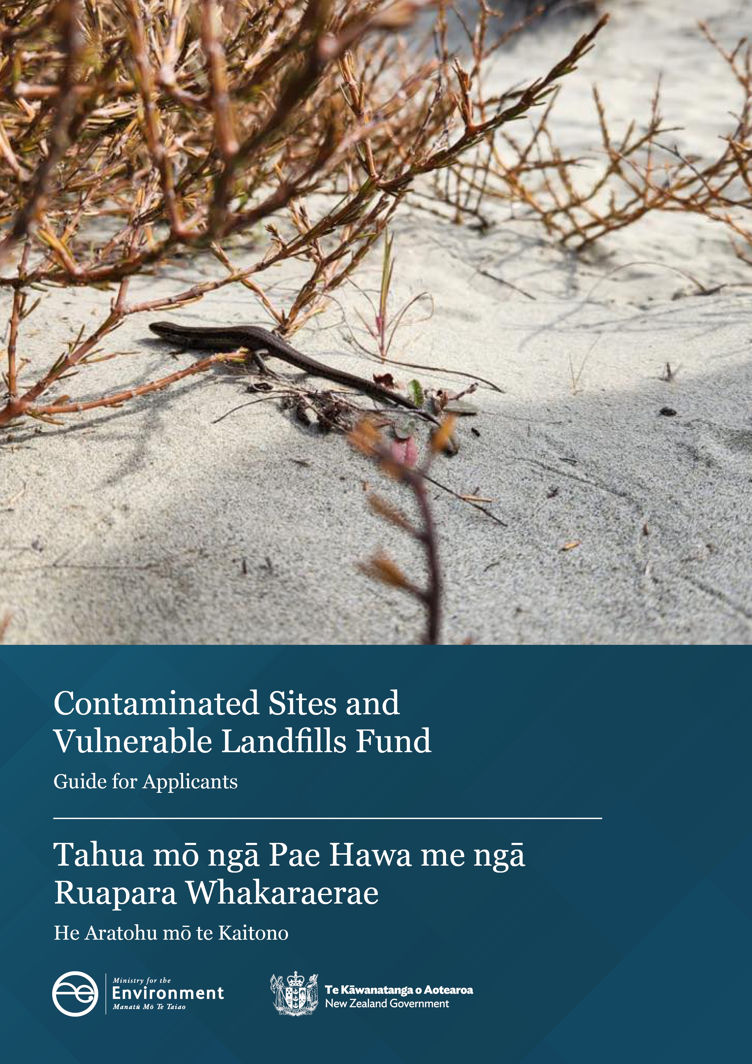

**Disclaimer**

The information in this publication is, according to the Ministry for the Environment’s best efforts, accurate at the time of publication. The Ministry will make every reasonable effort to keep it current and accurate. However, users of this publication are advised that:

* the information does not alter the laws of New Zealand, other official guidelines, or requirements
* it does not constitute legal advice, and users should take specific advice from qualified professionals before taking any action based on information in this publication
* the Ministry does not accept any responsibility or liability whatsoever whether in contract, tort, equity, or otherwise for any action taken as a result of reading, or reliance placed on this publication because of having read any part, or all, of the information in this publication or for any error, or inadequacy, deficiency, flaw in, or omission from the information in this publication
* all references to websites, organisations or people not within the Ministry are for convenience only and should not be taken as endorsement of those websites or information contained in those websites nor of organisations or people referred to.

This document may be cited as: Ministry for the Environment. 2025. *Contaminated Sites and Vulnerable Landfills Fund: Guide for applicants*. Wellington: Ministry for the Environment.

Cover image: A northern grass skink in the remediated Tāhunanui back beach   
Image source: Nelson City Council

First published in September 2024, updated in July 2025, by the  
Ministry for the Environment   
Manatū mō te Taiao  
PO Box 10362, Wellington 6143, New Zealand  
[environment.govt.nz](http://www.environment.govt.nz)

ISBN: 978-1-991140-38-8 (online)

Publication number: ME 1849

© Crown copyright New Zealand 2025

# Contents

Acronyms and terms 4

About this guide 5

Process overview 6

Getting started 6

Enquiry form 7

Application stage 7

Project summary 7

Funding summary 8

Project objectives 9

Work plan milestone table 10

Project risks and mitigations 15

How your applications will be assessed 17

# Tables

Table 1: Project costs eligible for Contaminated Sites and Vulnerable Landfills Fund 11

Table 2: Project costs ineligible for Contaminated Sites and Vulnerable Landfills Fund (CSVLF) 11

Table 3: Example work plan milestones 13

Table 4: Example project risk table 16

Table 5: Main questions regarding Contaminated Sites and Vulnerable Landfills Fund criteria 17

# Figures

Figure 1: What to expect from the Contaminated Sites and Vulnerable Landfills Fund (CSVLF) process 6

Figure 2: The SMART framework 9

# Acronyms and terms

|  |  |
| --- | --- |
| **ARO** | Assessment of remedial options (Phase 3) |
| **CLMG** | Contaminated Land Management Guidelines (produced by the Ministry for the Environment) |
| **CSVLF** | Contaminated Sites and Vulnerable Landfills Fund |
| **DSI** | Detailed site investigation (Phase 2) |
| **HAIL** | Hazardous Activities and Industries List (published by the Ministry for the Environment) |
| **NESCS** | National Environmental Standard for Assessing and Managing Contaminants in Soil to Protect Human Health 2011 |
| **Phase 1** | Preliminary site investigation (PSI), which establishes the contamination history of the site and is part of the contaminated site identification process |
| **Phase 2** | Detailed site investigation (DSI), where the nature and extent of contamination and risk to human health and the environment are determined |
| **Phase 3** | Remedial planning, where remedial and/or management strategies that will mitigate the risk posed by contaminants are considered. Possible remedial/management methods are further developed to determine the most appropriate and cost-effective option(s), and a remedial action plan (RAP) that details the selected remedial and management works is prepared |
| **Phase 4** | Remediation, where remedial and management works are carried out in accordance with the RAP developed in Phase 3 |
| **PSI** | Preliminary site investigation (Phase 1) |
| **RAP** | Remediation action plan (Phase 3) |
| **RMA** | Resource Management Act 1991 |
| **SMART** | Specific, measurable, achievable, realistic, timely |
| **SQEP** | Suitably qualified and experienced practitioner |

# About this guide

This document supports you through your Contaminated Sites and Vulnerable Landfills Fund (CSVLF) application submission.

#### Background

Land, sediment and water can potentially become contaminated when hazardous substances and/or waste are not used, stored or disposed of in a safe and contained manner. This may lead to harm or risk of exposure to these contaminants on human health and/or the environment.

Managing the effects of contaminant discharges into the environment is subject to the [Resource Management Act 1991 (RMA)](https://www.legislation.govt.nz/act/public/1991/0069/latest/DLM230265.html), including the:

* [National Environmental Standard for Assessing and Managing Contaminants in Soil to Protect Human Health 2011 (NESCS)](https://environment.govt.nz/acts-and-regulations/regulations/national-environmental-standard-for-assessing-and-managing-contaminants-in-soil-to-protect-human-health/)
* [Contaminated Land Management Guidelines (CLMG) 1, 2 and 5](https://environment.govt.nz/publications/?keyword=contaminated%20land%20management%20guidelines&sort=title_asc).

A range of industrial practices that may result in contamination are listed in the [Hazardous Activities and Industries List (HAIL)](https://environment.govt.nz/publications/hazardous-activities-and-industries-list-hail/) provided by the Ministry for the Environment (the Ministry).

The CSVLF is focused on supporting councils and land owners to clean up legacy contaminated land and vulnerable landfill sites contaminated by HAIL activities either before the RMA came into effect or after 1991 where enforcement action was not able to be taken.

#### Purpose of the Contaminated Sites and Vulnerable Landfills Fund

The purpose of the CSVLF is to reduce the harm and risk posed to human health and/or the environment from exposure to contamination and waste from high-risk legacy contaminated sites and closed landfills that are vulnerable to erosion or water inundation.

#### Check you are eligible

Before starting your application, please review the gazetted [CSVLF eligibility and assessment criteria](https://gazette.govt.nz/notice/id/2024-go4619).

# **Process overview**

Figure 1: What to expect from the Contaminated Sites and Vulnerable Landfills Fund (CSVLF) process

An overview of the three stages of the CSVLF process; 
Application (1 to 3 months)
Contracting (2 to 4 months)
Project management (duration as per contract)

# Getting started

The Funds Management System (FMS) is the software system the Ministry investment function uses to manage applications through to contracting, monitor active projects, and to collect and analyse data that we use to report back to the government to help make evidence-based investment and policy decisions.

To get started, we require a two-step verification process:

1. [**RealMe**](https://www.realme.govt.nz/): You will first need to have a RealMe account. You may use either your personal account or your business account. If you do not have a RealMe account, follow the instructions on the RealMe website to sign up. Once you have logged in, you will be redirected back to FMS.
2. **FMS account**: When you log into FMS using your RealMe details, you will be asked to complete an FMS user registration. Update your contact details and if you do not have an FMS business account already, create an account for your organisation.

#### Need more help getting started?

[These guidelines](https://environment.govt.nz/assets/publications/FMS-client-portal-user-guide-for-applicant-organisations.pdf) have step-by-step instructions to set yourself up in FMS.

You should now be all set up to access the Enquiry Form and all future applications and grant reporting functions with the Ministry.

# Enquiry form

The enquiry form is an opportunity for the Ministry to first hear about your project and determine its eligibility against our gazetted criteria. You can access a link to this form on our [website](https://environment.govt.nz/what-you-can-do/funding/contaminated-sites-fund/#how-to-apply).

The help text on the enquiry form includes guidance, and the contents of this guide can also be helpful.

Once you have submitted your enquiry form, a member of the CSVLF team will reach out to discuss next steps.

# Application stage

If your project is eligible for the CSVLF you will be invited to complete a full application form. This will be sent to you via our FMS. The information you provided at the enquiry stage will be carried through to the application form.

The application form includes guidance to help you fill out the document. This guide includes example content for particular sections, which can be used in your application and amended based on the specifics of your project.

If you have a question about the application form that is not covered in this guide, you can email [CSVLF@mfe.govt.nz](mailto:CSVLF@mfe.govt.nz).

## Project summary

For the project summary question, you should provide a short, high-level overview of the project and what it will achieve. Please see examples below. You can copy these examples and edit to reflect your project.

* **Phase 2** **project**. This project will involve undertaking a detailed site investigation (DSI) to confirm the nature and extent of contamination at the site. The main deliverable will be a DSI report. The information from this phase will be used to inform the remedial planning phase.
* **Phase 3** **project**. This project will outline and assess remedial options for the site and develop a plan for undertaking the remedial works. The main deliverables will be an assessment of remedial options (ARO) and a remedial action plan (RAP). This information will help determine the preferred option and appropriate methodology to be used during the remedial works.
* **Phase 4** **project**. This project will involve undertaking remedial works at the site in accordance with the RAP. Site validation will be required once remediation is complete in line with the RAP, with the main deliverables being a site validation report and, if required, a long-term management plan. At the end of the project, the risk will be mitigated (or managed), and the site will be suitable for the purpose determined in the RAP.

Note that contaminated land investigations and technical reports are required to be done by a suitably qualified and experienced practitioner (SQEP) with the relevant certification, for example, the Certified Environmental Practitioner – Site Contamination Specialist. We also request all technical reports be peer reviewed by an independent SQEP to confirm they are compliant with CLMG 1 and CLMG 5.

#### Sustainable remediation and management

For Phase 3 and Phase 4 projects, you must show that you have considered sustainable remediation and management.

The principle underlying sustainable remediation is that the decisions we make today will not compromise future generations. The aim of sustainable remediation and management is to find an acceptable balance between the effects of undertaking remediation activities and the expected benefits of those activities.

A sustainability assessment of proposed remedial options could involve considering broader environmental impacts, for example, on natural resource use, greenhouse gas emissions, and generation or transfer of waste. A sustainability assessment may also consider other outcomes of the remediation, such as protecting or restoring sensitive cultural or heritage areas.

Determining the appropriate methodologies for your project will be site-specific and should be based on international standards that:

* are considered appropriate by the SQEP undertaking the remedial planning
* are cost effective
* the project decision-makers agree with.

Examples of relevant international standards are:

* International Standard ISO 18504:2017 Soil quality – sustainable remediation
* Australian Standard AS ISO 18504:2022
* the Sustainable Remediation Forum (SuRF)-ANZ and SuRF-UK frameworks for evaluating sustainable remediation options.

## Funding summary

When completing your project funding summary, note the following.

* Totals in this section should match those in the more detailed budget provided as part of the milestone table later in the application.
* The milestone table section of this document provides more detailed guidance relating to what costs are eligible to include in your project budget.
* The Ministry will not cover in-kind costs, and these should not be included in the total project cost. In-kind costs are any costs that are not billable, such as internal staff time, donated equipment and volunteer time.
* All amounts should exclude GST.

#### Co-funding

The Ministry will typically contribute 50 per cent of the total project costs, and some co-funding must be provided for the project from other sources. Co-funding is typically provided by either the applicant or the land owner (if different).

Any funding request for more than 50 per cent of total costs will be considered against the following criteria:

* the applicant’s resources (for example, the number of ratepayers residing in a district and level of deprivation)
* the size of the project, considering the project value compared with the applicant’s resources
* the size and scale of the project’s benefits to Aotearoa New Zealand
* the availability of funding.

The maximum the Ministry will contribute towards a project is 75 per cent of the costs.

**Note: All guidance for completing the ‘Site information’ and ‘Site risk screening’ sections is provided in the application form.**

## Project objectives

Objectives are statements clearly describing what the project must realistically achieve to succeed and what strategies will be implemented to enhance or improve the current situation.

Your application needs to outline your project objectives. For each objective, the application needs to describe the milestones and relevant main activities that will be completed during the project, to meet that objective.

Projects typically have between one and four objectives, depending on the complexity of the project. Phase 2 and Phase 3 projects typically follow a standard approach based on the reports required to be delivered for investigating contaminated land and planning the remediation. Phase 4 projects may be more variable, based on site-specific requirements. Below are example objectives, which can be copied and refined to fit your project.

All objectives should use the SMART framework.

Figure 2: The SMART framework

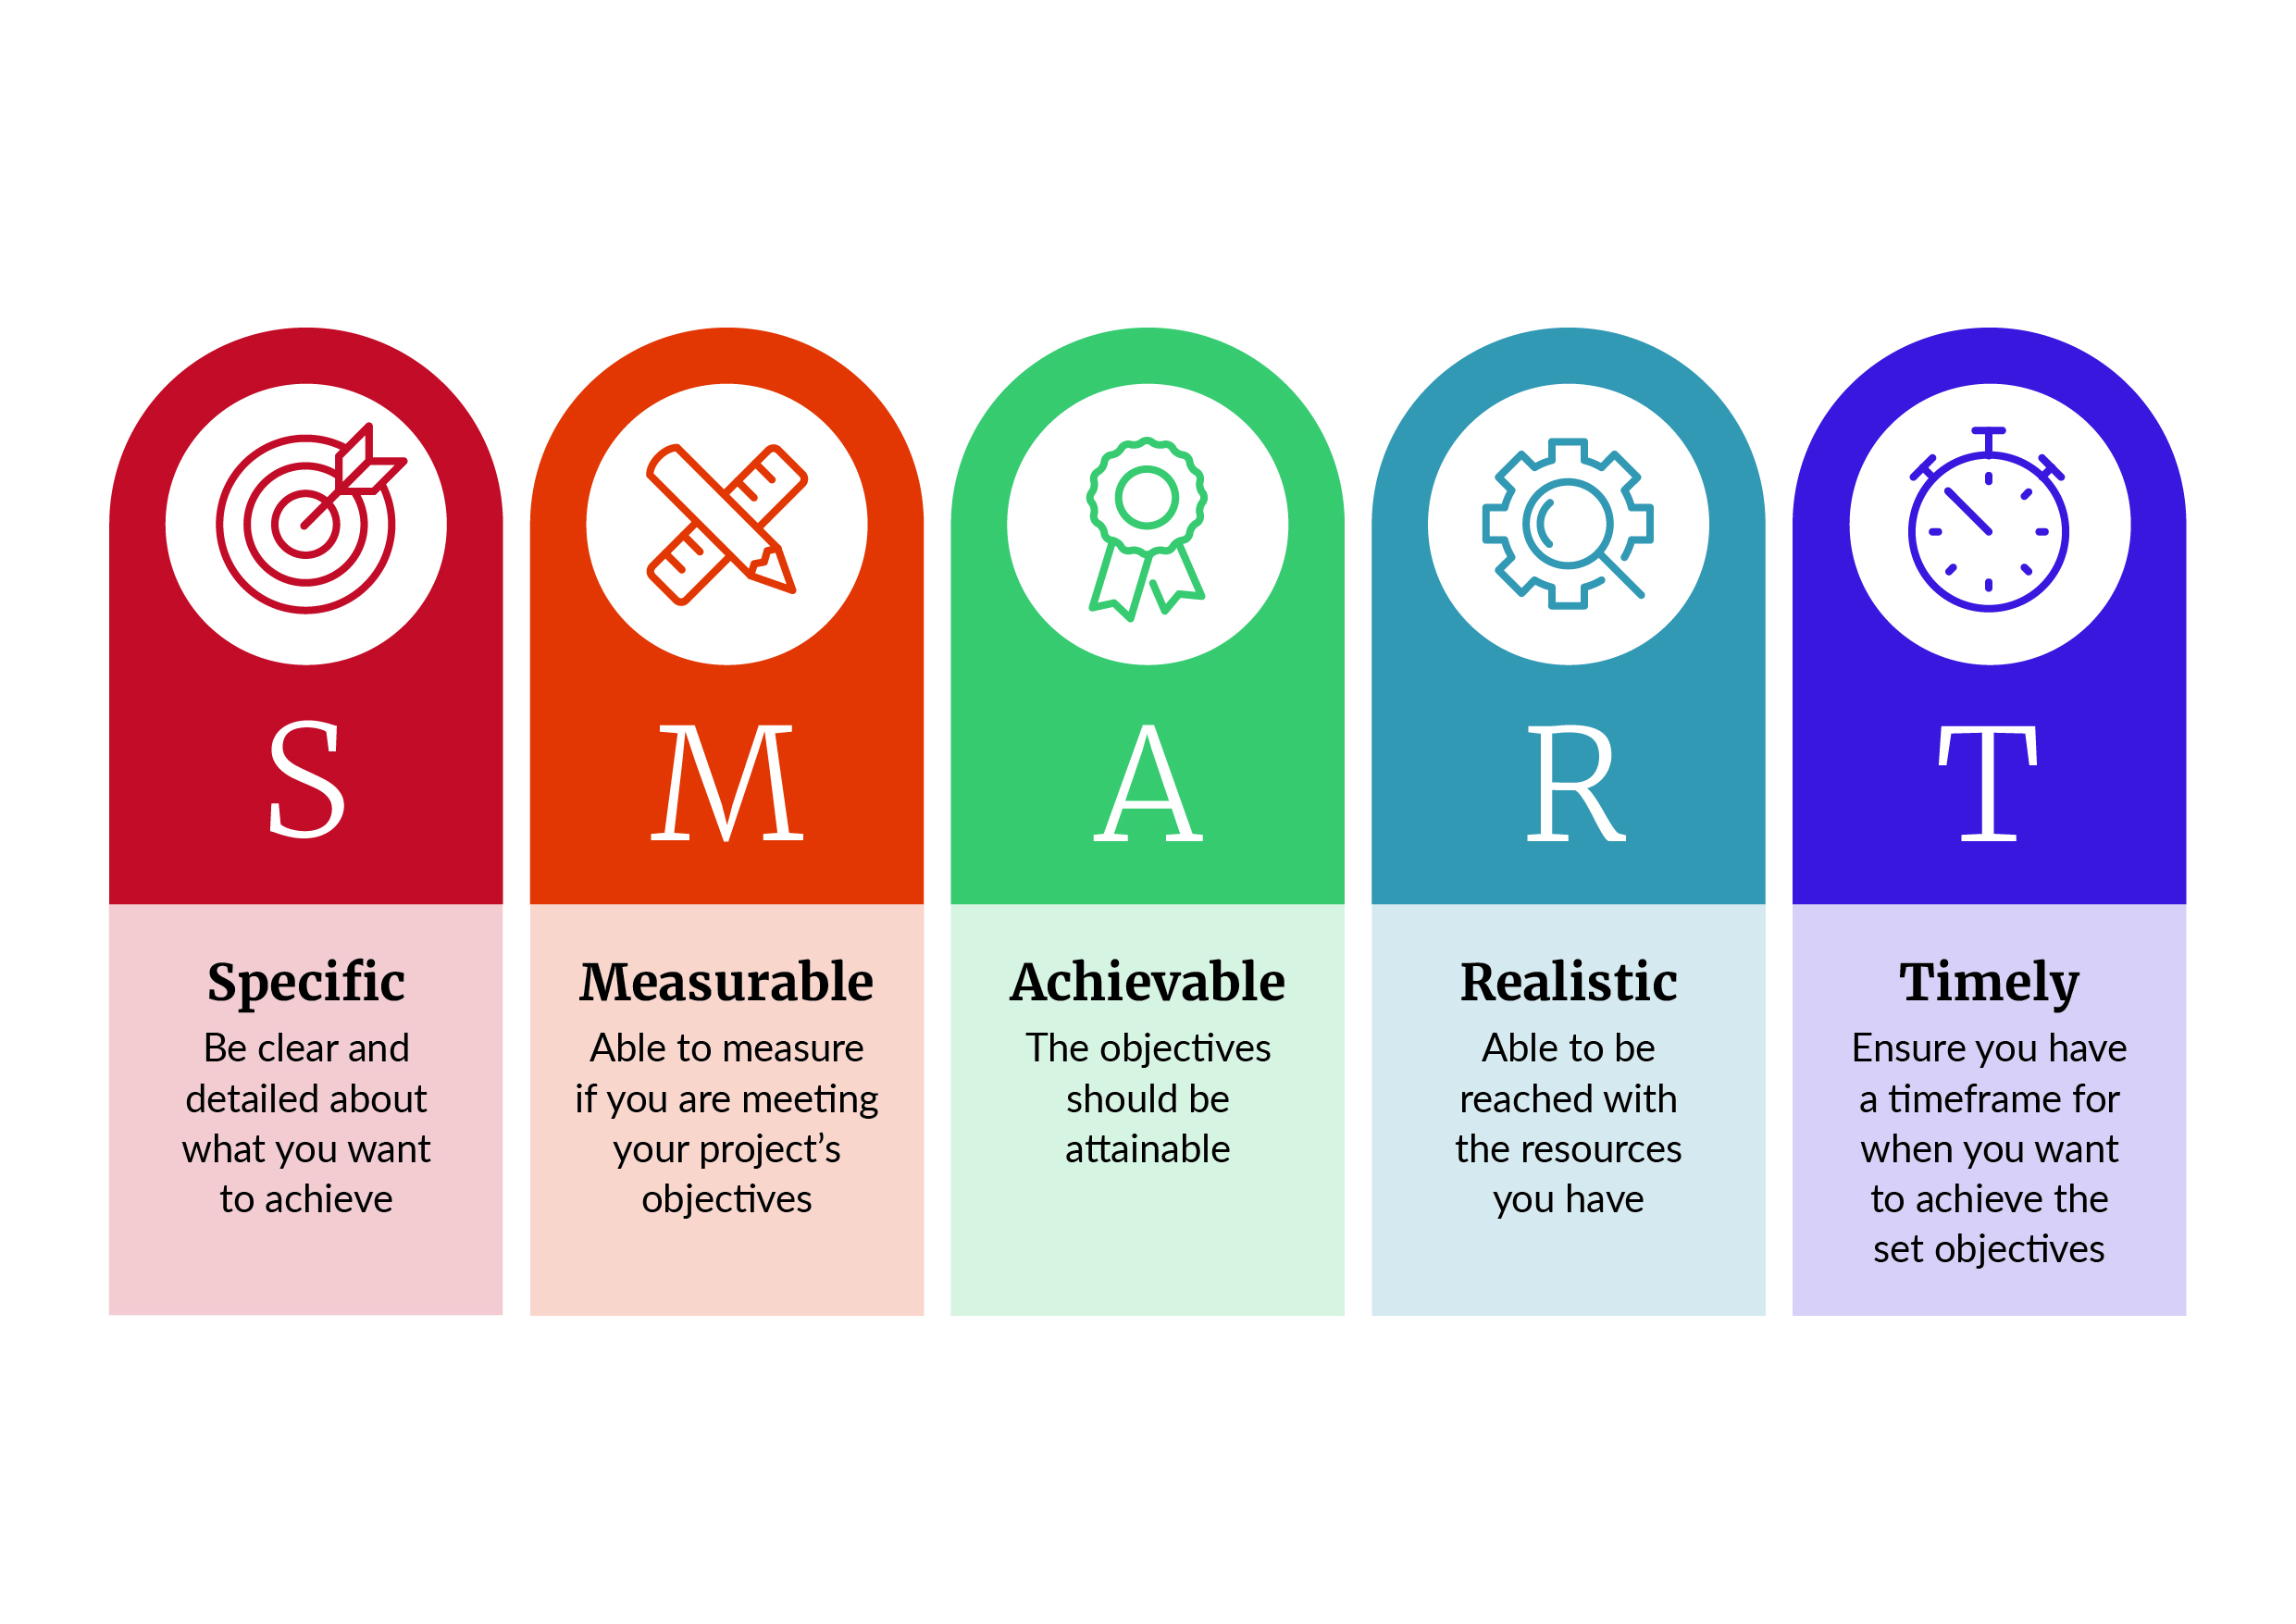

### Examples of SMART objectives for different projects

##### Phase 2 project objective

* By the end of the project, successfully complete a Phase 2 DSI and subsequent reporting compliant with CLMG 1 and CLMG 5 that allow for informed decisions to be made on subsequent phases of the remediation.

##### Phase 3 project objectives

* Within [number] months of the project start date, successfully complete an ARO compliant with CLMG 1 and CLMG 5 that allows for informed decisions to be made on the remediation of the site.
* By the end of the project, successfully complete a RAP compliant with CLMG 1 and CLMG 5 that outlines the agreed remedial option(s) and relevant methodology to be implemented during the Phase 4 remediation.

##### Phase 4 project objectives

* Within [number] months of the project start date, procure an SQEP and an experienced contractor and establish the project structure necessary to deliver the remediation project as described in the RAP.
* Within [number] months of the project start date, remove contaminated material and waste from the site and dispose of it in an appropriate disposal facility, in line with the RAP.
* By [date], develop a long-term management plan suitable for controlling minor future soil disturbance or disposal and, if necessary, for monitoring of remedial measures.
* By the end of the project, complete site validation testing and provide a site validation report confirming that the site has been remediated to the required standards, in line with the RAP.

**Note: All guidance for completing the ‘Benefits’, ‘Partnerships and project stakeholders’ and ‘Experience, capability and project delivery’ sections is provided in the application form.**

## Work plan milestone table

Meeting an objective is a milestone. It is a significant achievement that typically results in a project progressing to undertaking the next objective.

The project work plan details the activities involved in reaching that milestone and meeting the project objectives. Milestone activities are the main actions you will complete. Each activity should have a related deliverable; this is the evidence you will provide to the Ministry to show the activity has been completed. Main deliverables are the technical reports that will show the objective has been met. Examples of milestone activities and deliverables are provided in the Example work plan milestones section below.

Eligible costs (expenses) related to project activities and deliverables should be included in a milestone table. Table 1 provides information on eligible costs for claiming from the CSVLF. Not all milestone activities will have chargeable costs against them, in those cases, the budget section of the milestone table can be left blank. Project costs not included in table 1 are ineligible to be covered by the CSVLF and should not be included in the milestone table. table 2 provides examples of costs that should be excluded.

Table 1: Project costs eligible for Contaminated Sites and Vulnerable Landfills Fund

| Category | Eligible project costs |
| --- | --- |
| Consultants and contractors | Relevant costs for consultants and contractors, including:   * completing investigations, assessments and reporting such as the detailed site investigation, assessment of remedial options, remediation action plan and site validation report * peer reviews of technical reports * undertaking the remedial works.   Relevant costs should be justified through the scope of work and cost-effective prices determined through appropriate procurement, such as the Government Electronic Tender Service (GETS NZ) or preferred tendering. |
| Venue and equipment | Equipment and plant hire related to the delivery of the project. |
| Financial, legal, information technology and project management | Reasonable financial, legal, information technology services and project management costs required to deliver the project. |
| Health and safety | Health and safety equipment and training. |

Table 2: Project costs ineligible for Contaminated Sites and Vulnerable Landfills Fund (CSVLF)

| Category | Ineligible project costs |
| --- | --- |
| In-kind costs | The Ministry will not cover in-kind costs, which are any costs that are not billable, such as internal staff time, donated equipment and volunteer time. |
| Phase 1 costs | Costs associated with Phase 1 preliminary site investigations. |
| Other funding sources, including government agencies | Costs for projects that would be more appropriately funded by other funding sources, including government agencies.  Costs associated with statutory duties of local government (that is, activities councils are required to undertake by law, such as local government planning, resource consent approval, or monitoring functions). |
| Retrospective costs | Retrospective or backdated costs, unless specifically agreed to by the Ministry. |
| Business-as-usual operating costs | Costs relating to an organisation’s ‘normal’ activities, including (but not limited to):   * buying material and equipment that are normal parts of an organisation’s responsibilities for managing their property and day-to-day business * the maintenance and running costs of vehicles (including warrants of fitness and registration) * the purchase and/or maintenance of buildings. |
| Reinstatement costs or improvements to sites | The CSVLF is designed to support the remediation of contaminated sites, ensuring the level of contamination and exposure is reduced and the risk is mitigated.  Site reinstatement includes returning the remediated area to a reasonable state where the disturbed area is backfilled and stable. The CSVLF will not cover the amenity landscaping or site restoration, or development of the site for other purposes, such as creating or reinstating a car park or a sports field. |
| Out-of-scope costs | The CSVLF does not provide for the removal of a structure’s hazardous or harmful building material, or the building of structures or barrier systems that are not related to the containment of contaminated material, discharges or waste.  Costs for engineered coastal, or waterway protection that functions only to minimise erosional impact on the shoreline and riverbanks.  Any other costs identified as out of scope for the project during the application or contracting process. |
| Capital expenditure | The Ministry will not contribute towards the purchase of capital assets. |
| Ineligible sites | The CSVLF cannot contribute to the remediation of sites that do not meet its eligibility criteria, such as:   * sites where activities that may cause contamination are ongoing * most sites that were contaminated after the Resource Management Act 1991 came into force * investigations or remediation of contaminated or potentially contaminated land on Crown-owned land where the Crown is liable for the contamination. |
| Specifications in the funding deed | Funding may not be used for investigations or remediation on land that falls outside the area identified in the funding deed. |

Table 3: Example work plan milestones

|  |  |  |  |  |  |  |
| --- | --- | --- | --- | --- | --- | --- |
| Milestone number | Milestone | Milestone start date | Milestone due date | Ministry contribution requested | Co-funder contribution | Total estimated cost |
| Example milestone | Successfully complete a DSI compliant with CLMG 1 and CLMG 5 by the end of the project. | 01/10/2024 | 30/06/2025 | $27,500 | $27,500 | $55,000 |
| Activity number | Activity | Deliverable | | Expense description | Expense type | Expense estimate |
| 1 | Engage a certified SQEP who has appropriate experience to undertake the DSI. | Letter of engagement, contract or similar showing an SQEP has been engaged and including details of the qualifications and experience of the SQEP selected. | | – | Choose an item. | – |
| 2 | Complete the DSI and produce a report that is compliant with CLMG 1 and CLMG 5. | Copy of the DSI report incorporating any peer-review amendments. | | Consultancy costs for the DSI. | Consultants and sub-contractors | $50,000 |
| 3 | Peer review of the DSI by an independent certified SQEP confirming it is compliant with CLMG 1 and CLMG 5. | Copy of the peer review confirming the DSI is compliant with CLMG 1 and CLMG 5. | | Costs for the DSI peer review. | Consultants and sub-contractors | $5,000 |
| 4 | Make decisions on whether remediation is required and, if so, decide timeframes for when remedial planning will commence. | Copy of the decision by relevant decision-maker (eg, Executive Leadership Team). | | – | Choose an item. | – |
| 5 | Submitting Ministry reporting documents. | Ministry reporting documents submitted (milestone report; copies of invoices for costs being claimed >$5,000, project-specific cost code set up, tax invoice for the Ministry). | | – | – | – |

**Notes:** CLMG = Contaminated Land Management Guidelines; DSI = detailed site investigation; SQEP = suitably qualified and experienced practitioner.

|  |  |  |  |  |  |  |
| --- | --- | --- | --- | --- | --- | --- |
| Milestone number | Milestone | Milestone start date | Milestone due date | Ministry contribution requested | Co-funder contribution | Total estimated cost |
| Example milestone | Complete an ARO report that is compliant with CLMG 1 within four months of signing the Deed of Funding. | 01/09/2024 | 30/11/2024 | $10,500 | $10,500 | $21,000 |
| Activity number | Activity | Deliverable | | Expense description | Expense type | Expense estimate |
| 1 | Engage a certified SQEP who has appropriate experience to complete the ARO. | Letter of engagement, contract or similar showing an SQEP has been engaged and including details of the qualifications and experience of the SQEP selected. | | – | Choose an item. | – |
| 2 | Complete the options assessment and produce the ARO report. | Copy of the ARO report incorporating any peer-review amendments. | | Consultancy costs for the ARO. | Consultants and sub-contractors | $20,000 |
| 3 | Peer review of the ARO by an independent certified SQEP confirming it is compliant with CLMG 1. | Copy of the peer review confirming the ARO is compliant with CLMG 1. | | Costs for the ARO peer review. | Consultants and sub-contractors | $1,000 |
| 4 | Decision-makers consider completed ARO and select a preferred remedial option. | Confirmation of remedial option selected (eg, meeting minutes, signed memo, other approval method). | | – | Choose an item. | – |
| 5 | Submitting Ministry reporting documents. | Ministry reporting documents submitted (milestone report; copies of invoices for costs being claimed >$5,000, project-specific cost code set up, tax invoice for the Ministry). | | – | – | – |

**Notes:** ARO = assessment of remedial options; CLMG = Contaminated Land Management Guidelines; SQEP = suitably qualified and experienced practitioner.

## Project risks and mitigations

A risk is something that may affect the completion and success of your project. It is good practice to identify all concerns about your project at an early stage and what mitigations you will put in place to address these. When completing the Project risks table in the application form, see the descriptions for each column below:

* **likelihood** – chance of event happening
* **severity** – seriousness of possible results from events
* **impact** – extent to which event may affect the organisation
* **impact details** – what will happen if the risk eventuates
* **mitigation** – what you will do to prevent or reduce the likelihood of the risk eventuating
* **residual risks** – after mitigation, the remaining potential outcomes related to this risk.

For Phase 4 projects, we may require you to produce a detailed risk management plan.

Project risks should be reviewed regularly, with any new risks and mitigation strategies added as they are identified. Table 4 provides examples of project risks and associated analyses, to help you complete your analysis of relevant risks to your project.

Table 4: Example project risk table

| Risk # | Risk | Category | Likelihood | Severity | Impact | Impact details | Mitigation | Residual risks |
| --- | --- | --- | --- | --- | --- | --- | --- | --- |
| 1 | Delays in completing the reports | Progress | Medium | Low | Low | Completing assessment of remedial options and remediation action plan may be delayed from dates set out in the project plan. | Project manager to monitor delivery of activities to ensure main reports are completed by agreed times. | Delays in completing reports and milestones. |
| 2 | Budget overspend | Financial | Medium | Low | Low | Costs escalate beyond budgeted amounts, requiring additional budget to be sought or affecting the scope of the project. | Complete detailed project planning to reduce unknowns that may arise during project delivery.  Project manager to monitor costs against budget to track and manage any project overspend early. | Additional budget required from recipient / third party to complete the project. |
| 3 | Reports not produced to required standards | Quality | Low | Medium | Medium | Reports produced are of a standard that leaves main questions unanswered, and the project is not able to progress to the next phase. | Ensure procurement of a suitably qualified and experienced practitioner with relevant experience and expertise to complete reports.  Engage a certified suitably qualified and experienced practitioner to peer review reports to ensure they meet required standards. | Reports require reworking to bring them up to the required standard. |

# How your applications will be assessed

Eligible applications will be assessed by a panel of experts in contaminated land management. The panel will review applications and provide recommendations on whether funding should be approved. To supplement the [CSVLF eligibility and assessment criteria](https://gazette.govt.nz/notice/id/2024-go4619), table 5 outlines the main questions related to the criteria that the panel will consider.

The panel will give preference to applications that score highly against these questions. Missing information or insufficient investigation may result in applications being declined, or in conditions being placed on a funding offer. We recommend you seek peer reviews of technical reports to consider whether the information provided and the investigation undertaken are sufficient.

Decisions for projects requesting less than $1 million will be made by the Ministry by a moderation panel. For projects requesting more than $1 million in funding, decisions will be made by the Minister for the Environment.

Table 5: Main questions regarding Contaminated Sites and Vulnerable Landfills Fund criteria

|  |  |
| --- | --- |
| **Site information** | Has the applicant provided sufficient detail about the site and detail about the HAIL activities undertaken on the site?  Have the technical reports provided to support the application been done by an SQEP and peer reviewed by an independent SQEP? |
| **Site risk screening** | Does a demonstrated need exist, and are there consequences of not addressing the contamination? Has a sufficient conceptual site model (hazard, source, receptor and pathway) been developed? |
| **Site vulnerability status** | Has the applicant demonstrated that the site is at imminent risk where the contaminants and/or landfill contents have been exposed and/or released into the environment because of recent severe weather events?  Has the relevant information been obtained and provided to indicate erosion and/or inundation is likely to be occurring more frequently?  What actions have been taken to monitor effects and investigate the vulnerability of the site?  Has the applicant provided evidence, such as hydrographic surveys of the river and/or coastline, showing changes?  What evidence has the applicant provided that shows the remediation of this site is a priority due to an increase in risk? For example, has an assessment been completed that confirms an imminent risk of contaminants and waste being mobilised into the environment exists that warrants this project being done in the coming 12 months?  Note the timeliness of the remediation should not relate to a state of emergency response or legislative requirements, such as non-compliance with section 15 of the RMA. |
| **Sustainable remediation and management** | Has the applicant considered sustainable remediation and management as part of their Phase 3 project?  If so, have they considered the sustainable remediation principles and practices in the relevant international standards?  In the remedial options assessment, has the applicant considered initiatives such as waste recovery and the minimisation of waste being redisposed to landfill, soil reuse, or on-site retention or treatment of material?  Are the decisions, methods, targets and outcomes clearly justified in the ARO and the RAP, including how they have been considered in conjunction with cost effectiveness, health and safety, expediency and other relevant factors? |
| **Prioritisation** | The Ministry will also consider the priority of the project based on the level of contamination, vulnerability of the site in a changing climate, and the amount of money available to invest. Decisions will be guided by the priority list ranking for contaminated sites, and the priority assigned to vulnerable landfill sites due to the extent of the impending risk.  Does the site have a high ranking on the priority list (indicating it is more highly contaminated and likely to have a greater effect on human health and the environment), meaning funding is well invested in reducing the risk sooner rather than later?  Is the erosion risk and threat of exposure increasing or changing at a rate that gives this site priority over others? |
| **Environmental, social, cultural or economic benefits** | Are there any environmental, social, cultural and economic benefits of the project beyond reducing risk to the environment and/or human health? If so, are they clearly articulated, and has the applicant considered how these benefits will be measured?  Is the site in an area that has cultural significance or natural, ecological, scientific or recreational value?  Is the project supported by mana whenua? |
| **Strategic value** | Strategic value means the likely ability of projects to act as catalysts that enhance and extend the uptake of best practice and/or innovation for contaminated land management in Aotearoa New Zealand.  Does the project have the potential to be of high strategic value for Aotearoa New Zealand? |
| **Project scope** | Has the scope of the project been clearly defined?  Does a demonstrated need exist for the proposed solutions, and are there consequences of not addressing the contamination? |
| **Proposed project and likelihood of success** | Is the proposed project phase appropriate for the problem described?  Has the applicant shown how the project will achieve its goals and how the effectiveness of the project will be monitored, evaluated and reported?  Does the project methodology align with relevant contaminated land management guidance? |
| **Partnerships and stakeholders** | Has the applicant identified which individuals and/or partner organisations will be involved in the project?  Does the project involve the partner organisations necessary to ensure its success? Will the project require the involvement of other organisations or individuals not detailed in the application? |
| **Land owners** | Is the current land owner or occupier willing to help financially with the project? |
| **Dependencies and links to any other work** | Does the application identify any links to, or dependencies on, other projects? |
| **Project costs** | Are the project costs sufficient and reasonable for the activities proposed? |
| **Funding contribution** | Is there at least a 50% co-funding contribution? If not, is there rationale provided for requiring a higher level of support?  Has co-funding been secured? |
| **Capability to successfully deliver the project (project management and governance)** | Will the project engage personnel with the required technical, project management and financial management skills to successfully deliver the project?  Will appropriate financial systems and governance structures be in place for a project at the scale proposed?  How will the effectiveness of the project be monitored, evaluated and reported? |
| **Risk management** | Has the applicant identified appropriate risks for the project phase? |

**Notes:** ARO = assessment of remedial options; HAIL = Hazardous Activities and Industries List; RAP = remediation action plan; RMA = Resource Management Act 1991; SQEP = suitably qualified and experienced practitioner.