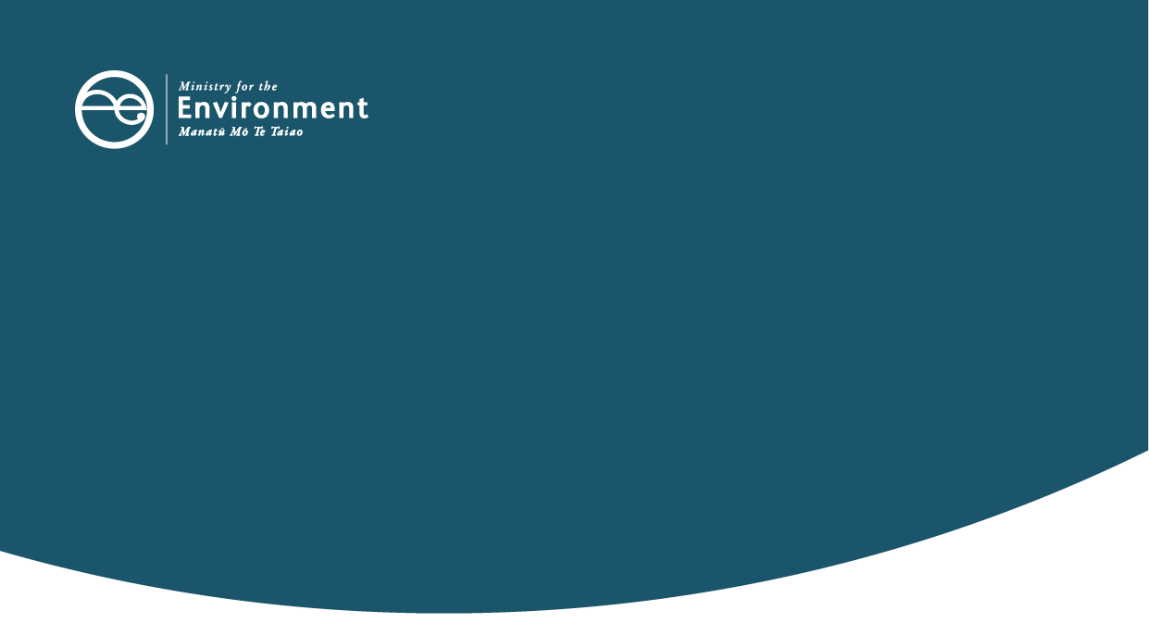

Waste Minimisation Fund audits
This information sheet provides information about Waste Minimisation Fund expenditure audits. It explains what audits are, why they are conducted, and how they are carried out.

About Te Pūtea Whakamauru Para Waste Minimisation Fund
The contestable Waste Minimisation Fund (WMF) supports projects that increase the reuse, recovery and recycling of materials. This helps reduce waste to landfill, one-off use of materials. and litter.
Part 3 of the Waste Minimisation Act establishes a levy on waste disposed of at certain waste disposal facilities (landfills). A portion of the levy collected is allocated to waste minimisation projects through the WMF or otherwise granted through Minister for the Environment approved projects.
Find out more about the fund on our Te Pūtea Whakamauru Para Waste Minimisation Fund web pages.

Audit under the Waste Minimisation Act
The Ministry for the Environment’s Waste Operations team administers the operational aspects of the Act including collecting and distributing waste levy funds. Part of this responsibility involves the Secretary for the Environment appointing auditors under section 87 to audit any person who is paid levy money, including money received for WMF projects.
Auditors have powers under the Act, including the power to inspect and examine property, books, accounts, records or documents. The Act sets out certain offences for intentionally preventing an auditor from carrying out their statutory functions or duties, as well as refusing to supply, or providing false or misleading, information when sought by an auditor using their powers. Auditors will make it clear when powers are being exercised on a particular audit.

What is a Waste Minimisation Fund audit?
A WMF audit is an examination of information, records and project outcomes to assess whether project funds received have been spent appropriately in accordance with the terms and schedules of the Deed of Funding. WMF audits are conducted by either external third-party auditors or Ministry officials who are appointed as auditors under the Act.

Why we audit
The audits are conducted to provide assurance to the Ministry that projects funded from the WMF are carried out in accordance with their funding deeds. The specific objectives of a WMF audit could include assessing:
- whether the funding expenditure is appropriate and in accordance with the funding deed and the Act
- whether reported results are accurate and project deliverables are met in accordance with the funding deed
- the effectiveness of the project processes, to minimise the risk of misreporting and fraud.

What to expect from an audit

Starting the audit
We will email or post you a notification of audit letter. The letter will outline:
- the audit objectives and scope (including relevant milestone/s)
- information you need to provide before our site visit (this excludes information already provided to the Waste Minimisation Fund team)
- tentative times for a site visit or meeting
- requests for relevant personnel and information to be available during the site visit.
We will follow up with a phone call or email to arrange a time for the site visit, discuss any difficulty in collating the information, and to answer any questions about the audit.
Before the notification of audit, the information provided to investment managers on the milestone(s) of your project will be reviewed.

During the audit
During an audit we will:
- visit site and interview relevant project staff, if required
- examine information and records (both physical and electronic)
- examine policies, processes and systems
- assess and verify project deliverables.
We know an audit can affect your business routine, so the WMF audit is designed to cause as little disruption as possible. This may include one to two days on site. There is no set time for completion of an audit; however, we will look to provide an indication of the estimated timeframe within the notification of audit.
The length of the audit will depend on how large and complex the project is, the availability of appropriate staff, access to records and information, and the adequacy of systems and processes in place.
The auditor will provide updates on the progress throughout the audit and you will have opportunities to comment and respond to the audit findings.

Finalising the audit
Once all relevant information has been reviewed, the auditor will contact you to discuss the audit outcome. The outcome may include any process, documentation gaps, errors or issues identified and recommendations to minimise any risks identified. This will be your opportunity to make any final comments on the findings.
After the discussion, you will receive a formal written document advising of the outcome.
Where a moderate or significant issue is identified, such as misspending of waste minimisation funds, attention will be drawn to the corresponding section within the Act and/or funding deed. It could lead to withholding of funding payments, or requirement for funds to be repaid to the Ministry. We will assess the amount of funding repayable based on the findings of the audit, as well as consider any variations to the funding deed or deed termination.

Our approach to the audit outcome
Reiterating the point above, on the issues identified during the audit, we may take the following actions per the Waste Minimisation Act 2008 – Compliance, Monitoring and Enforcement Strategy:
- provide education to promote voluntary compliance
- require potential retainment or repayment of funds
- monitor (including follow up on the recommendations and increased audit frequency)
- investigate alleged breaches
- prosecute/fine in accordance with section 65.

Confidentiality
Any information or records you give to an auditor will remain confidential and be kept secure. Auditors have a professional obligation not to disclose confidential information unless it is specifically required to meet the objectives of the audit or as required by law.
The Ministry is subject to the Official Information Act 1982. A person may make a request for information we hold. This may cover information gathered during an audit. In these instances, we will consider the request in accordance with the Official Information Act 1982 and will consult with you before making a decision on the request.

Further information
For further information about WMF audits, please contact the Waste Operations – Compliance, Monitoring and Enforcement / Te Tūtohu, te Aroturuki me te Whakauruhi team by emailing WMFcompliance@mfe.govt.nz.

Published in March 2022 by the  Ministry for the Environment – Manatū Mō Te Taiao  Publication number: INFO 1007 environment.govt.nz | 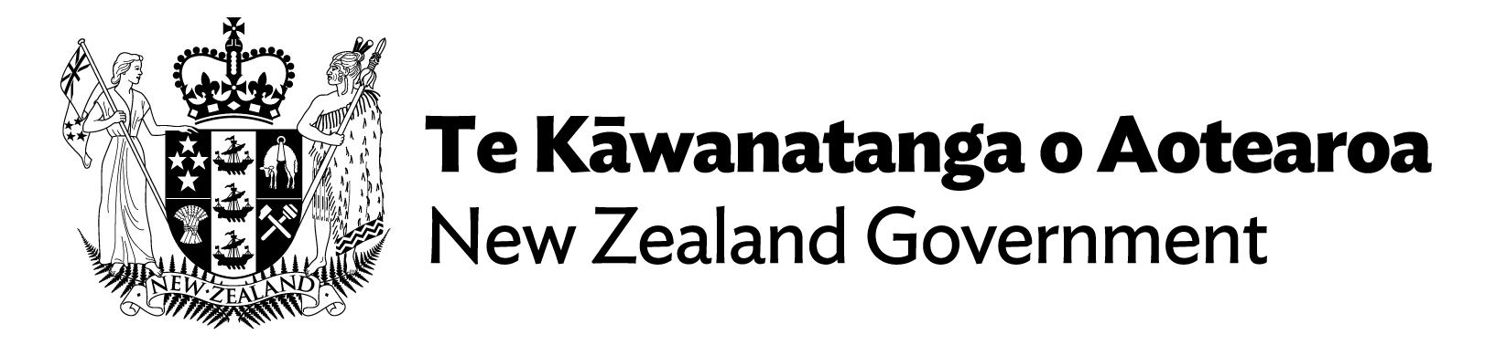

The Waste Minimisation Act 2008 encourages a reduction in the amount of waste we generate and dispose of in New Zealand. The aim is to reduce the environmental harm of waste and provide economic, social and cultural benefits for Aotearoa New Zealand.

