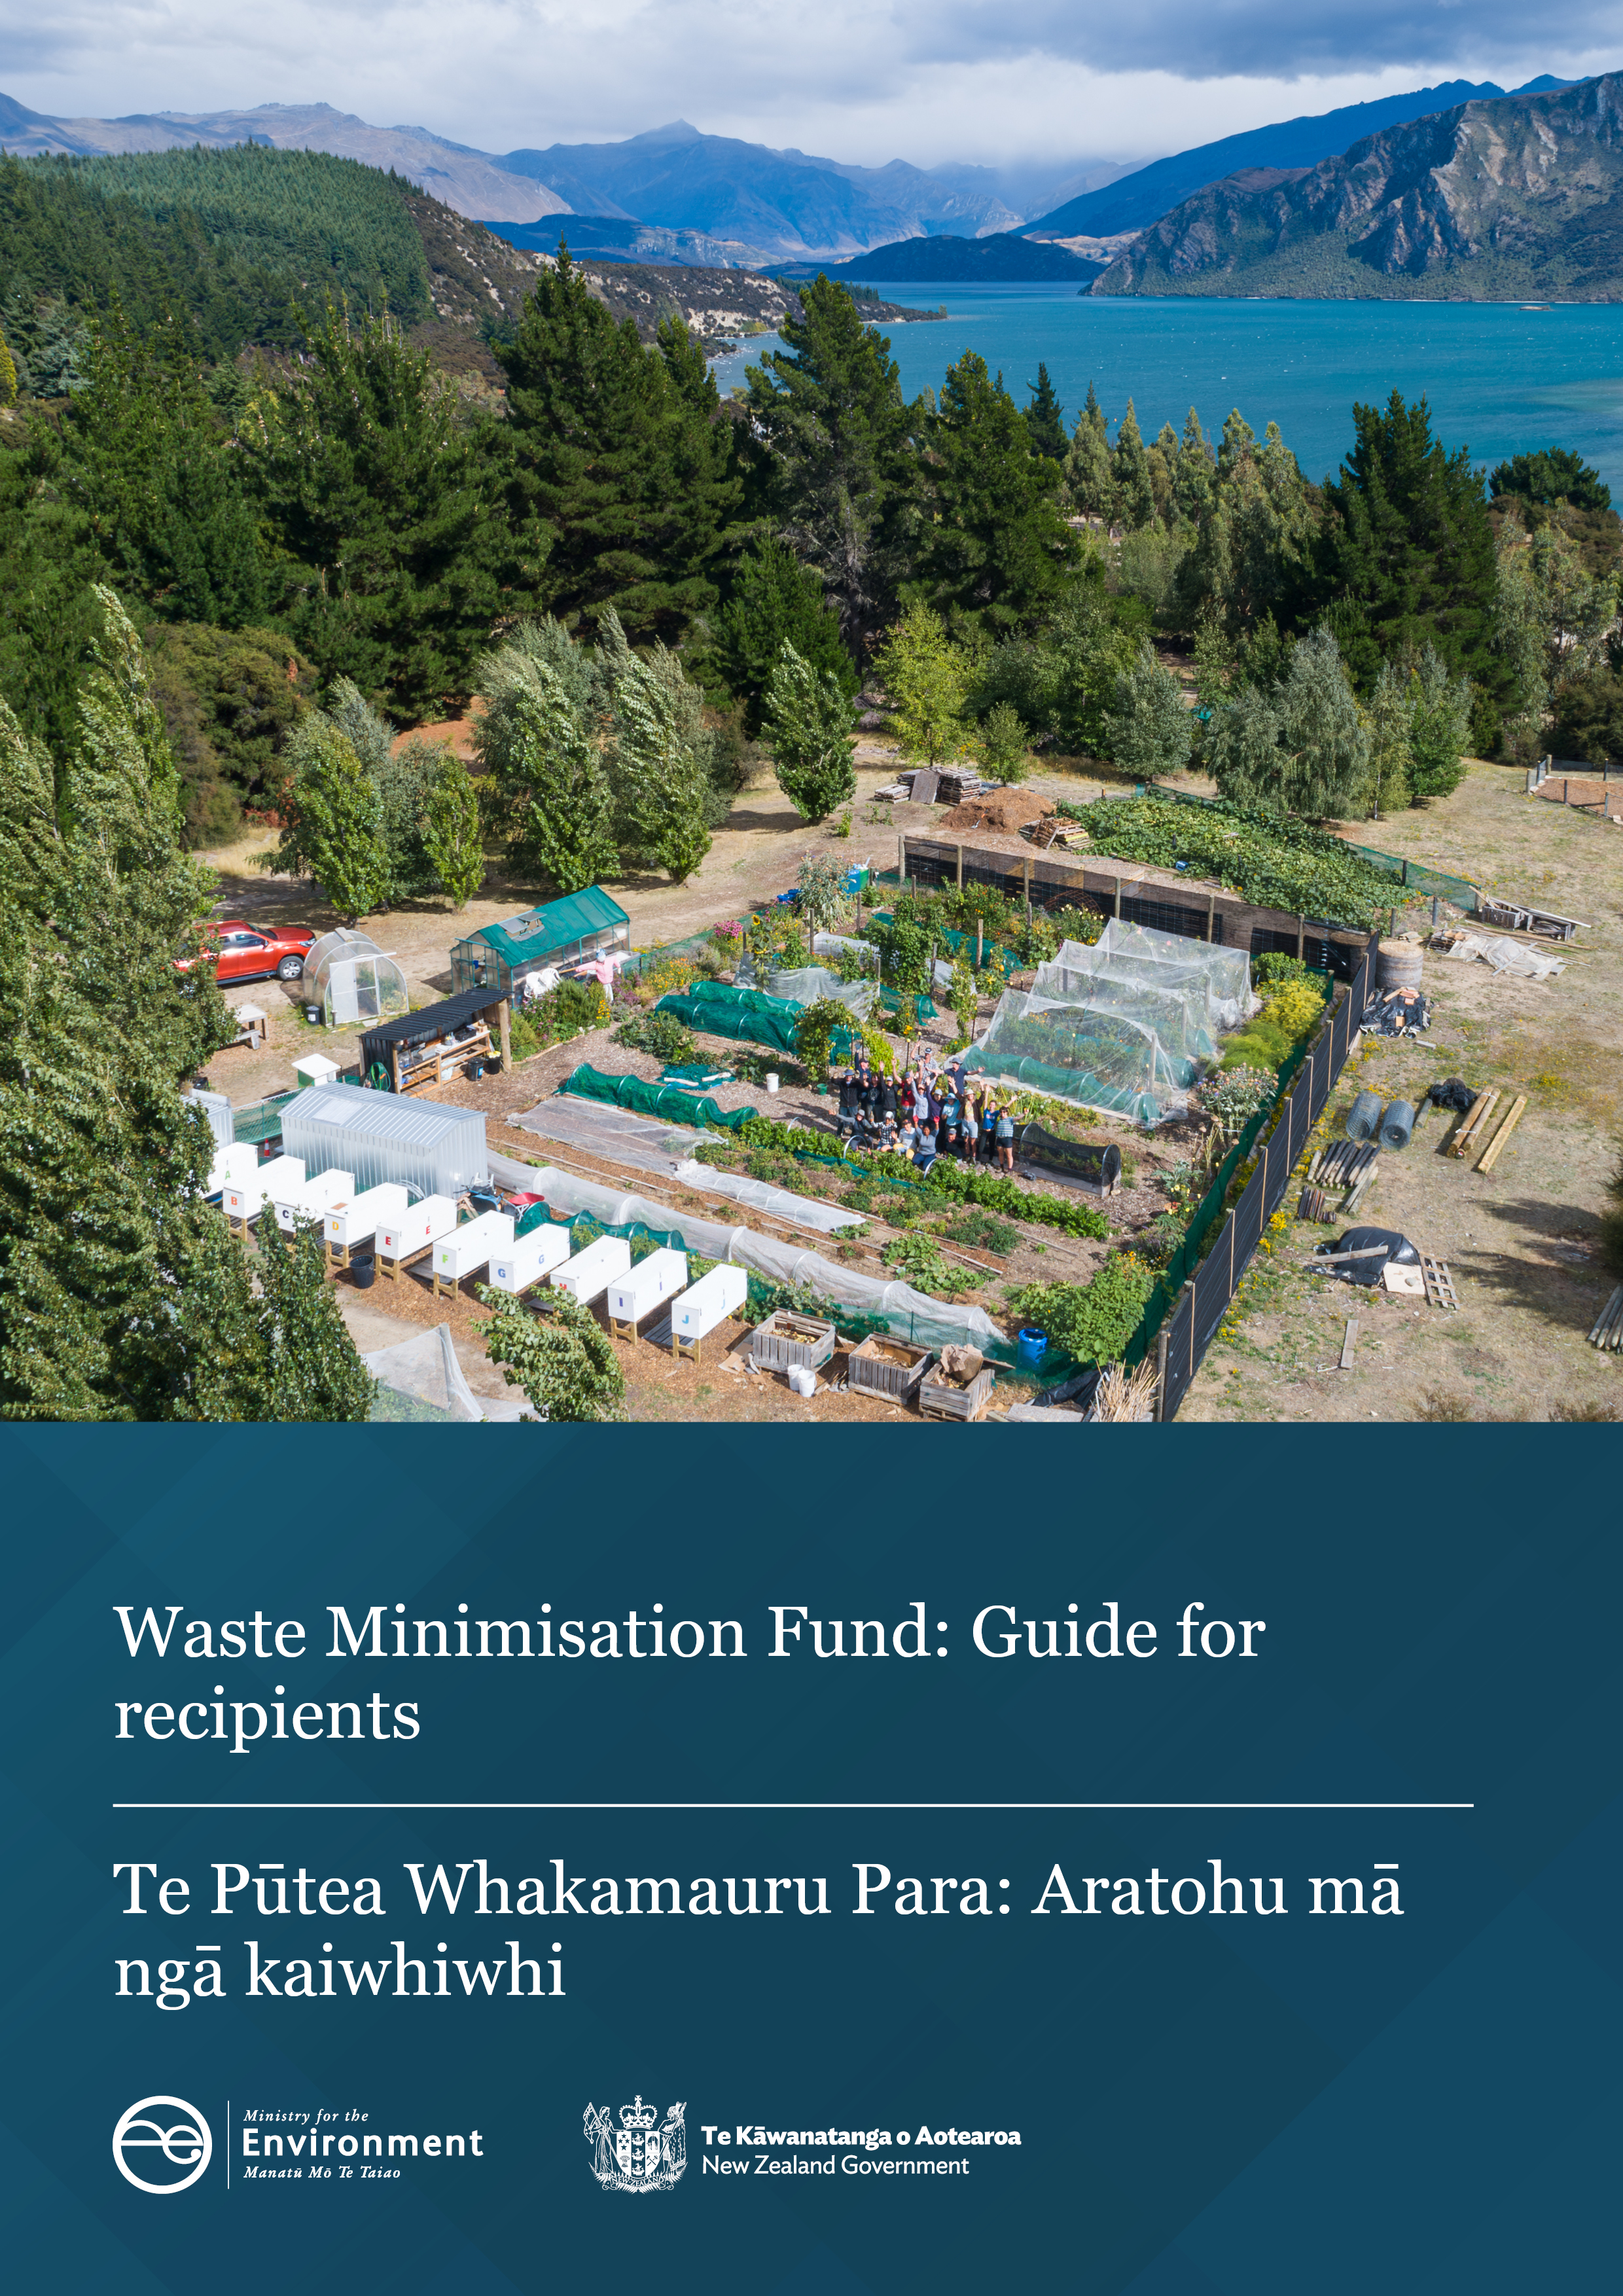

Disclaimer
The information in this publication is, according to the Ministry for the Environment’s best efforts, accurate at the time of publication. The Ministry will make every reasonable effort to keep it current and accurate. However, users of this publication are advised that:
- the information does not alter the laws of New Zealand, other official guidelines, or requirements
- it does not constitute legal advice, and users should take specific advice from qualified professionals before taking any action based on information in this publication
- the Ministry does not accept any responsibility or liability whatsoever whether in contract, tort, equity, or otherwise for any action taken as a result of reading, or reliance placed on this publication because of having read any part, or all, of the information in this publication or for any error, or inadequacy, deficiency, flaw in, or omission from the information in this publication
- all references to websites, organisations or people not within the Ministry are for convenience only and should not be taken as endorsement of those websites or information contained in those websites nor of organisations or people referred to.

This document may be cited as: Ministry for the Environment. 2025. Waste Minimisation Fund: Guide for recipients. Wellington: Ministry for the Environment.

Published in April 2025 by the
Ministry for the Environment
Manatū Mō Te Taiao
PO Box 10362, Wellington 6143, New Zealand
environment.govt.nz
ISBN: 978-1-991140-77-7
Publication number: ME 1886
Cover image: Grow Wānaka
© Crown copyright New Zealand 2025

Contents
About this guide 5
Part one: Contract phase 5
Developing your project plan 7
The Deed of Funding 10
GST registration 10
Due diligence 10
Approval and sign-off 11
Part two: Implementing your project 12
Your requirements and responsibilities 12
Milestone reporting and payments 14
Changes to the Deed of Funding 16
Multi-year projects 16
Remediation plans 17
Termination and recovery of a grant 17
End of project and final milestone 17
Post-project reporting 18
Appendix 1: Project result indicators 19
Appendix 2: Travel expense policy 24
Air travel 24
Out-of-town travel expenses 24

Tables
Table 1: Contract phase: Summary of the first 3–5 months 6
Table 2: Funding conditions details 10
Table 3: Requirements and responsibilities 12
Table 4: Milestone reporting 15
Table A1.1: Full list of result indicators 19
Table A1.2: Examples of result indicators 21

Figures
Figure 1: Example of indicator with disaggregation 8
Figure 2: Example of multiple year indicator 8
Figure 3: Example of milestone report detail 15

About this guide
Congratulations – your waste investments application was successful!
The Ministry for the Environment’s (the Ministry) Waste Investments business group administers the Waste Minimisation Fund – Te Pūtea Whakamauru Para (WMF).
This document is a guide to support you through the contract phase of your funding process. It includes details on:
- how to complete your project plan
- key aspects of the Deed of Funding (the Deed)
- the relevant timeframes and requirements.
Furthermore, the guide provides details on the implementation phase of your project, including:
- responsibilities and requirements
- how to make payment claims
- how to change the project plan or Deed.
An investment manager from the Ministry will be on hand to guide you through the process. We look forward to working with you to reduce waste in Aotearoa New Zealand.

Part one: Contract phase
The contract phase consists of finalising the project plan, project budget and the Deed. Once agreed and signed, these documents form the basis for the Ministry’s funding for your project.
Do not start your project until the contract process is complete. The WMF can only reimburse costs incurred after both parties have signed the Deed.
Both parties must agree on the Deed (including the project plan and budget) no later than five months from when the Ministry received your signed Confirmation of Intent to Proceed. If you don’t meet this deadline, we may withdraw the funding offer.

Table 1: Contract phase: Summary of the first 3–5 months
Step | Description
Invitation to contract and Confirmation of Intent to Proceed (COIP) | You should have received a successful application letter with your award of funding and a copy of the COIP, via the Funds Management System (FMS). The COIP and accompanying letter confirm the maximum funding approved and the conditions.  By signing and submitting the COIP, you are accepting the general and specific funding conditions the Ministry has outlined for the project.
Action: Sign and return your COIP
Third-party due diligence check | For most projects we request a third party to conduct a due diligence assessment that includes credit and reference checks. (For more detail, see Due diligence.) The findings may result in additional funding conditions, additional considerations in your project plan, or in some cases we may withdraw the funding offer.
Project plan | After we receive your signed COIP, we will send you a pre-populated project plan via FMS and an accompanying email with comments and feedback from your investment manager to guide you on completing the project plan.  You should submit your online project plan in the FMS Client Portal within three weeks of submitting your COIP.  This process generally involves several drafts and interactions with your investment manager. Retain the tracked changes and comments in this document until the final draft.  For more details about completing your plan, see Developing your project plan.
Action: Submit your project plan and budget
Deed of Funding (the Deed) | The Deed sets out the terms under which the Ministry can provide funding to you. Here is a copy of the standard Deed  Please review the Deed in full as soon as possible. If you have concerns or questions about any clauses in the Deed, please raise them as soon as possible with your investment manager. You should also consider taking independent legal advice about the Deed.  You or your investment manager may also request to add a ‘special term’ to the Deed, which is an additional clause requested by either party to accommodate specific requirements not covered by (of deviating from) the general terms. When you have completed a draft Deed, it will pass through the Ministry’s review and approval process. This includes a peer review, legal review and relevant manager’s approvals. The review can take a month and may result in changes to the draft Deed and project plan.
Action: Review the standard Waste Investments Deed of Funding as soon as possible
Action: Sign the Deed | When the project plan and Deed are agreed and finalised, they can be signed. This must be no later than five months from submitting the COIP form, including the review and sign-off process. When the Ministry and your organisation have signed the Deed, your project can begin.
Start project

Developing your project plan

Incorporating feedback
We will issue a prepopulated project plan form via the Client Portal. It may include feedback and comments, and your investment manager will also organise a meeting with you to discuss. These comments focus on the project work plan, milestones and deliverables, objectives, budget details, and results indicators.
Please only make changes that respond to the feedback in the pre-populated sections. If any details of your project have changed since you submitted your application, please first discuss with your investment manager.
If you have any questions about the pre-populated fields, we encourage you to:
- revisit the Waste Minimisation Fund: Guide for applicants
- contact your investment manager.

Capital asset table
Please include costs, estimated date of possession and a description of all capital assets you will purchase that are individually valued at NZ$5,000 or more (excluding GST). The WMF contribution to capital assets will usually (unless stated otherwise) align with the proportion of the total project costs provided by the WMF. Your investment manager will advise you of any requirements for the WMF contribution to capital assets.
The Ministry will complete the column of the table about the restriction period. We will assess its duration based on the capital asset type and Inland Revenue guidance on depreciation timeframes (see general depreciation rates) . During the restriction period you must meet requirements for the capital assets. For more detail, see Implementing your project, and the Deed of Funding.
Benefits
At the application stage, you answered several questions about the impact of your project. You now need to update the project plan and give an overview of the long-term impact and benefits from your project. These benefits are measured across five areas:
- environmental
- economic and financial
- social and cultural
- post-project
- beyond business as usual.
To help you complete the benefits table, your previously provided responses on the application form have been pre-populated in FMS.
Note that you will need to report on statements made in the benefits table upon completion of the project and in post-project reporting.

Results
The results section helps to measure the impact of your project. Results are quantitative indicators of the change you expect to see as a result of your project activities.
Targets are recorded under the indicators. You will need to forecast a target and track progress over time. Results are achieved either while the project is underway, or after it is completed.
In the dropdown list in the results section, select the indicators that best fit your project, and enter your current baseline information and targets. When calculating the target, it is the additional change that you aim to achieve as result of the project. The target should not include any baseline figure. In the description field, provide detailed information of the target you are aiming to achieve, how this is calculated, and a break down into waste stream and region.
Some indicators have disaggregation fields where you can break down data to record results by region and targeted waste materials. Make sure you scroll down to the end of the pop-up window to see if this is applicable. You can find a full list of all waste result indicators and examples in appendix 1 of this guide.
Figure 1: Example of indicator with disaggregation
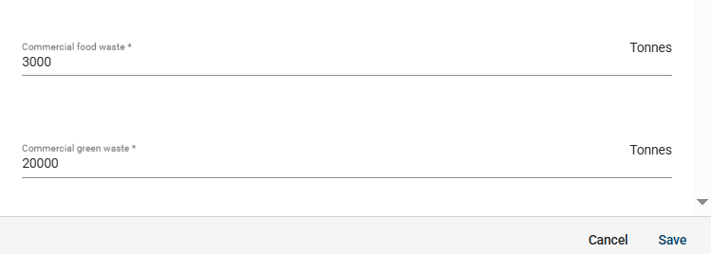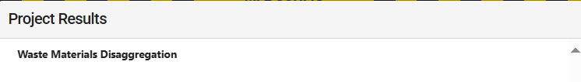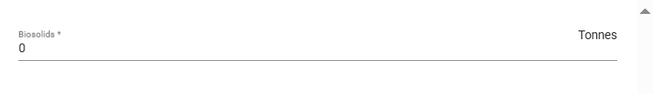
The screenshot in figure 1 shows how the results table will populate after you click save.
It features a three-year project with a baseline of zero tonnes of household food waste being composted. It is expected that from Year 2, the new service will annually divert 10,000 tonnes of food waste from landfills to the composting facility, or 20,000 tonnes across the life of the project, plus 30,000 in the three-year post-reporting period.
Figure 2: Example of multiple year indicator
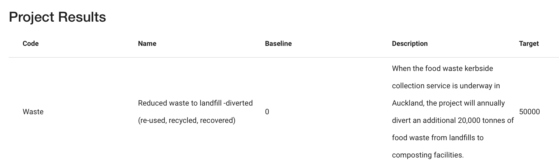
Tips
- The baseline refers to the situation before the project began.
- Only use numbers in the baseline. Add any relevant details in the description field.
- The target is cumulative for the project life and the three year post-project reporting period. If the target is achieved in Year 1, do not add it again in subsequent years. For example, if you aim to employ two people, and achieve this in Year 1, the target should be two in Year 1 and zero for all other years, for a total target of two.
- The totals in the disaggregation fields must reflect the target.
- Results are reported on up to three years after the project is completed. Therefore, the total period for each result should include the duration of your project plus three years post project.
- Data for some of the indicators can only be broken down into regions, in which case the waste material field is not applicable.
- Time your milestones to allow for a successful completion of your project, with a minimum need for adjustments.

Health and safety
You must have a health and safety policy in place and submit a copy of the policy to the Ministry. Depending on the nature of your project, you may also be required to have a project specific health and safety plan in place. WMF funding can contribute to health and safety documentation at your first milestone, if these are not in place already.
If your project involves third parties such as consultants or subcontractors working on site, the project specific health and safety plan must address how you plan to consult, cooperate and coordinate with each other.
You must also identify a primary health and safety lead in your organisation, detailing their responsibilities in relation to the project and in coordination with any sub-contractors procured for the delivery of the project.

Budget
You may need to update the budget following changes in costs or requirements from the application stage. Ensure you provide a detailed breakdown of costs in your work plan. More guidance and examples of this process can be found in the Guide for applicants. The approved funding amount is fixed, and you must meet any potential increases in costs. Your investment manager may also comment on what costs we can accept as part of the budget. Costs that you can’t claim in the budget include:
- business as usual and ongoing operational costs
- contingency costs of more than 10 per cent
- costs already incurred
- in-kind costs (eg, the donation of land or equipment and volunteer hours)
- debt servicing
- purchase of land.

The Deed of Funding
Review the terms and conditions of the Deed of Funding as soon as possible. We recommend that you seek independent legal advice, to understand what it means for your organisation.
Please notify your investment manager as soon as possible if you are unable to accept the standard terms and conditions, or if you have any questions.
There are some conditions that you will need to confirm have been satisfied on signing the Deed – including, but not limited to, those in table 2.
Table 2: Funding conditions details
Condition | This means you agree that:
Full funding | - all co-funding has been secured for your project. This includes funding you as the recipient will contribute, and any funding from a third party  - you will not require any further funding from the Ministry (other than the agreed amount) to complete the project
Signing authority | - you have full power and authority to enter into and perform the Deed of Funding  Note: A duly authorised representative of your organisation must execute the Deed. For territorial authorities this should either be two elected members or officers delegated with this authority. If officers sign the Deed, we may request evidence of the delegation instrument.
True and accurate information provided | - all information given to the Ministry is true and accurate, and no change has occurred since you supplied it  - you have disclosed all relevant information to the Ministry
Multi-year projects | Any funding after the first year depends on:  - the Ministry being satisfied with your use of the funding for the previous year  - the completion of a satisfactory project plan for that year, detailing the deliverables
Third-party intellectual property rights | - you have the legal entitlement to use the intellectual property provided as part of the deliverables  - providing the Ministry with specified deliverables does not infringe on the intellectual property rights of any third party  - in the event that it does infringe on any third party’s intellectual property, the recipient agrees to indemnify the Ministry in respect of any claim arising from that infringement

GST registration
Government funding is taxable. If you are conducting a taxable activity and your annual income exceeds NZ$60,000, your organisation must be registered for GST. You can offset the GST on any goods and services you buy against the GST amount the Ministry provides in addition to the funding. If you are not GST registered, you will bear the full cost of GST on goods and services you purchase for the project.
For more information, see www.ird.govt.nz/gst/or phone 0800 377 776.

Due diligence
To ensure the responsible investing of public money, we require most recipient organisations to undergo a due diligence assessment by a third party. This process is designed to assess how well equipped your organisation is to deliver the project, and to identify potential risks. Projects requesting over $1 million in funding will have already gone through this process in the application stage. Due diligence may include:
- a credit check and review of the organisation’s financial position
- reference checks and a review of your organisational capability
- an assessment of your health and safety policies, processes, capabilities and history
- a review of your commercial positioning, and a project viability assessment
- a review of your governance and legal structures and capabilities
- an assessment of your project and quality management approaches.
If your project is required to undergo due diligence, we will inform you in writing. We will outline the information and documents needed, where to send them and by what date. The requested information and documents will be sent to the third party conducting the assessment.
Due diligence must be completed before the Deed is signed. Please submit all requested information and documents within the timeframes. Delays in submitting information may delay the contract phase of the process.
The outcome of the assessment may result in additional funding conditions. In some instances, the Ministry may withdraw the funding offer, based on the findings.

Approval and sign-off
Once you and your investment manager are happy with the Deed (including the project plan and budget), the documents go through the Ministry’s internal review and approval process.
Depending on the value and complexity of the project, it may also require a legal review, along with approvals up to the Ministry’s relevant delegated financial authority (based on the value of the grant). There may be further feedback and revisions during this process.
When the Deed is approved, the relevant delegated financial authority will sign it on behalf of the Ministry. Your investment manager will then send it to you for countersigning. Please arrange for the Deed to be signed promptly by a person with the authority to sign on behalf of your organisation.
After countersigning, the Deed is considered executed and you can start implementing your project. Once the Ministry has processed the Deed, your investment manager will provide you with your unique Deed number. Keep a record of this Deed number as it will be required during the project for reporting and as identifier on your invoices.

Part two: Implementing your project
We are excited to formally kick start the activities of your project! Your investment manager will be in regular contact to monitor progress and compliance with the Deed. This may be by email, phone or in person. Your work plan milestones are trigger points for sharing information and formal reporting requirements, but we encourage open and timely communication with the Ministry, particularly when issues occur and before changes are made or needed.
You must not announce the WMF funding until you have received written approval to do so from your investment manager. The Minister for the Environment may wish to announce the investment and has two months following the execution of the Deed to decide. If the Minister decides not to announce the project, your investment manager will inform you in writing that you can publicly announce your project yourself. We will inform you of the requirements for publications at that time.

Your requirements and responsibilities
Table 3 outlines some of your key requirements and responsibilities. For the full details, see your Deed of Funding.
Table 3: Requirements and responsibilities
Requirement | Responsibilities
Health and safety | You must comply with the Health and Safety at Work Act 2015, applicable regulations, and industry best practice guidelines when carrying out your project.  If a notifiable health and safety event occurs in relation to the implementation of your project, you must inform the Ministry at the same time you inform WorkSafe.  At all times during the project, you must keep the Ministry informed of material health and safety information about the project, including, but not limited to:  - reports of any safety incidents (including near misses) and details of injured personnel and any unsafe or hazardous acts or conditions (as soon as practicable)  - details of any new hazards or significant amendments to your safety management plan  - evidence, if requested, of compliance with your health and safety policies, or the health and safety plan for the project.
Conflicts of interest | Your organisation must have a conflict-of-interest policy in place. If this is not submitted during the application process, you must submit one with Milestone 1.  If an actual, potential or perceived conflict exists in relation to the project, you must develop a conflict-of-interest management plan for approval by the Ministry. If a conflict arises during the project, you must inform your investment manager as soon as possible.  In some instances, WMF funding can contribute towards the development of a conflict-of-interest plan if required.
Procurement | Your grant is sourced from public money. Projects funded by the WMF must follow the same procurement good practice guidelines that government agencies follow. This will help ensure that projects meet public expectations of the use of public money.  Procurement guidelines for government agencies may be different from those your organisation normally uses. It is your responsibility to check that your policies and processes are consistent with the guidelines issued by the Office of the Auditor-General. See https://oag.parliament.nz/good-practice/procurement.
Capital assets | You can only use funding for capital assets if they are specified in the Deed (via the project plan). Examples of capital assets include machinery, office equipment, buildings, and manufacturing plants.  You must inform your investment manager within two days of taking possession of any capital assets for your project, valued at NZ$5,000 or more.  Capital assets will be subject to a restriction period specified in the Deed. During this period you must:  - retain full possession of the assets  - maintain the assets in a good state of repair, and in good working order and condition  - insure the assets for the full replacement cost.  See clause 2.7 of the Deed for more information about the restrictions during this period. Failure to meet the terms for capital assets may result in the Ministry requesting repayment of some (or all) of your grant.  The Ministry may register a security interest over any capital assets funded by the WMF on the Personal Property Securities Register (PPSR). The PPSR is the New Zealand Government’s electronic register used to record details of security interests over personal property. See www.ppsr.govt.nz.
Sub-contracting | If you intend to sub-contract part of your project, you must detail sub-contractors in the project plan. If there are any changes to sub-contractors, you must inform your investment manager and update the sub-contractor table in FMS Client Portal with your milestone reporting process.  You remain wholly responsible for the project (including any work, acts or omissions undertaken by sub-contractors).  You must:  - follow agreed processes for procurement, and oversee, monitor and actively manage any conflicts of interest in respect to sub-contractors  - have an appropriate contract in place between you and your sub-contractor  - have a process to communicate your organisation’s health and safety policies and management plans to your sub-contractor; and ensure that the sub-contractor complies with these and has in place appropriate policies and safety management plans and procedures of their own  - monitor any work carried out by your sub-contractor (including audit requirements).
Recording and reporting | You must keep a detailed and accurate record of all your income, expenditure, procurement decisions, data collection and evaluation activities for your project. This information is submitted to the Ministry in milestone reports, and is assessed. We require you to put systems in place to track expenditure, such as using a unique cost code within your accounting software. If you are claiming for staff time or other personnel costs, we expect you to track the time and expenses, and provide evidence of this.  Records must be retained and available for review for at least seven years after completion of the project.  Clearly mark all commercially sensitive information when reporting to the Ministry.  The key reports we will ask you to deliver are:  - Milestone reports – In these reports you demonstrate that you have completed and achieved the activities and objectives of the project and provide evidence of costs incurred. Milestone reports are linked to payment claims for your grant. See Milestone reporting and payments.  - Progress reports – Your investment manager may ask you to produce progress reports at various points throughout your project. They are intended to be snapshots of how your project is progressing, in between the more detailed milestone reports.  - Final milestone report – At the end of your project, your last milestone report will have an extra section for you to reflect on how your project went, next steps, and feedback to the Ministry of your funding experience and support received.  - Post-project reports – For up to three years after your project closes, we request short updates on how things are going, and whether the project is bringing lasting benefits, such as diverting waste.
Reasonable costs | You can only claim for costs that are reasonable and incurred to advance your project, in accordance with the Deed.  Any claims for personnel costs should be based on actual costs. This could be an hourly rate, or a portion of salary based on the time spent on project tasks. For example, if a project manager is required to spend one day of a five-day work week on these tasks, we can contribute towards 20 per cent of their salary (noting costs are split between the Ministry and the recipient). You will need to provide evidence of time spent on the project (eg, a timesheet, contract, confirmation from human resources).  If you will be claiming domestic travel costs, please see appendix 2 for the travel expense policy. You must detail these costs in the project plan and budget.
Audits | The Ministry has a responsibility to ensure that government funds are spent correctly and appropriately. There is a chance that your project may be randomly selected for a full independent audit. The purpose of this type of audit is to check compliance with the terms and schedules of the Deed, including the project plan.  We may also undertake a full audit if there are any concerns about the financial performance of the project, or your ability to meet the deliverables.  An audit may be made at any time during or after delivery of the project.  In most cases the Ministry covers the cost of the audit. However, your organisation should be prepared to cover any costs of complying with the audit, such as additional personnel time. If any misappropriation or material discrepancy is found, your organisation will be liable for the costs of the audit and repayment of misappropriated or incorrectly claimed grant monies.  You will receive a copy of the audit report when it becomes available.
Intellectual property | Under the terms and conditions of the Deed, you will own all intellectual property created through your project, on the condition that you permit the Ministry to use, and make available, any intellectual property created through the project:  - for monitoring compliance with the Deed  - for the development of Ministry policy  - to advance the purposes of the Waste Minimisation Act  - for other reasonable non-commercial Ministry purposes.  This requirement applies indefinitely, beyond the term of the Deed. An example of when we may use this condition is to review project outcomes over time, to help develop investment in waste minimisation, or focus on problematic waste streams.

Milestone reporting and payments
For each completed milestone, you must submit a milestone report and the relevant supporting documentation including your invoice (see figure 3 and table 4).
You will receive a notification when these reports are available for you to complete through FMS. This will usually be a month before the report is due. Your investment manager will keep in touch throughout your project, and can make reports available to you early if the project is ahead of schedule.
Figure 3: Example of milestone report detail
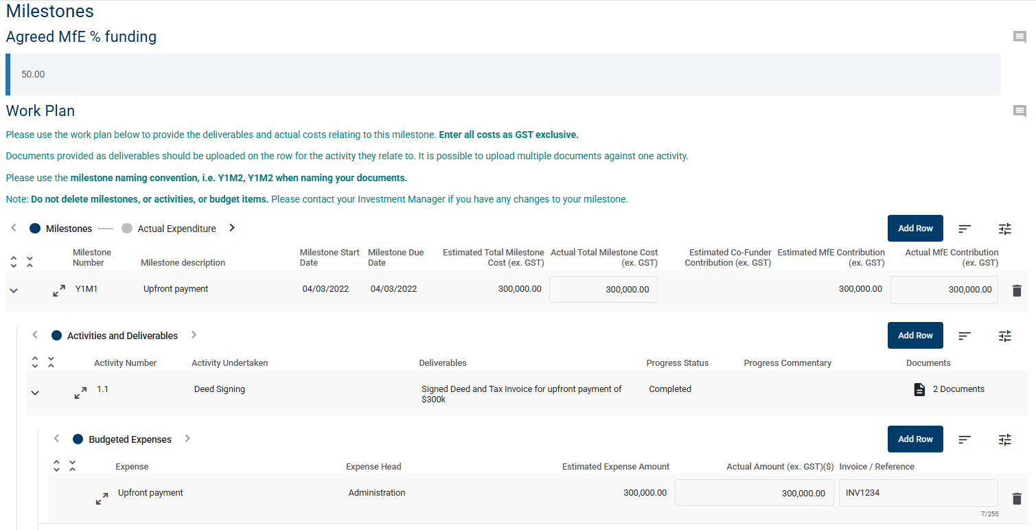
We understand that during the life of your project, changes may be needed. If you need to change the budget or activities during the milestone period, please inform your investment manager as soon as possible, so they can consider your request.
Your investment manager will assess the milestone report and if everything is in order, they will recommend payment.
Table 4: Milestone reporting
Document | At the end of every milestone:
Milestone report | Fill out the milestone report template in FMS. The report contains information about the status of activities, deliverables, objectives, results, key performance indicators (KPIs), costs, health and safety, risk management, and procurement.  The KPIs relate to areas that we require you to assess. These include the timeline, budget, how well resourced you are, and whether the project is meeting objectives. The milestone report explains how to assess KPIs.
Invoices and receipts verifying expenditure | Any costs you claim must be supported by documentation (eg, if you spent NZ$12,000 on a consultant, you must provide their invoice).  List all expenses for the milestone period in your budget. In most instances you will only need to provide invoices for expenses over NZ$5,000 (excluding GST). However, your investment manager may ask to spot-check listed invoices for expenses under NZ$5,000.  Upload related invoices to the specific budget and cost line in accordance with your work plan. If you have a significant number of invoices, we encourage you to combine them all into a single PDF for ease of upload and review.
Milestone deliverables | Attach evidence of achieving milestone activities and deliverables, as outlined in the milestone work plan of your project plan – for example:  - copies of reports  - photographs of project progress  - monitoring or evaluation data  - records of project activities  - media coverage or other publicity  - documents showing staff recruitment.
Tax invoice | Upload a GST tax invoice for the amount you are claiming for the relevant milestone. It must contain the words ‘tax invoice’ and show:  - your GST number  - the invoice number  - your Deed of Funding number  - the total claim amount (both GST inclusive and exclusive figures)  - the GST component.

We aim to process and pay each milestone within 30 calendar days of submission of the milestone report. However, this may be delayed if there are gaps in the report and further information or documentation is needed. If your report needs additional work, your investment manager will return it to you with feedback. You should update the report as soon as possible and resubmit.
Any milestone that is not, or partially completed requires a written explanation from you. This might result in a partial payment of the amount claimed, or changes to upcoming milestones so that the overall objectives are achieved.

Changes to the Deed of Funding
Any changes to the Deed must be agreed in writing between the parties. Contact your investment manager immediately if you anticipate a change is required to your project or Deed, this may include delays to deliver project activities by a certain milestone due date or a change in budget and costings.
Depending on the nature and scale of change, your investment manager will inform you of next steps to formalise the change. We will consider variations to assist effective project management but not to accommodate unsatisfactory performance.

Multi-year projects
During the contract phase, you complete a milestone work plan for the duration of your project. If developing a work plan for the entirety of your project is not possible, for instance, only years one and two are clear at the time of contracting, you will need to complete a new milestone work plan and detailed budget for any subsequent years of the project, showing the milestones, activities, deliverables and estimated costs. This must be approved by the Ministry before the start of the next project year.
Funding in subsequent years is subject to the Ministry being satisfied with the use of the funding for the previous year, your ongoing adherence to the terms and conditions of the Deed, and the availability of funding. If the conditions have not been satisfied, we may terminate your Deed.

Remediation plans
If we believe you have breached, or will breach the Deed, we will notify you via a delivery notice (by letter or email). You are then required to produce a remediation plan as soon as possible (and within 10 working days). Your investment manager will email you a template for the remediation plan.
The plan should set out:
- the details of the breach (including its causes, expected duration and impact on the project, and your obligations under the Deed)
- any proposed changes to the project plan
- the steps you will take to eliminate and mitigate the effect of the breach, and prevent it from reoccurring.
The Ministry will review the remediation plan and either accept it or send it back with feedback. You should action the plan as soon as practicable following approval.

Termination and recovery of a grant
If there is a significant issue with the project, such as discontinuation, we may withhold payment until it is resolved. If the issue is not resolved to the Ministry’s satisfaction, we may send you a written notice suspending or terminating your grant.
In certain circumstances, we may send you a written notice requesting that you repay some, or all, of your grant (any payments made to date).
See the Deed of Funding for more information about termination and recovery of a grant.

End of project and final milestone
When the final project milestone is reached, you are asked to complete a final milestone report which includes an additional section to provide reflections on your project overall, next steps, and feedback on your experience working with the Ministry. This final report will be submitted via FMS.
The Ministry may choose to publish (parts of) the benefits and outcomes noted in your final report, so make sure you clearly mark any confidential or commercially sensitive information.
We must receive all documentation on or before the agreed completion date in your Deed. You must notify the Ministry immediately if you are not able to submit your reporting by the agreed due date. Any invoices submitted outside the Deed’s timeframe are at the Ministry’s discretion and may not be paid.
No final payment will be made until the Ministry is satisfied that the final milestone and project is complete, which may require a satisfactory audit of the project.

Post-project reporting
You are also required to report on the outcomes of your project for three years after it closes. We will be in touch each year on or around the anniversary of your project completion, to request this short report and provide further details. To facilitate this, please ensure the key contact person for future reporting post-project is up to date in FMS Client Portal.

Appendix 1: Project result indicators
Table A1.1: Full list of result indicators
Result indicator title | Definition | Unit of measure
Co-funding unlocked | Value of additional investment in waste minimisation resulting from the project taking place. | Dollars
Estimated Weight of reduced imports displaced by recovered resources (e.g. # tonnes p/a etc) | This indicates the change in use of imported materials. | Tonnes
Employment created by project in full time equivalent (FTE) roles per year | Economic impact indicated by number of new FTE roles created. | People
Increased Waste Minimisation behaviour -Data collected via survey or feedback | This is the change in behaviour from an established baseline. It could be indicated by a pre- and post- campaign survey or direct observational measurement. For example, if your project will run a campaign aimed at reducing use of takeaway coffee cups, your organisation could conduct a survey before and after the campaign to measure the level of takeaway cup avoidance. Alternatively, if your intervention is focused on reducing contamination of kerbside recycling you would measure recycling contamination rates pre and post intervention. | Percentage
Increased awareness or knowledge of Waste Minimisation -Data collected via survey, feedback, or similar | This is the change in awareness from an established baseline. It could be indicated by a pre and post campaign survey. For example, if your project will run a campaign aimed at raising awareness about a Product Stewardship Scheme, your organisation could conduct a survey to before and after the campaign to measure the level of awareness about the scheme. | Percentage
Improving the efficiency of measurement and accuracy of data on waste to landfill | Increasing information management capability and facilitating better capture, availability and analysis of data. Incentivising measurement and building a shared culture that understands the value of using data to learn and make effective decisions. | Tonnes
Number of alternative, innovative, new or new to NZ solutions for reducing waste tested by project | This is a count of the number of innovative solutions without measuring reach or impact (actual or forecast) of these solutions. It would apply to a feasibility or investigative project (or stage of project) rather than applied projects. | Number
Number of alternative, innovative, new or new to NZ solutions for re-use of resources tested by project | This is a count of the number of innovative solutions without measuring reach or impact (actual or forecast) of these solutions. It would apply to a feasibility or investigative project (or stage of project) rather than applied projects. | Number
Number of cultural indicators or measures used in data monitoring and management | Reflects integration of Te Ao Māori concepts and actions into Waste Minimisation solutions. | Number
Number of formal community / iwi / industry / government partnerships developed as part of or as a result of the funded project | Number of formal community / iwi / industry / government partnerships developed as part of or as a result of the funded project | Number
Number of guidelines for best practice for disposal of waste created or implemented by project | This applies to projects that are formalising best practice guidelines or making changes to enable the implementation of best practices. | Number
Number of international or domestic laws, policies, conventions etc that project increases compliance with or awareness of | This is a count of international or domestic laws, policies, conventions etc. It provides an indication of changing practices and compliance in waste. | Number
Number of organisations engaged in product stewardship scheme | This will provide an indication of the impact of Product Stewardship Schemes. | Number
Number of people, (from schools, NGO groups and businesses etc) attending educational presentations or workshops provided as part of funded project | This is a count of attendees which will give an indication of the potential scale of impact. | People
Number of projects that are codesigned and/or led by iwi | Reflects the uptake and facilitation of waste minimisation solutions designed or led by iwi | Number
Processing capacity added by new infrastructure (e.g. # tonnes p/a) | Increased capacity to collect, consolidate, transport and/or process waste. This measure could be applied to individual waste streams or materials e.g. provision of capacity to sort plastics into multiple material types arising from optical sorting. | Tonnes
Reduced waste to landfill - waste not created (any diverted waste should be counted as diversion, and not be included as a reduction) | Waste avoidance arising from alternative projects or practices, improved designs of systems, better practices, more collection streams and initiatives in schools, industry, marae and community groups to reduce waste. This measure should not include any waste being diverted but refers to avoidance and reduction at source. | Tonnes
Reduce waste to landfill -waste diverted (re-used, recycled, recovered) | Waste minimisation and diversion of waste to landfill to beneficial reuse, recycling or recovery through innovative and alternative projects, improved designs of systems, better practices, more collection streams and initiatives in schools, industry, marae and community groups to recover, recycle or re-use waste. | Tonnes
Uptake of tool/resource developed by project | Uptake of project deliverable/s, such as App, guideline, educational tool. Form of uptake will vary with deliverable, e.g. downloads, of App, hireage/usage of educational tool. | Number
Number of households participating in kerbside recycling | This is used by Territorial Authorities for reporting on regional kerbside collection schemes | Number

Table A1.2: Examples of result indicators
Indicators and definitions |  | Examples
Indicator  Estimated weight of reduced imports as displaced by recovered resources  Definition  Indicates the change in amount of imported materials used.  Unit of measure: Tonnes |  | Description:  Setting up the recycling plant in Auckland will produce 1,000 tonnes of recycled plastics that can be used to replace virgin plastic, minimising imports.
 |  | Baseline | Target |  |  | Disaggregation
 |  |  | Y1 | Y2 | Y3 | NZ regions | Value | Waste material | Value
 |  | 0 | 0 | 500 | 500 | Auckland – Tāmaki Makaurau | 700 | Plastic Type 4 – LDPE | 800
 |  |  |  |  |  | Waikato | 300 | Plastic Type 6 – EPS | 200
 |  | Totals | 1,000 |  |  |  | 1,000 |  | 1,000

Indicator  Employment created by project (FTE per annum equivalent)  Definition  Economic impact indicated by number of FTE roles.  Unit of measure: People |  | Description:  To implement the programme, the organisation will need to increase its capacity across two regions from 10 to 15 employees – with 5 new FTEs at composting facilities, within six months of commissioning the new equipment.
 |  | Baseline | Target |  |  | Disaggregation
 |  |  | Y1 | Y2 | Y3 | NZ regions |  | Value | Waste material | Value
 |  | 10 | 5 | - | - | Auckland – Tāmaki Makaurau |  | 3 | Household food waste | 3
 |  |  |  |  |  | Waikato |  | 2 | Commercial food waste | 2
 |  | Totals | 5 |  |  |  |  | 5 |  | 5
Indicator  Number of alternative, innovative, new or new-to-New Zealand solutions for reducing waste tested by the project  Definition  A count of the number of innovative solutions without measuring reach or impact (actual or forecast) of these solutions. It would apply to a feasibility or investigative projects rather than working projects.  Unit of measure: Number |  | Description:  The feasibility study will investigate the viability of a chemical recycling technology in the context of the New Zealand market. The technology will break plastic down into monomers to be used to manufacture new products. We will examine all aspects of the proposed advanced recycling solution, including technical, economic, financial, legal and environmental.
 |  | Baseline | Target |  |  | Disaggregation
 |  |  | Y1 | Y2 | Y3 | NZ regions |  | Value | Waste material | Value
 |  | 0 | 0 | 0 | 1 | National – Motu | 1 |  | Plastics 1, 2 and 5 | 1
 |  | Totals | 1 |  |  | 1 |  |  | 1

Indicator  Processing capacity expanded by new infrastructure  Definition  Increased capacity to collect, consolidate, transport or process waste. Could apply to individual waste streams or materials (eg, sorting plastics by eye into multiple material types).  Unit of measure: Tonnes |  | Description:  Increase the processing capacity of wood waste in the Manawatū-Whanganui region by 10,000 tonnes following the commissioning of new equipment.
 |  | Baseline | Target |  |  | Disaggregation
 |  |  | Y1 | Y2 | Y3 | NZ regions |  | Value | Waste material | Value
 |  | 20,000 | 0 | 0 | 10,000 | Manawatū –Whanganui | 10,000 |  | Timber | 7,000
 |  |  |  |  |  |  |  |  | Treated timber | 3,000
 |  | Total | 10,000 |  |  |  | 10,000 |  |  | 10,000
Indicator  Reduce waste to landfill and divert (reuse, recycle, recover)  Definition  Waste minimisation and diversion of waste to landfill to beneficial reuse, recycling or recovery through innovative and alternative projects, better system design, better practices, more collection streams and initiatives in schools, industry, marae and community groups.  Unit of measure: Tonnes |  | Description:  When the food waste kerbside collection service is underway in Auckland, the project will annually divert an additional 20,000 tonnes of food waste from landfills to composting facilities.
 |  | Baseline | Target |  |  | Disaggregation
 |  |  | Y1 | Y2 | Y1 | Y2 |  | Y1 | Y2 | Y1
 |  | 0 | 0 | 10,000 | 10,000 | Auckland – Tāmaki-Makaurau | 20,000 |  | Household food waste | 20,000
 |  | Totals | 20,000 |  |  |  | 20,000 |  |  | 20,000

Appendix 2: Travel expense policy
This policy is a guide to what the Ministry considers to be reasonable travel-related expenses.
You may only claim travel-related expenses incurred by your organisation’s personnel named as members of the project team, or sub-contracted personnel. You must keep receipts of any travel-related expenses, as we may check these before we reimburse you.

Air travel
Where alternatives to air travel are available, such as video conferencing, that is the Ministry’s preference.
Domestic: We encourage the purchase of the cheapest, non-flexible fares.
International: This grant does not cover international air travel expenditure unless your Deed expressly states otherwise.

Out-of-town travel expenses
You may claim actual and reasonable expenses (on receipt) for meals and other incidental expenses while on out-of-town business for the purpose of delivering the project, as set out below.

Meal costs
Maximum rates (GST inclusive) are:
- breakfast NZ$25
- lunch NZ$25
- dinner NZ$50.
Alcohol charges are not accepted.

Accommodation
Maximum contribution of NZ$200 (GST inclusive) per night.

Other expenses: Taxis/ride share/rental car/parking
You may claim for moderate and conservative use of taxi/ride share/rental car or parking necessary to deliver the project, if you provide receipts. Use more cost-effective and environmentally friendly options (eg, walking, bus) where feasible and practicable.

Use of private motor vehicle
You may claim the cost of using a private vehicle for business relating to the delivery of the project. You may claim mileage using the claim rates set by Inland Revenue for calculating the estimate of expenditure for employees’ business use of private motor vehicles (see the Inland Revenue website for kilometre rates for the relevant income year).
We assume that where travel is in a personal vehicle, the traveller is principally responsible for insurance coverage. The Ministry will not be liable for any costs incurred in the event of an accident in these circumstances.

