
Kaupapahere pūtea kaikerēme
Claimant funding policy
Waitangi Tribunal inquiries

Disclaimer
The information in this publication is, according to the Ministry for the Environment’s best efforts, accurate at the time of publication. The Ministry will make every reasonable effort to keep it current and accurate. However, users of this publication are advised that:
- the information does not alter the laws of New Zealand, other official guidelines, or requirements.
- it does not constitute legal advice, and users should take specific advice from qualified professionals before taking any action based on information in this publication.
- the Ministry does not accept any responsibility or liability whatsoever whether in contract, tort, equity, or otherwise for any action taken as a result of reading, or reliance placed on this publication because of having read any part, or all, of the information in this publication or for any error, or inadequacy, deficiency, flaw in, or omission from the information in this publication.
- all references to websites, organisations or people not within the Ministry are for convenience only and should not be taken as endorsement of those websites or information contained in those websites nor of organisations or people referred to.
This document may be cited as: Ministry for the Environment. 2024. Claimant funding policy: Waitangi Tribunal inquiries. Wellington: Ministry for the Environment.

Published in November 2024 by the
Ministry for the Environment
Manatū mō te Taiao
PO Box 10362, Wellington 6143, New Zealand
environment.govt.nz
ISBN: 978-1-991140-44-9 (online)
Publication number: ME 1854
© Crown copyright New Zealand 2024

Contents
Background 4
Purpose 4
Who can access funding 5
What funding will be provided 5
Funding for attending Tribunal events 5
Funding for preparatory hui 6
Funding of research costs 6
Funding post-inquiry engagement 6
Funding for one-off costs 7
What cannot be funded 7
What is actual and reasonable 7
Appendix 1 8

Background
The Crown has a responsibility to make Waitangi Tribunal processes accessible for claimants in a realistic and practical way. In Whakatika ki Runga, the Waitangi Tribunal set out that this responsibility is a corollary of the creation of the Waitangi Tribunal under the Treaty of Waitangi Act 1975, and further arises under the principles of partnership, equity, active protection and rangatiratanga.
To give effect to this responsibility, Cabinet mandated the Interim Common Claimant Funding Policy for Lead Agencies (the “Interim Claimant Funding Policy”) (see Appendix 1) on 31 July 2023 which applies across government. The Interim Claimant Funding Policy sets out minimum funding requirements for agencies leading kaupapa inquiries.
Accordingly, this policy should be applied for all contemporary Tribunal inquires that Manatū mō te Taiao | Ministry for the Environment (the Ministry) is the lead agency for.

Purpose
The purpose of this claimant funding policy is to outline the funding available for all Waitangi Tribunal inquiries that the Ministry is the lead agency for and how that funding will be administered.
This claimant funding policy covers:
- who can access funding, including funding to support the participation of kaumātua, whānau hauā and tangata turi
- what funding can be provided for:
- Tribunal events
- preparatory hui
- post-inquiry engagement
- research
- how to access funding
- guidance on what is actual and reasonable.
This claimant funding policy aligns with the interim common claimant funding policy and is subject to any whole-of-government review. In the event of any inconsistency, please refer to the Ministry policy.

Who can access funding
Claimants and claimant witnesses (including up to three support people) participating in an inquiry can access funding. Funding is also available to support people, to ensure all claimants have the tautoko they need during hearings. The funding will ensure kaumātua, whānau hauā and tangata turi can participate.
Interested parties (including their witnesses and support people) may be eligible for funding. This will be determined on a case-by-case basis.

What funding will be provided

Funding for attending Tribunal events
The following costs will be provided for claimants, claimant witnesses, and up to three support people per claimant or claimant witness participating in a Tribunal event:
- domestic travel, where required (such as transport between airports, accommodation and event venues), including:
- domestic flights where required (actual and reasonable costs)
- buses, ferries, trains and rental cars (actual and reasonable costs)
- petrol (actual and reasonable costs) or mileage ($0.95 per kilometre)
- taxis or ride share options (actual and reasonable costs)
- parking (actual and reasonable costs)
- accommodation where required (actual and reasonable costs)
- meals (excludes alcohol and minibar) up to $73 per person per day excluding GST.
The Tribunal recommends that agencies provide a mechanism for upfront funding that does not depend on claimants submitting receipts for reimbursement. The Ministry will consider the use of Tandem, its travel management supplier, to provide claimants the option of upfront funding for travel, accommodation and meals.
Where the specified amounts for mileage and meals do not seem sufficient, agencies can fund higher amounts on a case-by-case basis. Examples of when this discretion may be used include when a location has limited meal options that are high in price, or when there are higher-than-average travel costs for the time of the event.

Funding for preparatory hui
The Ministry will fund the actual and reasonable costs for claimants to hold preparatory hui for claimants and claimant witnesses to meet and prepare for Tribunal events. This will include:
- claimants and claimant witnesses (including up to three support people) to travel to and from preparatory hui (subject to the same parameters as attending Tribunal events above)
- venue hire
- audio-visual equipment hire
- catering
- any required accommodation.
Additional costs will be considered on a case-by-case basis through discussion with claimants.

Funding of research costs
The Ministry will consider requests from claimants to fund research to support their claims. This will involve:
- considering whether the research has a clear link to the claim
- working with the Tribunal and claimants to identify the research topic, whether the research is useful, and who should fund the research.
The Ministry will endeavour to reach agreement with claimants regarding the research topic, who undertakes the research, and what review and quality assurance processes will be in place. However, the Ministry can still fund claimant research where it is agreed they will have limited input into these matters.
The Ministry will engage with the claimant group in a co-ordinated way. Claimants can be funded as a collective.

Funding post-inquiry engagement
The Ministry may fund the actual and reasonable costs of claimants and their support people attending any post-inquiry engagement, including hui between claimant groups and with MfE.
The Ministry may fund other engagement with claimants outside the inquiry process. This will be assessed on a case-by-case basis.
Consideration should be given to the Cabinet Office Circular 19(3) Better Co-ordination of Contemporary Treaty of Waitangi Issues, particularly paragraph 1, which outlines the requirements when undertaking formal engagement. Informal conversations and engagement regarding the Ministry’s approach to Tribunal recommendations should be had with claimants before seeking approval from Cabinet on a formal approach.

Funding for one-off costs
Different claimants will have different needs. To respond to these diverse needs, the Ministry may fund other costs not expressly included in this policy where reasonable, on a case-by-case basis. These could include, for example, costs to participate virtually, or koha for staying overnight in a private residence or marae. The Ministry and claimants or claimant counsel will agree to these costs ahead of costs being incurred.

What cannot be funded
The Ministry cannot fund time, lost wages or legal costs for claimants, claimant witnesses, or their support people.

What is actual and reasonable
Claimant participation is the priority, but when deciding what is actual and reasonable the Ministry will also consider:
- if claimants, claimant witnesses and support people need to be accommodated overnight
- the distance people must travel and if a suitable form of transport has been selected
- if the number of people from a claimant group and support people attending the event is reasonable
- the comparable costs for travelling to the location at the time of the event
- the comparable costs for accommodation in the location at the time of the event.
The Ministry will discuss with claimants or claimant counsel what amounts might be reasonable ahead of costs being incurred or rejecting any payments.
Reasonable costs should include funding additional support to enable kaumātua, whānau hauā and tangata turi to participate. This could include extra nights’ accommodation to avoid long periods in cars, extra costs of accessible accommodation, accessible taxis, or provisions for service animals. This is not an exhaustive list, and other costs will be considered by the Ministry on a case-by-case basis.

Appendix 1

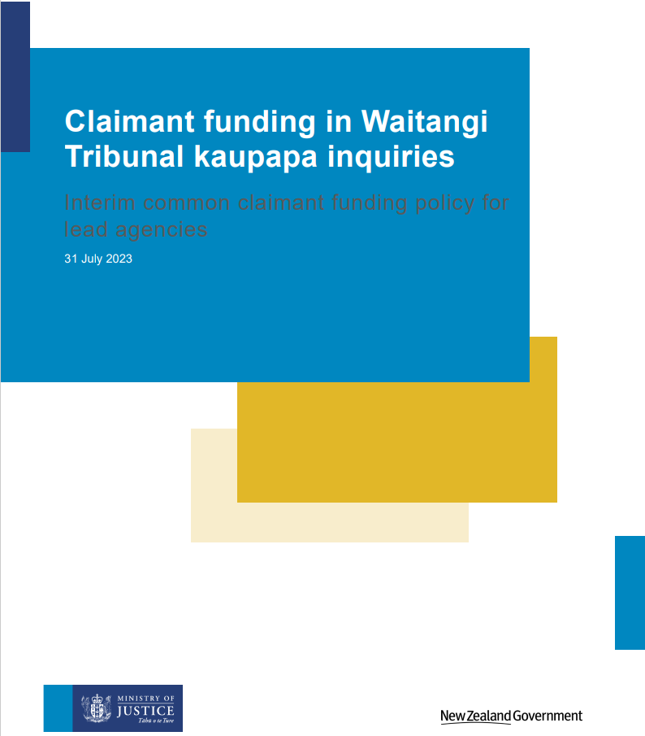

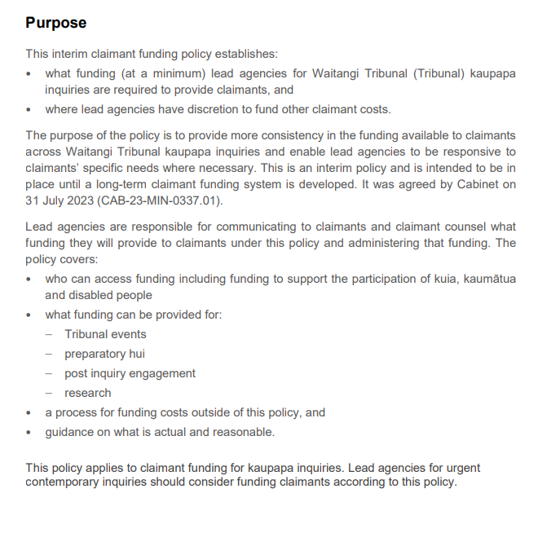

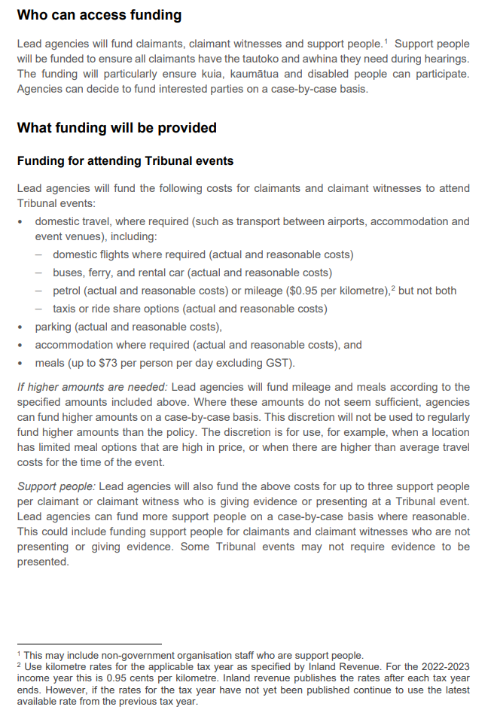

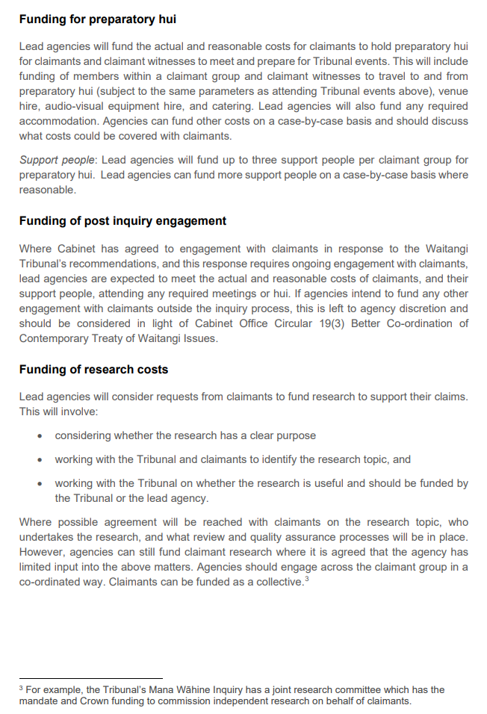

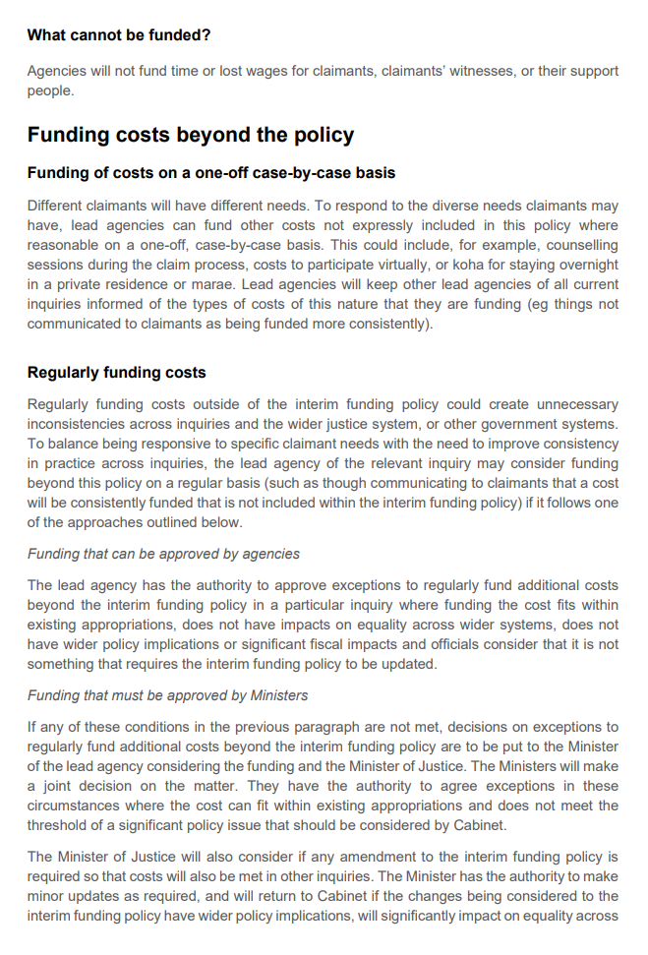

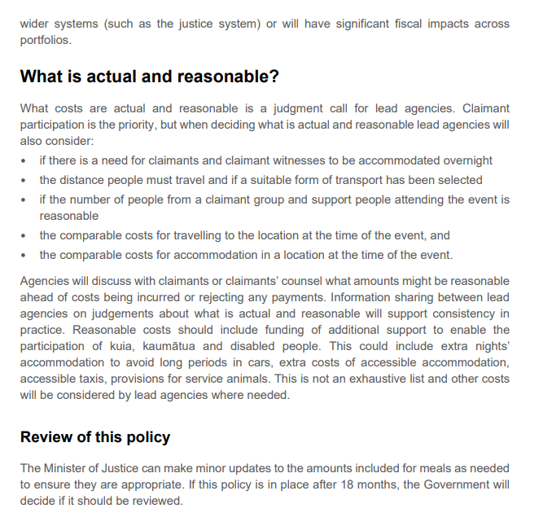

Waitangi Tribunal. 2023. Report on Whakatika ki Runga, a Mini-Inquiry Commencing Te Rau o te Tika – Pre-publication Version. Wellington: Waitangi Tribunal.
With the exception of Wai 2358 retrospective funding and stage-3 funding which have separate policies.
Plans for a long-term funding system is outlined in the Cabinet paper approving the interim claimant funding regime.
See What is actual and reasonable for more guidance.
Use kilometre rates for the applicable tax year as specified by Inland Revenue. For the 2022/23 financial year this is 0.95 cents per kilometre. Inland Revenue publishes the rates after each tax year ends. However, if the rates for the tax year have not yet been published, continue to use the latest available rate from the previous tax year.
$83.95 inclusive of GST (October 2023).
More support people can be funded where reasonable and will be determined on a case-by-case basis.
Available from the Department of the Prime Minister and Cabinet’s website.

