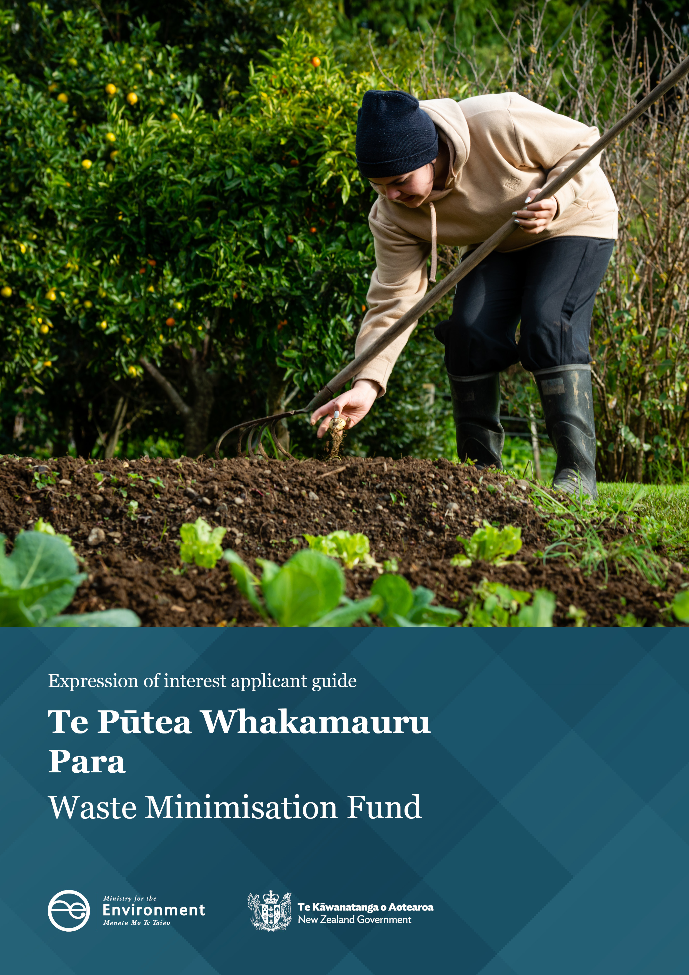
Disclaimer
The information in this publication is, according to the Ministry for the Environment’s best efforts, accurate at the time of publication. The Ministry will make every reasonable effort to keep it current and accurate. However, users of this publication are advised that:
- The information does not alter the laws of New Zealand, other official guidelines, or requirements.
- It does not constitute legal advice, and users should take specific advice from qualified professionals before taking any action based on information in this publication.
- The Ministry does not accept any responsibility or liability whatsoever whether in contract, tort, equity, or otherwise for any action taken as a result of reading, or reliance placed on this publication because of having read any part, or all, of the information in this publication or for any error, or inadequacy, deficiency, flaw in, or omission from the information in this publication.
- All references to websites, organisations, or people not within the Ministry, are for convenience only and should not be taken as endorsement of those websites or information contained in those websites nor of organisations or people referred to.

This document may be cited as: Ministry for the Environment. 2023. Waste Minimisation Fund: Expression of interest applicant guide. Wellington: Ministry for the Environment.

First published in October 2022. Updated version published in December 2023.
Published by the
Ministry for the Environment
Manatū mō te Taiao
PO Box 10362, Wellington 6143, New Zealand
environment.govt.nz
ISBN: 978-1-99-102580-7
Publication number: ME 1689
© Crown copyright New Zealand 2023

Contents

_Toc116900058
About this guide 4
Applicant details 4
Project summary 4
The Waste Minimisation Fund outcomes 5
Funding summary 5
Project details 6
Project impact 6
Project objectives 7
Experience, capability and project delivery 10
Estimated budget 11
What happens next 12
Expression of interest assessment 12
What to expect from the WMF application process 13

About this guide
This document supports you throughout your Waste Minimisation Fund (WMF) expression of interest (EOI) submission. It covers every section of the EOI form and provides a high-level guide to answering the questions.
When completing your submission, you can comment on the fields within the online form by clicking on the comments section on the right-hand side. Comments are a way of sharing information or asking any questions you have while completing your application. Also, your Investment Manager can use it to give you feedback and request any further information they need.

Applicant details
The information you provide in this section will be used throughout all the project stages. For the project main contact, ensure you choose the person most suited to responding to queries about the EOI.

Project summary
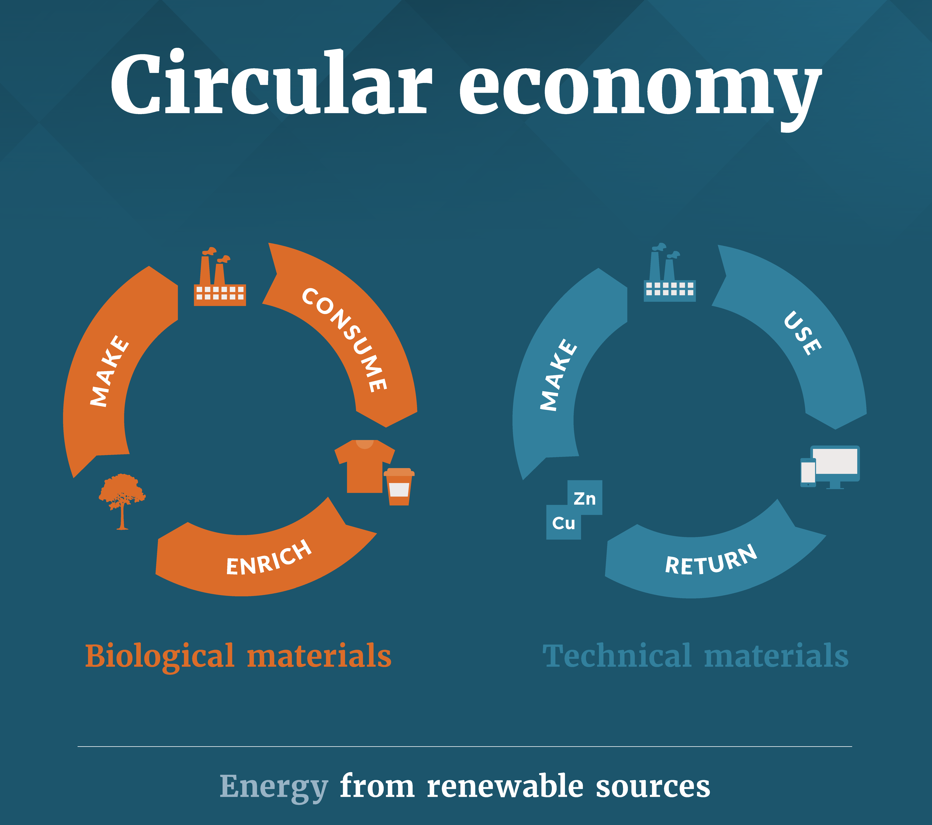
In the project summary section, you must provide a concise overview that includes the main details of your project. These are:
- the problem or waste minimisation opportunity you have identified
- how the project is addressing the problem through a low-emission, circular economy solution
- the locations where the project activities will occur
- how the project delivers on the fund’s outcomes.
Please also explain how your project fits with what is being funded and select the main waste streams your project addresses.

The Waste Minimisation Fund outcomes
The Fund has the following desired outcomes:
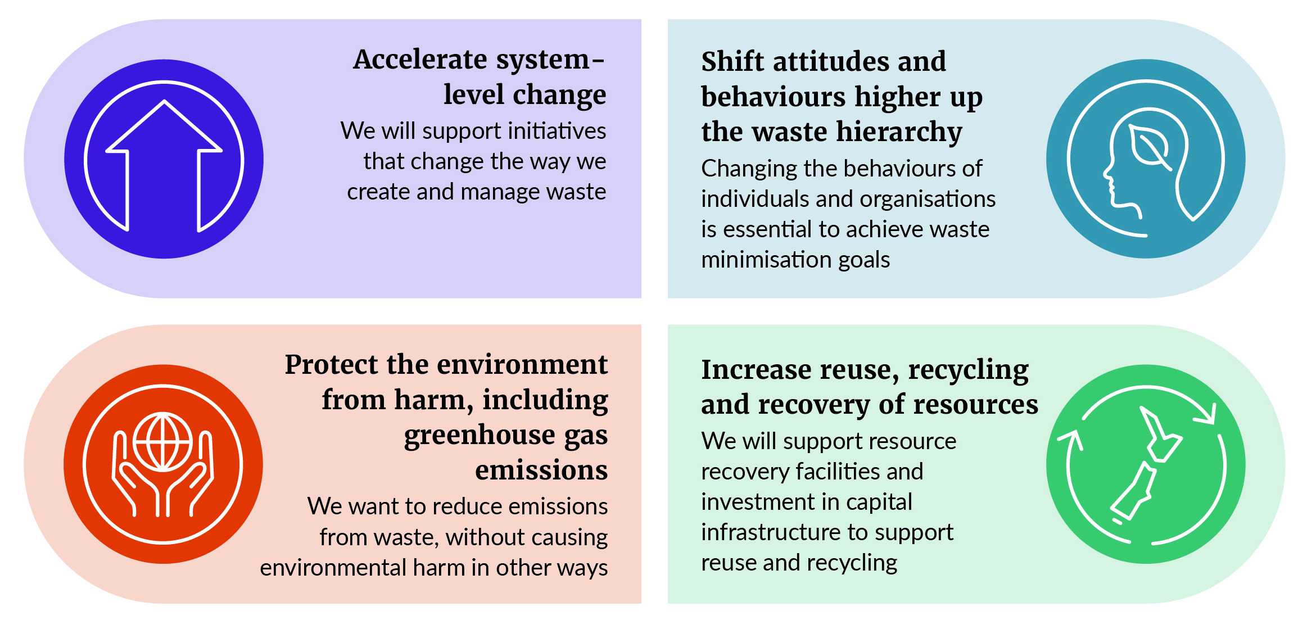
For information on what is currently being funded, visit Waste Minimisation Fund | Ministry for the Environment.

Funding summary
In this section, you need to include the estimated total project cost and how much of that is being requested from the WMF. Tell us how much your organisation will contribute and any other third-party co-funders.
Ensure the amount of WMF funding requested is above our minimum grant sizes, which can be found on our website. There is no maximum grant limit on what you can apply for.
When completing your project funding summary, note that:
- for commercially oriented applications, the Ministry will contribute a maximum of 40 per cent of the total project cost. That means applicants and potential co-funders must contribute at least 60 per cent of the total cost. The Ministry may seek a higher or lower level of co-funding on a case-by-case basis. Generally, proposals with high levels of co-funding from the applicant are more likely to be supported by the WMF
- there may be flexibility in the co-funding requirement for community, iwi and hapū, and local government projects on a case-by-case basis. This flexibility depends on the level of public and community benefit, contribution to outcomes, and is based on reasonable costs and whether the project is additional to normal business
- in-kind funding, such as voluntary hours and donated services, are not considered co-funding
- for infrastructure projects, WMF funding should be targeted towards capital assets and/or costs

Examples of what we don’t fund
- Existing business-as-usual activities. Funding must be used to either implement a new initiative or significantly expand an existing one.
- Projects where financial support is already provided by other government agencies.
- Projects with access to other sources of capital and/or that replace existing solutions.
- Retrospective costs for waste minimisation projects that have already begun or been completed.
- Ongoing operational costs.
- Projects outside New Zealand.
- Administrative costs for preparing WMF applications.
- Purchase of alcohol, tobacco, illegal substances or gaming.
- Costs related to fundraising.
- Prize money or entrance fees.
- Debt servicing.

Project details
In this section, you’ll need to elaborate on the problem or opportunity your project is addressing. Explain:
- how your solution addresses the problem
- how it is a low-waste, low-emission, circular economy solution
- any opportunities your project delivers to minimise harm to the environment.
Detail the waste stream(s) targeted, climate change impacts, and any other global change drivers you may have identified.
Please include information on your project inputs – such as technologies, capital assets, work programmes, cultural knowledge, and feedstock – that may be used for its implementation. Highlight the project outputs or products resulting from your project activities.
If the project’s scope is research or feasibility, include a brief description of any research or business case development you have already completed. Any supporting documents can be uploaded under the ‘checklist and document upload’ section of the online form before submission.

Project impact
This section collects information the WMF team can use to measure and understand the impact of your project and how well it delivers across the WMF outcomes. This will enable the WMF team to assess your project’s projected impact and value for money.

Project objectives
Your EOI needs to outline your project objectives. Each objective needs to clearly describe the key activities that will be carried out during the project. The objectives also need to align with the problem and solution that you have identified. Your project should have between two and four objectives using the SMART framework.

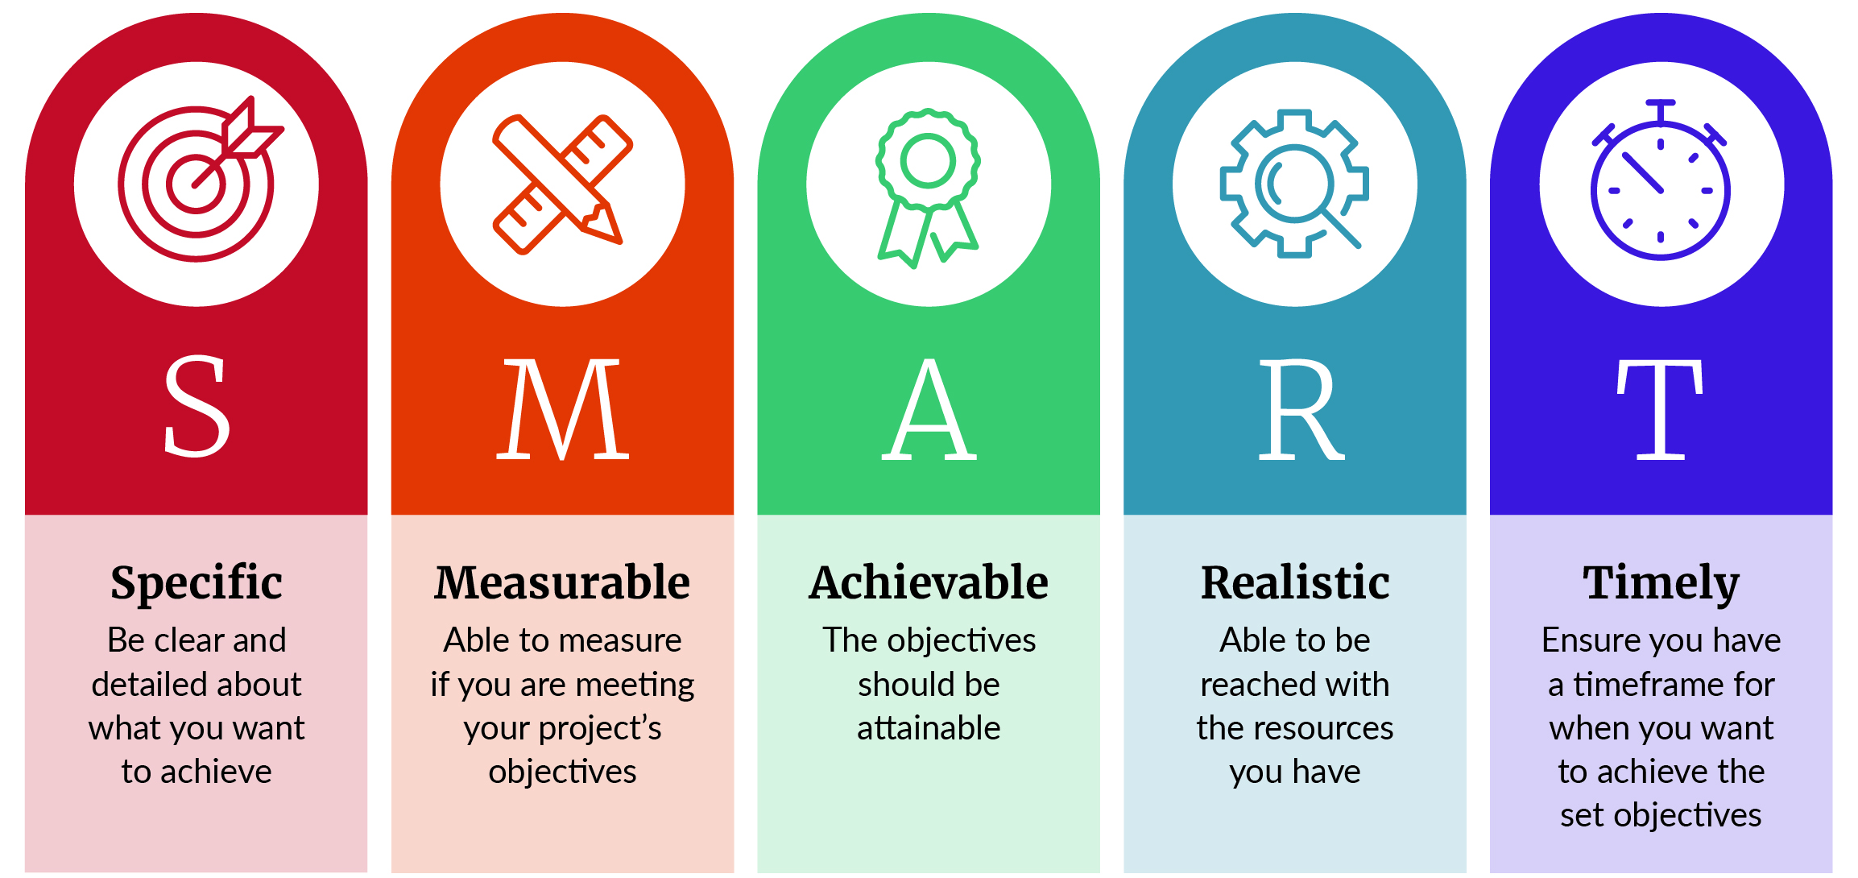

Examples of SMART objectives
- Set up facilities to provide [X] regions with [X amount] more processing capacity for organic waste, with a new processing facility by the end of project year one.
- Procure and install a [X model] shredder which will improve haulage density of [X] tonnes per cubic metre for wood waste haulage within two weeks of becoming operational.
- Locate and make operational a site as a new [X] resource recovery centre to divert [X] tonnes of construction and demolition waste from landfill by the end of project year one.
- Procure specialist support and develop a business case for the collection and beneficial reuse of domestic organic waste, with an indicative business case completed within six months of project commencement and a full business case by the end of year one.
- Procure and develop a business case by the end of year one to expand the existing composting facility from 10,000 tonnes per annum to 30,000 tonnes per annum.

Benefits
Describe the specific benefits your project will achieve. Benefits are the advantages gained from the change that the project will achieve. They should contribute to the change needed to achieve one or more of the WMF outcomes. They are usually long term and can occur during the project or after completion.
To guide good decision-making and ensure robust investment decisions, the WMF team needs to evaluate the project’s benefits in relation to the WMF outcomes. Understanding your project’s benefits is essential during the assessment process. They allow you to measure your project’s impact and the potential reach of the fund’s investment. We need to understand each advantage gained, who it will impact, and when it is likely to be realised. Benefit statements may also include quantitative targets if appropriate and should be specific enough they can be assessed as achieved or not achieved if the project goes ahead.
Note, this section is for the outcomes/long-term benefits that will result from the project, rather than a list of project activities.

Benefit section question | What we’re looking for in your answer
How, and by how much, will your project minimise waste?  (Max. 1000 characters) | The WMF aims to boost New Zealand’s performance in waste minimisation. If applicable, provide a tonnage of waste diverted and detail how and where the waste is currently disposed (ie, without this project, where the waste would go), where the waste will be diverted to, and how will it be processed.  Example 1:  This project will result in the ongoing diversion and processing of [X] tonnes of household organic waste from [X] landfill every year. The household organic waste will be diverted to the [X] processing facility. This diversion will result in long-term substantial gains in carbon emission minimisation and protecting the environment. It will also provide opportunities to ensure circularity for organic waste collection, processing, and end market uses in this region.  Example 2:  The project will divert [X] tonnes of construction and demolition (C&D) waste from landfills per every $[X] investment, strategically leveraging co-funding and WMF contribution to divert [X] tonnes of C&D waste to [X] processing facility in the [X] region. In the long term, this project will provide the necessary facilities to promote the recovery and reuse of resources through the resell and recycling of various C&D materials upstream into [X] product/s.
How will your project impact greenhouse gas emissions and protect the environment from harm?  To calculate your project’s emissions, we encourage you to use the information and guidance provided on our website on measuring and reporting greenhouse gas emissions.  (Max. 1000 characters) | The WMF aims to accelerate New Zealand’s transition towards a low-emissions economy.  Example 1:  The new recycling solution will reduce the import of [X] virgin materials, minimising carbon emissions from international freight and raw material input for the production of virgin materials that would otherwise have been disposed at landfills. We expect that during project implementation alone, the import of [X] virgin materials will decrease by 100 tonnes and that, within two years from project completion, our reliance on imported virgin materials would have reduced by 80 per cent from the current 2022 baseline, with a corresponding increase in the domestic supply of recycled product.  Example 2:  If the project confirms the viability of using treated timber as boiler fuel, it will have the potential to annually reduce carbon emissions and divert approximately [X] tonnes of treated timber from landfills across New Zealand every year. This represents [X] tonnes of CO₂ per year in reduced carbon emissions and contributes to protecting the environment from climate change.
How will your project consider te ao Māori and/or create better outcomes for tangata whenua?  (Max. 1000 characters) | WMF supports projects that encourage Māori participation and the application of te ao Māori principles as a Treaty partner.  Example 1:  As a Māori organisation, we are kaitiaki (guardians) for the environment in our rohe. Our project integrates our local mātauranga and will connect with and empower whānau, local iwi, and the community to increase awareness around reducing organic waste and the benefits of composting. Being able to put our beliefs into practice will enhance our community’s mana.
Example 2:
Our project will work closely with local iwi/hapū to evaluate and co-design a solution to process food and green waste in the rohe. This will support the identification/development of a solution that maximises diversion from landfill and emissions reduction in a way that embraces te ao Māori and mātauranga Māori principles. It will also provide Māori with the chance to input, invest, and/or operate the resulting facility at a mutually suitable level.

Moving from a linear to a circular economy requires fundamental changes to the way we create and manage resources.  How will your project help accelerate this change?  (Max. 1000 characters) | To support the vision of a low-emission, circular economy, the WMF supports projects that accelerate system-level change.  Example 1:  The project will scale the existing resource recovery facility to increase the collection and reuse of C&D waste in the South Island. This will result in both an increase in the amount of material diverted from landfill for use, and an increase in the awareness of C&D waste minimisation and reuse. This raising of awareness, along with greater availability of recovered material, will increase the local circular economy for these types of resources.  Example 2:  The project will standardise food waste composting by establishing community composting hubs. The hubs will be an educational platform to encourage local composting by empowering individuals and businesses to use the compost to grow kai, creating food sovereignty, reducing carbon emissions, and fostering a circular use of organics.
How will your project lift the behaviour of people and businesses up the waste hierarchy towards more sustainable behaviour?  (Max. 1000 characters) | It is essential to facilitate the change in attitudes and behaviours of individuals and organisations to achieve waste minimisation goals.  Example 1:  The project will purchase [X] bins to implement kerbside collection of household organic waste in our region. A coordinated marketing campaign will also be launched to raise awareness of the programme and to develop more sustainable behaviours. This will make it easier for households to separate and dispose of organic materials, raising their awareness of how much of this waste they are creating. Participants will be supported to identify the types of organic waste they are creating and given strategies to help avoid it. This means there will be benefits for both minimising waste to landfill and reducing the amount of waste created.
Example 2:
The project will establish a network of regional, organic processing solutions, addressing logistical challenges in allowing the diversion of organics in marginalised areas. This will support the acceleration of the change in how we currently manage organic waste.
Are there any other benefits of this project that you have not covered in your earlier answers?  (Max. 1000 characters) | WMF invests in projects that maximise the return on investment, which includes additional environmental, social or cultural benefits that may not be captured above.  Example 1:  The project will yield economic benefits for the local community by creating six Full-Time Equivalent roles to achieve the key objectives and activities. It is expected a few more roles may be recruited after the project’s completion and that the project will provide a permanent source of employment to the local community. This will increase the number of people employed in waste minimisation in this region.  Example 2:  The project supports multiple organisations to work together, including territorial authorities, farmers, community groups, local iwi, and landfill operators. These relationships are expected to grow into an established network after the project is completed, increasing the region’s waste minimisation capability, which will positively impact the wider community and environment.
Beyond business-as-usual (additionality)  (Max. 1000 characters) | The WMF only supports new initiatives or the costs of expanding existing initiatives. Please provide a clear rationale as to why your project requires WMF investment. What will this investment enable that wouldn’t otherwise happen? Each project must demonstrate why it is difficult to access capital from other sources and how the project is outside the scope of day-to-day operations. Include any available information on competing activities/programmes/businesses that are already operating or implementing similar activities to those of your project.

Waste hierarchy
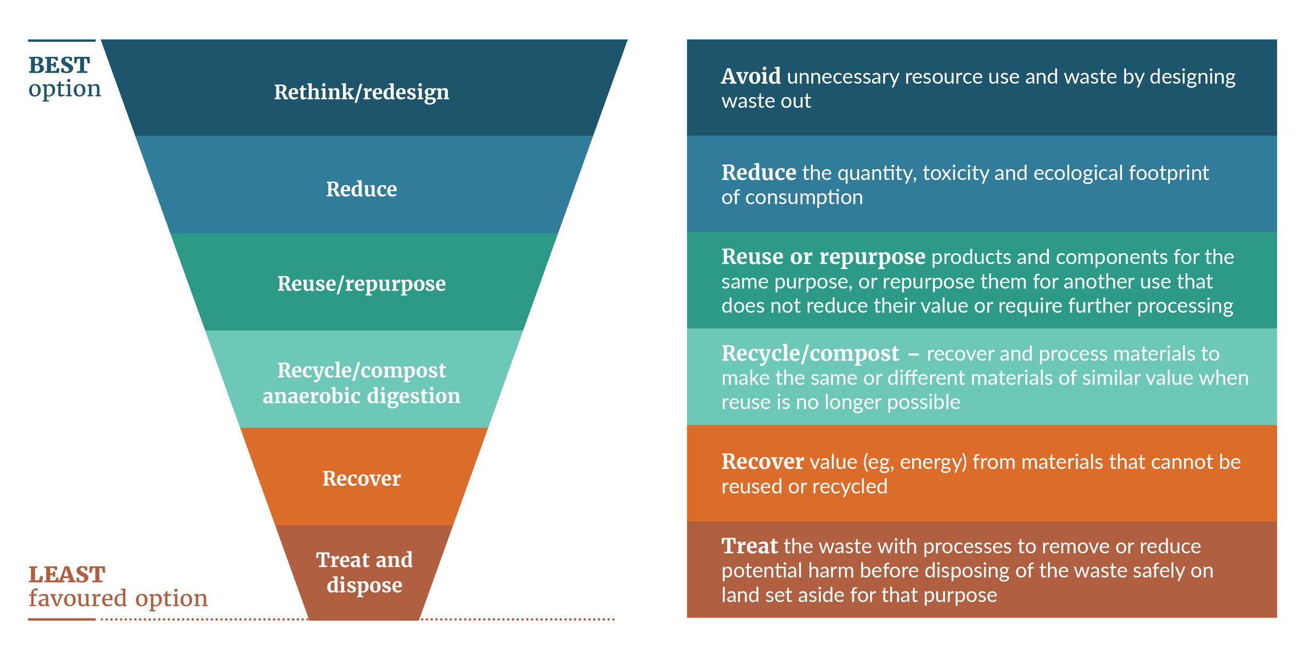

Experience, capability and project delivery
This section is about demonstrating your organisation’s ability to deliver the project. Include relevant experience, resources, skills, and any previous experience managing contestable grants. If applicable, provide information on the project business partners and any other strategic partners.

Estimated budget
In the budget section, you will need to identify high-level major expenses which reflect the total project costs in the funding section. Major expenses are indicative and can be grouped under the following general headings.
- Design and site preparation
- Personnel
- Administration
- Consultants and sub-contractors
- Purchase of capital assets and other capital costs
- Venue and equipment
- Travel and accommodation
- Promotion and dissemination of information
- Financial, legal and information technology (IT) expenses
- Health and safety
- Other miscellaneous costs.

What happens next

Expression of interest assessment
EOIs will be assessed using the scoring tool, noting that the resultant scores are not determinative and assessments may also include advice from subject matter experts and internal Ministry policy experts, as well as additional due diligence. Investment managers may contact applicants for further information on their EOI before the assessment starts. The assessment will then be moderated including comparison with other applications. Assessment scoring is used to support this moderation, but decisions are not based solely on the assessment score.
The possible outcomes of moderation are; a request for more information,, to decline the EOI; to move forward with the application process, with or without conditions, or for the EOI to stay in the pool of EOIs awaiting a decision.
The WMF is a year-round open fund and continuously receives EOIs. The Ministry for the Environment will periodically invite the most competitive EOIs to progress to the application phase. The number of projects invited to apply will vary based on the size and complexity of those projects.

Checklist: Before you submit
EOI submission checklist
- Does your project align with the WMF outcomes?
- Does your project align with what is currently being funded?
- Does your project provide benefits either regionally or across New Zealand, boosting how we reuse and minimise waste?
- Does your project involve new work or expanding on existing initiatives that minimise waste?
- Is funding towards the operational or capital costs required for this new initiative or expansion?
- Is your organisation financially contributing to the project?

What to expect from the WMF application process

