
Waste data – How to measure contamination in kerbside collections
Fact sheet on reporting obligations for territorial authorities
From 1 July 2024, territorial authorities are required to collect and report data on the annual tonnage of contamination in kerbside collections of recycling, food scraps, and food organics + garden organics (FOGO) that they manage, if their Waste Management and Minimisation Plan provides for these services.
The first annual report covering 1 July 2024 to 30 June 2025 is due for submission on 30 September 2025.
This fact sheet provides guidance on how to collect robust and comparable estimates of kerbside contamination. For other factsheets in the series see Further information.

What kerbside contamination records to keep
As part of the Waste Minimisation (Information Requirements) Amendment Regulations 2023, territorial authorities must record the following kerbside contamination information:
- annual contamination tonnages in the territorial authority’s kerbside recycling, food scraps or FOGO services
- administrative details covering:
- in situations where contamination tonnage is a combined figure for two or more territorial authorities:
- which other territorial authorities are included
- method used to estimate contamination for each territorial authority
- whether contamination tonnage includes waste from commercial or residential premises.

A territorial authority must report contamination tonnages separately for kerbside recycling collections and organics (food scraps or FOGO) collections. It is not required to provide contamination reporting for garden/green waste-only services or private kerbside services that it has not contracted. Contamination reporting is also not required for recycling drop-off locations, like transfer stations.

How to estimate kerbside contamination
The options below outline methods for estimating kerbside contamination. These options are presented in order from most to least recommended in terms of producing consistent and reliable data. Each option involves identifying target materials (suitable for recycling/organics processing) and non-target materials (contamination). For recycling, all materials that are too dirty for recycling are non-target materials.
Many factors may impact a territorial authority’s ability to use a more preferred option. These include the nature of the territorial authority’s collection contracts and the specific facility used for recyclables sorting and organics processing (referred to as facility from this point).

Option 1: Record tonnage of kerbside materials disposed of, subtracting an estimation for target materials inadvertently removed
This option is the most reliable way to estimate kerbside contamination. Option 1 is most suitable when a territorial authority is the sole user of the facility, or when it is possible to attribute waste to a particular territorial authority for another reason (eg, if only one territorial authority’s collection is sorted on a given day).
This method uses the overall tonnage of kerbside material that is removed as contamination, but acknowledges that some target materials are likely to be inadvertently included in the removed material. An audit estimates the target materials that are inadvertently removed as contamination. Subtracting non-target materials makes results from option 1 more comparable with results from scoop tests or bin audits (see option 2).
The option 1 contamination calculation involves three main steps.
- Step 1. Gather the total tonnage of kerbside collected materials that are removed during sorting and sent to disposal.
- Step 2. Audit a selection of the removed material to estimate the percentage of target materials inadvertently disposed of (see sampling advice below). Apply this percentage to the total tonnage of kerbside material disposed, to estimate the total tonnage of target material inadvertently disposed of.
- Step 3. Estimate the total tonnage of contamination by subtracting the estimated tonnage of target material inadvertently disposed from the total tonnage of kerbside material disposed (see figure 1).
Figure 1: Example of how to calculate kerbside contamination tonnage under option 1
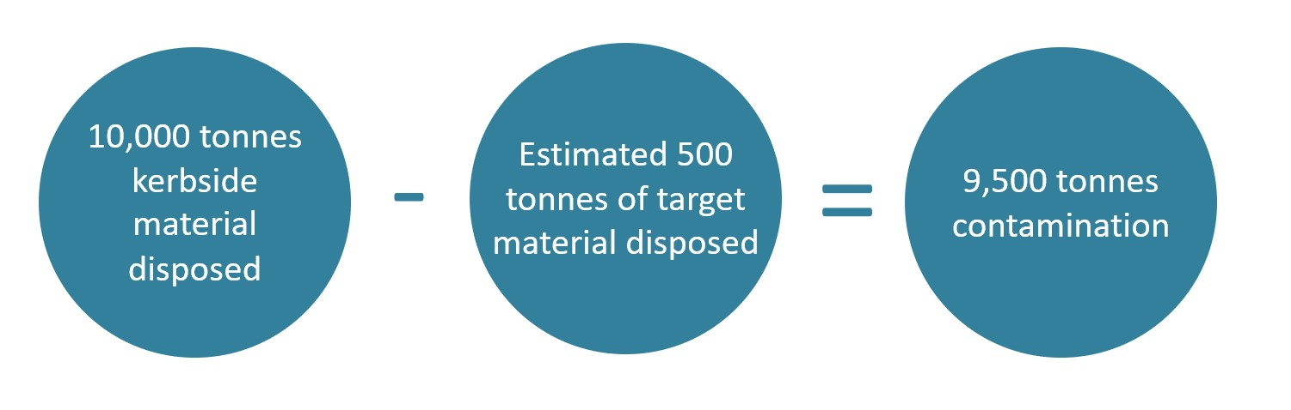

Option 2: Conduct contamination audits of a territorial authority’s kerbside collection
Where collections from multiple territorial authorities are mixed before or during facility sorting, option 1 may not be possible. In such cases, a territorial authority can use contamination audits to estimate its specific kerbside contamination.
There are two main approaches to conducting a kerbside contamination audit.
- Option 2a: Contamination scoop test. Use heavy machinery to take a ‘scoop’ of a predetermined size out of a collection truck after it enters the facility. Then sort the scoop into target materials and non-target materials. Weigh the sorted materials and use the results to calculate a contamination rate. Doing multiple scoop tests throughout the year produces a more reliable contamination rate (see sampling advice below).
- Option 2b: Contamination bin audit. Take a sample directly from kerbside receptacles rather than from the collection truck. Then sort the sample into target materials and non-target materials. This approach can be more suitable for auditing collections that are difficult to sort after a collection truck has compacted them (eg, food scraps or glass-in recycling collections).
After conducting contamination audits, it is possible to multiply the overall tonnage of kerbside material collected by the estimated contamination percentage, to produce an estimated kerbside contamination tonnage (see figure 2).
Figure 2: Example of how to calculate kerbside contamination tonnage under options 2a and 2b
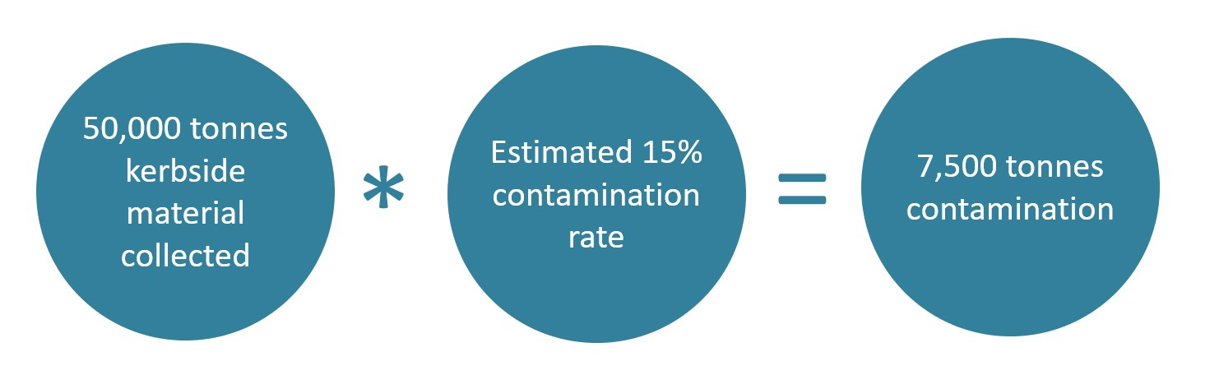

Option 3: Use facility-wide contamination data
In some cases, it may not be viable for territorial authorities to conduct contamination audits. In this case, the only data available to some territorial authorities may be on facility-wide contamination (based on materials received from multiple parties).
While data specific to each territorial authority are preferred, option 3 is to use facility-wide contamination data. This option involves three main steps.
- Step 1: Gather the overall tonnage of material the facility receives and later disposes of as contamination.
- Step 2: Calculate how much material (by weight) comes from a given territorial authority’s kerbside collection, as a percentage of the overall material that the facility receives.
- Step 3: Multiply the facility’s overall contamination tonnage (step 1) by the percentage from step 2 (see figure 3).
Figure 3: Example of how to calculate kerbside contamination under option 3
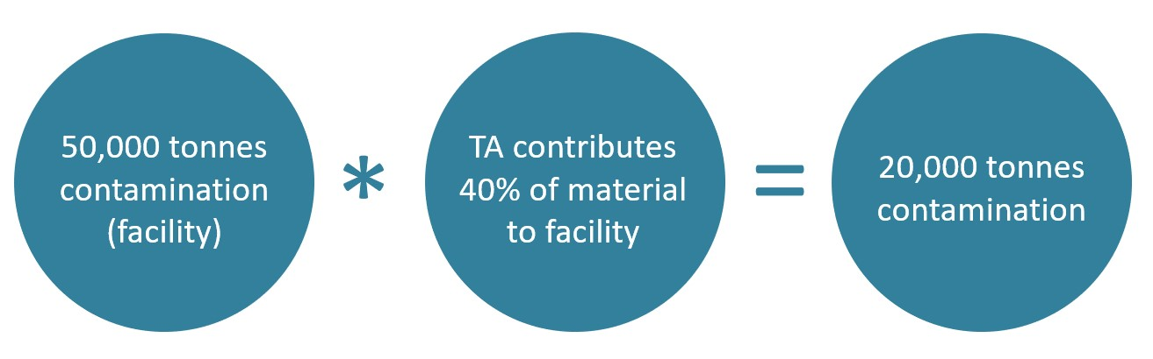
Note: TA = territorial authority

Option 4: Use an alternative estimation method
Where the previous three options are not possible, kerbside contamination can be estimated using the most relevant information available. If this option is utilised, territorial authorities may provide a brief description of the data sources and calculations used. This is the least preferred option.

Sampling advice
To produce robust data generated from scoop tests or bin audits, it is important to collect:
- samples that are representative of the area serviced by kerbside collections
- a sufficient number of samples to account for variation from scoop to scoop (or bin to bin) over the course of the year.
We encourage you to consult with a statistician to work out which is the most appropriate sampling strategy for your circumstances.

Bin audits
For general procedures for bin audits, see Procedure One: Classification of Domestic Wastes at Source in the Solid Waste Analysis Protocol (SWAP). The classification scheme may be simplified to two categories: target materials and non-target materials (contamination), although a more detailed material breakdown would provide additional insight into problematic materials.

Scoop tests
Sorting of material from scoop tests follows the same general methods as those for bin audits. We recommend briefly mixing materials, if possible, before taking a scoop (eg, using a loader) as heavier items may have worked their way to the bottom. It is important for any territorial authorities planning contamination audits to consider health and safety, particularly for sorting glass-in kerbside recycling.

How to submit records

Territorial authorities will be able to submit their reports online. The Ministry for the Environment is currently identifying the systems requirements for this new reporting.

Further information
Fact sheets in this series
This fact sheet is part of a series of three fact sheets for territorial authorities regarding their waste data and waste levy reporting obligations.
- For an overview of reporting obligations see the fact sheet Waste data – Overview of reporting obligations for territorial authorities.
- For more information on reporting on TA owned or operated resource recovery facilities see the fact sheet Waste data – Reporting on resource recovery facilities.
Find out more
Contact the Ministry for the Environment by emailing wastedataregsupport@mfe.govt.nz or visit the webpage Territorial authority waste data and waste levy reporting obligations.

Published in June 2024 by the  Ministry for the Environment – Manatū mō te Taiao  Publication number: INFO 1253 | 

This is a yes/no question. A percentage breakdown for kerbside contamination from commercial vs. residential premises is not required.

