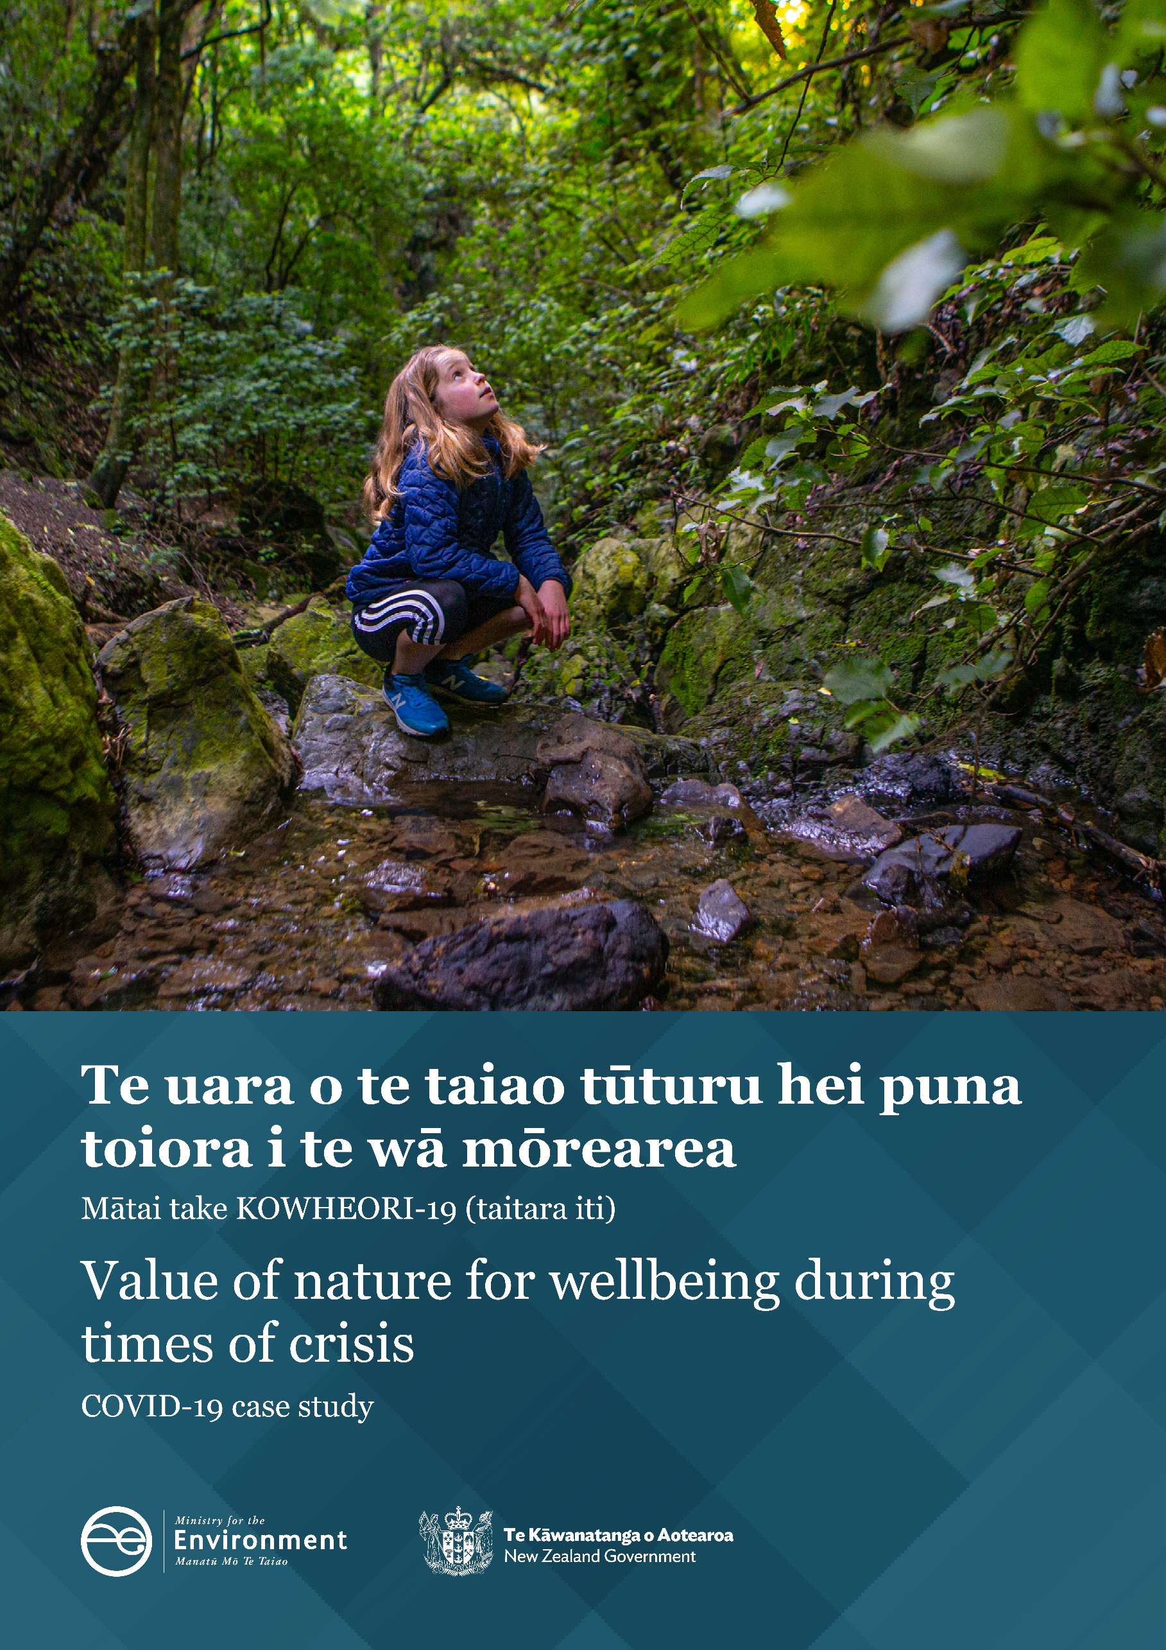

**Disclaimer**

The information in this publication is, according to the Ministry for the Environment’s best efforts, accurate at the time of publication. The Ministry will make every reasonable effort to keep it current and accurate. However, users of this publication are advised that:

* The information does not alter the laws of New Zealand, other official guidelines, or requirements.
* It does not constitute legal advice, and users should take specific advice from qualified professionals before taking any action based on information in this publication.
* The Ministry does not accept any responsibility or liability whatsoever whether in contract, tort, equity, or otherwise for any action taken as a result of reading, or reliance placed on this publication because of having read any part, or all, of the information in this publication or for any error, or inadequacy, deficiency, flaw in, or omission from the information in this publication.
* All references to websites, organisations or people not within the Ministry are for convenience only and should not be taken as endorsement of those websites or information contained in those websites nor of organisations or people referred to.

**Acknowledgements**

This report was prepared by Fiona Curran-Cournane, Mariona Roigé Valiente, Liam Daly, Constance Nutsford, Peggy Cunningham-Hales, Anne-Gaelle Ausseil and Pierre Tellier from the Ministry for the Environment at various times of its writing.

The authors thank Dr Carrie Barber (School of Psychology – Waikato University), and Edward Langley and Daniel Brownie (Kantar, formerly Colmar Brunton) for their early peer review; and Dr Chris Daughney for providing valuable report feedback during his time at the Ministry for the Environment. The authors would also like to thank Dr Alison Collins, Departmental Chief Science Advisor at the Ministry for the Environment, for her valuable review and feedback. External peer review was provided by Dr Lin Roberts (Lincoln University), whose comments and suggestions greatly improved the report.

This document may be cited as: Ministry for the Environment. 2022. *Value of nature for wellbeing during times of crisis: COVID-19 case study*. Wellington: Ministry for the Environment.

Published in September 2022 by the  
Ministry for the Environment   
Manatū Mō Te Taiao  
PO Box 10362, Wellington 6143, New Zealand

ISBN: 978-1-99-102565-4  
Publication number: ME 1673

© Crown copyright New Zealand 2021

This document is available on the Ministry for the Environment website: [environment.govt.nz](http://www.mfe.govt.nz).

# Contents

Executive summary 4

Purpose and background 6

Purpose of report 6

The connection between nature and wellbeing is an active research area 6

The environment provides essential benefits to our health and wellbeing 6

There is growing recognition of the link between people’s health, wellbeing and interaction with nature 7

Exploring nature-wellbeing connections during Alert Level 4 lockdown 7

Methodology 9

The survey 9

Survey design 9

Feelings during lockdown 10

Data analysis 10

Study limitations 11

Results 12

Survey demographics 12

Negative feelings were reported during lockdown 12

Many participants experienced challenging feelings during the lockdown period 12

Participants coped in different ways 14

Nature helped people cope 15

Many factors influence people’s connection with nature 16

People spent more time in nature during lockdown 18

People connected more with nature during and after lockdown 20

Discussion 23

Evidence supports the impact of lockdown on people’s wellbeing 23

Evidence supports how lockdown affected people’s relationship with nature 24

Local nature is important for people’s wellbeing 25

Wider considerations of research 26

Future research 26

Conclusion 28

References 29

Appendices 32

# **Executive summary**

The objective of this study was to improve our understanding of the contribution of nature to people’s wellbeing during times of crisis, using COVID-19 as a case study.

At the start of 2020, COVID-19 spread rapidly across the world, causing unprecedented disruption to the way we live our lives. In response, the New Zealand Government enacted an Alert Level system where most New Zealanders were required to lockdown at home under various restrictions. The first national Alert Level 4 lockdown lasted for over a month from 25 March to 27 April 2020.

The lockdown disruption triggered by COVID-19 provided an opportunity to explore how people coped during a period of crisis, and the ways in which nature supported people’s wellbeing. Approximately two weeks after the country moved to Alert Level 1 and all restrictions on gatherings and movement ended, the Ministry for the Environment commissioned Kantar (formerly Colmar Brunton) to survey at least 1000 adult New Zealanders on their experiences before, during and after the national Alert Level 4 lockdown, with a particular focus on lockdown itself.

**Feelings of wellbeing:** Of those surveyed, many participants experienced negative feelings associated with depression (67 per cent), anxiety (62 per cent) or loneliness (42 per cent) during the Alert Level 4 lockdown.

**Importance of time spent in nature:** For those who spent time in nature, it had a positive impact on mental wellbeing, helping to manage or avoid some of these negative feelings. The proportion of participants who rated spending time in nature as ‘very important’ to them for general wellbeing and social wellbeing increased from 47 per cent before lockdown to 62 per cent during lockdown. After lockdown, almost two weeks after the country moved to Alert Level 1, this figure was at 53 per cent, a drop from the peak during lockdown, but higher than before lockdown. Participants living closer to nature or spending more time in nature benefitted the most from exposure to nature.

**Where time was spent in nature:** Participants spent significantly more time in private gardens during lockdown and less time in public spaces than before lockdown. Almost 70 per cent of participants had access to a private garden during lockdown. Visiting parks was the next location frequented by participants during lockdown, but time spent at parks was lower than before lockdown. While spending time in private or communal gardens may be associated with an element of convenience, the responses suggest that benefits can be gained from exposure to manicured, modified landscapes, so are not limited to unmodified, ‘wilder’ landscapes, which can be harder to access, particularly when movement is restricted such as during Alert Level 4 lockdown.

**Barriers to nature:** Lockdown-related restrictions aside, concerns around health and catching COVID-19 were the biggest barriers to leaving the house during Alert Level 4 lockdown. Issues related to the accessibility of getting out into nature during lockdown included, for example, driving, cycling or public transport. After lockdown, most people felt they were too busy with work and other commitments to get out.

Findings from this study can be used to help better inform city design to ensure more people have easier access to greenspaces. It is important nature is brought into neighbourhoods, for example, by ensuring streets are lined with trees or that greenspaces are plentiful for all and well-maintained. Designing urban spaces with equitable access to nature is essential for resilient cities. These considerations add more value to nature-based solutions for adaptation as they have a physical protection role and contribute to overall mental resilience (Rigolon et al, 2018; McCormick, 2017).

Challenges to people’s wellbeing can increase as a result of lockdown-related restrictions as suggested by results from this study. Aucklanders may have experienced similar challenges when alert levels were changed multiple times throughout 2020 and 2021. Those people who may be facing current challenges from, for example feelings of COVID-19 fatigue, could be helped with continued exposure and interaction with nature to help support their wellbeing.

Considering the potential benefits from regular exposure to nature, future research could focus on increasing our understanding of any barriers to spending time in nature. In particular, lower socio-economic and more vulnerable communities should be examined to ensure there are enough resources to allow access to various forms of nature, particularly during times when everyday challenges are amplified.

Purpose and background

## Purpose of report

The objective of this study was to improve our understanding of the contribution of nature to people’s wellbeing during times of crisis, using COVID-19 as a case study. Gaining insight into the connection between nature and wellbeing at this time will help inform our response to and learnings from this pandemic, as well as to future periods of stress or uncertainty.

The survey was designed to explore the importance of the role nature plays in helping people manage their mental wellbeing during the national Alert Level 4 lockdown imposed in New Zealand in early 2020.

This study complements other research on the impacts of COVID-19 and can serve as a basis to look at nature’s connection to wellbeing.

## The connection between nature and wellbeing is an active research area

### The environment provides essential benefits to our health and wellbeing

A healthy environment provides many benefits integral to our health and wellbeing. These include material benefits such as food, timber or medicines, but also clean air and water, and other more subjective benefits like spiritual connections or sense of place. The capacity of ecosystems, habitats and species to support a good quality of life now and in the future contributes fundamentally to our resilience.

Many frameworks have been developed to describe how nature is connected to our wellbeing, with the Millennium Ecosystem Assessment (2005) being instrumental in this space. More recently, the Intergovernmental Platform on Biodiversity and Ecosystem Services (IPBES) formalised these relationships and reported on global trends in biodiversity and nature’s contributions to people(Ausseil & Collins, 2020; Díaz et al, 2018; IPBES, 2019). The concept, or term, ‘nature’s contributions to people’ recognises that our relationship and connection with nature extends well beyond using nature as a resource only. These contributions affect our wellbeing in different ways including by providing income, jobs and security, but also by contributing to our physical and mental health.

**‘Ko au ko te taiao, ko te taiao ko au.’**

**I am the environment, and the environment is me.[1]**

### There is growing recognition of the link between people’s health, wellbeing and interaction with nature

Nature’s non-material contributions improve health in many ways – mental, physical, social and cultural – that collectively have significant effects on people’s wellbeing (Blaschke, 2013; Bratman et al, 2019; Cox et al, 2017; Roberts et al, 2015; Robinson & Breed, 2019; Shanahan et al, 2015a; van den Bosch & Ode Sang, 2017). For example, experiences and interactions with forests, parks, beaches, native bush and open countryside provide opportunities for recreation and inspiration. Collectively, these interactions can be part of our cultural identity. Plants, animals and natural landscapes can form the basis of spiritual or social-cohesion experiences (Díaz et al, 2018).

One way in which our mental health can be affected by time in nature is that it helps shift our focus from problems or tasks, and reduces our cognitive load (Kaplan, 1995). For example, looking at a forest or garden does not require any mental effort, allowing a break – known as attention restoration from the constant focus that modern life demands (Kaplan, 1995).

Spending more time in nature is also linked to lower rates of depression and anxiety (Astell-Burt et al, 2013; Hartig et al, 2014; Shanahan et al, 2015a and b). Even being able to look out a window at nature can have restorative effects (Kaplan, 2001). Spending more time in nature improves our mental wellbeing in a number of ways, such as increasing our job satisfaction in office environments (Finnegan & Solomon, 1981). One study also found prisoners who had windows facing farm fields used health facilities less than those with internal-facing windows (Moore, 1981). The mental wellbeing we garner from nature is connected with other aspects of wellbeing. For example, being able to view nature while exercising has been shown to benefit mood and self-esteem (Pretty et al, 2005).

## Exploring nature-wellbeing connections during Alert Level 4 lockdown

Survey analysis explored the potential for a nature–wellbeing connection during the   
New Zealand Alert Level 4 national lockdown. It assessed whether mental health was affected and whether connections with nature altered these feelings. The objective was to use   
COVID-19 as a case study to better understand how nature contributes to wellbeing during times of crisis.

In March 2020, the New Zealand Government introduced a four-level alert system to manage and minimise the risk of spread of the COVID-19 virus. Timelines and alert level announcements are indicated in figure 1. During Alert Level 4 lockdown (25 March–27 April 2020), New Zealanders were confined to their homes and could only leave to exercise locally. This excluded activities such as swimming, boating and hunting. New Zealanders could only leave their home during the Alert Level 4 lockdown period to buy essential services or if they were an essential worker. The Government then progressively eased restrictions as the country moved to lower alert levels over the following months.

Figure 1: Schematic illustration of COVID-19 timelines and Alert Level announcements (Colmar Brunton & Ministry for the Environment, 2020)

While many people struggle with mental wellbeing at different points in their life, the ongoing challenges of COVID-19-related restrictions have had a compounding effect on wellbeing. In their report about protecting and promoting mental wellbeing beyond COVID-19 in Aotearoa New Zealand, Poulton et al (2020) suggested those previously at risk of experiencing wellbeing difficulties could become more at risk, and others could be new-at-risk.

# Methodology

## The survey

The Ministry for the Environment commissioned Kantar (formerly Colmar Brunton) to undertake a survey of at least 1000 individuals (appendix 1). Kantar conducted the survey over eight days between 15 June and 22 June 2020 (figure 1) and it took approximately 13 minutes to complete. The survey timeframe was almost nine weeks after the beginning of the national Alert Level 4 lockdown which restricted people’s movements to the home and local areas.

The survey used the Kantar Online Panel™, which adheres to the ISO 20252:2012 market, opinion and social research standard. The survey was conducted in line with the Research Association of New Zealand’s Code of Practice and all responses were anonymous. All participants freely agreed to take part in the survey and could drop out at any time.

Opting to take part in the survey indicated the participant’s consent. Only the data of those panellists who completed the survey were included in the analysis of results. Panellists received 10 Flybuy points for completing the survey. This helped ensure there was no missing data.

To be eligible for the survey, participants had to be over 18 years old and living in Aotearoa New Zealand since January 2020.

Interview targets were set for age, gender, ethnicity and region using the most recent (2018) census data. The data was post‑weighted to ensure the sample aligned with these targets (appendix 2). Post-stratification weights were applied to compensate for people with certain demographic characteristics being not as likely to respond to the survey. The weights were applied for the categories of age within gender, ethnicity and region.

Participants were questioned on their activities and feelings before, during and after the national Alert Level 4 lockdown, with additional questions focused on the lockdown period.

In total, 1001 participants completed the survey. Responses to this survey were individual and based on personal interpretation of how the participants felt at the different alert levels. The timing of the survey meant people were asked to remember or think back to how they felt before and during lockdown.

## Survey design

The survey’s intent was to help us understand how nature contributes to the wellbeing of individual people in times of crisis, using COVID-19 as a case study. In the survey, nature was defined as a space where you can see and hear nature, for example, a garden, a park, a reserve, a beach, a forest, the bush or open countryside. Nature includes the presence of plants, animals and natural landscapes. The survey gathered information about:

* participants’ demographics (for example, gender, age, ethnicity, residence type)
* participants’ emotions and situation during lockdown
* how much time participants spent in nature, where and why
* how participants saw nature contributing to their wellbeing before, during and after lockdown.

The survey’s lockdown-specific questions asked about residence type, household make-up, number and ages of children in the household if applicable, employment status and barriers to nature.

## Feelings during lockdown

To establish whether there was cause for a nature–wellbeing connection, the survey asked participants whether they experienced negative feelings during and after national lockdown restrictions (over March–June 2020).

Participants used ratings from 1 (not at all) to 6 (all the time), or 7 to 8 (don’t know or can’t remember to prefer not to say). The survey text provided examples of negative feelings that included:

* feeling down, depressed, irritable, or hopeless
* nervous, anxious or on edge
* loneliness.

The survey was not a clinical diagnostic tool but provided an idea about the level of negative feelings people experienced. The survey had an open-ended question on what the participant did (if anything) to help manage such feelings, and the reasons participants offered were thematically categorised in the analysis. The value of open-ended questions is they allow participants to provide in-depth responses to how they manage negative feelings in this instance, which could have otherwise been restricted via a closed, pre-coded list of options.

The survey also had a closed question about life satisfaction as a whole, ranging from 1 (completely dissatisfied) to 10 (completely satisfied).

## Data analysis

Open-ended questions were thematically categorised and analysed accordingly. For some survey questions, sub-group differences were tested for statistically significant differences between proportions (z-test). Any sub-group differences in this report are statistically significant at the 95 per cent confidence level unless otherwise specified. Results for a sample size of 1001 are subject to a maximum margin of error of +/-3.1 per centage points.

The ‘impact on wellbeing’ score was aggregated for each participant based on their experience of depression, anxiety or loneliness, and how spending time in nature during lockdown helped manage or avoid negative feelings. Their response to each statement was given a rating from   
-2 to +2 (-2 being ‘it made things a lot worse’ and +2 being ‘it made things a lot better’).   
Any ‘don’t know’ or ‘prefer not to say’ responses were given a score of zero. The scores on the three measures were added together to create an aggregate impact on wellbeing. For example, if someone said spending time in nature made their feelings of depression ‘a bit better’ (+1), their anxiety ‘a lot better’ (+2) and no difference to their loneliness (0), they had an aggregate impact score of +3. The aggregate scores ranged from -6 to +6 and have been grouped according to whether there was a positive impact, no impact or negative impact.

## Study limitations

Limitations of this survey include:

* Online panels tend to under-represent those living in lower-income households and those without internet access.
* The survey was completed after the Alert Level 4 lockdown. Asking participants to think back and recall their experiences and feelings for certain questions could be subject to false recall or post-rationalisation.
* The sample size is too small to ensure those who participated in the survey reflect or include the experiences and voices of all the people of Aotearoa New Zealand.
* All the responses are self-reports – people talking about their own experiences – and, although anonymous, people may tend to provide responses that are socially desirable.
* The survey is correlational, looking at the existing relationships between different factors, and it cannot fully explain all cause and effect.

With these limitations in mind, quotas were applied at the sampling and selection stage, and the results have been weighted to be as representative as possible of New Zealanders.

# Results

## Survey demographics

A total of 1001 participants completed the survey and were distributed across various locations in Aotearoa New Zealand (figure 2). Half of the participants identified themselves as female and the other half as male. A breakdown of summary statistics can be found in appendix 3.

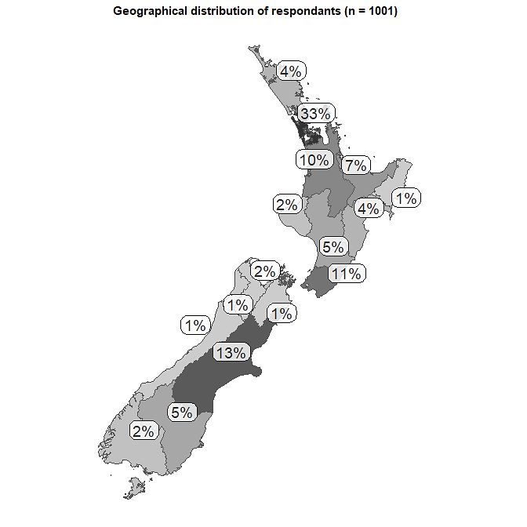

Figure 2: Geographical distribution of respondents across Aotearoa New Zealand

Note:Numbers do not add up to 100 due to rounding.

## Negative feelings were reported during lockdown

### Many participants experienced challenging feelings during the lockdown period

A lot of people reported experiencing negative feelings during the lockdown period (hereafter ’lockdown’ refers to Alert Level 4 unless otherwise specified).

The breakdown of these negative feelings experienced by various demographics is set out in appendices 4–6 and is summarised below. (We cover associations with the value of nature in later sections and elaborate on these in appendices 7–10).

* Nearly half (42 per cent) reported experiencing feelings of loneliness to some degree during lockdown (figure 3) – although only one in five of the participants was living in a single-person household (appendix 3).
* A large proportion manifested negative emotions: 62 per cent reported feelings of ‘nervousness, anxiety and being on edge’, and 67 per cent experienced feelings of ‘depression, irritability or hopelessness’ to some degree during lockdown.

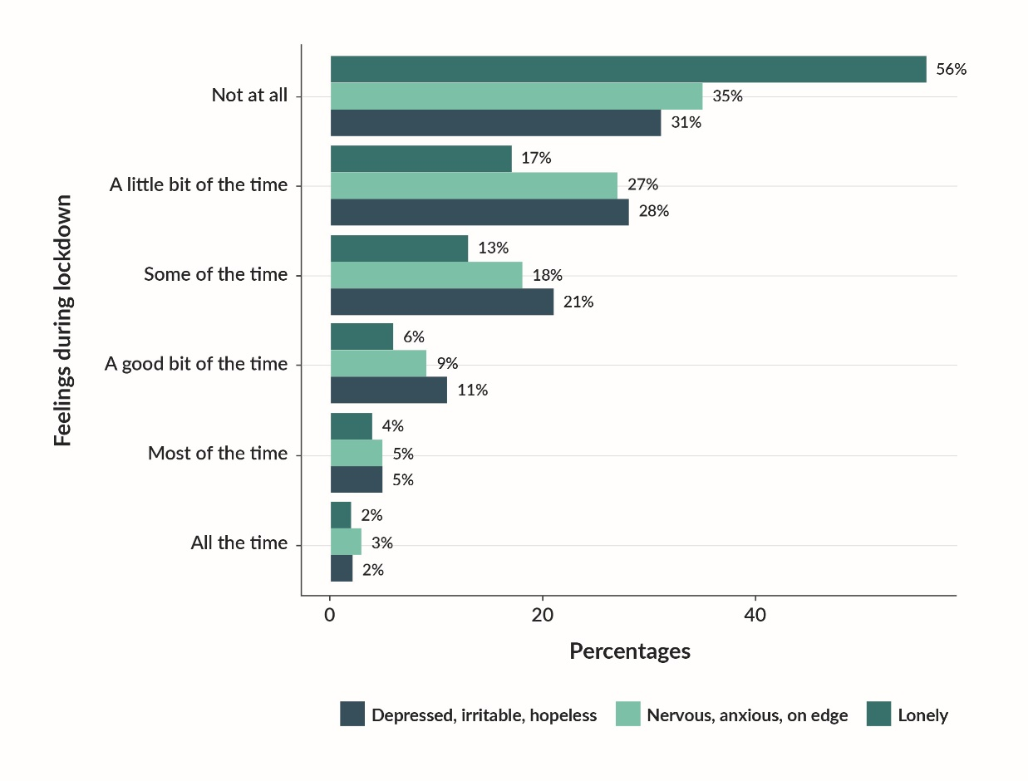

Figure 3: Percentages of those experiencing negative feelings during lockdown

Note the categories ‘Do not remember/Prefer not to say’ are not included in the graph, so percentages do not add to 100.

### Participants coped in different ways

Ten per cent of participants responded that connecting with nature was an important coping strategy for managing their negative feelings in general (that is, this question was not directed at coping strategies specifically during lockdown) (figure 4). The 10 per cent could be an underestimate as various forms of exercise, hobbies and self-care can take place in nature, so time in nature may be indirectly contributing to coping. For example, regardless of whether participants were reporting on time before, during or after lockdown, the two most frequent reasons they gave for spending time in nature were for exercise and mental wellbeing (figure 5). However, more participants gave exercise and wellbeing as their reason for spending time in nature before lockdown than during and after lockdown (figure 5).

Connecting with others/social cohesion (23 per cent) and self-care (22 per cent) were the most frequently mentioned coping strategies for managing negative feelings (figure 4). Hobbies (13 per cent) and exercise (11 per cent) were also popular ways.

Figure 4: Coping strategies[2] with managing difficult emotions in general (open-ended question)

Half of the respondents in the current study reported not doing anything, not experiencing these negative feelings or were unable to say how they coped (figure 4).

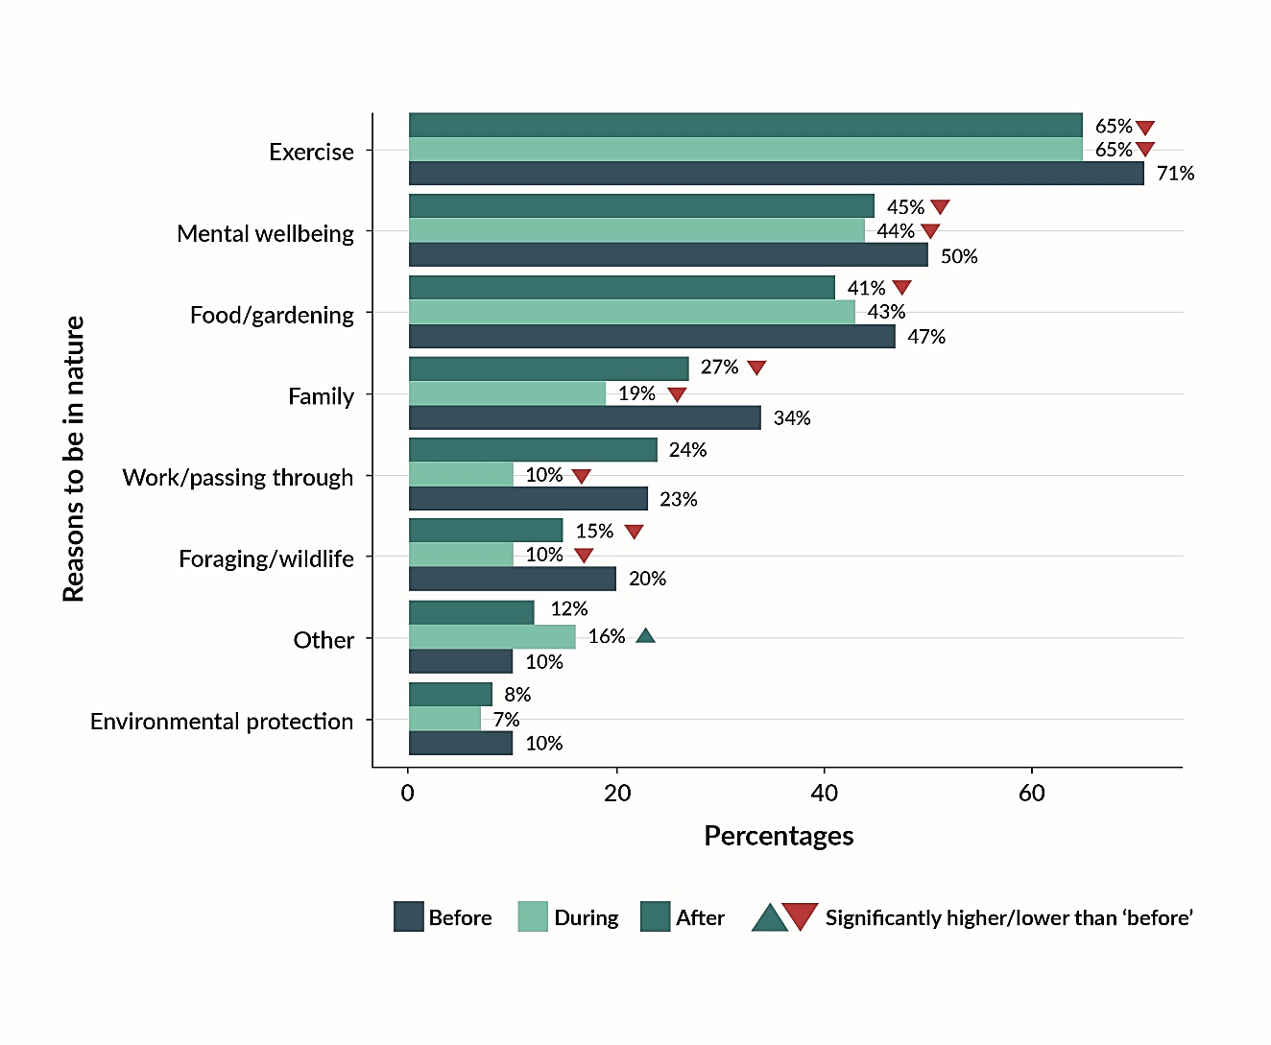Figure 5: Reasons for time spent in nature before, during and after lockdown

## Nature helped people cope

When asked in the current study specifically how spending time in nature during lockdown helped manage or avoid experiencing negative feelings, New Zealanders’ responses included:

* nature helped with coping with negative emotions such as feelings of depression (57 per cent of participants responded), feelings of nervousness (53 per cent) and had less of an effect on feelings of loneliness (37 per cent) (appendix 7).

When asked how spending time in nature during lockdown made them feel:

* 57 per cent of participants responded they experienced feelings associated with being happy, 57 per cent with feeling calm and 29 per cent felt energised (figure 6).

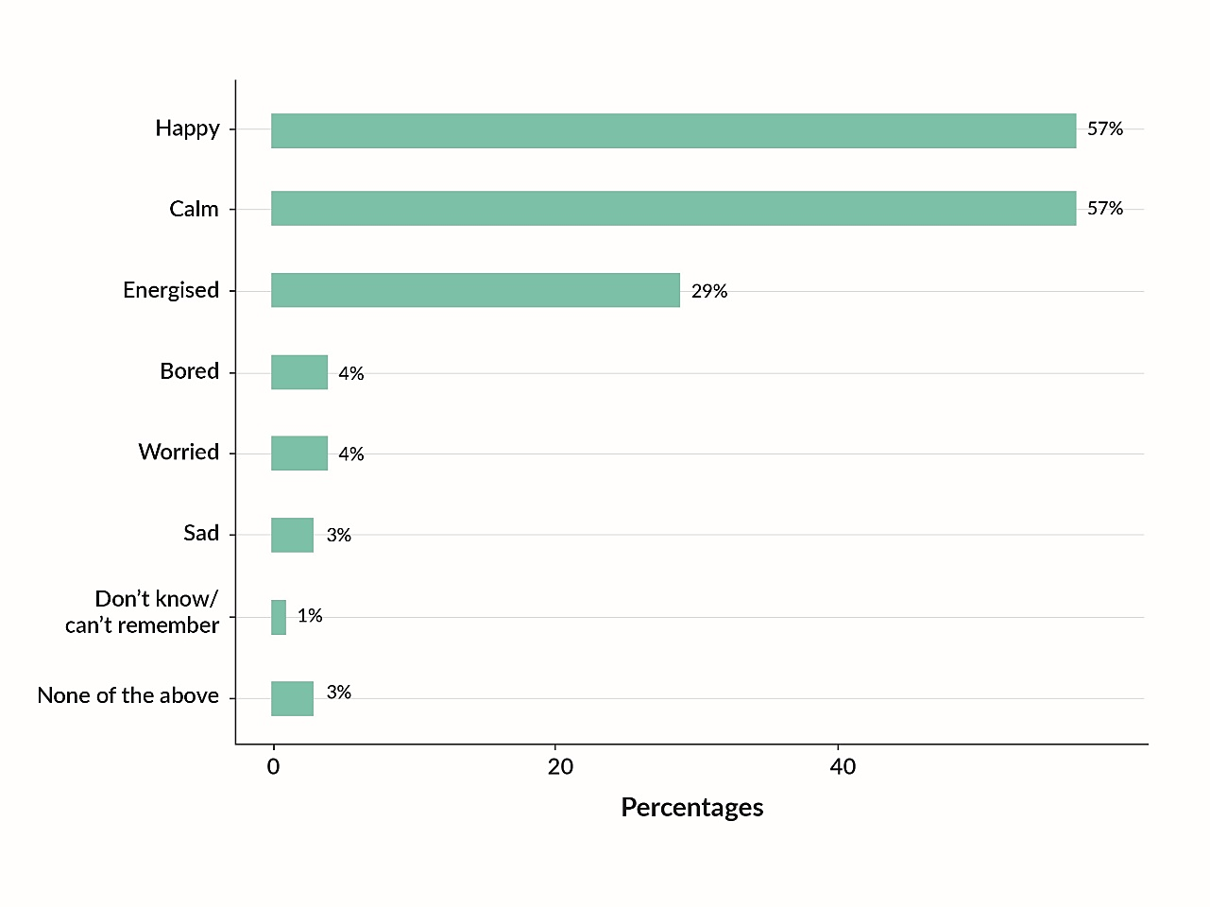Figure 6: Summary analysis of how spending time in nature during lockdown made people feel

### Many factors influence people’s connection with nature

#### Access to nature

Almost 70 per cent of participants had access to a private garden during lockdown (appendix 3). Access to a private garden fell sharply (to 40 per cent) for people living in city centres – significantly lower than the average of participants (appendix 11). If the definition of the city also included suburbs, then the percentage increased to 64 per cent (still significantly lower than the average). In contrast, 79 per cent of the respondents who lived in a rural setting during lockdown (either rural residential or isolated rural) had access to a private garden.

During lockdown, people spent significantly more time in private gardens and less time in public spaces than before lockdown (figure 7). Visiting parks was the next location frequented by participants during lockdown, but time spent at parks was significantly lower than before lockdown.

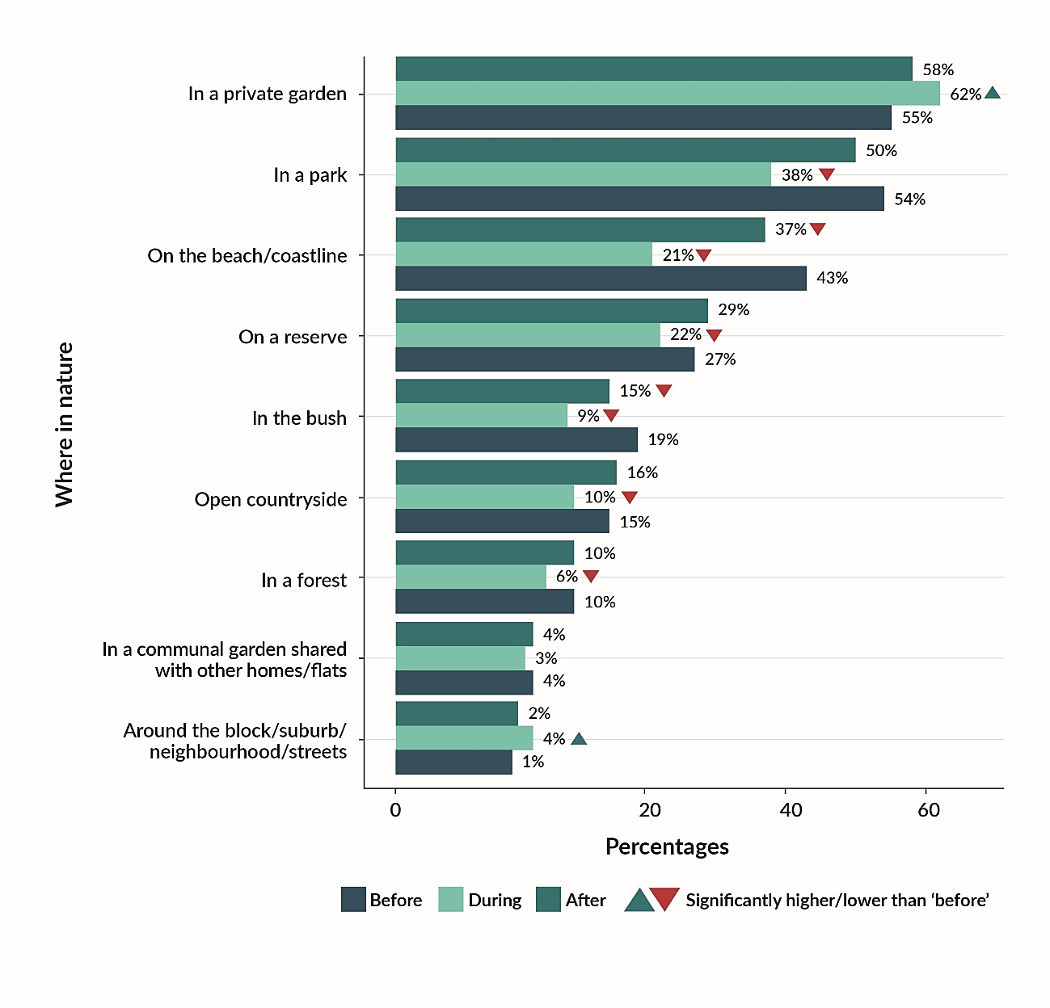Figure 7: Where time in nature was spent before, during and after lockdown

Those participantswho lived less than five minutes from a public greenspace were more likely to report that spending time in nature during lockdown made things a lot better when experiencing negative feelings than those who lived further away (more than 10 minutes without driving and excluding aprivate or communal garden surrounding theirhome (appendices 8–9). Women – particularly those living with children during lockdown or thoseaged over 30 **–** were most likely to be positively affected by being in nature to help manage experiencing negative feelings (appendices 8–9).

#### Barriers to spending time in nature

Aside from the lockdown restrictions, concerns around health and catching COVID-19 were the biggest barriers to leaving the house during Alert Level 4 lockdown (figure 8).

Specifically, during lockdown:

* 41 per cent reported health concerns was a barrier to spending more time in nature
* 27 per cent reported accessibility issues (driving/cycleway/pathway/public transport accessibility)
* 24 per cent reported no barriers apart from the lockdown rules.

After lockdown, most survey participants felt they were too busy with work and other commitments to get out.

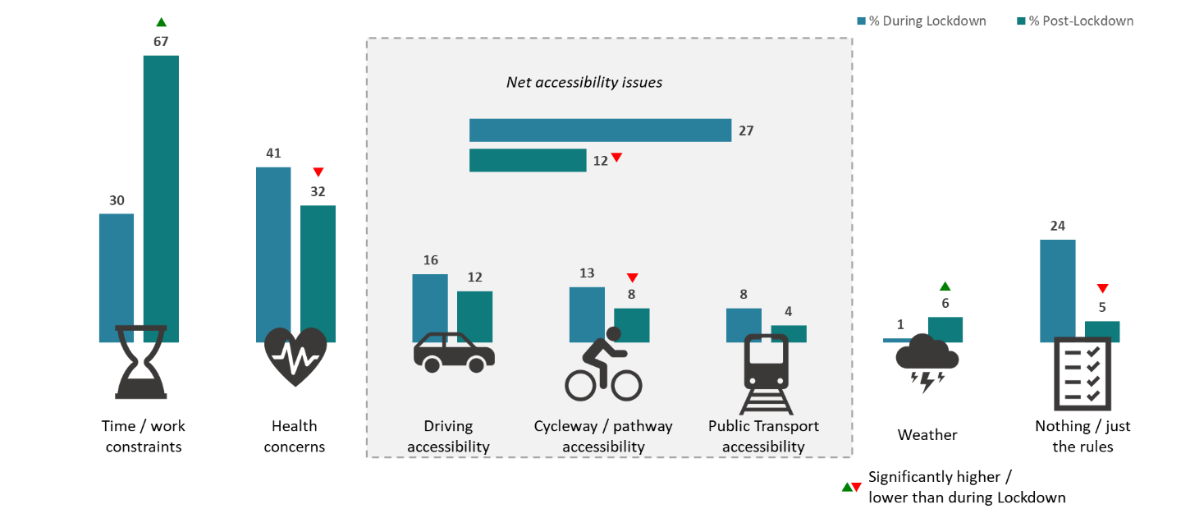

Figure 8: Barriers to spending time in nature during and after lockdown (Colmar Brunton and Ministry for the Environment, 2020)

### People spent more time in nature during lockdown

Participants reported spending more time in nature during lockdown than before. Particularly, the percentage of people who went out once a day increased from 20 per cent before lockdown to 35 per cent during lockdown, and those who went out more than once a day increased from 10 per cent to 17 per cent. People have continued going out more after lockdown (14 per cent) than before (figure 9).

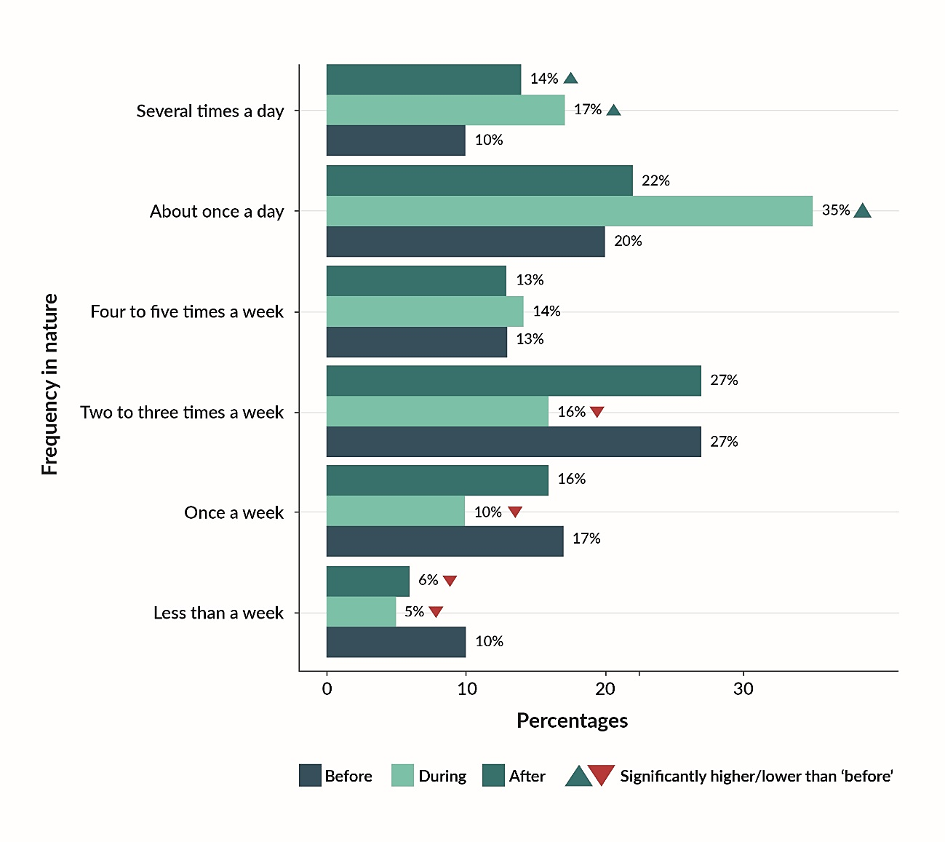 Figure 9: Frequency of time spent in nature before, during and after lockdown

Half of the participants reported venturing out at least once a day during lockdown (figure 9). The more time someone reported spending in nature during lockdown, the more benefit they derived for their wellbeing, compared with those who went out less often (figure 10).

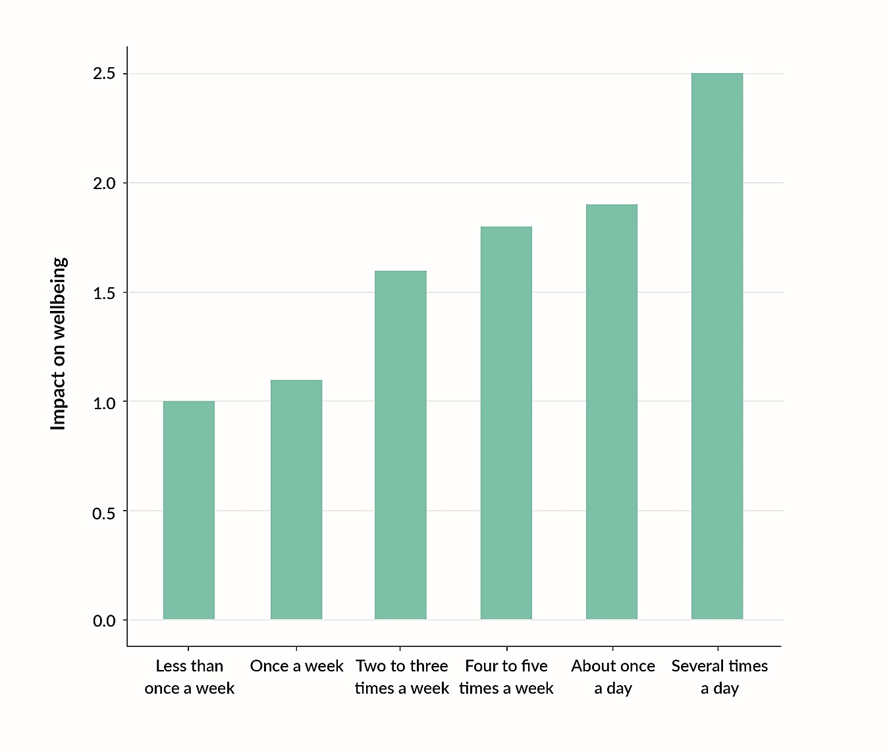Figure 10: Impact on wellbeing of time frequency spent in nature during lockdown

Note: Y axis scores indicate aggregate impact on depression, anxiety and loneliness on a scale from -6 to +6, where negative, zero and positive values indicate that time spent in nature worsened, made no difference or lessened these feelings, respectively (See data analysis).

### People connected more with nature during and after lockdown

The proportion of participants who rated spending time in nature as ‘very important’ to their wellbeing and social wellbeing increased from 47 per cent before lockdown to 62 per cent during lockdown (figure 11). After lockdown, this figure was at 53 per cent, a drop from the lockdown peak, but higher than before. This could indicate a lasting positive impact of nature on people, up until this point at least.

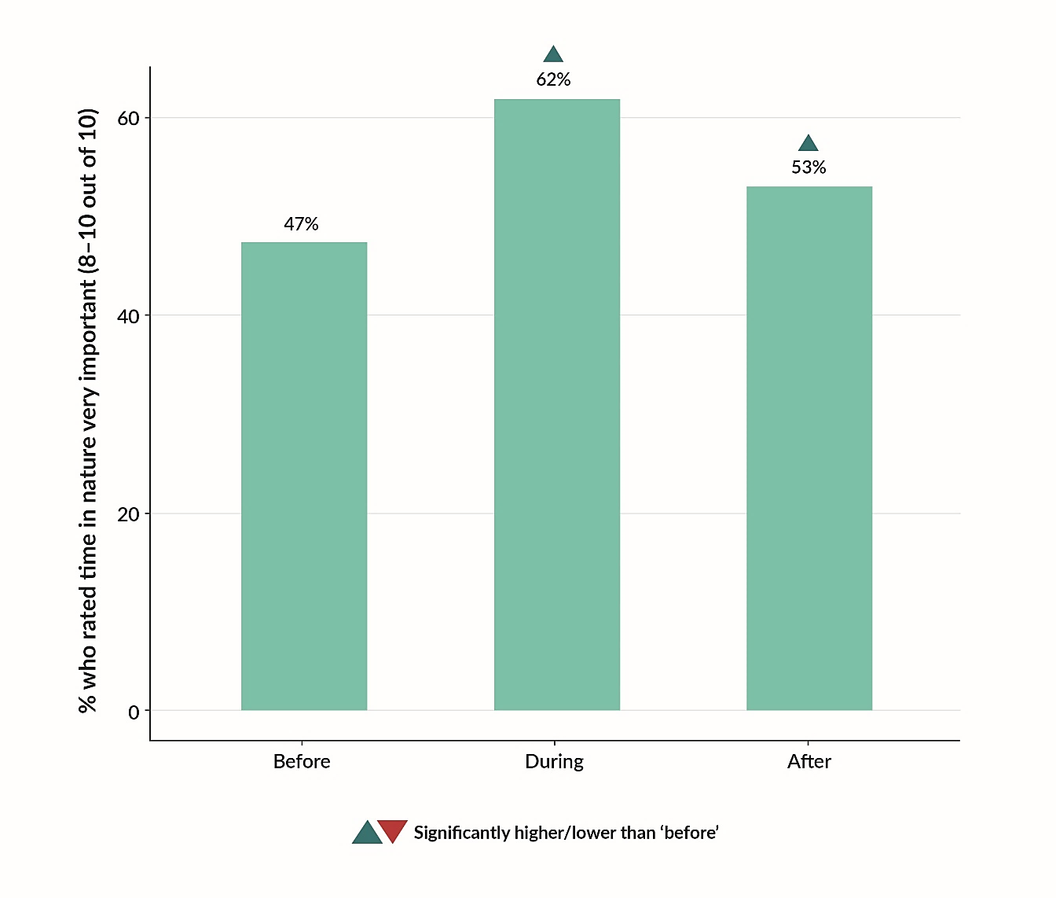Figure 11: Percentage of participants who rated time in nature as ‘very important’ for wellbeing and social wellbeing (before, during and after lockdown)

Early in the survey, participants were asked whether spending time in nature had become more important for wellbeing and social wellbeing over the last six months, that is, January to June 2020 encompassing before, during and after lockdown periods, and 53 per cent responded positively (appendix 12).

When an open-ended question was asked to understand these reasons, wellbeing (43 per cent), at a general level, was the most popular response (table 1). Following this, 29 per cent of New Zealanders spontaneously indicated that nature was more important to their wellbeing because of COVID-19 and the lockdown; and 17 per cent responded that nature was more important to their wellbeing for the various values provided by nature itself such as breathing fresh air, appreciating natural surroundings as well as changes in weather and scenery.

Table 1: Reasons[3] provided as to why nature had become more important for wellbeing and social wellbeing, from January to June 2020, encompassing before, during and after lockdown periods.

| **Reason** | **Percentage** |
| --- | --- |
| Wellbeing | 43 |
| COVID-19/lockdown | 29 |
| Nature | 17 |
| Time out | 16 |
| Physical health | 7 |
| Social connection | 3 |
| Other | 8 |
| Don’t know | 13 |

# Discussion

The report set out to explore a potential nature–wellbeing connection during times of crisis, using COVID-19 Alert Level 4 lockdown as a case study, and this was reflected in participants responses to a survey.

This finding was identified by establishing various wellbeing challenges participants experienced during the Alert Level 4 lockdown and corroborating these responses with other studies (see below). Participants reported that exposure to nature helped to alleviate these challenges and that the more time they spent in nature, the better they evaluated their wellbeing.

The responses suggested that benefits can be gained from exposure to manicured, modified landscapes, and thereby are not limited to more unmodified, ‘wilder’ landscapes which can be harder to access, particularly during times when movement is restricted such as during Alert Level 4 lockdown.

## Evidence supports the impact of lockdown on people’s wellbeing

The participants in this study reported experiencing negative feelings associated with depression, nervousness and/or anxiety, and loneliness during Alert Level 4 lockdown (figure 3). While many people experience negative feelings at various stages in life, these feelings can be heightened during times of crisis and uncertainty.

This is comparable to another survey during the 2020 Alert Level 4 lockdown in Aotearoa New Zealand, where 30 per cent of 1028 participants reported experiencing high levels of anxiety or depression. Women, in particular, experienced more heightened feelings of these emotions, as well as worrying about the various aspects of the COVID-19 pandemic (Barber & Naved, 2020). A survey of over 3000 Māori reported that about 20 per cent said they suffered adverse psychological outcomes (stress, sadness and, in some cases, depression) as a result of the COVID-19 pandemic (Houkamau et al, 2021).

Wellbeing can be impacted by job or income loss, with close to half of all New Zealanders experiencing an economic loss during Alert Level 4 lockdown (Prickett et al, 2020). Two-thirds (22,000) of those who lost their jobs between the March and September quarters were women (Statistics New Zealand, 2020).

Every-Palmer et al (2020) also found that 30 per cent of survey respondents reported moderate to severe psychological distress (Kessler Psychological Distress Scale (K10)), 16 per cent moderate to high levels of anxiety, and 39 per cent low wellbeing. These results are well above baseline measures. Poorer outcomes were seen among young people, those who had lost jobs or who had less work, those with poor health status, and those who had past diagnoses of mental illness.

In contrast to these studies, Beaglehole et al (2022) reported approximately 9 per cent of surveyed New Zealanders reported ‘excellent’ wellbeing during the national 2020 lockdown, and those who reportedly thrived were more likely to be male, older, less educated, non-smoking as well as identifying with certain ethnicities. This figure compares to the 7 per cent of people who reportedly thrived in a pre-lockdown national survey. A related study also reported ‘silver linings’ experienced by New Zealanders associated with lockdown  
(Jenkins et al, 2021).

In the current study, as well as social cohesion and self-care, coping strategies to help manage experiencing negative feelings during lockdown included spending time in nature (figure 4).

## Evidence supports how lockdown affected people’s relationship with nature

A large proportion of participants rated spending time in nature as being ‘very important’ to them for wellbeing and social wellbeing regardless of alert levels, but the proportion was highest (62 per cent) during national lockdown in 2020 (figure 11). Regardless of whether it was before, during or after lockdown, the two most frequent reasons study participants gave for spending time in nature were for exercise and mental wellbeing (figure 5). The more often people spent time in nature during lockdown, the better they evaluated their wellbeing   
(figure 10).

A study in Scotland that aimed to explore people’s relationship with nature during lockdown reported that 35 per cent of participants specifically referenced managing stress as a reason for exercising outdoors. Of these, 63 per cent stated these experiences helped them destress, relax and unwind, with 58 per cent feeling energised and revitalised (Stewart & Eccleston, 2020). That said, the restricted ability of being able to swim in rivers and the ocean or cycle off-track, for example, during lockdown-related restrictions in New Zealand impacted participants’ connections with nature (Greenaway, 2020). Another study in the USA found that, although participants reported an increase in the value of nature, contact with nature and/or outdoor physical activity decreased for low income and minority ethnicity populations during the COVID-19 pandemic (Pearson et al, 2021).

Greenaway (2020) reported that because of slowing down during lockdown, New Zealand participants felt more connected with nature – seeing, hearing and feeling nature more intensely, both at home and in local areas – that generated a sense of calm and alleviated numerous anxieties. As a result of lockdown-related restrictions and not being able to visit rivers and the ocean, for example, some participants substituted these activities with   
exploring nature closer to home – appreciating walking in their local bush, watching birds   
and insects up close, growing food, caring for the whenua, mindfulness and general wellbeing (Greenway, 2020).

Another study conducted during lockdown reported how the decline in vehicle traffic had a positive impact on neighbourhoods across a range of Aotearoa New Zealand cities (Wild, 2020). Those living in low-traffic neighbourhoods valued the quieter streets (air pollution was a less common theme than noise pollution), which heightened the sounds of surrounding nature. Feelings of being less rushed or relaxed and new opportunities to walk and cycle were also valued, as well as the enjoyment of nature, and the sense of friendlier or more social streets (Wild, 2020).

Participants from various surveys expressed feelings of gratefulness for the connections they made with nature (Barber & Naved, 2020; Greenaway, 2020). These authors reported that participants felt compassionate for those they considered less fortunate, for example those in apartments and towns, as well as appreciating living in Aotearoa New Zealand.

## Local nature is important for people’s wellbeing

Popular places where time was spent in nature included participants’ private gardens, parks, beaches and coastlines, and reserves. However, there were significantly fewer visits to parks, beaches and reserves during lockdown than before it (figure 7). In contrast, most participants reported spending more time in private gardens than before or after lockdown (figure 7). Almost 70 per cent of participants had access to a private garden. While spending time in private or communal gardens may be associated with an element of convenience, the responses suggest benefits can be gained from exposure to manicured, modified landscapes, and therefore the benefits of time in nature are not limited to more unmodified, ‘wilder’ landscapes that can be harder to access, particularly during times when movement is restricted such as during Alert Level 4 lockdown. Benefits can include both passively enjoying natural surroundings in gardens as well as feelings of productivity if actively gardening, planting vegetable seeds,[4] or undertaking backyard pest control (Shanahan, 2020).

Similarly, Poortinga et al (2021) reported that during the height of the first COVID-19 outbreak which led to severe lockdown restrictions in the United Kingdom, a private garden had a greater effect on protecting health when the nearest greenspace was perceived to be more than a 10-minute walk away. These authors suggested a private garden could partly compensate for lack of access to public greenspace, but also nearby public greenspaces were especially important for households without a private garden in times of crisis.

A New Zealand health survey reported the greenest neighbourhoods had the lowest risks of poor mental health, and that cardiovascular disease risk was reduced in neighbourhoods with greater than 15 per cent greenspace availability. However, the study could not link longer times in nature to increased stewardship. While the findings did not fully explain the relationship between greenspaces and health, physical activity was higher in greener neighbourhoods (Richardson et al, 2013).

More recent results have reported that adult New Zealanders living in areas with greenspaces, physical activity venues and supermarkets were more likely to have better physical health, with lower BMI and lower rates of type 2 diabetes, compared to those living in areas close to things like alcohol outlets, gambling venues, dairies and fast food shops (Hobbs et al, 2022). Martin et al (2020) also reported that visiting nature once a week or more was positively associated with general health, an effect they reported had a larger influence than the increase associated with having a high versus low socio-economic status. Relatedly, the benefits of gardening across multiple countries that were examined were reported to be ‘*overwhelmingly important for nature connection, individual stress levels, outdoor physical activity and food provision*’ during the COVID-19 pandemic (Egerer et al, 2022).

Knight (2020) argues for restoration of ‘neighbourhood nature’ areas that are more accessible for all, irrespective of socio-economic status or otherwise. This reflects the value of spending time in nearby parks and reserves compared to ‘wild’ national parks that can be out of reach for some New Zealanders.

## Wider considerations of research

Aside from the lockdown restrictions, concerns around health and catching COVID-19 were the biggest barriers to leaving the house during Alert Level 4 lockdown (figure 8). Such concerns may have reflected a tendency of participants to spend more outdoor time during lockdown in private gardens, potentially reflecting feelings that it is safer than on streets or in local parks. After lockdown, most survey participants felt they were too busy with work and other commitments to get out. Participants also spent less time in nature for exercise and wellbeing during and after lockdown than before lockdown (figure 5). Some of this can be attributed to seasonality – for example, fewer people may be likely exercising outside in early winter (in mid to late June when the survey was live), than during the Alert Level 4 period in autumn when temperatures were generally mild in many parts of the country (NIWA, 2020). There may also be other reasons at play, such as post-lockdown anxiety that could be further investigated.

In general, a higher proportion of New Zealand disabled people and lower-income households have reported as finding it ‘difficult’ to ‘very difficult’ to get to their nearest park or greenspace, compared to other population demographics (Statistics New Zealand, 2018). Such vulnerable communities could most likely benefit from regular exposure to nature for wellbeing needs when faced with constant daily challenges, irrespective of global crises. Additionally, as tangata whenua, Māori are particularly reliant on the environment as a cultural, social and economic resource and access to nature, particularly in urban spaces (Walker et al, 2019), will continue to be an important need for whanau, hapū and iwi.

While regular doses of nature have also been associated with environmental stewardship or guardianship – highlighting another important reason to engage with nature (Allen & Ferrand, 1999; Pooley & O’Connor, 2000) – other research has shown that less time is being spent with nature and that rapid urbanisation, sedentary lifestyles and modern childhoods are contributing to this decline(Hofferth, 2009; Pergams & Zaradic, 2006; Zhang et al, 2014). Opportunities to engage with nature may be lost as habitat loss and population declines of species continue around the globe(IPBES, 2019). Both time spent in what is considered ‘wilderness’ and time spent in our urban greenspaces and local parks are declining, with a more pronounced tendency in children than adults. This decline has been described as the ‘extinction of experience’ (Soga & Gaston, 2016). Houkamau et al (2021) reported that 10 per cent of Māori participants agreed “we need to reconnect with, protect and attune to nature” as a reflection from the COVID-19 situation in 2020.

## Future research

As previously noted, online survey panels tend to under-represent those living in lower-income households, so this demographic is under-represented in this study. Considering the reported benefits of regular exposure to nature from the current and wider studies, future research should focus on better understanding any barriers to spending time in nature. Lower socio-economic and vulnerable communities should be examined to ensure there are sufficient resources to allow access to various forms of nature, particularly when everyday challenges are amplified.

Participants in this study responded that time spent in nature for wellbeing after lockdown was not as high as it was before lockdown. This could be associated with many factors (such as season), and further research should explore whether reasons such as post-lockdown anxiety and expansion of work-related activities into non-work time combined with cultural norms and expectations of ‘busyness’, are contributing to this. Other research areas could also look at the impact of aversion to natural things, and how the quality or maintenance of a greenspace influences how people interact with nature.

How we can overcome potential future restrictions (related to other pandemics or otherwise) to improve interactions with nature is highly relevant, given the benefits nature can offer during such challenging times.

Conclusion

The results of this survey show that, for many people, interacting and connecting with nature can help with responding to negative feelings during times of crisis, and the more time people spent in nature, the greater the benefit to their wellbeing. The benefits to our wellbeing of exposure to nature reinforce how everyone can benefit when it comes to care and guardianship of nature. This can start in local communities to ensure that continued and intergenerational benefits are maintained or improved.

While participants choose to spend time in private or communal gardens may be associated with an element of convenience, the responses suggest that even exposure to manicured, modified landscapes delivers wellbeing benefits. The benefits of time in nature are therefore not limited to unmodified, ‘wilder’ landscapes, which can be harder to access, particularly when movement is restricted such as during Alert Level 4 lockdown. Such findings can be used to help better inform urban design so that people have more access to greenspaces and nature is incorporated into neighbourhoods, for example, by ensuring streets are lined with trees, public greenspaces are plentiful for all and are well-maintained. Designing urban spaces with equitable access to nature is essential for resilient cities and adds more value to nature-based solutions for adaptation as these solutions have a physical protection role and contribute to overall mental resilience (Rigolon et al, 2018, McCormick, 2017).

Challenges to people’s wellbeing can increase as a result of lockdown-related restrictions as suggested by the results from this study. Aucklanders may have experienced similar challenges when alert levels were changed multiple times throughout 2020 and 2021. Those people who may be facing current challenges from, for example feelings of COVID-19 fatigue, could be helped with continued exposure and interaction with nature to help support their wellbeing.

# References

Allen JB & Ferrand JL. 1999. Environmental locus of control, sympathy and proenvironmental behavior. A test of Geller’s actively caring hypothesis. *Environment and Behavior*, *31*(3), 338–353. https://doi.org/10.1177/00139169921972137

Astell-Burt T, Feng X & Kolt GS. 2013. Mental health benefits of neighbourhood greenspace are stronger among physically active adults in middle-to-older age: Evidence from 260,061 Australians. *Preventive Medicine*, *57*(5), 601–606. https://doi.org/10.1016/j.ypmed.2013.08.017

Ausseil AG & Collins A. 2020. *An evidence narrative: Understanding the role of the environment for well-being and resilience in COVID-19 recovery*. Ministry for the Environment

Barber CC and Naved S. 2020. *Coping with the COVID lockdown: Experiences of New Zealanders Preliminary Report. School of Psychology, University of Waikato*. https://www.waikato.ac.nz/news-opinion/media/2020/covid-19-mental-health-survey-shows-participants-are-stressed-but-resilient

Beaglehole B, Williman J, Bell C, Stanley J, Jenkins M, Gendall P, Hoek J, Rapsey C and Every-Palmer S. 2022. Thriving in a pandemic: Determinants of excellent wellbeing among New Zealanders during the 2020 COVID-19 lockdown; a cross-sectional survey. PLOS ONE 17(3): e0262745.

Blaschke P. 2013. Health and wellbeing benefits of conservation in New Zealand. *Science for Conservation*, *321*, 1–37.

Bratman GN, Anderson CB, Berman MG, Cochran B, de Vries S, Flanders J, Folke C, Frumkin H, Gross JJ, Hartig T, Kahn PH, Kuo M, Lawler JJ, Levin PS, Lindahl T, Meyer-Lindenberg A, Mitchell R, Ouyang Z, Roe J, … Daily GC. 2019. Nature and mental health: An ecosystem service perspective. *Science Advances*, *5*(7). https://doi.org/10.1126/sciadv.aax0903

Colmar Brunton and Ministry for the Environment. 2020. *Nature and Wellbeing during lockdown* (July 2020)

Cox DT C, Shanahan DF, Hudson HL, Fuller RA, Anderson K, Hancock S & Gaston KJ. 2017. Doses of nearby nature simultaneously associated with multiple health benefits. *International Journal of Environmental Research and Public Health*, *14*(2). https://doi.org/10.3390/ijerph14020172

Díaz S, Pascual U, Stenseke M, Martín-López B, Watson RT, Molnár Z, Hill R, Chan KMA, Baste IA, Brauman KA, Polasky S, Church A, Lonsdale M, Larigauderie A, van Leadley PW. 2018. Assessing nature’s contributions to people. *Science*, *359*(6373), 270–272. https://doi.org/10.1126/science.aap8826

Egerer M, Lin B, Kingsley J, Marsh P, Diekmann L and Ossolaga A. 2022. *Gardening can relieve human stress and boost nature connection during the COVID-19 pandemic*. Urban Forestry & Urban Greening 68: 127483.

Every-Palmer S, Jenkins M, Gendall P, Hoek J and Beaglehole B. 2020. *Psychological distress, anxiety, family violence, suicidality, and wellbeing in New Zealand during the COVID-19 lockdown: A cross-sectional study.* PLOS ONE 15: e0241658.

Finnegan MC & Solomon LZ. 1981. *Work attitudes in windowed vs windowless environments.* The Journal of Social Psychology. *115*(2), 291–292. https://doi.org/10.1080/00224545.1981.9711674

Greenaway A. 2020. *Slowing down enabled connection with nature.* Manaaki Whenua. https://www.landcareresearch.co.nz/news/slowing-down-enabled-connection-with-nature/

Hartig T, Mitchell R, De Vries SF & Frumkin H. 2014. *Nature and health.* Annual Review of Public Health. *35*, 207–228. https://doi.org/10.1146/annurev-publhealth-032013-182443

Hobbs M, TL Milfont, L Marek, Yogeeswaran and CG Sibley 2022. T*he environment an adult resides within is associated with their health behaviours, mental and physical health outcomes: A nationwide geospatial study*. Social Science and Medicine. https://doi.org/10.1016/j.socscimed.2022.114801.

Hofferth SL. 2009. *Changes in American children’s time – 1997 to 2003.* Electronic International Journal of Time Use Research. *6*(1), 26–47. https://doi.org/10.13085/eijtur.6.1.26-47

Houkamau CA, K. Dell, J. Newth, J. P. Mika, C. G. Sibley, T. Keelan and T. Dunn (2021). The wellbeing of Māori pre- and post-Covid-19 lockdown in Aotearoa New Zealand. https://cdn.auckland.ac.nz/assets/psych/about/our-research/MIFAS/Tech-Docs/MIFAS-Covid-19-2021-Report.pdf."

IPBES. 2019. *Global assessment report on biodiversity and ecosystem services of the Intergovernmental Science-Policy Platform on Biodiversity and Ecosystem Services*.

Jenkins M, Hoek J, Jenkin G, Gendall P, Stanley J, Beaglehole BB, Bell C, Rapsey C and Every-Palmer S. 2021. *Silver linings of the COVID-19 lockdown in New Zealand.* PLoS ONE: e0249678.

Kaplan R. 2001. *The nature of the view from home.* Environment and Behavior. *33*(4), 507–542. https://doi.org/10.1177/00139160121973115

Kaplan S. 1995. *The restorative benefits of nature: Toward an integrative framework.* Journal of Environmental Psychology. *15*(3), 169–182. https://doi.org/10.1016/0272-4944(95)90001-2

Knight C. 2020. *Nature and wellbeing in Aotearoa New Zealand: Exploring the connection*. Totara Press.

Martin L, White MP, Hunt A, Richardson M, Pahl S, Burt J. 2020. *Nature contact, nature connectedness and associations with health, wellbeing and pro-environmental behaviours.* Journal of Environmental Psychology.

McCormick R. 2017. *Does Access to Green Space Impact the Mental Well-being of Children: A Systematic Review*. Journal of Pediatric Nursing **37**: 3-7.

Millennium Ecosystem Assessment. 2005. *Ecosystems and human well-being: Synthesis*. Island Press, Washington, DC.

Moore EO. 1981. *A prison environment’s effect on health care service demands.* Journal of Environmental Systems. *11*(1), 17–34. https://doi.org/10.2190/KM50-WH2K-K2D1-DM69

NIWA. 2020. Climate summary for April 2020. https://niwa.co.nz/climate/monthly/climate-summary-for-april-2020.

Pearson AL, Horton T, Pfeiffer KA, Buxton R, Gardiner J, Liu W, Hunter RF and White MP. 2021. *Contact with nature as a mental health buffer for lower income communities during the Covid-19 pandemic*. Frontiers in Sustainable Cities 3.

Pergams ORW & Zaradic PA. 2006. *Is love of nature in the US becoming love of electronic media? 16-year downtrend in national park visits explained by watching movies, playing video games, internet use, and oil prices.* Journal of Environmental Management, *80*(4), 387–393. https://doi.org/10.1016/j.jenvman.2006.02.001

Pooley JA, & O’Connor MM. 2000. Environmental education and attitudes: Emotions and beliefs are what is needed. Environment and Behavior, *32*(5), 711–723. https://doi.org/10.1177/0013916500325007

Poortinga W, Bird N, Hallingberg B, Phillips R and Williams D. 2021. *The role of perceived public and private green space in subjective health and wellbeing during and after the first peak of the COVID-19 outbreak.* Landscape and Urban Planning 211: 104092.

Poulton R, Gluckman P, Menzies R, Bardsley A, Mcintosh T & Faleafa M. 2020. *Protecting and promoting mental wellbeing: Beyond Covid-19*.

Pretty J, Peacock J, Sellens M & Griffin M. 2005. *The mental and physical health outcomes of green exercise.* International Journal of Environmental Health Research, *15*(5), 319–337. https://doi.org/10.1080/09603120500155963

Prickett KC, Fletcher M, Chapple S, Doan N and Smith C. 2020. *Life in lockdown: The economic and social effect of lockdown during Alert Level 4 in New Zealand*. Wellington, New Zealand: Victoria University of Wellington.

Richardson EA, Pearce J, Mitchell R & Kingham S. 2013. *Role of physical activity in the relationship between urban greenspace and health.* Public Health, *127*(4), 318–324. https://doi.org/10.1016/j.puhe.2013.01.004

Rigolon A, Browning MHEM, Kangjae L and Seunguk S. 2018. *Access to urban green space in cities of the global south: a systematic literature review*. Urban Science *2*(3): 67.

Roberts L, Brower A, Kerr G, Lambert S, McWilliam W, Moore K, Quinn J, Simmons D, Thrush S, Townsend M, Blaschke P, Costanza R, Cullen R, Hughey K & Wratten S. 2015. *The nature of wellbeing: How Nature’s ecosystem services contribute to the wellbeing of New Zealand and New Zealanders*.

Robinson J & Breed M. 2019. *Green prescriptions and their co-benefits: Integrative strategies for public and environmental health.* Challenges, 10(1), 9. https://doi.org/10.3390/challe10010009

Shanahan DF. 2020. *The connection between people, nature and wellbeing in Wellington, Part 1*.

Shanahan DF, Fuller RA, Bush R, Lin BB & Gaston KJ. 2015a. T*he health benefits of urban nature: How much do we need?* BioScience, *65*(5), 476–485. https://doi.org/10.1093/biosci/biv032

Shanahan DF, Lin BB, Bush R, Gaston KJ, Dean JH, Barber E & Fuller RA. 2015b. T*oward improved public health outcomes from urban nature.* American Journal of Public Health, 105(3),   
470–477. https://doi.org/10.2105/AJPH.2014.302324

Soga M & Gaston KJ. 2016. *Extinction of experience: the loss of human-nature interactions.* Frontiers in Ecology and the Environment, 14(2), 94–101. https://doi.org/10.1002/fee.1225

Statistics New Zealand. 2018. *Wellbeing Statistics 2018 – neighbourhood and environmental.* https://www.stats.govt.nz/information-releases/wellbeing-statistics-2018.

Statistics New Zealand. 2020. C*OVID-19’s impact on women and work* (*4 November 2020)* https://www.stats.govt.nz/news/covid-19s-impact-on-women-and-work."

Stewart D & Eccleston J. 2020. *Enjoying the outdoors – monitoring the impact of Coronavirus and social distancing* (Nature Scot Research Report No 1252).

van den Bosch M & Ode Sang A. 2017. *Urban natural environments as nature-based solutions for improved public health – a systematic review of reviews*. Environmental Research, 158(November 2016), 373–384. https://doi.org/10.1016/j.envres.2017.05.040

Walker ET, Wehi PM, Nelson NJ, Beggs JR & Whaanga H. (2019). *Kaitiakitanga, place and the urban restoration agenda*. New Zealand Journal of Ecology, 43(3), 1–8. https://www.jstor.org/stable/26841824

Wild K. 2020. *Life in a low-traffic neighbourhood.* A report prepared for Women in Urbanism Aotearoa.

Zhang W, Goodale E & Chen J. 2014. *How contact with nature affects children’s biophilia, biophobia and conservation attitude in China*. Biological Conservation, 177, 109–116. https://doi.org/10.1016/j.biocon.2014.06.011

# Appendices

### Appendix 1: Nature and Wellbeing Questionnaire

**SCREENER**

**SR**

SCREEN OUT ANYONE NOT LIVING IN NZ (CODE 2)

Q1 Have you been living in New Zealand since January 2020?

|  |  |  |
| --- | --- | --- |
|  | Yes | 1 |
|  | No | 2 |

**NUMERIC**

ANYONE UNDER 18 TO BE SCREENED OUT

Q2 Please type your age in the box below

**SR**

Q3 What is your gender?

|  |  |  |
| --- | --- | --- |
|  | Male | 1 |
|  | Female | 2 |
|  | Gender diverse | 3 |

**SR**

Q4 Which of these regions do you live in?

|  |  |  |
| --- | --- | --- |
|  | Northland | 1 |
|  | Auckland | 2 |
|  | Waikato | 3 |
|  | Bay of Plenty | 4 |
|  | Gisborne | 5 |
|  | Hawke’s Bay | 6 |
|  | Taranaki | 7 |
|  | Manawatu-Wanganui | 8 |
|  | Wellington | 9 |
|  | Tasman | 10 |
|  | Nelson | 11 |
|  | Marlborough | 12 |
|  | West Coast | 13 |
|  | Canterbury | 14 |
|  | Otago | 15 |
|  | Southland | 16 |

**MR**

Q5 Which of these ethnic groups best describe(s) you?

*You can choose more than one*

|  |  |  |
| --- | --- | --- |
|  | New Zealand European | 1 |
|  | New Zealand Māori | 2 |
|  | Samoan | 3 |
|  | Cook Island Māori | 4 |
|  | Tongan | 5 |
|  | Niuean | 6 |
|  | Other Pacific Island (please type in) | 7 |
|  | Chinese | 8 |
|  | Indian | 9 |
|  | Other Asian (please type in) | 10 |
|  | Other European (please type in) | 11 |
|  | Other ethnic group (please type in) | 12 |

**ENVIRONMENTAL CONCERNS**

ASK ALL.

**DYNAMIC GRID**

Q6 How concerned or not are you about the following issues in New Zealand?

ROWS - RANDOMISE

|  |  |  |
| --- | --- | --- |
|  | Not having access to good, affordable healthcare | 1 |
|  | Pollution of lakes, rivers, and seas | 2 |
|  | The cost of living | 3 |
|  | The impact of climate change on New Zealand | 4 |
|  | Job security | 5 |
|  | Availability of affordable housing | 6 |
|  | Protection and management of conservation land and water ways | 7 |
|  | Inequalities between rich and poor | 8 |
|  | Build-up of plastic in the environment | 9 |
|  | The state of the New Zealand economy | 10 |
|  | Producing more sustainable foods | 11 |
|  | Making agriculture more sustainable | 12 |

COLUMNS SR

|  |  |  |
| --- | --- | --- |
|  | 1…Not at all concerned | 1 |
|  | 2 | 2 |
|  | 3 | 3 |
|  | 4 | 4 |
|  | 5 | 5 |
|  | 6 | 6 |
|  | 7 | 7 |
|  | 8 | 8 |
|  | 9 | 9 |
|  | 10…Extremely concerned | 10 |

**VALUES**

ASK ALL

**DYNAMIC GRID - RANDOMISE STATEMENTS**

Q7 Here we briefly describe some people.

Please read each description and think about how much each person is, or is not, like you.

Please select the answer that shows how much the person in the description is like you.

|  |  |
| --- | --- |
| **IF GENDER = 1:** He strongly believes that people should care for nature. Looking after the environment is important to him.  **IF GENDER = 2:** She strongly believes that people should care for nature. Looking after the environment is important to her.  **IF GENDER = 3:** They strongly believe that people should care for nature. Looking after the environment is important to them. | 1 |
| **IF GENDER = 1:** It is important to him to be rich. He wants to have a lot of money and expensive things.  **IF GENDER = 2:** It is important to her to be rich. She wants to have a lot of money and expensive things.  **IF GENDER = 3:** It is important to them to be rich. They want to have a lot of money and expensive things. | 2 |
| **IF GENDER = 1:** He believes that people should do what they are told. He thinks people should follow rules at all times, even when no-one is watching.  **IF GENDER = 2:** She believes that people should do what they are told. She thinks people should follow rules at all times, even when no-one is watching.  **IF GENDER = 3:** They believe that people should do what they are told. They think people should follow rules at all times, even when no-one is watching. | 3 |
| **IF GENDER = 1:** It is very important to him to help the people around him. He wants to care for their well-being.  **IF GENDER = 2:** It is very important to her to help the people around her. She wants to care for their well-being.  **IF GENDER = 3:** It is very important to them to help the people around them. They want to care for their well-being. | 4 |

COLUMNS SR

|  |  |  |
| --- | --- | --- |
|  | Very much like me | 1 |
|  | Like me | 2 |
|  | Somewhat like me | 3 |
|  | A little like me | 4 |
|  | Not like me | 5 |
|  | Not like me at all | 6 |

**WELLBEING**

ASK ALL

**SR**

Q8 Now a general question about your life. How do you feel about life as a whole?

*Please answer on a scale where 0 = completely dissatisfied, and 10 = completely satisfied*

|  |  |  |
| --- | --- | --- |
|  | 0 – completely dissatisfied | 1 |
|  | 1 | 2 |
|  | 2 | 3 |
|  | 3 | 4 |
|  | 4 | 5 |
|  | 5 | 6 |
|  | 6 | 7 |
|  | 7 | 8 |
|  | 8 | 9 |
|  | 9 | 10 |
|  | 10 – completely satisfied | 11 |
|  | Prefer not to say | 12 |
|  | Don’t know | 13 |

ASK ALL

**DYNAMIC GRID**

Q9 How often have you experienced each of the following over the last two weeks?

1. Been bothered by feeling **down, depressed, irritable or hopeless**
2. Been bothered by feeling **nervous, anxious or on edge**
3. Been bothered by feeling **lonely**

RANDOMLY REVERSE CODES 1-4

|  |  |  |
| --- | --- | --- |
|  | Not at all | 1 |
|  | Several days in the last two weeks | 2 |
|  | More than half the days in last two weeks | 3 |
|  | Nearly every day | 4 |
|  | Don’t know | 5 |

ASK ALL

**OPEN**

Q10 We can all experience feelings of depression, anxiety or loneliness.

What do you do, if anything, to help you manage these feelings?

+ Don’t know

+ I don’t do anything

+ I don’t experience these feelings.

**ROLE OF NATURE IN MANAGING WELLBEING**

ASK ALL

**SR**

Q11 How important or not is spending time in **nature** to your wellbeing or social wellbeing?

By nature, we mean a space where you can see and hear nature, for example a garden, a park, a reserve, a beach, a forest, the bush or open countryside. Nature includes the presence of plants, animals and natural landscapes.

Wellbeing could include your physical, mental or spiritual health.

Social wellbeing is about having good relationships and keeping peace with our whanau, family and friends.

|  |  |  |
| --- | --- | --- |
|  | 0 - Not at all important to my wellbeing / social wellbeing | 1 |
|  | 1 | 2 |
|  | 2 | 3 |
|  | 3 | 4 |
|  | 4 | 5 |
|  | 5 | 6 |
|  | 6 | 7 |
|  | 7 | 8 |
|  | 8 | 9 |
|  | 9 | 10 |
|  | 10 – Critical to my wellbeing / social being | 11 |
|  | Don’t know | 12 |

ASK ALL

**SR**

Q12 Over the last six months would you say spending time in nature has become (12 and 13a of the survey) to your wellbeing or social wellbeing?

Wellbeing could include your physical, mental or spiritual health.

Social wellbeing is about having good relationships and keeping peace with our whanau, family and friends.

REVERSE CODES 1-5 FOR 50%

|  |  |  |
| --- | --- | --- |
|  | A lot less important than six months ago | 1 |
|  | A bit less important | 2 |
|  | No difference | 3 |
|  | A bit more important | 4 |
|  | A lot more important than six months ago | 5 |
|  | Don’t know | 6 |

ASK IF NATURE HAS BECOME MORE IMPORTANT (CODES 4 OR 5 @ Q12)

**OPEN**

Q13a For what reasons has spending time in nature become **more** important to your wellbeing or social wellbeing over the last six months?

+ Don’t know

ASK IF NATURE HAS BECOME LESS IMPORTANT (CODES 1 OR 2 @ Q12)

**OPEN**

Q13b For what reasons has spending time in nature become less important to your wellbeing or social wellbeing over the last six months?

+ Don’t know

ASK ALL

**SR**

Q13c What, if any, **new** actions have you take to protect nature in the **last six months**?

*Please select all that apply.*

|  |  |  |
| --- | --- | --- |
|  | I have not taken any **new actions** in the last six months | 1 |
|  | Donated / raised funds for environmental charities or causes | 2 |
|  | Marching, demonstrating or taking other direct action | 3 |
|  | Signed a petition | 4 |
|  | Wrote to / contacted a politician | 5 |
|  | Made a submission to Parliament / Local / Regional Council | 6 |
|  | Planted trees / native plants | 7 |
|  | Trapped pests / got involved in pest control | 8 |
|  | Weeding greenspaces / reserves etc | 9 |
|  | Picking up litter / cleaning-up greenspaces / reserves / beaches etc | 10 |
|  | Other (please tell us) | 11 |
|  | Don’t know / can’t remember | 12 |

**ROLE OF NATURE PRE-COVID**

ASK ALL

**MR**

Q14 New Zealand was put into lockdown between 26 March and 27 April 2020 due to COVID-19. This was Alert Level 4. New Zealanders could only leave their home to exercise or to buy essential items, or if they were an essential worker.

For what reasons, if any, did you spend time in nature in the weeks **before** the lockdown?

*Please select all that apply*

RANDOMISE BLOCKS A-G, BLOCK H TO ALWAYS APPEAR LAST

|  |  |  |  |
| --- | --- | --- | --- |
|  | A | For work | 1 |
|  | A | Passing through on my way to somewhere else | 2 |
|  | B | To exercise the dog | 3 |
|  | B | For a leisurely walk, hike or tramp | 4 |
|  | B | For exercise / to keep fit | 5 |
|  | B | To take part in sports or other forms of recreation | 6 |
|  | C | To be with nature / raise my spirits | 7 |
|  | C | To help manage depression or stress | 8 |
|  | C | For fun / to feel alive / feel good | 9 |
|  | D | Gardening | 10 |
|  | D | Growing my own food | 11 |
|  | E | Hunting / fishing | 12 |
|  | E | To find / forage for food / gather kai | 13 |
|  | E | Bird watching / to see wildlife | 14 |
|  | F | Pest control / trapping | 15 |
|  | F | To clean / protect the environment | 16 |
|  | G | Family time / to play with the kids / grandkids | 17 |
|  | G | Holiday / camping trip | 18 |
|  | H | Other (please tell us) | 19 |
|  | H | I did not spend any time in nature | 20 |
|  | H | Don’t know / can’t remember | 21 |

ASK ALL WHO HAVE SPENT TIME IN NATURE PRIOR TO LOCKDOWN (CODES 1-19 @ Q14)

**SR**

Q15 In the weeks **before** the lockdown, how much time did you spend in nature?

|  |  |  |
| --- | --- | --- |
|  | Several times a day | 1 |
|  | About once a day | 2 |
|  | Four to five times a week | 3 |
|  | Two to three times a week | 4 |
|  | Once a week | 5 |
|  | Less than once a week | 6 |
|  | Don’t know / can’t remember | 7 |

ASK ALL WHO SPENT TIME IN NATURE BEFORE LOCKDOWN (CODES 1-19 @ Q14)

**MR**

Q16 Where did you spend time in nature in the weeks **before** the lockdown?

*Please select all that apply.*

|  |  |
| --- | --- |
| In a private garden | 1 |
| In a communal garden shared with other homes / flats | 2 |
| In a park | 3 |
| On a reserve | 4 |
| On the beach / coastline | 5 |
| In a forest | 6 |
| In the bush | 7 |
| Open countryside | 8 |
| Other (please tell us) | 9 |
| Don’t know / can’t remember | 10 |

ASK ALL WHO SPENT TIME IN NATURE BEFORE LOCKDOWN (CODES 1-19 @ Q14)

**SR**

Q17 Thinking back, how important or not was spending time in nature to your wellbeing or social wellbeing in the weeks **before** the lockdown?

Wellbeing could include your physical, mental or spiritual health.

Social wellbeing is about having good relationships and keeping peace with our whanau, family and friends.

|  |  |  |
| --- | --- | --- |
|  | 0 - Not at all important to my wellbeing / social wellbeing | 1 |
|  | 1 | 2 |
|  | 2 | 3 |
|  | 3 | 4 |
|  | 4 | 5 |
|  | 5 | 6 |
|  | 6 | 7 |
|  | 7 | 8 |
|  | 8 | 9 |
|  | 9 | 10 |
|  | 10 – Critical to my wellbeing / social being | 11 |
|  | Don’t know / can’t remember | 12 |

**ROLE OF NATURE UNDER LEVEL 4**

ASK ALL

**MR**

Q18 New Zealand was put into lockdown between 26 March and 27 April 2020 due to COVID-19. This was Alert Level 4. New Zealanders could only leave their home to exercise or to buy essential items, or if they were an essential worker.

For what reasons did you spend time in nature **during** the lockdown? Please remember all your answers will remain anonymous.

*Please select all that apply.*

RANDOMISE BLOCKS A-G, BLOCK H TO ALWAYS APPEAR LAST

|  |  |  |
| --- | --- | --- |
| A | For work | 1 |
| A | Passing through on my way to somewhere else | 2 |
| B | To exercise the dog | 3 |
| B | For a leisurely walk, hike or tramp | 4 |
| B | For exercise / to keep fit | 5 |
| B | To take part in sports or other forms of recreation | 6 |
| C | To be with nature / raise my spirits | 7 |
| C | To help manage depression or stress | 8 |
| C | For fun / to feel alive / feel good | 9 |
| D | Gardening | 10 |
| D | Growing my own food | 11 |
| E | Hunting / fishing | 12 |
| E | To find / forage for food / gather kai | 13 |
| E | Bird watching / to see wildlife | 14 |
| F | Pest control / trapping | 15 |
| F | To clean / protect the environment | 16 |
| G | Family time / to play with the kids / grandkids | 17 |
| G | Holiday / camping trip | 18 |
| H | Other (please tell us) | 19 |
| H | I did not spend any time in nature | 20 |
| H | Don’t know / can’t remember | 21 |

ASK ALL WHO SPENT TIME IN NATURE DURING LOCKDOWN (CODES 1-19 @ Q18)

**SR**

Q19 How much time did you typically spend in nature **during** the lockdown?

|  |  |  |
| --- | --- | --- |
|  | Several times a day | 1 |
|  | About once a day | 2 |
|  | Four to five times a week | 3 |
|  | Two to three times a week | 4 |
|  | Once a week | 5 |
|  | Less than once a week | 6 |
|  | Don’t know / can’t remember | 7 |

ASK ALL WHO SPENT TIME IN NATURE DURING LOCKDOWN (CODES 1-19 @ Q18)

**MR**

Q20 Where did you spend time in nature **during** the lockdown?

*Please select all that apply.*

|  |  |
| --- | --- |
| In a private garden | 1 |
| In a communal garden shared with other homes / flats | 2 |
| In a park | 3 |
| On a reserve | 4 |
| On the beach / coastline | 5 |
| In a forest | 6 |
| In the bush | 7 |
| Open countryside | 8 |
| Other (please tell us) | 9 |
| Don’t know / can’t remember | 10 |

ASK ALL

**SR**

Q21 Would you like to have spent more, or less time in nature than you did **during** the lockdown?

REVERSE CODES 1-5 FOR 50%

|  |  |  |
| --- | --- | --- |
|  | A lot less time | 1 |
|  | A little less time | 2 |
|  | I am happy with the amount of time I spend | 3 |
|  | A little more time | 4 |
|  | A lot more time | 5 |
|  | Don’t know | 6 |

ASK IF SPENT LESS TIME IN NATURE DURING LOCKDOWN THAN WOULD HAVE LIKED (CODES 4-5 @ Q21)

**MR**

Q22 Other than the rules which were in place during the lockdown, what, if anything, prevented you from spending more time in nature than you did?

*Please select all that apply.*

RANDOMISE BLOCKS A-F, BLOCK G ALWAYS APPEAR LAST

|  |  |  |
| --- | --- | --- |
| A | Too far to walk / cycle | 1 |
| A | Lack of cycle ways | 2 |
| A | Lack of disabled access | 3 |
| B | Public transport was not available | 4 |
| B | I did not want to go on public transport | 5 |
| B | I could not afford to take public transport | 6 |
| C | Too far to drive | 7 |
| C | I did not have access to a car / not able to drive | 8 |
| C | I could not afford to drive / pay for petrol | 9 |
| D | Lack of time | 10 |
| D | Too busy working | 11 |
| E | Lack of motivation / feeling down | 12 |
| E | I was ill / too tired | 13 |
| E | I was worried about catching COVID-19 | 14 |
| F | I had no one to go with | 15 |
| G | Other (please tell us) | 16 |
| G | Nothing / Just the rules | 17 |
| G | Don’t know / can’t remember | 18 |

ASK ALL

**SR**

Q23 At the time, how did the lockdown make you feel about nature?

REVERSE CODES 1-5 FOR 50%

|  |  |  |
| --- | --- | --- |
|  | It made me value nature a lot less | 1 |
|  | It made me value nature a bit less | 2 |
|  | It did not make any difference to how I feel about nature | 3 |
|  | It made me value nature a bit more | 4 |
|  | It made me value nature a lot more | 5 |
|  | Don’t know / can’t remember | 6 |

ASK ALL WHO SPENT TIME IN NATURE DURING LOCKDOWN (CODES 1-19 @ Q18)

**SR**

Q24 Thinking back, how important or not was spending time in nature to your wellbeing or social wellbeing **during** the lockdown?

Wellbeing could include your physical, mental or spiritual health.

Social wellbeing is about having good relationships and keeping peace with our whanau, family and friends.

|  |  |  |
| --- | --- | --- |
|  | 0 - Not at all important to my wellbeing / social wellbeing | 1 |
|  | 1 | 2 |
|  | 2 | 3 |
|  | 3 | 4 |
|  | 4 | 5 |
|  | 5 | 6 |
|  | 6 | 7 |
|  | 7 | 8 |
|  | 8 | 9 |
|  | 9 | 10 |
|  | 10 – Critical to my wellbeing / social being | 11 |
|  | Don’t know / can’t remember | 12 |

ASK ALL WHO SPENT TIME IN NATURE DURING LOCKDOWN (CODES 1-19 @ Q18)

**MR**

Q25 And how did spending time in nature **during** the lockdown make you feel?

*Please select all that apply.*

RANDOMISE

|  |  |  |
| --- | --- | --- |
|  | Bored | 1 |
|  | Energised | 2 |
|  | Worried | 3 |
|  | Calm | 4 |
|  | Sad | 5 |
|  | Happy | 6 |
|  | None of the above | 7 |
|  | Don’t know / can’t remember | 8 |

ASK ALL

**DYNAMIC GRID**

Q26 **During** the lockdown how often did you experience the following …?

1. Being bothered by feeling **down, depressed, irritable or hopeless**
2. Being bothered by feeling **nervous, anxious or on edge**
3. Being bothered by feeling **lonely**

RANDOMLY REVERSE CODES 1-4

|  |  |  |
| --- | --- | --- |
|  | Not at all | 1 |
|  | A little bit of the time | 2 |
|  | Some of the time | 3 |
|  | A good bit of the time | 4 |
|  | Most of the time | 5 |
|  | All the time | 6 |
|  | Don’t know / can’t remember | 7 |
|  | Prefer not to say | 8 |

ASK ALL WHO SPENT TIME IN NATURE DURING LOCKDOWN (CODES 1-19 @ Q18)

**DYNAMIC GRID**

Q27 How did spending time in nature **during** the lockdown help you manage, or avoid, any feelings of …?

1. **Depression, irritability or hopelessness**
2. **Nervousness, anxiety or being on edge**
3. **Loneliness**

REVERSE CODES 1-5 FOR 50%

|  |  |  |
| --- | --- | --- |
|  | It made things a lot worse | 1 |
|  | It made things a bit worse | 2 |
|  | It did not make any difference to how I felt | 3 |
|  | It made things a bit better | 4 |
|  | It made it a lot better | 5 |
|  | Don’t know | 6 |
|  | Prefer not to say | 7 |

**ROLE OF NATURE UNDER LEVEL 1**

ASK ALL

**MR**

Q28 Please now think about Level 1, which started on Tuesday 9 June. Under Level 1 all restrictions on movement due to COVID-19 were lifted (except the border).

For what reasons have you spent time in nature **under Level 1**?

*Please select all that apply.*

RANDOMISE BLOCKS A-G, BLOCK H TO ALWAYS APPEAR LAST

|  |  |  |
| --- | --- | --- |
| A | For work | 1 |
| A | Passing through on my way to somewhere else | 2 |
| B | To exercise the dog | 3 |
| B | For a leisurely walk, hike or tramp | 4 |
| B | For exercise / to keep fit | 5 |
| B | To take part in sports or other forms of recreation | 6 |
| C | To be with nature / raise my spirits | 7 |
| C | To help manage depression or stress | 8 |
| C | For fun / to feel alive / feel good | 9 |
| D | Gardening | 10 |
| D | Growing my own food | 11 |
| E | Hunting / fishing | 12 |
| E | To find / forage for food / gather kai | 13 |
| E | Bird watching / to see wildlife | 14 |
| F | Pest control / trapping | 15 |
| F | To clean / protect the environment | 16 |
| G | Family time / to play with the kids / grandkids | 17 |
| G | Holiday / camping trip | 18 |
| H | Other (please tell us) | 19 |
| H | I do not spend any time in nature | 20 |
| H | Don’t know / can’t remember | 21 |

ASK ALL WHO SPEND TIME IN NATURE DURING LEVEL 1 (CODES 1-18 @ Q28)

**SR**

Q29 How much time have you typically spent in nature **under Level 1**?

Level 1 started on Tuesday 9 June.

|  |  |  |
| --- | --- | --- |
|  | I do not spend any time in nature | 1 |
|  | Several times a day | 2 |
|  | About once a day | 3 |
|  | Four to five times a week | 4 |
|  | Two to three times a week | 5 |
|  | Once a week | 6 |
|  | Less than once a week | 7 |
|  | Don’t know / can’t remember | 8 |

ASK ALL WHO SPENT TIME IN NATURE DURING LEVEL 1 (CODES 1-18 @ Q28)

**MR**

Q30 Where have you spent time in nature **under Level 1**?

*Please select all that apply.*

|  |  |
| --- | --- |
| In a private garden | 1 |
| In a communal garden shared with other homes / flats | 2 |
| In a park | 3 |
| On a reserve | 4 |
| On the beach / coastline | 5 |
| In a forest | 6 |
| In the bush | 7 |
| Open countryside | 8 |
| Other (please tell us) | 9 |
| Don’t know / can’t remember | 10 |

ASK ALL

**SR**

Q31 Would you like to be spending more or less time in nature than you **currently** do?

REVERSE CODES 1-5 FOR 50%

|  |  |  |
| --- | --- | --- |
|  | A lot less time | 1 |
|  | A little less time | 2 |
|  | I am happy with the amount of time I spend | 3 |
|  | A little more time | 4 |
|  | A lot more time | 5 |
|  | Don’t know | 6 |

ASK IF SPENDING LESS TIME IN NATURE THAN WOULD LIKE TO (CODES 4-5 @ Q31)

**MR**

Q32 What, if anything, prevents you from spending more time in nature than you   
**currently** do?

*Please select all that apply.*

RANDOMISE BLOCKS A-F, BLOCK G ALWAYS APPEAR LAST

|  |  |  |
| --- | --- | --- |
| A | Too far to walk / cycle | 1 |
| A | Lack of cycle ways | 2 |
| A | Lack of disabled access | 3 |
| B | Public transport is not available | 4 |
| B | I do not want to go on public transport | 5 |
| B | I cannot afford to take public transport | 6 |
| C | Too far to drive | 7 |
| C | I do not have access to a car / not able to drive | 8 |
| C | I cannot afford to drive / pay for petrol | 9 |
| D | Lack of time | 10 |
| D | Too busy working | 11 |
| E | Lack of motivation / feeling down | 12 |
| E | I have been ill / too tired | 13 |
| E | I am worried about catching COVID-19 | 14 |
| F | I have no one to go with | 15 |
| G | Other (please tell us) | 16 |
| G | Nothing / Just the rules | 17 |
| G | Don’t know / can’t remember | 18 |

**FINAL DEMOGRAPHICS**

SHOW ALL

**TEXT**

We’re almost at the end of the survey. For the final few questions, we’d like you to think about the home or place in which you lived during the lockdown at Alert Level 4.

As a reminder this took place between 26 March and 27 April 2020.

If you lived in more than one place during the lockdown, please think about where you spent the most time.

ASK ALL

**SR**

Q33 Where did you live during the lockdown (from 26 March to 27 April 2020)?

|  |  |  |
| --- | --- | --- |
|  | City centre | 1 |
|  | City suburb | 2 |
|  | Town centre | 3 |
|  | Town suburb | 4 |
|  | Rural residential area or village | 5 |
|  | Isolated rural area | 6 |

ASK ALL

**MR**

Q34 Did the home in which you lived **during** the lockdown, have any of the following?

|  |  |
| --- | --- |
| Private garden | 1 |
| Communal garden shared with other homes / flats | 2 |
| Back yard | 3 |
| Balcony you could go out on | 4 |
| Other outdoor space | 5 |
| None of the above | 6 |

ASK ALL

**SR**

Q35 Thinking about the home in which you lived during the lockdown, how long would it take you to reach **a public greenspace** without driving?

By **public greenspace**, we mean a space where you could see or hear nature, for example a park, a reserve, a beach, a forest, the bush or open countryside.

Please do **not** think about any garden or communal gardens surrounding the home.

|  |  |
| --- | --- |
| Up to 5 minutes | 1 |
| 6-10 minutes | 2 |
| 11-20 minutes | 3 |
| 21-30 minutes | 4 |
| More than 30 minutes | 5 |
| I could not easily leave the home | 6 |
| Don’t know | 7 |

ASK ALL

**SR**

Q36 Did you live by yourself during the lockdown?

|  |  |
| --- | --- |
| Yes | 1 |
| No | 2 |

ASK IF MULTI-PERSON HOUSEHOLD (CODE 2 @ Q36)

**NUMERIC**

Q37 How many people in the following age groups (including yourself) did you live with during the lockdown?

DP: Populate each category with 0 to begin with

|  |  |  |
| --- | --- | --- |
| 1 | Infants aged up to 24 months |  |
| 2 | Children aged 2-4 years old |  |
| 3 | Children 5-11 years old |  |
| 4 | Children aged 12-17 years old |  |
| 5 | Adults aged 18-69 years old |  |
| 6 | Adults aged 70+ |  |

ASK ALL

**SR**

Q38 Before the lockdown were you in employment?

|  |  |
| --- | --- |
| Yes | 1 |
| No | 2 |
| Don’t know / can’t remember | 3 |
| Prefer not to say | 4 |

ASK ALL IN EMPLOYMENT BEFORE LOCKDOWN

**SR**

Q39 And how did the lockdown impact your employment?

|  |  |
| --- | --- |
| I continued to go out to work as an essential worker | 1 |
| I worked from home | 2 |
| I took leave from work | 3 |
| I was unable to work | 4 |
| Other (please tell us) | 5 |
| Prefer not to say | 6 |

### Appendix 2: Post-stratification weight targets

#### Gender targets

|  |  |  |
| --- | --- | --- |
| Total sample size | Weighting | n |
| Males 18–29 | 11.1% | 111 |
| Males 30–39 | 8.3% | 83 |
| Males 40–49 | 8.1% | 81 |
| Males 50–59 | 8.2% | 82 |
| Males 60–69 | 6.7% | 67 |
| Males 70–79 | 4.2% | 42 |
| Males 80+ | 1.9% | 19 |
| Total male | 48.5% | 485 |
| Females 18–29 | 10.8% | 108 |
| Females 30–39 | 8.6% | 86 |
| Females 40–49 | 8.7% | 87 |
| Females 50–59 | 8.7% | 87 |
| Females 60–69 | 7.1% | 71 |
| Females 70–79 | 4.6% | 46 |
| Females 80+ | 2.7% | 27 |
| Total Female | 51.2% | 512 |

#### Regional targets

|  |  |  |
| --- | --- | --- |
| Regional quotas | Weighting | n |
| Northland | 3.8% | 38 |
| Auckland | 33.2% | 332 |
| Waikato | 9.7% | 97 |
| Bay of Plenty | 6.5% | 65 |
| Gisborne/Hawke’s Bay | 4.6% | 46 |
| Taranaki/Manawatu-Wanganui | 7.5% | 75 |
| Wellington | 10.7% | 107 |
| Tasman/Nelson/Marlborough/West Coast | 4.1% | 41 |
| Canterbury | 12.8% | 128 |
| Otago/Southland | 7.1% | 71 |

#### Ethnicity targets

|  |  |  |
| --- | --- | --- |
| Ethnicity | Weighting | n1 |
| Māori | 13.2% | 132 |
| Pacific Island | 6.4% | 64 |
| Asian | 15.2% | 152 |
| European | 71.9% | 719 |
| Other | 1.7% | 17 |

1 Some individuals will identify with different ethnicities, so will not sum to 1000.

### Appendix 3: Summary statistics of survey participants

| Demographics |  | Total number | Per centage |
| --- | --- | --- | --- |
| Totals | Base | 1001 | 100 |
| Total |
| Gender | Male | 487 | 49 |
| Female | 514 | 51 |
| Gender diverse | 0 | 0 |
| Age | 18–29 | 220 | 22 |
| 30–49 | 338 | 34 |
| 50–69 | 308 | 31 |
| 70+ | 135 | 13 |
| Age and gender | M 18–29 | 111 | 11 |
| M 30–49 | 165 | 16 |
| M 50+ | 211 | 21 |
| F 18–29 | 108 | 11 |
| F 30–49 | 174 | 17 |
| F 50+ | 232 | 23 |
| Ethnicity1 | European | 716 | 72 |
| Māori | 133 | 13 |
| Pacific | 64 | 6 |
| Asian | 153 | 15 |
| Household composition over lockdown2 | Single | 199 | 20 |
| Adults, no children | 476 | 48 |
| Family with pre-school children | 131 | 13 |
| Family with school-aged children | 253 | 25 |
| Women living with children | 162 | 16 |
| Men living with children | 160 | 16 |
| Situation over lockdown3 | Essential worker | 164 | 16 |
| Worked from home | 285 | 28 |
| Unable to work | 160 | 16 |
| Outdoors access in the home4 | Private garden | 690 | 69 |
| Communal garden shared with other homes/flats | 40 | 4 |
| Backyard | 730 | 73 |
| Balcony you could go out on | 300 | 30 |
| Other outdoor space | 290 | 29 |
| None of the above | 30 | 3 |
| Residential location over lockdown | City centre | 58 | 6 |
| City suburb | 498 | 50 |
| Town centre | 27 | 3 |
| Town suburb | 239 | 24 |
| Rural residential area or village | 143 | 14 |
| Isolated rural area | 36 | 3 |

1 More than one ethnicity could have been identified with.

2 More than one household composition option could have been available.

3 The option ‘*took leave from work*’ was excluded from the analysis as there were only 25 participants, making it unsuitable for statistical analysis. The ‘*other*’ and ‘*prefer not to say*’ options were left out of demographic analysis as they weren’t meaningful/useful. These people were included in the dataset, they were just not analysed by their situation over lockdown.

4 More than one outdoor area could have been available.

### Appendix 4: Breakdown of those experiencing feeling of *depression*, *irritability* and *hopelessness* during lockdown

Statistically significant higher/lower tests within each subgroup are provided in green and red font colour, respectively (z-test, p ≤ 0.05). Numbers represent weighted counts as described in appendix 2.

| Demographics | | Numbers | Not at all (%) | A little bit (%) | Some (%) | A good bit (%) | Most of the time (%) | All the time (%) | Don’t know (%) | Prefer not to say (%) |
| --- | --- | --- | --- | --- | --- | --- | --- | --- | --- | --- |
| Total | Total | 1001 | 31 | 28 | 21 | 11 | 5 | 2 | 2 | 1 |
| Gender | Male | 487 | 33 | 25 | 22 | 10 | 5 | 1 | 3 | 0 |
| Female | 514 | 29 | 31 | 19 | 12 | 4 | 2 | 1 | 1 |
| Age | 18–29 | 220 | 14 | 28 | 24 | 19 | 11 | 2 | 1 | 1 |
| 30–49 | 338 | 22 | 28 | 24 | 13 | 5 | 3 | 4 | 1 |
| 50–69 | 308 | 42 | 31 | 18 | 6 | 1 | 0 | 1 | 1 |
| 70+ | 135 | 58 | 23 | 13 | 4 | 0 | 1 | 2 | 0 |
| Ethnicity | European | 716 | 32 | 29 | 20 | 12 | 3 | 2 | 2 | 0 |
| Māori | 133 | 38 | 24 | 19 | 10 | 5 | 1 | 1 | 2 |
| Pacific | 64 | 30 | 31 | 15 | 10 | 6 | 5 | 1 | 1 |
| Asian | 153 | 22 | 23 | 27 | 10 | 10 | 1 | 6 | 1 |
| Household composition during lockdown | Single | 199 | 29 | 26 | 20 | 13 | 7 | 2 | 2 | 1 |
| Adults, no children | 476 | 36 | 28 | 19 | 11 | 4 | 1 | 2 | 0 |
| Family with pre-school children | 131 | 23 | 30 | 25 | 10 | 4 | 4 | 4 | 1 |
| Family with school-aged children | 253 | 28 | 29 | 23 | 10 | 4 | 1 | 4 | 1 |
| Women living with children | 162 | 24 | 32 | 19 | 13 | 5 | 3 | 2 | 2 |
| Men living with children | 160 | 26 | 28 | 29 | 8 | 4 | 1 | 4 | 0 |
| Employment status (during lockdown) | Essential worker | 164 | 29 | 27 | 28 | 5 | 5 | 2 | 3 | 1 |
| Worked from home | 285 | 28 | 31 | 22 | 11 | 4 | 1 | 3 | 0 |
| Unable to work | 160 | 24 | 31 | 22 | 12 | 6 | 2 | 3 | 0 |
| General wellbeing | Low satisfaction (0–4) | 91 | 19 | 17 | 23 | 17 | 10 | 10 | 2 | 1 |
| Medium satisfaction (5–7) | 434 | 22 | 30 | 25 | 16 | 4 | 1 | 2 | 0 |
| High satisfaction (8–10) | 441 | 43 | 29 | 17 | 5 | 4 | 0 | 2 | 1 |

### Appendix 5: Breakdown of those experiencing feelings of *nervousness*, *anxiety* or *being on edge* during lockdown

Statistically significant higher/lower tests are provided in green and red font colour, respectively. Numbers represent weighted counts as described in appendix 2.

| Demographics | | Numbers | Not at all (%) | A little bit (%) | Some (%) | A good bit (%) | Most of the time (%) | All the time (%) | Don’t know (%) | Prefer not to say (%) |
| --- | --- | --- | --- | --- | --- | --- | --- | --- | --- | --- |
| Total | Base | 1001 | 35 | 27 | 18 | 9 | 5 | 3 | 2 | 1 |
| Total | 1001 | 35 | 27 | 18 | 9 | 5 | 3 | 2 | 1 |
| Gender | Male | 487 | 38 | 24 | 18 | 9 | 4 | 3 | 3 | 1 |
| Female | 514 | 33 | 30 | 18 | 9 | 5 | 3 | 1 | 1 |
| Age | 18–29 | 220 | 22 | 18 | 25 | 15 | 10 | 6 | 2 | 2 |
| 30–49 | 338 | 25 | 30 | 21 | 11 | 6 | 3 | 2 | 2 |
| 50–69 | 308 | 45 | 33 | 13 | 5 | 2 | 0 | 2 | 1 |
| 70+ | 135 | 60 | 23 | 12 | 3 | 0 | 1 | 1 | 1 |
| Ethnicity | European | 716 | 35 | 29 | 18 | 8 | 4 | 3 | 2 | 1 |
| Māori | 133 | 39 | 28 | 16 | 10 | 2 | 2 | 1 | 2 |
| Pacific | 64 | 41 | 21 | 16 | 7 | 7 | 4 | 1 | 5 |
| Asian | 153 | 29 | 19 | 21 | 13 | 10 | 2 | 5 | 1 |
| Household composition during lockdown | Single | 199 | 33 | 26 | 15 | 9 | 7 | 4 | 2 | 3 |
| Adults, no children | 476 | 39 | 26 | 19 | 8 | 4 | 2 | 2 | 0 |
| Family with pre-school children | 131 | 30 | 31 | 19 | 11 | 4 | 3 | 1 | 1 |
| Family with school-aged children | 253 | 34 | 30 | 19 | 8 | 4 | 1 | 2 | 3 |
| Women living with children | 162 | 26 | 32 | 18 | 13 | 5 | 3 | 1 | 3 |
| Men living with children | 160 | 35 | 29 | 21 | 7 | 4 | 1 | 2 | 2 |
| Employment status (during lockdown) | Essential worker | 164 | 30 | 29 | 22 | 8 | 4 | 4 | 2 | 1 |
| Worked from home | 285 | 30 | 33 | 21 | 8 | 5 | 1 | 1 | 0 |
| Unable to work | 160 | 31 | 23 | 19 | 12 | 4 | 4 | 5 | 1 |
| General wellbeing | Low satisfaction (0–4) | 91 | 20 | 18 | 22 | 14 | 11 | 11 | 1 | 2 |
| Medium satisfaction (5–7) | 434 | 28 | 27 | 23 | 12 | 5 | 2 | 3 | 1 |
| High satisfaction (8–10) | 442 | 45 | 31 | 13 | 4 | 3 | 1 | 1 | 1 |

### Appendix 6: Breakdown of those experiencing feelings of *loneliness* during lockdown

Statistically significant higher/lower tests are provided in green and red font colour, respectively. Numbers represent weighted counts as described in appendix 2.

| Demographics | | Numbers | Not at all (%) | A little bit (%) | Some (%) | A good bit (%) | Most of the time (%) | All the time (%) | Don’t know (%) | Prefer not to say (%) |
| --- | --- | --- | --- | --- | --- | --- | --- | --- | --- | --- |
| Total | Base | 1001 | 56 | 17 | 13 | 6 | 4 | 2 | 2 | 1 |
| Total | 1001 | 56 | 17 | 13 | 6 | 4 | 2 | 2 | 1 |
| Gender | Male | 487 | 57 | 15 | 12 | 6 | 4 | 2 | 2 | 1 |
| Female | 514 | 56 | 18 | 13 | 5 | 5 | 1 | 1 | 1 |
| Age | 18–29 | 220 | 32 | 18 | 23 | 12 | 8 | 4 | 2 | 1 |
| 30–49 | 338 | 58 | 14 | 10 | 5 | 6 | 3 | 3 | 2 |
| 50–69 | 308 | 67 | 18 | 11 | 2 | 1 | 0 | 1 | 1 |
| 70+ | 135 | 65 | 20 | 7 | 5 | 2 | 0 | 1 | 0 |
| Ethnicity | European | 716 | 59 | 18 | 12 | 5 | 4 | 2 | 1 | 1 |
| Māori | 133 | 59 | 14 | 13 | 5 | 4 | 2 | 1 | 2 |
| Pacific | 64 | 56 | 15 | 7 | 7 | 8 | 2 | 2 | 1 |
| Asian | 153 | 41 | 16 | 20 | 9 | 7 | 2 | 4 | 1 |
| Household composition during lockdown | Single | 199 | 35 | 24 | 15 | 9 | 12 | 2 | 1 | 2 |
| Adults, no children | 476 | 61 | 16 | 12 | 4 | 3 | 2 | 2 | 0 |
| Family with pre-school children | 131 | 65 | 11 | 11 | 5 | 2 | 2 | 2 | 2 |
| Family with school-aged children | 253 | 64 | 14 | 10 | 6 | 2 | 0 | 2 | 1 |
| Women living with children | 162 | 62 | 13 | 11 | 7 | 3 | 1 | 1 | 2 |
| Men living with children | 160 | 62 | 15 | 11 | 6 | 1 | 1 | 3 | 1 |
| Employment status (during lockdown) | Essential worker | 164 | 57 | 15 | 14 | 6 | 3 | 3 | 2 | 1 |
| Worked from home | 285 | 62 | 15 | 10 | 4 | 5 | 1 | 2 | 0 |
| Unable to work | 160 | 55 | 13 | 13 | 9 | 4 | 2 | 2 | 1 |
| General wellbeing | Low satisfaction (0–4) | 91 | 36 | 17 | 14 | 7 | 14 | 10 | 1 | 2 |
| Medium satisfaction (5–7) | 434 | 51 | 17 | 17 | 7 | 4 | 1 | 2 | 1 |
| High satisfaction (8–10) | 442 | 67 | 17 | 8 | 3 | 3 | 1 | 1 | 1 |

### Appendix 7: Summary analysis of how spending time in nature during lockdown helped manage, or avoid, experiencing negative feelings

| How did spending time in nature during the lockdown help you manage, or avoid, any feelings of…? |  | Depression, irritability or hopelessness (%) | Nervousness, anxiety or being on edge (%) | Loneliness (%) |
| --- | --- | --- | --- | --- |
| **Base (in numbers, not per centage)** | | **863** | **863** | **863** |
| It made things a lot worse | | 1 | 1 | 1 |
| It made things a bit worse | | 6 | 7 | 5 |
| It did not make any difference to how I felt | | 29 | 33 | 50 |
| It made things a bit better | | 34 | 32 | 22 |
| It made it a lot better | | 23 | 21 | 15 |
| Don’t know | | 5 | 5 | 7 |
| Prefer not to say | | 2 | 2 | 1 |

### Appendix 8: Demographic breakdown of how spending time in nature during lockdown helped manage, or avoid, any feelings of *depression, irritability or hopelessness*

Statistically significant higher/lower tests within each subgroup are provided in green and red font colour, respectively (z-test, p ≤ 0.05). Numbers represent weighted counts as described in appendix 2.

| Demographics | | Numbers | It made things a lot worse (%) | It made things a bit worse (%) | It did not make any difference (%) | It made things a bit better (%) | It made it a lot better (%) | Don’t know (%) | Prefer not to say (%) |
| --- | --- | --- | --- | --- | --- | --- | --- | --- | --- |
| Gender | Male | **405** | 0 | 8 | 34 | 32 | 17 | 7 | 2 |
| Female | **458** | 1 | 5 | 25 | 35 | 29 | 3 | 1 |
| Age | 18–29 | **185** | 1 | 11 | 25 | 36 | 19 | 8 | 1 |
| 30–49 | **291** | 1 | 3 | 22 | 39 | 26 | 6 | 3 |
| 50–69 | **268** | 1 | 7 | 31 | 31 | 25 | 4 | 1 |
| 70+ | **119** | 1 | 5 | 50 | 24 | 18 | 1 | 1 |
| Age within gender | Male 18–29 | **95** | 2 | 10 | 33 | 33 | 10 | 7 | 5 |
| Male 30–49 | **136** | 0 | 5 | 27 | 33 | 21 | 10 | 5 |
| Male 50+ | **175** | 1 | 8 | 48 | 26 | 12 | 4 | 1 |
| Female 18–29 | **91** | 1 | 8 | 19 | 43 | 22 | 7 | 0 |
| Female 30–49 | **155** | 3 | 4 | 24 | 34 | 29 | 5 | 2 |
| Female 50+ | **212** | 0 | 7 | 36 | 29 | 27 | 1 | 1 |
| Ethnicity | European | **629** | 1 | 5 | 31 | 35 | 22 | 4 | 2 |
| Māori | **115** | 0 | 4 | 21 | 30 | 34 | 10 | 1 |
| Pacific | **54** | 2 | 3 | 22 | 40 | 25 | 9 | 0 |
| Asian | **124** | 2 | 13 | 28 | 31 | 18 | 6 | 3 |
| Distance to public greenspace | Up to 5 mins | **395** | 1 | 3 | 27 | 35 | 28 | 4 | 2 |
| 6–10 mins | **207** | 2 | 6 | 32 | 33 | 25 | 2 | 2 |
| 11–20 mins | **119** | 0 | 11 | 29 | 41 | 14 | 4 | 1 |
| 20 mins and above | **106** | 1 | 16 | 33 | 22 | 17 | 10 | 1 |
| Couldn’t easily leave home | **19** | 0 | 0 | 31 | 47 | 6 | 17 | 0 |
| Location during lockdown | City centre | **50** | 0 | 14 | 23 | 38 | 11 | 6 | 7 |
| City suburb | **425** | 1 | 7 | 30 | 35 | 23 | 3 | 1 |
| Town centre | **27** | 0 | 4 | 25 | 38 | 15 | 13 | 4 |
| Town suburb | **199** | 1 | 5 | 26 | 33 | 25 | 8 | 1 |
| Rural residential | **131** | 0 | 5 | 37 | 26 | 26 | 6 | 0 |
| Isolated rural | **31** | 0 | 3 | 26 | 37 | 25 | 3 | 5 |
| Household composition during lockdown | Single | **168** | 5 | 40 | 27 | 18 | 3 | 4 | 8 |
| Adults, no children | **416** | 7 | 34 | 32 | 20 | 5 | 1 | 8 |
| Family with pre-school children | **111** | 7 | 23 | 36 | 23 | 10 | 1 | 7 |
| Family with school-aged children | **216** | 5 | 28 | 33 | 25 | 6 | 2 | 6 |
| Women living with children | **143** | 4 | 23 | 37 | 31 | 3 | 2 | 4 |
| Men living with children | **131** | 9 | 30 | 31 | 18 | 11 | 1 | 9 |

### Appendix 9: Demographic breakdown of how spending time in nature during lockdown helped manage, or avoid, any feelings of *nervousness, anxiety or being on edge*

Statistically significant higher/lower tests within each subgroup are provided in green and red font colour, respectively (z-test, p ≤ 0.05). Numbers represent weighted counts as described in appendix 2.

| Demographics | | Numbers | It made things a lot worse (%) | It made things a bit worse (%) | It did not make any difference (%) | It made things a bit better (%) | It made it a lot better (%) | Don’t know (%) | Prefer not to say (%) |
| --- | --- | --- | --- | --- | --- | --- | --- | --- | --- |
| Gender | Male | **405** | 1 | 7 | 37 | 30 | 15 | 7 | 3 |
| Female | **458** | 1 | 6 | 29 | 33 | 26 | 3 | 1 |
| Age | 18–29 | **185** | 2 | 9 | 26 | 38 | 16 | 7 | 2 |
| 30–49 | **291** | 2 | 4 | 25 | 34 | 25 | 7 | 3 |
| 50–69 | **268** | 1 | 8 | 37 | 29 | 22 | 3 | 1 |
| 70+ | **119** | 0 | 5 | 52 | 24 | 18 | 1 | 0 |
| Age within gender | Male 18–29 | **95** | 2 | 10 | 33 | 33 | 10 | 7 | 5 |
| Male 30–49 | **136** | 0 | 5 | 27 | 33 | 21 | 10 | 5 |
| Male 50+ | **175** | 1 | 8 | 48 | 26 | 12 | 4 | 1 |
| Female 18–29 | **91** | 1 | 8 | 19 | 43 | 22 | 7 | 0 |
| Female 30–49 | **155** | 3 | 4 | 24 | 34 | 29 | 5 | 2 |
| Female 50+ | **212** | 0 | 7 | 36 | 29 | 27 | 1 | 1 |
| Ethnicity | European | **629** | 0 | 7 | 35 | 32 | 21 | 3 | 1 |
| Māori | **115** | 1 | 2 | 26 | 31 | 28 | 10 | 2 |
| Pacific | **54** | 4 | 6 | 20 | 40 | 22 | 7 | 0 |
| Asian | **124** | 4 | 10 | 31 | 29 | 16 | 7 | 3 |
| Distance to public greenspace | Up to 5 mins | **395** | 0 | 3 | 31 | 33 | 26 | 4 | 2 |
| 6–10 mins | **207** | 2 | 7 | 33 | 33 | 22 | 2 | 1 |
| 11–20 mins | **119** | 2 | 11 | 37 | 33 | 12 | 4 | 2 |
| 20 mins and above | **106** | 2 | 14 | 33 | 23 | 15 | 11 | 2 |
| Couldn’t easily leave home | **19** | 0 | 5 | 37 | 35 | 6 | 17 | 0 |
| Location during lockdown | City centre | **50** | 0 | 14 | 24 | 37 | 13 | 6 | 5 |
| City suburb | **425** | 2 | 7 | 31 | 35 | 21 | 2 | 2 |
| Town centre | **27** | 0 | 4 | 38 | 25 | 19 | 13 | 0 |
| Town suburb | **199** | 1 | 6 | 30 | 29 | 23 | 9 | 0 |
| Rural residential | **131** | 0 | 4 | 44 | 21 | 22 | 7 | 3 |
| Isolated rural | **31** | 0 | 3 | 33 | 42 | 18 | 0 | 4 |
| Household composition during lockdown | Single | **168** | 3 | 5 | 40 | 27 | 18 | 3 | 4 |
| Adults, no children | **416** | 1 | 7 | 34 | 32 | 20 | 5 | 1 |
| Family with pre-school children | **111** | 0 | 7 | 23 | 36 | 23 | 10 | 1 |
| Family with school-aged children | **216** | 1 | 5 | 28 | 33 | 25 | 6 | 2 |
| Women living with children | **143** | 1 | 4 | 23 | 37 | 31 | 3 | 2 |
| Men living with children | **131** | 1 | 9 | 30 | 31 | 18 | 11 | 1 |

### Appendix 10: Demographic breakdown of how spending time in nature during lockdown helped manage, or avoid, any feelings of *loneliness*

Statistically significant higher/lower tests within each subgroup are provided in green and red font colour, respectively (z-test, p ≤ 0.05). Numbers represent weighted counts as described in appendix 2.

| Demographics | | Numbers | It made things a lot worse (%) | It made things a bit worse (%) | It did not make any difference (%) | It made things a bit better (%) | It made it a lot better (%) | Don’t know (%) | Prefer not to say (%) |
| --- | --- | --- | --- | --- | --- | --- | --- | --- | --- |
| Gender | Male | **405** | 2 | 6 | 49 | 21 | 12 | 8 | 2 |
| Female | **458** | 0 | 5 | 50 | 22 | 16 | 6 | 1 |
| Age | 18–29 | **185** | 2 | 9 | 44 | 25 | 13 | 7 | 1 |
| 30–49 | **291** | 1 | 4 | 43 | 20 | 17 | 12 | 3 |
| 50–69 | **268** | 1 | 5 | 56 | 20 | 14 | 3 | 1 |
| 70+ | **119** | 1 | 4 | 61 | 23 | 11 | 1 | 0 |
| Age within gender | Male 18–29 | **95** | 4 | 9 | 41 | 23 | 15 | 7 | 1 |
| Male 30–49 | **136** | 2 | 5 | 39 | 21 | 16 | 13 | 4 |
| Male 50+ | **175** | 1 | 4 | 62 | 20 | 8 | 4 | 1 |
| Female 18–29 | **91** | 0 | 8 | 47 | 28 | 10 | 7 | 0 |
| Female 30–49 | **155** | 0 | 3 | 46 | 20 | 18 | 11 | 2 |
| Female 50+ | **212** | 1 | 5 | 54 | 21 | 18 | 1 | 1 |
| Ethnicity | European | **629** | 1 | 4 | 56 | 21 | 12 | 5 | 1 |
| Māori | **115** | 1 | 2 | 37 | 27 | 17 | 14 | 1 |
| Pacific | **54** | 1 | 4 | 33 | 31 | 24 | 4 | 4 |
| Asian | **124** | 2 | 11 | 35 | 21 | 20 | 9 | 2 |
| Distance to public greenspace | Up to 5 mins | **395** | 1 | 4 | 49 | 22 | 16 | 7 | 1 |
| 6–10 mins | **207** | 1 | 5 | 53 | 21 | 15 | 4 | 2 |
| 11–20 mins | **119** | 2 | 6 | 49 | 26 | 11 | 4 | 3 |
| 20 mins and above | **106** | 1 | 10 | 44 | 15 | 15 | 13 | 1 |
| Couldn’t easily leave home | **19** | 0 | 0 | 71 | 23 | 0 | 6 | 0 |
| Location during lockdown | City centre | **50** | 3 | 7 | 46 | 30 | 5 | 3 | 6 |
| City suburb | **425** | 1 | 6 | 51 | 21 | 16 | 4 | 1 |
| Town centre | **27** | 4 | 0 | 42 | 11 | 21 | 21 | 0 |
| Town suburb | **199** | 1 | 4 | 48 | 21 | 13 | 12 | 1 |
| Rural residential | **131** | 0 | 4 | 51 | 22 | 15 | 8 | 1 |
| Isolated rural | **31** | 0 | 7 | 57 | 21 | 11 | 0 | 4 |
| Household composition during lockdown | Single | **168** | 2 | 7 | 44 | 27 | 15 | 2 | 2 |
| Adults, no children | **416** | 1 | 5 | 56 | 20 | 13 | 5 | 1 |
| Family with pre-school children | **111** | 1 | 4 | 45 | 16 | 18 | 14 | 2 |
| Family with school-aged children | 216 | 1 | 4 | 42 | 22 | 18 | 12 | 2 |
| Women living with children | 143 | 0 | 1 | 49 | 21 | 20 | 8 | 1 |
| Men living with children | 131 | 2 | 8 | 38 | 22 | 13 | 16 | 2 |

### Appendix 11: Outdoor spaces at homes where participants lived during lockdown

Statistically significant higher/lower tests within each subgroup are provided in green and red font colour, respectively (z-test, p ≤ 0.05).

| Demographics | | Numbers | Private garden (%) | Communal garden (%) | Backyard (%) | Balcony (accessible) (%) | Other outdoor space (%) | None of the above (%) |
| --- | --- | --- | --- | --- | --- | --- | --- | --- |
| lockdown location | City centre | **57** | 40 | 9 | 38 | 23 | 22 | 10 |
| City suburb | **501** | 67 | 5 | 75 | 32 | 25 | 3 |
| Net city | **558** | 64 | 6 | 71 | 31 | 25 | 3 |
| Town centre | **28** | 64 | 0 | 74 | 30 | 12 | 2 |
| Town suburb | **236** | 73 | 3 | 72 | 26 | 23 | 2 |
| Net town | **264** | 72 | 3 | 72 | 26 | 22 | 2 |
| Rural residential | **144** | 79 | 4 | 80 | 29 | 46 | 2 |
| Isolated rural | **34** | 79 | 0 | 74 | 37 | 73 | 6 |
| Net rural | **178** | 79 | 3 | 79 | 30 | 51 | 3 |

### Appendix 12: Responses of whether spending time in nature had become less or more important for participants wellbeing and social wellbeing, from January – June 2020, encompassing before, during and after lockdown periods

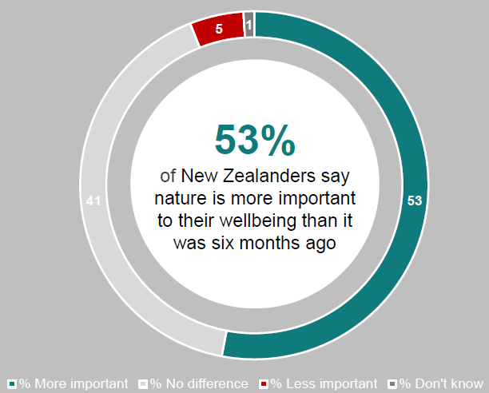

Source – Colmar Brunton & Ministry for the Environment, 2020

1. Rangiway, B (2018) Te Kaharoa – the eJournal on Indigenous Pacific Issues. Vol 11, 2018, ISSN1178-6035 <https://www.tekaharoa.com/index.php/tekaharoa/article/view/241/221>
2. ‘Help’ included counselling, talking with counsellor or therapist and/or taking medication/supplements.   
   ‘Busy’ included work such as cleaning/organising the house and distraction. ‘Other’ included to just carry on. ‘Nature’ included getting outside, spending time in nature/garden and going for a walk along the beach. ‘Exercise’ included exercise/being active, playing sport and riding a bike. ‘Hobbies’ included watching TV/Netflix/YouTube, reading and listening to music. ‘Self-care’ included getting plenty of sleep, praying or practicing spiritual beliefs, eating well/healthily, and mindfulness. ‘People’ included connecting with children/family/friends/neighbours. ‘Nothing’ included don’t know, don’t experience these feelings or don’t do anything.
3. Wellbeing included peace/calm, mental health, stress alleviation and relaxation. COVID-19/lockdown included appreciation and ability to get outdoors during lockdown, because of isolation. Nature included fresh air, connecting and/or appreciation with nature and/or surroundings, change of scenery, and weather. Time out included freedom, quiet and time out from daily life. Physical health included exercise and/or fitness and better for health. Social connection included spending time with family and connecting to people.
4. Coronavirus: Garden centres running out of vegetable seedlings as people rush to plant (March 2020) <https://www.stuff.co.nz/national/health/coronavirus/120486040/coronavirus-garden-centres-running-out-of-vegetable-seedlings-as-people-rush-to-plant>