
E toru tekau tau o ngā mahere whakahaere ā-hapū, ā-iwi:
He tirohanga whānui
Three decades of iwi and hapū management plans: An overview
Disclaimer
The information in this publication is, according to the Ministry for the Environment’s best efforts, accurate at the time of publication. The Ministry will make every reasonable effort to keep it current and accurate. However, users of this publication are advised that:
• The information does not alter the laws of New Zealand, other official guidelines, or requirements.
• It does not constitute legal advice, and users should take specific advice from qualified professionals before taking any action based on information in this publication.
• The Ministry does not accept any responsibility or liability whatsoever whether in contract, tort, equity, or otherwise for any action taken as a result of reading, or reliance placed on this publication because of having read any part, or all, of the information in this publication or for any error, or inadequacy, deficiency, flaw in, or omission from the information in this publication.
• All references to websites, organisations or people not within the Ministry are for convenience only and should not be taken as endorsement of those websites or information contained in those websites nor of organisations or people referred to.
Context and acknowledgements
The majority of this report was prepared for the Ministry of the Environment in 2022 by Planz Consultants, with input from a panel of resource management practitioners, assisted by central government staff. The panel comprised experienced practitioners from across Aotearoa New Zealand with specific expertise in developing and implementing iwi management plans, including Elva Conroy, Dyanna Jolly, Edward Ashby, Siani Walker, Rowena Cudby, Robert McLean and Andrew Brown. Further revisions to place the analysis within the existing context of the Resource Management Act 1991 and emerging topics were made by Ministry staff in 2022 and 2023.
Most importantly, we acknowledge the numerous kaitiaki, iwi, hapū and whānau who have contributed to the development of the iwi and hapū management plans referenced for this review. Your collective efforts to preserve and protect the mauri of our environment and people are recognised and appreciated.

This document may be cited as: Ministry for the Environment. 2024. Three decades of iwi and hapū management plans: An overview. Wellington: Ministry for the Environment.
Published in February 2024 by the
Ministry for the Environment
Manatū mō te Taiao
PO Box 10362, Wellington 6143, New Zealand
environment.govt.nz
ISBN: 978-1-991077-12-7 (online)
Publication number: ME 1721
© Crown copyright New Zealand 2024

Contents
Executive summary 8
How this report is organised 8
Common themes from the review of IHMPs 9
Key observations 9
Introduction 11
Purpose and scope of this report 11
Part One — What are IHMPs? 14
Characteristics of existing plans 15
Common IHMP structure and content 21
Te ao Māori content 36
Te ao Māori cultural values 42
Common IHMP content – environmental domains 60
Emerging content 99
Plan implementation and effectiveness 116
Part Two — Future considerations for iwi and hapū planning 126
Managed retreat 126
Environmental limits 126
Spatial planning 127
Cultural landscapes 130
Māori land and papakāinga 131
Mana Whakahono ā Rohe 132
Conclusion 133
References 134
Government reports 134
Other reports 134
Glossary 138

Tables
Table 1: Examples of terminology used for plan structure 22
Table 2: Examples of IHMP vision statements 39
Table 3: Papakāinga policy provisions taken from three different IHMPs. 84
Table 4: Example of infrastructure-related issues 90
Table 5: Wai-related policies in various plans associated with the issues in table 4 91
Table 6: References to both monitoring and compliance in a sample of IHMPs 119

Figures
Figure 1: Map of Mahaanui Iwi Management Plan takiwā (area) 17
Figure 2: Relationships between the Tauranga Moana Iwi Management Plan (2016–2026) and other plans and processes 20
Figure 3: The contents page of the Ngāti Hauā Environmental Management Plan in which the domains are those mostly commonly addressed by the IHMPs reviewed 23
Figure 4: Tauranga moana mātauranga-based policy framework of the Tauranga Moana Iwi Management Plan (2016–2026) 24
Figure 5: Structure of the Mahaanui Iwi Management Plan 2013 25
Figure 6: Map of marae in the area covered in the Waikato-Tainui Environmental Plan 2013 28
Figure 7: Map from the Ngati Umutahi Whenua Management Plan showing the pre-raupatu (land confiscation) boundaries 29
Figure 8: Map of from the Hineuru Iwi Trust Iwi Environmental Management Plan 2022 identifying the area of interest during a Treaty settlement process 30
Figure 9: Map of the Ngāti Hauā area of interest overlaid with council boundaries, from Te Rautaki Tāmata Ao Turoa o Hauā – Ngāti Hauā Environmental Management Plan 2018 31
Figure 10: A map from Tauranga Moana Iwi Management Plan (2016–2026) of the Tauranga Moana area of interest, indicating marae, land use, council boundaries and natural features 32
Figure 11: A map also taken from the Tauranga Moana Iwi Management Plan (2016–2026) showing catchment boundaries and contributing waterways 33
Figure 12: Map from the Mahaanui Iwi Management Plan 2013 34
Figure 13: A map taken from the Waitaki Iwi Management Plan 2019 showing areas of historical mahinga kai resources (ie, weka) 35
Figure 14: Te Whakapapa o Te Wai and guiding Te Arawa values 38
Figure 15: The framework of the Whaia Te Mahere Taiao a Hauraki Iwi Environmental Plan 2004’s vision 40
Figure 16: Vision, mission statement and strategic objectives from Whakamarohitia ngā wai o Waikato – Te Arawa River Iwi Trust Environmental Plan 2021 41
Figure 17: The cultural-values framework relevant to Patuharakeke Hapū, from Patuharakeke Hapū Environmental Management Plan 2014 43
Figure 18: The Ngāi Tamawharirua cultural-values framework, Ngāi Tamawharirua ki te Rereatukahia Marae Hapū Management Plan 2015 44
Figure 19: Te Arawa Te Whakapapa o te Wai Guiding values chart, from Te Tūāpapa o ngā wai o Te Arawa – Te Arawa Cultural Values Framework 2019 45
Figure 20: A graphic showing how guiding principles can aid in the implementation of cultural values, from Te Tūāpapa o ngā wai o Te Arawa – Te Arawa Cultural Values Framework 2019 45
Figure 21: The Hua Parakore values framework 46
Figure 22: Mauri as an overlapping indicator of economic, social, cultural and environmental wellbeing — from Tai Whenua, Tai Tangata, Tai Ao – Te Kotahitanga o Te Atiawa Taranaki Environmental Management Plan 2020 48
Figure 23: Mauri indicators using a freshwater-mahinga kai health index according to Te Ātiawa ki Whakarongotai — from Whakarongotai o te moana, Whakarongotai o te wā – Kaitiakitanga Plan for Te Ātiawa ki Whakarongotai 2019 48
Figure 24: An example of an objective addressing the mauri of water according to Ngāti Hine — from Ngā Tikanga mo te Taiao o Ngāti Hine – Ngāti Hine Iwi Environmental Management Plan 2008 49
Figure 25: Ngā Tikanga mo te Taiao o Ngāti Hine – Ngāti Hine Iwi Environmental Management Plan 2008 provides another example of an objective relating to the mauri of water, here supported by outcome statements 50
Figure 26: A goal relating to the mauri of inland and coastal waters and how to progress it — from Kahungunu ki Uta, Kahungunu ki Tai Marine and Freshwater Fisheries Strategic Plan mai Paritu ki Turakirae 2010 50
Figure 27: Example of a table format showing the connections between objectives, issues and policies — from Waitaki Iwi Management Plan 2019 51
Figure 28: A table clearly linking kaitiakitanga with objectives, policies and methods — from Te Mahere ā Rohe mō Ngāti Rangitihi – Ngāti Rangitihi Iwi Environmental Management Plan 2011 53
Figure 29: A table from Te Kāuru Taiao Strategy – Te Kāuru Eastern Manawatū River Hapū Collective 2016 relating kaitiakitanga to other key elements of the strategy 54
Figure 30: An example of a strategic goal and objective that connect tikanga with wellbeing outcomes —from Ki Uta, Ki Tai Ngā Puna Rau o Rangitīkei – Rangitīkei Catchment Strategy and Action Plan 2019 56
Figure 31: The Tauranga Moana Mātauranga Policy Framework — from Tauranga Moana Iwi Management Plan 2016–2026 59
Figure 32: The land-related Policy 23, with its associated actions, in the Tauranga Moana Iwi Management Plan (2016–2026) 62
Figure 33: A summary of whenua-related issues, and their associated objectives and policies from Te Whānau a Te Haraawaka Hapū Resource Management Plan 2017 63
Figure 34: The hapū environmental matrix for water — from Te Taiao o Te Whatuoranganuku – Ngāti Tamateatutahi – Ngāti Kawiti Hapū Environmental Management Plan 2015 67
Figure 35: Whakataukī from the beached marine mammals section of the Mahaanui Iwi Management Plan 2013 68
Figure 36: Example of a table format being used to present a coastal-use and development objective and its related policies in Te Rautau Te Rāhui Taketake — Ngāti Whakaue ki Maketu Hapū Management Plan 2018–2028 69
Figure 37: Example of how projects can be used to give effect to a coastal-use and development objective — from Te Rautau Te Rāhui Taketake — Ngāti Whakaue ki Maketu Hapū Management Plan (2018–2028) 70
Figure 38: Project 9, with its corresponding policies addressing climate change, from Tūhoromatanui – Ngā Pōtiki Environmental Plan (2019–2029) 75
Figure 39: Project 10 and its corresponding climate change policies, from Tūhoromatanui – Ngā Pōtiki Environmental Plan (2019–2029) 76
Figure 40: Mahinga kai species important to Te Ātiawa ki Whakarongotai — from Whakarongotai o te moana, Whakarongotai o te wā – Kaitiakitanga Plan for Te Ātiawa ki Whakarongotai 2019 79
Figure 41: Waimakariri Marae aspirations and priorities that relate to papakāinga, from Te Rautaki Tāmata Ao Turoa o Hauā: Ngāti Hauā Environmental Management Plan 2018. 84
Figure 42: Issues, objectives, policies and projects clearly set out in Te Rautau Te Rāhui Taketake – Ngāti Whakaue ki Maketu Hapū Management Plan (2018–2028) developed by Ngāti Hangarau 85
Figure 43: A unique Rural Marae Community Zone, as found in Te Koikoi Kararo – Ngāti Hangarau Hapū Management Plan 2021 87
Figure 44: Example of policy provisions for the development of whānau land in Te Koikoi Kararo – Ngāti Hangarau Hapū Management Plan 2021 (1/2) 87
Figure 45: Example of policies and actions for the development of whānau land in Te Koikoi Kararo – Ngāti Hangarau Hapū Management Plan 2021 (2/2) 88
Figure 46: An example of provisions, policy and umbrella objective regarding social infrastructure in the Ko Tā Maniapoto Mahere Taiao – Maniapoto Environmental Management Plan 2018 93
Figure 47: Example of an inward-facing policy regarding Te Mana o Te Wai — from Tūhoromatanui – Ngā Pōtiki Environmental Plan 2019–2029 101
Figure 48: A Te Mana o Te Wai objective, policy and associated actions relating to water quality – from Ko Tā Maniapoto Mahere Taiao – Maniapoto Environmental Management Plan 2018 102
Figure 49: Te Mana o Te Wai objective and supporting policies and methods in the Poipoia Te Ao Turoa – Ngāti Rārua Environmental Strategy 2021 103
Figure 50: Frequency of references to cultural landscapes in IHMPs containing the term 107
Figure 51: Policy 26.5 from the Tauranga Moana Iwi Management Plan 2016–2026, in which the plan authors call for Māori design inputs in public realm projects 112
Figure 52: Examples of renewable energy objectives and policy provisions from the Ngāti Ruanui Environmental Management Plan 2012 114
Figure 53: Methods from the renewable energy section of the Ngāti Ruanui Environmental Management Plan 2012 114
Figure 54: Geothermal energy provisions from Te Rautau Te Rāhui Taketake – Ngāti Whakaue ki Maketu Hapū Management Plan (2018–2028) 116
Figure 55: A graphic of the hapū engagement process, taken from Te Taiao o Te Whatuoranganuku – Ngāti Tamateatutahi – Ngāti Kawiti Hapū Environmental Management Plan 2015 117
Figure 56: The purpose of cultural monitoring set out in the Mahaanui Iwi Management Plan 2013 120
Figure 57: A policy from the Mahaanui Iwi Management Plan 2013 showing cultural monitoring as part of a suite of heritage management tools 121
Figure 58: A mātauranga-related policy that sets out cultural monitoring actions – from Ngāti Hauā Environmental Management Plan 2018 122
Figure 59: Actions in the Tapuika Environmental Management Plan 2014–2024 advocating for more opportunities for cultural monitoring 123
Figure 60: Kāi Tahu framework of cultural values for The Queenstown Lakes Spatial Plan 2021 128
Figure 61: Overview of the structure of the Queenstown Lakes Spatial Plan 2021 129

Executive summary
This review contributes to existing Ministry for the Environment (MfE) resources relating to the development and implementation of iwi and hapū management plans (IHMPs).
The Resource Management Act 1991 (RMA) has provided some recognition of iwi and hapū planning since its enactment. The status of planning documents that are recognised by an iwi authority was elevated from “have regard to” to “take into account” as a result of the Resource Management Amendment Act 2003. MfE produced guidance in 2000, and in 2004 commissioned a study on the use and perceived effectiveness of IHMPs. Over the last three decades iwi and hapū have developed and revised hundreds of IHMPs. MfE currently has records for 187 planning documents created primarily for use under the RMA by iwi, hapū and marae.
This research examines the IHMPs that MfE has on record to bring forward insights about what these documents include, how they are organised, and what some of the newer plans provide. It could be characterised as a retrospective, because the IHMPs examined were all published over the past 30 years, with the majority published in the last decade.

How this report is organised
Part one of the report identifies the results of analysis conducted on 97 of the IHMPs in MfE’s database. This includes both common and unique characteristics of existing plans such as structure, te ao Māori content, expressions of cultural values, environmental domains, emerging content and plan implementation and effectiveness. It uses thematic analysis derived from an examination using a combination NVivo analysis software and reading for qualitative understanding. Good examples from specific plans are drawn in and included to illustrate the observations made.
At the end of each section are some recommendations drawn from the analysis that could help future preparers of IHMPs, whether producing a new document, adding content or updating an existing section.
Part two of the report considers ongoing and emerging issues and opportunities in resource management that iwi and hapū writing or revising IHMPs may wish to consider. The section was informed by conversations with a group of experienced RMA practitioners working for iwi, IHMP preparers, and MfE policy advisors. Topics covered include the usefulness of identifying and defining cultural landscapes, addressing Māori land, housing and economic development, the increasing use of spatial planning by councils, the need to articulate rohe-relevant responses to climate change, and discussion of environmental limits. Opportunities to tie IHMP content to RMA participation tools (such as Mana Whakahono ā Rohe) and freshwater planning processes are also raised.
Though printing is clearly an option for the reader, this report is intended to be used as an electronic document, with links to source material throughout. It can be read from start to finish or out of order, using the “find” command on a computer to dive into specific topics of interest.

Common themes from the review of IHMPs
Iwi and hapū management plans vary in their function, the geographic area they cover and their content. However, three main types of plans are identified: place-based plans, resource-based plans and, more frequently in the last decade, values-based plans. Each type has its own value and benefit. Values-based plans tend to reflect a clear kaupapa-Māori approach.
Plans have been developed by both individual and collectives of iwi, hapū and marae. The sections common to most plans tend to be about establishing whakapapa connections and the statutory context; policy provisions related to features of interest; and engagement and implementation provisions. Natural domains covered in the IHMPs typically are whenua (land), wai (both freshwater and coastal), hau (air), ngahere (forest) and indigenous flora and fauna. Other priority issues include the management of cultural heritage, infrastructure, energy, tourism and natural resource extraction. Cultural values, such as taonga (treasured possessions), kaitiakitanga (guardianship), mauri (life force), whakapapa (genealogical relationships), rangatiratanga (chiefly authority), mātauranga (knowledge) and tikanga (protocol), are addressed extensively. Some plans adopt a kaupapa (theme)-Māori policy framework, whereas in others the framework is an overarching cultural values one.
The surveyed plans are heavily weighted towards recognition of environmental matters, although there is evidence of social, economic and cultural policy provisions as well. Plans produced more recently incorporate the concepts of Te Mana o te Wai, cultural landscapes, spatial planning and urban design, and renewable energy.

Key observations
Key observations include:
- Iwi and hapū typically develop IHMPs to influence the management of their natural resources but might also consider IHMPs as equally a medium in which to articulate their aspirations for cultural, economic and social wellbeing outcomes.
- As the role of spatial planning increases in resource management, there is an opportunity for iwi and hapū to use cultural landscapes to illustrate their history, taonga, contemporary interests and future aspirations in an interconnected and holistic way.
- It may be useful for iwi and hapū to include in IHMPs their rohe-relevant policy responses to Te Mana o te Wai, use of mātauranga in policy and planning, environmental limits and other overarching, system-wide concepts in resource management as they emerge.
- Iwi and hapū who have adopted value and policy frameworks that are informed by kaupapa Māori are creating a strong internal core for their taiao practitioners.
- The Crown should consider funding mechanisms that will help iwi and hapū build capacity to develop and manage the implementation of their IHMPs and engage with spatial planning processes as they arise in their rohe.
- Further research into the effectiveness of IHMPs, in partnership with iwi and hapū, is recommended to help preparers focus on the most impactful content.
- Further research could also identify existing practice and strategies for linking preparation of IHMPs with the negotiation of Mana Whakahono ā Rohe and the development of joint management agreements and/or transfers of RMA functions.

Introduction
The Resource Management Act 1991 (RMA) has provided some recognition of iwi and hapū planning since its enactment. The status of planning documents that are recognised by an iwi authority was elevated from “have regard to” to “take into account” as a result of the Resource Management Amendment Act 2003. The Ministry for the Environment (MfE) produced guidance in 2000, and in 2004 commissioned a study on the use and perceived effectiveness of IHMPs. Over the last three decades iwi and hapū have developed and revised hundreds of IHMPs. MfE currently has records for 187 planning documents created primarily for use under the RMA by iwi, hapū and marae.
This research examines the IHMPs that MfE has on record to bring forward insights about what these documents include, how they are organised, and what some of the newer plans provide. It could be characterised as a retrospective because the IHMPs examined were all published over the past 30 years, with the majority published in the last decade.
MfE has relationship agreements with several iwi that state that technical support will be provided for developing iwi and hapū management plans (IHMPs). This report has been developed to help provide this technical support and to guide future IHMP-related research.

Purpose and scope of this report
The research forming the basis of this report examined the following:
- trends and innovation
- good-practice examples of IHMPs (structure, layout, presentation, ease of use)
- plan content, including content beyond natural resources
- methods of recognising and protecting cultural landscapes, eg, mātauranga (knowledge), tikanga (protocols), customary practice
- effective and/or innovative plans dealing with different natural domains
- use of maps and spatial layers
- providing for intangible values (eg, ancestral or metaphysical associations)
- consultation and engagement
- aspirations for involvement in monitoring, compliance and enforcement
- climate change impacts and adaptation
- any other topics of note.
Consequently, various examples of IHMP content have been collated. The report also identifies potential opportunities for IHMPs to respond to recent national direction under the RMA and other emerging issues in environmental policy. The primary purpose of this review is to provide reference material for iwi and hapū who may be developing new or updating existing IHMPs. The information may also be of value to a wider range of policy and planning practitioners.
Alongside this report, a number of presentations were developed to provide technical support to iwi and hapū as they develop their IHMPs.
Note that analysing the effectiveness of IHMP content in terms of the plan’s objectives being achieved was not in the scope of this review.

Plan review methods
Information was processed several ways, including reading the plans (‘manual review’) and using ‘NVivo’, a software programme designed for qualitative and mixed methods research.
From the 170 documents collated, only 96 were suitable for analysis, primarily due to file duplication, or documents being appendices to other plan documents. In total, the review references 96 separate plans. Processing plan content yielded information on the frequency of the use of terms and selected themes, and produced charts and other visualisation outputs on topics such as word frequency and word hierarchy.
Sections in this report are organised by themes. Examples of each theme are illustrated by figures and their accompanying text, as well as excerpts. Each section concludes with key observations. While these observations mainly identify trends across IHMPs, some highlight the effectiveness of those trends. These observations and comments are based on the knowledge and experience of the reference group of resource management practitioners; they do not constitute official advice on best practice.

Engagement with resource management practitioners
Of eight practitioners identified as possible members of a reference group to provide insights into practitioner experiences, only six were available to participate at any one time. These practitioners represented a broad range of professional expertise gained through involvement with central and local government, iwi authorities, iwi and hapū environmental entities and Treaty-settlement governance entities, including as consultants and contractors for all the above.
Over 10 weeks, the practitioners took part in four online hui that focused on targeted topics. The practitioners’ skills and experience ranged from interacting with the resource management system, spatial planning and cultural landscapes, to developing and using IHMPs. Each hui was supported by Ministry staff from various teams. The practitioners provided contextual information relevant to their experiences, and reviewed and provided feedback on the draft report and four presentations.

Sources of information
IHMPs developed by tangata whenua are the main source of information for this report. Nearly 100 IHMPs authored between 1990 and 2022 taken from a Ministry for the Environment database were reviewed. A small selection of other management plans (eg, joint, co-management) were also reviewed. Other documents and plans such as iwi and hapū relationship agreements and Treaty settlements have not been reviewed.
The IHMPs use various dialects of te reo Māori, and some use macrons whereas others use the double-vowel approach. This report adopts the spelling conventions used by each plan and therefore it will contain variation in macron use and dialect.
Other sources of information included documents created by resource management practitioners, academics and central and local government. Literature from the Government, iwi organisations, planning consultants and planning submissions, and published academic work, also informed the review process and its outputs.
All reference material has been taken from publicly accessible sources.

Review limitations
There are two main limitations to the review. Firstly, budget constraints meant it was not possible to analyse each plan in depth or comprehensively, as some were over 300 pages long.
Secondly, and for a similar reason, only a limited number of examples could be presented for each theme. Consequently, some otherwise valid and insightful examples may not have been identified and discussed, although that does not mean they are of any less value to this kaupapa.
To address the limitations, a broad spectrum of examples is included, demonstrating how various plans uniquely address a particular theme. Thus, insights can be gained into how specific tangata whenua respond to various resource management matters in terms of IHMP format and presentation, and policy provision.

Part One — What are IHMPs?
Iwi and hapū management plans, IHMPs or sometimes IMPs, are planning documents prepared by tangata whenua that express their values, issues and aspirations for the sustainable management of the environment in their rohe (area). These plans also provide a framework for decision-making in the resource management system, although their scope often extends to include tangata whenua objectives for social, economic and cultural wellbeing. This latter approach is indicative of a holistic, tangata whenua worldview where the wellbeing of the environment is inseparable from the wellbeing of the people. The term ‘IHMP’ is commonly applied to a resource management plan prepared by one or a collective of iwi, an iwi authority, a post-settlement governance entity, rūnanga or hapū.
In the current RMA framework, IHMPs must be ‘taken into account.’ The RMA establishes three criteria for IHMPs to be taken into account when plans are being drawn up under that act. These are that they must be:
- recognised by an iwi authority
- relevant to the resource management issues of the region/district
- lodged with the relevant council(s).
There are varying perspectives on the function of IHMPs. Some iwi and hapū consider their main function is to build internal capacity and capability through the articulation of a collective vision of aspirations and objectives for iwi and hapū resource management needs. For others, the main purpose of IHMPs is to be integrated into the resource management planning system so as to best influence its decision-making, and these plans, therefore, often state expectations and principles for engagement. In such plans, the cultural elements may be far less pronounced. Other plans have taken a hybrid approach, adopting a planning framework that is based on kaupapa (themes) Māori and presenting it in such a way that facilitates effective cross-cultural communication between tangata whenua and decision-making organisations. Recognising this variety of methodologies helps to explain the diverse range of IHMPs that have been created over the last three decades.
Other reasons for the diversity across IHMPs include the fact many are clearly place-based, and that there are differences in the relationships between their creators and capacity available to develop them.
A 2004 report by KCSM Consultancy Solutions (KCSM) identifies three key features of effective IHMPs, including that they should:
- be structured for the target audience to help the audience understand and implement them
- reflect both a Māori worldview and be highly useable for councils and other parties to allow for Māori concepts and values to translate into technical plan provisions
- highlight the value tangata whenua add to resource management processes.
No known research has been undertaken to assess the ‘usability’ of plans for councils and the ability of Māori concepts and values to effectively translate into technical council plan provisions. KCSM’s 2004 report also identified nine essential elements of an IHMP. These are:
- Description of the iwi or hapū – who they are, for example, whakapapa, history.
- Purpose of the IMP – why it was prepared, who it is prepared for and what it is seeking to achieve, for example, environmental, social, cultural and economic goals.
- Rohe – the area being covered by the IMP.
- Issues the IMP seeks to address – for example, stormwater and sewage outfalls; environmental degradation; vegetation clearance; housing.
- Objective, policies and methods – statements identifying what outcomes are being sought by the IMP to address the issues and how this can be achieved; for example, by research; information gathering and monitoring resource consents.
- Participation – the circumstances when the iwi or hapū seek consultation with an agency, for example, a council or consent applicant, the process to be used, points of contact, and the information the iwi or hapū need to enable it to assess the agency’s proposal.
- Administration of the IMP – who is responsible for the IMP, for example, iwi authority; hapū authority; marae committee.
- Readability – the IMP is well structured and easy to understand.
- Review – how and when the IMP will be reviewed.
Many of these essential elements were present, to various extents, in the reviewed plans.

Characteristics of existing plans
Many of the plans were prepared by or on behalf of individual iwi or hapū. Some were written by a collective with shared and/or overlapping geographical areas and resource interests. Others were produced as a result of Treaty settlements. Pan-tribal plans were also evident. Examples include the Tauranga Moana Iwi Management Plan (2016–2026) and the Whakamarohitia ngā wai o Waikato: Te Arawa River Iwi Trust – Environmental Management Plan 2021, each prepared by a collective of three iwi, and Te Tūāpapa o ngā wai o Te Arawa — Te Arawa Cultural Values Framework 2019, prepared by over 50 hapū and iwi. Plans developed by tangata whenua on behalf of marae, such as the Mōtakotako Marae Hapu Management Plan, are less common.
Other plans, such as the Whaka-Ora Healthy Harbour Catchment Management Plan 2018, have been co-developed by territorial authorities, iwi and other external stakeholders. Technically, these plans are not representative of an IHMP given the role of other parties in their development. However, such plans may be influenced by IHMPs and therefore are included for comparative purposes.

Plans prepared by iwi collectives
The Rangitīkei Catchment Strategy and Action Plan 2019 was prepared by Ngā Puna Rau o Rangitīkei, a collective of hapū and iwi who have a connection to the Rangitīkei Awa (River) and catchment, from its source to the sea. The iwi and hapū who committed to supporting the plan are:
- Ngāti Apa
- Ngāti Tamakōpiri
- Ngāti Whitikaupeka
- Ngāi Te Ohuake (including Ngāti Hinemanu and Ngāti Paki)
- Ngāti Tauira and/or Ngāti Kauae
- Ngāti Hauiti.
This strategy focuses on a single catchment in the Manawatū-Wanganui Region, under the jurisdiction of the Horizons Regional Council. An introductory paragraph details the document’s purpose:
Ngā Puna Rau o Rangitīkei (NPRR) has developed this Catchment Strategy and Action Plan ... to provide a clear picture of how we want to see the health and wellbeing of the Awa and its tributaries, and the work programme we think will result in restoration of the health of Awa and its catchment. We want the health and wellbeing of the Awa to be restored. We expect this to require a different type of conversation and approach to the balance of activity occurring across the Awa, and how the impacts of those activities will be managed.
Another example is the 2013 Mahaanui Iwi Management Plan, prepared by a working group of one or two representatives from each of six rūnanga who retain mana whenua (authority of customary rights) from the Hurunui River to the Hakatere River and inland to the Southern Alps Ka Tiritiri o Te Moana (see figure 1). The collective consisted of:
- Ngāi Tūāhuriri Rūnanga
- Te Hapū o Ngāti Wheke (Rāpaki)
- Te Rūnanga o Koukourārata
- Ōnuku Rūnanga
- Wairewa Rūnanga
- Te Taumutu Rūnanga.
Figure 1: Map of Mahaanui Iwi Management Plan takiwā (area)
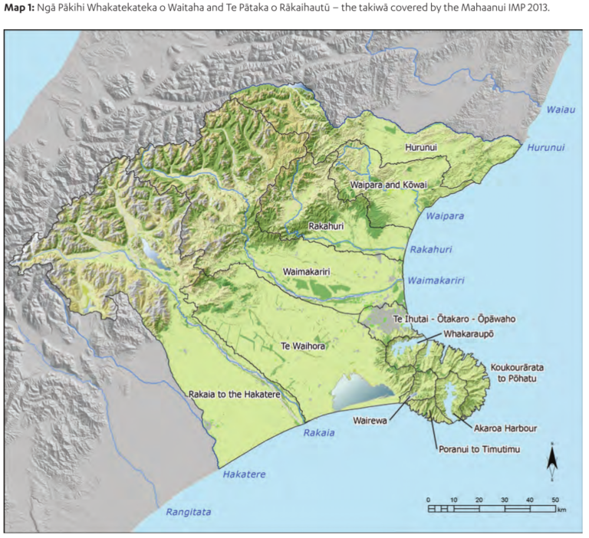
The plan is described as:
an expression of kaitiakitanga and rangatiratanga. It is a manawhenua planning document … [that] provides a values-based, plain language policy framework for the protection and enhancement of Ngāi Tahu values, and for achieving outcomes that provide for the relationship of Ngāi Tahu with natural resources across Ngā Pākihi Whakatekateka o Waitaha and Te Pātaka o Rākaihautū.
The plan is lodged with Canterbury Regional Council and five district councils, demonstrating its geographical extent.
The Central North Island Forests Iwi Collective (CNIF) developed the He Mahere Putahitanga: A pan-tribal iwi planning document to outline the collective’s aspirations for their Treaty settlement lands. The document is a ‘living, working’ document that is modular in character, allowing for flexibility and ease of future updates. The iwi collective comprises:
- Ngāi Tuhoe
- Ngāti Tūwharetoa
- Ngāti Whare
- Ngāti Manawa
- Ngāti Rangitihi
- Ngāti Raukawa
- affiliated Te Arawa iwi and hapū.
The Treaty settlement lands subject to the plan relate to 176,000 hectares of land in the Central North Island that were “historically confiscated or acquired by the Crown through illegal means.” The purpose of the plan is:
to outline our collective aspirations for our Treaty Settlement Lands. We want to reconnect, restore balance and find better ways to live with the land – for ourselves and our tamariki and mokopuna. Therefore, we want to ensure that:
- we are visible; we are heard; and we are influential;
- our relationship with our Treaty settlement lands is recognised.
- we collectively have fair access to development opportunities for our land in a way that promotes sustainable management (eg, land use that reflects land use capability).
The plan is lodged with four regional councils and six district councils, demonstrating its geographical extent.
Te Tūāpapa o ngā wai o Te Arawa — Te Arawa Cultural Values Framework 2019 is an award-winning, values-based plan representing the interests of Te Arawa Lakes Trust (TALT) and over 50 iwi and hapū. The plan articulates the values of TALT as they relate to the collective’s long-term aspirations for Te Arawa Lakes. The values are noted to be intrinsic, and as such they “recognise our inalienable relationship with the lakes, rivers, streams, groundwater aquifers and geothermal resources.”
Objectives of the framework are detailed as being to:
- ensure the Te Arawa lakes are managed and restored in a manner consistent with Te Arawa values
- effect positive change in relation to the Te Arawa lakes – environmentally, socially, culturally and economically
- show leadership in relation to the Te Arawa lakes for intergenerational benefit
- improve awareness and knowledge about the traditional relationship of Te Arawa with the lakes.
The framework is lodged with the Rotorua Lakes Council and the Bay of Plenty Regional Council.
The Tauranga Moana Iwi Management Plan (2016–2026) is a pan-tribal plan developed on behalf of Ngāti Ranginui, Ngāi Te Rangi and Ngāti Pūkenga “as it relates to Tauranga Moana: Te Awanui (Tauranga Harbour), surrounding lands and waters including the ocean.”
The purpose of the plan is:
to articulate the collective vision and aspirations of Ngāti Ranginui, Ngāi Te Rangi and Ngāti Pūkenga, in relation to Tauranga Moana. It is an environmentally focused plan with formal recognition under the Resource Management Act and includes priority issues, outcomes and actions for the next ten years (2016–2026).
Five core elements provide a structure for the policy framework, which in balance, represent a healthy Tauranga Moana:
- Tūhauora Tinana – Healthy Waters
- Tūhauora Whenua – Healthy Land
- Tūhauora Wairua – Cultural Heritage
- Tūhauora Whānau – Our people and relationships
- Tūhauora Hinengaro – Knowledge.
Supporting objectives include that the plan:
- presents a new pathway, a proactive approach to support Tauranga Moana iwi and hapū at all levels within environmental management
- seeks to inspire greater collaboration now, in advance of Treaty settlements and freshwater reforms
- seeks to influence positive change and highlight that we have a greater role to play in restoring the health and wellbeing of Tauranga Moana.
Figure 2: Relationships between the Tauranga Moana Iwi Management Plan (2016–2026) and other plans and processes
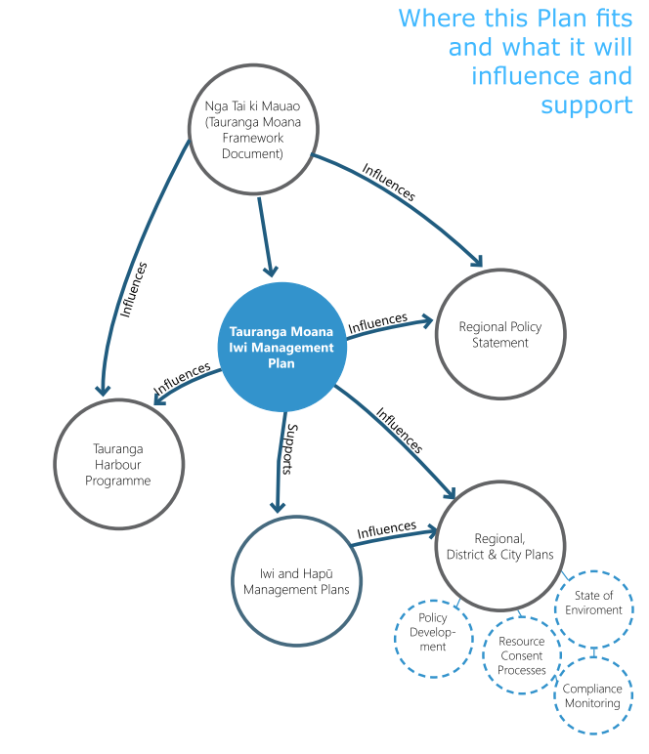
Figure 2 illustrates the relationships between the plan and other statutory and non-statutory documents and processes. The plan is lodged with the Bay of Plenty Regional Council and the Tauranga City Council.

Tangata whenua collaboration on other plans
The following two plans are examples of collaborative plans developed by iwi or hapū and external parties such as the Department of Conservation, territorial authorities and other infrastructure-based entities. They demonstrate how IHMPs can be leveraged to inform other statutory and non-statutory mechanisms and processes, as a result of Treaty settlements, joint management or co-management.
The Whaka-Ora Healthy Harbour Catchment Management Plan 2018 was developed by five entities, including:
- Te Hapū o Ngāti Wheke
- Te Rūnanga o Ngāi Tahu
- Lyttelton Port Company Limited
- Canterbury Regional Council
- Christchurch City Council.
The purpose of the plan is detailed in the following passage:
… [the plan] sets out a way forward for all of us as a community to ensure that the ecological and cultural health of Whakaraupō/Lyttelton Harbour as mahinga kai is restored for us and our children after us. The key purpose of this plan is to ensure that Whakaraupō/Lyttelton Harbour is a healthy, abundant, and interconnected environment for people to practice mahinga kai – however that may look to them.
The second example of a plan that involves tangata whenua and external agencies is Te Waihora Joint Management Plan: Mahere Tukutahi o Te Waihora, 2005. This was the first statutory joint land-management plan between the Crown and iwi, resulting from the settlement of Ngāi Tahu claims against the Crown. It was prepared by Te Rūnanga o Ngāi Tahu with advice from Te Waihora Management Board (local papatipu rūnanga representatives) and the Canterbury Conservancy of the Department of Conservation. The plan is effective for 10 years, or for an extended period as agreed by Te Runanga o Ngai Tahu and the Minister of Conservation.
Long-term objectives and detailed policies and methods provide for effective integrated management of the Joint Management Plan Area, including the natural and historic resources in the area. The plan represents a coming together of the rangatiratanga of Ngāi Tahu and the kāwanatanga (governorship) of the Crown for the enhancement and protection of this taonga.
Observations – plan owners
Some IHMPs are pan-tribal, although most plans represent the interests of individual iwi and hapū. One of the referenced plans was prepared on behalf of a marae collective.
Such collective IHMPs tend to be based on a catchment or defined Treaty settlement boundaries, and they address a resource of importance to iwi or hapū, that is, awa, whenua (land) and moana (coastal environments).
IHMPs and the processes to develop them can inform other types of management plans like joint management and co-management plans.

Common IHMP structure and content
The plans serve different functions for different owners. One role is as a guiding document for empowering iwi, hapū and their kaitiaki (guardians) to manage their taonga and transfer intergenerational knowledge. Another role is more pragmatic, being to inform and guide councils, resource users and the wider community in their interactions with iwi and hapū in matters of resource management. Often IHMPs serve a combination of these functions. Whatever the proposed purpose, the plans generally have similar formats and structures when it comes to content, including policy responses to resource management issues.
Typically, plans establish whakapapa associations between the people, the place and the resources early in the document, and then identify and detail the issues and aspirations for the natural, cultural social and/or economic resources of importance. Generally, the plans include the identification of issues, objectives, policies and methods. Given the environmental focus of most plans, this structure can improve the communication of a plan’s content and the ease with which its guidance is implemented. Te reo Māori terms were often used as alternative terms, as shown in table 1.
Table 1: Examples of terminology used for plan structure
Terms used | Alternative terms
Issue | Kaupapa
Objectives | Outcome, desired outcome, overarching goal, central goal, whainga (objectives)
Policies | Tikanga
Methods | Actions, action plans
Identifying and describing the issues clearly, from an iwi and hapū perspective, can establish their wider context, including the cause and scope of a problem. Clear description of an issue also provides insights into the underlying reasons for the plan provisions. The issues section is where iwi and hapū can present an issue in terms that are important and relevant to themselves as kaitiaki.
Objectives can be understood as outcome-focused statements of a preferred future state or as aspirations for a particular area or resource. Objectives, desired outcomes and goals encountered in the IHMPs varied widely in their focus, and geographic and time scales, although many tended to focus on the integrity and wellbeing of the environment and future generations. The objectives stated in the plans are a critical feature, and as discussed in Part Two, the identification and communication of iwi and hapū objectives is of fundamental importance to successful iwi participation in the resource management system.
Policies provide direction or signal a pathway to achieve an objective, and are statements of an intended action that, ideally, is allocated to a responsible party. Policies are implemented by methods, and method sections ideally state specific and clear actions. A wide range of methods and actions is specified in the plans, with some differentiating between actions to be undertaken by iwi and hapū and those to be adopted by councils and other relevant parties.
When applied to district and regional plans, this structure is recognised as making ‘plans shorter, less complex and easier to read.’ The structure could serve IHMPs well as arguably there are benefits in adopting a familiar structure when it comes to resource management decision-making. However, a potential trade-off would be the ability for iwi and hapū to express their rangatiratanga through a kaupapa-Māori approach.

Examples of IHMP domains and content
Although there are variations, whenua, wai, hau and moana tend to be the most common domains. Yet how these domains are addressed is wide ranging, from a specific focus on a resource itself, to categorising the plan and domains topographically, to representations of atua Māori, to structuring the plan and domains ecologically. Below are examples of the most typical content and plan structures.
The contents page of Te Rautaki Tāmata Ao Turoa o Hauā – Ngāti Hauā Environmental Management Plan 2018 shows the most common environmental domains that are included in plans (figure 3). Content pages also reveal the structure and scope of IHMPs.
Figure 3: The contents page of the Ngāti Hauā Environmental Management Plan in which the domains are those mostly commonly addressed by the IHMPs reviewed
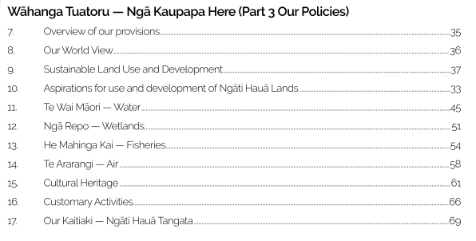
Figure 4: Tauranga moana mātauranga-based policy framework of the Tauranga Moana Iwi Management Plan (2016–2026)
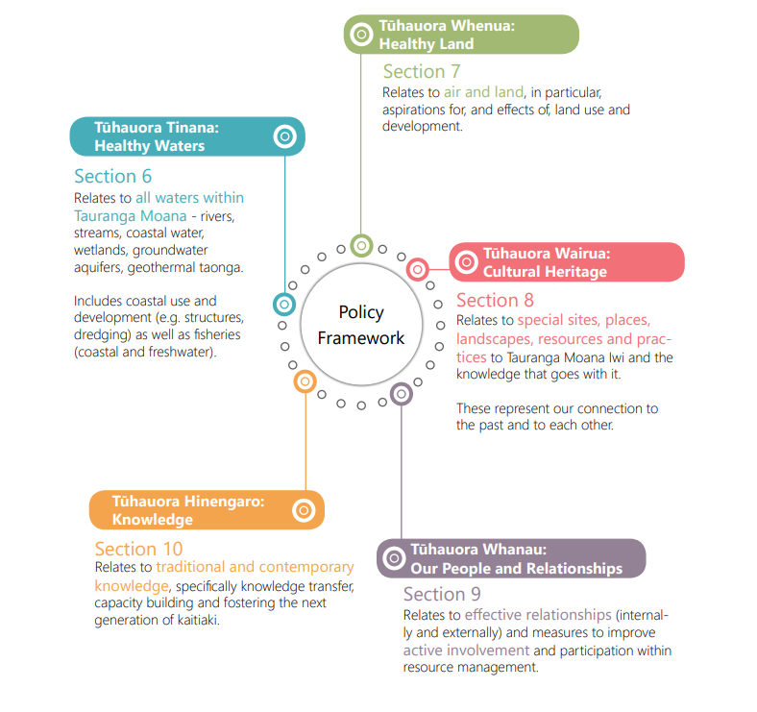
The Tauranga Moana Iwi Management Plan (2016–2026) is another example that contains the most commonly addressed domains of the natural environment. However, it uniquely adopts a mātauranga-based policy framework. This allows Tauranga Moana iwi to “articulate and organise resource management planning concepts and tools (eg, policy) – as they relate to the health and wellbeing of Tauranga moana – with a Māori lens.” The plan focuses heavily on two main domains: “Tūhauora Tinana – Healthy Waters”, and “Tūhauora Whenua – Healthy Land”. However, cultural heritage, “Our People and Relationships” and knowledge also have dedicated sections in the plan. Tūhauora Tinana details provisions for all waters in the rohe, including freshwater, groundwater, geothermal water, wetlands, coastal waters and fisheries taonga. Tūhauora Whenua relates to both air and land, and focuses specifically on two main matters: the effects of land use and development, and iwi aspirations for land use and development. This plan effectively communicates its content, including responses to some of the more common issues in the key domains. Yet the adoption of a policy framework that is based on the mātauranga of Tauranga Moana sets it apart from a large proportion of the plans. Adopting cultural values frameworks, that are mātauranga based, is discussed below.
Another example of a well-structured plan is the Mahaanui Iwi Management Plan 2013. Each domain is addressed through adopting a broad, general policy for the whole takiwā, and issue-specific policy for each sub-region. Again, similar to many other plans, the main domains covered are air, water, land, forests and coast. However, unlike most of the plans analysed, this plan also deals with offshore domains, with specific policies related to the seabed, and offshore exploration and mining. Figure 5 shows the structure of this plan. The plan establishes Ngāi Tahu manawhenua over the takiwā, and how the regional scale issues are categorised by atua (deities) Māori; while localised matters are categorised by catchment. Again, place-based mātauranga, this time in terms of atua Māori and ancestral landscapes, informs the structure and content of this plan.
Figure 5: Structure of the Mahaanui Iwi Management Plan 2013
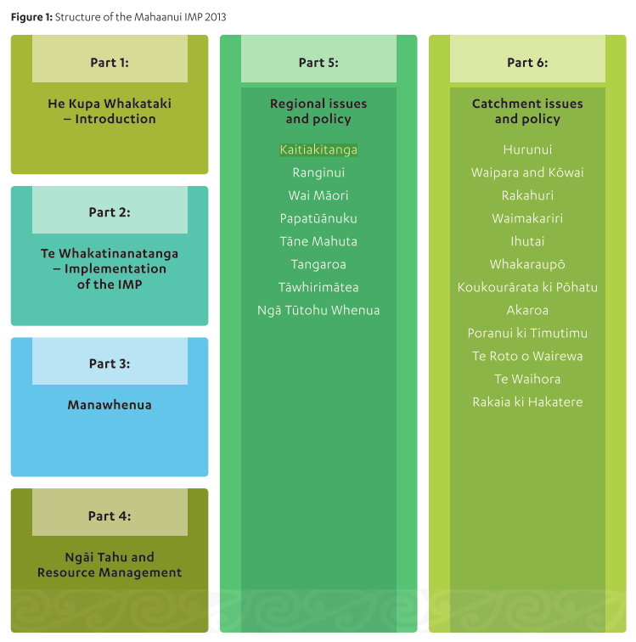
A final example with a unique approach to plan structure is the Ngāti Rangi Taiao Management Plan 2014, which draws upon Ngāti Rangi whakapapa to form a kaupapa-Māori “Te Hanga Whare” or “house-building” framework for the plan.
The framework of our Taiao Management Plan is based on the structure of a whare [house or building]. The utilisation of the whare to structure the plan is likened to our eponymous ancestor Paerangi-i-te-Whare-Toka and his House of Stone. Using this analogy allows Ngāti Rangi to have a strong conceptual base to develop our Taiao Management Plan.
This framework allows non-uri [non-relatives] to gain a thorough understanding of Ngāti Rangi. The plan offers an invitation for people to enter the house of Ngāti Rangi, to view our tikanga and to understand our thoughts, viewpoints and responsibilities. For our own uri, it is an articulation of who we are as descendants of the House of Stone.
The plan is divided into five sections that emulate the different structural components of a whare as follows:
- Section 1 is te roro whare – the verandah. The function of this section “is likened to a kuia [female elder] and her role as the reo pōwhiri (or welcoming voice) for all manuhiri [visitors] who enter the whare. The kuia sets the foundations for a pōwhiri. It therefore sets the scene for the plan by addressing the outline, purpose, overall vision and desired outcomes.”
- Section 2 is te tatau – the entranceway. This section introduces plan users to Ngāti Rangi as it “depicts who we are, and the values and guiding principles we hold to. Again, for us as uri, it reaffirms who we are and what we believe.”
- Section 3 is ngā pou o te whare – the pillars of the house. This section contains the central, structural elements of the plan, as described below:
The pou of the whare ... are structurally important as the key element in the stability and support of a sound building. Without these pillars the whare will crumble. For this document, our pou are the atua. Ngāti Rangi have decided to utilise the atua to formulate our perspectives on issues relating to Ngāti Rangi and the care and management of the taiao within our tribal boundaries…
Under each pou, our issues, objectives, policies and rules have been outlined. Where possible, rules have been developed for all issues under each pou.
- Section 4 is the rafters – ngā heke kōrero, an inward-facing section that acts as a guide for hapū and whānau members in the process of making submissions on issues of interest.
- Section 5 is te pani kōkōwai – the final touches. Like paint or varnish finally applied to a building’s exterior, this section closes the plan, providing concluding comments. The final touches are necessary to “ensure the structure is protected from deterioration.” This statement conveys the notion that protection of the people and the environment, as required for a whare too, requires a future focus and ongoing efforts by a collective.
Observations – example plan structures
Several plans adopt a kaupapa-Māori structure to their IHMP documents.
These plans included concepts drawn from atua Māori, tūpuna (ancestors) and other expressions of whakapapa, such as the whakapapa of wai.
IHMPs are not required to fit a western planning-world structure and, therefore, these values-based plans are a good representation of a kaupapa-Māori approach and an expression of rangatiratanga.
A modular approach to plan structure provides flexibility, particularly for incorporating updates to policy provisions and introducing new issues.
A values-based plan supports iwi and hapū to express their desired outcomes, their own approach, and how they operate. It also anchors iwi and hapū to their whakapapa, whenua and rawa taiao (natural resources), that is, connections in te ao Māori (Māori worldview). The Ngāti Rangi plan, using the whare analogy, reflects this well. It gives the reader an awareness of their approach, of the cultural importance of the wharenui and the role that each of its components play.
If developing or updating an IHMP, iwi and hapū should consider if a values-based plan structure and kaupapa-Māori policy framework can articulate their aspirations and communicate their worldview better than a conventional structure.

Examples of maps and mapping content
Plans typically use maps as part of their core structure, with almost 80 per cent of IHMPs including maps of some sort. They range from copies of Māori land plans, topographical maps, geological maps, territory maps, terrestrial and marine zone maps, to catchment and groundwater maps (see figures 6–13 for examples).
Figure 6: Map of marae in the area covered in the Waikato-Tainui Environmental Plan 2013
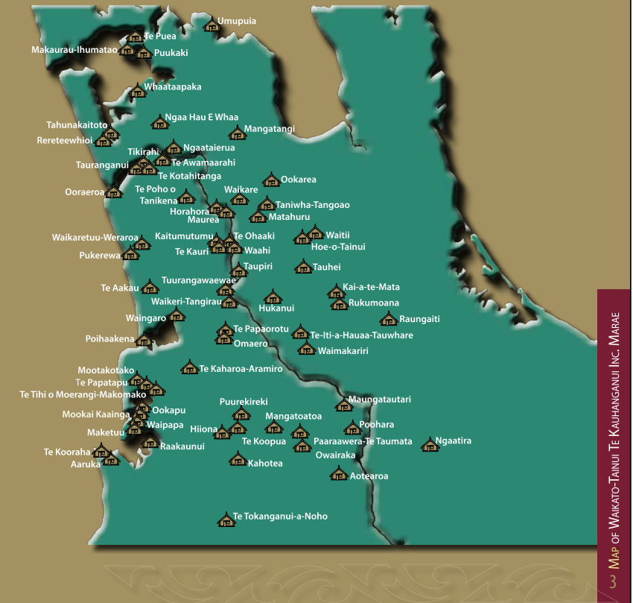
Figure 7: Map from the Ngati Umutahi Whenua Management Plan showing the pre-raupatu (land confiscation) boundaries
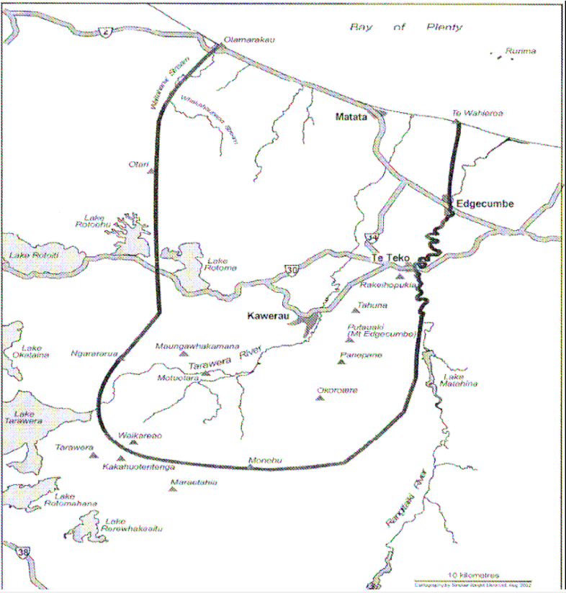
When combined with contemporary boundary maps and associated data, the type of map shown in figure 7 helps establish whakapapa and historical connections to a geographic location but can also reinforce (and perhaps introduce) the extent of land loss and change endured by many iwi, hapū and whānau during the last two centuries.
Figure 8: Map of from the Hineuru Iwi Trust Iwi Environmental Management Plan 2022 identifying the area of interest during a Treaty settlement process
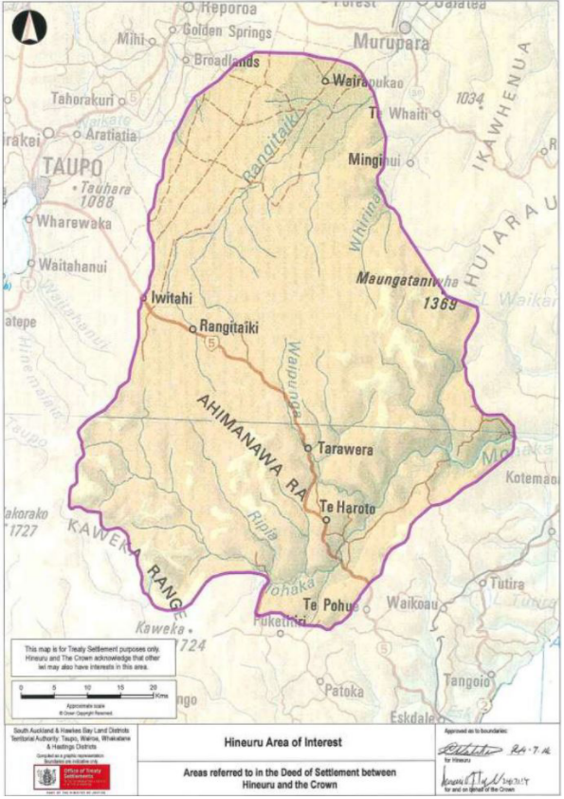
Such contextual information as shown in figure 8 can be of value for decision-makers because it highlights potential interests that may be subject to other statutory processes beyond the RMA, for example.
Figure 9: Map of the Ngāti Hauā area of interest overlaid with council boundaries, from Te Rautaki Tāmata Ao Turoa o Hauā – Ngāti Hauā Environmental Management Plan 2018
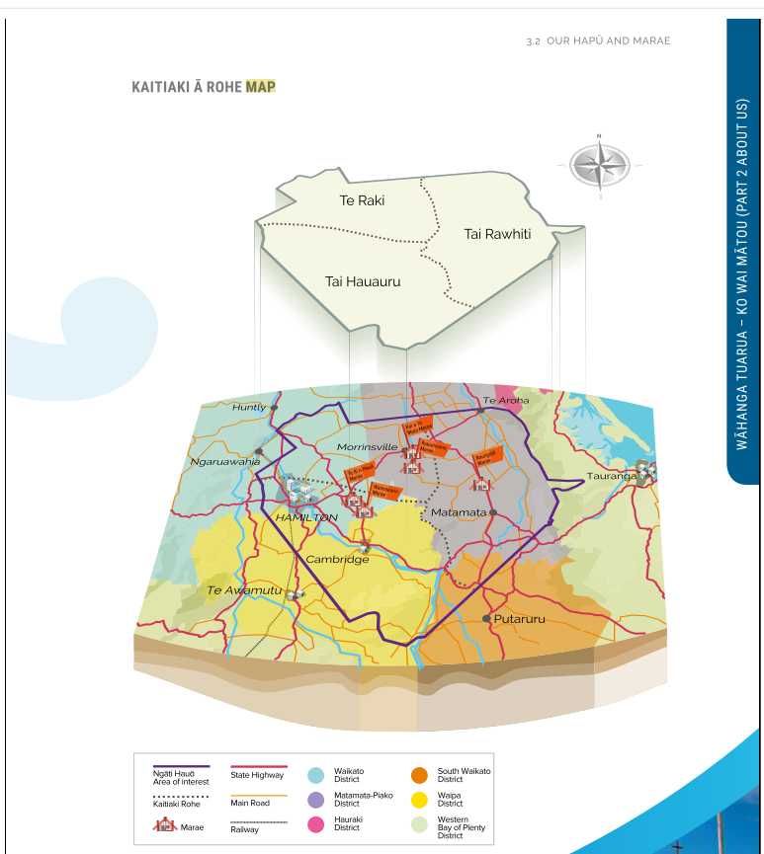
Maps like figure 9 present cultural, regulatory and institutional boundaries, and major waterways and transportation routes in a succinct manner.
Figure 10: A map from Tauranga Moana Iwi Management Plan (2016–2026) of the Tauranga Moana area of interest, indicating marae, land use, council boundaries and natural features
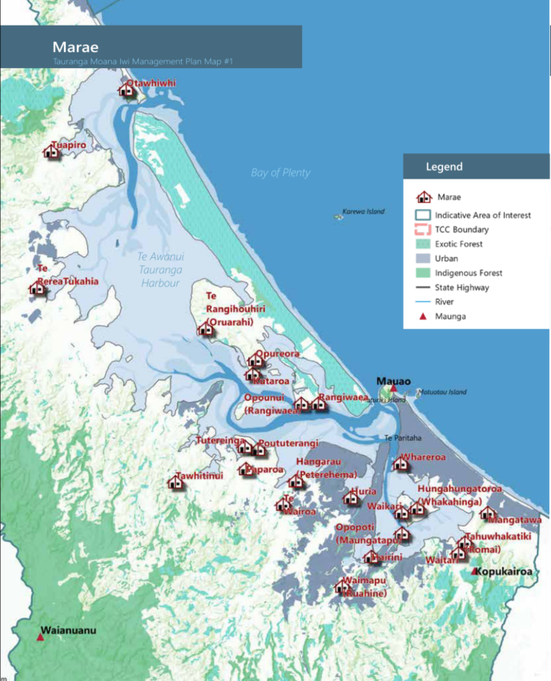
Figure 11: A map also taken from the Tauranga Moana Iwi Management Plan (2016–2026) showing catchment boundaries and contributing waterways
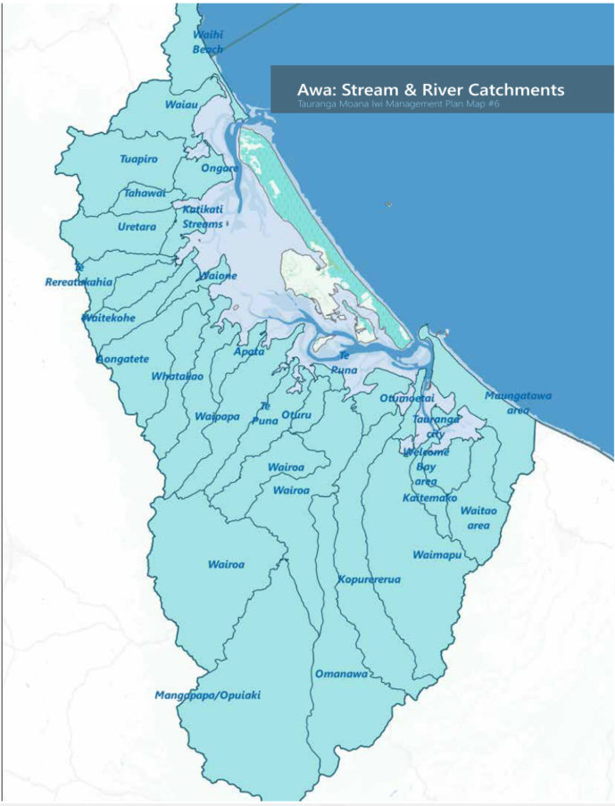
Figures 10 and 11 demonstrate the potential of Geographic Information Systems (GIS) to provide different layers of information (eg, locations of natural resources and values, rights and interests).
Figure 12: Map from the Mahaanui Iwi Management Plan 2013
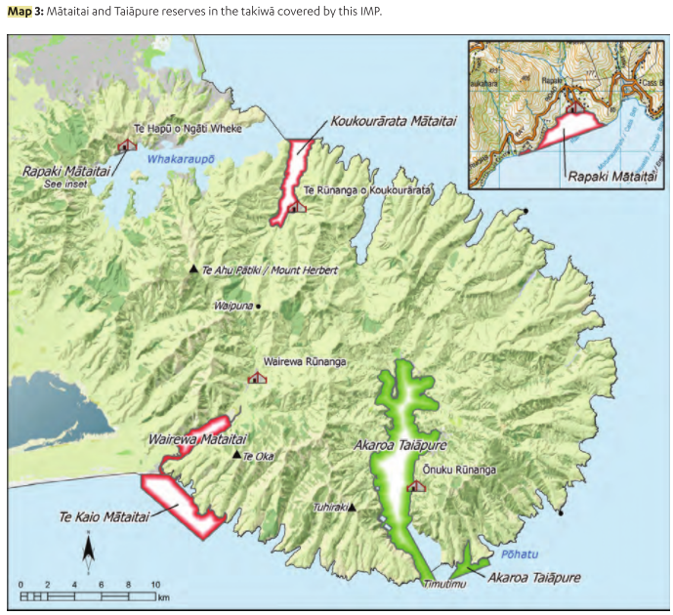
Some maps, such as figure 12, are used to show alternative resource management mechanisms like mātaitai and taiāpure (seafood-gathering areas). Such mechanisms sit outside the RMA but they refer to areas of tribal and hapū interest that need identification and protection, beyond the statutory provisions identified in the primary statute.
Figure 13: A map taken from the Waitaki Iwi Management Plan 2019 showing areas of historical mahinga kai resources (ie, weka)
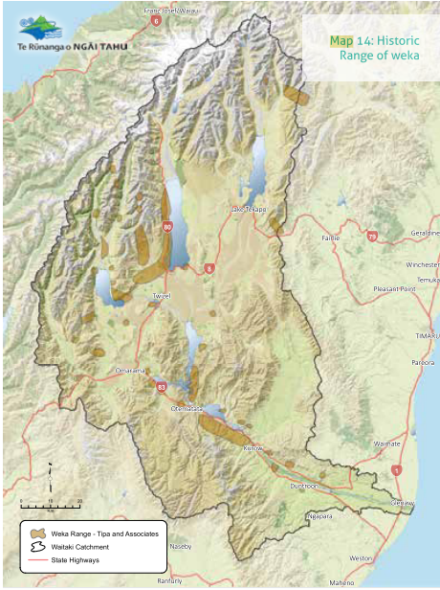
By including areas of historical mahinga kai resources, maps like figure 13 communicate historical and contemporary associations (for planning and decision-making), as well as identifying cultural associations (to enhance cultural identity).
Observations – mapping
Including maps is common in plans although the characteristics of the mapped features, the presentation and level of detail vary widely.
Maps can identify the cultural, environmental, social and economic interests of iwi and hapū and, therefore, can communicate desired wellbeing outcomes.
That maps can represent iwi and hapū interests makes them valued resources and that value will likely increase with the growing emphasis on spatial-based planning in the future.
Maps are a very helpful tool for depicting takiwā and/or rohe, and marae, locations. The mapping of resources found on or in the whenua, awa and moana results in ‘lines’ and ‘boxes’ being drawn on a map. Planning processes require this degree of specificity. However, the drawing of lines on maps should also be supported by policies and/or tikanga that require tangata whenua to interpret the mapped resources. Map makers are therefore obliged to engage with iwi and hapū to understand the kōrero (narrative) associated with the resource(s) in question, as well as the extent of the resource(s). That is to say, the significance of the resource and its mapping go beyond any lines drawn. In fact, the lines are drawn to initiate a conversation; they are not promoting a definite ‘in the box’ and ‘outside the box’ perspective. Resource management practitioners need to understand that a te ao Māori approach to mapping is not necessarily the same as a western approach.
Iwi and hapū should consider developing their internal capability and capacity to produce mapping resources. It is important to consider iwi or hapū levels of comfort with taonga being identified and mapped, and having this information in the public realm. Data governance requirements should be defined.

Te ao Māori content
This review identified that vision statements, guiding principles and cultural-values frameworks were commonly adopted in IHMPs. While these elements may not be essential, they provide insights into te ao Māori for plan users and they communicate cultural concepts of importance to the tangata whenua of a rohe. Examples of these vision statements, guiding principles and cultural-values frameworks are discussed below.

Establishing whakapapa
The KCSM report of 2004 states that effective plans need to identify the parties for whom the plan is prepared. Approaches ranged from simple descriptive statements to dedicated sections containing whakapapa charts reaching back to the atua Māori with supporting pūrakau (narratives) connecting the people to their rohe as mana whenua. A small selection of these plans is described below.
One approach taken in Te Kahukura a Ngāti Korokoro, Ngāti Wharara me Te Poukā: The Ngā Hapū o Te Wahapū o Te Hokianga nui a Kupe Hapu Management Plan 2008 includes a discrete “Hapū Whakapapa” section that begins with the statement that “The Hapū whakapapa is a chain of some 32 links back to the first ancestor Kupe, the first footprints in the sand at Te Pouahi, those generations ago.” The plan includes two supporting pages of whakapapa charts that establish the ancestral connections of the hapū to their takiwā.
Te Rautaki Taiao a Raukawa – Raukawa Environmental Management Plan 2015 acknowledges the whakapapa of the iwi in a chapter that presents the whakapapa of “Raukawa the Ancestor.” Alongside a whakapapa chart that connects Raukawa to the Tainui and Takitimu waka is a summary of the hikoi (journey) of the mother of Raukawa, Māhinaarangi, and the naming of the landscape in remembrance of this hikoi. A couple of supporting maps show the route of her journey and the ancestral names embedded in the landscape in remembrance. Of note is the statement that the function of the plan is not to reproduce the history of Raukawa in full, but that:
… it is important to deliver a short summary of this kōrero to provide some insight into the Raukawa iwi and our takiwā. It is also significant that embedded within our stories, memories, and geographies are roadmaps for the expression and practice of values and tikanga for both the present and the future.
A further example is the Mahaanui Iwi Management Plan 2013, which details the whakapapa of the six rūnanga under a section titled “Manawhenua”. The chapter provides a brief introduction to the marae, history and takiwā of each of the six rūnanga, and is complemented by a map identifying the location of their six marae.
As described earlier, Te Tūāpapa o ngā wai o Te Arawa — Te Arawa Cultural Values Framework 2019 is a values-based policy statement for the management of Te Arawa lakes, rivers, streams, tributaries, puna (freshwater spring) and surrounding land, as opposed to a more generalised statement for the takiwā or rohe as a whole. This acknowledges the role and mandate of Te Arawa Trust as owners and hunga tiaki (collective of kaitiaki) of 14 lakes in the Rotorua district. Figure 14 shows the plan’s unique approach – it defines the whakapapa of te wai, which also serves as the overarching Te Arawa values that are used to inform decision-making.
Figure 14: Te Whakapapa o Te Wai and guiding Te Arawa values
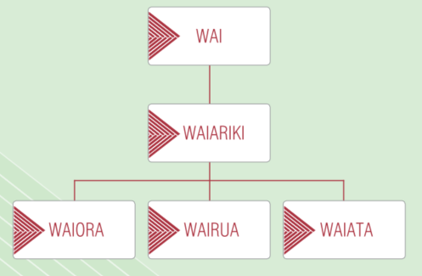
Identifying whakapapa connections to an area or resource is a significant component of IHMP. Doing so helps convey the depth of association of mana whenua to their takiwā, and the surrounding resources and landscapes. It can help bring a deeper level of understanding to support the transfer of intergenerational knowledge and help plan users and decision-makers to comprehend tangata whenua identity and their connection to their taonga.

Purpose – vision statement
A further component of effective plans is also clearly identifying their purpose and supporting visions. Vision statements (ngā wawata) were used extensively throughout the reviewed plans, with the visions often conveyed in te reo Māori terms and via frameworks based on kaupapa-Māori values. Vision statements appear to enable iwi and hapū to express their cultural identity, whakapapa, mātauranga, whakataukī (proverb) and other cultural values. They commonly incorporate powerful proclamations that reflect the obligations of Te Tiriti o Waitangi, and assert aspirations for sovereignty and/or rangatiratanga and/or self-determination and healthy environments for future generations. Table 2 provides examples of vision statements extracted from a selection of IHMPs.
Table 2: Examples of IHMP vision statements
IHMP | Vision statement
Ngati Porou ki Hauraki Plan 2015 | The return of the Tohora.
Ngā Tikanga mo te Taiao o Ngāti Hine Plan 2008 | “Ma Ngāti Hine ano Ngāti Hine e kōrero ma roto i te whanaungatanga me te kotahitanga –Self-determination through kinship and unity.”  “By this we mean that we will:  - decide what is important for ourselves  - be united and organised  - speak with one voice  - practice “te tu o Ngati Hine”  - have our reo as a language of everyday conversation  - be economically independent  - control and manage our lands and waterways”
Ngāti Rangiwewehi Plan 2012 | “He taura whiri tatau – E kore e whatia!”  “Ngati Rangiwewehi sovereignty is protected and nurtured for present and future generations.”
Ngai Tukairangi, Ngati Tapu Hapu Management Plan 2014 | “To ensure that the Tino Rangatiratanga of Ngati Tapu and Ngai Tukairangi is paramount in the Kaitiakitanga of our Whenua and Moana in Tauranga Moana.”
Other vision statements are derived from whakapapa and mātauranga. One plan with such vision statements is the Tai Tumu – Tai Pari – Tai Ao – Waikato-Tainui Environmental Plan 2013. It references a maimai aroha (expression of affection) from Kiingi Taawhiao which refers to a particular state of the environment as their vision:
The Vision of the Plan is taken from a maimai aroha of the second Maaori King, Taawhiao, where he laments with a heavy heart his longing for and adoration of the taonga; natural resources of his homeland.
The maimai aroha of Kiingi Taawhiao is the key driver and indicator of environmental health and wellbeing in this Plan.
Waikato-Tainui aspires to the restoration of the environment to the state that Kiingi Taawhiao observed when he composed his maimai aroha.
Some plans provide visual representations of their vision statement(s) to demonstrate their connections to other parts of the plan. For example, the Whaia Te Mahere Taiao a Hauraki Iwi Environmental Plan 2004 presents a circular model, emphasising the centrality of the vision to the various domains and values (figure 15).
Figure 15: The framework of the Whaia Te Mahere Taiao a Hauraki Iwi Environmental Plan 2004’s vision
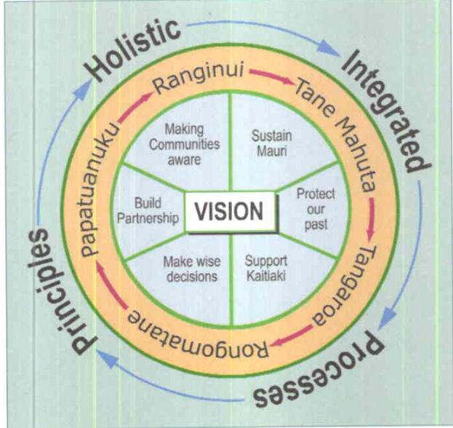
Figure 16 (overleaf) is from the Whakamarohitia ngā wai o Waikato – Te Arawa River Iwi Trust Environmental Plan 2021, and shows the relationship between the vision statement and other provisions in the plan. Of note is the prominence of cultural values, which frame and conceptualise the proposed strategic objectives. Such an approach appears to be more prevalent in recent plans, as discussed below.
Figure 16: Vision, mission statement and strategic objectives from Whakamarohitia ngā wai o Waikato – Te Arawa River Iwi Trust Environmental Plan 2021
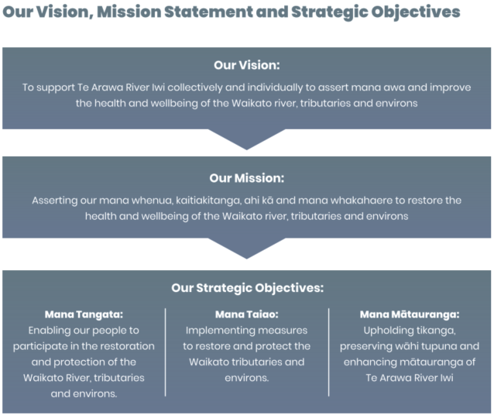
Observations – vision statements
Plans assert the mana and rangatiratanga of the iwi and hapū in their vision statements.
Vision statements can be used to inspire and motivate individuals and collectives to undertake future actions and aim for a desired state.
A vision statement describes a preferred future state for iwi and hapū. Using conventional terms, the mission is how iwi or hapū propose to assert the vision. Objectives are iwi or hapū goals, delivered through the policies and methods, to achieve the desired outcomes. Iwi or hapū may choose to conceptualise their statement, position or declaration via whakataukī (an unattributed saying or proverb) or whakatauākī (an attributed saying, quote, or proverb).
An IHMP should be a document serving iwi and hapū first and foremost, and secondarily for informing others, and to make contact beyond the iwi or hapū. An IHMP is not a replacement for engaging with iwi and hapū; rather, it is a reference document providing background on the iwi and/or hapū with whom the reader will be engaging. A vision statement declares an overarching state against which all outcomes can be assessed.
The language used in an IHMP is key. For example, “Outcomes” is a clear indicator that what follows are iwi and/or hapū outcomes and expectations. Some outcomes rely on external parties (central government, local government, developers) to participate and achieve the same outcome, for the benefit of te taiao (the natural environment) as well as the wider community.

Te ao Māori cultural values
Te ao Māori values, commonly referred to as ‘cultural values’, are of central importance in most IHMPs. Articulating cultural values in plans is useful in the context of the RMA. For example, cultural values can support tailored interpretations of concepts such as tikanga, kaitiakitanga and Te Mana o te Wai that account for the specific context of tangata whenua and their kaupapa.
Cultural-values frameworks form the basis of some IHMPs (see below). The four most common cultural values addressed in the plans were mauri, kaitiakitanga, tikanga and mātauranga.

Cultural-values frameworks
Several of the reviewed plans are structured around their guiding values. Such an approach allows for a culturally relevant, iwi and hapū-based expression of those values, thereby allowing the developers to better articulate their cultural identity and the relationships between different cultural values.
The Patuharakeke Hapū Environmental Management Plan 2014 is an example (figure 17). The plan states “guiding values, principles or practices shape our view of … the environment and resource management. These are reoccurring themes throughout this plan and are also intended to guide us in the implementation of this plan.”
Figure 17: The cultural-values framework relevant to Patuharakeke Hapū, from Patuharakeke Hapū Environmental Management Plan 2014
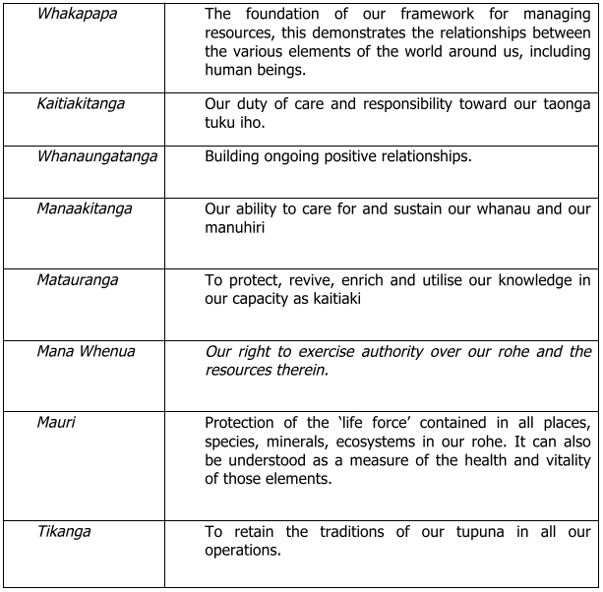
Many of the values in figure 17 are frequently referenced in the plans. The Ngāi Tamawharirua ki te Rereatukahia Marae Hapū Management Plan 2015 provides a good example of this (see figure 18). The process of identifying and prioritising the values is grounded in place-based mātauranga and whakapapa: So, kaumatua (elders) from each of the marae identify the relevant values. It is noted that this cultural-values framework was based on a previous exploration of values undertaken during the development of a cultural-impact assessment.
Figure 18: The Ngāi Tamawharirua cultural-values framework, Ngāi Tamawharirua ki te Rereatukahia Marae Hapū Management Plan 2015
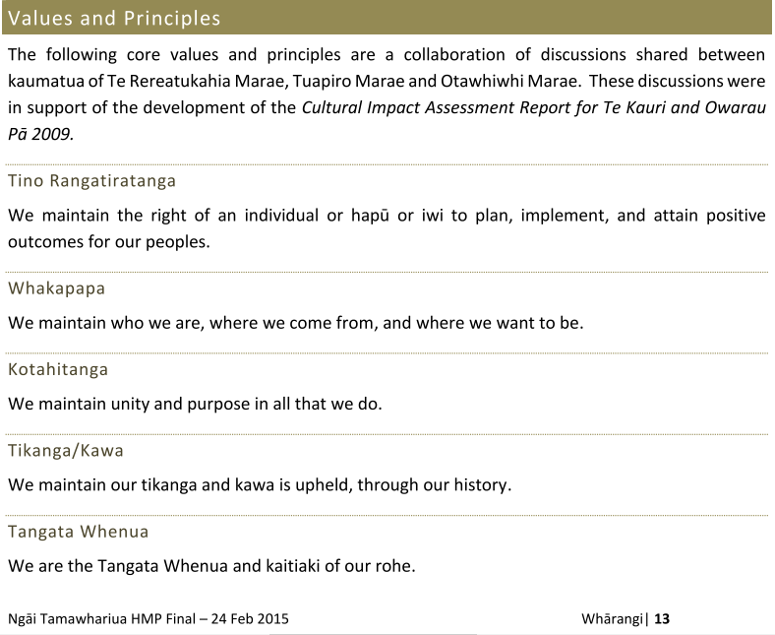
Another example of a plan that develops and expresses a cultural-values framework is Te Tūāpapa o ngā wai o Te Arawa – Te Arawa Cultural Values Framework 2019. It articulates the values and long-term aspirations for Te Arawa lakes, and all contributing waterways and puna (figure 19 overleaf). The plan’s purpose is to “provide a holistic and values-based foundation for the management of the Te Arawa lakes and surrounding land.” The guiding Te Arawa values are related to ‘Te Whakapapa o te Wai’ and are summarised as wai, waiariki, waiora, wairua and waiata. The plan then elaborates these values to identify the various elements of each, the inter-relationships and how they are embedded Te Arawa mātauranga.
Figure 19: Te Arawa Te Whakapapa o te Wai Guiding values chart, from Te Tūāpapa o ngā wai o Te Arawa – Te Arawa Cultural Values Framework 2019
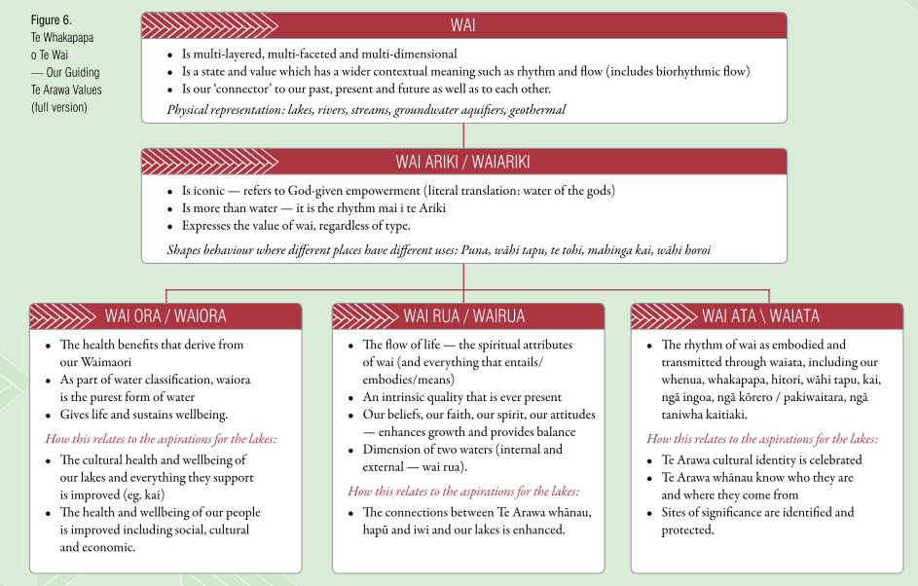
A main component of this values framework is the guiding principles, which “provide the ‘bridge’ between the conceptual components of te Whakapapa o Te Wai and the Tangible actions” (see figure 20). The principles, and the graphics depicting them, can guide plan users as they interpret and implement such frameworks and suggest how to achieve the desired outcomes.
Figure 20: A graphic showing how guiding principles can aid in the implementation of cultural values, from Te Tūāpapa o ngā wai o Te Arawa – Te Arawa Cultural Values Framework 2019
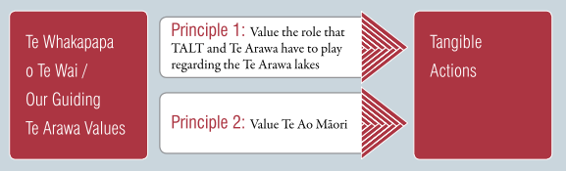
A final example is the Whakarongotai o te moana, Whakarongotai o te wā – Kaitiakitanga Plan for Te Ātiawa ki Whakarongotai 2019, which again adopts a values approach but interprets it through a distinctly kaupapa-Māori framework for planning. The kaupapa-Māori framework is based on Hua Parakore, which is described as a “framework developed by Te Waka Kai Ora, the Māori Organics Collective, to provide guidance and support to growers in implementing tikanga Māori to produce ‘hua parakore’ or ‘pure products’. This framework adopts six kaupapa that “reflect a broad spectrum of different types of values, from tangible values of energy and biology, through to more abstract values of connectivity and spirituality” (figure 21). These values inform the structure of the plan and include whakapapa, wairua, mana, māramatanga, te ao Tūroa and mauri.
Figure 21: The Hua Parakore values framework
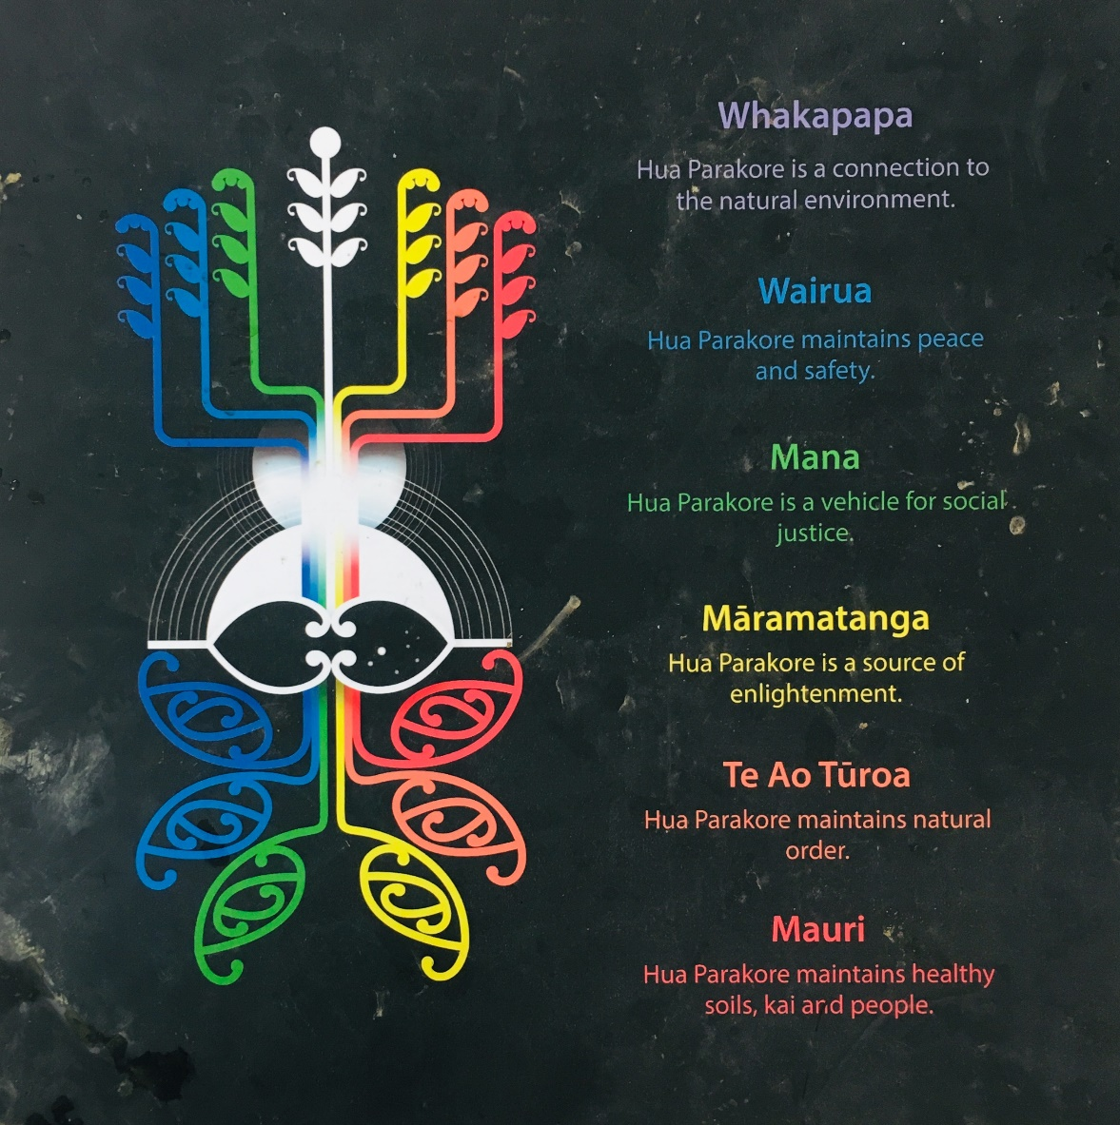

Some commonly mentioned cultural values
Another observation is that although kaupapa-Māori values are used widely, they are often referred to individually, outside of an overarching and structured framework. A small selection of the most common values is discussed below.

Mauri
Mauri is the most commonly identified cultural concept in the plans, with almost 90 per cent using the term.
The Tawharau o Nga Hapu o Whakatohea Iwi Management Plan 1993 details a Whakatōhea understanding of mauri:
Mauri generates, regenerates and upholds creation, binding physical and spiritual elements of elements of all things together. When something dies, the mauri is no longer able to bind those elements together and thereby give life. Without mauri nothing can survive.
Although not strictly an IHMP, Te Waihora Joint Management Plan, Mahere Tukutahi o Te Waihora 2005 provides a good interpretation of mauri. This description connections mauri with other cultural values such as whakapapa and kaitiakitanga as well as notions of wellbeing.
Mauri may be described as the life force, present in all objects living and inanimate, a force that stems from the beginnings and a value that is distinguished by the qualities of health, abundance, vitality, the pristine and unpolluted. The maintenance of the mauri of natural resources is important for the health and well-being of the people, to maintain the vitality of culture, practices, values and beliefs. This is a responsibility enshrined in whakapapa, through kaitiakitanga, an obligation to safeguard the well-being and mauri of ancestral land, water, sites, wähi tapu [ancestral landscapes], valued flora and fauna and other taonga for future generations – mō tātou, ā, mō kā uri a muri ake nei, for us and our children after us.
As a concept, mauri is the primary focus of the reviewed plans, deeply embedded across all domains. A figure in the Tai Whenua, Tai Tangata, Tai Ao – Te Kotahitanga o Te Atiawa Taranaki Environmental Management Plan 2020 conveys the importance of mauri (figure 22).
Figure 22: Mauri as an overlapping indicator of economic, social, cultural and environmental wellbeing — from Tai Whenua, Tai Tangata, Tai Ao – Te Kotahitanga o Te Atiawa Taranaki Environmental Management Plan 2020
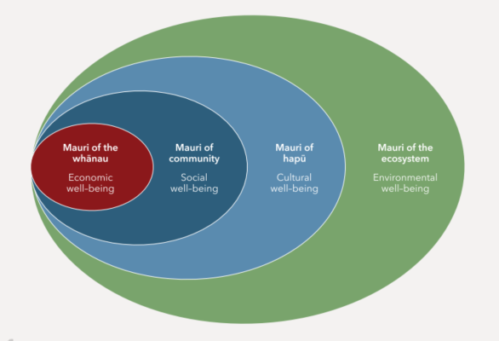
Also foundational to the IHMPs is the objective to protect and enhance mauri on behalf of future generations. To give effect to this idea, the Whakarongotai o te moana, Whakarongotai o te wā – Kaitiakitanga Plan for Te Ātiawa ki Whakarongotai 2019 describes a healthy state of mauri as being evident in several freshwater health indicators (see figure 23).
Figure 23: Mauri indicators using a freshwater-mahinga kai health index according to Te Ātiawa ki Whakarongotai — from Whakarongotai o te moana, Whakarongotai o te wā – Kaitiakitanga Plan for Te Ātiawa ki Whakarongotai 2019
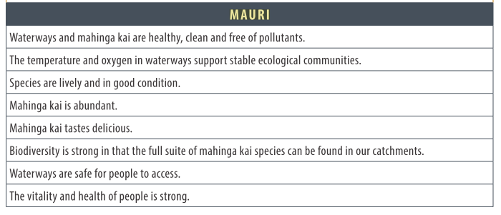
Some IHMPs present the significance of mauri in their vision statements, including the Whaia te Mahere Taiao a Hauraki – Hauraki Iwi Environmental Plan 2004, which includes the vision “Kia mau ki te mauri o te Taiao o Hauraki.” This vision statement also informs the central goals of the plan, which include “Hauraki Whānui sustaining and enhancing the mauri of ecosystems, habitats, species and natural resources under their care in the Hauraki tribal region.”
As shown in figure 24, the Ngā Tikanga mo te Taiao o Ngāti Hine – Ngāti Hine Iwi Environmental Management Plan 2008 is another plan that references mauri in its plan objectives, here in relation to water. This objective clearly identifies the significance of mauri for the wellbeing of current and future generations of Ngāti Hine, and all living things.
Figure 24: An example of an objective addressing the mauri of water according to Ngāti Hine — from Ngā Tikanga mo te Taiao o Ngāti Hine – Ngāti Hine Iwi Environmental Management Plan 2008
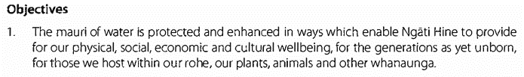
The Whakamarohitia ngā wai o Waikato – Te Arawa River Iwi Trust Environmental Plan 2021 supports the overarching objective “to restore and enhance the mauri of land, water and geothermal taonga” with a list of eight related outcomes (figure 25).
Figure 25: Ngā Tikanga mo te Taiao o Ngāti Hine – Ngāti Hine Iwi Environmental Management Plan 2008 provides another example of an objective relating to the mauri of water, here supported by outcome statements
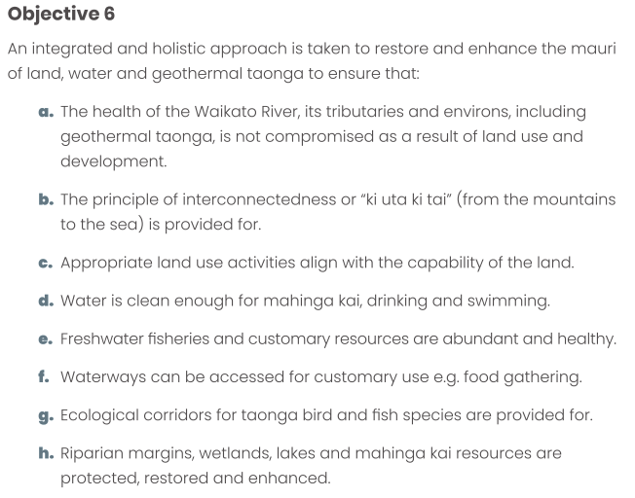
In terms of implementation, the Kahungunu ki Uta, Kahungunu ki Tai Marine and Freshwater Fisheries Strategic Plan mai Paritu ki Turakirae 2010 contains a table (see figure 26 for an extract) that connects a mauri-centred goal with time-specific activities and tasks to progress that goal. The format of this information is an effective way to present the relationship between the goals and corresponding actions.
Figure 26: A goal relating to the mauri of inland and coastal waters and how to progress it — from Kahungunu ki Uta, Kahungunu ki Tai Marine and Freshwater Fisheries Strategic Plan mai Paritu ki Turakirae 2010
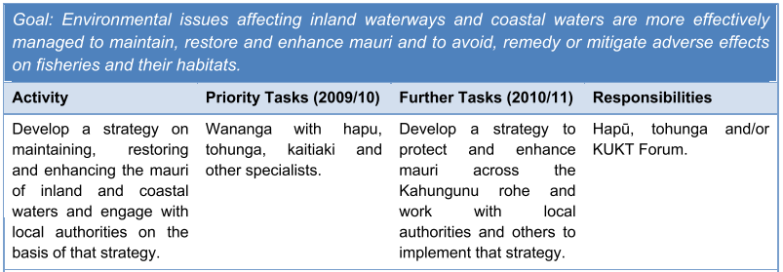
A final example of policy provisions being linked to mauri-related issues, objectives, policies and an action is from the Waitaki Iwi Management Plan 2019 (figure 27). Here, too, the information is clearly presented in a table.
Figure 27: Example of a table format showing the connections between objectives, issues and policies — from Waitaki Iwi Management Plan 2019
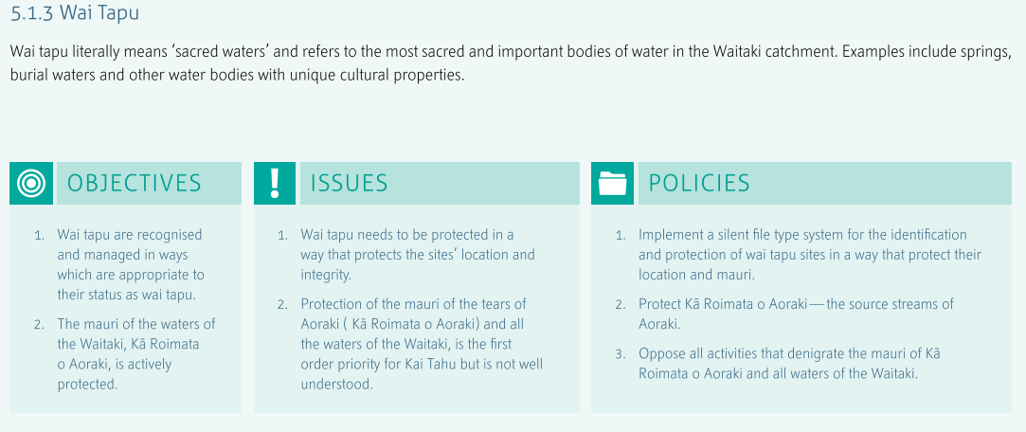

Kaitiakitanga
This review observed that kaitiakitanga is also a foundational value, being referred to in over 90 per cent of the IHMPs. Although several plans contain dedicated kaitiakitanga sections, a large proportion of plans adopt kaitiakitanga as an overarching, foundational cultural value.
For example, the Whakatakoto kaupapa mo te Hapu o Ngati Kuta ki Te Rawhiti – Ngati Kuta ki Te Rawhiti Hapu Management Plan 2004 conveys the Ngāti Kuta relationship with kaitiakitanga in the statement that:
The developing of kaitiakitanga and other traditional resource management methods with modern techniques, practices and processes is a key aim of Ngati Kuta. Kaitiakitanga is a vital factor for sustaining well-being. In 1840 our status as kaitiaki and our responsibility to practise kaitiakitanga was acknowledged in Article II of Te Tiriti o Waitangi.
The Ngāti Kuta plan also lists several other concepts that come under the umbrella of their understanding of kaitiakitanga, including “the concepts of mana/authority, mauri/ spiritual life principle, tapu/sacredness, mātauranga/knowledge, rahui/conservation, manaaki/hospitality, tuku/gift, transfer, whakapapa/genealogy, whanaungatanga/kinship.”
Te Poha o Tohu Raumati – Te Rūnanga o Kaikōura Environmental Management Plan Te Mahere Whakahaere Taiao o Te Rūnanga o Kaikōura 2007 includes an insightful statement from their whanaunga (people) that elaborates an understanding of kaitiakitanga. This statement conveys the significance of kaitiakitanga to iwi and hapū wellbeing and identifies a clear focus on future generations.
Kaitiakitanga in the resource management context means maintaining and enhancing the integrity of life – sustaining the resources we all depend upon to survive. Our philosophies are simple and rigorously imposed. We want clean water – because we eat the fish that comes from it. We want plenty of water, so that we can drink it. We want nourishing soils so we can grow our gardens to eat and our trees and birds and insects can survive. We want clean air so we can breathe easy. We need to work together because we are all part of a finely balanced ecosystem. We want all this because our kids are going to inherit this place and when you have kids you automatically become a futurist, and their future means everything to us. Kaitiakitanga means ensuring our children have all that, and that is what we are guarding.
Te Mahere ā Rohe mō Ngāti Rangitihi – Ngāti Rangitihi Iwi Environmental Management Plan 2011 provides another good example of presenting kaitiakitanga (again in a table format; see figure 28) using the commonly adopted issues, objectives, policies and methods structure.
Figure 28: A table clearly linking kaitiakitanga with objectives, policies and methods — from Te Mahere ā Rohe mō Ngāti Rangitihi – Ngāti Rangitihi Iwi Environmental Management Plan 2011
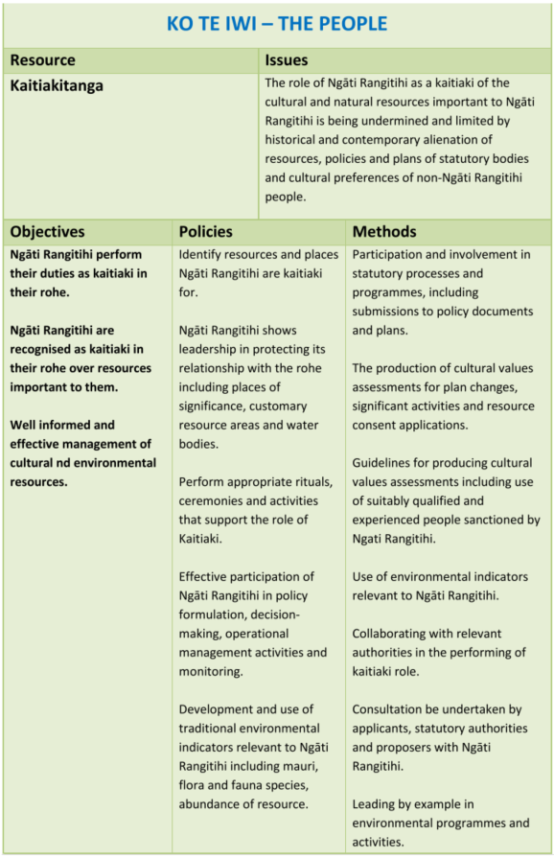
Finally, Te Kāuru Taiao Strategy – Te Kāuru Eastern Manawatū River Hapū Collective 2016 also adopts the helpful table format, relating to “Kaitiakitanga – Relationships, Wisdom/Vision and Principles, Strategies of the Manawatū Catchment” (figure 29). The table clearly identifies the connections between kaitiakitanga and visions, principles and strategies for air, water and land.
Figure 29: A table from Te Kāuru Taiao Strategy – Te Kāuru Eastern Manawatū River Hapū Collective 2016 relating kaitiakitanga to other key elements of the strategy
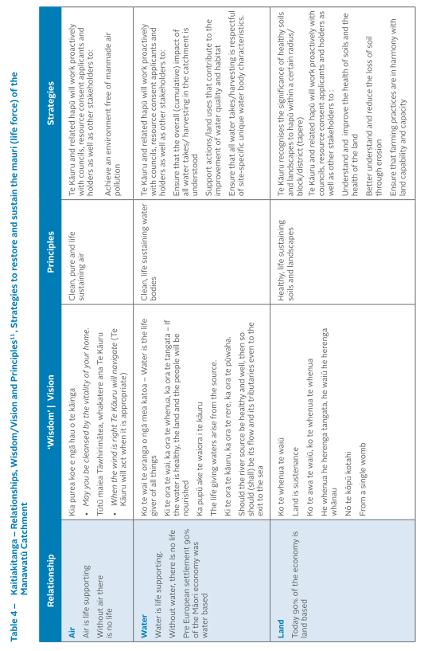
Observations – cultural values
It is important that cultural values be included in IHMPs to communicate a tangata whenua worldview in the resource management system.
Iwi and hapū cultural values are presented in IHMPs. However, they are not always explicitly identified as such. For example, terms such as turangawaewae, kawa, and tikanga were not always defined in headings but arose in the body of the text.
In some IHMPs, the values are based on Te Tiriti o Waitangi and associated principles, whereas in other plans the values are based on He Whakaputanga – the Declaration of Independence of the United Tribes of New Zealand. Clearly, IHMP values are based on the perspective of each iwi and hapū.
Language use needs to be considered in IHMPs as it may not always be appropriate to simply translate te reo Māori to English. Kupu Māori (Māori words) may be most effective in conveying cultural values and identity – an essential component of IHMPs. While language barriers do not reduce the responsibility of resource management decision-makers to ‘take into account’ IHMPs, the provision of English translations provided by tangata whenua in IHMPs helps non-reo speaking practitioners and resource users alike with understanding te ao Māori concepts and values.
From the perspective of a RMA practitioner, it would be valuable for an IHMP to include a description of circumstances when a cultural-values or impact assessment (CVA and CIA, respectively) might be required. It would be helpful to outline what CVA and CIA are, why one is needed, when is each required, and how is each delivered (ie, expectations around costs, resourcing and timeframes) as resource management practitioners and other plan users would find this useful.

Tikanga
The concept of tikanga was identified in nearly all of the reviewed plans. For example, Te Uru Taiao o Ngāruahine – Ngāruahine Kaitiaki Plan 2021 contains a short definition of tikanga as a “Rule, code, way, practice, convention, protocol or correct procedure. A customary set of values and practices that have been developed over time and are deeply embedded in the social context”. Where tikanga is identified in the various IHMPs, culturally relevant practices and processes are outlined that an iwi or hapū might use or expect other parties to adopt. Therefore, it appears that the expression of tikanga is intended to guide interactions with a particular resource or group, or in a resource management process.
In the Ki Uta, Ki Tai Ngā Puna Rau o Rangitīkei – Rangitīkei Catchment Strategy and Action Plan 2019, the significance of tikanga to Rangitīkei is clear and that value is linked to the strategic goal and corresponding objective, both aimed at achieving wellbeing outcomes (see figure 30).
Figure 30: An example of a strategic goal and objective that connect tikanga with wellbeing outcomes —from Ki Uta, Ki Tai Ngā Puna Rau o Rangitīkei – Rangitīkei Catchment Strategy and Action Plan 2019
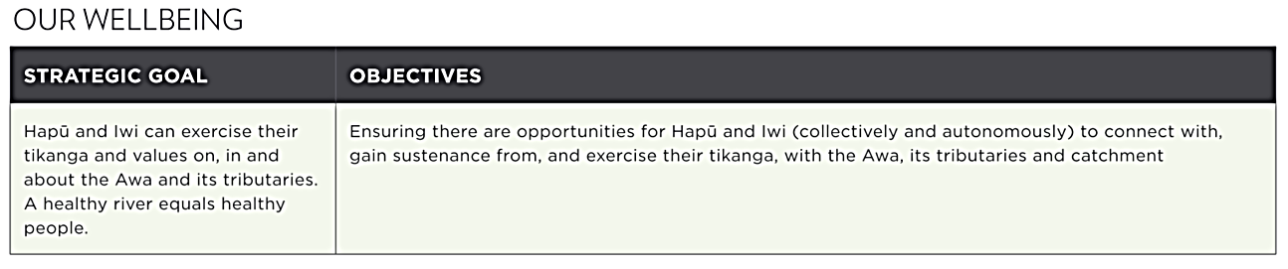
Some other tikanga references detail an intent to continue traditional harvesting practices. For example, the Hineuru Iwi Trust Iwi Environmental Management Plan 2022 mentions the iwi’s right to access geothermal waters: “in accordance with our tikanga and planning and consenting should take account of this”. Similarly, Te Uru Taiao o Ngāruahine – Ngāruahine Kaitiaki Plan 2021 specified a policy for marine mammal strandings, stating, “Ensure that processes and responses are undertaken in accordance with the accepted tikanga and kawa [protocols] of Ngāruahine and the affected Hapū, including the harvesting of cultural materials and the burial of deceased mammals”. These examples of specific provisions highlight the inherent relationship between the maintenance of tikanga, customary indigenous rights, cultural-identity indicators and cultural wellbeing. Provisions such as these help to reinforce the intent to recognise, and actions deriving from the recognition of, Te Tiriti commitments and tino rangatiratanga.
In terms of plan implementation, tikanga is also mentioned in the context of traditional management practices. Again, using Te Uru Taiao o Ngāruahine – Ngāruahine Kaitiaki Plan 2021 as an example, the plan sets out a policy seeking support for the iwi descendants to monitor stream health using both western and tikanga-based methods. Other tikanga- and kawa-based tools such as rāhui (prohibition) were present in some IHMPs. The Tai Whenua, Tai Tangata, Tai Ao — Te Kotahitanga o Te Atiawa Taranaki Environmental Management Plan 2019 includes a policy that seeks to “identify opportunities for Te Ātiawa to use rāhui in accordance with tikanga to protect and enhance inshore fish stocks”.
The contribution of tikanga to cultural identity and the knowledge base of future generations is outlined in policy TTTT1.1, which states:
Require restoration of mahinga kai areas and species, and preserve the tikanga associated with these resources, by:
a) integrating mahinga kai objectives into planning documents;
b) developing and implementing restoration projects;
c) conducting wānanga [courses] to teach our future kaitiaki about our mahinga kai traditions; and
d) identify and support options for restoring populations of mahinga kai species.
And finally, at a more functional level, some plans use tikanga as their term for the methods or actions sections, while the He Mahere Pūtahitanga: A Pan-tribal Iwi Planning Document on behalf of the Central North Island Forests Iwi Collective states that the collective desires that input from hearing panels or commissioners “who understand tikanga and the perspective of the local iwi and hapū” be prioritised in relevant decision-making processes.

Mātauranga Māori
Seventy per cent of the reviewed IHMPs included the cultural value mātauranga. Mātauranga Māori is defined in Te Taiao o Te Whatuoranganuku – Ngāti Tamateatutahi-Ngāti Kawiti Hapū Environmental Management Plan 2015 as “Māori knowledge. The body of knowledge originating from Māori ancestors, including the Māori world view and perspectives, Māori creativity and cultural practices”.
Policy 3.3(b) of the Whatitiri Hapu Environmental Plan 2016 is indicative of other plans that intend to better recognise mātauranga and states that:
Use will be made of relevant Mana Whenua ki Whatitiri matauranga/traditional environmental knowledge and practice in decision-making associated with all resources, including water bodies, soils, minerals, air, flora, fauna, energy and heritage.
The plan also includes a key policy statement that “the intellectual property rights associated with that knowledge will be respected and protected”.
Also conveying the need to respect mātauranga is the significant section “Mātauranga Māori Protocols” in the Whakarongotai o te moana, Whakarongotai o te wā – Kaitiakitanga Plan for Te Ātiawa ki Whakarongotai 2019. The plan provides insights into the function of mātauranga Māori protocols and mātauranga Maōri as a concept:
Protocols are required to ensure appropriate process and use when engaging and working with mātauranga Māori. This is both for kaitiaki who are responsible for the creation, use and protection of mātauranga Māori, but also for those who work in the public and private sector who will encounter and engage with mātauranga Māori. Mātauranga Māori is a significant taonga protected by Te Tiriti o Waitangi and through the Resource Management Act provisions that relate to Māori relationships with taonga.
This plan goes on to define a series of ethical principles of mātauranga Māori including, in brief, that:
6. Mātauranga Māori is created or applied in order to manifest certain kaupapa or values. It is not a ‘value free’ or ‘objective’ knowledge system.
7. Mātauranga Māori is sacred. The appropriate kaitiaki of any mātauranga determine the limitations of who can access mātauranga and how it can be used.
8. The generation and holding of mātauranga Māori must be pursued in a way that is authentic.
9. The creation, use and validation of authentic mātauranga Māori requires tikanga Māori spaces.
A section like this is very valuable for plan users, both internal and external, at the very least allowing them to gain a baseline level of understanding to support any intended engagement.
The Rising above the Mist – Te Aranga Ake I Te Taimahatanga – Ngāti Tahu – Ngāti Whaoa Iwi Environmental Management Plan 2019 addresses mātauranga in a slightly different manner, adopting it as a core value: “Mātauranga mo te katoa – education and knowledge for all”. Mātauranga is related to education and knowledge as being “key to managing our resources well,” and the plan asserts that by “building the capability of our tamariki/rangatahi [children/youth] they will be well prepared for mahi in the future’. Importantly, mātauranga is also intended to be shared beyond iwi and hapū, including “across agencies to identify how best to care for our environment together”.
The Ko Tā Maniapoto Mahere Taiao – Maniapoto Environmental Management Plan 2018 includes an objective that is resource specific and based in mātauranga Māori, stating that the related policies and actions are “to collate and share Maniapoto tikanga, kawa and mātauranga of ﬁsheries to promote understanding and cooperation”. An intent to communicate mātauranga is captured in Policy 16.3.4.1, which expresses the aspiration that “Maniapoto and other users or regulators of ﬁsheries within the Maniapoto rohe promote opportunities for learning about ﬁsheries through projects, wānanga and practices”. There are several actions attached to this policy, mainly centred around collating and sharing mātauranga through wānanga, then working with the mātauranga through regulations and traditional practices such as rāhui.
The pan-tribal Tauranga Moana Iwi Management Plan (2016–2026) mentioned previously adopts a “Mātauranga-based Policy Framework”, inspired by several other mātauranga models. The intention was to provide a more holistic and integrated way of looking at the taiao and its people. The framework comprises five core elements that make up the mātauranga framework against which the “best health” of Tauranga Moana is assessed, including “mind, body, spirit, family and land” (see figure 31).
Figure 31: The Tauranga Moana Mātauranga Policy Framework — from Tauranga Moana Iwi Management Plan 2016–2026
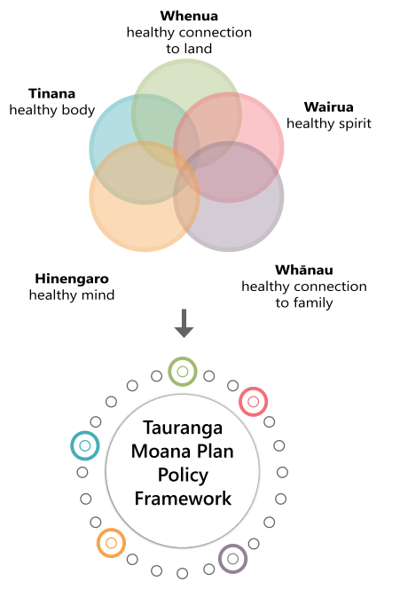 | 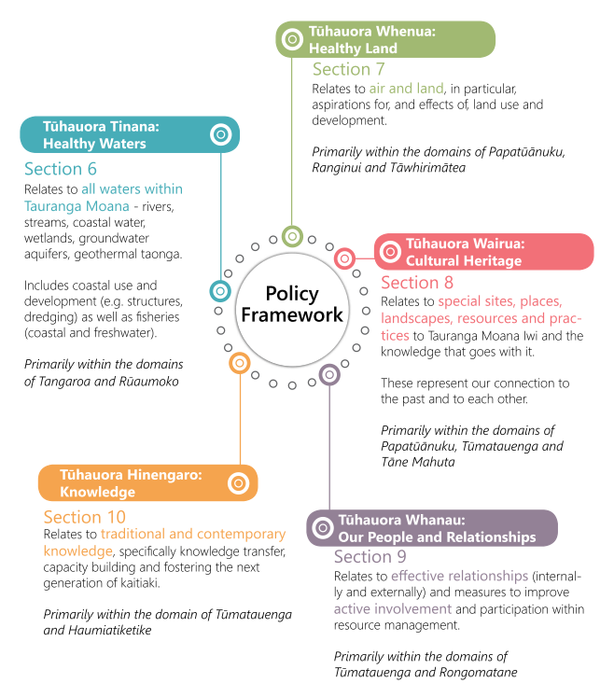
It remains to be seen whether mātauranga-based policy frameworks can be used effectively by resource management authorities and applicants. Such an approach is distinctly Māori and mātauranga underpins the content of many of the plans, irrespective of whether the concept is specifically referenced. Frameworks in which mātauranga is explicit provide insights into cultural values for non-Māori practitioners and decision-makers alike.
Observations – tikanga and mātauranga Māori
Tikanga has an important role in IHMPs and is an expression of tino rangatiratanga in the context of the RMA. Tikanga is recognised by the Courts as part of New Zealand’s common law and emphasised that decision makers (such as RMA commissioners) should address tikanga, particularly with respect to section RMA 6e (Māori relationship with taonga), 7a (kaitiakitanga) and 8 (taking into account the principles of the Treaty of Waitangi).
Mātauranga Māori is knowledge, ie, iwi or hapū intergenerational knowledge. It can be used as evidence to support matters of tikanga in RMA decision-making. Iwi and hapū could use an IHMP to advise what role tikanga and mātauranga play in strategic, regional and local planning.
Some IHMPs acknowledge that iwi and hapū have subject matter experts for their kōrero, tikanga, kawa, and so on. Consent applicants, local and central government and other authorities need to recognise and commission evidence from these specialists just as they would any other subject matter expert (such as an arborist or engineer) when planning projects or developing policy.
Specifying a preference for commissioners with relevant knowledge of tikanga and mātauranga Māori is potentially one method to influence outcomes, given their elevated role in the freshwater planning process.
IHMPs might outline or refer to tikanga, but it’s good to make clear that iwi and hapū should be engaged to provide the necessary detail on tikanga matters.
Where mātauranga is held at different levels of an iwi or hapū structure, it is helpful for an IHMP to explain this for plan users so they understand who they might expect to talk to about a particular issue.

Common IHMP content – environmental domains
Many plans are structured around a core set of environmental domains, perhaps unsurprisingly, given IHMPs have their basis as resource management instruments. Social- and economic-focused policies were less common.
Below are several examples that demonstrate the commonalities among plans, and also the diversity of policy approaches towards the core environmental domains.

Whenua (land)
Whenua is addressed in all the IHMPs, spotlighting the cultural significance of whenua to te ao Māori.
The Tai Tumu – Tai Pari – Tai Ao – Waikato-Tainui Environmental Plan 2013 features a wide-ranging and dedicated section on whenua. Waikato-Tainui detail their aspirations for, and relationship with, their whenua in the following statement:
For Waikato-Tainui all land has mauri and all land has value to Waikato-Tainui. The mauri of much of the land within the rohe of Waikato-Tainui has been adversely affected by its historical and current use. Waikato-Tainui seeks to restore the mauri of the land in balance with achieving the environmental, social, cultural, spiritual, and economic aspirations of Waikato-Tainui. Waikato-Tainui recognises that restoring the mauri of land needs to occur in partnership with the wider community, local authorities, government, and commercial and industrial users.
The main whenua-related issues that Waikato-Tainui identify and seek to manage include: soil and erosion management, nutrient loss and water-quality management, land contamination, floodplains, drainage and integrated catchment management. Each whenua-related issue has its own associated objectives, policies and methods.
Te Uru Taiao o Ngāruahine – Ngāruahine Kaitiaki Plan 2021 contains a Papatūānuku section to guide the management of the iwi whenua. The place-based issues regarding Papatūānuku include:
- the use of hazardous substances
- intensive farming practices
- industrial activities
- residential development
- waste and stormwater management
- mineral and hydrocarbon exploration and extraction
- alternative energy generation
- new cemeteries and crematoriums
- the establishment of Significant Natural Areas (SNAs)
- freedom camping.
In the Ngāti Tama ki Te Waipounamu Trust Environmental Management Plan 2018, whenua is divided into two sections: ‘Whenua (Maunga and Hill country)’ and ‘Whenua (Valleys and Plains)’. While the plan recognises common whenua-related issues like farming, mining and exploration, and industrial activity, the IHMP also recognises forestry operations (indigenous and exotic), national park management, energy generation and stock transport as issues of note in their takiwā. These specific issues are less evident in other IHMPs, reinforcing the context-specific nature of plan content.
A good example of a land-related policy and corresponding actions is Policy 23 from the Tauranga Moana Iwi Management Plan 2016–2026. There, indigenous biodiversity and taonga species are integrated into many of the land-based policies. Of note are the actions, the content of which clearly demonstrate the potential for integrating technical, biophysical and cultural matters in an IHMP (see figure 32).
Figure 32: The land-related Policy 23, with its associated actions, in the Tauranga Moana Iwi Management Plan (2016–2026)
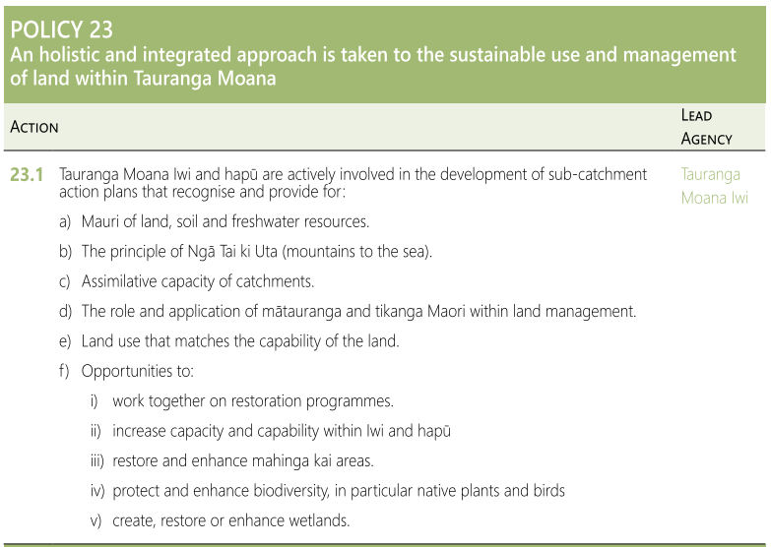
A good example of clearly presented relevant issues, objectives and policies, in a summary table, is taken from Te Whānau a Te Haraawaka Hapū Resource Management Plan 2017 (figure 33).
Figure 33: A summary of whenua-related issues, and their associated objectives and policies from Te Whānau a Te Haraawaka Hapū Resource Management Plan 2017
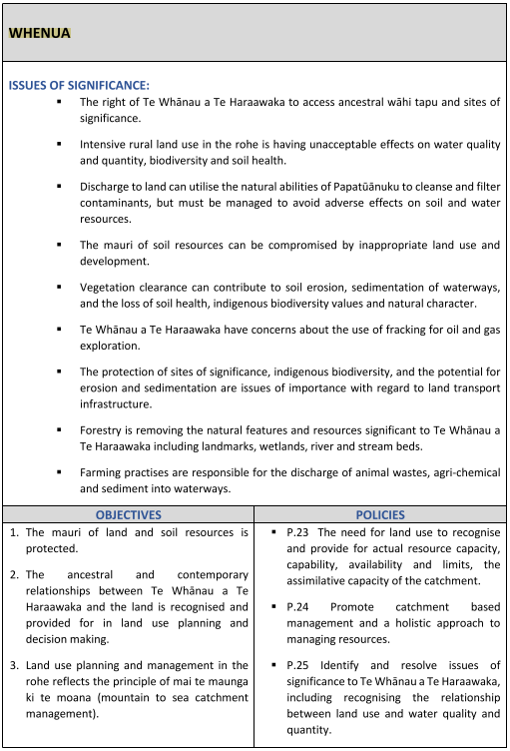
Observations – whenua
A wide range of issues are raised (eg, erosion, land development, sedimentation, biodiversity, forestry) in the whenua sections of IHMPs.
Reference to integrated-catchment principles like “Ki uta ki tai, mai te maunga ki te moana”, is common.
Whenua can include sites of significance and cultural heritage situated in the whenua, awa, moana and maunga of the rohe.
While using some planning and other technical jargon can help draw the attention of planners and other resource management practitioners, it’s best to use plain language, so that taiao-related objectives and policies can be interpreted clearly by multiple audiences.

Wai (freshwater and coastal waters)
Wai, or water, is another natural domain that is addressed in all the plans, albeit in a variety of ways.
The relatively early Tawharau o Nga Hapu o Whakatohea Iwi Management Plan 1993 contains a section on ancestral water, and while it is one of the earliest plans, many of the issues it identifies were widely encountered in the preparation of this review (others were place-based). Whakatōhea describe their relationship with water as one where:
Water is a very significant resource to Whakatohea. Water is life-giving with its own mauri or lifeforce which must be nurtured as a living entity. Water represents the lifeblood of Papatuanuku, the tears of Ranginui, and is the domain of Tangaroa … According to holistic beliefs, the wellbeing of water is a reflection of the wellbeing of the land, and this in turn is a reflection of the wellbeing of the Tangata Whenua, Whakatohea.
According to Te Whakatōhea, significant ancestral water-related issues include:
- ad hoc and inappropriate developments allowed within the Ohiwa Harbour catchment
- adverse effects of poorly located and controlled land-based activities on people’s health and the mauri of water, fish, kaimoana and their habitats. Activities include those resulting in animal and human waste, sewage effluent overflows, contaminated stormwater, siltation, soil erosion, fertilisers, sprays, pesticides, flooding, and residential, agricultural, horticultural, commercial and industrial waste into water
- adverse effects of runoff from roads, bush and scrub clearance, forestry development, earthworks, new and established subdivisions, and discharges and leachate from sewage systems, septic and industrial waste tanks, dairy sheds, piggeries, open drains, boats, effluent ponds, public toilets, and rubbish dumps
- adverse spiritual and cultural effects of treated or untreated wastes entering water
- boats discharging human, engine fuel, and other wastes into water. The burial of tuupaapaku [the dead] at sea
- uncertainties regarding the capacity of land-based soakage fields to cope with sewage effluent volumes
- dumping of rubbish alongside rivers and streams
- reclamations
- inadequate water supply and sewage disposal services for marae and papa kainga housing
- government irrigation schemes established in the Whakatōhea rohe but refusing to involve landowners
- lack of involvement in planning and deciding the location of any structures (eg, boat ramps, moorings, jetties) in the coastal marine area (area above mean high water springs to the 12-mile limit)
- Crown and government agencies allocating and selling rights to use, take, dam and divert water resources rightly owned by Whakatohea
- the draining of wetlands for purposes including those of agriculture and horticulture, resulting in loss of significant spawning grounds of whitebait, fish and eels, and traditional food and cultural resources of Whakatohea
- the need to restrict use, access and development of certain sites and areas (eg, waahi tapu located in coastal marine areas, lagoons, rivers and stream beds; specific springs and areas of water with special historic and cultural significance)
- flooding and siltation of water including coastal marine areas, kaimoana and their habitats from activities such as mining riverbeds, forestry, farming, major storms, farming methods, the clearing of vegetation cover, roading, earthworks and subdivisions
- the need to place restrictions on water when drownings occur.
This plan extensively covers water-related issues and is a good example of an IHMP that gives voice to technical, environmental and cultural elements related to water.
Another relatively early plan of note is the Kāi Tahu ki Otago Natural Resource Management Plan 2005, which contains both a “Wai Māori” section and a “Te Taiao o te Taku Tai” section. The “Wai Māori” section addresses issues such as:
- current water management does not adequately address Kāi Tahu ki Otago cultural values
- cross-mixing of water
- deteriorating water quality
- lack of consideration given to Kāi Tahu ki Otago cultural values in water research
- the fundamental question of ownership of water resources remaining unresolved
- damming
- lack of adequate minimum flows providing for Kāi Tahu ki Otago cultural values
- setting of minimum flows may not appropriately consider social, biological and cultural needs.
Again, the general issues identified by Kāi Tahu ki Otago display similarities to those in the Whakatōhea plan. However, here, the water management system that allocates minimum flows is given more priority, as is the issue of water ownership. It is interesting to note that, after almost two decades, these two matters are still primary issues playing out in the planning and legal systems for Kāi Tahu, suggesting that in some cases the ‘take into account’ weighting has been insufficient to address freshwater issues satisfactorily. The National Policy Statement for Freshwater Management 2020 requires that freshwater is managed in a way that gives effect to Te Mana o te Wai and this has been carried into the proposed Regional Policy Statement for Otago. This is potentially an area of increasing influence for Kāi Tahu’s planning documents.
Also of interest is that the plan mentions that Kāi Tahu values are not considered in water-related research, perhaps signalling the role of cultural-impact assessments, cultural values reports and cultural flow studies, which have since become more widely used in Otago to inform regional council water plans.
In this section, the Kāi Tahu ki Otago plan uses a conventional method to present the objectives and policies for the following wai Māori categories:
- discharges
- dams/diversions
- water extractions
- irrigation
- river and instream works
- bank erosion
- willow removals
- gravel extractions
- land use and management.
An alternative approach is adopted in Te Taiao o Te Whatuoranganuku – Ngāti Tamateatutahi – Ngāti Kawiti Hapū Environmental Management Plan 2015, which uses an environmental matrix to present the issues and policies relevant to water in the hapu takiwā (figure 34). While the terminology is unusual, the structure is conventional as it identifies issues (overview), objectives (environmental interests), policies (aspirations) and methods (hapū actions). Environmental triggers are also described, which indicate where engagement with hapū will be necessary. Many of the provisions are similar in content to those in other plans; however, the intent to improve hapū engagement with traditional knowledge, through hapū field trips and working with local kura (schools) and kōhanga reo (Māori language preschools) for example, is not widely expressed in other plans.
Figure 34: The hapū environmental matrix for water — from Te Taiao o Te Whatuoranganuku – Ngāti Tamateatutahi – Ngāti Kawiti Hapū Environmental Management Plan 2015
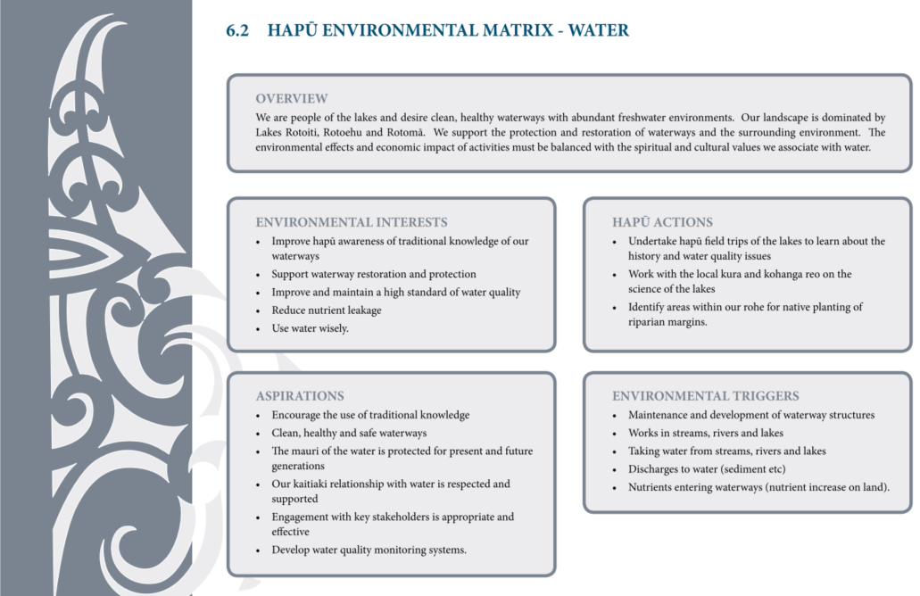
Coastal waters are also covered extensively in the plans. As mentioned above, the Kāi Tahu ki Otago Natural Resource Management Plan 2005 includes a comprehensive “Te Taiao o te Takutai” section, whereas the Mahaanui Iwi Management Plan 2013 includes a “Tangaroa” section. The main issues addressed in that section of the latter plan include:
- statutory acknowledgements
- coastal water quality
- coastal wetlands
- estuaries and hāpua [harbours]
- tools to protect customary ﬁsheries and the marine environment
- foreshore and seabed
- coastal and marine cultural heritage
- coastal land use and development
- access to coastal environments
- oﬀshore exploration and mining
- aquaculture
- beached marine mammals
- freedom camping.
An overarching principle that comes through the Mahaanui Iwi plan is the principle of “Ki Uta ki Tai”. In the context of coastal water quality, this manifests as “a catchment-based approach to coastal water quality issues, recognising and providing for impacts of catchment land and water use on coastal water quality.” A holistic approach is reflected in how Mahaanui integrate aquaculture and beached marine animals into this section, given these issues have overlapping environmental, economic, social and cultural elements. In terms of aquaculture, the IHMP conveys the need to ensure the six rūnanga participate in decision-making about development. The basis for this intent is, firstly, that mana whenua whakapapa to the area and so retain customary rights, and, secondly, the guarantees under Te Tiriti o Waitangi. There are also Ngāi Tahu entitlements to coastal space “as per the NTCSA 1998 and Māori Commercial Aquaculture Settlement Act 2004.” It is interesting to note a policy in this section that also requires Ngāi Tahu Holdings to engage with rūnanga when considering marine farming ventures. This indicates specific reference to tribal organisational structures and the importance of aligning cultural, environmental, social and economic aspirations in a post-settlement environment.
References to policies relating to beached marine mammals in this plan demonstrate the potential for culturally relevant provisions (relating to tikanga, kawa and use of traditional resources) being included in IHMPs. The plan further conveys the significance of this issue by presenting the whakataukī used in evidence for the Ngāi Tahu Fisheries Claim (figure 35).
Figure 35: Whakataukī from the beached marine mammals section of the Mahaanui Iwi Management Plan 2013
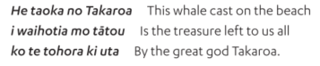
Again, the policies in the beached marine mammal section are framed to ensure engagement of rūnanga in accordance with their rights guaranteed in Te Tiriti, and through working arrangements with the Department of Conservation.
Lastly, the “Tangaroa” section of this plan relates to the material on mātaitai and taiāpure (seafood gathering) reserves. Inclusion of such sections, related to customary fisheries tools for example, can help to normalise, validate and communicate alternative resource management tools to plan users, as can sections relevant to rāhui.
A final example of how plans deal with the coastal environment is Te Rautau Te Rāhui Taketake — Ngāti Whakaue ki Maketu Hapū Management Plan 2018–2028. The importance of the coastal environment to hapū existence is clearly conveyed in this statement:
The Maketu and Waihi Estuaries are highly significant to Ngāti Whakaue. These natural resources have sustained the people since the landing of Te Arawa canoe at Maketu. The food basket “Te Pātaka” could feed everyone, the food was plentiful with kahawai, mullet, pātiki, pipi, titiko, pūpū and other varieties of kaimoana (seafood). It was a resource that could replenish easily. The natural resources provided food for all.
Figure 36: Example of a table format being used to present a coastal-use and development objective and its related policies in Te Rautau Te Rāhui Taketake — Ngāti Whakaue ki Maketu Hapū Management Plan 2018–2028
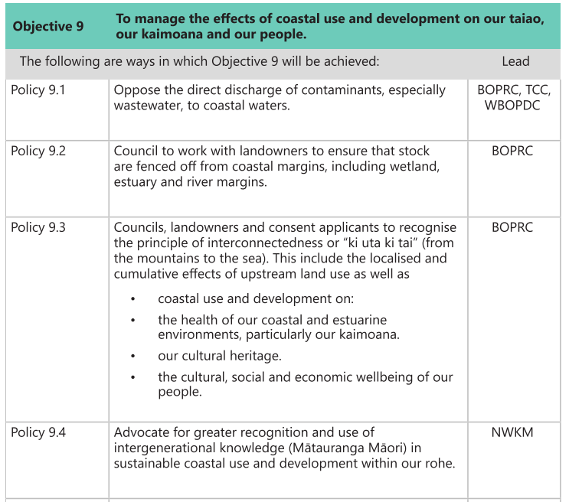
The plan presents the provisions related to coastal-development pressures on the environment, people and kaimoana (seafood) resources in a table (see figure 36). This format lets users quickly identify and understand the connections between objectives and policies. Identifying the parties responsible for leading the policies is also good practice.
Apart from practical measures to preserve the integrity of the taiao, food resources and, therefore, the wellbeing of the people, this plan includes the reoccurring theme of enhanced recognition and use of hapū rangatiratanga, cultural values and cultural concepts in decision-making. For example, in the methods section (“projects”), initiatives to enhance hapū rangatiratanga are outlined to give effect to the policies, as well as to build capacity and capability in a hapū-led programme of environmental monitoring (see figure 37). Thus, this plan section demonstrates that provisions can be a place to integrate initiatives for environmental, social, cultural and economic outcomes that appear throughout an IHMP.
Figure 37: Example of how projects can be used to give effect to a coastal-use and development objective — from Te Rautau Te Rāhui Taketake — Ngāti Whakaue ki Maketu Hapū Management Plan (2018–2028)
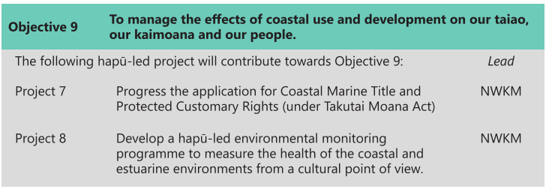
Observations – wai Māori
Plans provide a detailed explanation of tangata whenua relationships with water.
A preferred hierarchy of water use is identified in some IHMPs.
In some plans, the cultural importance of, and traditional practices related to, water are conveyed in whakapapa- and tikanga-based issues and provisions.
Some plans assert that iwi and/or hapū should have a greater role in monitoring of, and compliance over, waterbodies. There may be value in future and revised IHMPs clearly stating this intent where it is deemed a priority.
Water quality and quantity is a long-standing and significant issue for a number of iwi, with many carrying forward provisions written into IHMPs over 20 years ago.
In this respect, IHMPs should state review periods, which could allow any lack of improvement in iwi and/or hapū priority issues to be addressed. This, in turn, would mean that iwi and hapū could consider amending their updated or next IHMP (eg, by using stronger language such as ‘avoid’, ‘oppose’).

Hau (air)
Approximately 80 per cent of the reviewed plans contain references to air, whereas almost 50 per cent reference the Māori term ‘hau’.
Te Uru Taiao o Ngāruahine – Ngāruahine Kaitiaki Plan 2021 contains an atua Māori-informed section called “Ranginui – Air and Atmosphere”. A Ngāruahine understanding of air is stated as:
Ngāruahine considers the air and atmosphere to be a manifestation of Ranginui, although all atua are connected through the air. Ranginui is valued for the life supporting properties provided and as a connector element/atua between land, freshwater, and the sea. Ranginui includes the stars and all the space between himself and Papatūānuku. It is the interface between these two vital atua that provides the conditions for life. The mauri of this taonga is affected by excess light, noise, odours, and atmospheric discharges.
The plan elaborates on “te mauri o te hau” by describing concepts that connect to hau, such as the relationships of prominent ancestors with hau, the Pai Mārire faith and hauora or hau kāinga. With respect to te mauri o te hau, this plan states:
Degraded mauri manifests itself in poor visibility and irregular winds. Clarity of the night sky is critical to utilising the maramataka [Māori lunar calendar] for fishing, harvesting, and planting activities. No other element/atua displays the transboundary effects of poor environmental behaviour better than the air/Ranginui.
One of the main issues identified by Ngāruahine is the recognition the quality of air is affected by: discharges, including agricultural, domestic and industrial contaminants; artificial noise; artificial lighting; and alternative energy generation activities.
The response to the issues is listed in these key objectives:
The mauri of Ranginui is protected and enhanced by:
- Avoiding an increase in noise and visual pollution.
- Maintaining or improving the visual clarity of the Ngāruahine Cultural Landscape and the night sky.
- The sanctity and sanctuary offered by significant Ngāruahine sites is preserved for current and future generations.
- Recognition of Ngāruahine values and mātauranga as valid indicators in air quality strategies, plans and monitoring.
A unique feature of these objectives is the expressed relationship between the visual clarity of the hau and the concept of a Ngāruahine cultural landscape – a connection that is not mentioned in any other IHMP reviewed. There are plans that mention viewshafts to protect views to significant maunga, or mention the impacts of light-spill. However, in these plans the focus is on excluding or controlling built form, as opposed to considering the air space as a cultural landscape. The policy regarding the latter applies to resource consents and encourages “activities which have adverse effects on the visual clarity of Ngāruahine Cultural Landscapes and the night sky” to have the following conditions imposed:
- the use of CIAs [cultural impact assessments]
- the planting of native tree species
- requiring artificial lighting to minimise glare and light trespass.
Finally, another policy of note in Te Uru Taiao o Ngāruahine – Ngāruahine Kaitiaki Plan 2021 relates to initiatives to reduce emissions through culturally responsible decision-making. The policy reads:
Encourage and support all Marae within the rohe of Ngāruahine to develop and adopt energy use reduction measures including but not limited to:
- Sourcing services, goods, and materials from providers as close to the marae as possible;
- The use of solar and wind generation to provide energy for marae;
- Identifying the embedded emissions of goods and services and promoting less harmful alternatives.
The setting forth of these policies, and the encouragement of their adoption, appears to be a conscious effort to protect and enhance the mauri of Ranginui via promotion of renewable energy for marae and wider, environmentally conscious decision-making in and on behalf of their communities.
Another example of a plan dealing with hau is Te Poha o Tohu Raumati – Te Rūnanga o Kaikōura Environmental Management Plan Te Mahere Whakahaere Taiao o Te Rūnanga o Kaikōura 2007. Section 3.1 is called ‘Ō te Hau’ and it categorises three main hau-related matters: discharges to air, global atmosphere issues and amenity values. Of note is that Ngāti Kuri identify several indicators associated with atmosphere and air. These include:
… visibility, view of specific landmarks, natural quiet, celestial darkness, ability for sound to carry naturally, darkness, unimpeded by light, ability to breathe uncontaminated air, ability to hear the sea, purity of air (smell, taste), clean rain, ability to smell the sea.
A selection of more specific issues identified that are relative to the “discharges to air” section include: the “cultural impact of airborne diseases”; insufficient time allowed for rūnanga (and other community-based organisations) to respond to highly technical discharge-to-air applications; and protection of wāhi tapu (sacred sites) from corrosive contaminants in air. An example of a corresponding policy is: “To require consent authorities and applicants to assess proposed discharge activities in terms of cumulative effects, Ngāti Kuri values and indicators for air quality, and the potential risks to human health”. This policy therefore advocates for assessment in terms of mātauranga Māori indicators as well as pushes for better recognition of cumulative effects, which (anecdotally) tend to be given less weight in decision-making.
Other plan provisions related to hau suggest that Ngāti Kuri should extend their kaitiaki role beyond their local area (eg, the provisions related to the impacts of discharges to air at a global and atmospheric scale). At this scale, the plan mentions consideration be given to the cumulative impacts of farming practices and deforestation on carbon dioxide levels, for example. Supporting policies include:
- To support and encourage efforts to reduce emissions of greenhouse gases.
- To work with Te Rūnanga o Ngāi Tahu to contribute the views of Ngāti Kuri to tribal- and national-scale climate change policies and processes.
- Any government climate change legislation must recognise and provide for the Treaty of Waitangi.
- To support and encourage the use of indigenous species and restoration projects to address global atmospheric issues.
- Climate change legislation associated with forests and carbon credits should promote, encourage and reward the restoration and sustainable use of indigenous forests.
Again, the recognition of hapū and/or rūnanga or iwi mana, rangatiratanga and kaitiakitanga in decision-making is apparent in the policies. Of note is the leveraging of the collective mana of Ngāi Tahu in developing policies at a national scale, as well as signalling the commitment to the relationship that is established through Te Tiriti. In terms of the environmental impacts of air-related kaupapa, these provisions also display a consciousness of the effects of climate change. Climate change is the subject of the following section.
Observations – hau
Te hau is recognised as part of a cultural landscape, and policy provisions seek to protect the integrity of the hau and to control encroachment into the hau of physical structures and light-spill.
Some IHMPs recognise viewshafts to significant features (eg, maunga) and the clarity of the night sky.
Protecting and enhancing the mauri of hau is an identified priority in IHMPs.
Some IHMPs recognise the relationship of the mauri of hau with renewable energy and general hauora.
Some IHMPs recognise the relationship between hau and ngahere – green corridors for birds, flying insects and other fauna to traverse the whenua. An example is the establishment of green belts or corridors by Auckland Council in Tamaki Makaurau from the Waitakere Ranges through the regional parks, local parks and areas of high vegetation (ie, large rural areas in Rodney), to the Hauraki Islands, or Waiheke or Aotea/Great Barrier Islands, or Coromandel Peninsula. These green corridors are to enable the movement of manu from the west coast to the east coast to the Hauraki Islands, by way of ngahere passages through the urban environment.

Climate change
Climate change not only threatens habitats, natural resources and species, it also impacts on the ability of hapū and iwi to access resources and carry out customary practices, such as mahinga kai and kaitiaki functions like cultural harvest and use. Climate change also poses a risk to some sites of cultural significance, such as hapū and iwi assets and marae. Yet climate change is addressed in only 50 per cent of the reviewed plans, although it does appear more frequently in IHMPs developed over the last decade or so. An example of an IHMP with dedicated climate change policy material is the Ngāi Tahu Climate Change Strategy 2018.
As climate change is an urgent issue that is being widely discussed at national and global levels, IHMPs can inform and influence planning decisions aimed at mitigation and adaptation. For example, IHMPs can identify the issues relevant to a takiwā and convey in iwi and hapū terms any related aspirations, policies and actions.
Where climate change is discussed in IHMPs, it is often located with other policies relating to emissions to air, and natural hazards. Some plans do, however, include dedicated climate change sections. The following sample of plans presents how some iwi and hapū express climate change provisions.
Te Tangi a Tauira – Ngāi Tahu ki Murihiku Natural Resource and Environmental Management Plan 2008 considers the cumulative effects of climate change, and how these may impact on the mauri of all things. The plan outlines concerns about activities that produce greenhouse-gas emissions in Murihiku, and how these activities contribute to cumulative effects globally. The risks that climate change poses for food security (particularly kaimoana), the predicted increase in the intensity and frequency of natural hazards, and the threats that increased erosion poses to wāhi taonga (treasured sites) and wāhi tapu sites are also addressed. Of note is a case study looking at the threat of climate change to mahinga kai, like tītī (muttonbird) and tio (rock oyster), and how mātauranga Māori could be used to create mahinga kai indicators.
While the Murihiku IHMP does not list implementation methods, it comprehensively addresses climate change from an iwi perspective, and places issues in a global context of cumulative effects. In terms of structure, the plan addresses climate change in three themes: the “localised inﬂuences on the global environment, economy and industry and inﬂuences of climate change on society and health.”
Overarching policy themes addressed in the IHMP include:
- advocating for the development of climate change policies at a tribal level including the sharing of rūnanga principles and views in cooperation with Ngāi Tahu
- building community awareness of and resilience towards climate change impacts and natural hazards, including generation of knowledge via targeted research
- engagement and collaboration on initiatives targeted at reducing greenhouse gas emissions and increasing sustainable energy
- restoration of indigenous ecosystems
- recognition of the impacts of climate change on health and wellbeing, and engagement with Murihiku rūnanga in any policy responses.
Another example of a plan addressing climate change is the Tūhoromatanui – Ngā Pōtiki Environmental Plan 2019–2029, which raises Ngā Pōtiki concerns about risks posed to historical sites, wāhi tapu and wāhi taonga, along with the lack of information about climate change and natural hazard risks associated with their takiwā.
Plan objectives are again aimed at building resilience in Nga Pōtiki, although implementation initiatives are also included, such as a series of hapū-led projects to improve resilience and tackle climate change in the takiwā. For example, Projects 9 and 10, on the impacts of climate change and a marae preparedness plan, are shown below in figures 38 and 39, respectively, alongside their corresponding policies.
Figure 38: Project 9, with its corresponding policies addressing climate change, from Tūhoromatanui – Ngā Pōtiki Environmental Plan (2019–2029)
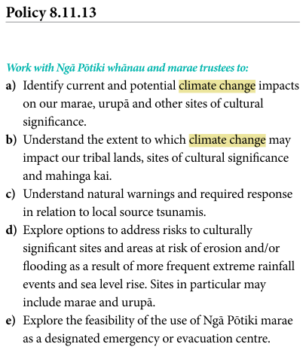 | 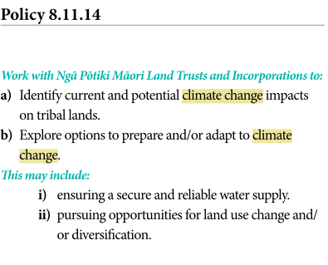
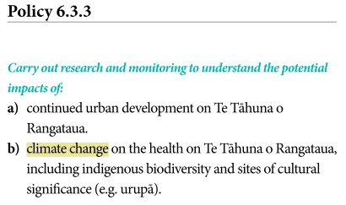 | 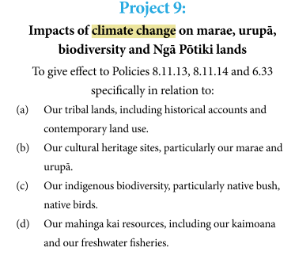
Figure 39: Project 10 and its corresponding climate change policies, from Tūhoromatanui – Ngā Pōtiki Environmental Plan (2019–2029)
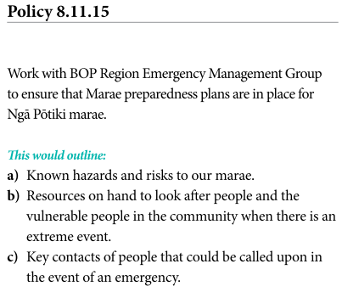 | 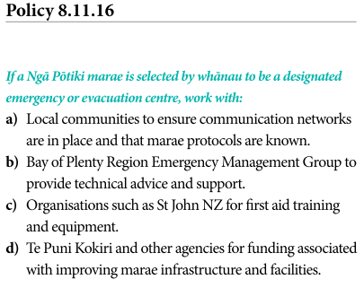
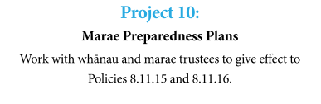
The Ngā Tikanga mo te Taiao o Ngāti Hine – Ngāti Hine Iwi Environmental Management Plan 2008 outlines the direct impacts of climate change, such as its negative effects on the health and wellbeing of Ngāti Hine, the increasing severity and frequency of extreme events, ocean acidification, the reduction or extinction of indigenous flora and fauna, and the increasing pressure on infrastructure in coastal settlements. The IHMP outlines actions that mainly focus on taking advantage of opportunities that the changing climate may provide. For example, Ngāti Hine aim to:
- replace exotic forests with native forests to take advantage of carbon credits
- identify new business and investment opportunities to have climate change work to their advantage
- take advantage of a warmer and wetter climate in Northland to restore and enhance natural wetlands, waterways and freshwater fisheries.
Observations – climate change
IHMPs are increasingly including policies and guidance about natural hazards and the potential impacts of climate change (eg, preparedness and adaptation).
Plans tend to:
- focus on strategic engagement and collaboration
- express an intent to build knowledge and understanding of risks of climate change at a local level
- focus on the restoration and protection of indigenous ecosystems including mahinga kai from the effects of climate change
- express an intent to understand and maximise economic opportunities associated with climate change.
- have policies that refer to building and planning for climate change resilience.
The “Marae Preparedness Plan” spells out opportunities for collaboration regarding climate change with entities such as Civil Defence and its Emergency Management Agency. Marae are a focal point for whānau, hapū and iwi. Notably, during significant storm events, when rural areas become isolated, it is usually a marae that becomes the evacuation and/or rescue centre for the wider community because marae have wharenui and established wharekai to support considerable numbers of people. Correspondingly, IHMPs could advocate for marae and haukāinga to be funded and supported to be ready in such events.

Mahinga kai
Mahinga kai is well referenced in the IHMPs, with 75 per cent mentioning or addressing it; the only terms having more references are ‘taonga’ and ‘whenua’. Of note is the fact the five plans with the most frequent references to mahinga kai all whakapapa to Ngāi Tahu and Te Waipounamu.
While technically not an IHMP, the Waihora Joint Management Plan – Mahere Tukutahi o Te Waihora 2005 provides an insightful description of mahinga kai resources and discusses many of the issues mentioned in the IHMPs. The plan states, that for Ngāi Tahu:
Te Waihora is a tribal taonga, a resource traditionally used by the whole of Ngāi Tahu Whānui. The rights to these resources were shared by many different hapū, each with access to the shore of the lake closest to their takiwā, through wakawaka (family gathering sites) and the traditional practices of manaaki, kai hau kai and networks of whakapapa.
As a mahinga kai, Te Waihora provided fish and shellfish, was a birding ground for many species and was the gathering place for numerous plant and other natural materials. The swamps provided raupō and harakeke and Kaitorete Spit provided fish, pingao and other plant species. Mahinga kai resources include trees for whare and waka (buildings and canoes); plants and animals used as tohu (signs) for fishing and planting times; rongoā species (medicines) and kai (food); feathers and plant fibre for weaving; mud and soils, tree bark and berries for dyes; and plant seeds for oil. Materials such as bone, shells, wood and stone were also used to produce taonga and other everyday tools. The resources are taonga because they enabled and sustained life in the harsh southern environment and constituted a major food source of the area. Of all the resources gathered at Te Waihora, the plentiful fish, particularly tuna and pātiki, were most valued.
This description reveals the breadth of the physical resources, tikanga and corresponding mātauranga that are related to mahinga kai. In doing so, it demonstrates the significance of mahinga kai in te ao Māori, and the importance of strong mahinga kai-related provisions in IHMPs.
Examples of mahinga kai-related objectives in the plan include:
- The rangatiratanga and kaitiaki of Ngāi Tahu are upheld by Ngāi Tahu and respected by the Department [of Conservation] within the management of Te Waihora.
- Ngāi Tahu management within Te Waihora is in accordance with tikanga and kawa.
- Te Waihora is recognised and supported as a mahinga kai.
- Ngāi Tahu have access to, and use of, a plentiful supply of high quality mahinga kai from Te Waihora.
Many methods are identified in the plan to give effect to the aspirations of Ngāi Tahu for Te Waihora. An example of a method that seeks to build identity, capacity and capability of the kaitiaki of Te Waihora reads:
Support the development and implementation of a complementary system of tangata tiaki to enable Ngāi Tahu to assist in the expression of rangatiratanga over Te Waihora in the gathering of food and other natural materials.
Whakarongotai o te moana, Whakarongotai o te wā – Kaitiakitanga Plan for Te Ātiawa ki Whakarongotai 2019 is a North Island IHMP with several references to mahinga kai. The deep relationship of this cultural concept to whakapapa is presented in Te Atiawa terms:
Whakapapa is also felt through our connection to certain mahinga kai species, sites and customary practices … The activity of mahinga kai is a central part of our way of life, and going out as a family to special places to fish or camp renews those whakapapa connections to place, to the atua and to each other. Our whakapapa connections across neighbouring iwi have also always provided us with the ability to access sites outside our own rohe, and share resource.
In terms of this plan’s structure, mahinga kai is embedded throughout, being present in “ngā huanga” (objectives) and “ngā tikanga” (policies) and “five-year priorities” (methods/actions) for the various plan categories. These categories include provisions that relate mahinga kai to whakapapa, wairua, te ao Turoa, mana, maramatanga and mauri.
A huanga in the whakapapa category reads “All generations enjoy harvesting and eating mahinga kai”. Tikanga listed to achieve this objective are:
H. Gathering, preparation, cooking and eating of mahinga kai is provided for and taught.
I. The use of traditional natural foods, fibres, medicines and other resources is provided for, supported and encouraged.
J. Tamariki and rangatahi are familiar with mahinga kai and are taught to appreciate our traditional delicacies.
M. Wānanga are held to learn our histories, waiata, te reo, tikanga, mahinga kai, rongoā [medicines], etc.
This plan sets out five-year priorities in the methods section to give effect to the tikanga related to whakapapa and mahinga kai, including:
Any wānanga or learning opportunities such as Hui Rangatahi will include opportunities for teaching and experiencing traditional practices such as rongoā and mahinga kai.
Environmental monitoring and natural resource management work carried out by the Trust will prioritise attention to species and sites that support traditional customary use practices.
The Charitable Trust will develop initiatives that promote the enjoyment of mahinga kai.
Te Ātiawa ki Whakarongotai also provides a list of mahinga kai species significant to them (see figure 40).
Figure 40: Mahinga kai species important to Te Ātiawa ki Whakarongotai — from Whakarongotai o te moana, Whakarongotai o te wā – Kaitiakitanga Plan for Te Ātiawa ki Whakarongotai 2019
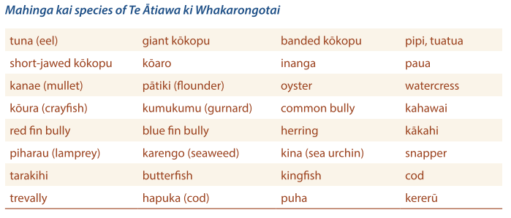
The plan structure is clear and logical, as evidenced by some of the key objectives that relate mahinga kai to mauri:
a) Land, waterways and mahinga kai are healthy, clean and free of pollutants.
d) Mahinga kai is abundant.
e) Mahinga kai tastes delicious.
f) Biodiversity is strong in that the full suite of mahinga kai species can be found in our catchments.
h) The vitality and health of people is strong.
Corresponding tikanga include:
e) Ensure there is adequate flow in waterways to sustain diverse and abundant mahinga kai.
f) Protect, maintain and enhance all mahinga kai sites, including through reseeding stocks.
g) Prevent mahinga kai species from being exposed to contaminated sites.
i) Feed our people with clean, safe and delicious mahinga kai from our rohe.
And finally, the five-year priority for mauri related to mahinga kai is that “Land, waterways and mahinga kai are clean and free of pollutants”.
Observations – mahinga kai
Plans emphasise the importance of reconnecting with, and enhancing, mahinga kai and the associated mātauranga.
Whakapapa connections are highlighted in the IHMPs, as is the relationship of mahinga kai with cultural identity and wellness. A good example of whakapapa connections with mahinga kai is the poukai every year in the Waikato-Tainui area. One marae is known for pātiki (flounder) and it is an expected delicacy. However, the presence of pollutants in Te Manuka o Hotunui (Manukau Harbour) can render this resource unavailable, and potentially impact the mana of the iwi and/or hapū, and the marae.
IHMPs identify the need to explore opportunities to rebuild capability and capacity to support kaitiaki monitoring programmes.
IHMPs promote the consideration of the use of cultural indicator frameworks and a role for mātauranga-based monitoring.
Mahinga kai is not in isolation, as it is the whenua, wai, hau, moana, among other things, and can include customary practices, including rāhui.

Fisheries and aquaculture
Aquaculture as a theme is addressed in almost half of the IHMPs, although this is a low level of referral compared to other themes. Several plans demonstrate that aquaculture is seen as a way to enhance Māori economic development and generate sustainable income streams for hapū and whānau. One such plan is Te Rautau –Te Rāhui Taketake – Ngāti Whakaue ki Maketu Hapū Management Plan 2018–2028, which describes the hapū aspirations for land-based aquaculture, seaweed aquaculture and hapū-led aquaculture in accordance with tikanga. One interesting issue that Ngāti Whakaue raise about aquaculture development in their rohe is a potential inability to access geothermal water and/or heat for “greenhouse kai production or land-based aquaculture”. Accessing geothermal energy, a traditional resource, is a unique place-based indicator of whakapapa in this plan.
Objective 12 seeks to “restore and sustainably manage our taonga fish, shellfish and seaweed species to, in turn, enhance our cultural, social and/or economic wellbeing”. Examples of supporting but internal-facing policies state the hapū seek to work with the Maketu Taiāpure Committee to “determine where to focus kaimoana restoration efforts within the Maketu Taiāpure [and] discuss aspirations for aquaculture (ie, seaweed, agar) within the Maketu coastal area” Policy 12.9 is more comprehensive and outward facing, directed towards the Bay of Plenty Regional Council and the Ministry for Primary Industries:
Provide for, and enable, hapū-led aquaculture that is sustainable and in accordance with tikanga Māori, particularly where:
- alternative opportunities to enhance Māori development are limited;
- to revitalise past practices (eg, agar production);
- there are opportunities to grow our knowledge base and up skill our labour force;
- there are opportunities to supplement or complement natural fish, shellfish and seaweed stocks.
The IHMP promotes Project 18 to implement the above policies. This project updates a 2009 Aquaculture Feasibility Study, and proposes that it:
Takes into account changes since 2009 (eg, new regional coastal plan, updated Bay of Plenty aquaculture strategy).
- Confirms hapū aspirations.
- Confirms the steps needed to progress 1-2 pilot projects within our rohe. This includes:
- Species to be grown (eg, tuna, koura, seaweed) and associated habitat requirements.
- Method (eg, coastal, freshwater or landbased), scale (eg, small scale / marae use or commercial use) and associated infrastructure requirements.
- Planning requirements and permissions for research/pilot study, development and processing (i.e. from regional council, district council, Ministry for Primary Industry and Department of Conservation)
Lastly is Project 19, a Seaweed Pilot Project to grow karengo (southern laver/Porphyra columbina) and/or produce agar (pia whakatipu). This project demonstrates the potential for context-specific economic development in the coastal marine area and the intent for Ngāti Whakaue ki Maketu to maintain their historical associations, practices and traditional economies.
Aquaculture provisions are also contained in Te Uri o Hau Kaitiakitanga o te Taiao 2011. This early plan sets out specific provisions and management needs associated with both the customary rights of the iwi and commercial aquaculture in its rohe. The customary rights were recognised by way of a settlement, as described below:
As part of the Te Uri o Hau Claims Settlement Act, the Crown agreed to restore to Te Uri o Hau access to traditional foods and food gathering areas. In particular, the cultural redress package recognised the customary non-commercial relationship between Te Uri o Hau [and] oysters within the existing Māori Oyster Areas of the Kaipara Harbour.
The corresponding objective in the plan advocates: “Effective customary harvesting and management of Te Uri o Hau Māori Oyster Reserves within the Kaipara Harbour by tangata whenua/ahi kā.” Proposed methods include collaborating with controlling agencies, and hapū and/or iwi, as well as “working with kaitiaki/ahi kā to ensure they are empowered through resourcing to sustainably manage and harvest the Māori Oyster Reserves”
Other aquaculture provisions in the plan include a specific section related to shellfish farming and aquaculture. The vision of Te Uri o Hau in this regard is stated as “The provision of sustainable economic stability for Te Uri o Hau in shellfish farming and aquaculture to provide for growing demand for shellfish resources nationally and internationally”. Supporting policies promote the establishment of aquaculture ventures in the statutory area of Te Uri o Hau, and proposed methods to do so include that “Te Uri o Hau will develop current marine farming licences and diversify shellfish farming and aquaculture opportunities seeking expertise and capital with potential joint venture partners”
A final example is the Patuharakeke Hapu Environmental Management Plan 2014. The plan states that Patuharakeke have specific rights and interests in where and how aquaculture takes place in their rohe. The plan acknowledges that aquaculture can have adverse effects on their values, specifically on their “cultural landscapes and seascapes, mahinga kai and other taonga species” It also identifies the potential of sustainable aquaculture to contribute to the cultural, social and economic wellbeing of Patuharakeke.
Several policies in the plan relate to Patuharakeke having a role in decision-making through engagement on aquaculture development in their rohe, including the allocation of marine and land space. An interesting policy aimed at economic value creation is Policy 9.9.3 (c), which states “When any sustainable aquaculture ventures are agreed to within our rohe moana, Patuharakeke will share tangible economic benefits” Policy 9.9.3 (e) is also of note in that it seeks collaboration to explore “ways of developing marae-based or customary aquaculture (eg, for non-commercial purposes such as to support, enhance, restore and supplement existing/depleted mahinga kai)” Thus, Patuharakeke see aquaculture in terms of its economic, social, cultural and environmental potential, and have developed policies that are aimed at leveraging opportunities, not just policies aimed at mitigating environmental effects.
Observations – Aquaculture
Policies advocate seeking economic, social and cultural opportunities as well as providing a framework for managing environmental effects.
Some IHMPs express an intent to explore and engage with whakapapa-based innovation.
Some IHMPs promote the use of natural resources for commercial purposes (ie, geothermal), to support aquaculture initiatives.
Connections are made between aquaculture development and the potential for adverse effects on cultural landscapes and seascapes.
Some IHMPs identify the links between aquaculture and customary resources such as mahinga kai, and the potential to combine these for the benefit of the community.
Some IHMPs direct developers to engage with mana whenua during the development, feasibility assessment and implementation phases of aquaculture projects.
Some IHMPs raise the need to support initiatives to build iwi and hapū roles as kaitiaki to restore and replenish resources in their area for marae, iwi and hapū needs.
Some IHMPs identify opportunities for capability building and other ideas via kaupapa-specific plans involving a Crown agency and iwi and/or hapū (eg, plans such as the Tai Timu Tai Pari Sea Change Hauraki Gulf Marine Spatial Plan, which was led by the Hauraki Gulf Forum, a statutory body created to promote and facilitate the integrated management and the protection and enhancement of the Hauraki Gulf Islands).
Mapping areas of existing aquaculture and of proposed customary or marae-based aquaculture could be useful for future spatial planning. Such maps could also indicate which areas are more or less appropriate for different kinds of aquaculture.

Papakāinga development
Several plans identify aspirations for papakāinga (tangata whenua housing) developments to respond to the housing needs of whānau and kaumatua. Such developments are seen to provide opportunities for whānau to reconnect and return to their ancestral lands, and regenerate tribal areas socially, culturally and economically. The IHMPs recognise the potential of papakāinga housing developments to alleviate the problem of substandard housing for iwi, hapū and whānau. Yet iwi like Ngati Rehua, in their Ngāti Rehua Ngātiwai ki Aotea Trust Hapū Management Plan 2013, point to obstacles in the development of papakāinga housing in their rohe, despite having sufficient land resources available for development. Obstacles such as access to funding and overly restrictive planning and consenting regimes are identified, as is the cost-prohibitive expense of providing infrastructure for such developments.
In terms of plan objectives, several plans aspire to a system that enables papakāinga development in the iwi or hapū rohe. For example, the Rising above the mist – Te Aranga Ake I Te Taimahatanga Ngāti Tahu – Ngāti Whaoa Iwi Environmental Mangaement Plan 2019 sets a short-term goal to have papakāinga development options included in district plans and a long-term goal to have “papakāinga land developments established and thriving.” This expression of a strategic intent by Ngāti Tahu and Ngāti Whaoa – to influence the planning system – in the IHMP is an initiative that could be of value for all future IHMPs.
Aspirations that view papakāinga development through an environmental and social lens are found in Te Rautaki Tāmata Ao Turoa o Hauā – Ngāti Hauā Environmental Management Plan 2018 (see figure 41). The plan presents a range of papakāinga centred aspirations and priorities of relevance to Waimakariri Marae.
Figure 41: Waimakariri Marae aspirations and priorities that relate to papakāinga, from Te Rautaki Tāmata Ao Turoa o Hauā: Ngāti Hauā Environmental Management Plan 2018.
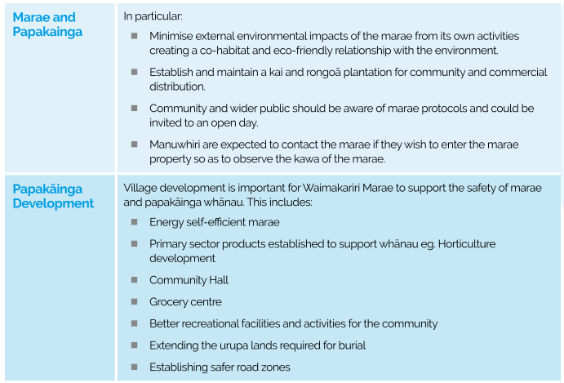
Several other plans also include policies with initiatives targeted at papakāinga and housing developments, including the examples shown in Table 3.
Table 3: Papakāinga policy provisions taken from three different IHMPs.
IHMP | Plan papakāinga-related policy
Matakana and Rangiwaea Islands Hapū Management Plan 2017 | “explore ways to fund infrastructure, power, water and wastewater systems for papakāinga”.
Whakamarohitia ngā wai o Waikato – Te Arawa River Iwi Trust Environmental Plan 2015 | “ensure that Te Arawa River Iwi are not unfairly disadvantaged in relation to papakāinga and Māori land development. This includes zoning and access to water”
Te Uri o Hau Kaitiakitanga o te Taiao Plan 2011 | “Sustainably manage and use natural resources while providing for adequate housing infrastructure and population growth within the statutory area of Te Uri o Hau”
A policy in the Whatitiri Hapu Environmental Plan 2016 states that “Papakāinga developments initiated by whānau will be supported to facilitate the resettlement and re-association of tangata and whenua”. The next component of this policy is interesting: “Council control of papakāinga should be confined to matters of health and safety and should not require contributions of land”. This statement refers to the contested issue of rating of Māori land and development contributions, and expresses the iwi and hapū intent for tino rangatiratanga or self-determination of their own matters, as it relates to ancestral lands, and as guaranteed by Te Tiriti.
Te Rautau Te Rāhui Taketake – Ngāti Whakaue ki Maketu Hapū Management Plan 2018–2028 has a compact section defining hapū objectives, policies and actions regarding the hapū housing aspirations (see figure 42). It is a good example of a simply presented, yet comprehensive, consideration of Ngāti Whakaue housing-related visions, needs and proposed actions.
Figure 42: Issues, objectives, policies and projects clearly set out in Te Rautau Te Rāhui Taketake – Ngāti Whakaue ki Maketu Hapū Management Plan (2018–2028) developed by Ngāti Hangarau
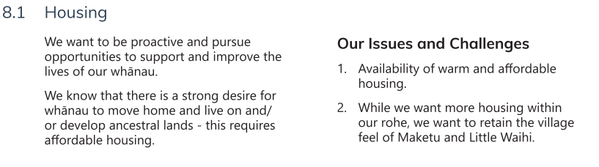
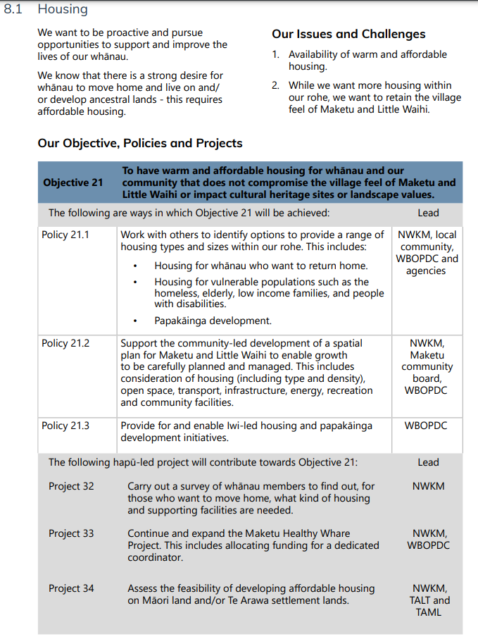
An approach that is potentially valuable for other IHMPs is taken in Te Koikoi Kararo – Ngāti Hangarau Hapū Management Plan 2021, which highlights the role of an existing designated special-purpose zone called the ‘Ngāti Hangarau Rural Marae Community Zone’ (figure 43). The zone enables “marae-based activities, higher density residential housing as well as health, education, and social services”. The plan communicates the overall intent for their relevant land blocks to be:
Our people have aspirations to return and build on whānau land. This Plan encourages and supports whānau who want to move home. We also want to retain the rural feel and character of the area. Careful and strategic planning is needed to ensure that we balance both aspirations, so that development happens in the right place and in the right way.
The plan presents objectives, several policies and priority actions to guide hapū aspirations in a table format, as seen in figures 44 and 45.
Figure 43: A unique Rural Marae Community Zone, as found in Te Koikoi Kararo – Ngāti Hangarau Hapū Management Plan 2021
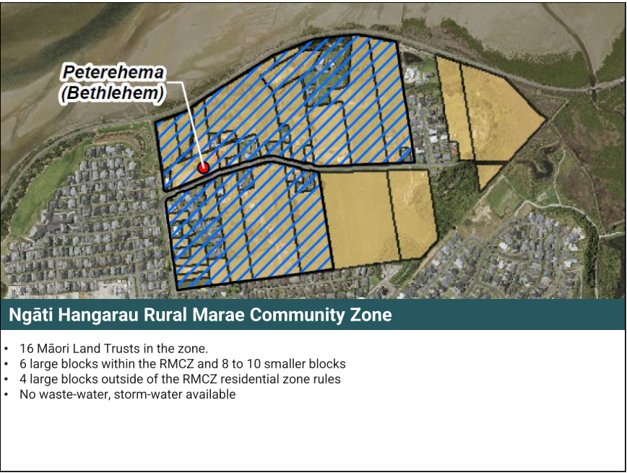
Of note is the mention that the Rural Marae Community Zone is not serviced for wastewater and stormwater. The IHMP includes a statement that appears to seek to influence local authority decision-making in favour of infrastructure servicing of the area. Specifically, one policy states an intent for hapū rangatiratanga in decision-making over infrastructure servicing of hapū land.
Figure 44: Example of policy provisions for the development of whānau land in Te Koikoi Kararo – Ngāti Hangarau Hapū Management Plan 2021 (1/2)
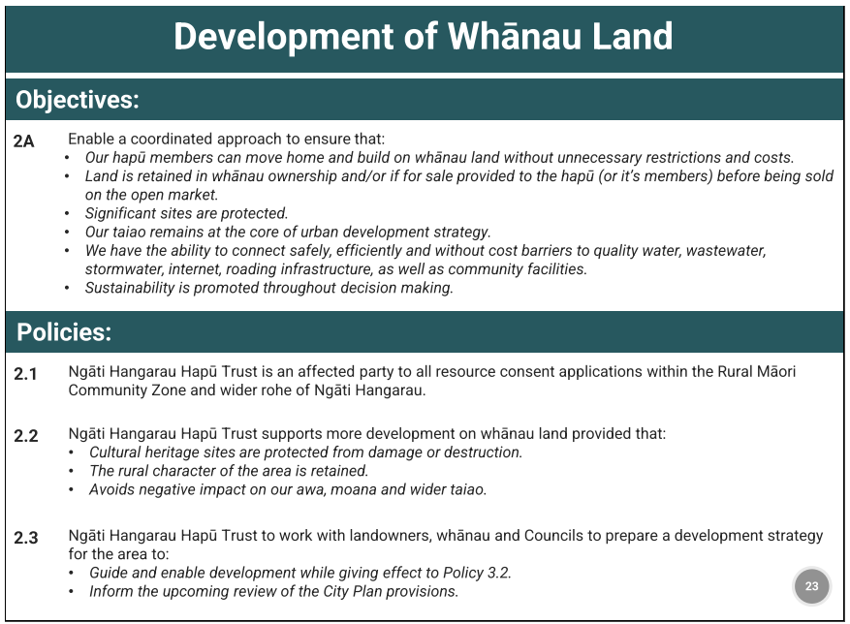
It is apparent in this plan that while development is not unwanted, amenity and cultural heritage values need to be acknowledged and respected and are best addressed through a strategic planning process.
Figure 45: Example of policies and actions for the development of whānau land in Te Koikoi Kararo – Ngāti Hangarau Hapū Management Plan 2021 (2/2)
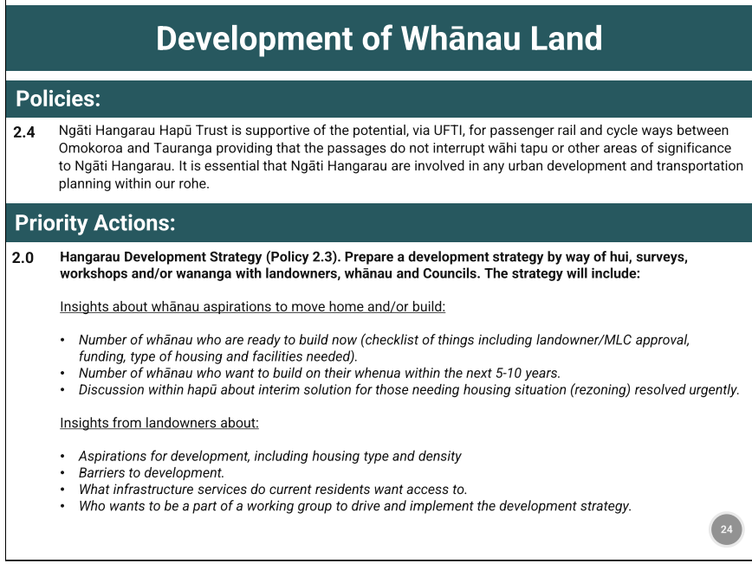
Observations – papakāinga development
Creating dedicated marae or papakāinga zones may be of value to influence and inform decisions affecting supporting infrastructure, proposed density and built-form matters.
Several IHMPs suggest there is a need to better understand the opportunities afforded by papakāinga and associated housing initiatives, and the extent and breadth of the needs they might address.
Some IHMPs identify the planning regime, infrastructure costs and infrastructure availability as barriers to papakāinga development.
Some IHMPs also identify providing papakāinga as a means to address housing issues and reconnect with tribal and hapū lands.
There are a growing number of council district plans that include provisions for the development of papakāinga on Māori land, on Treaty settlement land and/or on general land where it can be demonstrated that tangata whenua have ancestral land and/or connections.
Central government-led initiatives to enable the creation of papakāinga need to be coordinated across agencies such as Kāinga Ora, Te Puni Kokiri and Te Taupapa Kura Kāinga – Ministry of Housing and Urban Development (HUD), to support development and remove barriers to achieving papakāinga aspirations. IHMPs can signal the need for closer relationships with, and engagement by, these agencies.
Spatial planning presents an opportunity to identify infrastructure needs and influence strategic priorities as they relate to papakāinga.

Infrastructure
Almost 70 per cent of the plans mention infrastructure. Reoccurring themes include:
- the ongoing pressure for infrastructure expansion associated with urban growth and its associated effects
- inequitable access to infrastructure
- inadequate infrastructure negatively affecting water quality
- lack of engagement of iwi and hapū on infrastructure projects.
The Ko Tā Maniapoto Mahere Taiao – Maniapoto Environmental Management Plan 2018 contains a thorough section on infrastructure and industry. For Maniapoto, infrastructure includes but is not limited to:
- transport (roads, state highways, railway lines and airﬁelds)
- energy generation (coal mines, natural gas pipelines and hydro dams)
- electricity transmission (high voltage lines, pylons and underground lines)
- telecommunications (cell phone towers, transmission towers and underground ultra-fast broadband)
- solid and hazardous waste (landﬁlls, rubbish dumps and storage facilities)
- water services (water treatment plants and pipelines), wastewater infrastructure (wastewater treatment plants, stormwater systems and pipelines)
- natural hazard infrastructure (ﬂood protection, drainage schemes, coastal defence works and structures).
Of note is that this IHMP is the only one of approximately 100 that also uses and defines “social infrastructure”:
- public housing, hospitals, schools, prisons, cemeteries and police stations
- public facilities (swimming pools, libraries, halls, event centres, sports grounds, parks and reserves, and carparks)
- marae, papakāinga, urupā, Māori reserves, kōhanga reo, kura and wānanga.
Table 4 summarises a selection of infrastructure-related issues that iwi and hapū have raised in their plans, and table 5 presents the policy responses to those issues.
Table 4: Example of infrastructure-related issues
IHMP | Issues
Kāi Tahu ki Otago Natural Resources Plan 2005 | - Potential for adverse effects of infrastructure and utility expansion on their taonga, including their cultural landscapes.  - The loss of mahinga kai.  - Inadequate coastal sewerage infrastructure.  “The hydro infrastructure on the main stem of the Clutha/Mata-au has forced mahika kai into the tributaries. Modification of these tributaries by land use change and more recently land use intensification adds to the loss of mahika kai.”
Te Awanui Tauranga Harbour Iwi Management Plan 2008 | Describes the adverse impacts of infrastructure on their fisheries and kaimoana taonga.
Patuharakeke Hapu Environmental Management Plan 2014 | “The right to reside on, use and develop Māori land is constrained by land zoning rules, housing density rules, provision of infrastructure and services, and multiple ownership.”  “Developers have not contributed to the true cost of providing infrastructure and services for new development, leaving the existing communities to carry the shortfall. There have been occasions where the infrastructure provided as part of large-scale developments has been substandard.”  “ … times where the council has deliberately pursued a solution which we find unacceptable (eg, an ocean outfall as part of the Ruakaka Long Term Wastewater Treatment Plant Consent).”
Mahaanui Iwi Management Plan 2013 | “There can be signiﬁcant cultural issues associated with the unnatural mixing of water between and within catchments.”

Table 5: Wai-related policies in various plans associated with the issues in table 4
IHMP | Policies
Kāi Tahu ki Otago Natural Resources Plan 2005 | Re: Wai Tai and Wai Māori:  “To promote best practice methods for waterway, river and harbour works that:  - provide for fish passage at all times  - minimise sedimentation during proposed works  - minimise the risk of contaminants entering any waterway.”  “To encourage the development of sewerage infrastructure to receive and treat all wastewater discharge from tourist vessels.”
Te Awanui Tauranga Harbour Iwi Management Plan 2008 | For the following overarching objective: “To reduce the impacts on cultural values resulting from infrastructural development in, on or near Te Awanui” the policies relating to it include:  - “to avoid any alteration or reclamation of any wetland or harbour space of Te Awanui during all roading or road related works near the harbour  - to provide preventative measures in the form of restoration and enhancement to avoid any effects of coastal erosion resulting from infrastructural activity near Te Awanui and/or its tributaries  - to avoid adverse effects on culturally important areas, including waterways and culturally important landscape features as a result of works, including the storage and or disposal of spoil as a product of works.”
Patuharakeke Hapu Environmental Management Plan 2014 | “a) Patuharakeke will participate fully in all decision-making processes of agencies over planning for, development and management of utilities, amenities and infrastructure within our rohe. Such participation should commence at the outset of any planning or business cycle.  b) Innovative means of providing for infrastructure should be encouraged, eg, farming of algae for biofuels on sewerage treatment ponds, effluent disposal to support indigenous forestry.  c) New developments should be levied to pay the full and true cost of infrastructure.”
Mahaanui Iwi Management Plan 2013 | Wai Māori Policy 10.2 – “Water infrastructure proposals that will result in the unnatural mixing of waters will be assessed by Papatipu Rūnanga on a case-by-case basis, allowing for consideration of:  (a) the varying perspectives of diﬀerent hapū to the unnatural mixing of waters in their takiwā;  (b) the current state of water quality, water quantity, indigenous biodiversity and other cultural values within particular waterways; and  (c) diﬀerent mixing scenarios, including provisions to avoid or mitigate cultural issues and/or provide cultural beneﬁt.”
Returning to the Maniapoto IHMP, the plan describes two social infrastructure-related issues:
22.2.6.1 There has been an inequitable distribution of resources to support Maniapoto social infrastructure, such as, supporting the development of papakāinga, urupā, Māori reserves, kōhanga reo, kura and wānanga. Historically, Maniapoto has contributed extensive lands for community development and beneﬁt. Typically, this contribution has not been reciprocated.
22.2.6.2 There is a general lack of Maniapoto identity, culture and visibility in landscape and urban designs within Maniapoto rohe and community developments. Maniapoto participation in community planning and development will ensure Maniapoto values are recognised and acknowledged.
They are addressed in a corresponding objective and policy, and actions, as shown in figure 46.
Figure 46: An example of provisions, policy and umbrella objective regarding social infrastructure in the Ko Tā Maniapoto Mahere Taiao – Maniapoto Environmental Management Plan 2018
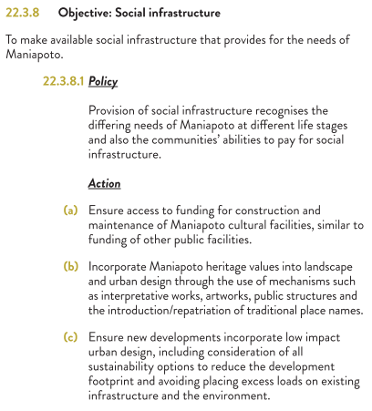
Observations – infrastructure
Infrastructure is frequently mentioned in IHMPs, although some interpretations of what constitutes infrastructure are broader than others eg, social infrastructure is raised in some plans and not others.
Including social infrastructure is not common in IHMPs, however, its inclusion may prove an effective way to achieve outcomes.
There is an emphasis on avoiding the detrimental effects of infrastructure on taonga, water and landscapes. For example, infrastructure policies developed by Kāi Tahu have been picked up by district plans through wāhi tūpuna mapping, which signals where infrastructure could be a threat to the values in each of the landscapes, and triggers cultural assessments to address this.
IHMP perspectives on infrastructure highlight existing inequities in access to, and resourcing for, infrastructure.
Infrastructure issues regarding stormwater or wastewater discharge to taonga resources, such as outfall pipes terminating to moana, awa (river) or repo (wetland), should be clearly stated in an IHMP. The Ngāti Whakaue ki Maketu Hapū Management Plan 2018–2028 is a good example of a clear and direct policy reference: “Policy 9.1 Oppose the direct discharge of contaminants, especially wastewater, to coastal waters”.
Insufficient infrastructure capacity is affecting new housing and/or intensification developments. Some councils don’t have sufficient funding to upgrade their existing infrastructure. IHMPs should state their creators’ preferred outcomes for housing or commercial development, and how they seek to work with specific agency partners to enable infrastructure outcomes.

Tourism
Tourism is mentioned in over 60 per cent of the plans. Te Poha o Tohu Raumati -Te Rūnanga o Kaikōura Environmental Management Plan Te Mahere Whakahaere Taiao o Te Rūnanga o Kaikōura 2007 states that: “Tourism can have both positive and negative impacts. ‘Smart tourism’, such as ecotourism, can enhance and complement our communities and the natural environment.” Tourism objectives and policy provisions tend to convey three key themes:
- the management of the effects of tourism activities on the environment
- capturing and managing opportunities for iwi, hapū and whānau through tourism initiatives
- the need for authentic engagement with mana whenua.
The effects of tourism are recognised in both Te Tangi a Tauira – Ngāi Tahu ki Murihiku Natural Resource and Environmental Management Plan 2008 and Te Poha o Tohu Raumati –Te Rūnanga o Kaikōura Environmental Management Plan Te Mahere Whakahaere Taiao o Te Rūnanga o Kaikōura 2007, which identify the pressure placed on community infrastructure as a result of tourism.
A closer look at the Whakatakoto kaupapa mo te Hapu o Ngati Kuta ki Te Rawhiti – Ngati Kuta ki Te Rawhiti Hapu Management Plan 2004, a comparatively early IHMP, reveals a concentration of tourism-related references. The plan contains a dedicated section on tourism, which is not surprising given the hapū rohe includes Russell, a tourism destination at Kororāreka in the Bay of Islands. The plan states that “The islands and adjacent undeveloped aspects of the coastline are very precious jewels within the area and are the prime attraction for tourists. Such jewels require the uppermost respect and care.” The main policy response focuses on protection of the islands and coastline, and associated values, through working with the Department of Conservation and other agencies. Of note is the plan’s call for targeted research on fish stocks and tourism impacts to further develop hapū economic capabilities through tourism.
Te Poha o Tohu Raumati – Te Rūnanga o Kaikōura Environmental Management Plan Te Mahere Whakahaere Taiao o Te Rūnanga o Kaikōura 2007, mentioned above, contains the most references to tourism of all the IHMPs. The plan discusses Kaikoura, a high-volume tourism destination susceptible to the environmental and economic impacts of tourism activities. Specific issues – identified as “Ngā Take” in the plan include:
- increasing numbers of tourists and the impact on environment
- existing camping grounds along State Highway One are largely in areas of significance to tangata whenua; some are wāhi tapu
- public access to private property (Māori land)
- waste discharge from campervans
- coastal camping and impacts on coastal environment
- impacts of tourism on waterways (eg, camping)
- ability of local community infrastructure to handle increased pressure from tourism (rubbish and water)
- litter on beaches
- location and upkeep of access tracks
- impact on mahinga kai, particularly kaimoana (taking above limits).
Several policies focus on mitigating the effects of tourism, as expected. However, of interest are two policies related to the need for engagement with, and respect for the mana of, mana whenua in the tourism industry. Firstly,
Interpretation and information relating to Ngāi Tahu history, values, traditions or beliefs (including place names) is not to be provided to any clients as part of any commercial guiding and interpretation activity unless the interpretation and information is agreed to by Te Rūnanga o Kaikōura as being appropriate and accurate.
The second policy states:
Any interpretation and information relating to Ngāti Kuri history, values, traditions or beliefs associated with areas of significance to Ngāti Kuri is best prepared and delivered by Ngāti Kuri. When concessionaires seek to use cultural history (eg, Ngāti Kuri stories) in their operations, Te Rūnanga o Kaikōura recommends that a Rūnanga representative is employed as part of the concession activity to provide and interpret such information.
The need for authenticity and tangata whenua engagement around tourism activities is also highlighted as an issue in the Tai Tumu – Tai Pari – Tai Ao – Waikato-Tainui Environmental Plan 2013, which states:
Waikato-Tainui cultural and spiritual integrity risks being undermined through commercialisation, particularly if such commercial initiatives are not appropriately led. Waikato-Tainui is keen to ensure authenticity when tourism activities endeavour to portray cultural and spiritual perspectives within the Waikato-Tainui rohe. This is best achieved when the activity is owned, led, operated, or staffed by Waikato-Tainui tribal members with cultural and/or spiritual expertise.
In this regard, this IHMP iwi policy promotes a process for collaborative engagement between tourism operators and Waikato-Tainui.
A final example of a plan with tourism-related content is Te Uri o Hau Kaitiakitanga o te Taiao Plan 2011, which has a dedicated ecotourism section. Te Uri o Hau recognises the underutilisation of the Kaipara Harbour for its ecotourism potential. The iwi’s main objective is to: “Develop a financially feasible ecotourism plan to unlock the potential of ecotourism within the statutory area of Te Uri o Hau.” Corresponding policies promote collaboration across multiple agencies and stakeholders, and “developing a long-term profitable strategy for ecotourism utilising natural resources and sites of significance and cultural redress properties within the statutory area of Te Uri o Hau.”
Observations – tourism
Several IHMPs identify a need for more planning, research and data to understand the effects of tourism and the opportunities for tourism ventures.
IHMPs call for iwi and/or hapū place-based tourism initiatives to be valued.
Authentic and early engagement with mana whenua is a focus of several plans.
Good outcomes for mana whenua will likely depend on cross-agency and stakeholder relationships.
For effective iwi and hapū engagement, and for opportunities to be realised, significant interest areas will need to be identified in, and integrated into, overarching policy documents.
IHMPs call for tangata whenua-led tourism initiatives that involve iwi and hapū telling their stories and sharing their connections to place.

Wellbeing
Wellbeing is mentioned in approximately 80 per cent of the plans. With the exception of Tawharau o Nga Hapu o Whakatohea Iwi Management Plan 1993, only a few early plans mention it. The Whakatōhea plan identifies the following issues:
Western society and systems inherently focused on individual wellbeing as opposed to collective wellbeing. The ongoing individualisation of rights to land, water, fisheries, intellectual property and other ancestral taonga of Whakatohea, and the resulting fragmentation and inefficient use of taonga.
The cumulative adverse effects of raupatu, government laws, and other breaches of the Treaty on the social, economic and cultural wellbeing of Whakatohea and Whakatohea taonga. Accordingly, all proposals which affect Whakatohea taonga, no manner how seemingly minor, are of significance to Whakatohea.
These two issues alone demonstrate a holistic and collectivised understanding of wellbeing and an often-discussed tension between western and indigenous values. Te Whakatōhea were subjected to significant raupatu in the 1860s, which saw much of their tribal land confiscated. It is perhaps unsurprising that this plan has markedly more references to Māori land and wellbeing than many of the other plans.
The corresponding policy for the above two issues reads, “The active recognition and protection of Tino Rangatiratanga for the collective wellbeing of present and future generations of Whakatohea.”
The connection between the retention of land and wellbeing is also mentioned in the Ngai Tukairangi, Ngati Tapu Hapu Management Plan 2014, which sets out the vision statement that “Ngai Tukairangi and Ngāti Tapu will maintain ahi ka.” Ahi ka, here, allows for the practice of kaitiakitanga:
… for as long [as] our people remain on this land. We recognise that the health and wellbeing of our people is inextricably intertwined with our environment. To maintain this – as hapu, we will retain Māori land for the benefit of our people.
Several plans convey the interdependency of wellbeing with mauri, kaitiakitanga, and the health and wellbeing of the environment and tangata whenua. Again, drawing from the Tawharau o Nga Hapu o Whakatohea Iwi Management Plan 1993:
… the maintenance of the mauri is important for the health and wellbeing of all people, to maintain the vitality of culture, practices, values, and beliefs. Kaitiakitaka enshrines an obligation to safeguard the wellbeing of land, air, water, flora and fauna and biodiversity.
The Poipoia Te Ao Turoa – Ngāti Rārua Environmental Strategy 2021 is another recent plan that has a holistic view of wellbeing embedded throughout it, as part of an overarching concept of te ao Tūroa.
For Ngāti Rārua, all things are interrelated and connected by whakapapa: the divine and the human; the living and the inanimate; the past, present and future. Ngāti Rārua view all natural resources as being gifts from ngā atua kaitiaki. These spiritual guardians maintain the mauri of ngā taonga tuku iho – the treasures of the natural world – which are central to Ngāti Rārua spiritual, cultural and economic wellbeing.
The Waitaki Iwi Management Plan 2019 states that “a culturally healthy ecosystem is vital for cultural wellbeing.” Several plans drew similar conclusions and identified direct connections between wellbeing and various natural resources like water, air and mahinga kai. For example, the Tawharau o Nga Hapu o Whakatohea Iwi Management Plan 1993 states that “according to holistic beliefs, the wellbeing of water is a reflection of the wellbeing of the land, and this in turn is a reflection of the wellbeing of the Tangata Whenua, Whakatohea.” This connection between water and wellbeing is also found in an objective of the Ngā Tikanga mo te Taiao o Ngāti Hine — Ngāti Hine Iwi Environmental Management Plan 2008:
The mauri of water is protected and enhanced in ways which enable Ngati Hine to provide for our physical, social, economic and cultural wellbeing, for the generations as yet unborn, for those we host within our rohe, our plants, animals and other whanaunga.
Air is mentioned in the Ngātiwai Iwi Environmental Policy Document 2015, which states that “the quality of the air within the rohe of Ngātiwai, and thus the wellbeing of tāngata whenua and the surrounding environment, is being negatively impacted upon by emissions of contaminants.”
The plans also make clear that wellbeing is affected by factors beyond the natural world, such as education and cultural heritage. The Tawharau o Nga Hapu o Whakatohea Iwi Management Plan 1993 identifies that Crown agencies assuming ownership of Whakatōhea taonga and cultural materials, such as whale carcasses, can adversely impact iwi cultural wellbeing, thereby identifying the relationship between cultural heritage, traditional practices and thus cultural identity and wellbeing.
The relationship between wellbeing and education is drawn in Te Awaroa Ngati Kahu Hapu Environmental Management Plan 2011 where it states that “A third goal for education is linked to well-being. Education should be able to make a major; if not the major – contribution to health and wellbeing and to a decent standard of living.”
Observations – wellbeing
The IHMPs treat wellbeing holistically and identify relationships between it and cultural concepts like mauri, kaitiakitanga and whakapapa, as well as relationships with education, heritage, cultural identity and cultural practices.
Wellbeing is mentioned in a large proportion of IHMPs, but it is mentioned less than other reviewed concepts in any one IHMP.
Collective wellbeing appears to be prioritised over individual wellbeing, which is indicative of an indigenous worldview.
The IHMPs draw strong associations between wellbeing and whenua, the latter including the maintenance of access to, and retention of, ancestral lands.
Wellbeing is a concept that is being prioritised in central- and local-government policy. Inclusion of wellbeing in IHMPs, particularly wellbeing indicators informed by kaupapa Māori, will benefit hapū and iwi as it proactively frames wellbeing from the perspective of iwi and hapū.

Emerging content
Despite being an implementation tool under the RMA, IHMPs have evolved to include a diverse range of content, beyond environmental material.
Many plans include social, economic and cultural content in addition to addressing environmental matters, which speaks to the holistic worldview of te ao Māori, and is a result of the plans being drafted by, and ownership resting firmly with, iwi and hapū. Recent years have seen emerging concepts being integrated into the latest plans whereas some early concepts have been given more prominence in them. A selection of these concepts and themes are discussed below, including Te Mana o Te Wai, spatial planning, cultural landscapes, urban design and renewable energy.

Te Mana o Te Wai
Although a number of IHMPs that pre-date the term recognise similar concepts in their freshwater policies, use of “Te Mana o Te Wai” (TMoTW) as a term is relatively new in the planning system. It was introduced into secondary legislation through the National Policy Statement for Freshwater Management (NPS-FM) in 2014 and was given elevated status in the NPS-FM 2020. The NPS-FM 2020 states:
Te Mana o te Wai is a concept that refers to the fundamental importance of water and recognises that protecting the health of freshwater protects the health and well-being of the wider environment. It protects the mauri of the wai. Te Mana o te Wai is about restoring and preserving the balance between the water, the wider environment, and the community.
Therefore, when freshwater is managed, TMoTW requires that the health and wellbeing of the water is protected, and human health needs are provided for before enabling other uses of water. Only 15 per cent of the IHMPs refer to this term specifically. Notably, those IHMPs that use the term do not always relate their TMoTW policies to the NPS-FM.
Those plans that refer to TMoTW have done so in a variety of ways, some relatively superficially and with little detail on how TMoTW might be accommodated. Overarching issues associated with the concept of TMoTW are presented in Te Mahere Whakarite Matatiki Taiao Ō Ngāti Awa – Ngāti Awa Environmental Plan 2019, which provides some context in an issue statement:
The current allocation system of first in first serve does not recognise Te Mana o te Wai, nor does it allow for equitable sharing for sustainable uses. This creates an imbalance; locks out other users (particularly on underutilised Māori Land) and affects instream life and mahinga kai resources.
Iwi and hapū management plans have an important role in enabling the six principles of the NPS-FM regarding the roles of tangata whenua in the management of freshwater, and thus can inform the implementation of the NPS-FM. While not exhaustive, the following examples provide a glimpse into how TMoTW is presented in IHMPs.
The Tūhoromatanui – Ngā Pōtiki Environmental Plan 2019–2029 adopts a proactive approach and demonstrates the dual-facing role of IHMPs when referring to TMoTW. On one hand, the plan has a specific policy directed at the Bay of Plenty Regional Council to recognise TMoTW in its freshwater management, planning and decision-making. On the other hand, Policy 8.3.27 is directed at the descendants of Nga Pōtiki and encourages them to initiate a series of actions to best prepare and position themselves for the implementation of the NPS-FM (see figure 47).
Figure 47: Example of an inward-facing policy regarding Te Mana o Te Wai — from Tūhoromatanui – Ngā Pōtiki Environmental Plan 2019–2029
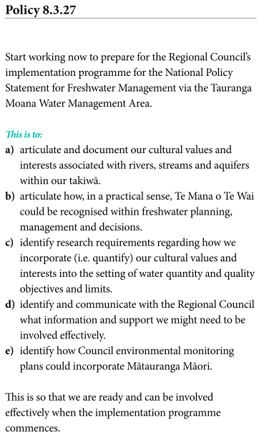
The Ko Tā Maniapoto Mahere Taiao – Maniapoto Environmental Management Plan 2018 refers to the Ngā Wai o Maniapoto (Waipā River) Act 2012, which formalises Ngāti Maniapoto co-management of the Waipā River. This Act identifies a commitment to co-governance and co-management arrangements as the “foundation for the restoration and maintenance of the Waipā River” and a purpose to “restore and maintain the quality and integrity of the waters that ﬂow into and form part of the Waipā River on behalf of present and future generations.”
The Ngā Wai o Maniapoto (Waipā River) Act 2012 established five principles for governing the Waipā River, principle one being “Te Mana o Te Wai.” Section 14.1.6 of the IHMP relates to the TMoTW principle and states that:
Te Mana o te Wai refers to the quality and integrity of the waters that sustained the physical and spiritual wellbeing of Maniapoto. The continued health and wellbeing of current and future generations and all other living things that depend on water is important to Maniapoto.
In Section 14.3.2 (see figure 48), the plan refers to TMoTW with respect to its water quality objective, policy and actions.
Figure 48: A Te Mana o Te Wai objective, policy and associated actions relating to water quality – from Ko Tā Maniapoto Mahere Taiao – Maniapoto Environmental Management Plan 2018
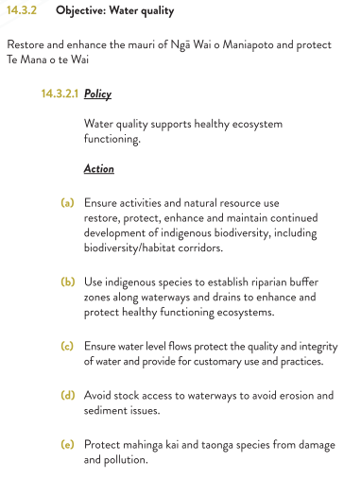
A final example is taken from the Poipoia Te Ao Turoa – Ngāti Rārua Environmental Strategy 2021, which includes a section dedicated to TMoTW. The general thrust of the IHMP’s policies and methods includes recognition of the mana of mana whenua and enhancing the understanding of a Ngāti Rārua worldview (figure 49).
Figure 49: Te Mana o Te Wai objective and supporting policies and methods in the Poipoia Te Ao Turoa – Ngāti Rārua Environmental Strategy 2021
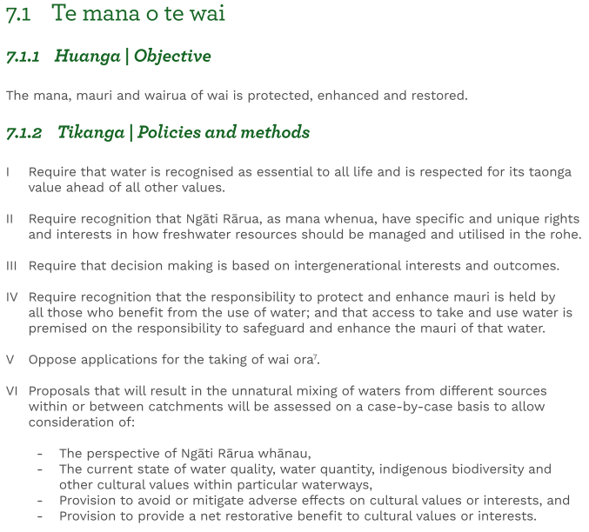
Observations – Te Mana o Te Wai
According to the NPS-FM, freshwater must be managed in a way that gives effect to TMoTW. This national policy provides a strong lever that can be used in IHMPs to promote iwi and hapū expectations for wai and freshwater management.
Although TMoTW is relatively new, the concept is not. The term itself is used in only approximately 15 per cent of IHMPs.
TMoTW is occasionally presented in IHMPs independently of references to the content of the NPS-FM or to uses of that term.
IHMPs currently establish whakapapa associations with, provide practical tools for management of, and convey iwi and hapū values for freshwater, giving shape to TMoTW.
An opportunity exists to elaborate on iwi and hapū interpretations of TMoTW when new IHMPs are drawn up or existing ones are revised. By more widely applying this concept and increasing its significance, iwi and hapū will be better positioned to partner on the implementation of TMoTW in the NPS-FM. Some IHMPs indicate that some iwi and hapū have started to seize this opportunity.

Spatial planning
Spatial plans and their associated processes are not often mentioned in the IHMPs, with only 10 per cent containing objectives and policies related to spatial planning. Those plans that do reference spatial planning are all relatively new, with the oldest plan being the Tauranga Moana Iwi Management Plan 2016–2026.
Te Pou o Kāhu Pōkere – Iwi Management Plan for Ngāti Whātua Ōrākei 2018 provides a helpful description of the iwi understanding of spatial planning and its context for Aotearoa New Zealand:
Spatial planning is a key tool for improving strategic planning, especially in terms of integrating land use and infrastructure provision. It goes beyond traditional land use planning to integrate policies for the development and use of land with other policies and programmes which inﬂuence the nature of places and how they function, for example sectoral policies such as transport, regional policy, ﬂood risk management and agriculture. It is a collaborative exercise, in which key stakeholders with an interest in use of land and allied activities work together to identify optimal solutions. Crucially, spatial planning also provides an ideal vehicle to embed mātauranga Māori and enable a true partnership approach to planning, in line with the principles of Te Tiriti o Waitangi.
The most recent plan to recognise spatial planning and its processes is the Hineuru Iwi Trust Iwi Environmental Management Plan 2022. It notes that such processes undertaken outside of the rohe may influence policies and initiatives in the rohe. The appeal for active participation in spatial planning processes is stated in one of the plan’s ‘desired outcomes’: “Hineuru should be engaged and involved in decisions on spatial planning in our rohe, and if decisions outside of our rohe will affect Hineuru.”
The potential for decisions that arise from spatial planning to impact on natural resources is raised in the Ko Tā Maniapoto Mahere Taiao – Maniapoto Environmental Management Plan 2018. The plan includes an action to “recognise the significance of and provide for wetlands in spatial planning.”
A further example is that of the Tūhoromatanui – Ngā Pōtiki Environmental Plan 2019–2029, which is unique in that it contains spatial planning-related policies for councils and Crown agencies, as well as policies for the descendants of Ngā Pōtiki. Council and Crown agencies are addressed in Policy 6.3.2, which states that they should collaborate with tangata whenua to develop a spatial plan for Te Tāhuna o Rangataua. The plan is required to be ‘Rangataua-centric’, and also needs to:
b) be action-focused and guided by tikanga and intergenerational knowledge
c) be focused on collaborative initiatives that result in noticeable improvements to:
i) water quality within Te Tāhuna o Rangataua and Kaiate Stream
ii) indigenous fish and shellfish (i.e. extent, diversity & quality)
iii) indigenous native bush (i.e. restore the ‘korowai’ of our maunga)
iv) the amount and extent of pest plants and animals within and/or adjacent to Te Tāhuna o Rangataua
v) the amount and extent of erosion of the estuarine foreshore
vi) the number and quality of discharges into Te Tāhuna o Rangataua.
Also of interest is Policy 6.3.4, which calls for support for the appointment of a dedicated position or contractor in Ngā Pōtiki to assist with implementing the above policies.
Te Pou o Kāhu Pōkere – Iwi Management Plan for Ngāti Whātua Ōrākei 2018 contains a section that is dedicated to urban design and spatial planning and, therefore, has a unique approach. Two desired spatial planning outcomes are identified, including that “Ngāti Whātua Ōrākei should be fully engaged as Treaty partners and mana whenua in spatial planning for Auckland” and that “spatial plans should be given statutory force under the Resource Management Act.”
The Tauranga Moana Iwi Management Plan 2016–2026 conveys an iwi understanding of spatial planning in the following statement:
Spatial planning is a way of identifying and mapping these values and uses; understanding where conflicts occur and developing tools to manage or address conflicts. It is about looking at Tauranga Moana as a whole, and not just the aspects that Councils have responsibility for. It provides an opportunity to work with Central Government agencies and the community to find ways to share, and care for, the coastal parts of Tauranga Moana.
Marine spatial planning encompasses matters of relevance to iwi and hapū such as those in Tauranga Moana. The Tauranga Moana Iwi Management Plan (2016–2026) recognises the collaborative nature of spatial planning. The plan’s Policy 8 relates the need to “work together to address conflicting uses and values within Tauranga Moana (including Te Awanui / Tauranga Harbour).” Given the multiple interests in the Tauranga Moana rohe, Action 8.1 details the need for support for the development of a Marine Spatial Plan for Tauranga Moana, which would:
a) involve Tauranga Moana Iwi and hapū, Mauao Trust and Tauranga Moana Iwi Customary Fisheries Trust
b) involve Central Government Agencies such as the Department of Conservation and Ministry for Primary Industries
c) seek to protect sites, areas and landscapes of significance, kaimoana areas as well as sites, areas and landscapes of significance
d) identify areas where coastal use and development should not occur. In particular, marinas and ski/jet ski lanes
e) identify potential Marine Protected Areas.
At a different scale, Te Rautau Te Rāhui Taketake – Ngāti Whakaue ki Maketu Hapū Management Plan 2018–2028 also recognises the value of spatial planning as it relates to the hapū aspirations for housing. Specifically, Objective 21 seeks to “have warm and affordable housing for whānau and our community that does not compromise the village feel of Maketu and Little Waihi or impact cultural heritage sites or landscape values.” Spatial planning is seen as a tool to achieve the above objective by way of Policy 21.2 which seeks to:
Support the community-led development of a spatial plan for Maketu and Little Waihi to enable growth to be carefully planned and managed. This includes consideration of housing (including type and density), open space, transport, infrastructure, energy, recreation, and community facilities.
Observations – spatial planning
As a concept, spatial planning is not widely referred to in the IHMPs, although several point out its value as both a process and a tool.
Spatial planning can be used at differing scales and for many different applications, including determining the future use of local, regional and marine areas. All of these scales are relevant to the interests of iwi and hapū and spatial planning will likely have an ongoing role in resource management, so it will be valuable for iwi and hapū to have the skills, tools and internal positions going into any engagement on a spatial plan.
Spatial planning processes bring together many parties and interests for the purposes of allocating areas for specific uses, obtaining and managing funding and making investment decisions. IHMPs provide an opportunity to signal iwi and hapū funding needs to support tangata whenua participation in spatial planning processes, as well as to implement strategic priorities identified through spatial planning.

Cultural landscapes
Spatial plans, regional policy statements and district plans integrate matters like land use, infrastructure, hazards, climate change and outstanding natural and culturally significant landscapes. Cultural landscapes (also referred to as ancestral landscapes or wāhi tūpuna) provide a tool for Māori cultural values at place to be identified spatially in a manner that still protects the location of specific sites. They can also illustrate connections between significant places and provide a framework for holistic management across planning topics.
Cultural landscapes are not commonly referred to in IHMPs (fewer than 30 per cent). However, one possible reason for this is the widespread use of an alternative term, ‘cultural heritage’ (used in over 60 per cent of plans). Another potential reason could be that cultural landscapes are a broad and holistic concept which is still in the early stages of being adopted into a planning system which is more focused on site-specific controls over discrete places like wāhi tapu. Recent efforts by iwi to incorporate cultural landscapes, such as in the Ngāi Tahu takiwā, have led to new frameworks for the management of significant places that do not rely on site-specific schedules. There are cases where a cultural landscape mapping in plans has resulted in Environment Court decisions supporting their protection.
Figure 50: Frequency of references to cultural landscapes in IHMPs containing the term
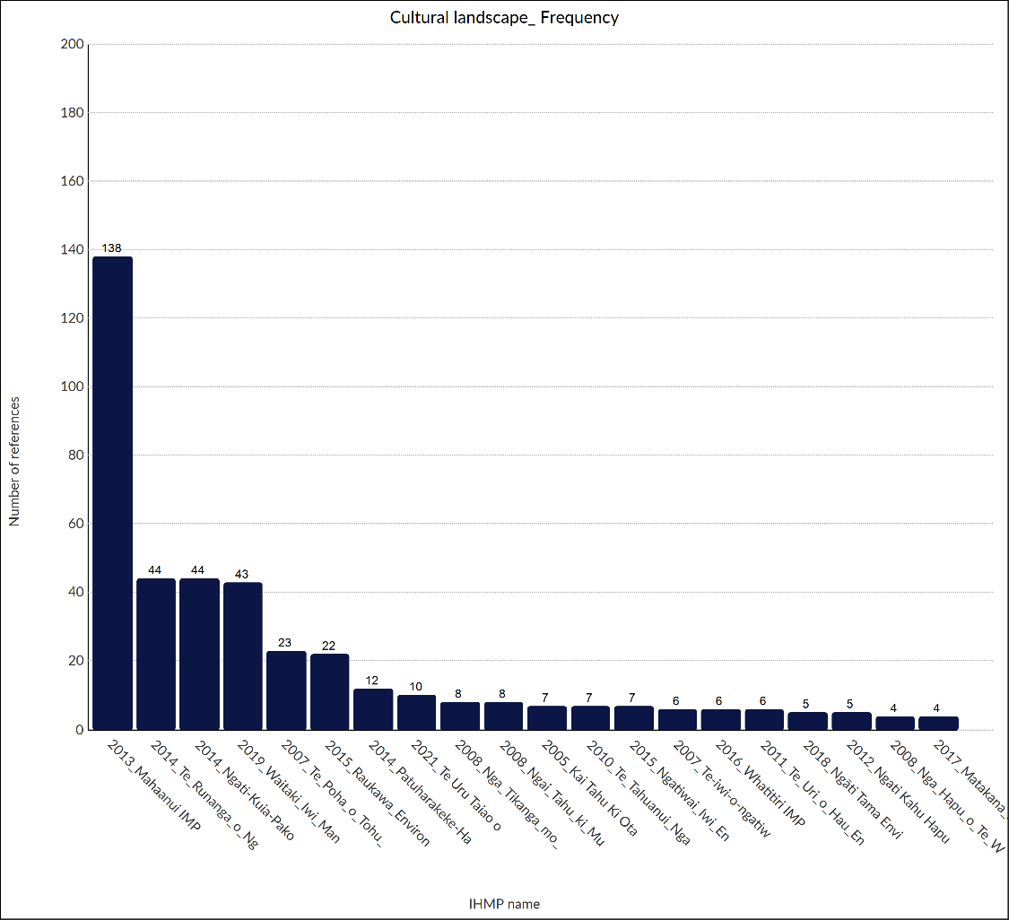
As shown in figure 50 above, the Mahaanui Iwi Management Plan 2013 references cultural landscapes the most, out of all reviewed plans. A helpful definition of the concept is included in this plan which states:
A cultural landscape is a geographical area with particular (and often related) traditional, historical, spiritual and ecological value to Ngāi Tahu. An area may be identiﬁed as a cultural landscape due to the concentration of values in a particular location, the particular importance of the area to Ngāi Tahu cultural, history or identity, or the need to manage an area as a particular landscape unit. Cultural landscapes are integral to Ngāi Tahu culture, identity and history, and are testament to relationship of tāngata whenua with the land over time. They are intergenerational: providing future generations (our tamariki and mokopuna) the opportunity to experience and engage with the landscape as their tūpuna once did.
Conceptually, cultural landscapes can include almost anything, from maunga and waterways, to coastlines and volcanic soils. For example, Te Uru Taiao o Ngāruahine – Ngāruahine Kaitiaki Plan 2021 identifies the night sky as a cultural landscape worthy of protection. The relationship between cultural landscapes and food sovereignty is also identified in that plan. Te Rautaki Taiao a Raukawa – Raukawa Environmental Management Plan 2014 signals the breadth of the concept in the statement that “for Raukawa, these areas of whenua, waterscapes, and skyscapes are celebrated within Raukawa lore, and collectively make up our cultural landscape.”
Cultural landscape-related issues expressed in IHMPs tend to be loss of control and access, degradation of mana and mauri, and that statutory processes provide no protection from infrastructure and development. For example, the Whatitiri Hapu Environmental Plan 2016 described the ongoing destruction of, and damage to, their cultural landscapes, and Te Rautaki Taiao a Raukawa – Raukawa Environmental Management Plan 2014 echoed similar concerns, stating that the mana and the mauri of their cultural landscapes are being degraded.
Other issues addressed in that IHMP are that:
- “our Raukawa mana whakahaere, mana whenua, and our ability to fully undertake our kaitiaki role and responsibilities within landscape is undermined”
- large areas of the Raukawa cultural landscape remain unresearched
- there is limited available Raukawa mātauranga relating to our cultural landscape.”
In a practical sense, each of these matters are constraints to mana whenua engaging with and protecting their cultural landscapes.
Te Uru Taiao o Ngāruahine – Ngāruahine Kaitiaki Plan 2021 also expresses the notions of degradation, loss of control and a perceived lack of statutory protection for cultural landscapes:
Much of the Ngāruahine Cultural Landscape has been destroyed or modified by colonisation. This destruction has been maintained by contemporary land use practices and resource management processes.
Many sites of significance within the rohe of Ngāruahine are not actively protected
due to a lack of faith from Whānau and Hapū around the statutory heritage processes involved.
The Ngā Tikanga mo te Taiao o Ngāti Hine – Ngāti Hine Iwi Environmental Management Plan 2008 cites a further issue: the opinions of archaeologists and landscape architects tend to be given greater weight than that of the ahi kā and kaitiaki. That is, there is a lack of value given to mātauranga Māori and the relationship of Māori with their takiwā. The more recent Waitaki Iwi Management Plan 2019 also acknowledges this ongoing issue.
Justification for a policy approach that is based on cultural landscapes is given in the Mahaanui Iwi Management Plan 2013:
A cultural landscape approach is used by Papatipu Rūnanga to identify and protect tāngata whenua values and interests from the eﬀects of subdivision, land use change and development. While many speciﬁc sites (eg, pā sites) are protected as recognised historic heritage, the wider contexts, settings or landscapes in which they occur are not. A cultural landscape approach enables a holistic identiﬁcation and assessment of sites of signiﬁcance, and other values of importance such as waterways, wetlands and waipuna [freshwater spring].
The above-mentioned Ngā Tikanga mo te Taiao o Ngāti Hine – Ngāti Hine Iwi Environmental Management Plan 2008 responds to some of the overarching issues through provisions such as the following:
2. Councils must take responsibility for advocating and educating landowners and developers about areas or sites of customary value, in consultation with Te Runanga o Ngāti Hine.
3. Our cultural landscape should be afforded at least as high a priority as other landscape values when being considered as part of any process under the RMA, the Conservation Act or the LGA.
4. Preparation of landscape assessments for resource consent applications and similar process should be done in conjunction with Ngāti Hine to ensure that the cultural aspects of the landscape are given full recognition alongside other values such as natural character and amenity values.
5. Monitoring of effects on cultural landscapes within Ngāti Hine rohe is the responsibility of the ahika and kaitiaki. This should be reflected in all relevant consent conditions. This function should be formally transferred to Ngāti Hine as tangata whenua.
An objective in the Whatitiri Hapu Environmental Plan 2016 makes clear the desire for strategic improvements to the heritage management system whereby, “All councils implement more appropriate provisions for cultural landscapes under their historical heritage responsibilities, such as the development and implementation of cultural landscape strategies.”
Some IHMPs promote opportunities for the wider community to recognise cultural landscapes, including again Te Rautaki Taiao a Raukawa – Raukawa Environmental Management Plan 2014. Its method M19 states that: “Local authorities should develop opportunities for celebrating Raukawa Cultural Heritage as a foundation of district identity and sense of place (eg, cultural landscape mapping, events and interpretation of sites).”
The Mahaanui Iwi Management Plan 2013 identifies the opportunities offered by enhancement of cultural landscapes in response to the 2011 Christchurch Ōtautahi earthquakes:
The restoration of cultural landscape values in Ōtautahi is critical to rebuilding the relationship of Ngāi Tahu to this ancestral place. This was an important kaupapa for tāngata whenua prior to the stirring of Rūamoko, and has become even more important in the post-earthquake environment. The rebuild and redevelopment of the city presents the opportunity for local government, Ngāi Tahu and the community to incorporate and showcase Ngāi Tahu cultural identity and values in a more visionary and integrated way. Enhancement of cultural landscape values contributes to the cultural and social wellbeing, through enhancing a sense of identity and belonging for Ngāi Tahu in the city.
In summary, cultural landscapes, ancestral landscapes and wāhi tūpuna have played a modest role in IHMPs to date, although this is increasing. Benefits would result from wider acknowledgement of cultural landscapes in the resource management system and IHMPs. The plans can be a tool to promote enhanced recognition of Māori identity, values and heritage.
At a spatial-planning scale, cultural landscapes can be part of identifying whakapapa connections over a wider context, thereby signalling the need for further engagement and meaningful dialogue with mana whenua to shape policy and development frameworks. Cultural landscapes can also be a mechanism to communicate mātauranga Māori through institutional or private planning and design initiatives, such as for streetscapes, cycle trails and university accommodation and other buildings.
Finally, iwi and hapū have the ability to recognise, protect, and restore cultural landscapes under the RMA, addressing a combination of matters of national importance and other important matters under sections 6 and 7. These include (but are not limited to) 6b (outstanding natural landscapes and features), 6e (relationship between Māori and their taonga), 6f (historic heritage), 6g (protection of customary rights), 7a (kaitiakitanga). This is an area where iwi and hapū have an opportunity to promote new methods for the management of their cultural landscapes in plans.
Observations – cultural landscapes
The term ‘cultural landscape’ appears in modest frequency in IHMPs, which tend to mention ‘cultural heritage’ more frequently.
There are diverse interpretations for what constitutes a cultural landscape.
IHMPs tend to identify degradation of the mauri, lack of control and access, and lack of protection as key issues affecting cultural landscapes. Some plans identify opportunities to enhance cultural landscapes.
There are opportunities for iwi and hapū to lead on the development and implementation of new methods to protect and/or enhance cultural landscapes under the RMA.
Cultural landscapes recognise how iwi and hapū relate to their environment. Spatial planning can help connect contemporary needs and historical or ancestral associations, but it is up to iwi and hapū to determine how their cultural landscapes fit with spatial planning.
Identification, enhancement and protection of cultural landscapes will require some form of mapping capability and supporting policy provisions.

Urban design
Good urban design can lead to enhanced environmental, social, economic and cultural outcomes. Urban design has the potential to reflect Māori values and cultural landscape features in both form and function. While only 10 per cent of the plans acknowledge urban design, there is evidence of an increasing desire for expressions of te ao Māori in public spaces through collaboration between councils, Crown agencies and tangata whenua.
The relatively few acknowledgements of the potential of urban design are mainly concentrated in Te Pou o Kāhu Pōkere – Iwi Management Plan for Ngāti Whātua Ōrākei 2018 and the Mahaanui Iwi Management Plan 2013. Interestingly, these two plans were produced in established or developing partnerships with local or unitary authorities in high-growth urban areas. Such relationships are important to facilitate collaborative design initiatives in these areas. The ability to engage in kaupapa is reinforced by statutory requirements, and IHMPs can play an increasing role in the expression of Māori values in urban environments.
The former plan, by Ngāti Whātua Ōrākei, states that the iwi intent for cultural design in urban spaces is:
At heart, … a matter of recognising and building distinctive places – developing the distinguishing characteristics of an area or place, be they social, cultural, environmental, or economic. Undertaken with a kaupapa Māori model, urban design has enormous potential to create distinctive places – ‘places for Māori to be Māori’.
The relationship between urban design and energy efficiency is also presented in this plan, through identification of a series of energy conscious design principles. Sustainable urban-design practice is also discussed in a range of techniques aimed at “reducing pollutants at source, ecological treatments and restoring the natural functioning of waterways.”
The Mahaanui Iwi Management Plan 2013 also includes design guidelines for low-impact urban design and urban sustainability options. Policies include those in support of sustainable transport measures, such as public transport, pedestrian walkways and cycleways. Also in the IHMP is the requirement that Ngāi Tahu be recognised to have a “key role to play in planning and managing the urban environment, as tangata whenua and Treaty partner.”
Urban design and cultural landscapes are two components of the Ngāi Tahu Subdivision and Development Guidelines section. A specific example is in the Ihutai catchment section, where a policy seeks to “ensure that Ngāi Tahu maintains a prominent and inﬂuential role in the re-build of Ōtautahi post-earthquake, with speciﬁc focus on achieving tangata whenua aspirations” regarding matters such as:
(b) a more visible cultural presence in the urban environment;
(d) protection and enhancement of cultural landscape values in the urban environment, particularly indigenous biodiversity;
(h) general ‘greening’ of the city through low impact urban design and a strong sustainability focus on the redevelopment of residential, public and commercial spaces; and
(i) improved stormwater and wastewater management and infrastructure, reﬂecting Ngāi Tahu values and tikanga.
To promote an increased involvement by iwi in urban design initiatives, the Tūhoromatanui – Ngā Pōtiki Environmental Plan 2019–2029 adopts Policy 6.4.9 for SmartGrowth, which includes the Tauranga City Council area. This policy seeks to “provide opportunities for Māori artists to be involved in creating or designing cultural recognition elements into urban design and landscape planning for Pāpāmoa and Te Tumu.” Policy 7.5.18 is intended to provide Ngā Pōtiki descendants more opportunities to celebrate their Ngā Pōtikitanga. This policy sets out direction to use “cultural recognition elements in urban design and landscape planning,” such as Māori artwork, pou whenua and information boards. Such methods are commonly adopted cultural design elements nationwide.
Similarly, Policy 26.5 of the Tauranga Moana Iwi Management Plan 2016–2026 seeks urban and cultural design outcomes using Māori design principles for public projects (see figure 51).
Figure 51: Policy 26.5 from the Tauranga Moana Iwi Management Plan 2016–2026, in which the plan authors call for Māori design inputs in public realm projects
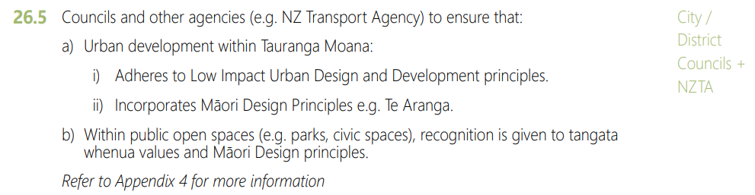
The final example taken from the Ko Tā Maniapoto Mahere Taiao – Maniapoto Environmental Management Plan 2018 promotes urban design outcomes through social infrastructure. The relevant policy requires that the “provision of social infrastructure recognises the differing needs of Maniapoto at different life stages” and that this be achieved in part by asserting “Maniapoto heritage values into landscape and urban design through the use of mechanisms such as interpretative works, artworks, public structures and the introduction/repatriation of traditional place names.” All these mechanisms link strongly with positive social outcomes and increased cultural and local identity.
Though not currently referenced in IHMPs, a useful resource for urban design is Te Aranga Māori Design Principles, developed by Māori design professionals in 2005 in response to the New Zealand Urban Design Protocol. These principles continue to be developed by Ngā Aho and cited in design guidance by councils and others, for example, in the Auckland Design Manual. Iwi and hapū could use these principles and the guidance built up around them as support for articulating their own aspirations for the design of urban areas and public spaces in their rohe.
Observations – urban design
Urban design is not well represented in the reviewed IHMPs, although some iwi and hapū have identified its potential benefits for tangata whenua.
Cultural design opportunities for mana whenua are growing in urban spaces and built form. Such opportunities often tend to rely on individuals and established relationships in the absence of supporting policy.
IHMPs tend to identify and describe the relationship between urban design (and low-impact design solutions) with values like kaitiakitanga and manaakitanga.
Tangata whenua influence in urban design offers opportunities to express cultural narratives and identity in related cultural landscapes.

Renewable energy
Renewable energy is mentioned in 30 per cent of the IHMPs, although the references are relatively few. Sources of renewable energy include water, wind, solar, tidal, geothermal and biomass. In general, plans tend to focus on two main themes: the effects of renewable energy developments, and iwi and hapū aspirations for involvement in renewable energy initiatives at various scales.
The Mahaanui Iwi Management Plan 2013 identifies as an issue that “Ngāi Tahu have a particular interest in energy generation, distribution and use” to both express their kaitiaki role and seek partnership opportunities in any development projects.
Policies conveying their kaitiaki-based role include:
P17.1 Ngāi Tahu must have a strategic and inﬂuential role in decisions about energy extraction and generation in the region, as a Treaty partner with speciﬁc rights and interests in resources used for energy generation, particularly water.
P17.3 To require that the energy sector engage with Ngāi Tahu at the concept development stage, rather than at the resource consent stage and to support the use of Cultural Impact Assessment (CIA) reports to assess potential and actual eﬀects of proposals on Ngāi Tahu values.
P17.4 To require that local authorities develop and implement eﬀective policies requiring the use of renewable energy and energy saving measures in residential, commercial, industrial and other developments.
P17.5 To support in principle the use of wind and solar energy generation in the region.
The Ngāti Ruanui Environmental Management Plan 2012 contains a dedicated section on renewable energy that includes policies for water, wind, solar, tidal, geothermal and biomass power resources. An example of the corresponding policy framework is presented in figure 52 and figure 53.
Figure 52: Examples of renewable energy objectives and policy provisions from the Ngāti Ruanui Environmental Management Plan 2012
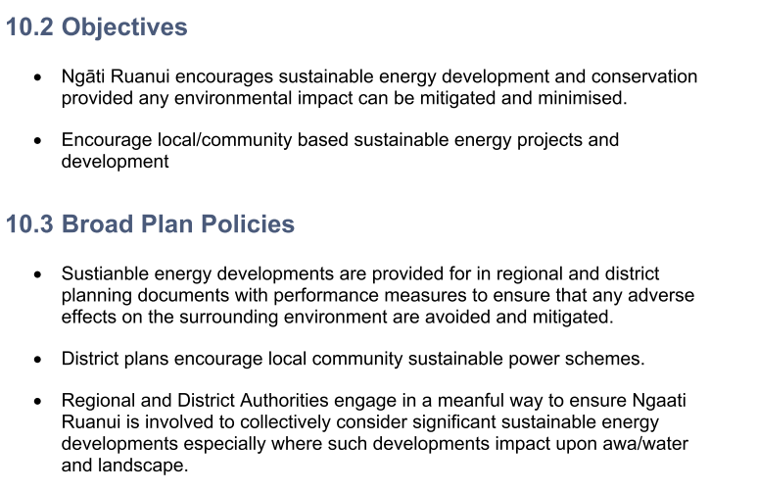
These plan provisions recognise the influence that regional and district planning documents, and their governing authorities, have over the management of renewable energy resources. Ngāti Ruanui have framed the IHMP provisions to advocate for meaningful engagement between the territorial authorities and Ngāti Ruanui, as well as seeking more consideration of renewable energy developments. This approach appears to seek enhanced relationships and a corresponding recognition of the mana and kaitiakitanga of mana whenua.
Figure 53: Methods from the renewable energy section of the Ngāti Ruanui Environmental Management Plan 2012
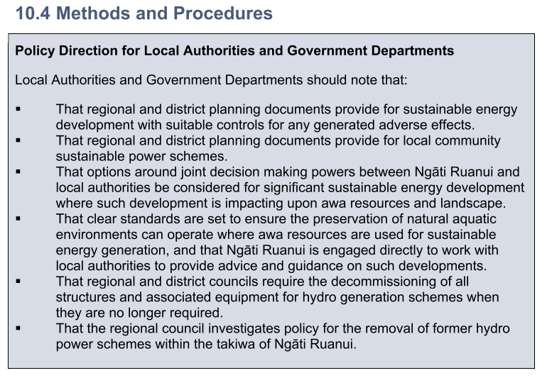
The Ngaa Rauru Kiitahi Puutaiao Management Plan also contains a renewable energy section:
Ngaa Rauru Kiitahi supports the kaupapa of renewable energy. Renewable energy generation and the use of renewable energy resources are preferred over non-renewable energy resources in our rohe.
The IHMP helps to identify in practical terms the iwi kaitiaki role, and some of the sensitivities that might arise with renewable energy developments. Specifically, not all renewable energy projects may be acceptable to Ngaa Rauru Kiitahi, as they will only support those projects that align with iwi worldviews and values. For example, although hydro power is a renewable energy resource, a dam on a river highly valued by Ngaa Rauru Kiitahi would not be acceptable because it would impact adversely on iwi cultural and environmental values. Similarly, a wind farm located on land containing an urupā (burial ground) would not be acceptable to the iwi, nor would a biofuels plant on a culturally sensitive site.
The other broad theme is the intent of iwi and hapū to undertake renewable energy developments to reduce the effects of climate change and enhance the resilience of their communities. This intent is exemplified in the Matakana and Rangiwaea Islands Hapū Management Plan 2017, which identified a “lack of efficient renewable energy sources” as an issue for the hapū. The plan carries this idea to the “social goals” section, which states that iwi seek to “build renewable energy sources.” The plan states:
Our goal is to invest in renewable green energy sources and, to the extent possible, become self-sufficient. We want to maximise and utilise resources on the island, or within the moana that promotes self-sufficiency and affordable housing for whanau, Hapu, Iwi. We are keen to explore R & D opportunities for sustainable use of alternative energy sources on the island.
Policy 7.6.5 of the Tūhoromatanui – Ngā Pōtiki Environmental Plan 2019–2029 is likewise inward-facing and for descendants. It signals an environmentally conscious intent for marae and papakāinga developments. It seeks to “support efforts by Ngā Pōtiki marae, papakāinga and land developers to assess and review their methods of accessing or using water and electricity.” This includes exploring the feasibility of “onsite power generation using renewable energy.”
A similar policy is in the Whakamarohitia ngā wai o Waikato – Te Arawa River Iwi Trust Environmental Plan 2021 and the Ngāti Kea Ngāti Tuara Iwi Environmental Management Plan 2016.
An interesting reference to other sources of energy in Te Rautau Te Rāhui Taketake – Ngāti Whakaue ki Maketu Hapū Management Plan 2018–2028 promotes the sustainable allocation, use and management of geothermal energy, water and heat sources, in particular where they occur on, or can benefit, Māori land and underutilised Māori land. The relevant provisions are shown in figure 54.
Figure 54: Geothermal energy provisions from Te Rautau Te Rāhui Taketake – Ngāti Whakaue ki Maketu Hapū Management Plan (2018–2028)
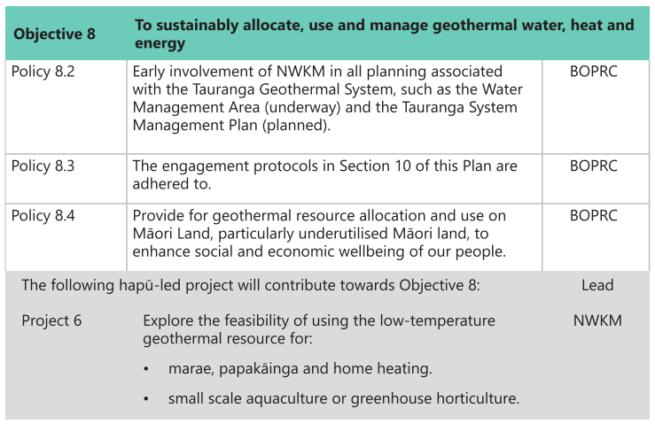
Observations – renewable energy
Renewable energy is not often specifically mentioned in IHMPs, though most plans have objectives and policies relating to infrastructure.
Where it is mentioned, two main themes are apparent: the need to manage the effects of renewable energy developments and to advocate for increased initiatives; and involvement of tangata whenua in the development of renewable energy projects.
A clear relationship between renewable energy and climate change is presented in the IHMPs.
A broad spectrum of renewable energy sources are identified in the IHMPs.
IHMPs recognise the need for strategic planning and research in renewable energy.
Including renewable energy proposals in IHMPs might help to influence spatial planning as well as project planning by potential developers of renewable energy.

Plan implementation and effectiveness
IHMPs are written in a variety of different ways, with unique objectives, resources and context in which they are developed. However, some plans are written in a manner that is easier for councils to interpret and, therefore, take into account. Assessment of the effectiveness of the policy provisions is beyond the scope of this project. However, partnership processes to develop IHMPs may contribute to IHMPs that are easier for councils to take into account in plan making and granting consents.
Te Pou o Kāhu Pōkere – Iwi Management Plan for Ngāti Whātua Ōrākei 2018 has a simple structure that was developed through a collaborative co-design process. The IHMP is divided into four clear sections: two sections introduce Ngāti Whātua Ōrākei and their rohe, one section covers engagement processes and the kaitiakitanga section covers the issues of relevance. The development partner was Auckland Council, and its planning staff provided technical expertise to ensure the plan contained provisions that could be workable in practice.
The plan’s development involved a series of design workshops, and resource management practitioners from both iwi and council worked together to draft the plan provisions. Shared resourcing can be seen to be an expression of partnership, and this plan development process is an example of partnership in practice.
One important element of this plan’s development was a formal process to release and promote the plan, including a celebratory event with various stakeholders. The formalities surrounding the release were seen to elevate the mana of the plan among practitioners and decision-makers.

Consultation and engagement
Almost 100 per cent of the reviewed plans contain provisions for consultation and terms for engagement. This is unsurprising given consultation and engagement provisions are a foundational element of IHMPs and are significant matters for iwi and hapū kaitiaki.
Some IHMPs include considerable detail about engagement processes, providing information on specific matters for consultation, and engagement requirements for resource consents and plan changes. Some plans also provide contact details and clearly outline consultation processes by way of graphic representations, (eg, figure 55).
Figure 55: A graphic of the hapū engagement process, taken from Te Taiao o Te Whatuoranganuku – Ngāti Tamateatutahi – Ngāti Kawiti Hapū Environmental Management Plan 2015
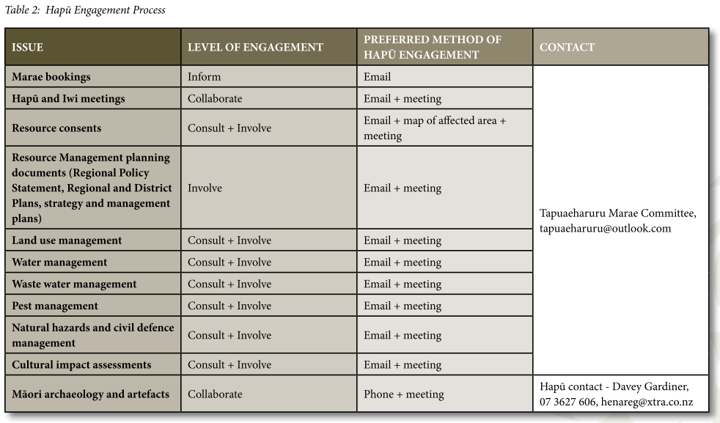
Overall, most iwi and hapū desire to be more involved in resource management processes, and there is a definite preference for early engagement and for increasing engagement as Treaty partners.
For example, Te Tangi a Tauira – Ngāi Tahu ki Murihiku Natural Resource and Environmental Management Plan 2008 contains a consultation policy that outlines guidelines and processes that agencies can follow when consulting with Ngāi Tahu ki Murihiku via Te Ao Mārama Inc. Details include that sufficient information and time must be provided to allow for comprehensive understanding and informed decision-making, and that information delivered orally should be given equal weight as written information.
Te Pou o Kāhu Pōkere – Iwi Management Plan for Ngāti Whātua Ōrākei 2018 contains engagement protocols, stating which matters the hapū wish to be engaged on, and preferred methods of engagement. For example, they wish to be consulted on any proposal which involves dredging, reclamation or marine structures in the coastal area. The IHMP also specifies that the hapū prefer to be engaged early in the process of policy development or development projects, and prefer a proactive approach in the nature of the partnership.
The Tūhoromatanui – Ngā Pōtiki Environmental Plan 2019–2029 contains a very clear and detailed section about engaging with Ngā Pōtiki. Sub-sections outline principles of engagement, the spectrum of Māori engagement, specific expectations for resource consent processes and also for council strategies and plans. These sub-sections contain protocols, types of engagement, examples and information requirements. The section on the spectrum of expectations begins with requesting information, and carries on to empowerment via transfer of powers (section 33 in the RMA).
The Tai Tumu – Tai Pari – Tai Ao – Waikato-Tainui Environmental Plan 2013 includes a flow chart for consultation and engagement. It provides guidance for someone who may want to engage with the iwi, and the steps they should follow to ensure that engagement is effective. Specifically, the plan suggests an applicant should prepare a draft preliminary report (if possible) that can provide a foundation for consultation and engagement on the existing or proposed activity. The plan defines what should be included in the report and prescribes how it could be used.
Finally, the Tapuika Environmental Management Plan 2014 emphasises the value of consultation for building relationships and enabling awareness of Tapuika values and issues. The iwi define consultation protocols for matters such as concession applications and council processes, and provide examples of matters that require consultation with them. For example, the iwi wish to be consulted on conservation management plans, regional plans and national policy statements. Tapuika iwi also support the concept of Māori constituencies and Māori voting for Māori councillors. They also identify types of relationship agreements that can strengthen relationships between Tapuika and external agencies.
Observations – consultation and engagement
Consultation and engagement appear widely throughout the IHMPs.
IHMPs do not constitute engagement or consultation with iwi. This point can be reinforced in the IHMP. Direction can be provided to government agencies, councils and potential consent applicants on how to use IHMP content in their due diligence prior to engagement.
IHMPs are becoming more directive regarding iwi expectations for stronger degrees of engagement that reflect their status as Treaty partners.
Different types and scales of collaborative projects may require different levels of engagement and the use of different mechanisms, such as cultural-impact assessments or cultural-values reports.

Monitoring, compliance and implementation
There were no dedicated monitoring and compliance sections in the plans, although 15 per cent of the IHMPs contained some reference to the term ‘monitoring and compliance’. Individual searches of either word found that ‘compliance’ is mentioned in over 60 per cent of the plans, and ‘monitoring’ is referenced in over 90 per cent of plans.
Examples where both monitoring and compliance are referred to are provided in table 6.
Table 6: References to both monitoring and compliance in a sample of IHMPs
IHMP | Objectives, aspirations and/or kaupapa | Policies
Te Iwi o Ngatiwai Iwi Environmental Policy Document 2007, p 17 | General engagement policy | “Whenever tāngata whenua are involved in setting conditions for consent, they then are responsible or jointly responsible for monitoring compliance with those conditions.”
Te Tangi a Tauira — Ngāi Tahu ki Murihiku Natural Resource and Environmental Iwi Management Plan 2008, p 191 | Specific reference to aquaculture | “Recognise and be involved in the development of programmes that recognise for protection of ecological, heritage, wāhi tapu and wāhi taonga values. This includes involvement in ongoing management, setting of consent conditions and monitoring and compliance programmes.”
Te Awaroa Ngati Kahu Hapu Environmental Management Plan 2011, p 53 | In relation to the integrity of the Wairoa River | “Ngati Kahu require copies of all monitoring and compliance reports for consented activities relating to the Awa to be forwarded to TRONK upon their completion or availability.”
Mahaanui Iwi Management Plan 2013, p 28 | In relation to general implementation of the plan | “To work with local government to develop memorandum of understandings regarding the implementation of the Mahaanui IMP in council processes, with speciﬁc reference to the use of the IMP to:  (g) Inform resource consent monitoring and compliance processes, including providing for tangata whenua values in these.”
Patuharakeke Hapu Environmental Management Plan 2014, p 24 | Implementation methods | “j) All agencies need to provide adequate and timely information on all activities and programmes affecting Patuharakeke, our values and our taonga to Patuharakeke. In particular, information should be supplied regarding:  i. resource consents (notified and non-notified), permit and concession applications, including previous staff reports and monitoring/compliance records in the case of consent renewal applications;”
‘Monitoring’ is referenced in two main ways in the IHMPs. Firstly, the plans refer to a need for cultural monitoring and cultural monitors for archaeological and heritage-related matters. Secondly, in addition to calling for that sort of monitoring, some plans also refer to a need for cultural monitoring that is to be applied to further environmental domains (eg, freshwater). There were a few references to monitoring of the IHMP itself.
Specifically, aspirations for cultural monitoring inputs by iwi and hapū were mentioned in 10 per cent of the reviewed plans. Several examples are detailed below although the first two relate to heritage matters.
Te Rautau Te Rāhui Taketake – Ngāti Whakaue ki Maketu Hapū Management Plan 2018–2028 defines the purpose of cultural monitoring as “to observe activities associated with earthworks, including cultural advice to contractors and Project Team members and implementing accidental discovery protocols.” An interesting policy in this plan, which is not in any other plan, calls for an inward-facing action for cultural monitor training. The plan states that, “We have a limited pool of trained cultural monitors. It is important that we build capacity to share the load and enable more whānau to come on board.”
The Mahaanui Iwi Management Plan 2013 also provides a purpose statement for cultural monitoring from their perspective (see figure 56).
Figure 56: The purpose of cultural monitoring set out in the Mahaanui Iwi Management Plan 2013
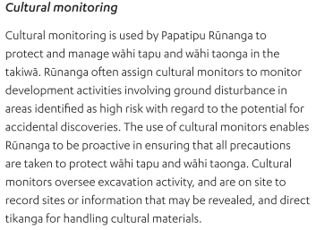
This IHMP also promotes the wider application of cultural monitoring, as seen in a cultural landscape policy that prescribes a process for monitoring developments that might cause harm to heritage-related taonga (see figure 57). Cultural monitoring is shown to be one of a suite of mechanisms used when there is a high risk to sensitive heritage sites.
Figure 57: A policy from the Mahaanui Iwi Management Plan 2013 showing cultural monitoring as part of a suite of heritage management tools
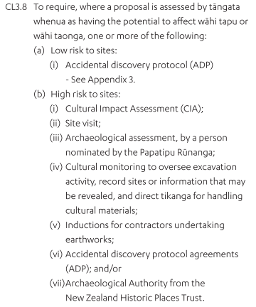
Both plans require the use of cultural monitors to ensure tikanga and other cultural values are implemented in the management of heritage-related taonga. Cultural monitors in this instance typically have clear and well documented roles. Yet, cultural monitoring for other taonga appears to be less of a focus in the IHMPs overall – although there are several that signal an intent to increase the cultural monitoring regime.
The Ko Tā Maniapoto Mahere Taiao – Maniapoto Environmental Management Plan 2018 is an example of a plan that advocates for cultural monitoring inputs beyond heritage matters. The plan recognises that:
There is also a lack of cultural monitoring tools to recognise matters of signiﬁcance to Maniapoto and to contribute to state of the environment reports. The addition of cultural indicators in monitoring reports, such as, the mauri of waterways and the health and vitality of mahinga kai sites, taonga species and aquatic ecosystems are important information to inform Maniapoto decision-making. This information will contribute to policy development and support restoration initiatives.
A broad reference to cultural monitoring is also included in the Patuharakeke Hapu Environmental Management Plan 2014:
As kaitiaki and mana whenua, Patuharakeke must be involved in the monitoring of all aspects of the health of our rohe. For this to happen there needs to be:
- increased integration of monitoring across agencies
- increased reliance and use on community level and community-based monitoring
- increased recognition and use of cultural indicators
- resourcing of kaitiaki.
A cultural monitoring framework for our health and wellbeing needs to recognise that:
- It is important for us as a hapu to determine methods to measure the current state, changes and rates of change (decline, destruction, improvement or revitalisation) of our environment. This must be done with full and effective participation of our taumata and resource management practitioners.
The Te Rautaki Tāmata Ao Turoa o Hauā – Ngāti Hauā Environmental Management Plan 2018 integrates iwi aspirations for enhanced cultural monitoring in a methods section, “Revitalisation of our Mātauranga”.
Figure 58: A mātauranga-related policy that sets out cultural monitoring actions – from Ngāti Hauā Environmental Management Plan 2018
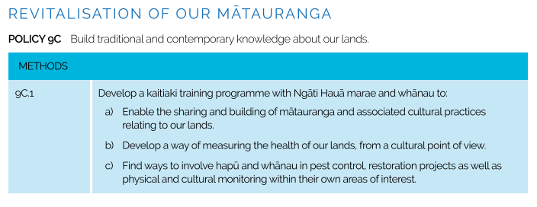
And finally, this same desire for increased opportunities for cultural monitoring by iwi, hapū and whanau is also articulated in the Tapuika Environmental Management Plan 2014–2024 (see figure 59).
Figure 59: Actions in the Tapuika Environmental Management Plan 2014–2024 advocating for more opportunities for cultural monitoring
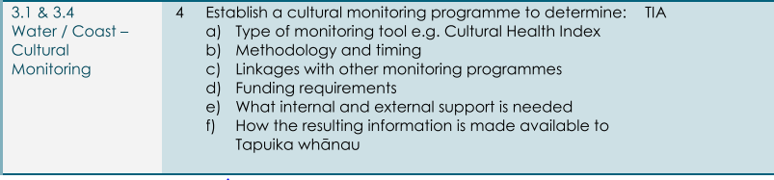

Implementation of IHMPs
The Mahaanui Iwi Management Plan 2013 provides a standalone section dedicated to implementation of the IHMP and provides a good example of policies to support implementation.
Specifically, Policy IMP1.2 confirms the commitment of the six rūnunga who prepared the plan to work with local government and other parties to implement it. Policy IMP1.3 references the WAI262 (Ko Aotearoa Tenei) Waitangi Tribunal report in stating that:
The Papatipu Rūnanga who have prepared this plan support the ﬁndings of the Waitangi Tribunal report on WAI 262 (see Box – Ko Aotearoa Tēnei) regarding iwi resource management plans and the recognition of kaitiaki interests, namely that:
(a) Kaitiaki priorities need to be integrated into local authority decision-making, and IMP are a way to achieve this; and
(b) IMP, as plans setting out iwi policies and priorities for managing the environment within their tribal areas, should bind local authority decision-making, just as regional policy statements, regional plans, and district plans do.
Implementation policies included in this plan are comprehensive, and include provisions
such as:
- guiding councils towards establishing memoranda of understanding
- working alongside other agencies to meet statutory requirements pertaining to the principles of Te Tiriti o Waitangi
- working alongside all parties to provide training sessions to support implementation.
The policies also state the preferred weightings of IHMP provisions alongside other policy instruments such as regional plans.
Other IHMPs, such as Te Kahukura a Ngāti Korokoro, Ngāti Wharara me Te Poukā – Ngā Hapū o Te Wahapū o Te Hokianga nui a Kupe Hapū Environmental Management Plan 2008 (Te Kahukura), also recognise the importance of implementation. However:
The Pākanae Resource Management Committee acknowledges that it will take time for Government agencies and organisations to implement the policies within this plan; therefore we have prioritised the issues that the Hapū foresee as requiring urgent attention and identified performance measures and relevant parties.
The plan then provides two tables of high-priority and medium-priority issues with which to initiate implementation. Both the Mahaanui Iwi Management Plan 2013 and Te Kahukura recognise the need for tangata whenua to support external agencies for the implementation of an IHMP.
In other plans, such as Ko Tā Maniapoto Mahere Taiao Maniapoto Environmental Management Plan 2018, implementation initiatives are embedded throughout each of the domain sections. Te Mahere Whakarite Matatiki Taiao Ō Ngāti Awa – Ngāti Awa Environmental Plan 2019 embeds directions for implementation throughout but also has a dedicated section for implementation, monitoring and review. As well as providing a table of “plan topics” and associated implementation “methods”, this IHMP also identifies opportunities for action, targeted at Te Rūnanga o Ngāti Awa [TRONA] and external agencies:
Opportunities for Action – Te Runanga o Ngāti Awa – The following are ways in which TRONA can ‘give life’ to this Plan.
1 Ensure sufficient resourcing within the TRONA Taiao unit to implement the above actions.
2 Annual governance-level meetings with partner agencies to discuss Plan implementation.
3 Initiate a ‘Te Mana Whakahono-a-Rohe’ agreement.
4 Provide communications and engagement support.
5 Utilise existing networks both internally (within Ngāti Awa – hapū, marae committees, Lands Trusts and incorporations, Ngāti Awa Group Holdings Limited), and externally (Central Government agencies, Councils).
Opportunities for Action – Partner agencies – The following are ways in which Central Government (eg, DOC, MPI, MfE, TPK) and Councils (BOPRC, WDC, KDC) can ‘give life’ to this Plan.
1 Co-designed work programmes, including engagement planning, research and monitoring.
2 Staff training eg, to understand Ngāti Awa values or the implications of statutory acknowledgment areas on their work.
3 Six monthly governance-level meetings with TRONA.
4 Involve the Ngāti Awa Taiao Unit in State of the Environment monitoring and/or reporting.

Observations – monitoring, compliance and implementation
Some IHMPs express a desire for increased cultural monitoring of environmental factors, not just those related to heritage. However, the reviewed plans are only signalling the need for future cultural monitoring programmes and are not identifying implementation policies.
Monitoring and compliance matters are not well covered in IHMPs.
A small number of IHMPs set out provisions for monitoring IHMPs.
Implementation provisions are a necessary part of IHMPs, and the reviewed IHMPs typically identify methods for plan owners as well as methods for external agencies and interest parties.
The National Policy Statement for Freshwater Management 2020 provides for the use of mātauranga Māori in the management of freshwater, including for monitoring progress against target attributes.

Part Two — Future considerations for iwi and hapū planning
Iwi and hapū planning interacts with a complex statutory environment, a broad range of scientific and social domains, and the realities of a changing world. Whether responding to changing legislation, interpreting scientific research, or responding to climate change, there are many reasons to treat planning as an ongoing process supported by living, responsive documents. Below are six areas of future focus to consider when developing or revising plans.

Managed retreat
Managed retreat is the carefully planned and managed movement away from areas, such as coastal or riverside sites, that are at high risk of natural hazard and climate change impacts.
Managed retreat has significant implications for Māori and their taonga. Research shows that Māori communities are more sensitive to natural hazards and climate impacts than other communities owing to the proximity of their housing, infrastructure and sites of cultural significance to the coast (and other at-risk areas). Sites at risk also include marae, urupā, pātaka kai (food gathering area) and wāhi tapu.
Central and local government efforts to address managed retreat will also likely raise a distinct set of issues relating to policy frameworks and legislation regarding Māori rights and interests, including Māori land, Treaty settlement legislation, takutai moana legislation and IHMPs. Iwi and hapū have an opportunity to broaden the scope of IHMPs to consider managed retreat and other climate adaptation strategies.
Iwi and hapū around New Zealand are already planning for adaptation. For example, the Ngāi Tahu Climate Change Strategy 2018 provides strategic direction, priorities, and actions to guide managed retreat for taonga and to build marae and community resilience.

Environmental limits
Environmental limits are currently provided for freshwater in the National Policy Statement for Freshwater Management 2020. Within that framework there are 10 attributes pertaining to water quality that require limits. Regional councils can, in consultation with communities and tangata whenua, identify other relevant attributes.
There are several associated opportunities for iwi, hapū and Māori groups to address environmental limits in their IHMPs. These include the identification of:
- appropriate takiwā or management units for each domain to inform limit-setting
- preferred environmental limits for freshwater and potentially other domains
- any supporting mātauranga Māori evidence and indicators on the state of the environment in these areas that Māori wish to share
- tikanga Māori measuring and monitoring requirements.
IHMPs could also address data sovereignty requirements for tangata whenua, with policies outlining considerations of the design, use and collection of data and cultural monitoring information. Other features to take into account include specifically identifying iwi and hapū requirements for the use of tikanga and Māori environmental management methods, such as cultural monitoring and rāhui.

Spatial planning
Although not an explicit feature of the RMA, spatial planning currently occurs in different areas in accordance with different drivers. Some regions, such as Auckland, have legislative requirements to produce spatial plans (the Auckland Plan and structure plans). Other regions use spatial planning to manage growth and transportation connections within and between regions (eg, Smartgrowth, FutureProof), and others have developed them voluntarily under the Local Government Act 2002 (eg, Tairāwhiti Regional Spatial Plan). The Hauraki Gulf Marine Spatial Plan is an example of spatial planning done in partnership by mana whenua and central/local government agencies.
The National Policy Statement on Urban Development 2020 requires local authorities with tier 1 and tier 2 urban environments to prepare a future development strategy to plan for adequate supply of plan-enabled, infrastructure-ready land to meet their projected housing needs over the next 10–30 years. This strategy includes spatial identification of areas and a clear statement of hapū and iwi values and aspirations for urban development.
In essence, much of the forward planning undertaken now for environmental management, development, and infrastructure has a spatial component. This review confirmed that a large proportion of IHMPs focus predominantly on environmental interests, consistent with the plans being a primary instrument for iwi and hapū under the RMA. As spatial planning increases in use there is an opportunity, and arguably a need, for IHMPs to apply a wider lens to the ways such planning can also incorporate iwi and hapū social, cultural and economic aspirations and to partner on priorities.
Some IHMPs already contain strategic content and mapping that is relevant for spatial planning. One such example is a values framework and an overarching structure in the 2021 Queenstown Lakes Spatial Plan, which was developed by Kāi Tahu rūnanga delegates, the Queenstown Lakes District Council and central government (see figures 60 and 61). For the parties concerned, the values provided overarching guidance for process and spatial decision-making that was referenced against a mana whenua worldview.
Strategic decision-making, with its intergenerational implications, needs to be informed by culturally relevant and responsive values. Therefore, iwi and hapū need to be sufficiently positioned and enabled to participate as partners in any spatial planning process. Yet giving effect to such values, and their associated principles, will require effective and resourced engagement with mana whenua throughout all stages of the spatial planning and implementation process, regardless of what is included in an IHMP.
Figure 60: Kāi Tahu framework of cultural values for The Queenstown Lakes Spatial Plan 2021
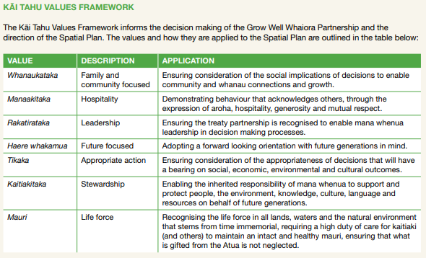
Figure 61: Overview of the structure of the Queenstown Lakes Spatial Plan 2021
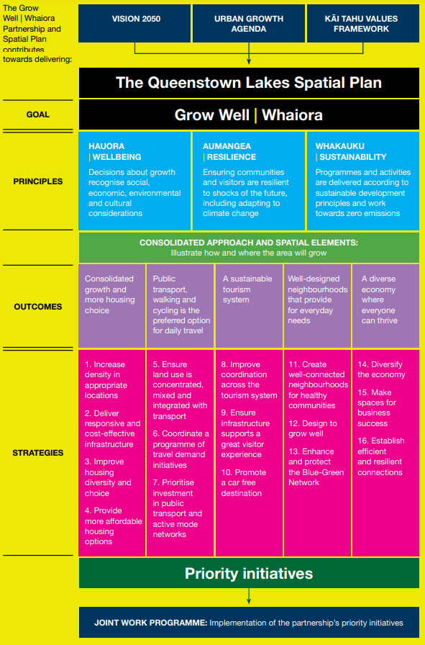
To be effective contributors to spatial strategy, iwi, hapū and Māori may need capability to map (eg, with Geographic Information Systems (GISs)) and therefore spatially represent the cultural interests that they think are appropriate to map. As part of this, iwi and hapū will need to determine how their interests could be best represented and considered in context, potentially including a cultural landscape.
Mapped features in IHMPs can be tangible or non-tangible, such as: sites of significance, wāhi tapu, water sources, wāhi tohu, wāhi tūpuna, significant soils, papakāinga areas, awa and moana. These features of interests will need to be identified in a manner that iwi and hapū are comfortable with and supported by a ‘proportionate’ level of evidence, including mātauranga. The location of wāhi tapu, for example, can be identified broadly in landscapes, via generic written labelling of the landscape’s values, overlay buffers or similar, rather than locating an actual site by specific boundary lines or point features. There are obvious tensions involved. Another important consideration is what level of information is to be released into the public realm. However, whatever form mapped iwi and hapū information may take, its presence in any spatial planning process will be critical, as is a need for enhanced and strategic iwi and hapū capability and capacity in this field.

Cultural landscapes
As the sections above have identified, one mechanism that could support iwi and hapū engagement in both the current and new resource management systems is the adoption of cultural landscapes as a tool. Cultural landscapes can be used to overlay a whakapapa connection to wide geographical areas, potentially covering an entire takiwā, to identify associations. In doing so, cultural landscapes can signal a holistic and interrelated form of cultural connection with numerous features, including (but not limited to):

- soils
- viewshafts
- awa and water catchments
- maunga
- cultural heritage sites
- trails and trading routes
- pā and nohoanga (dwelling place)
- ritual areas
- waka landing sites
- mahinga kai

- Māori land
- marae
- papakainga
- valued intangible associations
Accordingly, the potential scope for cultural landscapes is significant, although efforts to increase protection at a landscape level will need to be supported by robust evidence and mātauranga.
Several iwi and hapū adopted cultural landscape approaches in their IHMPs as the basis for integrating other planning mechanisms, although this is not widespread. One example is the 2005 IHMP of Kāi Tahu ki Otago, which has a cultural landscapes policy. The iwi has since extended this concept into the wāhi tūpuna mentioned in the Dunedin City District Plan, the Queenstown Lakes District Plan and, more recently, the proposed Waitaki District Plan. This has led to recognition of Kāi Tahu wāhi tūpuna in the Otago Regional Policy Statement, which requires that local councils include mapped wāhi tūpuna in their plans.
Wāhi tūpuna also appear in the Queenstown Lakes Spatial Plan 2021. This has resulted in wāhi tūpuna being represented at the district-, regional- and spatial-plan level, providing increased recognition and visibility for iwi whakapapa-based interests in statutory documents. Wāhi tūpuna are identified as large areas, and their values, including wāhi tapu sites, are noted as existing in the landscapes without identifying their site-specific locations on the maps. In the district and regional plans, the maps are linked to corresponding objectives, policies and rules.
Given the above, possible areas and features that iwi and hapū could identify in the spatial planning process are:
- those that iwi and/or hapū want to assert rangatiratanga over, including areas to protect
- those where needed infrastructure is missing, or areas where provision of infrastructure should be constrained
- those for which future growth is preferred, including such things as papakāinga development zones, and/or those where development is inappropriate
- those for regeneration or rehabilitation from a cultural or biodiversity perspective (eg, mahinga kai areas) or for culturally appropriate urban design.
The use of cultural landscapes in spatial planning could permit more holistic and integrated consideration of iwi and hapū interests in their rohe at the earliest, most strategic stage of planning. Such measures will also need to be supported by strategic objectives, policies and implementation methods mandated by iwi and hapū.

Māori land and papakāinga
Iwi and hapū management plans provide opportunities for owners of Māori land to identify where infrastructure is desired for the development of their land, including that which will enable the development of housing and papakāinga.
In some cases, there are aspirations for papakāinga development in parcels of land subject to different zoning rules. Situations like this could be addressed in IHMPs with action plans formulated to enable and standardise papakāinga-related development rules. Further, where activities are being restricted on Māori land due to negative zoning or designation arrangements, those may also be identified in IHMPs and targeted for mitigation.
Māori land and papakāinga provisions are well represented in current IHMPs and these plans are a strong foundation upon which new and revised plans could draw ideas for their own whenua and papakāinga provisions.
Māori land, particularly coastal land, is very likely to be impacted by climate change, and owners of Māori land tend to be the least resourced to respond. This relates to the points below relating to adaptation to natural hazards and activities that may be desired or necessary over the next 30–50 years.

Mana Whakahono ā Rohe
Mana Whakahono ā Rohe (MWāR) is a mechanism introduced in 2017 amendments to the RMA. Tangata whenua and local authorities can use MWāR as a framework to discuss and reach agreement on how they will work together under the RMA, in a way best suiting the local circumstances. Only a small number of IHMPs currently reference MWāR, though the number of operative MWāR agreements is growing.
IHMPs can address a range of matters and processes to be advanced through MWāR, including (but not limited to) power-sharing mechanisms, such as joint management agreements and transfer of powers from a territorial authority. Other opportunities for integration between IHMPs and MWāR include defining procedures for resource consent and consent monitoring processes, as well as engagement processes for involvement in plan and policy development. Social procurement processes could also be defined.
With respect to engagement, creators of IHMPs should consider stating funding expectations for engagement, both with respect to consenting, and engagement for plan and policy development with territorial authorities. Clear communication of expectations, clear description of desired processes and procedures, and identification of opportunities in an IHMP will be beneficial and will support the implementation of MWāR.

Conclusion
This review has shown how IHMPs produced over the past thirty years are structured, what they include, and how content is changing with emerging issues and trends. The examples included here will hopefully help iwi and hapū when making decisions on future content for their own planning documents.
Assessment or in-depth evaluation of plan content or domains was not undertaken and, therefore, the information herein can only be considered as baseline information to inform future research. This baseline information is derived from a broad spectrum of examples that are representative of iwi and hapū policy responses to the various domains.
Collating examples of best practice for various domains and themes will require further research, which itself is contingent on an assessment of the effectiveness of plan provisions (judged by whether plan objectives and outcomes are achieved). Iwi, hapū, councils and decision-makers will benefit from that information.
This review identified that while some environmental domains – like land, water and air – are well covered in IHMPs, social and economic policies are not as widely addressed. Similarly, there is only a modest number of kaupapa-Māori policy and cultural values frameworks embedded throughout the plans, so this is an area of opportunity for iwi and hapū when they update existing plans or develop new ones.
Other potential opportunities to respond to the emerging issues and trends exist in building capacity and capability for spatial planning, urban design, mapping and the use of cultural landscapes. Climate change and associated adaptation plans will require consideration, as will the policy implications of Te Mana o te Wai. Mātauranga and tikanga could also provide opportunities to promote culturally relevant environmental indicators and monitoring programmes. Other wellbeing indicators should also be considered, given IHMPs serve uses beyond their resource management functions.

References

Government reports
Kāhui Wai Māori. 2019. Te Mana o te Wai. The health of our wai, the health of our nation. Wellington: Kāhui Wai Māori.
Ministry for the Environment. 2020. Report of the Resource Management Review Panel, June 2020. Wellington: Ministry for the Environment.
Ministry for the Environment. 2000. Te Raranga a Mahi: Developing environmental management plans for whānau, hapū and iwi. Wellington: Ministry for the Environment.
Ministry for the Environment. 2021. Patterns in Resource Management Act Implementation: National Monitoring System data 2014/15 to 2019/20. Wellington: Ministry for the Environment.
Ministry for the Environment. 2020. Trends in Resource Management Act implementation: National Monitoring System 2014/15 to 2018/19. Wellington: Ministry for the Environment.
Ministry for the Environment. 2022. Aotearoa New Zealand’s first national adaptation plan. Wellington: Ministry for the Environment.
Te Puni Kōkiri. Unpublished. Iwi Management Plan Guidance Note, June 2005.

Other reports
Kennedy N. Unpublished. Ngā horanuku o mātou tūpuna i Tāmaki Makaurau. Planning for the cultural landscapes of Tāmaki Makaurau report. Auckland: Auckland Council
Kennedy N. Unpublished. Ngā horanuku o mātou tūpuna i Tāmaki Makaurau – Modelling cultural landscapes in the Auckland region. Auckland: Auckland Council
KCSM Solutions Ltd. 2004. Review of the effectiveness of iwi management plans – An iwi perspective. Wellington: Ministry for the Environment.
Te Waka Kai Ora. 2011. Nga kaupapa o Hua Parakore. Wellington: Te Waka Kai Ora.
Tūānuku Limited and Conroy and Donald Consultants Limited. 2020. Tangata Whenua perspectives on growth management within the Western Bay of Plenty Sub-region. A desktop analysis prepared for the Urban Form and Transport Initiative (UFTI). Wellington: Urban Form and Transport Initiative.

Iwi and hapū management plans
1990 | Te Whakatau Kaupapa Ngai Tahu Resource Management Strategy for the Canterbury region
1993 | Tawharau o Nga Hapu o Whakatohea Iwi Management Plan
2000 | Te iwi o Rakaipaaka Hapu Environment and Resource Management Plan
2002 | Ngai Tahu Pounamu Resource Management Plan
2002 | Ngāti Kōata No Rangitoto Ki Te Tonga Trust Iwi Management Plan
2003 | Ngāti Tuwharetoa Environmental Iwi Management Plan
2004 | Whaia Te Mahere Taiao a Hauraki — Hauraki Iwi Environmental Plan
2004 | Whakatakoto kaupapa mo te Hapu o Ngati Kuta ki Te Rawhiti – Ngati Kuta ki Te Rawhiti Hapu Management Plan
2004 | Nga Taonga Tuku Iho Ki Whakatu Management Plan
2005 | Kāi Tahu Ki Otago Natural Resource Management Plan
2005 | Ngāti Hikairo Iwi Management Plan — Freshwater
2005 | Te Waihora Joint Management Plan — Mahere Tukutahi o Te Waihora
2006 | Ngati Umutahi Whenua Management Plan
2007 | Te Poha o Tohu Raumati — Te Rūnanga o Kaikōura Environmental Management Plan Te Mahere Whakahaere Taiao o Te Rūnanga o Kaikōura
2007 | Te Iwi o Ngatiwai Iwi Environmental Policy Document
2008 | Ngā Tikanga mo te Taiao o Ngāti Hine — Ngāti Hine Iwi Environmental Management Plan
2008 | Te Tangi a Tauira — Ngāi Tahu ki Murihiku Natural Resource and Environmental Management Plan
2008 | Te Awanui Tauranga Harbour Iwi Management Plan
2008 | Te Kahukura a Ngāti Wharara me Te Poukā – Ngā Hapū o Te Wahapū o Te Hokianga nui a Kupe Hapu Management Plan
2010 | Poutama Iwi Management Plan
2010 | Kahungunu ki Uta, Kahungunu ki Tai, Marine and Freshwater Fisheries Strategic Plan mai Paritu ki Turakirae
2010 | Te Tahuanui Ngati Hikairo Heritage Management Plan
2010 | Te Taumutu Rūnanga Natural Resource Management Plan
2011 | Kia matau kia mohio e ora ana Te U Kai Po o Nga Hapu o Whaingaroa Environmental Management Plan
2011 | Te Mahere ā Rohe mō Ngāti Rangitihi — Ngāti Rangitihi Iwi Environmental Management Plan
2011 | Ngati Whare Iwi Management Plan
2011 | Te Uri o Hau Kaitiakitanga o te Taiao Plan
2012 | Hapu/Iwi Management Plan of Nga Ariki Kaiputahi
2011 | Te Awaroa Ngati Kahu Hapu Environmental Management Plan
2012 | Ngāti Rangiwewehi Iwi Environmental Management Plan
2012 | Ngati Ruanui Environmental Management Plan
2012 | Ngati Hori Freshwater Resources Management Plan
2012 | Raukawa Fisheries Plan
2013 | Mahaanui Iwi Management Plan
2013 | Ngāi Te Ahi Hapū Management Plan
2013 | Ngaa Rauru Kiitahi Puutaiao Management Plan
2013 | Ngāti Pūkenga Iwi ki Tauranga Trust Iwi Management Plan
2013 | Ngāti Rehua Ngātiwai ki Aotea Trust Hapū Management Plan
2013 | Tai Tumu Tai Pari Tai Ao Waikato-Tainui Environmental Plan
2015 | Ngāi Tamawhariua Ki Te Rereatukahia Marae Hapū Management Plan
2014 | Ngai Tukairangi, Ngati Tapu Hapu Management Plan
2014 | Ngāti Rangi Taiao Management Plan
2014 | Te Rūnanga o Ngāti Kuia Pakohe Management Plan
2014 | Patuharakeke Hapu Environmental Management Plan
2014 | Tapuika Environmental Management Plan 2014–2024
2014 | Te Ātiawa o te waka-a-Māui Iwi Environmental Management Plan
2014 | Tūtaekurī Awa Management and Enhancement Plan
2014 | Waikato River Authority Vision and Strategy for the Waikato River
2014 | Waitaha Iwi Management Plan
2015 | Te Taiao o Te Whatuoranganuku – Ngāti Tamateatutahi – Ngāti Kawiti Hapū Environmental Management Plan
2015 | Ngāti Porou ki Hauraki Marine and Coastal Area Plan
2015 | Te Rautaki Taiao a Raukawa – Raukawa Environmental Management Plan
2015 | Te Taiwhenua o Heretaunga Mana Ake — An expression of Kaitiakitanga
2015 | Te Arawa River Iwi Trust Environmental Plan 2015–2025
2015 | Ngāi Tamawhariua ki te Rereatukahia Marae Hapū Management Plan
2016 | Ngāti Kea Ngāti Tuara Iwi Environmental Management Plan
2016 | Tauranga Moana Iwi Management Plan 2016–2026
2016 | Te Kāuru Taiao Strategy — Te Kāuru Eastern Manawatū River Hapū Collective
2016 | Te Uriroroi Hapu Environmental Management Plan
2017 | Matakana and Rangiwaea Islands Hapū Management Plan
2017 | Pirirakau Hapū Management Plan
2017 | Te Iwi o Ngāi Takoto Environmental Plan
2017 | Te Whānau a Te Haraawaka Hapū Resource Management Plan 2017–2027
2018 | Kaituna He Taonga tuku iho — A treasure handed down
2018 | Lake Māhinapua Management Plan
2018 | Whaka-Ora Healthy Harbour Catchment Management Plan
2018 | Ko Tā Maniapoto Mahere Taiao – Maniapoto Environmental Management Plan
2018 | Te Tāhu o te Whāriki: Anchoring the foundation: Te Rūnanga o Ngāi Tahu Climate Change Strategy
2018 | Te Rautaki Tāmata Ao Turoa o Hauā – Ngāti Hauā Environmental Management Plan
2018 | Ngāti Tama ki Te Waipounamu Trust Environmental Management Plan
2018 | Te Pou o Kāhu Pōkere – Iwi Management Plan for Ngāti Whātua Ōrākei
2018 | Te Rautau Te Rāhui Taketake – Ngāti Whakaue ki Maketu Hapū Management Plan 2018–2028
2019 | Tūhoromatanui — Ngā Pōtiki Environmental Plan 2019–2029
2019 | Ki Uta, Ki Tai Ngā Puna Rau o Rangitīkei – Rangitīkei Catchment Strategy and Action Plan
2019 | Te Mahere Whakarite Matatiki Taiao Ō Ngāti Awa – Ngāti Awa Environmental Plan
2019 | Rising above the Mist – Te Aranga Ake I Te Taimahatanga – Ngāti Tahu – Ngāti Whaoa Iwi Environmental Management Plan
2019 | Te Tūāpapa o ngā wai o Te Arawa — Te Arawa Cultural Values Framework
2019 | Whakarongotai o te moana, Whakarongotai o te wā – Kaitiakitanga Plan for Te Ātiawa ki Whakarongotai
2019 | Rautaki Tiaki Whenua Reserves Management Plan 2019–-2029
2019 | Waitaki Iwi Management Plan
2020 | Tai Whenua, Tai Tangata, Tai Ao — Te Kotahitanga o Te Atiawa Taranaki Environmental Management Plan
2017 | He Mahere Pūtahitanga — A Pan-tribal Iwi Planning Document on behalf of the Central North Island Forests Iwi Collective
2021 | Mōtakotako Marae Hapu Management Plan
2021 | Ngai Tamarawaho Hapu Management Plan
2021 | Te Koikoi Kararo — Ngāti Hangarau Hapū Management Plan
2021 | Poipoia Te Ao Tūroa – Ngāti Rārua Environmental Strategy
2021 | Whakamarohitia ngā wai o Waikato – Te Arawa River Iwi Trust Environmental Plan
2021 | Te Arawa River Iwi Trust Fisheries Plan
2021 | Te Uru Taiao o Ngāruahine – Ngāruahine Kaitiaki Plan
2022 | Hineuru Iwi Trust Iwi Environmental Management Plan

Other plans
2017 | Tai Timu Tai Pari Sea Change Hauraki Gulf Marine Spatial Plan
2006 | Dunedin City District Plan
2020 | Paetae Kotahitanga ki Te Tai Poutini Partnership Protocol
2021 | The Queenstown Lakes Spatial Plan
2021 | Queenstown-Lakes District Plan
2022 | Waitaki District Draft District Plan
2021 | Proposed Otago Regional Policy Statement

Glossary
Note: Translations have not been provided for some words in a specific plan where their translation was deemed best interpreted within that plan.
Term | Definition
Aotearoa | New Zealand
Atua | Spiritual guardian, god, deity
Awa | River
Kōrero | Conversation, or a narrative about a place or thing
Hāpua | Harbour(s)
Hauora | Health
Hapū | Sub-tribe, pregnant
Hīkoi | Journey
Hunga tiaki | Collective or group of guardians
Iwi | Tribal social grouping
Kaimoana | Seafood
Kāinga | Settlement
Kaitiaki | Guardian, custodian
Kaitiakitanga | Guardianship, custodianship
Kaumātua | Elders
Kaupapa | Subject topic, reason, theme, policy
Kawa | Rules, protocols or procedures
Kāwanatanga | Governorship
Ki uta ki tai | From the mountains to the sea, catchment based environmental management
Kōhanga reo | Māori language preschool
Kuia | Female elder
Kupu Māori | Māori words
Kura | School
Maimai aroha | Expression or token of affection
Mahinga kai | Food gathering, preparation and preservation locations
Mana whenua | Authority/jurisdiction of customary rights associated with a tribal region or traditionally recognised area of land.
Mana moana | Authority/jurisdiction of customary rights associated with a tribal region or traditionally recognised section of coastline or marine area.
Manaakitanga | A concept about hospitality, generosity and mutual respect of others.
Manuhiri | Visitor or guest
Marae | Ancestral meeting ground
Maramataka | Māori almanac and lunar calendar
Mātaitai | A mātaitai reserve identifies an area that is a place of importance for customary food gathering and allows for tangata whenua to manage these areas.
Maunga | Mountain
Mauri | The essential life force of all things, spiritual essence.
Mātauranga | Knowledge
Moana | Ocean, sea
Mokopuna | Grandchild, descendants
Ngahere | Bush or forest
Nohoanga | Dwelling place or campsite
Ora | Active, healthy or alive
Pā | Fortiﬁed settlement site
Papakāinga | Places where tāngata whenua live primarily clustered around marae and other places of signiﬁcance.
Papatūānuku | Atua of the earth, Earth mother and wife of Ranginui
Pātaka kai | Food gathering area. Can also refer to a pantry or food storage area.
Puna | Freshwater spring. See also, “waipuna”
Rāhui | To put in place a temporary or permanent restriction or prohibition on an area or behaviour. Used as a resource management tool to place restrictions.
Rangatahi | Youth
Rangatiratanga | The right to exercise chiefly authority or leadership of a group. Includes resource ownership and the rights guaranteed under Article 2 of Te Tiriti o Waitangi.
Raupatu | To confiscate or take without right. Commonly used to refer to land taken by the Crown in the early 1860s.
Rawa taiao | Natural resources
Repo | Wetland
Rohe | Boundary, region, or area
Rongoā | Medicine, remedy, or treatment
Rūnanga | A council, board, or iwi authority
Taiāpure | Area management tool for managing areas that have customarily been of special significance to an iwi or hapū as a source of food or for spiritual or cultural reasons.
Takiwā | District, area, or territory
Tamariki | Children
Taonga | Treasured possession
Te ao Māori | Māori worldview
Te taiao | The natural environment
Tikanga | Rule, code, way, practice, convention, protocol or correct procedure. A customary set of values and practices that have been developed over time and are deeply embedded in the social context.
Tuupaapaku | The dead or deceased
Tūpuna | Ancestors
Uri | Descendants or relatives
Urupā | Burial ground, cemetery, graveyard
Wāhi taonga | Treasured site
Wāhi tapu | Sacred site
Wāhi tupuna | Ancestral landscapes or place of ancestral significance
Wai Māori | Freshwater, clear water, natural water
Waipuna | Freshwater spring or spring water
Wānanga | Educational course, lesson, seminar
Whainga | Objectives
Whakapapa | Ancestral lineage, ancestral connections, genealogical relationships. Can also be used as a verb to “relate”.
Whakatauki | Proverb, saying, or aphorism
Whānau | Extended family
Whanaunga | Relatives, relations, related people
Whare | House or building

Ministry for the Environment. 2000. Te Raranga a Mahi: Developing environmental management plans for whanau, hapu and iwi. Wellington: Ministry for the Environment.
KCSM Consultancy Solutions. 2004. Review of the effectiveness of Iwi Management Plans. An iwi perspective. Prepared for the Ministry for the Environment by KCSM Consultancy Solutions. Wellington: Ministry for the Environment.
Te Mana o te Wai is a concept for freshwater management that was included in the National Policy Statement for Freshwater Management in 2014 as “the integrated and holistic well-being of a freshwater body.” The concept was amended in the National Policy Statement for Freshwater Management 2020 and it continues to evolve through local and regional implementation and changes at the central government level.
Quality Planning. 2017. What is an Iwi Management Plan? Retrieved from https://www.qualityplanning.org.nz/index.php/node/1006 (10 November 2022).
Quality Planning. 2017. What is the statutory recognition of an Iwi Management Plan? Retrieved from https://www.qualityplanning.org.nz/node/1009 (10 November 2022).
KCSM Consultancy Solutions. 2004. Review of the effectiveness of Iwi Management Plans. An Iwi perspective. p 11.
KCSM Consultancy Solutions. 2004. Review of the effectiveness of Iwi Management Plans. An Iwi perspective. p 7.
SME comment as part of review process.
Ki Uta, Ki Tai Ngā Puna Rau o Rangitīkei – Rangitīkei Catchment Strategy and Action Plan 2019, p 9.
Mahaanui Iwi Management Plan 2013, p 17.
He Mahere Pūtahitanga — A pan-tribal iwi planning document on behalf of the Central North Island Forests Iwi Collective, p 1.
He Mahere Pūtahitanga — A pan-tribal iwi planning document on behalf of the Central North Island Forests Iwi Collective, p 1.
Te Tūāpapa o ngā wai o Te Arawa — Te Arawa Cultural Values Framework 2015, p 6.
Te Tūāpapa o ngā wai o Te Arawa — Te Arawa Cultural Values Framework 2015, p 2.
Tauranga Moana Iwi Management Plan 2016–2026, p (i).
Tauranga Moana Iwi Management Plan 2016–2026, p 2.
Tauranga Moana Iwi Management Plan 2016–2026, p 23.
Tauranga Moana Iwi Management Plan 2016–2026, p(i).
Whaka-Ora Healthy Harbour Catchment Management Plan 2019, p 4.
Quality Planning. 2017. Plan content: issues, objectives, policies and rules. Retrieved from https://www.qualityplanning.org.nz/node/595 (10 November 2022).
Ngāti Hauā Environmental Management Plan 2018.
Te Tangi a Tauira – Ngāi Tahu ki Murihiku Natural Resource and Environmental Management Plan 2008.
For example Tūtaekurī Awa Management and Enhancement Plan 2014, Mahaanui Iwi Management Plan 2013.
Whaka Ora Healthy Harbour Catchment Management Plan 2019.
Te Rautaki Tāmata Ao Turoa o Hauā – Ngāti Hauā Environmental Management Plan 2018, p 5.
Tauranga Moana Iwi Management Plan 2016–2026, p 21.
Ngāti Rangi Taiao Management Plan 2014, p 10.
Waikato-Tainui Environmental Plan 2013, p 8.
Ngati Umutahi Whenua Management Plan, p 7.
Hineuru Iwi Trust Iwi Environmental Management Plan 2022, p 16.
Te Rautaki Tāmata Ao Turoa o Hauā — Ngāti Hauā Environmental Management Plan 2018, p 19.
Tauranga Moana Iwi Management Plan 2016–2026, p 9.
Mahaanui Iwi Management Plan 2013, p 148.
Waitaki Iwi Management Plan 2019, p 89.
Te Kahukura a Ngāti Korokoro, Ngāti Wharara me Te Poukā – Ngā Hapū o Te Wahapuū o Te Hokianga nui a Kupe Hapu Management Plan 2008, p 15.
Te Rautaki Taiao a Raukawa – Raukawa Environmental Management Plan 2015, p 18–19.
Mahaanui Iwi Management Plan 2013, p 31.
Te Tūāpapa o ngā wai o Te Arawa — Te Arawa Cultural Values Framework 2015, p 12.
Ngati Porou ki Hauraki Marine and Coastal Area Plan 2015, p 13.
Ngā Tikanga mo te Taiao o Ngāti Hine, p 17.
Ngāti Rangiwewehi Iwi Environmental Management Plan 2012, p 12.
Ngai Tukairangi, Ngati Tapu Hapu Management Plan 2014, p 8.
Tai Tumu Tai Pari Tai Ao Waikato-Tainui Environmental Plan 2013, p 5.
Whaia Te Mahere Taiao a Hauraki Iwi Environmental Plan 2004, p 11.
Whakamarohitia ngā wai o Waikato – Te Arawa River Iwi Trust Environmental Plan 2021, p 19.
Patuharakeke Hapū Environmental Management Plan 2014, p 13.
Ngāi Tamawharirua ki te Rereatukahia Marae Hapū Management Plan 2015, p 13.
Te Tūāpapa o ngā wai o Te Arawa - Te Arawa Cultural Values Framework 2019, p 13.
Te Tūāpapa o ngā wai o Te Arawa - Te Arawa Cultural Values Framework 2019, p 14.
Whakarongotai o te moana, Whakarongotai o te wā – Kaitiakitanga Plan for Te Ātiawa ki Whakarongotai 2019, p 9.
Whakarongotai o te moana, Whakarongotai o te wā – Kaitiakitanga Plan for Te Ātiawa ki Whakarongotai 2019, p 9.
Te Waka Kai Ora 2011. Nga kaupapa o Hua Parakore. Wellington: Te Waka Kai Ora.
Tawharau o Nga Hapu o Whakatohea Iwi Management Plan 1993, p 9.
Te Waihora Joint Management Plan – Mahere Tukutahi o Te Waihora 2005, p 100.
Tai Whenua, Tai Tangata, Tai Ao – Te Kotahitanga o Te Atiawa Taranaki Environmental Management Plan 2020, p 10.
Whakarongotai o te moana, Whakarongotai o te wā – Kaitiakitanga Plan for Te Ātiawa ki Whakarongotai 2019, p 55.
Whaia te Mahere Taiao a Hauraki – Hauraki Iwi Environmental Plan 2004, p 11.
Whaia te Mahere Taiao a Hauraki – Hauraki Iwi Environmental Plan 2004, p 12.
Ngā Tikanga mo te Taiao o Ngāti Hine- Ngāti Hine Iwi Environmental Management Plan 2008, p 35.
Whakamarohitia ngā wai o Waikato – Te Arawa River Iwi Trust Environmental Plan 2015, p 48.
Kahungungu ki Uta, Kahungungu ki Tai Marine and Freshwater Fisheries Strategic Plan mai Paritu ki Turakirae 2010, p 15.
Waitaki Iwi Management Plan 2019, p 39.
Whakatakoto kaupapa mo te Hapu o Ngati Kuta ki Te Rawhiti -Ngati Kuta ki Te Rawhiti Hapu Management Plan, p 16.
Whakatakoto kaupapa mo te Hapu o Ngati Kuta ki Te Rawhiti -Ngati Kuta ki Te Rawhiti Hapu Management Plan, p 27.
Te Poha o Tohu Raumati -Te Rūnanga o Kaikōura Environmental Management Plan Te Mahere Whakahaere Taiao o Te Rūnanga o Kaikōura 2007, p 21 (quote attributed to Raewyn Solomon).
Te Mahere ā Rohe mō Ngāti Rangitihi – Ngāti Rangitihi Iwi Environmental Management Plan 2011, p 18.
Te Kāuru Taiao Strategy – Te Kāuru Eastern Manawatū River Hapū Collective 2016, p 22.
Te Uru Taiao o Ngāruahine – Ngāruahine Kaitiaki Plan 2021, p (v).
Ki Uta, Ki Tai Ngā Puna Rau o Rangitīkei - Rangitīkei Catchment Strategy and Action Plan 2019, p 24.
Hineuru Iwi Trust Iwi Environmental Management Plan 2022, p 26.
Te Uru Taiao o Ngāruahine – Ngāruahine Kaitiaki Plan 2021, p 44.
Te Uru Taiao o Ngāruahine – Ngāruahine Kaitiaki Plan 2021, p 55.
Tai Whenua, Tai Tangata, Tai Ao Te Atiawa Iwi Environmental Management Plan 2019, p 69.
Tai Whenua, Tai Tangata, Tai Ao Te Atiawa Iwi Environmental Management Plan 2019, p 77.
For example the Whakarongotai o te moana, Whakarongotai o te wā – Kaitiakitanga Plan for Te Ātiawa ki Whakarongotai 2019.
He Mahere Pūtahitanga: A pan-tribal Iwi Planning Document on behalf of the Central North Island Forests Iwi Collective, p 12.
Te Taiao o Te Whatuoranganuku - Ngāti Tamateatutahi-Ngāti Kawiti Hapū Environmental Management Plan 2015, p 109.
Whatitiri Hapu Environmental Plan 2016, p 14.
Whatitiri Hapu Environmental Plan 2016, p 14.
Whakarongotai o te moana, Whakarongotai o te wā – Kaitiakitanga Plan for Te Ātiawa ki Whakarongotai 2019, p 51.
Whakarongotai o te moana, Whakarongotai o te wā – Kaitiakitanga Plan for Te Ātiawa ki Whakarongotai 2019, p 52–53.
Rising above the Mist – Te Aranga Ake I Te Taimahatanga-Ngāti Tahu – Ngāti Whaoa Iwi Environmental Management Plan 2019, p 52.
Rising above the Mist – Te Aranga Ake I Te Taimahatanga-Ngāti Tahu – Ngāti Whaoa Iwi Environmental Management Plan 2019, p 46.
Rising above the Mist – Te Aranga Ake I Te Taimahatanga-Ngāti Tahu – Ngāti Whaoa Iwi Environmental Management Plan 2019 p 46.
Ko Tā Maniapoto Mahere Taiao – Maniapoto Environmental Management Plan 2018, p 76.
Ko Tā Maniapoto Mahere Taiao – Maniapoto Environmental Management Plan 2018, p 76.
Tauranga Moana Iwi Management Plan 2016 – 2026, p 21.
Tauranga Moana Iwi Management Plan 2016 – 2026, p 21.
Tauranga Moana Iwi Management Plan 2016 – 2026, p 23.
Takamore v Clarke [2012] NZSC 116.
Tai Tumu Tai Pari Tai Ao – Waikato-Tainui Environmental Plan 2013, p 176.
Ngāti Tama ki Te Waipounamu Trust Environmental Management Plan 2018, p 28–40.
Tauranga Moana Iwi Management Plan 2016 – 2026, p 54.
Te Whānau a Te Haraawaka Hapū Resource Management Plan, 2017–2027, p 29.
“From the mountains to the sea”.
Tawharau o Nga Hapu o Whakatohea Iwi Management Plan 1993, p 27.
Tawharau o Nga Hapu o Whakatohea Iwi Management Plan 1993, p 27–28.
Kāi Tahu ki Otago Natural Resource Management Plan, 2005, p 59.
National Policy Statement on Freshwater Management 2020, sections 2.2(1) and 3.2(2).
Te Taiao o Te Whatuoranganuku - Ngāti Tamateatutahi-Ngāti Kawiti Hapū Environmental Management Plan 2015, p 33.
Te Taiao o Te Whatuoranganuku - Ngāti Tamateatutahi-Ngāti Kawiti Hapū Environmental Management Plan 2015, p 33.
Mahaanui Iwi Management Plan 2013, p 142.
Mahaanui Iwi Management Plan 2013, p 144.
Mahaanui Iwi Management Plan 2013, p 153.
Mahaanui Iwi Management Plan 2013, p 154.
Te Rautau Te Rāhui Taketake - Ngāti Whakaue ki Maketu Hapū Management Plan 2018 – 2028, p 33.
Te Rautau Te Rāhui Taketake - Ngāti Whakaue ki Maketu Hapū Management Plan 2018 – 2028, p 34.
Te Rautau Te Rāhui Taketake - Ngāti Whakaue ki Maketu Hapū Management Plan 2018 – 2028, p 35.
Te Uru Taiao o Ngāruahine – Ngāruahine Kaitiaki Plan 2021, p 37.
The Pai Mārire faith was developed by Te Ua Haumēne (née Horopapera). Haumēne translates to “wind man”, indicating that he communicated with God on the breath of the wind (hau).
Te Uru Taiao o Ngāruahine – Ngāruahine Kaitiaki Plan 2021, p 37.
Te Uru Taiao o Ngāruahine – Ngāruahine Kaitiaki Plan 2021, p 37.
Te Uru Taiao o Ngāruahine – Ngāruahine Kaitiaki Plan 2021, p 38.
Te Uru Taiao o Ngāruahine – Ngāruahine Kaitiaki Plan 2021, p 38.
Te Poha o Tohu Raumati -Te Rūnanga o Kaikōura Environmental Management Plan Te Mahere Whakahaere Taiao o Te Rūnanga o Kaikōura 2007, p 41.
Te Poha o Tohu Raumati -Te Rūnanga o Kaikōura Environmental Management Plan Te Mahere Whakahaere Taiao o Te Rūnanga o Kaikōura 2007, p 44.
Te Tangi a Tauira - Ngāi Tahu ki Murihiku Natural Resource and Environmental Management Plan 2008, p 68.
Te Tangi a Tauira - Ngāi Tahu ki Murihiku Natural Resource and Environmental Management Plan 2008, p 69.
Te Tangi a Tauira - Ngāi Tahu ki Murihiku Natural Resource and Environmental Management Plan 2008, p 69.
Te Tangi a Tauira - Ngāi Tahu ki Murihiku Natural Resource and Environmental Management Plan 2008, p 73.
Te Tangi a Tauira - Ngāi Tahu ki Murihiku Natural Resource and Environmental Management Plan 2008, p 69.
Te Tangi a Tauira - Ngāi Tahu ki Murihiku Natural Resource and Environmental Management Plan 2008, p 73.
Tūhoromatanui – Ngā Pōtiki Environmental Plan 2019 – 2029, p 37 and p 127.
Tūhoromatanui – Ngā Pōtiki Environmental Plan 2019 – 2029, p 126 and p 127.
Ngā Tikanga mo te Taiao o Ngāti Hine- Ngāti Hine Iwi Environmental Management Plan 2008, p 82.
Te Waihora Joint Management Plan, Mahere Tukutahi o Te Waihora, 2005, p 50.
Te Waihora Joint Management Plan, Mahere Tukutahi o Te Waihora, 2005, p 96.
Te Waihora Joint Management Plan, Mahere Tukutahi o Te Waihora, 2005, p 98.
Whakarongotai o te moana, Whakarongotai o te wā – Kaitiakitanga Plan for Te Ātiawa ki Whakarongotai 2019, p 15.
Whakarongotai o te moana, Whakarongotai o te wā – Kaitiakitanga Plan for Te Ātiawa ki Whakarongotai 2019, p 16.
Whakarongotai o te moana, Whakarongotai o te wā – Kaitiakitanga Plan for Te Ātiawa ki Whakarongotai 2019, p 17.
Whakarongotai o te moana, Whakarongotai o te wā – Kaitiakitanga Plan for Te Ātiawa ki Whakarongotai 2019, p 43.
Whakarongotai o te moana, Whakarongotai o te wā – Kaitiakitanga Plan for Te Ātiawa ki Whakarongotai 2019, p 42.
Te Rautau Te Rāhui Taketake - Ngāti Whakaue ki Maketu Hapū Management Plan 2018 – 2028, p 30
Te Rautau Te Rāhui Taketake - Ngāti Whakaue ki Maketu Hapū Management Plan 2018 – 2028, p 39
Te Rautau Te Rāhui Taketake - Ngāti Whakaue ki Maketu Hapū Management Plan 2018 – 2028, p 39
Te Rautau Te Rāhui Taketake - Ngāti Whakaue ki Maketu Hapū Management Plan 2018 – 2028, p 41
Te Uri o Hau Kaitiakitanga o te Taiao Plan 2011, p 51
Te Uri o Hau Kaitiakitanga o te Taiao Plan 2011, p 57
Te Uri o Hau Kaitiakitanga o te Taiao Plan 2011, p 79
Te Uri o Hau Kaitiakitanga o te Taiao Plan 2011, p 79
Patuharakeke Hapu Environmental Management Plan, p 86
Patuharakeke Hapu Environmental Management Plan, p 86
Patuharakeke Hapu Environmental Management Plan, p 86
Ngāti Rehua Ngātiwai ki Aotea Trust Hapū Management Plan 2013, p 17
Ngāti Rehua Ngātiwai ki Aotea Trust Hapū Management Plan 2013, p 18; Rising above the mist - Te Aranga Ake I Te Taimahatanga Ngāti Tahu - Ngāti Whaoa Iwi Environmental Mangaement Plan, p 125
Rising above the mist - Te Aranga Ake I Te Taimahatanga Ngāti Tahu - Ngāti Whaoa Iwi Environmental Mangaement Plan, p 65
Te Rautaki Tāmata Ao Turoa o Hauā: Ngāti Hauā Environmental Management Plan 2018, p 34
Matakana and Rangiwaea Islands Hapū Management Plan 2017, p 62.
Whakamarohitia ngā wai o Waikato – Te Arawa River Iwi Trust Environmental Plan 2015, p 33.
Te Uri o Hau Kaitiakitanga o te Taiao Plan 2011, p 55.
Whatitiri Resource Management Plan 2016, p 19.
Whatitiri Resource Management Plan 2016, p 19.
Te Rautau Te Rāhui Taketake - Ngāti Whakaue ki Maketu Hapū Management Plan 2018 – 2028, p 68.
Te Koikoi Kararo -Ngāti Hangarau Hapū Management Plan 2021, p 19.
Te Koikoi Kararo -Ngāti Hangarau Hapū Management Plan 2021, p 19.
Ko Tā Maniapoto Mahere Taiao – Maniapoto Environmental Management Plan 2018, p 94–98.
Kāi Tahu ki Otago Natural Resource Management Plan 2005, p 70.
Kāi Tahu ki Otago Natural Resource Management Plan 2005, p 76.
Kāi Tahu ki Otago Natural Resource Management Plan 2005, p 131.
Te Awanui Tauranga Harbour Iwi Management Plan 2008, p 57.
Patuharakeke Hapu Environmental Management Plan 2014, p 41.
Patuharakeke Hapu Environmental Management Plan 2014, p 47.
Kāi Tahu ki Ōtakou Natural Resources Plan 2005, p 113
Te Awanui Tauranga Harbour Iwi Management Plan 2008, p 55.
Te Awanui Tauranga Harbour Iwi Management Plan 2008, p 55.
Patuharakeke Hapu Environmental Management Plan 2014, p 48.
Ko Tā Maniapoto Mahere Taiao – Maniapoto Environmental Management Plan 2018, p 96.
Ko Tā Maniapoto Mahere Taiao – Maniapoto Environmental Management Plan 2018, p 98.
Te Poha o Tohu Raumati –-Te Rūnanga o Kaikōura Environmental Management Plan Te Mahere Whakahaere Taiao o Te Rūnanga o Kaikōura 2007, p 123.
Whakatakoto kaupapa mo te Hapu o Ngati Kuta ki Te Rawhiti -Ngati Kuta ki Te Rawhiti Hapu Management Plan, p 108.
Te Poha o Tohu Raumati – Te Rūnanga o Kaikōura Environmental Management Plan Te Mahere Whakahaere Taiao o Te Rūnanga o Kaikōura 2007, p 107–108.
Te Poha o Tohu Raumati – Te Rūnanga o Kaikōura Environmental Management Plan Te Mahere Whakahaere Taiao o Te Rūnanga o Kaikōura 2007, p 108.
Te Poha o Tohu Raumati – Te Rūnanga o Kaikōura Environmental Management Plan Te Mahere Whakahaere Taiao o Te Rūnanga o Kaikōura 2007, p 109.
Tai Tumu Tai Pari Tai Ao – Waikato-Tainui Environmental Plan 2013, p 251.
Te Uri o Hau Kaitiakitanga o te Taiao Plan 2011, p 82.
Te Uri o Hau Kaitiakitanga o te Taiao Plan 2011, p 82.
Tawharau o Nga Hapu o Whakatohea Resource Management Plan 1993, p 23.
Tawharau o Nga Hapu o Whakatohea Resource Management Plan 1993, p 23.
Ngai Tukairangi, Ngati Tapu Hapu Management Plan 2014, p 18.
Ngai Tukairangi, Ngati Tapu Hapu Management Plan 2014, p 18.
Tawharau o Nga Hapu o Whakatohea Resource Management Plan 1993, p 50.
Poipoia Te Ao Turoa – Ngāti Rārua Environmental Strategy 2021, p 1.
Waitaki Iwi Management Plan 2019, p 96.
Tawharau o Nga Hapu o Whakatohea Resource Management Plan 1993, p 26.
Ngā Tikanga mot e Taiao o Ngāti Hine - Ngāti Hine Environmental Management Plan 2008, p 35.
Ngātiwai Iwi Environmental Policy Document 2007, p 15.
Tawharau o Nga Hapu o Whakatohea Resource Management Plan 1993, p 36.
Te Awaroa Ngati Kahu Hapu Environmental Management Plan 2011, p 5.
For example, the Mahanui IMP 2013 does not reference Te Mana o te Wai but does include concepts such as water is a taonga essential to all life, with a collective responsibility to protect and enhance its mauri, and the importance of managing water in a way that protects indigenous flora and fauna, meets the health and safety needs of humans, then is allocated for sustainable production of food and generating electricity, and lastly, is equitably allocated to support development aspirations.
National Policy Statement for Freshwater Management 2020, p 5.
National Policy Statement for Freshwater Management 2020, p 9.
Te Mahere Whakarite Matatiki Taiao Ō Ngāti Awa – Ngāti Awa Environmental Plan 2019, p 36.
National Policy Statement for Freshwater Management 2020, Subclause 1.3.3–4.
Tūhoromatanui – Ngā Pōtiki Environmental Plan 2019 – 2029, p 75–76.
Tūhoromatanui – Ngā Pōtiki Environmental Plan 2019 – 2029, p 79.
Ko Tā Maniapoto Mahere Taiao – Maniapoto Environmental Management Plan 2018, p 62.
Ko Tā Maniapoto Mahere Taiao – Maniapoto Environmental Management Plan 2018, p 62.
Ko Tā Maniapoto Mahere Taiao – Maniapoto Environmental Management Plan 2018, p 68.
Poipoia Te Ao Turoa – Ngāti Rārua Environmental Strategy 2021, p 26.
Te Pou o Kāhu Pōkere – Iwi Management Plan for Ngāti Whātua Ōrākei 2018, p 25.
Hineuru Iwi Trust Iwi Environmental Management Plan 2022, p 27.
Ko Tā Maniapoto Mahere Taiao – Maniapoto Environmental Management Plan 2018, p 73.
Tūhoromatanui – Ngā Pōtiki Environmental Plan 2019 – 2029 , p 36.
Tūhoromatanui – Ngā Pōtiki Environmental Plan 2019 – 2029 , p 36.
Te Pou o Kāhu Pōkere – Iwi Management Plan for Ngāti Whātua Ōrākei 2018, p 26.
Tauranga Moana Iwi Management Plan 2016 – 2026, p 46.
Tauranga Moana Iwi Management Plan 2016 – 2026, p 39.
Tauranga Moana Iwi Management Plan 2016 – 2026, p 39.
Te Rautau Te Rāhui Taketake - Ngāti Whakaue ki Maketu Hapū Management Plan 2018 – 2028, p 68.
Te Rautau Te Rāhui Taketake - Ngāti Whakaue ki Maketu Hapū Management Plan 2018 – 2028, p 68.
For example, in Self Family Trust v Auckland Council [2018] NZEnvC 49 the court in its decision to exclude Pukaki peninsula from the Auckland Rural Urban Boundary did so in large part because of effects on the cultural landscape values, which were described in a precinct in the Auckland Unitary Plan, as well as the effects on the relationship of Te Akitai Waiohua with their cultural values across the landscape.
Mahaanui Iwi Management Plan 2013, p 165.
Te Uru Taiao o Ngāruahine – Ngāruahine Kaitiaki Plan 2021, p 38.
Te Uru Taiao o Ngāruahine – Ngāruahine Kaitiaki Plan 2021, p 60.
Te Rautaki Taiao a Raukawa – Raukawa Environmental Management Plan 2014, p 94.
Whatitiri Hapu Environmental Plan 2016, p 28.
Te Rautaki Taiao a Raukawa – Raukawa Environmental Management Plan 2014, p 95.
Te Rautaki Taiao a Raukawa – Raukawa Environmental Management Plan 2014, p 95.
Te Uru Taiao o Ngāruahine – Ngāruahine Kaitiaki Plan 2021, p 60.
The Ngā Tikanga mo te Taiao o Ngāti Hine- Ngāti Hine Iwi Environmental Management Plan 2008, p 29.
Waitaki Iwi Management Plan 2019, p 110.
The Ngā Tikanga mo te Taiao o Ngāti Hine- Ngāti Hine Iwi Environmental Management Plan 2008, p 29.
Whatitiri Resource Management Plan 2016, p 28.
Te Rautaki Taiao a Raukawa – Raukawa Environmental Management Plan 2014, p 99.
Mahaanui Iwi Management Plan 2013, p 233.
Te Pou o Kāhu Pōkere – Iwi Management Plan for Ngāti Whātua Ōrākei 2018, p 25.
Te Pou o Kāhu Pōkere – Iwi Management Plan for Ngāti Whātua Ōrākei 2018, p 24.
Te Pou o Kāhu Pōkere – Iwi Management Plan for Ngāti Whātua Ōrākei 2018, p 31.
Mahaanui Iwi Management Plan 2013, p 233.
Mahaanui Iwi Management Plan 2013, p 233.
Tūhoromatanui – Ngā Pōtiki Environmental Plan 2019 – 2029, p 41.
Tūhoromatanui – Ngā Pōtiki Environmental Plan 2019 – 2029, p 60.
Tauranga Moana Iwi Management Plan 2016 – 2026, p 56.
Ko Tā Maniapoto Mahere Taiao – Maniapoto Environmental Management Plan 2018, p 68.
Ngā Aho. Ngā Aho. Retrieved 29 January 2024.
Auckland Design Manual. Te Aranga principles. Retrieved 29 January 2024.
Mahaanui Iwi Management Plan 2013, p 122.
Mahaanui Iwi Management Plan 2013, p 122.
Ngāti Ruanui Environmental Management Plan 2012, p 63.
Ngāti Ruanui Environmental Management Plan 2012, p 63.
Ngāti Ruanui Environmental Management Plan 2012, p 63.
Ngaa Rauru Kiitahi Puutaiao Management Plan, p 21.
Ngaa Rauru Kiitahi Puutaiao Management Plan, p 21.
Matakana and Rangiwaea Islands Hapū Management Plan 2017, p 23.
Matakana and Rangiwaea Islands Hapū Management Plan 2017, p 68.
Tūhoromatanui – Ngā Pōtiki Environmental Plan 2019 – 2029 , p 63.
Tūhoromatanui – Ngā Pōtiki Environmental Plan 2019 – 2029 , p 64.
SME communication during engagement hui, 2022.
Te Taiao o Te Whatuoranganuku – Ngāti Tamateatutahi – Ngāti Kawiti Hapū Environmental Management Plan 2015, p 20.
Te Tangi a Tauira — Ngāi Tahu ki Murihiku Natural Resource and Environmental Management Plan 2008, p 218–219.
Te Pou o Kāhu Pōkere – Iwi Management Plan for Ngāti Whātua Ōrākei 2018, p 17–19.
Tūhoromatanui – Ngā Pōtiki Environmental Plan 2019–2029, p 24–27.
Tai Tumu Tai Pari Tai Ao – Waikato-Tainui Environmental Plan 2013, p 44.
Tai Tumu Tai Pari Tai Ao – Waikato-Tainui Environmental Plan 2013, p 49–55.
Tapuika Environmental Management Plan 2014–2024, p 63–66.
Te Rautau Te Rāhui Taketake — Ngāti Whakaue ki Maketu Hapū Management Plan 2018 – 2028, p 84.
Te Rautau Te Rāhui Taketake — Ngāti Whakaue ki Maketu Hapū Management Plan 2018 – 2028, p 56.
Mahaanui Iwi Management Plan 2013, p 55.
Ko Tā Maniapoto Mahere Taiao – Maniapoto Environmental Management Plan 2018, p 66.
Patuharakeke Hapu Environmental Management Plan 2014, p 33.
Te Rautaki Tāmata Ao Turoa o Hauā – Ngāti Hauā Environmental Management Plan 2018, p 40.
Tapuika Environmental Management Plan 2014–2024, p 67.
Mahaanui Iwi Management Plan 2013, p 27.
Mahaanui Iwi Management Plan 2013, p 27.
Te Kahukura a Ngāti Korokoro, Ngāti Wharara me Te Poukā – Ngā Hapū o Te Wahapū o Te Hokianga nui a Kupe Hapū Environmental Management Plan 2008, p71–72.
Subpart 2 – Mana Whakahono a Rohe: Iwi participation arrangements of the Resource Management Act 1991 provides a mechanism for iwi and local authorities to discuss, agree, and record ways in which tangata whenua may, through their iwi authorities, participate in resource management and decision-making processes.
Te Mahere Whakarite Matatiki Taiao Ō Ngāti Awa – Ngāti Awa Environmental Plan 2019, Section 10, p 1–2.
Specific information on limit setting and action plans under the NPS-FM 2020 can be found here: https://environment.govt.nz/publications/limit-setting-and-action-plans-factsheet/
National Policy Statement on Urban Development 2020. Subpart 4, section 3.13. National Policy Statement on Urban Development 2020 (environment.govt.nz)
The Queenstown Lakes Spatial Plan 2021, p 17.
Queenstown Lakes District Council. 2022. Queenstown Lakes Spatial Plan. Retrieved from https://www.qldc.govt.nz/your-council/council-documents/queenstown-lakes-spatial-plan#what-is-spatial-planning (10 November 2022).

