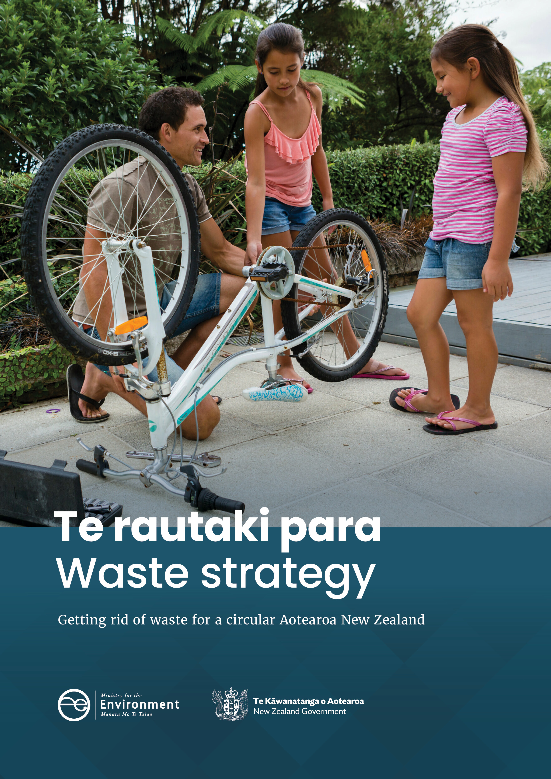
Disclaimer
The information in this publication is, according to the Ministry for the Environment’s best efforts, accurate at the time of publication. The Ministry will make every reasonable effort to keep it current and accurate. However, users of this publication are advised that:
- The information does not alter the laws of New Zealand, other official guidelines, or requirements.
- It does not constitute legal advice, and users should take specific advice from qualified professionals before taking any action based on information in this publication.
- The Ministry does not accept any responsibility or liability whatsoever whether in contract, tort, equity, or otherwise for any action taken as a result of reading, or reliance placed on this publication because of having read any part, or all, of the information in this publication or for any error, or inadequacy, deficiency, flaw in, or omission from the information in this publication.
- All references to websites, organisations or people not within the Ministry are for convenience only and should not be taken as endorsement of those websites or information contained in those websites nor of organisations or people referred to.

This document may be cited as: Ministry for the Environment. 2023. Te rautaki para | Waste strategy. Wellington: Ministry for the Environment.

Published in March 2023 by the
Ministry for the Environment
Manatū Mō Te Taiao
PO Box 10362, Wellington 6143, New Zealand
ISBN: 978-1-991077-07-3 (online)
Publication number: ME 1742
© Crown copyright New Zealand 2023
This document is available on the Ministry for the Environment website: environment.govt.nz.

Contents
Message from the Minister 6
Introduction 8
How was the waste strategy developed? 8
What role does it have? 8
What happens next? 9
What does the waste strategy mean for you? 10
What is this strategy about? 12
Getting rid of waste 12
… including reducing emissions 13
… by moving towards a circular economy 14
… enriched by te ao Māori 17
Vision and guiding principles 18
Our vision for 2050 18
Guiding principles 18
How do we get there? 20
A waste strategy with three phases 20
Phase 1 – now to 2030: Embedding circular thinking into systems 22
Phase 2 – 2030–40: Expanding to make circular normal 23
Phase 3 – 2040–50: Helping others do the same 24
What do we need to do now? 25
Focus on achieving our targets 25
Getting the building blocks in place to enable change 28
Goal 1: Systems 28
Goal 2: Infrastructure 32
Goal 3: Responsibility and accountability 36
Making more of our activity circular and producing less waste 39
Goal 4: Using less, for longer 39
Goal 5: Resource recovery systems 41
Goal 6: Recovering value 44
Reducing emissions and other negative environmental effects 47
Goal 7: Emissions 47
Goal 8: Contaminated land 50
How will we know if we are making progress? 53
How we will assess progress 53
Building the data we need 53
Using targets 54
Evaluating and reporting 55
References 56

Tables
Table 1: What does the waste strategy mean for you? 10
Table 2: Main considerations for waste to energy technology 45

Figures
Figure 1: Characteristics of linear and circular economies 14
Figure 2: Waste hierarchy 15
Figure 3: Three phases of getting rid of waste for a circular Aotearoa New Zealand 20
Figure 4: Waste hierarchy with targets 25
Figure 5: Indicative view of strategic planning cycle 29

Message from the Minister

We have to change how we make, use, manage and dispose
The way we create and manage waste in Aotearoa New Zealand is way behind many other developed countries.
Most of the materials we use end up in landfill. Too much rubbish goes into recycling bins, too many recyclables go into rubbish bins, and there’s too much of both. Every year, New Zealand generates more than 17 million tonnes of waste. We send almost 13 million tonnes of that to landfill. This means we lose the value of over two-thirds of the materials we use.
Solid waste is not the only problem; the way we produce, manage and dispose of things also generates emissions of greenhouse and other gases. Reduced waste reduces the depletion of limited resources, including the limited capacity of the atmosphere to absorb greenhouse gas emissions. In 2020, waste contributed around 4 per cent of our total greenhouse gas emissions and around 9 per cent of our biogenic methane emissions, mainly generated by the decomposition of organic wastes such as food, garden, wood and paper waste. The remaining biogenic methane emissions are mostly from agricultural sources.
Many of the products we use aren’t built to be repaired, and, even when they are, it’s often cheaper to throw them away and replace them, rather than source parts (if they’re available).
New Zealanders care about this and are rightly demanding change. The waste sector agrees that change is needed and recognises the opportunities from catching up with the world’s best-performing countries.

We can, and should, do better
The way we tackle waste touches many aspects of how we all live and work.
The change we need is not simply getting better at recycling. It’s about recognising that when any of us ‘throws something away’, it doesn’t cease to exist. It has to go somewhere: ‘away’ is usually a landfill.
Significant potential exists in Aotearoa New Zealand to reduce the waste being generated through better design, new business models, and products that are easier to repair. This strategy is based on circular economy principles that support both emissions and solid waste reduction goals.
When something does need to be disposed of as waste, we can do better at recovering useful resources through recycling. Recovering more economic value from waste provides environmental, social and cultural benefits and reduces the risks of harm to human health and the environment.
With this new strategy, our government sets out a long-term path to achieve the vision of Aotearoa New Zealand in 2050 as a low-emissions, low-waste society, embedding circular economy principles.
We need high-quality systems and infrastructure for the whole country that enable widespread circular management of products and materials, including reuse, repair and recycling.
This strategy sets the direction over the next three decades for work on waste: central and local government, the waste management sector, individual industries and businesses, and households and communities. It aims to lift our performance from stragglers to the front of the pack. It sets the goals and targets New Zealand must meet by 2030 to successfully achieve this vision.
Our government has started this work with a series of initiatives. We are establishing regulated product stewardship schemes. We have banned a wide range of single-use or hard to recycle plastic products and invested in projects to minimise or deal responsibly with waste.
We will continue this work with new legislation setting the framework to achieve our strategic goals and action and investment plans to carry out those goals in the medium term.
When I was speaking to the Chair of WasteMINZ Wayne Plummer, he said it feels like he has “spent 25 years lobbying, and five years doing”. I am pleased to be releasing this strategy on behalf of the Government, and look forward to the next 30 years of doing.

Hon David Parker
Minister for the Environment

Introduction

How was the waste strategy developed?
The Government decision in 2020 to increase and expand the waste disposal levy was the beginning of a step-change in our approach to waste. The Ministry for the Environment established a ‘waste foundations’ workstream to ensure we had the systems in place to use levy funds strategically. Developing this new waste strategy has been a central part of that work.
The Ministry began by working with two advisory groups that brought together substantial expertise on the waste sector, waste minimisation and circular economy thinking, and te ao and mātauranga Māori. Many workshops and discussions confirmed support for a long-term outlook to 2050; and a broad, ambitious approach that covers all aspects of how we use, manage and dispose of materials.
In October 2021, the Government released a consultation paper with proposals for a new waste strategy and new legislation (Ministry for the Environment, 2021b). We received 628 substantive submissions and 1,862 template responses (Ministry for the Environment, 2023a). This final new waste strategy has been prepared taking account of:
- the extensive, thoughtful feedback received in the submissions
- the Government’s decisions on waste and the circular economy in Te hau mārohi ki anamata | Towards a productive, sustainable and inclusive economy: Aotearoa New Zealand’s first emissions reduction plan (Ministry for the Environment, 2022a), and submissions received in consultation on the draft emissions reduction plan
- progress on individual projects across the waste work programme, such as the ongoing development of regulated product stewardship schemes, proposals to transform recycling, the proposals being developed for the new waste legislation, and the enhanced systems for managing investment to minimise waste
- emerging issues, including rapidly growing interest in the potential of chemical recycling, waste to energy technologies, and bioeconomy and renewable energy possibilities.

What role does it have?
The strategy lays out:
- the vision for 2050 and guiding principles, which set the direction and tone for the changes ahead
- the broad pace and phasing for the changes
- goals for the strategy’s three phases between now and 2050
- targets for the first phase, to achieve by 2030
- the work priorities to focus on to achieve the 2030 goals and targets
- the approach to measuring and assessing progress.
This document provides a lot of information on the work and changes ahead. This is so everyone can see what’s coming and work out what it will mean for them.
The clear signals will allow the waste management industry, local authorities, community organisations, businesses and individuals to start to plan their own changes.
The strategy will also be directly relevant for local government:
- When a territorial authority is preparing, amending or revoking a waste management and minimisation plan, it must “have regard to the New Zealand Waste Strategy” or any equivalent government policy (Section 44 of the Waste Minimisation Act 2008).
- The government may direct a territorial authority to change its waste management and minimisation plan if that will help achieve the waste strategy (section 48 of the Waste Minimisation Act 2008).
The consultation proposals for new waste legislation included requiring there to be a strategy and giving it a much stronger role in guiding central and local government planning, activities and investment. If these proposals proceed, the strategy will become more legally and practically important over time.

What happens next?
The strategy provides high-level direction. The next step is for government to work with local authorities, the waste management sector and others to develop a first action and investment plan (AIP).
The AIP is a supporting plan that will flesh out what’s needed to deliver on the waste strategy. It will spell out:
- the immediate priorities for the next five years in different geographical areas, communities, material streams and risk areas
- the mix of regulatory, investment, behaviour change, infrastructure, system change and other actions planned to address the immediate priorities
- the sequence of the actions and how they fit together
- who needs to do what.
The waste strategy and AIP will then govern planning and activity across central and local government. They will also enable organisations in the waste management sector to plan their own activities. The Ministry will regularly assess, and publicly report on, progress against the strategy and AIP.
The Government will prepare a fresh AIP roughly every five years. The exact timing will depend on progress being made and the need for a new plan. The Government will also review and refresh the strategy periodically, in keeping with proposed new legislative requirements.
The proposed new legislation on waste would embed this cycle of strategy, planning and public reporting into law. If that occurs, this cyclical process will give the waste management sector the direction it has asked for.

What does the waste strategy mean for you?
This is not just a strategy for government. To achieve this level of transformational change, everyone needs to get involved. Table 1 summarises what different groups and sectors can do to help.
- What does the waste strategy mean for you?
Group | Action
Everyone | Increase your or your organisation’s awareness of waste; evaluate established practices and habits; identify opportunities to reduce what you consume and avoid waste.  Be willing to try new ways of doing things and alternative products or services, like ‘product as service’ or reuse schemes.  Embrace the new systems that are coming, like extended recycling services. Learn how to use them properly, and choose products and packaging that can be recycled by these services.  Use your power as a customer or consumer to pressure suppliers to adopt practices that reduce waste.  Support other people to change as well.
Households and individuals | Consider hiring or borrowing something you won’t use often, rather than buying your own.  Learn how and where to get things repaired.  Shop at and donate/sell through second-hand shops, online sites and community exchange events.  Compost your food scraps and green waste at home or by using a collection service.  Get involved in citizen science projects.
Non-governmental organisations and communities | Use advocacy to keep being a catalyst for change.  Support businesses and households to make changes, by giving them information and help.  Keep creating community-led initiatives, like repair hubs, swap centres, clean-up campaigns and community gardens with composting.  Help build our national data on material flows and waste, through research and citizen science projects.  Hold businesses and government to account for their progress towards this strategy’s goals.
Businesses and industries | Rethink and redesign your processes, products and packaging to reduce waste.  Keep up to date with what your industry is doing to reduce waste.  Push for, and take part in, voluntary or mandatory product stewardship schemes.  Work with local community groups and non-governmental organisations on initiatives to reduce waste.  Hold your business and industry to account by systematically measuring and reporting on progress.
Waste management sector | Get involved in implementing this strategy and the process to develop an action and investment plan.  Consider how you can develop your facilities and services, so they form part of a national network for circular management of resources.  Develop industry norms and standards, to make it easy for different parts of the national network to connect.  Help develop and implement standardised national regulation of the sector.  Support the national waste data programme, to help create high-quality evidence for future policymaking and investment.
Local government | Get involved in implementing this strategy and the process to develop an action and investment plan. Use the strategy as the starting point for your next waste management and minimisation plan.  Look for opportunities to work with other councils on new, or expanded, facilities and services that will contribute to a national network for circular management of resources.  Support local community groups and non-governmental organisations with their initiatives to reduce waste.  Link with national behaviour change programmes to support and expand the reach of your local activity.  Make sure that planning and consenting processes take account of the need for waste management infrastructure and services.  Plan and resource the work needed to identify and manage vulnerable landfills and other contaminated sites.
Central government | Make sure that circular economy and waste reduction goals connect with and inform other strategies, plans and programmes across government.  Be an effective leader and steward of this strategy and the waste management sector, in particular by building and sharing data, and regularly evaluating and reporting on progress.  Build engagement systems and processes, to facilitate coordination and collaboration across the sector.  Use the Government’s procurement power to drive changes in market behaviour.  Lead by example.

What is this strategy about?

Getting rid of waste
By definition, almost all waste is undesirable: if we have to look for a way to dispose of it, it is a waste of something.
Modern societies extract, use, manage and dispose of materials in ways that cannot be sustained. We frequently rely on extracting non-renewable virgin resources, using them briefly
– often just once – then sending them to landfill. That approach pays no attention to the finite nature of our planet’s resources, the value that those products and materials may have, and the environmental harm we are causing by disposing of things.
Aotearoa New Zealand cannot be complacent. Compared with other countries, our reuse and recycling rates are poor. In 2021, each New Zealander is estimated to have sent nearly 700 kilograms of waste to municipal landfills. That makes us one of the highest generators of waste per person in the Organisation for Economic Co-operation and Development. We have patchy systems and services, and fragile markets, for many recycled materials. This is, in part, because of the challenges posed by our geography and small population.
We can’t keep consuming the planet’s resources at the same rate to make new things. We can’t keep looking for places to bury or burn the things we don’t want anymore. Nobody wants to set aside ever more space for new landfills, and it’s a waste to put useful materials into a landfill then seal it up. Nor do we want the environmental consequences of burning rubbish, or to invest in the large incinerators that would be needed to minimise toxic discharges.
It’s better not to generate waste in the first place.

… including reducing emissions
Our wasteful way of living also creates environmental problems. Visible problems include old disposal sites now at risk from erosion or flood damage, and litter clogging drains and polluting our oceans. The way we produce, manage and dispose of things also results in the emission of greenhouse and other gases. Unwanted emissions are themselves forms of waste. Better managing, and avoiding the production of waste, reduces the depletion of limited resources – including the limited capacity of the atmosphere to absorb greenhouse gas emissions.
When organic material like food scraps, plant matter, paper, cardboard or timber is sent to a landfill, it produces methane as it breaks down. Although methane is not the main greenhouse gas, its warming effect is 28 times greater than carbon dioxide. In 2019, waste caused around 4 per cent of Aotearoa New Zealand’s total greenhouse gas emissions and around 9.1 per cent of its biogenic methane emissions. Decomposing organic material in landfills generated 94 per cent of these emissions (Ministry for the Environment, 2022a).
Reducing the amount of organic waste that ends up in landfills will have multiple benefits. It will:
- reduce the amount of methane that is produced, which will reduce our greenhouse gas emissions
- reduce the overall volume of waste going into landfills, so that existing facilities can operate for longer
- mean we’re using organic matter more efficiently and wasting less, in ways that can help regenerate the soil.
Many of our municipal landfills have gas capture systems that either burn some of the methane and carbon dioxide being produced or use it to produce energy. However, that’s not enough. It doesn’t provide the other benefits of avoiding organic material going to a landfill in the first place, and it still results in emissions of both methane and carbon dioxide, including after the landfill has ceased operating.
Minimising waste can also help reduce greenhouse gas emissions in other ways. By rethinking production processes, supply chains, business models and disposal methods we can reduce emissions throughout the whole lifecycle of products and materials, not just at the end of their life.
Te hau mārohi ki anamata | Towards a productive, sustainable and inclusive economy: Aotearoa New Zealand’s first emissions reduction plan includes specific targets and initiatives on waste. This strategy reflects those initiatives and targets, and the urgency of tackling climate change.

… by moving towards a circular economy

Linear and circular economies
Taking natural resources, making them into something, using and then disposing of it – is referred to as a ‘linear economy’.
In contrast, a ‘circular economy’ is a system where extracted materials are used and reused for as long as possible. For technical or synthetic materials, the ideal scenario is that they are reused forever. Biological (organic) materials will eventually be returned to the soil to enrich it (see figure 1).
  - Characteristics of linear and circular economies
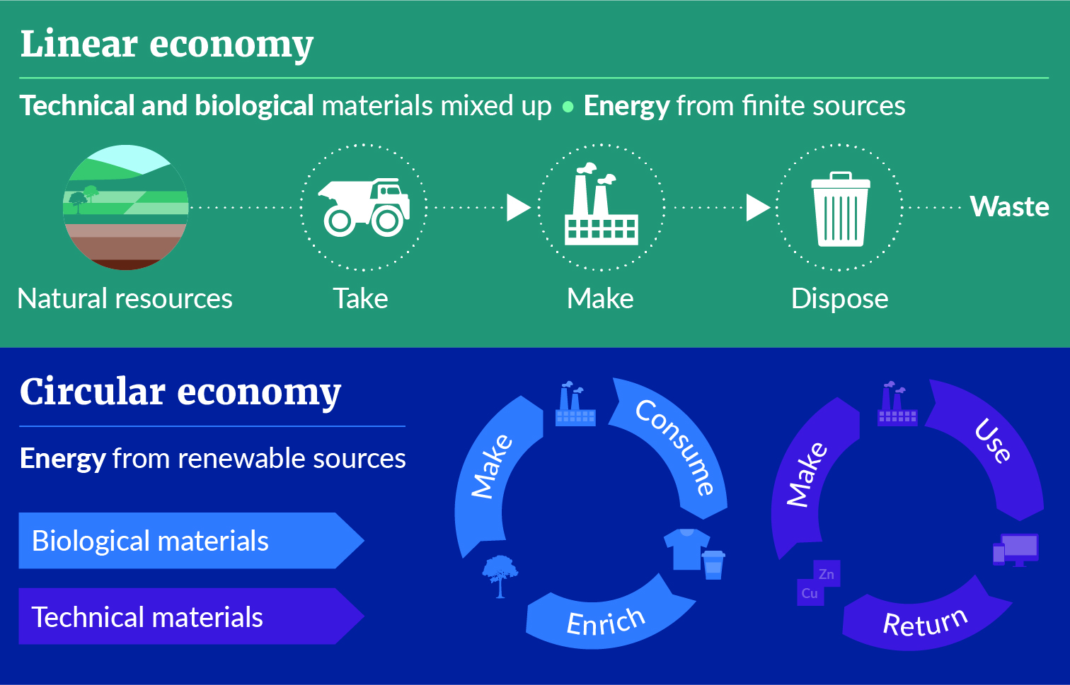
The Ellen MacArthur Foundation has led international thinking on the circular economy since it was created in 2010. This is the Foundation’s description of the circular economy:
The circular economy is based on three principles, driven by design:
- Eliminate waste and pollution
- Circulate produce and materials (at their highest value)
- Regenerate nature.
It is underpinned by a transition to renewable energy and materials. A circular economy decouples economic activity from the consumption of finite resources. It is a resilient system that is good for business, people and the environment. (Ellen MacArthur Foundation, n.d.)

Many countries have adopted circular economy principles:
- Japan has had government policies on a circular economy since the 1990s. In 2001, it enacted legislation on establishing a “sound material cycle society”, promoting effective use of resources and green purchasing.
- The European Union has included circular economy thinking in its directives and policies since 2013.
- Germany passed a Circular Economy Act in 2012, to promote using circular economy models and managing waste in ways that are compatible with the environment.
- The United Kingdom issued the Circular Economy Package in 2020, which is a package of policies built on previous circular economy commitments and goals for England, Scotland and Wales.
- Many Australian states have adopted circular economy laws and strategies in recent years. This includes new circular economy legislation passed in Victoria and New South Wales in 2021.
- Members of the Secretariat of the Pacific Regional Environment Programme (SPREP) endorsed a circular economy approach in the Pacific Regional Action Plan: Marine Litter 2018–2025 (SPREP, 2018).
Committing Aotearoa New Zealand to a circular economy means we stay in step with many of our major trading partners. We have already committed to developing a full circular economy and bioeconomy strategy in the emissions reduction plan. This waste strategy is an essential first step. It builds on internationally recognised circular economy principles and adapts them for our context.

Waste hierarchy
Circular economy principles build on a tool known as the ‘waste hierarchy’. This tool illustrates the best and least favoured options to reduce and manage waste. Many versions exist of the waste hierarchy; some are very technical. For this strategy, we have developed a simple version that is easy to understand and use (see figure 2).
  - Waste hierarchy
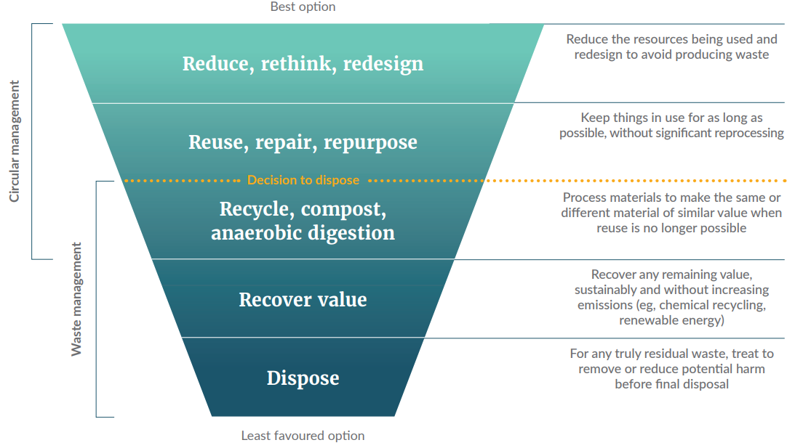
The top layers of the waste hierarchy represent a circular approach to managing materials. The yellow line in figure 2 is the point at which something has no further use in its original form and needs to be managed as waste. The layers below this line make up the waste management system.
No strict boundaries exist between the layers of the waste hierarchy. Some activities or ways of reusing things can fit in more than one layer, depending on how you characterise them. This is especially true at the lower layers, as technology develops and blurs the line between recycling and recovering value. The emerging field of chemical recycling is a case in point. Within the layers there may also be more or less preferred approaches, such as repair before repurpose.
It’s best to regard the waste hierarchy as an indication of preferences, rather than a prescriptive tool.

Reduce, rethink, redesign
The first layer of the waste hierarchy is about getting smarter about what we use and how we make things, to avoid generating waste in the first place. For example, not using unnecessary packaging; constructing things more efficiently, so there are fewer offcuts; selling soap in bars rather than in plastic bottles; and simply making things that last longer.

Reuse, repair, repurpose
The second layer of the waste hierarchy is about continuing to use things for as long as possible once they have been made. This includes making it easy to get something repaired; reusing containers (such as refill systems for groceries); or repurposing used timber to make raised garden beds. Repurposing includes food rescue and using unwanted by-products from one process as the raw materials for another process.
Recycling and composting are part of both the circular and waste management systems. However, they are the least preferred form of circular management, although the best form of waste management.

Recycle, compost, anaerobic digestion
The middle layer of the waste hierarchy is about reprocessing things, so their materials can be used again. Ideally, they are remade into the same thing, so the materials stay in use at the same value. Melting down glass bottles to make new bottles and recycling aluminium cans are examples of how materials can be used indefinitely.
‘Downcycling’ means reprocessing something to a less valuable use. For example, turning soft plastics into fence posts or crushing glass to use in roading. The more that materials get downcycled, the less likely they can be recycled again.
Compost is specific to organic material. Because it returns nutrients in organic material to the soil, and helps regeneration, it is a form of recycling: it keeps materials in use rather than disposing of them. Anaerobic digestion of organic material produces biogas, as well as solid and liquid material, to return to the soil.

Recover value
Some technologies extract the remaining value from materials before, or while, they are disposed of. Waste-to-energy facilities are a common example. However, recovering value must be done without increasing emissions or instead of a preferred method higher in the waste hierarchy. Ideally, these facilities process renewable material.

Final disposal
The bottom layer of the waste hierarchy is about permanently disposing of materials. Traditionally, this means using landfills and incinerators. The bottom layer should be reserved for residual waste that can no longer be used in any other way. Final disposal of waste often needs to be accompanied by some form of treatment, to minimise the environmental effects.

… enriched by te ao Māori
Circular economy thinking shares many underlying values with te ao Māori. At a practical level, both focus on not creating waste in the first place and cycles of continual regeneration.
In te ao Māori, the fundamental concept of whakapapa is closely linked and adds further richness. Whakapapa can be broadly described as the kinship between all living things: past, present and future. Whakapapa not only exists between people but between people and the planet. That kinship creates connection, respect and responsibility. Inherent in whakapapa is the need for us to:
- understand how things are connected – in ecosystems or economies – and the potential consequences of our interventions on an existing balance
- recognise and respect the mauri (shared life force) and mana (its external recognition) of nature, and the resources it gives us, as well as those of people
- accept our responsibility to care for nature and what it gives us, as well as people.
In this way, whakapapa gives rise to kaitiakitanga – our stewardship responsibility to actively care for the environment around us.
Whether you think in terms of whakapapa and kinship, or in terms of an environmental ethic and circular economy, those values are important for the transformation we are seeking.
- We must think about how things are connected and how our actions affect them.
- We must recognise the value in natural resources and make the best use of them.
- We must step up to our responsibility to care for nature.
This strategy brings these values together into a vision and principles that create a platform for change unique to Aotearoa New Zealand. The values underpin every part of the waste strategy; they should guide all our actions under the strategy in the future.

Vision and guiding principles

Our vision for 2050
By 2050, Aotearoa New Zealand is a low-emissions, low-waste society, built upon a circular economy.
We cherish our inseparable connection with the natural environment and look after the planet’s finite resources with care and responsibility.

Guiding principles

Take responsibility for how we make, use, manage and dispose of things
- Enable people, businesses, organisations and sectors to do the right thing, by improving systems, services and information.
- Shift the responsibility and cost of minimising and managing waste to industries and consumers, and away from communities, nature and future generations.
- Create accountability, by having transparent data and reporting and clear regulated obligations.
- Aim for Aotearoa New Zealand to become as self-sufficient in managing its own waste as practicable.
Apply the waste hierarchy preferences to how we manage materials
- Rethink and redesign products, to avoid using materials unnecessarily, design out waste and pollution, and make it easy to reuse and recycle products.
- Keep products and materials in use for as long as possible, as far up the waste hierarchy as possible.
- Extract remaining value from waste before or during final disposal, where that can be done sustainably and without increasing emissions
Protect and regenerate the natural environment and its systems
- Take account of the planet’s limits by choosing renewable over non-renewable resources.
- Reduce greenhouse gas emissions during a material’s entire lifecycle, from extraction, manufacturing and production through to recycling and final disposal.
- Recognise the need to enhance ecosystems, by replenishing natural resources as they are used.
- Clean up and repair environmental damage from current and historical activities.
Deliver equitable and inclusive outcomes
- Recognise the unique perspectives, needs and approaches facing different local communities, businesses, hapū, iwi and whānau.
- Ensure the costs and benefits of change are distributed equitably among communities and across generations.
- Develop and invest to create opportunities and jobs in local and regional communities.
Ensure our systems for using, managing and disposing of materials are financially sustainable
- Develop innovative business models, new markets and more demand for circular solutions and recycled materials.
- Encourage investment from diverse sources of capital and maximise the benefits of co-investment.
- Use central government funding to complement private funding, not displace it.
Think across systems, places and generations
- Consider how the social situation of individuals, whānau, iwi and communities, and their locations – rural and urban, national or international – affect their perspectives.
- Recognise the connections between waste and other environmental, social and economic issues, including climate change and biodiversity.
- Consider how Aotearoa New Zealand’s systems can support or connect with others, especially in Australia and the Pacific.

How do we get there?

A waste strategy with three phases
This strategy has three phases. These phases recognise the need to balance our strong ambition with the reality of where we are now, the complexity of the task ahead, and the amount of work we need to do. Each phase has goals that build on those from the previous phase and create momentum over time.
  - Three phases of getting rid of waste for a circular Aotearoa New Zealand

No firm boundaries exist between one phase ending and another starting; instead, they broadly indicate the sequence and trajectory of change.
Each phase has multiple goals that focus on different aspects of managing materials and waste. The actions to achieve the goals often overlap or contribute to more than one goal. This is because the change ahead is not one-dimensional. We need to work in many areas, and many different parties need to work together, to align and coordinate many different elements.
In broad terms, the logic behind these phases is as follows.
- First, Aotearoa New Zealand needs to get its own house in order, by getting ready for a long-term programme of systematic change. Initially, we need to focus on putting in place:
- national systems for planning, funding, investing and reporting, as well as long-term behaviour change programmes
- a legal framework to regulate what is circulating in our economy and how it is managed and disposed of; and an administrative framework to properly support and enforce the regulations
- the infrastructure systems, equipment and facilities we need to collect, sort and process unwanted materials across as much of the country as practicable
- the knowledge, planning and tools we need to prioritise and tackle the task of safeguarding and remediating old or at-risk disposal sites and contaminated land.
- Second, we need to build on the many initiatives already underway. Systematically, and over time, we can use and enhance existing systems and tools to shift business models and behaviour further up the waste hierarchy and into more circular ways of operating.
- Next, we will reach a tipping point where circular thinking is no longer an effort or a novelty, but is what consumers expect and is a normal way of doing business and supplying goods and services.
- Finally, we must maintain the momentum of change and extend the scope and range of circular activity as far as we can, by taking it into more challenging sectors, products and materials.
As Aotearoa New Zealand advances down this path and shifts to circular ways of operating, we must look beyond our own shores. Cooperating with Australia is likely to be important to establish viable recycling systems and markets for some materials. We also need to consider the close connection between our two economies as we introduce regulatory changes for individual products and materials.
With Australia, we have already been working with our Pacific neighbours to support their efforts to reduce and manage waste better (SPREP, 2016, 2018), particularly through the Secretariat of the Pacific Regional Environment Programme. Small islands face even greater challenges than we do, given their size, geography and distance from other markets and facilities. As we build our domestic systems to support a circular economy, we must consider where and how Pacific nations can access those systems.
We want to get to a point where Aotearoa New Zealand has caught up with other countries in how it manages materials and avoids waste. We want to see the amount of waste we generate and dispose of comparing well with other countries, and know we are improving the natural environment rather than continuing to harm it. We want to be able to hold our head up internationally and share what we have learnt and done.

Phase 1 – now to 2030: Embedding circular thinking into systems

Goals

By 2030, our enabling systems are working well and behaviour is changing
The building blocks are in place to enable change | - The strategic planning, regulatory, investment and engagement systems are in place and operating to drive and support change.
 | - We have a comprehensive national network of facilities supporting the collection and circular management of products and materials.
 | - We all take responsibility for how we produce, manage and dispose of things, and are accountable for our actions and their consequences.
More activity is circular and we produce less waste | - We use fewer products and materials, and using them for longer, by making them more durable, and repairing, reusing, sharing and repurposing them.
 | - Resource recovery systems are operating effectively for core materials and across all regions.
 | - We look for ways to recover any remaining value from residual waste, sustainably and without increasing emissions, before final disposal.
Emissions and other environmental indicators are improving | - Emissions from waste are reducing in line with our domestic and international commitments.
 | - Contaminated land is sustainably managed and remediated, to reduce waste and emissions and enhance the environment.

Phase 2 – 2030–40: Expanding to make circular normal

Goals

By 2040, circular management of materials is normal, expected and well supported
Circular activity is widespread | - Repairing, sharing and reusing are common, and the preferred options where practicable.  - Resource recovery systems are easy to access and cover many materials.  - There is strong demand for recycled material and products.  - Aotearoa New Zealand’s systems are working with others across Australia and the Pacific.
Residual waste is minimal | - We are extracting the maximum value from materials and products before or during final disposal, where appropriate and sustainable.  - Residual waste has reduced to a minimum, as has the need for final disposal facilities.
Emissions and other environmental indicators keep improving | - Emissions from the resource recovery and waste management sector are reducing in line with domestic and international commitments.  - Plastic pollution has significantly decreased.  - Programmes to manage or remediate contaminated land and old disposal sites are well advanced.

Phase 3 – 2040–50: Helping others do the same

Goals

By 2050, New Zealand is a low-emissions, low-waste circular economy and is helping other countries make the change
Domestic systems are as circular as possible | - Aotearoa New Zealand’s consumption of virgin resources is largely from renewable sources and has stabilised at sustainable levels.  - Regeneration is the norm and part of our circular business models.
Aotearoa New Zealand is contributing to regional and global circular networks | - Aotearoa is part of a regional Pacific network for circular management of materials.  - Aotearoa is active in international efforts to support low-emissions, low-waste circular economies.
Our management of materials does not harm the environment | - Resource recovery systems operate effectively, based on a strong understanding of carbon footprints.  - Residual waste, and the need for final disposal facilities, is minimal, as is its environmental impact.

What do we need to do now?

Focus on achieving our targets
This strategy sets three national targets for us to achieve by 2030 (see figure 4). The targets focus on the three most important changes we need to make.
- Waste generation: reduce the amount of material entering the waste management system, by 10 per cent per person.
- Waste disposal: reduce the amount of material that needs final disposal, by 30 per cent per person.
- Waste emissions: reduce the biogenic methane emissions from waste, by at least 30 per cent.
These targets are ambitious. To achieve them, we need to take action in many areas and at every level of the waste hierarchy.
For all three targets, we only have patchy data at the moment to set baselines and measure our progress. Some of the data is old and some comes with a high degree of uncertainty. Improving the data is a central part of the Ministry’s work programme; it features in many of the goals and actions in this strategy.
Limited data is not a reason to exclude targets from the waste strategy. Targets are an important way to provide focus and to motivate. As the data improves, we expect to be able to refine and extend the targets we are using, through the cycle of AIPs and reviews of this strategy.
  - Waste hierarchy with targets
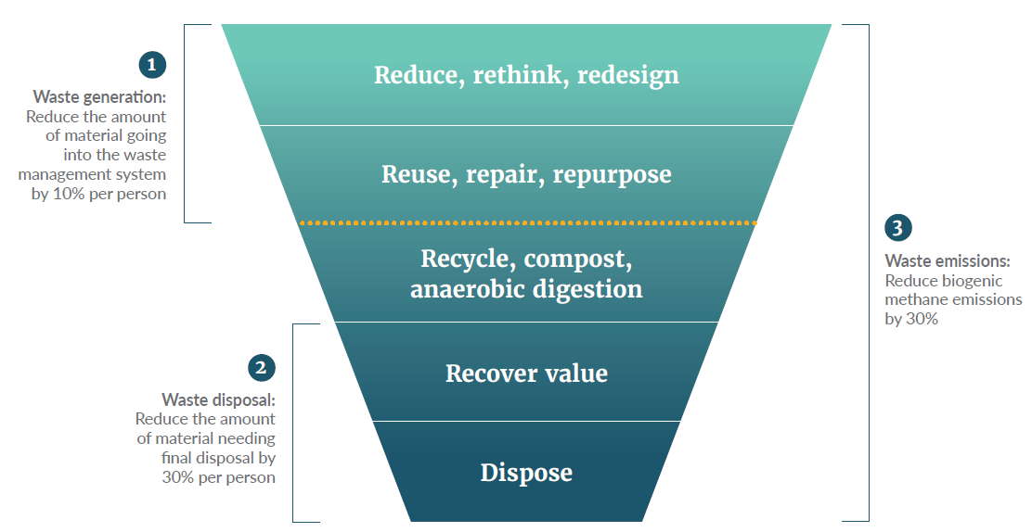

Reduce the amount of material entering the waste management system by 10 per cent per person
This target is about reducing the amount of material going into the waste management system for recycling, recovery of value or final disposal. Measuring what crosses that line is a good measure of how much progress we are making on keeping materials in the top two layers of the waste hierarchy. In other words, are we increasing the amount of circular activity and reducing the amount of material we are disposing of?
To achieve a 10 per cent drop in waste by 2030 means we need to significantly change our behaviour and approach in all activities and business sectors.
Given current data limitations, we need to do some work to define and establish a baseline before this becomes an effective target we can use to monitor progress. Addressing the data problem is a priority in the workstream to develop a national waste data system.
A waste generation target like this is widely used internationally, so once we have the data systems working to support it, we will be able to compare our progress with others.
We could also work to develop supporting targets for different sectors. In particular, the Carbon Neutral Government Programme may enable us to set a waste generation target for the public sector. It should also be possible for the construction sector to establish data sources and set targets soon, drawing on the Building for Climate Change programme.
By using all these data sources, we expect to be able to set a benchmark and build a good picture of progress against this target in the next few years.

Reduce the amount of material that needs final disposal
by 30 per cent per person
The first target is about reducing how much material goes into the waste management system for recycling and final disposal. However, when material does come into the system, we need to increase the proportion that gets recycled and reduce the amount that goes to landfill or another location for final disposal.
Our second target will keep us focused on this issue. As with the first target, the data that will be gathered from disposal facilities should let us set a benchmark and monitor progress reasonably soon.
As the data improves, we will look at setting more detailed or supporting targets. For example, it may be useful to set separate targets for household and non-household waste. From landfill audits, we can collect data on household waste going into landfills. Over time, we should be able to supplement this with data from the licensing and tracing systems included in the proposals for new waste legislation, and data on waste going through recycling systems.

Reduce the biogenic methane emissions from waste
by at least 30 percent
The third target is closely linked to the emissions reduction plan target of reducing all biogenic methane by 40 per cent by 2035 (Ministry for the Environment, 2022a). Around 94 per cent of waste emissions are biogenic methane, generated when organic material (such as food scraps, plant matter, timber, paper and cardboard) starts to break down in a landfill. Some, but not all, landfills have systems to flare or capture the gas, but they don’t capture all emissions.
Reducing the emissions from waste in landfills will contribute significantly to Aotearoa New Zealand achieving the overall emissions reduction plan target for biogenic methane.
Again, data is a challenge. The Ministry must work with climate change agencies and the waste management sector to gather more and better-quality data.

Getting the building blocks in place to enable change

Goal 1: Systems
Strategic planning, regulatory, investment and engagement systems are in place and operating to drive and support change

Priorities
Goal 1 is about getting organised. It involves new or improved systems for regulation, investment, planning and reporting, data collection, and more. This effort will set us up to work together in new ways and clarify what we can each be doing.
To achieve Goal 1 by 2030, we must focus on the following priorities.
1.1 | Pass and implement new legislation to:  - require long-term strategic planning and reporting  - enable a pipeline of regulatory changes to manage products and materials circulating in the economy and reduce the amount of waste that is recycled or sent for final disposal  - create a comprehensive regulatory regime for all waste management activity (ie, recycling and final disposal).
1.2 | Set up strategic planning and reporting systems that provide everyone with clear direction.
1.3 | Set up data collection systems that provide good quality information, to help us assess progress and agree priorities.
1.4 | Set up funding and investment systems that will support this strategy’s goals and priorities.
1.5 | Establish partnerships and collaboration relationships that will enable us to pool our resources and coordinate our activities.
Central government needs to lead most of this work, because it is about creating national planning, regulatory and investment systems. However, local government, the waste management sector, and other private sector organisations must be closely involved in putting these systems in place, to ensure they are practical and effective for everyone who needs to work with them in the years ahead.

Priority 1.1: New waste legislation
New waste legislation is critical. It will create the legal frameworks, powers and obligations needed to drive change. The intention is for it to be in force in 2025.
Some of the legislative changes will come into effect immediately, while others will be phased in over time. For example, regulation of waste management activity is likely to be phased in between 2025 and 2030. The new law will create powers or regulatory systems to support an ongoing pipeline of more detailed regulations, such as phasing out problematic materials and introducing more regulated product stewardship schemes.

Priority 1.2: Strategic planning and reporting systems
The proposed legislation will embed a system of strategic planning and reporting on waste for central and local government. Precise timing is still to be determined, but the central government cycle would look something like the outline given in figure 5. Local government planning cycles, including development of waste management and minimisation plans, will also draw on and input into this cycle (noting different councils are at different stages in their own planning cycles).
  - Indicative view of strategic planning cycle
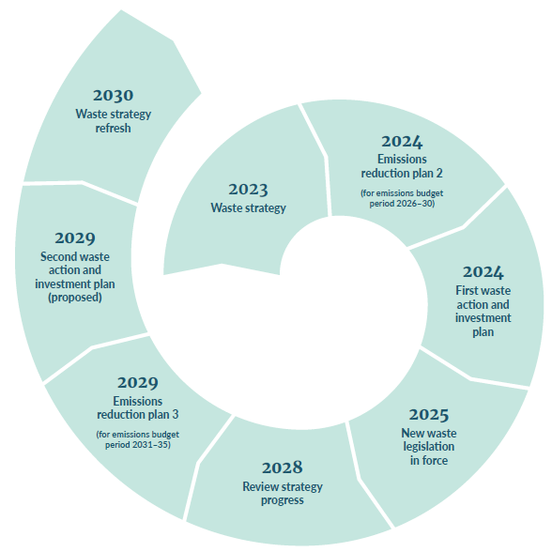

Priority 1.3: Data collection systems
Better data is vital for good long-term planning and reporting. Steps to build a strong platform of data on material flows and waste management include:
- defining and agreeing the data sets the Ministry and others want to use
- expanding our data sources and methods of collecting data. For example, draw on mandatory data reporting, information collected by audits (where possible), the proposed licensing and tracking systems, citizen science projects and lifecycle assessments
- establishing data management protocols that enable aggregate data to be shared, while commercial confidentiality of specific information is protected
- creating online, public dashboards of data, for easy access and use by all those with an interest.

Priority 1.4: Funding and investment systems
The waste disposal levy will generate significant funds to help achieve this strategy. Other public funding is also made available for waste minimisation initiatives from time to time. Much of our work on establishing good underlying systems relates to ensuring we can effectively manage this funding and investment.
The Ministry has already redesigned the processes for its increased investment activity using the Waste Minimisation Fund, Plastics Innovation Fund and COVID-19 recovery funding. The next step is to align the central government investment framework to this strategy, the AIP – once it is developed – and any changes resulting from the new waste legislation.
Other priorities include:
- improving access to funding for Māori
- attracting more investment partners and sources of capital, including other central and local government agencies, the private sector and iwi.
Councils will also need to consider how to use funding they receive from the waste disposal levy in line with the overall strategic framework. The AIP process and other engagement systems being developed are designed to give councils the clear shared context, direction and priorities they need for preparing their own plans. That greater engagement should also support greater collaboration between councils and with central government.

Priority 1.5: Collaboration and engagement
Because the changes we want to make are deep and complex, we must work together. Almost every action in this strategy needs many parties to contribute. Central government can lead in some areas, but it is equally important we build and resource systems that enable all the players to work together effectively.
Groups and organisations are already working together on particular projects or initiatives and achieving great results. But this takes effort and a sense of common purpose. Getting standing arrangements and agreed protocols in place will set us up for easier and more effective cooperation.
For example, we need:
- cross-government arrangements to connect relevant areas, such as work that the Ministry of Business, Innovation and Employment is just beginning on a circular and bioeconomy strategy
- a simple way for central and local government to work together on areas of mutual interest, given that our waste responsibilities are intertwined
- long-term working relationships with the main private sector organisations and non-governmental organisations (NGOs) in the waste management sector
- a broader range of mechanisms to engage with and support the many businesses, sectors, community groups and individuals who support a shift to a circular economy.
A particular area of focus must be to build Māori capacity and engagement on waste reduction issues. We know many Māori are concerned about waste, but it is one of many issues competing for attention. Some Māori organisations are doing excellent work in this area (eg, the work Para Kore does with marae to support better waste disposal practices). We intend to investigate and pilot initiatives to better support Māori to achieve their objectives relating to waste.

Goal 2: Infrastructure
A comprehensive national network of facilities supports the collection and circular management of products and materials

Priorities
Goal 2 is about getting the equipment and infrastructure in place that we need for a coherent, nationwide network of facilities for the collection and circular management of products and materials. We have it in some places, for some materials, at least for recycling. But we need it everywhere, for all materials that are able to be reused or recycled. People can’t do the right thing with unwanted materials if the supply chain isn’t there to take them.
To achieve Goal 2 by 2030, we must focus on the following priorities.
2.1 | Align the overall direction and approach across central and local government, and the waste management sector.
2.2 | Ensure planning laws and systems recognise waste management services and facilities as essential infrastructure and a development need.
2.3 | Secure investment from diverse sources.
2.4 | Put in place arrangements that will help parties plan and deliver projects together, efficiently and effectively, so we create a coherent, national circular-resource network.

What is waste management infrastructure?
There are four main types of waste management infrastructure.
Collection infrastructure includes collection vehicles, skip bins, domestic bins for kerbside collections, and bins and collection points at shops and other public places.
Resource recovery infrastructure includes transfer stations and vehicles, drop-off facilities, sorting facilities and washing plants for reuse schemes.
Reprocessing infrastructure includes composting and anaerobic digestion facilities for organic material, plastics processing plants, and plants for managing construction and demolition waste.
Disposal infrastructure includes waste to energy plants, incineration facilities and landfills.

Priority 2.1: Alignment on direction and approach
Infrastructure is the second building block we need to get in place if we are to drive rapid change. Waste and resource recovery infrastructure has developed in an ad hoc way over time and lacking an overall plan or vision. Individual territorial authorities and the private sector have been responsible for the infrastructure, and more could be done to encourage collaboration.
The result has been inconsistencies and gaps in infrastructure and services, inefficiencies and suboptimal rates of recovery. Analysis of our existing infrastructure confirms that what we have now is patchy: between locations and across types of materials. Read more about Waste and resource recovery: Infrastructure and services stocktake.
We now have an opportunity to change that.
Reflecting the vision and principles, this goal is for infrastructure that is comprehensive in three respects:
- nationwide coverage: we need to address the unequal services and facilities in different parts of the country, and make sure smaller and rural communities have services
- range of products and materials: we need to build collection and processing systems that can adapt over time to manage a growing range of products and materials, and not be limited to the core materials where recycling is currently viable
- circular management options: we need to ensure the systems support activity as high up the waste hierarchy as possible, so that, for example, they can incorporate reuse, repair and repurposing services as well as recycling.
To achieve this goal, we need to build from existing systems and processes to create an approach to developing infrastructure that is coherent and coordinated across the waste management sector and country. We are more likely to find economies of scope and scale if we work collaboratively and look across the different parts of the country and different material streams.
The main tools for achieving greater coherence and coordination are:
- the collaborative strategic planning processes being established to support this strategy (including the AIP process)
- the increasing funding for central and local government from the waste disposal levy.
The proposal to embed the strategic planning and reporting framework in the legislation will also help, by strengthening the obligation on councils to align their work with the nationally agreed goals and priorities.
The first step is for central and local government, the waste management sector and others with an interest in circular resource management to build a shared view of what this goal means in practice and chart a path for achieving it. The AIP process will provide the framework for those discussions.
As we do this, it will be important to balance two of the waste strategy’s principles.
- The aim for Aotearoa New Zealand to become as self-sufficient in managing its own waste as practicable. This means we must increase our domestic capability to process recycling and dispose of specialised and hazardous forms of waste
- The need to consider how Aotearoa New Zealand’s systems can support or connect with others, especially in Australia (trans-Tasman systems may sometimes be more effective and efficient) and the Pacific (our systems may be able to support smaller nations that have greater challenges than us).
Across all this work, we must prioritise reducing greenhouse gas emissions. This means looking at the emissions generated, including transport emissions, throughout the entire lifecycle of materials, from extraction, manufacturing and production through to recycling and end of life disposal.
There will not be a ‘one-size-fits-all’ answer. Different places and materials will require different solutions. But, in future, those differences should be deliberate and for good reason, rather than accidents of history. And bringing all the solutions together should add up to a coherent national network of services and facilities that enable all of us to manage our waste responsibly.

Priority 2.2: Recognition in planning laws and systems
Waste management facilities and services have not always been included in lists of essential infrastructure; for example, they are not included as a lifeline utility in the Civil Defence Emergency Management Act 2002 or in the definition of infrastructure in the Resource Management Act 1993. Yet the COVID-19 lockdowns in 2020 quickly showed us that waste management services and facilities are essential and must be able to operate, even when most of our economic and social activity pauses.
Waste legislation and resource management legislation could also work together better to manage waste and resource recovery systems. To do so, we need a long-term, coordinated approach to infrastructure planning, to ensure it aligns with planning for developing homes and communities (New Zealand Infrastructure Commission, 2022). This includes identifying and protecting strategic infrastructure corridors decades in advance through our national, regional and local spatial planning tools. The New Zealand Infrastructure Commission’s Rautaki Hanganga o Aotearoa New Zealand Infrastructure Strategy 2022–2052 now includes waste management as core economic infrastructure (New Zealand Infrastructure Commission, 2022).
Waste management facilities and services have not always been included in lists of essential infrastructure; for example, they are not included as a lifeline utility in the Civil Defence Emergency Management Act 2002 or in the definition of infrastructure in the Resource Management Act 1993. Yet the COVID-19 lockdowns in 2020 quickly showed us that waste management services and facilities are essential and must be able to operate, even when most of our economic and social activity pauses. The New Zealand Infrastructure Commission’s Rautaki Hanganga o Aotearoa New Zealand Infrastructure Strategy 2022–2052 includes waste management as core economic infrastructure (New Zealand Infrastructure Commission, 2022).
In practical terms, our planning and consenting systems need to ensure that:
- new buildings include space for the full range of bins that occupiers will need, whether they are commercial premises, apartment blocks or townhouse complexes
- developments include sufficient space for collection vehicles to operate
- local areas include space for community facilities, including collection points for a range of products and materials, recycling facilities like small local composting, and repair hubs
- regional plans provide for a coherent network of collection points, transfer stations, and processing and disposal facilities, and good transport links between them.
Although central and local government are largely responsible for making this happen, the waste management sector, businesses and communities all have a part to play, by ensuring they consider these needs when they plan new developments.

Priority 2.3: Investment from a range of sources
Earlier estimates of the investment needed to bring our systems up to a reasonable standard were that between $2 billion and $3 billion would be required.
The revenue generated by the expanded waste disposal levy provides a good start for the investment needed in circular resource infrastructure, but we cannot wait for the levy to generate that level of funding on its own. Because the private sector participates extensively in the waste management sector, it is appropriate that it also invests in the solutions. In general, public funding should be used to fill gaps or kickstart facilities and services that the market struggles to provide; it should not displace private sector investment and activity.
Recognising that levy funds will not be enough in the short term, central government has provided additional funding for new and upgraded infrastructure in recent years. It committed $75 million from the Climate Emergency Response Fund to get infrastructure in place quickly, to reduce methane emissions by diverting organic waste from landfills.
Circular resource management is a growth area, with significant scope for innovation. Opportunities exist for iwi and other new investors to get involved and support new infrastructure, industries and jobs, locally and regionally.
Central government will manage the investment of its levy funds to leverage funding from other sources and work with other government investment vehicles, where appropriate.

Priority 2.4: Working together
Putting priorities 2.1 to 2.3 in place is not enough on its own. We also need to actually deliver projects, and deliver them in a way that cumulatively builds a coherent network of services and facilities.
The Government can play an important role in helping different parties work together. That may include:
- supporting local authorities to work across districts and regions
- helping establish industry norms on technical issues, to enable interoperability
- finding community partners to extend services into hard-to-reach areas.
The Government can also help reduce the risks for commercial and community operations, through collecting and sharing data, improving waste collection systems and promoting behaviour change. The regulatory changes that will follow the new waste legislation will also help create a more consistent and stable national framework to support the circular management of resources.

Goal 3: Responsibility and accountability
We are all taking responsibility for how we produce, manage and dispose of things, and are accountable for our actions and their consequences

Priorities
Goal 3 is about people and organisations being motivated to change to more circular behaviour and to do the right thing when they dispose of something. We know the public strongly supports change, but it is important we focus on hearts and minds, so that support turns into action.
To achieve Goal 3 by 2030, we must focus on the following priorities.
3.1 | Deliver long-term, evidence-based behaviour change programmes.
3.2 | Give people clear and consistent information on what to do, and why and how to do it.
3.3 | Set clear legal obligations on waste disposal, and enforce them effectively with sanctions.
3.4 | Report regularly to the public on the environmental consequences of how we are managing and disposing of materials.

Priority 3.1: Long-term, evidence-based behaviour change programmes
We will need to support people to examine and change their current business practices, personal habits and routines, in all their consumption, management and disposal activities.
To make circular approaches the norm, we need to run long-term programmes that address the barriers to adopting sustainable behaviours, and enable and encourage individuals, households and businesses to take action to prevent waste. This involves more than giving people clear information; we must invest in substantial behaviour change initiatives.
Many businesses, NGOs and local authorities already promote waste minimisation actions. These organisations are often under-resourced and unable to sustain long-term initiatives. We also lack a consistent national narrative that ensures the public knows when and how to take action. Central government has, at times, funded organisations or campaigns, or run its own campaign on a particular issue, but has not had a consistent presence in this area of work. Consultation showed strong support for government to take on a central role.
To achieve the waste strategy’s goals, central government intends to develop and deliver a long-term behaviour change programme. This will not be a ‘one-size-fits-all’ standardised approach. It also will not take over the work that others are already doing. We recognise that these organisations have different roles, opportunities and areas of expertise, and target different audiences. Our aim is to provide an overarching programme that complements and supports their work, and to help them leverage off each other’s efforts. To successfully deliver these behaviour change programmes, we will need to work together and as partners.
The intention is that this new function would be funded by the waste disposal levy in future, once that is enabled by the proposed new waste legislation. In the meantime, the Climate Emergency Response Fund has provided short-term funding, so we can start programmes that will help households and businesses reduce the amount of organic waste they send to landfill.

Priority 3.2: Public information
Without timely, accurate and clear information, it’s hard for consumers to make informed choices or know the best ways to reduce or dispose of waste. All these groups can help give people clear information.
- Central government, particularly in relation to any new legal obligations being created by or under the new waste legislation, such as duties of care on how to dispose of waste appropriately.
- Local government, particularly when it creates additional obligations through bylaws or establishes new services.
- Waste management industry, on how to use its recycling services to minimise contamination, and where and how to dispose of hazardous materials.
- Producers, manufacturers, suppliers and retailers, on what their products and materials are made of, whether they can be repaired, how long they should last, and how and where they should be returned, recycled or disposed of.
Some specific initiatives are planned to support providing clear information. For example, the proposed new waste legislation is likely to include powers to require information to be provided to consumers, for example, on aspects of the particular product, or labelling on products and packaging explaining how to return, recycle or dispose of it. The plan to standardise kerbside recycling across the country would also give people clearer information on what to do.

Priority 3.3: Legal obligations and sanctions
This priority is concerned with building both responsibility and accountability. The proposals for the new waste legislation will have a central role here. They include creating new, comprehensive obligations for how people dispose of things and how that waste is managed, including through:
- duties of care (ie, responsibilities for how people manage materials for disposal)
- licensing waste management operators and facilities
- improved legal arrangements to support and enforce compliance.
These proposed legal obligations will be backed up with offences and penalties. The proposed new legislation will include a full set of powers and enforcement tools for the responsible agencies; sanctions and penalties to match the nature of the breach or offence; and a wider range of enforcement tools.

Priority 3.4: Public reporting
Accountability is more than making individuals accountable for following legal obligations. Other critical layers include the accountability of the organisations responsible for the systems in place to manage waste, and our shared accountability for the cumulative environmental consequences of what we are doing.
The focus on improving our data and reporting regularly to the public (see Goal 1) are both designed to improve accountability. They are ways to hold public agencies – and all of us
– to account for how we are doing.

Making more of our activity circular and producing less waste
Goal 4: Using less, for longer
We are using fewer products and materials, and using them for longer, by making them more durable, and repairing, reusing, sharing and repurposing them

Priorities
Goal 4 is simply about using less. It involves using all the tools and techniques in the top two layers of the waste hierarchy. This requires us to rethink what we need and how we design and manufacture things, so we use fewer virgin resources. We also need to make things that last longer, can be reused and are easier to repair.
To achieve Goal 4 by 2030, we must focus on the following priorities.
4.1 | Find different ways of doing things, and support more circular business models and practices.
4.2 | Make it easy and cost effective to repair things.
4.3 | Create more systems and facilities that support things being reused.

Priority 4.1: Doing things differently
This goal is essential to moving towards a circular economy, and achieving the target of reducing the amount of waste we generate and put into the waste management system by 10 per cent. It is about rethinking and redesigning products, services and business models in every aspect of our lives and work.
To achieve this goal, we need to create a climate of innovation. As a society, we could consume fewer virgin resources, generate less waste and recycle more if we rethink the way we do things.
Central government can support innovation in these ways:
- provide seed funding for research, initial business cases, prototypes, equipment and infrastructure
- help groups of interested people and organisations form networks, so they can connect with others with the same goals and benefit from each other’s expertise and resources
- work with particular sectors to address any regulatory barriers that are preventing them from making sensible changes
- be willing to experiment and lead the way by adopting redesigned services and products.
Customers also have an important role. Consumer demand is a powerful way to drive change in businesses and supply chains. Whether you are an individual, small or large business, or community organisation, you can create pressure through your purchasing choices and the information you ask for.

Priority 4.2: Repairing more things
The difficulty in getting products repaired is one of the reasons that things end up in landfills. Even when an item has a relatively minor fault, it often needs to be replaced by a new item. This frustrates many people, here and overseas, and has led to the ‘right-to-repair’ movement.
Consumer demand can be a powerful way to drive change across a supply chain, from retailers who sell products through to manufacturers who supply them.
Consumer pressure can encourage new business opportunities for repair services, where gaps exist. Communities can also get involved. Many local repair hubs are starting up and finding they are quickly overwhelmed by the demand for their service. Local authorities could support these initiatives by, for example, making space for them in resource recovery centres or other community facilities.
Central government will continue to look for ways to support the right-to-repair movement through legislation and regulations. For example, we are considering whether the new waste legislation should enable, for specific categories of products:
- a minimum level of repairability (such as through setting design standards)
- manufacturers and suppliers to provide information on repairability
- product stewardships schemes including repairability as a goal or obligation.
Beyond waste legislation, there is scope to draw on international experience and look at amending other relevant legislation, such as intellectual property law, the Consumer Guarantees Act 1993 and the Fair Trading Act 1986.
Many governments are taking steps to enable products to be repaired more easily and cost-effectively. The Government will monitor those initiatives and adopt them into its own domestic systems, where appropriate.

Priority 4.3: Reusing things
Reuse systems – where the same container or other packaging is used repeatedly for the same purpose – are a good example of a circular business model. Innovative businesses and customer demand can also drive change in this area.
Many businesses are already exploring reuse options but can face challenges. For example, there may be costs to get set up (such as equipment to collect and clean items) and transporting items for reuse can create greenhouse gas emissions. Central government can help overcome these challenges by providing seed funding, connecting people with others who may want to get involved, and changing regulations that are getting in the way.
Central and local government, and the waste management sector, must think about how to cater for future reuse systems when developing the infrastructure to support collection and processing of products and materials (see also Goal 2).
Goal 5: Resource recovery systems
Resource recovery systems are operating effectively for core materials and across all regions

Priorities
Goal 5 is about recycling. It involves creating a consistent recycling service across the country for core materials. Having a standardised service will make it easier for people to use it. It will also increase the quality of the material collected, by reducing the amount that is contaminated.
To achieve Goal 5 by 2030, we must focus on the following priorities.
5.1 | Simplify material streams so more can be recycled, more easily.
5.2 | Strengthen collection systems and services across the country.
5.3 | Get more people and organisations recycling, and recycling well.
5.4 | Create more demand for recycled materials.

Priority 5.1: Material streams
One of the challenges with recycling is that the processes are based on individual materials (such as glass, paper, aluminium and specific types of plastic), but products and packaging often combine several different materials (for example, a paper cup with a plastic lining). This limits recycling. Encouraging manufacturers to use a single material, or combine materials in ways that make it easy to separate them again, can make a big difference to what can be recycled and reducing what is sent to landfills.
The Government can support change in this area by:
- encouraging and funding research and innovation on better ways to use recyclable materials
- setting design standards that control the composition of some products or packaging (this is included in the proposed new waste legislation)
- requiring manufacturers and suppliers to provide consumers with clear information on recyclability, so they can make informed choices when they buy things, which will create pressure for businesses to change
- removing hard-to-recycle materials from our economy.
We’ve already taken steps in that direction through the National Plastics Action Plan for Aotearoa New Zealand (Ministry for the Environment, 2021a) by phasing out some plastic bags, PVC containers and expanded polystyrene packaging, with additional phase outs still to come. Meanwhile, we can look beyond plastics to consider what other products or materials we could remove from our economy.

Priority 5.2: Collection systems
We have increasingly efficient supply chains that get products to people and businesses wherever they need them. However, our systems for collecting them back up again, so they can be reused or recycled, are much patchier. While Goal 2 focuses on creating the infrastructure we need to provide a consistent service around the country, Goal 5 is about the systems that ensure materials can be collected efficiently for processing (eg, for recycling).
Most councils already provide kerbside collection services for household recycling; some also provide this service for small businesses, particularly in urban areas. But what they collect and how they collect it varies, which makes it confusing for people when they change locations.
We need all councils to take responsibility for kerbside collection of household recycling and general waste. The proposed new waste legislation would clarify that this is a core responsibility for councils.
In urban areas, kerbside collections can build on existing systems. In small towns and rural areas, it is harder to find ways to collect dry recycling and organic material. Councils will need to work together, and with central government and the waste management sector, to find solutions. The Government has announced plans to address these types of issues as part of its work to transform recycling (Ministry for the Environment, 2023b).
Several other initiatives will both help drive the creation of more developed supply chains for collection and processing and rely on them to operate.
At a sector and product level, voluntary and regulated product stewardship schemes depend on there being a collection system (such as retailers or identified collection points). Voluntary schemes operate for a number of products with varying degrees of success. The Government is also working with industry on six regulated, mandatory product stewardship schemes over the next few years for:
- agrichemicals and their containers
- electrical and electronic products, including large batteries
- farm plastics
- plastic packaging
- refrigerants
- used tyres.
The intention is to establish a pipeline to create more extended producer responsibility schemes, once the new waste legislation has been passed, to provide a streamlined process for creating and running these schemes.

Priority 5.3: Getting everyone recycling well
Priorities 5.1 and 5.2 are about the materials for recycling and the systems to collect and process them. But we also need people to use the systems and use them correctly.
Standardising what is collected around the country, and how it is collected, will make a big difference to people recycling correctly. Having clear, standardised labels on products and packaging will also help (see Goal 4).
Having long-term behaviour change campaigns, which clearly set out our responsibilities, are important (see Goal 3). These campaigns will be particularly important for motivating everyone to recycle correctly, because this will often involve them changing their existing habits.

Priority 5.4: Market demand
Another critical part of an effective recycling system is having a use, and preferably a market, for the recycled materials. Currently, there are few or no takers for some recycled materials; for other materials the markets are volatile. However, in some cases (such as metal), the market is reasonably effective and stable.
This is another area where everyone has a role. Customer demand can be powerful in driving change. When customers choose products that contain recycled content over those that do not, it encourages more manufacturers to follow suit. Customers at any stage of a supply chain can have an influence. For example, businesses that manufacture things, or use packaging, can demand materials that contain more recycled content.
The Government can fund research and innovation that supports markets and infrastructure that supply or use recycled material. The proposed new waste legislation would also give the Government power to require a proportion of recycled content in specified products.
The waste management sector is the backbone of this process, because waste management organisations are the primary investors in waste collection and processing infrastructure and facilities. These organisations need a reliable supply of material to recycle, affordable technology to process it, and a steady demand for what it produces. At the moment, this balance is fragile, but the changes set out in this strategy should redress that balance over time.

Goal 6: Recovering value
We look for ways to recover any remaining value from residual waste, sustainably and without increasing emissions, before final disposal.

Priority
Goal 6 is about using available technologies to extract as much value as we can from waste that cannot be recycled and is destined for final disposal. Although recovering value is near the bottom of the waste hierarchy, and should not displace options further up, we will continue to have residual waste for some time. This is a challenging area that we must approach cautiously, but if we can use truly residual waste without harming the environment we should do so.
To achieve Goal 6 by 2030, we must focus on the following priority.
6.1 | Embed a balanced and consistent approach to recovering value from waste across government and industry strategies, policies and actions.

Priority 6.1: Balanced and consistent plans and actions

What do we mean by ‘recovering value’?
‘Recovering value’ means extracting all potential value from waste before or as part of its final disposal. The most common ways to do this involve waste to energy technologies. These technologies use different processes to extract energy from waste (typically heat, electricity or fuel). It is a rapidly evolving space that crosses many policy areas (such as energy, waste, circular economy, climate change and bioeconomy). It therefore needs a coordinated approach across government.
Some waste to energy processes are well established in New Zealand. For example, woody residues are used in combined heat and power plants at sawmills, and used cooking oil is converted into biodiesel. Other countries use processes that are not yet established in Aotearoa New Zealand, such as incinerating municipal solid waste with heat recovery.
Sometimes the boundary between a process that recycles resources and one that converts waste to energy is unclear, because some processes produce hydrocarbons that can be used either as fuel or to create physical materials. This applies to bio-derived and fossil-derived hydrocarbons. For example:
- ethanol derived from waste can be used as fuel, food, a medical sanitiser or to make plastics
- hydrocarbons produced by the thermal breakdown of plastic waste can be used as fuel or, if the quality is good enough, for remaking plastics. Thermal processes are typically fuelled by burning some of the hydrocarbons. Burning fossil-derived hydrocarbons, in the process or in fuel outputs, adds to greenhouse gas emissions.
New technologies are emerging all the time and are likely to continue blurring these boundaries. However, experience overseas has shown that it pays to be cautious with a new process until its benefits have been tested and proven.

Why we need to balance competing principles and considerations of waste to energy technology
In principle, extracting remaining value from waste that cannot be used further up the waste hierarchy is an attractive proposition. However, there are competing principles and risks, so we need an approach that recognises this and strikes a sensible balance.
For any technology, we need to consider four aspects: purpose, feedstock, processing and energy produced (see table 2).
- Main considerations for waste to energy technology
Aspects to consider | Questions to ask
Purpose | What is the primary aim: to dispose of a hazardous or problematic waste or to generate energy?
Feedstock | What waste material will be processed: is it biological, non-biological or mixed?  Is the waste truly residual with no higher value?  Is there a sustainable, long-term supply of the waste material, taking into account all our planned waste-reduction initiatives and commitment to reduce all waste (including residual waste)?  How far will the waste material need to be transported?
Processing | What emissions will the processing plant produce?  What other by-products will be created, and how harmful are they?  How will by-products be disposed of?
Energy produced | Will the plant generate more energy than it uses, will there be a net gain?  Can the additional energy produced be used?  What type of energy will it displace: renewable or non-renewable?
The choice of feedstock is likely to be important to the environmental impact of any waste to energy technology: you get out what you put in. A single stream of clean, renewable biological waste is likely to be relatively easy to process and have fewer toxic discharges or residues.
In general, using biological materials (biomass) to create energy can have positive effects, including reducing emissions. However, biomass is an important raw material for the circular bioeconomy. Therefore, it may be better to keep waste biomass from producing and consuming food in the food cycle (for example, in compost) or use it to make biomaterials, than use it for energy.
Single waste streams with fossil-derived hydrocarbons (such as sorted plastics or tyres) can be used in many chemical recycling and waste to energy processes, because their composition is clean and known. However, single waste streams that are sorted can be more appropriately used in processes higher up the waste hierarchy, such as recycling.
Using mixed and non-biological waste (like municipal solid waste) in waste to energy processes can be technically challenging. These types of waste are more likely to create hazardous by-products and generate greenhouse gas emissions.
Large scale waste to energy facilities, like incinerators, are significant capital investments that depend on having a consistent supply of feedstock for their 20- to 30-year lifetime. However, many other initiatives are under way to reduce, reuse and recycle waste, particularly plastic. These include phasing out single-use and hard-to-recycle plastics, and improving recycling systems. These initiatives will quite quickly reduce the supply of this type of feedstock for a waste to energy operation.

What we need to consider and explore
These various considerations combine to produce our broad assessment, as outlined below.
- Waste to energy technology has the potential to displace fossil fuels in industrial applications like process heat (currently dominated by natural gas and coal) and transport (currently reliant on oil).
- Proposals that use clean renewable biomass as a feedstock are most likely to align with our circular economy goals, as the feedstock can be sustainable, they are less likely to produce harmful by-products and have the potential to reduce greenhouse gas emissions.
- Proposals that use single waste streams (such as tyres, treated timber, waste engine oil and some plastics) will need to be considered on a case-by-case basis.
- Pyrolysis, incineration or gasification of municipal solid waste is unlikely to align with our circular economy goals, due to their negative effects on the climate, dependency on continued linear waste generation, and likelihood of causing hazardous discharge.
We intend to develop and apply this thinking across government over the next few years, particularly in the context of the circular and bioeconomy strategy work that is getting under way through the emissions reduction plan. This will inform how government agencies implement initiatives and provide advice, including on matters like the application of the waste disposal levy, decarbonisation, regional economic development funding, as well as any government input into consenting applications.

Reducing emissions and other negative environmental effects
Goal 7: Emissions
Emissions from waste are reducing in line with our domestic and international commitments

Priorities
Goal 7 is about reducing emissions from waste. It links directly to our second target, as well as targets in the emissions reduction plan. This is obviously an urgent focus.
To achieve Goal 7 by 2030, we must focus on the following priorities.
7.1 | Generate less waste that produces emissions when it is disposed of.
7.2 | Recycle organic material instead of sending it to landfills.
7.3 | Capture more of the greenhouse gases being produced by organic material in landfills.

Priority 7.1: Create less organic waste
The main greenhouse gas emission generated by waste is methane; it is produced by organic material breaking down in landfills. Organic material includes food scraps, garden waste, paper, cardboard and timber. In line with the waste hierarchy, our first priority must be reducing the amount of organic waste we generate in the first place. Many initiatives are available that businesses, NGOs, households and individuals can take to do this.
Across the food supply system, we need to find more efficient ways to produce and consume food, so that we minimise the amount of usable food we discard. That can happen, for example, because it is uneconomic to harvest the remains of a crop or some of the crop does not reach a required quality standard (because it’s the wrong shape or colour).
Many solutions are available to those types of problems. For example:
- growers could let the public, communities or NGOs come onsite to gather what is left after the commercial harvest, assuming this can comply with their health, safety and biosecurity obligations
- growers could find alternative markets or uses for produce that does not meet quality standards (such as food businesses for juice or soup, or supermarkets that market ‘odd’ produce)
- food rescue organisations help minimise food waste by giving it to people in need.
When households change their behaviours, it can prevent significant amounts of food being wasted. Simple steps include planning meals before shopping and storing food properly. Restaurants and cafes can also reduce their costs by storing and managing stock better and using non-traditional parts of ingredients.
Not all food can be repurposed to feed people. However, it can sometimes to be used to feed livestock or as a component in another product or manufacturing process, as long as this complies with safety and biosecurity requirements. If no beneficial ways are available to use food waste, it needs to be recycled (priority 7.2).
The Government is already establishing national programmes to help households and businesses prevent and reduce food waste and, where possible, garden waste (see Goal 3).
The scope is huge to reduce other forms of organic waste. The building and construction sector is now focusing on reducing the amount of timber that is sent to landfills. It is doing this by improving designs and plans, ordering fewer materials to avoid surplus, minimising offcuts and separating materials for recycling during construction. When a building nears the end of its life, renovating, refitting or refurbishing it should be considered. If a building cannot be saved, deconstructing rather than demolishing it means its materials retain some value. The Building for Climate Change programme aims to reduce emissions from constructing and operating buildings and ensure buildings are prepared for the future effects of climate change (Ministry of Business, Innovation and Employment, 2021).

Priority 7.2: Recycle more organic material
When organic material does need to be disposed of, we need to maximise the amount that is recycled into beneficial uses. The main options are compost and anaerobic digestion. We can develop several initiatives.
- Introduce nationwide, standardised kerbside collection of household food scraps, and potentially garden waste, and support and educate people on how to use the system (see Goal 6).
- Support councils to implement standardised kerbside systems (see Goal 1 and Goal 6).
- Fund and invest in infrastructure to collect, process, manage and recycle organic waste (food, garden, construction and demolition waste) (see Goal 2).
We can do more to encourage composting at home or community gardens. Composting has the added benefits of avoiding the transport emissions generated by kerbside collections, encouraging people to use compost to grow their own food and strengthening community connections.
The Waste Minimisation Act 2008 includes a power to control or prohibit how something is disposed of. This power is likely to continue in the new waste legislation. One of the emissions reduction plan’s main initiatives is to investigate limiting or banning organic waste from landfills by 2030, as long viable alternatives are available that people can use.

Priority 7.3: Capture more landfill gas
Many, but not all, class 1 landfills taking municipal waste have systems to capture the gas produced by decomposing organic waste. Even where there are capture systems, they still let some methane through into the atmosphere. The emissions reduction plan includes a commitment to require all class 1 facilities to have a landfill gas capture system in place by the end of 2026. Sites without a system could be banned from accepting organic waste in the future.
The emissions reduction plan also commits to exploring whether non-municipal landfills (classes 2 to 5) need gas capture systems and whether to ban disposal of organic material at these sites by 2030.

Goal 8: Contaminated land
Contaminated land is being remediated and managed to reduce waste and emissions, and enhance the environment

Priorities
Goal 8 is about identifying and protecting old disposal sites and other contaminated sites, and establishing long-term programmes to remediate and manage them. It is important that we fix the environmental damage our past practices have caused. Climate change provides added impetus to do this, given the increasing risk that erosion, flooding or other weather events will expose or breach old landfills and other disposal locations.
To achieve Goal 8 by 2030, we must focus on the following priorities.
8.1 | Use the resource management reforms to create a new framework for identifying and sustainably managing contaminated land.
8.2 | Identify and assess the risks to communities and the environment posed by vulnerable landfills and other contaminated sites.
8.3 | Reduce the volume of soil disposed of at landfills, by increasing soil diversion and reuse.

Priority 8.1: A new framework for identifying and managing contaminated land
Aotearoa New Zealand has a legacy of pollution and contaminated soil from past practices for storing and using hazardous substances, and disposing of waste and hazardous wastes.
We are not well equipped to manage these problems. The current regulatory framework for preventing and managing contaminated land is ambiguous and piecemeal. The prevailing approach to managing contamination is ‘dig and dump’, which means we treat considerable volumes of soil as waste and transport them to landfills.
Resource management reforms are now under way. They provide an opportunity to change the regulatory framework and our overall approach to managing contaminated land.
The proposals for the Natural and Built Environments Act and National Planning Framework include better ways to identify and manage contaminated land along with a clarified liability regime for meeting the costs. These changes will establish a regulatory framework that is fit for the future, protecting health, and restoring the environment in a sustainable way.
The challenge is then for all involved to use that framework to address the problems, starting with the most vulnerable or at-risk sites.

Priority 8.2: Identify and assess the risks from vulnerable landfills and other contaminated sites
In March 2019, part of the Fox Landfill on the West Coast was washed away during an extreme weather event. It spread waste materials over 21 kilometres of river and 60 kilometres of coastline. The clean-up exercise took almost six months. Volunteers and staff from the Department of Conservation and New Zealand Defence Force spent thousands of hours picking up and disposing of rubbish from the rivers and beaches. The Government bore most of the cost.
In future, we can expect more extreme weather events and rising sea levels, which will increase the threat to our landfills and contaminated sites. Arotakenga Huringa Āhuarangi: A Framework for the National Climate Change Risk Assessment for Aotearoa New Zealand outlines the risks and actions we must take to prepare for what lies ahead (Ministry for the Environment, 2019).
Starting with landfills at risk from climate change, we want to see these high-risk sites identified and prioritised for adaptation and action. We know there are at least 110 closed landfills that are vulnerable to rising sea levels, but the total number of at-risk sites will be more.
Once sites are identified, those responsible for each site need to lead the preparation and implementation of a site management plan, including an emergency response and contingency plans. Most landfills are owned by a local authority or private company, but ownership can change after a site is closed.
When high-risk landfills are remediated or relocated, the materials at the site should be recovered, wherever practicable. Consistent with this strategy’s principles and goals, we should minimise the waste that needs to be redisposed of at a landfill.
Whatever approach we take, remediating landfills is costly. The National Adaptation Plan has already signalled we need to keep working on how best to support the funding of that work (Ministry for the Environment, 2022c).

Priority 8.3: Disposal of soil
Soils are living ecosystems that sustain and support all life, including microbes, plants, animals and humans. Soils are a scarce, finite and living resource.
We are currently wasting large volumes of soil by trucking it to landfills as waste during development projects, or when we manage and remediate contaminated land. Transporting soil creates carbon emissions, in addition to the other negative environmental effects.
Landfill operators use soil to temporarily cover waste materials, to reduce odour and wind-blown litter during their daily operations. Their operating consent or standard procedures often require them to do this, although alternative daily covers are sometimes available.
Increasingly, we are learning that sending surplus soils to landfill is not always desirable or sustainable in the long term. By removing soil from its original location, we make it unavailable for productive or regenerative purposes, which is at odds with the principles of a circular economy.
We need to change our approach, recognise the inherent value of soils and reduce the volume that ends up in landfills. We can do this by applying circular economy concepts to how we use and treat soils. For example, we need to:
- investigate how and why we generate excess soils during construction and demolition
- obtain good data on the volume of soil disposed of at landfills
- promote sustainable remediation of soil as the norm, including treating contaminated soils on site
- explore options to recover and reuse soils when they have been moved off site.

How will we know if we are making progress?

How we will assess progress
For some things in this strategy, especially the initial building blocks for change, assessing progress will simply be about achieving milestones for projects, that is, checking we are getting things done. Examples of this are getting new legislation passed in Parliament and producing the first AIP.
Beyond that, to assess our progress in any meaningful way we need data. In all our systems for managing and using materials, and managing waste, we need to start collecting data systematically and using it to measure, monitor and report on our progress. That way, between us, we will understand material flows and what is being disposed of where.
In the early years of this strategy, we must do our best to work with the limited data currently available. Priority 1.3 includes initiatives that aim to steadily improve the situation. By the time we prepare the next iteration of this strategy, we should have robust evidence to help us make decisions.

Building the data we need
Traditionally, individual councils have collected data on waste, through their waste assessment and waste planning work. The information gathered and how it is measured often vary. We need to bring that information together, and build on it, to create a full national picture.
Until recently, the only consistent data that was being collected nationwide was the volume of waste going to around 30 class 1 municipal disposal facilities. These facilities have been required to report data since 2009, as part of the waste disposal levy process.
Alongside the expansion of the coverage of the waste disposal levy, the Government has also expanded the data reporting requirements for waste management facilities and operators. Data is collected from:
- class 1 municipal disposal facilities
- class 2 construction and demolition disposal facilities
- class 3 and class 4 managed or controlled fill disposal facilities
- class 5 cleanfills
- industrial monofills
- transfer stations.
Sites must report the gross tonnage of waste or diverted material that enters the site and the tonnage that is reused, recycled or removed (diverted tonnage). Transfer stations must also report the tonnage that they send on to disposal or processing facilities.
The Ministry also has an overall data programme that is building on this core information to generate an overall picture of material flows into and through the waste management system. We need to gather data from a variety of sources, using nationally consistent categories and reporting formats, make sure the data is reliable, and make it available to be used for a range of purposes.
Many new regulatory initiatives on waste are likely to include a data component. For example, the proposals for standardised kerbside recycling collections include mandatory reporting from operators directly to central government, with the aggregate data being published online. The regulated product stewardship schemes being developed will all have data collection and reporting components.
Other initiatives include:
- working with WasteMINZ to review and update the National Waste Data Framework
- partnering with organisations like Keep New Zealand Beautiful and Sustainable Coastlines to maintain citizen science activities that provide data on litter
- working with other government agencies and programmes, for example:
- Stats NZ, for data on waste exports
- climate change organisations for data on greenhouse gas emissions from waste
- the Carbon Neutral Government Programme for data on the volume of central government’s waste.
This is just the beginning. The intention is to work with the sector to identify further information needs and potential data sources, and to steadily increase the range and quality of data available to meet those needs.
The Ministry aims to develop an online platform where up-to-date, aggregate data is publicly available.

Using targets
If they can be measured and monitored, targets help focus attention and motivate people and organisations to change. Progress towards a single target does not have to be directly measurable. Often, we can assess progress by evaluating information from several different data sources that, combined, provide a reasonable picture of whether change is happening.
Given the limited data available now, this strategy includes only three targets on critical topics. We know that changes already under way will give us reliable data to measure Target 1 (waste generation) and Target 2 (final waste disposal) within the next few years. At that point, we can set benchmarks and start to monitor and report on progress.
As our data picture improves, we should be able to develop more targets to drive action in other areas of the waste strategy and build an even richer picture. For example, it may be useful to have data sources, targets and measures that:
- let us track our efforts on material streams like food waste, plastics and glass
- show us the geographical coverage of services
- link with the roll out of regulatory initiatives (such as product stewardship schemes or sector licensing)
- let us track progress further up the waste hierarchy, such as product durability, repair rates and uptake of reuse systems.
These developments don’t have to wait for the next iteration of this strategy. The work with the sector to develop and report on the supporting AIPs will be one way we can make progress, along with many other initiatives that are under way.

Evaluating and reporting
One of this strategy’s guiding principles is to take responsibility and be accountable for how we make, use, manage and dispose of things. At a national level, we can support that with systematic and regular evaluation and reporting on progress. Robust data must be the foundation for this work, but it also needs to be periodically interpreted and assessed.
Many of our public sector agencies are required to prepare regular independent reports. For example, the Public Finance Act 1989 requires reports on the state of the economy, and the Environmental Reporting Act 2015 requires reports on the state of the environment.
Following that model, proposals for the new waste legislation include statutory requirements for the Government to periodically review and refresh this strategy and for the Ministry to regularly report progress against it.
We expect it will be useful to complete a progress report before we prepare each new AIP and before we revise this strategy. As our data set grows, these progress reports will give us the opportunity to evaluate, reflect and learn; they will inform our next steps.

References
Ellen MacArthur Foundation. n.d. Circular Economy Introduction: What is a Circular Economy? Retrieved from www.ellenmacarthurfoundation.org/topics/circular-economy-introduction/overview (9 November 2022).
Ministry for the Environment. 2019. Arotakenga Huringa Āhuarangi: A Framework for the National Climate Change Risk Assessment for Aotearoa New Zealand. Wellington: Ministry for the Environment.
Ministry for the Environment. 2021a. National Plastics Action Plan for Aotearoa New Zealand. Wellington: Ministry for the Environment.
Ministry for the Environment. 2021b. Te kawe i te haepapa para | Taking responsibility for our waste: Proposals for a new waste strategy; Issues and options for new waste legislation. Wellington: Ministry for the Environment.
Ministry for the Environment. 2022a. Te hau mārohi ki anamata | Towards a productive, sustainable and inclusive economy: Aotearoa New Zealand’s first emissions reduction plan. Wellington: Ministry for the Environment.
Ministry for the Environment. 2022b. Transforming recycling: Consultation document. Wellington: Ministry for the Environment.
Ministry for the Environment. 2022c. Aotearoa New Zealand’s first national adaptation plan. Wellington: Ministry for the Environment
Ministry for the Environment. 2023a. Taking responsibility for our waste: Summary of submissions. Wellington: Ministry for the Environment
Ministry for the Environment. 2023b. Improving household recycling and food scraps collections. Wellington: Ministry for the Environment
Ministry of Business, Innovation and Employment. 2021. Building for Climate Change. Retrieved from www.mbie.govt.nz/building-and-energy/building/building-for-climate-change (13 November 2022).
New Zealand Infrastructure Commission. 2022. Rautaki Hanganga o Aotearoa New Zealand Infrastructure Strategy 2022–2052. Wellington: New Zealand Infrastructure Commission | Te Waihanga.
SPREP (Secretariat of the Pacific Regional Environment Programme). 2016. Cleaner Pacific 2025: Pacific Regional Waste and Pollution Management Strategy, 2016–2025. Apia, Samoa: SPREP.
SPREP. 2018. Pacific Regional Action Plan: Marine Litter 2018–2025. Apia, Samoa: SPREP.

Other foundation projects include new legislation on waste, waste parts of Te hau mārohi ki anamata | Towards a productive, sustainable and inclusive economy: Aotearoa New Zealand’s first emissions reduction plan (Ministry for the Environment, 2022a) and a programme to build better national data on waste.
It is proposed that the new legislation uses a wider extended producer responsibility framework to replace the product stewardship provisions in the current legislation.
These policies include the policy commitments in the emissions reduction plan, chapter 15 (Ministry for the Environment, 2022a). They are repeated here to make it easy to see the connections with waste initiatives.
The Resource Management Act 1991 is the main legislation for identifying and managing contaminated land. It is supported by the National Environmental Standard for Assessing and Managing Contaminants in Soil to Protect Human Health (NESCS). The NESCS is a national set of planning controls and soil-contaminant standards administered by territorial authorities.

