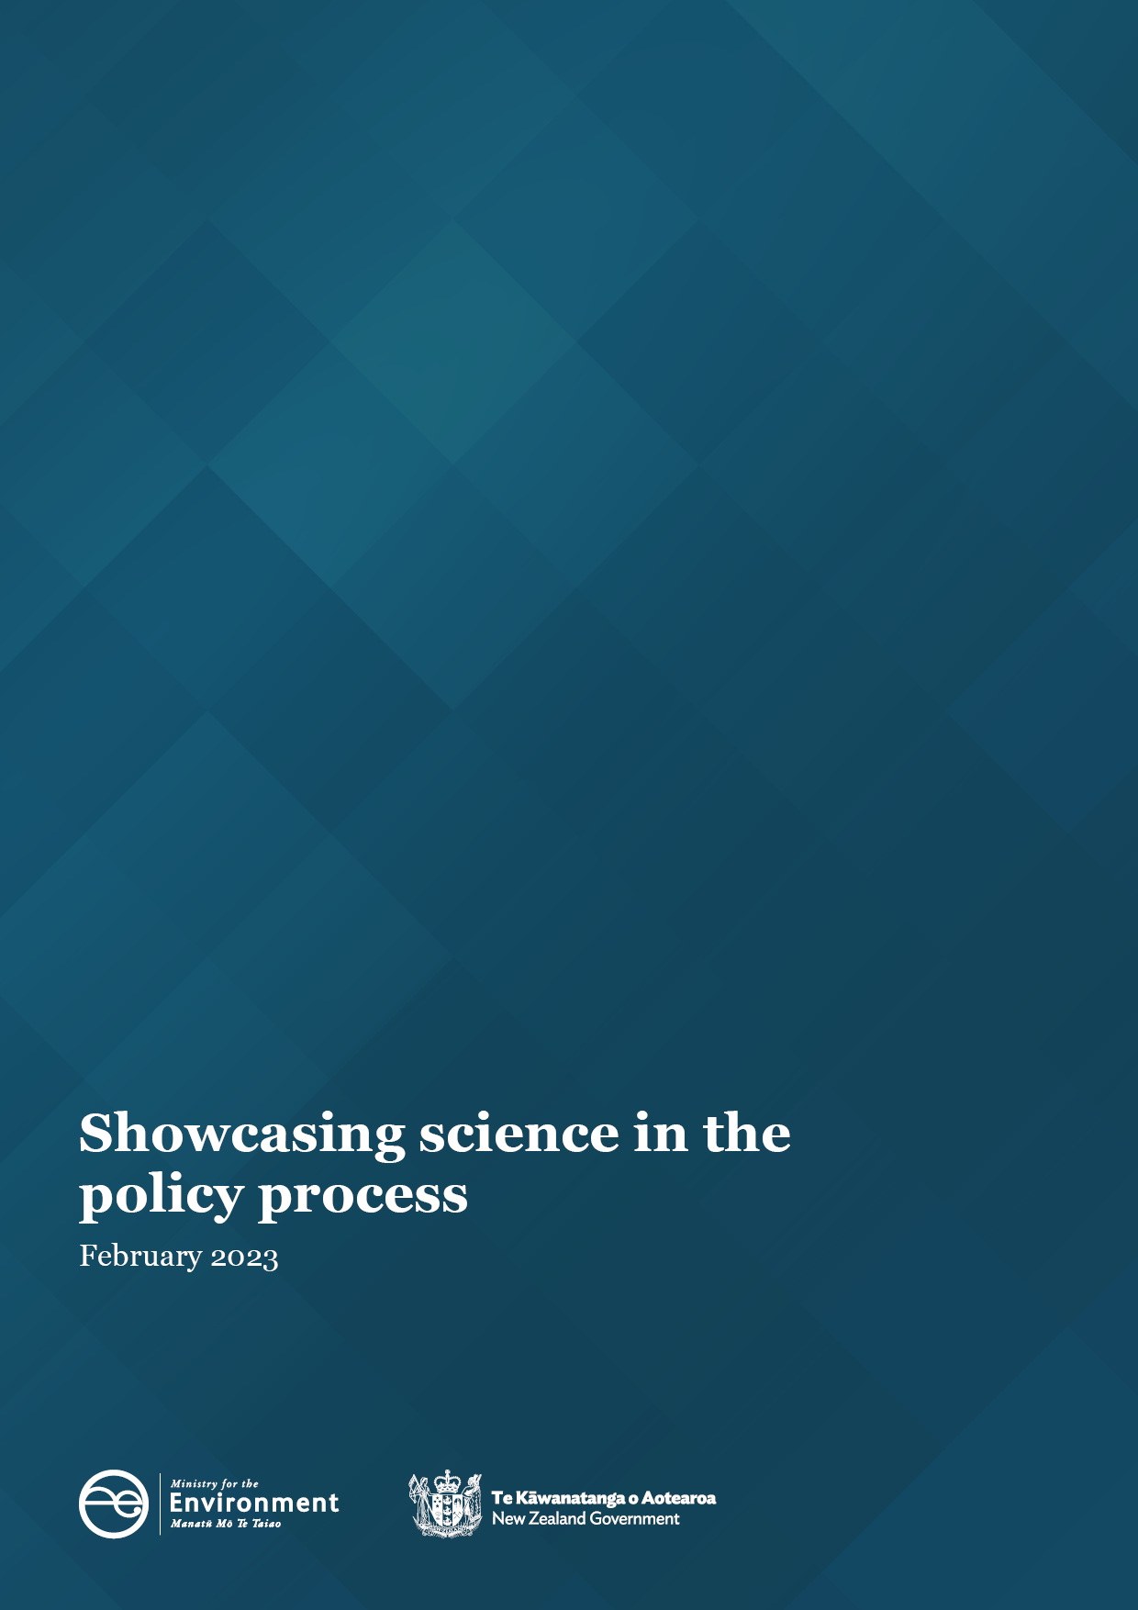

Acknowledgements
The Ministry for the Environment would like to thank Dr Cindy Baker for her input into Swimming against the tide of decline.

This document may be cited as: Ministry for the Environment. 2023. Showcasing science in the policy process. Wellington: Ministry for the Environment.

Published in February 2023 by the
Ministry for the Environment
Manatū Mō Te Taiao
PO Box 10362, Wellington 6143, New Zealand
environment.govt.nz
ISBN: 978-1-991077-30-1
Publication number: ME 1741
© Crown copyright New Zealand 2023

Contents
Message from the Secretary for the Environment 4
Message from the Departmental Chief Science Advisor 5
Swimming against the tide of decline 6
When the science and policy stars align 8
Litter data comes full circle 10

Message from the Secretary for the Environment

I have been proud to champion science and evidence over my time as Secretary for the Environment and the breadth of work happening across the Ministry is substantial. We’re publishing regular rigorous state of the environment and greenhouse gas emission reports, building new tools to aid farmers improve freshwater quality, and supporting science-led innovation in resource efficiency.
I’m excited to present this showcase of how the Ministry for the Environment is building its science and evidence capability and using it to create better policies and make change on the ground. These three snapshots show the people behind that work, as well as the impact it is having.
These stories remind me that nature improves our wellbeing, especially when we spend time researching in nature and using that knowledge to restore it. I hope this showcase makes you curious about the weird and wonderful things we are still finding out about our precious environment. And I hope it reminds you that science doesn’t just happen in academia and research institutes, but also in communities, councils and government departments up and down the country.
Vicky Robertson
Secretary for the Environment
February 2023
Message from the Departmental Chief Science Advisor

Much of the Ministry for the Environment’s science endeavours are embedded – and therefore hidden – in policy work, but behind the scenes you discover incredible effort, amazing talent, and significant knowledge.
From a personal perspective, I have never seen such complexity and trans-disciplinarity in my research career than at the science–policy interface.
The three cases studies in this year’s Science Showcase highlight some of the exciting science at the Ministry, and illustrate that complexity.
When I read through their stories, three themes strike me:
- The science–policy interface is a social process. Our people make the intersection of science and policy a curious, constructive, and collaborative experience.
- It takes time to build evidence. We cannot rely on the science and policy stars always aligning; we need to work with the research community to ensure foundational evidence is there when we need it.
- Science can connect, inspire and empower. Each of these stories show the contribution science makes in bringing together diverse communities, exploring different views and values, and working toward meaningful change.
The science–policy interface isn’t always easy to navigate, but it is certainly rewarding. An incredible array of science-to-policy activity is happening across the Ministry, and these are just three examples. I look forward to sharing more stories in next year’s science showcase.
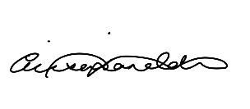
Alison Collins
Departmental Chief Science Advisor
February 2023

Swimming against the tide of decline
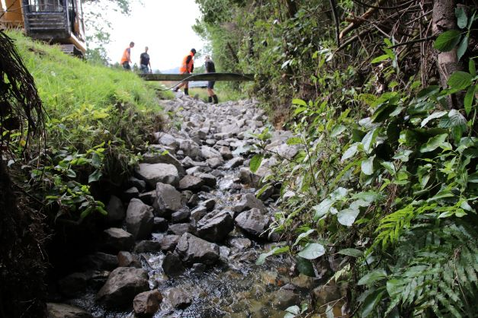 Image: Construction of a rock ramp fish pass in Shannon, Horowhenua Credit: Horizons Regional Council
Swimming against the tide of decline
Almost three-quarters of Aotearoa New Zealand’s indigenous freshwater fish species (39 of 54) are either threatened with extinction or at risk of becoming threatened. One of the biggest causes of this decline is reduced access to habitat due to structures and other modifications to streams and rivers that prevent the fishes’ migration.
The fish passage action plan project, which kicked off in 2022, aims to address this. This collaborative project connects the National Institute of Water and Atmospheric Research (NIWA), four regional councils, tangata whenua and the Ministry for the Environment’s expert ‘science practitioners’.
The goal of the project is for iwi, hapū and regional councils to identify barriers to fish migration, mitigate those barriers and then monitor their effectiveness. NIWA is upskilling regional council scientists and iwi and hapū rangatahi through a series of workshops. These workshops teach participants how to identify issues with and recommend changes to culverts, weirs and other structures that might be blocking fish. The feedback from participants has been fantastic, with one council staff member saying it was a “dream come true” to have NIWA scientists working with them.
The action plans form part of the implementation strategies for the Ministry’s Essential Freshwater policy package. “The fish passage policies are there because of Ministry policy colleagues with a strong technical background in freshwater ecosystems, and who worked intensively on the Essential Freshwater policies, understood the impact they would have,” Ministry for the Environment Principal Advisor Alice Bradley says.
Bradley’s own science expertise was critical in establishing the project. Following her Master of Science (Zoology), Alice worked on the ground assessing the ecological impacts of proposals like wastewater discharges, stormwater treatment ponds and similar infrastructure projects on fish. This experience helped Bradley understand what a fish passage action plan would involve and the physical fieldwork it would require. It also built crucial connections: “The fish passage science community in New Zealand is pretty small, so we all get to know each other,” Bradley says.
One of the members of that community is Dr Cindy Baker, a Principal Scientist of Freshwater Fish at NIWA and national fish passage expert. Her unique experience includes locating the first known spawning site for a Southern Hemisphere lamprey species (piharau/kanakana) by using innovative antenna arrays to detect micro-tags attached to the fish. She also helped develop measures at the Huntly Power Station water intake that increased the survival rate of the delicate smelt fish from just five per cent to over 60 per cent. Dr Baker was a lead writer of the fish passage action plan, and also supports council staff and rangatahi to write their own plans.
The team is supported by senior analyst Ilka Pelzer, who manages the contract. “She is the engine getting things done which lets me turn my mind to the more technical aspects” says Bradley.
A bridge between science and policy
Bradley sees herself as a ‘science practitioner’ – a bridge between the active research side of science and the policy side.
“We can write in plain English, translating the raw science into terms that our policy people can then use to guide Ministers in their decisions.”
She is also quick to point out that she doesn’t consider herself the “ultimate expert” on fish passage.
“We’re not the researchers. We know enough to know when we need to bring in the big guns, or when we can give the science advice ourselves.”
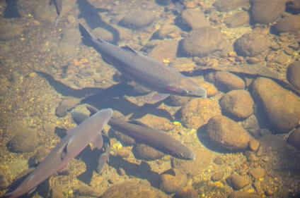
Alice also notes that science and policy are inextricably linked.
“You can’t have evidence-based policy without involving scientists. There’s a role for everyone on the science spectrum, from the researchers to the science practitioners. It’s also important to have some science skills embedded throughout the policy teams, working on projects from the very beginning – as it was with fish passage.” Image: Freshwater fish

When the science and policy stars align
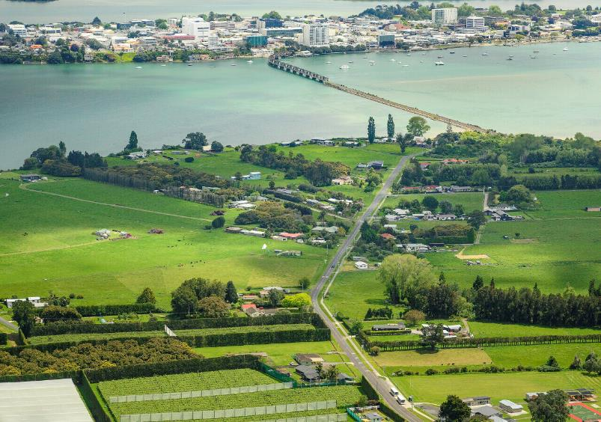
Image: Matapihi, Tauranga
When the science and policy stars align
Released in September 2022, the National Policy Statement for Highly Productive Land (NPS-HPL) protects Aotearoa New Zealand’s most valuable productive land for future generations. This important policy is derived from a long history of evidence-based science.
The NPS-HPL’s origins lie in the Ministry for the Environment and Statistics New Zealand’s Our Land 2018 report, which revealed that large areas of our most productive land were being lost to urban development and lifestyle blocks.
About 3,830,000 hectares or 15 per cent of Aotearoa’s land area is considered highly productive, meaning it’s particularly good for growing crops or farming animals. In the past 20 years about 35,000 hectares of this valuable resource has been used for urban development, making it unavailable for food production. The data in Our Land 2018 articulated the long-held concerns of many in Aotearoa’s soil science community.
Principal Scientist at the Ministry for the Environment, Fiona Curran-Cournane is a land and soil scientist who has studied the loss of highly productive land. Her previous work, including on Auckland Council’s Unitary Plan, demonstrated how development disproportionately encroached on the country’s best land and soil.
Curran-Cournane explains the importance of the New Zealand Land Resource Inventory, a national database that uses data from aerial photography, published and unpublished reference material, and extensive field work. The Inventory includes a Land Use Capability (LUC) classification, which rates land from the most versatile (class 1), to unstable, erosion-prone land that is not suitable for any productive use (class 8).
The LUC system created a common understanding of land types, and the database underpinned years of work by many soil scientists. Ministry for the Environment Senior Policy Analyst Alex Macdonald says the LUC classification was the “only database comprehensive enough to underpin national policy”.
Curran-Cournane also notes that data held by councils was critical in telling the story of our changing landscape. She references historic geospatial layers that show how Auckland’s urban area has expanded since 1915. Other important datasets included information on highly productive land earmarked for development, and maps that showed the number of rural subdivision resource consents in areas not intended for built development. Publishing this information in peer-reviewed scientific journals and technical reports meant the data gained credibility and was made more accessible.
Years of work by the soil science community, articulated in Our Land 2018, set the stage for Environment Minister David Parker’s announcement in late 2018 that the Government would develop policy to slow the loss of highly productive land.
The road to policy
When it came to writing the NPS-HPL, the policy team had to consider both the soil science and the potential economic impact, especially on the already rising cost of housing in New Zealand. Macdonald says developing the policy meant balancing multiple potential outcomes.
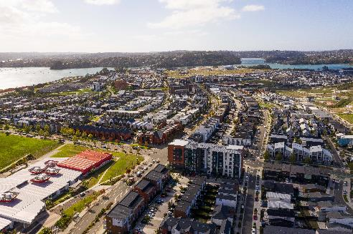
“There were clear costs and risks of working on that interface of urban growth and soil protection. As policy people and planners, we had to navigate that, guided by robust evidence and science, to come up with solutions that will work now and in the future.”
Both Macdonald and Curran-Cournane say science has a further role to play in monitoring how effective the NPS-HPL is over time. “Policy is only as good as its effectiveness and we will need a really strong evidence base to assess how it’s working or whether adjustments should be made to the policy,” Curran-Cournane says.
Image: Hobsonville Point, Auckland
Credit: Kāinga Ora – Homes and Communities

Litter data comes full circle
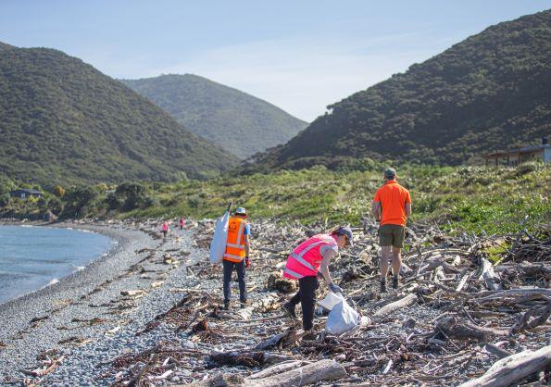
Image: A Litter Intelligence Programme beach clean-up on Kāpiti Island
Litter data comes full circle
Just five years ago there was almost no data on the quantity, type and location of litter and plastics in New Zealand. But now, the Litter Intelligence programme – a unique collaboration between the Ministry for the Environment, the Department of Conservation, Statistics New Zealand and Sustainable Coastlines – provides top-tier information on plastic pollution from beaches across the country.
Data from the programme informed Rethinking Plastics, the major report from the Office of the Prime Minister’s Chief Science Advisor, and has shaped policies to phase out single-use plastics.
When the Ministry’s waste team assumed responsibility for the Litter Act in 2016 they quickly realised they would need more robust data. In order to review and recommend changes to the Litter Act they would need to know the amount and type of waste polluting our environment, as well as the critical pollution areas.
The Ministry’s Waste Minimisation Fund saw potential in Sustainable Coastlines Charitable Trust. At the time, Sustainable Coastlines had an excellent network of volunteers doing beach clean-ups and delivering education programmes.
“We felt they had a critical role as a grass-roots, beach clean-up project,” Waste Streams Policy Team Manager Liz Butcher says.
The Ministry’s Waste and Resource Efficiency group connected Sustainable Coastlines with experts at the Department of Conservation, Statistics New Zealand, and the Ministry’s environmental reporting specialists.
Together, this group would expand the current beach clean-up efforts into a rigorous, long-term monitoring programme. The new programme would create a standardised methodology and develop and run programmes to train volunteer groups to collect, identify and record litter items.
The revised programme gained Waste Minimisation Fund backing and the Litter Intelligence data meets Statistics New Zealand’s highest, tier-1 rating. This means it can be used in formal environmental reporting, and act as baseline data to show changes in our environment.
Butcher says having the right skills around the table was critical to the project’s success.
“You really need people with the right level of science capability on all sides. At one point an independent contractor came in who was able to speak all the relevant languages – government, science, and not-for-profit – and things worked really well from that point.”
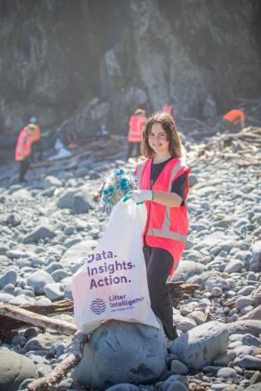
Waste Minimisation funding also played a big role, and Butcher says this gave Sustainable Coastlines the opportunity to “build their capacity and contribute to policy”.
“It really reinforced how pervasive plastics are in the environment,” Butcher says.
While the results confirmed many existing assumptions about plastic pollution, Liz says tier-1 evidence is required for providing the evidence for policies.
“It is also critical for monitoring. It’s starting to show that the plastic bag ban was effective, and we expect to see that for straws and other items being phased out in the future.”
Data from the Litter Intelligence programme is free and accessible to all at www.litterintelligence.org.
Image: A Litter Intelligence Programme beach clean-up on Kāpiti Island

