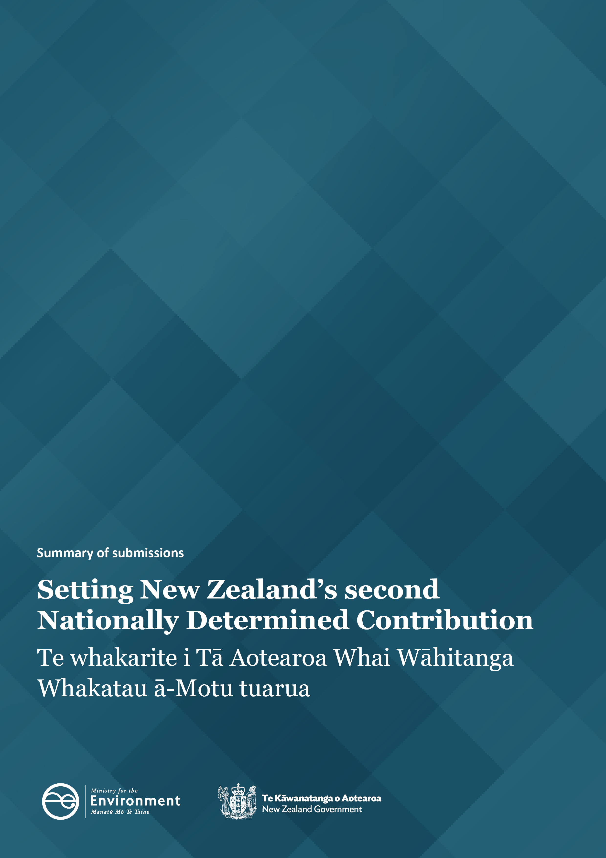

Disclaimer
The information in this publication is, according to the Ministry for the Environment’s best efforts, accurate at the time of publication. The Ministry will make every reasonable effort to keep it current and accurate. However, users of this publication are advised that:
- the information does not alter the laws of New Zealand, other official guidelines, or requirements
- it does not constitute legal advice, and users should take specific advice from qualified professionals before taking any action based on information in this publication
- the Ministry does not accept any responsibility or liability whatsoever whether in contract, tort, equity, or otherwise for any action taken as a result of reading, or reliance placed on this publication because of having read any part, or all, of the information in this publication or for any error, or inadequacy, deficiency, flaw in, or omission from the information in this publication
- all references to websites, organisations or people not within the Ministry are for convenience only and should not be taken as endorsement of those websites or information contained in those websites nor of organisations or people referred to.

This document may be cited as: Ministry for the Environment. 2025. Setting New Zealand’s second Nationally Determined Contribution: Summary of submissions. Wellington: Ministry for the Environment.

Published in March 2025 by the
Ministry for the Environment
Manatū mō te Taiao
PO Box 10362, Wellington 6143, New Zealand
environment.govt.nz
ISBN: 978-1-991140-66-1
Publication number: ME 1874
© Crown copyright New Zealand 2025

Contents
Introduction 5
About Nationally Determined Contributions 5
Feedback on setting NDC2 6
How we engaged 6
Scope of this report 6
Engagement tools 6
Who responded? 7
Key findings 8
The Climate Change Commission’s advice 8
Priority factors to consider when setting NDC2 8
Economic considerations 9
New Zealand’s fair share 10
International cooperation 11
Individual submissions 11

Tables
Table 1: Submissions received – by group type 7
Table 2: Submitters’ views on the Commission’s key findings on NDC2 8
Table 3: Submitters’ top priority to be considered when setting NDC2 9

Figures
Figure 1: New Zealand’s economic factors to consider when setting NDC2 9
Figure 2: What factors make a ‘fair share’ 10
Figure 3: Support for domestic and international action to meet NDC2 11

Introduction
The Ministry for the Environment (the Ministry) sought feedback from New Zealanders to inform the setting of New Zealand’s climate target for 2031–35 under the Paris Agreement - New Zealand’s second Nationally Determined Contribution (NDC2).
This report summarises the views expressed by New Zealanders between 19 November and 8 December 2024. It does not provide any recommendation to the Government in making decisions on setting NDC2. The Government set New Zealand’s NDC2 in January 2025. Further information is available on the Ministry’s website.

About Nationally Determined Contributions
Nationally Determined Contributions (NDCs) are at the heart of the Paris Agreement. NDCs are how countries contribute to the global temperature goal of the Paris Agreement, to hold the increase in the global average temperature to well below 2°C above pre-industrial levels and pursue efforts to limit the temperature increase to 1.5°C.
Under the Paris Agreement, NDCs must represent each country’s highest possible ambition. This term has no agreed definition but can be understood as the greatest effort a country can make to reduce emissions reflecting their circumstances. As countries have different circumstances (or capacities to reduce emissions), the effort required to achieve the same level of emissions reductions varies from country to country.
Countries must set NDCs that they intend to meet and pursue actions with the aim of achieving them. There are a range of actions that a country might take to meet its NDC, including encouraging domestic emissions reductions, increasing ways to remove carbon from the atmosphere, and international cooperation (eg, paying other countries for emissions reductions that count towards New Zealand’s target).

Feedback on setting NDC2

How we engaged
During November to December 2024, the Ministry conducted a three-step engagement approach to seek feedback from New Zealanders to inform the setting of NDC2. This included:
- targeted engagement: Ministry officials met with key stakeholders and partners
- opportunity for public feedback: members of the public were able to submit their views on setting NDC2 between 19 November and 8 December 2024
- market research: the Ministry commissioned The Research Agency to explore the public’s views on the extent to which NDCs should be achieved domestically, and what role – if any – international cooperation should play.

Scope of this report
This report summarises the findings from the opportunity for public feedback. Findings from targeted engagement and market research can be accessed separately on the Ministry’s website.
We sought feedback from the public on five questions about how New Zealand should set its NDC2. These five questions covered:
- the Climate Change Commission’s advice
- priority factors to consider when setting NDC2
- economic considerations
- New Zealand’s fair share
- international cooperation.

Engagement tools
New Zealanders were invited to submit their views using the Ministry’s online public engagement and survey platform, Citizen Space.
Submitters could answer all five or only some of the questions. Some submitters also contacted the Ministry via email and provided further written feedback. If identical submissions were made through both methods, one was counted and the other archived.

Who responded?
The Ministry received a total of 337 submissions. Table 1 provides detail of submissions by group categories.
Table 1: Submissions received – by group type
Group type | Number of submissions
Individuals/other | 187
Business/industry | 59
Non-governmental organisation/charity | 39
Academic/Subject-matter expert | 38
Local government | 12
Iwi/hapū | 2
Total | 337

Key findings

The Climate Change Commission’s advice
Question 1: Do you have any comments on the Climate Change Commission’s advice?
On average, submitters indicated support for the Commission’s advice that New Zealand could achieve greater net emissions reductions in the NDC2 period (2031–35) than in the NDC1 period (2021–30) through domestic action alone. Table 2 shows the percentage of submitters who expressed agreement or disagreement with each of the Commission’s five key findings. 137 submitters answered this question.
Table 2: Submitters’ views on the Commission’s key findings on NDC2
Climate Change Commission’s key findings | Agree  (%) | Disagree (%) | Did not answer  (%)
1. New Zealand could achieve greater net emissions reductions in the NDC2 period (2031–35) than in the NDC1 period through domestic action alone. | 68 | 4 | 28
2. The Commission estimated that domestic emissions reductions of up to 69% below 2005 levels by 2035 are achievable during the NDC2 period. | 4 | 10 | 86
3. Actions to achieve these emissions reductions would need to start before 2031 to be effective. | 7 | 0 | 93
4. Delaying action, or introducing policies that encourage high-emission activities, may make it impossible to make these contributions to emissions reductions through domestic action. | 19 | 2 | 79
5. The target contribution of 69% requires New Zealand to assume faster and higher adoption rates of technological and systems changes than are currently expected. | 6 | 1 | 93

Priority factors to consider when setting NDC2
Question 2: What factors should the Government prioritise when setting NDC2?
Submitters ranked the top three (out of seven) factors that they would like the Government to prioritise when setting NDC2. Table 3 shows the highest priority factors identified. 273 submitters answered this question.
When looking at the combined top three priorities (rather than just the top priority), submitters indicated an overall preference for New Zealand to align with the temperature goal and requirements of the Paris Agreement, while considering our national circumstances and impacts to the economy.
Additionally, submitters provided other answers to the factors that should be prioritised when setting NDC, including:
- future environmental and socioeconomic impacts from climate change
- New Zealand’s highest possible ambition
- our relative international standing (eg, our country’s leadership in the Pacific region).
Table 3: Submitters’ top priority to be considered when setting NDC2
Priority factors | Percentage of respondents | Number of respondents
Align with Paris Agreement | 54 | 147
Highest possible ambition | 22 | 59
Minimise costs | 7 | 18
Minimise economic impacts | 7 | 18
Align with the Global Stocktake | 7 | 18
Ensure a clear delivery plan | 3 | 7
New Zealand’s relative international standing | 2 | 6
Total | 100 | 273

Economic considerations
Question 3: What factors in New Zealand’s economic outlook should be taken into consideration when setting NDC2?
Out of the 217 submitters who answered this question, 46 per cent said economic factors should be considered when setting NDC2. These included a range of issues, such as inflation and the cost of living, the importance of exports to the New Zealand economy, and opportunities for electrification in the future.
Figure 1: New Zealand’s economic factors to consider when setting NDC2

Our ability to take action came in second place in submitters’ consideration (27 per cent), followed by the availability of and potential to use renewable energy resources in New Zealand (25 per cent) and sectoral emissions profiles (eg, agriculture and transport).

New Zealand’s fair share
Question 4: What factors do you think are most important for deciding a ‘fair share’ for New Zealand for its NDC2?
In total, 231 submitters answered this question. Their responses highlighted the most relevant factors that should guide what New Zealand’s fair share is when determining NDC2:
- New Zealand’s status as a developed country
- New Zealand’s ability and capacity to take action
- other factors such as New Zealand’s high per capita emissions, the need to set a benchmark for other countries to follow, and New Zealand’s leadership in the Pacific.
Figure 2: What factors make a ‘fair share’

Other submitters took a different view, highlighting:
- New Zealand’s relatively low share of global emissions, and that other high-emitting countries should do more
- the need to consider the affordability and impact on the economy
- New Zealand’s high proportion of agricultural emissions.

International cooperation
Question 5: Should NDC2 be set at a level that is achievable with domestic action only or should it be set at a level that is achievable with a mix of domestic action and international cooperation (offshore mitigation)?
In total, 281 submitters answered this question. Of these, 54 per cent, indicated support for NDC2 to be set at a level achievable through a mix of domestic action and international cooperation. 21 per cent favoured a domestic only target, and 25 per cent were unsure, did not answer or selected ‘other’.
Submitters who indicated ‘other’, expressed a range of different views on the role that international cooperation and wider climate policy and economic considerations for setting and meeting NDC2.
Figure 3: Support for domestic and international action to meet NDC2

Individual submissions
Alongside this summary, the Ministry has also published individual submissions from those who gave their consent to publicly share their feedback. These are available on Citizen Space.
Further information on NDC2 is available on the Ministry for the Environment website.

