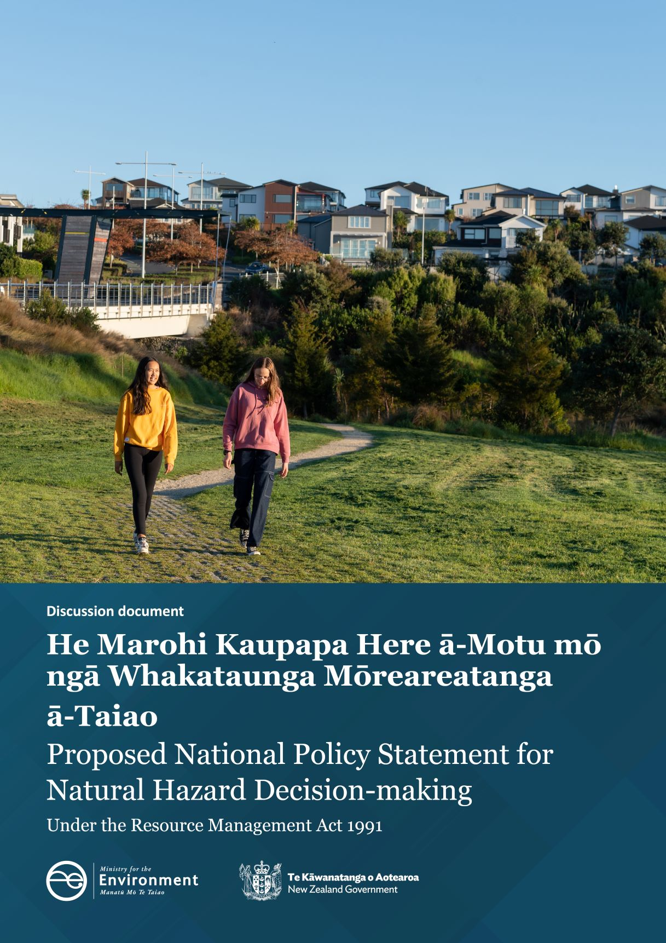

Disclaimer
The information in this publication is, according to the Ministry for the Environment’s best efforts, accurate at the time of publication. The Ministry will make every reasonable effort to keep it current and accurate. However, users of this publication are advised that:
- the information does not alter the laws of New Zealand, other official guidelines, or requirements
- it does not constitute legal advice, and users should take specific advice from qualified professionals before taking any action based on information in this publication
- the Ministry does not accept any responsibility or liability whatsoever whether in contract, tort, equity, or otherwise for any action taken as a result of reading, or reliance placed on this publication because of having read any part, or all, of the information in this publication or for any error, or inadequacy, deficiency, flaw in, or omission from the information in this publication
- all references to websites, organisations or people not within the Ministry are for convenience only and should not be taken as endorsement of those websites or information contained in those websites nor of organisations or people referred to.

Acknowledgements
The Ministry for the Environment is working closely with Toka Tū Ake EQC to develop the National Policy Statement for Natural Hazard Decision-making and the comprehensive National Direction for Natural Hazards.

This document may be cited as: Ministry for the Environment. 2023. Proposed National Policy Statement for Natural Hazard Decision-making: Discussion document. Wellington: Ministry for the Environment.

Published in September 2023 by the
Ministry for the Environment
Manatū mō te Taiao
PO Box 10362, Wellington 6143, New Zealand
environment.govt.nz
ISBN: 978-1-991077-87-5
Publication number: ME 1801
© Crown copyright New Zealand 2023

Contents
Executive summary 5
Part 1: Context 8
Natural hazard risks and impacts in Aotearoa 8
Requests for central government support for managing natural hazard risks 9
National Climate Change Risk Assessment and national adaptation plan 9
Current resource management system 9
Government work programme to reduce natural hazard risks under the Resource Management Act 1991 10
Part 2: Problems to solve 14
Inconsistent identification and assessment of natural hazards and risks 14
Variation in resource management planning frameworks for considering natural hazard risks 14
Lack of involvement of tangata whenua 15
Proposed National Policy Statement for Natural Hazard Decision-making as a first step 15
Part 3: Key policy proposals of the proposed National Policy Statement for Natural Hazard Decision-making 16
Purpose 16
Proposed scope 17
Proposed objective 20
Policy 1 and definitions: natural hazard risk categories 20
Policy 2: Assessing natural hazard risks 20
Policy 3: Precautionary approach in decision-making 21
Policy 4: Restricted discretionary and controlled activities 21
Policy 5: Direction on new development in areas of high, moderate and low risk 22
Policy 6: Reducing natural hazard risks through mitigation 23
Policy 7: Recognising and providing for Māori and tangata whenua interests and te Tiriti principles 24
Implementation timing 25
Implementation guidance 26
Links to other national direction 26
Further information 27
Part 4: How to have your say 28
Timeframes 28
How to make a submission 28
For more information 28
Publishing and releasing submissions 29
Questions 30
Appendix A: Proposed National Policy Statement for Natural Hazard Decision-making 31
Appendix B: Process for developing a national policy statement 32
References 33

Figures
Figure 1: Government work programme to improve management of natural hazard risks 12
Figure 2: Overview of the proposed National Policy Statement for Natural Hazard Decision-making 16
Figure B.1: National policy statement development process 32

Executive summary
This consultation document seeks your views on the proposed National Policy Statement for Natural Hazard Decision-making (NPS-NHD). The aim of the proposed NPS-NHD is to provide direction to decision-makers on the appropriate weight to attach to natural hazard risk in planning decisions relating to new development under the Resource Management Act 1991 (RMA).

The problem we want to solve
Aotearoa New Zealand is increasingly at risk from a range of natural hazards, including earthquakes, flooding and landslips. Severe weather events are becoming more frequent due to climate change. Building new developments like houses, office buildings, shops, roads and schools in areas at high risk from natural hazards increases risk to human life, community wellbeing, property, infrastructure, and may lead to adverse effects on the environment. It also exposes land owners, councils, the Crown and New Zealanders in general to increased social and economic costs. This issue was highlighted by the impacts of the severe weather events in 2023.
Local authorities are responsible for managing significant risks from natural hazards under the RMA. At the moment, the way local authorities identify natural hazards and assess risk and risk tolerance is variable throughout the country. There is currently no national direction to guide decision-making on development proposals and to require risk assessments where natural hazards are a concern. As a result, decision-makers sometimes attribute less weight to natural hazard risk than to other matters, such as the need for new infrastructure and housing.

Government work programme to address natural hazard risk under the Resource Management Act 1991
The Government has proposed a phased work programme to improve the management of natural hazard risks under the RMA. This programme involves:
- the proposed NPS-NHD (the focus of this consultation process), which is an interim measure intended to be developed and implemented by early 2024
- the proposed comprehensive National Direction for Natural Hazards, to be developed over the next one-to-two years.
The Ministry for the Environment is working closely with the Toka Tū Ake EQC to develop the NPS-NHD and the comprehensive National Direction for Natural Hazards.
The proposed comprehensive National Direction for Natural Hazards will support local authorities to identify natural hazards and risks in a consistent and rigorous way, understand the level of risk tolerance by a community or other party, and provide direction on making decisions on land use in hazard-prone areas. It may also include further guidance on how planning processes support adaptation to climate change.
The proposed NPS-NHD is a necessary interim step because RMA planning and consenting practices will continue while comprehensive national direction is being developed and resource management reforms are being delivered and implemented. Therefore, action is needed now to limit new development in areas where the risk of natural hazards is intolerable. The NPS-NHD would be included in National Direction for Natural Hazards in the medium to long term, depending on further government decisions. The NPS-NHD would then be transitioned into the National Planning Framework as part of the resource management reforms.

Proposed National Policy Statement for Natural Hazard Decision-making
The proposed NPS-NHD would direct decision-makers to take a risk-based approach to natural hazards when making planning decisions relating to new development.
The proposed NPS-NHD will identify three natural hazard risk categories (high, moderate and low). It will direct decision-makers to address the level of risk based on the likelihood and consequence of a natural hazard event, and then assess the tolerance to a natural hazard event in relation to the proposed new development.
Tolerance is based on many factors, including the willingness and capability of those affected by the risk (eg, the community, Māori or the Crown) to bear the direct and indirect risks and costs of the natural hazard.
Based on a decision-maker’s assessment of natural hazard risk and the tolerance to the risk, the proposed NPS-NHD will direct the decision-maker to:
- in high natural hazard risk areas, avoid new development unless the level of risk can be reduced to at least a tolerable level
- in moderate natural hazard risk areas, reduce risk to as low as reasonably practicable
- in low natural hazard risk areas, enable new development.
The NPS-NHD would have an immediate effect, because decision-makers would need to have regard to the NPS-NHD when making decisions on resource consents or designations and give effect to the NPS-NHD for any private plan change decisions on and from the commencement date of the NPS-NHD. Local authorities would also need to give effect to the NPS-NHD through updating their planning instruments as soon as reasonably practicable. Until a plan change has been made, decisions will rely on existing plans, including the plan’s rules to trigger the need for a consent. As part of a plan change, local authorities may choose to remap natural hazard risk areas and reclassify the level of natural hazard risk accordingly, but the NPS-NHD will not require them to do so.
Remaining Māori land is disproportionately exposed to natural hazard risk, and developing Māori land can be challenging. The proposed NPS-NHD seeks to acknowledge and deliver on the Treaty of Waitangi principles of active protection and tino rangatiratanga by requiring decision-makers. It will do this by requiring decision-makers to engage early and involve tangata whenua (through existing resource management processes) when making decisions on new developments on specified Māori land where a high or moderate risk exists.
A draft of the proposed NPS-NHD, which outlines the policy intent of the proposal, is included in appendix A, to help with the consultation process. The NPS will likely change when a final version is developed, following this consultation process.

Seeking your feedback
We seek your views on the proposed NPS-NHD by 20 November. This document includes questions to help in providing feedback. You can make a submission by:
- using our online submission tool, available at: https://consult.environment.govt.nz/environment/proposed-nps-for-natural-hazard-decision-making
- writing your own submission. If you are posting your submission, send it to Ministry for the Environment, PO Box 10362, Wellington 6143 or email it to naturalhazardRMA@mfe.govt.nz.
Further information on how to make a submission is provided in Part 4. When the consultation period has ended, officials will analyse and summarise submissions. They will provide final policy advice to the Government on the preferred options later this year. Submissions will inform the final drafting of the NPS-NHD and further decisions required from Cabinet later this year.

Part 1: Context
This part outlines Aotearoa New Zealand’s natural hazard risk exposure, how natural hazard risks are managed in Aotearoa under the Resource Management Act 1991 (RMA), and the Government’s work programme to improve management of the risks and impacts from natural hazards.

Natural hazard risks and impacts in Aotearoa
Aotearoa is exposed to a range of natural hazards, due to its position on the boundary of the Pacific and Australian tectonic plates and its geography. Natural hazard events include earthquakes, volcanic eruptions, erosion, landslides, floods and tsunami, which are often exacerbated by extreme weather events. Climate change is increasing the severity and frequency of some natural hazards, including flooding, heatwaves, drought, wildfire, sea-level rise, and coastal erosion and inundation.
From 2009 to 2019, Aotearoa had 5 major earthquakes, 35 weather events, 28 flood events and 2 wildfires that have cumulatively cost over $37 billion in damage (NZIER, 2020). The Reserve Bank of New Zealand estimates the total claims cost for private insurance (ie, excluding Toka Tū Ake EQC payouts) from the 2023 Auckland Anniversary flooding will be around $1.6 billion to $2.1 billion, with a further $1.4 billion to $2.1 billion from the effects of Cyclone Gabrielle in February 2023.
Analysis of Toka Tū Ake EQC’s claims data between 2000 and 2017 for weather-related damage, by the New Zealand Institute of Economic Research (NZIER), found that Northland, Bay of Plenty, Nelson and Tasman had the highest claims in proportion to their populations. This suggests these regions face high exposure and vulnerability to weather events. Nine regions also face the possibility that their storm costs will grow at a faster rate than their regional incomes, namely: Northland, Auckland, Manawatu–Whanganui, Hawke’s Bay, Tasman–Nelson, Bay of Plenty, Waikato, Otago and Canterbury (NZIER, 2020). This analysis further predicted that Auckland could face substantial increases in storm costs because of the growth of its capital asset stock, a prediction proven to be accurate based on the weather-related damage in Auckland in 2023.
Across Aotearoa, climate change projections predict an increase in natural hazard risk. These risks, as outlined in the National Climate Change Risk Assessment (Ministry for the Environment, 2020), include exacerbated risks from existing natural hazards, such as flooding, erosion and drought. Increasing temperatures are also causing sea levels to rise, resulting in new natural hazard risks to coastal communities. With over 65 per cent of New Zealanders living close to the sea or near tidal rivers increased frequency of high-intensity storms and sea-level rise will have a significant impact (OECD, 2019). The costs of natural hazard events will continue to increase for individuals, businesses, and local and central government. Storm damage due to climate change is expected to increase by 3 per cent to 7 per cent between now and 2050 (NZIER, 2020).
Because Aotearoa experiences a range of risks from natural hazards, it is difficult to find sites for our towns and cities to grow and develop. Most growth and development decisions involve weighing and choosing between different interests, constraints and risks, and the many different options (such as stormwater systems, flood flow paths, stop banks) to reduce risks.

Requests for central government support for managing natural hazard risks
Local authorities have requested support from central government for decision-making on new development in high-risk locations (Local Government New Zealand, 2011). They have reported the need for more defined and stringent provisions that will enable them to better consider developments in high-risk areas, and decline resource consents, if appropriate. Local authorities have shared recent examples where they were unable to decline planning consents for properties in areas of high flood risk and the land has since been badly affected by Cyclone Gabrielle and other recent severe weather events.
Recent engagement with local government has also indicated more support is needed from central government through national direction so that local authorities can consider natural hazard risks appropriately alongside other matters, including the need for housing and economic development. This need is also reflected in submissions from councils on the first national adaptation plan (Ministry for the Environment, 2022b).
The insurance industry has requested central government support to prevent development from occurring on flood-prone land, with IAG specifically requesting a national policy statement to cease development in flood-prone locations (IAG, 2022; Insurance Council of New Zealand, 2014). In 2014, the Insurance Council of New Zealand requested a review of the natural hazard regulations under the RMA to introduce changes that would require local authorities to decline consent applications where long-term data shows that the risk from natural hazards will increase.

National Climate Change Risk Assessment and national adaptation plan
The National Climate Change Risk Assessment provides a national picture of how Aotearoa may be affected by climate change-related hazards (Ministry for the Environment, 2020). It identifies the most significant risks and opportunities for Aotearoa from climate change. The first national adaptation plan responds to these risks and sets out the Government’s long-term adaptation strategy and priorities for action (Ministry for the Environment, 2022a). Actions in the national adaptation plan include developing national direction under the National Planning Framework on natural hazard risk management and climate adaptation within the Natural and Built Environment Act 2023; improving information about hazards, exposure and vulnerability; and developing interim resilience standards for infrastructure and housing.

Current resource management system
The RMA is the primary land use planning legislation for Aotearoa and provides for the management of significant risk from natural hazards. Other regulatory regimes also manage natural hazard risks and impacts in New Zealand.
The purpose of the RMA is to promote the sustainable management of natural and physical resources (s5). The RMA also identifies the management of significant risks from natural hazards as a matter of national importance (s6). Local authorities have responsibilities to manage the use of land to avoid or mitigate natural hazards. In achieving the purpose of the RMA, local councils also have to consider the effects of climate change (s7). In the context of natural hazard planning, this means considering the exacerbating impacts of climate change on all natural hazards. Also essential to consider is section 8 of RMA, where any decisions made under the Act need to take into account the principles of te Tiriti o Waitangi (the Treaty of Waitangi).
Under the RMA, no comprehensive national direction exists relating to natural hazard risk planning, including data gathering, mapping, managing risk and developing rules for hazard-prone areas. Local authorities (which are primarily responsible for managing significant risks from natural hazards through land use planning) currently identify natural hazards, assess, and manage natural hazard risk and risk tolerance, in a variable and inconsistent way, leading in some locations to limited effectiveness.
In the New Direction for Resource Management in New Zealand, the Resource Management Review Panel found a lack of clear national direction has led to issues arising in the management of effects from natural hazards and climate change (Resource Management Review Panel, 2020, p 11).
Mandatory national direction should be required for: (ii) climate change adaptation and reduction of risk from natural hazards consistent with the national climate change risk assessment and national adaptation plan under the CCRA (Climate Change Response Act).
This affects the extent to which plans address and manage these risks.
A 2015 report by the Parliamentary Commissioner for the Environment provides modelling of the number of homes, businesses and roads that are low lying and likely to be affected by sea-level rise for Auckland, Wellington, Christchurch, Dunedin, Napier, Whakatāne, Tauranga, Motueka and Nelson. The report recommends national direction to “take direction on planning for sea-level rise out of the New Zealand Coastal Policy Statement and put it into another National Policy Statement, such as that envisaged for dealing with natural hazards” (Parliamentary Commissioner for the Environment, 2015, p 73).

Government work programme to reduce natural hazard risks under the Resource Management Act 1991
The Government has proposed a phased work programme to reduce natural hazard risks under the RMA. This involves preparing:
- the proposed National Policy Statement for Natural Hazard Decision-making (NPS-NHD) as a first step in providing national direction on natural hazard risks (the focus of this consultation process)
- the proposed comprehensive National Direction for Natural Hazards.
The Ministry for the Environment is working closely with Toka Tū Ake EQC to develop the NPS-NHD and the comprehensive National Direction for Natural Hazards

Proposed comprehensive National Direction for Natural Hazards
National direction that will build on the proposed NPS-NHD is in development to provide a comprehensive, nationally consistent planning framework for natural hazards under the RMA. It will help address many of the current issues with identifying, assessing and managing risks from natural hazards under the RMA. Potential content will include:
- standardised methodologies for mapping natural hazards and assessing risks to inform land use planning decisions
- defined risk thresholds, established by developing and implementing a standardised risk tolerance assessment methodology to define areas that may be ‘tolerable’ or ‘intolerable’ to natural hazard risks
- standardised terms such as ‘significant natural hazard risk’ and ‘intolerable natural hazard risk’
- a nationally consistent policy approach to managing land use activities in areas exposed to natural hazard risks.
Developing comprehensive national direction is expected to take one-to-two years, and local authorities will require further time to implement it.
The NPS-NHD is proposed as a necessary first phase of national direction for natural hazards. The NPS-NHD would either be included in the comprehensive National Direction for Natural Hazards in the medium-to-long term, depending on policy decisions made. The NPS-NHD will then be transitioned into the National Planning Framework as part of the resource management reform.

Resource management reform
The Government has replaced the RMA with the Natural and Built Environment Act 2023 and Spatial Planning Act. The Bills received Royal Assent in August 2023. A major focus of the Natural and Built Environment Act is on promoting positive environmental outcomes, including reducing the risks arising from, and improving environmental resilience to, natural hazards and the effects of climate change. The first National Planning Framework will include natural hazards content that will guide the development of regional spatial strategies under the Spatial Planning Act.
The RMA will remain in force through the transitional period of the Natural and Built Environment Act and Spatial Planning Act. This is expected to take 7 years to 10 years, as the new system is turned on region by region. During the transitional period, RMA plans and policy statements will still have effect and provide the planning framework for decisions on resource consents and designations. National direction will also have effect on RMA plans, consents and designations. Therefore, national direction on natural hazards is a necessary interim step to improve natural hazard risk management for the immediate future.

Climate change and Community-led retreat
The Parliamentary Environment Committee has opened an inquiry into climate adaptation, exploring community-led retreat and adaptation funding – how communities in Aotearoa could be enabled to relocate from areas vulnerable to climate change. It is also looking at how the costs of adapting to climate change could be met.
Community-led retreat means relocating homes, businesses, cultural sites or taonga out of harm’s way, in a carefully planned process, that involves the community at every step. This process can be done before a natural disaster or severe weather event happens, or afterwards.
It is one option that can be used to respond to the risks posed by climate change, but there are others. Communities can also choose to remain as they are; to protect assets, for example, by building stop banks, sea walls, or improving stormwater systems; or to accommodate nature, for example, by raising properties.
The proposals relating to natural hazards will sit alongside climate adaptation legislation.
The inquiry’s findings are expected to inform development of the Climate Change Adaptation Bill, in 2024. You can find more information on the Ministry’s website.
Figure 1 outlines the Government’s natural hazard work programme and its interaction with RMA reform.
Figure 1: Government work programme to improve management of natural hazard risks
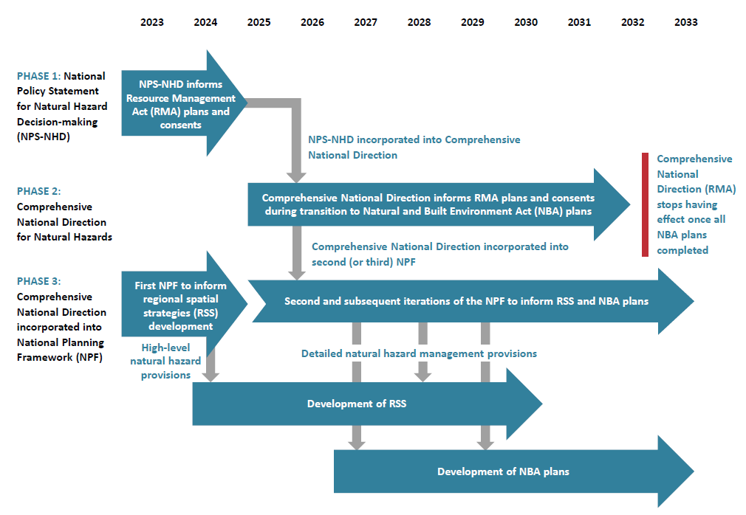

Related government programmes on natural hazards and climate change adaptation
The Government’s work programme to address natural hazard risk under the RMA complements other actions underway to improve the way the Government manages natural hazards under other legislation. The work programme includes the following actions.
- The Treasury and Ministry for the Environment’s programme to address the Future of Severely Affected Locations (FOSAL).
- The Ministry of Business, Innovation and Employment (MBIE) guidance on the natural hazard-related provisions of the Building Act 2004.
- The Local Government Official Information and Meetings Amendment Bill to improve natural hazard information in Land Information Memoranda (LIMs).

Part 2: Problems to solve
This part defines the problems with current approaches to managing natural hazard risks under the RMA. In summary, the resource management system is not delivering optimal outcomes for managing risks from natural hazards. Some of the significant issues to address are outlined below, based on discussions and hui held with local authorities, te Tiriti o Waitangi partners and industry stakeholders leading up to this consultation.

Inconsistent identification and assessment of natural hazards and risks
- Gaps exist in regional and territorial authority approaches to identify and map natural hazards and risks, and risk information is often incomplete or out of date. Older data and risk assessments still in use do not always incorporate climate change impacts and do not predict what may happen in the future. Information needs to consider future risks across timeframes (eg, in 50 or 100 years), rather than at the time of the resource consent application or plan change.
- Local authority decision-makers are reluctant to make decisions based on the uncertainties of natural hazard information. There is no agreed approach on how to obtain robust data, and local authorities are hesitant to address contentious decisions on land use if information is incomplete or not robust. Due to the nature of some natural hazards, it may be impossible for local government to provide the level of certainty about natural hazard likelihood or consequence that community members expect to inform decision-making.
- Councils face financial constraints. Obtaining relevant information on natural hazards and risks is expensive.

Variation in resource management planning frameworks for considering natural hazard risks
- Aotearoa has no agreed framework for how decision-makers should consider natural hazard risks under the RMA. It is unclear what a ‘significant’ risk is, how to assess risk tolerance, what risks should be assessed (eg, health and safety, economic, cultural, social and environmental risks) and how often assessments should be undertaken.
- Decision-makers often give more weight to competing priorities that have a stronger mandate to address. There are complex competing priorities on land use when deciding where to develop. This often involves choosing between different types of constraints and risks and balancing multiple outcomes. Regional policy statements and district plans may contain objectives and policies to consider natural hazard risks, but rules may not be as stringent as needed. National direction has been provided on other matters such as urban development, but there is nothing specific in place on natural hazards.

Lack of involvement of tangata whenua
- Consideration of natural hazard or climate change impacts on hapū, iwi and Māori is insufficient. While some RMA plans acknowledge Māori interests in relation to natural hazard risks in their objectives, they contain no clear rules to deliver on these interests.
- Engagement with Māori on natural hazard responses and climate change varies. Greater partnership between government and Māori is needed to identify and manage the impacts of natural hazards and ensure mātauranga Māori and Māori worldviews are incorporated into all steps of risk management and assessment processes.

Proposed National Policy Statement for Natural Hazard Decision-making
as a first step
Most of the issues outlined above require a long-term work programme to prepare a comprehensive national framework, along with guidance on how to derive consistent technical information that will support decision-making. These measures will be provided through the proposed comprehensive National Direction for Natural Hazards and will take time to develop.
Addressing the weight that decision-makers should give to natural hazards in plans, plan changes, resource consents and designations is a priority for the proposed NPS-NHD. Another priority is to provide a consistent framework to consider and address natural hazard risks regarding new development proposals.
Questions
- Is more action needed to reduce development from occurring in areas facing natural hazard risk?
- Are there any other parts of the problem definition that you think should be addressed through the NPS-NHD? Why?
- Are there other issues that have not been identified that need to be addressed through the NPS-NHD or the comprehensive National Direction for Natural Hazards?

Part 3: Key policy proposals
of the proposed National Policy Statement for Natural Hazard Decision-making
This part outlines the purpose and content of the proposed NPS-NHD. It also outlines the policy intent for each objective and policy, and follows up with questions to consider when making a submission. A draft of the proposed NPS, which outlines the policy intent of the proposal, is included in appendix A, to help with the consultation process. The NPS-NHD will likely change when a final version is developed following this consultation process.
Figure 2 gives an outline of the proposed NPS-NHD.
Figure 2: Overview of the proposed National Policy Statement for Natural Hazard Decision-making
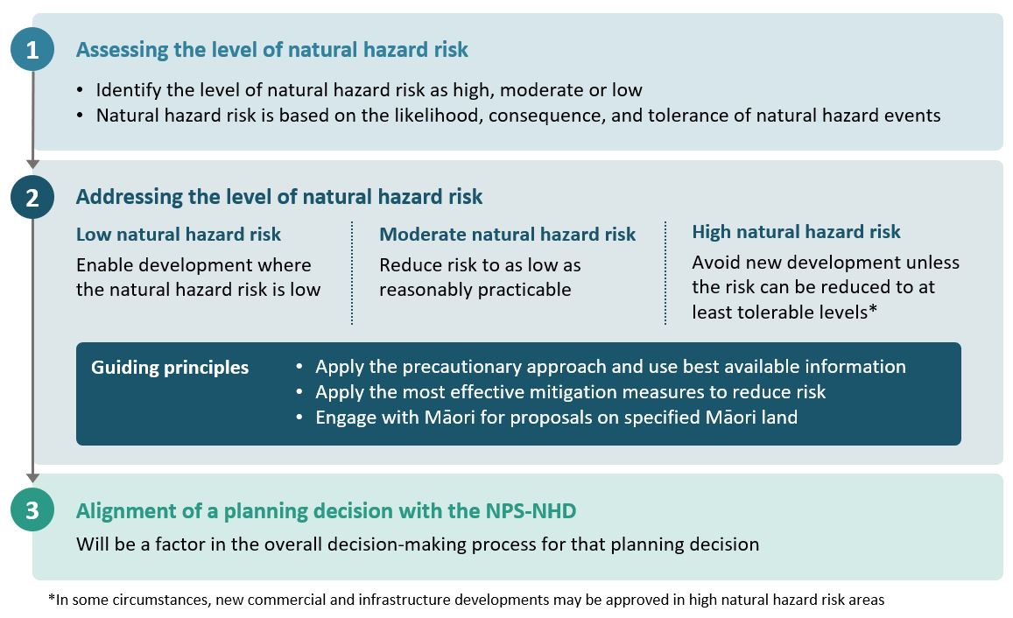

Purpose
The overall purpose of the proposed NPS-NHD is to minimise the risks from natural hazards. It will do this by directing decision-makers under the RMA to take a risk-based approach to natural hazards when making planning decisions on new physical development, such as buildings and structures and subdivisions.
The proposed NPS-NHD will support local authorities in their role of managing significant risks from natural hazards as a matter of national importance under section 6(h) of the RMA and in carrying out their functions under section 30 and section 31 of the RMA. It will add weight to the consideration of natural hazards in RMA decision-making because it is a higher-order document than a local authority regional policy statement or plan. For example, decision-makers must give effect to the proposed NPS-NHD when changing plans and must have regard to it when making decisions on resource consents and proposed designations. The proposed NPS-NHD will provide local authorities with greater certainty and confidence about how to weigh natural hazard risk against other competing interests in decision-making on new development proposals.
National policy statements must be consistent with the purpose of the RMA. The Minister for the Environment must give notice of why they consider the proposed national direction is consistent with the purpose of the RMA under section 46A(4)(a)(ii) to promote the sustainable management of natural and physical resources and, in particular, the need to avoid, remedy or mitigate any adverse effects of activities on the environment.
The purpose and objective of the proposed NPS-NHD is consistent with the purpose of the RMA because it will affect decisions made on the management of physical resources in the form of new dwellings, buildings and structures, subdivisions, and on the wider environment. It will help protect people and communities from the adverse effects of natural hazards by ensuring the risks of a natural hazard to people, communities and property are assessed as part of a plan change, consent application or designation process. As a result of this assessment, appropriate safeguards will then be put in place or, where appropriate, plan changes and consent applications will be declined. The proposed NPS-NHD will also provide for the social, economic and cultural wellbeing of people and communities by enabling new facilities, services and developments for cultural needs and purposes if the risks can be assessed and mitigated appropriately.
Question
- Do you support the proposed NPS-NHD’s requirement that decision-makers take a risk-based approach when making decisions on new development in natural hazard areas? Why or why not?

Proposed scope
The proposed NPS-NHD will apply to all planning decisions made under the RMA on new physical developments, such as buildings and structures, where a risk exists from natural hazards. Planning decisions include decisions on a:
- resource consent application
- regional policy statement or proposed regional policy statement
- regional plan or proposed regional plan
- district plan or proposed district plan
- designation
- change to a plan requested under Schedule 1, Part 2 of the RMA.
The proposed NPS-NHD would apply to all decision-makers under the RMA. Decision-makers can include local authorities, requiring authorities, independent decision-makers, the Environment Court, the Minister for the Environment and the Minister of Conservation.
The proposed NPS-NHD would only affect decisions on new development. It would not affect existing use rights under the following.
- Existing resource consents approved for new development before the enactment date of the NPS. New developments, even if they are not yet built but have a resource consent granted, will be able to go ahead without change if the development has started before the consent lapses.
- Activities currently permitted in district plans unless the activity status is changed through a plan change. Different types of developments will be permitted in plans that do not require resource consents. These activities will remain unchanged until a local authority initiates a plan change process to give effect to the proposed NPS-NHD. This may change the activity status from permitted to another status, for example, to a controlled or restricted discretionary activity, in which case a consent would be required.
The proposed NPS-NHD will only affect decisions made under the RMA. It will not affect decisions made under the Building Act 2004.

Natural hazards in scope
The proposed NPS-NHD adopts the RMA definition of natural hazards, which would mean that all natural hazards are within scope. Considering the effects of climate change on natural hazards is also part of determining the extent of the natural hazard and the risks associated with an event.
All natural hazards pose risks to human life, property and infrastructure and may have adverse effects on the environment. The impacts of one or more natural hazards can be cumulative. Including all natural hazards within the scope of the proposed NPS-NHD will have greater impact on reducing risks and will also enable decision-makers to consider multiple hazards together.
The NPS-NHD could, however, be limited to certain natural hazards, such as flooding, coastal erosion, active faults, liquefaction and landslips, because they pose the most widespread risk to life and property and guidance is available on assessing the risks from these hazards.

New development activities in scope
The proposed NPS-NHD would apply to planning decisions that result in or enable new physical development of buildings or structures. It defines new development to include all new buildings or structures, extensions to existing buildings, replacement of existing buildings and the construction, extension or replacement of infrastructure. This includes residential and multi-unit dwellings, papakāinga, marae, educational facilities, health facilities, visitor accommodation, community facilities, commercial and infrastructure developments.
The definition does not include the use of land without buildings or structures, for example, for primary production activities or recreation purposes.
Questions
- Should all natural hazards be in scope of the proposed NPS-NHD? Why or why not?
- If not all natural hazards are in scope, which ones should be included? Why?
- Should all new physical development be in scope of the proposed NPS-NHD?
Why or why not?

Interaction between the need for housing and protection from natural hazards
Existing direction and policy under the Resource Management Act 1991 (RMA), to enable urban development, includes:
- section 30(1)(ba) and section 31(1)(aa) of the RMA
- the National Policy Statement on Urban Development 2020 (NPS-UD).
The NPS-UD ensures the towns and cities of Aotearoa New Zealand are well-functioning urban environments that meet the changing needs of the country’s diverse communities. It includes provisions that direct councils to enable urban intensification and provide land to support housing supply so that housing affordability, access and choice are improved.
Changes to the RMA, introduced by the Resource Management (Enabling Housing Supply and Other Matters) Amendment Act 2021 (RMA-EHS), were designed to rapidly accelerate the intensification of housing in the main existing urban areas of Aotearoa. The RMA-EHS does this by bringing forward the implementation of the intensification requirements in the NPS-UD, and by incorporating the Medium Density Residential Standards (MDRS) in RMA district plans. The RMA-EHS requires plan changes (or variations) through an intensification planning instrument.
The MDRS provide a set of development standards that must be incorporated into district plans. They enable three dwellings of up to three storeys per site as a permitted activity. To enable a rapid housing supply response, the MDRS have immediate legal effect when applied in existing residential areas once the intensification planning instrument has been publicly notified, unless a qualifying matter applies or more lenient density standards have been applied. The MDRS apply to all tier 1 urban environments under the NPS-UD, and to Rotorua, and will apply to existing residential areas except for large settlement zones, offshore islands, and urban environments with a population of less than 5,000.
The proposed NPS-NHD would not alter the NPS-UD requirements for local authorities to provide sufficient land for new development.
To minimise disruption and complexity for local authorities, the proposed NPS-NHD would not require changes to be made to the intensification planning instruments that territorial authorities are currently progressing to implement the NPS-UD and the MDRS, in accordance with section 80F of the RMA. Territorial authorities are in the process of changing plans to provide land for development, and these processes will continue. Most local authorities have applied natural hazard risk as a qualifying matter to their proposed plan changes. In these areas, intensification would be limited, to protect and provide for qualifying matters (in this case, natural hazard risk).
The proposed NPS-NHD would not change the existing qualifying matters framework under the NPS-UD. Relevant local authorities can modify the intensification requirements to accommodate a qualifying matter, such as natural hazards, if the qualifying matter would make the required level of development inappropriate.
Question
- What impact do you think the proposed NPS-NHD would have on housing and urban development? Why?

Proposed objective
The proposed NPS-NHD includes one objective to set clear direction on the outcome it seeks to achieve:
The risks from natural hazards to people, communities, the environment, property, and infrastructure, and to the ability of communities to quickly recover after natural hazard events, are minimised.
The objective sets direction on the broad spectrum of potential impacts from natural hazards that decision-makers must consider when making decisions on regional policy statements, plans, resource consents and designations in relation to new development.
Question
- Do you agree with the proposed objective of the NPS-NHD? Why or why not?

Policy 1 and definitions: natural hazard risk categories
Under the proposed NPS-NHD, policy 1 will require decision-makers, when making planning decisions under the RMA, to determine whether a natural hazard risk is high, moderate or low.
- High natural hazard risk means a risk from natural hazards that is intolerable.
- Moderate natural hazard risk means a risk from natural hazards that is more than a low risk but is not intolerable.
- Low natural hazard risk means a risk from natural hazards that is generally acceptable.
The definitions provide a transparent, certain and consistent approach to categorising risk. The categories are principle-based rather than highly prescriptive, to provide decision-makers with discretion on how to apply them.
Question
- What are the pros and cons of requiring decision-makers to categorise natural hazard risk as high, moderate or low?

Policy 2: Assessing natural hazard risks
Policy 2 outlines the criteria that decision-makers must consider when determining whether a natural hazard risk, in relation to new development, is high, moderate or low under policy 1. These criteria include consideration of:
- first, the likelihood of a natural hazard event occurring (either individually or in combination) and the consequences of the natural hazard event occurring, including potential loss of life, serious injury, adverse effects on the environment, and potential serious damage to property and infrastructure
- second, tolerance to a natural hazard event, including the willingness and capability of those who are subject to the risk (such as a community, Māori or the Crown) to bear the risk of that natural hazard (including its cost) and any indirect risks associated with it.
The criteria are principle-based rather than overly prescriptive. The criteria provide local authorities with the discretion to apply them in a way that reflects regional and local circumstances, the type of natural hazard and the type of new development, and to apply the existing information a region or district holds on natural hazards.
Question
- What are the pros and cons of directing decision-makers to assess the likelihood, consequence and tolerance of a natural hazard event when making planning decisions?

Policy 3: Precautionary approach in decision-making
Policy 3 would direct decision-makers to adopt a precautionary approach when determining natural hazard risk, if the risk from natural hazards is uncertain, unknown or little understood and where the natural hazard risk could be intolerable.
Policy 3 recognises that information gaps exist on natural hazards and their associated risks across regions and districts (as outlined in part 2) and that, where this occurs, a precautionary approach is required in decision-making on new development. This approach has been taken to avoid placing undue burden on local authorities to gather new information immediately.
Question
- What are the pros and cons of directing decision-makers to adopt a precautionary approach to decision-making on natural hazard risk?

Policy 4: Restricted discretionary and controlled activities
Policy 4 would ensure that natural hazard risk is included as a matter of control for any new development that is classified as a controlled activity in a plan, and as a matter of discretion for any new development that is classified as a restricted discretionary activity.
This policy would ensure that decision-makers consider natural hazard risk where a plan does not currently specify it as a matter of control or discretion.
The Minister is also considering whether it would be more appropriate to implement the intended policy in the form of national environmental standards.
Question
- What are the pros and cons of requiring natural hazard risk as a matter of control for any new development classified as a controlled activity in a plan, and as a matter of discretion for any new development classified as a restricted discretionary activity?

Policy 5: Direction on new development in areas of high, moderate and low risk
Policy 5 directs decision-makers to take specific actions when assessing new developments based on the level of natural hazard risk. The proposed NPS-NHD directs decision-makers to:
- avoid new development in high natural hazard risk areas unless:
- the level of risk is reduced to at least a tolerable level or
- the development is not defined as a new hazard-sensitive development, a functional or operational need exists, no practicable alternative locations exist, and the risk is reduced to as low as reasonably practicable
- reduce natural hazard risk to new development in areas of moderate natural hazard risk to a level that is as low as reasonably practicable
- enable new activities in areas of low natural hazard risk.
Policy 5 aims to provide a clear, consistent approach for decision-makers when addressing natural hazard risk. Giving certainty to decision-makers on how to address natural hazard risk at different risk levels will enable people, communities, investors, developers, and service and infrastructure providers to confidently plan for and use land.
Decision-makers will need to apply policy 5 when assessing each resource consent, designation and private plan change application, where natural hazard risk is within their discretion. When local authorities pursue plan changes, they will need to apply this direction within the scope and boundaries of the plan change.
The proposed NPS-NHD seeks to avoid new development in areas of high natural hazard risk (except where one of the exemptions above can be met) because the level of natural hazard risk is intolerable (eg, it would cause loss of life or serious damage to infrastructure or property).
The proposed NPS-NHD also enables new commercial and infrastructure development in areas of high natural hazard risk in limited circumstances. This aims to balance the objective to reduce the amount of development going ahead in areas at high risk from natural hazards, with the reality that, in some situations, new commercial or infrastructure development (eg, a port) may need to occur in areas of high natural hazard risk so that a community can continue to function.
The proposed NPS-NHD seeks to allow new development in areas of moderate natural hazard risk because the level of risk is tolerable, even though a natural hazard event would likely cause some damage. While development is likely to be allowed in these areas, the proposed NPS-NHD directs decision-makers to reduce risk to as low as reasonably practicable.
The proposed NPS-NHD directs local authorities to enable new development in areas of low natural hazard risk because the level of risk is acceptable. Enabling development in areas of low natural hazard risk will help to address the need for housing supply, while still preventing sensitive new development in high-risk areas.
Applying Policy 5: Development in high, moderate or low risk areas
Kevin, who owns a property in an urban area, has now gathered information and talked to his local council to understand the known likelihood, consequences and tolerance of natural hazard risk as it applies to his proposed development decision-making. These discussions have established that some parts of Kevin’s site have ‘high natural hazard risk’. This is based on the likelihood of there being frequent flood events that would cause serious damage to a building in this location and serious injury to occupants, and that level of risk would be considered intolerable.
Other areas of the site have risk that is not intolerable, but still not acceptable. Kevin won’t be able to develop in those areas with intolerable risk, because it is unlikely effective works to reduce risk to tolerable levels can be taken. Kevin can proceed with development in areas where there is less than intolerable risk but will need to undertake mitigation risk reduction works (such as raised floor levels and ensure access to the street after a flood) that will remain effective for the lifetime of the proposed development, to reduce risk to as low as reasonably practicable.

Questions
- What are the pros and cons of requiring planning decisions to ensure the specific actions to address natural hazard risk outlined in policy 5?
- What is the potential impact of requiring decision-makers to apply this framework in their decision-making? Will it improve decision-making?

Policy 6: Reducing natural hazard risks through mitigation
Policy 6 directs decision-makers to adopt the most effective natural hazard mitigation measures to reduce the level of natural hazard risk, provided those measures do not exacerbate an existing natural hazard risk or create a new risk either on the site or on the surrounding area.
Mitigation measures could include, but are not limited to, avoiding development on part of a site, physical works (including structures), management of stormwater flow, management of vegetation and limited duration of resource consents for certain activities.
Policy 6 also directs decision-makers to prefer:
- nature-based solutions, where they are possible and effective, because they can be more resilient and effective and have environmental co-benefits
- comprehensive area-wide mitigation measures, where they are possible and effective, because they are more likely to be effective at reducing natural hazard risk over a larger area. These are likely to be more appropriate for plan changes rather than individual applications.
The proposed NPS-NHD will still allow for site-specific and hard-engineering measures, if they are possible or more effective. Site-by-site measures will still be relevant to decisions on resource consents, designations and private plan changes.
Question
- What are the pros and cons of providing direction to decision-makers on the types of mitigation measures that should be adopted to reduce the level of natural hazard risk?

Policy 7: Recognising and providing for Māori and tangata whenua interests and te Tiriti principles
Policy 7 recognises and provides for Māori and, in particular, tangata whenua values, interests and aspirations as well as partnership under te Tiriti. It does this by requiring decision-makers to engage early and involve tangata whenua when making decisions (through existing resource management processes) on new developments on specified Māori land in high or moderate natural hazard risk areas. Māori will also be involved in assessing the tolerance of a natural hazard event in relation to new development on specified Māori land.
The proposed NPS-NHD aims to acknowledge and deliver on te Tiriti principles of active protection and tino rangatiratanga. The NPS-NHD would protect Māori people and communities from the impacts of natural hazards. It provides for Māori land and Māori development aspirations and requires a tailored approach to meet partnership commitments through te Tiriti and legal obligations made through Tiriti settlements.
Policy 7 is important because Māori land is disproportionately exposed to natural hazard risk. According to several reports, 80 per cent of the around 800 marae in the country are in low-lying coastal areas or near flood-prone rivers (Insurance Council of New Zealand, 2022, p 22). Te Ture Whenua Māori Act 1993 recognises land as taonga tuku iho for its owners, their whānau and hapū and promotes the retention, occupation and development of that land.
Policy 7 is supported by clause 3.2, which makes it clear that local authorities must discuss natural hazard risk with tangata whenua in accordance with existing requirements under the RMA. Adapting to environmental change is not new to Māori: it has always been a part of traditional Māori knowledge systems. Māori, iwi and hapū have a deep understanding of the impact of natural hazards on their whenua, and the potential exists to incorporate this understanding into risk and tolerance assessments. Policy 7 encourages local authorities to engage with tangata whenua to discuss and agree on whether and how these knowledge systems can be incorporated into local authority assessment of natural hazard risk. Further guidance will be provided on this subject.
There is work underway on climate adaptation more broadly, including particular implications for Māori. This work focusses on how to enable communities in Aotearoa to relocate from areas vulnerable to climate change. It is also looking at how the costs of adapting to climate change could be met. The inquiry will consider how a Tiriti-based adaptation system could work for iwi, hapū and Māori communities, especially for decisions affecting whenua and whānau, and how lessons learned from past severe weather events and natural disasters might be considered for recoveries in the future. You can find more information on the Ministry for the Environment website.
Questions
- Does policy 7 appropriately recognise and provide for Māori rights, values and interests? Why or why not?
- Can traditional Māori knowledge systems be incorporated into natural hazard risk and tolerance assessments?
- Does the requirement to implement te Tiriti settlement requirements or commitments provide enough certainty that these obligations will be met? Is there a better way to bring settlement commitments into the NPS?

Implementation timing
The proposed NPS-NHD will have legal effect on the date of commencement. The commencement date is based on 28 days from notifying the NPS-NHD in the New Zealand Gazette.
From the date the NPS comes into force, decision-makers must have regard to this NPS-NHD when considering resource consent applications, designations and give effect to the NPS-NHD in private plan changes. Until a local authority makes a plan change, decisions will rely on existing plans, including the plan’s rules to trigger the need for a consent. Local authorities must give effect to the NPS in changes to their regional policy statements and plans, as soon reasonably practicable.
The proposed NPS-NHD includes an implementation provision outlining that, if a local authority’s planning documents already include objectives and policies that are consistent with the NPS-NHD, then the local authority is not required to provide further consideration to the NPS-NHD in planning decisions. The aim of this provision is to minimise disruption and implementation costs for local authorities that already have effective risk-based decision-making approaches for natural hazard management.
Until a local authority makes a plan change, decisions will rely on existing plans including their rules to trigger the need for a consent. Where the consent required is a restricted discretionary activity or controlled activity, it would require that a matter of discretion or matter of control for natural hazards (or similar) is present in the existing plan. If a consent is required for a restricted discretionary activity or controlled activity, and there is no natural hazard matter of discretion or matter of control, the NPS will not be something to consider in the decision-making process for that consent.
Questions
- Is the implementation timeframe workable? Why or why not?
- What do you consider are the resourcing implications for you to implement the proposed NPS-NHD?

Implementation guidance
To support the implementation of the proposed NPS-NHD, the Government intends to work with iwi, hapū and Māori and local government in preparing guidance to help local authorities implement the policies in the proposed NPS-NHD.
Question
- What guidance and technical assistance do you think would help decision-makers to apply the proposed NPS-NHD?

Links to other national direction

National Policy Statement on Urban Development
The National Policy Statement on Urban Development (NPS-UD) ensures the towns and cities of Aotearoa are well-functioning urban environments that meet the changing needs of the country’s diverse communities. It includes policies that direct councils to enable urban intensification and housing supply, to improve housing affordability, access and choice.
The proposed NPS-NHD would not alter the NPS-UD requirements for local authorities to provide sufficient land for new development.
To minimise disruption and complexity for local authorities, the proposed NPS-NHD will not require changes to the intensification planning instruments that relevant local authorities are progressing to implement the NPS-UD and the Medium Density Residential Standards, in accordance with section 80F of the RMA. Many territorial authorities have completed or are near the end of the planning process to provide development capacity, and these processes will continue. Clause 1.5 of the NPS-NHD makes this intention clear.

New Zealand Coastal Policy Statement
The New Zealand Coastal Policy Statement 2010 (NZCPS) (Department of Conservation, 2010) guides local authorities in their day-to-day management of the coastal environment and coastal marine area. It includes objectives and policies relating to the identification of coastal hazards, and the subdivision, use and development of the coastal environment.
The NZCPS includes ‘avoidance policies’ in relation to activities taking place in the coastal environment and coastal marine area that could increase harm from coastal hazards, along with activities involving the redevelopment, or change in land use, that would increase the risk of adverse effects from coastal hazards. The NZCPS also encourages redevelopment, or change in land use, where it would reduce the effects of coastal hazards, including managed retreat.
The policies in the proposed NPS-NHD are not inconsistent with the NZCPS. For example, policy 1 and policy 2 require a risk-based approach to identify risks from natural hazards. In providing direction on development in each risk category, policy 5 may be more lenient and allow for some level of increased risk. In contrast, the NZCPS direction does not allow for any level of increased risk in the coastal environment. Clause 1.6 of the NPS-NHD stipulates that the NZCPS will prevail over the proposed NPS-NHD in the coastal environment, if there is a conflict between the two documents.

Further information
For more information about the impact of the proposed NPS-NHD and an assessment of the alternative options, see the Supplementary analysis report on the Ministry’s website. An evaluation report required under section 32 of the RMA will be provided with the final NPS-NHD for government decisions.

Part 4: How to have your say
The Government welcomes your feedback on this consultation document. The questions presented throughout the document are a guide only. You do not have to answer all the questions, and all comments are welcome. To ensure others clearly understand your point of view, you should explain the reasons for your views and give supporting evidence if needed.

Timeframes
This consultation starts on 18 September 2023 and ends on 20 November 2023. When the consultation period has ended, officials will analyse and summarise submissions. They will provide final policy advice to the Government on the preferred options later this year. Submissions will inform the final drafting of the proposed NPS-NHD and further decisions required from Cabinet later this year.

How to make a submission
You can make a submission in two ways:
- via Citizen Space (our consultation hub)
- by writing your own submission.
We request that you do not email or post submissions as this makes analysis more difficult. However, if you need to, please send written submissions to Ministry for the Environment, PO Box 10362, Wellington 6143 and include:
- your name or organisation
- your postal address
- your telephone number
- your email address.
If you are emailing your submission, send it to naturalhazardRMA@mfe.govt.nz as a:
- PDF, or
- Microsoft Word document (2003 or later version).
Submissions close at 11.59pm on 20 November 2023.

For more information
Please direct queries to naturalhazardRMA@mfe.govt.nz.

Publishing and releasing submissions
All or part of any written submission (including names of submitters) may be published on the Ministry for the Environment’s website, environment.govt.nz. Unless you clearly specify otherwise in your submission, the Ministry will consider that you have consented to website posting of both your submission and your name.
Contents of submissions may be released to the public under the Official Information act 1982 following requests to the Ministry for the Environment (including via email). Please advise if you have any objection to the release of any information contained in a submission and, in particular, which part(s) you consider should be withheld, together with the reason(s) for withholding the information. We will take into account all such objections when responding to requests for copies of, and information on, submissions to this document under the Official Information Act 1982.
The Privacy Act 2020 applies certain principles about the collection, use and disclosure of information about individuals by various agencies, including the Ministry for the Environment. It governs access by individuals to information about themselves held by agencies. Please clearly indicate in your submission if you do not wish your name to be included in any summary of submissions that the Ministry for the Environment may publish.

Questions
- Is more action needed to reduce development from occurring in areas facing natural hazard risk?
- Are there any other parts of the problem definition that you think should be addressed through the NPS-NHD? Why?
- Are there other issues that have not been identified that need to be addressed through the NPS-NHD or the comprehensive National Direction for Natural Hazards?
- Do you support the proposed NPS-NHD’s requirement that decision-makers take a risk-based approach when making decisions on new development in natural hazard areas? Why or why not?
- Should all natural hazards be in scope of the proposed NPS-NHD? Why or why not?
- If not all natural hazards are in scope, which ones should be included? Why?
- Should all new physical development be in scope of the proposed NPS-NHD?
Why or why not?
- What impact do you think the proposed NPS-NHD would have on housing and urban development? Why?
- Do you agree with the proposed objective of the NPS-NHD? Why or why not?
- What are the pros and cons of requiring decision-makers to categorise natural hazard risk as high, moderate or low?
- What are the pros and cons of directing decision-makers to assess the likelihood, consequence and tolerance of a natural hazard event when making planning decisions?
- What are the pros and cons of directing decision-makers to adopt a precautionary approach to decision-making on natural hazard risk?
- What are the pros and cons of requiring natural hazard risk as a matter of control for any new development classified as a controlled activity in a plan, and as a matter of discretion for any new development classified as a restricted discretionary activity?
- What are the pros and cons of requiring planning decisions to ensure the specific actions to address natural hazard risk outlined in policy 5?
- What is the potential impact of requiring decision-makers to apply this framework in their decision-making? Will it improve decision-making?
- What are the pros and cons of providing direction to decision-makers on the types of mitigation measures that should be adopted to reduce the level of natural hazard risk?
- Does policy 7 appropriately recognise and provide for Māori rights, values and interests? Why or why not?
- Can traditional Māori knowledge systems be incorporated into natural hazard risk and tolerance assessments?
- Does the requirement to implement te Tiriti settlement requirements or commitments provide enough certainty that these obligations will be met? Is there a better way to bring settlement commitments into the NPS?
- Is the implementation timeframe workable? Why or why not?
- What do you consider are the resourcing implications for you to implement the proposed NPS-NHD?
- What guidance and technical assistance do you think would help decision-makers to apply the proposed NPS-NHD?

Appendix A: Proposed National Policy Statement for Natural Hazard Decision-making

Read the proposed National Policy Statement for Natural Hazard Decision-making on the Ministry for the Environment’s website.

Appendix B: Process for developing a national policy statement
The statutory requirements for preparing national policy statements are outlined in section 46A of the Resource Management Act 1991 (RMA) and can involve either a Minister for the Environment single-led process or a Board of Inquiry decision-making process.
The process for preparing the National Policy Statement for Natural Hazard Decision-making (NPS-NHD) is a single process under section 46A(4) of the RMA, as figure B.1 outlines. The Minister for the Environment has selected this approach due to the need for urgent national direction to support decision-making on development exposed to natural hazard risks, and on the basis of the engagement that has occurred on the need for this proposed NPS-NHD.
Figure B.1: National policy statement development process
Cabinet decision to prepare an NPS
Notification of proposed NPS-NHD to the public and iwi authorities and reasons why the Minister for the Environment
considers that the proposed national direction is consistent with the purpose of the RMA
Public and iwi consultation on proposed NPS-NHD, including draft provisions (allow reasonable time and opportunity for public and iwi authorities to make a submission on the NPS)
Section 46A report summarising submissions, responses and recommendations made to the Minister for the Environment on issues raised in consultation process
Minister for the Environment consideration of recommendations made in section 46A report.
Cabinet decisions on any policy changes
Final drafting and certification process, preparation of RMA section 32 evaluation report
Cabinet decisions to publicly notify NPS-NHD in New Zealand Gazette and newspapers
NPS has legal effect 28 days after public notices
Pre-Cabinet decisions engagement occurred from April to July with local government, resource management practitioners, insurance sector, government agencies, iwi and Māori groups
Note: NPS = National policy statement; NPS-NHD = National Policy Statement for Natural Hazard Decision-making; RMA = Resource Management Act 1991.

References
Department of Conservation. 2010. New Zealand Coastal Policy Statement 2010. Wellington: Department of Conservation.
IAG. 2022. IAG seeks three step plan for natural hazard prone New Zealand homes. Retrieved 3 July 2023.
Insurance Council of New Zealand. 2014. Protecting New Zealand from Natural Hazards. Wellington: Insurance Council of New Zealand.
Insurance Council of New Zealand. 2022. ICNZ submission on the draft National Adaptation Plan Including Managed Retreat. Wellington: Insurance Council of New Zealand.
Local Government New Zealand. 2011. The Local Government Case for a National Policy Statement for Flood Risk. Wellington: Local Government New Zealand.
Ministry for the Environment. 2020. National Climate Change Risk Assessment for Aotearoa New Zealand: Main Report – Arotakenga Tūraru mō te Huringa Āhuarangi o Aotearoa: Pūrongo whakatōpū. Wellington: Ministry for the Environment.
Ministry for the Environment. 2022a. Aotearoa New Zealand’s First National Adaptation Plan. Wellington: Ministry for the Environment.
Ministry for the Environment. 2022b. National Adaptation Plan: Summary of Submissions. Wellington: Ministry for the Environment.
NZIER (New Zealand Institute of Economic Research). 2020. Investment in natural hazards mitigation- Forecasts and findings about mitigation investment. Wellington: NZIER.
OECD (Organization for Economic Co-operation and Development). 2019. Responding to Rising Seas: OECD Country Approaches to Tackling Coastal Risks. Paris, France: OECD.
Parliamentary Commissioner for the Environment. 2015. Preparing New Zealand for rising seas: Certainty and uncertainty. Wellington: Parliamentary Commissioner for the Environment.
Resource Management Review Panel. (2020). New directions for resource management in New Zealand. Wellington: Resource Management Review Panel.
Toka Tū Ake EQC. 2023. Risk Tolerance Methodology. Wellington: Toka Tū Ake EQC.

Decision-makers include local authorities, independent decision-makers appointed by local authorities, the Environment Court and the Minister for the Environment.
These include the Building Act 2004, Civil Defence and Emergency Management Act 2002, Local Government Act 2002, Local Government Official Information and Meetings Act 1987 and Climate Change Response Act 2002.
Hazard-sensitive developments are defined as residential dwellings, including papakāinga and retirement villages, marae, educational facilities, emergency services, hospitals and other health care facilities, and community facilities.
Examples of nature-based solutions include planting or retaining forests and vegetation to stabilise slopes to reduce the risk of landslides, protecting and enhancing wetlands to help regulate flooding, and enhancing coastal vegetation and sand dunes to protect the area from storm surges and coastal inundation.
Examples of hard-engineering solutions include concrete stop banks, culverts, sea walls, soil nails and other engineering solutions. Where hard-engineering solutions are considered necessary, the form and location of any protection structures are to be designed to minimise adverse effects on the natural environment. This is a requirement in the coastal environment and coastal marine area under the New Zealand Coastal Policy Statement.
Specified Māori land in the NPS-NHD has the same definition as used in the NPS – Indigenous Biodiversity, to provide consistency between national direction.

