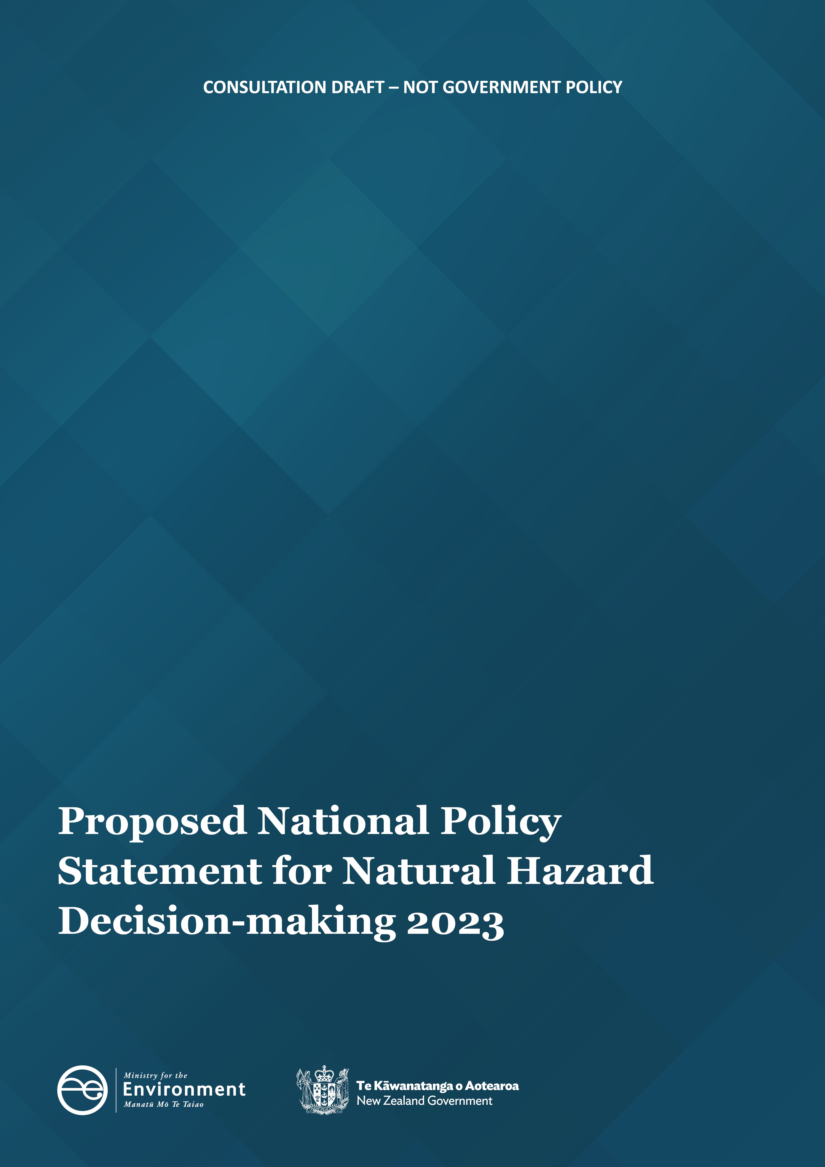

Authority
This National Policy Statement was approved by the Governor-General under section 52(2) of the Resource Management Act 1991 on [to come], and is published by the Minister for the Environment under section 54 of that Act.

Contents
Part 1: Preliminary provisions 4
1.1 Title 4
1.2 Commencement 4
1.3 Application 4
1.4 Interpretation 4
1.5 Application to intensification planning instruments 5
1.6 Relationship with New Zealand Coastal Policy Statement 2010 5
Part 2: Objective and policies 6
2.1 Objective 6
2.2 Policies 6
Part 3: Implementation 8
3.1 Outline of Part 8
3.2 Tangata whenua involvement 8
3.3 Best information 8
Part 4: Timing 9
4.1 Timing 9
4.2 Existing policy statements and plans 9

- Preliminary provisions
  - Title
- This is the National Policy Statement for Natural Hazard Decision-making 2023.
  - Commencement
- This National Policy Statement comes into force on [to come].
  - Application
- This National Policy Statement applies only to planning decisions that result in or enable new development.
  - Interpretation
- In this National Policy Statement:
Act means the Resource Management Act 1991
commencement date means the date on which this National Policy Statement comes into force, as identified in clause 1.2
decision-maker means any person exercising functions or powers under the Act
high natural hazard risk means a risk from natural hazards that is intolerable
low natural hazard risk means a risk from natural hazards that is generally acceptable
moderate natural hazard risk means a risk from natural hazards that is more than a low risk, but is not intolerable
natural hazard has the meaning in the Act and includes, without limitation, natural hazards arising from the effects of climate change
new development means development:
        - of new buildings, structures, or infrastructure on land that currently does not have buildings, structures, or infrastructure located on it; or
        - that is the extension or replacement of existing buildings, structures, or infrastructure.
new hazard-sensitive development means a new development relating to any of the following:
        - residential dwellings, including papakāinga and retirement villages:
        - marae:
        - educational facilities:
        - emergency services:
        - hospitals and other health care facilities:
        - community facilities.
planning decision means a decision on any of the following:
        - a resource consent:
        - a regional policy statement or proposed regional policy statement:
        - a regional plan or proposed regional plan:
        - a district plan or proposed district plan:
        - a designation:
        - a change to a plan requested under Part 2 of Schedule 1 of the Act.
specified Māori land means land that is any of the following:
        - Māori customary land and Māori freehold land (as defined in Te Ture Whenua Māori Act 1993):
        - land set apart as a Māori reservation under Part 17 of Te Ture Whenua Māori Act 1993 or its predecessor, the Māori Affairs Act 1953:
        - land held by or on behalf of an iwi or a hapū if the land was transferred from the Crown, a Crown body, or a local authority with the intention of returning the land to the holders of mana whenua over the land:
        - land vested in the Māori Trustee that is constituted as a Māori reserve by or under the Māori Reserved Land Act 1955, and remains subject to that Act:
        - land that forms part of a natural feature that has been declared under an Act to be a legal entity or person (including Te Urewera land within the meaning of section 7 of the Te Urewera Act 2014):
        - the maunga listed in section 10 of the Ngā Mana Whenua o Tāmaki Makaurau Collective Redress Act 2014:
        - Treaty settlement land, being land held by a post-settlement governance entity (as defined in the Urban Development Act 2020) where the land was transferred or vested and held (including land held in the name of a person such as a tipuna of the claimant group, rather than the entity itself):
          - as part of redress for the settlement of Treaty of Waitangi claims; or
          - by the exercise of rights under a Treaty settlement Act or Treaty settlement deed.
  - Application to intensification planning instruments
- In order to minimise disruption and complexity for local authorities, nothing in this National Policy Statement applies to a specified territorial authority (as defined in section 2 of the Act) when it is preparing an intensification planning instrument under section 80F of the Act.
  - Relationship with New Zealand Coastal Policy Statement 2010
- The provisions of the New Zealand Coastal Policy Statement prevail over the provisions of this National Policy Statement if there is a conflict between them.

- Objective and Policies
  - Objective
Objective: The risks from natural hazards to people, communities, the environment, property, and infrastructure, and on the ability of communities to quickly recover after natural hazard events, are minimised.
  - Policies
Policy 1: When making planning decisions, decision-makers are to determine the level of natural hazard risk as high, moderate, or low.
Policy 2: When determining natural hazard risk, decision-makers are to consider:
        - first, the likelihood of a natural hazard event occurring (either individually or in combination) and the consequences of the natural hazard event occurring, including potential loss of life, serious injury, adverse effects on the environment, and potential serious damage to property and infrastructure; and
        - second, tolerance to a natural hazard event, including the willingness and capability of those who are subject to the risk (such as a community, Māori, or the Crown) to bear the risk of that natural hazard (including its cost) and any indirect risks associated with it.
Policy 3: Decision-makers must adopt a precautionary approach when determining natural hazard risk if:
        - the natural hazard risk is uncertain, unknown, or little understood; and
        - the natural hazard risk could be intolerable.
Policy 4: Natural hazard risk must be a:
        - matter of control for any new development that is a controlled activity; and
        - matter of discretion for any new development that is a restricted discretionary activity.
Policy 5: Planning decisions must ensure that:
        - in areas of high natural hazard risk, new development is avoided unless the level of risk is reduced to at least a tolerable level or:
          - the new development is not a new hazard-sensitive development; and
          - there is a functional or operational need for the new development to be located in the area of high natural hazard risk, and
          - there are no practicable alternative locations for the new development; and
          - risk is reduced to as low as reasonably practicable; and
        - in areas of moderate natural hazard risk, mitigation measures are taken to reduce natural hazard risk to new development as low as reasonably practicable; and
        - in areas of low natural hazard risk, new development is enabled.
Policy 6: The most effective natural hazard mitigation measures are adopted to reduce natural hazard risk over the life of any proposed new development, provided the natural hazard mitigation measures do not exacerbate natural hazard risks in other areas, and where possible:
        - nature-based solutions are preferred over hard-engineering solutions; and
        - comprehensive area-wide measures are preferred over site-specific solutions.
Policy 7: Māori and, in particular, tangata whenua values, interests, and aspirations are recognised and provided for, including through early engagement, when making decisions on new development on specified Māori land where there is a high or moderate natural hazard risk.

- Implementation
  - Outline of Part
- This Part sets out a non-exhaustive list of things that local authorities must do to give effect to the objective and policies of this National Policy Statement, but nothing in this Part limits the general obligation under the Act to give effect to that objective and those policies.
  - Tangata whenua involvement
- Natural hazard risk is a matter that must be discussed with tangata whenua in accordance with existing requirements under the RMA.
  - Best information
- In giving effect to this National Policy Statement, decision-makers must use the best information available at the time, which means, if practicable, using complete and scientifically robust data.
- In the absence of complete and scientifically robust data, the best information may include information obtained from modelling, as well as partial data, local knowledge, and information obtained from other sources, but in this case decision-makers must:
        - prefer sources of information that provide the greatest level of certainty; and
        - take all practicable steps to reduce uncertainty (such as through monitoring or the validation of models used).
- A local authority:
        - must not delay making decisions solely because of uncertainty about the quality or quantity of the information available; and
        - if the information is uncertain, must interpret it in the way that will best give effect to this National Policy Statement.

- Timing
  - Timing
- From the date on which this National Policy Statement comes into force, decision-makers must have regard to it when making decisions on:
        - resource consent applications;
        - designations; and
        - a change to a plan requested under Part 2 of Schedule 1 of the Act.
- As soon as reasonably practicable, every local authority must give effect to this National Policy Statement by updating their policy statements and plans.
  - Existing policy statements and plans
- To the extent that policy statements and plans already (at the commencement date) give effect to this National Policy Statement, local authorities are not obliged to make changes to wording or terminology merely for consistency with it.
- In case of dispute, the onus is on the local authority to show that, despite the different wording or terminology used, their policy statement or plan does implement this National Policy Statement.
- However, if a local authority chooses to amend an operative policy statement or plan by merely changing wording or terminology for consistency with this National Policy Statement, the amendment is to be treated as the correction of a minor error (and therefore, under clause 20A of Schedule 1 of the Act, the amendment can be made without using a process in that Schedule).

