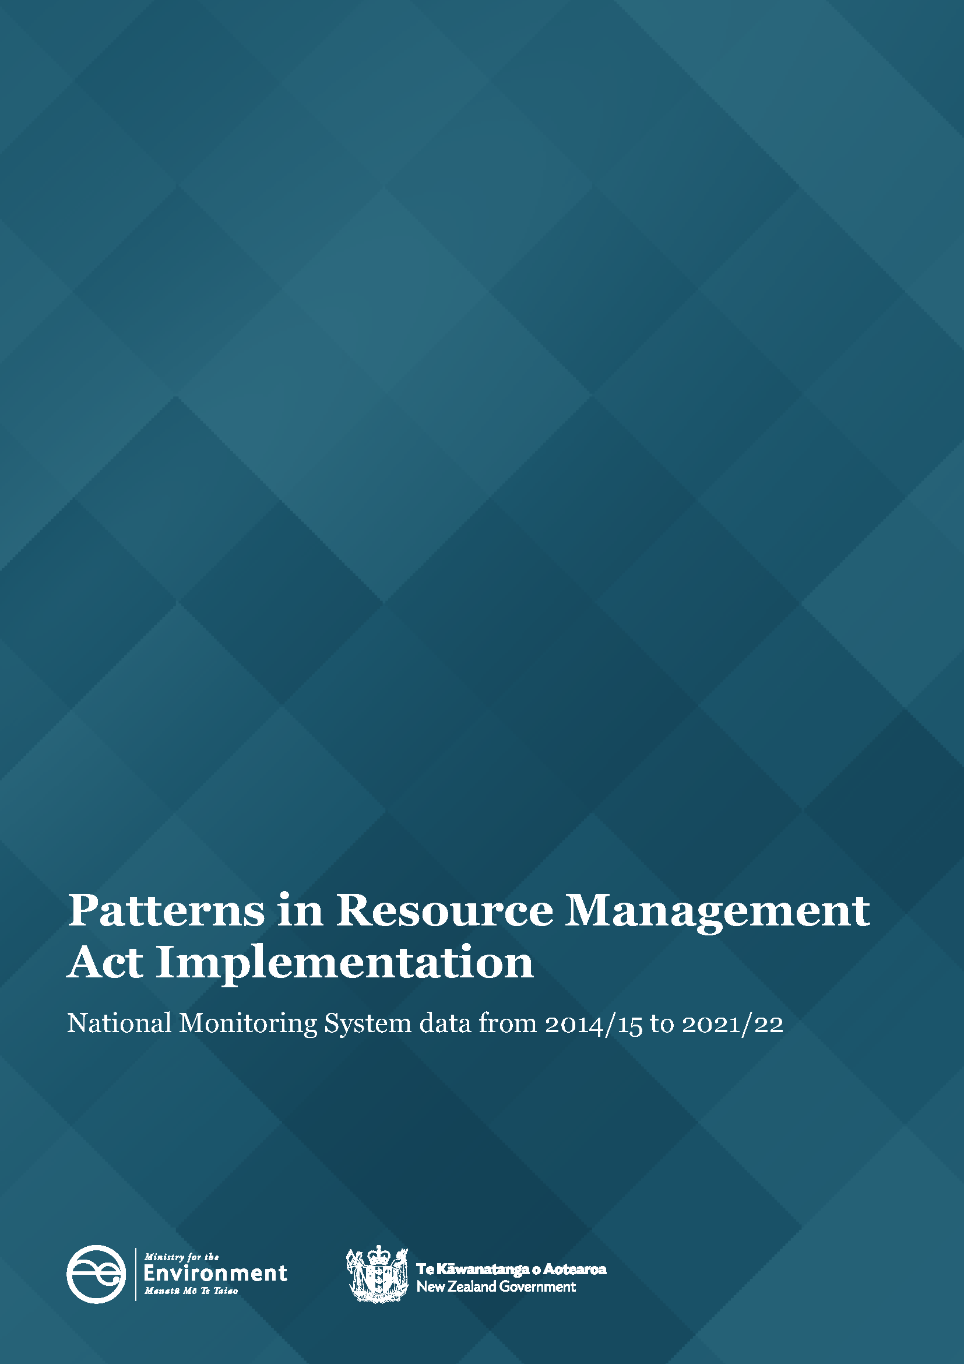
Patterns in Resource Management Act Implementation
National Monitoring System data from 2014/15 to 2021/22

Disclaimer
The information in this publication is, according to the Ministry for the Environment’s best efforts, accurate at the time of publication. However, users of this publication are advised that:
- The information does not alter the laws of New Zealand, other official guidelines, or requirements.
- It does not constitute legal advice, and users should take specific advice from qualified professionals before taking any action based on information in this publication.
- The Ministry does not accept any responsibility or liability whatsoever whether in contract, tort, equity, or otherwise for any action taken as a result of reading, or reliance placed on this publication because of having read any part, or all, of the information in this publication or for any error, or inadequacy, deficiency, flaw in, or omission from the information in this publication.
- All references to websites, organisations or people not within the Ministry are for convenience only and should not be taken as endorsement of those websites or information contained in those websites nor of organisations or people referred to.
Copyright
© Crown copyright New Zealand 2023. Unless otherwise stated, this copyright work is licensed for
re-use under a Creative Commons Attribution 4.0 International licence. In essence, you are free to copy, distribute and adapt the work, as long as you attribute the work to the New Zealand Government and abide by the other licence terms. To view a copy of this licence, visit Creative Commons Attribution 4.0 International licence.
If you publish, distribute, or otherwise disseminate this work (or any part of it) to the public without adapting it the following attribution statement should be used: Source: Ministry for the Environment and data providers and licensed by the Ministry for the Environment for re-use under the Creative Commons Attribution 4.0 International licence. If you adapt this work in any way, or include it in a collection and publish, distribute, or otherwise disseminate that adaptation or collection to the public, the following attribution statement should be used: This work uses material sourced from the Ministry for the Environment and data providers, which is licensed by the Ministry for the Environment for re-use under the Creative Commons Attribution 4.0 International licence.
Where practicable, please hyperlink the name of the Ministry for the Environment to the Ministry for the Environment web page that contains, or links to, the source data.
Acknowledgements
We would like to acknowledge the contribution of local authorities who collect and provide the data for the National Monitoring System that informs this report.
This document may be cited as: Ministry for the Environment. 2023. Patterns in Resource Management Act Implementation – National Monitoring System data from 2014/15 to 2021/22. Wellington: Ministry for the Environment.
Published in September 2023 by the
Ministry for the Environment
Manatū Mō Te Taiao
PO Box 10362, Wellington 6143, New Zealand
environment.govt.nz
ISBN: 978-1-991077-81-3
Publication number: ME 1791
© Crown copyright New Zealand 2023
Contents

About this National Monitoring Systems data report 5
Patterns in RMA implementation 6
Resource consent data patterns 6
The number of resource consents by year and type has risen 6
Three councils continued to process the highest number of resource consent applications 7
A lower percentage of new resource consent applications were processed
within statutory timeframes 10
Councils continued to approve most new resource consent applications 12
Varying types of resource consents have been declined 13
Percentage of new resource consents that were notified remained low 14
Councils increased the use of section 37 and decreased the use of section 92 16
Median processing times of consent types varied from 2014/15 to 2021/22 17
Plan-making processes 19
Councils completed a higher percentage of plans within two-year statutory timeframes 19
Iwi and hapū participation within the resource management system 21
There was a downward pattern in how councils budgeted for iwi and hapū to participate in consenting and plan-making 21
The number of new iwi management plans or iwi planning documents endorsed continues to be low 22
Compliance monitoring and enforcement 23
There was variation in which councils took enforcement action 24
Councils had a small increase in the number of monitoring and enforcement
staff 25

Figures
Figure 1: Number of new consents granted (by year and type) 7
Figure 2: Number of new resource consents granted (by council) 8
Figure 2a: Number of councils that processed fewer than 1,000 new resource consents 9
Figure 3: Percentage of new consents granted or declined that were processed within statutory timeframes 10
Figure 4: Percentage of new consents granted or declined that were processed within statutory timeframes 11
Figure 5: Percentage of new consents that were granted 12
Figure 6: Percentage of new consents that were declined (by year and type) 13
Figure 7: Percentage of new resource consent applications that were notified 14
Figure 8: Percentage of new resource consent applications that were notified (by council) 15
Figure 9: Percentage of new consent applications granted or declined that used at least one section 37 or section 92 16
Figure 10: Median processing time of new consent types (in working days, by year) 17
Figure 11: Median processing time of new consents granted or declined (by council) 18
Figure 12: Percentage of plans decided within the statutory timeframe 19
Figure 13: Median processing time to complete a plan change once notified 20
Figure 14: Percentage of councils that provided budget to iwi/hapū to participate in either the development of resource management plans or processing of resource consents 21
Figure 15: Number of new iwi management plans endorsed by iwi authorities and lodged with councils 22
Figure 16: Number of enforcement actions taken by councils (by council type) 24
Figure 17: Number of FTE council staff for consenting, monitoring and enforcement, and planning 25
Figure 18: Total FTEs working on resource management at councils 26

About this National Monitoring Systems data report
This report is written to inform central and local government of patterns in Resource Management Act 1991 (RMA) implementation, which reflects the roles councils play in everyday decision-making under the RMA. Every year, the Ministry for the Environment (the Ministry) collects information from councils on their implementation of the RMA, and this report has been publicly released to make it accessible to the wider resource management community.
The report is organised by topic and highlights patterns in how councils have implemented the RMA over the past eight years, as recorded by the National Monitoring System (NMS). The data collected by the NMS will continue to inform the Ministry’s understanding of how the current resource management system has been working and will provide information for a new resource management system.
In some sections of this report, the data are broken down to reflect the types of councils where differences have occurred in RMA implementation.
Unless otherwise noted:
- all consenting facts and figures relate to a council’s decision to grant or decline new resource consent applications within the 2021/22 financial year
- the report excludes data from applications that were incomplete, withdrawn or returned
- the term ‘processed’ refers to consents that were granted or declined
Key patterns from 2021/22
- The number of resource consents, by consent type, granted by councils increased overall, except for coastal permits, which were at their lowest since 2014/15.
- A lower percentage of new resource consents were processed within statutory timeframes, and there was a continuing rise in section 37 use but a small decline in the use of section 92.
- The percentage of resource consents being notified was at its lowest level since 2014/15.
- The median processing time for new resource consents was 46 days.
- There was a downward pattern in how councils provided budget support for iwi and hapū involvement within resource consent processing and plan-making.
- The overall number of full-time equivalent (FTE) council staff working in resource management was at its highest level since 2014/15.
- the term ‘plan-making’ refers to policy statements or plans, changes or variations that were started, continued or completed by councils within the 2021/22 financial year.

Patterns in RMA implementation

Resource consent data patterns
Under the RMA, certain activities require a resource consent. A resource consent is permission from a council for an activity that might affect the environment, and that is not allowed ‘as of right’ by the district or regional plan. Some types of subdivision activities also require a resource consent. Where discretion by a council needs to be exercised, the council may place conditions on an application while still allowing it to go ahead.
There are different categories of resource consents depending on the rules in a district or regional plan: coastal permits, combined land-use and subdivision consents, discharge permits, land-use consents, subdivision consents, and water permits.

The number of resource consents by year and type
has risen
In 2021/22, 39,773 new (section 88) resource consents were granted. Figure 1 (overleaf) shows an increase from the previous year and the highest number of consents granted since 2016/17.
Most consent types granted by local authorities increased overall, except for resource consents relating to coastal permits, which were at their lowest since 2014/15. The total number of consents granted by local authorities has varied each year since 2014/15.
Figure 1: Number of new consents granted (by year and type)
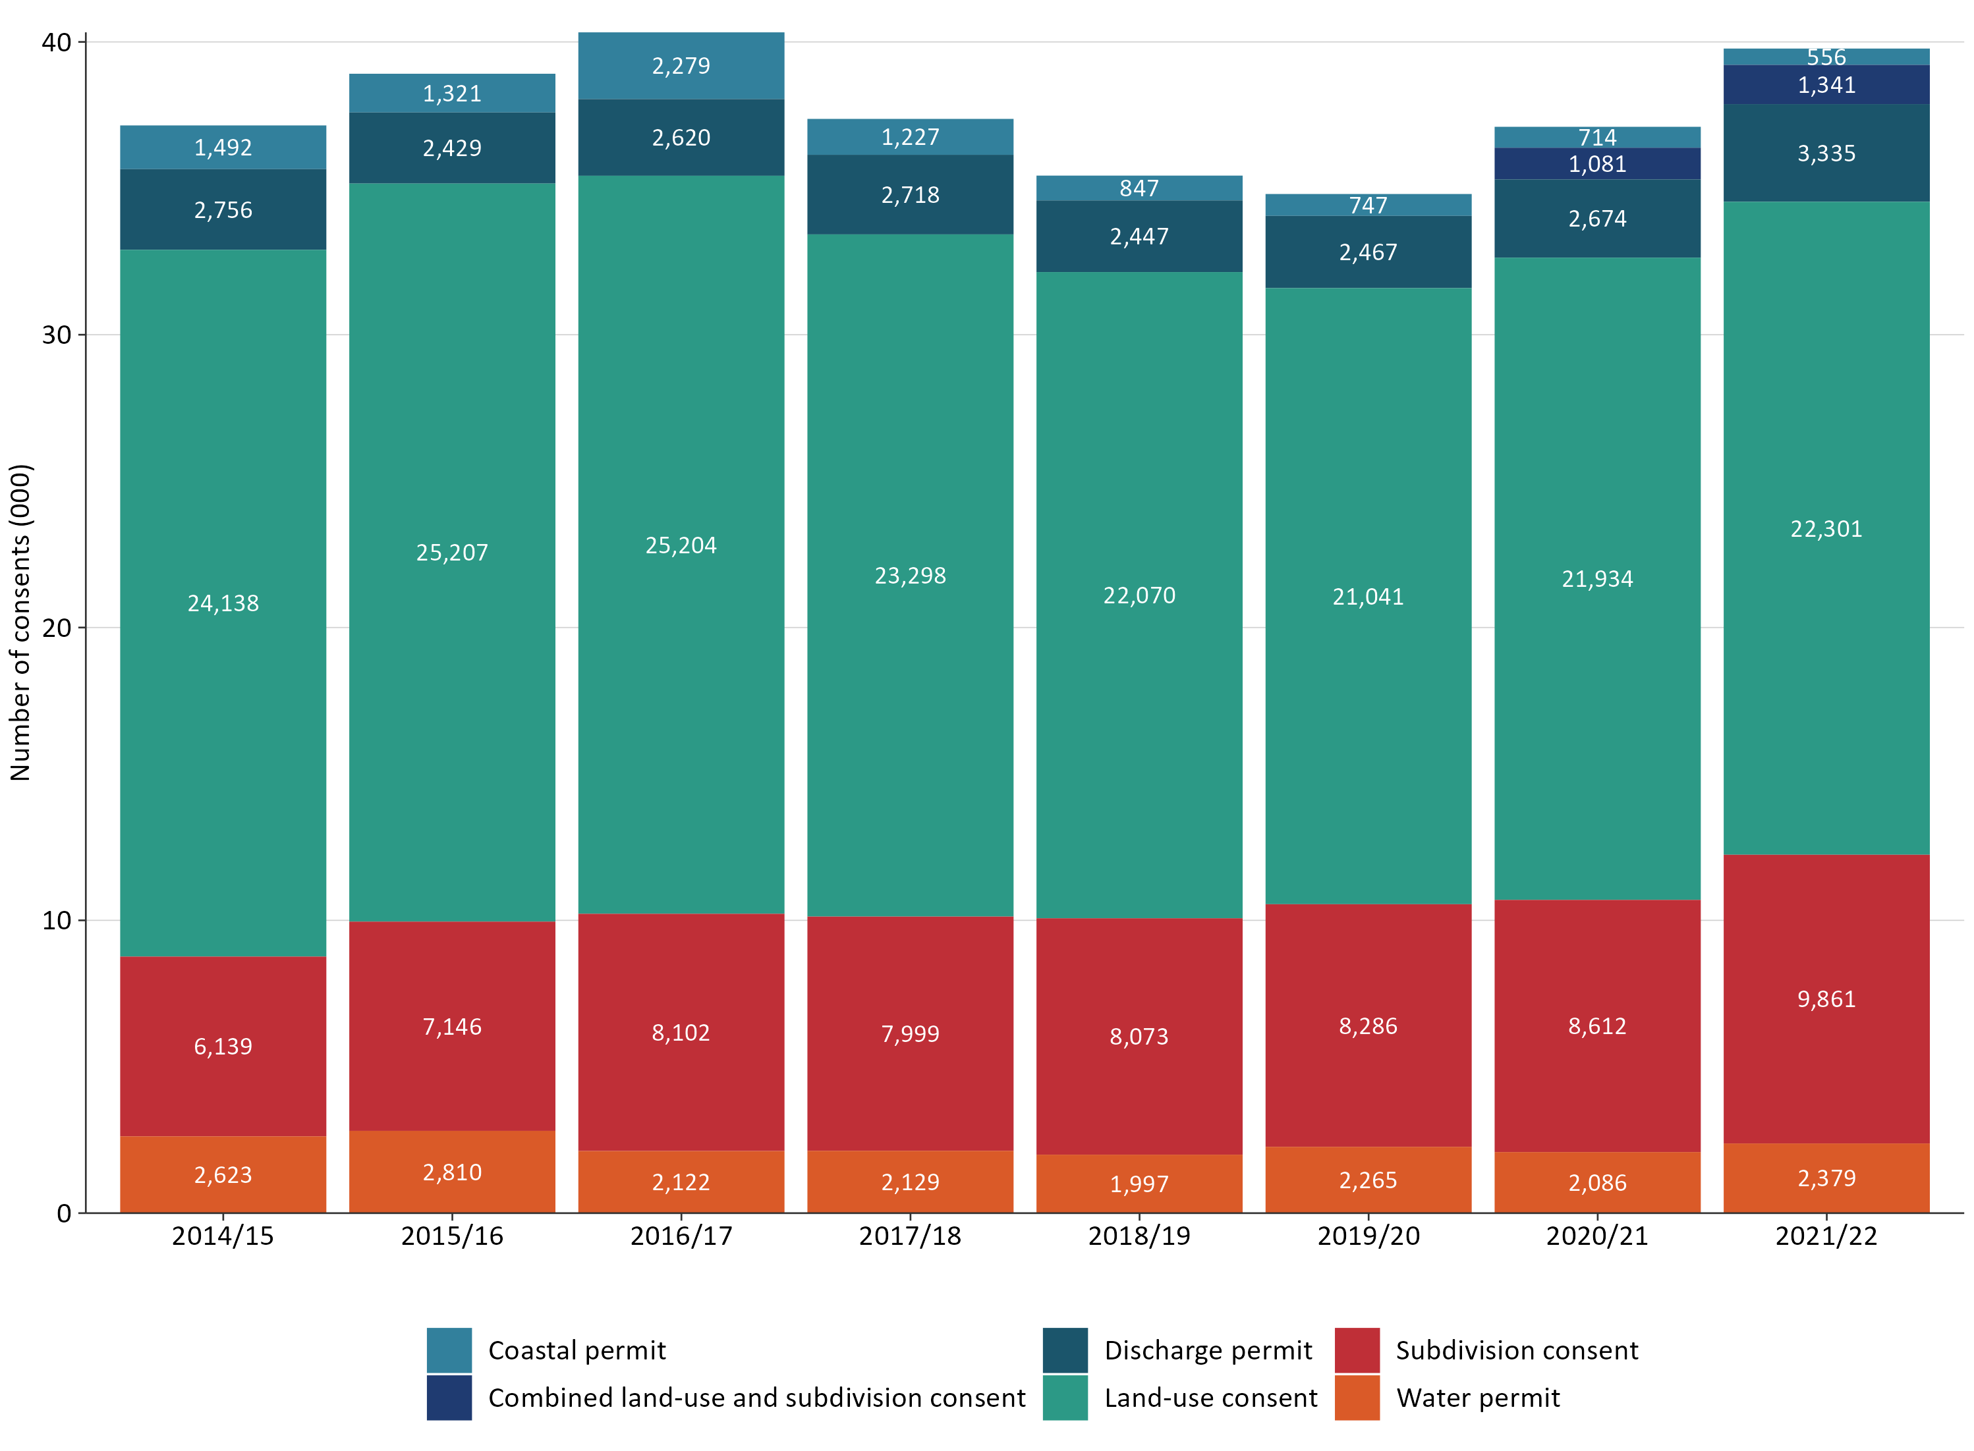
A new dataset was included in 2020/21 to illustrate combined land-use and subdivision consents. In 2021/22, the overall number of these combined land-use and subdivision consents slightly increased, to 1,341 (an increase of 24.1 per cent from the previous year).

Three councils continued to process the highest number of resource consent applications
Patterns in the national data set have been consistently influenced by Auckland Council, which has continually processed the highest number of resource consents – with close to 12,500 processed in 2021/22 (see figure 2 overleaf). Christchurch City Council processed the second-highest number of resource consents (for the third year in a row), followed by Marlborough District Council with the third-highest number of consents (for the second year in a row).
The data provided by councils in relation to the number of combined land-use and subdivision consents processed showed that Christchurch City Council had processed the highest number (478), with the second-highest number processed by Whanganui District Council (152). Auckland Council had not categorised any resource consents as being in the combined
land-use and subdivision category.
Figure 2: Number of new resource consents granted (by council)
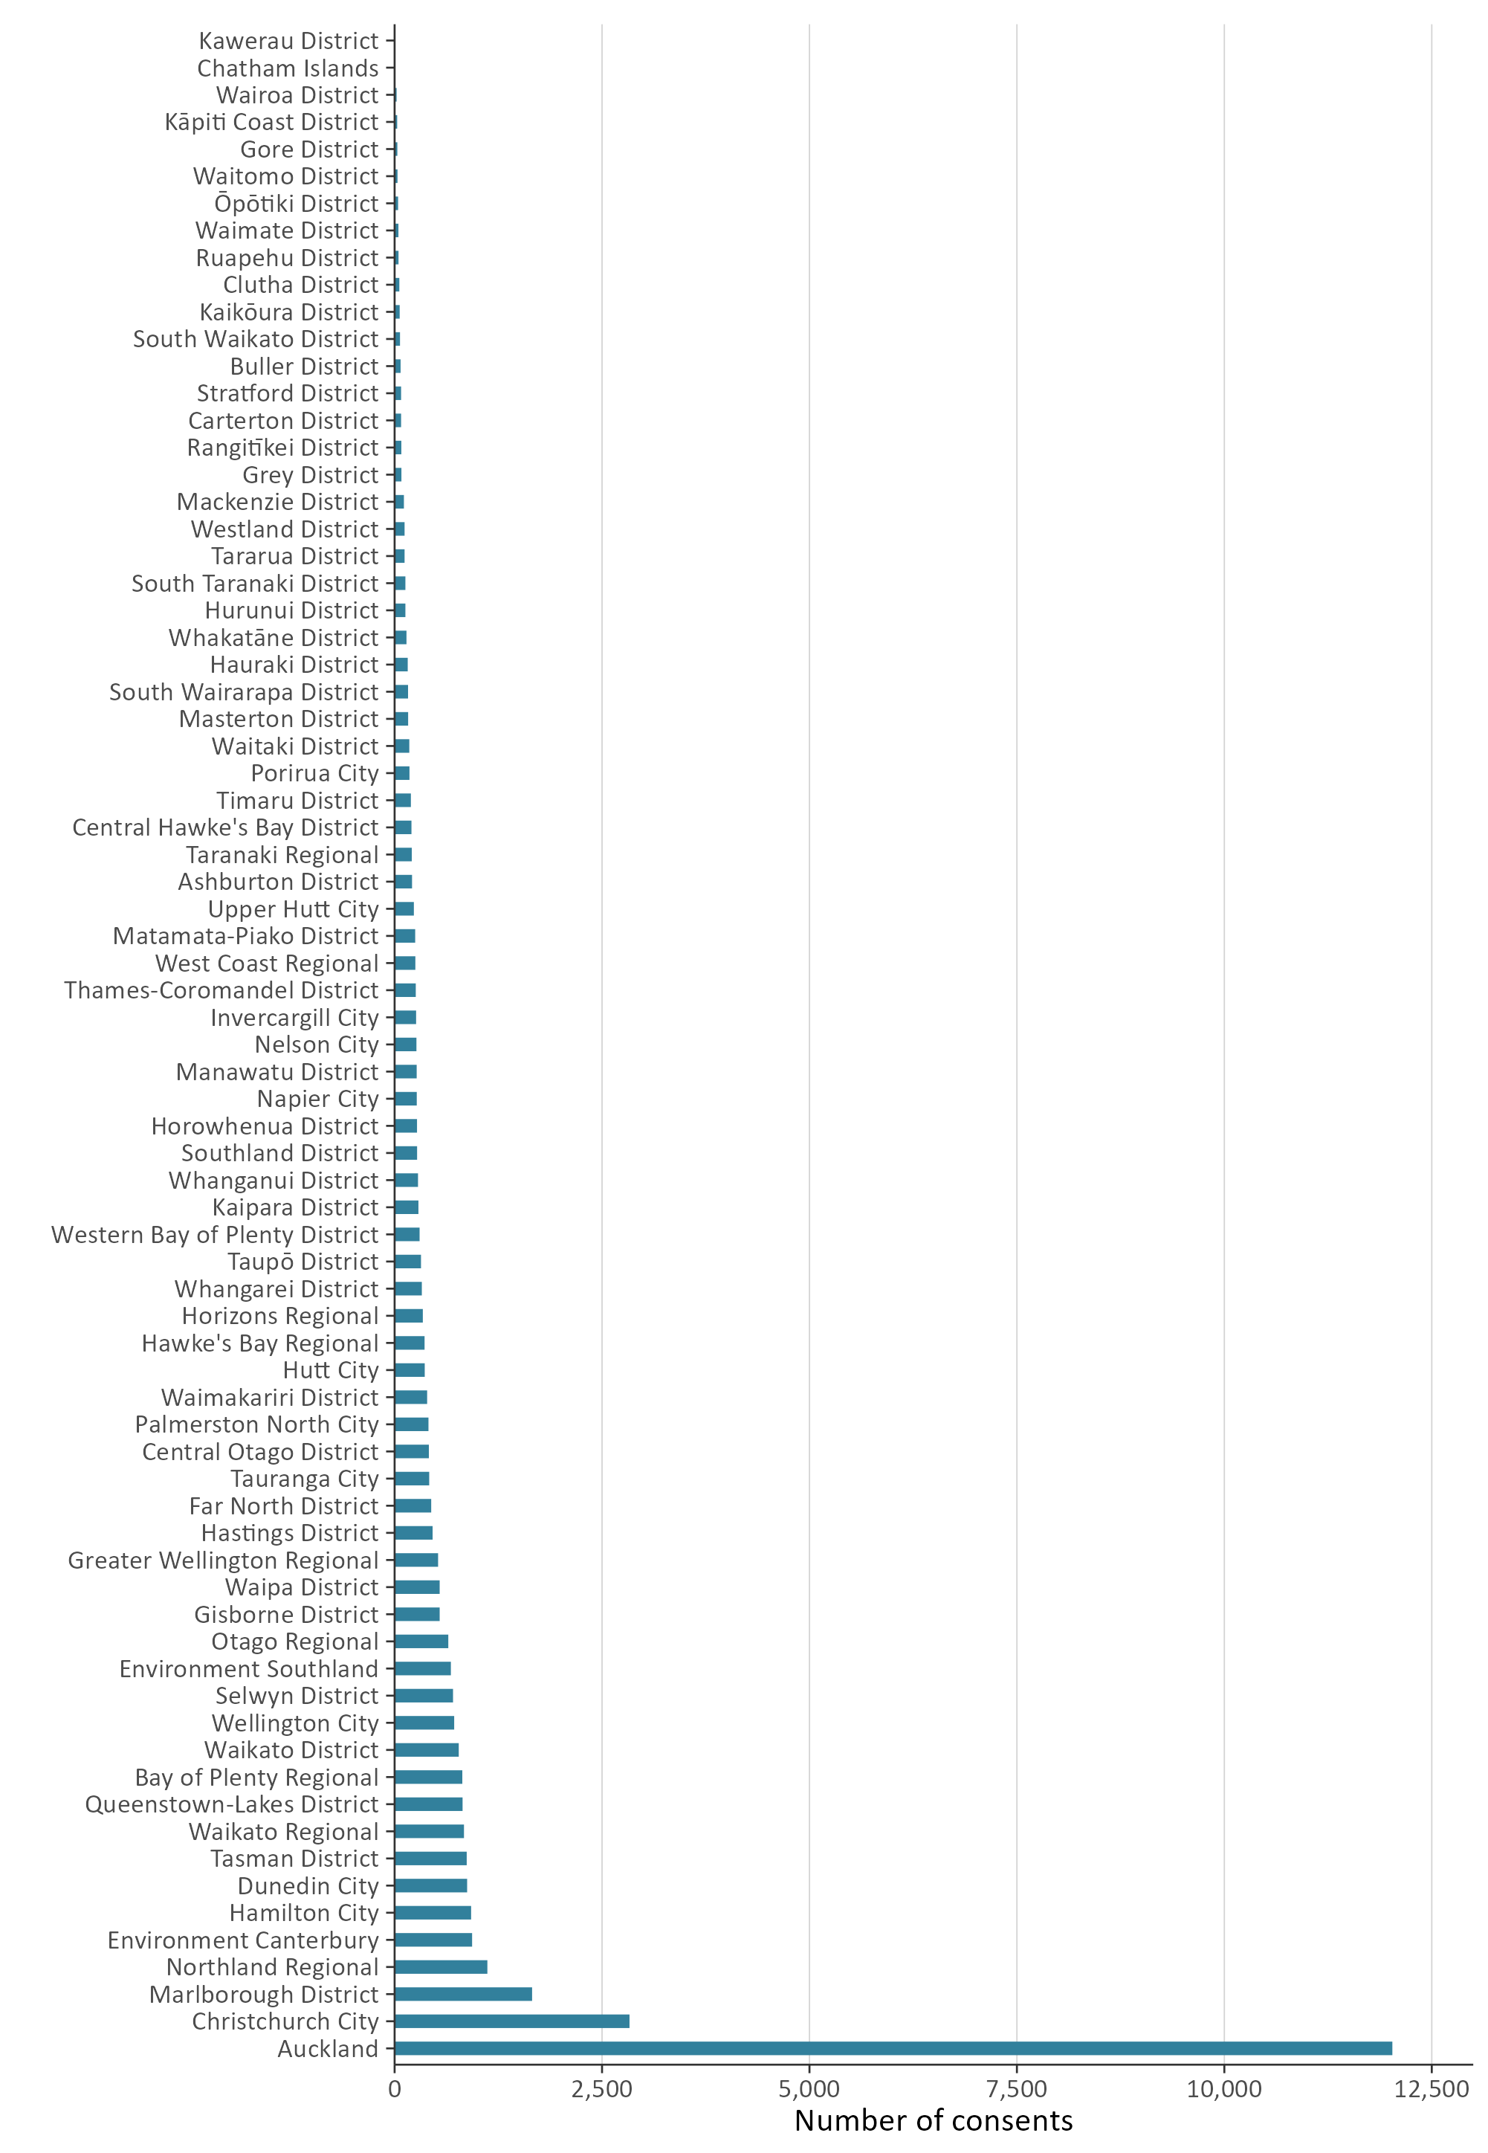

Figure 2a shows those councils which processed fewer than 1,000 new resource consents in the 2021/22 financial year, which represents just under 94 per cent of all councils that provided data.
Figure 2a: Number of councils that processed fewer than 1,000 new resource consents
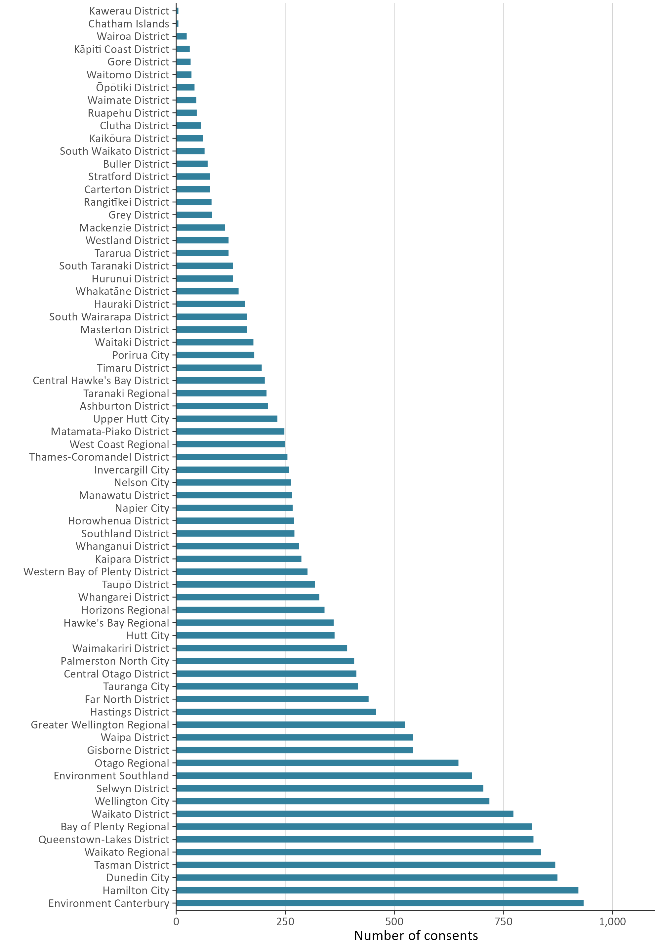

A lower percentage of new resource consent applications were processed within statutory timeframes
Councils have a responsibility under the RMA to process resource consent applications within a set amount of time. When a council does not meet the statutory timeframe to process a resource consent, and special circumstances do not apply, the council must give the applicant a discount on administrative charges. This requirement, which was introduced under the Resource Management (Discount on Administrative Charges) Regulations 2010, provides a financial incentive for all councils to meet the statutory timeframes.
Figure 3 and figure 4 reflect a lower percentage of new resource consents being processed within statutory timeframes in 2021/22. Figure 3 shows the overall decline in the timeliness of councils processing resource consents, which dropped to the lowest level since 2014/15. This 8.3 per cent decrease is mostly influenced by Auckland Council data.
Figure 3: Percentage of new consents granted or declined that were processed within statutory timeframes
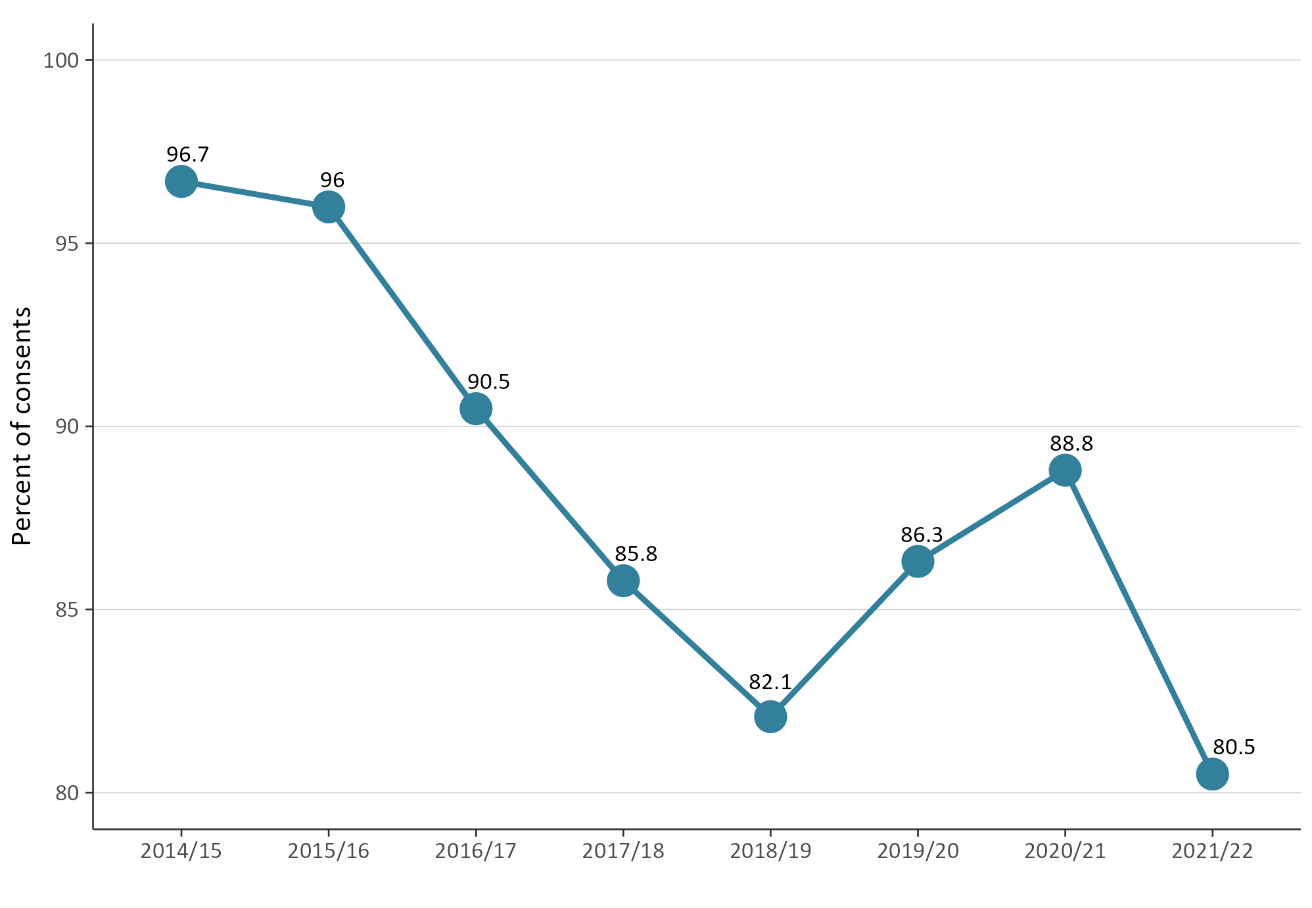

Figure 4 shows the effect of Auckland Council’s individual data patterns on national-level data within the NMS. Excluding Auckland Council, processing times decreased, compared to the 2020/21 national dataset, but that decrease was less than the decrease occurring at Auckland Council. The overall pattern therefore shows a decline in the percentage of consents processed within statutory timeframes since 2014/15.
Figure 4: Percentage of new consents granted or declined that were processed within statutory timeframes
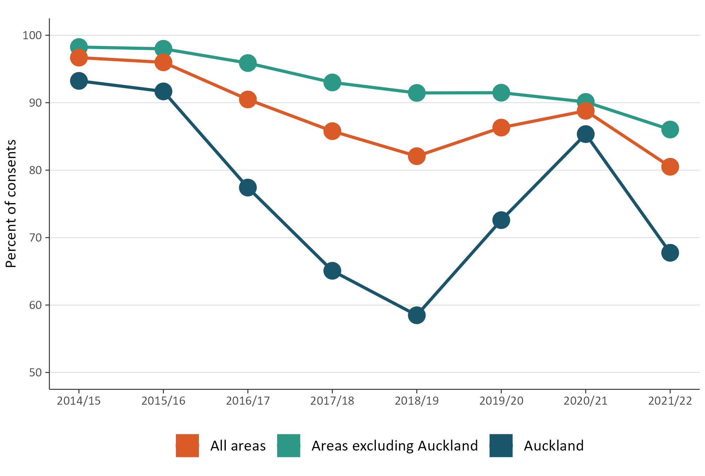

Councils continued to approve most new resource consent applications
Variability in the number of approved new resource consents since 2014/15 has been low, with more than 99 per cent of all resource consents granted each year. The percentage of new resource consents approved by councils across Aotearoa New Zealand remained consistently high in the 2021/22 period (see figure 5).
Figure 5: Percentage of new consents that were granted
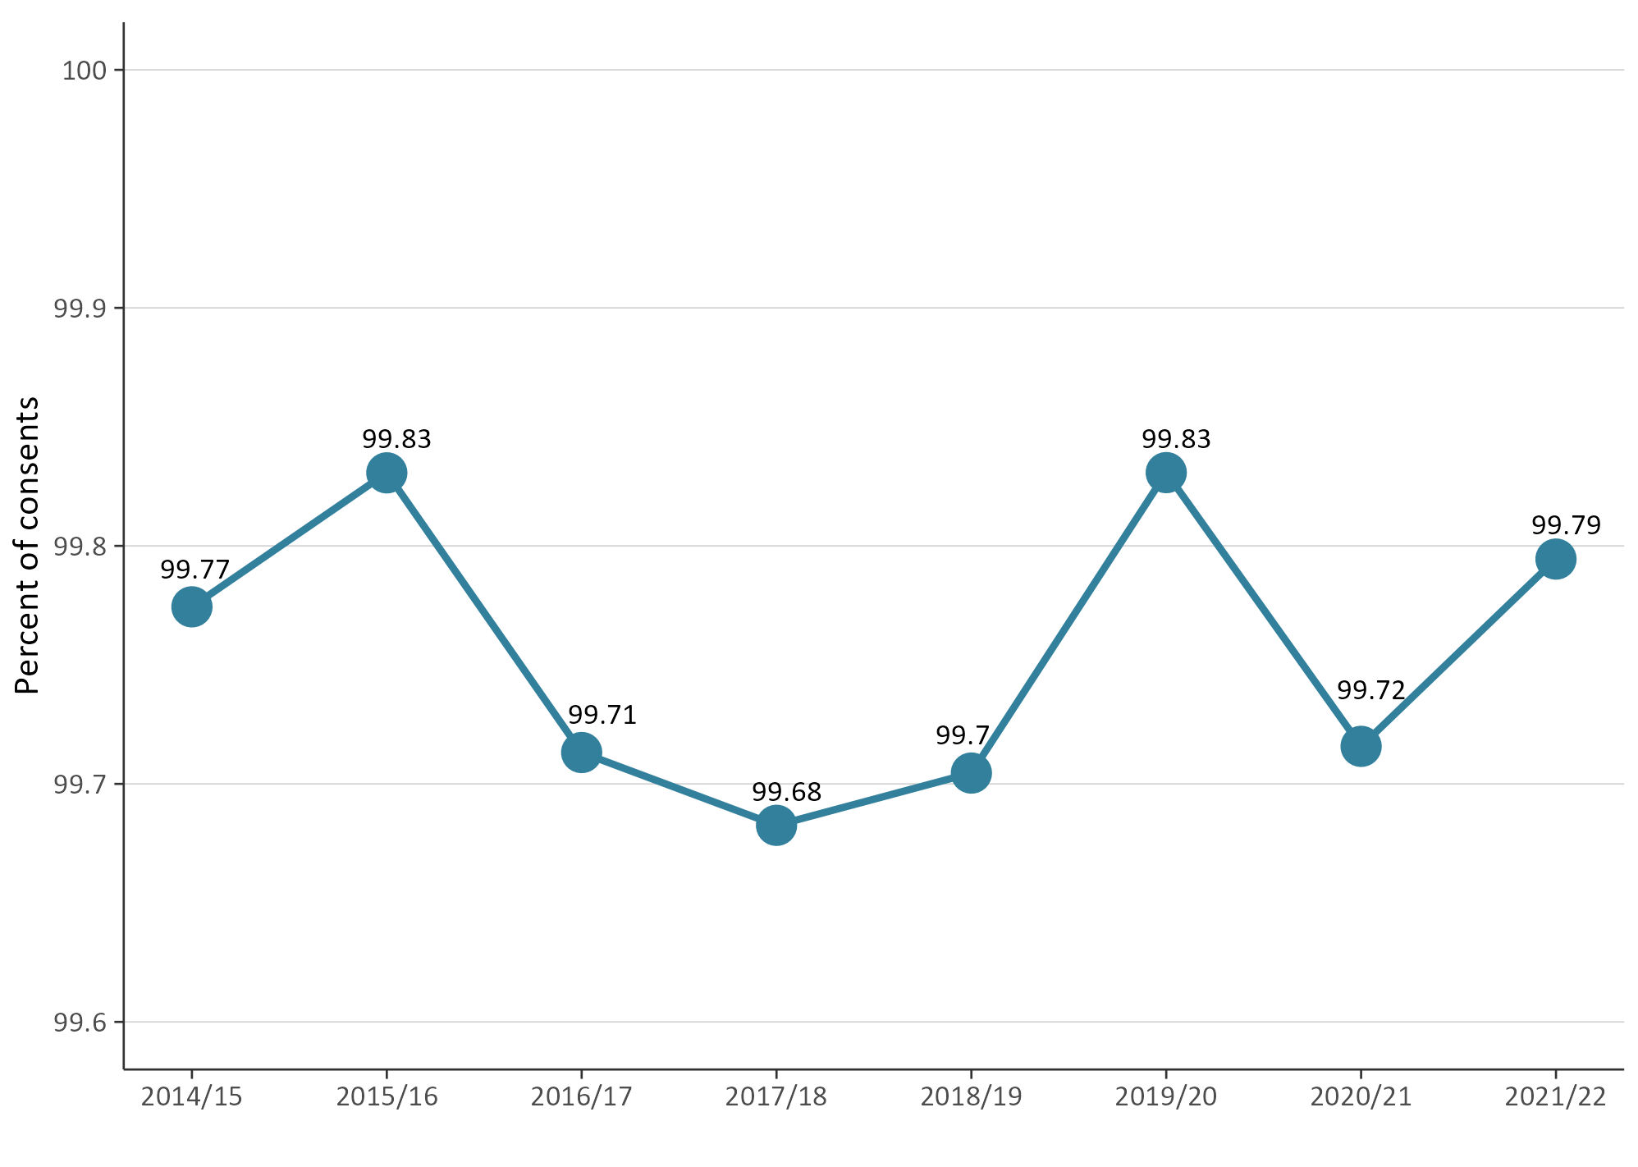

Varying types of resource consents have been declined
NMS data collected since 2014/15 have provided the types of resource consents that have been declined or refused by councils. Overall, the figures have generally remained stable across years and by type, with minor fluctuations, as shown in figure 6.
The 2021/22 national dataset showed only minor variations in the types of resource consents being declined. Compared to 2020/21, declined combined land-use and subdivision consents decreased, but declined water permits increased.
Figure 6: Percentage of new consents that were declined (by year and type)
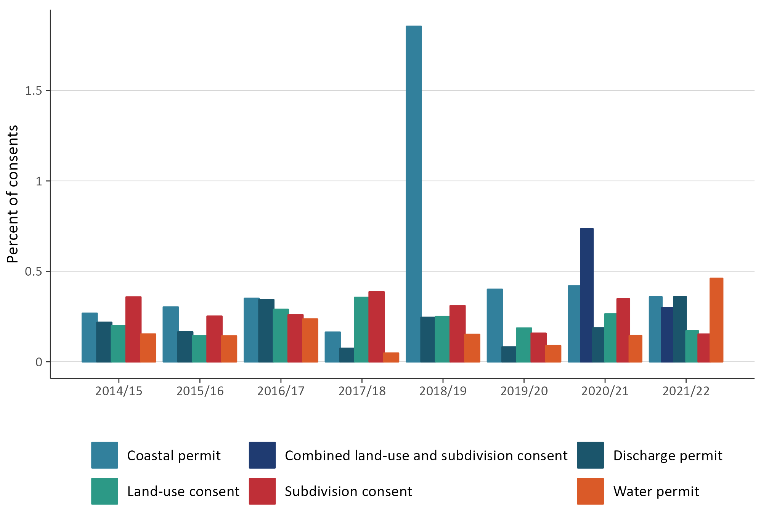

Percentage of new resource consents that were notified remained low
The proportion of notified resource consents has historically remained low — over any year it has been under 4 per cent (of all new resource consent applications). This is because most resource consent applications are processed on a non-notified basis.
The 2021/22 national dataset showed the percentage of notified consents was at its lowest since the Ministry began collecting NMS data in 2014/2015 (see figure 7).
Figure 7: Percentage of new resource consent applications that were notified
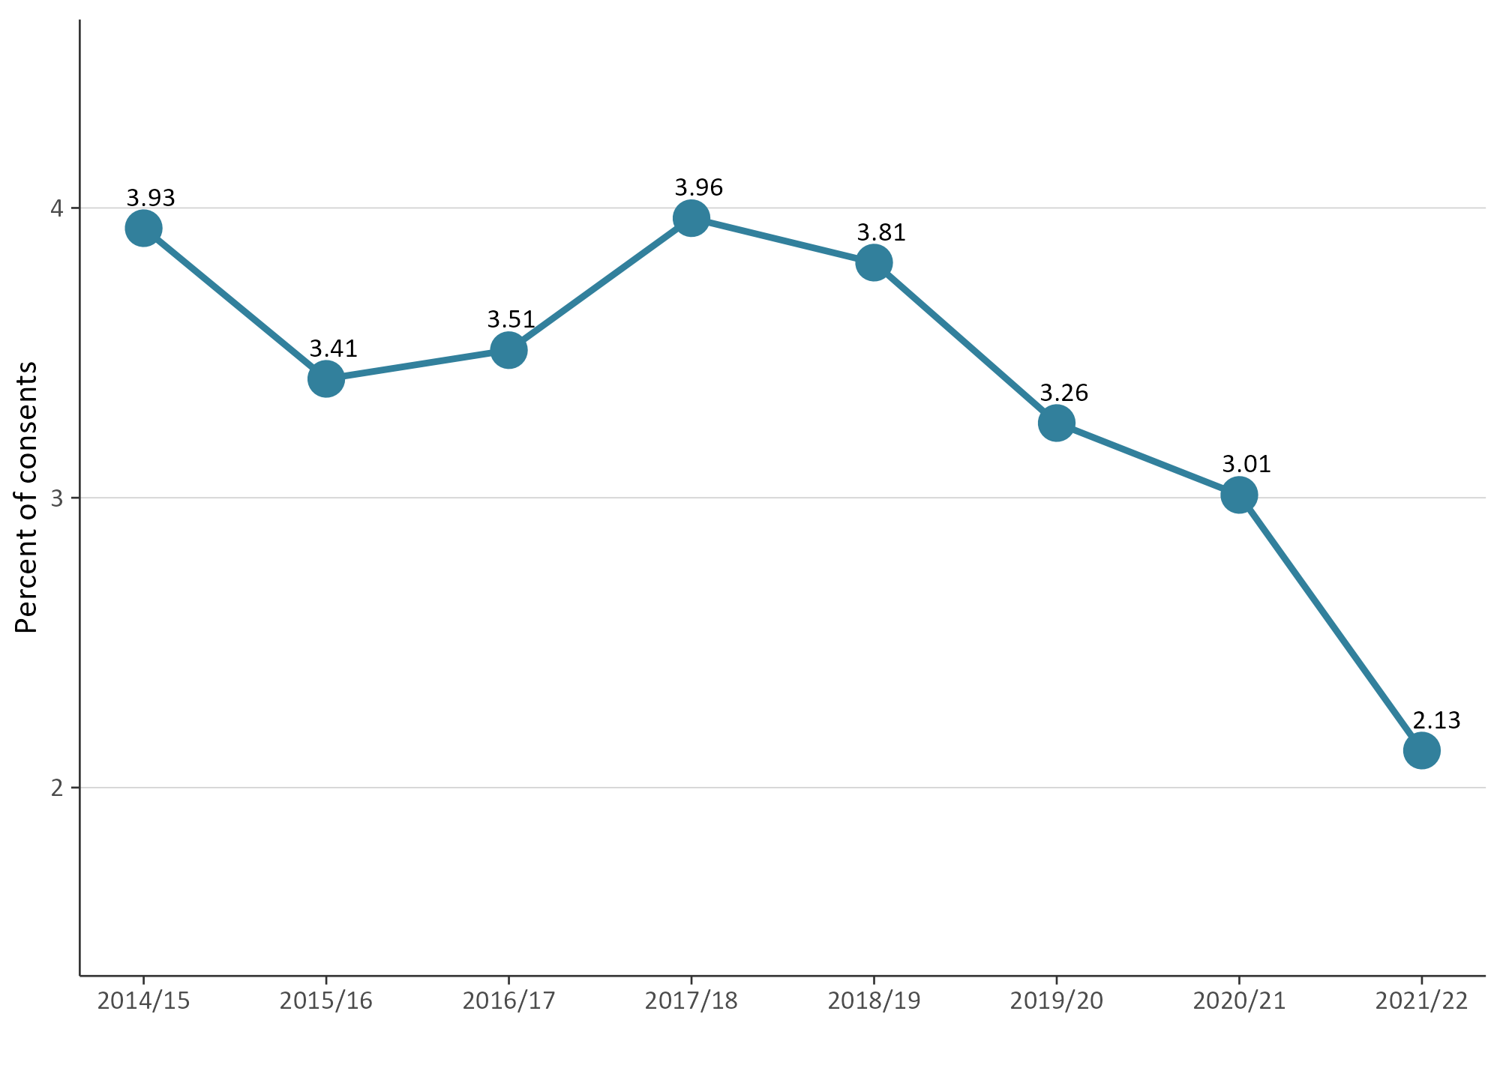
The 2021/22 national dataset showed the highest proportion of notified consents were processed by Marlborough District Council, followed closely by Buller District Council (see figure 8 overleaf).

Figure 8: Percentage of new resource consent applications that were notified (by council)
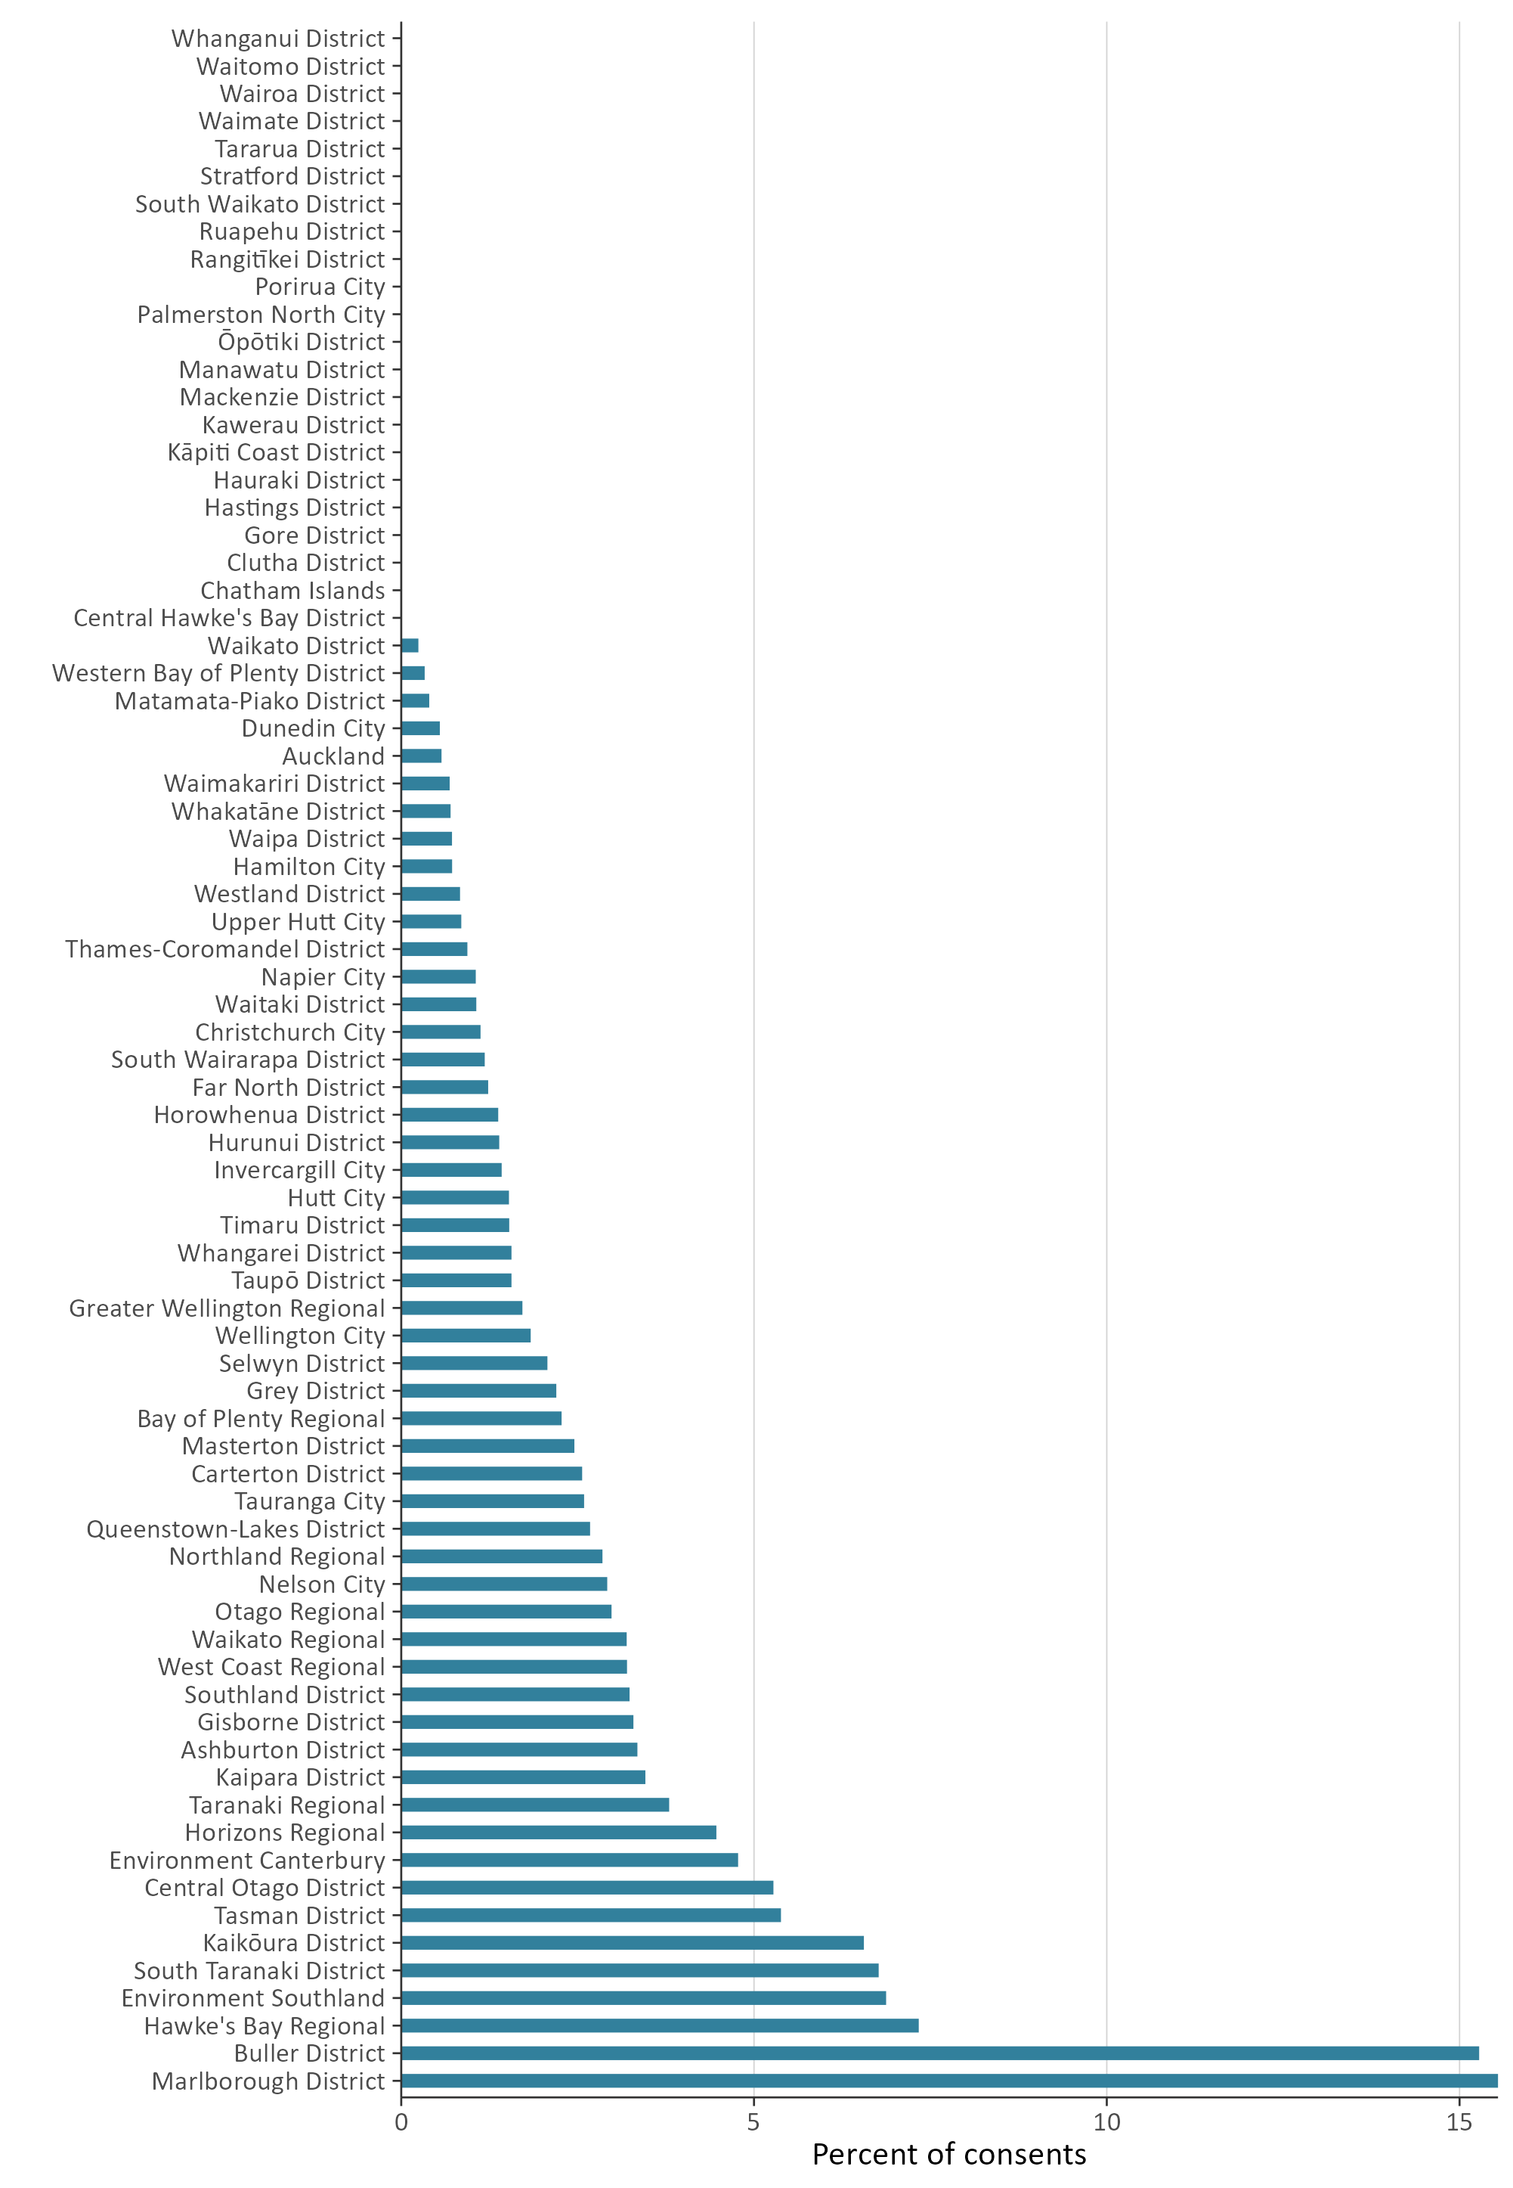

Councils increased the use of section 37 and decreased the use of section 92
Section 37 of the RMA allows a council additional working days during the processing of a resource consent, provided that certain circumstances are met. Where used, section 37 allows a council to double the statutory timeframes or to waive a failure to comply with the statutory timeframes. In using section 37, a council must take into account the interests of persons who may be directly affected by the waiver, the interests of the community in making a decision on a consent, and a council’s overall duty to avoid unreasonable delay.
Section 92 of the RMA allows a council to ask for more information from a resource consent applicant before making a decision on the application. The ‘processing clock’ is paused once, while the applicant responds to the council’s request. Generally, a council seeks additional information to better understand a proposed consenting activity and any environmental effects it may have.
Figure 9 shows that the use of sections 37 and 92 has increased overall since 2014/15. From 2020/21 to 2021/22, use of section 37 increased 8.4 per cent, but use of section 92 decreased 2.1 per cent.
Figure 9: Percentage of new consent applications granted or declined that used at least one section 37 or section 92
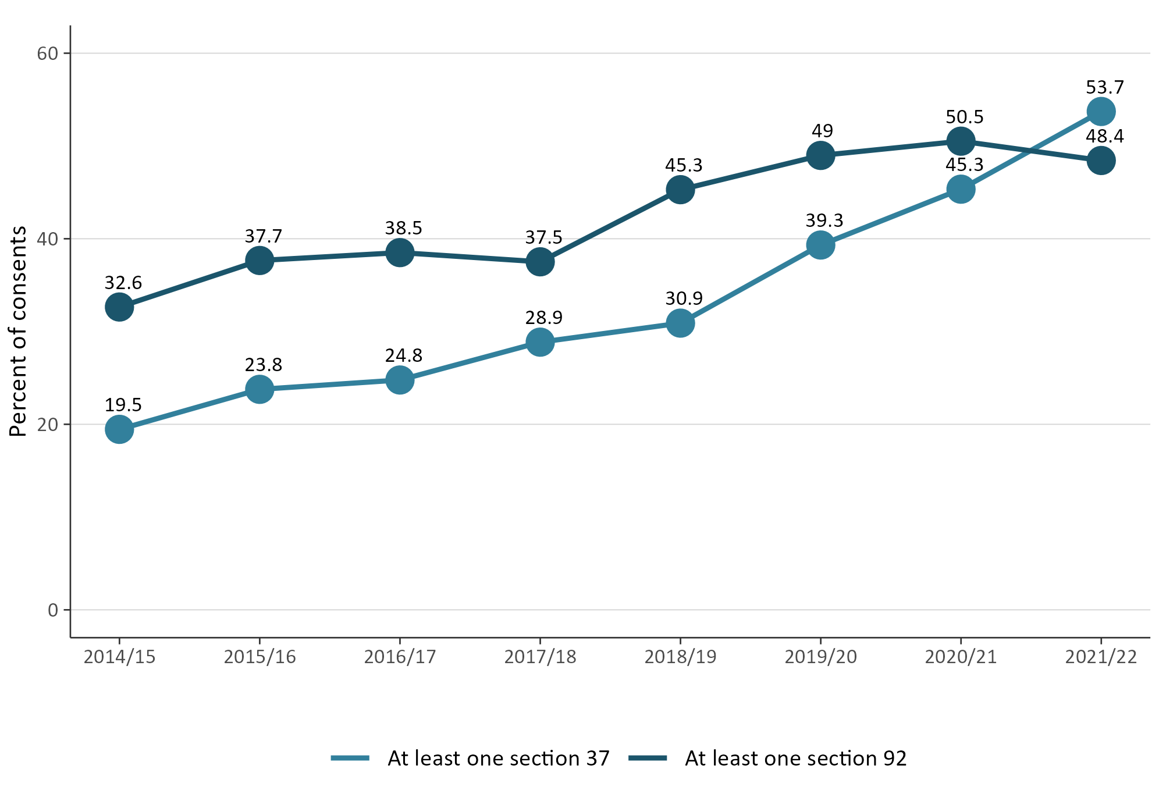

Median processing times of consent types varied from 2014/15 to 2021/22
Figure 10 contains a breakdown of types of resource consent applications and the median length of time (in working days) that councils took to process them. This data includes processing to grant or decline a resource consent.
Combined land-use and subdivision consents were reported for the first time in 2020/21, and councils took a median of 35 days to process these applications. The 2021/22 data shows that all types of consents took longer to process, compared to 2020/21, with a median processing timeframe of 46 days. However, coastal and water permit processing times decreased, with median timeframes of 31 and 55 days, respectively.
Figure 10: Median processing time of new consent types (in working days, by year)
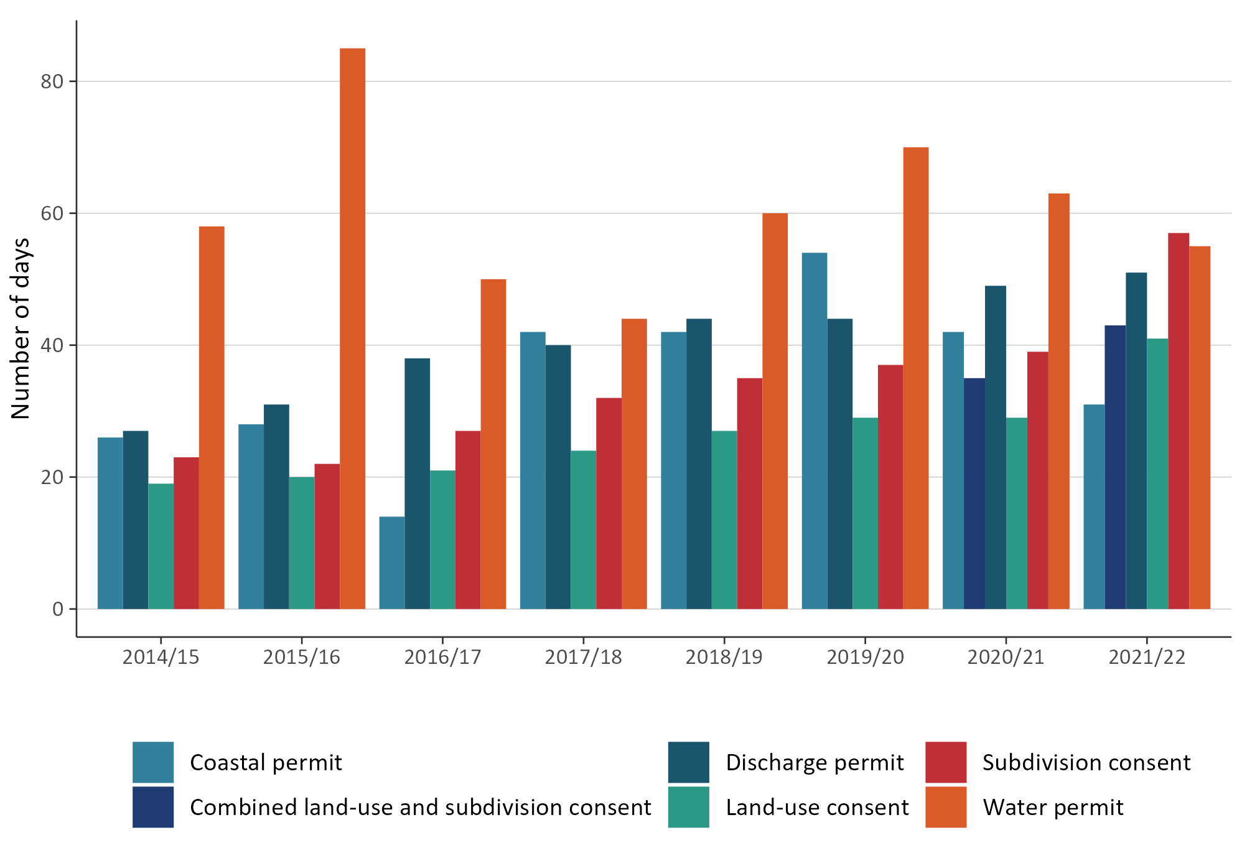
Figure 11 (over leaf) shows the median processing time for new consents, by council. Of the district and city councils, South Wairarapa District Council (for the second year) recorded the lowest median processing days and Hutt City Council recorded the highest median processing days.
Of the regional councils, West Coast Regional Council recorded the lowest median processing days, and Taranaki Regional Council provided the highest number of median processing days. Of the unitary councils, both Auckland Council and Tasman District Council recorded a higher number of median processing days, and Chatham Islands Council recorded the lowest.

Figure 11: Median processing time of new consents granted or declined (by council)
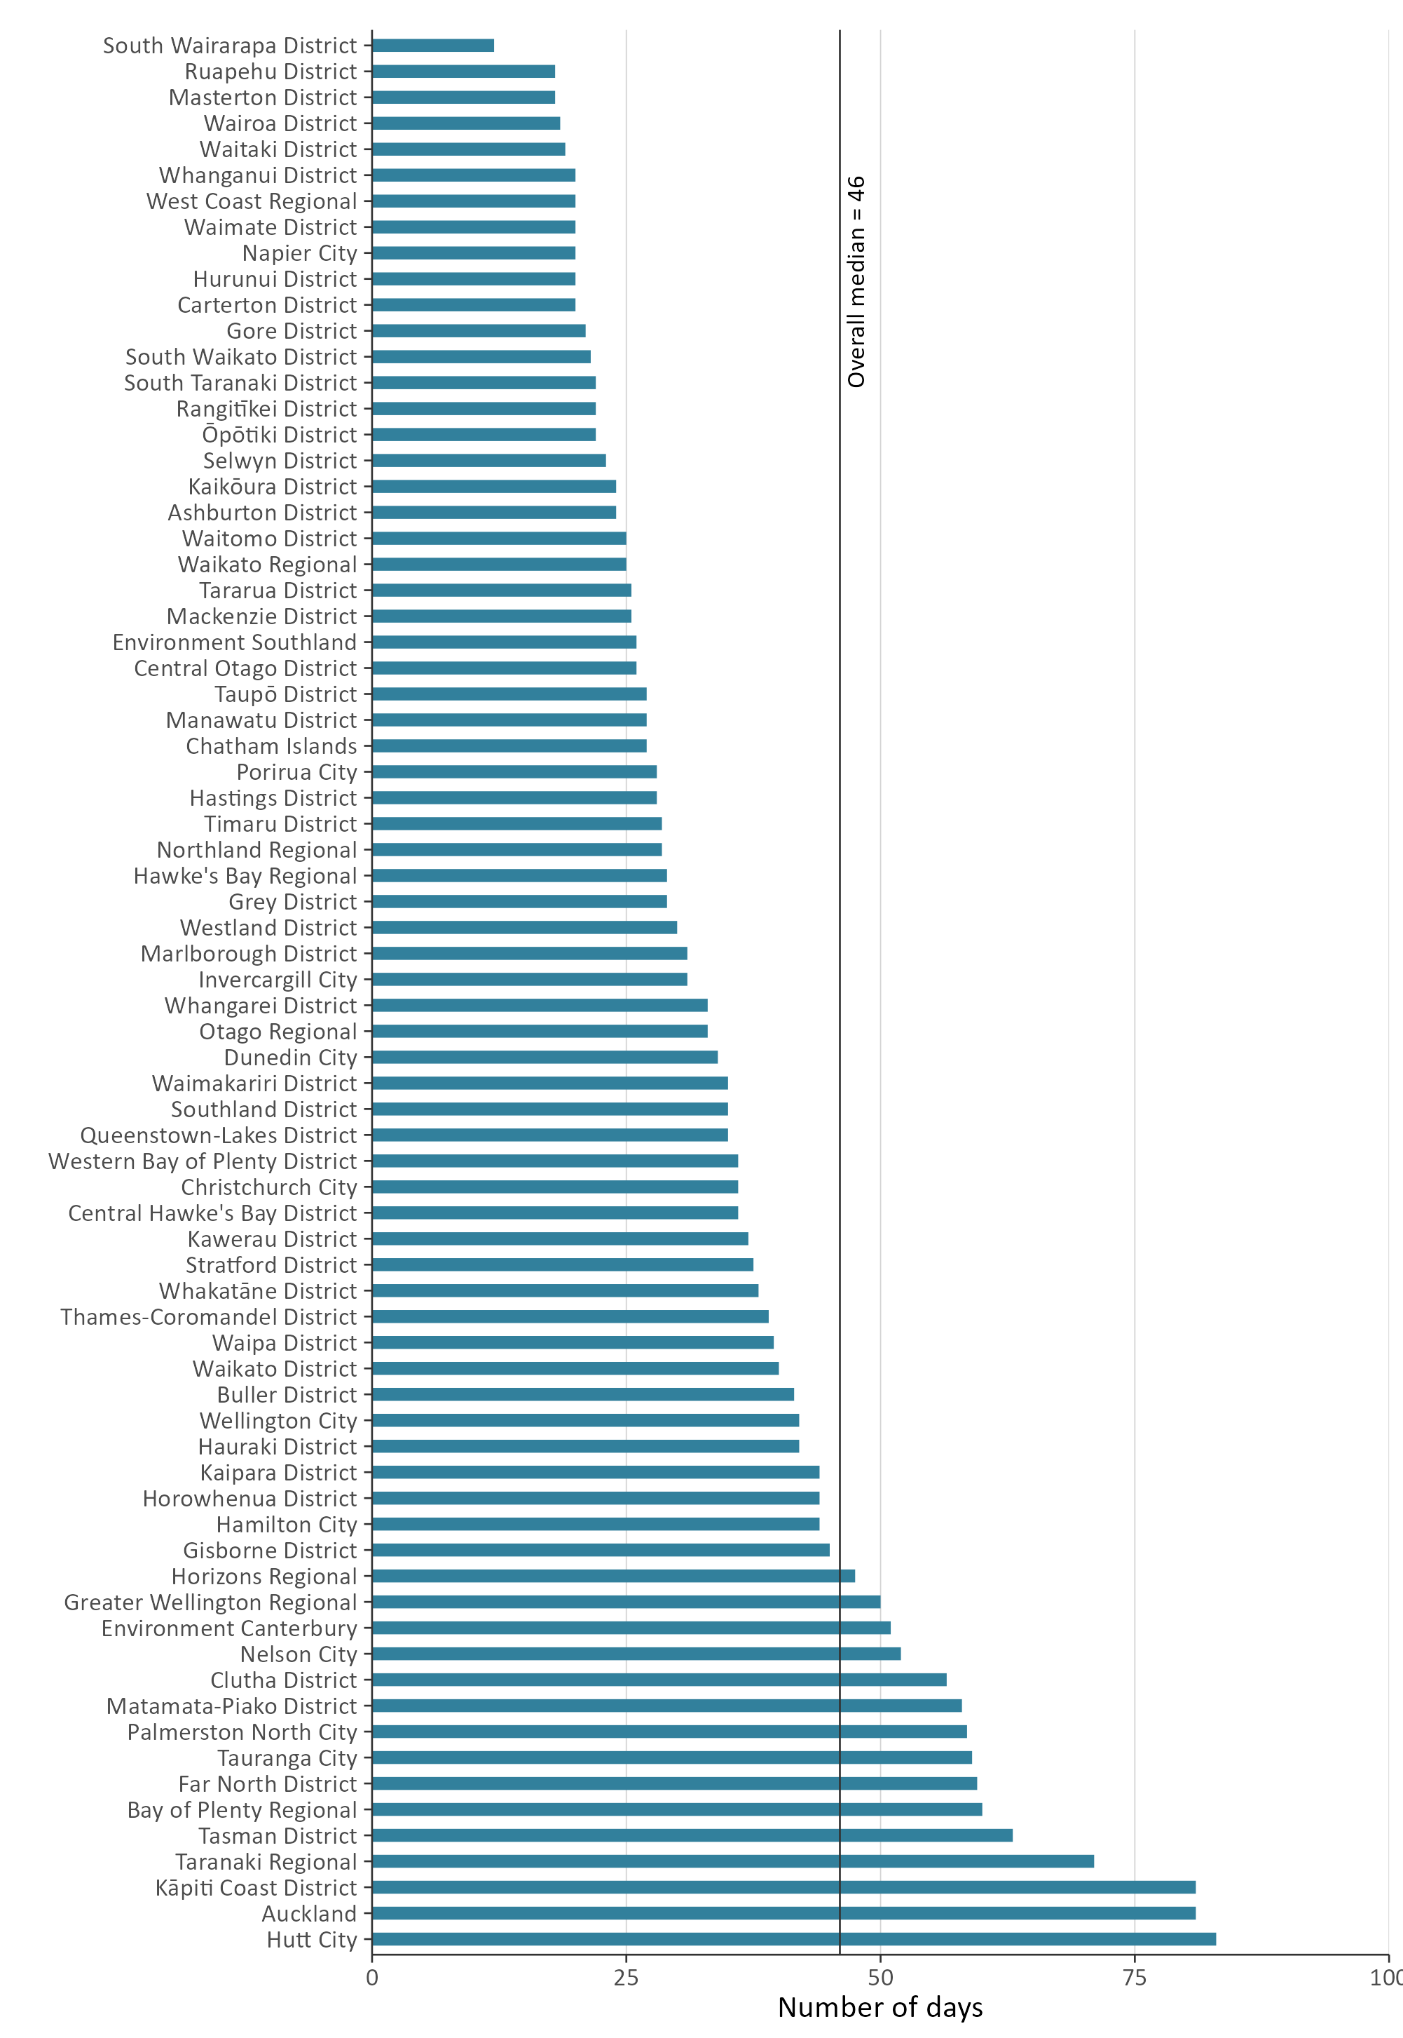

Plan-making processes
Councils must prepare regional and district plans under sections 30 and 31 of the RMA. A regional or district plan will state what activities can be undertaken as of right (‘permitted’) and what activities require a resource consent.
Councils must review their plans, or any plan provisions, at least every 10 years. Plan changes can be initiated by councils or requested by private individuals or entities. These are known as plan-making processes.
The Resource Legislation Amendment Act 2017 introduced a requirement for councils to seek an extension from the Minister for the Environment if they wanted to exceed the two-year statutory timeframe to decide on a proposed plan from the date of notification (Schedule 1, clause 10A of the RMA).

Councils completed a higher percentage of plans within two-year statutory timeframes
Under Schedule 1 of the RMA, all councils are required to meet the two-year timeframe (from notification) for making decisions on proposed plans or plan changes.
Figure 12 shows that, since 2014/15, councils have completed an increasing percentage of plan changes within two years of notification. For 2021/22, the percentage of plans meeting the two-year timeframe increased 2.6 per cent from the previous year.
The overall data for 2021/22 showed the highest percentage of plans decided within the statutory timeframe since 2014/15.
Figure 12: Percentage of plans decided within the statutory timeframe
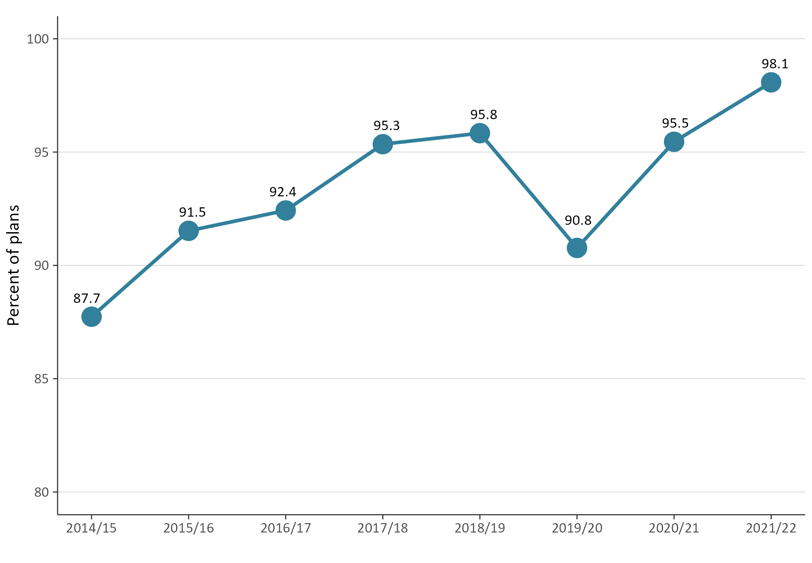
Figure 13 shows that processing time has remained relatively consistent since 2015/16. In 2021/22, the median processing time for completing this task was 1.08 years after notification, which is a small decrease compared to 2020/21 (when the median processing time was 1.1 years).
Figure 13: Median processing time to complete a plan change once notified
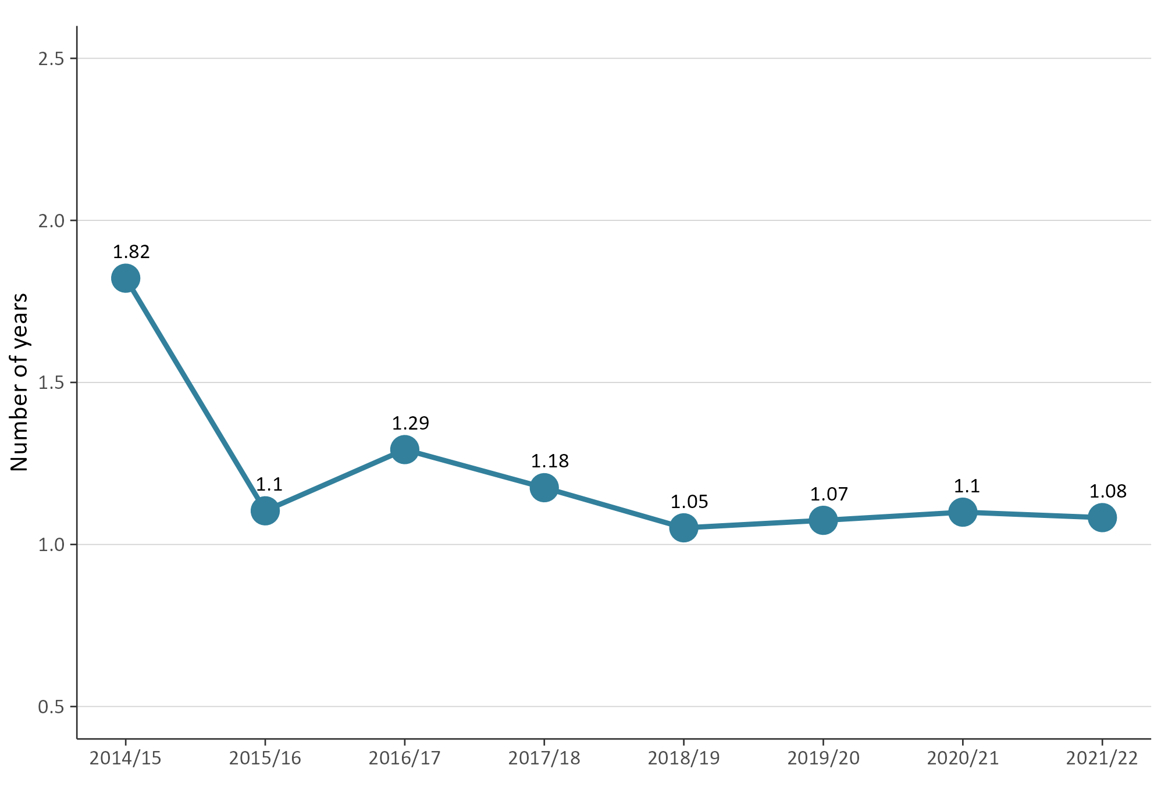

Iwi and hapū participation within the resource management system
The RMA sets out different ways to enable iwi and hapū participation in resource management processes. Councils also have processes in place to support tangata whenua participation in resource management.
This support can come in the form of a budgetary commitment from councils to support iwi and hapū to participate in both plan-making and consenting processes. In-kind forms of support, such as access to databases or memoranda of understanding, may also be available.

There was a downward pattern in how councils budgeted for iwi and hapū to participate in consenting and
plan-making
Figure 14 shows the percentage of councils providing budget for iwi and hapū to participate in either planning or consenting matters. Since 2014/15, the percentage of councils across Aotearoa New Zealand that have provided budget to iwi and hapū has varied – between 44 and 62 per cent for plan-making, and between 26 and 42 per cent for consenting.
There was a decrease in the percentage of councils that provided budget to iwi and hapū to participate in either the development of resource management plans or processing of resource consents, compared to 2020/21.
Figure 14: Percentage of councils that provided budget to iwi/hapū to participate in either the development of resource management plans or processing of resource consents
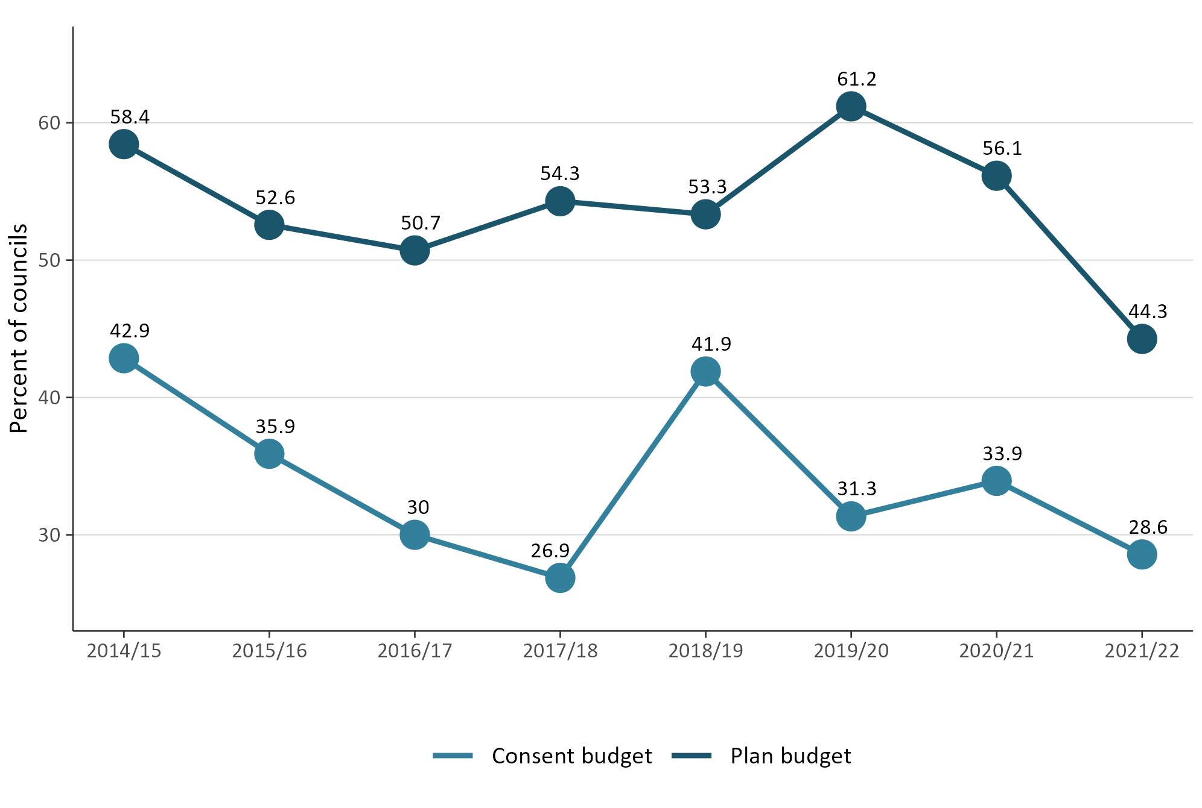

The number of new iwi management plans or iwi planning documents endorsed continues to be low
Iwi management plans describe resource management issues of importance to tangata whenua. Iwi management plans can also be used to express values relating to specific areas, natural resources or taonga. They provide guidance for interactions between councils and iwi/hapū, as well as direction on decision-making and information requests. An IMP can help improve understanding of specific values and interests for tangata whenua.
Figure 15 shows that, in 2021/22, the number of new iwi management plans endorsed by iwi authorities and lodged with councils remained low.
Figure 15: Number of new iwi management plans endorsed by iwi authorities and lodged
with councils
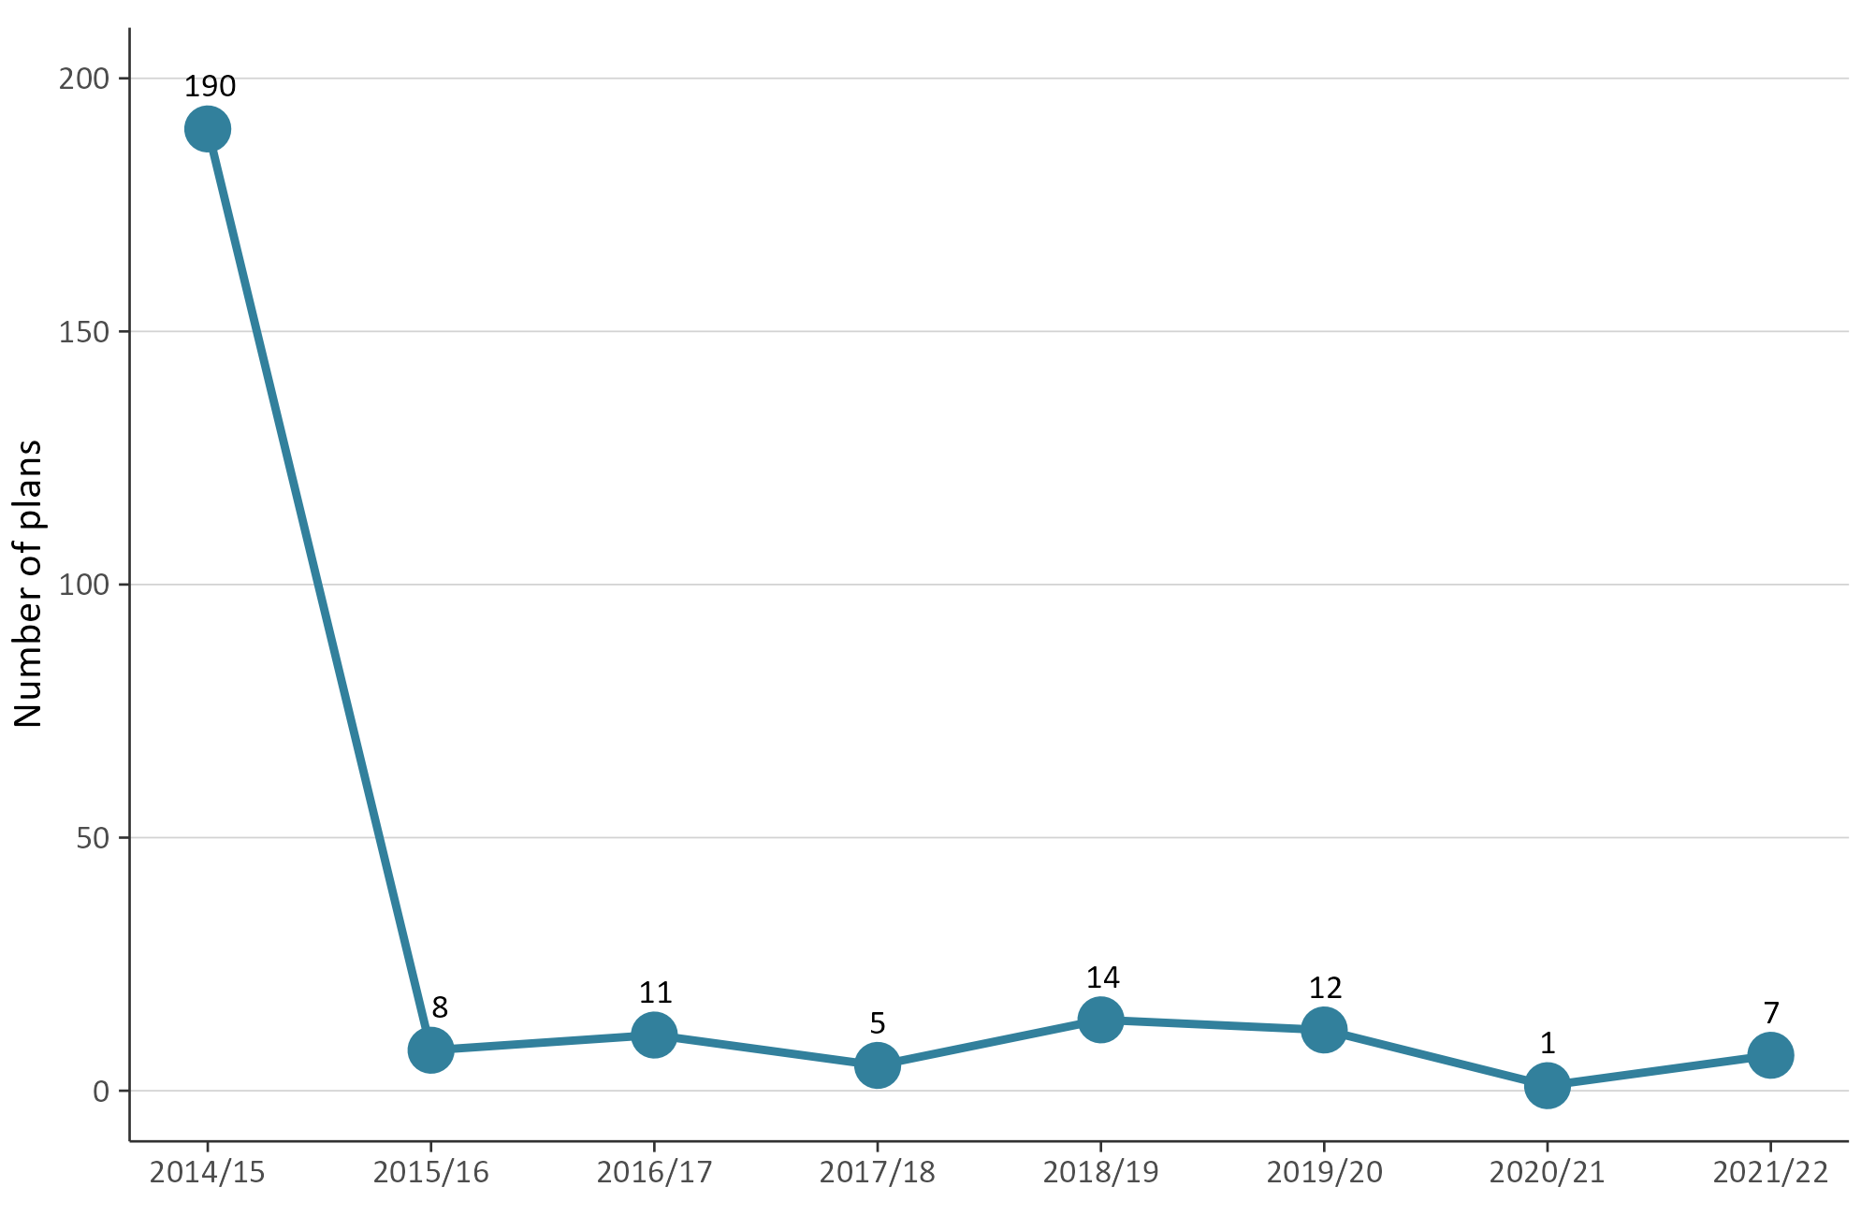
Note: Iwi management plans lodged with more than one council are counted separately.

Compliance monitoring and enforcement
Under the RMA, councils have a responsibility to monitor a range of matters as part of their compliance monitoring and enforcement (CME) duties. CME functions enable councils to:
- ensure the efficiency, effectiveness and enforcement of policy statements and plans
- monitor and enforce the exercising of resource consents and resource management plans
- ensure people and companies are delivering the environmental outcomes supported by councils.
CME is an important part of councils fulfilling their statutory functions to demonstrate that their objectives, policies and methods are meeting the purpose of the RMA. The amount of active CME work varies between councils, depending on the number of consents they have and the local environmental context.
Councils can use different types of enforcement tools under the RMA, from issuing abatement notices or seeking enforcement orders, through to issuing infringement notices or taking prosecutions.

There was variation in which councils took enforcement action
Enforcement action taken by unitary authorities in 2021/22 increased, compared to previous years of 2020/21 and 2019/20.
Figure 16 illustrates that, since 2016/17, the number of enforcement actions reported by regional councils and territorial authorities (district and city councils) has remained generally consistent, with a slight decrease for regional councils in 2021/22 and a further increase for territorial authorities.
Figure 16: Number of enforcement actions taken by councils (by council type)
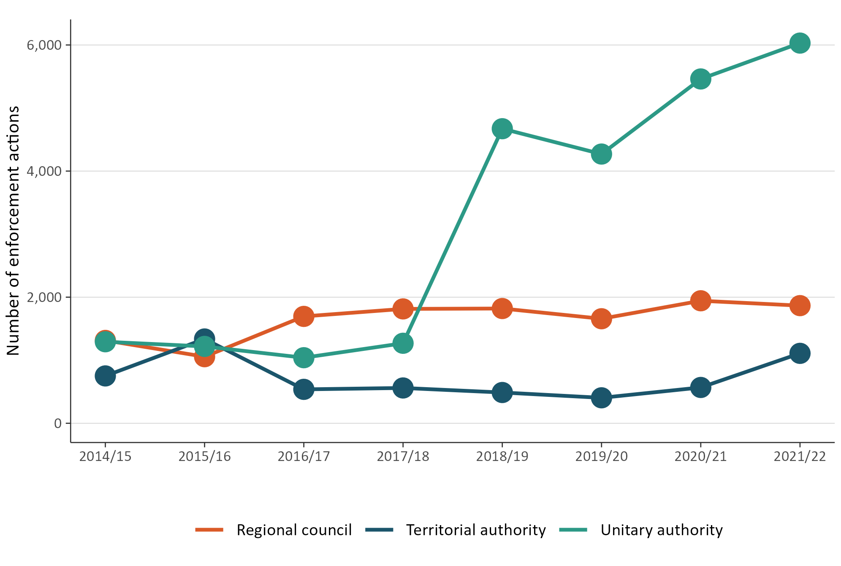

Councils had a small increase in the number of monitoring and enforcement staff
Full-time Equivalents (FTEs) is a measure of the number of employees working in the different areas of consenting monitoring and enforcement and plan-making at councils. Since 2014/15, consenting staff FTEs have remained higher than those measured in plan-making and CME (see figure 17).
The 2021/22 data showed an overall increase in FTEs for councils. Although FTEs for consenting staff remained consistent compared with previous data from 2020/21, FTEs for monitoring and enforcement slightly increased. FTEs for planning policy staff also increased slightly, compared with 2020/21.
Figure 17: Number of FTE council staff for consenting, monitoring and enforcement, and planning
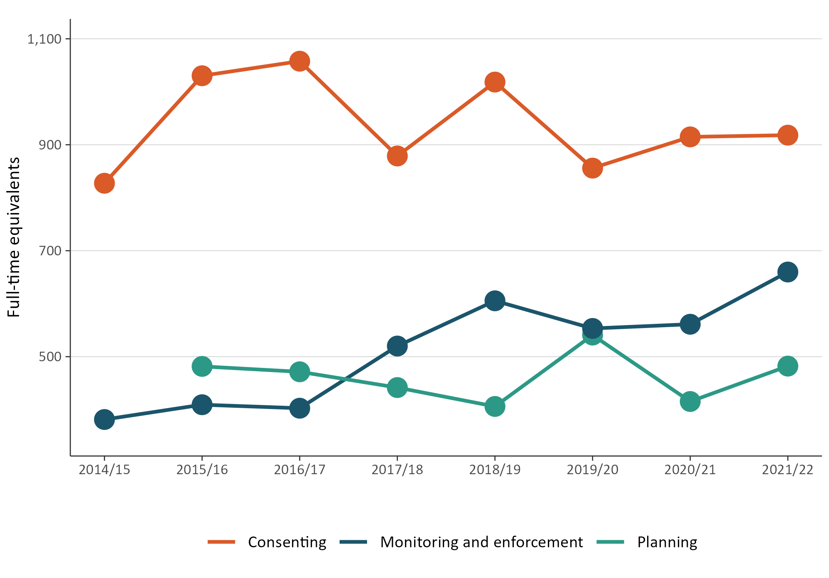

Figure 18 shows councils employed their highest number of FTEs in the resource management field since 2014/15 (the data combined consenting, monitoring and enforcement, and planning policy staff).
Figure 18: Total FTEs working on resource management at councils
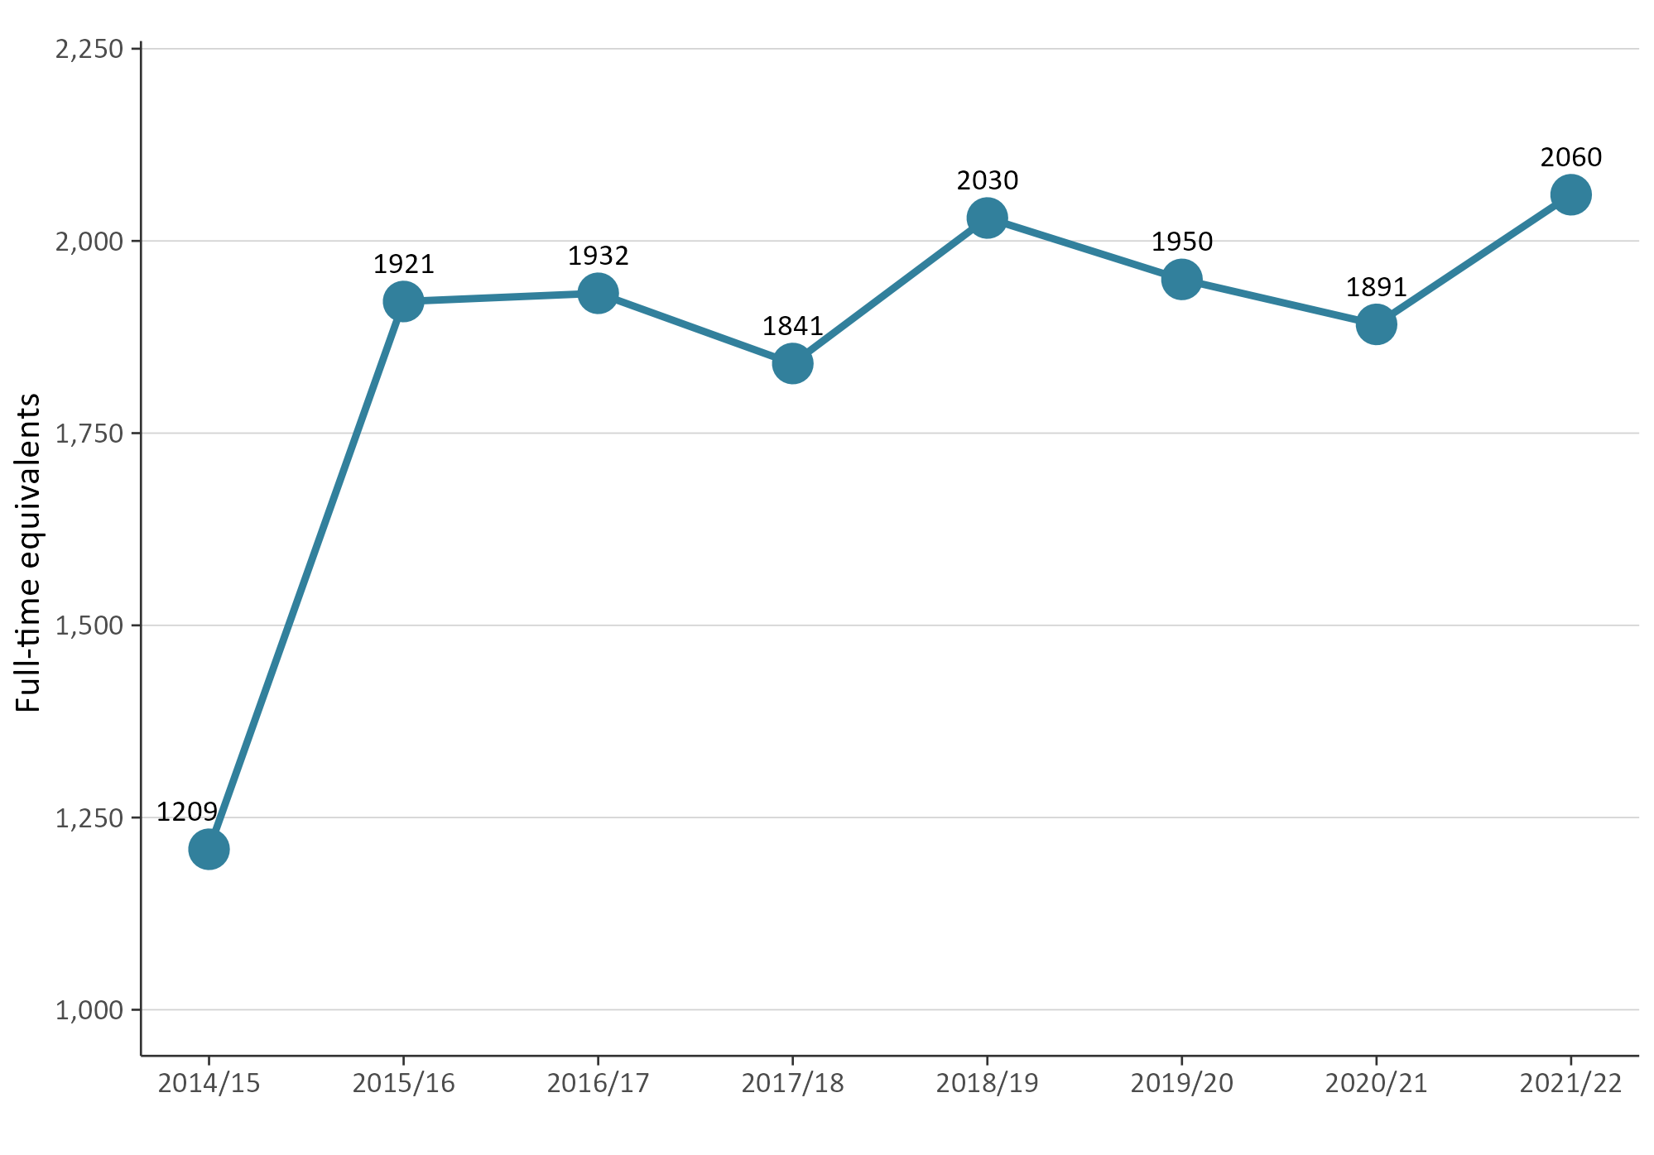
Note: FTE data records the number of staff employed and does not include vacancies.

The RMA uses the term ‘local authorities’. In this report we have used ‘councils’ to refer to all local authorities – that is, district and city councils, regional councils and unitary authorities.
For the 2021/22 national data set, one council (Ōtorohanga District Council) did not provide survey data. Kapiti Coast District Council, and Rotorua Lakes Council provided incomplete data.

