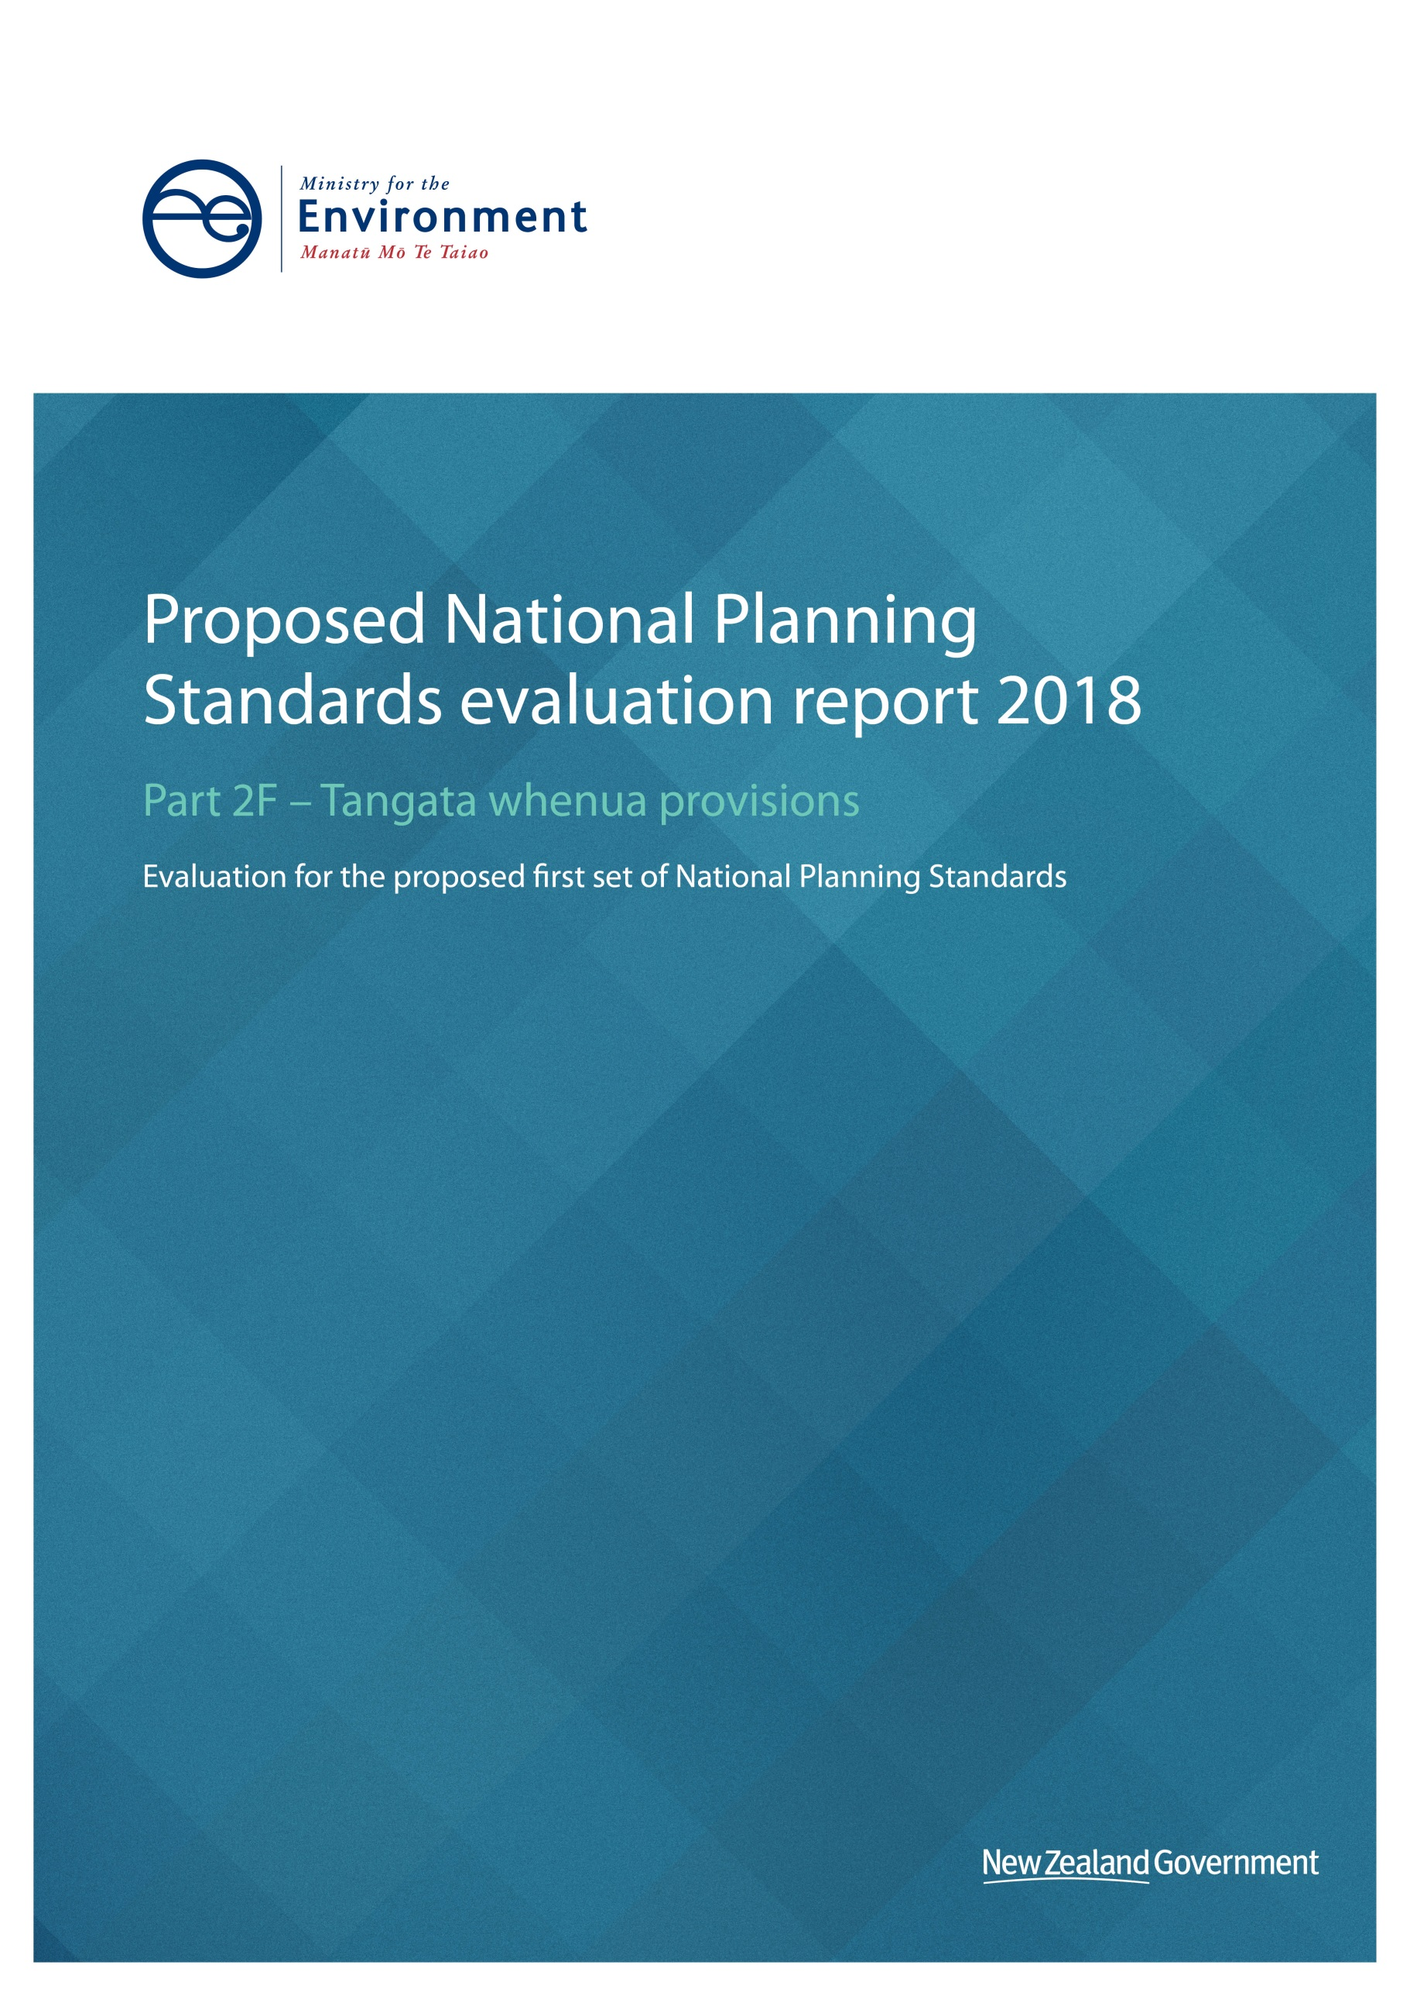

This document may be cited as: Ministry for the Environment. 2018. Proposed National Planning Standards evaluation report 2018: Part 2F – Tangata whenua provisions. Wellington: Ministry for the Environment.

Published in June 2018 by the
Ministry for the Environment
Manatū Mō Te Taiao
PO Box 10362, Wellington 6143, New Zealand
ISBN: 978-1-98-852558-7 (online)
Publication number: ME 1361
© Crown copyright New Zealand 2018
This document is available on the Ministry for the Environment website: www.mfe.govt.nz.
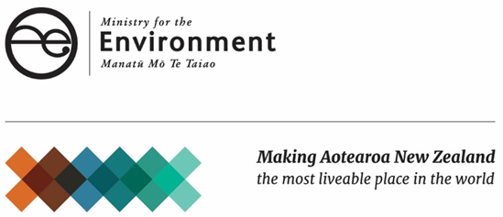

Context to this document
This document forms part of the Evaluation Report for the Proposed National Planning Standards. This document should be read in conjunction with the other documents that make up the report as a whole. The Evaluation Report for the Proposed National Planning Standards report is set out as follows:

Part 1 – Overall assessment
Part 2 – Individual standard assessments
Part 2A Plan and policy statement structure and format
Part 2B Spatial planning tools and zone framework
Part 2C Definitions
Part 2D Noise and vibration metrics
Part 2E Electronic functionality and accessibility and mapping
Part 2F Tangata whenua provisions
Part 3 – Implementation

Contents
Context to this document 3
Contents 4
1 Introduction 5
1.1 Māori resource management perspective 5
1.2 Recognition of Māori resource management 5
2 Statutory context 7
2.1 Section 6, 7 and 8 7
2.2 Section 58G 7
2.3 Section 18A 7
3 National instruments 8
4 National guidance documents 9
5 Research and practice that informed the development of these components 10
5.1 Plan review 10
5.2 Advice from practitioners 10
6 Initial approach to tangata whenua components 11
7 Consultation on these components 12
8 Summary of the issues analysis 14
9 Amendments to the standard as a result of consultation 15
10 Quantification of benefits and costs 17
11 Cost and benefit assessment 18
12 Risk of acting/not acting if there is uncertain or insufficient information about the subject matter of the provisions 19
13 Conclusion/summary of rationale for the preferred option 20

Introduction
Tangata whenua components are included in several National Planning Standards (planning standards or standards. These planning standards are assessed under separated sections of this report. These sections are:
- 2A.1 District plan, regional plan and regional policy statement structure and format standards 2A
- 2A.2 Zones framework and spatial planning tools
- 2B.1 Definitions
- 2C Electronic functionality and accessibility, and mapping
The tangata whenua components of these planning standards were formed through a distinct consultation process. This section addresses the formation of standards. However as the scale and significance of these components alone does not necessitate a review of the options of each component, the assessment of the costs and benefits of these components is incorporated in the relevant sections outlined above. The tangata whenua standards discussed in this evaluation report have become draft planning standard S-TW Part 2 Tangata Whenua Part Structure National Planning Standard.

Māori resource management perspective
Māori have a long history of connection with the environment, which is reflected in knowledge, values and world views. The rohe and tūrangawaewae of iwi, hapū and whānau established through ongoing settlement in specific geographical locations has meant that particular views, values and mātauranga have developed about those places. There are, however, common elements that underlie a collective Māori view of the environment. For example, whakapapa is central to a Māori world view and provides for relationships with the natural environment. Māori believe the interrelationship and connection between humans and the environment makes up a whole ecological and spiritual system, to be carefully sustained for current and future generations.

Recognition of Māori resource management
Part 2 of the Resource Management Act 1991 (RMA) confirms and acknowledges the role of Māori in resource management. Sections 6(e), 6(f) and 6(g) require that “the relationship of Māori and their culture and traditions with their ancestral lands, water, sites, wāhi tapu, and other taonga”, “the protection of historic heritage from inappropriate subdivision, use and development” and “the protection of protected customary rights” are recognised and provided for. Section 7(a) requires that particular regard is given to kaitiakitanga, and section 8 requires that the principles of the Treaty of Waitangi are taken into account. The approach to interpreting Māori values and concepts is important for the effective consideration of these matters in RMA decision-making.
There are complex and wide-ranging reasons for why a district or regional plan or policy statement may approach tangata whenua issues in a particular manner. The complexity of individual iwi–council relationships and local issues has a significant impact on how each district and region addresses certain topics. Furthermore, the particular views developed by iwi, hapū and whanau as a result of ongoing settlement in specific geographical locations means that different approaches to environmental management exist.
Iwi and hapū all over Aotearoa/New Zealand have their own ways of planning for and managing the environment that are steeped in generations of wisdom, knowledge and practical implementation. Therefore, a Māori planning and resource management perspective may not necessarily fit the confines of a local authority plan or a national planning standard.

Statutory context

Section 6, 7 and 8
Sections 6(e), 7(a), 7(aa) and 8 are relevant to this topic. The tangata whenua standards provide a place to include information on how these sections have been taken into account in plans.

Section 58G
Section 58G states that the first set of national planning standards must include certain elements, which are considered as minimum requirements. These are:
- a structure and form for policy statements and plans, including references to relevant national policy statements, national environmental standards, and regulations made under this Act; and
- definitions; and
- requirements for the electronic functionality and accessibility of policy statements and plans.
Tangata whenua provisions are a common part of the structure and form of plans, accordingly this gives effect to section 58G(a).

Section 18A
Section 18A of the RMA states procedural principles. The principles in this section set out how people exercising powers and functions under the RMA must act. The tangata whenua standards help assist councils achieve some of the requirements of this section, as set out in table 1.
Table 1: How the tangata whenua standards assist councils in meeting section 18A procedural principles
Section Number | Provision | How these standards assist local authorities
18A(a) | (a) use timely, efficient, consistent, and cost-effective processes that are proportionate to the functions or powers being performed or exercised | These standards will mean fewer resources may be required when considering the approach for tangata whenua provisions in plans.
18A(b)(ii) | (b) ensure that policy statements and plans—  (ii) are worded in a way that is clear and concise; and | Standards for tangata whenua provisions are intended to assist with making plans clear and concise by providing a consistent location for this information and guidance on content.
18A(c) | (c) promote collaboration between or among local authorities on their common resource management issues. | Standard sections may help to enable councils to share best practice on the inclusion of tangata whenua in plans and planning processes, promoting collaboration.

National instruments
There are five National Policy Statements (NPSs) currently in effect. The instrument(s) and associated provisions relevant to this standard are:
Table 2: Relevant national instruments
NPS | Relevant objectives/policies | How standards give effect
National Policy Statement for Freshwater Management 2014 (amended 2017)  New Zealand Coastal Policy Statement 2010 | AA. Te Mana o te Wai | The district plan, regional plan and regional policy statement standards provide a location for councils to outline consultation with tangata whenua undertaken to administer the plan, and tangata whenua consultation requirements and processes.  Planning concepts from mātauranga Māori can continue to be used under the standards. This includes the use of mātauranga Māori in freshwater management units.  A place is provided to outline how the plan has taken into account RMA section 6(e), relationships of Māori with the environment, section 7(a), recognition of kaitiakitanga and section 8, taking into account the principles of the Treaty of Waitangi.
There are also six national environmental standards (NESs) currently in effect. There are no NESs directly relevant to this topic.

National guidance documents
The following national guidance documents are considered relevant to this topic:
Table 3: Relevant national guidance documents
Document | Relevant section | Relevance
Quality Planning website | Plan components, consultation with tangata whenua, consent support, FAQs about iwi management plans, FAQs on cultural impact assessments | Quality Planning provides advice on best practice for RMA processes. A link to best practice processes may be included in the consultation and engagement with tangata whenua section.
Wellington International Airport Ltd vs Air NZ [1991] 1 NZLR 671 (Court of Appeal) | Consultation | The Wellington International Airport Ltd vs Air NZ [1991] 1 NZLR 671 decisions outlines best practice consultation processes. A link to best practice processes may be included in the consultation and engagement with tangata whenua section.  The planning standards give effect to this advice by incorporating references to the need to develop plans in consultation with tangata whenua.

Research and practice that informed the development of these components

Plan review
In 2016 and 2017, the Ministry for the Environment reviewed the tangata whenua provisions in all district plans and selected regional planning documents. Topics included:
- iwi and hapū planning documents
- statutory acknowledgements
- Resource Management Act 1991 (RMA) and Treaty of Waitangi principles
- tangata whenua-council relationships
- consultation
- tangata whenua provisions sections
- te reo terms in definitions or glossary sections
- Māori land/development areas
- sites of significance, customary marine titles and protected rights areas.
This review identified variation in the location, structure and content of tangata whenua planning topics, as outlined in the Tangata Whenua Provisions in Resource Management Plans research paper.
An example of variation includes where iwi and hapū planning documents are referenced in district plans. A number of councils acknowledge iwi and hapū planning documents in specific iwi sections, while others address them in strategic and introductory sections. Similarly, some plans refer to statutory acknowledgements in the introduction, some attach them as an appendix or on maps, and others place them in tangata whenua sections. This inconsistency makes it difficult to identify tangata whenua provisions in plans, affecting their effectiveness.
In addition, tangata whenua provisions are often incorporated inconsistently into plans, which can lessen recognition of Māori interests in resource management and planning.
Tangata whenua engagement and representation in planning processes is also varied. Variation can result from iwi, hapū and geographic differences. However, it can also result from lack of engagement or understanding of the inclusion and implementation of tangata whenua values and perspectives. Setting out where and how to include tangata whenua provisions in plans provides an opportunity to direct authorities to engage in discussions and collaborations with tangata whenua and incorporate tangata whenua perspectives.

Advice from practitioners
In 2017, the Minister for the Environment also tested ideas that came out of the above research with a Māori Advisory Group, consisting of eight Māori planning practitioners with a range of planning experience. The practitioners provided feedback on the scope of standards and the draft standards themselves.

Initial approach to tangata whenua components
We are proposing that tangata whenua components are included as part of the plan structure standards for all plans (considered in part 2A of this report). The tangata whenua standards are largely grouped together in:
- Part 1 General provisions for district plan structure
- Part 2 District-wide matters, for regional plans and regional policy statements.
Sections in these parts include:
- an explanation of local iwi/hapū identification of iwi authorities and values
- tangata whenua–local authority relationships, cultural impact assessments and monitoring
- engagement with tangata whenua, RMA requirements, best practice
- recognition of iwi and hapū planning documents
- statutory acknowledgements.
A place is also provided for a te reo Māori glossary in the interpretation section of all plans. The purpose and context of the plan and principal/strategic objectives and policies sections recognize sections 6(e), 7(a) and 8 of the RMA, and the Treaty of Waitangi.
A cultural purpose zone, overlay and mapping tools for sites of significance are also included as part of the tangata whenua standards.

Consultation on these components
The Ministry for the Environment consulted the government’s Iwi Advisory Group on the approach to developing planning standards. This resulted in the establishment of a Māori Advisory Group (MAG), including planners with experience in this area of planning. The MAG have provided advice on draft standards, engagement and a consultation document. Pilot councils, the practitioners’ drafting group and Te Puni Kokiri have also provided feedback on draft standards. Ngāti Ruanui have represented the Iwi Advisory Group and provided an iwi perspective.
The following is a summary of the primary consultation undertaken in respect of this topic:
Table 4: Consultation undertaken to date
Who | What | When | Relevant issues raised
Iwi Advisory Group – Tina Porou | Meeting to discuss approach to development of tangata whenua standards | August 2017 | - link to iwi perspective through Ngati Ruanui  - use of Maori Advisory Group.
Māori Advisory Group | Hui and written feedback on discussion document and engagement approach | August ^{t} 2017  October 2017 | - Te Tiriti and RMA sections 6, 7 and 8 based relationships important  - standards an opportunity to encourage best practice  - prominent placement of tangata whenua provisions near introduction  - use of flowcharts and outlining how to use IPD/consult  - define where terms have legal weight  - enabling zone for Māori development  - about encouraging councils to build relationships.  Draft standards –  - reflect current context eg Mana Whakahono a Rohe agreements (MWaR)  - include standard section on consultation  - statutory acknowledgement identification process good  - include customary marine titles  - provide enabling zone for Māori activities  - provide timeline of engagement and enable adequate time for responses from iwi
Te Rūnanga o Ngāti Ruanui Trust | Meeting and written feedback on draft discussion paper and standards | Initial submission period  September & October 30th | - need for incorporation of tangata whenua provisions  - align with RMA and Te Tiriti principles  - add customary marine titles  - integrate mātauranga Māori and tikanga Māori
Pilot councils | Submissions on draft discussion paper | October 2017 | - standard sections and headings useful  - avoid standard content where possible (need for local variation important)
Practitioners’ Drafting Group | Meeting and submission on draft discussion paper | October 2017 | - hyperlinks useful  - zone to enable development  - maintain flexibility with focus on headings  - interlink chapter  - link to already developed best practice
Te Puni Kokiri | Written submission | November 2017 | - hyperlinks  - integrate into plan and section  - maintain flexibility  - focus on sections and headings

Summary of the issues analysis
Based on the analysis and consultation outlined above the following issues have been identified:
Table 5: Summary of issues analysis
Issue | Comment | Response
Issue 1: To what extent tangata whenua provisions should be standardised – standardise content or structure | - standardisation has benefit of encouraging incorporation and consideration in planning processes  - however, local variation and the desire of iwi and hapū to contribute to forming provisions makes standardisation difficult. | - mandatory section with optional content and guidance on what could be included  - leave flexibility for iwi and councils to determine content.
Issue 2: Where to locate tangata whenua provisions in plans | - placing upfront in single section draws attention throughout plan  - however, integration ensures incorporation throughout plan/planning. | Place upfront in Purpose and Context of plan, tangata whenua and strategic direction section; a section but also incorporated throughout.
Issue 3: Use of te reo Māori in plans | - local variation makes it difficult to standardise  - option to place words in glossary or definition sections. | - Optional translation  - Inclusion in both glossary and definition section
Issue 4: Tools to identify and protect sites of significance in plans | Options depending on level of protection desired and type of site to be protected. | Provision of zone and overlay and use of mapping symbols.

Amendments to the standard as a result of consultation
Table 6: Amendments to standard as a result of consultation
Component | Why
Tangata whenua provisions integration | Throughout consultation, there was a general consensus that a section for tangata whenua provisions would be valuable for placing these clearly and upfront for consideration throughout the plan. This was especially the case for process-based provisions such as consultation and use of iwi planning documents. This was the approach originally intended.  Stakeholders emphasised the importance of linking provisions throughout the plan, so that they are considered appropriate and consistently referenced by plan users. This was especially the case for outcome-based provisions, eg consultation practices. This led to a focus on integration of standards throughout the plans and the placement of some provisions in the Purpose and Context of the plan, and Principal/Strategic Objectives and Policies sections. Stakeholders also reinforced a need to enable flexibility with iwi and councils for the development of plan content. Standards were written at a high level as a result, with a focus on guidance, policies and objectives.
RMA and Treaty of Waitangi (Te Tiriti o Waitangi) Principles | Stakeholders emphasised a desire for aligning standards with Te Tiriti o Waitangi partnership and principles and RMA sections 6(e), 7(a) and 8. Stakeholders reinforced the need to place RMA and Treaty of Waitangi principles upfront, so that they would be considered throughout the plan and provide a basis for iwi and councils to develop relationships. This approach was adopted.
Explanation of iwi and hapū section | A focus on explaining environmental relationships and perspectives was maintained, as a result of support for this by stakeholders.
Council relationships | An approach of explaining council relationships in a tangata whenua section was maintained. Consultation with stakeholders led to an emphasis on making provisions flexible, to encourage iwi and council to discuss them as a way of forming relationships. Recent tools such as Mana Whakahono a Rohe agreements are reflected in the standard.
Consultation and engagement | Stakeholders placed a strong emphasis on using planning standards as a way to reinforce the need and processes for consultation and engagement with tangata whenua. A mandatory approach to the inclusion of these standards in plans was adopted as a result. Advice to include a link to current best practice was also included as a result of emphasis placed on this.
Iwi planning documents | Consultation reinforced a desire to reference iwi plans via hyperlinks, rather than include specific provisions. A suggestion for councils to include guidance on the use of iwi planning documents is included as part of the guidance section.
Statutory acknowledgements  Sites of significance and customary marine titles | Consultation reinforced a desire to reference statutory acknowledgements via hyperlinks in text, rather than include explanations or legislation in provisions.  Stakeholders emphasised a desire for councils to address how sites of significance were identified. A suggestion to include content on this in Planning Standards guidance was included in response.
Māori land and development –cultural purpose zone | The ability to apply this zone to land other than land owned by Māori and to land where Māori development is taking place was maintained as a result of consultation. Emphasis was also placed on maintaining provisions that enable cultural activities in the zone framework.
Use of te reo Māori | An original proposition by the Ministry for the Environment was to explore translating aspects of plans into te reo. Stakeholders emphasised the difficulty of this because of variation in dialects, leading to an adoption of an approach of optional translation of sections.  The approach of including te reo words with definitions where they have legal weight and defining others in a glossary section was maintained.
Mapping symbols | Sites of significance and statutory acknowledgements symbols were maintained, with identification of type of site of significance in a schedule. A symbol for customary marine title and protected customary rights is also proposed.

Quantification of benefits and costs
Section 32(2)(b) of the Resource Management Act 1991 (RMA) requires that, where practicable, the benefits and costs of a proposal are to be quantified. Given the assessment that the scale and significance of the proposed National Planning Standards (planning standards, or standards) is high, a cost-benefit analysis of the planning standards was commissioned by the Ministry for the Environment.
The Castalia report combined structure and format together with tangata whenua standards, so there is no specific cost-benefit ratio (CBR) for these provisions alone. Assuming an implementation period of five years, the report concluded that the BCR for all National Planning Standards would be 1.53. The standards in the structure and form category returned a BCR of 1.76. The economic evaluation is available on the Ministry for the Environment website.

Cost and benefit assessment
The costs and benefits of the tangata whenua components of the planning standards are addressed in the assessment of the other standards that they relate to. As noted in the introduction these are:
- 2A.1 District plan, regional plan and regional policy statement structure and format standards 2A
- 2A.2 Zones framework and spatial planning tools
- 2B.1 Definitions
- 2C Electronic functionality and accessibility, and mapping.

Risk of acting/not acting if there is uncertain or insufficient information about the subject matter of the provisions
It is considered that there is certain and sufficient information on which to base the proposed standard as:
- an extensive amount of research has been undertaken in the development of the national planning standards, including specific research into tangata whenua planning provisions across all district and a selection of regional plans by the Ministry in 2017
- the proposed standards are the result of consultation with a Māori Advisory Group, consisting of eight practitioners with experience in tangata whenua planning from a wide variety of backgrounds
- Proposed standards were also tested with pilot councils and the Practitioners’ Drafting Group
- the planning standards have been informed by cost-benefit analysis results from Castalia report
- the standards have been tested for their suitability with tangata whenua provisions in the RMA and principles from the Treaty of Waitangi.
There are uncertainties around how the standards will be implemented in a consistent manner by councils and used by iwi authorities. This will be addressed by supporting iwi and councils with comprehensive implementation guidance.

Conclusion/summary of rationale for the preferred option
This evaluation has been undertaken in accordance with Section 32 of the RMA in order to identify the need, benefits and costs and the appropriateness of the proposal having regard to its effectiveness and efficiency relative to other means of achieving the purpose of the RMA. The evaluation demonstrates that this proposal is the most appropriate option to achieve planning standards objectives as it:
- provides consistency in the structure and some content of tangata whenua planning provisions, making tangata whenua standards easier to identify and incorporate in plans
- reduces the resources required to develop tangata whenua provisions, increasing the likelihood that they are incorporated into plans and the capacity of councils to focus on including best practice
- maintains flexibility for content to reflect and achieve local outcomes, enabling locally specific tangata whenua aspirations to be expressed
- improves best practice and environmental outcomes by addressing and integrating tangata whenua provisions in plans.

Castalia. 2018. Economic Evaluation of the Introduction of the National Planning Standards. Prepared for the Ministry for the Environment. Wellington: Ministry for the Environment

