Ngā mana tāpui whenua i raro i te Ture Taiao Tūturu me te Hanga
Requiring authorities under the Natural and Built Environment Act
The new resource management system:
Natural and Built Environment Act 2023
and Spatial Planning Act 2023

New laws are being phased in that aim to help Aotearoa New Zealand protect and manage the environment and its resources. The Spatial Planning Act 2023 (SPA) and the Natural and Built Environment Act 2023 (NBA) were enacted on 23 August 2023.
The NBA contains provisions relating to requiring authorities that will take effect from November 2023.
A requiring authority is a person or entity that can require land to be set aside (designated) for a public purpose such as a hospital, school or network.
The NBA:
- adds council-controlled organisations as requiring authorities
- enables more network utility operators to apply to be requiring authorities
- enables ‘other applicants’ to apply to be requiring authorities.
Until November 2023, the requiring authority provisions in the Resource Management Act 1991 (RMA) will continue to be in effect.

This factsheet covers:
- who can be a requiring authority under the NBA from three months after the date of Royal assent
- criteria for approval as a requiring authority.

Who can be a requiring authority under the NBA from November 2023
Ministers of the Crown, local authorities and council-controlled organisations are automatically requiring authorities under the NBA.
Network utility operators listed in the NBA can apply for requiring authority status.
The NBA adds the following network utility operators to the list of those who can apply:
- emergency service providers
- the landward part of port operations and inland ports operated under the Port Companies Act 1988.
Note that while some port operations can apply for requiring authority status, designations do not apply to the coastal marine area.
Other applicants can also apply to be a requiring authority providing they meet certain criteria.

Criteria for approval as a requiring authority
Network utility operators and ‘other applicants’ may apply to the Minister for the Environment for requiring authority status.
The Minister can make any inquiries, impose any conditions, and request any information necessary to help their consideration. The Minister may only approve an applicant as a requiring authority for the purposes of a particular project or work or a particular network utility operation.
The Minister must be satisfied that the applicant is appropriate for the purposes of carrying out the work and is likely to satisfactorily carry out all the responsibilities (including financial responsibilities) of a requiring authority. This includes giving proper regard to the interests of those affected and to the interests of the environment.
There are additional tests for ‘other applicants’ seeking requiring authority status. The Minister must not approve other applicants as a requiring authority unless the Minister is satisfied that all the following criteria are met:
- the project or work provides a significant and identifiable public benefit necessary for the functioning of the economy, the health and safety of people, or the protection of the environment
- the public benefit is for the general public or a sufficient section of the public
- there are limited options for locating the project or work due to operational requirements or the project or work responds to a defined need in a specific location
- the size and scale of the project or work is such that approval as a requiring authority is appropriate
- the project or work is not a commercial retail activity or a facility to support a commercial retail activity; however, if the project or work has a significant and identifiable public benefit it is not precluded just because the operator charges a fee for access or obtains a commercial benefit from it.
The Minster may also consider other relevant matters including whether the project would be more appropriately progressed using a plan change process or resource consent, rather than a designation.
Once approved as requiring authorities “other applicants” can apply for notices of requirement and have powers to compulsorily purchase land. The Minister has the power to revoke requiring authority status in certain circumstances.

Legal references
Network utility operators who can apply for requiring authority status | NBA Part 1, section 11
Minister’s consideration and criteria for requiring authority status | NBA sections 513 and 514
Minister’s power to revoke requiring authority status | NBA section 516

Disclaimer
The information in this publication is, according to the Ministry for the Environment’s best efforts, accurate at the time of publication. The Ministry will make every reasonable effort to keep it current and accurate. However, users of this publication are advised that:
- The information provided has no official status and so does not alter the laws of New Zealand, other official guidelines or requirements.
- It does not constitute legal advice, and users should take specific advice from qualified professionals before taking any action as a result of information obtained from this publication.
- The Ministry for the Environment does not accept any responsibility or liability whatsoever whether in contract, tort, equity or otherwise for any action taken as a result of reading, or reliance placed on this publication because of having read any part, or all, of the information in this publication or for any error, or inadequacy, deficiency, flaw in or omission from the information provided in this publication.
- All references to websites, organisations or people not within the Ministry for the Environment are provided for convenience only and should not be taken as endorsement of those websites or information contained in those websites nor of organisations or people referred to.

Published in August 2023 by the  Ministry for the Environment – Manatū Mō Te Taiao  Publication number: INFO 1171 | 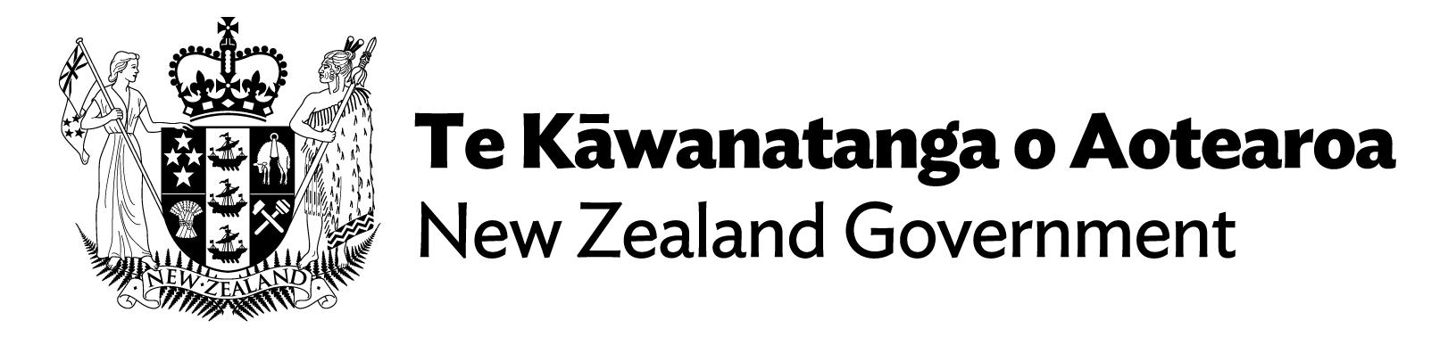

Section 513 of the NBA.
Sections 514(1)–(3) of the NBA.
Section 514(4) of the NBA.
Section 514(6) of the NBA.
Section 514(8) of the NBA.

