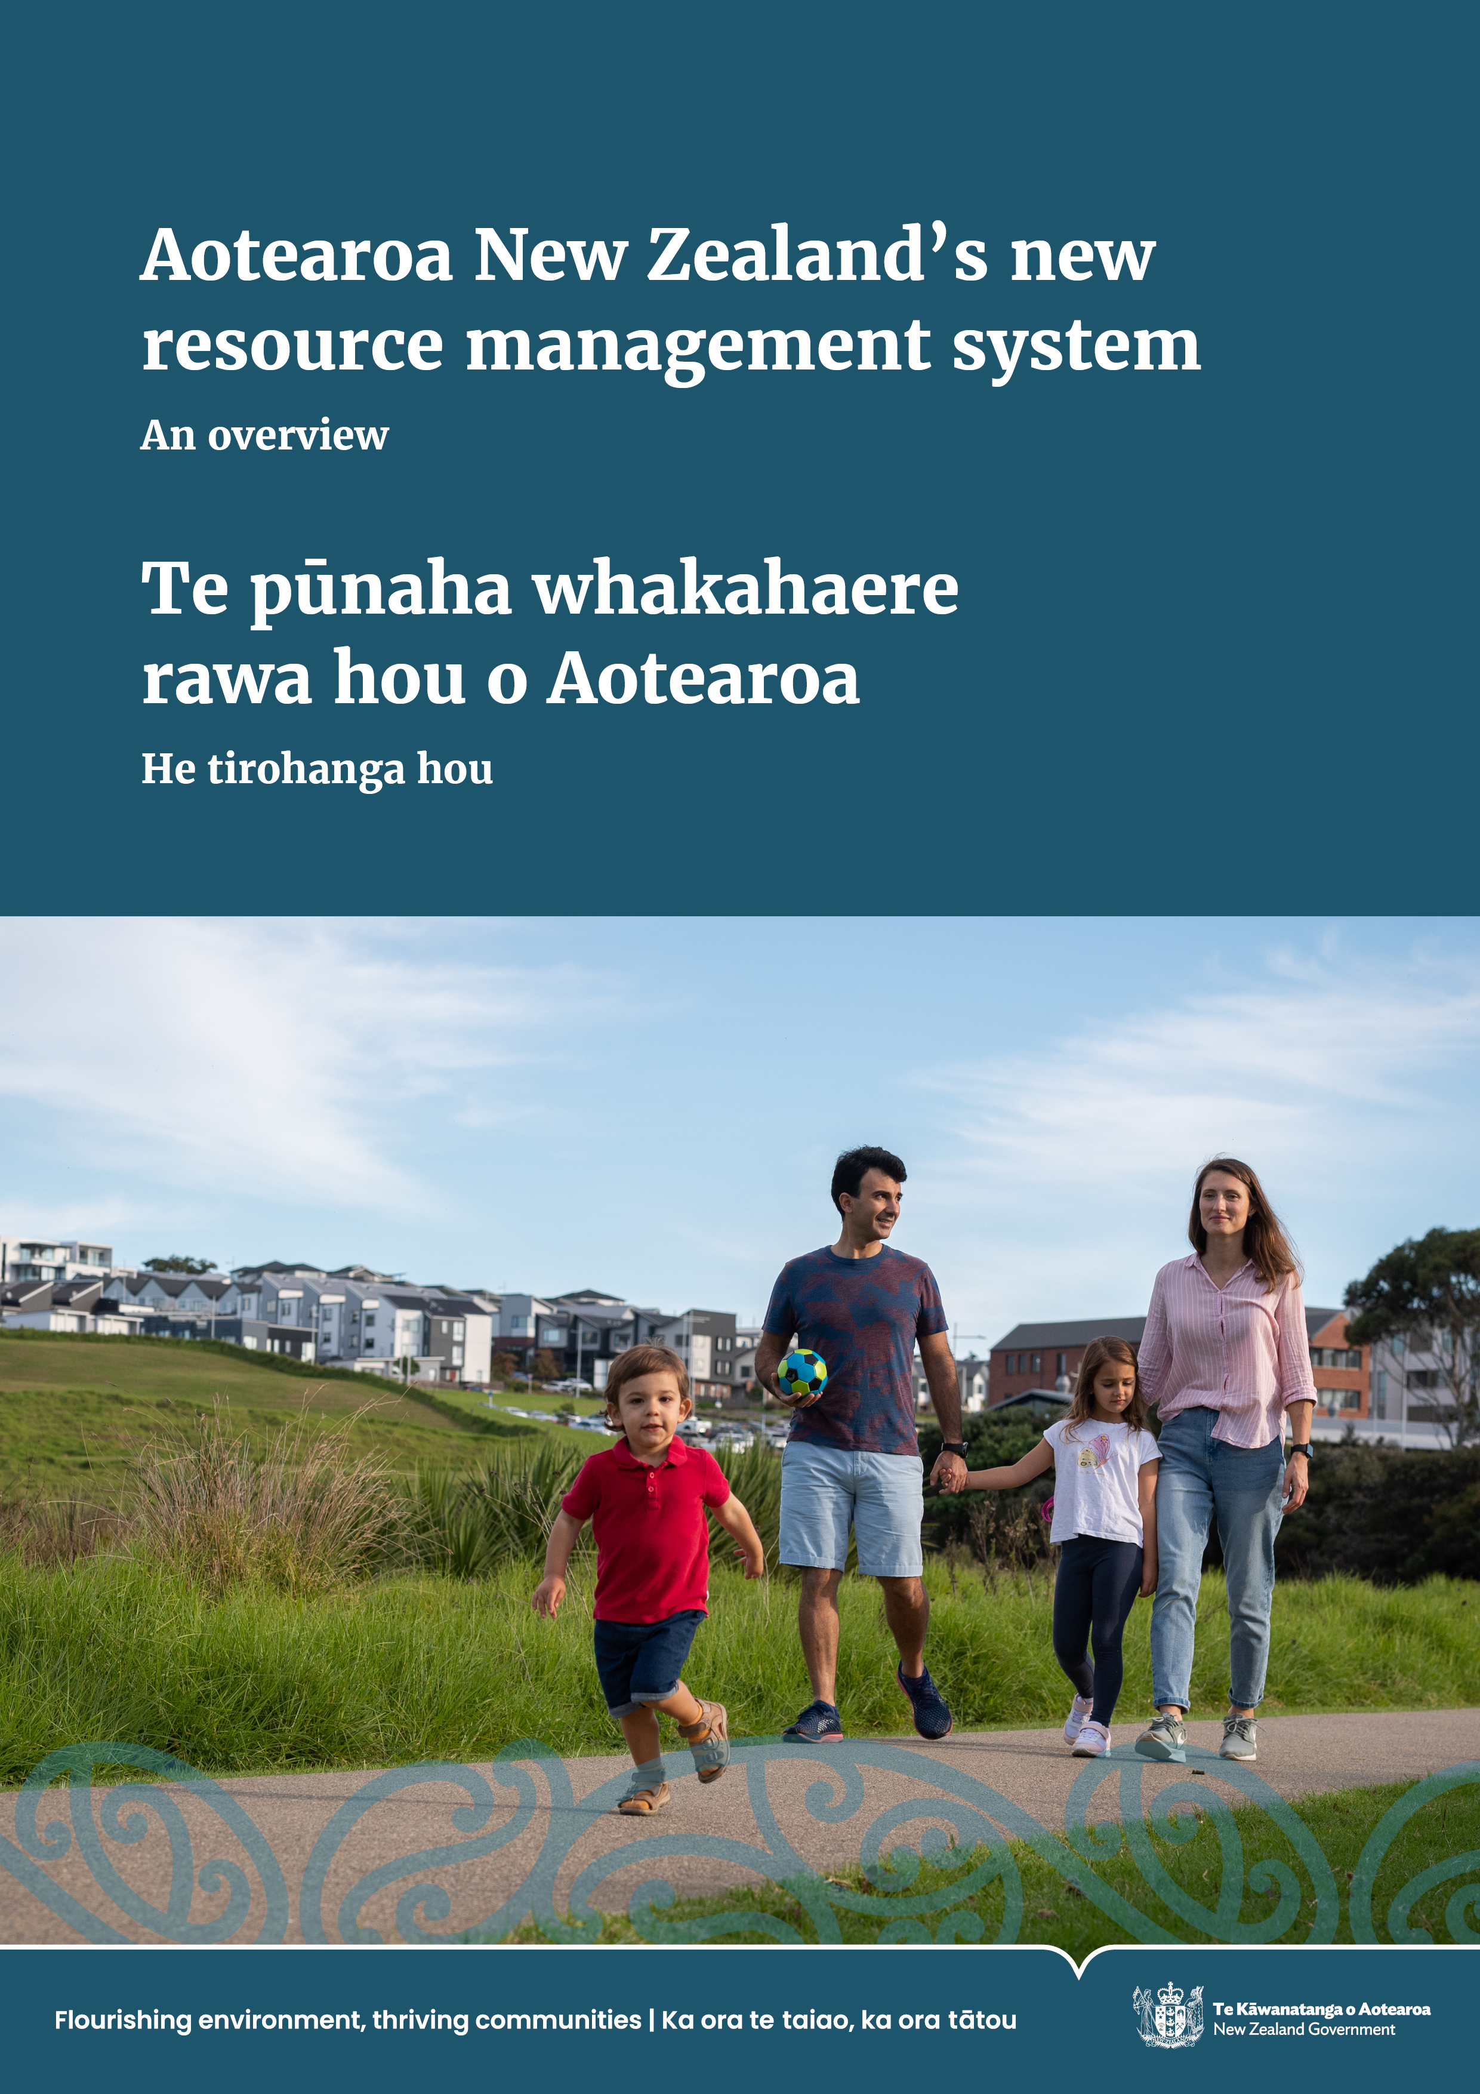
Aotearoa New Zealand’s new resource management system: An overview | Te pūnaha whakahaere rawa hou o Aotearoa: He tirohanga hou
NOTICE
The Natural and Built Environment Act 2023 and Spatial Planning Act 2023 were repealed in December 2023. These Acts’ provisions
do not apply.
This publication can be accessed for research purposes only.

Disclaimer
The information in this publication is, according to the Ministry for the Environment’s best efforts, accurate at the time of publication. The Ministry will make every reasonable effort to keep it current and accurate. However, users of this publication are advised that:
- The information does not alter the laws of New Zealand, other official guidelines or requirements.
- It does not constitute legal advice, and users should take specific advice from qualified professionals before taking any action based on information in this publication.
- The Ministry does not accept any responsibility or liability whatsoever whether in contract, tort, equity or otherwise for any action taken as a result of reading, or reliance placed on this publication because of having read any part, or all, of the information in this publication, or for any error, or inadequacy, deficiency, flaw in or omission from the information in this publication.
- All references to websites, organisations or people not within the Ministry are for convenience only and should not be taken as endorsement of those websites or information contained in those websites, nor of organisations or people referred to.

This document may be cited as: Ministry for the Environment. 2023. Aotearoa New Zealand’s new resource management system: An overview | Te pūnaha whakahaere rawa hou o Aotearoa: He tirohanga hou. Wellington: Ministry for the Environment.

Published in August 2023 by the
Ministry for the Environment
Manatū mō te Taiao
PO Box 10362, Wellington 6143, New Zealand
environment.govt.nz
ISBN: 978-1-991077-70-7 (print)
978-1-991077-75-2 (online)
Publication number: ME 1786
© Crown copyright New Zealand 2023

Contents
Message to readers 5
About this document 7
Structure of our new resource management system 7
Purpose of this document 7
Structure of this document 8
Part one: Resource management system reform context 9
The need for reform 10
Timeline of resource management reform 10
Policy development 12
Overview of the new resource management system 17
Next steps 20
Part two: Components of the new resource management system 23
Key components of the new resource management system 24
Spatial Planning Act 25
Natural and Built Environment Act 26
National Planning Framework 29
Environmental limits and targets 31
Strategies and plans 34
A new consenting regime 43
Designations 45
Allocation of resources 46
Aquaculture management 48
Compliance and enforcement 50
Monitoring requirements 51
Decision-making in the new system 53
Roles and responsibilities 54
Part three: Transitioning to the new resource management system 61
Overview and objectives 62
Legislated timing and processes 62
Transitioning to the new system 66
Support for a successful transition and implementation 69
Appendix 1: List of abbreviations 71
Appendix 2: Resource management reform key documents 72

Table
Table 1: Four consenting categories 44

Figures
Figure 1: Timeline of the resource management reform journey 12
Figure 2: Overview of the new resource management system 19
Figure 3: Key components of the new resource management system 25
Figure 4: Mandatory matters for environmental limits 33
Figure 5: Regional spatial strategy integration across different legislation 36
Figure 6: Regional spatial strategy development process 38
Figure 7: Natural and built environment plan development process 41
Figure 8: Overview of three pathways to change natural and built environment plans 42
Figure 9: Indicative implementation rollout sequence 64
Figure 10: Transition stages in the new system 67

Message to readers
Tēnā koutou katoa
Over the past several years the Government has been on a journey to reform Aotearoa New Zealand’s resource management system.
It has been clear for some time that the Resource Management Act 1991 is not working as well as intended. This was highlighted through a number of reports produced over the past few years. It culminated in the comprehensive review of the entire resource management system by an expert panel, commissioned by government and chaired by former Court of Appeal Judge, Hon Tony Randerson KC. The panel’s 144 recommendations provided the basis for the policy that was developed to address the environmental and developmental challenges that face us today.
The Natural and Built Environment Act and the Spatial Planning Act were passed into law on 23 August 2023. These two new laws significantly change the way our natural and built environment is managed. This important and substantial reform affects all aspects of the environment – it is legislation that affects everybody.
Clean air and water; housing; infrastructure such as roads, hospitals and schools; renewable energy; farming; and commerce – are all impacted by these laws.
The Natural and Built Environment Act sets out how the environment will be protected and used. It covers land use, along with environmental protection, water takes, and discharges and use of coastal marine areas. Natural and built environment plans will regulate the way in which a region’s resources will be managed, how environmental limits and targets will be set locally, how to enable infrastructure and development, and how to resolve conflicts between outcomes.
The Spatial Planning Act mandates that each region will develop long-term spatial strategies. It is intended that this will create a more efficient planning system that anticipates future growth and increasing risks from natural hazards and climate change. It is intended to reduce costs and better coordinate central government, local government and private sector investment. It will identify where housing and infrastructure will go, earlier in the planning cycle. This will provide certainty to local and central government, as well as to developers and infrastructure providers, and enable them to better plan and fund their investments.
The Spatial Planning Act will fill a critical gap in the current resource management system by delivering long-term spatial planning across the regions of Aotearoa. The implementation of the Spatial Planning Act will be governed and supported by the Spatial Planning Board, an interdepartmental executive board. Together with the Natural and Built Environment Act, it will deliver a resource management system that meets the needs of Aotearoa today and into the future.
The Acts provide important mechanisms for meeting Government’s objective that the reforms give effect to the principles of Te Tiriti o Waitangi, and better recognise te ao Māori including mātauranga Māori.
The new and improved roles for Māori provided for by the Acts are in addition to the roles in resource management that successive governments have agreed with iwi through Treaty settlements.
The Government is fully committed to ensuring the integrity, intent and effect of these settlements are upheld in the new system.
Implementing the new resource management system comes at a time of change. The severe weather events in early 2023 demonstrated the reality of climate change, how widespread and costly the impacts can be, and the urgency to both reduce emissions and help communities be better prepared for the future.
The events also underscored the importance of taking an integrated approach to effective resource management, climate mitigation and adaptation, and infrastructure planning to protect communities. The new legislation brings these dimensions of our wellbeing into a more future-focused framework to prepare our nation for the challenges that lie ahead.
As we turn to the implementation of the new system, I would like to acknowledge the support of our partners and many others who have worked with the Ministry for the Environment to develop the policy that underpins the new legislation. And to the many people and organisations who made submissions to the Environment Committee – we thank you for your time and effort to help make the new resource management system a reality.
Ngā mihi nui

James Palmer
Secretary for the Environment
Chair, Spatial Planning Board

About this document

Structure of our new resource management system
In February 2021, the Government announced it would reform the resource management system by replacing the Resource Management Act 1991 (RMA) with three new laws:
- the Natural and Built Environment Act (NBA) – to protect and restore the environment while enabling development. This Act is the main replacement for the RMA
- the Spatial Planning Act (SPA) – to help coordinate and integrate long-term spatial planning in each region. This Act requires regional spatial strategies (RSS) and implementation plans to be developed
- the Climate Change Adaptation Act (CCAA) – to address complex issues associated with managed retreat.
The NBA and the SPA were enacted in August 2023.
The first national adaptation plan includes an action to pass legislation for retreat – the Climate Change Adaptation Bill (CCAB) - in the period 2022-2024. The Minister of Climate Change asked the Environment Committee to initiate an inquiry into community-led retreat and adaptation funding. To support the proposed inquiry, the Ministry for the Environment published two reports. On 24 August 2023, the committee agreed to initiate this inquiry, including to report back to Parliament on legislative proposals for the CCAB. More information about the Inquiry can be found on the Environment Committee web page.

Purpose of this document
This document gives an overview of the key components of the new resource management system and outlines the process for transition and implementation.
It provides information about what has been enacted in the NBA and SPA to help interested parties understand the new system. This document does not cover the CCAB.

Structure of this document
Part one provides an overview of the resource management system reform process.
Part two sets out a summary of the new resource management system.
Part three contains information about transitioning to the new system.

Note on ‘the Minister’
When this document refers to ‘the Minister’, it means the Minister or Ministers responsible for the administration of the SPA and the NBA. This responsibility
lies with the Minister for the Environment or, for the coastal marine area, the
Minister of Conservation.

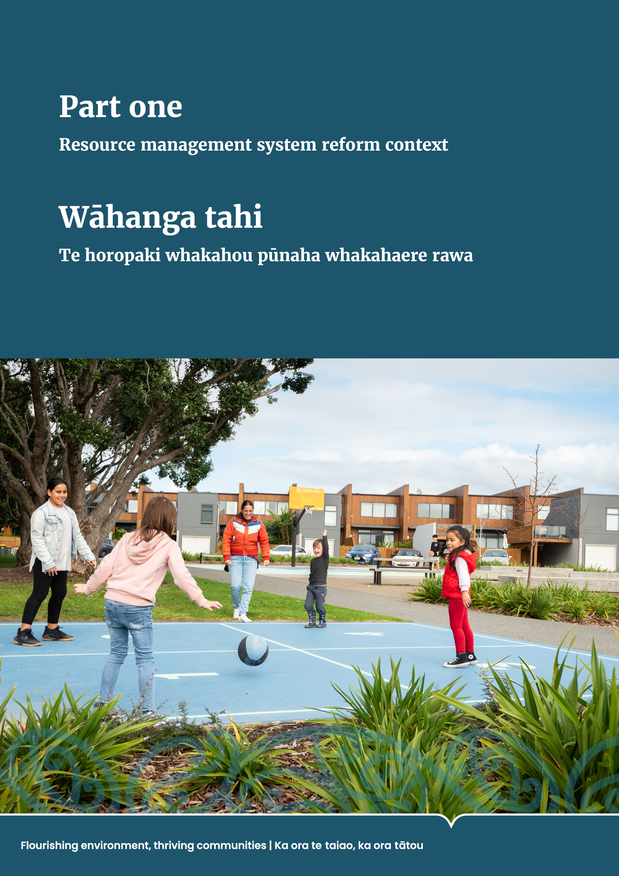
Part one: Resource management system reform context

The need for reform
The Resource Management Act 1991 (RMA) has been Aotearoa New Zealand’s main law governing how people interact with natural resources, plan their urban environments and undertake development. As well as managing air, soil, water and the coastal marine area, the RMA regulated land use and the provision of infrastructure.
There is broad consensus that the resource management system introduced by the RMA in 1991 did not adequately protect the natural environment or enable development where it was needed. Ecosystems have been degraded by poorly managed cumulative effects, there has been a loss of biodiversity and responses to
the challenges of climate change have been slow.
Similarly, decisions made under the RMA entrenched the status quo and discouraged development, contributing to rapid increases in urban land prices. Housing in Aotearoa is now among the least affordable in Organisation for Economic Co-operation and Development member countries. The RMA also contained insufficient recognition of te Tiriti o Waitangi (the Treaty of Waitangi) and a lack of support or tools to enable meaningful Māori participation in the resource management system.
Successive amendments added complexity to the RMA. There were also significant problems with how it was being implemented. These included a lack of national direction and guidance, a lack of resourcing for those in the system who were responsible for implementing it, and poor support from central government for developing plans in the early stages of the RMA’s implementation.
Many people working in the system expressed frustration with the inefficiency and ineffectiveness of RMA plans and processes, as well as with the inadequate interaction and alignment of the RMA and other legislation, and the lack of coherence and effectiveness of national direction.
Reforming the resource management system provides an opportunity to simplify its processes, improve the quality of the natural environment, deliver well-functioning cities and towns, and improve outcomes for Māori.

Timeline of resource management reform
In July 2019, the Government appointed an expert panel to review the resource management system under the RMA. The panel was led by retired Court of Appeal Judge, Hon Tony Randerson KC. This was the most significant, broad-ranging and inclusive review since the RMA was enacted.
The review was primarily focused on the RMA, its interface with other specific legislation and a new role for regional spatial planning. The review consulted widely with local government, Māori, the private sector and other stakeholders.
The Randerson Panel’s report, New Directions for Resource Management in New Zealand, identified similar issues to those found in previous reviews of the resource management system conducted by civil society – including reviews by the Productivity Commission in 2017, the Environmental Defence Society in 2018 and the Waitangi Tribunal from 1993 to 2020.
The panel’s recommendations provided a strong platform for change and in February 2021, the Government announced it would repeal the RMA and enact the Natural and Built Environment Act 2023 (NBA), Spatial Planning Act 2023 (SPA) and Climate Change Adaptation Act (CCAA).
In June 2021, Parliament referred an exposure draft of key aspects of the NBE Bill to the Environment Committee to conduct an inquiry through the select committee process. This also gave the public an early opportunity to see key aspects of the new resource management system and provide feedback.
In November 2021, the Environment Committee reported the findings of its inquiry
to Parliament. Its report provided a list of ideas to make the resource management system efficient, proportionate, affordable and less complex. This report and recommendations informed subsequent ministerial oversight group decisions on the new system.
In November 2022, the NBE and Spatial Planning (SP) Bills were introduced to Parliament to be considered together through a select committee process. The Environment Committee received more than 3,000 submissions on the Bills, and there was broad support for the reform of the system. Many submitters provided constructive comments to improve the workability of the new legislation.
In June 2023, the Environment Committee reported its findings to Parliament. It restructured and made some significant changes to the NBE Bill, as well as changes to improve how the NBE and SP Bills work together, and then recommended by majority that they be passed.
The Bills became law in August 2023.
- Timeline of the resource management reform journey
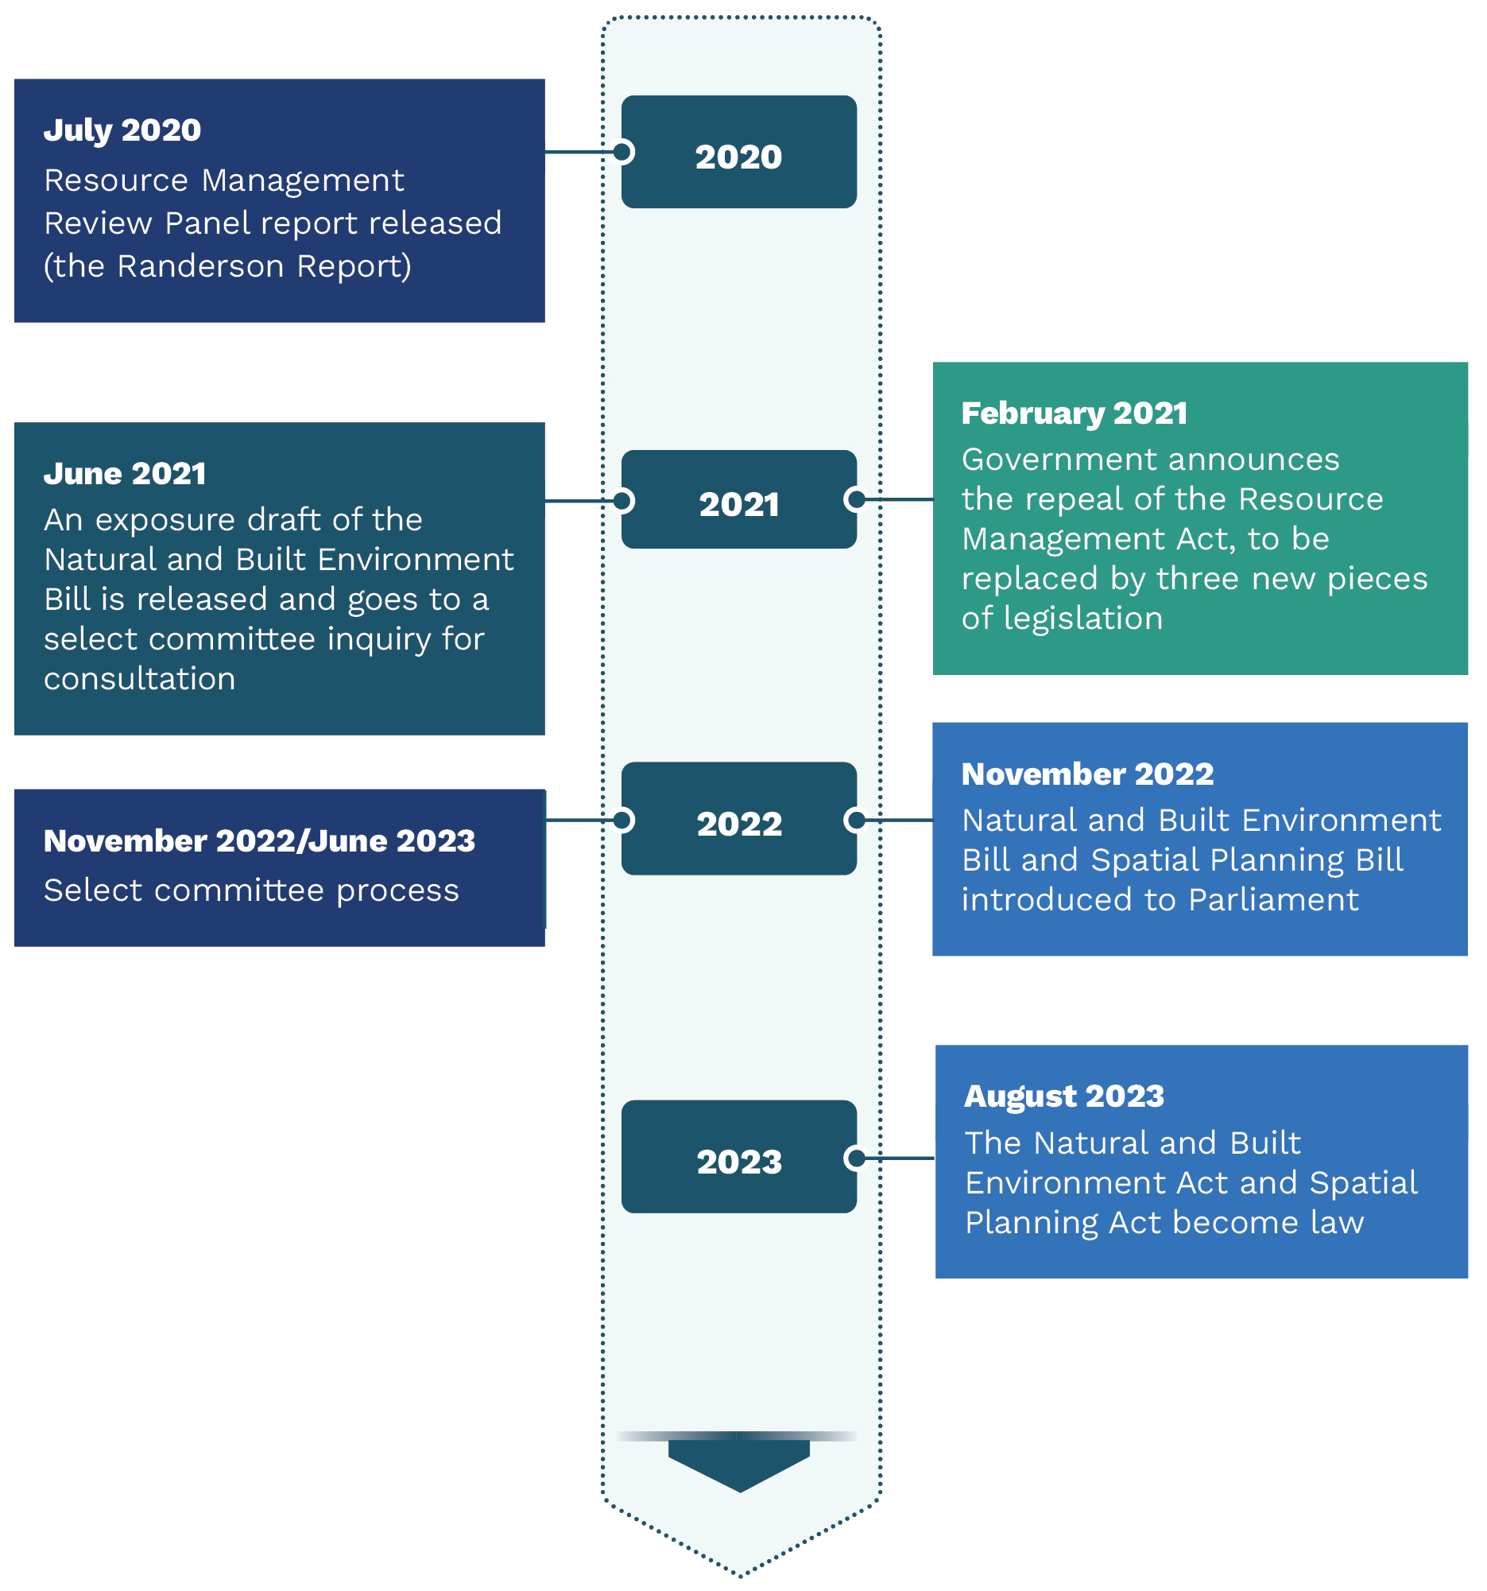

Policy development

Oversight and decision-making
The policy development for this reform followed the recommendations of the Randerson Panel closely. A ministerial oversight group was given delegations from Cabinet to make decisions on the policy.
An interagency executive board called the Strategic Planning Reform Board was established in April 2021 under the Public Service Act 2020. The board had oversight
of the development of the SP Bill. Alongside its statutory role to deliver the SPA, the board also provided oversight across the wider resource management reform programme.
Members of the board included chief executives of the Ministries for the Environment, Transport, and Housing and Urban Development; Departments of Internal Affairs and Conservation; and the Treasury. The Office for Māori Crown Relations – Te Arawhiti acted as an observer.
The Strategic Planning Reform Board provided strong collective public-sector ownership of the new resource management system as it was developed. This collaborative approach led to good-quality input in the development of the SP Bill.
The Ministry for the Environment led work across the central government to finalise the details of the NBE and SP Bills.

Engagement with partners and stakeholders
The Ministry engaged a wide range of stakeholders to ensure the policy development was robust. This included:
- public consultation by the Randerson Panel through its issues and options paper in 2019 and 2020
- ongoing regular strategic engagement with key hapū, iwi and Māori and local government advisory groups
- public consultation on the NBE Bill exposure draft through an Environment Committee inquiry in 2021
- targeted engagement with hapū, iwi and Māori, local government and key sector stakeholder groups on the SP Bill and remaining NBE policy that was not included in the exposure draft from November 2021 to March 2022
- a sustained campaign to raise awareness of the proposed future system in May and June 2021 before the release of an exposure draft of the NBE Bill and again between July and November 2022 before the NBE and SP Bills were introduced to Parliament.
Through its engagement efforts, the Ministry sought to raise awareness and increase understanding of the proposed resource management system reform. This was intended to enable hapū, iwi and Māori, local government, sector stakeholders and
the public to make meaningful contributions to the reform process.

Hapū, iwi and Māori engagement
The Ministry had ongoing and regular engagement with hapū, iwi and Māori collective groups throughout the policy development process. These groups provided advice, tested policy and helped develop ideas for implementing and transitioning to the new system. The Ministry also held online and in-person regional hui with hapū, iwi and Māori and engaged with Māori leadership collective groups and their technical experts over a two-year period. The groups were:
- Freshwater Iwi Leaders Group and Te Wai Māori Trust
- Te Tai Kaha Collective, which comprises the New Zealand Māori Council, Federation of Māori Authorities and Ngā Kaiārahi o te Mana o te Wai Māori (formerly Kāhui Wai Māori).

Upholding Treaty settlements, Ngā Rohe Moana o Ngā Hapū o Ngāti Porou Act 2019 and other resource management arrangements
The NBA requires the Government to uphold the integrity, intent and effect of Treaty settlements, the Ngā Rohe Moana o Ngā Hapū o Ngāti Porou Act 2019, joint management agreements and Mana Whakahono ā Rohe in the new resource management system.
The RMA interfaces with more than 70 Treaty settlements. Engagement with
post-settlement governance entities is underway to reach agreement on how to continue to uphold these arrangements, as well as with ngā hapū o Ngāti Porou
in relation to the Ngā Rohe Moana o Ngā Hapū o Ngāti Porou Act 2019.
Engagement with relevant entities will also ensure natural resource arrangements agreed by hapū, iwi and Māori entities and local government under the existing provisions of the RMA, such as Mana Whakahono ā Rohe and joint management agreements, are upheld in the new system.

Upholding rights under the Marine and Coastal Area (Takutai Moana) Act 2011
The new resource management system will uphold rights under the Marine and Coastal Area (Takutai Moana) Act 2011 (Takutai Moana Act 2011). Under the Takutai Moana Act 2011, applications for recognition of customary interests along the coastlines of Aotearoa have been filed with the High Court and directly to the Crown. These take the form of applications for customary marine title and protected customary rights.
Customary marine title and protected customary rights include significant resource management rights for whānau, hapū and iwi, such as the right to prepare a planning document and a permission right over some resource consents for customary marine title holders. In addition, and with a few specified exceptions, resource consents cannot be granted without the permission of a protected customary rights group if the activity will, or is likely to, have a more than minor adverse effect on the exercise of a protected customary right. The new resource management system has been designed so these rights will continue under the new legislation.

Local government engagement
Throughout the policy development process, the Ministry undertook regular engagement with local government. This was enhanced in 2021 with the establishment of the Local Government Steering Group. This group comprises elected members and senior council executives, and its members come from a range of territorial, regional and unitary councils from metropolitan, provincial and rural areas.
The steering group met at least monthly, and the Minister for the Environment met with the group regularly. The group provided independent advice on the key proposals for the new resource management system, with a focus on how the voice of local people could be heard in that system. Specific advice on this topic informed the development of policy.
The group also advised how to transition to the new system and how key proposals should be implemented. Its current focus is to provide advice on the transition to, and implementation of, the new resource management system and the National Planning Framework (NPF).
Engagement with local government also included meetings with mayoral forums, elected representatives and senior local government staff. Meetings with specific councils were held, including Auckland Council for its experience in developing the Auckland Unitary Plan and Auckland Plan 2050. The Ministry has also met regularly with Local Government New Zealand metropolitan, regional, and rural and provincial sector groups, as well as Taituarā – Local Government Professionals Aotearoa.
Local government has a key role in implementing the new system. A new advisory group, the Local Government Implementation Group, has been set up to provide practical advice.

Sector stakeholder engagement
The Ministry engaged with key sector stakeholder groups including but not limited to:
- the Resource Management Reform Group (ie, Property Council New Zealand, Infrastructure New Zealand, Employers and Manufacturers Association, and BusinessNZ)
- environmental non-government organisations (eg, Environmental Defence Society, Forest & Bird, Fish & Game New Zealand, Greenpeace Aotearoa and ECO)
- the Food and Fibre Forum
- infrastructure, development and business leaders
- energy generators and retailers
- the New Zealand Planning Institute
- RMLA (Association for Resource Management Practitioners).

Efficiency working group
One of the Government’s objectives for the resource management system reform was to improve the efficiency and effectiveness of the system and reduce its complexity, while retaining appropriate local democratic input.
To ensure this objective was achieved, the Ministry established a working group of practitioner experts in October 2022 to review the design of the proposed system. The working group focused on plan-making and consenting, evaluating the proposed system for efficiency as well as identifying other possible solutions. The working group included a range of highly experienced resource management practitioners and members of the development sector.
The working group assessed the NBE and SP Bills for their ability to meet the reform’s efficiency objective and provided a final report to the Ministry in mid-December 2022 with more than 90 detailed recommendations. The Ministry considered these recommendations alongside suggestions made by submitters during the preparation of the departmental reports that were submitted to the Environment Committee.

Overview of the new resource management system

Objectives for the new system
The Government’s objectives for the new resource management system are to:
- protect and where necessary restore the natural environment, including its capacity to provide for the wellbeing of present and future generations
- better enable development within environmental biophysical limits, including a significant improvement in housing supply, affordability and choice, and timely provision of appropriate infrastructure, including social infrastructure
- give effect to the principles of te Tiriti and provide greater recognition of te ao Māori, including mātauranga Māori
- better prepare for adapting to climate change and risks from natural hazards, and better mitigate emissions contributing to climate change
- improve system efficiency and effectiveness, and reduce complexity, while retaining appropriate local democratic input.

Purpose of the new system
The purpose of the new resource management system is to uphold te Oranga o te Taiao, the health of the environment. The purpose must be achieved in a way that protects the health of the natural environment and, subject to that, enables the use and development of the environment in a way that promotes the wellbeing of present and future generations.

How the new system works
The NBA and SPA work together as a single integrated system (figure 2). The intent of the new system is to shift the weight of activity upwards to the planning stage, reducing the need for decisions on resource use to be made on a consent-by-consent basis.
With this intent, the new system works as follows.
- A National Planning Framework will guide the development of 15 regional spatial strategies (RSS).
- New regional planning committees (RPCs) will produce RSS and NBE plans in each region.
- RSS must give effect to provisions of the NPF where directed by the NPF.
- RSS must otherwise be consistent with the provisions of the NPF.
- RSS will guide the development of 16 regional natural and built environment plans (NBE plans) including for the Chatham Islands.
- NBE plans must give effect to the provisions of the NPF.
- NBE plans must be consistent with RSS.
See part two for more information about the key components and decision-making in the new system.

Key transformational shifts
The new resource management system:
- moves to an outcomes-based system, rather than just managing adverse effects
- provides comprehensive and integrated national direction
- gives effect to the principles of te Tiriti and provides a more strategic role for Māori in regional and national strategy and planning
- establishes a regional collaborative approach to planning and reduces the number of local government resource management plans
- provides a more strategic and coordinated approach to long-term regional planning by central government, local government and Māori
- requires more planning up front to identify what activities are permitted, thus reducing the need to apply for resource consents
- moves to efficient and equitable resource allocations
- improves monitoring, reporting and oversight.
- Overview of the new resource management system
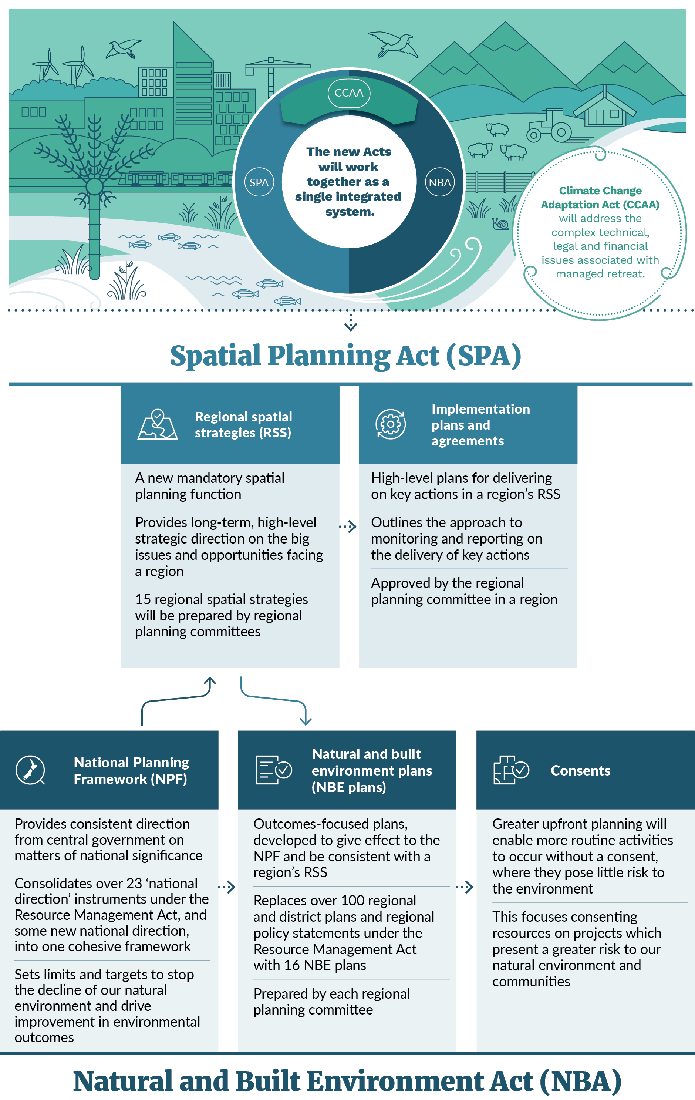

Impacts of the new system
In September 2022, the Ministry completed a supplementary analysis report (SAR) on the new resource management system. The SAR built on the Interim Regulatory Impact Statement: Reforming the resource management system that was prepared for the exposure draft. The SAR considered the regulatory impacts of the SP and NBE Bills and concluded that the Cabinet objectives for the new system could be achieved.
With effective implementation, impacts of the new system will arise, in part, from:
- more consistent and integrated national direction through the NPF
- RSS giving effect to the NPF and supporting community and environmental wellbeing by enabling and driving change and adaptation
- a reduction in the number of plans and improvements in plan quality and decision-making with greater clarity and certainty for all
- reduced consenting requirements and limited appeal rights while ensuring environmental safeguards remain in place
- lower ongoing process costs. Excluding the new system’s one-off establishment costs, the ongoing process costs are estimated to be about 7 per cent lower (approximately $85 million annually)
- a positive monetised benefit-cost ratio for the new resource management system, which has been estimated conservatively at 2.58, but realistically could be around 4.90
- other possible benefits, including for the natural environment.

Next steps
Two key pieces of the new resource management system are now in place. Some provisions of the NBA, such as new compliance and enforcement provisions, came into force upon enactment.
The next steps include developing the tools that are enabled by the new legislation.
This includes developing the NPF, which will be a comprehensive and cohesive framework of national direction on how decision-makers will give effect to the new legislation. It will provide direction for the development of RSS and NBE plans by regional planning committees. Further targeted engagement on the draft NPF will be undertaken over the next several months. The first iteration of the NPF will be a transitional document and will be considered by a board of inquiry and open for public consultation in 2024.
The Spatial Planning Board, formerly the Strategic Planning Reform Board, has been given new functions as of 1 July 2023. The Board will govern and support the implementation of the Spatial Planning Act.
Different regions will switch over to the new system at different times. The full system will turn on in each region once the RSS and NBE plans are completed. New applications for resource consents will then be considered under those plans. The Ministry is working with the first regions to fully implement and test the new system, but the transition to the new system is expected to take up to 10 years.
See part three for more information on transition and implementation.

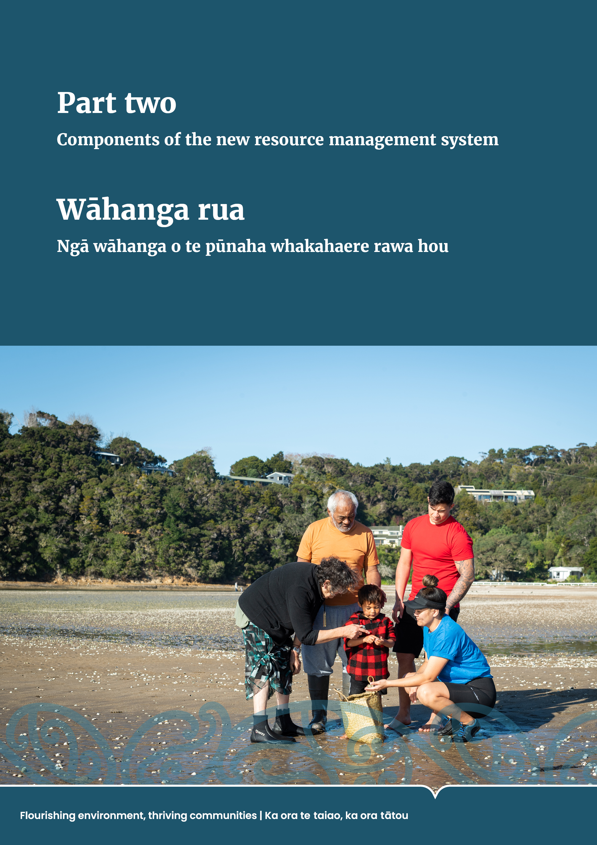
Part two: Components of the new resource management system

Key components of the new resource management system
The Natural and Built Environment Act (NBA) and the Spatial Planning Act (SPA) will work together to form the core part of the new resource management system (figure 3). They provide the statutory framework for the planning, use and allocation of resources in the natural and built environment across Aotearoa New Zealand.
The NBA is the main replacement for the Resource Management Act 1991 (RMA). It covers management of the natural and built environment including land use, environmental protection, water takes and discharges, and coastal marine areas. It supports the wellbeing of both present and future generations and gives effect to the principles of te Tiriti o Waitangi (the Treaty of Waitangi).
The NBA introduces the National Planning Framework (NPF) that will provide direction on matters of national significance, environmental limits and targets, as well as identifying and resolving conflict among outcomes if possible. It requires 16 natural and built environment plans (NBE plans) to be made that will replace the regional policy statements and district and regional plans currently required under the RMA. The NBA also introduces a revised resource consenting regime, which builds on the RMA consent system and introduces process efficiencies.
The SPA provides spatially based regional planning for the longer term. It requires the development of 15 regional spatial strategies (RSS) and an implementation plan to integrate planning for aspects of the environment. These aspects include land use, infrastructure, the coastal marine area and climate change responses. RSS help achieve the purpose of the NBA.
Under the NBA and SPA, 16 regional planning committees (RPCs) will be established with responsibility for producing RSS and NBE plans. These committees will include representatives from local authorities and Māori in each region. A central government representative will be appointed under the SPA for developing the RSS.
Both the NBA and SPA require those exercising powers or performing functions or duties under them to give effect to the principles of te Tiriti.
- Key components of the new resource management system
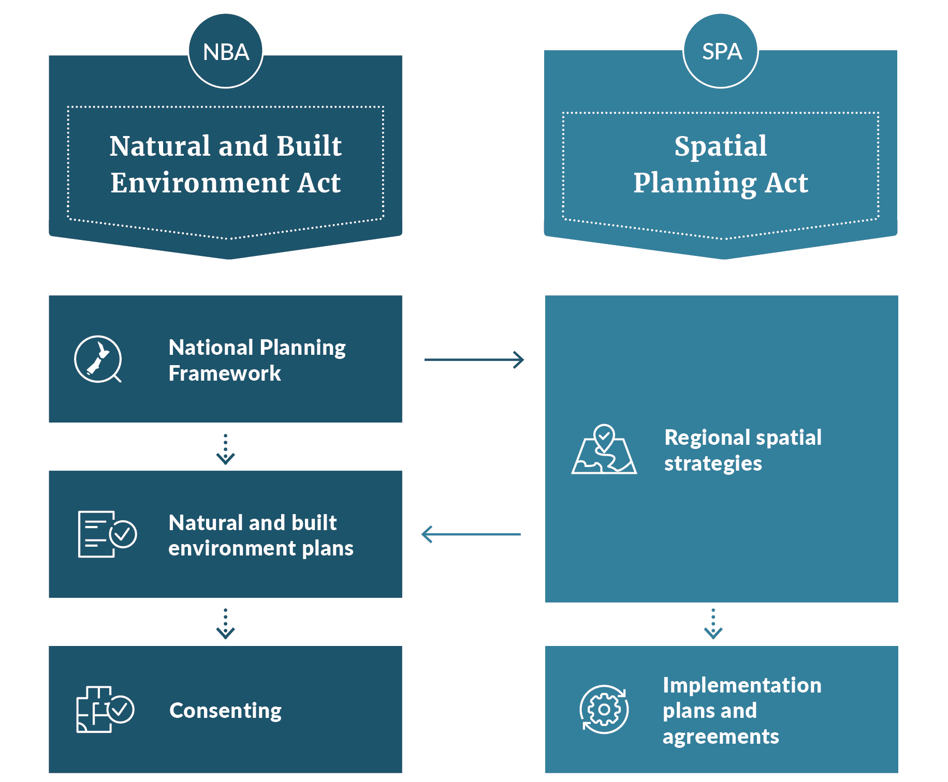

Spatial Planning Act
The SPA will create a new function in the resource management system. It provides for mandatory spatial planning across all regions and requires that central government, regional councils, territorial authorities, and hapū, iwi and Māori work together on a spatial strategy for their region.
The SPA provides for RSS that set out the long-term (30 to 100 years), high-level strategic direction for each region, focusing on the vision, objectives and key actions and the big opportunities and issues facing the region. RSS bring together planning, environmental management, infrastructure provision, and funding and investment
to achieve the vision and objectives.
A key role of the SPA is to integrate natural and built environment planning and investment with other key planning and investment. This includes planning and investment under the Local Government Act 2002, the Land Transport Management Act 2003 and the Water Services Entities Act 2022. These Acts are important connections to the resource management system and substantive changes to them are not proposed as part of this reform.

Natural and Built Environment Act
The NBA is the main piece of legislation that replaces the RMA. It provides a new framework for regulating both environmental planning and land-use planning.

The purpose of the Act
The NBA’s purpose is to uphold te Oranga o te Taiao. The purpose must be achieved in a way that protects the health of the natural environment and, subject to this, enables the use and development of the environment in a way that promotes the wellbeing of both present and future generations.
Te Oranga o te Taiao is a concept drawn from te ao Māori. It means all of the following.
- The health of the natural environment.
- The relationship between the health of the natural environment and its capacity to sustain life.
- The relationship between the health of the natural environment and the health and wellbeing of people and communities.
- The interconnectedness of all parts of the environment.
- The relationship between iwi and hapū and te taiao that is based on whakapapa.

Achieving the purpose of the Act
The NBA sets out key means for achieving its purpose. These are as follows.
- System outcomes must be provided for at a national level through the NPF and
at a regional level in plans.
- Environmental limits and their associated targets must be set in the NPF and in plans for each of the required domains, and compliance with those limits and targets is required.
- The NPF is also required to provide direction on the integrated management of the environment in relation to matters of national significance and matters where consistency is desirable and provide direction on the resolution of conflicts about environmental matters.
- Discretionary targets may be set in the NPF and in plans for achieving outcomes.
- RSS must be prepared under the SPA to:
- help achieve the purpose of the NBA and the system outcomes provided under it
- promote the integrated performance of functions under the NBA, the Land Transport Management Act 2003, the Local Government Act 2002 and the Water Services Entities Act 2022.
- NBE plans must achieve the purpose of the NBA by providing for the integrated management of the natural and built environment in their region.
- Decision-making principles are to be applied.
- The attributes of places of national importance and highly vulnerable biodiversity areas must be recognised, protected and sustained for their intrinsic value and for the benefit of both present and future generations.
- The protection of natural features (including geoheritage) and landscapes that are outstanding at the local and regional scales may be provided for.
- The effects of activities on the environment must be managed.

Giving effect to the principles of te Tiriti o Waitangi
The NBA and SPA require all persons exercising powers and performing functions and duties to give effect to the principles of te Tiriti.
The change in language from “take into account” in the RMA to “give effect to” in the new system will provide better recognition and implementation of the principles of te Tiriti. The Ministry for the Environment (the Ministry) will develop guidance to help people understand what shifts in practice are required.

A greater focus on positive outcomes
The new resource management system makes an important shift toward achieving outcomes, rather than just managing adverse effects.
The NBA aims to improve resource management by providing system outcomes that establish what must be achieved at the national and regional levels to ensure the purpose of the Act is achieved.
System outcomes must be provided for in the NPF and NBE plans, and these in turn will provide policies, methods and rules that will direct the consideration of resource consent applications.
There is also a section that outlines how the system outcomes must be provided for. This section requires that when providing for outcomes:
- the health of the natural environment and its capacity to sustain life must be protected in accordance with the purpose
- not all outcomes are required to be achieved in all places or at all times
- conflict between or among outcomes must be identified and resolved at the highest practicable level within the NPF and plans made under the NBA
- achieving compatibility between or among outcomes must be preferred rather than achieving one outcome at the expense of another
- the goal of achieving outcomes, at both the national and regional levels, must be preferred over the goal of avoiding conflict.

Managing environmental effects
The shift in focus from managing effects (under the RMA) to achieving outcomes (under the NBA) does not mean that effects will not be managed. Rather, the intention is that effects will be managed to achieve outcomes, not as an end in itself.
In addition to the general duty to avoid, remedy or mitigate adverse effects, which is carried over from the RMA into the NBA, the NBA sets out an effects management framework for managing environmental effects on identified significant biodiversity and cultural heritage areas. This framework applies unless there is an exemption or
the NPF specifies a more stringent approach (eg, it may be appropriate for it to be mandatory to avoid some effects). The NPF may also apply the framework to other resources.
The new effects management framework requires adverse effects to be managed
as follows.
- Adverse effects must be avoided where practicable.
- Any adverse effects that cannot be avoided must be minimised where practicable.
- After avoidance and minimisation, any remaining adverse effects must be remedied where practicable.
- After avoidance, minimisation and remediation, any remaining adverse effects must be offset where practicable.
- If adverse effects remain after avoidance, minimisation, remediation and offsetting, then enhancement must be provided as redress; otherwise the activity must not proceed.
While this prescriptive approach to managing effects only applies to specific circumstances, it is also a requirement that consideration is given to whether there are other circumstances where this or a similar approach should be applied, as directed in the NPF or in plans.

National Planning Framework
The NPF will be one of central government’s primary ways to influence and direct the new resource management system.
The transitional NPF will consolidate most existing national direction that was developed under the RMA into a single integrated framework that directs how regions manage the natural environment and development. The NPF will provide direction and guidance to both RSS and NBE plans. Plans will be required to give effect to the NPF as directed while RSS must give effect to the NPF to the extent the framework directs and must otherwise be consistent with it.
A transitional NPF proposal must be notified within eight months of enactment of the NBA. Further information about the transitional NPF is outlined below.
The NPF will provide direction on matters of national significance or where consistency is desirable and will provide direction on all the system outcomes. This will include mandatory environmental limits, to protect human health or to prevent degradation of ecological integrity from the state it was at the date the NBA commenced. The NPF will also provide direction on resolving conflicts about environmental matters or between and among system outcomes.
The process for preparing, amending and reviewing the NPF is set out in the NBA. The Minister of Conservation is responsible for NPF provisions that apply solely to the coastal marine area, in consultation with the Minister for the Environment. The Minister for the Environment is responsible for other NPF provisions but must consult with the Minister of Conservation for provisions that apply to both the coastal marine area and the non-coastal marine area.

Scope of the National Planning Framework
The NBA requires the NPF to include mandatory content, including direction on:
- how decision-makers are to achieve system outcomes
- how the use and development of the environment is to promote the wellbeing of both present and future generations within relevant environmental limits
- environmental matters and priorities and how they are to be dealt with
- how the implementation and effectiveness of the framework is to be monitored
- each system outcome
- the resolution of conflicts about environmental matters, including conflicts between or among the environmental outcomes
- the following specified matters:
- the components of ecosystems that should be managed to protect ecological integrity of the natural environment and human health
- enabling papakāinga on Māori land
- enabling development capacity well ahead of expected demand
- enabling infrastructure and development corridors
- enabling renewable electricity generation and its transmission
- urban trees and green spaces
- enabling supply of fresh fruit and vegetables
- environmental limits and targets for air, indigenous biodiversity, coastal water, estuaries, freshwater and soil.

Transitional National Planning Framework
The transitional NPF is the initial step in delivering national direction for the new resource management system. It will be in place in 2025, in time to inform the development of the first RSS.
To facilitate a smooth transition from the RMA, the transitional NPF will be prepared on the basis of existing RMA national direction as long as it is compatible with the requirements of the NBA. It will provide direction to support the delivery of the RSS.
Most existing RMA national direction will be incorporated into the transitional NPF, including the National Policy Statement for Freshwater Management, the National Policy Statement on Urban Development, the RMA’s Medium Density Residential Standards, the National Policy Statement for Highly Productive Land and the National Policy Statement for Indigenous Biodiversity. The content of some RMA national direction instruments will not be included in the transitional NPF as they are currently being amended or need updating to work effectively in the new system.
Any content required by the NBA that is not included in the transitional NPF will be included in a notified change to the NPF by 1 January 2028.
The transitional NPF is also likely to provide new direction to support the development of the first RSS in each region. This will include some overarching content that provides direction on resolving conflicts, along with new direction to fill some key gaps in RMA national direction. This includes infrastructure, natural hazards, climate change, cultural heritage and outstanding natural features and landscapes.
The transitional NPF must be notified for public consultation through a board of inquiry process within eight months of enactment of the NBA. The Minister will be responsible for establishing the board of inquiry.
Before the NPF proposal is notified, the Minister is required by the NBA to issue an engagement draft and seek feedback from local government and hapū, iwi, and Māori groups. This engagement draft of the transitional NPF will be issued in the second half of 2023. The engagement draft and feedback received on it will inform the transitional NPF proposal that is notified for consideration by the board of inquiry.

Transition phase
Now that the NBA and SPA have been enacted, there will be a transition period (of about 10 years) until all new RSS and NBE plans are in force. During this time in relation to the NPF:
- the transitional NPF will be in place to inform the development of the first RSS, with subsequent amendments to the NPF made in time to inform the development of the first NBE plans
- RMA national direction will remain in force to continue directing RMA plans and decision-making under the RMA
- powers under the RMA to develop and amend an existing national direction instrument will remain in force during the transition period, with a requirement that newly developed RMA national direction will need to consider consistency with the NBA
- new or amended RMA national direction and amendments to the NPF can be made as part of a single combined process, if that option is chosen by the Minister
- a new National Māori Entity will be established with a primary role to monitor te Tiriti performance of the resource management system. It will also be able to provide advice on the NPF (in addition to direct input by hapū, iwi and Māori). More information about roles and responsibilities in the system can be found in the National Māori Entity for performance monitoring section.
The NPF will be amended over time to respond to emerging issues and implement key government policy direction. The NPF must be reviewed at least once every nine years, although the Minister will be able to review all or part of the NPF more frequently.

Environmental limits and targets
One of the five objectives of resource management reform is to better enable development within environmental limits. This is intended to improve housing supply, affordability and choice, as well as to provide appropriate infrastructure, including social infrastructure.
Environmental limits must be set for certain aspects of the natural environment to protect ecological integrity and human health. They are set across six aspects of the natural environment: air, indigenous biodiversity, coastal water, estuaries, freshwater and soil (figure 4). They may also be set for other matters.
The purpose of setting environmental limits is to prevent the ecological integrity of an aspect of the natural environment from degrading from the state it was in at the date the NBA commenced or, if in relation to human health, to protect human health. Minimum acceptable limits must be set to drive improvement if the current state of ecological integrity is unacceptably degraded. This is similar to the use of ‘national bottom lines’ in the National Policy Statement for Freshwater Management 2020.
Human health limits work differently. These limits must be informed by relevant health guidelines published or advised by the Ministry of Health or the Minister of Health. These health guidelines are often agreed by the World Health Organization following considerable research internationally.
A mandatory target must also be set for each environmental limit. This defines a desired future state to drive improvement in ecological integrity or reduce risks to human health. Discretionary targets can also be set to help drive improvement towards achieving wider outcomes.
Limits and targets will be set within management units and must be set at an appropriate spatial scale to ensure no loss of ecological integrity and that human health is protected.
- Mandatory matters for environmental limits
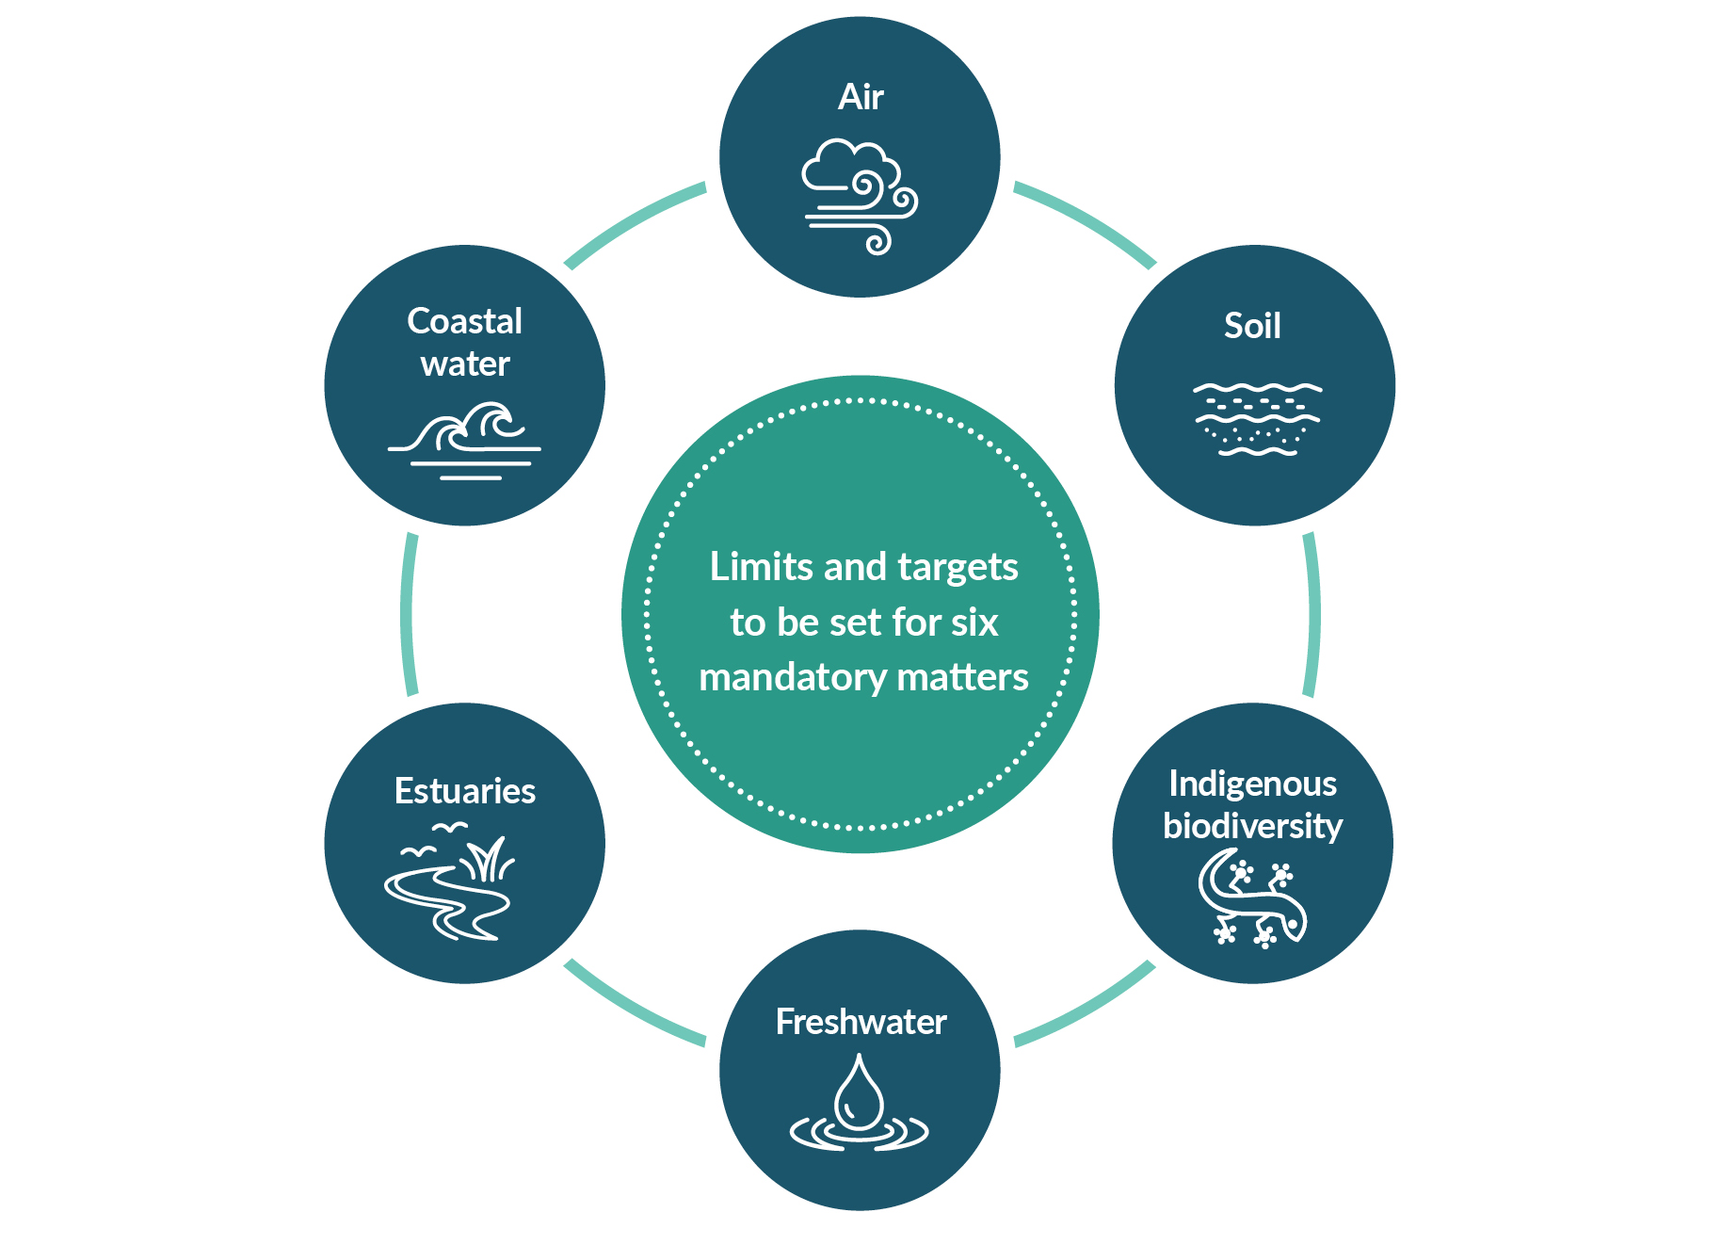
Environmental limits and their related targets may be set nationally in the NPF. Otherwise, the NPF may provide for limits and targets to be set locally in NBE plans. Discretionary targets associated with outcomes may be set by the Minister, or the Minister may direct how they are to be set by a planning committee.
The NBA enables the NPF to set out:
- what aspects of the natural environment to measure for ecological integrity and human health
- how the aspects are to be measured
- any requirements for how to set limits or targets
- any direction about how the aspects are to be managed (ie, to defend limits and achieve targets).
The NBA requires a panel to assess and review the science and evidence, including mātauranga Māori, that underpin potential limits and targets before the NPF is referred to a board of inquiry.

Exemptions to limits
An exemptions process for limits is available. An application can be made to the Minister by an RPC, a Crown agency or a requiring authority during the preparation or revision of an NBE plan or RSS.
Applications for exemptions are not available at the consenting stage. This is to avoid unplanned degradation from cumulative, ad hoc decision-making on individual development applications. An application for an exemption must be able to demonstrate that they have considered options for complying with the environmental limit or the minimum acceptable limit that has been achieved.
In making a decision on an application for an exemption, the Minister must consider:
- whether an exemption from an environmental limit results in the least possible net loss of ecological integrity compatible with the proposed activity
- whether the activity provides identifiable public benefits that justify any loss of ecological integrity
- a time limit for an exemption and whether any conditions should be imposed.

Strategies and plans
Fewer discrete documents are required in the new system. One RSS and one NBE plan are now produced for each region, with 15 RSS and 16 NBE plans nationwide (Nelson and Tasman will plan their RSS and NBE plans together, and the Chatham Islands can choose to develop an RSS). This approach simplifies and will improve the integration of the resource management system, and also places a greater focus on planning.
The new resource management system is designed to encourage broad public engagement with RSS and NBE plan development. This is to ensure an RPC has access to good information and understands the perspectives of a community.

Regional spatial strategies
RSS provide long-term, high-level strategic direction for integrated spatial planning in a region. They have a critical role in driving and enabling change in regions through resource management and investment decisions. RSS are developed by an RPC and set a vision and objectives to guide a region for 30 or more years. The vision and objectives are expressed spatially and accompanied by actions to realise the vision.

The strategies must provide direction on matters that are significant in the region or of national importance, including (where appropriate):
- areas that do or may require protection, restoration or enhancement
- areas of cultural heritage and areas with resources that are of significance to Māori
- areas subject to constraints (eg, natural hazards and areas affected by climate change)
- areas appropriate for housing and development
- areas where significant land-use change is required (eg, to meet growth needs or comply with environmental limits)
- strategic sites and indicative locations for future infrastructure.
Each RSS will be a mixture of maps, other visual illustrations and narrative to make the plan user friendly. All RSS are required to be consistent with or, if directed, give effect to the NPF. The NPF may also require an RSS to take specific actions or use particular methods (eg, mapping methods to support consistency across regions).
In developing RSS, RPCs are required to have particular regard, or regard, to a range of instruments (figure 5). These include the Government Policy Statement on Land Transport 2021, the Government Policy Statement on Housing and Urban Development, the Interim Government Policy Statement on Health 2022–2024, a proposed Government Policy Statement on Water Services, any proposed Government Policy Statement on the Electricity Industry, the Minister’s response to the 30-year Rautaki Hanganga o Aotearoa – New Zealand Infrastructure Strategy 2022–2052, the Aotearoa New Zealand Biodiversity Strategy, statements of community outcomes and regional environmental outcomes, planning documents recognised by hapū and iwi, statutory acknowledgements and relevant documents prepared under other Acts.
- Regional spatial strategy integration across different legislation
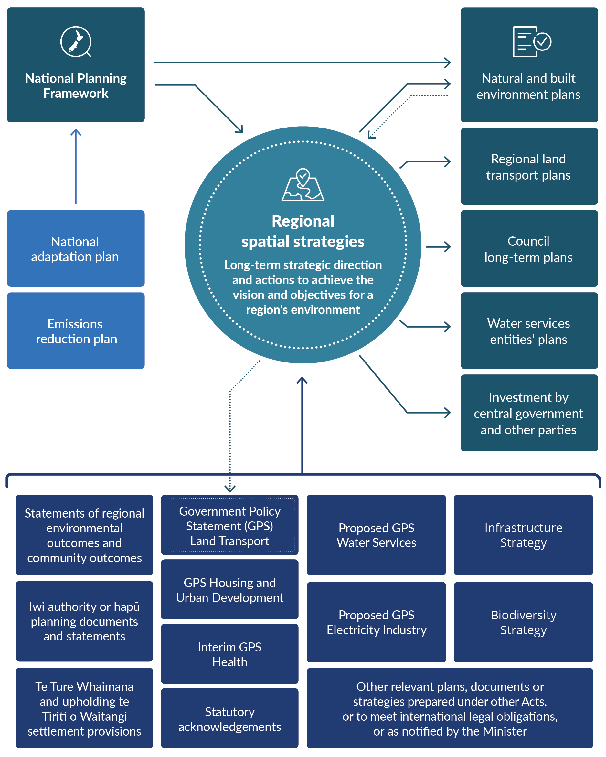

Implementation plans and agreements
The SPA requires that an RSS is accompanied by an implementation plan. An implementation plan sets out the steps to implement or progress the key actions in
the RSS. It must be approved by an RPC in consultation with delivery partners (ie, those who will lead a key action). Delivery partners could be central or local government, hapū, iwi and Māori, community groups and/or the private sector.
Progress on actions must be reported on annually, and the RPC must review the implementation plan every three years or when there is a significant change to the RSS.
Delivery partners may also decide to enter into optional implementation agreements to give effect to specific projects or actions identified in the implementation plan. Together, implementation plans and implementation agreements provide a way to:
- link projects and programmes to funding streams from different sources
- connect key parties (they may be public, partially privatised or private) and activities
- sequence infrastructure provision in a logical way.

Developing regional spatial strategies
Each RPC develops and approves an RSS (figure 6). The SPA requires an RPC to develop and adopt an engagement process to encourage broad engagement and ensure interested groups and individuals can provide effective input. This process must include several defined steps. An RPC, however, has significant flexibility to design an engagement process to suit the needs of interested parties and communities.
The RPC is expected to consider how best to encourage input from the region. This could include taking different engagement approaches for different issues, parts of the community or parts of the region.
The Spatial Planning Board will coordinate central government’s strategic priorities in a region. This will enable efficient integration across the range of agencies that have a role to play in spatial planning.
The RPC will undertake early engagement with interested parties and the public on the matters that will be addressed in the RSS. This should include important issues and opportunities for the region.
A draft RSS will then be developed with options, analysis and scenarios to test with the community. If requested by an appointing body, the draft RSS will be provided to that body to review before it is notified. Once notified, submissions will be received and considered, and hearings held.
To do this work, an RPC will first need to gather and consider robust information. It will then create a draft evaluation report setting out the key evidence used, and scenarios or options considered, and its rationale for deciding what to include in the draft RSS. The evaluation report will be finalised at the end of the process, providing a permanent record of the evidence used and the decisions made. Decisions will be made by consensus, but a dispute resolution process is available if consensus cannot be reached.
- Regional spatial strategy development process
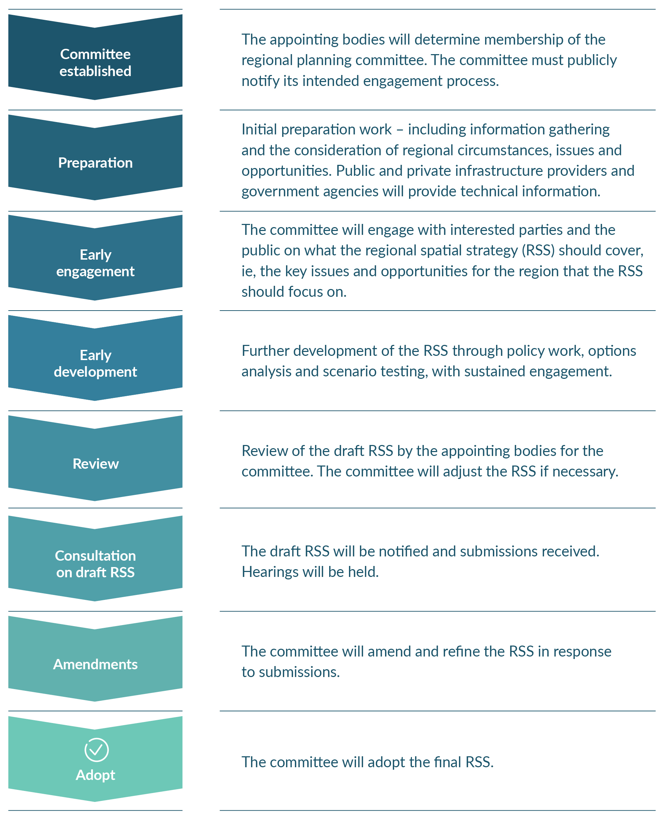
The SPA does not provide for appeal rights, but judicial review is available to those who consider the RSS process or content was not consistent with the requirements
of the Act.
The RPC can amend the RSS, including if issues are encountered in translating the provisions into the NBE plans. The level of engagement for any amendments will vary, but significant changes that are not required by the NPF will need engagement.

Reviewing a regional spatial strategy
An RSS must be replaced every nine years. If issues arise, however, it can be reviewed, and if necessary amended, at any time. It must be reviewed in specified circumstances, such as when a new NPF is issued, or if a new NBE plan is inconsistent with the RSS. In most cases, amendments will be made through an engagement process similar to that used when developing an RSS, but in some cases streamlined changes can be made (eg, to bring the RSS into line with an NPF).

Natural and built environment plans

Plans are focused on outcomes
NBE plans provide a framework for managing the natural and built environment in each region. The plans are focused on outcomes (ie, the results regions want to achieve). They must give effect to the NPF and, except in limited circumstances set out in the NBA, they must be consistent with the region’s RSS.
RMA regional policy statements and regional and district plans will be replaced by one NBE plan for each region. NBE plans will be prepared by each region’s RPC, which comprises local government and hapū, iwi or Māori representatives, with support from a secretariat.

Developing a plan
When developing the NBE plan, the RPC must seek input from local communities, other stakeholders, and hapū, iwi and Māori (figure 7). The RPC has two years to prepare an NBE plan for public notification.
Local authorities may provide a statement of community outcomes (SCO) or a statement of regional environmental outcomes (SREO) to an RPC. SCOs are prepared by territorial authorities and express the views of a district or local community. SREOs are proposed to address any significant resource management issues faced by a region or local community and are prepared by regional councils. RPCs are required to have particular regard to SCOs and SREOs when they are developing plan provisions and in their decision-making. Local authorities may also review how the matters in SCOs and SREOs have been included in a plan, before it is notified.
Hapū, iwi and Māori entities also have an early and sustained role in developing an NBE plan. Planning documents prepared by hapū and iwi are another matter that RPCs must have particular regard to.
Enduring submissions are a new feature of the plan development process. These are submissions that are raised during early engagement but lodged before the formal notification of a plan. Like normal primary submissions, enduring submissions hold weight in plan hearings.
Checks and balances are built into the plan development process. RPCs are required
to provide a report to the Ministry, describing how the plan gives effect to the NPF
and sets and applies environmental limits. Local authorities and other appointing bodies may also review and comment on the draft plan before it is notified.

Submissions, hearings and appeals
After an NBE plan has been notified, the RPC has 28 months to make and publicly notify its decisions on the plan. Any person or entity can make a submission, but submitters must provide full information and identify or provide any supporting evidence when filing a submission. The time period for lodging submissions and supporting information is longer than under the RMA, and this approach is designed
to increase the transparency, efficiency and fairness of the process.
In relation to developing the first NBE plan, or plan changes following the standard process, plan hearings will be run by an independent hearing panel (IHP) and will usually be chaired by an Environment Court Judge. Alternative dispute resolution processes, pre-hearings and conferencing with experts are mechanisms available to resolve or narrow disputes before hearings begin.
There are also limits on bringing new evidence to IHP hearings that was not provided by the close of the submission period. The IHP must make its recommendations to the RPC, which decides whether to accept or reject the recommendations of the IHP and publishes a version of the plan incorporating these decisions.
Where an IHP recommendation is accepted by the RPC, and the recommendation is within the scope of submissions, appeals are limited to points of law in the High Court. Where an IHP recommendation is accepted but is outside the scope of submissions or it is rejected, merit-based appeals can be made to the Environment Court. There are limits on bringing any new evidence to the Environment Court that was not provided
in the earlier IHP process.
- Natural and built environment plan development process
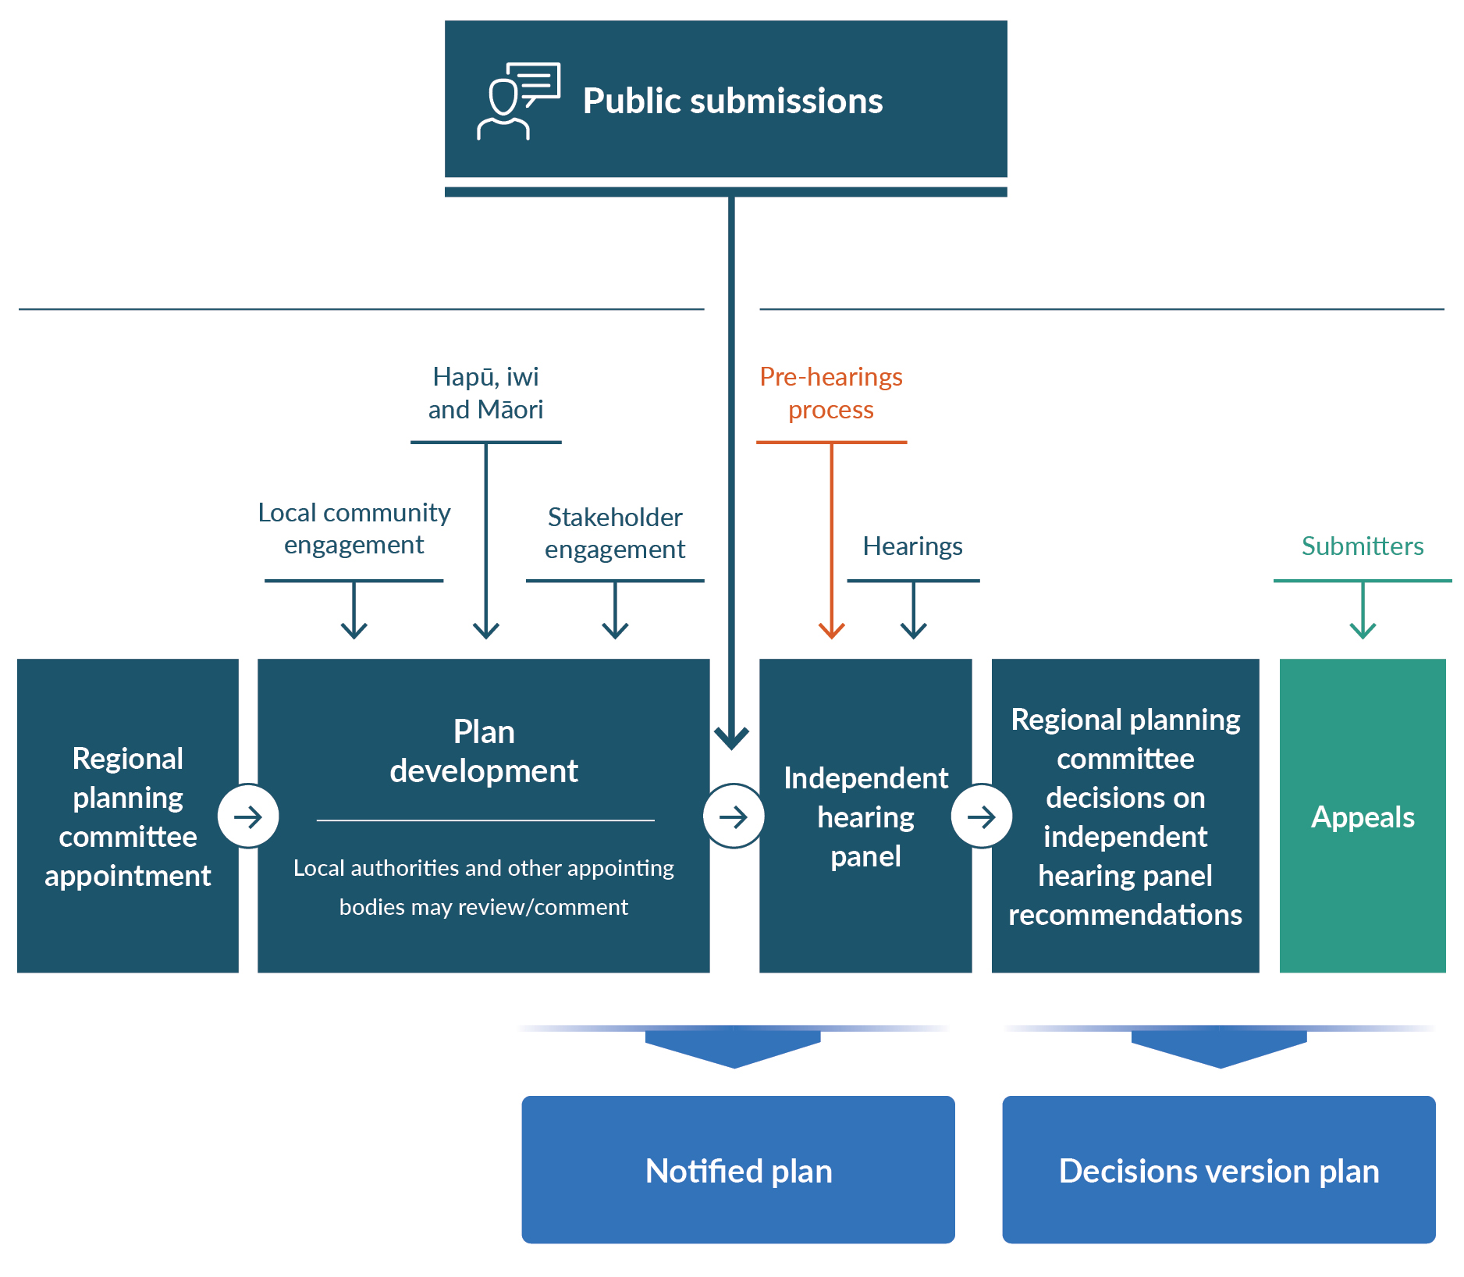

Plan changes and reviews
Each RPC is responsible for reviewing and changing its own NBE plan. The RPC, a local authority, the Minister for the Environment or any other party (through a private plan change request) can initiate or request a change to an NBE plan. There are three different processes for undertaking plan changes, which are designed to respond to the scale and significance of the issues being considered as part of the proposal (figure 8).
The most significant plan changes will follow the standard process, which is the same process used for the development of the first NBE plans. Less complex changes (eg, local rezoning, local centre planning or local natural resource issues) can use a proportionate process. An urgent process is also available if specific criteria are met. These processes are intended to keep the planning system flexible and responsive.
The proportionate and urgent plan-change processes adopt the standard plan-change process, with modifications. Under these processes, accredited commissioners, rather than an IHP, will be used to conduct hearings and make recommendations to the RPC on submissions made on the proposals.
- Overview of three pathways to change natural and built environment plans
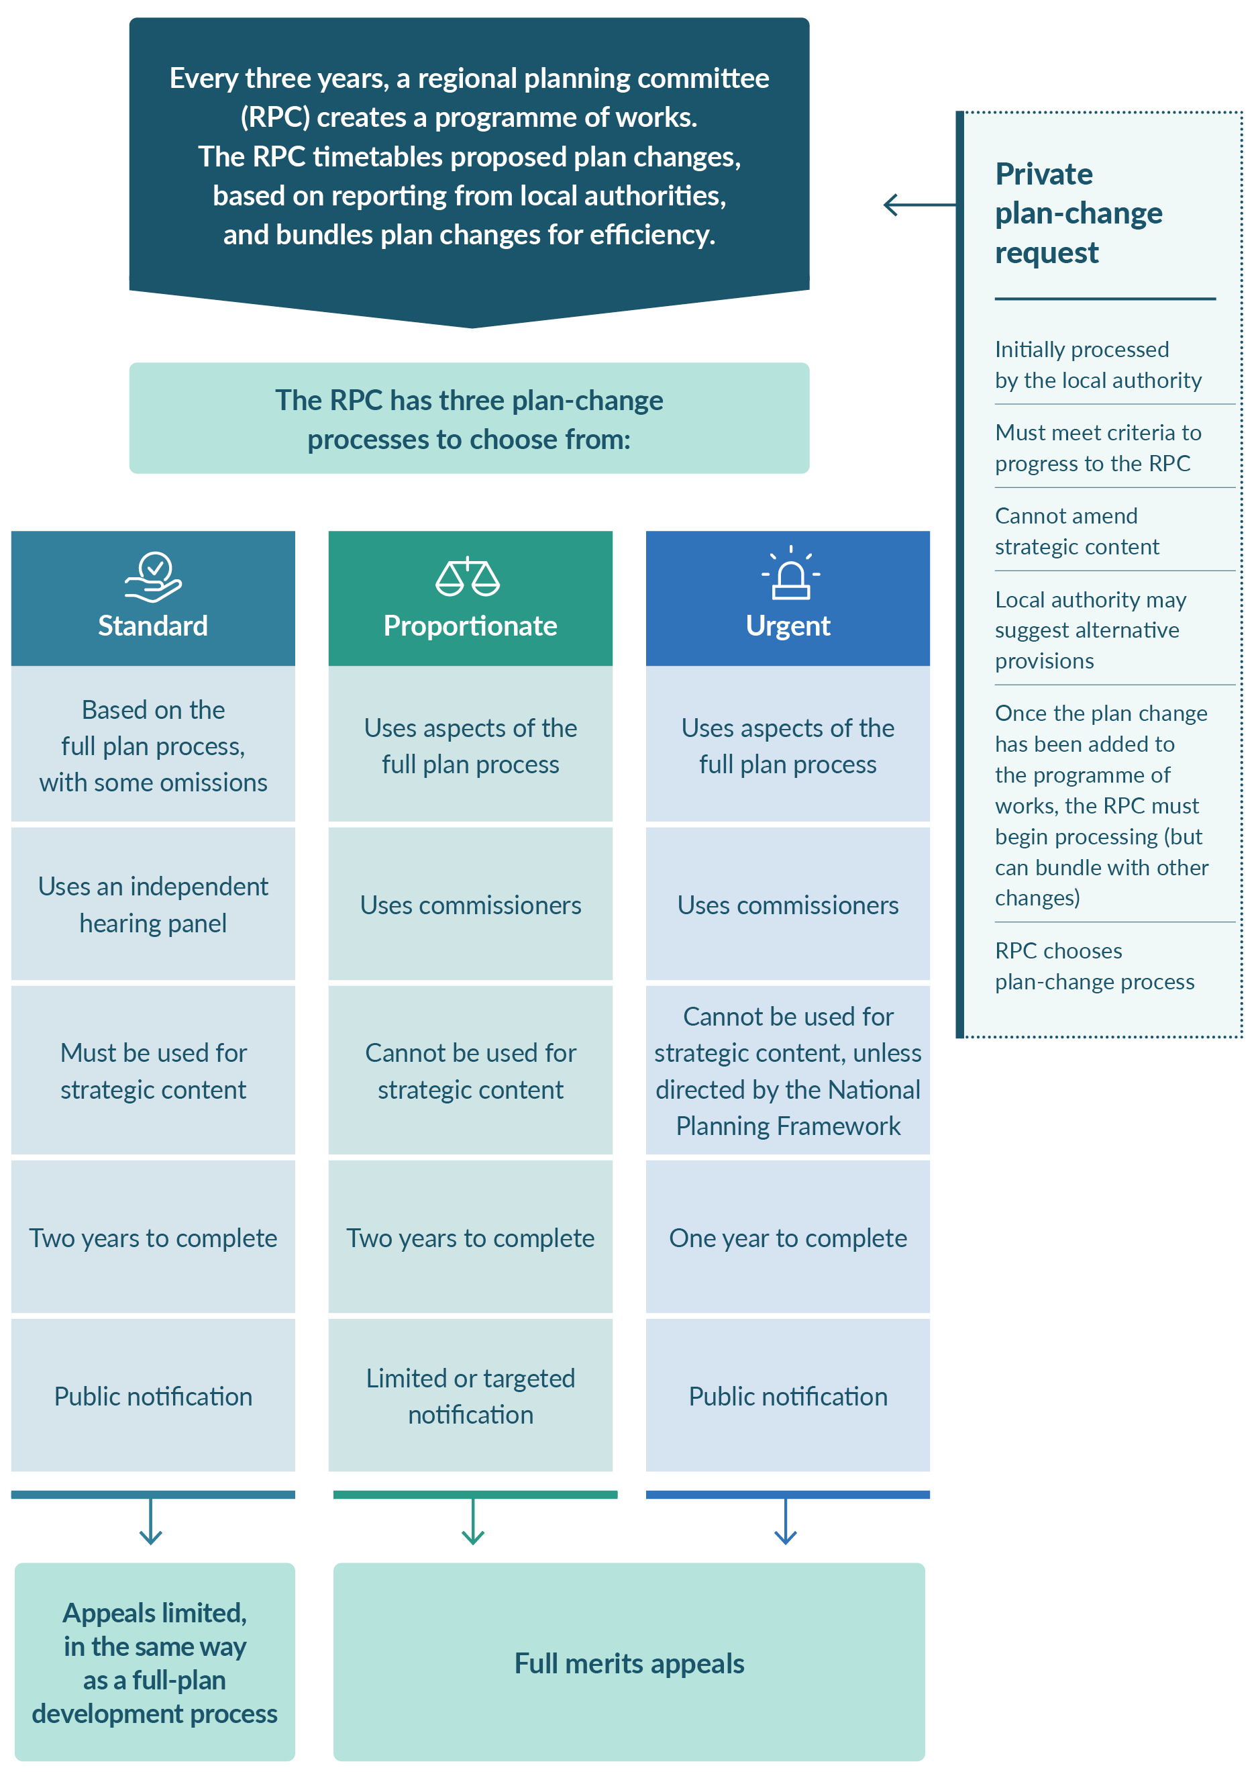

Private plan changes are provided for in the NBA. The NBA sets requirements for private plan change requests including a requirement for the change to be consistent with the RSS. If these requirements are not met, local authorities can reject the request. Approved private plan change requests are passed on to the RPC to be processed as a plan change.

NBE plan monitoring and evaluation
The NBA requires local authorities to report to the RPC every three years, identifying any issues from monitoring the plan, recommendations about what the plan should include, and plan changes requested by local authorities. The RPC will use this information to produce a programme of work, identifying the plan changes to be made in the next three years. Every nine years, the RPC must also reassess its full NBE plan
to consider whether it continues to meet the requirements of the NBA.

A new consenting regime
Resource consents continue to have an important role in the resource management system. Stronger planning instruments such as the NPF and NBE plans are integral to driving certainty and effectiveness in the new consenting regime.
The NPF and NBE plans are empowered to permit more activities if they are appropriate and within environmental limits. Any requirements for consent should only be for activities that require merits assessment so that a tailored approach can be provided for (due to site-specific characteristics or similar). Activities that are generally well understood, including their effects relevant to outcomes, are anticipated to be managed better through planning instruments. Should a consent be required, there should also be more certainty around what information or approach is required.
The types of consents required are the same as under the RMA, and include:
- land-use consents
- subdivision consents
- coastal permits
- water permits
- discharge permits.
Councils are responsible for managing and making decisions for most consent applications. Some applications may be eligible for processing under alternative consenting pathways, such as through a board of inquiry or expert consenting panel. These applications will have specific characteristics and may be nationally significant.

Achieving outcomes and managing effects
The NPF and NBE plans will identify activities in one of four categories (table 1). These will determine whether an activity requires a consent or not.
- Four consenting categories
Category | Description
Permitted | Activities with effects that can be identified and that are well understood. Effects can be managed through requirements (if any) without bespoke consent conditions, are consistent with relevant outcomes and comply with prescribed limits. No consent will be required.
Anticipated | Activities with positive and adverse effects that are generally known but  the extent of the effects needs to be determined through assessment on  a case-by-case basis. These activities are also consistent with relevant outcomes and prescribed limits are met. Consents will be required, but  only certain matters are subject to councils’ assessment.
Discretionary | It is unclear or unknown whether the activity is likely to comply with a limit, achieve targets or be consistent with relevant outcomes. Consents will be required, and the activity is expected to be subject to broader assessment by councils.
Prohibited | Activities that will breach a prescribed limit and are not consistent with a relevant environmental outcome. No consents can be applied for these activities.
Under the new system, the NPF or NBE plans can permit activities. Some of these activities can only be categorised as permitted if they meet certain conditions set out in the NPF or NBE plan. NBE permitted activities can require third-party written approvals or certified reports prepared by suitably qualified persons. In such cases, the NPF or NBE plan will direct whether or not a permitted activity notice is required and, if it is required, the activity must not begin before the notice is issued.
Resource consents will be required for activities categorised within the anticipated and discretionary activity categories. The NBA is intended to drive more consistent categorisation of activities and provide for a more outcomes-focused approach. The level of assessment will therefore be proportionate to the complexity of the application and the potential outcomes and effects.

Fast-track consenting for certain activities
A fast-track consenting pathway for certain housing and infrastructure proposals is available as an alternative process to general consenting and designations. It has similarities to the key procedural steps in the COVID-19 Recovery (Fast-track Consenting) Act 2020.
For a project to use this pathway, it must meet the eligibility criteria in the NBA. The Minister has broad discretion to decide whether an eligible activity may be referred to the Environmental Protection Authority for consideration by an expert consenting panel (ECP), appointed by the Chief Environment Court Judge. The ECP will make the decisions on the application (ie, grant or decline). The fast-track consenting process, once referred to the ECP, has more truncated timeframes and appeal rights. There is no ability to publicly notify the application, and only certain parties may submit (ie, by invitation from the ECP).

Increased certainty about the consent process
The NPF and NBE plans will prescribe the notification and information requirements for resource consent applications. An assessment of environmental effects is still required as part of consent applications. These assessments will be more targeted for anticipated activities and more comprehensive for discretionary activities where outcomes and effects are less certain.
The NPF and NBE plans may specify affected persons for any activities that trigger consents. This will provide certainty for applicants, hapū, iwi and Māori, stakeholders and decision-makers. It will also reduce potential time delays and costs. The NPF or NBE plan can also authorise consent authorities to make notification decisions and identify affected persons, in accordance with the provisions. Notification decisions by consent authorities may be challenged in the Environment Court.
For substantive consent decisions, there is typically an appeal pathway to the Environment Court. In some circumstances, appeals to the Environment Court will be restricted if an alternative regional dispute resolution is used.

Relationship with the allocation of resources
Resource consents will continue to play a critical role in the allocation of resources, including implementing new allocation methods specified in the NPF or NBE plans. During the transition period and before NBE plans are updated in response to allocation statements, consents for freshwater-related activities will have a shorter maximum duration. This is to create a greater opportunity for NBE plans to effect change.

Designations
The designation process is available to secure and protect land for new and existing infrastructure. NBA designations will have a 10-year lapse period. The RSS is a consideration in decision-making on designations. Where a project or work has been spatially identified in an RSS and an assessment of alternatives has been undertaken and considered by the RPC as part of the RSS development, an assessment of the alternatives is not required as part of the NBA designation process. Where a project or work is described in an RSS, then an assessment of whether it is necessary is not required.

Expanded access to designation powers
Designation powers are available to a wider range of infrastructure providers. Port operators (under the Port Companies Act 1988) can designate for land-based activities (outside the coastal marine area), and fire and emergency services will have automatic access to designation powers.
Other providers such as electricity generators can apply to the Minister for requiring authority status, including for a specific project or purpose, if they satisfy the “public benefit” criteria.

Construction and implementation plans allow flexibility for environmental assessments
Construction and implementation plans (CIPs) are either primary or secondary. Primary CIPs identify the scope of works for the construction and operation of designated infrastructure, as well as how its associated effects will be managed. Primary CIPs are notified and provide opportunities for the public and other affected parties to be part of setting longer-term management measures. Secondary CIPs include more detailed information to be considered by the territorial authority.

Allocation of resources

Allocation system issues under the RMA
The system of allocation under the RMA is characterised by ‘first-in-first-served’ consenting, with access to resources based on assessing consent applications in the order they are lodged. Existing consent holders are also prioritised over other applicants when replacement consents are sought.

New allocation framework
The NBA includes an enabling framework for allocating resources. This framework implements the Randerson Panel’s recommendations and enables a range of allocation methods.
The framework has mandatory requirements for NBE plans to include an allocation method or methods for taking, diverting or using freshwater, and nitrogen discharges. The framework can also be applied to other specified resources.
This framework is designed to help create a more deliberate and strategic approach to the allocation of certain freshwater resources. First-in, first-served consenting and the near-automatic renewal of consents held by existing users will no longer be the only approach for allocating certain freshwater resources.
RPCs are required to develop allocation methods in NBE plans for certain freshwater resources. They must have particular regard to the resource allocation principles of environmental sustainability, equity and efficiency alongside other relevant provisions in the NBA, and any relevant NPF direction. The Minister is also required to have particular regard to the resource allocation principles when issuing direction on allocation methods through the NPF.
These allocation provisions are intended to result in more efficient, sustainable and equitable approaches to allocation.

Freshwater Working Group
The NBA provides for the establishment of a freshwater working group. This group will produce a report that considers and makes recommendations on matters relating to freshwater allocation, and on an engagement process between the Crown and iwi and hapū at the local or regional level on freshwater allocation. The Government must respond to the report within six months.
The Crown is then required to engage with iwi and hapū at a regional or local level on matters of freshwater allocation relevant to the NBE plan for the region, with a view to developing an agreed allocation statement. When an RPC receives an allocation statement, it must update the relevant provisions of its NBE plan within five years.

Allocation methods
The NBA enables a range of allocation methods for specified resources. These include comparative (merits-based) consenting and market-based allocation methods (eg, auctions and tenders).
Comparative consenting enables decision-makers to compare applications against criteria and determine them together. The order of lodgement does not affect decision-making. Market-based allocation methods are not available for freshwater takes and diversions.
There are no changes to the existing RMA provisions on charging for sand, shingle, shell and other natural materials; for occupation of marine or river space; or for geothermal energy. Payments of royalties to customary marine title holders for sand and shingle extraction will continue.

Transitional consents for freshwater activities
Many freshwater consents will expire and be replaced during the transition to the new resource management system. Long-term consents, however, are a practical barrier to moving away from first-in, first-served and will affect the ability of NBE plans to bring change.
Two proposals temporarily reduce the maximum duration that freshwater take and discharge consents can be granted for under the:
- RMA before NBE plans take effect
- NBA before NBE plans are updated on receipt of allocation statements.
Freshwater take and discharge consents lodged with a consent authority from the day after the NBA receives royal assent can only be granted for a period of no more than five years after rules relating to allocation methods in a region’s first NBE plan have legal effect. This will provide a greater opportunity for NBE plans to effect change. It will also preserve future options for more equitable access to freshwater resources for Māori and others with underdeveloped land. Note that existing consents, and consent applications lodged any time up to and including the day the NBA received royal assent, are not affected by these provisions.
Exemptions apply for all existing hydro-electricity generation schemes, as well as reticulated water supplies, and public wastewater and stormwater networks. The construction, operation, upgrading or maintenance of specified nationally significant infrastructure is also exempt.
The Minister may exempt further limited activities through regulations. Existing users will still be prioritised when replacing an existing consent and can use a simplified consenting process.
A 10-year maximum consent duration will apply to freshwater take and discharge consents under the NBA until an NBE plan is updated by an RPC on receipt of an allocation statement. The exemptions outlined above will apply. In the long term, consent durations may be up to 35 years.

Aquaculture management
Marine aquaculture is a primary use of coastal space in some regions across Aotearoa. The RMA allocated space for aquaculture and managed its environmental effects within the territorial sea (ie, 12 nautical miles from the coast). Other aspects such as biosecurity, harvest of wild-caught mussel spat, food safety and some impacts on fishing are managed under other statutes.
The new system retains these same roles but uses different tools. It will provide more space allocation and consenting processes that are intended to be more efficient and provide greater certainty. This is also expected to provide for new opportunities (eg, open ocean aquaculture) and enable adaptation to climate change, and management of adverse effects (including cumulative effects) and biosecurity issues. One important focus is to better support the Crown in delivering on its settlement obligations under the Māori Commercial Aquaculture Claims Settlement Act 2004.
Related outcomes include integration of decisions on space allocation and related developments (eg, landing and processing facilities), ensuring environmental effects are appropriately managed and upholding takutai moana rights.
Achieving these outcomes relies on planning through an RSS and NBE plan development. Full achievement of the intended approach, therefore, will only come about once NBE plans are in place. Aquaculture planning in NBE plans must give effect to the NPF and must be consistent with the limits and targets in the coastal marine area set through the NPF.

Aquaculture and regional spatial strategies
Strategic spatial planning in the coastal marine area may be part of preparing an RSS. When developing an RSS, an RPC can consider aquaculture in the context of spatial planning for other marine uses and values and must consider other relevant statutory instruments. RSS can look across both the land and sea, making connections between anticipated aquaculture growth and the land-based infrastructure required to service that growth.
RPCs are required to consider the New Space Plan developed under the Māori Commercial Aquaculture Claims Settlement Act 2004. Committees will provide early notification of draft RSS content to the Minister responsible for the Māori Commercial Aquaculture Claims Settlement Act. This is intended to prompt engagement between the Crown and iwi to ensure the Crown’s settlement obligations in that region can be meaningfully delivered in the future.

Aquaculture and natural and built environment plans
Through NBE plans, RPCs will carry out detailed planning including zoning for aquaculture. The committees have access to a range of tools for allocating space. These include addressing competition for space and Treaty settlement requirements and ensuring space is used effectively. RPCs must also recognise aquaculture settlement areas (space reserved for Treaty settlement negotiations) in their plans.
Planning and consenting processes will also address the effects of aquaculture on the environment and on other activities. Planning can help protect aquaculture operations from the effects of other activities (eg, discharges that would affect water quality).
The Minister responsible for aquaculture has greater ability to recommend regulations that amend plan provisions to achieve Government objectives for aquaculture, including better provision for aquaculture Treaty settlement obligations. The Minister can specify situations where they, rather than the regional council, would be responsible for allocating authorisations for aquaculture-related resources.
That Minister is also able to continue to apply a temporary stay on receipt of consent applications for aquaculture. This may occur at their initiative or at the request of regional councils or RPCs where there is high and competing demand. The new system also has tools for situations where better planning controls for biosecurity are needed, or to support aquaculture settlement.

Aquaculture consents
Consents for aquaculture retain the default minimum consent duration in the RMA
of 20 years. There are some exceptions, however, where the applicant has requested
a shorter period or a shorter period is required to ensure that adverse effects on the environment are adequately managed. The minimum default consent duration can also be modified through the NPF.
Maximum consent durations of 35 years remain, in line with consent durations for other activities in the coastal marine area. Consent lapse periods for aquaculture have been brought into line with other activities and set at five years.
Under the NBA, an ‘undue adverse effects on fishing’ test (under the Fisheries Act 1996) can be carried out when aquaculture zones are being established in NBE plans or as part of consenting.

Changes to the RMA for the transition
Amendments to the RMA will enable the outcomes sought by some of the new aquaculture provisions to be realised during the transition.

Compliance and enforcement
The new resource management system is supported by a compliance monitoring
and enforcement regime, implemented by local government and the Environmental Protection Authority.

Changes to compliance and enforcement include:
- broadening the cost-recovery provisions for compliance and enforcement in the NBA, allowing for costs to be recovered for compliance monitoring of permitted activities and investigations of non-compliant activities
- a substantial increase in financial penalties, broadening the range of offences subject to fines for commercial gain and increasing the limitation period to two years
- prohibiting the use of insurance for fines, infringement fees and pecuniary penalties
- allowing consent authorities to consider an applicant’s compliance history in the consent process
- providing for alternative sanctions to traditional enforcement action, and providing for new intervention tools, including enforceable undertakings and consent revocation.

Compliance and enforcement during the transition
Compliance and enforcement activities will continue under the RMA until a region’s first NBE plan takes effect. Many of the compliance and enforcement changes, however, can be used by NBA regulators under the RMA immediately. The remaining changes will become available in two stages – the first after six months and the second after two years.

Monitoring requirements
The NBA requires local authorities to continue to monitor the:
- state of the environment
- effectiveness of NBE plans
- efficiency and effectiveness of NBA processes.
The NPF sets out methods, indicators and other requirements that apply to the monitoring of environmental limits and targets. This will support consistency for monitoring across the country. It will also help provide long-term and comparable national trends on environmental conditions, as well as an evidence base for regional and national environmental reporting and decision-making.
Monitoring information gathered by local authorities will feed into three-yearly reports from local authorities to each RPC. The RPC may then make decisions on any issues, opportunities and/or outcomes the NBE plan should address. RPCs are responsible for producing a regional monitoring and reporting strategy to help coordinate monitoring and reporting across a region. RPCs are required to produce a five-yearly assessment of environmental changes and trends in their region.
Hapū, iwi and Māori have an opportunity to work with local authorities on how mātauranga Māori, tikanga Māori and other methods could be used to monitor the environment and the effectiveness of NBE plans.
The SPA requires RPCs to monitor and report annually on the delivery of their implementation plans for RSS. The SPA also requires that implementation plans specify how each key action identified in an RSS will be monitored and reported on, and who is responsible.
A new National Māori Entity will be established with a primary role to monitor Tiriti performance of the resource management system. More information can be found in the National Māori Entity for performance monitoring section.

System oversight by central government
Oversight of the NBA and SPA will help ensure the new resource management system is being implemented as intended. It will also ensure the legislation remains fit for purpose and that the objectives and outcomes of the system are being delivered.
Central government has a stronger regulatory stewardship and operational oversight role in the new system. This is underpinned by a requirement in the NBA and SPA to develop a system monitoring, reporting and evaluation framework across both Acts. The framework is expected to contain a range of indicators and metrics. These will provide consistent monitoring of the system performance indicators, track the implementation of the new system and assess progress against environmental and development indicators.
The framework provides a basis for central government to report annually on the results of NBA and SPA system performance monitoring. Central government must also evaluate and report on the operation and effectiveness of the NBA and SPA to Parliament at least every six years. This approach to monitoring and reporting provides regular information on the implementation and effectiveness of the system and on any changes that are needed.
The Parliamentary Commissioner for the Environment (PCE) may, at their discretion, review the Government’s evaluation report. The Government is required to respond in writing to any review carried out by the PCE. The PCE, along with other bodies like the Office of the Auditor-General, will continue to provide independent oversight of the system.

Ministerial powers
Ministerial powers of assistance and intervention will largely carry over from the RMA into the NBA and SPA. These include powers to:
- investigate the performance of a local authority or RPC and make recommendations
- direct a change or review of an RSS or an NBE plan
- appoint persons to perform powers, functions and duties under the NBA.
New powers enable the Minister to direct RPCs and local authorities to take action in certain circumstances and provide the Minister with the ability to address unsatisfactory performance of an RPC.

Decision-making in the new system
The new regional planning committees will enable integrated RSS and NBE plan-making in each region. The RPCs will make final decisions on RSS and NBE plans.
Each region will establish an RPC that includes members appointed by local authorities and Māori in the region. The Minister will appoint one member to the RPC to represent central government. This member will join the RPC for SPA matters only, with full voting rights for those matters.
Flexibility is provided in how RPCs are formed, but there are minimum composition requirements. Each RPC will have at least six members, with at least two Māori members appointed through a Māori appointment process. Regions will decide for themselves whether they want more members than the minimum required.
For local government, members will be appointed by councils, with each territorial authority and regional council able to have a member on the RPC. Local government members may be an elected mayor, chair of a regional council, elected member or any other person that a local authority agrees to appoint.
An iwi and hapū committee for the region will be formed and will engage with iwi, hapū and Māori groups with interests, and determine the Māori appointing body/bodies.
Following engagement, the iwi and hapū committee will lead discussions with local authorities on the size and make-up (composition) of RPCs. It will also determine the process of establishing or selecting a Māori appointing body or bodies. This body or bodies will then make appointments to the RPC.
Each RPC will be hosted by a local authority and supported by a director and a secretariat. The secretariat will provide administrative support and technical advice to the RPC, supporting the RPC’s development of the RSS and NBE plan, together with RPC engagement with local communities and other interested parties in their development.
RPCs have flexibility to establish subcommittees to focus on particular issues or a part of the region. Subcommittees can also be established if required by an Order in Council to provide advice on matters for which a regional council is responsible. Cross-regional planning committees can also be established to address RSS matters that concern two or more regions, with the agreement of the RPC and the Minister (or at the Minister’s direction).

Roles and responsibilities
This section sets out the roles and responsibilities for the main decision-makers in the new system. These decision-makers are:
- local government
- central government
- hapū, iwi and Māori.

Local government
Local government continues to have critical roles in implementing the new resource management system. It will continue to shape our regions, cities and districts through the strategies and plans developed by RPCs. Local government, central government and Māori in RPCs work to identify how a region will grow, adapt and change in the next 30-plus years.

Regional spatial strategies and natural and built environment plan development
Local authorities will:
- play an essential connecting role between local communities and RSS and NBE plan development
- contribute to the development of RSS and NBE plans, including by providing information, resource and expertise (note, councils can provide support through resourcing of the RPC secretariat function)
- provide local plans to inform strategy and plan development, with the NBA providing for place-shaping documents, such as local plans, under the Local Government Act 2002 (eg, town centre plans, community plans)
- lead the development of statements of community outcomes and statements of regional environmental outcomes, which will be an important contribution to the development of the RSS and NBE plans
- support engagement with local communities on strategies and plans, collaborating with hapū, iwi and Māori and building on existing relationships
- review and provide feedback on draft strategies and plans.

Implementing regional spatial strategies and natural and built environment plans
Regional councils retain responsibility for natural resource functions. Territorial authorities retain their core land-use and subdivision responsibilities.
Local authorities implement RSS through plans and functions under the Local Government Act 2002 and through implementation plans and agreements under the SPA. They continue to be responsible for consenting.
Local authorities continue to be responsible for compliance and enforcement, including deciding when to take enforcement action. Local authorities may be required to provide consistent and regular local environmental reporting. They have roles in monitoring the implementation of RSS and regulatory instruments under NBE plans.

Central government
Central government now has a more active role in the resource management system, with stronger system stewardship and participation at a regional level.
This role includes:
- the Minister providing greater national direction, with responsibilities for the NPF and with powers to ensure it is fully implemented through RSS and NBE plans (eg, directing that changes are made to give effect to provisions in the NPF)
- the Minister being responsible for setting limits and targets, including prescribing any requirements for RPCs to set them in plans
- the Spatial Planning Board being responsible for coordinating central government agencies’ input into regional spatial planning. It will play a critical role in overseeing, coordinating, supporting, and monitoring the implementation of the SPA. It is supported by the Spatial Planning Policy Office.
- a more active role in the regions, with the Minister appointing one central government member to each RPC to work with local government and Māori to develop an RSS. The member will communicate central government’s strategic priorities and be part of the decision-making process for RSS and implementation plans
- engaging with hapū and iwi at a local level on matters related to freshwater allocation
- having key responsibilities in monitoring, reporting, evaluating and responding to the performance of the system
- playing a stronger role in system oversight. This includes more active participation, identifying issues earlier and undertaking formal monitoring. National oversight is provided by independent bodies such as the Parliamentary Commissioner for the Environment and the National Māori Entity
- providing support for the transition to and implementation of the new system. This includes support for developing digital tools and the first tranche of RSS and NBE plans.

Hapū, iwi and Māori
The new system strengthens the role of Māori.
The provisions for Māori in the NBA and SPA extend beyond iwi authorities. Groups representing hapū have a similar role to iwi in the system. Māori groups with interests have the opportunity to be involved in processes to appoint representatives and engage in planning. These groups include, but are not limited to, Māori landowners, mātāwaka and district committees of the New Zealand Māori Council.
Treaty settlements, the Ngā Rohe Moana o Ngā Hapu o Ngāti Porou Act 2019 and existing RMA agreements between Māori and local government must be upheld in the new system.

National level
Several matters of importance under the RMA have been carried forward under the NBA as outcomes to be achieved through the NPF and NBE plans. These include:
- recognising and providing for the relationship of hapū and iwi and the exercise
of their kawa, tikanga Māori (including kaitiakitanga) and mātauranga Māori in respect of their ancestral lands, water, sites, wāhi tapu, wāhi tūpuna and other taonga
- recognising statutory acknowledgements consistently with the provision made
for them in the relevant legislation.
A new National Māori Entity will monitor the effectiveness of decisions made by those exercising powers and performing functions and duties in giving effect to the principles of te Tiriti.

Regional level
At the regional level, Māori are considered partners in the development of RSS and NBE plans, working alongside local government and, in the case of RSS, central government. This is achieved through the following ways.
- Regional planning committees will see Māori, local government and central government working together on key issues and opportunities facing a region. RPCs will govern the process of developing and deciding on RSS and RSS implementation plans, and NBE plans.
- Each RPC will be required to initiate engagement agreements with hapū, iwi and Māori that support their participation in the RSS and NBE planning processes. Engagement agreements are intended to provide a way for hapū, iwi and other Māori groups with interests to agree with the RPC on how they will be engaged
in the development of RSS and NBE plans.
- Hapū and iwi planning documents have statutory weighting. When preparing or changing RSS and plans, an RPC must have “particular regard” to te Oranga o te Taiao statements and other planning documents recognised by hapū and iwi (including iwi management plans and coastal marine title plans).
- Māori are to be involved as a party to voluntary implementation agreements created to implement an aspect of an RSS.

Local level
At the local level, there is continuing provision for a number of tools that support partnership and agreed ways of working between councils and Māori, including Mana Whakahono ā Rohe, joint management agreements and transfers of power. Legislative barriers to their uptake have been removed, and positive obligations added for RPCs and councils to investigate their use. These tools support local flexibility in relationships between hapū, iwi, local authorities and RPCs.
Local authority Māori participation policies are a new requirement in which a local authority sets out how it will provide for Māori to participate in the functions they carry out. They are prepared in collaboration with hapū, iwi and other Māori groups with interests.

Funding and implementation
The new system requires that engagement agreements, Māori participation policies and Mana Whakahono ā Rohe include adequate resourcing for agreements contained within them.
Central government will monitor whether these provisions result in adequate funding for Māori participation in the new system and will consider changes if needed. In addition to this, Ministers agreed to provide time-bound funding and support to build Māori capacity and capability during the transition to the new system.
The Ministry is preparing a package of implementation support for local government and Māori to transition to the new system. This will include guidance, training, facilitation and direct support for regional collaboration and capacity building.

National Māori Entity for performance monitoring
A National Māori Entity (Entity) will provide independent monitoring of the cumulative effect of decisions taken by those undertaking functions, duties and powers in giving effect to the principles of te Tiriti at national, regional and local levels.
The Entity is not intended to be representative of hapū, iwi or Māori and will operate independently from Government. This ensures it can act freely as an independent monitor of the system.
The Entity’s role and functions do not replace any roles or voices of hapū, iwi or Māori in the system. Its existence does not limit the need for central and local government to engage directly with tangata whenua through their work.
The Entity will:
- be established as an independent statutory entity under the NBA
- regularly monitor groups with functions, duties and powers under the NBA and SPA to assess whether decisions taken under these Acts are giving effect to the principles of te Tiriti
- provide the Minister with six-yearly summary reports that indicate whether the environment is being effectively managed to give effect to the principles of te Tiriti
- be able to require information for and responses to its monitoring reports (but not from the Courts or tribunals) as well as recommend ministerial intervention if significant issues are identified
- be able to, based on the knowledge and insights gained through its primary (monitoring) function, provide:
- input into early-stage policy development of the NPF and board of inquiry processes, in addition to input by hapū, iwi and Māori
- advice to those in the system proactively or on request.
The Entity consists of a seven-member board, nominated by hapū, iwi and Māori. A nominating committee will recommend people for appointment as members of the Entity, after calling for expressions of interest from hapū, iwi and Māori. The committee will be established by the Minister and consist of five people with suitable skills and expertise to nominate members. The final appointment of members will be confirmed by the Minister, in consultation with the Minister for Māori Crown Relations: Te Arawhiti, and the Minister for Māori Development. Once established, the Entity may change its name.

Specific provisions for Māori land
Māori land is subject to Te Ture Whenua Māori Act 1993. It is a taonga tuku iho of cultural importance and is often held collectively. Consideration is required for Māori land across a range of matters to recognise the unique ownership, legal and practical characteristics of this land.
Specific provisions for Māori land include:
- the NPF providing direction on enabling papakāinga on Māori land
- requiring the consent of Māori landowners before placing heritage protection orders on Māori land
- protections for identified Māori land in relation to designations under the NBA and potential infrastructure or infrastructure corridors under the SPA.

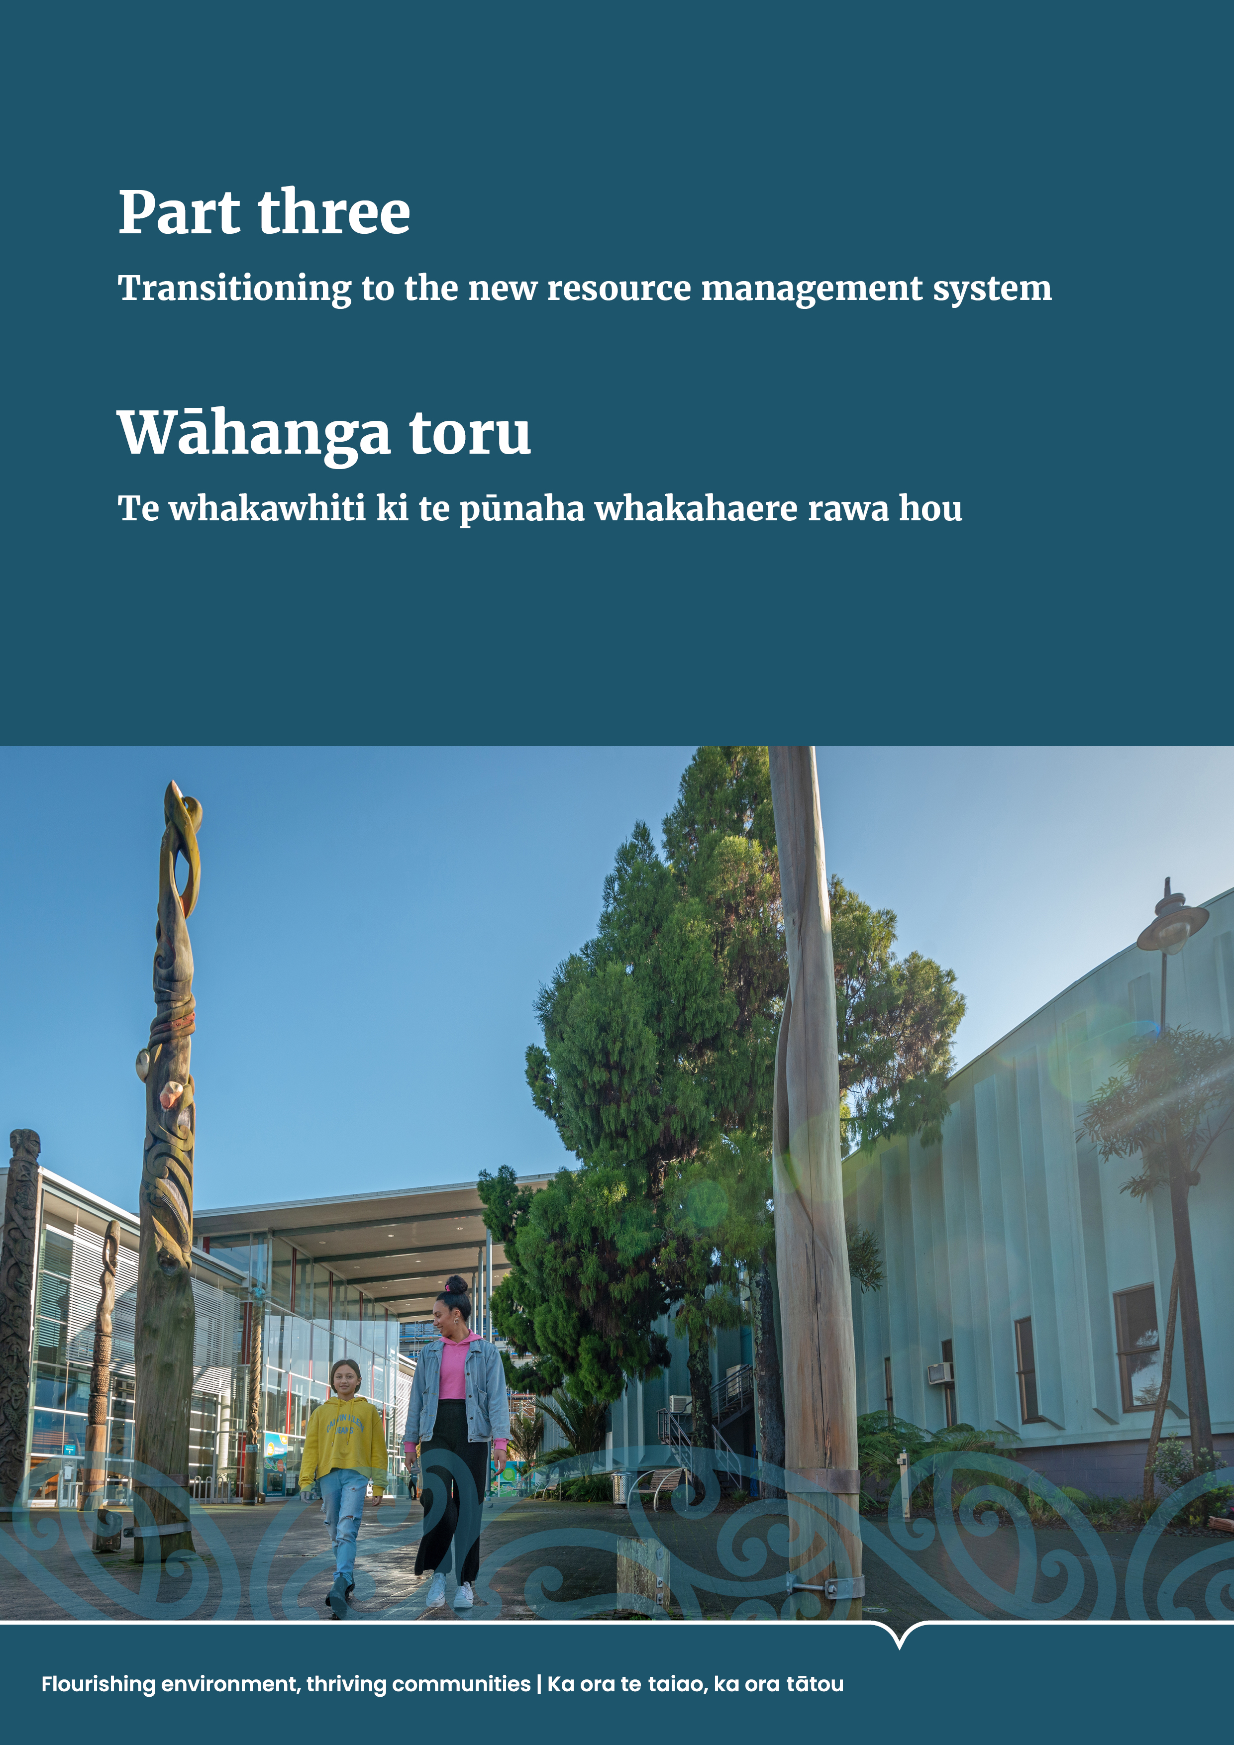

Part three: Transitioning to the new resource management system

Overview and objectives
The new resource management system requires changes for local government, hapū, iwi and Māori, central government, stakeholders and other participants in the system. The Ministry for the Environment (the Ministry) and the Spatial Planning Board have work underway to support the transition to and implementation of the new system.
The objectives for transition and implementation are to:
- have the necessary measures in place to ensure transformational change in the system
- provide as much certainty as possible through the transition for system users and implementers
- enable hapū, iwi and Māori to effectively participate as partners in the new system, and enable te ao Māori and mātauranga Māori to guide the transition and implementation of the new system
- maintain and strengthen system integrity and stewardship
- implement the new system in an efficient and effective way, focused on reducing complexity and partnering for success.
A region will generally switch from applying the Resource Management Act 1991 (RMA) to applying the Natural and Built Environment Act (NBA) once a regional spatial strategy (RSS) and a natural and built environment plan (NBE plan) are in place in that region. Different regions will switch at different times. It is therefore important to maintain robust implementation of the RMA while the new system is being established.

Legislated timing and processes
The transition to the new resource management system is expected to take up to 10 years. It will be complete once every region has an RSS and an NBE plan in place and any residual RMA consent processes are finished. Several interdependencies shape the timing of the transition to and implementation of the new system. These are laid out in the legislation and include the following.
- The transitional National Planning Framework (NPF) will direct the development of the first RSS. It must be notified within eight months of enactment and is anticipated to be in force in 2025.
- There is a process outlined in the legislation to uphold Treaty settlements, the Ngā Rohe Moana o Ngā Hapū o Ngāti Porou Act 2019 (NHNP Act) and other arrangements in the new system.
- A regional planning committee (RPC) must be established in each region and will have at least six members with membership from local authorities and at least
two Māori members appointed through a Māori appointment process. Regions
will decide for themselves whether they want more members than the minimum required.
- Central government will appoint one member to each RPC in relation to development of its RSS only (not for the NBE plan).
- Each RPC must develop an RSS and an NBE plan.
The time required to complete these steps will differ in each region. Figure 9 sets out an indicative timetable for implementation.
- Indicative implementation rollout sequence
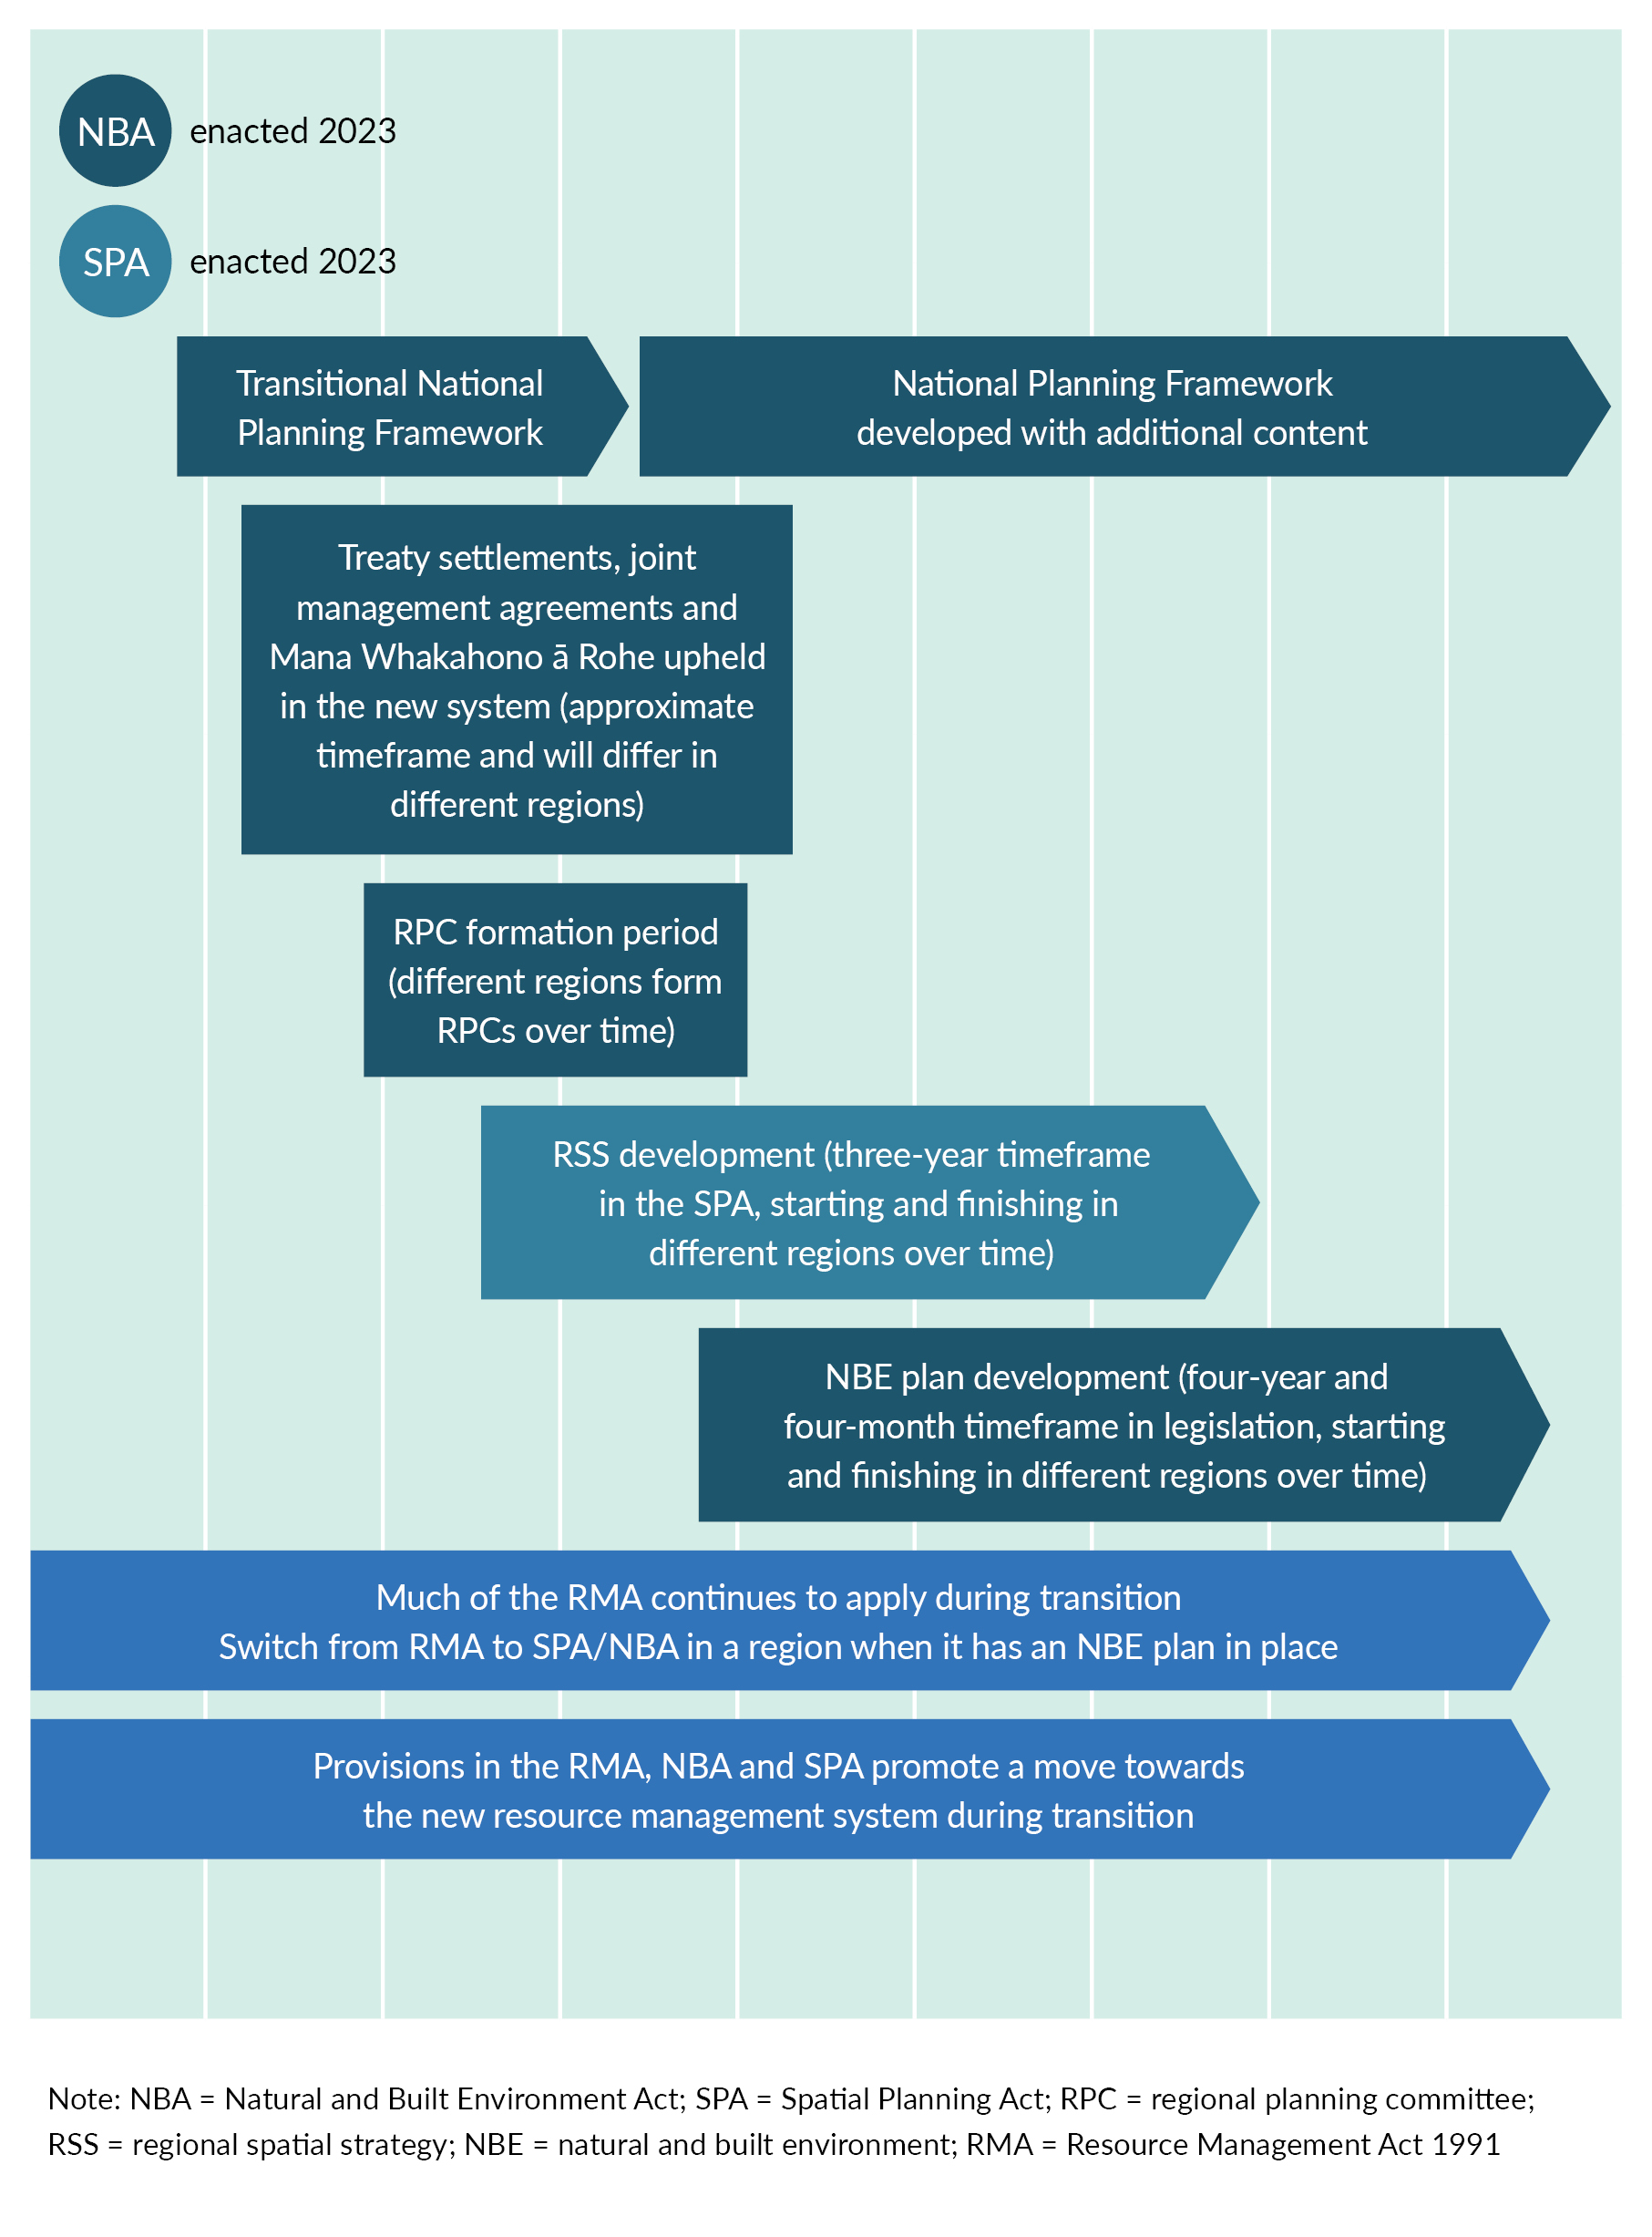

Forming regional planning committees
The process for forming an RPC is described in part two. The formation process for an RPC in a region begins with an Order in Council, subject to any one of the following conditions.
- Agreement has been reached with the relevant parties on upholding Treaty settlements, the NHNP Act and other applicable arrangements, and there is agreement from the relevant parties to initiate RPC formation.
- Agreement has been reached with the relevant parties on upholding other arrangements, and amendments to the relevant Treaty settlement Acts or the NHNP Act have been enacted.
- The Order in Council occurs at least two years after enactment of the NBA.
Alongside this, there is a requirement for decision makers under the NBA to give existing Treaty settlements, the NHNP Act and other arrangements the same or equivalent effect as they have in relation to the RMA. This requirement continues until amendment legislation has been enacted upholding relevant Treaty settlements and the NHNP Act (if required) or until the other arrangements have been transitioned.
The Crown must use its best endeavours to promote the enactment of amendments to Treaty settlement legislation and the NHNP Act within 18 months of royal assent of the NBA.
Once initiated in a region, the RPC formation process has prescribed timeframes of up to 12 to 18 months, depending on whether there is agreement on the composition and appointments processes for the RPC. The Minister can extend the timeframes, subject to criteria.

Developing regional spatial strategies
The process for developing an RSS is described in part two. A region’s first RSS must be adopted within three years of the establishment of an RPC. The Minister responsible may grant extensions, subject to certain criteria.
The Spatial Planning Board governs and supports the implementation of the Spatial Planning Act. It will fulfil a critical central government coordination role, along with implementation support, monitoring and stewardship functions. The Board will be supported by the Spatial Planning Policy Office.

Developing natural and built environment plans
The process for developing an NBE plan is described in part two. The development of a region’s first NBE plan will take no more than four years and four months, and this timeframe starts no later than 40 working days after an RSS is adopted.
An RPC will determine to what extent its RSS and NBE plan will be developed concurrently, if at all.

Transitioning to the new system
Until a region has an NBE plan in place, much of the RMA continues to apply. This includes national direction, regional policy statements and plans, and many processes such as consenting and designations. Councils need to continue implementing these instruments during this time.
It is important that robust implementation of the RMA is maintained during the transition period. This includes work to address critical issues, such as those related to freshwater, urban development and natural hazards.
Councils must continue to progress changes to existing RMA plans particularly in respect of freshwater.
At any one time, only one law (ie, either the RMA or the NBA) will apply to individual proceedings and decisions such as resource consent applications. Consenting under the NBA will begin in a region once an NBE plan is in place.
- Transition stages in the new system
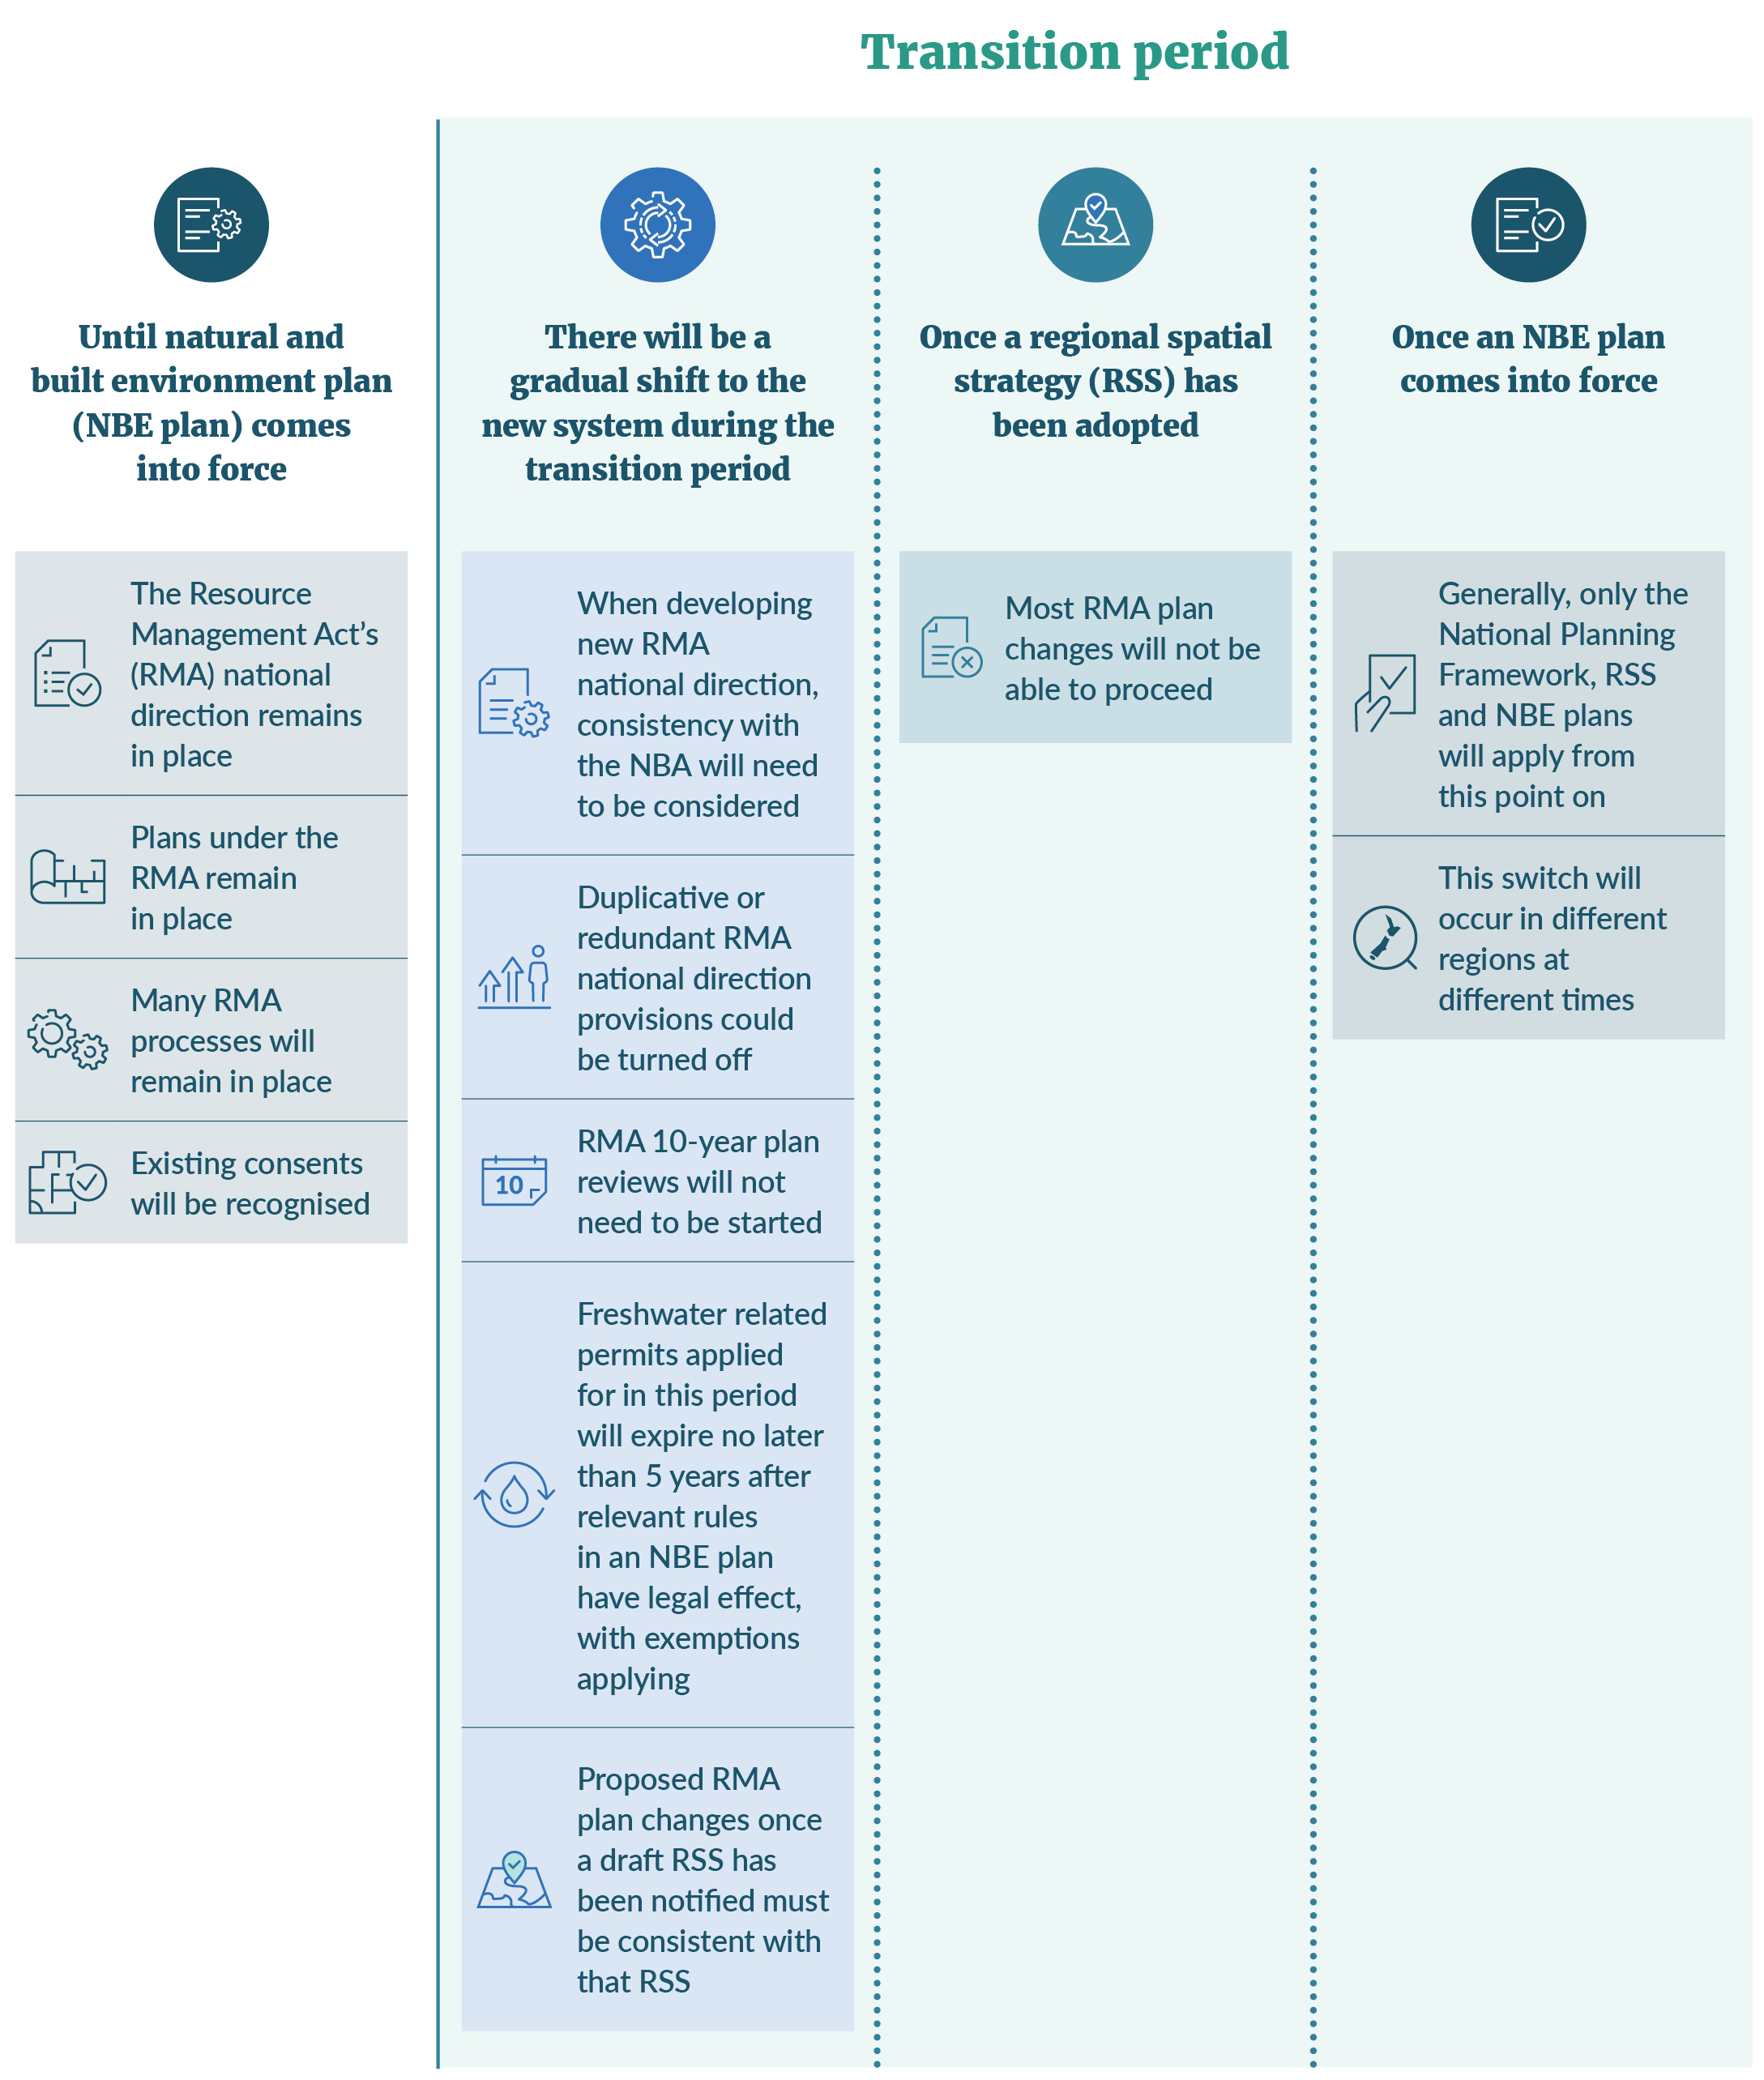

RMA national direction
Existing RMA national direction will remain in force during the transition and will continue to direct all day-to-day consenting and planning decisions in regions where an NBE plan is not yet in place.
The NPF will inform the development of RSS and NBE plans and will not apply to RMA plans while they are current.
The policy intent of existing RMA national direction will be consolidated into the NPF. Therefore, much of the work councils and others undertake to implement existing RMA national direction, such as the National Policy Statement for Freshwater Management 2020 and the National Policy Statement on Urban Development 2020, can be used to support the development of RSS and NBE plans.
The Minister may amend the RMA national direction during the transition period ­including by using a combined process with development of the NPF to promote consistency. The Minister may also make amendments to existing RMA national direction without using a public consultation process, if the content would be more efficiently addressed through processes in the Spatial Planning Act (SPA) or NBA or
if the content is redundant in the context of transition.

New provisions that apply from the day after royal assent
Many aspects of the new resource management legislation will only apply once an RSS and an NBE plan are in place. However, the SPA and various NBA provisions come into force on the day after royal assent. These include a requirement to develop the NPF.
A small number of NBA provisions relating to decision-making and on-the-ground processes apply from the day after royal assent or shortly after that. These include provisions relating to fast-track consenting, compliance and enforcement, management of aquaculture and who can apply to become a requiring authority. There is also a requirement in the NBA that the integrity, intent and effect of Treaty settlements, the NHNP Act and other arrangements made under the RMA are upheld in the new Act and system.

RMA changes that apply during the transition period
The application of some RMA provisions has been amended either through direct amendments to the RMA or through transitional provisions in the NBA. Examples of application during transition include the following.
- New applications for freshwater-related resource consents lodged from the day after the NBA receives royal assent will be subject to a reduced maximum duration, with some exemptions applying.
- RMA plan changes can be made in a region until the RPC adopts an RSS. After this time, RMA plan changes can only be made to address urgent issues or errors, and to implement national direction.
- The requirement to begin RMA plan reviews will cease when the NBA is enacted. Reviews that are underway may continue.
- Amendments to the RMA related to the Freshwater Planning Process, to clarify the application of section 80A.
- Some of the NBA’s new compliance monitoring and enforcement powers and tools may be used immediately under the RMA. Examples include provisions related to increased fines, improved financial assurance and longer limitation periods. Other new provisions will be available either six months or two years after royal assent.

Support for a successful transition and implementation
The Government has a range of work programmes underway to support a successful transition and implementation process. This includes maintaining effective implementation of the RMA while core elements of the new system are being developed.
Implementation will be led regionally and build on the existing knowledge, work and relationships of councils, hapū, iwi and Māori, and other users of the system. Central government will support and enable these efforts.

Supporting the first regions to implement the system
Some regions will be ready to implement the new system earlier than others. The Government will support and work closely with these first regions to establish their RPCs, and to develop their RSS and NBE plans.
This first group of regions will help demonstrate the workability of the new system, provide lessons for the regions that follow, and inform the type of support and system improvements that may be needed.
Work is also underway to explore how the Government can support the regions that follow to prepare for their transition.

Practice, capacity and training
The Ministry has work underway to identify the number and characteristics of people currently working in the resource management workforce. This work is focused on the demands on the workforce during transition, and its capacity to deliver the requirements of the new system effectively.
The research will inform planned work on the practice and capacity support needed for users of the new system. This will enable local government, hapū, iwi and Māori, and resource management practitioners to partner and participate successfully.
Work is also underway to ensure those who interact with the system have the information they need to understand and implement it. This includes information on how the RMA applies during the transition. Initial information will be available on the Ministry’s website soon after royal assent of the SPA and NBA, and more detailed information and guidance will be published later.

Using digital technologies and data services
Digital technology and data services can provide valuable support to ensure the new system is efficient and effective. A robust digital system will help more people access and use information to improve the quality of the resource management system.
The Ministry has established advisory groups comprised of members from local government, central government agencies, and hapū, iwi and Māori to investigate digital technologies that could support the needs of regions and their communities.

Funding in the future system
The Government has allocated significant funding to support the development and implementation of the new system. Over the next few years, this funding will help central government to:
- fund costs for hapū, iwi and Māori participation in national-level functions
- uphold the Crown’s Tiriti obligation to ensure hapū, iwi and Māori are adequately resourced to undertake their legislated role in the system
- provide support for local government and hapū, iwi and Māori to transition to the new system.
Local government will fund:
- RPCs and their secretariats, which are jointly funded by the relevant regional and territorial authorities
- ongoing hapū, iwi and Māori participation in functions at a regional level.

Appendix 1: List of abbreviations
CCAA | Climate Change Adaptation Act
CCAB | Climate Change Adaptation Bill
CIP | construction and implementation plan
ECP | expert consenting panel
IHP | independent hearing panel
NBA | Natural and Built Environment Act
NBE Bill | Natural and Built Environment Bill
NBE plan | natural and built environment plan
NHNP Act | Ngā Rohe Moana o Ngā Hapū o Ngāti Porou Act 2019
NPF | National Planning Framework
PCE | Parliamentary Commissioner for the Environment
RMA | Resource Management Act 1991
RPC/s | regional planning committee/s
RSS | regional spatial strategy/regional spatial strategies
SAR | supplementary analysis report
SCO/s | statement/s of community outcomes
SP Bill | Spatial Planning Bill
SPA | Spatial Planning Act
SREO/s | statement/s of regional environmental outcomes

Appendix 2: Resource management reform key documents
Environment Committee. 2021. Inquiry on the Natural and Built Environments Bill: Parliamentary Paper.
Environment Committee. 2023. Natural and Built Environment Bill, As reported from the Environment Committee.
Environment Committee. 2023. Spatial Planning Bill, As reported from the Environment Committee.
Ministry for the Environment. 2020. Reforming the resource management system. Cabinet Paper CAB-20-MIN-0522. Wellington: Cabinet Office, Department of the Prime Minister and Cabinet.
Ministry for the Environment. 2021. Departmental Report on the Natural and Built Environments Bill exposure draft 2021.
Ministry for the Environment. 2021. Extracts from Waitangi Tribunal commentary, findings and recommendations on the Resource Management Act 1991.
Ministry for the Environment. 2021. Interim regulatory impact statement: Reforming the resource management system.
Ministry for the Environment. 2021. Natural and Built Environments Bill: Parliamentary paper on the exposure draft.
Ministry for the Environment. 2021. Our future resource management system: Materials for discussion.
Ministry for the Environment. 2021. Resource management system reform – update on policy decisions and proposal to undertake further engagement. Cabinet Paper CAB-21-MIN-0469. Wellington: Cabinet Office, Department of the Prime Minister and Cabinet.
Ministry for the Environment. 2022. Natural and Built Environment Bill and Spatial Planning Bill: Approval for Introduction. Cabinet Paper CAB-22-MIN-0485. Wellington: Cabinet Office, Department of the Prime Minister and Cabinet.
Ministry for the Environment. 2022. Our future resource management system: Overview.
Ministry for the Environment. 2022. Resource management reform: The need for change.
Ministry for the Environment. 2022. Resource management system reform: update on how the reform objectives will be achieved. Cabinet Paper CAB-22-MIN-0458. Wellington: Cabinet Office, Department of the Prime Minister and Cabinet.
Ministry for the Environment. 2022. Supplementary Analysis Report: The new resource management system.
Ministry for the Environment. 2023. Departmental Report on the Natural and Built Environment Bill (report and supporting documents are under ‘Submissions and Advice’ tab).
Ministry for the Environment. 2023. Departmental Report on the Spatial Planning Bill (report and supporting documents are under ‘Submissions and Advice’ tab).
Ministry for the Environment. 2023. Our future resource management system: Developing the next stages.
Ministry for the Environment. 2023. Our future resource management system: Developing the National Planning Framework.
Ministry for the Environment. 2023. Resource management reform: Environmental limits and targets.
New Zealand Productivity Commission. 2017. Better urban planning: Final report.
Parliamentary Counsel Office. 2023. Natural and Built Environment Bill.
Parliamentary Counsel Office. 2023. Spatial Planning Bill.
Resource Management Review Panel. 2020. New Directions for Resource Management in New Zealand: Report of the Resource Management Review Panel: Summary and key recommendations.
Severinsen G, Peart R. 2018. Reform of the Resource Management System: A model for the Future: Synthesis report. Prepared for the Environmental Defence Society Incorporated.





The Natural and Built Environment Act was called the Natural and Built Environments Act by the Randerson Panel. The ‘s’ has since been dropped on the basis that there is one environment, even though it is made up of various components.
The Spatial Planning Act was originally called the Strategic Planning Act by the Randerson Panel. It has been renamed to better describe its function.
Report of the Expert Working Group on Managed Retreat: A Proposed System for Te Hekenga Rauora/Planned Relocation and Community-led retreat and adaptation funding – issues and options.
Resource Management Review Panel. 2020. New Directions for Resource Management in New Zealand: Report of the Resource Management Panel Review Panel.
New Zealand Productivity Commission. 2017. Better Urban Planning: Final Report.
Severinsen G, Peart R. 2018. Reform of the Resource Management System: The Next Generation Synthesis Report. Prepared for the Environmental Defence Society Incorporated.
Ministry for the Environment. 2021. Extracts from Waitangi Tribunal Commentary, Findings and Recommendations on the Resource Management Act 1991.
The Strategic Planning Reform Board was renamed the Spatial Planning Board in July 2023 and has new functions relating to the implementation of the SPA.
Resource Management Review Panel. November 2019. Transforming the Resource Management System: Opportunities for Change – Issues and Options Paper.
An exposure draft Bill is a version of a draft Bill that is released, in whole or in part, before the Bill is introduced.
There are 11 regions and 5 unitary councils in Aotearoa, making a total of 16 regions. Nelson and Tasman will plan their RSS and NBE plans together, which is why there are only 15 RSS required to be developed across Aotearoa. The Chatham Islands is not required to complete an RSS (although it can choose to) but it must develop an NBE plan, which is why there are 16 NBE plans in the new system.
Ministry for the Environment. 2022. Supplementary Analysis Report: The new resource management system. Wellington: Ministry for the Environment.
The benefit-cost ratio is an indicator showing the relationship between the relative costs and benefits of a proposed programme, expressed in monetary or qualitative terms. If the benefit-cost ratio is greater than 1.0, the programme is expected to deliver a positive net present value.
Nelson and Tasman are treated as a single region, and the Chatham Islands is not required to have an RSS.
Note that the durations of freshwater consents are becoming shorter. For example, the average length of freshwater take consents issued in 2021 for Waikato, Hawke’s Bay, Marlborough, Canterbury and Southland was 10–13 years.
Members of the board comprise chief executives of the Ministries for the Environment, of Transport, and Housing and Urban Development and the Departments of Internal Affairs and Conservation. The chief executive of Te Arawhiti participates in board meetings as an advisor.
This means that 10 working days have passed since the RPC published its decisions on an independent hearing panel’s recommendations. At this point the first plan is treated as operative, with some exceptions. For further information, please refer to the new resource management legislation or the Ministry’s website.

