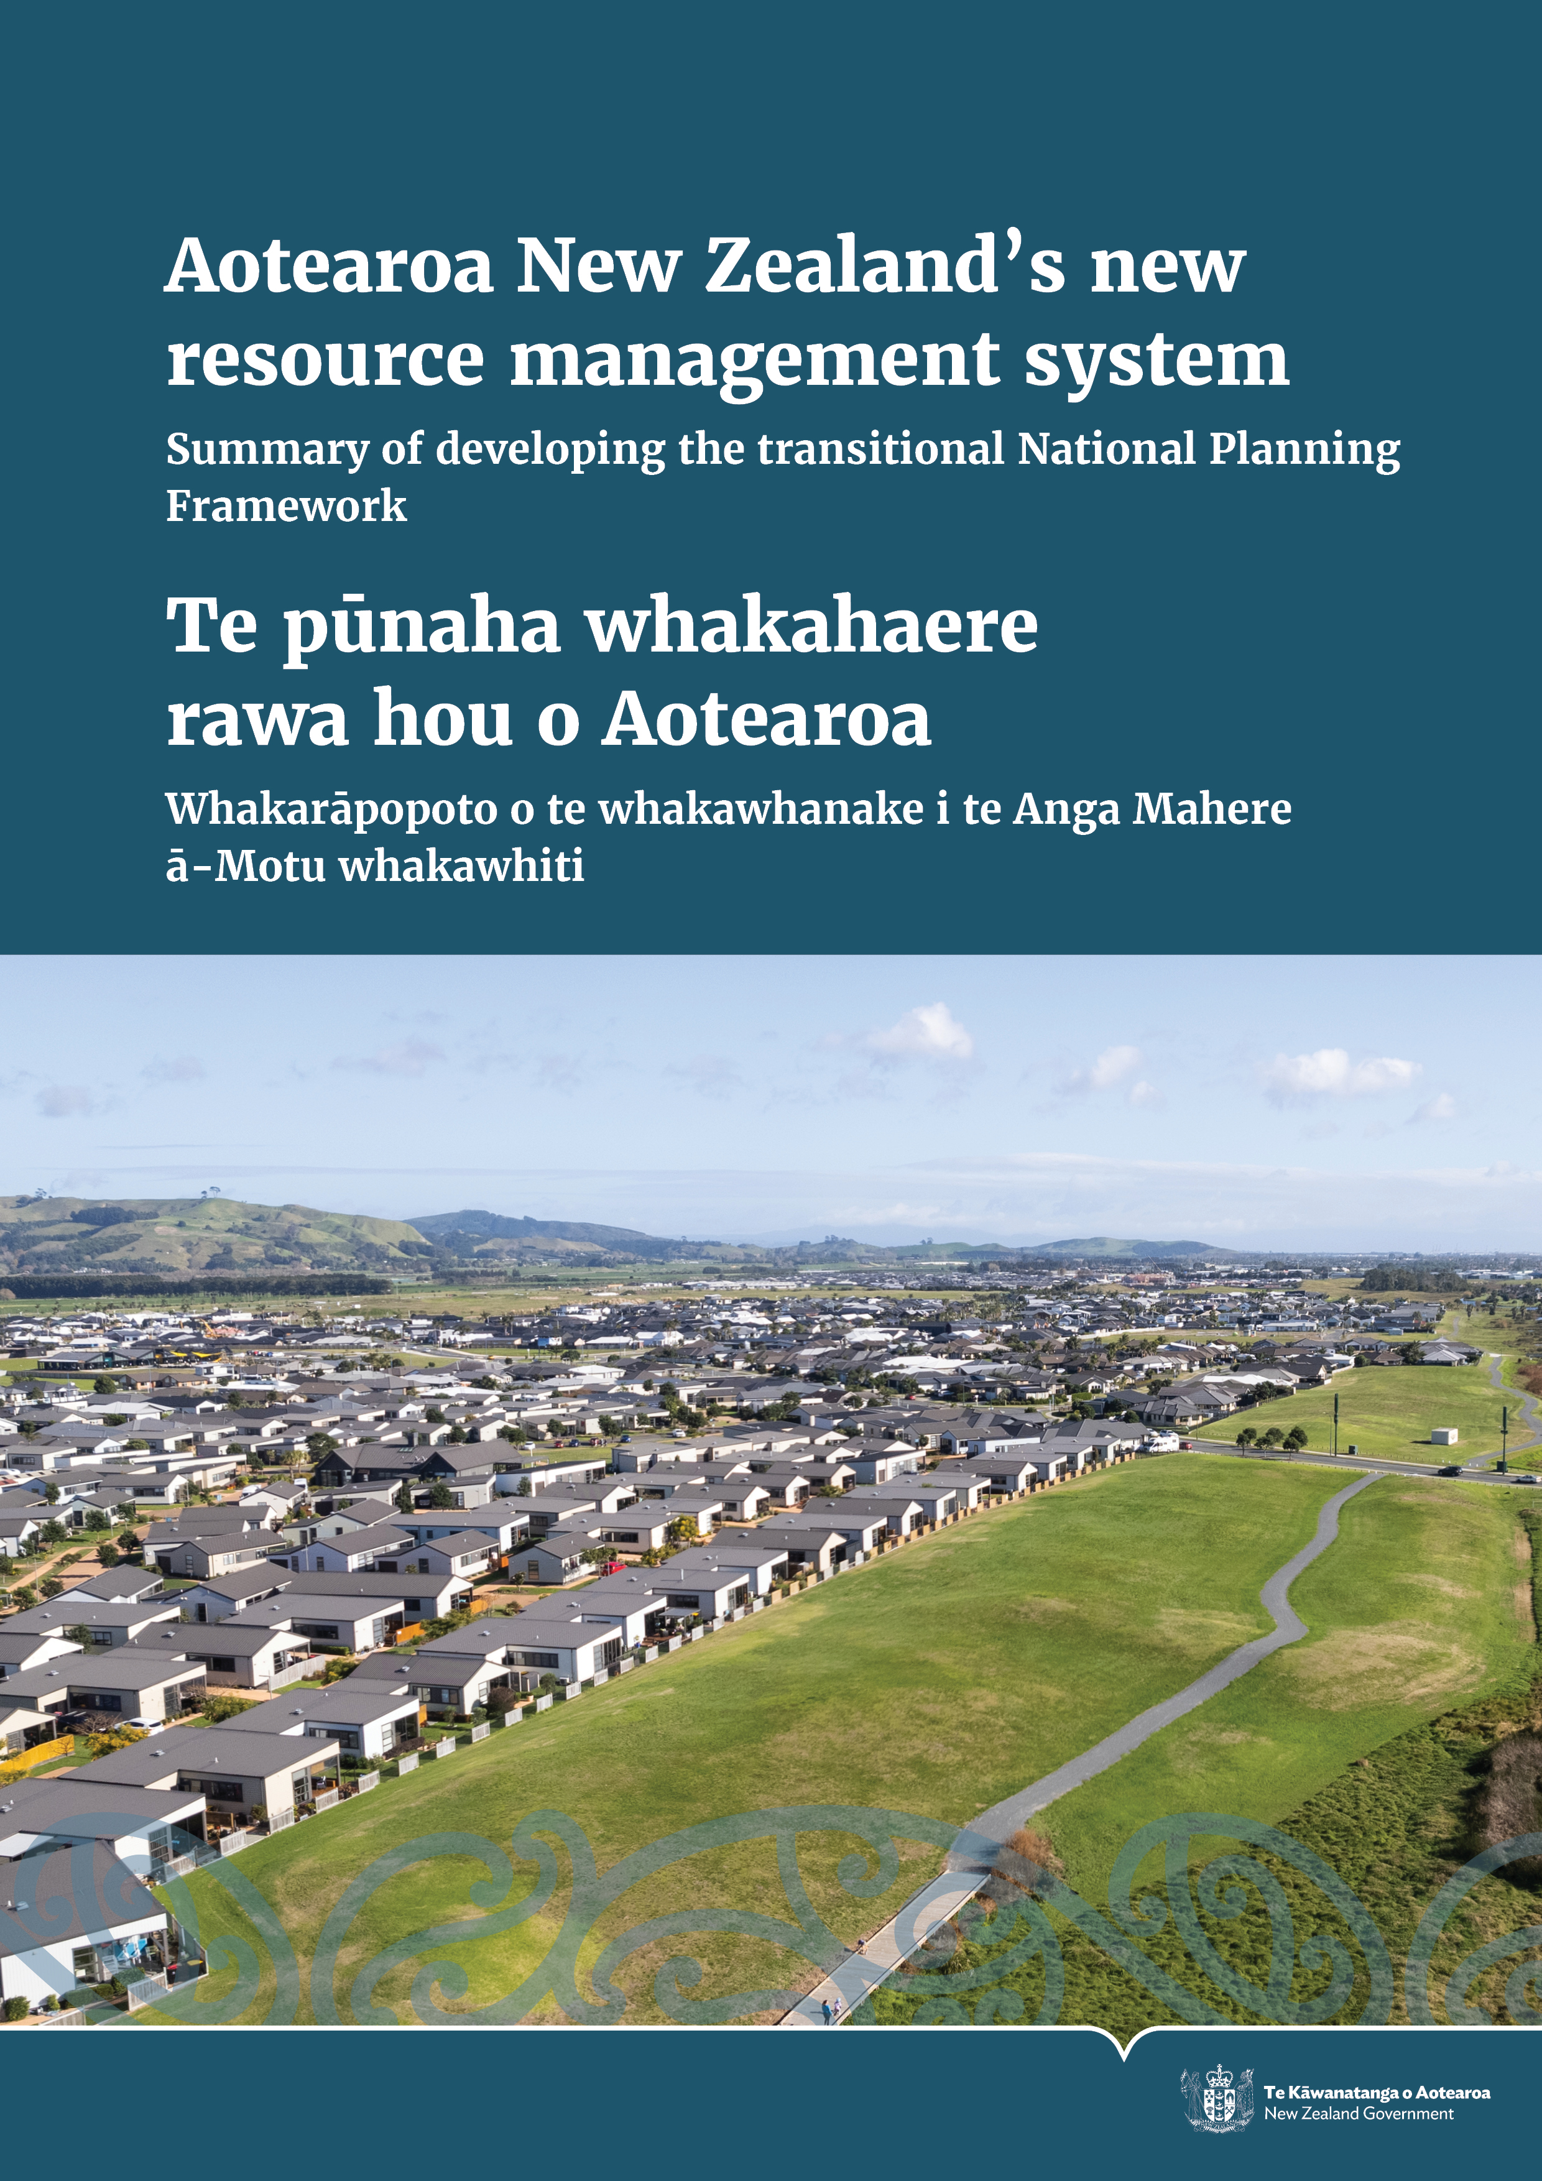

Disclaimer
The information in this publication is, according to the Ministry for the Environment’s best efforts, accurate at the time of publication. The Ministry will make every reasonable effort to keep it current and accurate. However, users of this publication are advised that:
- the information does not alter the laws of Aotearoa New Zealand, other official guidelines, or requirements
- it does not constitute legal advice, and users should take specific advice from qualified professionals before taking any action based on information in this publication
- the Ministry does not accept any responsibility or liability whatsoever whether in contract, tort, equity, or otherwise for any action taken as a result of reading, or reliance placed on this publication because of having read any part, or all, of the information in this publication or for any error, or inadequacy, deficiency, flaw in, or omission from the information in this publication
- all references to websites, organisations, or people not within the Ministry are for convenience only and should not be taken as endorsement of those websites or information contained in those websites nor of organisations or people referred to.

This document may be cited as Ministry for the Environment. 2023. Aotearoa New Zealand’s new resource management system: Summary of developing the transitional National Planning Framework | Te pūnaha whakahaere rawa hou o Aotearoa: Whakarāpopoto o te whakawhanake i te Anga Mahere ā-Motu whakawhiti. Wellington: Manatū Mō Te Taiao | Ministry for the Environment.

Published in October 2023 by the
Ministry for the Environment
Manatū Mō Te Taiao
PO Box 10362, Wellington 6143, New Zealand
ISBN: 978-1-991077-91-2 (online)
Publication number: ME 1804
© Crown copyright New Zealand 2023
This document is available on the Ministry for the Environment website: www.mfe.govt.nz.

Contents
Introduction 5
Context 5
The purpose of the National Planning Framework (NPF) 8
What’s in the draft transitional NPF proposal? 8
Next steps 10
Appendix A: Detailed overview of the content of the transitional National Planning Framework (NPF) proposal 12

Tables
Table 1: Scope and structure of the draft engagement version of the transitional NPF proposal 12
Table 2: Resource Management Act 1991 (RMA) National Direction in the transitional NPF proposal and future NPFs 15
Table 3: Changes to existing national direction to ensure consistency with the Natural and Built Environment Act 2023 (NBA) and Spatial Planning Act 2023 (SPA 16
Table 4: Proposed new attributes for which limits must be set 19

Figures
Figure 1: Key components of the future resource management system 6
Figure 2: Timeline of the resource management reform journey 7
Figure 3: Indicative implementation rollout sequence 11

Introduction
The Minister for the Environment (together with the Minister of Conservation) is reaching out to local government and our Māori partners to help develop and shape the draft transitional National Planning Framework (NPF) proposal before it is publicly notified and referred to a Board of Inquiry (BOI) for public submissions in April 2024.
The Ministry for the Environment (the Ministry) has prepared this document to help explain the draft of the transitional NPF proposal and assist our key partners in providing feedback.

Context
After nearly 30 years of the Resource Management Act 1991 (RMA), in 2019 the Government began rethinking the laws governing te taiao (the environment).
New challenges were being acknowledged such as climate change, so an expert panel was set up to advise the Government on the next steps.
As a result of the expert panel’s advice, a pathway for reform of the resource management (RM) system was suggested, and new laws have been passed to provide the legal framework for change – the Natural and Built Environment Act 2023 (NBA) and the Spatial Planning Act 2023 (SPA).
A third law, the Climate Change Adaptation Bill, is still being worked on. Once passed, this will complete the new legislation package to replace the RMA.
In essence, the intent of the new laws is to protect te taiao while providing for Aotearoa New Zealand’s need for development and infrastructure.
Some changes will start immediately, but it’s going to take up to 10 years to shift entirely into the new RM system.
One of the major reform changes is the NPF. The engagement draft of the transitional NPF proposal brings together multiple national policy statements, national environmental standards, and regulations that exist under the RMA. The draft also suggests new direction for several areas.
The proposal sets the foundation for regional planning and decision-making under the new legislation.
Under the new RM system, regional planning committees (RPCs) will develop 15 regional spatial strategies (RSSs) across Aotearoa. The aim is for the transitional NPF to be in place in 2025, to inform the first RSS.
- Key components of the future resource management system
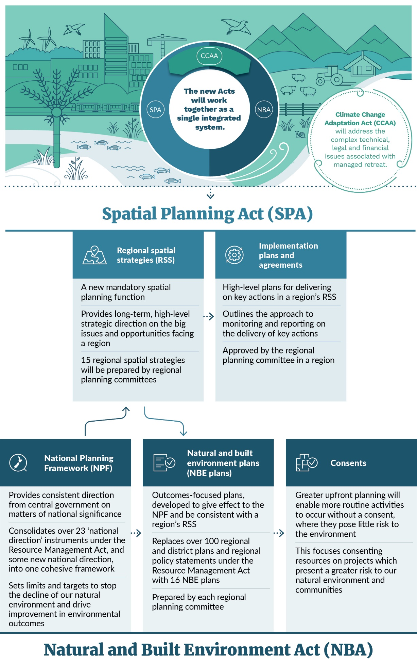
- Timeline of the resource management reform journey
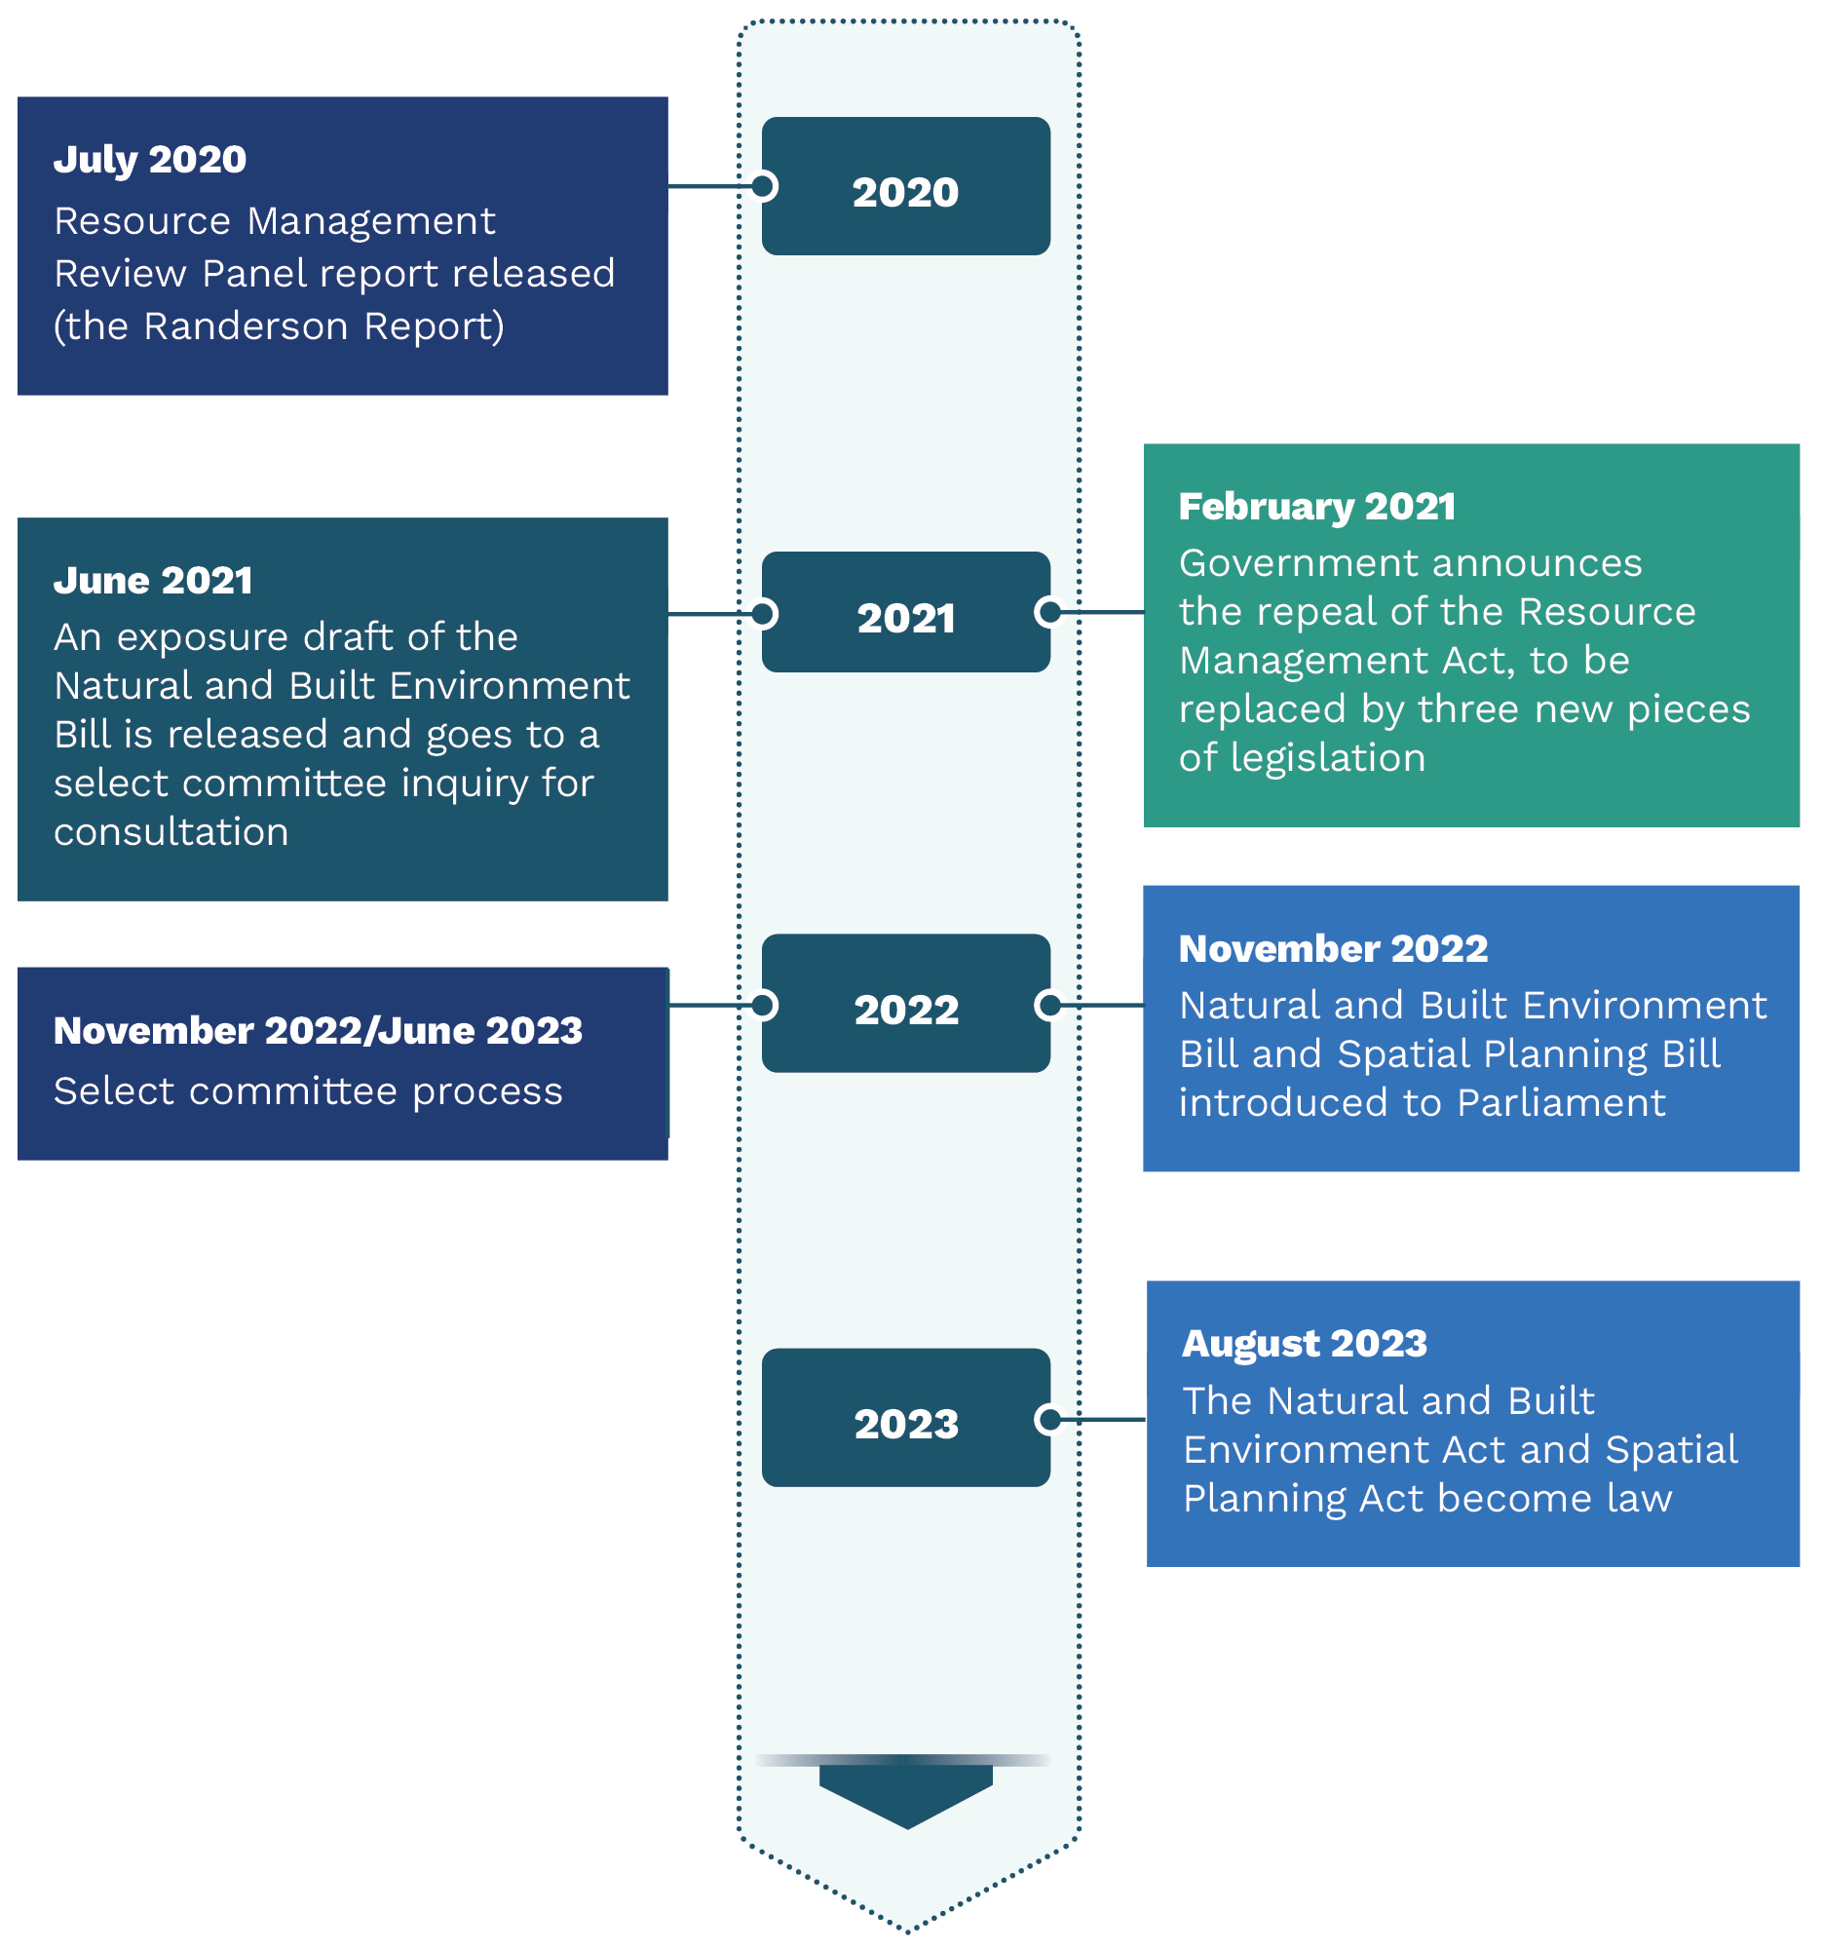

The purpose of the National Planning Framework (NPF)
The transitional NPF proposal merges many of the national policy statements, standards, and regulations produced under the Resource Management Act 1991 (RMA) into one framework, alongside new direction where needed, to guide regional decision-making on how to manage te taiao (the environment).
The NPF must:
- uphold te Oranga o te Taiao
- give effect to the principles of te Tiriti o Waitangi (the Treaty of Waitangi)
- set the platform for new natural and built environment plans (NBE plans) to achieve positive outcomes for te taiao
- be made in accordance with the decision-making principles in the Natural and Built Environment Act 2023 (NBA)
- set environmental limits and targets, or provide direction for the setting of environmental limits and targets in NBE plans.

What’s in the draft transitional NPF proposal?
The content of the draft transitional NPF proposal is structured as a series of ‘domain parts’, focused on environmental domains (such as freshwater, or the coastal environment) and topic areas (such as urban development or infrastructure). The transitional NPF proposal has an overarching layer that links the existing national policy statements and rules under the RMA with the new direction under the NBA.
The draft transitional NPF proposal includes the following.
- Preliminary provisions deal with matters such as commencement, interpretation/definitions, and provide an explanation of how to use the NPF.
- Overarching content that provides broad system direction aimed at helping the implementation of policy in an integrated manner.
- Existing RMA national direction. The NBA requires that the transitional NPF proposal is prepared on the basis of RMA national direction to the extent it is compatible with the requirements of the NBA.
- New national direction provides for system outcomes in the NBA that are not adequately covered by current RMA national direction, or the overarching layer mentioned above. This is a requirement of the NBA. The main topics covered by this national direction are:
- protection (or, if degraded, restoration) of outstanding natural features (ONFs) and outstanding natural landscapes (ONLs)
- conservation of cultural heritage
- reduction of greenhouse gas emissions and removal of those gases from the atmosphere
- risk reduction, adaptation, and resilience to the effects of natural hazards and climate change
- infrastructure direction, including policy, standards and rules to improve its efficient delivery.
- New national direction on urban trees and green spaces is provided in the urban chapter.
- Plan-making requirements, such as a regional spatial strategy (RSS) template, are provided.
A detailed breakdown of what is and is not included at this stage can be found in appendix A.

Next steps
The Minister for the Environment and the Minister of Conservation are now receiving feedback from local government, iwi authorities, groups that represent hapū, and groups that represent Māori, on the engagement draft of the transitional National Planning Framework (NPF) proposal, to assist in its further development before consideration by a Board of Inquiry (BOI). This period of engagement will run from September 2023 until December 2023.
Once this period of engagement has concluded, the feedback will be considered and will inform the transitional NPF proposal. The transitional NPF proposal is expected to be notified around April 2024, and public submissions will be invited. A BOI has been established to enquire into the proposal and hear public submissions.

Board of Inquiry process
The BOI will consider the submissions and provide recommendations to the Minister for the Environment and the Minister of Conservation on the transitional NPF proposal. This process will inform decisions on the transitional NPF proposal, expected to be made by the responsible Minister in 2025. The transitional NPF proposal is expected to come into force in 2025, to inform the development of RSSs.
- Indicative implementation rollout sequence
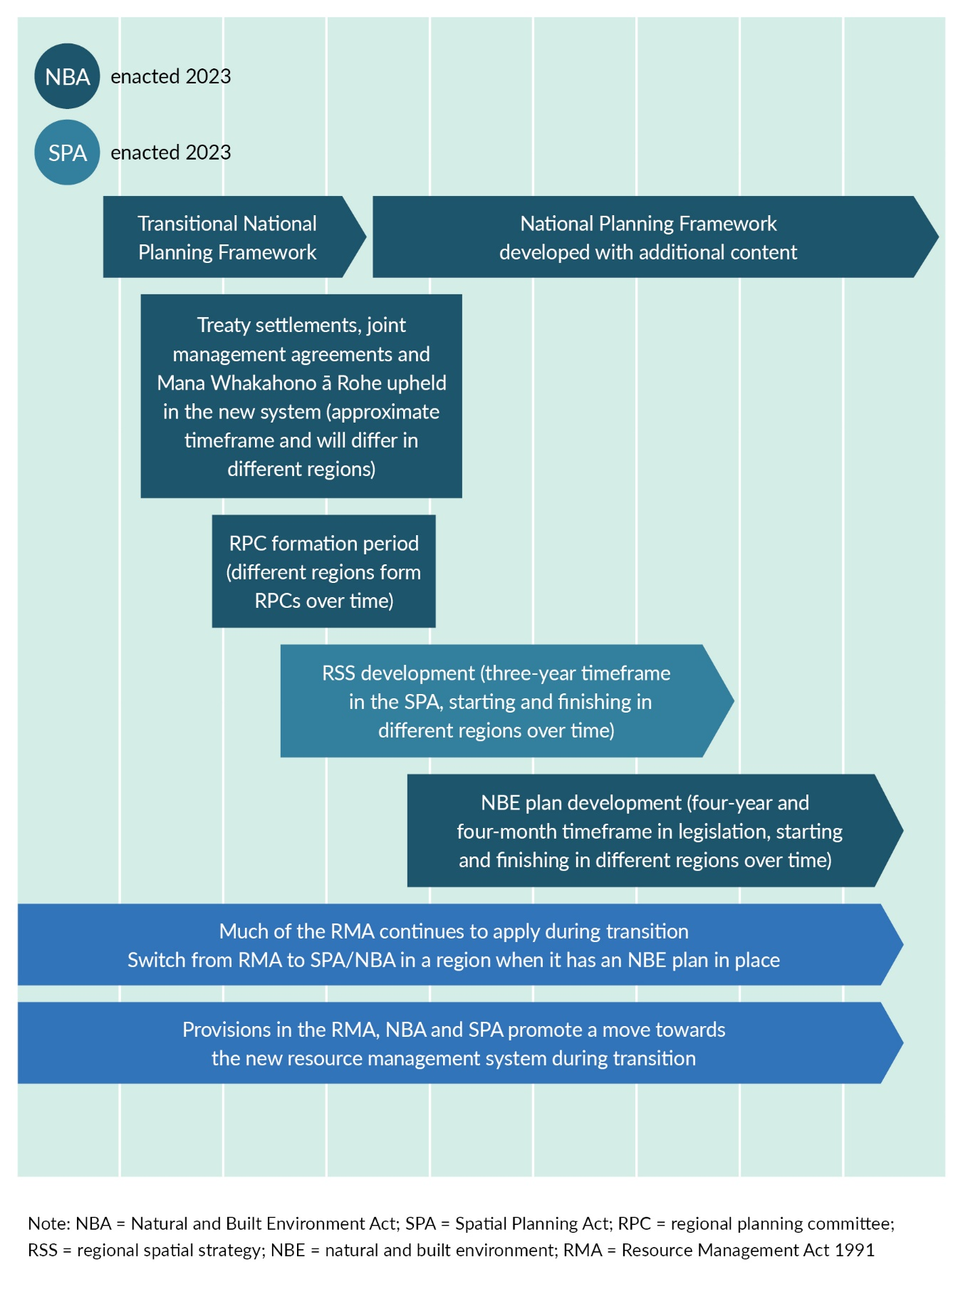

Appendix A: Detailed overview of the content of the transitional National Planning Framework (NPF) proposal
- Scope and structure of the draft engagement version of the transitional NPF proposal
Part | Content
Preliminary provisions | - Title  - Commencement
Overarching matters | Content that assists the integration of the domain parts of the NPF by addressing cross-cutting issues  - Interpretation  - Direction on decision-making, including integrated management, long-term planning, nature-based solutions, and resolving conflicts between environmental matters  - Engagement with iwi, hapū and other Māori groups  - Monitoring the implementation and effectiveness of the NPF  - Environmental limits and targets
Freshwater | - Redrafted National Policy Statement for Freshwater Management (NPS-FM), retaining Te Mana o Te Wai  - Redrafted National Environmental Standards for Freshwater (NES-F)  - Redrafted Resource Management (Stock Exclusion) Regulations  - Redrafted Resource Management (Measurement and Reporting of Water Takes) Regulations
Coastal environment | - Redrafted New Zealand Coastal Policy Statement 2010 (NZCPS)  - Redrafted National Environmental Standards for Marine Aquaculture (NES-MA)
Land and soil | - Redrafted National Policy Statement for Highly Productive Land (NPS-HPL)  - Redrafted National Environmental Standards for Assessing and Managing Contaminants in Soil to Protect Human Health (NES-CS)  - Redrafted National Environmental Standards for Storing Tyres Outdoors (NES-STO)
Air | - Redrafted National Environmental Standards for Air Quality (NES-AQ) (in part)
Indigenous biodiversity | - Redrafted National Policy Statement for Indigenous Biodiversity (NPS-IB)
ONFs and ONLs | High-level strategic direction on protecting and restoring degraded outstanding natural features (ONFs) and outstanding natural landscapes (ONLs)  - The main components are:  - a framework outcome for ONFs and ONLs  - a requirement to consider the location, extent, values and characteristics for ONFs and ONLs  - a requirement to consider the ways available to support the protection, maintenance and, where appropriate, the restoration of identified ONFs and identified ONLs  - a requirement to consider potential conflicts between protection of landscapes and natural features and other activities, and how they can be resolved or reduced  - a requirement to consider what further work is needed to support the development of the content of the relevant natural and built environment plan (NBE plan) concerning the ONFs and ONLs in the region.
Cultural heritage | High-level strategic direction on protecting cultural heritage, including sites of significance to Māori  - The main components are:  - a framework outcome for cultural heritage  - a requirement to consider the location, extent and characteristics of cultural heritage  - a requirement to consider the ways available to support the protection, maintenance, restoration and, where appropriate, the enhancement of cultural heritage  - a requirement to consider the potential conflicts between cultural heritage protection and other activities, and how they can be resolved or reduced  - a requirement to consider what further work is needed to support the development of the content of the relevant NBE plan concerning the cultural heritage in the region.
Natural hazards and the effects of climate change | High-level strategic direction on risk reduction, adaptation, and resilience to natural hazards and climate change  - The main components are:  - a framework outcome for natural hazards and the effects of climate change  - a requirement to identify the natural hazards and effects of climate change that are particularly relevant to the region  - a requirement to consider the risks associated with natural hazards and effects of climate change, and to adopt a risk-management approach  - a requirement to consider strategic opportunities to adapt and increase resilience to natural hazards and the effects of climate change  - a requirement to consider whether more information is needed to prepare NBE plan content on natural hazards and the effects of climate change and associated risks.
Greenhouse gas emissions | - Redrafted National Policy Statement and National Environmental Standards for Greenhouse Gas Emissions from Industrial Process Heat (NPS/NES-IGHG)  New high-level direction on greenhouse gas emissions  - The main components are:  - a framework outcome for reducing and removing greenhouse gases, in order to mitigate climate change  - a requirement to consider opportunities to support activities, including land-use changes, that lead to reductions in greenhouse gas emissions  - a requirement to recognise and consider carbon sinks, including whether any need to be protected, restored or enhanced  - a requirement to broadly assess the greenhouse gas emissions impacts of future infrastructure and urban development using spatial scenarios in RSSs  - a requirement to consider whether more information or evidence is needed to prepare NBE plans in relation to greenhouse gas emissions reduction and removals.
Urban development | - Redrafted National Policy Statement for Urban Development (NPS-UD)  - Redrafted Resource Management (Enabling Housing Supply and Other Matters) Amendment Act – includes Medium Density Residential Standards (MDRS)  New high-level strategic direction for urban trees and green spaces  - The main components proposed are:  - policies for management of urban trees  - a requirement to consider urban tree canopy coverage when developing an RSS  - a requirement to consider whether further work is needed to support the development of NBE plan content on urban trees  - direction to ensure tree protection methods in NBE plans will be efficient and effective.
Infrastructure | - Redrafted National Environmental Standards for Electricity Transmission Activities (NES-ETA)  - Redrafted National Environmental Standards for Telecommunication Facilities (NES-TF)  High-level strategic direction for infrastructure  - The main components are:  - an infrastructure framework outcome  - policy to support the provision and protection of existing, planned and potential infrastructure  - integration of long-term land use and infrastructure planning and funding  - a requirement to engage with infrastructure providers early, to understand infrastructure needs  - the identification in RSS of opportunities for infrastructure and what must be considered when doing so  - managing conflicts between infrastructure and other outcomes, particularly in areas with environmental protections  - policy to enable renewable energy and other infrastructure that will reduce emissions and improve resilience to natural hazards and the effects of climate change  - standards and rules to provide consistency for common infrastructure activities.
Planning standards | - Redrafted National Planning Standards  - The main components are:  - a framework outcome regarding consistency across RSS and NBE plans  - contents and structure for RSS  - electronic accessibility and functionality standards for RSS  - noise and vibration standards and assessment methods.

- Resource Management Act 1991 (RMA) National Direction in the transitional NPF proposal and future NPFs
RMA National Direction included in the transitional NPF proposal | RMA National Direction intended to be included in future iterations of the NPF
- National Policy Statement for Freshwater Management (NPS-FM) (including 2023 amendments)  - National Environmental Standards for Freshwater (NES-F) (including 2023 amendments)  - Resource Management (Stock Exclusion) Regulations  - Resource Management (Measurement and Reporting of Water Takes) Regulations  - New Zealand Coastal Policy Statement 2010 (NZCPS)  - National Environmental Standards for Marine Aquaculture (NES-MA)  - National Policy Statement for Highly Productive Land (NPS-HPL)  - National Environmental Standards for Storing Tyres Outdoors (NES-STO)  - National Environmental Standards for Assessing and Managing Contaminants in Soil (NES-CS)  - National Policy Statement for Indigenous Biodiversity (NPS-IB)  - National Environmental Standards for Air Quality (NES-AQ) (in part)  - National Policy Statement and National Environmental Standards for Greenhouse Gas Emissions from Industrial Process Heat (NPS/NES-IGHG)  - National Policy Statement for Urban Development (NPS-UD) and Resource Management (Enabling Housing Supply and Other Matters) Amendment Act – includes Medium Density Residential Standards (MDRS)  - National Environmental Standards for Electricity Transmission Activities (NES-ETA) (incorporated into ‘Infrastructure’ part of the NPF)  - National Environmental Standards for Telecommunication Facilities (NES-TF) (incorporated into the 'Infrastructure’ part of the NPF)  - National Planning Standards (definitions and RSS standards). | - Instruments currently under review or development, which are not included in the transitional NPF proposal:  - National Policy Statement for Renewable Electricity Generation (NPS-REG)  - National Policy Statement on Electricity Transmission (NPS-ET)  - National Environmental Standards for Sources of Human Drinking Water (NES-DW)  - National Environmental Standards for Plantation Forestry (NES-PF)  - some National Planning Standards.

- Changes to existing national direction to ensure consistency with the Natural and Built Environment Act 2023 (NBA) and Spatial Planning Act 2023 (SPA
Topic area | Changes to existing national direction
Freshwater | - New direction has been included for regional planning committees (RPCs) to consider long-term visions for freshwater when preparing their RSS.  - The NPS-FM objective has been reframed as a framework outcome, and the phrase “natural and physical resources” has been replaced with “water bodies, freshwater ecosystems, and activities that affect freshwater and receiving environments”.  - The setting of freshwater environmental limits is required for the listed mandatory ecological health attributes. The freshwater National Objectives Framework (NOF) baseline states have been updated to include the 2023 environmental limit as an option to inform target setting, allowing the RPC to base targets on the state representing the least degradation.  - Some terms used in the NPS-FM freshwater NOF have been changed for the NPF, to avoid confusion with terminology used in the NBA, but the underlying meaning and intent have not changed. For example, “limits on resource use” is now “controls on resource use”.  - The NES-F feedlot discretionary and non-complying activity regulations have been redrafted in the NPF as one discretionary activity regulation, with conditions that must be imposed by consent authorities.  - Restricted discretionary activities in the NES-F have become anticipated activities, without any preclusion on public notification.  - Non-complying activities in the NES-F have become discretionary activities.  - The phrase “avoid, remedy or mitigate” in the NPS-FM has been replaced with “avoid, minimise or remedy”.  - NOF progress reporting has been aligned with the NBA state-of-the-environment reporting frequency.
Coastal environment | - Objectives and policies have been reworded as clear statements of outcomes and policies, with some content becoming implementation provisions.  - The extent of the coastal environment is now required to be mapped in RSS (at a generalised level) and NBE plans must provide detailed mapping of these areas.  - New direction specifies who is responsible for implementing certain provisions.  - Joint responsibility has been allocated to the Minister of Conservation and Minister for the Environment for monitoring and reviewing the effectiveness of the coastal environment domain part of the NPF.
Marine aquaculture | - An outcome has been added for marine aquaculture, articulating the existing policy intent.  - Restricted discretionary activities in the NES-MA have been redrafted as anticipated activities in the NPF.  - The ability of plans to set more lenient activity status for replacement consents has been removed, as the only status more lenient than an anticipated activity is a permitted activity, and this is not consistent with the original policy.
Highly productive land | - References to RMA matters of national importance in the NPS-HPL have been redrafted in the NPF to align with how the NBA refers to those matters (ie, as system outcomes).  - There is a requirement that, if land is identified for future urban development in an RSS, that land cannot be identified afterwards as highly productive land (HPL).  - HPL provisions in the NPF do not recognise any pathways by which land can be identified for future urban development, except through RSS.  - The term “construction” has been added (alongside “maintenance, operation, upgrade, or expansion”) to the definition of specified (HPL) infrastructure and defence facilities on HPL. This change addresses the NBA system outcome for well-functioning urban and rural areas, and NPF infrastructure framework outcomes and policies.
Contaminated land | - An outcome for contaminants in soils has been added, articulating the existing intent of the requirements.  - Restricted discretionary activities in the NES-CS have been redrafted as anticipated activities in the NPF, without any preclusion on public notification.
Storage of tyres | - An outcome for storing tyres outdoors has been added, articulating the existing intent of the requirements.  - Restricted discretionary activities in the NES-STO have been redrafted as anticipated activities in the NPF, without any preclusion on public notification.
Indigenous biodiversity | - The objective of the NPS-IB has been redrafted as an indigenous biodiversity outcome and adjusted for alignment with the NBA, along with the policies.  - Significant natural areas (SNAs) have been renamed significant biodiversity areas (SBAs).  - Direction is provided for transferring SNAs identified under the NPS-IB into SBAs in the NPF, to ensure current work under the RMA can be transferred.  - Responsibilities of regional councils and territorial authorities have been transferred to RPCs where necessary for plan-making functions.  - Regional councils will retain the responsibility for developing regional biodiversity strategies, and RPCs will be required to have regard to the relevant regional biodiversity strategies when developing restoration outcomes, policies, and methods for inclusion in plans.  - RPCs will now be required to consider SBAs that have already been identified – as well as areas that may qualify as SBAs or highly vulnerable biodiversity areas – in the preparation of RSS.  - Principles for biodiversity offsetting and compensation have been removed from the NPF, as they are contained within the NBA itself.  - To avoid confusion with NBA environmental limits and targets terminology, use of the term “target” has been changed to “goal” for the indigenous vegetation cover direction.
Air quality | - An outcome statement for air quality has been added, articulating the existing policy intent of the NES-AQ.  - The existing wood burner provision has been amended in accordance with the 2020 proposed amendments to the NES-AQ. These amendments include:  - Updating the design standard for solid fuel burner discharge.  - Broadening prohibited discharges from wood burners to apply to solid fuel burners. This closes a known loophole, by applying the design standard to all new domestic solid fuel burners including open fires, wood, coal, pellet and multifuel burners, cookers and water boilers.  - The transitional NPF proposal does not carry over the existing ambient air quality and consenting provisions. These are proposed to be provided for in later NPFs, in time to inform NBE plans.
Greenhouse gas emissions (from industrial process heat) | - A new framework outcome for greenhouse gas emissions has been added, articulating existing policy intent.  - Restricted discretionary activities have been redrafted as anticipated activities.  - “Emissions plans” have been renamed “greenhouse gas reduction plans”.
Urban | - Future development strategy (FDS) provisions have been redrafted as direction for RPCs for the development of RSS. Review timeframes, the effect of FDSs, and implementation plans have been superseded by the SPA requirements for RSS.  - Requirements to prepare Housing and Business Development Capacity Assessments (HBAs) have been redrafted as direction to RPCs for RSS and NBE plans.  - The transitional NPF proposal seeks to apply the MDRS to the relevant residential zones of all RPCs’ NBE plans that it currently applies to under the RMA, with the same process for qualifying matters.  - Restricted discretionary activities in the MDRS have been redrafted as anticipated activities.  - The meaning of “plan-enabled” development capacity has been redrafted to include both NBE plans and RMA plans, to allow for the preparation of HBAs during the transition between RMA plans and NBE plans.  - The NPF has been drafted to require that HBAs be prepared by the relevant local authorities, if no RPC has been appointed in time to prepare HBAs as required under the NPF.
Infrastructure | - Restricted discretionary activities in the NES-ETA and NES-TF are anticipated activities.  - Non-complying activities in the NES-ETA and NES-TF are discretionary activities, except the non-complying activity for exceedance of standards for radiofrequency generating facilities, which becomes a prohibited activity.
Planning standards | - New standards have been added for RSS, which provide an appropriate degree of flexibility to ensure each region has a vision-driven, region-specific spatial strategy. These standards include:  - mandatory structure elements, including headings for content, including introduction, how the strategy works, regional context, vision, objectives, actions and supporting information  - minimum electronic accessibility and functionality requirements.  - Standard definitions have been included, and these apply across the NPF, NBE plans, and RSSs.  Structure, chapter, and form standards for NBE plans have not been included in the transitional NPF proposal, as it is intended that these standards be replaced with standards developed for the new system in a future amendment to the NPF.

- Proposed new attributes for which limits must be set
Mandatory matter in clause 38 of the NBA | Proposed attribute(s)
Air | No attribute
Indigenous biodiversity | Indigenous vegetation cover
Coastal waters and estuaries | Saltmarsh extent  Seagrass extent
Estuaries | Sediment mud content  Sediment accretion rate  Nuisance macroalgae
Freshwater | No new attributes – existing attributes from NPS-FM carried forward
Soil | Erodible soil stabilisation

That is, the connection between the health of the natural environment and its ability to sustain life and the interconnectedness of all parts of the environment.

