Te whakatere i te hātepe whakaaetanga
Fast-track consenting process
The new resource management system:
Natural and Built Environment Act 2023
and Spatial Planning Act 2023

New laws are being phased in that aim to help Aotearoa New Zealand protect and manage the environment and its resources. The Spatial Planning Act 2023 (SPA) and the Natural and Built Environment Act 2023 (NBA) were enacted on 23 August 2023.
The NBA provides for a fast-track consenting process for certain infrastructure and housing activities. The fast-track process is available for both resource consents and for notices of requirement to designate land, from 24 August 2023.

This factsheet covers:
- key stages in the fast-track consenting process
- activities eligible for fast-track consenting
- activities not eligible for fast-track consenting
- steps in the NBA fast-track consenting process
- cost recovery
- transitional matters.

Key stages in the fast-track consenting process
There are two key stages in the NBA fast-track consenting process:
- Ministerial referral. The Minister for the Environment (the Minister), supported by the Environmental Protection Authority (EPA), determines whether an activity is eligible to be referred to an expert consenting panel (ECP).
- The ECP, supported by the EPA, considers and decides on the full application, in a shorter timeframe than for the standard consents process, and with restricted appeal rights.
There are different levels of information required at each stage. The Minister will not require the same level of detail a panel would require in a resource consent application or notice of requirement (in Stage 2).
The NBA fast-track consenting process broadly mirrors the process in the COVID-19 Recovery (Fast-track Consenting) Act 2020 (FTCA). However, there are several key differences, including:
- only certain activities are eligible for an application to the ECP (see table below)
- the EPA, rather than the Ministry for the Environment, advises the Minister whether to accept an application for referral to the ECP
- the Chief Environment Court Judge, rather than a separately appointed convenor, convenes
the ECP
- there are longer timeframes for the ECP to make its decision, including for the submissions period.

Activities eligible for fast-track consenting
You can apply for fast-track consenting for these activities from 24 August 2023.
Communications | Housing
- a broadcasting facility  - a telecommunications network | - a housing development, subject to criteria in clause 16(3) of Schedule 10 of the NBA
Other central or local government, or private facilities | Transport
- correction facilities, including the provision of rehabilitation and reintegration services  - defence facilities operated by the New Zealand Defence Force  - educational facilities  - fire and emergency service facilities  - health facilities | - an airport operated by an airport authority as defined in section 2(1) of the Airport Authorities Act 1996, including any airport-related navigation infrastructure  - a port operated by a port company (as defined in section 2(1) of the Port Companies Act 1988)  - the New Zealand rail network, including the interisland ferry facilities  - the state highway network, local roads, or rapid transit services
Water | Energy
- flood control and protection, including drainage  - the distribution or treatment of water, wastewater, or stormwater | - electricity or gas distribution or electricity transmission network  - renewal of a consent for renewable energy generation, including hydro-electricity, a facility for wind or solar energy generation

Activities not eligible for fast-track consenting
If the proposed activity would take place in a customary marine title or protected customary rights area, you must get agreement in writing from the customary marine title or protected customary rights group. An activity is not eligible for fast-track consenting if this condition is not met.

Steps in the NBA fast-track consenting process
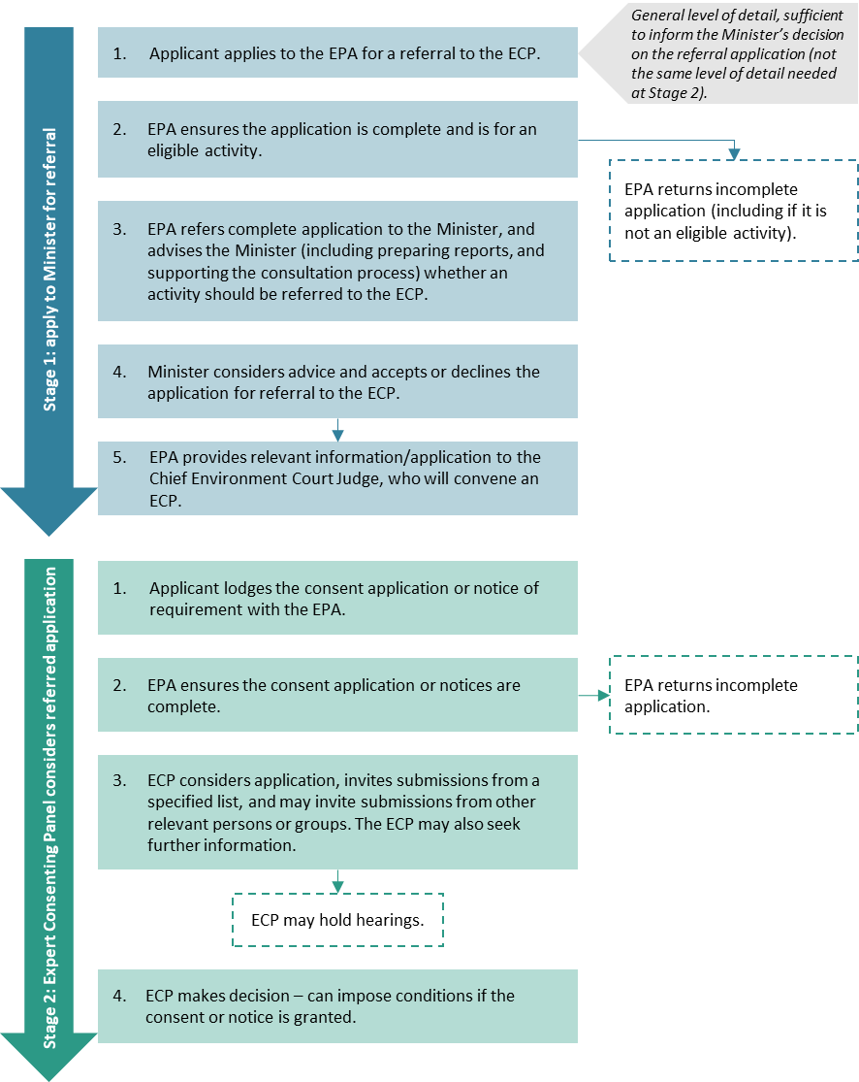

Stage 1: Application to the Minister for referral to the ECP
In considering the referral application, among other matters, the Minister (or Ministers, if the activity is in the CMA), must:
- copy the referral application to and invite written comments from certain groups, such as relevant local authorities and relevant Ministers of the Crown
- receive and consider a report from the EPA that identifies a range of matters including relevant iwi authorities and Treaty settlement entities, Treaty settlements (or recognised negotiation mandates or current negotiations), any relevant customary marine title area or protected customary rights area, and relevant provisions of the Ngā Rohe Moana o Ngā Hapū o Ngāti Porou Act 2019 (if any). The report will also include EPA’s advice whether to accept or decline the application for referral.
The Minister may decline a referral application on various grounds, including whether the usual consenting process is more appropriate. The Minister has discretion to decline an application, even if it is eligible to be referred to an ECP.
If the Minister refers an application to an ECP, they can also prescribe additional requirements for the full application in Stage 2. These include more comprehensive information requirements, additional people the ECP must invite comments from, and a timeframe for lodging the Stage 2 application.

Stage 2: Application to the Expert Consenting Panel
When the Minister accepts an application for referral to the ECP, the EPA informs the Chief Environment Court Judge of the referral.
The Chief Environment Court Judge seeks nominations from local authorities, the regional planning committee (once established), and relevant iwi authorities.
The Chief Environment Court Judge receives nominations for and appoints the ECP that will hear and decide on the substantive application.
A 10 working day timeframe is provided for the nomination process.

Submissions
The fast-track consenting process has a different process of inviting submissions from standard consenting processes. The ECP will only invite submissions from relevant persons or groups, similar to the process used under the FTCA.
The ECP has the discretion to invite other persons or parties to make a submission, including those representing a relevant public interest.

Hearings and appeals
Under the NBA, there is no requirement for the ECP to hold a hearing on an application. However, the ECP may hold a hearing if they consider it necessary.
The NBA places limits on appeal rights on the ECP’s decision. An appeal may be made to the High Court on a question of law by certain parties, and leave may be sought to appeal to the Supreme Court in certain circumstances.

Cost recovery
The EPA is required to recover costs from applicants for both stages of the fast-track consenting process.

Transitional matters
The NBE fast-track consenting process begins earlier than other consenting pathways under the NBA, so different provisions apply during the transition period in each region.
The transition period finishes in each region at the region’s ‘NBEA date’. The NBEA date is 10 days after the region notifies the decisions version of its first Natural and Built Environment Plan (NBE plan).
The transitional provisions are:
- during Stage 1 of the application process, NBA provisions apply to the Minister’s decision on whether to refer an application to the ECP.
- during Stage 2 of the application process, the ECP considers the full application under the RMA provisions, including Resource Management Act 1991 (RMA) planning instruments.
There are also specific requirements for applications lodged during the ‘applicable interim period’.
Contact the EPA directly on making an NBA fast-track consenting application to the Minister.

Disclaimer
The information in this publication is, according to the Ministry for the Environment’s best efforts, accurate at the time of publication. The Ministry will make every reasonable effort to keep it current and accurate. However, users of this publication are advised that:
- The information provided has no official status and so does not alter the laws of New Zealand, other official guidelines or requirements.
- It does not constitute legal advice, and users should take specific advice from qualified professionals before taking any action as a result of information obtained from this publication.
- The Ministry for the Environment does not accept any responsibility or liability whatsoever whether in contract, tort, equity or otherwise for any action taken as a result of reading, or reliance placed on this publication because of having read any part, or all, of the information in this publication or for any error, or inadequacy, deficiency, flaw in or omission from the information provided in this publication.
- All references to websites, organisations or people not within the Ministry for the Environment are provided for convenience only and should not be taken as endorsement of those websites or information contained in those websites nor of organisations or people referred to.

Published in August 2023 by the
Ministry for the Environment – Manatū mō te Taiao
Publication number: INFO 1175

If the referral application relates to an activity within a coastal marine area (CMA), the decision must be made jointly with the Minister of Conservation.
Refer to Schedule 10 clause 17 and 22. Also refer to Schedule 1 clause 28 of the NBA for the transitional provisions.
Schedule 10 clause 14 of the NBA.
Schedule 10 clause 14 of the NBA.
Defined at section 9(1) of the Marine and Coastal Area (Takutai Moana) Act 2011 and Ngā Rohe Moana o Ngā Hapū o Ngāti Porou Act 2019 (in reference to Ngā hapū o Ngāti Porou) – in Schedule 10 clause 15 of the NBA.
Schedule 10 clause 18(2) of the NBA.
Schedule 10 clause 18(7) of the NBA.
Schedule 10 clause 16 of the NBA.
Schedule 10 clause 20 of the NBA.
Schedule 10 clause 46 of the NBA.
Schedule 10 clause 26 of the NBA.
Schedule 10 clause 42 of the NBA.
Schedule 10 clause 94 of the NBA.
Schedule 1 clauses 27–36 of the NBA.
Schedule 1 clause 34 of the NBA.

