Whenua hawa
Contaminated land
The new resource management system:
Natural and Built Environment Act 2023
and Spatial Planning Act 2023

New laws are being phased in that aim to help Aotearoa New Zealand protect and manage the environment and its resources. The Spatial Planning Act 2023 (SPA) and the Natural and Built Environment Act 2023 (NBA) were enacted on 23 August 2023.
The NBA addresses the management of contaminated land differently to the Resource Management Act 1991 (RMA). The emphasis in the NBA has shifted to the polluter-pays principle, meaning that those who cause or allow contamination to occur bear the costs of managing the pollution. There is also a clear responsibility for regulatory agencies and landowners to prevent or remedy harm to human health and the environment from contamination and to minimise further harm.
Some contaminated land provisions commence on 24 August 2023.

This fact sheet covers:
- Hazardous Activities and Industries List (HAIL) and HAIL land
- how HAIL land is managed during the transition period
- the polluter-pays principle
- significant contaminated land sites
- cost recovery.

HAIL and HAIL land
The HAIL comprises hazardous activities and industries in Aotearoa New Zealand that have the potential to cause contamination. The HAIL is published and maintained by the Ministry for the Environment.
‘HAIL land’ means land that is, or has been, used for an activity or industry listed in the HAIL.

How HAIL land is managed during the transition period
As we move from the RMA to the NBA, regional councils have certain responsibilities that apply from 24 August 2023, including to:
- identify all HAIL land within their regional boundaries
- maintain a publicly available register that contains an up-to-date record of all HAIL land identified within their boundaries.

The polluter-pays principle
The polluter-pays principle describes the liability regime where polluters are to be held accountable for the effects on human health and the environment.
In terms of contaminated land, a polluter has been defined as a person who has caused or allowed a discharge of a contaminant into the environment.

Significant contaminated land sites
From NBA commencement, the Minister (in consultation with the Environmental Protection Authority (EPA) and the relevant local authority), has the power to classify or declassify an area as a significant contaminated land site.
Once land is identified as significant contaminated land, the EPA takes over the role as lead regulator using RMA powers, until the region’s natural and built environment plan (NBE plan) comes into effect. The EPA then adopts the functions and powers of the local authority and regional council.

Cost recovery
The EPA must first consult with the local authorities before it takes any action regarding contaminated land under the NBA. On commencement of the NBA, the EPA or the local authority can recover from the polluter the actual and reasonable costs they incurred from taking action. If the EPA is unable to recover costs from the polluter under the contaminated land provisions, it may recover costs from the local authority.

Disclaimer
The information in this publication is, according to the Ministry for the Environment’s best efforts, accurate at the time of publication. The Ministry will make every reasonable effort to keep it current and accurate. However, users of this publication are advised that:
- The information provided has no official status and so does not alter the laws of New Zealand, other official guidelines or requirements.
- It does not constitute legal advice, and users should take specific advice from qualified professionals before taking any action as a result of information obtained from this publication.
- The Ministry for the Environment does not accept any responsibility or liability whatsoever whether in contract, tort, equity or otherwise for any action taken as a result of reading, or reliance placed on this publication because of having read any part, or all, of the information in this publication or for any error, or inadequacy, deficiency, flaw in or omission from the information provided in this publication.
- All references to websites, organisations or people not within the Ministry for the Environment are provided for convenience only and should not be taken as endorsement of those websites or information contained in those websites nor of organisations or people referred to.

Published in August 2023 by the  Ministry for the Environment – Manatū Mō Te Taiao  Publication number: INFO 1173 | 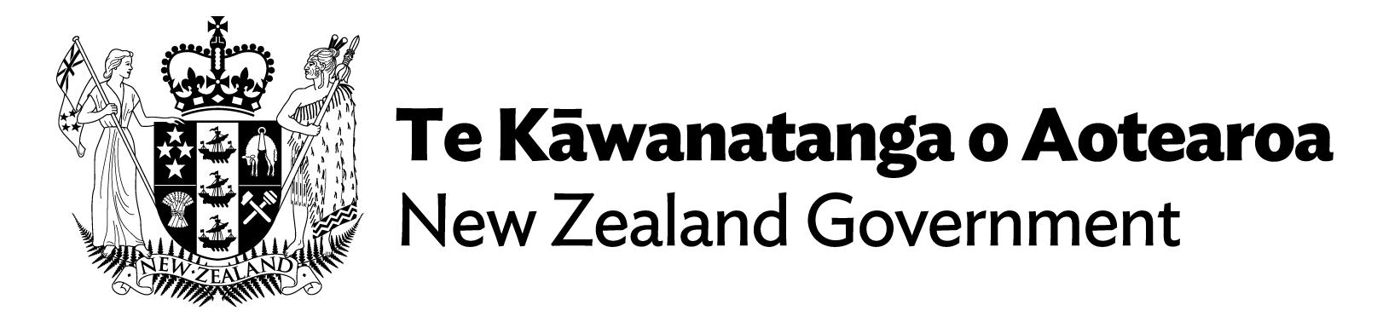

Section 404 of the NBA.
Section 403 of the NBA.
Section 407 of the NBA.
Section 411 of the NBA.
Section 409 of the NBA.
Section 410 of the NBA.
Section 412 of the NBA.
Section 413 of the NBA.
Section 414 of the NBA.

