Tautuku me te uruhi
Compliance and enforcement
The new resource management system:
Natural and Built Environment Act 2023
and Spatial Planning Act 2023

New laws are being phased in that aim to help Aotearoa New Zealand protect and manage the environment and its resources. The Spatial Planning Act 2023 (SPA) and the Natural and Built Environment Act 2023 (NBA) were enacted on 23 August 2023.
New and updated compliance and enforcement (C&E) powers and tools will be available while the system moves from the Resource Management Act 1991 (RMA) to the NBA. These changes will come in progressively over a two-year period from 24 August 2023.
Part 11 of the NBA contains the C&E provisions from the RMA, along with new or expanded C&E tools and powers to support increased deterrence, more flexible intervention, and the ability for councils to recover more costs associated with their C&E activities.

This factsheet covers:
- C&E during the transition period
- key areas of change
- NBA C&E provisions available under the RMA

C&E during the transition period
The enforcement provisions in Part 12 of the RMA will remain in force until the region’s NBEA date (this is the date 10 days after a regional planning committee has notified the decisions version of its first Natural and Built Environment Plan). New NBA C&E tools and powers will also be available under the RMA during the transition. This means:
- enforcement activity relating to offending that occurred before 24 August 2023 will continue under the RMA.
- enforcement activity for offending that occurs from 24 August 2023, but before a region’s NBEA date, will continue under the RMA; however, in this instance, some C&E provisions will be available to use under the RMA.
- from a region’s NBEA date, enforcement activity will occur under the NBA, meaning that Part 11 of the NBA will come into force in different regions at different times.

Key areas of change
The C&E provisions in the NBA can be categorised into four areas:
- enhancing responsibilities for duty holders
- interventions and penalties that put the onus of remediation on offenders
- enhancing flexibility and agility with tool modernisation
- improved focus on prevention and risk.

NBA C&E provisions available under the RMA

- There are some changes to C&E in the NBA that will apply under the RMA from 24 August 2023:
- The penalties for criminal offending increase from $300,000 to $1 million for individuals and from $600,000 to $10 million for companies
- the limitation period for criminal offences increases from 12 months to 2 years, meaning regulators have longer to take action against non-compliance; the limitation period for civil enforcement action is 6 years
- the maximum jail sentence is reduced (now up to 18 months), removing the right to elect trial by jury in prosecutions
- RMA abatement notice provisions are broadened to include consent notices and covenants imposed by the conditions of a resource consent, and to strengthen the ability to take preventive action
- applications for resource consents can be declined on the grounds of a poor compliance history and may be suspended or revoked in response to non-compliance with their requirements
- ancillary penalties, for example for failing to give information to an enforcement officer and continuing offence penalties, are increased
- excessive noise orders can have effect for up to eight days as opposed to 72 hours under the RMA
- financial assurance orders can be required as a condition of a resource consent or when a particular activity is being undertaken, and may be in the form of a bond, insurance, or other type of assurance.
- Regulators can recover costs associated with permitted activity monitoring, investigations of non-compliance, and prosecutions. It will only apply to the costs incurred after the date the NBA came into effect.

Disclaimer
The information in this publication is, according to the Ministry for the Environment’s best efforts, accurate at the time of publication. The Ministry will make every reasonable effort to keep it current and accurate. However, users of this publication are advised that:
- The information provided has no official status and so does not alter the laws of New Zealand, other official guidelines or requirements.
- It does not constitute legal advice, and users should take specific advice from qualified professionals before taking any action as a result of information obtained from this publication.
- The Ministry for the Environment does not accept any responsibility or liability whatsoever whether in contract, tort, equity or otherwise for any action taken as a result of reading, or reliance placed on this publication because of having read any part, or all, of the information in this publication or for any error, or inadequacy, deficiency, flaw in or omission from the information provided in this publication.
- All references to websites, organisations or people not within the Ministry for the Environment are provided for convenience only and should not be taken as endorsement of those websites or information contained in those websites nor of organisations or people referred to.

Published in August 2023 by the  Ministry for the Environment – Manatū Mō Te Taiao  Publication number: INFO 1172 | 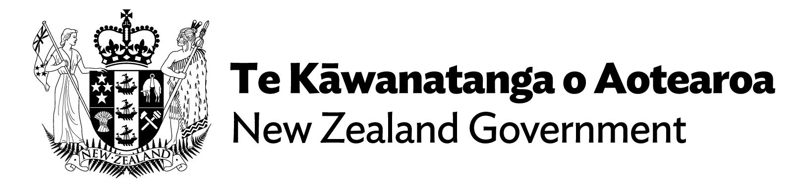

Schedule 1 clause 66(3) of the NBA.
Schedule 1 clause 65(2), sections 649(1)(d) and (e) of the NBA.
Schedule 1 clause 65(8) of the NBA, section 285(5) of the NBA.
Schedule 1 clause 66(3) of the NBA.
Schedule 1 clause 65(9) of the NBA.
Schedule 1 clause 65(7), sections 674–691 of the NBA.
Schedule 1 clause 66(6), section 722 of the NBA.

