**Housing – Streamlined Planning Process**

**Changes introduced by the Resource Management (Consenting and Other System Changes) Amendment Act 2025**

These changes, which passed into law on 20 August 2025, belong to a wider programme of resource management reform. Visit the Ministry for the Environment’s [webpage about the new Amendment Act](https://environment.govt.nz/acts-and-regulations/acts/rm-amendment-act-2025) for more information.

## Context

### What is the streamlined planning process?

Under the Resource Management Act 1991 (RMA), councils can use the existing streamlined planning process (SPP) for the preparation of a planning instrument under the RMA, if they meet certain entry requirements. The SPP is for proposals that:

* implement national direction
* address urgent public policy needs
* meet significant community needs, or
* resolve plan issues or combine multiple plans.

### Previous system

Under the previous system, any local authority seeking to use an SPP was required to apply for ministerial approval. The Minister for the Environment (the Minister) could approve the request and then issue a direction to the local authority. The Minister could tailor the process, adding steps (such as technical reviews) if needed. At a minimum, the SPP process had to include:

* consultation with affected parties, including iwi
* a submission process, including a report that shows how those submissions have been considered and provides a cost–benefit evaluation (the evaluation report required by section 32 of the RMA).

Local authorities were required to submit draft decisions to the Minister for approval. There were limited appeal rights.

### Key changes

|  |
| --- |
| * Section 19 of the Amendment Act amends section 80B of the RMA. * Sections 70(3A) to 70(22) amend clauses 75, 76, 77, 78, 82 to 87, 90 to 94 and 95 of Schedule 1 of the RMA and insert new clauses 75A and 93A. |

The Resource Management (Consenting and Other System Changes) Amendment Act 2025 (the Amendment Act) amends the SPP for all planning instruments, removing the requirement for the Minister to approve the plan change at the end of the process. The Amendment Act introduces additional appeal rights for some council decisions on plan changes.

The Amendment Act requires the appointment of an SPP Panel to receive submissions and make recommendations to the council on the plan change. The Minister may appoint up to half the members of the panel directly.

Through this amended process, the Minister has no role in making final decisions on recommendations; instead, councils consider the recommendations from the SPP Panel. Accepted recommendations from the SPP Panel become operative with no appeal rights, and rejected recommendations may be appealed to the Environment Court on merits, or to the High Court on questions of law. There is no further right of appeal to the Court of Appeal or Supreme Court.

Figure 1 shows the streamlined planning process and indicates changes to requirements from the Amendment Act.

## Implementation considerations

* For councils this means the Minister is no longer the decision-maker on a SPP. Councils must consider the expert recommendations and make their decisions public, so accountability is maintained through transparency and appeals.
* If the SPP is for a listed planning instrument, the council must “notify” the Minister seeking direction to use the SPP, rather than applying to use the SPP.
* There is no significant change to the role of iwi, hapū, Māori in the decision-making process. This change affects who makes the final call, not who is involved in shaping the plan and recommendations. Iwi engagement happens throughout the SPP, including during submissions and hearings.

|  |  |
| --- | --- |
| Published in August 2025 by the  Ministry for the Environment | Manatū mō te Taiao Publication number: INFO 1324 |  |

Figure 1: Streamlined planning process (SPP)

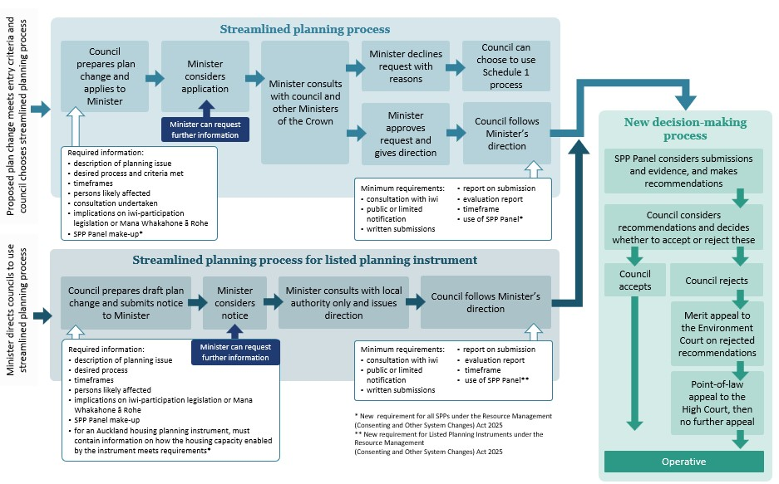

|  |  |
| --- | --- |
| Published in Month 202X by the  Ministry for the Environment | Manatū mō te Taiao Publication number: INFO XXXX |  |