

Updating National Direction: Changes to Stock Exclusion Regulations
April 2026
Recent changes have been made to national direction under the Resource Management Act 1991 (RMA) to make the resource management system work more effectively.
Regulation 17 of the Stock Exclusion Regulations has now been amended so that it no longer applies to beef cattle and deer that are not intensively grazing.

Context
The Resource Management (Stock Exclusion) Regulations 2020 (Stock Exclusion Regulations) regulate access to water bodies by beef cattle, dairy cattle, dairy support cattle, deer and pigs. Regulation 17 previously required all stock to be excluded from natural wetlands that support threatened species, as described in the National Policy Statement for Freshwater Management 2020.
Regulation 17 has now been amended so that it no longer applies to beef cattle and deer that are not intensively grazing. This regulation continues to exclude dairy cattle, dairy support cattle, pigs, beef cattle and deer that are intensively grazing from any natural wetland that supports a population of threatened species.
This change helps to meet the Government’s objectives for resource management reform, making it easier to get things done by enabling primary sector growth and development while also improving regulatory quality in the resource management system.

Key changes
Key changes to Stock Exclusion Regulations
- Amendment to Regulation 17: Exclusion of stock from natural wetlands that support threatened species described in National Policy Statement for Freshwater Management 2020.
- No longer applies to beef cattle and deer that are not intensively grazing.

Implementation considerations
Published in April 2026 by the  Ministry for the Environment | Manatū mō te Taiao  Publication number: INFO 1379 | 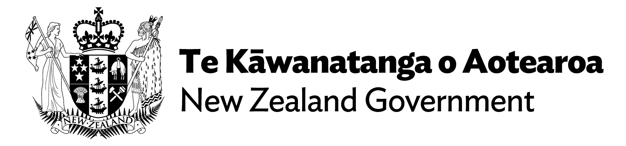

For local government
Regulations made under section 360 of the RMA will apply immediately once they come into effect.
Regional councils and unitary authorities may adopt more stringent stock exclusion requirements in their regional plans as part of their Freshwater Management Plan. Other existing rules related to stock exclusion continue to apply.
For farmers
The Stock Exclusion Regulations apply to any person who owns or controls stock. Local authorities (regional councils and unitary authorities) are responsible for managing and enforcing stock exclusion, and may adopt stock exclusion requirements in their regional plans. Check with your regional council or unitary authority for further details on stock exclusion rules in your region.

Transition to the new planning system
All existing national direction under the RMA will be reassessed and restructured to ensure it aligns with the goals and framework of the new planning system that will be established by the Planning and Natural Environment Bills.
The policy intent of the changes to national direction under the existing RMA will be transferred to the new system as appropriate.
For more information about the transition into the new planning system see the Ministry for the Environment fact sheet The New Planning System: Transitioning into the new planning system

For further information
For more information, see the Ministry for the Environment website’s page on Stock exclusion regulations

Under the Stock Exclusion Regulations, intensively grazing means break feeding, grazing on annual forage crops, or grazing on pasture that has been irrigated with water in the previous 12 months.

