

Updating National Direction: Changes to Multiple Instruments for Quarrying and Mining Provisions
December 2025
Recent changes have been made to national direction under the Resource Management Act 1991 (RMA) to make the resource management system work more effectively.
This fact sheet outlines changes to four national direction instruments under the RMA to align definitions and consent processes for quarrying and mining.

Context
Four national policy instruments (see box below) provide direction to councils to identify and manage the adverse effects of quarrying and mining to protect significant natural areas, highly productive land and natural inland wetlands. Previously, terms and consent pathways across these four instruments were inconsistent. A set of changes has been made to allow for more consistent and enabling regulation and management of quarrying and mining activities and better alignment between instruments.
Amendments to quarrying and mining provisions within four national policy instruments
- National Policy Statement for Indigenous Biodiversity (NPSIB)
- Align terms to describe quarrying and mining activities (clause 3.11).
- Amend the quarrying and mining gateway test (clause 3.11).
- Introduce definitions for quarrying activities and ancillary activities.
- National Policy Statement for Freshwater Management (NPS-FM)
- Add an ‘operational need’ test in relation to quarrying and mining (clause 3.22).
- National Environmental Standards for Freshwater (NES-F)
- Change the discretionary activity status for quarrying affecting wetlands by adding an ‘operational need’ test (section 45A).
- Change the discretionary activity status for minerals and ancillary activities affecting wetlands by adding an ‘operational need’ test (section 45D).
- National Policy Statement for Highly Productive Land (NPS-HPL)
- Alignment of terms to describe quarrying and mining activities (Clause 3.9)
- Remove the definition for aggregate extraction.
- Introduce definitions for quarrying activities and ancillary activities.
- Amend the quarrying and mining gateway tests (clause 3.9).

Key changes
These changes simplify and align consent rules for quarrying and mining across national instruments, making them clearer and less restrictive. By adding an ‘operational need’ test, standardising terminology and broadening benefit criteria, the amendments reduce compliance barriers and support Government priorities for infrastructure and growth, while retaining environmental safeguards.

Add ‘operational need’ test
- Introduce ‘operational need’ in addition to the ‘functional need’ in NPS-FM and NES-F wetland consent pathways. This makes it easier for quarrying and mining projects to meet gateway tests.

Align terminology
- Replace ambiguous terms like ‘mineral extraction’ and ‘aggregate extraction’ with:
- ‘extraction of minerals and ancillary activities’
- ‘quarrying activities’.
- Include definitions from the National Planning Standards for clarity.

Amend gateway tests
- Remove the requirement for benefits to be ‘public’; allow broader consideration of benefits (including private and regional).
- Add regional benefits to mining consent pathways.
- Remove the test requiring proof that benefits ‘could not otherwise be achieved using resources within New Zealand’.
- Maintain the requirement for an effects management hierarchy (avoid, remedy, mitigate, offset, compensate).

Implementation requires immediate action

Immediate steps
Councils must now have regard to the above changes in provisions (as relevant – eg, the NPSIB and NPS-HPL) when making consent decisions. Amendments to the NES-F take effect immediately and will drive both consent applications and decision-making as soon as the amended NES-F is gazetted.
In respect of the relevant freshwater sections (on wetlands) in the NPS-FM, these clauses must be directly inserted into regional plans as soon as possible, without using the plan-making process in Schedule 1 of the RMA (see section 55 of the RMA).

Transition to the new planning system
All existing national direction under the RMA will be reassessed and restructured to ensure it aligns with the goals and framework of the new planning system established by the Planning and Natural Environment Bills.
The policy intent of the changes to national direction under the existing RMA will be transferred to the new system as appropriate, as will the intent of other changes previously considered.

For further information
For more information, see the Ministry for the Environment website.
National Policy Statement for Indigenous Biodiversity
National Policy Statement for Freshwater Management
National Environmental Standards for Freshwater
National Policy Statement for Highly Productive Land
Published in December 2025 by the  Ministry for the Environment | Manatū mō te Taiao  Publication number: INFO 1374 | 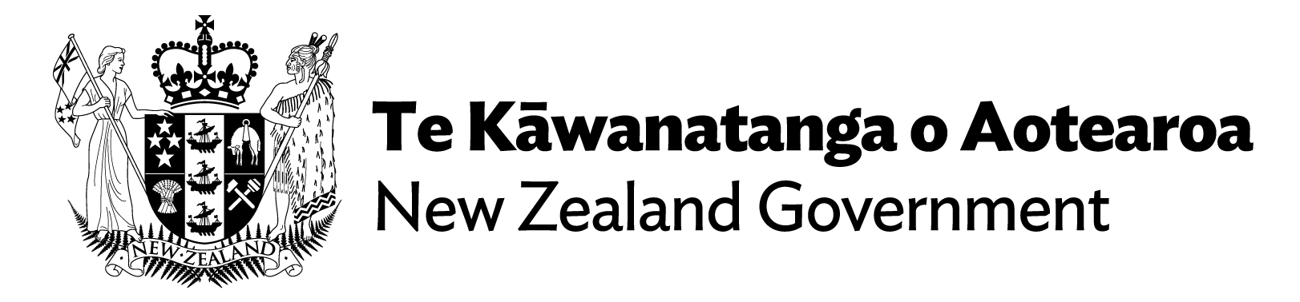

Ministry for the Environment. 2019. National Planning Standards. Wellington: Ministry for the Environment.

