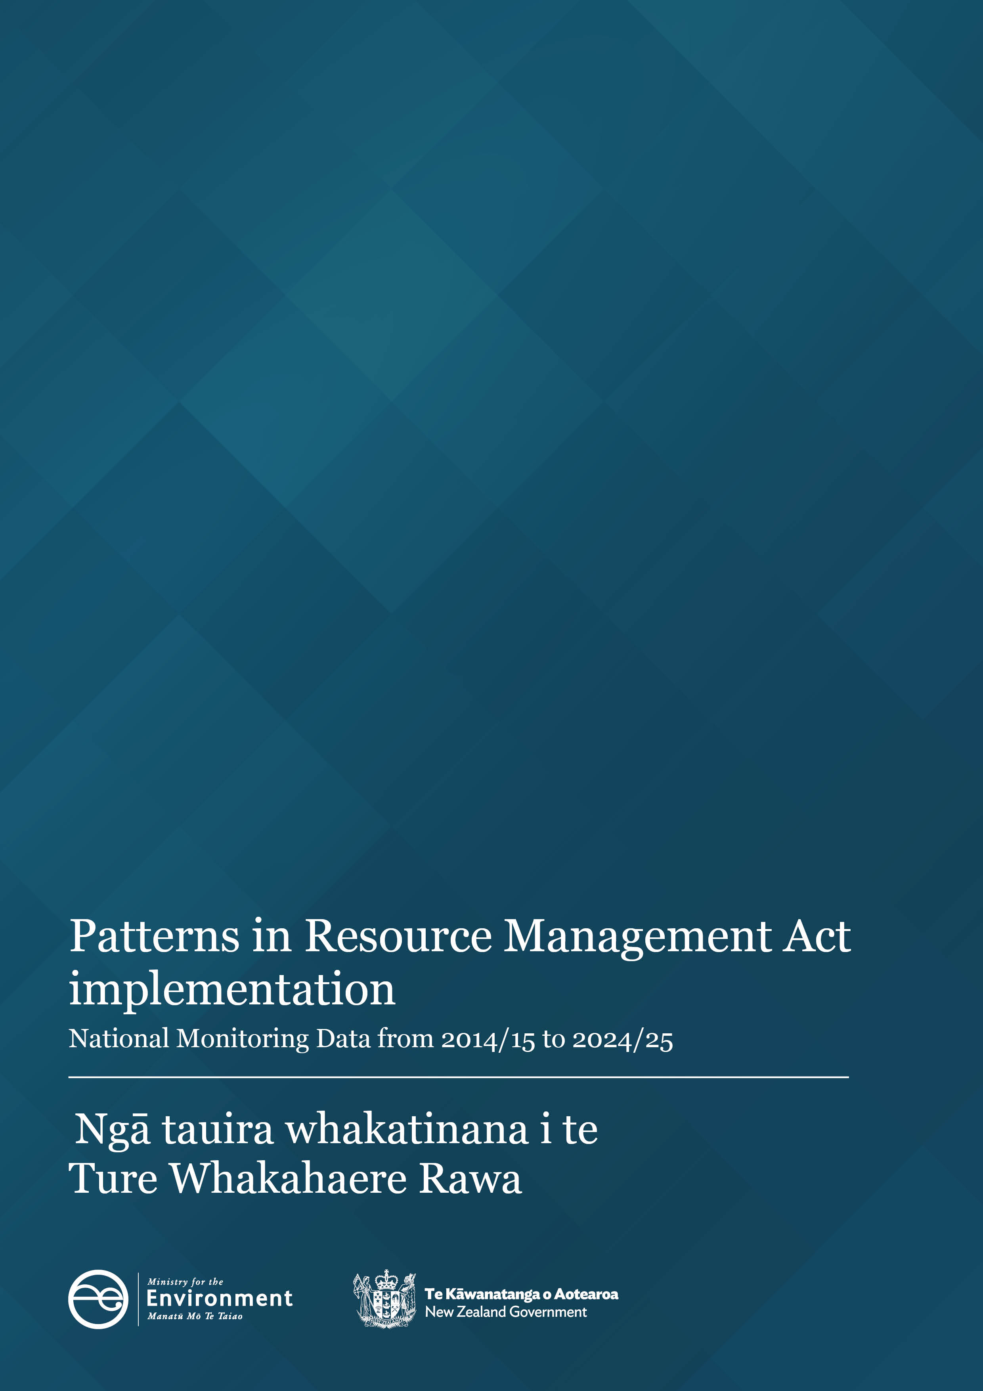
Disclaimer
The information in this publication is, according to the Ministry for the Environment’s best efforts, accurate at the time of publication. However, users of this publication are advised that:
- The information does not alter the laws of New Zealand, other official guidelines, or requirements.
- It does not constitute legal advice, and users should take specific advice from qualified professionals before taking any action based on information in this publication.
- The Ministry does not accept any responsibility or liability whatsoever whether in contract, tort, equity, or otherwise for any action taken as a result of reading, or reliance placed on this publication because of having read any part, or all, of the information in this publication or for any error, or inadequacy, deficiency, flaw in, or omission from the information in this publication.
- All references to websites, organisations or people not within the Ministry are for convenience only and should not be taken as endorsement of those websites or information contained in those websites nor of organisations or people referred to.
Copyright
© Crown copyright New Zealand 2026. Unless otherwise stated, this copyright work is licensed for re-use under a Creative Commons Attribution 4.0 International licence. In essence, you are free to copy, distribute and adapt the work, as long as you attribute the work to the New Zealand Government and abide by the other licence terms. To view a copy of this licence, visit Creative Commons Attribution 4.0 International licence.
If you publish, distribute, or otherwise disseminate this work (or any part of it) to the public without adapting it the following attribution statement should be used: Source: Ministry for the Environment and data providers and licensed by the Ministry for the Environment for re-use under the Creative Commons Attribution 4.0 International licence. If you adapt this work in any way, or include it in a collection and publish, distribute, or otherwise disseminate that adaptation or collection to the public, the following attribution statement should be used: This work uses material sourced from the Ministry for the Environment and data providers, which is licensed by the Ministry for the Environment for re-use under the Creative Commons Attribution 4.0 International licence.
Where practicable, please hyperlink the name of the Ministry for the Environment to the Ministry for the Environment web page that contains, or links to, the source data.

Acknowledgements
We would like to acknowledge the contribution of local authorities who collect and provide the data for the National Monitoring System that informs this report.
This document may be cited as: Ministry for the Environment. 2026. Patterns in Resource Management Act Implementation – National Monitoring System data from 2014/15 to 2024/25. Wellington: Ministry for the Environment.
Published in June 2026 by the
Ministry for the Environment
Manatū Mō Te Taiao
PO Box 10362, Wellington 6143, New Zealand
ISBN: 978-1-991404-53-4
Publication number: ME 1979
© Crown copyright New Zealand 2026
This document is available on the Ministry for the Environment website: environment.govt.nz

Contents
About this National Monitoring System data report 5
Patterns in RMA implementation 7
Resource consent data patterns 7
The number of new resource consents granted has increased 7
Three councils continued to process the highest number of new resource consent applications 8
Higher percentage of new resource consents processed on time since 2023/24 10
Decrease in the percentage of new resource consents granted by the councils 10
Percent and type of declined new resource consent applications 12
The proportion of notified resource consents remained low 13
Councils used Section 37 more and Section 92 less in 2024/25 16
Median statutory processing times for resource consents by types remained largely consistent, 2024/25 17
Plan-making processes 20
Councils’ timeliness in completing their plan change processes declined in 2024/25 20
Iwi and hapū participation within the resource management system 21
There was variation in how councils budgeted for iwi and hapū participation in consenting and plan-making 21
The number of new iwi management plans remains low 22
Compliance, and enforcement 23
Enforcement action taken by councils continues to show variation 23
Staffing levels on resource management work varied 24

Figures
Figure 1: Number of new (Section 88) consents granted by year and valid reported consent type 7
Figure 2: Number of new (Section 88) consents granted in 2024/25 by council 8
Figure 2a: Number of new (Section 88) consents granted in 2024/25 by council (showing only those fewer than 1,000) 9
Figure 3: Percentage of new (Section 88) consents granted or declined that were processed within statutory timeframes 10
Figure 4: Percentage of new (Section 88) consents granted or declined that were processed within statutory timeframes across all councils 11
Figure 5: Percentage of new (Section 88) consents that were granted 12
Figure 6: Percentage of new (Section 88) consents that were declined by type and year 13
Figure 7: Percentage of new (Section 88) consent applications that were notified 14
Figure 8: Percentage of new (Section 88) consent applications notified in 2024/25 by council area 15
Figure 9: Percentage of new (Section 88) consents granted or declined that used at least one Section 37 or Section 92 16
Figure 10: Median statutory days lapsed for processing time of new (Section 88) consents granted or declined/refused by year and type 17
Figure 11a: Median statutory days lapsed by new (Section 88) councils granted or declined/refused as reported by councils in 2024/25 18
Figure 11b: Statutory days lapsed when council processing new (Section 88) consents, in 2024/25 by council 19
Figure 12: Median processing time to complete a plan change once notified for reported plan changes 20
Figure 13: Percentage of councils that reported ding budget to iwi and hapū to participate in either the development of resource management plans or processing of resource consents 22
Figure 14: Number of new iwi management plans endorsed by iwi authorities and lodged with councils 23
Figure 15: Number of enforcement actions (infringement notices, abatement notices and enforcement order applications) taken by councils by council type 24
Figure 16: Number of full-time equivalents working on resource management at councils by subject area 25
Figure 17: Number of full-time equivalents staff working on resource management at councils 25

About this National Monitoring System data report
This report is written to inform central and local government of patterns in Resource Management Act 1991 (RMA) implementation, which reflects the roles councils play in everyday decision-making under the RMA. Every year, the Ministry for the Environment (the Ministry) runs the National Monitoring System (NMS), asking each council to provide data on how they have implemented the RMA for the previous year 1 July – 30 June. A national data set is then created by the Ministry using all councils’ data for the purposes of this report. The NMS report is then publicly released to make it accessible to the wider resource management community. Each report draws on data from twenty-four months to twelve months prior to its release, as the latest full financial year of data available at the time.
This report is organised by topic and highlights patterns in how councils have implemented the RMA over the past ten years, as recorded by the NMS. The data collected by the NMS will continue to inform the Ministry’s understanding of how the current resource management system has been working. The report does not assess future investment in the planning system, but may provide a baseline for future monitoring and planning system work.
The report excludes data that has not been reported to the Ministry or reconciled by councils.
In some sections of this report, the data is broken down to types of councils where differences have occurred in RMA implementation.
Unless otherwise noted:
- all consenting facts and figures relate to a council’s processing of new resource consent applications within 1 July 2024 – 30 June 2025
- the report excludes data from new resource consent applications that were incomplete, withdrawn or returned
- the term ‘processing’ refers to the granting or declining of new resource consent applications. Consent applications that have not yet been granted or declined are not included in analyses.
- the ‘plan-making’ section refers to policy statements or plans, changes or variations that were started, continued or completed by councils within the 2024/25 financial year.
Key patterns from 2024/25
- There was an increase in the number of new resource consents processed by councils.
- Most councils processed fewer than 1,000 new resource consents.
- Councils continued to grant over 93 per cent of all new applications.
- Councils decreased the use of Section 92 (Further information requests) and increased the use of Section 37 (Power of waiver and extension of time limits)
- The proportion of new resource consents being notified was 2 per cent.
- The median statutory processing time for new resource consents decreased.
- Councils employed their highest number of full-time equivalent staff for resource management.
These key patterns are described in more detail in the sections below.

Patterns in RMA implementation

Resource consent data patterns
Under the RMA, certain activities require a resource consent. A resource consent is permission from a council for an activity that might affect the environment and that is not allowed ‘as of right’ by the district, regional or unitary plan, or a national environmental standard. A resource consent is also required for some types of subdivision activities.
There are different categories of resource consents according to the rules in a district, regional or unitary plan, or a national environmental standard: coastal permits, combined land-use and subdivision consents, discharge permits, land-use consents, subdivision consents, and water permits.

The number of new resource consents granted has increased
Figure 1 outlines the number and type of new resource consents granted by councils since 2014/15.
In 2024/25, councils granted 32,974 new Section 88 resource consents. Of these, 32,959 were reported as falling within one of the consent type categories shown in Figure 1.
This was higher than 30,578 in 2023/24, but still lower than earlier years. Land-use and subdivision consents both increased from 2023/24.

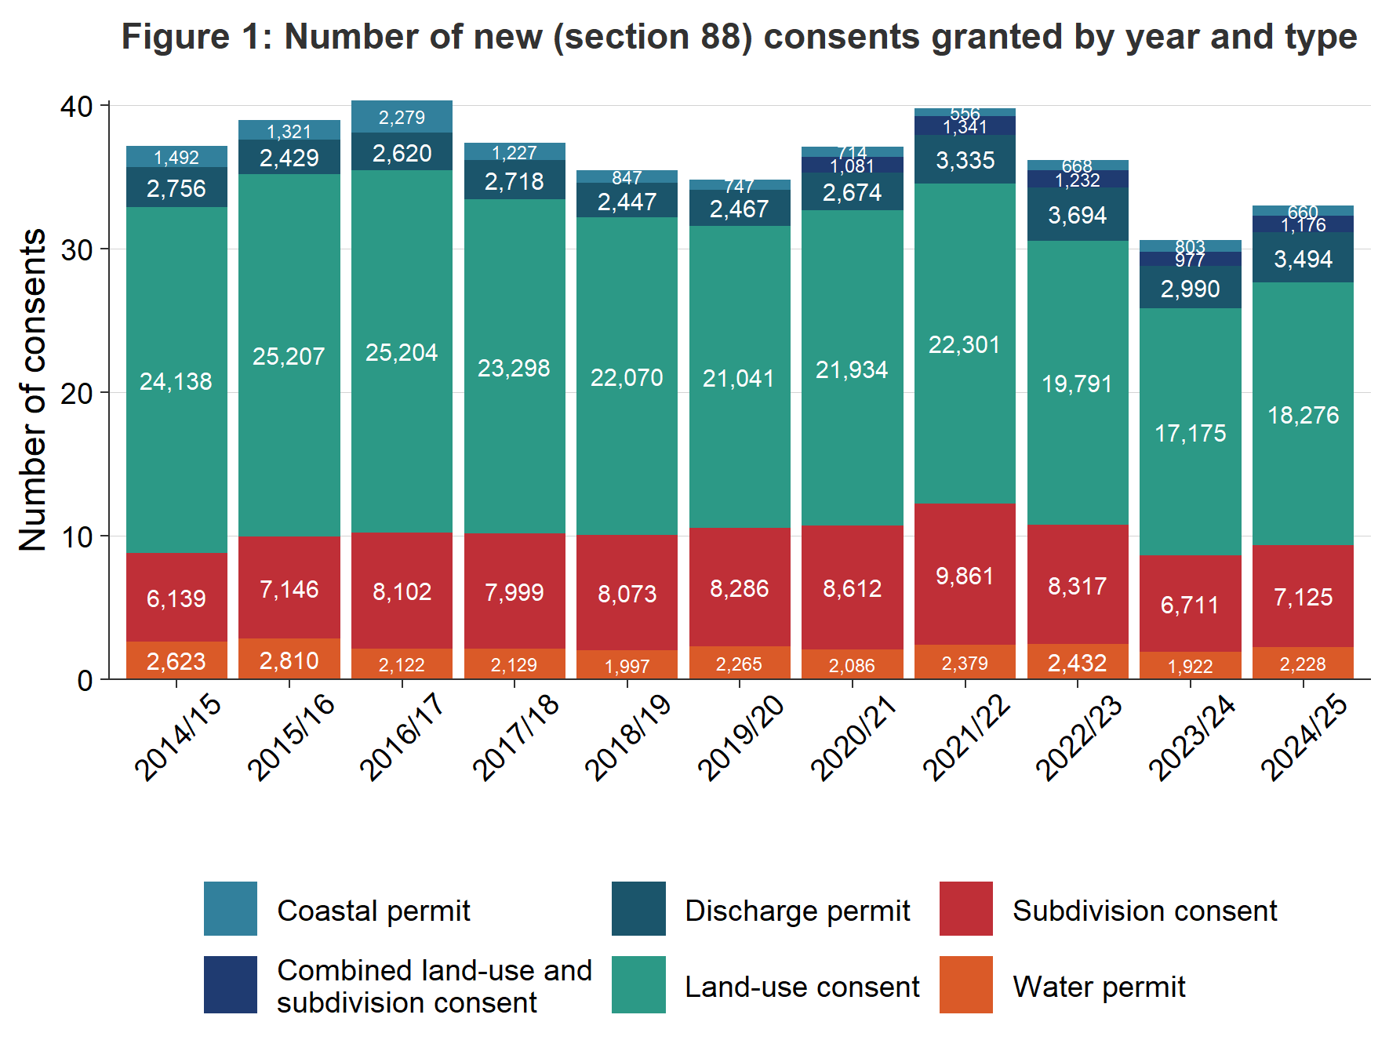Figure 1: Number of new (Section 88) consents granted by year and reported consent type
Note: Figure 1 shows Section 88 consents reported as falling within one of the consent type categories shown. The remaining records are included in the overall total but excluded from the consent-type breakdown.

Three councils continued to process the highest number of new resource consent applications
Of all the councils across New Zealand, 77 of the 78 processed fewer than 2,500 new resource consents in 2024/25. This is consistent with the 2023/24 findings. Auckland Council processed more than 7,500 new resource consents in 2024/25.
All other councils processed fewer than 2,500 new resource consents, Christchurch City Council processed the second-highest number for the sixth year in a row. Marlborough District Council processed the third-highest number for the fourth year in a row. Auckland Council continues to process the highest number of consents in 2024/25. Figure 2 shows the number of new resource consents granted by each council in 2024/25.
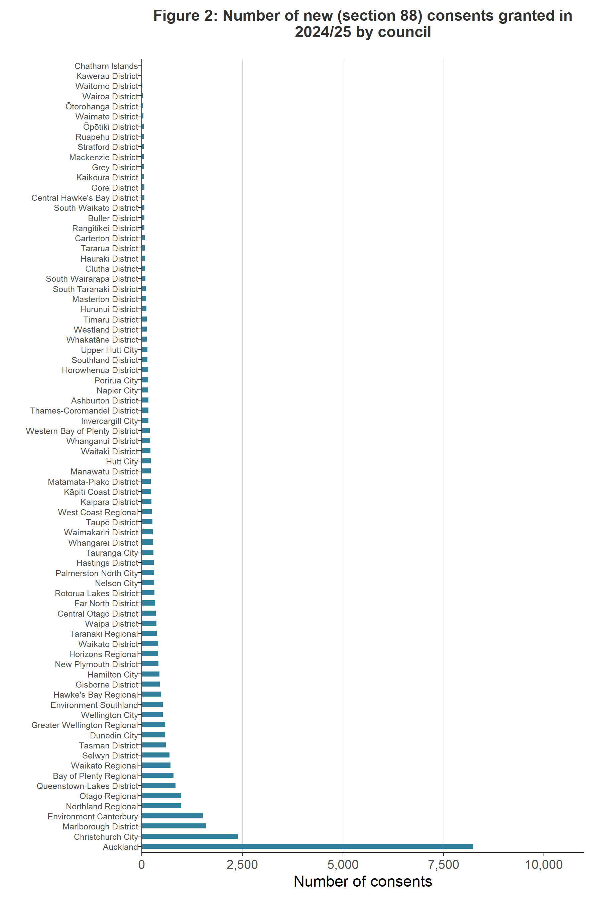
Figure 2: Number of new (Section 88) consents granted in 2024/25 by council
Figure 2a shows those councils that processed fewer than 1,000 new resource consents in the 2024/25 year, which represents just under 96 per cent of all councils. This is similar to processed application numbers from the 2023/24 reporting year.
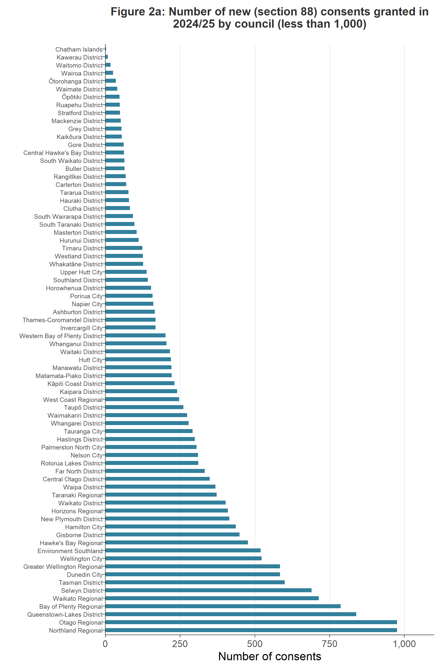
Figure 2a: Number of new (Section 88) consents granted in 2024/25 by council (showing only those fewer than, 1,000)

Higher percentage of new resource consents processed on time since 2023/24
Councils have a responsibility under the RMA to process resource consent applications within a set amount of time. For example, the statutory time limit for a non-notified consent is 20 working days.
When a council cannot meet its statutory requirements for processing a resource consent, and special circumstances do not apply, the council must give the applicant a discount on administrative charges. This requirement, which was introduced under the Resource Management (Discount on Administrative Charges) Regulations 2010, provides a financial incentive for all local councils to meet the RMA’s statutory timeframes.
Figure 3 shows the percentage of new resource consents processed within statutory timeframes. Over the course of 2024/25, 87 per cent of new resource consents were processed within the statutory time limits set out in the RMA. This is a 5 percentage-point increase from the previous year.
Figure 3 and figure 4 show the percentage of new resource consents processed within statutory timeframes in the 2024/25 financial year.
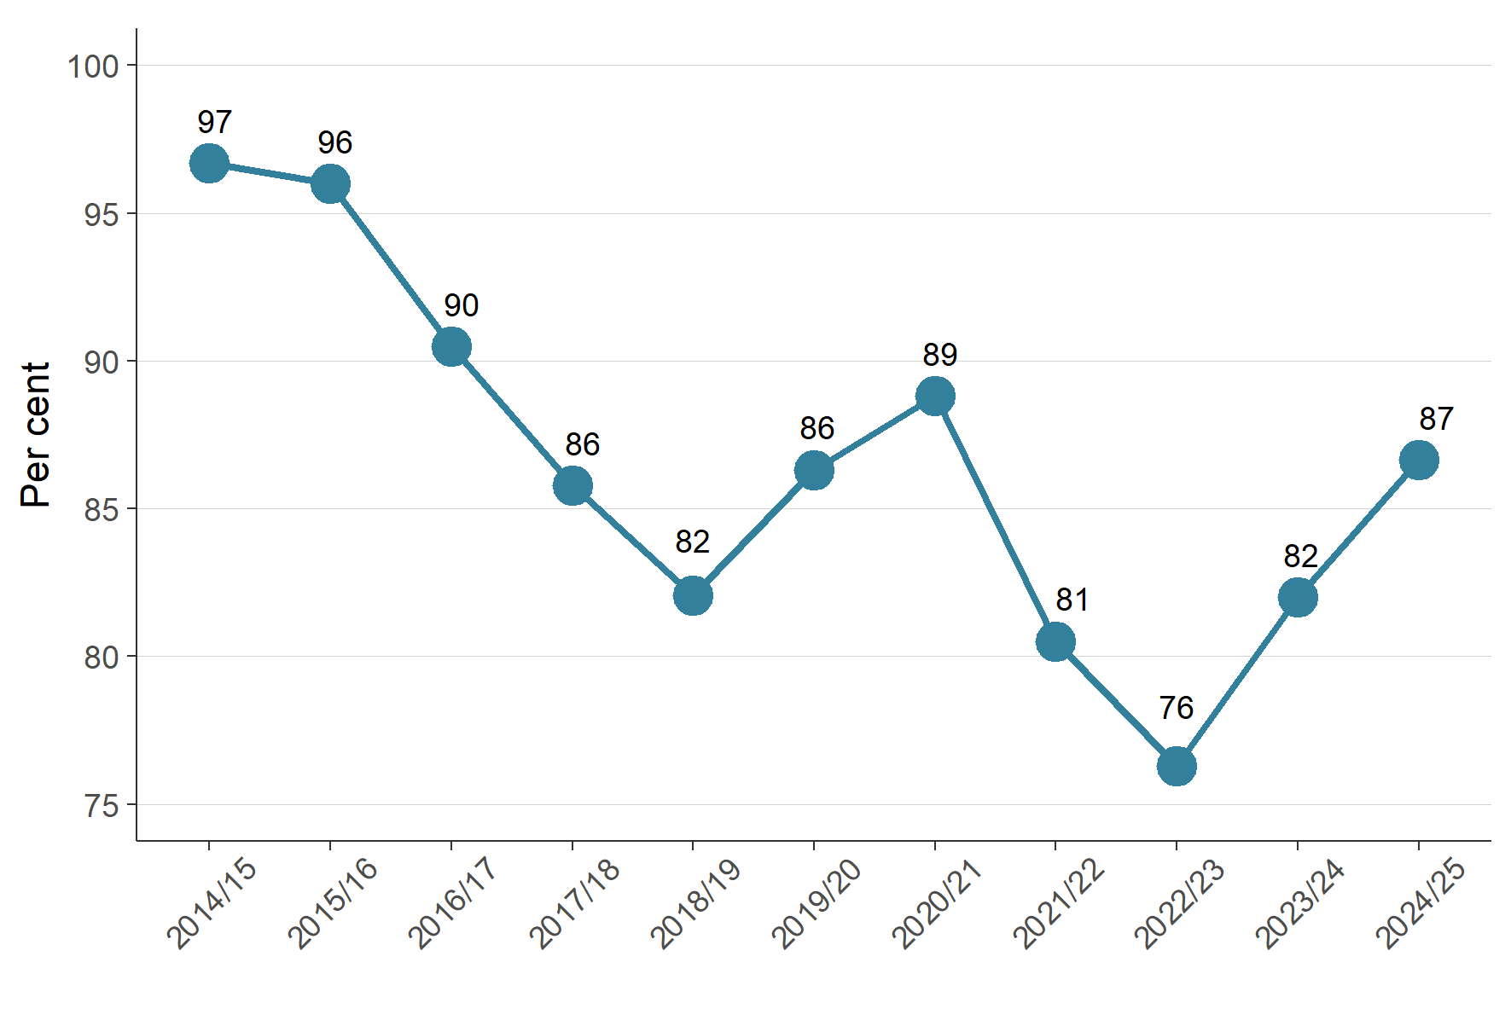
Figure 3: Percentage of new (Section 88) consents granted or declined that were processed within statutory timeframes
The data in Figure 3 is based on consents processed by all councils, including the overwhelming influence of Auckland Council. However, as shown in Figure 4, there is an increase in the number of new resource consents processed within the statutory time limits across other councils too, since the 2022/23 reporting year. While Auckland Council experienced a 2 per cent increase in compliance with statutory time limits, other areas experienced a 5 per cent increase, compared with the 2023/24.

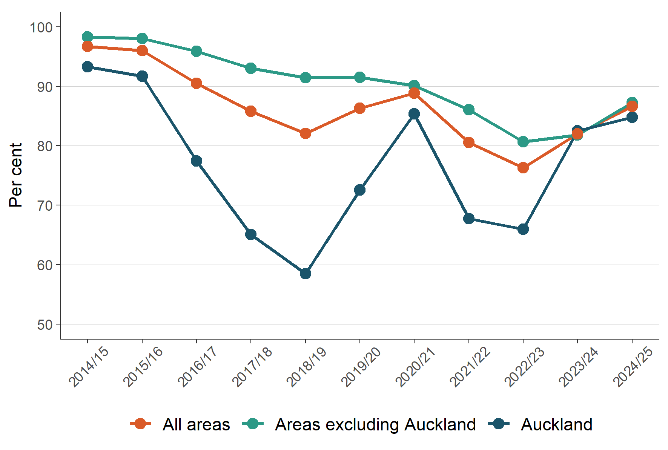
Figure 4: Percentage of new (Section 88) consents granted or declined that were processed within statutory timeframes across all councils

Decrease in the percentage of new resource consents granted by the councils
Figure 5 shows the percentage of approved new resource consent applications. 93 per cent of new resource consents were granted in 2024/25. There has been a decrease in the percentage of new resource consents granted since the 2021/22 reporting year.
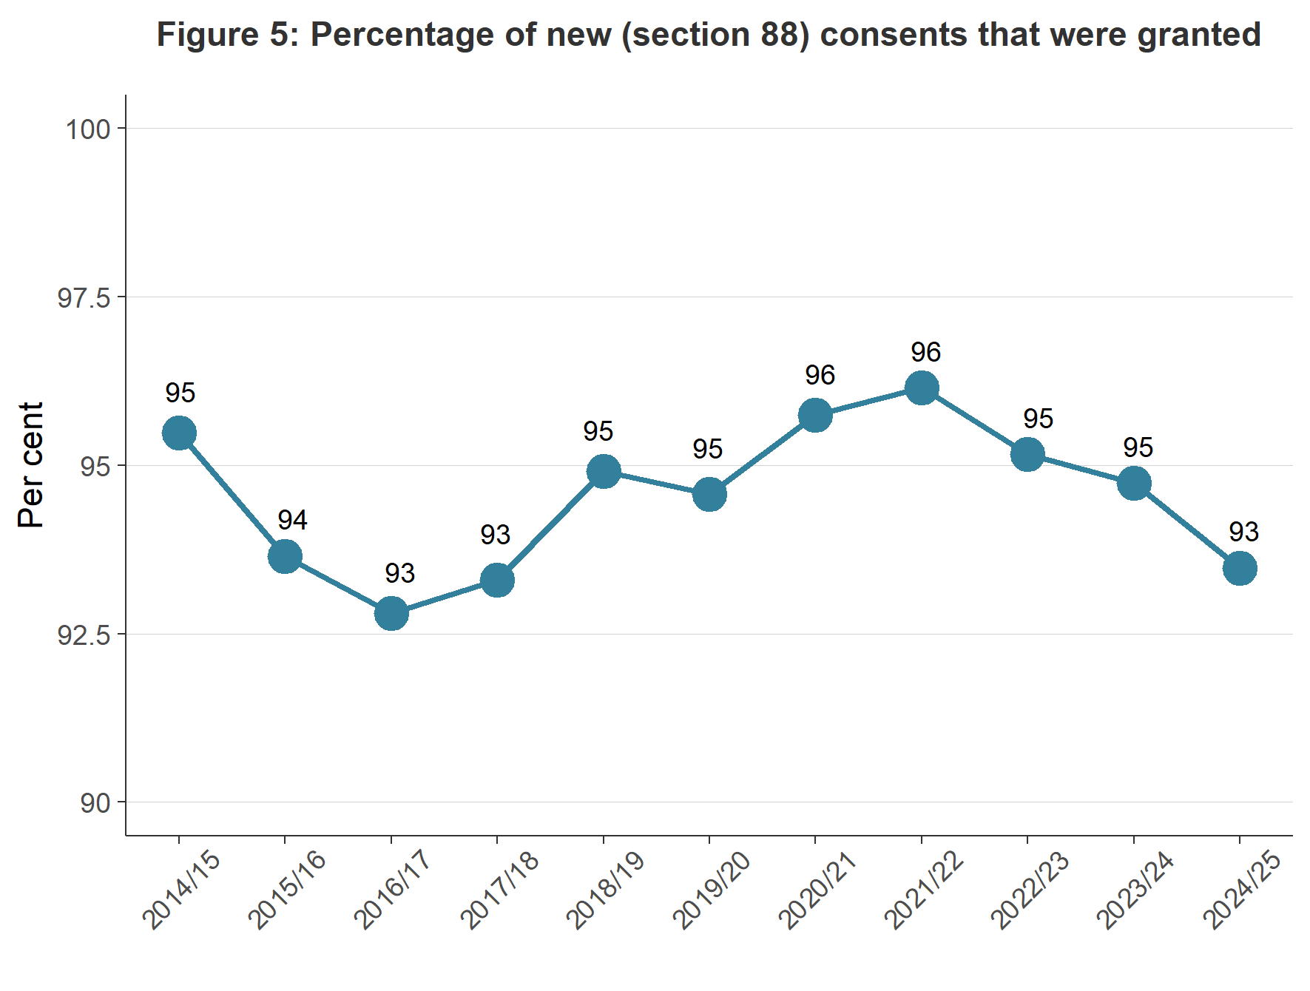
Figure 5: Percentage of new (Section 88) consents that were granted

Percent and type of declined new resource consent applications
NMS data since 2014/15 has provided the types of resource consents that have been declined by councils. Overall, the figures have generally remained stable and low across years and by type, with fluctuations.
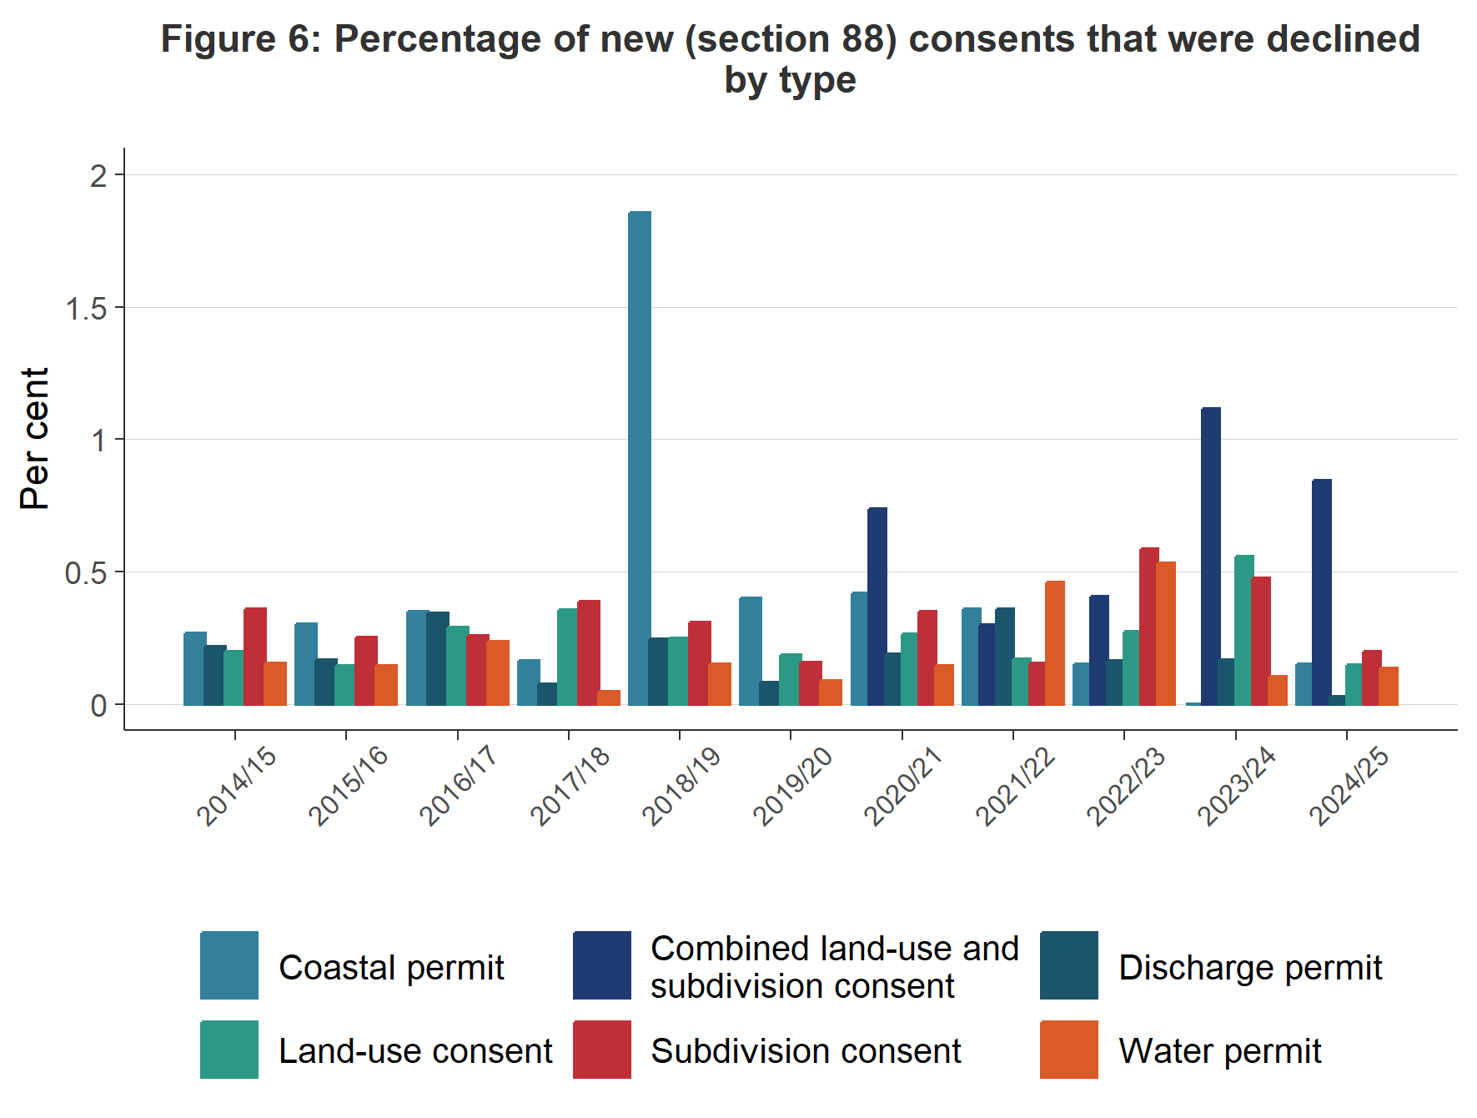
Figure 6: Percentage of new (Section 88) consents that were declined by type and year
Figure 6 shows the percentage of new Section 88 resource consent applications declined by consent type, where a valid consent type was available. Compared with 2023/24, the percentage of coastal permits and water permits declined was higher.

The proportion of notified resource consents remained low
When processing a new resource consent application, a council may determine that its effects require it to be publicly notified. The proportion of notified resource consents has historically remained low; over any year it has been under 4 per cent (of all new resource consent applications). Therefore, most new resource consent applications are processed on a non-notified basis.
In 2024/25, 2.1 per cent of new resource consent applications were notified (see figure 7). This decreased from 2.5 per cent in 2023/24 and was the same reported percentage as 2021/22.

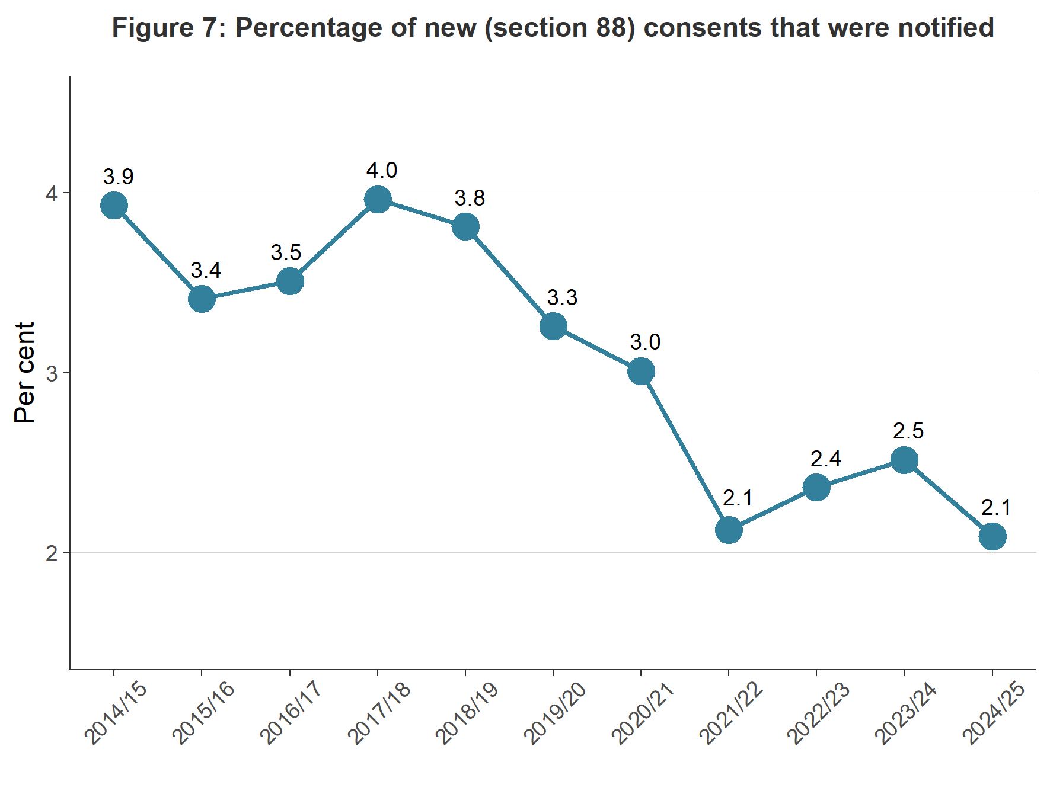
Figure 7: Percentage of new (Section 88) consent applications that were notified
Figure 8 shows the percentage of resource consent applications notified by council area. In 2024/25, Buller District Council notified the highest proportion of consent applications (more than 25 per cent), followed by Marlborough District Council (almost 10 per cent). Buller District Council notified the highest percentage of consents in 2023/24 too.
In 2024/25, 38 councils notified fewer than 1 per cent of resource consent applications and 10 councils notified 5 per cent or greater.
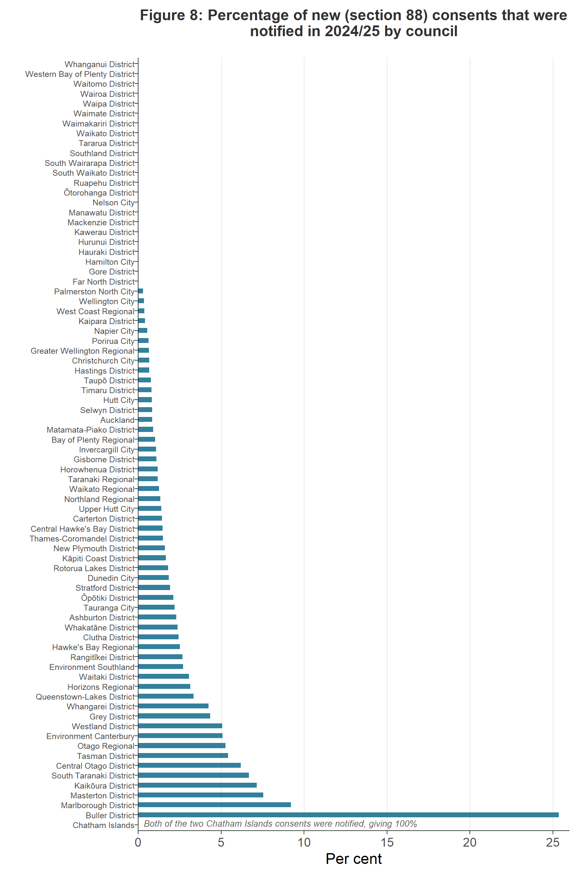
Figure 8: Percentage of new (Section 88) consent applications that were notified in 2024/25 by council

Councils used Section 37 more and Section 92 less in 2024/25
Section 37 allows a council additional working days where certain circumstances are met during the processing of a resource consent. Where used, Section 37 allows a council to double the statutory timeframes or to waive a failure to comply with the statutory timeframes. In using Section 37, a council must take into account the interests of those who may be directly affected by the waiver, the interests of the community in making a decision on a consent, and a council’s overall duty to avoid unreasonable delay.
Section 92 of the RMA allows a council to ask for more information from a resource consent applicant before making a decision on the application. The “processing clock” is paused while the applicant responds to the council’s request. Generally, a council seeks additional information to better understand a proposed activity seeking consent and any effects it may have on the environment. When a council is processing a consent, both Section 37 and Section 92 can be used one or more times on the same application where certain circumstances occur.
Figure 9 shows that use of Section 37 by all councils had a 2 percentage point increase in 2024/25. Figure 9 also shows that use of Section 92 by all councils saw an 11 percentage point decrease in 2024/25.
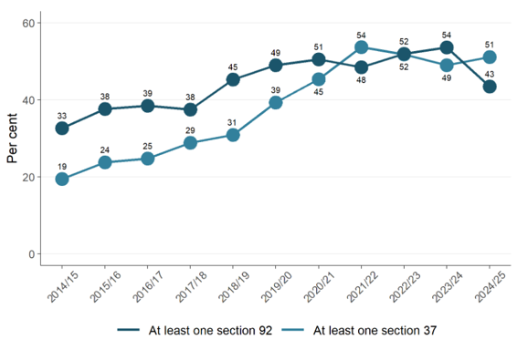
Figure 9: Percentage of new (Section 88) consents granted or declined that used at least one Section 92 or Section 37

Median statutory processing time for resource consents by type remained largely consistent, 2024/25
Figure 10 shows the median length of time (statutory days) that councils took to process consents in 2024/25, broken down by consent type. The data includes processing time to grant or decline a new resource consent.
The 2024/25 data shows that consent applications nationwide had a median processing time of 19 statutory days. Figure 10 shows that the timeframe for processing coastal permits, land-use consents, and water permits was 19 statutory days, consistent with 2023/24. Figure 10 also shows that combined land-use and subdivision took a median time of 20 statutory days. Discharge permit took a median statutory timeframe of 19 days, compared with 20 days in 2023/24.
Reporting on combined land-use and subdivision consents was introduced in 2020/21. Figure 10 shows that, for 2024/25, the median statutory time to process this type of consent increased to 20 days.

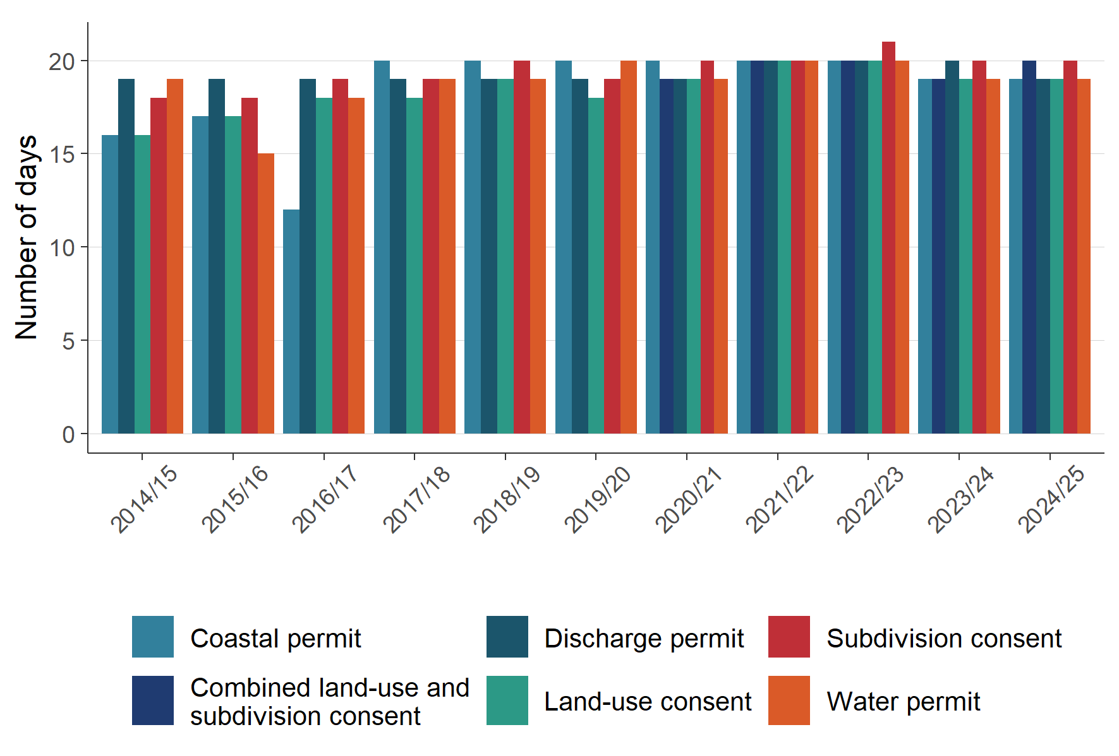
Figure 10: Median statutory days lapsed for processing time of new (Section 88) consents granted or declined/refused by year and type

Figure 11a shows the median time councils took to process new resource consents in 2024/25, broken down by council. The 2024/25 data shows that Buller District Council took the highest median number of statutory days (over 30 days). Figure 11b shows the number of statutory days lapsed when processing new consents in 2024/25 as reported by the councils. Figure 11b shows the number of statutory days lapsed when processing new consents in 2024/25 as reported by the councils. This includes all new consents, regardless of whether they were notified or required a hearing. Statutory processing timeframes under the RMA vary according to the notification status and complexity of the application. Non-notified consent applications without a hearing are subject to shorter decision timeframes, while notified or more complex applications are given more time to allow for a more comprehensive assessment and decision-making process.

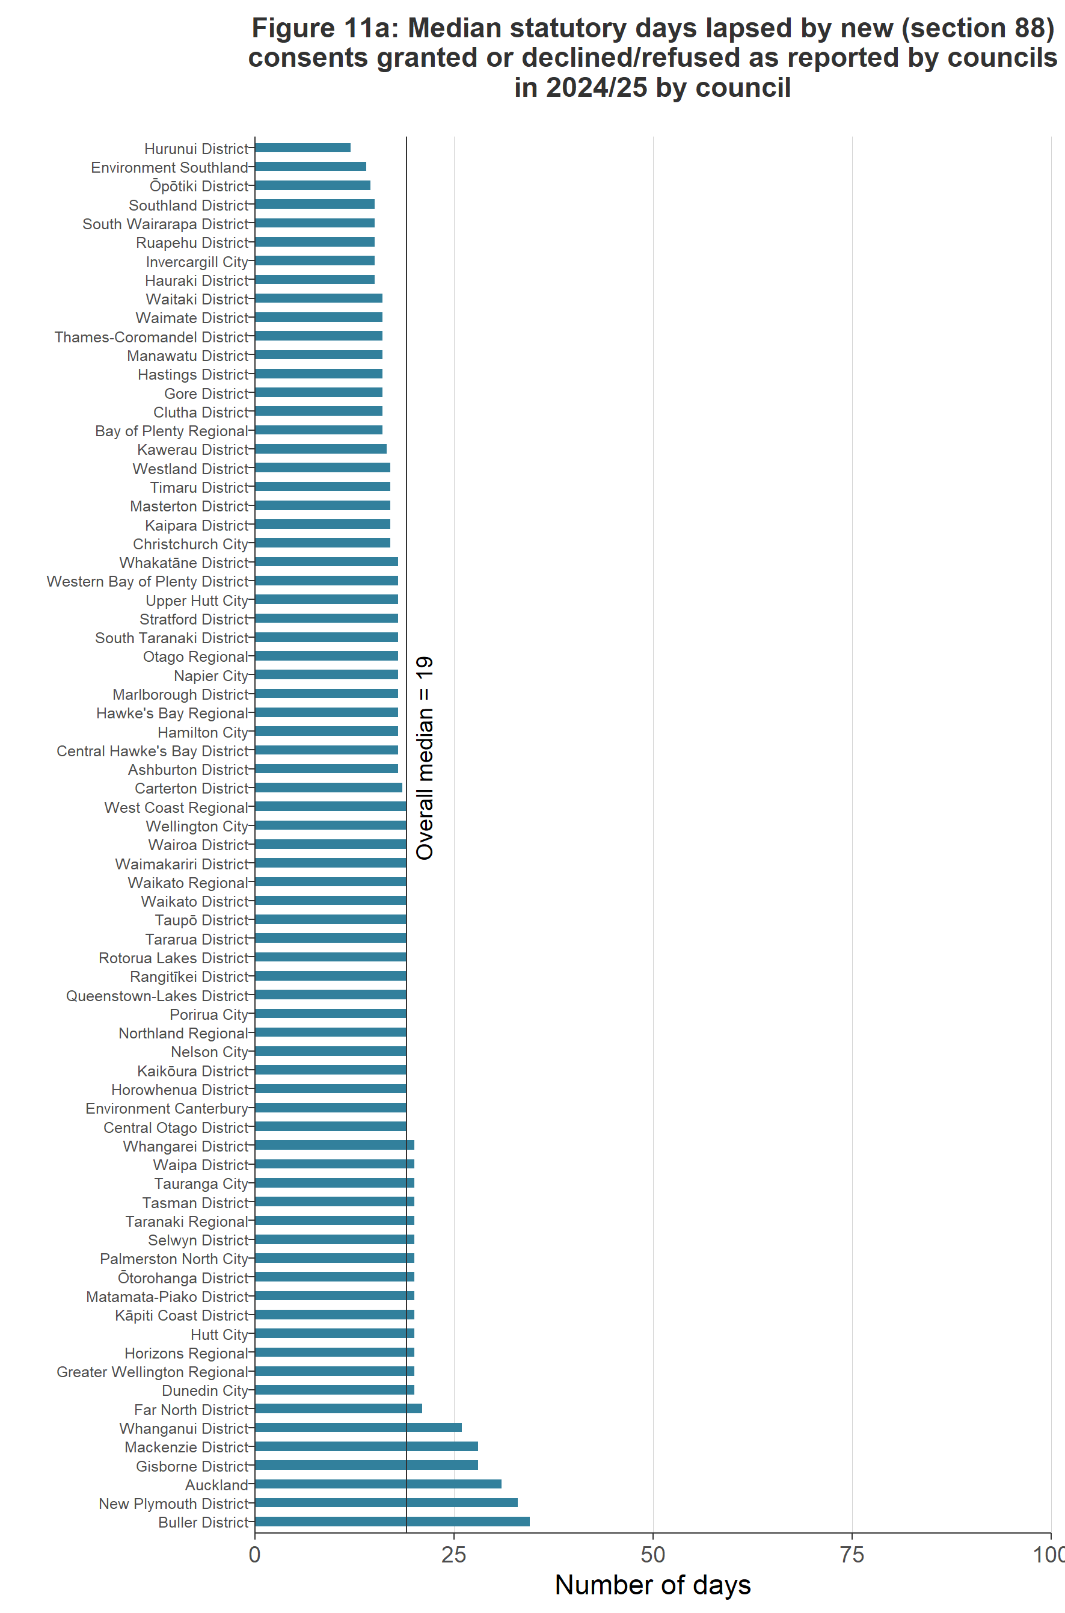
Figure 11a: Median statutory days lapsed by new (Section 88) consents granted or declined/refused as reported by councils in 2024/25

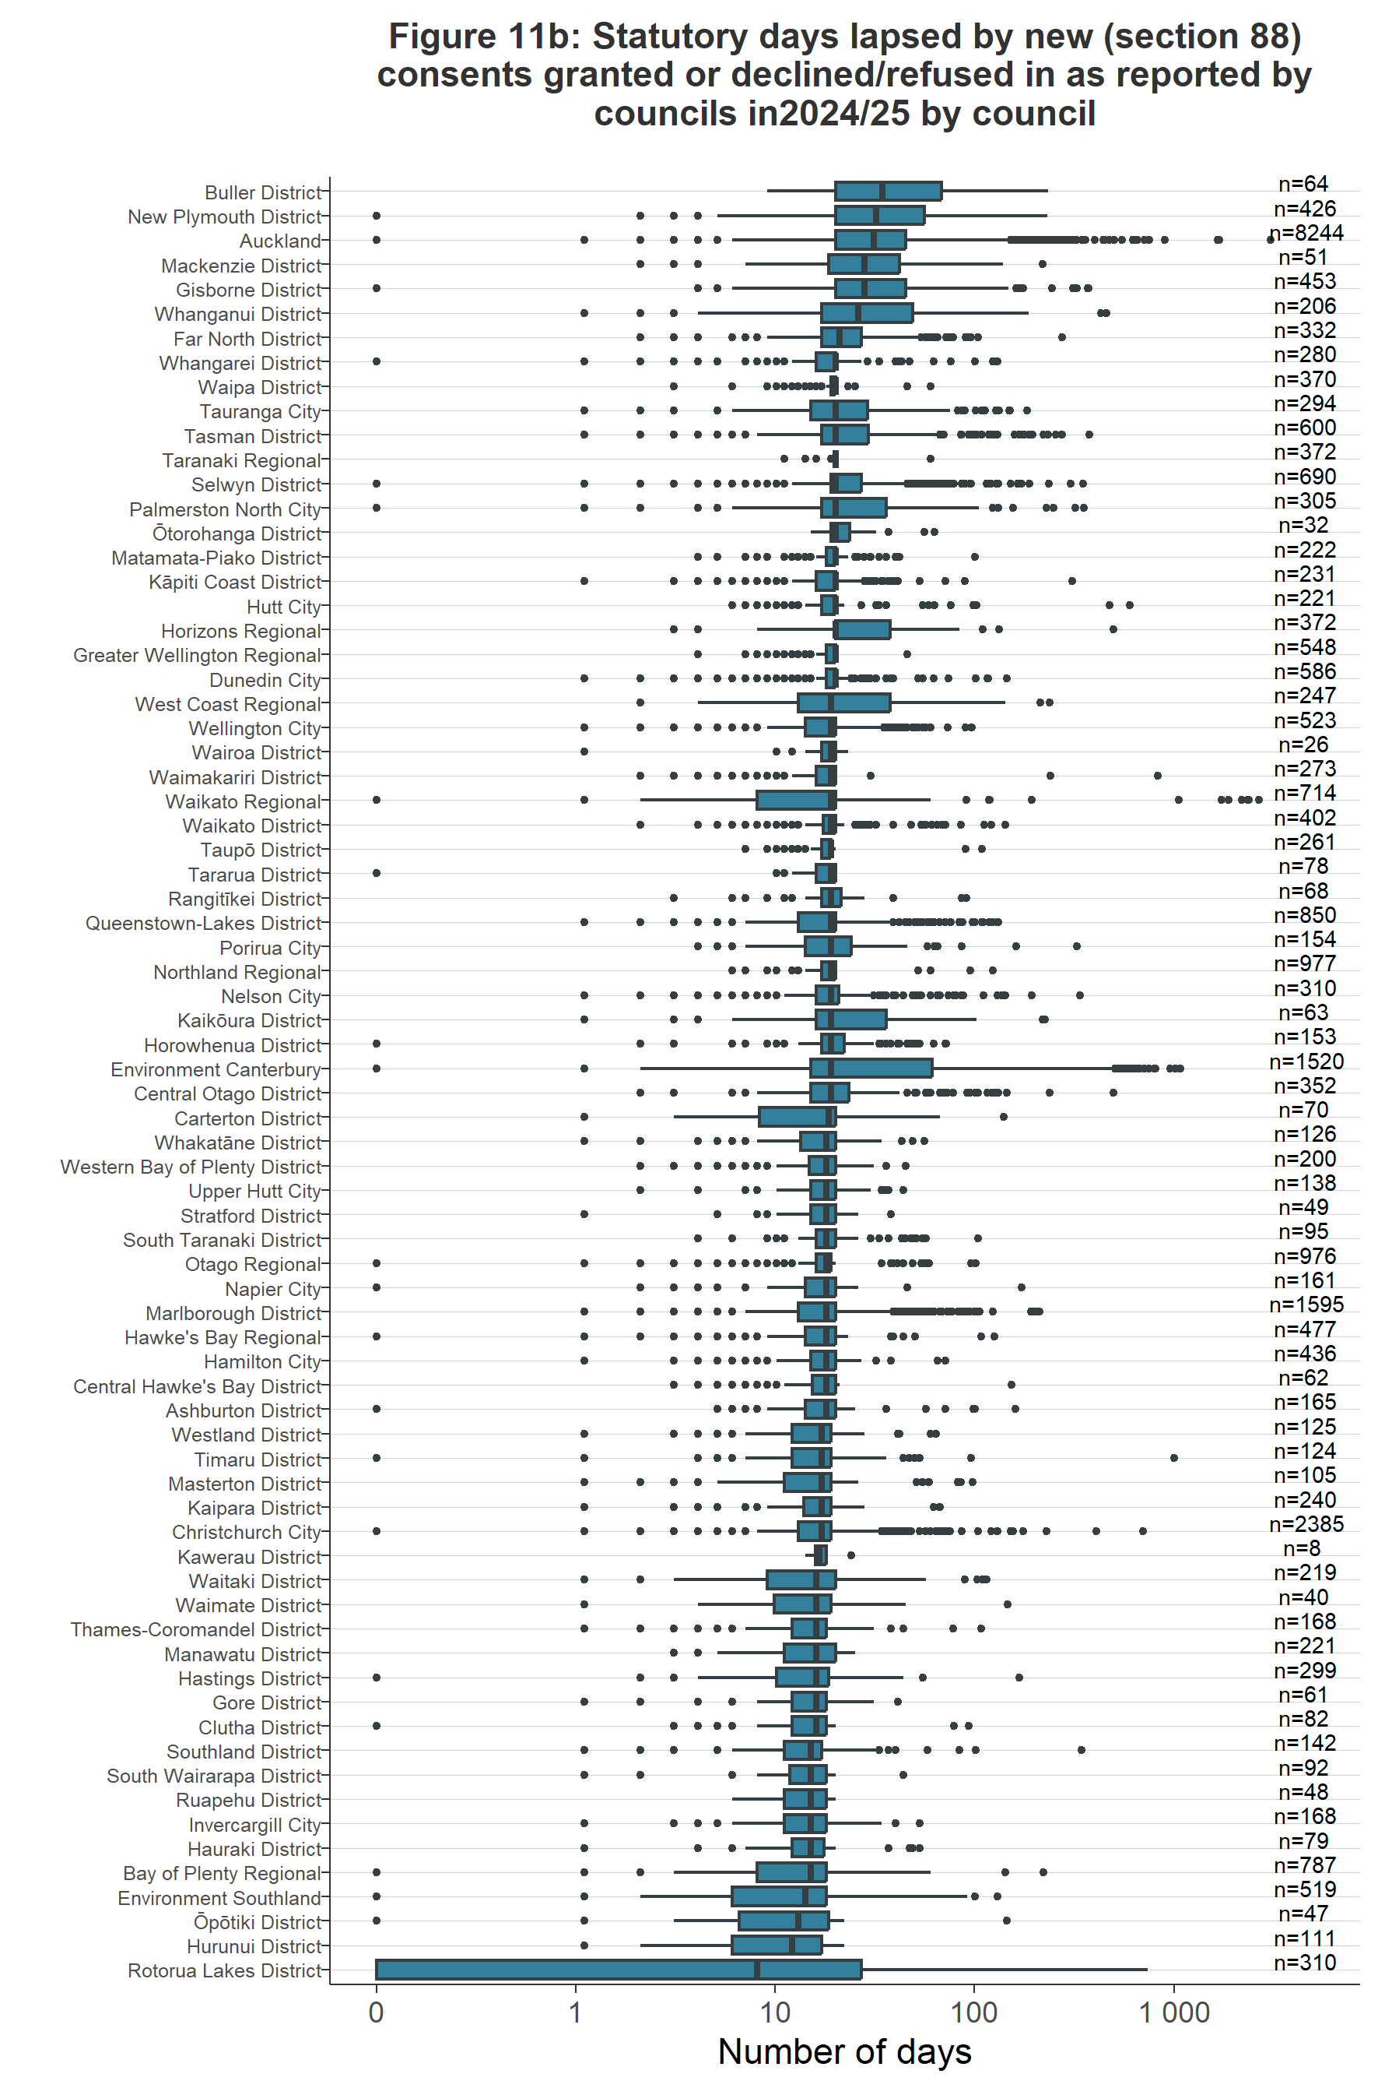
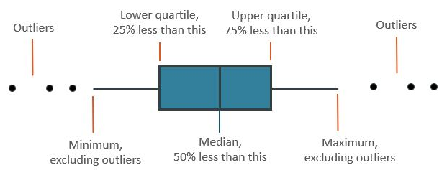
Note: n is the number of consents granted or declined/refused
Figure 11b: Statutory days lapsed when processing new (Section 88) consents, in 2024/25 by council

Plan-making processes
Councils prepare regional policy statements and regional, district and unitary plans under Part 5 and Schedule 1 of the RMA. A regional, district or unitary plan provides a list of activities requiring a resource consent and may also include a list of ‘permitted activities’.
Councils must review their policy statements and plans, or any plan provisions, at least every 10 years. Plan changes can be initiated by councils or can be requested by private individuals or entities. Plan changes and other plan-making processes occur under Schedule 1 of the RMA.

Councils’ timeliness in completing their plan change processes declined in 2024/25
Under Schedule 1, Clause 5 of the RMA, all local authorities are required to meet a two-year timeframe, from notification, to make decisions on proposed plans or plan changes.
Figure 12 shows that, from 2014/15 to 2023/24, a downward trend has occurred in median plan-change timeframes, indicating that councils have continued to improve the median time taken to progress a plan-making process. However, this trend reverses in 2024/25, with processing time rising markedly to 1.4 years.
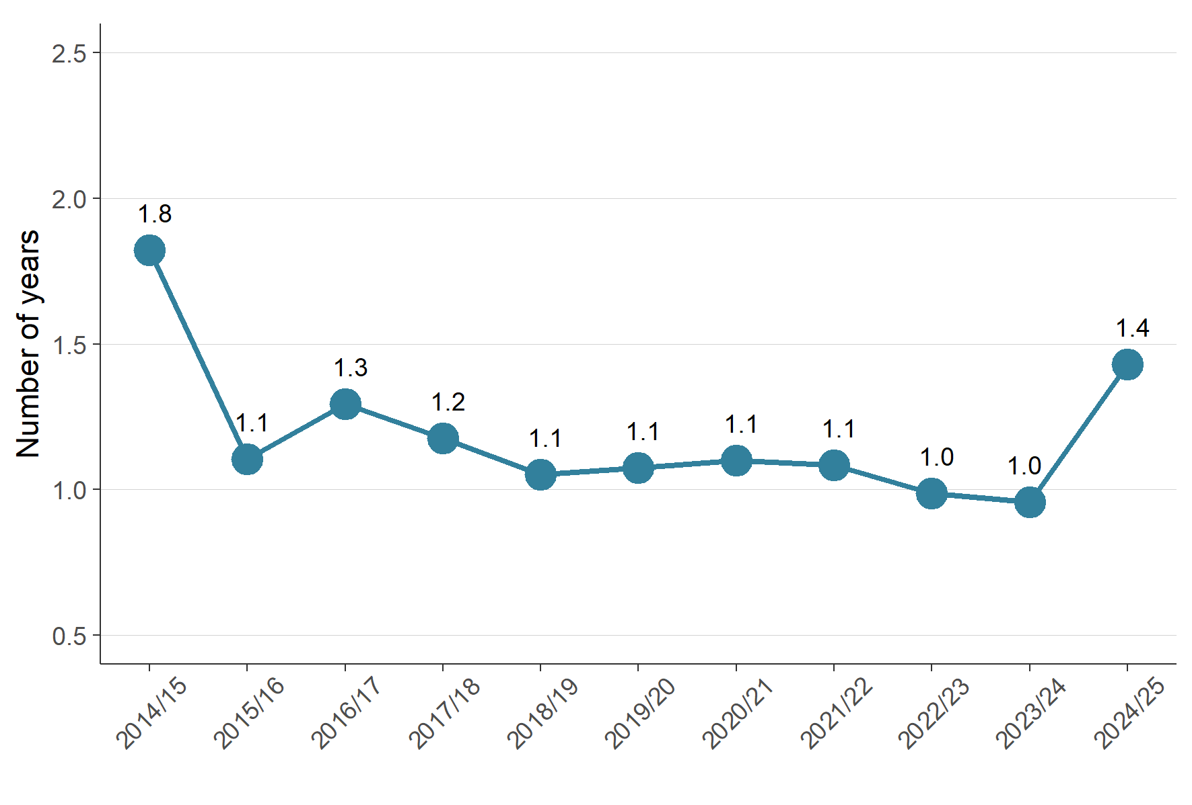
Figure 12: Median processing time to complete a plan change once notified for reported plan changes

Iwi and hapū participation within the resource management system
The RMA sets out different ways to enable iwi and hapū participation in resource management processes. Councils also have provisions in place for specific tangata whenua participation in resource management processes.
Provisions may come in the form of budgetary commitments from councils to support iwi and hapū along with other forms of contribution such as access to databases or memoranda of understanding.

There was variation in how councils budgeted for iwi and hapū participation in consenting and plan-making
Figure 13 shows the percentage of all 78 councils who reported providing a budget for iwi and hapū to participate in plan-making and resource consent processes. Since 2014/15, there has been a general downward pattern for both, from 58 per cent (2014/2015) to a low of 32 per cent in 2023/24 for plan-making; however, in 2024/25 it has increased from 32 per cent (2023/2024) to 38 per cent. Similarly for resource consenting, contributing councils decreased from 42 per cent (2014/15) to a low of 22 per cent in 2022/23; however, over the last two years this increased to 31 per cent in 2024/25.
The 2024/25 data show an increase of nearly 6 percentage points in councils reporting that they provide budget to iwi and hapū to participate in resource consenting processes. The data indicates that there is also a 6 percentage point increase in councils providing budget to iwi and hapū in the plan-making process, compared with the previous year.
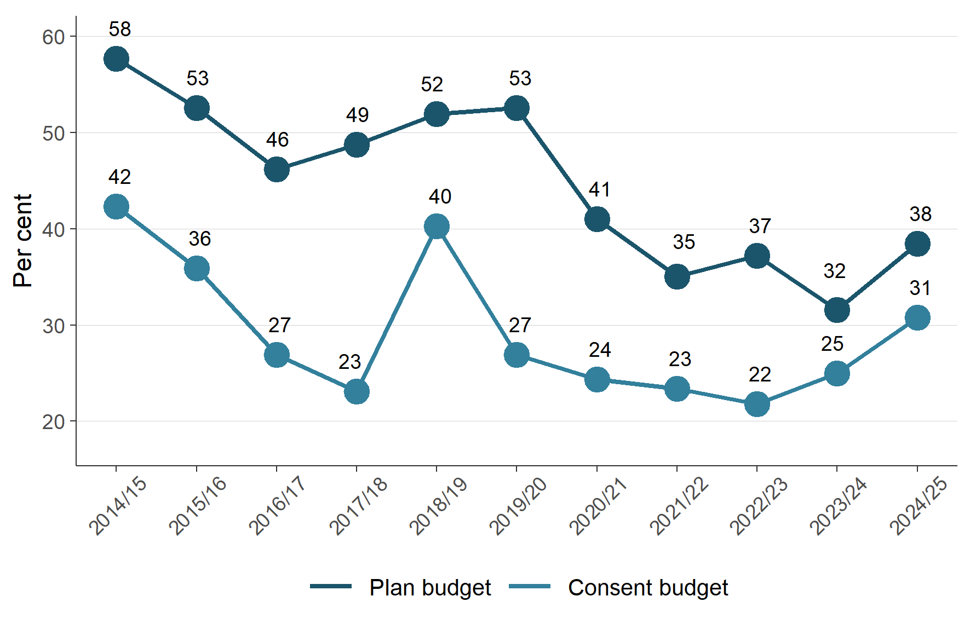
Figure 13: Percentage of councils that reported providing budget to iwi and hapū to participate in either the development of resource management plans or processing of resource consents

The number of new iwi management plans remains low
Iwi management plans describe resource management issues of importance to tangata whenua and can also be used to express values relating to specific areas, natural resources or taonga. Iwi management plans can also provide guidance for interactions between councils and iwi and hapū, as well as direction on decision-making and information requests. An iwi management plan can help improve understanding of specific values and interests for tangata whenua.
Figure 14 shows that, in 2024/25, the number of new iwi management plans endorsed by iwi authorities and lodged with councils remains low.

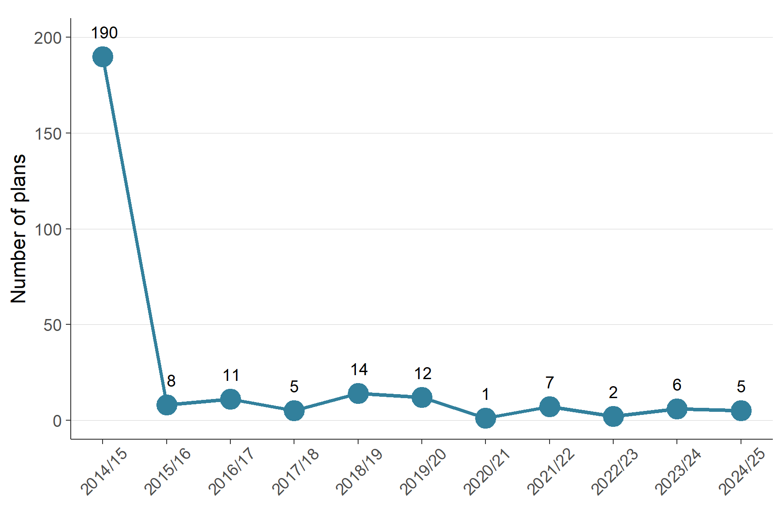
Figure 14: Number of new iwi management plans endorsed by iwi authorities and lodged with councils
Note: Iwi management plans lodged with more than one council are counted separately.
Note: 2014/15 was the first year of the NMS in its current form with many historical management plans received.

Compliance and enforcement
Under the RMA, all councils have a responsibility to monitor a range of matters as part of their compliance and enforcement duties. Such functions enable all councils to:
- ensure the efficiency, effectiveness and enforcement of policy statements and plans
- monitor and enforce the exercising of resource consents and resource management plans
- ensure people and companies are delivering the environmental outcomes supported by councils.
Compliance and enforcement is an important part of councils fulfilling their statutory functions to show that their objectives, policies and methods are meeting the purpose of the RMA. The amount of active compliance and enforcement work varies between councils, depending on the number of consents they have and the local environmental context.
Councils can use different types of enforcement tools under the RMA, from issuing abatement notices or seeking an enforcement order, through to issuing an infringement notice or taking a prosecution.

Enforcement action taken by councils continues to show variation
Figure 15 shows enforcement actions taken by councils since 2014/15. The 2024/25 data showed that territorial authorities, Auckland Council and unitary authorities increased their enforcement actions, compared to 2023/24. Whereas regional councils decreased their enforcement actions, compared to 2023/24.
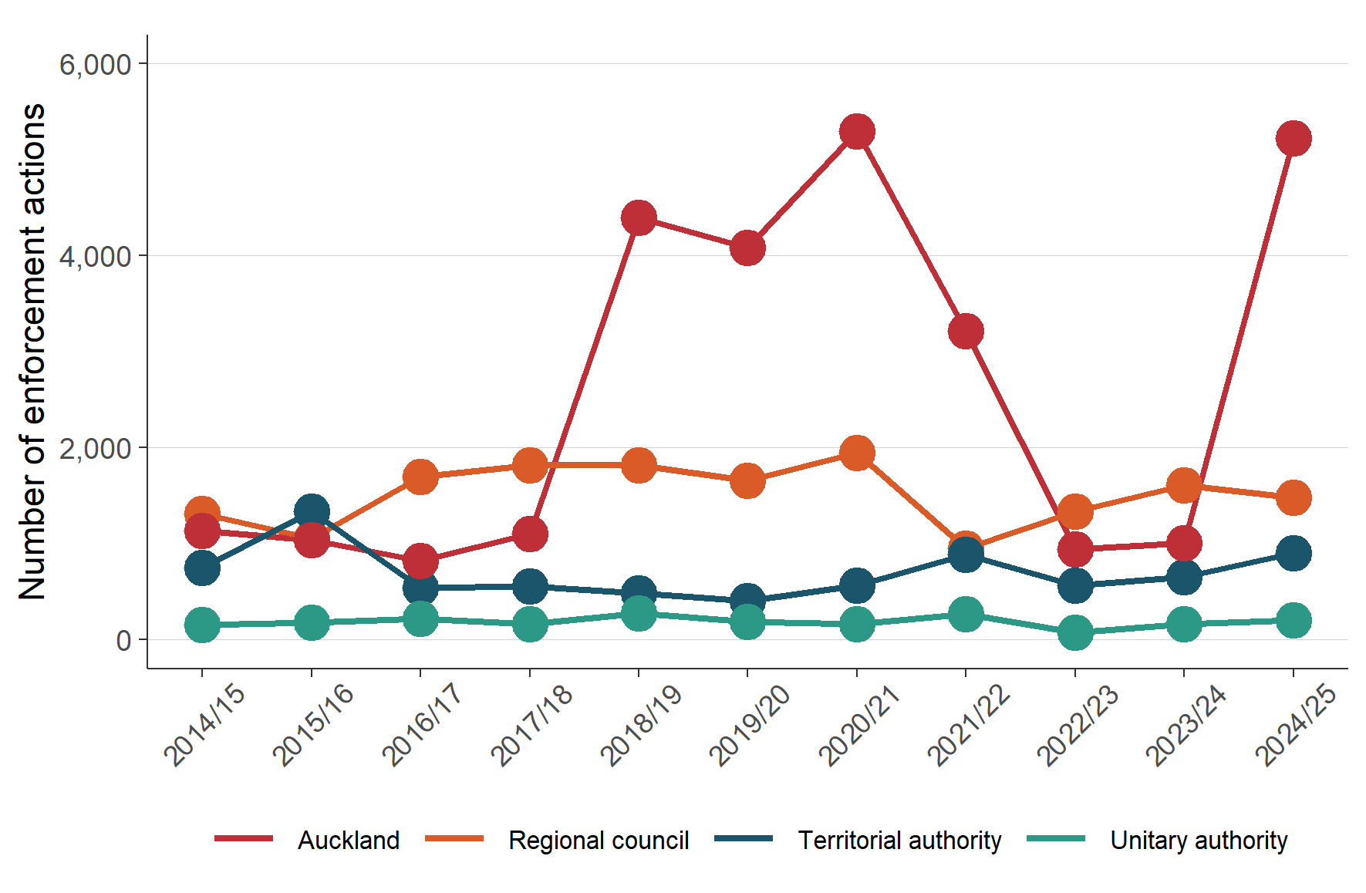
Figure 15: Number of enforcement actions (infringement notices, abatement notices and enforcement order applications) taken by councils by council type

Staffing levels on resource management work varied
Full-time equivalents (FTEs) measure the effective number of employees working across plan preparation processes (planning), consenting, and compliance and enforcement at councils. Since 2014/15, consenting staff numbers have remained higher than full-time equivalents measured in planning and compliance and enforcement.
Figure 16 shows an increase in the number of consenting staff during 2024/25, 1,308 full-time equivalents, compared with the previous year.
In 2024/25, the data also showed that the number of full-time equivalents for planning staff and compliance, monitoring and enforcement staff increased, compared with the previous year.

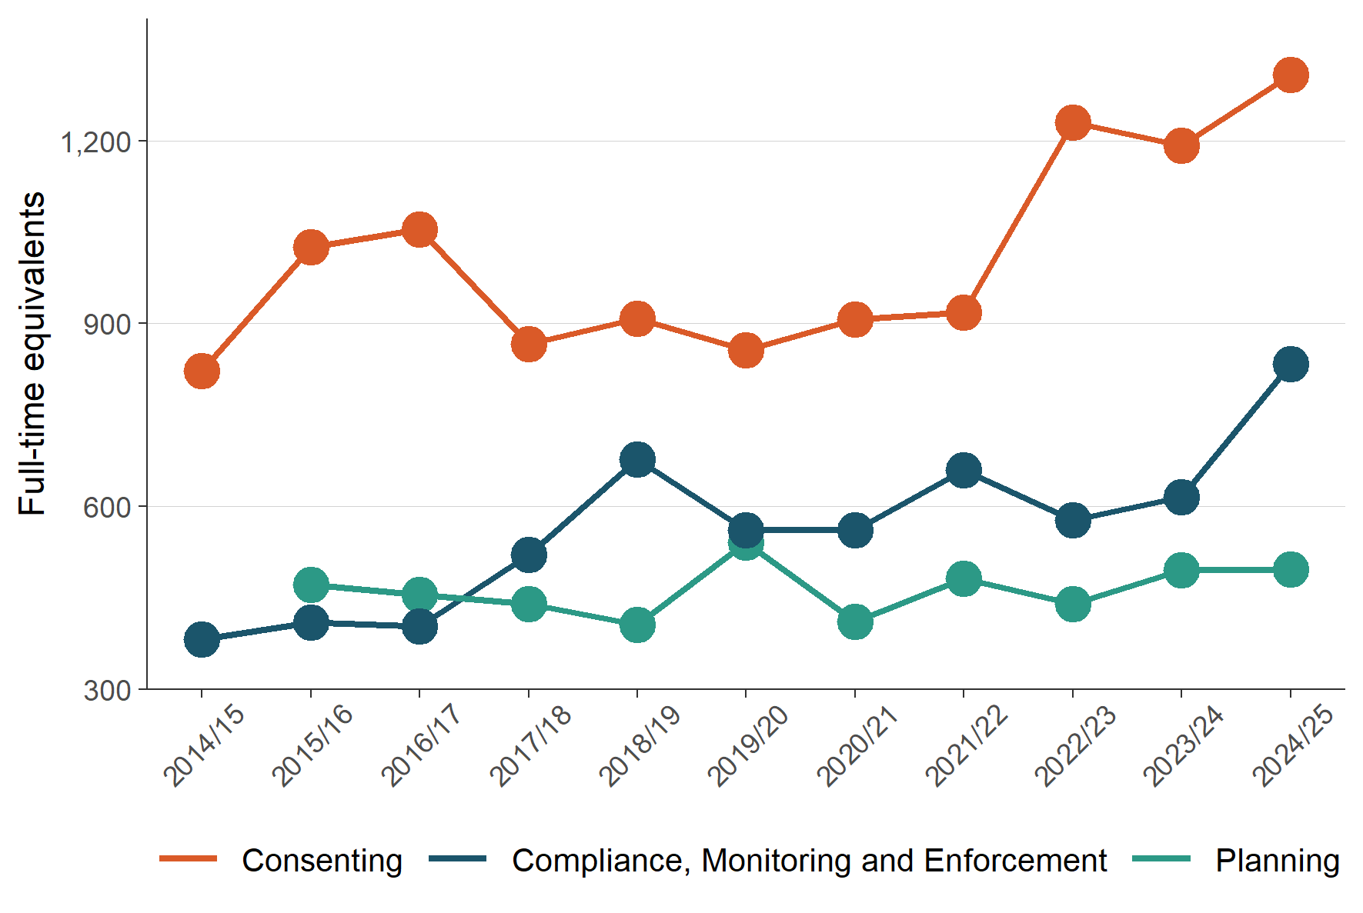
Figure 16 Number of full-time equivalents working on resource management at councils by subject area
Figure 17 shows councils employed their highest number of full-time equivalents in resource management (combining consenting, compliance, monitoring and enforcement, and planning policy staff) in 2024/25. The 2024/25 data illustrate an increase in full-time equivalents, continuing since 2020/21.
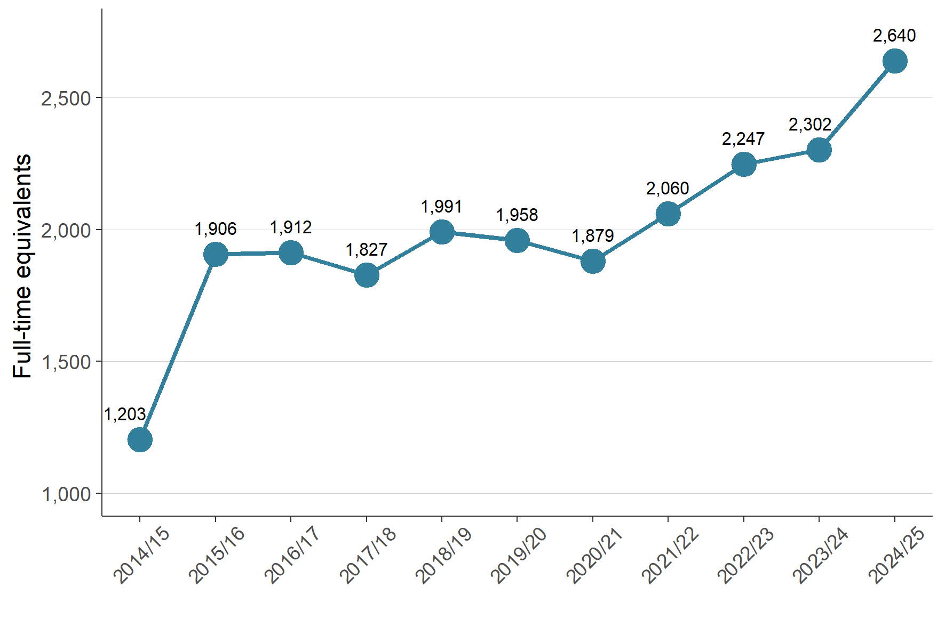
Figure 17: Number of full-time equivalents staff working on resource management at councils
Note: Full-time equivalents data records the number of staff employed and do not include vacancies.

The RMA uses the term ‘local authorities’. In this report, we have used ‘councils’ to refer to all local authorities, that is, district and city councils, regional councils and unitary authorities.

