

Fact sheet 3

The New Planning System
Protecting the environment

Transforming how we plan and care for our unique natural environment
New Zealand’s new planning system will make it easier to build the houses and infrastructure our country needs, let farmers and growers get on with doing what they do best, and boost our primary sector while protecting the environment.
Communities will be able to set their own aspirations for their water bodies, ensuring decisions reflect local priorities and values. This approach enables a more effective balance between environmental protection and economic interests. By putting control in the hands of local communities, we could achieve solutions that work for both the environment and the economy.
Two new Bills with clear roles
The new planning system is set out in two new Bills. Once passed, these will replace the current Resource Management Act 1991 (RMA):
- The Planning Bill lays out the framework for how land can be used and developed.
- The Natural Environment Bill is focused on managing the use of natural resources and protecting the environment.
The new planning system is made up of more than just new Bills. National instruments – including national policy directions and standards – will provide specific requirements to councils on how to protect and enhance the natural environment, including setting binding environmental limits. This will inform how councils develop their plans and make consenting decisions. The new planning system will include helpful changes made under recent changes to the RMA.

Protecting what matters most
The new planning system will significantly change how New Zealand protects and enhances its natural environment. In short:
- there will be clear environmental limits to protect nature and people’s health
- spatial planning will help councils and communities map out where development and protection should happen, making sure important areas for native species are looked after and environmental limits are respected
- you can keep using your land, and development will be enabled, if you stay within the limits
- if biodiversity rules make it hard to use your land, you may be able to access relief (such as cash payments or lower rates)
- it will be easier to get approvals, with less double-up between different laws such as the Wildlife Act.
Decisions in the new planning system will work like a funnel. Clear goals at the top for how we plan and protect the environment, then national direction and standards narrow what’s up for debate from there. This means decisions stick and everyone has more certainty.

Environmental limits: clear boundaries and action when needed
Under the RMA, there wasn’t always clear, binding limits for things like clean air, water, land or native species. Sometimes this meant problems with the use of those resources weren’t caught early, and it was hard to fix things once they went wrong.
Under the new planning system, binding environmental limits will make it clear where the boundaries are for using resources.
- Human health limits will be set nationally, by the Government (guided by health advice).
- Ecosystem health limits will be set by councils using national standards and good data. These cover air, freshwater, coastal water, land and soils, and indigenous biodiversity.
- The Government can specify minimum levels for ecosystem health limits. However, there may be circumstances where a council and community consider it appropriate to set less stringent limits to those set by the Government. This is possible provided a justification report is prepared.
- All environmental limits will be applied to specific areas (called management units). These will be shaped by what communities want for their area, and decision-makers must balance people’s health and the natural environment with the economic needs of the region.
If a limit is exceeded or broken, councils must prepare an action plan showing how they will manage things back within the limit and over what period. If there is no risk of breaking a limit there will be fewer rules for you to follow.
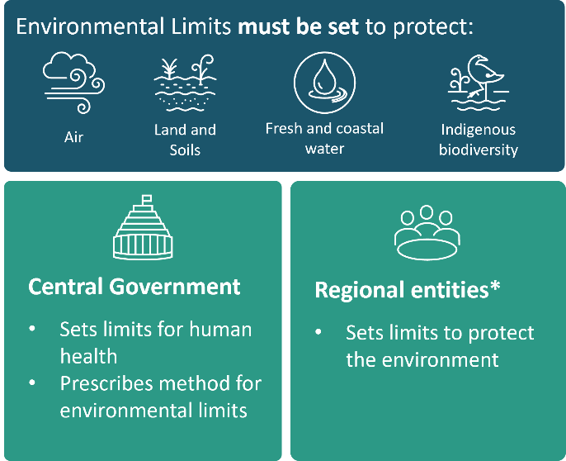
*Currently regional councils

The new planning system will protect indigenous biodiversity
New Zealand’s unique indigenous biodiversity is under pressure. The new planning system will enable development while protecting indigenous biodiversity – making protection and restoration clearer and fairer and recognising landowners’ efforts.
Indigenous biodiversity will be protected through:
- a goal of no net loss for indigenous biodiversity
- a compulsory ecosystem health limit for indigenous biodiversity
- nationally consistent rules and standards for how indigenous biodiversity is managed and protected.

How councils set and apply rules about indigenous biodiversity
The Government will use national instruments to set nationally consistent objectives and policies for managing and protecting indigenous biodiversity. Councils will use this to:
- set limits that protect indigenous biodiversity (eg, minimum indigenous vegetation across a wider area, or consistent criteria for identifying areas of high biodiversity value)
- apply an approach based on ecological value – to prioritise areas for protection, restoration or development
- follow assessment principles: use the best available information, engage openly with landowners, and explain clearly how information will be used.

Recognising efforts to help nature
The new planning system will better recognise the impact on landowners when some planning controls limit the use of their land, while encouraging those who are making an effort to protect nature.

Regulatory relief
You may be able to get ‘relief’ if particular rules have a big impact on how you can use your land. This covers rules about:
- land-based indigenous biodiversity and significant natural areas
- significant historic heritage
- outstanding natural features and landscapes
- areas of high natural character within the coastal environment, wetlands, lakes and rivers and their margins.
Relief could include things like cash payments, lower rates, extra development rights, no-fee consents, land swaps, or expert advice.
The Planning Tribunal can help if you and the council can’t agree on what relief you should get. Under the new planning system, relief will be triggered for lower-level impacts on you than under the old system.

Offsetting, restoration and credits
The new planning system encourages landowners to help protect native plants and animals by making sure there is no net biodiversity loss. This means if your activity harms native species or habitats, you may need to ‘offset’ that by restoring other areas or habitats. Biodiversity credits may reward landowners who actively protect and enhance native biodiversity. National rules will explain how these work.

Working better with other laws
The new planning system is designed to work better with other existing laws, reducing duplication and streamlining processes for you and consenting authorities.

Wildlife Act
Under the current system, many infrastructure, mining and construction projects need a resource consent and a wildlife permit under the Wildlife Act 1953. Under the new planning system, you won’t need a separate wildlife permit for most projects.

Fisheries Act
The new planning system keeps fisheries management under the Fisheries Act, while planning rules focus on environmental effects and land use. This reduces overlap, gives more certainty, and ensures fishing rights are properly considered in planning decisions.

Water Conservation Orders will focus on key values
Water Conservation Orders (WCOs) recognise and protect the outstanding values of particular bodies of water. Existing WCOs will stay in place under the new planning system and new ones can be introduced, but several changes will be made:
- The criteria for the creation of WCOs will be narrowed.
- Local authorities like councils will be responsible for monitoring WCOs.
- It will be easier to change WCOs over time.
What happens next?
Before they become law, the public gets to have a say about the new Bills through select committee hearings in early 2026 – this is an opportunity to make improvements.
Once the Bills are in place, the next step is to confirm the national instruments needed to guide spatial planning. People will also get a chance to submit on this. There will be transitional arrangements for existing resource consent holders:
- All consents under the RMA will be extended until at least mid-2031.
- You can obtain a new consent under the transitional system from mid-2026.
- A new National Policy Statement – Freshwater will be introduced by mid-2026, which will assist anyone who wishes to obtain a new consent early.
The first spatial plans are expected within a set period after the law is enacted. Government hopes to have the transitional system up and running in the middle of 2026, and the full system working by 2029.

For more information, visit environment.govt.nz.
Published in December 2025  by the Ministry for the Environment | Manatū mō te Taiao  Publication number: INFO 1354 | 