

Fact sheet 2

The New Planning System
Stronger direction and a plan for getting there

Better planning for a better New Zealand
New Zealand’s new planning system will make it easier to build the houses and infrastructure our country needs, let farmers and growers get on with doing what they do best, and boost our primary sector while protecting the environment.
Whether you’re a developer, farmer, planner or community member, the new planning system is designed to make it easier to make decisions and get things done. Alongside new legislation, stronger national instruments will mean less confusion, more certainty, and better outcomes for New Zealand’s environment and people.
There will be a phased transition to the new planning system, so it’s clear what’s changing when, and there is plenty of support for those who are implementing those changes. That is explained here.
Two new Bills with clear roles
The new planning system is set out in two new Bills. Once passed, these will replace the current Resource Management Act 1991 (RMA):
- The Planning Bill lays out the framework for how land can be used and developed.
- The Natural Environment Bill is focused on managing the use of natural resources and protecting the environment.

More certainty and national consistency

The new planning system is made up of more than just new Bills.
National instruments – including national policy directions and standards – will provide specific requirements for councils to develop their plans and make consenting decisions. These replace a confusing mix of overlapping and sometimes conflicting national policy statements and environmental standards under the RMA with one consistent, nationwide response. This will make it easier for councils, developers and communities to understand what’s required.
Each bill will have its own set of:
- National policy direction: Sets out what the Government expects councils to do to achieve the goals of the bill.
- National standards: Implement the national policy direction and provide the detailed requirements, technical details, templates, and methods for councils to develop plans and make decisions.

What stronger central instruments means for local decision-making
The new planning system is all about certainty. It provides a clear hierarchy for everyone to work with. Decisions in the new planning system work like a funnel. Clear goals are set at the top by the legislation, then national directions and standards narrow what’s up for debate from there. This means decisions stick, and investors, communities and developers have certainty to plan.
- Councils retain responsibility for local plans and consenting but must operate within the national framework.
- Councils have some flexibility, as long as they justify it for local reasons and align with directions and standards.
- The new planning system aims to balance national priorities (eg, housing, infrastructure, environmental protection) with local needs.
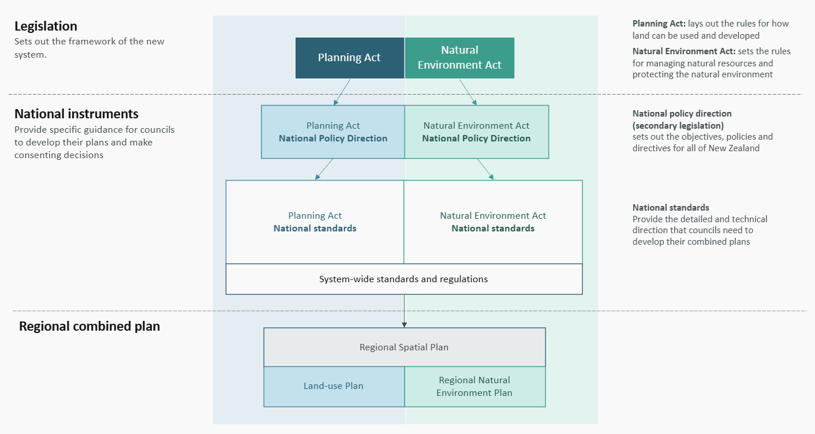
Figure 1: How the national instruments will operate within the framework that the new Bills create.

National instruments – what’s changing?

Current system (RMA):
National direction under the RMA is fragmented and confused. There are multiple documents, sometimes conflicting, and leaving a lot for councils to interpret. Often, councils have to reconcile competing priorities, leading to inconsistency and additional burden.

New planning system:
One national policy direction will sit under the Planning Bill and another under the Natural Environment Bill. These will be standalone secondary legislation that will:
- explain how the goals will be achieved
- what aspects of a goal should be prioritised
- how to manage any conflicts between the goals within each Bill and, as far practicable, between the goals of both Bills.
National policy direction will filter through to the national standards, other planning documents and decision-making processes across the system. It will apply to all of New Zealand.

National standards will set requirements and provide technical direction
National standards put the national policy direction into action by providing the requirements and technical direction that councils need to develop their combined plans – which include spatial, land-use and natural environment plans. This will guide consenting decisions. It is key to driving greater standardisation and consistency in the new planning system.

National standards:
- provide more detailed requirements to councils on how to achieve the national policy direction
- set clear and consistent ways for councils to develop their plans
- set clear and consistent ways for councils to do things such as how to gather information and evidence for plans, which could include identifying risks from natural hazards like floods
- establish how to set environmental limits, define what those limits are, and outline the steps councils must take to measure environmental factors
- provide standardised plan content including definitions, zones, overlays and district-wide matters
- allow certain activities and direct consenting and permitting.

What the national standards may cover
The national standards are currently being developed and will be delivered in stages and aligned with council plan-making needs. Some potential national standards may include:
Planning Act – Potential standards | Natural Environment Act – Potential standards
- Standardised zones  - How to identify and respond to natural hazards  - Housing growth targets  - Regulatory relief  - Identifying historic heritage  - Managing infrastructure capacity | - Environmental limits  - Permitting commercial vegetable growing  - Constructing water storage  - Constructing wetlands  - Monitoring requirements  - Freshwater standards  - Indigenous biodiversity standards

Regulations will also be a critical part of the new planning system
In addition to national instruments, the Government will make regulations to support the new planning system. These regulations are essential for ensuring the new planning system operates smoothly and councils have the tools they need.
The new planning system is designed to be streamlined and flexible. Unlike the RMA, which is highly detailed and prescribes every decision – big or small – the new Bills take a different and more streamlined approach. Core provisions are set out in the legislation, while leaving procedural and technical details to regulations. This means:
- Faster updates – regulations can be changed more quickly and easily than legislation, so procedures stay fit for purpose and respond to changing needs.
- Less complexity – the law focuses on what matters most, rather than spelling out every step.
The Government will also make regulations to cover practical matters such as cost recovery, enforcement, and emergency responses. These regulations will help make sure the new planning system works day-to-day.
For more information, visit environment.govt.nz.
Published in December 2025 by the  Ministry for the Environment | Manatū mō te Taiao  Publication number: INFO 1361 | 

