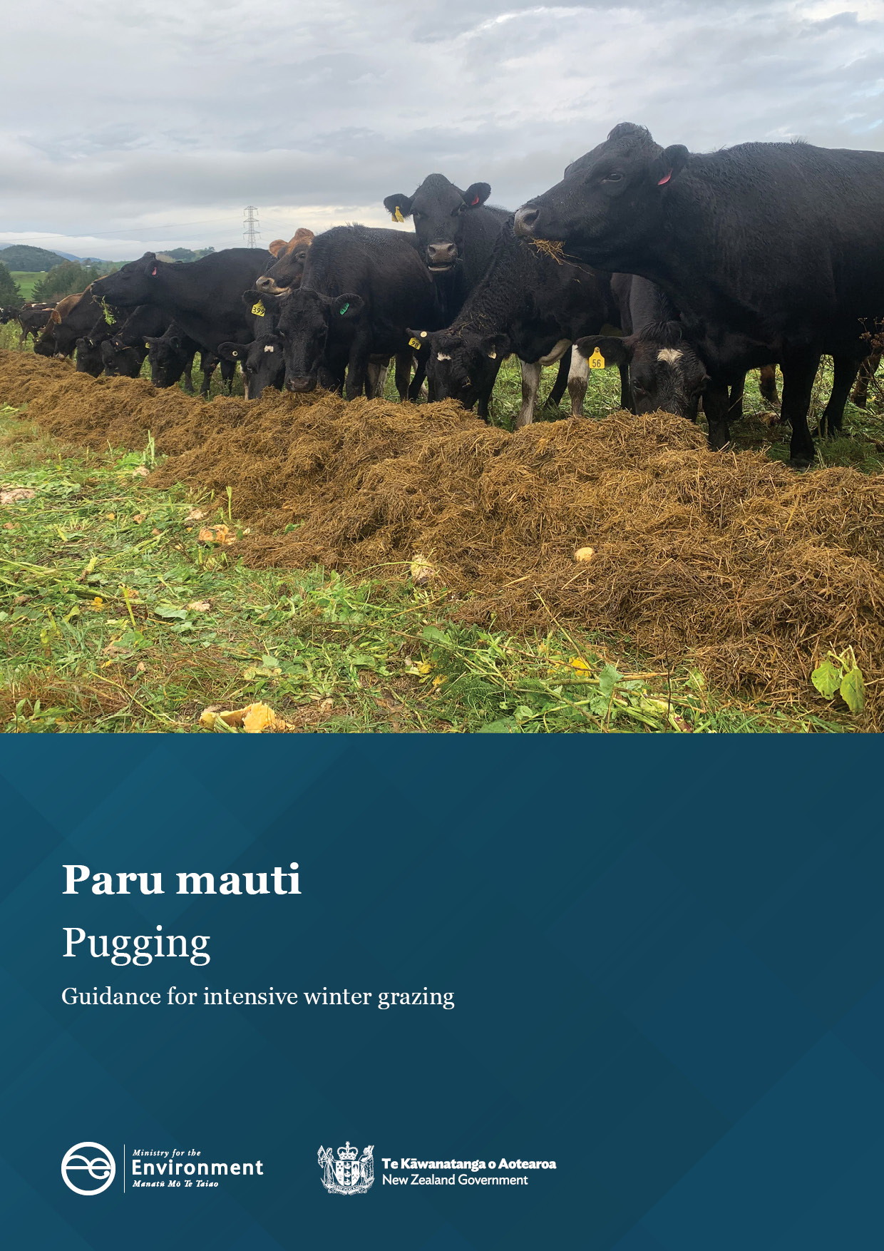

Disclaimer
The information in this publication is, according to the Ministry for the Environment’s best efforts, accurate at the time of publication. The Ministry will make every reasonable effort to keep it current and accurate. However, users of this publication are advised that:
- the information does not alter the laws of New Zealand, other official guidelines, or requirements
- it does not constitute legal advice, and users should take specific advice from qualified professionals before taking any action based on information in this publication
- the Ministry does not accept any responsibility or liability whatsoever whether in contract, tort, equity, or otherwise for any action taken as a result of reading, or reliance placed on this publication because of having read any part, or all, of the information in this publication or for any error, or inadequacy, deficiency, flaw in, or omission from the information in this publication
- all references to websites, organisations or people not within the Ministry are for convenience only and should not be taken as endorsement of those websites or information contained in those websites nor of organisations or people referred to.

Acknowledgements
Prepared for the Ministry for the Environment by John Drewry and Veronica Penny from Manaaki Whenua – Landcare Research, Seth Laurenson from AgResearch and Wei Hu from
Plant & Food Research. This guidance was improved from comments and photos provided by industry groups and colleagues at Plant & Food Research, AgResearch, Manaaki Whenua – Landcare Research and Massey University.
The Ministry for the Environment would also like to thank the regional council and Ministry for Primary Industries staff who provided feedback during the development of this guidance.

This document may be cited as: Ministry for the Environment. 2023. Pugging: Guidance for intensive winter grazing. Wellington: Ministry for the Environment.

Published in March 2023 by the
Ministry for the Environment
Manatū Mō Te Taiao
PO Box 10362, Wellington 6143, New Zealand
environment.govt.nz
ISBN: 978-1-991077-34-9
Publication number: ME 1746
© Crown copyright New Zealand 2023

Contents
Executive summary 5
1. Introduction 6
2. Overview of policy 7
3. Impacts on the environment 10
3.1 Soil structure 10
3.2 Soil pugging, compaction and structural vulnerability 11
4. Implementing the policy 15
4.1 Summary of key risk factors and mitigations 15
4.2 Compliance 17
5. Pre-winter planning 18
5.1 Site selection 18
5.2 Soil type and soil information 19
5.3 Critical source areas 21
5.4 Slope 22
5.5 Sowing the winter forage crop 22
6. During winter – grazing and paddock management 25
6.1 Grazing and cows’ lying time 25
6.2 Strategic grazing 27
6.3 Off paddock facilities and duration-controlled grazing 29
6.4 Supplements, troughs and back-fencing 31
7. After winter – paddock management 34
7.1 Assessment 34
7.2 Remediation 37
8. Limitations and knowledge gaps 40
9. Glossary 41
References 42

Table
Table 1: Summary of key risk factors contributing to actions and mitigations on ‘all reasonably practicable steps’ to minimise adverse effects from pugging on freshwater quality 15

Figures
Figure 1: A very compacted pallic soil (left) and a non-compacted pallic soil (right). 10
Figure 2: Soil pugging, surface ponding and reduced soil infiltration after IWG of cows on a winter forage crop in South Otago. 13
Figure 3: Soil drainage classes 19
Figure 4: Winter grazing study (Burkitt et al, 2017) on a swede crop in Manawatū, showing pugging on an imperfectly drained soil. 20
Figure 5: Winter grazing study (Burkitt et al, 2017) on a swede crop in Manawatū, showing reduced pugging on a well-drained soil. Conventional grazing was also used. 21
Figure 6: Differences in soil physical damage simulated using a ‘cow treading implement’ to assess mitigation options in forage crops, after oats were established with (left) inversion-till and (right) no-till. 23
Figure 7: Differences in pugging after a forage crop (fodder beet or kale) was established with no-till (NT) or inversion-till (IT). 23
Figure 8a, b: South Otago IWG study showing the critical source area was the last break that was grazed. Cows grazed from the top of the paddocks and were break-fed progressively downhill towards the critical source area. 27
Figure 9: A grass ‘break-out’ area within a forage crop paddock, Southland, that was used as a ‘fresh’ area for cows resting in adverse weather conditions. 30
Figure 10: Winter grazing, supplementary feed and soil type study on pasture in Manawatū (Fransen et al, 2022). 32
Figure 11: A page from the VSA guide showing good, moderate and poor soil condition. 34
Figure 12: Visual soil assessment in December 2021 of a Pallic soil (imperfectly drained) on a dairy farm. 35
Figure 13: Visual soil assessment in December 2021 of a Brown soil (well-drained) on a dairy farm. 36
Figure 14: Mechanical soil aeration using a ‘Clough pan-aerator’ with winged tips for improving soil structure after winter forage crop grazing. 38

Executive summary
Intensive winter grazing (IWG) of livestock on annual forage crops (eg, swedes, kale, fodder beet and oats) is an important part of many farm systems to help feed stock and keep them in good condition. IWG can lead to soil pugging, which results in increased overland flow and loss of sediment, nutrients and bacteria to waterways, as well as nutrient leaching. This has impacts on water quality and increases losses of greenhouse gases.
The Resource Management (National Environmental Standards for Freshwater) Regulations 2020 (NES-F) introduced regulations to manage the adverse effects of IWG, including a standard for pugging. The following regulation applies (NES-F):
26A Pugging standard
- A person using land on a farm for intensive winter grazing in accordance with regulation 26 must take all reasonably practicable steps to minimise adverse effects on freshwater of any pugging that occurs on that land.
The purpose of this guidance is to help farmers, land managers and councils to manage and monitor IWG activities in a way that is consistent with the regulations and minimises the impacts on the environment. It includes recommended practices for planning and managing IWG, emphasising factors that could be considered when determining the ‘reasonably practicable steps’ to minimise adverse effects of any pugging on freshwater.
This report presents a summary of key research — illustrated by case studies and pilot studies — and recommended practices from research and industry.
To reduce pugging impacts, the following factors may be considered:
- planning before forage crop establishment (site selection, soil types, slope and crop establishment methods)
- grazing management (traditional and strategic grazing)
- paddock management (feed supplements, troughs and back-fencing)
- post-grazing soil assessment and remediation.
Separate guidance documents for intensive winter grazing, with recommended practices, are available for critical source areas and groundcovers.

1. Introduction
Intensive winter grazing (IWG) is a farming practice in which livestock are confined over winter to outdoor feeding areas planted with annual forage crops such as swedes, kale and fodder beet (Ministry for the Environment, 2022).
IWG of forage crops can lead to soil pugging (penetration of soil by hooves of grazing livestock), soil structural damage, increased overland flow and loss of sediment, nutrients and bacteria to waterways, with impacts on water quality.
This report provides practical management options to minimise soil pugging impacts under IWG of forage crops.

2. Overview of policy
The Resource Management (National Environmental Standards for Freshwater) Regulations 2020 (NES-F Regulations) introduced regulations to manage the adverse effects of IWG. These include a standard for pugging:
26A Pugging standard
- A person using land on a farm for intensive winter grazing in accordance with regulation 26 must take all reasonably practicable steps to minimise adverse effects on freshwater of any pugging that occurs on that land.
The pugging standard requires that measures are taken to minimise the effects of pugging and bare ground, within the specific context of the farming operation. These requirements do not influence the ability to apply for resource consent, but they do mean:
- a failure to meet the pugging and ground-cover standards allows councils to issue abatement notices and enforcement orders, or undertake prosecution based on non-compliance with regulations
- A person using land for IWG must provide any information required by a regional council enforcement officer for the purpose of monitoring compliance with the pugging standard.
It is important to note that a regional rule or resource consent can be more stringent than any of the intensive winter grazing regulations. If this is the case, the more stringent regional rule or resource consent prevails over the regulations (Ministry for the Environment, 2022).
Considerations for determining what is ‘reasonably practicable’
The pugging standard requires that all reasonably practicable steps are taken to minimise adverse effects of pugging on freshwater.
Given that many factors can be considered when determining suitable mitigations for pugging (eg, soil type and climate), there will inherently be variation in what ‘reasonably practicable steps’ must be taken to ensure compliance. The addition of the word ‘all’ emphasises that a farmer must ensure they have explored and deployed all available and relevant management options suited to their grazing practice and risk, in the context of their unique farm system.
In practice, this means enforcing the regulation would need an enforcement officer to determine what is practicable on a case-by-case basis. This guidance provides some key factors and variables that could impact operational decisions and may be considered when determining what is reasonable and practical in any given situation.
Some criteria that could be used when determining what are reasonably practicable steps are outlined below. The considerations discussed in this document are suggestions only and do not limit any other factors which may be relevant to consider when determining what steps are reasonably practicable on a case-by-case basis. The four considerations are:
1. The likelihood of the risk concerned occurring.
2. The degree of impact that might result from the risk.
3. The availability and suitability of actions and/or mitigation options to eliminate or minimise the risk.
4. Whether the associated cost to undertake the available steps to avoid or minimise the risk is proportionate to the risk.
These key considerations are illustrated in the context of IWG in the table below:
Consideration | Explanation
The likelihood of the risk concerned occurring | The likelihood or probability of a risk occurring may influence the level of mitigation or the suitability of the activity (or scale of activity) proposed.  For example, a paddock with a higher slope, poorly draining soil and a high-stocking density is more likely to result in surface contaminant run-off occurring than a low-slope paddock with free-draining soils.* More extensive mitigations, such as leaving wider buffer areas around critical source areas or using sediment traps, could be considered in a higher risk area.  These factors are discussed in more detail in section 3.2.
The degree of impact that might result from the risk | If there is a containment source (ie, an IWG paddock) in close proximity or with a high degree of connectivity to a waterbody with no mitigations in place, it is likely to have a greater impact on the receiving waterbody during prolonged or severe weather events.  The unique farm and environmental context, including the receiving environment, should be considered in evaluating the potential impacts on freshwater.  It is good practice if farm records reflect the potential and actual risks that have been considered, and options as well as actions to appropriately address these risks, that have been evaluated and executed.
The availability and suitability of actions and/or mitigation options to eliminate or minimise the risk | If the availability of suitable equipment, supplies or contractors is necessary to implement appropriate mitigations, this may factor into how reasonably practicable it is to undertake a particular intervention.  For example, if lack of building supplies and/or contractor availability restricts building a feed pad in time for the winter grazing season, it may be more appropriate to identify a suitable paddock where stock can be shifted to in the event of severe weather.  However, it may also be relevant to consider the overall suitability of the area for IWG if mitigations cannot, or are unlikely to, appropriately manage effects.  It is good practice to have a plan in place which considers alternative management options or approaches that could be taken if supply chain or availability may be a factor.
Whether the associated cost to undertake the available options to avoid or minimise the risk is proportionate to the risk | It could be relevant to consider how the degree of impact and likelihood of risk occurring may factor into the cost of appropriate mitigation.  For example, it could be relevant to consider whether a large cost of mitigation is disproportionate to the degree of impact and likelihood of risk occurring. For example, a very costly mitigation action such as installing a wintering barn may not be required where the degree of impact and likelihood of risk are low.
*Note that lower risk is meant in the context of IWG and all intensively grazed areas in winter carry a high risk.

3. Impacts on the environment

3.1 Soil structure
Soil structure is important for soil water drainage and water storage, root penetration, air movement, plant yield and environmental performance, including freshwater quality and greenhouse gas emissions. Healthy and well-structured soils have good friable structure and adequate large pores so nutrients, air and water can move in well-connected pores (figure 1, right image). In contrast, poorly structured soils typically have dense, firm soil, with few visible large cracks and pores, making it difficult for roots to penetrate, and thus have poor drainage and air movement (figure 1, left image). Large soil pores (macropores) are responsible for air movement and drainage but are the most susceptible to damage.
Soil structure is represented by the arrangement of soil aggregates and air- or water-filled pore space and is associated with a range of ecosystem services (Houlbrooke et al, 2021; Hu et al, 2021). The degrading of soil structure occurs when the soil stress associated with vehicles or grazing animals exceeds the soil’s bearing strength. Intensive winter grazing of forage crops can greatly reduce soil surface infiltration, soil pore volumes and connectivity, from the impact of pugging (eg, Drewry and Paton 2005; Hu et al, 2021).
Figure 1: A very compacted pallic soil (left) and a non-compacted pallic soil (right).
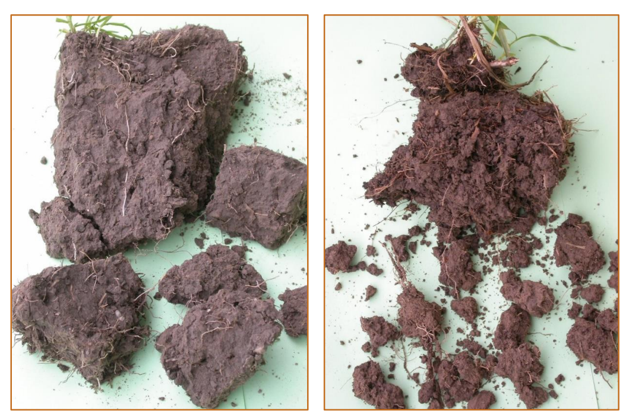
The compacted soil has large dense aggregates that are difficult to break apart. The non-compacted soil has smaller more friable aggregates with many visible cracks and pores. Photos supplied by J Drewry.

More information
More information on soil structure is available from the following sources:
- Soil health and resilience publications (Manaaki Whenua – Landcare Research)
- Pugging and soil compaction – What influences pugging? (Beef + Lamb New Zealand)
- Soil Structure: Its importance to resilient pastures (New Zealand Grasslands Association)
Key points
- Soil structure is important for soil water drainage, water storage, root penetration, air movement, plant yield and environmental performance.
- Healthy and well-structured soils have good friable (ie, crumbly) structure, adequate large pore space and pore connectivity for both water storage and transport. In contrast, poor soil structure has inadequate large pores and pore connectivity, typically showing as dense, firm aggregates, with few visible large cracks and pores.

3.2 Soil pugging, compaction and structural vulnerability
The National policy statement for freshwater management 2020 defines ‘pugging’ as ‘the penetration of soil by hooves of grazing livestock’ (New Zealand Government, 2020).
Soil pugging can occur when soil pores are filled with water, which can result in a semi-liquid mix of soil and water on the soil surface. Pugging in wet, soft soil is the deformation of soil under treading, causing deep hoof imprints. It is often associated with considerable soil or plant damage (Drewry et al, 2008; Houlbrooke et al, 2021). Pugging does not tend to compress soil but instead results in a very rough and smeared soil surface. Pugging during intensive winter grazing can dramatically reduce pore connectivity, and therefore water infiltration. This results in overland flow, which can carry sediment and nutrients. Several case studies illustrating impacts on the environment are presented later.
Soil compaction, a related process, usually occurs in unsaturated soil (moderately wet or below field capacity) and mostly beneath the pugged surface layer of soil. Some large pores are air-filled and these get compressed when soil is compacted.
The risk of pugging and degrading the soil structure is related to factors such as soil structural vulnerability, climate and intensity of winter grazing (from livestock type, crop yield and duration of treading). In North Otago, greater soil physical damage typically occurred on kale, swedes and triticale under cattle grazing than sheep grazing (Houlbrooke et al, 2009). Soil properties influence their vulnerability to damage. Soil structural vulnerability is the ability of soil structure to cope with vehicle traffic or livestock treading. The soil structural vulnerability index (SVI) is estimated from phosphorus retention, soil carbon and clay contents and soil drainage class (Hewitt and Shepherd, 1997). The SVI can be obtained from S-map factsheets. The SVI is a useful initial guide when planning soils to use for IWG. However, S-map is published at regional, not farm scale. The SVI does not consider weather, farm management or adequate representation of carbon, so some caution should be applied when using it.
Best practice would require managing pugging in IWG paddocks to try to prevent or reduce the following risk factors occurring at the same time. For example, if high grazing intensity is combined with high-clay content soils under wet conditions, then an appropriate management option to minimise pugging is to reduce stocking intensity. The risk factors are:
- soils with a high-clay content (a function of the soil type) are more vulnerable to pugging damage during wet conditions (Laurenson and Houlbrooke, 2016)
- soil wetness (a consequence of drainage, as affected by slope, soil type or landscape)
- high grazing intensity (related to crop type, yield, stocking density, animal type and duration of grazing). Greater grazing intensity and heavier animals can result in more soil pugging and physical damage.
Donovan and Monaghan (2021) recently developed a surface-erosion model which accounts for the damaging effect of animal grazing and lack of vegetative cover that is typical under IWG. The model captures the important effects of soil vulnerability (including moisture content) and grazing intensity. Modelled surface soil erosion from grazed winter forage crops (11 t/ha/yr) is typically much greater than for pasture (0.83 t/ha/yr) (Donovan, 2022).

More information
More information on soil pugging is available from the following sources (the Ministry does not necessarily endorse any information on these websites):
- Managing pasture damage after a period of bad weather (DairyNZ)
- Pugging and soil compaction – What influences pugging? (Beef + Lamb New Zealand)
- Soil health and resilience publications (Manaaki Whenua – Landcare Research)
Case study: Intensive winter grazing and soil structure on pallic soils
A study of intensive winter grazing (IWG) of cows on swedes and kale was conducted in South Otago on poorly drained pallic soils, over three years of consecutive IWG (Monaghan et al, 2017). Soil conditions between pre- and post-grazing of the crop indicated a high degree of visual soil deformation, pugging and a significant reduction of total porosity, in particular the larger soil pores that are critically important for drainage. This soil damage had a significant effect on overland flow due to decreased total soil pore space, reduced pore sizes and reduced pore continuity in surface soils (figure 2).
Figure 2: Soil pugging, surface ponding and reduced soil infiltration after IWG of cows on a winter forage crop in South Otago.
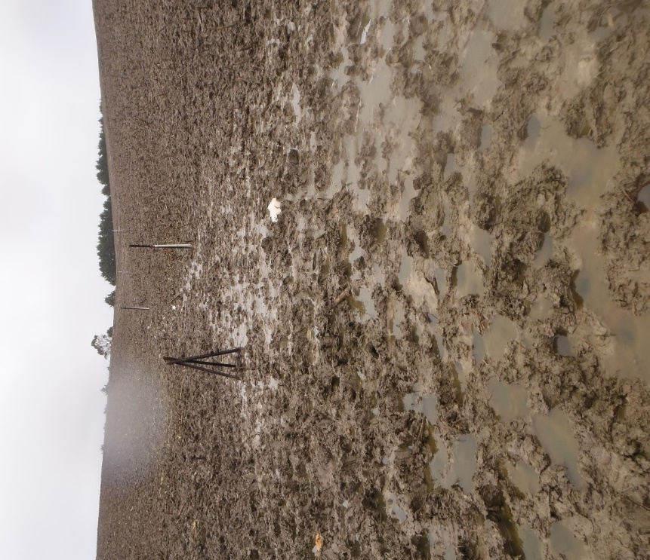This photo was taken before IWG regulations came into effect.
Photo supplied by S Laurenson.

Key points
- Soil pugging occurs on very wet soil when soil pores are filled with water. Soil compaction occurs under moist conditions, usually beneath the pugged surface layer.
- IWG treading damage can degrade soil structure, pore connectivity and infiltration rates, especially in imperfectly drained soils (eg, pallic soils). This causes ponding on the surface and allows surface water to transport sediment, bacteria and nutrients.
- Some crop cover or residual crops left after grazing can help protect soil from degradation and erosion.
- Retaining soil structure and soil strength before grazing is important. Undisturbed soils with an intact structure and good groundcover are less prone to physical damage than those disturbed by tillage with minimal groundcover.
- It may be best to avoid IWG on soils with high structural vulnerability, or soils with high clay content, particularly in very wet conditions.

4. Implementing the policy
Good planning and intensive winter grazing (IWG) practices will help ensure animals are adequately fed, while protecting animal welfare and minimising impacts of pugging on freshwater quality.

4.1 Summary of key risk factors and mitigations
Some of the key risk factors that could be considered when taking ‘all reasonably practicable steps’ to minimise adverse effects of pugging on freshwater are summarised in table 1. More details and sources of information are presented elsewhere in this document.
This guide is unable to provide risk and mitigations that apply to all scenarios. Even taking all reasonably practicable steps may still result in the occurrence of pugging damage. The unique farm and environmental context should be considered when evaluating the potential impacts on freshwater and whether the selected paddock is suitable for IWG to occur.
Table 1: Summary of key risk factors contributing to actions and mitigations on ‘all reasonably practicable steps’ to minimise adverse effects from pugging on freshwater quality
Factor | Considerations
Plan – selecting the right paddock
Soil | Risk factors  Soil type and/or drainage class and/or clay content  - Imperfectly or poorly drained soil has higher vulnerability to pugging than well-drained soil. Under IWG, imperfectly or poorly drained soil, combined with a high grazing intensity, could result in a greater risk of pugging damage and overland flow.  - Well-drained soil has greater risk of nutrient leaching than imperfectly or poorly drained soil, which should be considered.  - Soil with higher clay content has greater vulnerability to pugging damage in wet conditions than soil with lower clay content.
On-farm actions and/or mitigations
- Using farmer knowledge and/or the S-map. A land user’s on-farm knowledge and farm-scale soil survey maps are useful tools. S-map is available in many locations but only at regional scale.
- If several soil types are available on the farm, preference should be given to well-drained soil to reduce pugging.
- If possible, avoid grazing soils with high clay content in very wet conditions.
Slope | Risk factors  Slope and/or soil erodibility and/or groundcover  There is greater risk of soil erosion as slope increases and as groundcover decreases.
On-farm actions and/or mitigations
- Avoid steep slopes. Intensive winter grazing activities are permitted activities under NES-F IWG regulation 26 if they comply with the condition: “the slope of any land planted in annual forage crop used for IWG must be 10 degrees or less and is determined by measuring the slope over any 20-metre distance of the land”.
Pre-grazing and sowing – identifying risks and mitigating
Landscape | Risk factors  Critical source areas (CSAs) (refer to Ministry’s CSA guidance) and/or wet areas  - Wet soils are at greater risk of pugging and damage than dry soils.  - South-facing slopes tend to be wetter and more vulnerable to pugging damage than non-south-facing slopes.
On-farm actions and/or mitigations
- Paddock choice should include considering the area of grazing and the role of riparian buffers in relation to the location of critical source areas.
- Create buffer zones. Provide sufficient buffer zones between IWG and CSAs to limit sediment and nutrient losses.
- Choose non-south-facing slopes.
Crop | Risk factors  Tillage and/or crop choice
On-farm actions and/or mitigations
- Very wet areas, including critical source areas, should be identified and fenced off before sowing crops, and preferably left with vegetative cover.
- Reduced tillage. Use no tillage or minimum tillage practices (eg, shallow non-inversion tillage or strip tillage). Sow crops across slopes, rather than up and down the slope.
- Crop choice. Consider growing lower-producing crops (eg, kale rather than fodder beet) to reduce pugging. This reduces the intensity and duration of grazing.
During grazing – observe and manage
Stock | Risk factors  Size and class of stock
On-farm actions and/or mitigations
If practical, use lighter stock classes (eg, yearlings) with heavier-textured, more vulnerable soils.
Grazing practices and paddock management | Risk factors  Placement of supplements and/or vehicle movement
On-farm actions and/or mitigations
- Where practical, keeping some crop cover can help minimise soil damage and erosion. Very pugged and disturbed soil is likely to have more overland flow and greater erosion.
- Place supplements like baleage in the paddock, spaced out for grazing, while the crop is young. Place well away from critical source areas.
- Ensure animals are provided with sufficient feed, water and shelter. This will reduce stock movement and pugging damage.
- Place troughs well away from critical source areas.
- For grazing, aim to move breaks regularly. Consider using a back fence (except for deer). Consider on-off (duration controlled) grazing.
- Graze areas of highest vulnerability and risk, for example near critical source areas, as late in the season as possible.
- Consider strategic grazing (directional grazing) which is typically from the top of the slope and is break-fed progressively downhill.
- Ideally, do not graze the critical source area at all.
Weather | Risk factors  Heavy rainfall and/or bare ground  - Recent heavy rainfall and wet soil conditions can markedly increase the risk of soil pugging, bare ground and the occurrence of overland flow.
On-farm actions and/or mitigations
Have an adverse weather event plan if heavy rainfall occurs.
After grazing – observe, reflect and remediate
Soil assessment | Risk factors  Soil pugging damage
On-farm actions and/or mitigations
- Visually observing the soil may be useful to assess how the soil structure was affected by IWG. Consider using visual soil assessment (VSA) guides.
- Consider soil aeration (subsoiling) if required.
Ground cover | Risk factors  Bare soil
On-farm actions and/or mitigations
- Re-establishing groundcover: refer to the Ministry’s groundcover guidance.

4.2 Compliance
In terms of taking ‘all reasonably practicable steps’ for IWG on winter forage crops, the following points are important:
- A land user should demonstrate the extent to which they have assessed the appropriate factors, risks and management responses for their situation.
- While many lessons and practical recommendations can be applied from research studies and industry information, some caution may be needed to ensure these are applied in a practical manner, and appropriately for other soils, regions, farm systems and climates.

5. Pre-winter planning

5.1 Site selection
Key management considerations for site selection are summarised below.
- Check regional and national government regulations.
- Choose your paddocks carefully. Paddock choice can affect the yield, the cost of establishing and growing the crop, and how water quality may be affected.
- Identify ‘at-risk’ paddocks and plan accordingly. Previous winter experiences can be a good indicator of where pugging is likely to occur given the soil conditions.
- Consider several factors when selecting sites for winter grazing, such as slope, soil type, soil vulnerability index, grazing management, aspect, shelter, troughs, access and cultural values.
- If possible, try to avoid intensive winter grazing on south-facing slopes as these tend to be wetter and hence more vulnerable to pugging damage.
- Consider the role of riparian buffers in relation to where grazing occurs and critical source areas – see Ministry’s guidance on critical source areas.
- Consider critical source areas and resowing options as part of the whole system – see the other guidance documents on critical source areas and groundcovers.
- Current best practice suggests that preference should be given to free-draining soils for intensive winter grazing as they are likely to be more resilient to damage, however nitrate leaching is likely to be greater from these soils. More research is needed to help inform trade-offs for farm decision-making.
- Respect cultural values identified by local hapū/iwi and protect sites of cultural significance (eg, mahinga kai, wāhi tapu sites).
- Reflect on and review last winter and what could be improved. Plan to reflect and review after the next winter grazing season.
- Involve all the winter farm team in planning stock and paddock management so they know recommended practices, and when and why these are implemented. Make sure everyone is clear on the plan.

More information
More information on planning IWG is available from the Ministry for Primary Industries and industry websites (eg, DairyNZ, Beef + Lamb New Zealand, Foundation for Arable Research and Deer Industry New Zealand (DINZ)). These websites have industry-specific information, factsheets, templates and tools, for example:
- Intensive winter grazing module try for Primary Industries and Ministry for the Environment)
- Winter grazing and forage crop grazing (Beef + Lamb New Zealand)
- Forage cropping management (Beef + Lamb New Zealand)
- Wintering (DairyNZ)
- Selecting appropriate paddocks (DairyNZ)
- Sustainable winter dairy grazing on arable farms (Foundation for Arable Research)
- Deer facts (DINZ web page)
- Intensive winter feeding: Minimising the environmental risk (Deer NZ).

5.2 Soil type and soil information
Imperfectly or poorly drained soil has a greater risk of pugging and overland flow than well-drained soil. However, well-drained or stony soil has a greater risk of leaching than does imperfectly or poorly drained soil. Land users’ knowledge of areas that typically remain wet and are poorly drained, and/or those areas that have been pugged previously, may be sufficient to help guide paddock selection.
If there are several soil types on the farm, an indication of likely soils can be obtained from soil map (S-map); however, S-map soil mapping is published at a regional scale so it only provides a very broad estimate and is not yet available for all areas. S-map factsheets also report ‘nitrogen leaching vulnerability’. This vulnerability of a soil to nitrogen leaching is based on modelled characteristics of the soil and does not take into account climate or farm management details that are needed to fully assess this risk.
If possible, land users may wish to consider having a soil survey conducted to better map soils at a farm-scale resolution. Standards for soil mapping are explained in Grealish (2017).
If soil information for their area is limited, land users may wish to do their own visual soil assessment (VSA) to estimate the drainage characteristics or class of their soils. Some guidelines on drainage class can be found on the Soils Portal. It has a sequential step-by-step, simple ‘field key’ and examples for identifying drainage classes (see figure 3). It also has simple instructions on what to look for after digging a hole. For example, the instructions include questions like: ‘Is the soil mottled with rusty colours? Yes = Imperfectly drained’.
Figure 3: Soil drainage classes
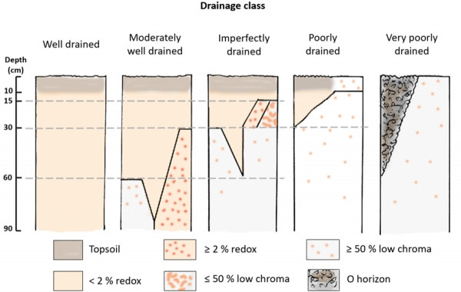
Source: Manaaki Whenua – Landcare Research Soils Portal.

More information
More information on S-map factsheets and standards for soil mapping is available from the following websites:
- Digital Soil Map of New Zealand (Manaaki Whenua –Landcare Research)
- New Zealand soil mapping protocols and guidelines (Manaaki Whenua –Landcare Research).
Case study: Sediment and nutrient losses from overland flow are affected by soil type
Spraying pasture before sowing and sowing forage crops by helicopter occurs in some areas on hill country for winter grazing. This is sometimes due to the challenges posed by limited accessibility and steep terrain.
Winter swede crops were established on an imperfectly and a well-drained soil in Manawatū (Burkitt et al, 2017). This study indicated that visual soil damage increased as beef cattle grazing time increased. Sediment losses from overland flow were 5.5 times greater on the imperfectly drained pallic soil (see figure 4) compared with the well-drained brown soil (see figure 5). Nutrient losses from overland flow were also greater from the imperfectly drained soil.
Figure 4: Winter grazing study (Burkitt et al, 2017) on a swede crop in Manawatū, showing pugging on an imperfectly drained soil.
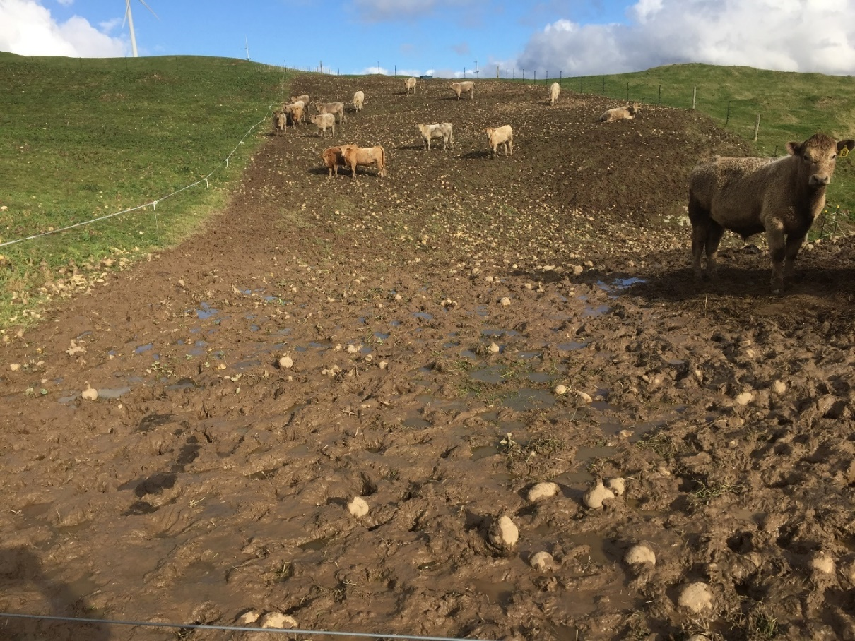Photo shows greater pugging occurred in the wetter area of the lower slope. Conventional grazing was used – starting at the bottom of the slope. No back-fence was used. This photo was taken before IWG regulations came into effect. Photo supplied by L Burkitt.
Figure 5: Winter grazing study (Burkitt et al, 2017) on a swede crop in Manawatū, showing reduced pugging on a well-drained soil. Conventional grazing was also used.
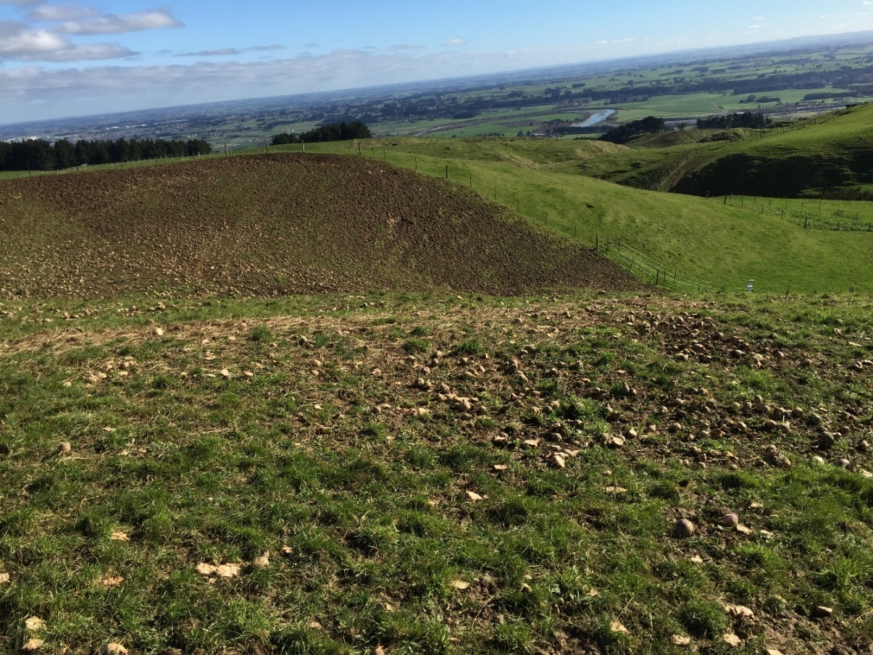This photo was taken before IWG regulations came into effect. Photo supplied by L. Burkitt.

5.3 Critical source areas
Critical source areas (CSAs) are areas within a paddock or catchment that contribute a disproportionally large quantity of contaminants to water (relative to their extent), leading to poor water quality. Protection of CSAs reduces pugging damage in vulnerable areas, and is most effective in reducing losses of sediment, faecal microorganisms and nutrients.
Key management considerations are as follows:
- Identify critical source areas in the planning and pre-sowing stage.
- Ideally, paddocks with large critical source areas (including areas prone to ponding) should be identified, fenced, left with vegetative cover, and grazing should be avoided.
- Locating IWG paddocks away from critical source areas and providing sufficient buffer zones also limit losses and should be factored into the site-selection process.
Additional and more detailed information, recommended management actions and photos to help identify critical source areas are available in the Ministry’s guidance on critical source areas.

5.4 Slope
Slope angle and length influence both the volume and erosive energy of surface water run-off (Renard et al, 1997). To minimise the impacts of pugging on sediment and nutrient loss, paddocks chosen for IWG should ideally have low slope. Slope angle influences the volume of soil transported downslope by animal treading under IWG conditions. Penny et al (2016) showed that pugging, when applied to a slope, caused greater downslope soil movement on steeper slopes.
The NES-F provides a permitted activity pathway for IWG occurring on slopes of 10 degrees or less (measured over a 20-metre distance across the land). A resource consent or a certified freshwater farm plan (when available) will be required if you cannot comply with all four default, permitted activity conditions, including the maximum slope requirement.
For more information on the permitted activity conditions, refer to the Ministry’s intensive winter grazing 2022 fact sheet.

5.5 Sowing the winter forage crop
In a pilot study conducted in Darfield, Canterbury in 2019 (unpublished), the use of strip tillage to grow fodder beet produced a comparable yield with conventional tillage but generated shallower pugging depth and higher infiltration capacity. The studies reported in this section show that establishing winter forage crops with reduced tillage (eg, no tillage, shallow non-inversion tillage or strip tillage) can be beneficial for reducing the risk of soil physical damage during winter grazing.
Some studies in this section are based on a single soil type, and/or climate, and a single year, while others were established as non-replicated, proof-of-concept, on-farm demonstration trials. Further research under different soils, climates and livestock farming systems is needed to evaluate the benefits and trade-offs of winter forage crop establishment methods to inform land user and policy decisions with stronger confidence.
Winter forage crop types can vary regionally, so crop establishment and grazing management practices can also differ. For example, dairy cow wintering in Southland and Otago is typically on brassicas, while in Poverty Bay, during winter, stock are commonly fed on plantain mixtures, chicory, brassicas, turnips and fodder beet crops (Belliss et al, 2022).

More information
More information on sowing the crop is available from the following websites:
- Forage cropping management (Beef + Lamb New Zealand)
- Sustainable helicropping (Balance)
Case study: Using tillage to establish winter forage crops
Although traditional tillage can potentially create a good seed bed for sowing forage crops, it also breaks down soil structure, making soils more vulnerable to pugging damage during IWG. In contrast, no- or reduced-tillage of soils can increase soil aggregate stability and bulk density, and hence soil strength and resistance to physical damage.
In Canterbury, Hu et al (2018) showed that using no-tillage to establish a forage crop on a pallic soil can help mitigate the adverse impacts of winter livestock treading on soil physical quality (figure 6). In another study, Hu et al (2020) found that the use of no-tillage also enhanced crop growth and water-use efficiency in the early stages of this barley crop.
Beare et al (2018) further confirmed the benefit of using no-tillage. They showed that, compared with intensive tillage, no-tillage establishment of winter forage crops (fodder beet and kale) significantly reduced soil physical damage during grazing, and did not result in yield penalty (figure 7). No-tillage also improved oat yields after grazing and nitrogen uptake, which reduced the risk of nitrogen leaching. Furthermore, there was more soil damage and poorer performance of the catch crop in plots grown with fodder beet than with kale. This was related to higher yield and greater grazing intensity of the fodder beet areas. This indicates that reducing forage crop yield can be beneficial for reducing grazing intensity and consequent pugging damage.
Figure 6: Differences in soil physical damage simulated using a ‘cow treading implement’ to assess mitigation options in forage crops, after oats were established with (left) inversion-till and (right) no-till.
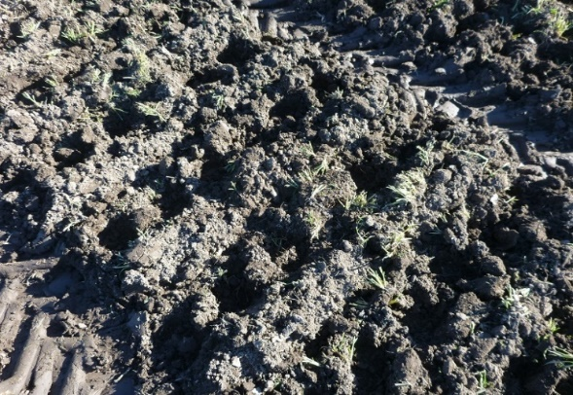 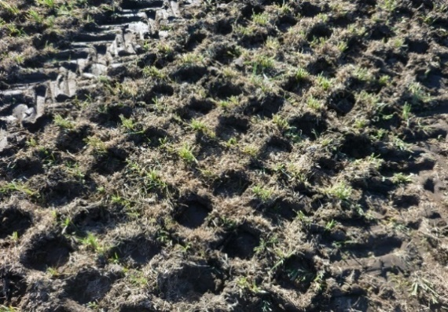Simulation was undertaken in winter (August) when soil was wet (at field capacity). Photos show the protection to the soil from using no-till (Hu et al, 2018). Photos supplied by W Hu.
Figure 7: Differences in pugging after a forage crop (fodder beet or kale) was established with no-till (NT) or inversion-till (IT).
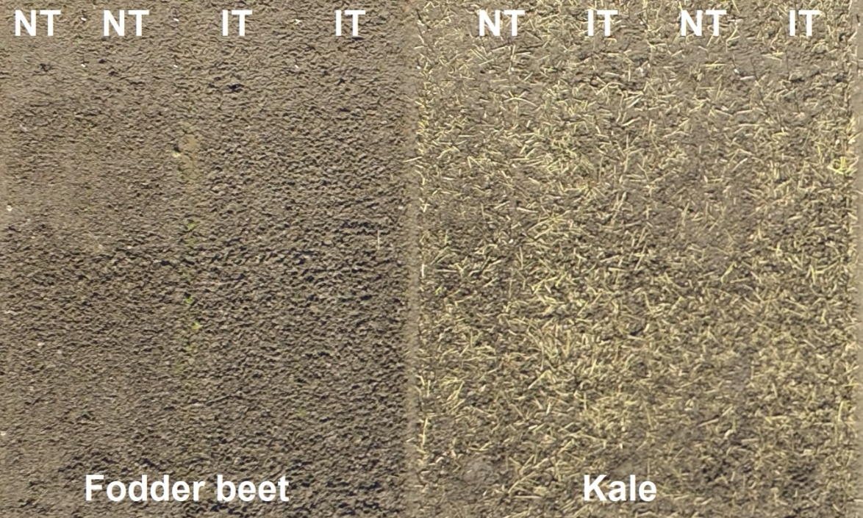Photos show less pugging in the lower yielding kale crop (relative to fodder beet) and less pugging in no-till soils, especially in fodder beet areas. Photos supplied by W Hu.

Key points
Traditional tillage (cultivation) can create good seed beds for sowing forage crops, but also breaks down soil structure, making soils more vulnerable to pugging.
- No-tillage or reduced tillage soils can maintain or increase soil aggregate stability, relative to traditional cultivation.
- High-forage crop yield usually means high grazing intensity, which increases the risk of pugging damage.
Key management considerations
- Where possible, it is best to use no-tillage or only minimum tillage practices (eg, shallow non-inversion tillage, strip tillage), especially on sloping land.
- Sow crops for grazing across slopes, if possible, rather than up- and downslope, to reduce run-off.
- Growing lower-producing crops (eg, kale rather than fodder beet) in highly vulnerable soils can often be beneficial for reducing pugging damage, which is associated with lower intensity of livestock treading.

6. During winter – grazing and paddock management

6.1 Grazing and cows’ lying time
Animal class and grazing duration are two significant drivers of pugging damage. When stocked at the same liveweight per hectare, the severity of hoof damage to the soil surface will be greater under cattle than under sheep (Betteridge et al, 1999; Houlbrooke and Laurenson, 2013). McDowell and Houlbrooke (2009) observed greater soil damage and subsequent sediment losses from cattle-grazed winter forage crops than from sheep-grazed winter forage crops. Ensuring animals are provided with sufficient feed (supplements and grazing), water and shelter will reduce stock movements and pugging damage.
Intensive winter grazing in wet conditions that result in pugging and muddy soils can result in little opportunity for cows to lie down. If lying time and rest is limited, cow health can be negatively affected and increase the risk of lameness (Schütz et al, 2019; Neave et al, 2022). Soil pugging depth has commonly been thought to have a big impact on cows’ lying time during winter grazing on crops. However, recent research shows cows spent less time lying down as soil conditions deteriorated, especially when surface water pooling increased during rainfall events (Neave et al, 2022). The research showed that surface wetness and the amount of water pooling, not the depth of soil pugging, had the biggest impact on cows’ lying time in winter crop paddocks (DairyNZ, 2022). Surface water pooling is a good indicator of a surface that is ‘too wet’.
Implementing key grazing management actions are summarised in the following points. Cow grazing implementation triggers and contingency planning via ‘gumboot scores’ is available from DairyNZ and Southern Dairy Hub (2022) (see the section on supplements).

Planning suggestions
- Involve the farm team in planning, stock and paddock management so they know recommended practices and when and why these are implemented.
- Match lighter stock classes (ie, yearlings) with heavier-textured, more at-risk soils.
- Reduce pugging risk by avoiding grazing heavy stock on steeper, more vulnerable soils, especially when wet.
- Work out where stock will graze before putting up fences, consider the location of stock water sources and avoid grazing critical source areas during winter.
- Provide buffer strips between waterways and the grazing area. This is good practice. The buffer strip must cover the entire active zone of transport and might need to be many metres either side of the gully centre.

Implementing grazing management
- The use of ‘strategic grazing’ (grazing from the top of the slope to the bottom) should be considered (see next section).
- Move breaks regularly to ensure good access to the feed.
- Give deer bigger feeding breaks than the breaks given to cattle. Minimise or avoid back-fencing for deer as it restricts their ability to move and can create significant stress. This results in the deer fence-pacing, crop trampling and pugging.
- Consider if there is appropriate shelter for stock. If necessary, consider using a stand-off area or temporary bedding to allow stock to rest on firm, dry ground.

More information
Winter grazing
- Intensive winter grazing module (Ministry for Primary Industries and Ministry for the Environment)
- Pugging and soil compaction – What influences pugging? (Beef + Lamb New Zealand)
- Winter grazing/Forage crop grazing (Beef + Lamb New Zealand)
- Wintering (DairyNZ)
- Deer facts: Intensive winter feeding: Minimising the environmental risk (Deer Industry New Zealand)
- Protect your paddocks and the environment (DairyNZ)
Pugging and cow lying time
- Inside Dairy, October/November Issue 2022 (DairyNZ)
- Wintering (DairyNZ)

Key points
- Involve the farm team in stock and paddock management so they know recommended practices and when and why these are implemented.
- Ensure animals are provided with sufficient feed (supplements and grazing), water and shelter to reduce stock movements and pugging damage.
- IWG in wet and pugged conditions can result in little opportunity for cows to lie down. Lying time is important for animal welfare. Surface wetness and the amount of water pooling, not the depth of soil pugging, has the biggest impact on cows’ lying time in winter crop paddocks.

6.2 Strategic grazing
Case study: Strategic grazing in South Otago
In an IWG study in South Otago, Monaghan et al (2017) showed that by grazing the at-risk critical source area (CSA) late in the winter season, sediment and nutrient loss were reduced significantly. Cows entered the crop at the top of the paddock and were break-fed progressively downhill towards the critical source area along one side of the gully and then the other side (figure 8a and b). This strategic grazing of IWG paddocks helps to protect the paddock’s at-risk areas from pugging damage and associated impacts to water quality. These areas include
heavy-textured soils that remain wet, or critical source areas. As part of the study, the critical source area was the last break that was grazed at the end of winter. Cows were allocated a
four-hour break (ie, on-off grazing) after a period of dry weather so the feed could be used, yet the potential for pugging damage was minimised.
In many instances, it may be best or more practical to retain existing groundcover and avoid grazing the critical source area altogether to prevent pugging and therefore impacts on water quality. This study was conducted before IWG regulations took effect. Resource consent is required if grazing a critical source area between 1 May and 30 September.
This strategic grazing approach located most of the soil pugging away from areas where water accumulated, hence maintaining the gully’s infiltration rates. Consequently, the volume of overland water flow for the non-protected catchments was 60 to 80 per cent greater than catchments with protected critical source areas. Compared with standard grazing, strategic grazing reduced sediment loads in overland flow by 94 per cent, total phosphorus by 84 per cent and ammonium-nitrate by 87 per cent.
This study used dairy cows; given that other stock classes may have different impacts, more research is needed, including other soil and stock types and climates.
Figure 8a, b: South Otago IWG study showing the critical source area was the last break that was grazed. Cows grazed from the top of the paddocks and were break-fed progressively downhill towards the critical source area.
(a)
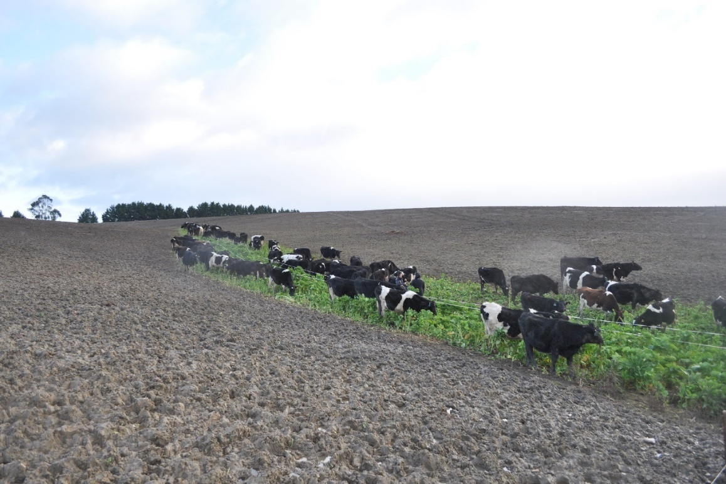
(b)
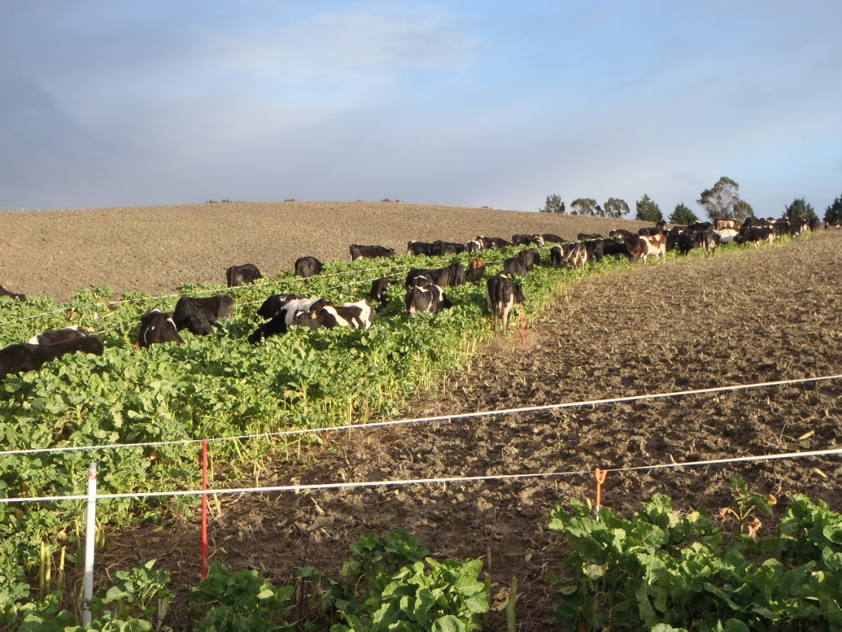
In these photos, the cows were in the critical source area but grazed for four hours only during on-off grazing. A central electric fence stopped them traversing backward and forward across the critical source area, thus minimising pugging. These photos were taken before IWG regulations came into effect. Photos supplied by S Laurenson.

More information
More information on strategic grazing is available from the following websites and paper:
- Reducing surface run-off from grazed winter forage crop paddocks by strategic grazing management (DairyNZ)
- Grazing strategies for reducing contaminant losses to water from forage crop fields grazed by cattle during winter (New Zealand Journal of Agricultural Research 60).
Key points
- Strategic grazing of paddocks and careful management of critical source areas can substantially reduce losses of sediment and phosphorus.
Key management considerations
- Where possible, graze from the top of the slope towards the bottom (see ‘Strategic grazing in South Otago’ case study), so the crop acts as a buffer. Strategic placement of the breaks around the critical source area means crops yet to be grazed may also act as a
buffer between the area of pugging and the critical source area.
- Grazing a critical source area between 1 May and 30 September will need a resource consent under NES-F. If it must be grazed during this timeframe, it would be appropriate to be cautious and graze for a shorter time, with lighter stock or when soil moisture content is not too high, thus minimising pugging and impacts to water quality.

6.3 Off-paddock facilities and duration-controlled grazing
Off-paddock facilities are used to accommodate cows during periods when soils are wet, often in association with duration-controlled grazing (DCG) practices (on-off grazing). Greater intensification of dairy systems has increased the reliance on such facilities for improving feed-use efficiency, achieving animal live weight gain and reducing soil pugging damage (Laurenson et al, 2017). Duration-controlled grazing limits the time cows spend on paddocks to just a few hours per day. It provides them enough time to consume much of their daily feed allowance yet avoids them moving back and forth in search of more food. Nitrogen losses are also often reduced by removing cows from wet paddocks because there are fewer urinary nitrogen returns to soil when crop nitrogen uptake is limited, and drainage volumes tend to be high.
The use of duration-controlled grazing also increases the volumes of solid and liquid effluents captured, which must be then reapplied to the land. The collected effluent(s) will typically need effluent-treated areas of the farm to be enlarged, or other effluent-spreading options. Holding cows in an off-paddock facility increases capital and operating expenditure by provision of infrastructure, increased labour inputs and the supply of quality feed (Laurenson et al, 2017). Generally, the capital cost of off-paddock facilities and operational costs will be similar across regions. However, farm-specific profitability will mostly be determined by the frequency and spatial extent to which soil water conditions allow for pugging damage under IWG. Further research is needed for whole-farm systems (eg, Beukes et al, 2013; Laurenson et al, 2016).
Having the flexibility to remove grazing animals from crops during heavy rainfall events may have significant advantages for limiting pugging damage. Consideration should be given to suitable temporary paddocks or off-paddock facilities where cows can be kept for short periods. This would include provisioning of feed and ensuring animal welfare. Land users will need to consider their overall farm system and practicality.
Grazing implementation and contingency planning suggestions via ‘gumboot scores’ are available from DairyNZ and Southern Dairy Hub (2022). Advice includes:
- ‘stand-off area decision rules’ incorporating recommendations on when to feed extra baleage, removing back-fences and shifting cows to a drier area
- sowing or leaving areas in grass for cows to use as ‘break-out’ areas within the winter forage crop paddock and as a ‘fresh’ area for cows resting in adverse weather conditions. An example is shown in figure 9.
Note some studies in this section are based on pilot studies, so more evaluation is needed.
Figure 9: A grass ‘break-out’ area within a forage crop paddock, Southland, that was used as a ‘fresh’ area for cows resting in adverse weather conditions.
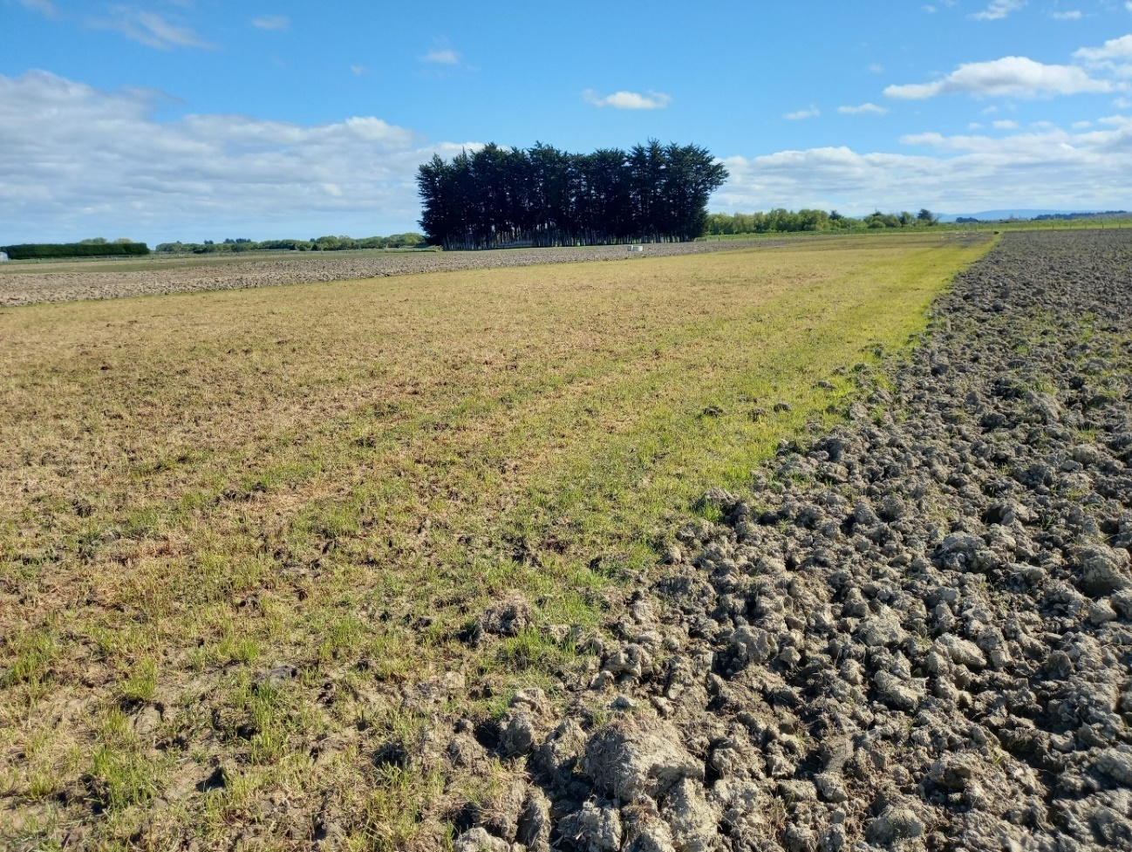
Photo supplied by R Monaghan.

More information
More information on duration-controlled grazing, ‘stand-off area decision rules’ and grass ‘break-out’ areas within the forage crop paddock to protect soil, is available from the following paper:
- Protect your paddocks and the environment — (DairyNZ)

Key points
- Off-paddock facilities can reduce the time cows spend on paddocks to a few hours per day. This provides enough time to consume much of their daily feed allowance while reducing pugging. Supplementary feed should be provided when livestock are in off-paddock facilities.
- Before planning off-paddock facilities, land users will need to consider the overall farm system, labour, capital and profit, effluent management, animal welfare, substrate maintenance and practicality.
Key management considerations
- Duration-controlled (on-off) grazing may be suitable, but consideration needs to be given to factors such as heavy damage in some areas, like gateways and laneways.
- Consider sowing or leaving areas in grass for cows to use as ‘break-out’ areas within the forage crop paddock and as ‘fresh’ areas for cow resting in adverse weather.

6.4 Supplements, troughs and back-fencing
Minimising stock movements across wet soils helps reduce pugging damage.
In South Otago, less physical deterioration of the soil occurred where cows were strip-grazed on swedes and kale crops with a back-fence erected 24 hours after grazing, than when grazed without back-fencing (Drewry and Paton, 2005). For the IWG strategic grazing case study, back-fencing was undertaken at 7- to 10-day intervals after grazing (Monaghan et al, 2017). In contrast, their standard grazing treatment had no back-fencing, as is common practice in southern regions.

More information
More information on good practice and feeding supplements is available from the following websites and paper:
- Intensive winter grazing module (Ministry for Primary Industries and Ministry for the Environment)
- Winter grazing/Forage crop grazing (Beef + Lamb New Zealand)
- Reducing nutrient and sediment losses in surface run-off by selecting cattle supplement feeding areas based on soil type in New Zealand hill country (New Zealand Journal of Agricultural Research).

Case study: Supplementary feeding in hill country
At a Manawatū hill country farm used for sheep and beef cattle production, a study was undertaken to evaluate soil type and the effects of supplementary feeding on water quality and surface run-off volumes (figure 10).
Fransen et al (2022) conducted this study for about one month on a moderately to imperfectly drained Brown soil and on a well-drained Brown soil. Beef cows were fed pasture and a supplement of hay. Before the supplementary feeding, pasture treading damage was minimal, but where the hay was positioned, cows tended to congregate and cause more pugging damage.
It was concluded the imperfectly drained soil produced 4.8 times the total run-off volume compared with the well-drained soil. This led to the imperfectly drained soil losing 2.5 times the amount of sediment, and 4.5 to 6.3 times the amount of total phosphorus, dissolved phosphorus and total nitrogen, compared with the well-drained soil (Fransen et al, 2022). Treading damage is likely to have lowered the infiltration rate of both soils.
It was concluded that careful supplementary feed placement could potentially reduce sediment and nutrient loss via surface run-off.
Figure 10: Winter grazing, supplementary feed and soil type study on pasture in Manawatū (Fransen et al, 2022).
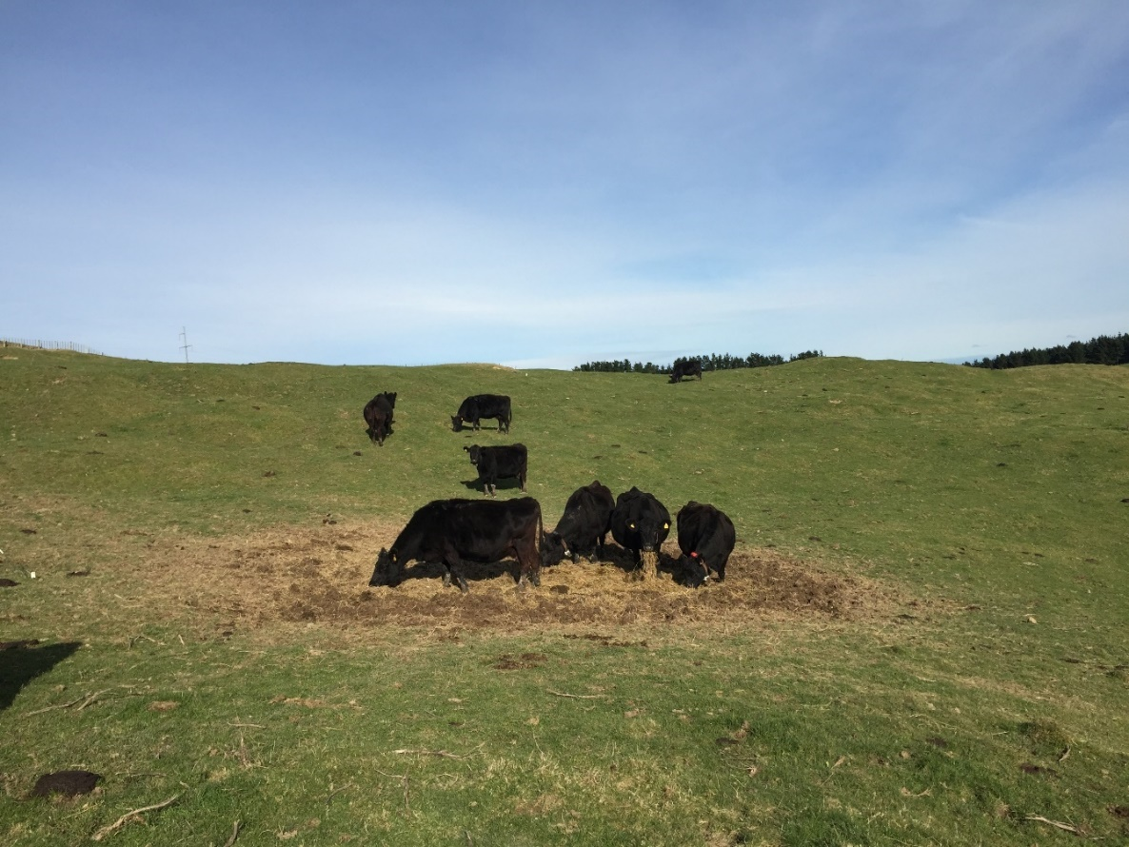Photo shows the area where supplementary feed was placed on the well-drained soil.
Photo supplied by L Burkitt.

Key management considerations
- Ensure animals are provided with enough feed, water and shelter to reduce pugging. Use of back-fencing should not compromise stock access to shelter if it is needed.
- It is good practice to place troughs (portable and permanent) and supplementary feed well away from any critical source area and other water courses. Portable troughs help reduce stock movement.
- Where practical, move portable troughs and back fences regularly.
- Where practical, put supplements such as baleage in the paddock, spaced for grazing, while the crop is young. This will help minimise soil damage from tractors in winter.
- If possible, to minimise pugging and overland flow, place supplementary feed on
well-drained soils.
- Back-fence land that has already been grazed to minimise further soil damage, especially when soil is wet. Back-fencing is not usually appropriate for deer.

7. After winter – paddock management

7.1 Assessment
After intensive winter grazing, visual inspection of the soil may be useful to assess soil structure, and therefore the type of cultivation needed for the next crop, for example, whether a light or more intensive cultivation is needed. An example of intensive cultivation is mouldboard ploughing, with secondary cultivation (eg, multiple maxi-tilling, power-harrowing, harrowing and rolling) which are needed to break up the soil sufficiently so a conventional seeder can be used.
Visual soil assessment (VSA) may be a useful tool to help land users gain knowledge of soils on their farms, including after winter grazing. Examples using VSA to assess soil pre- and post-winter grazing for fodder beet and kale paddocks are provided by DairyNZ and Southern Dairy Hub (2022). Post-winter grazing VSA scores were much less (ie, worse condition) compared with pre-winter grazing.
Visual observation can show good or poor soil structure (see figure 1 and figure 11). A visual soil assessment can also be useful for identifying the presence of mottles, an important indicator for soil drainage class.
Figure 11: A page from the VSA guide showing good, moderate and poor soil condition.
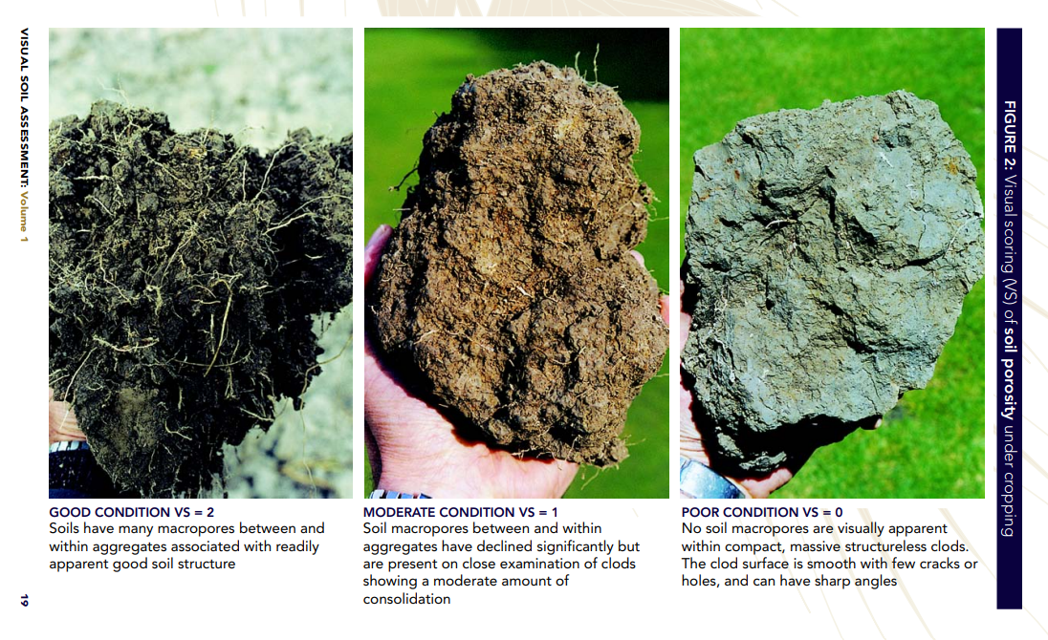

Case study: Visual soil assessment of soils in Southland
The following photos illustrate the use of visual soil assessment of soils on dairy farms in Southland (figure 12 and figure 13).
Figure 12: Visual soil assessment in December 2021 of a pallic soil (imperfectly drained) on a dairy farm.
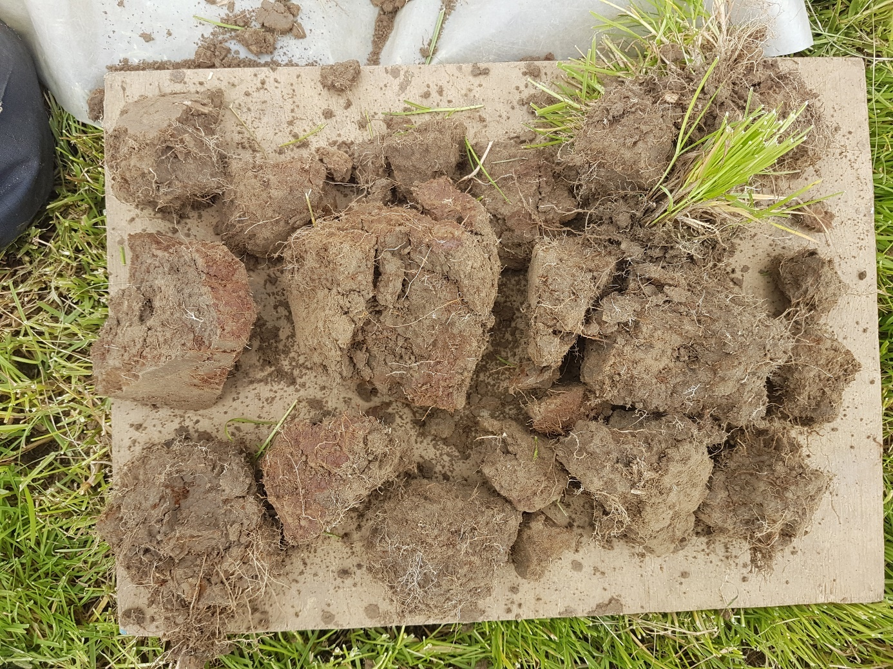
The site was a one-year-old pasture (sown October 2020), after two years of winter forage crop grazing. The soil shows large dense aggregates and mottling on aggregate surfaces (indicating compaction). Photo supplied by C Smith.
Figure 13: Visual soil assessment in December 2021 of a Brown soil (well-drained) on a
dairy farm.
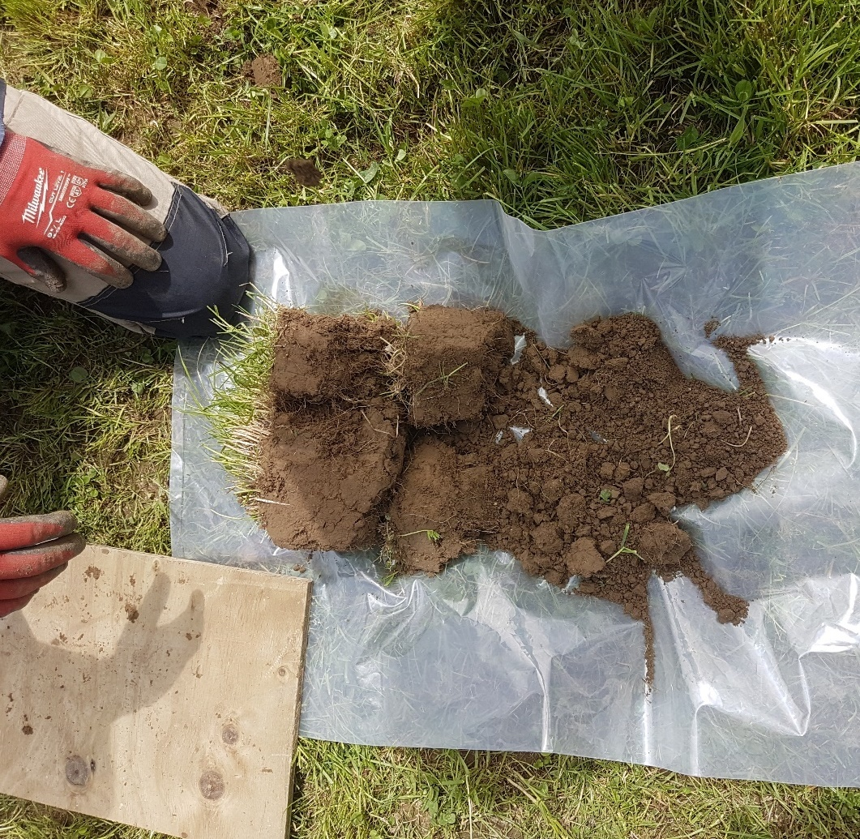
The site was a two-year-old pasture, after winter forage crop grazing. The site had been aerated one year before the assessment. The soil shows large aggregates near the surface, with many smaller, friable aggregates at the deeper depth. Photo supplied by C Smith.

More information
More information on visual soil assessment is available from the following website:
- Visual soil assessment field guide (Manaaki Whenua – Landcare Research)
In addition, VSA booklets may be available from your regional council.
Key points
- Visual inspection may be useful to assess the paddock’s soil structure and the type of cultivation that may be needed for the next crop.
Key management considerations
- Reflect and review how the winter grazing went and what you would change for next year. If an assessment of the physical condition of the soil after winter pugging shows the soil quality is poor, you could change the grazing and paddock management next winter. Possible steps are:
- take photos and record grazing and paddock management during intensive winter grazing
- assess soil condition after intensive winter grazing, for example using VSA
- assess whether overland flow containing sediment was lost to waterways and where and why
- determine whether further action is needed to maintain good soil condition and prevent risks to freshwater. Consider the recommended management actions in the Ministry’s set of three IWG technical guidance documents.

7.2 Remediation
Once soils are pugged, surface cultivation rather than deep tillage may help improve soil aeration and drainage and increase soil drying via evaporation (Yi et al, 2022). This could potentially reduce the risk of nitrate leaching and nitrous oxide emissions associated with wet soils.
Surface cultivation also benefits the early establishment of catch crops that can take up any remaining nitrogen in the soil after grazing.
Severely pugged soils can be aerated. If soil drainage is restricted, improve drainage by breaking up any impeding layer, such as by soil aeration, or install drainage systems.
Case study: Soil aeration for recovery of soil structure in North Otago
A study located in the rolling downlands of North Otago assessed the benefit of mechanical soil aeration (sub-soiling) for improving soil structure (Laurenson and Houlbrooke, 2014) (see figure 14). This assessment was made in soils that had been used for winter forage crop grazing immediately before the re-establishment of pasture. Before aeration, soils were in a poor physical state due to four consecutive years of cattle grazing on winter forage crops.
Aeration was effective in increasing soil macroporosity (0–10 cm depth) from 10 to 25 per cent and pasture growth by approximately 2 t/ha/yr, compared with non-aerated soil. However, improvements gained from aeration generally did not last longer than 18 months due to the subsequent grazing pressure from cows. This study showed that mechanical aeration can provide an immediate increase in the porosity of compacted soils, leading to improved pasture growth. However, processes involved in the formation of resilient soils are curtailed by repeated grazings after aeration.
An investment analysis to assess the potential economic benefits of mechanical soil aeration has been carried out on a North Otago dairy farm (Laurenson et al, 2015). Estimated changes in dairy farm profitability from soil aeration were calculated based on a 13-per cent increase in annual pasture production over a two-year period (from the area used for winter grazing).
The study considered both the fixed and variable costs associated with the modelled farm enterprise. The improvement in farm profitability due to greater pasture growth was realised through an increase in stocking rate and associated milk production. The net economic benefit from soil aeration (based on a milk sale price of NZ$6/kg milk solids (MS)) was NZ$1354 per year over a 12-year planning horizon. This equated to a net increase in annual profit over 12 years of NZ$67 per hectare of winter forage crop paddock that was aerated. Assuming the benefits of aeration are apparent for a two-year period only, and the milk price is NZ$6/kg MS, a minimum of 375 kg of dry matter per hectare per year more pasture must be grown each year to gain an economic return from mechanical aeration.
Figure 14: Mechanical soil aeration using a ‘Clough pan-aerator’ with winged tips for improving soil structure after winter forage crop grazing.
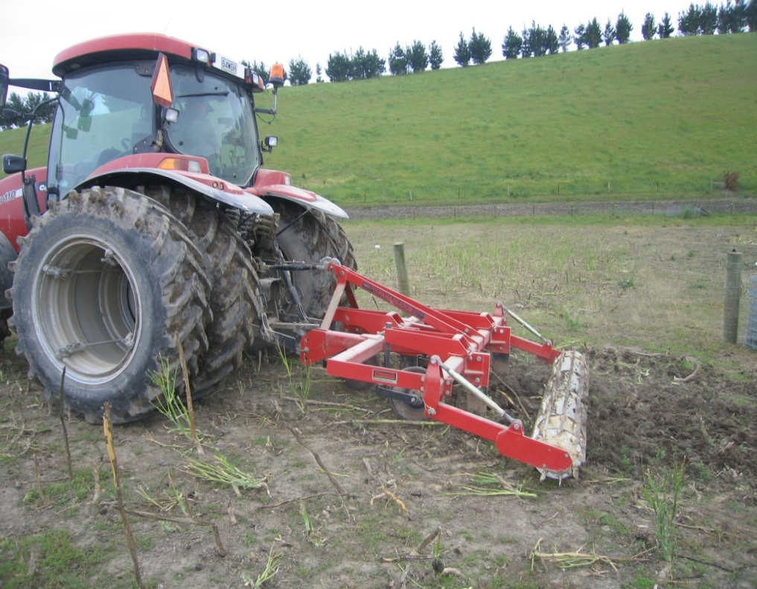
Aeration was carried out at a depth of 20 cm and soil water content of 24 per cent. The winged tips caused the soil to lift and shatter and improved soil porosity. Photo supplied by S Laurenson.

Key points
- Maintaining some groundcover or re-establishing vegetative groundcover quickly is important to minimise impacts of intensive winter grazing on water quality. See the Ministry’s guidance on groundcovers.
- Soil aeration can be effective in improving soil structure after intensive winter grazing of forage crops.
- As shown in the soil aeration case study, improvements gained from aeration generally may not persist longer than 18 months.
Key management considerations
- If soil structural damage after intensive winter grazing on forage crops is severe (eg, is very compact and has a low VSA score), consider using soil aeration.
- Remove silt build up from open channels and drains.
- Improve soil profile drainage by remediating any compacted or impeding layers by surface loosening, shallow chisel ploughing or soil aeration.
- Improve soil drainage by installing subsurface drainage systems (eg, mole-pipe systems).

8. Limitations and knowledge gaps
Limitations of this technical guidance include the following points.
- This technical guidance aims to bring together a mix of practical recommendations and a synthesis from key research programmes. While much research was evaluated in the process and the lessons transferred to the synthesis of this report, many studies have not been explicitly cited here.
- Individual intensive winter grazing circumstances may be unique and contain many levels of complexity. Due to this, this guide cannot provide suggestions or recommendations appropriate to all circumstances.
- Research studies typically focus on particular soil orders or drainage characteristics, regions, climates and management. While many lessons and recommendations can be applied in circumstances that differ from those in the research studies, some caution may be needed to ensure these are appropriate and practical for the situation. In winter, especially with heavy rainfall and cold conditions, sometimes even with the best intentions things can go wrong.
- Many of the studies on pugging and water quality have been undertaken on poorly drained or imperfectly drained pallic soils. Many winter forage studies have used dairy cattle. Therefore, when transferring the lessons from these studies to other livestock types and farming systems, soils, regions and climates, some caution should be applied.
The following knowledge gaps were identified while preparing this guidance.
- Land user-based tools developed for pastoral systems need more research before they can be applied with confidence to intensive winter grazing of forage crops.
- More information is needed nationally on soils and their characteristics under intensive winter grazing. This would help better inform current risks of pugging and impacts to water quality.
- Only a limited number of studies have characterised or measured actual pugging disturbance to soil in intensive winter grazing forage crop studies.
- We know little about the impact of soil pugging on soil infiltration and nitrate leaching. Further research and tools are needed to help inform trade-offs between intensive winter grazing impacts for farm decision-making.
- Improvements to various indexes such as soil structural vulnerability could be made, to enhance their usability under intensive winter grazing and typical wet winter conditions.
- For forage crop establishment, a limited number of case studies have shown the benefit of reduced tillage, but further research under different soils, climates and livestock farming systems is needed to evaluate the benefits and trade-offs to inform decision-making with more confidence.
- Most case studies reported in this guidance were on pallic soils, or in southern New Zealand. Further studies are needed on a range of soil orders and drainage classes, livestock types and farming systems, regions and climates.

9. Glossary
Term | Definition | Reference
Critical source area | Area within a paddock or catchment that contributes a disproportionally large quantity of contaminants to water (relative to its extent) | Technical guidance on critical source areas
Intensive winter grazing | Refers to grazing livestock on an annual forage crop at any time in the period 1 May to 30 September. The definition includes activities on a farm that support IWG and that may occur year-round, such as the preparation and sowing of land for grazing and the cultivation of annual forage crops | Ministry for the Environment (2022).
Pugging | The penetration of soil by hooves of grazing livestock | National policy statement for freshwater management 2020 (Ministry for the Environment, 2020).
Soil compaction | Compression of soil pores

Acronyms
Acronym | Term
IWG | Intensive winter grazing.
CSA | Critical source area.
DCG | Duration-controlled grazing.
VSA | Visual soil assessment.

References
Beare M, Gillespie R, Tregurtha C, Hu W. 2018. No-till establishment of fodder beet and kale to reduce soil compaction and the risk of nitrogen losses from winter grazing. Field day presentation. Forages for Reduced Nitrate Leaching programme, Lincoln University Research Dairy Farm, September 2018.
Belliss SE, Amies A, Pairman D, North H. 2022. National winter forage – intensive winter grazing map for winter 2021. Lincoln: Manaaki Whenua – Landcare Research Contract Report LC4149 for Regional Software Holdings Ltd.
Betteridge K, Drewry J, MacKay A, Singleton P. 2003. Managing treading damage on dairy and beef farms in New Zealand: booklet for farmers and industry. Wellington: AgResearch Ltd.
Betteridge K, Mackay AD, Shepherd TG, Barker DJ, Budding PJ, Devantier BP, Costall DA. 1999. Effect of cattle and sheep treading on surface configuration of a sedimentary hill soil. Australian Journal of Soil Research 37: 43–760.
Beukes P, Romera A, Clark D, Dalley D, Hedley M, Horne D, Monaghan R, Laurenson S. 2013. Evaluating the benefits of standing cows off pasture to avoid soil pugging damage in two dairy farming regions of New Zealand. New Zealand Journal of Agricultural Research 56: 224–238.
Burkitt LL, Winters JL, Horne DJ. 2017. Sediment and nutrient losses under winter cropping on two Manawatū hill country soils. Proceedings of the New Zealand Grassland Association 79: 27–34.
DairyNZ. 2022. Mythbuster. What really affects lying time in winter? Inside Dairy, October/November 2022: p 18. Hamilton: DairyNZ.
Donovan M. 2022. Modelling soil loss from surface erosion at high-resolution to better understand sources and drivers across land uses and catchments; a national-scale assessment of Aotearoa, New Zealand. Environmental Modelling and Software 147: p 105,228.
Donovan M, Monaghan R. 2021. Impacts of grazing on groundcover, soil physical properties and soil loss via surface erosion: A novel geospatial modelling approach. Journal of Environmental Management 287: p 112206.
Drewry JJ, Cameron KC, Buchan GD. 2008. Pasture yield and soil physical property responses to soil compaction from treading and grazing: a review. Australian Journal of Soil Research 46: 237–256.
Drewry JJ, Paton RJ. 2005. Soil physical quality under cattle grazing of a winter-fed brassica crop. Australian Journal of Soil Research 43: 525–531.
Fransen P, Burkitt L, Chibuike G, Bretherton M, Hickson R, Morris S, Hedley C, Roudier P. 2022. Reducing nutrient and sediment losses in surface run-off by selecting cattle supplement feeding areas based on soil type in New Zealand hill country. New Zealand Journal of Agricultural Research 1–18. https://doi.org/10.1080/00288233.2022.2086888
Grealish G. 2017. New Zealand soil mapping protocols and guidelines. Lincoln: Manaaki Whenua – Landcare Research.
Hewitt AE, Shepherd TG. 1997. Structural vulnerability of New Zealand soils. Australian Journal of Soil Research 35: 461–474.
Houlbrooke DJ, Drewry JJ, Laurenson S, Hu W, Carrick ST. 2021. Soil structure: its importance to resilient pastures. Resilient pastures symposium of New Zealand Grasslands Association. Agricultural Practice Series 17: pp 271–281.
Houlbrooke DJ, Laurenson S. 2013. Effect of sheep and cattle treading damage on soil microporosity and soil water holding capacity. Agricultural Water Management 121: 81–84.
Houlbrooke DJ, Paton RJ, Morton JD, Littlejohn RP. 2009. Soil quality and plant yield response under dryland and irrigated winter forage crops by sheep or cattle. Australian Journal of Soil Research 47: 470–477.
Hu W, Beare M, Tregurtha C, Gillespie R, Lehto K, Tregurtha R, Gosden P, Glasson S, Dellow S, George M, Tabley F, Qiu W, Baird D. 2020. Effects of tillage, compaction and nitrogen inputs on crop production and nitrogen losses following simulated forage crop grazing. Agriculture, Ecosystems & Environment 289: 106733.
Hu W, Drewry JJ, Beare M, Eger A, Müller K. 2021. Compaction induced soil structural degradation affects productivity and environmental outcomes: A review and New Zealand case study. Geoderma 395: 115035.
Hu W, Tabley F, Beare M, Tregurtha C, Gillespie R, Qiu W, Gosden P. 2018. Short-term dynamics of soil physical properties as affected by compaction and tillage in a silt loam soil. Vadose Zone Journal 17: 1–13.
Laurenson S, Houlbrooke DJ. 2014. Assessing the agronomic benefit of noninversion tillage for improving soil structure following winter grazing of cattle and sheep. Soil Use and Management 30: 595–602.
Laurenson S, Houlbrooke DJ. 2016. Identifying critical soil water thresholds to decrease cattle treading damage risk. New Zealand Journal of Agricultural Research 59: 444–451.
Laurenson S, Houlbrooke DJ, Beukes PC. 2016. Assessing the production and economic benefits from preventing cows grazing on wet soils in New Zealand. Journal of the Science of Food and Agriculture 96: 4584–4593.
Laurenson S, Monaghan R, Dalley D. 2017. Protect your paddocks, and the environment. DairyNZ Technical Series 34: 5–9.
Laurenson S, Turner J, Rendel J, Houlbrooke D, Stevens D. 2015. Economic benefits of mechanical soil aeration to alleviate soil compaction on a dairy farm. New Zealand Journal of Agricultural Research 58: 354–358.
McDowell RW, Houlbrooke DJ. 2009. Management options to decrease phosphorus and sediment losses from irrigated cropland grazed by cattle and sheep. Soil Use and Management 25: 224–233.
Ministry for the Environment. 2022. Intensive winter grazing fact sheet. Publication number: INFO 1067. Wellington: Ministry for the Environment.
Ministry for the Environment. 2020. National policy statement for freshwater management 2020. Wellington: Ministry for the Environment.
Monaghan R, Laurenson S, Dalley D, Orchiston T. 2017. Grazing strategies for reducing contaminant losses to water from forage crop fields grazed by cattle during winter. New Zealand Journal of Agricultural Research 60: 333–348.
Neave HW, Schütz KE, Dalley DE. 2022. Behaviour of dairy cows managed outdoors in winter: effects of weather and paddock soil conditions. Journal of Dairy Science 105: 8298–8315.
New Zealand Government. 2022. Resource Management (National Environmental Standards for Freshwater) Regulations 2022. Wellington: Parliamentary Council Office.
Penny VM, Almond PC, Laurenson S, Klik A. 2016. The effects of hillslope forage crop grazing in winter on soil erosion. New Zealand Grassland Association Grassland Research and Practice Series 16: 185–190.
Renard KG, Foster GR, Weesies GA, McCool DK, Yoder DC. 1997. Predicting soil erosion by water – a guide to conservation planning with the revised universal soil loss equation (RUSLE). Agricultural Handbook No. 703. Washington, DC: US Department of Agriculture.
Schütz KE, Cave VM, Cox NR, Huddart FJ, Tucker CB. 2019. Effects of three surface types on dairy cattle behaviour, preference, and hygiene. Journal of Dairy Science 102: 1530–1541.
Yi J, Hu W, Beare M, Liu J, Cichota R, Teixeira E, Guo L. 2022. Treading compaction during winter grazing can increase subsequent nitrate leaching by enhancing drainage. Soil and Tillage Research 221: 105424.

