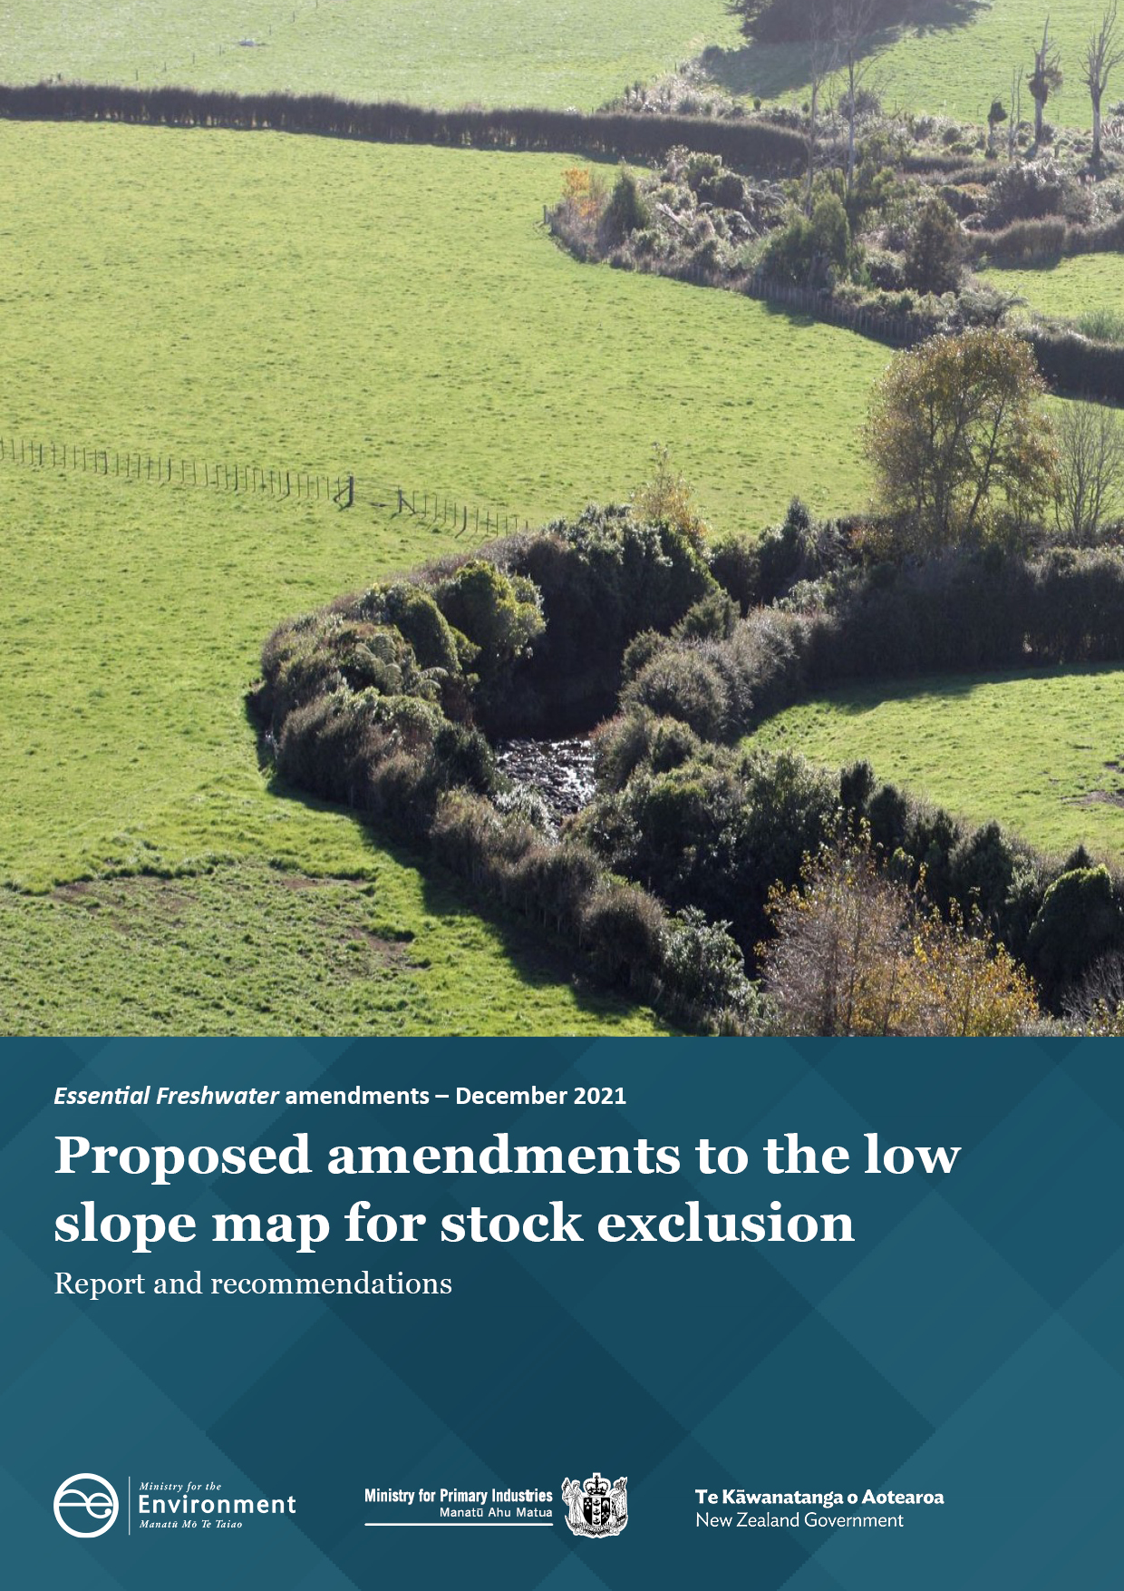
Disclaimer
The information in this publication is, according to the Ministry for the Environment’s best efforts, accurate at the time of publication. The Ministry will make every reasonable effort to keep it current and accurate. However, users of this publication are advised that:
- the information does not alter the laws of New Zealand, other official guidelines, or requirements
- it does not constitute legal advice, and users should take specific advice from qualified professionals before taking any action based on information in this publication
- the Ministry does not accept any responsibility or liability whatsoever whether in contract, tort, equity, or otherwise for any action taken as a result of reading, or reliance placed on this publication because of having read any part, or all, of the information in this publication or for any error, or inadequacy, deficiency, flaw in, or omission from the information in this publication
- all references to websites, organisations or people not within the Ministry are for convenience only and should not be taken as endorsement of those websites or information contained in those websites nor of organisations or people referred to.

This document may be cited as: Ministry for the Environment. 2022. Proposed amendments to the low slope map for stock exclusion: Report and recommendations. Wellington: Ministry for the Environment.

Published in November 2022 by the
Ministry for the Environment
Manatū Mō Te Taiao
PO Box 10362, Wellington 6143, New Zealand
ISBN: 978-1-99-102597-5
Publication number: ME 1705
© Crown copyright New Zealand 2022
This document is available on the Ministry for the Environment website: environment.govt.nz.

Contents
Introduction 4
Background on stock exclusion regulations and proposed changes 4
Report and recommendations 5
Submissions 5
Summary of recommendations 6
Themes from the submissions 7
The new approach is an improvement, but the map is still too inflexible 7
The map is inaccurate, and therefore ineffective 11
Proposed changes remove needed environmental protections in the high country 14
The need for guidance on stock exclusion regulations 17
Other analysis 19
Appendix 1: Current stock exclusion requirements 20

Introduction

Background on stock exclusion regulations and proposed changes
The purpose of the Resource Management (Stock Exclusion) Regulations 2020 (the regulations) is to provide environmental protection, by setting requirements to effectively exclude stock from access to water.
The regulations include land-based and activity-based triggers for requirements to exclude stock from access to waterways.
The map of low slope land is incorporated by reference in the regulations as a land-based trigger for requirements. The map’s purpose is to show areas where those who own or control beef cattle and deer must exclude them from access to waterways from 1 July 2025. This contributes to achieving the Government’s Essential Freshwater outcomes for halting degradation and improving freshwater quality. The map only triggers requirements in the regulations for areas highlighted as low slope land within the map.
The activity-based triggers for requirements in the regulations apply regardless of the low slope map. An important example of an activity-based trigger is the requirement for beef cattle and deer that are intensively grazing on any terrain to be excluded from access to waterways from 1 July 2023. The regulations state that ‘intensively grazing’ in this context means:
(a) break feeding; or
(b) grazing on annual forage crops; or
(c) grazing on pasture that has been irrigated with water in the previous 12 months.
This report groups the proposed changes in the consultation document Stock exclusion regulations: Proposed changes to the low slope map into two categories according to their purpose.
- One type of change is intended to improve how the map identifies low slope land, namely:
- using local terrain averaging as the mapping method
- managing stock exclusion on slopes of 5 to 10 degrees through freshwater farm plans. There will be a presumption that stock exclusion is required on land with an average slope between 5 and 10 degrees. This will be shown on the revised map, and managed by freshwater farm plans.
- The other type of change is intended to address the map’s unintended capture of low intensity farming in the high country, namely:
- introducing a 500-metre altitude threshold
- removing tall tussock and depleted grassland from the map.
When Cabinet agreed to consult on stock exclusion regulations in 2019, it agreed that national regulation would not apply to low intensity high country farming. Cabinet’s intention was to have a balance between the use of regulations and freshwater farm plans.
An intended outcome of the above changes is that outside the map, freshwater farm plans are used to manage land-based requirements to exclude stock (that is, on land with an average slope of between 5 to 10 degrees, above 500 metres in altitude, and in areas of depleted grassland and tall tussock). These areas are less likely to be intensively grazed, and excluding stock from access to waterways in such areas is likely to be more costly for relatively less environmental benefit.

Report and recommendations
This report provides recommendations to the Minister for the Environment and Minister of Agriculture on proposed amendments to the low slope map for stock exclusion. This map is incorporated by reference in the Resource Management (Stock Exclusion) Regulations 2020.
Submissions on the consultation document Stock exclusion regulations: Proposed changes to the low slope map informed the proposals outlined in this report. The consultation document sets out the criteria against which proposed changes were assessed.
Each section of the report provides:
- background on the topic
- the proposed amendment(s), as set out in the consultation document
- a summary and analysis of submissions
- recommendations to the Minister for the Environment and Minister of Agriculture.
Additional analysis of the issues and submissions covered in this report is available in the Summary of submissions and the Regulatory Impact Statement. These documents are available on the Ministry for the Environment website. Read this report alongside those documents for full context.

Submissions
The consultation period began on 26 July 2021 and closed on 7 October 2021.
Submitters raised the following main themes about the proposed changes to the low slope map:
- the new approach is an improvement, but the map is still too inflexible
- concerns that the revised map is inaccurate, and therefore ineffective
- the proposed changes remove needed environmental protections in the high country.
The need for guidance on stock exclusion requirements is another broad theme resulting from the consultation.
Detailed information on the submissions received, including a breakdown by sector, location, and issue, is provided in a separate summary of submissions.

Summary of recommendations
Following analysis of the submissions, some amendments to the proposed changes are recommended (see table 1).
Below is a summary of the substantive recommendations or options for Ministers to consider in this report. The recommendations or options are analysed further in the following sections of this report.
Table 1: Summary of recommendations or options
Proposed amendment | Recommendations or options
Use local terrain averaging as the mapping approach | Use local terrain averaging as the mapping approach  Remove the Chatham Islands from the low slope map.
Manage stock exclusion on slopes of 5 to 10 degrees through freshwater farm plans | No change recommended
Introduce 500-metre altitude threshold | No change recommended
Remove tall tussock and depleted grassland | Retain tall tussock and depleted grassland in the low slope map
 | Officials to develop guidance on stock exclusion requirements

Themes from the submissions

The new approach is an improvement, but the map is still too inflexible

Background
The low slope map (the current map) captures many areas of high slope land – nearly 11.5 per cent of the area captured by the current map is land with a slope greater than 10 degrees. The current map also fails to capture some areas of low slope land.
The current map includes any land currently grazed and any land that could be changed into a pastoral system in the future. The map needs to include these areas because it is the land-based trigger for the requirement to exclude beef cattle and deer from access to waterways.
The desirability of being able to exercise discretion was the issue most frequently mentioned by regional and primary sector stakeholders during discussions to investigate concerns raised about the current map. These stakeholders suggested that stock exclusion requirements need some flexibility, to allow for specific place-based circumstances that may not be accommodated in the national map.

Proposed amendments
In the consultation document, we proposed:
- using local terrain averaging as the mapping method
- managing stock exclusion on slopes of 5 to 10 degrees through freshwater farm plans.

Submissions
Submitters agree that local terrain averaging as a new mapping methodology is an improvement relative to the current map’s approach of averaging slope across land parcels.
Several of the other proposed changes are intended to increase the flexibility of stock exclusion requirements, by providing for areas to be managed through freshwater farm plans rather than by way of the regulations.
Beef + Lamb New Zealand opposes the low slope map, but comments that:
“If the s360 regulations are to remain in place, we agree that slopes between 5-10 degrees and land above 500m should be managed in a complementary manner via certified freshwater farm plans. The ability for farmers to work with their advisor or certifier to assess what is the best management approach to these areas is welcomed.”
Many submitters express a view that these changes do not go far enough to take into account diverse farming circumstances. They state a preference for freshwater farm plans as the single management response to the need to exclude stock from access to waterways.
Most primary sector submissions and some regional sector submissions share this view.
The submission from Federated Farmers exemplifies this theme, acknowledging: “…the changes have broadly addressed some areas of concern or impracticality” then going on to set out reasons why the low slope map ought to be removed from the regulations. These include that low slope land is not a workable proxy for stock intensity, and that a broad methodology across New Zealand results in unworkable situations.
In contrast, some submitters argue the proposed changes go too far in attempting to add flexibility. Fish and Game New Zealand’s submission comments:
“...permissive management of these effects is not consistent with the first and second priorities of Te Mana o Te Wai i.e. health and wellbeing of water bodies (first priority) and health needs of people (second).”
The submission goes on to conclude:
“...the proposed amendments reduce the consistency of a mandatory national standard for land between 5-10° or greater than 500 m altitude and defer decision making to an individual and a largely untested and yet-to-be implemented freshwater farm plan process.”
A minority of submitters agree that the proposed changes address the need for stock exclusion requirements to have some flexibility.

Analysis
The proposed changes address issues identified with the initial 2020 low slope map capturing too much steep land. The area of land over 10 degrees slope decreases to an estimated 0.07 per cent (from an estimated 11.5 per cent in the current map).
The purpose of a national map is to provide a consistent nationwide tool for identifying where the greatest risk to freshwater lies in relation to stock intensity. In identifying this risk accurately, mandatory requirements through the regulations should aim to minimise unnecessary or unintended impacts.
Flexibility is among the range of criteria in the consultation document. The topic that the map is insufficiently flexible, as raised by submitters, is within the scope of the consultation process.
Criticisms that the low slope map is inflexible fail to recognise that the regulations are constrained by law in the level of interpretation they can provide for (as noted in the consultation document). The regulation-making power to make stock exclusion regulations is very prescriptive. It only allows for measures for the purpose of excluding stock. It does not include any way to be flexible or exercise discretion about those measures.
There is no ability for the regulations to allow for discretion to take into account the diversity of farming systems across New Zealand, and that is not the intention of the regulations. Their intention is to impose minimum requirements on those who own or control stock to ensure that those stock do not enter waterways.
We acknowledge the need for flexibility. That is why we are recommending the low slope map only apply to land up to 5 degrees in slope, and below the 500-metre altitude threshold. Stock exclusion requirements for land not captured by the proposed low slope map will be managed through freshwater farm plans where the desired flexibility can apply. In areas with a slope between 5 and 10 degrees, there will be a presumption that freshwater farm plans will require stock to be excluded from waterways unless the farm plan process deems that it is impractical.
Recommendation
Progress with changes as consulted on, namely:
- using local terrain averaging as the mapping method
Agree/Disagree
- managing stock exclusion on slopes of 5 to 10 degrees through freshwater farm plans.

Agree/Disagree

Requests to remove areas from the low slope map
Some submissions request the removal of certain areas from the low slope map, for different reasons.
The submission from the Chatham Islands Council argues for removal of the Chatham Islands from the low slope map, both for reasons of consistency with low-intensity high country farming and in recognition of special circumstances related to geographic isolation:
“We consider that the argument for removing high country land from the low slope map (and therefore from the requirement to exclude beef cattle and deer from access to waterways) can equally be applied to the land on the Chatham Islands. Farming operations on the Islands also tend to have low stocking rates and the cost of excluding stock from waterways on the Islands is considerably higher than on mainland New Zealand because of isolation, high freight charges and zero unemployment.”
The High Country Accord Trust submission requests that pastoral leases be excluded from the low slope map, on the basis that they are extensive farm systems in locations where fencing costs are prohibitive and the benefits of fencing are arguable. The Accord’s view is that:
“...all pastoral leases should fall only into the freshwater farm regime and be specifically excluded from the low slope map”.
It notes that:
“...despite the intention not to capture extensive farming systems typified by pastoral leases the low slope map still does so in many cases.”
Several West Coast submitters ask for South Westland properties with Crown grazing licences to be removed from the low slope map. This request is supported by primary sector representative bodies.
West Coast Regional Council suggests either working with regional councils to remove areas of low-value rough grazing land, or providing an exemption for single pastoral systems with low stocking rates.

Analysis: Requests to remove areas from the low slope map
Submissions seek removal of areas from the low slope map on the basis that the impact on people and communities would be disproportionately great, given the challenges of excluding stock in these areas and the relatively low benefit for the environment due to the extensive way in which they are farmed.
We agree with the points made in the Chatham Islands Council submission that farming on the islands shares the features of low-intensity high country farming as described in the consultation document. We also agree that there are special circumstances associated with the geographic isolation of the Chatham Islands community that would make the impact of the low slope map disproportionately felt.
We recommend that the Chatham Islands be removed from the low slope map.
We note the request to remove pastoral leases from the low slope map. Officials discussed this request with representatives of the Department of Conservation and Toitū te Whenua Land Information New Zealand (LINZ), as agencies responsible for Crown leasehold land. We agreed that Crown land should be treated in the same way as other land. We therefore do not recommend that pastoral leases are removed from the low slope map.
We note the issues raised about South Westland properties with grazing licences. As above, our view is that Crown land should be treated in the same way as other land. We agree that being required to exclude stock from access to waterways in South Westland presents particular challenges. However, we note Cabinet’s intention to remove low-intensity high country farming from the low slope map does not apply to South Westland properties with grazing licences. The low slope map shows land on the West Coast that is flat, low-lying, and has the potential to be intensified.
We do not recommend that South Westland properties with grazing licences are removed from the low slope map.
Recommendation
Remove the Chatham Islands from the low slope map.
Agree/Disagree
Note we do not recommend removing South Westland properties with grazing licences from the low slope map.
Agree/Disagree

The map is inaccurate, and therefore ineffective

Background
The current map captures areas of high slope land that it wasn’t intended to – nearly 11.5 percent of the area captured by the current map is land with a slope greater than 10 degrees. The current map also fails to capture some areas of low slope land.
The current map involves averaging slope over entire land parcels. This has contributed to concerns, particularly in areas with variable terrain. Due to differences in size and shape between LINZ primary parcel blocks (land parcels), adjacent properties that share similar terrain have been captured inconsistently. This has created an issue of unfairness between farm properties.

Proposed amendments
In the consultation document, we proposed:
- using local terrain averaging as the mapping method
- managing stock exclusion on slopes of 5 to 10 degrees through freshwater farm plans.

Submissions
Some submitters suggest that the low slope map is inaccurate, and therefore ineffective.
Submissions provided by individuals, primary and regional sector bodies identify examples where the proposed revised map is considered unfit for purpose in that:
- low slope land is identified inconsistently
- a ‘buffer’ effect is seen across some river margins along steep-sided land where land has not been captured along the river margin
- it does not align with farmers’ intuitive understanding of land on their properties.
Marlborough District Council comments:
“It is Council’s contention that the averaging methods used in creation of both versions of the low- slope layer go against the intention to ‘align with the farmers’ intuitive understanding of their land’. A simplified approach that just documents the actual slope using the best available information would be preferable.”
Some submitters recommend that more accurate mapping technologies, such as LiDAR or New Zealand-wide digital elevation models, be used instead of the map to resolve the above concerns.

Regarding the use of LiDAR to identify low slope, Manaaki Whenua Landcare Research notes that:
“Over the next 5–10 years significant new data will become available to improve the mapping technologies used for slope maps (national LiDAR for instance). As slope maps are refined it is likely that exclusion requirements will change at the margins, where farmers might have already invested or not budgeted to invest.”
Several submitters suggest that regional rules and freshwater farm plans should replace the map as the primary method to identify where beef cattle and deer should be excluded from waterbodies.
Deer Industry New Zealand (DINZ) and the New Zealand Deer Farmers Association (NZDFA) share this view:
“DINZ and NZDFA maintain that stock exclusion or alternative approaches to mitigate the risk of stock accessing waterways is best determined through a (certified) farm environment plan that identifies prioritised actions based on assessment of risk to the environment within the farm and from farming operations.”
The Greater Wellington Regional Council submission notes:
“Although the map is an improvement on the previous map [...] it still excludes patches of low-slope ground that should clearly be included. It also now has small patches in the map across a waterbody that cannot practically be complied with alone. The map particularly does not make sense in the hill country of the Wellington region.”

Analysis
Submissions that the revised map is inaccurate are not raising concerns about the inclusion of steep land in the map. The proposed changes address this problem. They are from the opposite perspective: that the local terrain-averaging approach fails to accurately capture low slope land.
The proposed change of applying the low slope map only in areas with up to 5 degrees slope means that there is almost no steep land above 10 degrees slope in the revised map. Submissions about inconsistencies in the inclusion of land in the revised map are referring only to land with an average slope of 10 degrees or less.
Note that in areas with a slope between 5 and 10 degrees, there will be a presumption that freshwater farm plans will require stock to be excluded from waterways unless the farm plan process deems that it is impractical. On this basis the proposed changes to the low slope map do not impose any new costs on farmers. Rather, they reduce the area in which the regulations require stock exclusion. In doing so, they address the issue of the original map having captured steep land.
The revised map does not pick up all areas of low slope land, due partly to the new mapping approach. Local terrain averaging calculates an average slope based on the slope of the surrounding terrain. This means some small areas of flat land are not captured by the map, because they are surrounded by relatively steep land. This tendency is not a failure of the map to accurately detect slope. It is a function of the new mapping approach, which submitters agree is an improvement on the current map’s approach of averaging slope by land parcel.
The current map averages slope over large areas (land parcels). This means it treats large areas of land with similar slope differently due to variance in land parcels. The current map therefore creates equity issues between farms. Although the revised map does not pick up every area of land in the same way, it treats all the land in New Zealand in the same way.
Officials acknowledge there are areas where the map does not perfectly align with the contours of the land, and that LiDAR mapping can identify land to a finer resolution.
However, LiDAR is not available in all regions of New Zealand and will take several years to develop. Various mapping technologies are being developed in the medium to long term, but the intention of the regulations is to halt beef cattle and deer access to freshwater bodies from 1 July 2025, at the latest. As such, we consider that a national low slope map is the most consistent and equitable way to identify low slope land.
In addition, the nature of the section 360 regulations means that a tool to identify low slope land is an appropriate way to support the implementation of the regulations without unlawfully delegating slope identification onto farmers and regional councils.
The scale for the map of low slope land needs to balance precision and practicality. The proposed approach (of averaging slope across 4.5 hectare areas) was chosen to reduce the complexity and patchwork nature of a map with a finer resolution.
Freshwater farm plans are considered an ideal tool for addressing some of the shortcomings identified with the map such as islands, patches and excluded rivers in steep-sided gullies in the map. These are problems that would persist regardless of the slope threshold used.
Some submissions ask for the low slope map to be removed altogether, and for freshwater farm plans to be the sole management response to stock exclusion. Requests to remove the low slope map in its entirety are outside the scope of this process. The consultation document does not seek feedback on the decision to have a low slope map.
Recommendation
No change recommended.

Proposed changes remove needed environmental protections in the high country

Background
The current map captures extensive farming operations in the high country.
When Cabinet agreed to consult on stock exclusion regulations in 2019, it agreed that national regulation would not apply to low-intensity high country farming. Cabinet’s intention was to have a balance between the use of regulations and freshwater farm plans.

Proposed amendments
In the consultation document, we proposed:
- introducing a 500-metre altitude threshold
- removing tall tussock and depleted grassland from the map.
The intention of these proposed changes is that stock exclusion requirements on land above 500 metres in altitude and on land with tall tussock or depleted grassland land covers will be addressed through freshwater farm plans. This was to contribute to ensuring that land with a low carrying capacity and that is stocked at a low intensity is managed appropriately through freshwater farm plans.

Submissions
A range of submitters express concern that proposed changes remove necessary environmental protections in the high country. This view was a strong focus for ENGOs, and was also expressed by individuals and some regional councils.
An individual submitter in opposing the altitude threshold comments:
“Ki uta ki tai – from the mountains to the sea – recognises that all land resource uses are inter-related and all have an effect on freshwater quality through cumulative effects. Management of farming on high slope land in the high country may well adversely impact on freshwater quality down stream. Those areas and practices should therefore be captured in the scope of the regulation proposed.”
Submitters opposed to these changes describe them as creating a risk of over-reliance on freshwater farm plans, given freshwater farm plan regulations are not yet in place and are therefore seen as an unproven way to provide environmental protection.
An individual submitter focuses on implications for rare types of wetland and associated waterbodies in the Mackenzie and Ashburton Lakes basins, noting of the proposals:
“They are a significant improvement on the previous mapping in terms of general application and accuracy. However, the 500m altitude limit and exclusion of depleted grass lands and tall tussock grasslands have significant implications for some of our rarest and most degraded wetland types (eg, ephemeral turfs, red tussock wetlands) and associated waterbodies in the Mackenzie and Ashburton Lakes Basins. Extensive experience with industry and regional council farm environment plans both statutory and non-statutory in Canterbury and North Otago has demonstrated that even with the best intent on both sides, it is highly unlikely that the national FWFP [Freshwater Farm Plan] framework will be adequate to effectively protect these important habitats.”
Submitters propose a variety of solutions to this issue. Some oppose the altitude threshold and removal of land cover types. Some propose a different altitude threshold.
An individual submitter comments:
“I strongly suggest that the altitude threshold be applied to land over 600m ASL in order to capture the greater proportion of developed high country land on low slopes that feed directly into waterways. These waterways are often the headwaters of rivers and need a high level of protection. Over the last 20 years there has been a noticeable increase in the amount of low slope high country land that has been developed, intensively farmed, and in some cases irrigated.”
Others submit that it is inappropriate to have a single altitude threshold for the entire country, given climate variations across regions. For example, the High Country Accord notes:
“It is self-evident that for a country running north to south the environmental conditions at the southern end of the range will be materially different from those at the north.”
A change proposed by several submitters is to prioritise exclusion of stock from waterways at higher altitudes. This is suggested for reasons of practicality, in that fencing in low-lying areas is risky in the event of flooding. It was also suggested for reasons of environmental protection by one submitter:
“There is little to be gained by fencing larger streams and rivers down-country if freshwater has been contaminated by beef cows and deer defecating or pugging headwater streams and wetlands in up- land areas (“critical source areas”). Many critical headwater streams arise on sites above 500m elevation.”
Submissions in support of the proposed 500-metre altitude threshold generally agree with the reasons given in the consultation document. For example, an individual submitter comments:
“For the reasons outlined; high-country areas of extensive pastoral farming are generally stocked at lower rates and are difficult to access. Fencing will be more expensive than on low-slope land, due to both the extra fencing necessary on extensive blocks and the difficult access upping the price of fencing contractors. Significantly high costs, significantly less benefit. Much better to use that money elsewhere for biodiversity conservation, pest control, stock management etc.”

Analysis
Proposals to introduce an altitude threshold and remove areas with depleted grassland and tall tussock land covers from the map were developed to give effect to Cabinet’s intention in introducing the regulations that low-intensity pastoral farming in the high country would be managed by way of freshwater farm plans. The rationale for proposing to remove tall tussock and depleted grassland was based on pasture productivity data, which suggests that these land covers are unlikely to be able to support high volumes of stock.
Given that high-slope land and extensive pastoral systems tend to be stocked at lower rates, the marginal environmental benefit of excluding stock from accessing waterways in these areas is lower, for significantly higher costs. Cabinet, in introducing the regulations, intended that freshwater farm plans would be used to manage low-intensity high country farming. Freshwater farm plans provide for a tailored risk-based approach to reduce the impacts of pastoral activity.
We propose tall tussock and depleted grassland land covers be retained in the map. This is primarily in response to submitters’ concerns that their removal would send an undesirable signal that they are somehow less worthy of environmental protection. It could appear to counteract regulatory protections for natural wetlands. We recognise that removing these land cover types could also risk inconsistency with the purpose of the low slope map as a map of potential areas that could be used for grazing.
Finally, we note that most areas with these land covers will not be subject to mandatory stock exclusion requirements due to being at altitudes above the proposed 500-metre threshold.
Recommendation
Retain tall tussock and depleted grassland in the low slope map.
Agree/Disagree

The need for guidance on stock exclusion regulations

Background
Guidance on the regulations is available. Some aspects of the regulations have been criticised as unnecessarily complex and/or have been misunderstood. During the consultation period, most of the questions about stock exclusion were either requests for clarification or based on misunderstandings.

Proposed amendments
In the consultation document, we did not propose any amendments regarding guidance material.

Submissions
Submissions indicate a need for further guidance on the stock exclusion regulations.
Hawke’s Bay Regional Council notes:
“Communication of the changed approach needs to be clear that the original intention of stock exclusion up to 10 degrees remains but that the mapping approach has been refined and focused on land up to 5 degrees to give clarity and avoid inadvertent capture of higher slope land.”
Guidance is requested on a range of topics such as:
- financial assistance available for affected smaller Māori land blocks
- how the stock exclusion regulations relate to other regulations
- situations where an alternative to fencing is required on slopes of 0–5 degrees
- identifying critical source areas and progressively addressing them
- the relationship of the stock exclusion regulations with freshwater farm plans.
Submitters frequently discuss the low slope map as if it is the sum total of all regulatory requirements to exclude beef cattle and deer from access to waterways. The fact that it is only one part of stock exclusion requirements is not well understood.
Those submitters who think the low slope map is the sole management response to stock exclusion tend to view the proposed altitude threshold as having entirely removed the application of the regulations above 500 metres (whereas the proposed altitude threshold only applies to the low slope map, not to the regulations as a whole).
Other misunderstandings about how the regulations work include:
- that the low slope map imposes mandatory fencing requirements
- that areas outside the map of low slope land are no longer subject to the regulations.

Analysis
Evidence of the need for support and clarification suggests guidance must focus on more than the stock exclusion regulations that relate to low slope land (ie, regulations 14 and 15). To be effective, guidance must also show the relationship between the low slope map and the other stock exclusion requirements.
The low slope map is only intended to identify areas in which minimum requirements to exclude beef cattle and deer from access to waterways apply.
Although the low slope map does not show a complete picture of all land where stock may be excluded, such a map could be developed to support implementation for compliance purposes.
As noted in submissions from Te Rūnanga o Ngāi Tahu and Te Ao Marama, there are places:
“…where properties will be required do more (stock exclusion) than minimum standards to achieve environmental gains required to meet hauora and fully recognise Te Mana o te Wai.”
Because the low slope map shows a partial picture, it needs to be considered in its intended context. The extent of this wider context is determined by factors other than the low slope map, including:
- requirements in the regulations to exclude stock (these include the requirement to exclude beef cattle and deer that are intensively grazing, and requirements associated with excluding all stock from natural wetlands)
- freshwater farm plans
- regional plans (councils are not permitted to apply more lenient requirements than those in the low slope map).
In setting a minimum requirement, the map does not offer a solution to all the problems associated with stock access to waterways. Instead, it addresses the need to exclude beef cattle and deer from access to waterways by putting a requirement on those who own or control them to ensure that this is done from 1 July 2025.
Freshwater farm plans are a crucial element of guidance on stock exclusion, given the uncertainty expressed by submitters about how the two will relate. It may yet be some time before freshwater farm plan regulations are fully implemented nationwide. In the meantime, the low slope map, along with other requirements in the regulations, provides confidence that the exclusion of stock from waterways is required.
Recommendation
Officials to develop guidance on stock exclusion requirements as part of the rollout of freshwater farm plans.
Agree/Disagree

Other analysis
Submitters commented on areas that are not directly related to the proposals. These submissions were on topics such as:
- setback distances
- weed and pest management within the riparian margin
- a risk that the regulations require farmers to fence public land
- Chilean needle grass
- the definition of ‘wide river’
- the definition of ‘permanent fence’.
Officials note these concerns. As they are outside the scope of the current consultation, no changes are recommended.

Appendix 1: Current stock exclusion requirements
Figure 1: Stock exclusion requirements: How do they work?
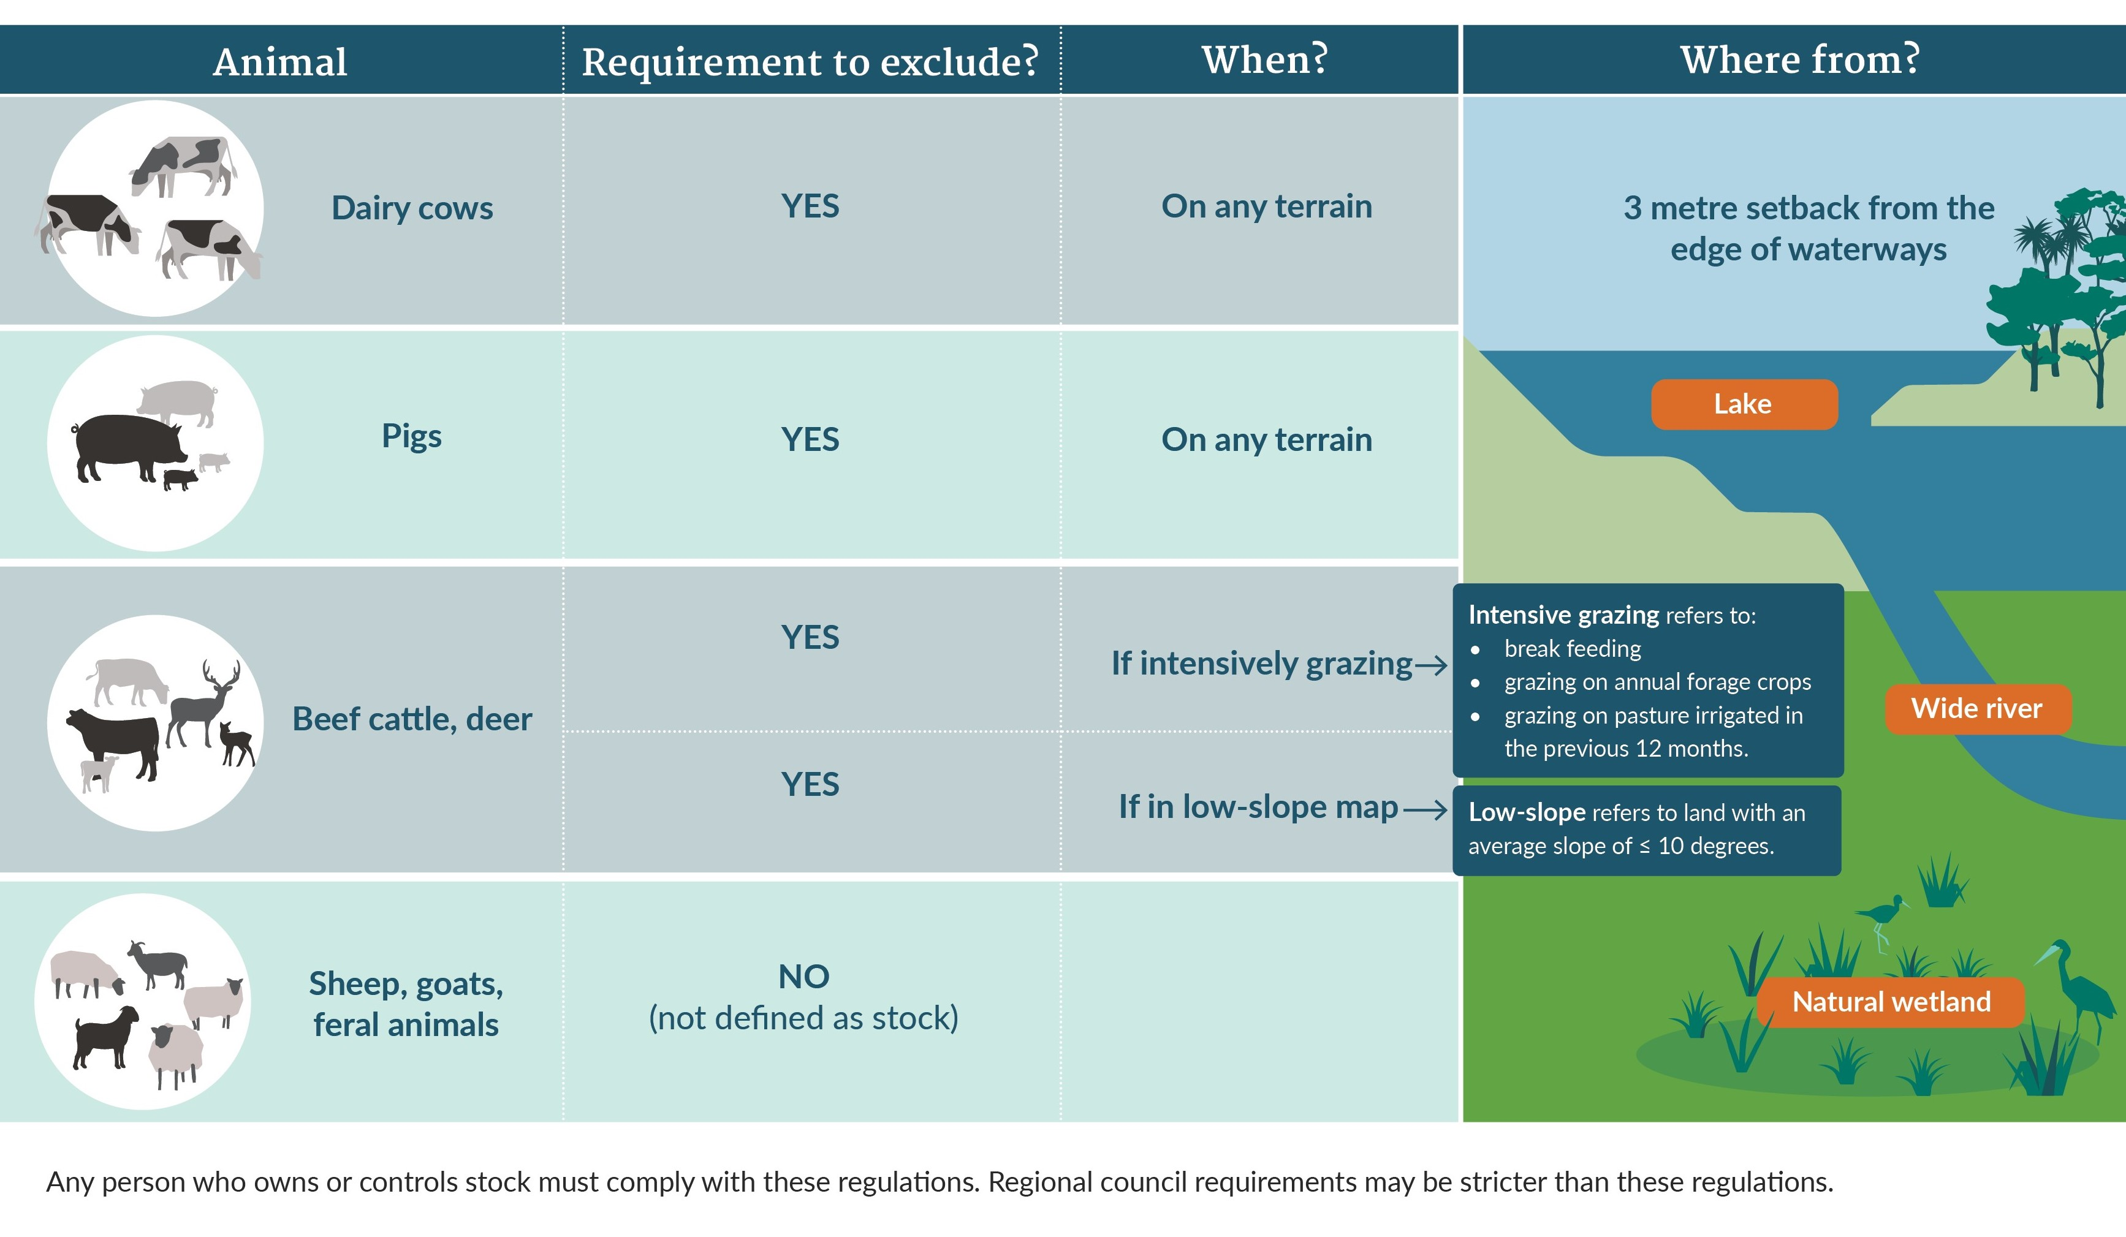
Note: requirements in the above infographic apply from different dates. They:
- EITHER apply in all cases to stock in a new pastoral system (one created on or after the 2020 commencement date)
- OR from 1 July 2023
- OR from 1 July 2025 – this is the date from which the low slope map applies to beef cattle and deer.
Notes regarding wetlands – all stock:
- on low slope land must be excluded from any natural wetland that is 0.05 hectares or more
- must be excluded from any natural wetland that is identified in a regional or district plan or a regional policy statement that is operative on the commencement date (that is, on 3 September 2020)
- must be excluded from any natural wetland that supports a population of threatened species as described in the compulsory value for threatened species in the NPS-FM 2020 (including a natural wetland identified in a regional plan that becomes operative after the commencement date).

The regulations were prepared under section 360 of the Resource Management Act 1991.
Requirements to exclude dairy cattle and pigs from access to waterways apply regardless of terrain.
In the decisions that initiated consultation in September 2019, Cabinet agreed to consult on: ‘requiring dairy and beef cattle, deer and pigs to be excluded from lakes, rivers (greater or equal to one metre wide), and wetlands through national regulation which does not apply to sheep, or to low-intensity high country farming;’ (emphasis added).
This is set out in s 360(1)(hn) of the Resource Management Act 1991.
The percentage of land with slope over 10 degrees reduces from approximately 11 per cent of the land in the current map to approximately 0.07 per cent of land in the revised map.
In the decisions that initiated consultation in September 2019, Cabinet agreed to consult on: ‘requiring dairy and beef cattle, deer and pigs to be excluded from lakes, rivers (greater or equal to one metre wide), and wetlands through national regulation which does not apply to sheep, or to low-intensity high country farming;’ (emphasis added).
Altitude above sea level.
This is not the case. In requiring stock to be “effectively excluded” from access to waterways, the regulations neither mention the means for exclusion nor make any references to fencing.

