|  |  |  |
| --- | --- | --- |
| Projections of HFC stocks and emissions to 2050 in relation to key factors influencing HFC consumption |  | Prepared for  Ministry for the Environment  30 June 2020 |

|  |  |
| --- | --- |
| **Authors** | Wayne Hennessy and Don Cleland |
|  |  |
| **Client name** | Ministry for the Environment |
| **Client address** | PO Box 10362  Wellington |
|  |  |
| **Date of Issue** | 30 June 2020 |
|  |  |

# Executive Summary

1. The bulk supply of HFCs is being phased down under the Kigali Amendment to the Montreal Protocol. New Zealand has adopted a ten-step phase-down schedule that will mean the net supply of new bulk HFCs will be reduced to 52% below a baseline level in 2025 and 75% below in 2031 (OLPA, 2018).
2. The Ministry for the Environment is seeking to develop an evidence base to inform the reporting of HFC projections because there is considerable uncertainty about future stocks and emissions. The purpose of this study is that Verum Group is to develop estimates (and uncertainties) under a range of scenarios for New Zealand’s projected drawdown, reuse, destruction and emissions of HFCs.
3. For the first stage of this study we have called upon the expertise of Dr Don Cleland in the various refrigeration technology sectors because these will have the largest influence on future HFC emissions. Key findings are presented here from his detailed assessment (Appendix A) of the development of types of lower GWP refrigerants, implementation issues for New Zealand (particularly flammability/safety) and their current and future affordability. His report includes information we have gathered in the second stage of contacting 27 New Zealand stakeholders and international experts for their views on various alternatives and how their usage will be influenced by the phase-down and ETS pricing.
4. Non-flammable retrofit or drop-in options exist for most original HFCs (refrigerants R134a, R507A, R404A, R410A). Generally these alternatives have GWPs about half those of the original refrigerants. So they already allow a quick reduction in GWP for most new systems and for service of existing systems without major changes in refrigeration practice, once prices and availability mean they are competitive.
5. International technology shifts will mainly be driven by the European F-Gas phase-down schedule which is the most advanced internationally (EIA, 2015). Apart from CO2, all near-zero GWP alternatives (GWP<150) are flammable which limits their application to systems with low charge unless expensive safety precautions are undertaken. This can usually only be justified for large scale systems. CO2 use as a refrigerant is limited by its high pressure (non-standard equipment) and its poorer performance in a transcritical cycle. New non-flammable low GWP refrigerants with good pressure/temperature match to the original HFCs are unlikely to be discovered.
6. The international 150 g charge limit on flammable (A3) and less flammable (A2L) refrigerants is quite restrictive and effectively means that, without other measures that have significant costs, flammable refrigerant can be used only for very small charge hermetically sealed systems such as domestic refrigerators. Recently an international standard (IEC 2019) increased the limits to 500 g for A3 and to 1200 g for A2L refrigerants that are heavier than air in hermetically sealed systems where the compressor is integrated into the appliance housing. Incorporating this change in limits into New Zealand standards will allow flammable refrigerants to be used for a wider range of hermetic systems.
7. Small scale, hermetically sealed systems are in rapid transition to flammable low GWP refrigerants for new equipment. Domestic refrigerators and freezers have largely completed the transition, while the shift for dehumidifiers, stand-alone refrigerated display cabinets, domestic AC and some small commercial AC will be completed over the next 5 to 10 years. Some AC systems in new vehicles contain low GWP R1234yf (an HFO) but it is not yet clear when the majority of vehicle manufacturers will shift away from R134a.
8. Large scale systems will continue to use natural refrigerants such as ammonia and/or they will transition to lower charge designs (e.g. indirect secondary refrigerants) that allow flammable low GWP refrigerants to be used safely and cost-effectively. Such applications include most industrial refrigeration for food processing, supermarkets and large scale building AC using chilled water.
9. Applications with moderate charge sizes (too high to make use of flammable refrigerants cost-effectively) will be the most challenging to shift to very low GWP refrigerants. Examples include: medium scale AC systems, public transport AC, transport refrigeration, dairy farm refrigerated vats and walk-in cold rooms for retail, food service and restaurants. Non-flammable alternatives (with GWP approximately half of the original HFCs) can be used for new equipment and retrofits as soon as refrigerant prices and availability incentivise such changes. Long term, low GWP options are unlikely without significant changes to system designs that will be expensive.
10. Investment in the refrigeration sector is very driven by capital costs and most new installations are still usually decided by the initial cost rather than the life-cycle costs, including for some large industrial systems. Even with higher prices, refrigerant will likely remain less than 10% of the cost of a new plant. Therefore the economic drivers to retire plant early and shift to low GWP alternatives are likely to remain low.
11. Small to medium enterprise owners represent the vast majority of commercial refrigeration and AC systems and typically have limited knowledge of their systems and their risks from refrigerant supply and pricing, in contrast to owners of large industrial systems and medium commercial systems on multiple sites (supermarkets) that are leaders in planning their refrigeration risks. SMEs are usually dependent on the knowledge of their service companies and averse to significant expenditure on capital they see as secondary to their core business. Many contractors report crisis situations where decisions are made on short term repair solutions rather than on longer term system upgrades. Such decisions will clearly be influenced by refrigerant price increases due to the ETS and perhaps scarcity. Understanding the economic impacts on the huge range of SMEs would require a major economic study.
12. The current high prices for HFO alternative refrigerants may drop significantly in a few years with more supply competition and higher sales volumes. Two foam blowing supply companies revealed they are likely to shift to R1234ze(Z) within the next 5 years if HFC prices continue to rise (partly driven by customers’ sustainability goals). In contrast for R134a used in MAC servicing, even if the current NZ price of the R1234yf component of the retrofit alternative R513A was halved to $200/kg, it would require an ETS price of about $120/tonne CO2 for R134a to be more expensive than R513A (or about $50/tonne CO2 if the R1234yf price reduces to $100/kg).
13. Currently the Recovery Trust collects for destruction about 40 tonnes of HFC refrigerants annually and this has been estimated to be less than 40% of the refrigerant that could and should be recovered and destroyed. Destruction rates in some other countries are reported to be greater than 40% of refrigerant available for recovery but there is no uniformity in the way such rates are measured. A proposed product stewardship scheme for refrigerants is widely supported by the industry. Education and incentives to encourage higher levels of recovery for reuse and destruction could significantly reduce emissions due to deliberate (illegal) atmospheric venting of refrigerant.
14. Reuse of refrigerant will be increasingly attractive as refrigerant prices increase from the ETS and from scarcity resulting from the phase-down. It is currently a reasonably common practice within a single organisation because there is certainty about quality. However, reusing a refrigerant in a different system requires it to be re-processed to remove contaminants and to ensure its purity and composition unless the source system is known to be in good condition. Re-selling the refrigerant requires even stricter re-processing but the required specialist facilities will become more cost-effective as refrigerant prices rise.
15. Based on the near-term (5 to 10 year) technology options identified in Appendix A, Verum Group has developed a workbook to explore the HFC stocks and emissions pathways to 2050 (Figure 1) for seven scenarios based on a range of policy and price assumptions (Table 1). For six of the scenarios (excluding C Business-As-Usual), new bulk supply of each refrigerant mixture has been fitted to meet New Zealand’s phase-down budget. One of these six (F) explores the implications of extensive use of imported reused refrigerants to meet the supply shortfall of new HFCs, because these reused refrigerants are excluded from the phase-down budget.

|  |  |  |  |  |  |
| --- | --- | --- | --- | --- | --- |
| **Scenario** | **Phase-down** | **ETS price** | **Reuse** | **Destruction** | **Description** |
| C slow transition BAU | No | $25 | no imports, negligible within NZ | current 11% of retired | Business-As-Usual current trends as baseline for assessing other scenarios; only changes are from likely shifts in international technology. |
| A reactive transition | Yes | $25 | no imports, 10% of early retired | current 11% of retired | Limited initial awareness of impending steep decline in new HFCs leads to major reduction in commercial/industrial refrigeration and stationary AC equipment stocks from early retirement 2025-29. |
| B planned transition | Yes | $25 | no imports, 20% of all retired | current 11% of retired | Education on low GWP alternatives and improved installation, maintenance and recovery for destruction and reuse (compared with A); major reduction in equipment stocks resulting from early retirement from 2023-27 but less severe than A. |
| D reactive transition | Yes | $50 | no imports, 20% of all retired | current 11% of retired | Higher ETS price drives an earlier major reduction in equipment stocks from early retirement 2023-29, improved leakage rates for commercial/industrial refrigeration and stationary AC, a reduced MAC service rate (compared with A). |
| E reactive transition | Yes | $75 | no imports, 30% of all retired | current 11% of retired | Much higher ETS price drives an earlier major reduction in equipment stocks from early retirement 2023-27, further improved leakage rates for commercial/industrial refrigeration and stationary AC, a reduced MAC service rate (compared with D). |
| F planned transition  high reuse | Yes | $25 | unlimited imports, negligible within NZ | current 11% of retired | Low level of early retirement because access to imported reused refrigerants makes up half of shortfall in imported new HFCs. |
| G reactive transition high destruction | Yes | $25 | no imports, 20% of all retired | 22% of retired from 2025, 33% from 2030 | Same as B with improved recovery for reuse and destruction. |

**Table 1 –** Summary of scenario assumptions

**Figure 1** – Total HFC emissions comparison for the seven scenarios

1. Scenarios A, B, D and E show peak emissions around 2025 resulting from different assumptions about the timing of early equipment retirement. Taking E as an example of price impact assumptions, the major ETS price increase in 2020 rapidly warns the various industry sectors of the future HFC price risks. Nevertheless, without access to imported reused HFCs, there is still major early retirement of HFC equipment stocks from 2023-29. The high price signal results in further improved leakage rates for commercial/industrial refrigeration and stationary AC, a reduced MAC service rate and increased reuse of retired refrigerants (compared with D).
2. In planned transition scenario B, it is assumed that industry sectors plan from 2020 for the impending sharp phasedown in HFC supply with extensive education of industry stakeholders on low GWP alternatives and improved installation, maintenance and recovery for destruction and reuse (compared with A). Without access to imported reused refrigerants, there is still a major reduction in equipment stocks from 2023-27 resulting from early retirement but it is more planned and the refrigerant supply mix is optimised to maximise the use of lower GWP refrigerants.
3. For 2020-2035 cumulative total HFC emissions, scenarios A, B, D and E are all 23-28% lower than the total for the C BAU scenario and similarly for 2020-2050 A, B, D and E are all 50-56% lower than the total for C. All four scenarios are assumed to have substantial amounts of early retirement so they would be expected to have lower cumulative emissions (especially in 2050) because that represents several years when that retired equipment is not requiring HFCs to replace leakage.
4. With enhanced recovery for G, 2020-2035 cumulative total HFC emissions are slightly lower than the scenarios above at 34% lower than the total for C (and 9% below the B scenario it is derived from). For 2020-2050 cumulative total HFC emissions are similar to those for A, B, D and E at 55% lower than the total for C (and 11% below the B scenario it is derived from). The 2020-2050 cumulative emissions figure of 25.7 Mt CO2-e represents 3.0 Mt CO2-e of avoided emissions from the extra recovery for destruction compared with B.
5. F is arguably the scenario that is closest to current policy settings because it allows relatively unrestricted access to imported reused HFCs to meet the shortfall resulting from the phase-down. For 2020-2035 cumulative total HFC emissions, F is 10% lower than the total for the C BAU scenario and similarly for 2020-2050, F is 19% lower than the total for C. More importantly, without the continued high growth of imported AC equipment for C, the total HFCs in 2050 equipment stocks for F are 33% lower than for C.
6. It is important to note that the reduction outcomes from Scenarios A, B, D, E and G could be considered desirable compared with the F outcome. However, the unavailability of imported reused bulk HFCs is an assumption for modelling purposes to estimate the impacts of different factors on the emissions pathway. Current policy is for relatively unrestricted availability of imported reused refrigerants in order to avoid early retirement of a major proportion of the equipment stocks in each sector. While some of this modelled early retirement would be replaced by new equipment using natural and low GWP refrigerants, most of it would represent a significant reduction in industrial and commercial refrigeration services that would not be economically realistic.
7. Combining the known uncertainties of the HFC inventory sector breakdown with the much higher ones of projecting future emissions is a highly speculative exercise: +50-70% has been estimated for total HFC emissions in 2035 for the different scenarios (and +50% for 2020-2035 cumulative emissions). Therefore in strict statistical terms, only the most extreme differences would be considered significant at a 95% confidence level.

# Purpose

The Ministry for the Environment is seeking to develop an evidence base to inform the reporting of greenhouse gas emissions projections in the Industrial Processes and Product Use (IPPU) sector for hydrofluorocarbon gases (HFCs), in particular, because there is considerable uncertainty about future consumption and emissions. The purpose of this study is that Verum Group provides expert analysis and opinion on the volume and composition of the stockpile of gases in New Zealand and estimates under a range of scenarios for New Zealand’s projected drawdown, reuse, destruction and emissions of HFCs.

For the first stage of this study we have called upon the expertise of Dr Don Cleland in the various refrigeration technology sectors because these will have the largest influence on future HFC emissions. His assessment of the development of types of lower GWP refrigerants, implementation issues (particularly flammability/safety) and their current and future affordability are presented in detail in Appendix A with a summary below. To prepare this extensive overview, he has summarised the international literature on alternative refrigerants and called upon his international network of refrigeration experts for some unpublished discussion material in this fast-moving field.

For the second stage, we viewed submissions from New Zealand stakeholders on the Ministry’s Kigali Amendment consultation process and then contacted many of them (and others) for their views on the influence of the phase-down and ETS price on the current and future mix of HFC refrigerant types and volumes in their individual sectors (dependent on availability and cost of alternatives for each technology). Some of these views are summarised in Appendix A.

For the third stage, we have developed an Excel workbook based on the National Greenhouse Gas Inventory Common Reporting Format that takes historical stocks and manufacturing, operating and disposal emissions for each HFC in each sub-application (user sector) and projects an emissions pathway to 2050 under various policy and implementation assumptions. Those assumptions, outcomes and uncertainties are detailed for seven scenarios in Appendix B and are summarised below.

# Assessment of Technology Options

For the first stage of this study we have called upon the expertise of Dr Don Cleland in the various refrigeration technology sectors because these will have the largest influence on future HFC emissions. Key findings are presented here from his detailed assessment (Appendix A) of the development of types of lower GWP refrigerants, implementation issues for New Zealand (particularly flammability/safety) and their current and future affordability. His report includes information we have gathered in the second stage of contacting 27 New Zealand stakeholders and international experts for their views on various alternatives and how their usage will be influenced by the phase-down and ETS pricing. Key findings are summarised below.

Non-flammable retrofit or drop-in options exist for most original HFCs (refrigerants R134a, R507A, R404A, R410A) but generally have intermediate GWPs (about half of the GWP of the original refrigerants). These alternatives already allow a quick reduction in GWP for most new systems and for service of existing systems without major changes in refrigeration practice, once prices and availability mean they are competitive.

International technology shifts will mainly be driven by the European F-Gas phase-down schedule which is the most advanced internationally (EIA, 2015). Apart from CO2, all near-zero GWP alternatives (GWP<150) are flammable which limits their application to systems with low charge unless expensive safety precautions are undertaken. This can usually only be justified for large scale systems. CO2 use as a refrigerant is limited by its high pressure (non-standard equipment) and its poorer performance in a transcritical cycle. New non-flammable low GWP refrigerants with good pressure/temperature match to the original HFCs are unlikely to be discovered.

Small scale applications, especially those using small scale, hermetically sealed systems, are in rapid transition to flammable low GWP refrigerants for new equipment. Domestic refrigerators and freezers have largely completed the transition, while the shift for dehumidifiers, stand-alone refrigerated display cabinets, domestic AC and some small commercial AC will be completed over the next 5 to 10 years. Some AC systems in new vehicles already contain low GWP R1234yf but it is not yet clear when the majority of vehicle manufacturers will shift away from R134a.

Large scale systems will continue to use natural refrigerants such as ammonia and/or they will transition to lower charge designs (e.g. indirect secondary refrigerants) that allow flammable low GWP refrigerants to be used safely and cost-effectively. Such applications include most industrial refrigeration for food processing, supermarkets and large scale building AC using chilled water.

Applications with moderate charge sizes, that are too high to make use of flammable refrigerants cost-effectively, will be the most challenging to transition to very low GWP refrigerants. Examples include: medium scale AC systems, public transport AC, transport refrigeration, farm milk vats and walk-in cold rooms for retail, food service and restaurants. Non-flammable alternatives exist that allow GWP to be approximately halved relative to the original HFCs, and can be used for new equipment and retrofits as soon as refrigerant prices and availability incentivise such changes. Long term, low GWP options are unlikely without significant changes to system designs that will be expensive.

The refrigeration sector is very driven by capital costs and most new installations are still usually decided by the initial cost rather than the life-cycle costs, including for some quite large industrial systems. Even with higher refrigerant prices, refrigerant will likely remain less than 10% of the cost of a new plant. Therefore the economic drivers to retire plant early and transition to low GWP alternatives are likely to remain quite low.

It is likely to be a few years before current high prices for HFOs settle down with more supply competition and higher sales volumes. Two foam blowing supply companies revealed they are likely to shift to R1234ze(Z) within the next 5 years if HFC prices continue to rise (partly driven by customers’ sustainability goals). In contrast for R134a used in MAC servicing, even if the current NZ price of the R1234yf component of R513A, the retrofit alternative, was halved to $200/kg, it would require an ETS price of about $120/tonne CO2 for R134a to be more expensive than R513A (or about $50/tonne CO2 if the R1234yf price reduces to $100/kg).

For many years the charge limit for flammable refrigerants (A3) in an unrestricted space with people present was 150 g internationally. With the advent of A2L refrigerants that are less flammable than A3, the limit for them was also set to 150 g. These limits are quite restrictive and effectively mean that, without other measures that have significant costs, flammable refrigerant can only be used for very small charge hermetically sealed systems such as domestic refrigerators. However recently an international standard (IEC 2019) increased the limits to 500 g for A3 and to 1200 g for A2 and A2L refrigerants that are heavier than air in hermetically sealed systems where the compressor is integrated into the appliance housing. If this change is widely adopted it will allow flammable refrigerants to be used for a wider range of hermetic systems including small scale unitary refrigerated display cabinets and bottle coolers.

Several approaches to refrigerant charge size reduction are being increasingly adopted and modern system designs have refrigerant charges to do the same cooling duty that are often 50% or less than older designs. Recent examples include:

* Residential split system AC of the same capacity, reducing charge from about 1.2 kg to 0.6 kg as part of the transition for R410A to R32.
* Car AC systems reducing charge by more than 50% using micro-channel heat exchangers and piping rationalisation as part of the transition from R134a to R1234yf or R744.
* Supermarkets using glycol and CO2 as secondary refrigerants in cabinets so that the primary circuit charge can reduce by more than a factor 5.
* Horticultural coolstores using glycol as a secondary refrigerant for multiple coolstores on a site reducing the charge by more than a factor of 10 (also the safety benefit for people working in the coolstores plus better temperature and humidity control).

Refrigeration systems are designed to retain the refrigerant as any leakage is detrimental to performance as well as being a significant cost to repair the leakage and recharge the system (plus the environmental impact). Loss of refrigerant can be via on-going but slow fugitive leakage through seals and minute corrosion holes or similar, or via very infrequent catastrophic failure such as fractures of piping or fittings due to stress, vibration, corrosion or physical impacts leading to rapid, and often complete, loss of charge.

Annual rates of leakage vary greatly from system to system. They can be significantly less than 1% of charge per annum on average for small scale hermetic systems to 5-15% per annum on average for medium sized stationary systems, or up to 30% or more per annum on average for transport refrigeration or AC systems. Owners of larger system are more aware of the cost of replacement refrigerant and the cost of system under-performance and therefore more frequently undertake preventative maintenance, but many still only react to breakdown. As refrigerant become more expensive then it will provide greater incentive for owners to engage contractors to check for and repair leaks and potential sources of leaks. Therefore some reduction in average leakage rates is expected over time. Anecdotal evidence suggests that, to date, increased attention to leakage is minor except for larger charge systems.

Currently the Recovery Trust collects for destruction about 40 tonnes of HFC refrigerants annually and this has been estimated to be less than 40% of the refrigerant that could and should be recovered and destroyed. Destruction rates in some other countries are reported to be greater than 40% of refrigerant available for recovery but there is no uniformity in the way such rates are measured. A proposed product stewardship scheme for refrigerants is widely supported by the industry. Education and incentives to encourage higher levels of recovery for reuse and destruction could significantly reduce emissions due to deliberate (illegal) atmospheric venting of refrigerant.

Reuse of refrigerant is an increasingly attractive option as refrigerant supply becomes restricted due to phase-down and refrigerant costs increase. It is currently a reasonably common practice within a single organisation because there is certainty about quality. However, reusing a refrigerant in a different system requires it to be re-processed to remove contaminants and to ensure its purity and composition unless the source system is known to be in good condition. Re-selling the refrigerant requires even stricter re-processing but the required specialist facilities will become more cost-effective (whether in New Zealand, Australia or elsewhere) as refrigerant prices rise.

NZ is in the process of introducing a compulsory licensing scheme for technicians servicing RAC equipment, involving regular competence testing. Such a scheme will reduce the significant problem identified by some industry experts of “cowboys” undertaking service work with the corresponding risk of poor quality installations and greater refrigerant emissions. However, it will only be effective if compliance is actively and aggressively checked. Also given the size of the HFC banks in car AC and residential AC systems, it will be critical that these sectors remain part of the licensing regime if progress in reducing leakage rates plus refrigerant recovery at end of equipment life is to be achieved.

Appendix A includes a detailed discussion of the likely technology/refrigerant options for key sectors:

* All new domestic refrigerator, freezer, ice makers and dehumidifiers should rapidly transition to near-zero HC or HFO refrigerants due to their low charge.
* Most new domestic AC should transition from R410A to R32 in the next few years as they are low charge systems. Further, the average charge of new domestic AC units is likely to reduce by up to about 50%. Combined, these mean that the GWP bank will increase more slowly despite likely increasing sales of such systems.
* Servicing existing R410A systems with lower GWP refrigerants such as R466A (GWP=733) should help avoid early retirement of older units while lowering the GWP of the bank. R466A is not yet available in NZ. Near-zero GWP drop-in replacements for R410A in existing systems are unlikely to come available. In the longer term, domestic AC and heat pumps should transition to either near-zero GWP HFOs such as R1234yf or R1234ze(Z) (larger compressors) or HCs (if charges get below 1200 g or 500 g respectively).
* The EU F-Gas regulations mean that new cars in the EU have transitioned to R1234yf or R744 (CO2). Japanese, Korean and US car manufacturers have completed the R1234yf technology development including reduction in charge to less than 1 kg in most systems but new models entering NZ still use R134a and that transition is unlikely to be until after 2025. Imported used vehicles from Japan will continue to use R134a until about 5 years after the international transition.
* Servicing of R134a MAC could use intermediate GWP alternatives such as R513A (GWP=631). If both R134a and alternatives remain expensive then it is likely that many MAC systems will not be serviced if they lose their charge (owners will tolerate the discomfort given NZ’s generally mild climate). Alternatively, there may be the temptation to use cheap alternatives such as HC despite their higher flammability risks.
* Large commercial buildings tend to use chilled water distribution systems so refrigerant use is isolated to plant rooms which can be controlled more tightly and charge sizes are relatively small. Hence transition to low GWP alternatives should be straight-forward and could occur almost immediately.
* AC of small and medium sized commercial buildings is more problematic as they often employ higher charge R410A systems such that transition to flammable refrigerants such as R32 would be unlikely to meet safety regulations (e.g. larger scale split or ducted systems, or Variable Refrigerant Flow (VRF) systems that use refrigerant recirculation between AC units throughout a building). Servicing can use non-flammable intermediate GWP alternatives such as R466A but for new systems there are no obvious non-flammable low GWP candidates. Use of indirect AC systems or multiple smaller units would allow use of flammable, low GWP refrigerants but both have higher capital cost. Such changes may take a number of years to occur as manufacturers develop new products and building designers adapt their design philosophies.
* Currently about 80-90% of shipping containers use R134a and R404A for most of the remainder. R134a systems can be retrofitted with R513A, and R404A with R452A so this transition may occur rapidly. NZ practice will probably be dictated by international shipping companies that own most containers. Transition to near-zero refrigerants is fraught because ship owners are very nervous about flammable refrigerants.
* Refrigerated trucks tend to use R404A (e.g. larger trucks) or R134a (e.g. small trucks and vans). R452A (GWP=2140) has already largely displaced R404A (GWP=3922) in new units and can be used for servicing existing ones. R513A will similarly provide an intermediate GWP option for R134a. Small trucks can transition to R1234yf or similar (as for MAC) as charges are lower but the lack of non-flammable alternatives will hinder transition to near-zero GWP refrigerants for larger vehicles.
* Commercial self-contained refrigerated display cabinets usually have hermetic systems using R134a for chillers and sometimes R404A for freezers. The IEC (2019) Standard maximum charge increase for A3 refrigerants in such systems to 500 g means that most manufacturers will quickly transition to HCs such as propane or isobutane if they have not already done so. Leakage rates in such systems are usually very low.
* Supermarkets historically used R134a and R404A (in compressor racks serving a number of display cabinets and walk-in storage rooms) but in the last 5 years many new systems have used R744 (CO2) consistent with the world-wide trend (both direct and indirect secondary systems). For intermediate scale supermarkets, then the intermediate GWP non-flammable refrigerants such as R407F, R448A or R449A (instead of R404A) and R513A (instead of R134a) are the likely short term options if CO2 is not deemed cost-effective.
* There are a multitude of small walk-in refrigerated facilities that have usually been refrigerated via dedicated semi-hermetic systems for each room. Charges are often greater than 2 kg and up to 50 kg for multi-room systems so flammable refrigerants are restricted as alternatives.
* Service and new systems are likely to move to R513A, R407F, R448A, R448A, R452A or similar but in the longer term, charges will need to be reduced to enable flammable low GWP alternatives to be used. This will take time for system design and service expertise to develop so it is likely to only occur when refrigerant prices or regulation dictate radical change in practices.
* On-farm milk vats historically used R134a or R404A but more recent installations have used R407F. They typically have charges greater than 3 kg but they are usually located outside or in semi-open farm buildings so use of flammable refrigerant might be a future option.
* Large scale industrial systems are generally already using ammonia and this is likely to be the preference in an increasing fraction of new systems. This includes all of the meat, dairy (after the last R22 stores are converted or decommissioned), fish and chicken processing.
* The horticultural sectors use ammonia (most apple stores) or one of R404A, R134a, R407C or R407F (particularly for kiwifruit stores). New stores will increasingly use ammonia or other flammable low GWP primary refrigerants in indirect systems using secondary refrigerants such as glycol.
* Service of industrial systems not using ammonia (often R404A for low temperature or R134a for medium temperature) will use well-matched intermediate GWP alternatives such as R407F, R448A, R449A, R452A or R513A if there is a price advantage. The value of the product in industrial facilities is so high, that refrigerant cost becomes a secondary concern when servicing emergency break-downs.
* Overall, as for other sectors, low GWP options for the smaller to medium sized industrial applications will be the most challenging to implement given the likely flammability of these options and the medium charge sizes that will be difficult to reduce cost-effectively.

# Scenarios Development

Based on the near-term (5 to 10 year) technology options identified in Appendix A, Verum Group has developed an Excel workbook based on the National Greenhouse Gas Inventory Common Reporting Format that takes historical stocks and manufacturing, operating and disposal emissions for each HFC in each sub-application (user sector) and projects an emissions pathway to 2050 for a particular set of policy and implementation assumptions.

Two key principles lie behind the development of each scenario:

**Mass balance:** Every tonne of each HFC imported into NZ must be accounted as a re-export, an addition to bulk gas or equipment stocks, a manufacturing, operating or disposal emission or as recovery for destruction or for reuse. In practice this is a difficult balancing act to achieve and requires additions or removals from the stock of each bulk HFC over the time series so that by 2050 the goal is to have a realistic quantity for each HFC.

**Kigali phase-down budget:**  For six of the scenarios (excluding C BAU), new bulk supply of each refrigerant mixture has been taken through a number of iterations so that the total of CO2 equivalents from each HFC component meet the EPA ten-step phase-down budget based on the Ozone Layer Protection Act Regulations (OLPA 2018; detailed in Appendix A Table A1). One of these six (F) explores the implications of extensive use of imported reused refrigerants to meet the supply shortfall of new HFCs, because these reused refrigerants are excluded from the phase-down budget.

All projections are made without referring to the recession impacts from the corona virus pandemic and related issues. The length and depth of such impacts would be more appropriately estimated by an economist.

In considering the implications of the ETS price and of scarcity pricing resulting from the phase-down, we have had to develop an implicit hierarchy of (a) which RAC sectors would be prepared to pay the most for dwindling supplies and (b) which sectors would be prepared to invest capital in alternative refrigerants/technologies to avoid the (a) situation?

1. We consider that one of the sectors least likely to be shifted by prices is domestic AC. A major refrigerant price increase from ETS or scarcity would have little impact on new sales (because that price is a minor contributor to the capital and installation cost of the equipment) and the current rapid refrigerant shift is happening as a result of international manufacturers needing to meet EU F-Gas regulations in particular. Also householders will continue to service their existing heat pumps no matter the refrigerant price (with complaints) rather than put up with a poorly performing heat source.
2. Similarly, commercial businesses needing AC for their customers will keep their equipment running as long as possible until servicing breakdowns becomes too expensive to continue replacing expensive refrigerant and they are forced to upgrade technology (with major complaints to their service companies). As discussed in Appendix A, larger commercial AC equipment will be the sector that will be most difficult to find lower GWP alternative refrigerants for the near future. In the modelling, we have assumed that higher pricing will drive increased maintenance to reduce leakage.
3. Another sector where technology is slowing shifting because of international manufacturing trends is mobile AC. Increasing refrigerant price is a tiny proportion of a new vehicle price and will have no influence on sales, although marketing for environmental sustainability will have a significant influence for some buyers (as for technologies in other sectors). We believe high refrigerant prices (whether for HFCs or for currently very costly HFO alternatives) will have a somewhat contradictory impact on servicing: many NZ MAC vehicle owners choose to have poorly performing equipment because they do not see it as essential in our mild climate compared with Australia, Asia and many other countries. We have modelled that with higher refrigerant pricing, those vehicle owners who choose to keep their MAC performing well will be prepared to pay the higher service prices (with complaints) but that proportion of the vehicle fleet will decrease from the current 3% annual replacement of the MAC stocks to 2-2.5% with scarcity pricing, to 2% with an additional $50 ETS price and to just 1.5% with an additional $75 ETS price.
4. There is much discussion in Appendix A of the technology and refrigerant options for the supermarket and larger industrial sectors that would be considered leaders in terms of their priorities placed on high performing refrigeration equipment (minimising risk of failure that would cause major economic losses) and their preparedness to invest capital in technology designed to minimise future refrigerant price risk. Many operators have already shifted to low GWP refrigerant technologies or already have plans to do so for the plants or sites that will bring the highest return on investment in the near future. Many more have yet to make those decisions and that is why we have modelled that an instant ETS price increase signal to $50 or $75 would arguably ease the pain of transition if refrigerant prices increase markedly in about 5 years with scarcity. In the contrasting F scenario, there is no such price signal due to relatively unrestricted access to imported reused refrigerants.
5. Small to medium enterprise owners represent the vast majority of commercial refrigeration systems and typically have limited knowledge of their systems and their risks from refrigerant supply and pricing. They are usually dependent on the knowledge of their service companies and averse to significant expenditure on capital they see as secondary to their core business. Many contractors report crisis situations where decisions are made on short term repair solutions rather than on longer term system upgrades. Such decisions will clearly be influenced by refrigerant price increases due to the ETS and perhaps scarcity (despite major complaints from the owners).

Detailed assumptions are presented in Appendix B with a summary below for each scenario.

# Uncertainties

Uncertainties(estimated as 95% confidence limits) for the 2018 inventory 1816 kt CO2-e total HFC emissions were +25% (combining +30% for Stationary RAC, +24% for MAC, +26% for aerosols, +50% for foam blowing and +42% for fire protection in sequence of decreasing emissions contributions).

Combining these known uncertainties with the much higher ones of projecting future emissions is a highly speculative exercise. The approach taken has been to estimate a lower limit and an upper limit for total emissions in 2035 given the range of assumptions built into each scenario and treating those as 95% confidence limits about the mean even though such a treatment is very unlikely to be a Normal distribution.

To be clear, while the total net bulk supply of new HFCs is considered highly certain (+1%) because of the imports licensing, the high uncertainties arise from the flowing factors:

* The mix and amount of each new imported refrigerant.
* The tonnes of each new imported refrigerant assigned to filling new equipment (some of which is exported) or to replace leakage in existing equipment[1] or into bulk gas stocks.
* The amounts of each refrigerant imported as pre-charged equipment adding to the equipment stocks (not controlled by phase-down licensing).
* The retirement modelling of the equipment stocks (including the extra uncertainties arising from early retirement) and the consequent quantities recovered for reuse and destruction (proportions of the retired refrigerants fixed for each scenario).
* In the case of F scenario only, the total net bulk imports of reused refrigerants (amounts not currently controlled by phase-down licensing).
* The equipment imports for aerosols: emissions are assumed to become negligible after 2030 (and similarly negligible from foam blowing and fire protection).

# Scenarios Outcomes

The outcomes for each scenario are discussed in detail for each emissions sector in Appendix B. In this section a summary is presented of those outcomes with each emissions chart followed by summary charts comparing cumulative emissions 2020-50 and the total HFC stocks remaining in 2050 for each scenario.

**Figure 2 –** HFC emissions for Scenario A: reactive transition $25

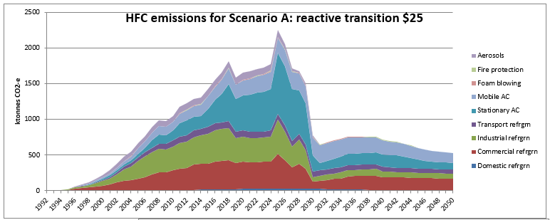

**Scenario A** **reactive transition $25** represents a projection of current trends if there is the planned Kigali phasedown, ETS price remains at $25 and the same shifts (as for C) in international technology that seem likely in the next 10 years (carried through to 2050). In contrast to B, there is limited initial awareness of the impending steep decline in new bulk HFC supply (assuming no access to imported reused refrigerants) until there is a major reduction in commercial/industrial refrigeration and stationary AC equipment stocks resulting from early retirement from 2025-29.

The trend in the emissions chart above shows growth continues until a sharp increase in 2025 and steep decline to a lower emissions level from 2030 as the massive level of early retirement overwhelms the limited recovery capacity for destruction and reuse. (The timing of the 2025 peak is an artefact of assuming a sudden instead of staged start of early retirement and the 2018 discontinuity arises from contradictory data for 2019 that has yet to be resolved.)

For the A scenario, 2035 total HFC emissions are estimated to be 758 kt CO2-e +80% because of the highly uncertain extent of early retirement. Cumulative HFC emissions 2020-35 emissions are considered less uncertain at 22.0 Mt CO2-e +60%.

**Figure 3 –** HFC emissions for Scenario B: planned transition $25

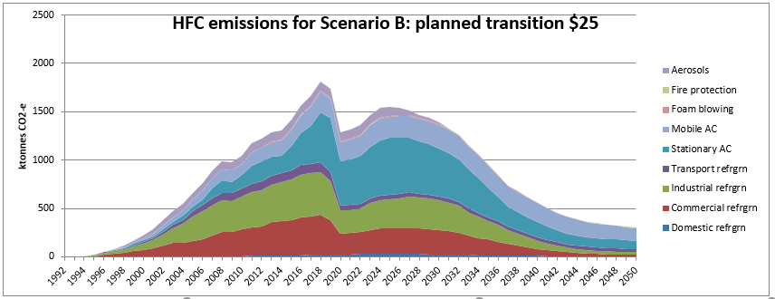

**Scenario B** **planned transition $25** represents a projection of current trends if there is the planned Kigali phasedown, ETS price remains at $25 and the same shifts (as C) in international technology that seem likely in the next 10 years (carried through to 2050). In contrast to A, the industry sectors plan from 2020 for the impending sharp phasedown in HFC supply with extensive education of industry stakeholders on low GWP alternatives and improved installation, maintenance and recovery for destruction and reuse (compared with A). Without access to imported reused refrigerants, there is still a major reduction in equipment stocks from 2023-27 resulting from early retirement but it is more planned.

The trend in the emissions chart above shows emissions sharply decrease in 2020 from a combination of regulations to restrict some equipment imports and industry education to improve awareness of the impending decrease in HFC supply and more widespread training that results in lower leakage rates and better recovery rates for destruction and reuse. Early retirement occurs more gradually than in A so retirement emissions rise to a peak in 2025 and slowly decrease through to 2050.

For the B scenario, 2035 total HFC emissions are estimated to be 956 kt CO2-e +60% because of the highly uncertain extent of early retirement. Cumulative HFC emissions 2020-35 emissions are considered less uncertain at 21.6 Mt CO2-e +50%.

**Figure 4 –** HFC emissions for Scenario C: BAU slow transition $25

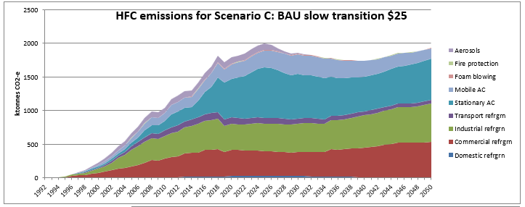

**Scenario C Business-As-Usual slow transition $25** represents a projection of current trends (including continued growth of the stationary AC sector in particular) with no Kigali phase-down, where the only changes are from shifts in international technology that seem likely in the next 10 years (influencing the two largest refrigerant banks for stationary AC and mobile/vehicle AC in particular). This serves the purpose of providing a baseline for assessing the outcomes of the other scenarios.

The trend in the emissions chart above shows steady growth until 2025 until shifts to alternative refrigerants (driven by international technology shifts and ETS price) cause a slow decline until 2040, mainly from the Stationary AC shift from R410A to R32 and the Mobile AC shift away from R134a. Then growth continues in the refrigeration and Stationary AC sectors. (The 2018 discontinuity arises from contradictory data for 2019 that has yet to be resolved.)

For the C scenario, 2035 total HFC emissions are estimated to be 1785 kt CO2-e +50% (lower than others because of the lack of early retirement). Cumulative HFC emissions 2020-35 emissions are estimated to be 22.0 Mt CO2-e +50%.

**Figure 5 –** HFC emissions for Scenario D: reactive transition $50

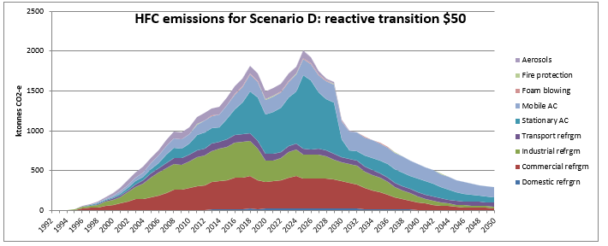

**Scenario D reactive transition $50** is fundamentally the same as A with the planned Kigali phasedown, ETS price is $50 from 2020-50 and the same shifts (as C) in international technology that seem likely in the next 10 years (carried through to 2050). The significant ETS price increase in 2020 rapidly warns the various industry sectors of the future HFC price risks but there is still major early retirement of HFC equipment stocks from 2023-29. There are also improved leakage rates for commercial/industrial refrigeration and stationary AC, a reduced MAC service rate and increased reuse of retired refrigerants (compared with A).

The trend in the emissions chart above shows the 2020 extra price signal produces a similar emissions decrease in 2020 to B, then increasing to 2025 as the early retirement emissions occur then sharply decline to a lower emissions level from 2030.

For the D scenario, 2035 total HFC emissions are estimated to be 851 kt CO2-e +70% because of the highly uncertain price effect and extent of early retirement. Cumulative HFC emissions 2020-35 emissions are considered less uncertain at 22.9 Mt CO2-e +50%.

**Figure 6 –** HFC emissions for Scenario E: reactive transition $75

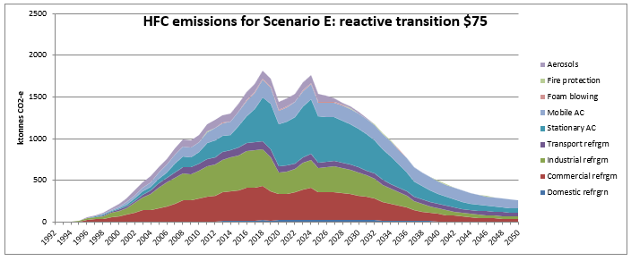

**Scenario E reactive transition $75** is fundamentally the same as A with the planned Kigali phasedown, ETS price is $75 from 2020-50 and the same shifts (as C) in international technology that seem likely in the next 10 years (carried through to 2050). The major ETS price increase in 2020 rapidly warns the various industry sectors of the future HFC price risks but there is still major early retirement of HFC equipment stocks from 2023-29. There are further improved leakage rates for commercial/industrial refrigeration and stationary AC, a reduced MAC service rate and increased reuse of retired refrigerants (compared with D).

The trend in the emissions chart above shows the 2020 extra price signal produces a similar emissions decrease in 2020 to B and D, then increasing to a 2023 peak as the first early retirement emissions occur then steadily decline through to 2050.

For the E scenario, 2035 total HFC emissions are estimated to be 874 kt CO2-e +70% because of the highly uncertain price effect and extent of early retirement. Cumulative HFC emissions 2020-35 emissions are considered less uncertain at 21.9 Mt CO2-e +50%.

**Figure 7 –** HFC emissions for Scenario F: reactive transition high imported reuse $25

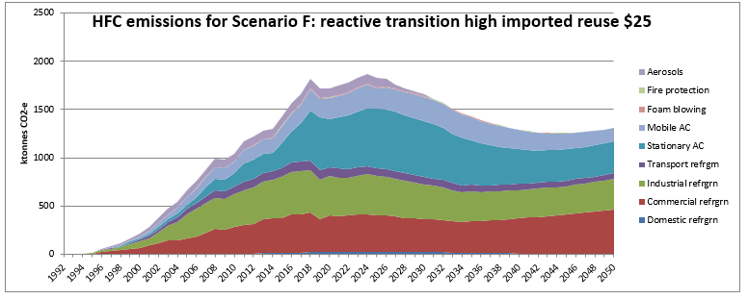

**Scenario F reactive transition high imported reuse $25** is fundamentally different from A and all other scenarios in having access to imported reused refrigerants. It is a projection of current HFC stocks and emissions trends if there is the planned Kigali phasedown for imported new refrigerants, ETS price remains at $25 and the same shifts (as C) in international technology that seem likely in the next 10 years (carried through to 2050). In contrast to A, B, D, E and G, there is a high level of relatively unrestricted reused HFC imports to meet about half of the shortfall in those scenarios and so avoiding the disruption from early retirement of HFC equipment stocks.

The summary charts show that under the F scenario, total HFC emissions from 2020-2035 would be 27.0 Mt CO2-e and from 2020-2050, 46.4 Mt CO2-e. HFCs contained in equipment stocks in 2050 would be 8.6 Mt CO2-e.

The trend in the total emissions chart above shows growth continues until 2023 followed by a slow decline for most of the series, with some sectors showing growth from around 2035 as part of the growth in refrigeration and AC services continues to be supplied by reused HFCs.

For the F scenario, 2035 total HFC emissions are estimated to be 1429 kt CO2-e +60% because of the uncertain extent of imported reused refrigerants. Cumulative HFC emissions 2020-35 emissions are considered less uncertain at 27.0 Mt CO2-e +50%.

**Figure 8 –** HFC emissions for Scenario G: planned transition high recovery $25

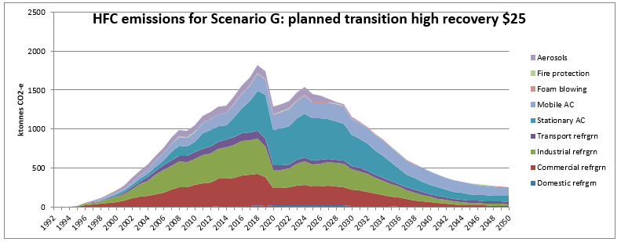

**Scenario G planned transition high recovery $25** is fundamentally the same as B with the planned Kigali phasedown, ETS price remains at $25 and the same shifts (as C) in international technology that seem likely in the next 10 years (carried through to 2050). In contrast to A, the industry sectors plan from 2020 for the impending sharp phasedown in HFC supply with a gradual but significant level of early retirement. In contrast to B and all other scenarios, stakeholder education and infrastructure are developed to double the average rate of recovery for destruction from 11% to 22% of retirements from 2020, then tripled to 33% from 2030. There is also equipment and training for a medium level of reuse from 2020.

The summary charts show that under the G scenario, total HFC emissions from 2020-2035 would be 19.8 Mt CO2-e and from 2020-2050, 25.7 Mt CO2-e. HFCs contained in equipment stocks in 2050 would be 3.3 Mt CO2-e (no change as expected). These first two figures represent respectively 8% and 11% reductions compared with the B scenario figures. The 2020-2050 cumulative emissions figure represents 3.0 Mt CO2-e of avoided emissions from the extra recovery for destruction compared with B.

The trend in the emissions chart above shows emissions sharply decrease in 2020 from a combination of regulations to restrict some equipment imports and industry education to improve awareness of the impending decrease in HFC supply and more widespread training that results in lower leakage rates and better recovery rates for destruction and reuse. Early retirement occurs more gradually than in A so retirement emissions rise to a peak in 2024 and slowly decrease through to 2050.

For the G scenario, 2035 total HFC emissions are estimated to be 779 kt CO2-e +60% because of the highly uncertain extent of early retirement. Cumulative HFC emissions 2020-35 emissions are considered less uncertain at 19.8 Mt CO2-e +50%.

The following charts compare the outcomes of the different scenarios. Note that different axis scales have been used in these three charts to highlight the sub-sector detail.

**Figure 9 –** Cumulative totalHFC emissions comparison 2020-2035

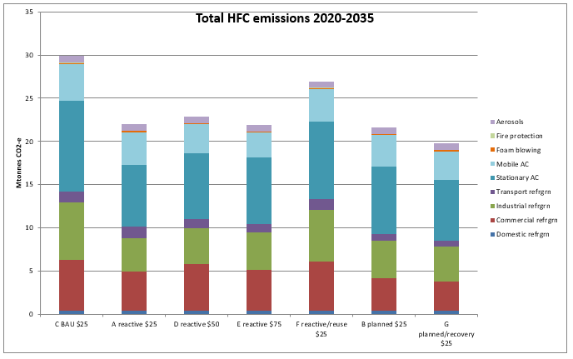

**Figure 10 –** Cumulative totalHFC emissions comparison 2020-2050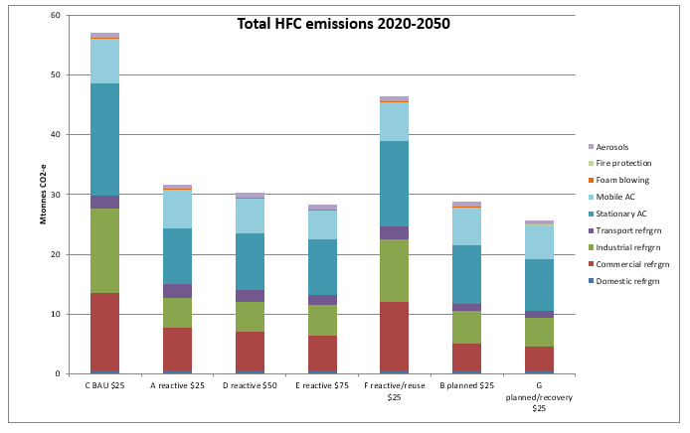

**Figure 11 –** TotalHFCs in equipment stocks comparison 2050

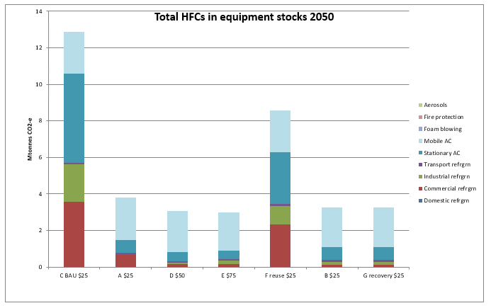

Before discussing the comparison in the charts above, caution must be taken in view of the high uncertainties estimated above for emissions in a single year (and somewhat lower for cumulative emissions). In strict statistical terms, only the most extreme differences would be considered significant at a 95% confidence level.

For 2020-2035 cumulative total HFC emissions, scenarios A, B, D and E are all 23-28% lower than the total for the C BAU scenario and similarly for 2020-2050 A, B, D and E are all 50-56% lower than the total for C. All four scenarios are assumed to have substantial amounts of early retirement so they would be expected to have lower cumulative emissions (especially in 2050) because that represents several years when that retired equipment is not requiring HFCs to replace leakage. For totalHFCs in 2050 equipment stocks A, B, D and E are 70-77% lower than for C due to that early retirement (with MAC retirement unchanged for all scenarios).

With enhanced recovery for G, 2020-2035 cumulative total HFC emissions are slightly lower than the scenarios above at 34% lower than the total for C (and 9% below the B scenario it is derived from). For 2020-2050 cumulative total HFC emissions are similar to those for A, B, D and E at 55% lower than the total for C (and 11% below the B scenario it is derived from).

F is arguably the scenario that is closest to current policy settings because it allows relatively unrestricted access to imported reused HFCs to meet the shortfall resulting from the phase-down. For 2020-2035 cumulative total HFC emissions, F is 10% lower than the total for the C BAU scenario and similarly for 2020-2050 F is 19% lower than the total for C. More importantly, without the continued high growth of imported AC equipment for C, the totalHFCs in 2050 equipment stocks for F are 33% lower than for C.

It is important to note that the reduction outcomes from Scenarios A, B, D, E and G could be considered desirable compared with the F outcome. However, the unavailability of imported reused bulk HFCs is an assumption for modelling purposes to estimate the impacts of different factors on the emissions pathway. Current policy is for relatively unrestricted availability of imported reused refrigerants in order to avoid early retirement of a major proportion of the equipment stocks in each sector. Most of this retirement would represent a significant reduction in industrial and commercial refrigeration services that would not be economically realistic.

# Glossary

AC Air Conditioning (also heat pumps for space heating).

Azeotrope Refrigerant blend that behaves like a pure refrigerant (no glide).

CFC ChloroFluoroCarbon refrigerant

Drop-in A replacement refrigerant that requires minimal system changes. Generally drop-ins have a similar pressure/temperature range (capacity) and a similar glide to the refrigerant being replaced, and are compatible with the oil type in the system.

EPA Environmental Protection Agency

ETS Emissions Trading Scheme

Glide The difference between the bubble and dew point for a refrigerant blend. Low glides simplify system design. High glides can reduce energy efficiency due to the negative effect of the glide on heat exchanger performance. For a few applications, high glides can be neutral or advantageous (e.g. if high temperature split in coolant being refrigerated). Generally, it is desirable to avoid refrigerants with high glides if possible.

GWP Global Warming Potential relative to CO2 (estimated impact over 100 years in the IPCC 2007 AR4 report).

HC Hydrocarbon refrigerant such as R170, R290, R600a and R1270.

HCFC HydroChloroFluoroCarbon refrigerant

HCFO HydroChloroFluoroOlefin refrigerant

HFC HydroFluoroCarbon refrigerant

HFO HydroFluoroOlefin refrigerant

Hermetic A refrigeration system that uses hermetically sealed compressors and welded or brazed piping and fitting so fugitive leakage is less likely but service of components requires the system seal to be “broken”.

MAC Mobile (vehicle) AC

NR Natural refrigerants including ammonia (R717), CO2 (R744) and HCs.

ODP Ozone Depletion Potential relative to CFCs R11 and R12.

RAC Refrigeration and Air Conditioning

Retrofit A replacement refrigerant with similar pressure/temperature range (capacity) that requires significant system changes such as oil type, elastomers, expansion valves and/or heat exchanger configuration (if different glide).

Semi-hermetic A refrigeration system that uses semi-hermetic compressors and fitting with gas tight seals that allow components in the system to be serviced and replaced independently but provides more sources for fugitive leakage.

Transcritical In transcritical systems, CO2 is cooled but does not condense at the gas cooler outlet, being above its 31oC critical temperature.

# References and Bibliography

There is a huge amount of trade and scientific literature on refrigerants and alternatives to HFCs. Unfortunately the reliability of some of the literature is dubious due to commercial imperatives, vested interests and other conflicts of interest and/or poor or poorly documented processes. The following are some sources of information and review articles that are a useful starting point plus specific references used.

1. [www.iifiir.org](http://www.iifiir.org) – International Institute of Refrigeration (IIR) website. In particular, FRIDOC is a bibliographic database concentrating on literature relevant to the refrigeration industry. Key other publications are the Transaction of ASHRAE (proceeding for the twice a year ASHRAE Conferences), the International Journal of Refrigeration, the Proceedings of Refrigeration Science and Technology Series (proceedings of IIR conference; often about 6 per year); Proceedings of the International Congress of Refrigeration (held 4 yearly).

1. [Bell](https://www.sciencedirect.com/science/article/abs/pii/S0140700719302361?via%3Dihub" \l "!), I.H., [Domanski](https://www.sciencedirect.com/science/article/abs/pii/S0140700719302361?via%3Dihub#!), P.A., [McLinden](https://www.sciencedirect.com/science/article/abs/pii/S0140700719302361?via%3Dihub#!), M.O., [Linteris](https://www.sciencedirect.com/science/article/abs/pii/S0140700719302361?via%3Dihub#!), G.T. 2019. The hunt for nonflammable refrigerant blends to replace R-134a, *International Journal of Refrigeration*, 104, 484-495. <https://doi.org/10.1016/j.ijrefrig.2019.05.035>
2. Bitzer 2018. Refrigerant Report 20 (A-501-16). <https://www.bitzer-refrigerantreport.com>
3. EEA 2020. Fluorinated greenhouse gases 2019 - Data reported by companies on the production, import, export, destruction and feedstock use of fluorinated greenhouse gases in the European Union, 2007-2018. EEA Report No 20/2019. European Environmental Agency.
4. EIA 2015. EU F-Gas Regulation Handbook: Keeping Ahead of the Curve as Europe Phases Down HFCs. Environmental Investigation Agency. https://eia-international.org/wp-content/uploads/EIA-F-Gas-Regulation-Handbook.pdf
5. IEC 2019. International Standard IEC60335-3-89:2019 - Household and Similar Electrical Appliances.
6. Lamb, R. 2016. Modern low charge ammonia system for the cold chain, *Proceedings 4th IIR Conference on Sustainability & the Cold Chain*, Auckland.
7. McLinden, M.O., Brown, J., Brignoli, R., Kazakov, A.F., Domanski, P.A. 2017. Limited options for low-global-warming-potential refrigerants. *Nature Communications* **8**:14476. https://doi.org/10.1038/ncomms14476
8. OLPA 2018. Ozone Layer Protection Act Regulations at 10/12/18 Schedules 6+1AA, relating to a High Court amendment.
9. Palm, B., 2008. Hydrocarbons as refrigerants in small heat pump and refrigeration systems – a review, *International Journal of Refrigeration*, 31, 552-563.
10. Schultz, K. 2019. Replacements for R410A with GWPs less than 300. *Proceedings 25th International Congress of Refrigeration*, Montreal, Canada, August 2019 (paper 144, DOI: 10.18462/iir.icr.2019.0144.

**People Questioned** (Email or Phone Interview; only listed if response received or contact made)

John Bowen – Director, Recovery Trust

John Cavill - Engineering Development Manager, Black Diamond Technologies Ltd

Gavin Cherrie – Director, 2 Plus Ltd (Kiwifruit sector)

Jacqui Derbyshire – Southern Hospitality Ltd

Adrian Dickison, Technical Fellow – Chemical Engineering, Beca Ltd

Carl Easton – Group Supply Manager, Temperzone Ltd

John Eve – Era Polymers

Philip Fleming – Executive Director, Aerosol Association of Australia Inc

Michael Hanright – On Farm Asset and Maintenance Manager, Fonterra Cooperative Group Ltd

Warwick Holtham – Sales Manager, Cooling Supplies

Peter Hutson – Technical and Training Manager, Black Diamond Technologies Ltd

Emmalee Keesing-Styles, Compliance Co-ordinator, ASCC Ltd (formerly Rebain Polymers)

Richard Lawton – Technical Director, Cambridge Refrigeration Technology, UK (Refrigerated transport sector)

Stuart MacKenzie – Director, Comprex Industries Ltd

Clifton Madgwick – Chemiplas Business Manager and Recovery Trust Director

Bill Mohs - Senior Refrigeration Design Engineer, Skope Industries Ltd

Chris Needham – Director, Transcold Group Ltd

Dave Nicholls – Technical Manager, Realcold

Alex Pachai – Technology Manager, Johnson Controls Ltd, Denmark

Andrew Patterson – Category Manager Air Conditioning, CoolDrive Ltd

James Pawson – Refrigeration Manager, Foodstuffs South Island

Dr Andy Pearson - Director, Star Refrigeration Ltd, UK

Professor Doug Reindl – University of Madison, USA (member of ASHRAE 15)

Brian Rees – Group Technical Manager, McAlpine-Hussmann Ltd

Paul Sturrock – Manager, Sturrock and Greenwood Ltd

Catherine Tocker – CoolCar Air-Conditioning Centre and VASA Automotive Air Conditioning, Electrical and Cooling Technicians of Australasia

Rodger Wyatt – Service Manager, Beattie Air Ltd

**APPENDIX A**

**PHASE-DOWN OF HFC REFRIGERANTS – ASSESSMENT OF TECHNOLOGY OPTIONS**

**D J Cleland**

**Summary**

HFCs have high GWP and are being phased down under the Kigali Agreement. Non-flammable retrofit or drop-in options exist for most original HFCs (refrigerants R134a, R507A, R404A, R410A) but generally have intermediate GWPs (about half of the original refrigerants). These alternatives already allow a quick reduction in GWP for most new systems and for service of existing systems without major changes in refrigeration practice, once prices and availability mean they are competitive.

Apart from R744 (CO2), all near-zero GWP alternatives (GWP<150) are flammable which limits their application to systems with low charge unless expensive safety precautions are undertaken. This can usually only be justified for large scale systems. R744 use is limited by its high pressure (non-standard equipment) and its poorer performances when rejecting heat to the ambient due to its low critical point (31oC). New non-flammable low GWP refrigerants with good pressure/temperature match to the original HFCs are unlikely to be discovered.

Small scale applications, especially those using small scale, hermetically sealed systems, are in rapid transition to flammable low GWP refrigerants for new equipment. Domestic refrigerators and freezers have largely completed the transition, while the shift for dehumidifiers, stand-alone refrigerated display cabinets, domestic AC (air conditioning) and some small commercial AC will be completed over the next 5 to 10 years. Some AC systems in new vehicles already contain low GWP R1234yf but it is not yet clear when the majority of vehicle manufacturers will shift away from R134a.

Large scale systems will continue to use NRs (natural refrigerants) such as ammonia (R717) and/or they will transition to lower charge designs (e.g. indirect secondary refrigerants) that allow flammable low GWP refrigerants to be used safely and cost-effectively. Such applications include most industrial refrigeration for food processing, supermarkets and large scale building AC using chilled water.

Applications with moderate charge sizes, that are too high to make use of flammable refrigerants cost-effectively, will be the most challenging to transition to very low GWP refrigerants. Examples include: medium scale AC systems, public transport AC, transport refrigeration, farm milk vats and walk-in cold rooms for retail, food service and restaurants. Non-flammable alternatives exist that allow GWP to be approximately halved relative to the original HFCs, and can be used for new equipment and retrofits as soon as refrigerant prices and availability incentivise such changes. Long term, low GWP options are unlikely without significant changes to system designs that will be expensive.

1. **Introduction**

Under New Zealand’s commitments under the Kigali Agreement of 2016 and the Paris Agreement of 2015, it will need to phase-down use of the high GWP HFC refrigerants. The phase-down schedule under Kigali and NZ response to Kigali via amendment of the Ozone Layer Protection Act (OLPA 2018) are summarised in Table A1.

The Kigali Agreement limits bulk net imports of HFCs but does not restrict import of equipment pre-charged with HFC refrigerants. The underpinning rationale is that imported HFCs will eventually be emitted if they are not exported or destroyed. In contrast, the Paris Agreement requires NZ to report progress on achieving its emission reduction targets based on estimates of HFC and other greenhouse gas emissions summarised as tonnes of CO2 equivalent each year. Given that refrigerants are used in sealed systems, there can be many years between import and emission. Thus importation rates that meet the Kigali Agreement (and also previously met earlier agreements) may result in a major challenge for NZ to meet its Paris Agreement obligation due to the inventory of refrigerants contained in the multitude of working refrigeration and air conditioning (AC) systems.

This document looks at the outlook and options for the NZ refrigeration and air conditioning (RAC) industry to help NZ meet both its Kigali and Paris Agreement obligations including the impact of international developments and other factors affecting refrigerant use and rates of future emissions.

**Table A1:** Phase-down of HFCs under the 2016 Kigali Agreement.

|  |  |  |  |  |
| --- | --- | --- | --- | --- |
|  | **Developed Countries** | **Developing Countries (Group 1/2)** | **New Zealand**  **(effective 1 Jan. 2020)** | **EU F-Gas**  **(effective 1 Jan. 2015)** |
|  |  | Article 5 Countries/ GCC, India, Iran, Iraq, Pakistan | OLPA, 2018 | EIA, 2015 |
| Baseline HFC Component | Av. 2011-2013 | Av. 2020-2022/  Av. 2024-2025 | 1796 kt CO2-e | Av. 2009-2019 |
| Baseline HCFC Component | 15% of baseline | 65% of baseline |  |
| Freeze |  | 2024/2028 |  | 100% - 2015 |
| 1st step | 90% -2019 | 90% -2029/2032 | 79% - 2020 | 93% - 2016 |
| 2nd step | 60% -2024 | 70% -2035/2037 | 70% - 2021 | 63% - 2018 |
| 3rd step | 30% -2029 | 50% -2040/2042 | 65.6% - 2022 | 45% - 2021 |
| 4th step | 20% -2034 |  | 56.6% - 2023  47.7% - 2025 | 31% - 2024 |
| Plateau | 15% -2036 | 15% -2045/2047 | 38.7% - 2027 | 24% - 2027 |
|  |  |  | 29.8% - 2029 | 21% - 2030 |
|  |  |  | 24.6% - 2031 |  |
|  |  |  | 19.4% - 2034  14.2% - 2036 |  |

1. **Refrigerant Options**

Table A2 summarises the key HFC refrigerants used by the NZ RAC industry including their composition, GWP and other key characteristics (e.g. ODP, oil compatibility, toxicity and flammability class, temperature glide, boiling point). Figure A2 summarises the flammability class criteria. In general terms, HFC refrigerants have zero ODP but high GWP, and those historically used are non-flammable and non-toxic (class A1), and have zero or low temperature glides.

Table A2 also gives the same characteristics for most of the potential alternatives currently given ASHRAE codes. These comprise three broad groups:

1. Natural Refrigerants (NRs) that have zero ODP and zero or near-zero GWP but have one or more of the following limitations – flammability (HCs and ammonia), toxicity (ammonia) and/or very high operating pressures (CO2).
2. HFOs or mixtures of HFOs that have zero ODP, near-zero GWP and are non-toxic but are usually mildly flammable (A2L) and may have significant temperature glides (limiting efficient performance in some applications).
3. Mixtures of HFCs and HFOs that have zero or near-zero ODP, intermediate GWP and are non-toxic, but some are also mildly flammable (although many are non-flammable) and many have high temperature glides.

Groups 1 and 2 are possible long-term alternatives while Group 3 would be interim alternatives only due to their intermediate GWP. That is, Group 3 refrigerants often allow retrofit into existing systems with minimal system modification and minimal change in performance (capacity and efficiency). They are more rarely drop-in replacements because changes to oil, elastomers such as seals and components such as dryers and expansion valves are often required. Replacement with Group 1 or 2 refrigerants will usually require either very significant system modifications (if retrofitted) or a radically different system design (completely new system after retirement of existing system).

The possibility of discovery of new chemicals suitable to be used as refrigerants is considered extremely unlikely. A National Institute of Standards & Technology (NIST) study in the US screened over 60 million chemical structures and, outside NRs, the HFOs are the main options remaining that have no ODP, are not toxic or extremely dangerous in some way, and have thermodynamic and transport properties (e.g. boiling point and critical point, pressure/temperature relationship) that make them suitable as refrigerants (McLinden et al., 2017; Bell et al., 2019). Therefore the main remaining option for new refrigerant development is to investigate different blends of known chemicals rather than developing new chemicals. Even the process of blending is struggling to identify new refrigerants without at least one major practical constraint.

In selecting alternatives there are some common considerations:

* The 500 series of refrigerants are azeotrope mixtures that behave like pure substances (zero glide).
* The 400 series of refrigerants are zeotropic mixtures (non-zero glide).
* For most refrigeration systems, low or zero glide is desirable to simplify design and help ensure high operational performance (efficiency and capacity). Further, high glide refrigerants can have differential leakage of one component and are not well suited to flooded or pump circulation systems because differential separation of the components can occur between the low and high pressure sides of the system.
* Pressure ranges should not be excessively low (ideally not into vacuum to avoid air entering the refrigerant circuit) or excessively high (preferably below the common design pressure of 25 bar).
* Similar volumetric flowrate for the same capacity as the refrigerant it replaces to avoid existing compressors being too large or two small (or the motors mis-matched) and the heat exchanger circuiting being different.
* For most synthetic refrigerants, refrigeration capacity (for the same compressor volumetric capacity) is strongly related to boiling point (generally, lower boiling point translates to higher capacity).
* For most refrigerants, if they are used in an appropriate temperature/pressure range, then the differences in efficiency are comparatively small (less than 5%).
* A “well-matched” refrigerant in terms of pressure/temperature range can be used in similar equipment with only slight changes in capacity and/or energy efficiency (<10% different).
* If changing refrigerant with new equipment, then use of higher pressure refrigerants (for the same temperature) reduces piping and equipment size and reduces pressure ratios for the same temperature lift.
* Preference for refrigerants with lower discharge temperatures to reduce lubricant breakdown and mechanical wear in the compressor.
* Compatibility with the same oil as used for the refrigerant they are replacing to avoid the need for multiple oil changes for retrofit. Historically CFC and HCFC systems used low cost mineral oils but most HFC systems use POE oils. POE oils are more expensive but are better lubricants and generally have less fouling impact on heat exchanger performance.
* Reuse of refrigerants into the same system they were removed is accepted practice but reuse into other system requires re-processing to remove contaminants and, for blends, checking component compositions. Recovery and reuse of refrigerants for re-sale to other companies would require a higher standard of re-processing so that the composition and purify would meet consumer guarantees. Therefore refrigerant reuse is most likely to occur within a multi-RAC system business rather than between businesses.

**Table A2:** Key Characteristics for CFCs, HCFCs, HFCs, HFOs and Natural Refrigerants.

|  |  |  |  |  |  |  |  |
| --- | --- | --- | --- | --- | --- | --- | --- |
| Number | Trade Name(s) | Chemical Formula or Composition | BP (oC) | GWP | Safety Class | Glide (K) | Oil Compatibility/Comment |
| ChloroFluoroCarbons (CFCs) – ODP > 0: | | | | | | | |
| R11 | Trichlorofluoromethane | CCl3F | 24 | 4750 | A1 | 0 | M,AB; ODP=1 |
| R12 | Dichlorodifluoromethane | CCl2F2 | -30 | 10900 | A1 | 0 | M,AB; ODP=1 |
| R502 |  | 22 (49%); 115 (51%) | -45 | 4700 | A1 | 0 | AB; ODP=0.25 |
| HydroChloroFluoroCarbons (HCFCs) – ODP > 0: | | | | | | | |
| R22 | Chlorodifluoromethane | CHClF2 | -41 | 1810 | A1 | 0 | M,AB; ODP=0.055 |
| R40 | Chloromethane | CH3Cl; methyl chloride | -24 | 13 | B2 | 0 | M,AB; ODP=0.02; reacts with Al+air; HCC |
| R13I1 | Trifluoroiodomethane | CF3I | -23 | 0 | A1 | 0 | POE; ODP=0.01; IFC |
| HydroFluoroCarbons (HFCs) – ODP = 0: | | | | | | | |
| R23 | Trifluoromethane | CHF3 | -82 | 14800 | A1 | 0 | POE, PVE, AB*, PAG* |
| R32 | Difluoromethane | CH2F2 | -52 | 675 | A2L | 0 | POE, PVE, AB*, PAG* |
| R125 | Pentafluoroethane | C2HF5 | -49 | 3500 | A1 | 0 | Blend component |
| R134a | Tetrafluoroethane | C2H2F4 | -26 | 1430 | A1 | 0 | POE, PVE, AB*, PAG* |
| R143a | Trifluoroethane | C2H3F3 | -47 | 4470 | A2L | 0 | Blend component |
| R152a | Difluoroethane | C2H4F2 | -24 | 124 | A2 | 0 | POE, PVE, AB*, PAG* |
| R227ea | Heptafluoropropane | CF3CHFCHF3 | -16 | 3220 | A1 | 0 | Blend component |
| R245fa | Pentafluoropropane | CF3CH2CHF2 | 15 | 1030 | B1 | 0 | POE |
|  |  |  |  |  |  |  |  |
| R404A | Suva HP62, FX-70 | 125 (44%), 134a (4%), 143a (52%) | -47 | 3922 | A1 | 0.7 | POE,PVE,AB*,PAG* |
| R407A | Klea-60 | 32 (20%), 125 (40%) 134a (40%) | -46 | 2107 | A1 | 6.6 | POE,PVE,AB*,PAG* |
| R407C | Klea-66, Suva-9000 | 32 (23%), 125 (25%) 134a (52%) | -44 | 1774 | A1 | 7.4 | POE,PVE,AB*,PAG* |
| R407F | Performax LT | 32 (30%), 125 (30%) 134a (40%) | -46 | 1825 | A1 | 6.4 | POE,PVE,AB*,PAG* |
| R407H |  | 32 (32.5%), 125 (15%) 134a(52.5%) | -45 | 1490 | A1 | 7.0 | POE,PVE,AB*,PAG* |
| R410A | AZ-20 | 32 (50%), 125 (50%) | -51 | 2088 | A1 | 0.2 | POE,PVE,AB*,PAG* |
| R413A | ISCEON MO49 | 134a (88%), 218 (9%), 600a (3%) |  | 2050 | A1 |  | M,PAG,AB, POE |
| R417A | ISCEON MO59 | 125(46.6%), 134a(50%), 600(3.4%) | -39 | 2346 | A1 | 5.6 | M,POE,PVE,AB*,PAG* |
| R417B |  | 125(79%), 134a(18.2%), 600(2.8%) | -42 | 2920 | A1 | 3.4 | POE,PVE,AB*,PAG* |
| R422A | ISCEON MO79 | 125 (85.1%), 134a (11.5%), 600a (3.4%) | -49 | 3143 | A1 | 2.5 | M,POE,PVE,AB*,PAG* |
| R422D | ISCEON MO29 | 125 (65.1%), 134a (31.5%), 600a (3.4%) | -45 | 2729 | A1 | 4.5 | M,POE,PVE,AB*,PAG* |
| R424A | RS-44 | 125 (50.5%), 134a (47%), 600 (1%), 600a (0.9%), 601a (0.6%) | -39 | 2328 | A1 | 3.6 | M,POE,PVE,AB*,PAG* |
| R426A | RS-24 | 134a (93%), 125 (5.1%), 600 (1.3%), 601a (0.6%) | -29 | 1382 | A1 | 0.5 | M,POE,PVE,AB*,PAG* |
| R427A | Forane FX100 | 32 (15%), 125 (25%), 143a (10%), 134a (50%) | -43 | 2138 | A1 | 7.1 | M,POE,PVE,AB*,PAG* |
| R428A | RS-52 | 125 (77.5%), 143a (20%), 290 (0.6%), 600a (1.9%) | -47 | 3495 | A1 | 0.8 | M,POE,PVE,AB*,PAG* |
| R434A | RS-45 | 125 (63%), 143a (18%), 134a (15.7%), 600a (3.3%) | -45 | 3131 | A1 | 1.5 | M,POE,PVE,AB*,PAG* |
| R438A | ISCEON MO99 | 32 (8.5%), 125 (45%), 134a (44.2%), 600 (1.7%), 601a (0.6%) | -42 | 2264 | A1 | 6.6 | M,POE,PVE,AB*,PAG* |
| R442A | RS-50 | 125 (31%), 32 (31%), 134a (30%),152a (5%),227ea (3%) | -47 | 1888 | A1 | 4.6 | POE,PVE |
| R444A | AC5 | 32(12%),152a(5%),1234ze(E)(83%) | -34 | 92 | A2L | 10.0 | POE,PVE |
| R444B | L-20 | 32 (41.5%), 152a (10%), 1234ze(E) (48.5%) | -45 | 295 | A2L | 10.0 | POE,PVE |
| R447B | L-41z | 32(68%), 125(8%), 1234ze(E)(24%) | -50 | 740 | A2L | 4.0 | POE,PVE |
| R448A | Solstice N40 | 32(26%),125(26%),134a(21%) 1234ze(E) (7%), 1234yf (20%) | -46 | 1387 | A1 | 6.2 | POE,PVE |
| R449A | XP-40 | 32 (24%),125 (25%), 134a (26%), 1234yf (25%) | -46 | 1397 | A1 | 5.7 | POE,PVE |
| R449B |  | 32 (25.5%),125 (24.3%), 134a (27.3%),1234yf (23.2%) | -46 | 1412 | A1 | 6.0 | POE,PVE |
| R449C |  | 32 (20%),125 (20%), 134a (29%), 1234yf (31%) | -44 | 1251 | A1 | 6.1 | POE,PVE |
| R450A | N-13 | 134a (42%), 1234ze(E) (58%) | -24 | 604 | A1 | 0.6 | POE,PVE |
| R452A | XP44 | 32 (11%), 125 (59%) 1234yf (30%) | -47 | 2140 | A1 | 3.8 | POE,PVE |
| R452B | XL55,Solstice L-41y | 32 (67%), 125 (7%) 1234yf (26%) | -51 | 698 | A2L | 0.9 | POE,PVE |
| R452C |  | 32 (12.5%), 125 (61%), 1234yf (26.5%) | -48 | 2220 | A1 | 3.4 | POE,PVE |
| R453A | RS-70 | 125 (20%), 32 (20%), 134a (53.8%), 227ea (5%), 601a(0.6%), 600(0.6%) | -42 | 1765 | A1 | 4.2 | M,POE,AB |
| R454A | XL40, ARM-20b | 32 (35%), 1234yf (65%) | -48 | 239 | A2L | 5.7 | POE,PVE |
| R454B | XL41 | 32 (68.9%), 1234yf (31.1%) | -51 | 466 | A2L | 1.0 | POE,PVE |
| R454C | XL20 | 32 (21.5%), 1234yf (78.5%) | -46 | 148 | A2L | 7.8 | POE,PVE |
| R455A | Solstice L-40X | 32(21.5%),1234yf(75.5%), 744(3%) | -52 | 148 | A2L | 12.8 | POE,PVE |
| R456A | AC5X | 32(6%),1234ze(E)(49%),134a(45%) | -30 | 687 | A1 | 4.8 | POE,PVE |
| R457A | ARM-20a | 32(18%), 1234yf(70%), 152a (12%) | -43 | 139 | A2L | 7.2 | POE,PVE |
| R458A | TdX 20 | 32 (20.5%), 125 (4%), 134a(61.4%), 227ea (13.5%), 236fa (0.6%) | -40 | 1765 | A1 | 4.2 | M,POE,PVE,AB |
| R459A | ARM-71a | 32 (68%), 1234yf (26%), 1234ze(E) (6%) | -50 | 460 | A2L | 1.7 | POE,PVE |
| R459B | LTR11 | 32 (21%), 1234yf (69%), 1234ze(E) (10%) | -44 | 144 | A2L | 7.9 | POE,PVE |
| R460A | LTR10 | 32 (12%), 125 (52%), 134a (14%), 1234ze(E) (22%) | -45 | 2103 | A1 | 7.4 | POE,PVE |
| R460B | LTR4X | 32 (28%), 125 (25%), 134a (20%), 1234ze(E) (27%) | -45 | 1352 | A1 | 8.2 | POE,PVE |
| R463A | XP41 | 32 (36%), 125 (30%) 1234yf (14%), 134a (14%), 744 (6%) | -59 | 1494 | A1 | 12.2 | POE,PVE |
| R465A | ARM-25 | 32 (21%),1234yf (71.1%), 290 (7.9%) | -52 | 145 | A2 | 11.8 | POE,PVE |
| R466A |  | 32 (49%), 1234yf (11.5%), 13I1 (39.5%) | -52 | 733 | A1 | 0.7 | POE,PVE |
| R507A | AZ-50 | 125 (50%), 143a (50%) | -47 | 3985 | A1 | 0 | POE,PVE,AB*,PAG* |
| R513A | XP10 | 1234yf (56%), 134a (44%) | -30 | 631 | A1 | 0 | POE,PVE |
| R513B |  | 1234yf (58.5%), 134a (41.5%) | -29 | 596 | A1 | 0 | POE,PVE |
| R515B |  | 1234ze(E) (91.1%), 227ea (8.9%) | -19 | 293 | A1 | 0 | POE |
| R516B | ARM-42b | 1234yf(82%),152a(11%), 134a(7%) | -29 | 142 | A2L | 0 | POE |
| HydroChloroFluoroOlefins (HCFOs) – ODP < 0.001: | | | | | | | |
| R1224yd(Z) | (Z)chloro-tetrafluoro-propene | CHCl=CFCF3 | 14 | 4 | A1 | 0 | POE; ODP=0.00012 |
| R1233zd (E) | trans-chloro-trifluoro-propene | CHCl=CHCF3 | 18 | 5 | A1 | 0 | M,POE; ODP=0.00034 |
| HydroFluoroOlefins (HFOs) – ODP = 0: | | | | | | | |
| R1234yf | tetrafluoro-propene | CH2=CFCF3 | -30 | 4 | A2L | 0 | POE,PVE,PAG |
| R1234ze(E) | trans-tetrafluoro-propene | CHF=CHCF3 | -19 | 6 | A2L | 0 | POE,PVE |
| R1336mzz (E) | hexafluoro-butene | CF3CH=CHCF3 | 8 | 18 | A1 | 0 | POE |
| R1336mzz (Z) | cis-hexafluoro-butene | CF3CH=CHCF3 | 33 | 9 | A1 | 0 | POE |
| Natural Refrigerants (NRs) – ODP = 0: | | | | | | | |
| R170 | Ethane | C2H6 | -89 | 6 | A3 | 0 | M,POE,AB |
| R290 | Propane, Care 40 | C3H8 | -42 | 3 | A3 | 0 | M,PAO,POE,AB* |
| R600 | Butane | C4H10 | 0 | 20 | A3 | 0 | Blend Component |
| R600a | Isobutane, Care 10 | C4H10 | -12 | 3 | A3 | 0 | M,PAO,POE,AB* |
| R717 | Ammonia | NH3 | -33 | 0 | B2L | 0 | M,PAO,AB*,PAG*; reacts with copper |
| R744 | Carbon Dioxide | CO2 | -78 | 1 | A1 | 0 | M,POE,PAG |
| R1270 | Propylene | C3H6 | -48 | 2 | A3 | 0 | M,PAO,POE,AB* |
| Notes: GWP = Global Warming Potential (100 year; AR4) relative to CO2. ODP = Ozone Depletion Potential relative to CFC-11. BP = boiling point. M = mineral oil, AB = alkyl benzene oil, POE = polyol ester oil, PVE = polyvinyl ether oil, PAG = poly alkylene glycol oil, PAO = polyalphaolefin oils, * with restrictions. A1 = non-toxic and non-flammable, A2L = non-toxic and mildly flammable, A3 = non-toxic and highly flammable, B2L = toxic and mildly flammable, A2 = non-toxic and flammable. | | | | | | | |

1. **Refrigerant Pathway Options and Constraints**

Figure A1 gives a high level summary of the past and likely future replacement of synthetic refrigerants from CFCs to HCFCs and HFCs and now to HFOs or NRs.

Figure A1 is divided into four bands (sets of rows) from top to bottom:

1. R11-type refrigerants (very low pressure) most commonly used for large-scale centrifugal air-conditioning chillers above 0oC (high temperature applications).

1. R12/R134a-type refrigerants (low pressure) most commonly used for so-called medium temperature refrigeration, air-conditioning and heat pump applications above about -20oC.
2. R502/R507 and R22/R404A-type refrigerants (medium pressure) most commonly used for low and medium temperature refrigeration applications between about -40oC and 5oC but also for air-conditioning (R22 only).
3. R410A-type refrigerants (high pressure) most commonly used for air-conditioning and occasionally low temperature applications as low as -45oC.

Specialist synthetic refrigerants suitable for very low temperatures applications less than -40oC, such as R23, are not covered because their use in NZ is quite minor.

Figure A1 is also divided into six columns with the following characteristics corresponding roughly to different phase-down stages and/or types of substitute or alternative refrigerants:

1. The CFC synthetic refrigerants used before the Montreal Protocol phase-outs with both high ODP and very high GWP (long atmospheric lifetimes). These are non-flammable (A1) pure refrigerants with no glide and generally can operate with mineral oils.
2. The HCFC synthetic refrigerants used before the Montreal Protocol phase-outs with lower, but non-zero, ODP and lower GWP than CFCs largely due to their shorter atmospheric lifetimes. In some cases, HCFCs were used as interim replacement for CFCs but not all options are shown. These are pure A1 refrigerants with no glide and can generally operate with mineral oils.
3. The most common original HFC refrigerants with zero ODP but high GWP that were used as alternatives to the CFCs and HCFCs and are now subject to Kigali phase-down (i.e. R245ca, R134a, R507A, R404A, R410A). These are pure refrigerants, azeotropic blends or near azeotropic blends with zero or low glide, that are A1 refrigerants but are generally only compatible with POE oils. CFC and HCFC refrigerants in similar pressure/temperature ranges could often be retrofitted with these HFCs but usually required change of oil type and replacement of dryers, elastomers such as O-rings (e.g. due to differential swelling), and sometimes expansion valves. Some HFC blends used as interim CFC and HCFC drop-in alternatives, because they are compatible with mineral oils, but with GWP>2500 are also listed in this column.
4. HFC and HFO blends that can often be used as drop-in replacements for the original HFCs with 750<GWP<2500 (R134a replacements) or 1500<GWP<2500 (R22, R404A, R410A or R507A replacements). While all are A1, most have significant glides. Some are compatible with mineral oils as well as POE oils so that they can directly replace some of the CFCs and HCFCs as well as the original HFCs.
5. HFC and HFO blends that can be used as retrofit replacements for the original HFCs with GWP<750 (R134a replacements) or GWP<1500 (R22, R404A, R410A or R507A replacements). Many are mildly flammable (A2L) refrigerants and so are restricted to systems with low charge or special designs. Most have significant glides and none are compatible with mineral oils.
6. Long term replacement refrigerants with GWP<150 comprising either HFOs or NRs. Nearly all, except R744 (CO2), are flammable and some have high glides. All these refrigerants will require significant system design changes relative to the HFC refrigerants they replace, such that they are generally only suitable for new equipment and not retrofit, except for very low charge systems using HCs or HFOs. Due to their flammability many of these refrigerants will only be cost-effective/practical to use in systems with small charges or for larger capacity systems where the costs of safety precautions can be justified.

The following is a summary of the transitions options and limitations for each of the original HFC refrigerants without considering application specific aspects:

1. R123/R245ca – Not common in NZ. Transition to some near-zero GWP, A1 alternative refrigerants with zero glide seems feasible for new equipment. One option, R1224yd(Z), is an HCFO with extremely low ODP, which could require an exemption from the Montreal Protocol.
2. R134a – Transition to A1 alternatives with low or zero glide suitable for retrofit or new equipment is already feasible but the minimum GWP is about 600 (e.g. R513A) and availability and experience of retrofit in NZ are both still very low. There are alternatives with GWP <150, and many have zero or low glide, but all are flammable limiting their application. R1234yf is well-matched to R134a but R1234ze(Z) may be more competitive in terms of manufacturing cost and lower flammability (A1 below 30oC). However, it is a lower capacity refrigerant requiring about 25% larger displacement compressors relative to R134a or R1234yf. HCs such as R600a are also well-matched to R134a but are highly flammable (A3). Other NRs such as R717 (ammonia) might be used for some large scale applications but require radically different equipment designs than for R134a. R744 is A1 and can be used for a range of application scales but requires radically different equipment designs than R134a and has significant inherent energy efficiency penalties.
3. R507A - Transition to A1 alternatives with GWP between 1200 and 1900 that are suitable for retrofit or new equipment is already feasible (e.g. R407C, R407F, R448A, R449A, R449C plus R452A with GWP of 2140). However all have significant glides, and often have slighter lower capacity or cannot be used to temperatures as low as for R507A. There are synthetic alternatives with GWP <150, but all are flammable and have significant glides that limit their application, and there may be some slight capacity and temperature mismatches. HCs such as R290, R1270 and blends are well-matched but are highly flammable (A3). R744 is an A1 alternative that can be used at all application scales, but requires radically different equipment designs and has significant inherent energy efficiency penalty for medium temperature applications. Other NRs such as R717 might be used for some large scale applications.
4. R22 – Transition to zero ODP A1 HFC alternatives has already occurred for new equipment but these often have similar or higher GWP than R22 (e.g. R410A and R404A with low glide but higher GWP and R407C and R407F with similar GWP but high glide). Drop-in or retrofit A1 replacements compatible with mineral oil are available if an existing R22 system needs to be maintained but most have similar or higher GWP plus significant glides (e.g. R417A, R422D, R452A). A1 alternatives with slightly lower GWP suitable for retrofit are available but have significant glides (e.g. R448A, R449A, R449C). There are synthetic alternatives with GWP <150, but all are flammable and have significant glides that limit their application (e.g. R454C and 5 others plus R444B with GWP of 295). HCs such as R290, R1270 and blends are well-matched but are highly flammable (A3). R744 is an A1 alternative that can be used at all application scales, but requires radically different equipment designs and has significant inherent energy efficiency penalty for medium temperature applications. Other NRs such as R717 might be used for some large scale applications but require radically different equipment designs.
5. R404A – R404A was often the alternative chosen instead of R22 or R502 under the Montreal phase-down but has very high GWP of 3922. Transition options are very similar to those for R22 and R507A. R407F, R448A, R449A are common intermediate GWP alternatives but have significant glides. In addition, R452A, despite its high glide, is being commonly used as a well-matched drop-in alternative with about half the GWP of R404A. As for R22 and R507A, the flammable low GWP synthetic alternatives and HCs can be used in small charge systems and large scale systems can use NRs as alternatives, albeit with radically different system designs. Alternatives for medium scale systems are most difficult to identify because the charge is often too large to use flammable refrigerants, and the system is too small to justify the extra cost of engineered flammability safety systems.
6. R410A – R466A looks feasible as an A1 drop-in alternative with low glide and has a GWP<750 but is not yet in use in NZ. R32 is well matched and is being commonly used for low charge systems where an A2L flammable refrigerant can be used. R290 and R1270 or blends are well-matched and can be used when charge size is small enough for A3 refrigerants. No well-matched A2L alternative with GWP <150 is currently available but some blends comprising R32, R1234yf and R1132 or R125, R32 and R13I1 are showing potential (Schultz, 2019). However, any low GWP option is likely to be flammable so alternatives to R410A for higher charge systems will be difficult without significant system design changes.

|  |  |  |  |  |  |  |
| --- | --- | --- | --- | --- | --- | --- |
| **I: Pre-1990** | **II: Pre-2005** | **III: Pre-2012** | **IV** | **V** | **VI** |  |
| **CFCs**  **high GWP**  **ODP>0** | **HCFCs**  **high GWP**  **ODP>0** | **HFCs**  **high GWP**  **ODP=0** | **Drop-In**  **HFC/HFO Blends**  **GWP<2500**  **ODP=0**  **A1** | **Interim (retrofit)**  **HFC/HFO Blends**  **GWP<750 or 1500**  **ODP=0**  **A1unless noted** | **Long Term (new or mod. system)**  **NRs/HFOs**  **GWP<150**  **ODP=0**  **A2L unless noted** |  |
|  |  |  |  |  |  |  |
| 11 (4750)M |  | 245ca (1030) |  |  | 1336mzz(Z) (9)A1  1336mzz(E) (18)A1  1224yd(Z) (4)A1,HCFO |  |
|  | 123 (77) |  |  |  | 600a (3), 290 (3)A3,LC,M  717 (0)B2L,LC,M |  |
|  |  |  |  |  |  |  |
| 12 (10900)M |  | 134a (1430) | 426A (1382) | 450A (604)  513A (631)  +513B, 515BCL,  456AG | 1234yf (4)  1234ze (6)CL  444A (92)G  516A (142)  +152a (124)A2 |  |
|  |  |  |  |  | 600a (3), 290 (3) A3,LC,M  717 (0) B2L,LC,M |  |
|  |  |  |  |  |  |  |
| 502 (4659)M |  | 507A (3985) | 417A (2346)G,M  427A (2138)G,M  438A (2264)G,M | 449C (1251)G  448A (1387)G  449A (1397)G  +449BG, 449CG, 460BG | 444B (295)G  454A (239)G |  |
|  | 22 (1810)M | 422A (3143)M  422D (2729)G,M  428A (3495)G,M | 407C (1774)G  407F (1825)G  452A (2140)G  +407AG, 407HG, R417BG, 442AG,452CG, 460AG |  | 454C (148)G  455A (148)G  457A (139)G  459B (144)G  465A (145)G |  |
|  |  |  |  |  | 170 (6), 290 (3), 1270 (2)A3,LC,M  717 (0)B2L,M  744 (1)A1,M |  |
|  |  |  |  |  |  |  |
|  |  | 404A (3922) | 417A (2346)G,M  427A (2138)G,M  438A (2264)G,M | 449C (1251)G  448A (1387)G  449A (1397)G  +449BG, 449CG, 460BG | 444B (295)G  454A (239)G |  |
|  | 22 (1810)M |  | 407C (1774)G  407F (1825)G  452A (2140)G  +407AG, 407HG, R417BG, 442AG,452CG, 460AG |  | 454C (148)G  455A (148)G  457A (139)G  459B (144)G  465A (145)G |  |
|  |  |  |  |  | 170 (6), 290 (3), 1270 (2)A3,LC,M  717 (0)B2L,M  744 (1)A1,M |  |
|  |  |  |  |  |  |  |
|  | 22 (1810)M |  | 417A (2346)G,M  427A (2138)G,M  438A (2264)G,M | 449C (1251)G  448A (1387)G  449A (1397)G  +449BG, 449CG, 460BG | 444B (295)G  454A (239)G |  |
|  |  | 422A (3143)M  422D (2729)G,M  428A (3495)G,M  434A (3131)M | 407C (1774)G  407F (1825)G  452A (2140)G  +407AG, 407HG, R417BG, 442AG,452CG, 460AG |  | 454C (148)G  455A (148)G  457A (139)G  459B (144)G  465A (145)G |  |
|  |  | 404A (3922)  502A (3985)  410A (2088) |  |  | 170 (6), 290 (3), 1270 (2)A3,LC,M  717 (0)B2L,M  744 (1)A1,M |  |
|  |  |  |  |  |  |  |
|  |  |  |  | 466A (733) |  |  |
|  |  | 410A (2088) | 463A (1494)G  470A (909)G | 32 (675)A2L,LC  447B (740)A2L,G,LC  452B (698)A2L,LC  454B (466)A2L,LC  459A (460)A2L,LC |  |  |
|  | 22 (1810) |  |  |  | 290 (3), 1270 (2)A3,LC,M |  |

**Figure A1:** Pathways for refrigerant retrofit and replacement ( drop-in or retrofit with minimal changes to equipment, significant modifications to equipment, very different equipment). GWP values are given in brackets. The following are indicated if exception to column descriptor. A1 = A1, A2 = A2, A2L = A2L, A3 = A3, LC= low charge, CL = capacity lower (by >10%), G = high glide (>2.5K), HCFO = HCFO (ODP>0), M = compatible with mineral oil.



**Figure A2**: Criteria for classification of flammable refrigerants.

1. **Other Factors**

The following sections cover other factors that could affect the rate of HFC phase-down, the HFC bank size, the GWP level of the bank, and/or the amount of GWP emissions.

*4.1 Equipment Suppliers*

Most RAC equipment components and many small scale complete systems used in NZ are manufactured overseas. Thus the NZ response to HFC phase-down is highly dependent on international trends. The key countries are Europe (EU), the US, Japan and increasingly China and India.

Internationally, the EU is the leader environmentally and has adopted the strictest regulations related to refrigerants – the F-Gas regulations. Table A1 gives the current EU HFC phase-down schedule – it is faster than both the Kigali schedule and NZ’s approach. The most recent F-Gas regulations (EIA, 2015) have the following restrictions of the use of HFCs in the EU:

|  |  |  |
| --- | --- | --- |
| Implementation Date | GWP Limit | Applications |
| January 2015 | <150 | Domestic fridges and freezers |
| January 2017 | <150 | Car and light van AC |
| January 2020 | <2500 | Virgin refrigerant for service |
| January 2020  January 2022 | <2500  <150 | Hermetically sealed commercial systems |
| January 2020 | <150 | Moveable room AC appliances |
| January 2020 | <2500 | Stationary systems (excluding <-50oC) |
| January 2022 | <150 | Centralised multi-pack >40 kW  exception GWP <1500 for cascade primary circuit |
| January 2025 | <750 | Split AC with <3 kg charge |
| January 2030 | <2500 | Recovered or recycled refrigerant for service |

It is anticipated that the GWP limits and/or the dates will be tightened as new technology become available commercially. Many equipment suppliers are anticipating that the long term limit will be a GWP of 150 for most applications and are looking to develop options to meet this limit as soon as possible. However, the RAC contracting sector and the final customer’s willingness to adopt new options may significantly lag these developments.

*4.2 Refrigerant Prices*

Interesting, neither the EU collectively or the US has a direct carbon charge or tax on refrigerants so that response is driven by the regulations, such as F-Gas, plus their effect on supply and demand of refrigerants and hence price.

HFO refrigerants are inherently more difficult to manufacture than HFCs so their wholesale price (before taxes or levies) is likely to be more expensive. Currently global supply capacity for HFOs is relatively low (but growing) and so economies of scale are not yet apparent for many sectors. Further, for many sectors, demand is out-stripping supply so HFOs command a premium.

Some recently sourced EU wholesale prices were about $200/kg for R1234yf and $70/kg for R1234ze(Z) whereas common HFCs were as low as $20/kg. The lower price for R1234ze(Z) may reflect easier manufacture of that isomer and/or higher production economy of scale due to relatively high demand for foam blowing.

A NZ wholesaler recently advertised R1234yf for $380/kg while R134a, R448A and R410A were $70/kg, $90/kg and $100/kg respectively. The very high costs for the HFO refrigerants despite no ETS charge probably reflects low availability and low volumes of sales.

Currently, the low availability and high costs of HFO refrigerants in NZ act as a deterrent to their adoption as they remain more expensive than HFCs even with the ETS charge at its (recent) cap of $25/tonne CO2. ETS charges may need to significantly higher for refrigerants using HFOs to be cheaper than the HFC they might replace. For example, with an ETS price of $25/tonne CO2, then R134a might cost about $70/kg including an ETS component of $36/kg. In contrast, the retrofit alternative, R513A (44% R134a, 56% R1234yf), with a GWP of 631 would cost $143/kg if the cost of R1234yf is $200/kg (about half its current price in NZ). If the R134a and R1234yf prices (excluding ETS charge) remained unchanged, then the ETS price would need to increase to about $120/tonne CO2 for R134a to be more expensive than R513A (or about $50/tonne CO2 if the R1234yf price reduces to $100/kg). Of course, prices of imported blends containing HFOs might be lower than suggested by the prices of the pure components in NZ.

Longer term costs of HFO refrigerant should be less than $100/kg but due to manufacturing difficulty may never get as low as the $20/kg that was common for HFCs without ETS charges.

The refrigeration sector is very driven by capital costs and most new installations are still usually decided by the initial cost rather than the life-cycle costs, even for some quite large industrial systems. Even with higher refrigerant prices, refrigerant will likely remain less than 10% of the cost of a new plant. Therefore the economic drivers to retire plant early and transition to low GWP alternatives are like to remain quite low.

Further, for pricing to fully impact on behaviour then pre-charged equipment needs to be treated equally to equipment charged in NZ. For example, pre-charged equipment imports are exempt under the Kigali Agreement and while their refrigerants are subjected to ETS charges, they will have a significantly lower price than locally manufactured equipment if the Kigali phase-down causes high extra pricing of bulk HFCs due to scarcity. The creation of this distortion to the market would mean that pricing may have less effect in encouraging use of lower GWP refrigerants.

Also, the RAC contracting and service sector often suffers strong negative feedback from end-users when they pass on the extra refrigerant costs due to ETS charges. The RAC service sector’s attitude towards the ETS scheme, its impacts on refrigerant prices, and the need to transition to low GWP refrigerants, would be far more positive and supportive if the revenue from the ETS for refrigerants was demonstratively recycled into training or other transition initiatives for the sector.

*4.3 Safety Standards*

Safety standards will have a key impact on HFC phase-down especially as many alternatives are flammable (A2L or A3). NZ’s current standard is a joint Australia/New Zealand standard (AS/NZS 5149:2016 - “Refrigerating Systems and Heat Pumps - Safety and Environmental Requirements” in 4 parts). This standard generally does not deviate significantly from international standards but adoption of changes in international standards may be delayed. Some key international standards are The European Union standard (EN-378), ISO standard (ISO 5149:2014) and ASHRAE Standard 15.

Broadly, there are two approaches to flammability safety:

1. Limit refrigerant so that if the charge leaks into the surrounding space it will not be able to ignite (usually set at 20% or 25% of the Lower Flammability Limit, LFL). The charge limit depends on the size of the space and other factors such as occupancy levels and type, the refrigerant density, the height of the equipment etc. If such charge limits are met then other measures are often not necessary and equipment designed for non-flammable (A1) refrigerants can be used.
2. Take measures to minimise the likelihood that leaking refrigerant can reach the LFL and be ignited. The measures include:
   1. Methods of forming systems (e.g. joints and fittings) so leaks less likely
   2. Flame proof electrics
   3. Refrigerant detection
   4. Alarms
   5. Active ventilation of the space
   6. Charge limits related to occupancy levels and type but they are much higher than for the first approach.

A major challenge for the RAC contracting and service sector in dealing with flammable refrigerants is that the various codes, standards, rules and regulations that need to be met for a system to comply are spread across a number of disciplines and sources e.g. electrical, pressure vessels, chemical etc. Bringing all the rules and regulations relevant to RAC applications together into a single source that the contracting and service businesses could use would greatly simply transition to flammable refrigerants and would help ensure that systems are appropriately designed and safely operated.

For many years the charge limit for flammable refrigerants (A3) in an unrestricted space with people present was 150 g internationally. With the advent of A2L refrigerants that are less flammable than A3, the limit for them was also set to 150 g. These limits are quite restrictive and effectively mean that, without other measures that have significant costs, flammable refrigerant can only be used for very small charge hermetically sealed systems such as domestic refrigerators.

However recently the International Standards, IEC60335-3-89:2019 - Household and Similar Electrical Appliances, increased the limits to 500 g for A3 and to 1200 g for A2 and A2L refrigerants that are heavier than air in hermetically sealed systems where the compressor is integrated into the appliance housing. If this change is widely adopted it will allow flammable refrigerants to be used for a wider range of hermetic systems including small scale unitary refrigerated display cabinets and bottle coolers.

When considering charge levels, it should be noted that HC refrigerant charges are typically about half that for fluorocarbon refrigerants in the same system. This is due to their lower inherent density (charge is measured by mass but is determined by the internal volume of the system).

Use of A2L refrigerants has generated new concerns about the products of combustion of fluorocarbon refrigerants, particularly tri-fluoro-acetic acid (TFA) and phosgene, which are toxic and/or carcinogenic. The fact that A2L are flammable has increased the concern, but such compounds are formed if most fluorocarbons are combusted (e.g. during welding), so the new risk might be being overstated.

*4.4 Charge Reduction*

Historically the refrigerant charge has been <10% of the total cost of a refrigeration system, and efforts to reduce charge size have been low priority. Recently, phase-out schedules under the Montreal Protocol have created market scarcity and refrigerant prices have become higher and more volatile. In the future, refrigerant costs are likely to increase for HFC refrigerants due to ETS charges and scarcity of supply under Kigali phase-down, and for alternatives to HFCs such as HFOs due to their manufacturing complexity. Further, lower charges improve safety for flammable refrigerants.

All of these factors are driving equipment and system designers to try to reduce charge sizes without compromising system performance. Charge size can be reduced in a number of ways:

1. Reduction in pipe runs and sizes by making system more compact (size reduction is limited by pressure drop considerations).
2. Use of advanced evaporator and condenser designs with low internal volume (e.g. micro-channel heat exchangers; plate rather than shell and tube heat exchangers).
3. Reducing receiver volumes or eliminating receivers.
4. Shifting from flooded and pump-circulation system designs to direct-expansion designs (less of system volume contains liquid refrigerant).
5. Single stage or cascaded single stage systems rather than multi-stage system designs (reduced system volumes; expensive or risky refrigerant is only used in one of the cascaded systems).
6. Replacing remote evaporative condensers with air-cooled or water-cooled condensers (plus cooling towers) close to the engine room.
7. Designing standardised packaged refrigeration systems to replace bespoke field erected systems.
8. Use of indirect (secondary) rather than direct (primary) refrigeration systems - a compact low charge primary circuit using a small amount of the expensive, flammable and/or toxic refrigerant cools a low cost, non-flammable and non-toxic secondary refrigerant that is circulated to the refrigerated applications.

All of these approaches are being increasingly adopted and modern system designs have refrigerant charges to do the same cooling duty that are often 50% or less than older designs. Recent examples include:

* Residential split system AC of the same capacity, reducing charge from about 1.2 kg to 0.6 kg as part of the transition for R410A to R32.
* Car AC systems reducing charge by more than 50% using micro-channel heat exchangers and piping rationalisation as part of the transition from R134a to R1234yf or R744.
* Supermarkets using glycol and CO2 as secondary refrigerants in cabinets so that the primary circuit charge can reduce by more than a factor 5.
* Horticultural coolstores using glycol as a secondary refrigerant for multiple coolstores on a site reducing the charge by more than a factor of 10 (also the safety benefit for people working in the coolstores plus better temperature and humidity control).

While refrigerant prices will naturally encourage charge reductions, regulations that encourage more rapid adoption of systems with secondary refrigerants (so that the charge of the primary refrigerant is minimised) could have a significant impact on the size of the refrigerant bank in new equipment, particularly for medium and large scale stationary systems.

*4.5 Energy Efficiency*

In transitioning to low GWP refrigerants, then an important consideration is whether the energy efficiency is significantly reduced (more energy use to do the same amount of cooling). If the energy use goes up due to poorer energy efficiency then the operating costs increases and the emissions due to the energy use could offset any reductions in emissions from the refrigerant. An extreme case could result in transitioning to a low GWP refrigerant having a larger environmental impact than not changing. Ideally, any refrigerant transition would also increase energy efficiency thereby giving extra operating cost and environmental benefits.

In NZ, the electricity supply is already 80% renewable and is predicted to increase towards 100% renewable in the next 20 years. Therefore the environmental impact of changes in energy efficiency is likely to be small and the cost implications are likely to be most important.

If the alternative refrigerant is selected to be well-matched to the HFC refrigerant then change in energy efficiency is likely to be minor. Some general exceptions are that transitions to HCs or ammonia are likely to result in improved energy efficiency, while use of CO2 in a transcritical cycle is likely to have lower energy efficiency (CO2 is more efficient as a low temperature refrigerant in a cascade to another refrigerant rejecting heat to the ambient).

Many of the measures to reduce refrigerant charge have the potential to decrease energy efficiency (e.g. via poorer evaporator or condenser performance or large pressure drops). For cascades or secondary refrigerant system, then there is an extra temperature difference in the cascade or secondary heat exchanger so the primary refrigerant must operate at a colder temperature than for a primary only design. For secondary systems, there is also the extra energy to pump the secondary refrigerant and provide heating for defrost. However, these negatives are often compensated by a more efficient primary refrigerant being used because of the reduced risk with a lower charge. Operating experience has shown that cascade and secondary refrigerants systems are seldom significantly less efficient than primary refrigerant systems, so this penalty is usually not a major concern.

Refrigerants with significant glide can also lead to reduced energy efficiency relative to refrigerants with low or zero glide. In general, the higher the glide, the higher the penalty because heat exchanger performance is compromised to a greater extent (the glide reduces the available temperature difference for heat transfer). Occasionally, where the fluid being cooled undergoes a large temperature change, then the glide can be used favourably to improve energy efficiency (e.g. countercurrent configurations) but such situations are not common.

*4.6 Maintenance and Leakage*

Refrigeration systems are designed to retain the refrigerant as any leakage is detrimental to performance as well as being a significant cost to repair the leakage and recharge the system (plus the environmental impact). Loss of refrigerant can be via on-going but slow fugitive leakage through seals and minute corrosion holes or similar, or via very infrequent catastrophic failure such as fractures of piping or fittings due to stress, vibration, corrosion or physical impacts leading to rapid, and often complete, loss of charge.

Annual rates of leakage vary greatly from system to system. They can be significantly less than 1% of charge per annum on average for small scale hermetically sealed systems to 5-15% per annum on average for medium sized stationary systems, or up to 30% or more per annum on average for transport refrigeration or AC systems.

Historically, many owners of smaller systems are not aware of leakage and only get their systems serviced when they fail. Owners of larger system are more aware of the cost of replacement refrigerant and the cost of system under-performance and therefore more frequently undertake preventative maintenance, but many still only react to breakdown.

As refrigerant become more expensive then it will provide greater incentive for owners to engage contractors to check for and repair leaks and potential sources of leaks. Therefore some reduction in average leakage rates is expected over time. Anecdotal evidence suggests that, to date, increased attention to leakage is minor except for larger charge systems.

The impending licensing of service personnel and upskilling to handle flammable refrigerant is likely to both increase awareness of good practice and the need to minimise leakage. Therefore the quality and frequency of maintenance and the average rates of leakage are likely to improve steadily, but slowly, over time (there may be close to a step-change in expertise and attitude but this will only slowly affect the inventory of existing systems as they require maintenance or replacement).

*4.7 Refrigerant Destruction*

When a system is being decommissioned at the end of its life, and sometimes when a system is being serviced, then the charge needs to be removed. Regulations require that such refrigerant is recovered and either used to re-charge the same system, re-processed and reused for other systems, or destroyed in a manner such that it has no environmental effect.

In New Zealand, a destruction service is provided by the Trust for Destruction of Synthetic Refrigerants (Recovery Trust). This trust is administered by the industry and is funded by a voluntary levy collected by refrigerant wholesalers on all refrigerants. The trust operates depots in main centres which must accept free of charge all refrigerants. These are then stored for later destruction by conversion to harmless substances (in Australia).

Unfortunately, recovery of refrigerant for destruction has a significant labour cost that can be difficult to recover from system owners so there is a significant temptation to vent the refrigerant rather than recover it. While deliberate venting is illegal in NZ, the level of compliance checking is minimal so many less scrupulous service businesses will be tempted as the risk of prosecution is low.

Currently destruction is about 40 tonnes per annum which is about 4% of the approximately 1000 tonnes being imported. Taking into account growth in the refrigerant bank due to increasing numbers of systems and use of refrigerant to replace on-going leakage, the level of refrigerant destruction is estimated to be less than 40% of the refrigerant that could and should be recovered and destroyed. Rates of destruction overseas are reported to be greater than 40% of refrigerant available for recovery. Measures to encourage higher levels of recovery and destruction could significantly reduce emissions due to deliberate atmospheric venting of refrigerant. This will become increasingly important as large volumes of refrigerant are retired from equipment in the next 10 to 20 years, particularly if the Kigali phase-down leads to early retirement of equipment that becomes too expensive to service.

The proposal to develop a product stewardship scheme for refrigerant and refrigerant containing equipment is widely supported by the industry. However, any scheme will only be effective if it financially incentivises the desired behaviour and there is effort to monitor compliance and actively prosecute deviations.

*4.8 Refrigerant Reuse*

Reuse of refrigerant rather than destruction is an increasingly attractive option as refrigerant supply becomes restricted due to phase-down and refrigerant costs increase. Returning a refrigerant to the same system it was recovered from with minimal re-processing is generally acceptable because the refrigerant will not introduce any significant contaminants not already present in the system (unless the system is heavily contaminated e.g. due to a hermetic motor burn-out). It is currently a reasonably common practice within a single organisation.

However, reusing a refrigerant in a different system requires it to be re-processed to remove contaminants and to ensure its purity and composition unless the source system is known to be in good condition. Re-selling the refrigerant requires even stricter re-processing but such re-processing will become more cost-effective as refrigerant prices rise. Such processing for reuse requires specialist facilities. Such facilities are available in Australia and at least one service company is already undertaking R404A reuse in NZ.

Reuse of refrigerant should be encouraged because it may avoid the costly early retirement of a system using a phased-down refrigerant, and it does not add to the GWP emissions (other than on-going leakage) if the refrigerant is ultimately recovered and destroyed or reused at the end of the system life.

Regulations related to reuse of refrigerants need to be carefully constructed to avoid “black market” trading, sub-standard re-possessing of refrigerants, and/or prolonged use of high GWP refrigerants where transition to lower GWP alternatives would be technically straight-forward and cost-effective at market prices.

* 1. *Refrigerant Stockpiling*

As refrigerant prices fluctuate due to changes in supply and demand and generally rise due to ETS charges and phase-down, many large users and contractors may stockpile refrigerants as a risk management strategy. This occurred with R22 during the HCFC phase-out; reuse of R22 also occurred. Reuse and stockpiling are not considered negative but could affect the timing and quantum of emissions. Stockpiling can also have an effect on pricing as it can create artificial shortages as stock is accumulated and artificial surplus as stockpiles need to be used to avoid becoming a stranded asset.

* 1. *Technician Licensing*

NZ is in the process of introducing a licencing scheme for technicians servicing RAC equipment. It will be compulsory for all technicians installing and maintaining RAC systems to be licensed and licensing will involve regular competence testing.

Such a scheme will reduce the significant problem identified by some industry experts of “cowboys” undertaking service work with the corresponding risk of poor quality installations and greater refrigerant emissions. However, it will only be effective if compliance is actively and aggressively checked.

Also given the size of the HFC banks in car AC and residential AC systems, it will be critical that these sectors remain part of the licensing regime if progress in reducing leakage rates plus refrigerant recovery at end of equipment life is to be achieved.

1. **RAC Application Options**

In light of the above analysis, the following sections discuss the likely options and scenarios for key applications and sectors in NZ.

* 1. *Domestic*

All new domestic refrigerator, freezer, ice makers and dehumidifiers should rapidly transition to near-zero HC or HFO refrigerants due to their low charge. A risk is that old systems using R134a will continue to be used (e.g. beer fridge) until the refrigerant leaks rather than being recovered and reused or destroyed at the end of the equipment life. Incentives for households to retire old appliances, such as the proposed product stewardship scheme might avoid or reduce this problem.

Most new domestic AC and heat pump systems should transition from R410A to R32 in the next few years as they are low charge systems. Further, the average charge of new domestic AC units is likely to reduce by up to about 50%. Combined, these mean that the GWP bank will increase more slowly despite likely increasing sales of such systems.

Servicing existing R410A systems with lower GWP refrigerants such as R466A should help avoid early retirement of older units while lowering the GWP of the bank. R466A is not yet available in NZ. Near-zero GWP drop-in replacements for R410A in existing systems are unlikely to come available.

In the longer term, domestic AC and heat pumps should transition to either near-zero GWP HFOs such as R1234yf or R1234ze(Z) (larger compressors) or HCs (if charges get below 1200 g or 500 g respectively). Refrigerants such as R454B may be a second intermediary step after R32 before moving to very low GWP options. The timing of refrigerant changes will depend on when Japanese and Chinese manufacturers need to do this transition for other markets but is likely to be before 2035.

* 1. *Car AC*

Light vehicle AC has predominately used R134a. The EU F-Gas regulations mean that new cars in the EU have transitioned to R1234yf or R744. Japanese, Korean and US car manufacturers have completed the R1234yf technology development including reduction in charge to less than 1 kg in most systems but new models entering NZ generally still use R134a. For the Japanese and Korean vehicles that dominate in NZ, the transition to low GWP refrigerants will be determined by Japanese, Korean and US markets. However, it is unlikely to be until after 2025. Imported used vehicles from Japan will continue to use R134a until about 5 years after the international transition.

It appears that servicing of R134a vehicle AC could use intermediate GWP alternatives such as R513A or R450A. If both R134a and alternatives become or remain expensive then it is likely that many AC systems will not be serviced if they lose their charge (owners will tolerate the discomfort given NZ’s generally mild climate). Alternatively, there may be the temptation to use cheap alternatives such as HC despite their higher flammability risks.

* 1. *Commercial AC*

Large commercial buildings tend to use chilled water distribution systems so refrigerant use is isolated to plant rooms which can be controlled more tightly and charge sizes are relatively small. Hence transition to low GWP alternatives should be straight-forward and could occur almost immediately. Possibilities for water chillers include R1336mzz(Z), R1234ze(Z) or R717. For example, charges as low as 0.2 kg/kW have been reported for R717 water chillers which could allow their safe use even for public buildings (Lamb, 2016).

AC of small and medium sized commercial buildings is more problematic as they often employ higher charge R410A systems such that transition to flammable refrigerants such as R32 would be unlikely to meet safety regulations (e.g. larger scale split or ducted systems, or Variable Refrigerant Flow (VRF) systems that use refrigerant recirculation between AC units throughout a building). Servicing can use non-flammable intermediate GWP alternatives such as R466A but for new systems there are no obvious non-flammable low GWP candidates. Two possibilities to allow use of flammable, low GWP refrigerants are:

* Use of multiple smaller scale split system rather than a centralised system or
* Stay with a centralised system but use water distribution around the building (e.g. Hybrid VRF).

Both have higher capital cost - the first is more likely for smaller medium sized building and the latter for larger medium sized buildings. Such changes may take a number of years to occur as manufacturers develop new products and building designers adapt their design philosophies. Driven by the EU market, some hybrid VRF systems are starting to appear in NZ and longer term will be developed and be cost-effective for smaller systems. Transition to multiple lower GWP split systems could occur rapidly as R32 systems are already available but will be constrained by aesthetics and the higher capital costs due to reduced economy of scale on each unit.

* 1. *Transport AC*

AC in buses and trains is currently usually R134a and occasionally R410A and system charges are relatively low. Transition to and/or retrofit with R513A and R466A or equivalent is starting to be considered. It is likely that charges can be reduced to the extent that flammable low GWP refrigerants could be used, but there is strong resistance to flammability from end-users (e.g. fires in tunnels), so this transition may not occur until it happens in other sectors and confidence is gained of the risk being low. R744 is being investigated as an alternative, but poorer energy efficiency remains a significant barrier so it may not be the preferred long term alternative.

* 1. *Transport Refrigeration*

Shipping containers are currently about 80-90% R134a, 10-20% R404A plus a very small number of R744 units. Typical charge size is 4-5 kg. R134a systems can be retrofitted with R513A, and R404A with R452A so this transition may occur rapidly for service and potentially for new units as ETS prices rise and the phase-down leads to HFC scarcity. NZ practice will probably be dictated by international shipping companies that own most containers. Transition to near-zero refrigerants is fraught because ship owners are very nervous about flammable refrigerants even though charges could potentially be reduced to 1 to 3 kg per container. The poor energy efficiency of R744 is a barrier as ship power generation is tightly constrained.

Refrigerated trucks tend to use R404A (e.g. larger articulated trucks) or R134a (e.g. small trucks and vans). R452A has already largely displaced R404A in new units and can be used for servicing existing ones. R513A will similarly provide an intermediate GWP option for R134a. Small trucks can transition to R1234yf or similar (as for mobile AC) as charges are lower but the lack of non-flammable alternatives will hinder transition to near-zero GWP refrigerants for larger vehicles.

Sea-freight ships with refrigerated holds tend to use R22 (older), R717 (with brine secondary), R404A or R407C. There are few new ships due to the on-going shift to containers but they are likely to use indirect R717 or R744 (noting that R744 performs poorly in tropic regions with high sea and/or air temperatures). Service may move to intermediate GWP options but use of flammable low GWP alternatives is unlikely except for new indirect systems.

Fishing boats use R717, R404A, R407C or similar. As for sea-freight ships, new fishing boats are likely to use R717 or R744 in indirect systems. Given NZ waters are temperate the penalty with R744 is low as they can operate sub-critical most of the time with sea-water condensing. Service of HFC systems may move to intermediate GWP options like R452A but use of flammable low GWP alternatives is unlikely except for new indirect systems.

* 1. *Commercial Refrigeration*

Commercial refrigeration comprises all of the small walk-in refrigerated stores in restaurants, food service facilities and retail; supermarkets cabinets, and stand-alone cabinets and bottle coolers used in mini-markets/dairies, vending machines and dairy farm refrigerated milk vats.

1. Cabinets

Self-contained (stand-alone; unitary) cabinets usually have hermetically sealed systems using R134a (and sometimes R404A for freezers). In the past, while charges are usually less than 1 kg they have often been greater than 150 g so use of HC has been marginal. However, most manufacturers have worked to reduce charge size and the IEC (2019) Standard maximum charge increase for A3 refrigerants in such systems to 500 g means that most manufacturers will quickly transition to HCs such as R290 or R600a if they have not already done so. R744 has also been trialled but its performance is inferior and so is unlikely to have wide use.

Leakage rates in such systems are usually very low and economic life is often lower than for stationary systems so refrigerant demand for service is low. Intermediate GWP refrigerants such as R513A or R452A will enable average GWP of refrigerant banks to be lowered if service is required.

1. Supermarkets

Supermarkets historically used R134a and R404A (in compressor racks serving a number of display cabinets and walk-in storage rooms) but in the last 5 years many new systems have used R744 consistent with the world-wide trend (both direct and indirect secondary systems). Some smaller supermarkets may struggle to justify a R744 system but now this technology is mature its penetration down to smaller scales is likely to occur. Smaller supermarkets may shift to increased use of self-contained cabinets so the on-going need for non-R744 systems will be small. For intermediate scale supermarkets, then the intermediate GWP non-flammable refrigerants such as R407F, R448A or R449A (instead of R404A) and R513A (instead of R134a) are the likely short term options if R744 is not deemed cost-effective. Longer term, the likely paucity of suitable non-flammable low GWP refrigerants will drive such medium charge systems to R744 or to use of secondary refrigerants so refrigerant charges can be minimised, allowing a wider choice of primary refrigerant.

Service of older non-R744 systems is likely to quickly transition to drop-in alternatives such as R513A and R452A, R449A or similar, if incentivised by high refrigerant prices.

1. Walk-In Cold Rooms/Coolstores

There are a multitude of small walk-in refrigerated facilities that have usually been refrigerated via dedicated semi-hermetic systems for each room. Charges are often greater than 2 kg and up to 50 kg for multi-room systems so flammable refrigerants are restricted as alternatives.

Service and new systems are likely to move to R513A, R407F, R448A, R448A, R452A or similar but in the longer term, charges will need to be reduced to enable flammable low GWP alternatives to be used. This will take time for system design and service expertise to develop so it is likely to only occur when refrigerant prices or regulation dictate radical change in practices.

1. Dairy Farm Milk Vats

On-farm milk vats historically used R134a or R404A but more recent installations have used R407F. The number of farms is decreasing as they consolidate but many farms have added extra vats rather than larger vats as milk volumes grow so the number of systems is not declining. Further, recent changes to the milk cooling regulations mean that many milk cooling systems have had to be upgraded (extra capacity added). In some cases, this has involved indirect systems (e.g. ice banks or glycol) but reduction in charge has seldom been the priority. Farm vat systems typically have charges greater than 3 kg but they are usually located outside or in semi-open farm buildings so use of flammable refrigerant might be a future option. Such possibilities have not yet been rigorously examined. Transition of existing systems to R513A or R449C or similar is likely in the next 5 years as refrigerant prices and availability dictate.

*5.7 Industrial Refrigeration*

Industrial refrigeration includes all of the large scaler coolstores (chilled), coldstores (frozen), and process freezers and chillers. Most are associated with our food processing and manufacturing businesses; both domestic and export.

Large scale industrial systems are generally already using R717 (ammonia) and R717 is likely to be the preference in an increasing fraction of new systems. This includes all of the meat, dairy (after the last R22 stores are converted or decommissioned), fish and chicken processing.

The horticultural sectors use R717 (most apple stores) or one of R404A, R134a, R407C or R407F (particularly for kiwifruit stores). New stores will increasingly use R717 or other flammable low GWP primary refrigerants in indirect systems using secondary refrigerants such as glycol. This style of system has already been widely used for smaller Controlled Atmosphere (CA) stores due to the improved temperature control so its extension to the larger air-stores is straight-forward. This sector is very capital cost constrained so decisions including refrigerant selection will often be driven by initial rather than life-cycle costs.

Service of industrial systems not using R717 (often R404A for low temperature or R134a for medium temperature) will use well-matched intermediate GWP alternatives such as R407F, R448A, R449A, R452A or R513A if there is a price advantage. The value of the product in industrial facilities is so high, that refrigerant cost becomes a secondary concern when servicing emergency break-downs.

Overall, as for other sectors, low GWP options for the smaller to medium sized industrial applications will be the most challenging to implement given the likely flammability of these options and the medium charge sizes that will be difficult to reduce cost-effectively.

*5.8 Heat Pumps*

As NZ looks to decarbonise space heating and process heating it is likely to increase its heat pump use. Refrigerants for heat pumps for space heating will follow the same trends as for residential and commercial AC described above. Heat pumps for process heating will be larger scale industrial systems. Generally they will use NRs or will be designed to use low GWP refrigerants so the addition to the GWP bank should be minimal.

**APPENDIX B**

**ASSUMPTIONS, OUTCOMES AND UNCERTAINTIES FOR SEVEN SCENARIOS**

Verum Group has developed an Excel workbook based on the National Greenhouse Gas Inventory Common Reporting Format that takes historical stocks and manufacturing, operating and disposal emissions for each HFC in each sub-application (user sector) and projects an emissions pathway to 2050 for a particular set of policy and implementation assumptions.

Detailed assumptions are presented in the pages below for each scenario. These are the key features:

**Scenario A** **reactive transition $25** represents a projection of current trends with limited initial awareness of the impending steep decline in new bulk HFC supply (assuming no access to imported reused refrigerants) until there is a major reduction in commercial/industrial refrigeration and stationary AC equipment stocks resulting from early retirement from 2025-29.

**Scenario B** **planned transition $25** represents a projection of current trends with extensive education of industry stakeholders on low GWP alternatives and improved installation, maintenance and recovery for destruction and reuse (compared with A). Without access to imported reused refrigerants, there is still a major reduction in equipment stocks from 2023-27 resulting from early retirement but it is more planned.

**Scenario C Business-As-Usual slow transition $25** represents a projection of current trends (including continued growth of the stationary AC sector in particular) with no Kigali phase-down, where the only changes are from shifts in international technology that seem likely in the next 10 years (influencing the two largest refrigerant banks for stationary AC and mobile/vehicle AC in particular). This serves the purpose of providing a baseline for assessing the outcomes of the other scenarios.

**Scenario D reactive transition $50** is fundamentally the same as A with an ETS price of $50 that drives an earlier major reduction in equipment stocks resulting from early retirement from 2023-29, improved leakage rates for commercial/industrial refrigeration and stationary AC, a reduced MAC service rate and increased reuse of retired refrigerants (compared with A).

**Scenario E reactive transition $75** is fundamentally the same as A with an ETS price of $75 that drives an earlier major reduction in equipment stocks resulting from early retirement from 2023-27, further improved leakage rates for commercial/industrial refrigeration and stationary AC, a reduced MAC service rate and increased reuse of retired refrigerants (compared with D).

**Scenario F reactive transition $25** represents a projection of current trends with negligible early retirement because access to imported reused refrigerants makes up half of the shortfall in imported new HFC refrigerants.

**Scenario G planned transition $25** is fundamentally the same as B with improved recovery of retired refrigerants for destruction achieving approximately doubled proportions from 2025 and tripled from 2030, together with equipment and training for a medium level of reuse from 2020.

**Table A3 –** Assumptions used to develop each scenario

|  |  |  |  |  |  |  |  |
| --- | --- | --- | --- | --- | --- | --- | --- |
|  | **C BAU slow transition $25** | **A reactive transition $25** | **B planned transition $25** | **D reactive transition $50** | **E reactive transition $75** | **F reactive transition hi reuse $25** | **G planned transition hi recovery $25** |
| Kigali phasedown | No | Yes | Yes | Yes | Yes | Yes | Yes |
| CO2 price | $25 | $25 | $25 | $50 | $75 | $25 | $25 |
| Domestic refrigeration pre-charged imports | almost entirely HC by 2025 | same | same | same | same | same | same |
| Domestic refrigeration NZ manufactured | negligible | negligible | negligible | negligible | negligible | negligible | negligible |
| Commercial refrigeration pre-charged imports | very largely HC by 2025 | same | same | same | same | same | same |
| Commercial refrigeration NZ filled/manufactured | new R134a drops after 2030, no new R404A after 2025, R407F peaks 2033. CO2, R448A and particularly R449A continued growth. | same with early retirement and fast conversions because R404A scarce | 2021 ban on new R404A eqpt, early retirement and faster conversions because R404A scarce, improved installation/maintenance halves leakage | faster replacement than A with early retirement because R404A scarce and more costly, improved installation/maintenance reduces leakage | faster replacement than A with early retirement because R404A scarce and very costly, improved installation/maintenance reduces leakage | same as A with no early retirement because R404A not scarce | same as A |
| Industrial refrigeration NZ filled/manufactured | R134a same 10t/yr as it replaces retiring eqpt (reducing from 2030 to zero in 2040), no new R404A or R438A, R407F peaks 2033, R448A and R449A continued growth. Larger plant continued shift to naturals. | same with early retirement and fast conversions because R404A scarce | 2021 ban on new R404A eqpt, early retirement and faster conversions because R404A scarce, improved installation/maintenance halves leakage | faster replacement than A with early retirement because R404A scarce and more costly, improved installation/maintenance reduces leakage | faster replacement than A with early retirement because R404A scarce and very costly, improved installation/maintenance reduces leakage | same as A with no early retirement because R404A not scarce | same as A |
| Transport refrigeration pre-charged imports | full shift R404A to R452A by 2023. R134a 50% drop by 2035 | same | improved instllatn/maintenance halves leakage | same | same | same | same |
| Transport refrigeration NZ installed | full shift R404A to R452A by 2023. R134a 50% drop by 2035 | same | improved instllatn/maintenance halves leakage | same | same | same | same |
|  | **C BAU slow transition $25** | **A reactive transition $25** | **B planned transition $25** | **D reactive transition $50** | **E reactive transition $75** | **F reactive transition hi reuse $25** | **G planned transition hi recovery $25** |
| Stationary AC pre-charged imports | Annual 3% growth continues with R410A 90% replaced by R32 by 2025 (remaining 10% for larger domestic/small commercial); HFO for new small AC from 2030 | same with early retirement because R410A scarce | 2021 ban on new household R410A eqpt, early retirement because R410A scarce, improved installation/maintenance mainly for commercial | early retirement because R410A scarce, improved installation/maintenance mainly for commercial | early retirement because R410A scarce, improved installation/maintenance mainly for commercial | same as A with no early retirement because R410A not scarce | same as A |
| Stationary AC NZ filled/manufactured | shift to water chillers and R32 and HFO for medium commercial but 80% remains R410A from 2025 | same with early retirement because R410A scarce | same as above, particularly for commercial eqpt | same as above | same as above | same as above | same as A |
| Mobile AC pre-charged imports | HFO or HC 100% of new MAC by 2030 and >95% used MAC after 2040 | same as C; from 2025 service rate 3% of bank down to 2% from scarcity price | same as C; from 2025 service rate 3% of bank down to 2.5% from scarcity price | same as C; service rate 2.0%/yr | same as C; service rate 1.5%/yr | same as C | same as C |
| Mobile AC NZ filled/manufactured/retrofitted | negligible | negligible | minor level of R513A retrofit from 2020 | minor level of R513A retrofit from 2025 | major level of R513A retrofit from 2020 | negligible | negligible |
| Foam blowing imports | negligible | negligible | negligible | negligible | negligible | negligible | negligible |
| Foam blowing NZ manufactured | HFCs less costly than HFOs until 2030 then phased out by 2035 | same as C | full shift to HFOs by 2025 | full shift to HFOs by 2025 | full shift to HFOs by 2025 | same as C | same as B |
| Fire protection NZ filled | imports end 2025 as inert gases used in all new, reused in all existing systems | same | same | same | same | same | same |
|  | **C BAU slow transition $25** | **A reactive transition $25** | **B planned transition $25** | **D reactive transition $50** | **E reactive transition $75** | **F reactive transition hi reuse $25** | **G planned transition hi recovery $25** |
| Metered Dose Inhalers imports | inert alternative propellant developed and implemented in most inhalers around 2025 | same | same | same | same | same | same |
| Other aerosols imports | inert alternative propellant developed and implemented in most other aerosols around 2030 | same | same | same | same | same | same |
| Retirement | 10-19yr lifetime continues for commercial/industrial refrgrn, 8-19yr for AC | 10-19yr lifetime continues to 2024, then 2025-29: early retirement of half the commercial/industrial bank; similar for AC | more gradual early retirement of half of the commercial/industrial bank from 2023; similar for AC | price signal leads to 2023-29: earlier retirement of about half of the commercial/industrial bank; similar for AC | price signal leads to 2023-29: earlier retirement of about half of the industrial bank only; similar for AC | same as C | same as B |
| Recycled HFC imports | negligible | negligible | negligible | negligible | negligible | approximately half of BAU requirements | negligible |
| Recovery for reuse proportion of retired HFCs | negligible | 10% low level reuse from early retirement 2025-29 | equipment and training for medium level of reuse from 2020 20% of retirements, 10% for MAC | medium level of reuse from 2025 20% of retirements, 10% for MAC | high level of reuse from 2025 30% of retirements, 15% for MAC | negligible | equipment and training for medium level of reuse from 2020 20% of retirements, 10% for MAC |
| Recovery for destruction proportion of retired HFCs | 5yr avg 11% of each HFC | same | same | same | same | same | approximately doubled proportions from 2025, tripled from 2030 |

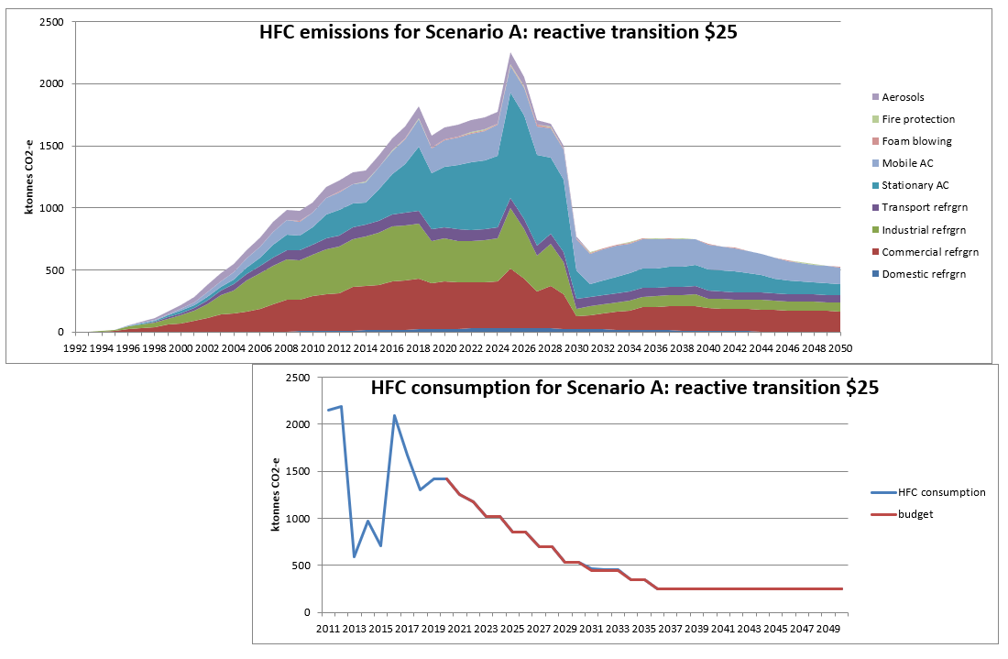**Scenario A reactive transition $25** is an estimate of the HFC stocks and emissions trends if there is the currently planned Kigali phasedown, ETS price remains at $25 and the same shifts (as C Business-As Usual) in international technology that seem likely in the next 10 years (carried through to 2050). In contrast to B, there is a range of industry awareness of the impending sharp reduction in HFC supply resulting in major early retirement of HFC equipment stocks from 2025-29.

As for C, **domestic refrigeration** pre-charged imports continue the trend of shifting almost 100% to hydrocarbons by 2025 and there is negligible NZ manufacture.

As for C, **commercial refrigeration pre-charged imports** (and local manufacture) continue the trend of shifting to 80-90% hydrocarbons by 2025.

As for C **commercial refrigeration NZ filled** for manufacture or installation, new R134a (mainly for supermarket conversions) drops after 2030, there is no new R404A after 2025 (mainly because of $25 ETS price), and R407F peaks in 2033 as CO2 (supermarkets), R448A and particularly R449A continue current growth as lower GWP alternatives driven by the ETS price. Once awareness grows of the severity of the impending phasedown, there are many fast conversions because R404A and other higher GWP refrigerants are scarce. However, their restricted availability leads to early retirement of 59% (by tonnage) of the equivalent bank in C by 2035. Some of the reduction would be due to shifts to lower GWP refrigerants, but most would represent a significant reduction in commercial refrigeration services.

In contrast to C for **industrial refrigeration** installation, new R134a supply reduces from 10t/yr to zero in 2030 as it replaces retiring equipment, there is no new R404A or R438A, R407F peaks in 2033, while the lower GWP alternatives R448A and R449A continue to grow to replace them. Larger plant continues to shift to natural refrigerants, mainly ammonia and some hydrocarbons (for smaller charges). Once awareness grows of the severity of the impending phasedown, there are many fast conversions because R404A and other higher GWP refrigerants are scarce. However, their restricted availability leads to early retirement of 91% (by tonnage) of the equivalent bank in C by 2035. Some of the reduction would be due to shifts to lower GWP refrigerants, but most would represent a major reduction in industrial refrigeration services.

As for C, **transport refrigeration** (both pre-charged imports and NZ installed) continues to shift from R404A to R452A (100% by 2023) and R134a drops 50% by 2035.

As for C, R410A in **stationary AC pre-charged imports** is 90% replaced by R32 by 2025 and the 10% remains for larger domestic and small commercial. Instead of the continued growth in C, R32 imports decline sharply after 2025 as awareness grows of the scarcity of R32 as well as R410A to service a huge equipment bank. HFO may replace R32 in some new small AC from 2030.

As for C, **stationary AC NZ filled/manufactured** for some medium and large commercial/industrial users shift to water chillers, R32 and HFO but 80% remains R410A from 2025 and commercial owners are prepared to pay high prices for the scarce refrigerant to keep their equipment operating. The total stationary AC equipment HFC bank is reduced to 64% less than the equivalent bank in C because of the early retirement forced by reduced availability of refrigerant to service the equipment.

As for C, new **mobile AC pre-charged imports** are 100% HFO or hydrocarbon by 2030 and >95% used MAC after 2040. There continues to be negligible NZ manufacture or retrofit filling. Increasing prices for scarce R134a reduce the MAC servicing rate from 3% to 2% of the vehicle fleet bank from 2025.

As for C, HFCs for **foam manufactured** in NZ are less costly than HFOs until 2030 and are then phased out by 2035. Imports of foam containing HFCs continue to be negligible.

As for C, bulk HFC imports for new **fire protection** equipment end by 2025 as inert gases replace them and any leaks from existing equipment are supplied from reused HFCs.

As for C, inert alternative propellants are developed and implemented in most **Metered Dose Inhalers** around 2025 and in **other aerosols** by 2030.

In contrast to C, for **equipment retirement modelling**, a 10-19yr lifetime range continues for commercial and industrial refrigeration to 2024 (8-19yr for AC), then from 2025-29 there is a major reduction in each sector's equipment bank because there is insufficient HFC to service the equipment.

As for C, there are negligible **imports of reused HFCs**. In contrast to C, there is a low level of reuse of 10% of the HFCs collected from early retired equipment driven by the high prices resulting from scarcity.

As for C, **recovery of retired refrigerants for destruction** continues at the 2015-19 average of 11% of retired HFCs.

The **summary charts** show that under the A scenario, total HFC emissions from 2020-2035 would be 22.0 Mt CO2-e and from 2020-2050, 31.7 Mt CO2-e. HFCs contained in equipment stocks in 2050 would be 3.8 Mt CO2-e.

The trend in the **emissions chart** above shows growth continues until a sharp increase in 2025 and steep decline to a lower emissions level from 2030 as the massive level of early retirement overwhelms the limited recovery capacity for destruction and reuse.

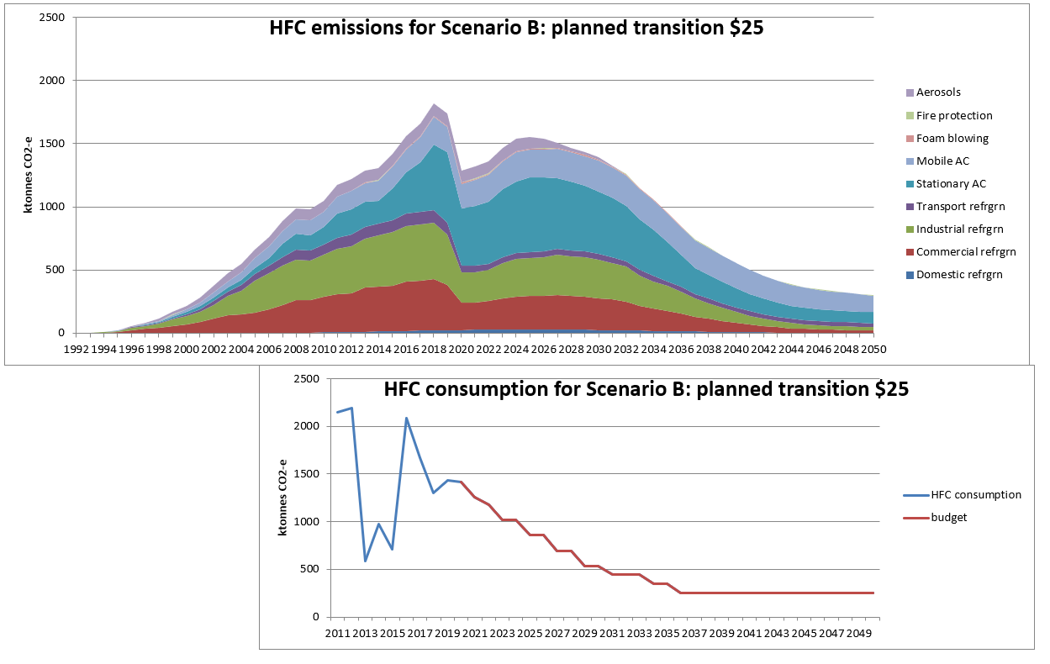**Scenario B planned transition $25** is an estimate of the HFC stocks and emissions trends if there is the currently planned Kigali phasedown, ETS price remains at $25 and the same shifts (as C) in international technology that seem likely in the next 10 years (carried through to 2050). In contrast to A, the industry sectors plan from 2020 for the impending sharp phasedown in HFC supply.

Instead of anticipating the extra high prices due to scarcity (as in D and E), it is assumed that in 2020 and 2021, importers build up their stocks of the lower GWP refrigerants (optimising any potential spare permits) to prolong the servicing of newer existing equipment.

As for C, **domestic refrigeration** pre-charged imports continue the trend of shifting almost 100% to hydrocarbons by 2025 and there is negligible NZ manufacture.

As for C, **commercial refrigeration pre-charged imports** (and local manufacture) continue the trend of shifting to 80-90% hydrocarbons by 2025.

In contrast to C **commercial refrigeration NZ filled** for manufacture or installation, new R134a (mainly for supermarket conversions) increases to 2030 before declining to zero by 2040. There is no new R404A after 2020 and no new R407F from 2030 as CO2 (supermarkets), R448A and particularly R449A continue current growth as lower GWP alternatives. There are many fast conversions because R404A and other higher GWP refrigerants are scarce. There is early retirement of 62% (by tonnage; similar to A) of the equivalent bank in C by 2035. Some of the reduction would be due to shifts to lower GWP refrigerants, but most would represent a significant reduction in commercial refrigeration services.

As for C (and unlike A) for **industrial refrigeration** installation, new R134a supply is steady at 10t/yr to 2030 and declines to zero in 2040 as it replaces retiring equipment. In contrast with C, there is no new R404A or R438A, and R407F declines to zero in 2030, while the lower GWP alternatives R448A and R449A continue to grow to replace them. Larger plant shifts at a much faster rate to natural refrigerants, mainly ammonia and some hydrocarbons (for smaller charges). The result is early retirement of 49% (by tonnage) of the equivalent bank in C by 2035. Most of the reduction would be due to shifts to lower GWP refrigerants, but some would represent a reduction in industrial refrigeration services.

As for C, **transport refrigeration** (both pre-charged imports and NZ installed) continues to shift from R404A to R452A (100% by 2023) and R134a drops 50% by 2035.

As for C, R410A in **stationary AC pre-charged imports** is 90% replaced by R32 by 2025 and the 10% remains for larger domestic and small commercial. In contrast to the continued growth in C, R32 imports decline sharply after 2025 and there is a 2021 ban on imports of smaller AC equipment containing R410A. HFO may replace R32 in some new small AC from 2030.

As for C, **stationary AC NZ filled/manufactured** for some medium and large commercial/industrial users shift to water chillers, R32 and HFO but 80% remains R410A from 2025 and commercial owners are prepared to pay high prices for the scarce refrigerant to keep their equipment operating. The total stationary AC equipment HFC bank is reduced to 59% less than the equivalent bank in C because of the early retirement forced by reduced availability of refrigerant to service the equipment.

As for C, new **mobile AC pre-charged imports** are 100% HFO or hydrocarbon by 2030 and >95% used MAC after 2040. There continues to be negligible NZ manufacture but there is a minor level of R513A retrofit from 2020. Increasing prices for scarce R134a reduce the MAC servicing rate from 3% to 2.5% of the vehicle fleet bank from 2025.

In contrast to C, HFCs for **foam manufactured** in NZ are fully replaced by HFOs by 2025. Imports of foam containing HFCs continue to be negligible.

As for C, bulk HFC imports for new **fire protection** equipment end by 2025 as inert gases replace them and any leaks from existing equipment are supplied from reused HFCs.

As for C, inert alternative propellants are developed and implemented in most **Metered Dose Inhalers** around 2025 and in **other aerosols** by 2030.

In contrast to C, for **equipment retirement modelling**, a 10-19yr lifetime range continues for commercial and industrial refrigeration to 2022, then the range is shortened gradually to 5-14 years by 2029 because there is insufficient HFC to service the equipment.

As for C, there are negligible **imports of reused HFCs**. In contrast to C, equipment and training is provided that achieves a medium level of reuse from 2020 of 20% of HFC retirements (10% for MAC).

As for C, **recovery of retired refrigerants for destruction** continues at the 2015-19 average of 11% of retired HFCs.

The **summary charts** show that under the B scenario, total HFC emissions from 2020-2035 would be 21.6 Mt CO2-e and from 2020-2050, 28.8 Mt CO2-e. HFCs contained in equipment stocks in 2050 would be 3.3 Mt CO2-e. These emissions results are similar to the A ones by 2035 and about 10% lower for total emissions 2020-50, mainly due to more gradual rather than sudden early retirement and an improved level of recovery.

The trend in the **emissions chart** above shows emissions sharply decrease in 2020 from a combination of regulations to restrict some equipment imports and industry education to improve awareness of the impending decrease in HFC supply and more widespread training that results in lower leakage rates and better recovery rates for destruction and reuse. Early retirement occurs more gradually than in A so retirement emissions rise to a peak in 2025 and slowly decrease through to 2050.

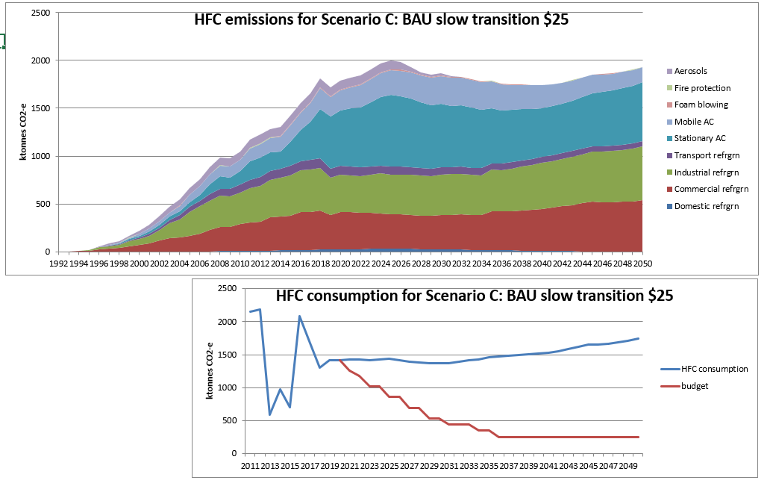**Scenario C Business As Usual slow transition $25** is an estimate of the HFC stocks and emissions trends if there is no Kigali phasedown, ETS price remains at $25 (in real terms) and the only changes are from shifts in international technology that seem likely in the next 10 years (carried through to 2050).

**Domestic refrigeration** pre-charged imports continue the trend of shifting almost 100% to hydrocarbons by 2025 and there is negligible NZ manufacture.

**Commercial refrigeration pre-charged imports** (and local manufacture) continue the trend of shifting to 80-90% hydrocarbons by 2025.

For **commercial refrigeration NZ filled** for manufacture or installation, new R134a (mainly for supermarket conversions) drops after 2030, there is no new R404A after 2025 (mainly because of $25 ETS price), and R407F peaks in 2033 as CO2 (supermarkets), R448A and particularly R449A continue current growth as lower GWP alternatives driven by the ETS price.

For **industrial refrigeration** installation, R134a is steady at 10t/yr as it replaces retiring equipment (reducing from 2030 to zero in 2040), there is no new R404A or R438A, R407F peaks in 2033, while the lower GWP alternatives R448A and R449A continues to grow. Larger plant continues to shift to natural refrigerants, mainly ammonia and some hydrocarbons (for smaller charges).ew R134a drops after 2030, there is no new R404A after 2025 (mainly because of $25 ETS price), and R407F peaks in 2033 as CO2 (supermarkets), R448A and particularly R449A continue current growth as lower GWP alternatives driven by the ETS price.

**Transport refrigeration** (both pre-charged imports and NZ installed) continues to shift from R404A to R452A (100% by 2023) and R134a drops 50% by 2035.

**Stationary AC pre-charged imports** continue annual 3% growth, with R410A 90% replaced by R32 by 2025 and the 10% remains for larger domestic and small commercial where there appear to be no alternatives in the medium term. HFO may replace R32 in some new small AC from 2030.

**Stationary AC NZ filled/manufactured** for some medium and large commercial/industrial users shift to water chillers, R32 and HFO but 80% remains R410A from 2025.

New **mobile AC pre-charged imports** are 100% HFO or hydrocarbon by 2030 and >95% used MAC after 2040. There continues to be negligible NZ manufacture or retrofit filling.

For **foam manufactured** in NZ, HFCs are less costly than HFOs until 2030 and are then phased out by 2035. Imports of foam containing HFCs continue to be negligible.

Bulk HFC imports for new **fire protection** equipment end by 2025 as inert gases replace them and any leaks from existing equipment are supplied from reused HFCs.

For aerosols, inert alternative propellants are developed and implemented in most **Metered Dose Inhalers** around 2025 and in **other aerosols** by 2030.

For **equipment retirement modelling**, a 10-19yr lifetime range continues for commercial and industrial refrigeration, and 8-19yr for AC.

There are negligible **imports of reused HFCs** or recycling of HFCs within NZ.

**Recovery of retired refrigerants** **for destruction** continues at the 2015-19 average of 11% of retired HFCs.

Higher prices from ETS and/or scarcity would increase incentives for recovery destruction + imported reused but these are omitted for A, B, D, E scenarios to separate those variables studied in F and G scenarios.

The **summary charts** show that under the C scenario, total HFC emissions from 2020-2035 would be 30.0 Mt CO2-e and from 2020-2050, 57.0 Mt CO2-e. HFCs contained in equipment stocks in 2050 would be 12.9 Mt CO2-e.

The trend in the **emissions chart** above shows steady growth until 2025 until shifts to alternative refrigerants (driven by international technology shifts and ETS price) cause a slow decline until 2040, mainly from the Stationary AC shift from R410A to R32 and the Mobile AC shift away from R134a. Then growth continues in the refrigeration and Stationary AC sectors. (The 2018 discontinuity arises from contradictory data for 2019 that is not yet resolved.)

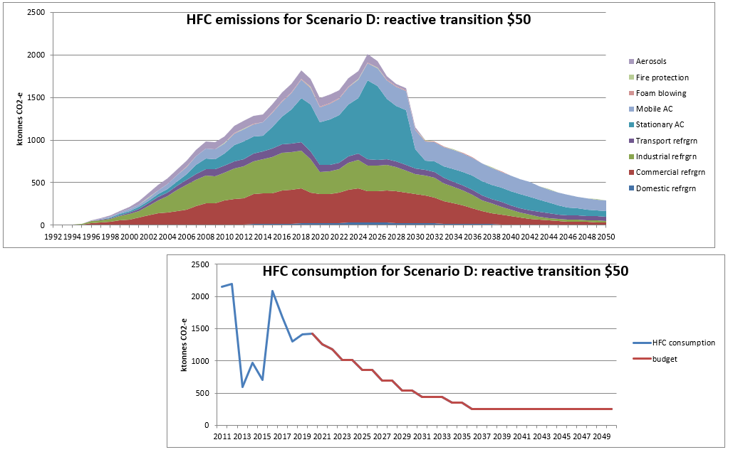**Scenario D reactive transition $50** is an estimate of the HFC stocks and emissions trends if there is the currently planned Kigali phasedown, ETS price is $50 from 2020-50 and the same shifts (as C) in international technology that seem likely in the next 10 years (carried through to 2050). As in A (in contrast to B), there is a range of industry awareness of the impending sharp reduction in HFC supply resulting in major early retirement of HFC equipment stocks from 2025-29. The significant ETS price increase in 2020 rapidly warns the various industry sectors of the future HFC price risks.

Seeing the high ETS price and anticipating the extra high prices due to scarcity, it is assumed that in 2020 and 2021, importers build up their stocks of the higher GWP refrigerants to prolong the servicing of older existing equipment.

As for C, **domestic refrigeration** pre-charged imports continue the trend of shifting almost 100% to hydrocarbons by 2025 and there is negligible NZ manufacture.

As for C, **commercial refrigeration pre-charged imports** (and local manufacture) continue the trend of shifting to 80-90% hydrocarbons by 2025.

As for C **commercial refrigeration NZ filled** for manufacture or installation, new R134a (mainly for supermarket conversions) drops after 2030 (to zero by 2040). With the added price signal, there is a faster shift to alternatives: no new R404A after 2023, and new R407F is zero from 2027 as CO2 (supermarkets), R448A and particularly R449A continue current growth as lower GWP alternatives. However, their restricted availability leads to early retirement of 60% (by tonnage) of the equivalent bank in C by 2035. Some of the reduction would be due to shifts to lower GWP refrigerants, but most would represent a significant reduction in commercial refrigeration services. Higher prices drive improved installation and maintenance to reduce leakage.

In contrast to C for **industrial refrigeration** installation, new R134a supply reduces from 10t/yr to zero in 2030 as it replaces retiring equipment. With the added price signal, there is no new R404A or R438A, and new R407F is zero by 2030, while the lower GWP alternatives R448A and R449A continue to grow to replace them. Larger plant continues to shift to natural refrigerants, mainly ammonia and some hydrocarbons (for smaller charges). However, their restricted availability leads to early retirement of 64% (by tonnage) of the equivalent bank in C by 2035 (less extreme than for A). Some of the reduction would be due to shifts to lower GWP refrigerants, but most would represent a significant reduction in industrial refrigeration services. Higher prices drive improved installation and maintenance to reduce leakage.

As for C, **transport refrigeration** (both pre-charged imports and NZ installed) continues to shift from R404A to R452A (100% by 2023) and R134a drops 50% by 2035. Higher prices drive improved installation and maintenance to reduce leakage.

As for C, R410A in **stationary AC pre-charged imports** is 90% replaced by R32 by 2025 and the 10% remains for larger domestic and small commercial. Instead of the continued growth in C, R32 imports decline sharply after 2025 as awareness grows of the scarcity of R32 as well as R410A to service a huge equipment bank. HFO may replace R32 in some new small AC from 2030.

As for C, **stationary AC NZ filled/manufactured** for some medium and large commercial/industrial users shift to water chillers, R32 and HFO but 80% remains R410A from 2025 and commercial owners are prepared to pay high prices for the scarce refrigerant to keep their equipment operating. The total stationary AC equipment HFC bank is reduced to 58% less than the equivalent bank in C because of the early retirement forced by reduced availability of refrigerant to service the equipment. Higher prices drive improved installation and maintenance to reduce leakage, mainly for commercial.

As for C, new **mobile AC pre-charged imports** are 100% HFO or hydrocarbon by 2030 and >95% used MAC after 2040. There continues to be negligible NZ manufacture but there is a minor level of R513A retrofit from 2025. Increasing prices for scarce R134a reduce the MAC servicing rate from 3% to 2% of the vehicle fleet bank from 2020.

In contrast to C, HFCs for **foam manufactured** in NZ are fully replaced by HFOs by 2025 due to the price increase. Imports of foam containing HFCs continue to be negligible.

As for C, bulk HFC imports for new **fire protection** equipment end by 2025 as inert gases replace them and any leaks from existing equipment are supplied from reused HFCs.

As for C, inert alternative propellants are developed and implemented in most **Metered Dose Inhalers** around 2025 and in **other aerosols** by 2030.

In contrast to C, for **equipment retirement modelling**, a 10-19yr lifetime range (8-19yr AC) continues for commercial and industrial refrigeration to 2022, then the range is shortened gradually to 5-14 years (same for AC) by 2029 because there is insufficient HFC to service the equipment. Then there is some extra early retirement for industrial refrigeration and for AC but not as extreme as for A.

As for C, there are negligible **imports of reused HFCs**. In contrast to C, there is a medium level of reuse of 20% of the HFCs collected from early retired equipment from 2025 (10% for MAC) driven by the high prices resulting from ETS and scarcity.

As for C, **recovery of retired refrigerants for destruction** continues at the 2015-19 average of 11% of retired HFCs.

The **summary charts** show that under the D scenario, total HFC emissions from 2020-2035 would be 22.9 Mt CO2-e and from 2020-2050, 30.2 Mt CO2-e. HFCs contained in equipment stocks in 2050 would be 3.1 Mt CO2-e.

The trend in the **emissions chart** above shows the 2020 extra price signal produces a similar emissions decrease in 2020 to B, then increasing to 2025 as the early retirement emissions occur then sharply decline to a lower emissions level from 2030.

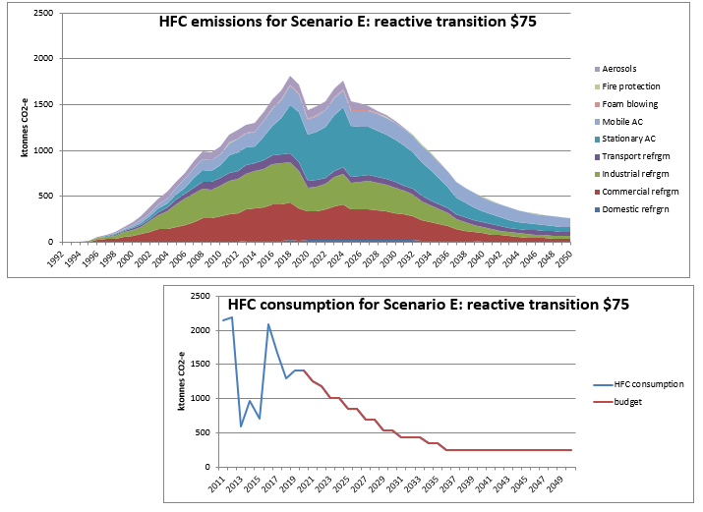

**Scenario E reactive transition $75** is an estimate of the HFC stocks and emissions trends if there is the currently planned Kigali phasedown, ETS price is $75 from 2020-50 and the same shifts (as C) in international technology that seem likely in the next 10 years (carried through to 2050). As in A (in contrast to B), there is a range of industry awareness of the impending sharp reduction in HFC supply resulting in major early retirement of HFC equipment stocks from 2025-29. The major ETS price increase in 2020 rapidly warns the various industry sectors of the future HFC price risks.

Seeing the very high ETS price and anticipating the extra high prices due to scarcity, it is assumed that in 2020 and 2021, importers build up their stocks of the higher GWP refrigerants to prolong the servicing of older existing equipment.

As for C, **domestic refrigeration** pre-charged imports continue the trend of shifting almost 100% to hydrocarbons by 2025 and there is negligible NZ manufacture.

As for C, **commercial refrigeration pre-charged imports** (and local manufacture) continue the trend of shifting to 80-90% hydrocarbons by 2025.

In contrast to C **commercial refrigeration NZ filled** for manufacture or installation, new R134a paradoxically rises to a steady 12t/yr until 2038 (declining to zero by 2045) mainly for supermarket conversions to R134a/CO2 systems. With the major increase in price signal, there is a much faster shift to alternatives: no new R404A after 2020, and new R407F is zero from 2025 as CO2, R448A and particularly R449A continue current growth as lower GWP alternatives. However, their restricted availability leads to early retirement of 60% (by tonnage) of the equivalent bank in C by 2035. Some of the reduction would be due to shifts to lower GWP refrigerants, but most would represent a significant reduction in commercial refrigeration services. Higher prices drive improved installation and maintenance to reduce leakage.

In contrast to C for **industrial refrigeration** installation, new R134a supply reduces from 10t/yr to zero in 2030 as it replaces retiring equipment. With the added price signal, there is no new R404A or R438A, and new R407F is zero by 2030, while the lower GWP alternatives R448A and R449A continue to grow to replace them. Larger plant continues to shift to natural refrigerants, mainly ammonia and some hydrocarbons (for smaller charges). However, their restricted availability leads to early retirement of 62% (by tonnage) of the equivalent bank in C by 2035 (less extreme than for A). Some of the reduction would be due to shifts to lower GWP refrigerants, but most would represent a significant reduction in industrial refrigeration services. Higher prices drive improved installation and maintenance to reduce leakage.

As for C, **transport refrigeration** (both pre-charged imports and NZ installed) continues to shift from R404A to R452A (100% by 2023) and R134a drops 50% by 2035. Higher prices drive improved installation and maintenance to reduce leakage.

As for C, R410A in **stationary AC pre-charged imports** is 90% replaced by R32 by 2025 and the 10% remains for larger domestic and small commercial. Instead of the continued growth in C, R32 imports decline sharply after 2025 as awareness grows of the scarcity of R32 as well as R410A to service a huge equipment bank. HFO may replace R32 in some new small AC from 2030.

As for C, **stationary AC NZ filled/manufactured** for some medium and large commercial/industrial users shift to water chillers, R32 and HFO but 80% remains R410A from 2025 and commercial owners are prepared to pay high prices for the scarce refrigerant to keep their equipment operating. The total stationary AC equipment HFC bank is reduced to 62% less than the equivalent bank in C because of the early retirement forced by reduced availability of refrigerant to service the equipment. Higher prices drive improved installation and maintenance to reduce leakage, mainly for commercial.

As for C, new **mobile AC pre-charged imports** are 100% HFO or hydrocarbon by 2030 and >95% used MAC after 2040. There continues to be negligible NZ manufacture but there is a major level of R513A retrofit from 2020 peaking at 100t in 2027. Increasing prices for scarce R134a reduce the MAC servicing rate from 3% to 1.5% of the vehicle fleet bank from 2020.

In contrast to C, HFCs for **foam manufactured** in NZ are fully replaced by HFOs by 2025 due to the price increase. Imports of foam containing HFCs continue to be negligible.

As for C, bulk HFC imports for new **fire protection** equipment end by 2025 as inert gases replace them and any leaks from existing equipment are supplied from reused HFCs.

As for C, inert alternative propellants are developed and implemented in most **Metered Dose Inhalers** around 2025 and in **other aerosols** by 2030.

In contrast to C, for **equipment retirement modelling**, a 10-19yr lifetime range (8-19yr AC) continues for commercial and industrial refrigeration to 2022, then the range is shortened gradually to 5-14 years (same for AC) by 2029 because there is insufficient HFC to service the equipment. Not as extreme as D or particularly A because the very high price signal drives early action to switch to alternatives.

As for C, there are negligible **imports of reused HFCs**. In contrast to C, there is a high level of reuse of 30% of the HFCs collected from early retired equipment from 2025 (15% for MAC) driven by the high prices resulting from ETS and scarcity.

As for C, **recovery of retired refrigerants for destruction** continues at the 2015-19 average of 11% of retired HFCs.

The summary charts show that under the E scenario, total HFC emissions from 2020-2035 would be 21.9 Mt CO2-e and from 2020-2050, 28.3 Mt CO2-e. HFCs contained in equipment stocks in 2050 would be 3.0 Mt CO2-e.

The trend in the emissions chart above shows the 2020 extra price signal produces a similar emissions decrease in 2020 to B and D, then increasing to a 2023 peak as the first early retirement emissions occur then steadily decline through to 2050.

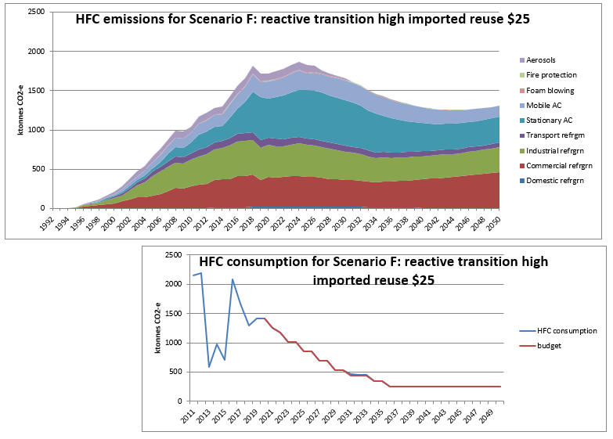**Scenario F reactive transition high imported reuse $25** is an estimate of the HFC stocks and emissions trends if there is the currently planned Kigali phasedown, ETS price remains at $25 and the same shifts (as C) in international technology that seem likely in the next 10 years (carried through to 2050). In contrast to A, B, D, E and G, there is a high level of relatively unrestricted reused HFC imports to meet the shortages in those scenarios and so avoiding the disruption from early retirement of HFC equipment stocks.

As for C, **domestic refrigeration** pre-charged imports continue the trend of shifting almost 100% to hydrocarbons by 2025 and there is negligible NZ manufacture.

As for C, **commercial refrigeration pre-charged imports** (and local manufacture) continue the trend of shifting to 80-90% hydrocarbons by 2025.

As for C **commercial refrigeration NZ filled** for manufacture or installation, new R134a (mainly for supermarket conversions) drops after 2030, there is no new R404A after 2025 (mainly because of $25 ETS price), and R407F peaks in 2024 as CO2 (supermarkets), R448A and particularly R449A continue current growth as lower GWP alternatives driven by the ETS price.

In contrast to C for **industrial refrigeration** installation, new R134a supply reduces from 10t/yr in 2025 to zero in 2040 as it replaces retiring equipment, there is no new R404A after 2025, R407F peaks in 2023, while the lower GWP alternatives R448A and R449A continue to grow to replace them. Larger plant continues to shift to natural refrigerants, mainly ammonia and some hydrocarbons (for smaller charges).

As for C, **transport refrigeration** (both pre-charged imports and NZ installed) continues to shift from R404A to R452A (100% by 2023) and R134a drops 50% by 2035.

As for C, R410A in **stationary AC pre-charged imports** is 90% replaced by R32 by 2025 and the 10% remains for larger domestic and small commercial. For both R32 and R410A equipment imports, an average of the C unrestricted and A restricted scenarios is calculated. HFO may replace R32 in some new small AC from 2030.

As for C, **stationary AC NZ filled/manufactured** for some medium and large commercial/industrial users shift to water chillers, R32 and HFO but 80% remains R410A from 2025 and commercial owners are prepared to pay high prices for the scarce refrigerant to keep their equipment operating. The total stationary AC equipment HFC bank is reduced to 64% less than the equivalent bank in C because of the early retirement forced by reduced availability of refrigerant to service the equipment.

As for C, new **mobile AC pre-charged imports** are 100% HFO or hydrocarbon by 2030 and >95% used MAC after 2040. There continues to be negligible NZ manufacture or retrofit filling. Increasing prices for scarce R134a reduce the MAC servicing rate from 3% to 2% of the vehicle fleet bank from 2025.

As for C **foam manufactured** in NZ, HFCs are less costly than HFOs until 2030 and are then phased out by 2035. Imports of foam containing HFCs continue to be negligible.

As for C, bulk HFC imports for new **fire protection** equipment end by 2025 as inert gases replace them and any leaks from existing equipment are supplied from reused HFCs.

As for C, inert alternative propellants are developed and implemented in most **Metered Dose Inhalers** around 2025 and in **other aerosols** by 2030.

As for C and in contrast with all other scenarios for **equipment retirement modelling**, a 10-19yr lifetime range continues for commercial and industrial refrigeration (8-19yr for AC). Early retirement is relatively minor and related mainly to ETS price.

There are **unrestricted** **imports of reused HFCs** to meet the shortfall resulting from the phasedown, assumed to be the average of the C and A scenarios. As for C, there is no significant reuse because there are not the high prices resulting from scarcity.

As for C, **recovery of retired refrigerants for destruction** continues at the 2015-19 average of 11% of retired HFCs.

The **summary charts** show that under the F scenario, total HFC emissions from 2020-2035 would be 27.0 Mt CO2-e and from 2020-2050, 46.4 Mt CO2-e. HFCs contained in equipment stocks in 2050 would be 8.6 Mt CO2-e.

The trend in the total **emissions chart** above shows growth continues until 2023 followed by a slow decline for most of the series, with some sectors showing growth from around 2035 as part of the growth in refrigeration and AC services continues to be supplied by reused HFCs.

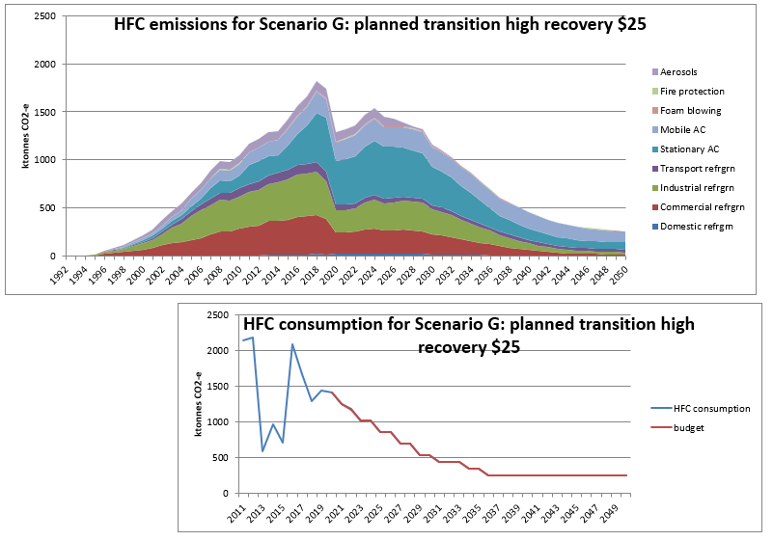**Scenario G planned transition with high recovery $25** is an estimate of the HFC stocks and emissions trends if there is the currently planned Kigali phasedown, ETS price remains at $25 and the same shifts (as C) in international technology that seem likely in the next 10 years (carried through to 2050). In contrast to A, the industry sectors plan from 2020 for the impending sharp phasedown in HFC supply with a gradual but significant level of early retirement. In contrast to B, stakeholder education and infrastructure are developed to double the average rate of recovery for destruction from 11% to 22% of retirements from 2025, then tripled to 33% from 2030. There is also equipment and training for a medium level of reuse from 2020.

As for C, **domestic refrigeration** pre-charged imports continue the trend of shifting almost 100% to hydrocarbons by 2025 and there is negligible NZ manufacture.

As for C, **commercial refrigeration pre-charged imports** (and local manufacture) continue the trend of shifting to 80-90% hydrocarbons by 2025.

As for B **commercial refrigeration NZ filled** for manufacture or installation, new R134a (mainly for supermarket conversions) increases to 2030 before declining to zero by 2040. There is no new R404A after 2020 and no new R407F from 2030 as CO2 (supermarkets), R448A and particularly R449A continue current growth as lower GWP alternatives. There are many fast conversions because R404A and other higher GWP refrigerants are scarce. There is early retirement of 62% (by tonnage; similar to A) of the equivalent bank in C by 2035. Some of the reduction would be due to shifts to lower GWP refrigerants, but most would represent a significant reduction in commercial refrigeration services.

As for B **industrial refrigeration** installation, new R134a supply is steady at 10t/yr to 2030 and declines to zero in 2040 as it replaces retiring equipment. In contrast with C, there is no new R404A or R438A, and R407F declines to zero in 2030, while the lower GWP alternatives R448A and R449A continue to grow to replace them. Larger plant shifts at a much faster rate to natural refrigerants, mainly ammonia and some hydrocarbons (for smaller charges). The result is early retirement of 49% (by tonnage) of the equivalent bank in C by 2035. Most of the reduction would be due to shifts to lower GWP refrigerants, but some would represent a reduction in industrial refrigeration services.

As for C, **transport refrigeration** (both pre-charged imports and NZ installed) continues to shift from R404A to R452A (100% by 2023) and R134a drops 50% by 2035.

As for B, R410A in **stationary AC pre-charged imports** is 90% replaced by R32 by 2025 and the 10% remains for larger domestic and small commercial. In contrast to the continued growth in C, R32 imports decline sharply after 2025 and there is a 2021 ban on imports of smaller AC equipment containing R410A. HFO may replace R32 in some new small AC from 2030.

As for B, **stationary AC NZ filled/manufactured** for some medium and large commercial/industrial users shift to water chillers, R32 and HFO but 80% remains R410A from 2025 and commercial owners are prepared to pay high prices for the scarce refrigerant to keep their equipment operating. The total stationary AC equipment HFC bank is reduced to 59% less than the equivalent bank in C because of the early retirement forced by reduced availability of refrigerant to service the equipment.

As for B, new **mobile AC pre-charged imports** are 100% HFO or hydrocarbon by 2030 and >95% used MAC after 2040. There continues to be negligible NZ manufacture but there is a minor level of R513A retrofit from 2020. Increasing prices for scarce R134a reduce the MAC servicing rate from 3% to 2.5% of the vehicle fleet bank from 2025.

As for B, HFCs for **foam manufactured** in NZ are fully replaced by HFOs by 2025. Imports of foam containing HFCs continue to be negligible.

As for C, bulk HFC imports for new **fire protection** equipment end by 2025 as inert gases replace them and any leaks from existing equipment are supplied from reused HFCs.

As for C, inert alternative propellants are developed and implemented in most **Metered Dose Inhalers** around 2025 and in **other aerosols** by 2030.

In contrast to C, for **equipment retirement modelling**, a 10-19yr lifetime range continues for commercial and industrial refrigeration to 2022, then the range is shortened gradually to 5-14 years by 2029 because there is insufficient HFC to service the equipment.

As for C, there are negligible **imports of reused HFCs**. In contrast to C, equipment and training is provided that achieves a medium level of reuse from 2020 of 20% of HFC retirements (10% for MAC).

In contrast to B and all other scenarios, **recovery of retired refrigerants for destruction** doubles from 2025 to 22% of retired HFCs and then triples to 33% from 2030.

The **summary charts** show that under the G scenario, total HFC emissions from 2020-2035 would be 19.8 Mt CO2-e and from 2020-2050, 25.7 Mt CO2-e (which represents 3.0 Mt CO2-e of avoided emissions from the extra recovery for destruction compared with B). HFCs contained in equipment stocks in 2050 would be 3.3 Mt CO2-e (no change as expected). These first two figures represent respectively 8% and 11% reductions compared with the B scenario figures.

The trend in the **emissions chart** above shows emissions sharply decrease in 2020 from a combination of regulations to restrict some equipment imports and industry education to improve awareness of the impending decrease in HFC supply and more widespread training that results in lower leakage rates and better recovery rates for destruction and reuse. Early retirement occurs more gradually than in A so retirement emissions rise to a peak in 2024 and slowly decrease through to 2050.

**Uncertainties** (estimated as 95% confidence limits) for the 2018 inventory 1816 kt CO2-e total HFC emissions were +/-25% (combining 30% for Stationary RAC, 24% for MAC, 26% for aerosols, 50% for foam blowing and 42% for fire protection in decreasing contributions).

Combining these known uncertainties with the much higher ones of projecting future emissions is a highly speculative exercise. The approach taken has been to estimate a lower limit and an upper limit for total emissions in 2035 given the range of assumptions built into each scenario and treating those as 95% confidence limits even though such a treatment is very unlikely to be a Normal distribution.

For the G scenario, 2035 total HFC emissions are estimated to be 779 kt CO2-e +/-60% because of the highly uncertain extent of early retirement. Cumulative HFC emissions 2020-35 are considered less uncertain at 19.8 Mt CO2-e +/-50%.

1. For MAC, distinction should be made between the fleet emission rates and service or replacement rates but that level of complexity has not been possible in the current study.