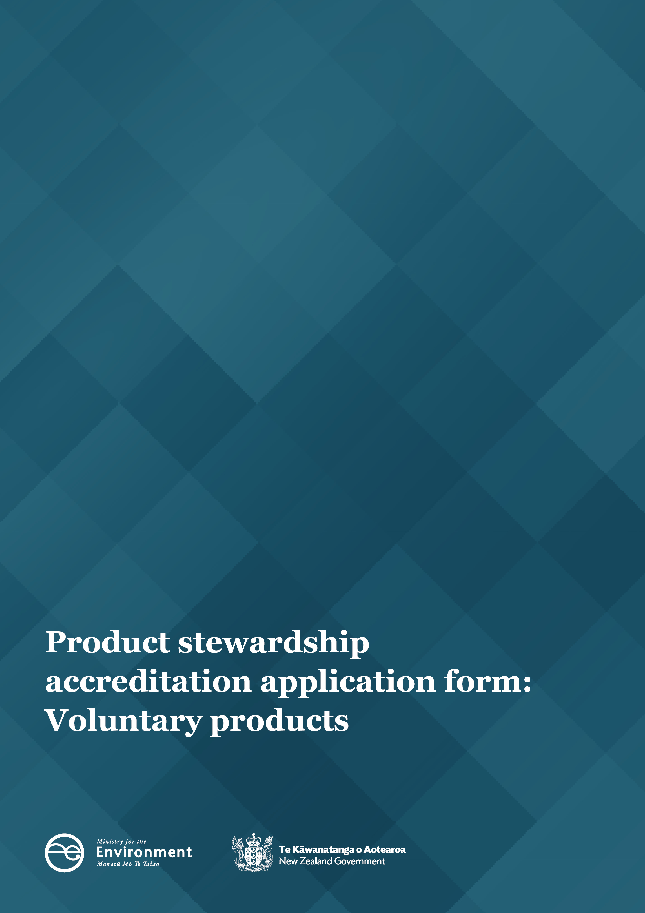

PART A: Applicant details
This part provides information about your organisation, including legal name, legal entity status and contact details. See the Guide for applicants for information on how to complete this form.
- Organisation details
Organisation name
Organisation registration number (optional)
Address  Including postcode | Physical address | Postal address
Telephone
Website address
Including social media handles (if applicable)

- Key personnel contact details – WMA section 14(a)
Primary contact name
Name of Scheme Manager
Role or job title
Email
Telephone
Secondary contact name
Role or job title
Email
Telephone

PART B: Scheme details
This part provides information about the scheme. Include the scheme name, what product(s) the scheme will address, life of the scheme and how the scheme operates.
- Scheme overview
Product category – WMA section 14(b)
Product stewardship scheme name (optional)
Description – WMA section 14(b) (approximately 200 words)
Provide a brief description of the problem, solution and how the scheme aims to manage the environmental impact of the product during its life cycle.
Scope – WMA section 14(b)
What specific products (including legacy and orphan products) will be included in the scheme?
Out-of-scope – WMA section 14(b)
What specific products will be excluded from the scheme (if applicable)?
Expiry date – WMA section 14(g) | seven years after Minister accreditation or  state the specific date:

- Collection and processing network
Describe the service network required to operate the scheme, including the geographical coverage of the scheme. Clearly identify how products will be collected and recovered, whether all products will be available for collection at the start of the scheme or phased in. If products are phased in explain how and when they will be brought into the scheme.
Collection and processing WMA sections 14(f)(ii) and 15(1)(c)
- Provide a detailed summary of how the scheme operates, including how the scheme either promotes waste minimisation and/or achieves a reduction in environmental harm from disposal of the product.
- Outline how the scheme will increase end-of-life management of the product higher up the waste hierarchy.
Location/geographical coverage of the scheme – WMA section 14(b)
Outline the geographical coverage of the scheme and describe how the scheme will achieve free and convenient collection.
New Zealand’s international obligations – WMA section 15(1)(d)
Provide (where possible) details of how the scheme meets all relevant international obligations relating to environment, trade and human rights.
- Regulations – WMA section 13(2)(e)
Will regulations be required to implement the scheme? | No (move to question 6)  Yes, please add more details in the table below.

Other regulation(s)
Complete the below table if you selected Yes in question 5. Describe what regulation(s) are required to implement the scheme. Also consider what part of the scheme requires regulation, who the rule(s) apply to, what they must or must not do, when the rule(s) would apply, and what happens if they do not meet the regulation(s).
Regulation  State the applicable WMA section. | Problem definition  Define what problem the regulation will resolve. | How will the regulation bring about the desired change?  Why is this the preferred option, is it feasible? | Benefits and costs  Who are the expected beneficiaries and what is the nature of the benefit? Where do the costs fall? | Risks and mitigations  What are the likely risks and unintended impacts? How significant are they and will they be minimised or mitigated?

PART C: Scheme objectives
This part outlines what the scheme will achieve (that is, what difference the scheme will make to New Zealand and New Zealanders) and the measures year on year you will use to show the scheme is on track to achieve success.
- Baseline data – WMA section 15(1)(c)
Current waste data
Outline the current levels of waste generated for this product in New Zealand. State whether data is based on estimates or actuals. Measurements may be based upon weight, litres or number of units.
Methodology for calculating waste data
Describe how the waste data is calculated. If the current waste data are estimates, explain how data will be captured by the scheme.

- Objectives – WMA sections 14(c), 15(1)(b)
List your scheme objectives. Ensure objectives are SMART (specific, measurable, achievable and relevant within the timeframe of the scheme).
Objective  Describe the tangible outcomes your scheme is trying to achieve |  | Target  Measurable values that show progress towards objective |  | Timeframe  Realistic and achievable timeframes |  | Monitoring targets  Describe how you will measure and monitor the targets
- Risk management (optional)
Describe potential risks that may adversely affect the performance of the scheme and how these risks will be managed. Where possible, give an indication of the likelihood and significance of the risk and any mitigation strategies to be included in the scheme.
Potential risk  Identify the potential risk | Likelihood of risk occurring  Low, medium or high |  | Consequence on scheme  Minor, moderate or severe |  | Impact on scheme  Describe the impact the risk would have on the scheme If it occurred |  | Strategy to mitigate  Describe what will be done to mitigate and/or manage the risk

PART D: Participants
This part outlines all the groups and individuals who will be impacted and/or involved in the scheme and what formal agreements are held.
- Scheme users – WMA section 14(d)
List the scheme users who will be impacted and/or involved in the scheme and the nature of their involvement. Scheme users referred to in the WMA as ‘classes of person’ are organisations/groups or individuals who have not signed an agreement to participate in the scheme but are crucial to the success of the scheme.
Organisation/group/individual name | Nature of involvement

- Scheme participants – WMA section 14(e)
List the scheme participants who will be involved in the scheme and the nature of their involvement, including how they will contribute to meeting scheme objectives. Scheme participants are parties or partner organisations required to participate in the scheme under legislation, to ensure the scheme’s success, or they have opted to take part in the scheme. Examples include importers, manufacturers, producers, retailers, collectors and recyclers.
Organisation name | Contact details  Key contact, address, email, telephone | Role and responsibilities  Including how they will contribute to meeting scheme objectives | Nature of involvement  Provide supporting documents where applicable

- Compliance and performance – WMA section 14(h)
Identify and describe the processes for compliance and enforcement of any agreements between participants to the scheme.

PART E: Governance
This part outlines leadership and decision-making, and how the governance group will carry out their duties and responsibilities in accordance with the highest professional standards.
- Governance arrangements and organisation structure – WMA section 14(f)
Describe the governance structure that will be implemented to ensure monitoring and management of scheme performance and effective decision-making occurs. Include key positions, roles and responsibilities, and detail how information flows between the product stewardship organisation and the governance board.
Governance arrangements
Describe how the governance structure meets best-practice guidelines for governance. Clearly outline who is responsible for:
- making decisions
- control and overall operation
- monitoring and reviewing.
Organisational structure – WMA section 14(f)(i) and (ii)
Describe how information flows between levels within the organisation and governance group.
Submit an organisational chart as supporting evidence.
- Record keeping – WMA section 14(f)(iii)
Record keeping – WMA section 14(f)(iii), Outline the arrangements for keeping records and making reports under the scheme.

PART F: Communications and reporting
This part outlines how you will promote the scheme, engage with scheme users and report on the scheme’s performance.
- Communication strategy – WMA section 14(j) and (k)
Outline the high-level communication tactics that will be used to promote the scheme.

- Reporting – WMA section 14(i)
Reporting to the Minister on scheme performance – WMA section 14(i)
Outline the process for writing your annual report. We recommend you include information on financial, environmental and participant performance.
Annual report timeframe (optional)
Please indicate if your scheme has a preferred timeframe for the annual report eg, calendar year, financial year, anniversary of the scheme’s accreditation, other.

Communication strategy – WMA section 14(j) and (k)
Outline how the scheme provides clear, regular communication to consumers, businesses and service providers (scheme users and scheme participants
– as listed in part D).
Audience  Who | Key message/desired response  What do we want them to think/do? What information do they need | Key promotional activity  How will the information be made available? | Frequency of key promotional activity  When and how often? | Roles/responsibilities  Who is responsible for the key promotional activity?

PART G: Environmental impact
This part provides more detailed information about the product life cycle and how the scheme aims to improve the environmental impacts.
- Environmental impact – WMA section 15(1)(c)
Describe the product’s environmental impact – WMA section 15(1)(c)
Provide a high-level description of the environmental impact of the product considering its design, manufacturing, use and end-of-life impacts with an emphasis on impacts in New Zealand (where appropriate).

Continual improvement – WMA section 15(1)(c)
Outline how the scheme will continually improve its environmental harm and maximise benefits at the products end of life

PART H: Funding
The part outlines how the scheme will be funded.
- Funding model – WMA section 14(l)
Describe how the scheme will be funded
Provide a breakdown of all estimated scheme-related income and expenditure for each year of the scheme (exclusive of GST).

PART I: Supporting documentation

- Additional information
List documents referenced in your application that are attached to this application. Ensure the name of each attached document matches the name in this reference table.
Do not list, attach or send referenced reports.
Reference | Question(s) supported | How this document supports your application

PART J: Declaration
Conflicts of Interest (to be completed by the Scheme Manager)
Does your organisation (including any personnel) have any perceived, actual or potential conflicts of interest in relation to this project?
Yes No
If yes, state the details of the conflict of interest:
Permission to undertake due diligence (optional)
Do you give the Ministry for Environment permission to complete due diligence checks on all key persons named as part of the governance arrangements of this proposed product stewardship organisation?
Yes No
Declaration
This declaration must be completed by a person with the organisation’s signing authority.
As a duly authorised representative of the organisation:
- I declare that to the best of my knowledge, the information contained in all sections of this application form, or supplied by us in support of our application, is complete, true and correct.
- I declare that I have the authority to sign this application form and to provide this information.
- I declare that the application is not being made by an organisation that is in receivership or liquidation, or by an undischarged bankrupt.
- I declare that I have provided information about any actual or potential conflicts of interest and I will promptly inform the Ministry for the Environment of any such conflicts if they arise following the submissions of this application.
- I understand that information presented to the Minister for the Environment and Ministry for the Environment is subject to disclosure under the Official Information Act 1982, other legislation, court orders, and in response to Parliamentary questions.
- I understand my rights in accordance with the Privacy Act 1993.
Name
Position
By typing your name in the space provided you are electronically signing this application form | Signature |  | Date
Send your completed application to: psaccreditation@mfe.govt.nz
Published in August 2022 by the
Ministry for the Environment – Manatū Mō Te Taiao
Publication number: INFO 1066

