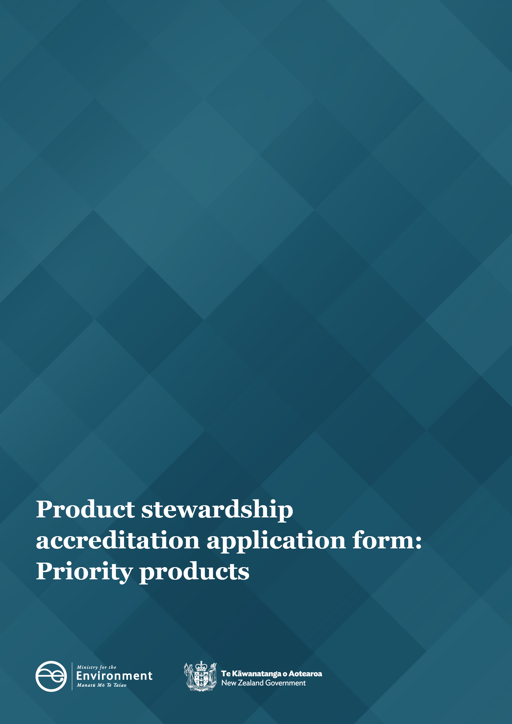

|  |  |  |
| --- | --- | --- |
| PART A: Applicant details | | |
| This part provides information about your organisation, including its legal name, legal entity status and contact details. See the Guide for applicants for information on how to complete this form. | | |
| 1. Organisation details – Ministerial Guidelines, Expected Product Stewardship Scheme Contents (1)a.i. | | |
| Organisation name  Not-for-profit entity name |  | |
| Organisation registration number  Certificate of incorporation |  | |
| Address  Including postcode | Physical address | Postal address |
| Telephone |  | |
| Website address  Including social media if applicable |  | |

|  |  |
| --- | --- |
| 1. Key personnel contact details – WMA section 14(a) | |
| Primary contact name  Name of Scheme Manager |  |
| Role or job title |  |
| Email |  |
| Telephone |  |
| Secondary contact name |  |
| Role or job title |  |
| Email |  |
| Telephone |  |

|  |  |
| --- | --- |
| PART B: Scheme details | |
| This part provides information about the scheme. Include the scheme name, what product(s) the scheme will address, life of the scheme and how the scheme operates. | |
| 1. Scheme overview | |
| Product category – WMA section 14(b)  Select all that apply. | tyres  electrical and electronic products  refrigerants and other synthetic gases  agrichemicals and their containers  farm plastics  plastic packaging  other please state: |
| Product stewardship scheme name *(optional)* |  |
| Description – WMA section 14(b) *(approximately 200 words).*  Provide a brief description of the problem, solution and how the scheme aims to manage the environmental impact of the product during its life cycle. |  |
| Scope – WMA section 14(b)  What specific products (including legacy and orphan products) will be included in the scheme? |  |
| Out-of-scope – WMA section 14(b)  What specific products will be excluded from the scheme (if applicable)? |  |
| Expiry date – WMA section 14(g) | seven years after Minister accreditation or  state the specific date: |
| 1. Collection and processing network | |
| Describe the service network required to operate the scheme, including the geographical coverage of the scheme. Clearly identify how products will be collected and recovered, whether all products will be available for collection at the start of the scheme or phased in. If products are phased in explain how and when they will be brought into the scheme. | |
| Collection and processing network – WMA section 14(f)(ii) and Ministerial Guidelines 4(1)a.ii.   * *Provide a detailed summary of how the scheme operates, including how the scheme either promotes waste minimisation and/or achieves a reduction in environmental harm from disposal of the product.* * *Outline how the scheme will increase end-of-life management of the product higher up the waste hierarchy.* | |
| Location/geographical coverage of the scheme – WMA section 14(b) and Ministerial Guidelines 4(1)b.ii.  Outline the geographical coverage of the scheme and describe how the scheme will achieve free and convenient collection, including for rural populations. | |
| Legacy and orphan products – Ministerial Guidelines 4(1)b.iii.  How will the scheme address legacy and orphan products? | |
| Infrastructure and network collaboration – Ministerial Guidelines 4(1)d.i.  Outline how the scheme will optimise use of existing and new collection and processing infrastructure and networks, and co-design and integration between product groups. | |
| New Zealand’s international obligations – WMA section 15(1)(d) and Ministerial Guidelines, Expected Product Stewardship Scheme Contents (1)b.v.  Where possible provide details of how the scheme meets all relevant international obligations relating to environment, trade and human rights.  Outline the scheme’s ability to obtain new permits, and/or identify existing permits held, for all activities in New Zealand in relation to the processing and potential export of the product(s) or their constituent components. | |
| 1. Regulations – WMA section 13(2)(e) | |
| Will regulations be required to implement the scheme? | No (move to question 6)  Yes, please add more details in the table(s) below. |

|  |  |  |
| --- | --- | --- |
| **Obligation to participate under WMA section 22(1)(a) (optional)**  If applicable, provide details on what the scheme participants are required to do to sell their product in the New Zealand market if regulations were made under WMA section 22(1)(a). | | |
| Scheme participants | Who is in this group?  *Describe the parties in this group* | To act in accordance with the scheme, all participants must:  *What do you want the scheme participant to do (or not do)?* |
|  |  |  |
|  |  |  |
|  |  |  |
|  |  |  |
|  |  |  |

|  |  |  |  |  |
| --- | --- | --- | --- | --- |
| **Other regulation(s)**  Complete the below table if you selected Yes in question 5. Describe what regulation(s) are required to implement the scheme. Also consider what part of the scheme requires regulation, who the rule(s) apply to, what they must or must not do, when the rule(s) would apply, and what happens if they do not meet the regulation(s). | | | | |
| Regulation  *State the applicable WMA section* | Problem definition  *Define what problem the regulation will resolve* | How will the regulation bring about the desired change?  *Why is this the preferred option, is it feasible?* | Benefits and costs  *Who are the expected beneficiaries and what is the nature of the benefit? Where do the costs fall?* | Risks and mitigations  *What are the likely risks and unintended impacts? How significant are they and will they be minimised or mitigated?* |
|  |  |  |  |  |
|  |  |  |  |  |
|  |  |  |  |  |
|  |  |  |  |  |

|  |  |
| --- | --- |
| 1. Health, safety and wellbeing – Ministerial Guidelines, Expected Product Stewardship Scheme Contents, (1)b.iv. | |
| Health, safety and wellbeing  Specify how people involved in the scheme will be suitably trained for their roles, including best practice in prevention and reduction of harm to people and environment. | |
| 1. Existing schemes – Ministerial Guidelines, Expected Product Stewardship Scheme Contents, (1)a.v. | |
| Outline the partnership and collaboration across multiple schemes (if applicable). | |
| Are there any existing and/or proposed product stewardships schemes for your product?  If yes, please continue to answer the questions in this section.  If no, please move to Part C. | Yes  No |
| Describe existing scheme(s)  A brief description of the existing scheme and how it manages the environmental impact of the product during its life cycle. | |
| Collaboration with existing scheme(s) – Ministerial Guidelines, Expected Product Stewardship Scheme Contents, (1)a.v.a.  What agreements are in place with the existing scheme, including how the schemes will cooperate, optimise infrastructure and how the scheme(s) will be communicated to users. | |
| Benefit of multiple schemes – Ministerial Guidelines, Expected Product Stewardship Scheme Contents, (1)a.v.b.  What is the net community and environmental benefit of multiple schemes (including any cost savings)? | |
| Gap and risk assessment – Ministerial Guidelines, Expected Product Stewardship Scheme Contents, (1)a.v.b.  Identify the gaps and risks (if any) between your scheme and existing scheme(s). | |

|  |
| --- |
| PART C: Scheme objectives |
| This part outlines what the scheme will achieve (i.e., what difference the scheme will make to New Zealand and New Zealanders) and the measures year on year you will use to show the scheme is on track to achieve success. |
| 1. Baseline data – WMA section 15(1)(c) |
| Current waste data  Outline the current levels of waste generated for this product in New Zealand. State whether data is based on estimates or actuals. Measurements may be based upon weight, litres or number of units. |
| Methodology for calculating waste data  Describe how the waste data is calculated. If the current waste data are estimates, explain how data will be captured by the scheme. |

|  |  |  |  |  |  |  |  |
| --- | --- | --- | --- | --- | --- | --- | --- |
| 1. Objectives – WMA sections 14(c), 15(1)(b) and Ministerial Guidelines, Expected Product Stewardship Scheme Contents, (1)c. | | | | | | | |
| List your scheme objectives and targets. Ensure objectives are SMART (specific, measurable, achievable and relevant within the timeframe of the scheme). | | | | | | | |
| Objective  *Describe the tangible outcomes your scheme is trying to achieve* | | Target  *Measurable values that show progress towards objective* | | Timeframe  *Realistic and achievable timeframes* | | Monitoring targets  *Describe how you will measure and monitor the targets* | |
|  | |  | |  | |  | |
|  | |  | |  | |  | |
|  | |  | |  | |  | |
|  | |  | |  | |  | |
| 1. Risk management (optional) | | | | | | | |
| Describe potential risks that may adversely affect the performance of the scheme and how these risks will be managed. Where possible, give an indication of the likelihood and significance of the risk and any mitigation strategies to be included in the scheme. | | | | | | | |
| Potential risk  *Identify the potential risk* | Likelihood of risk occurring  *Low, medium or high* | | Consequence on scheme  *Minor, moderate or severe* | | Impact on scheme  *Describe the impact the risk would have on the scheme if it occurred* | | Strategy to mitigate  *Describe what will be done to mitigate and/or manage the risk* |
|  |  | |  | |  | |  |
|  |  | |  | |  | |  |
|  |  | |  | |  | |  |
|  |  | |  | |  | |  |
|  |  | |  | |  | |  |
|  |  | |  | |  | |  |
|  |  | |  | |  | |  |
|  |  | |  | |  | |  |
|  |  | |  | |  | |  |

|  |  |
| --- | --- |
| PART D: Participants | |
| This part outlines all the groups and individuals who will be impacted and/or involved in the scheme and what formal agreements are held. | |
| 1. Scheme users – WMA section 14(d) | |
| List the scheme users who will be impacted and/or involved in the scheme and the nature of their involvement. Scheme users referred to in the WMA as ‘classes of person’ are organisations/groups or individuals who have not signed an agreement to participate in the scheme but are crucial to the success of the scheme. | |
| Organisation/group/individual name | Nature of involvement |
|  |  |
|  |  |
|  |  |
|  |  |
|  |  |
|  |  |

|  |  |  |  |
| --- | --- | --- | --- |
| 1. Scheme participants – WMA section 14(e) | | | |
| List the scheme participants who will be involved in the scheme and the nature of their involvement, including how they will contribute to meeting scheme objectives. Scheme participants are parties or partner organisations required to participate in the scheme under legislation, to ensure the scheme’s success, or they have opted to take part in the scheme. Examples include importers, manufacturers, producers, retailers, collectors and recyclers. | | | |
| Organisation name | Contact details  *Key contact, address, email, telephone* | Role and responsibilities  *Including how they will contribute to meeting scheme objectives* | Nature of involvement  *Provide supporting documents where applicable* |
|  |  |  |  |
|  |  |  |  |
|  |  |  |  |
|  |  |  |  |
|  |  |  |  |
|  |  |  |  |
|  |  |  |  |
|  |  |  |  |

|  |
| --- |
| 1. Compliance and performance – WMA section 14(h) |
| Identify and describe the processes for compliance and enforcement of any agreements between participants to the scheme. |

|  |
| --- |
| PART E: Governance |
| This part outlines leadership and decision-making, and how the governance group will carry out their duties and responsibilities in accordance with the highest professional standards. |
| 1. Governance arrangements and organisation structure – WMA section 14(f) and Ministerial Guidelines, Expected Product Stewardship Scheme Contents (1)a.iii., iv. and vi. |
| Describe the governance structure that will be implemented to ensure monitoring and management of scheme performance and effective decision-making occurs. Include key positions, roles and responsibilities, and detail how information flows between the product stewardship organisation and the governance board. |
| Governance arrangements – WMA section 14(f)(i) and (ii)  Describe how the governance structure meets best-practice guidelines for governance. Clearly outline who is responsible for:   * *making decisions* * *control and overall operation* * *monitoring and reviewing.* |
| Commerce Commission guidelines – Ministerial Guidelines, Expected Product Stewardship Scheme Contents, (1)a.iv.  *Describe how the governance arrangements will adhere to the Commerce Commission guidelines on collaborative activities between competitors.* |
| Transitional arrangements – Ministerial Guidelines, Expected Product Stewardship Scheme Contents, (1)a.iii.  *Outline the transitional arrangements, plans and preparations that will be in place before the scheme is fully operational (if applicable).* |
| Representation and appointment process – Ministerial Guidelines, Expected Product Stewardship Scheme Contents, (1)a.vi.  Outline how the directors or governance boards will:   * *be appointed* * *represent interests of producers, consumers and wider community* * *follow governance best-practice guidelines.* |
| Organisational structure – WMA section 14(f)(i) and (ii)  Describe how information flows between levels within the organisation and governance group.  Submit an organisational chart as supporting evidence. |
| 1. Procurement and record keeping – WMA section 14(f)(iii) and Ministerial Guidelines, Expected Product Stewardship Scheme Contents, (1)b.i. |
| Record-keeping and confidential data management – WMA section 14(f)(iii), Ministerial Guidelines Expected Product Stewardship Scheme Contents (1)b.iii  Describe how information will be managed within your scheme, including management of commercially sensitive and/or confidential information. |
| Procurement – Ministerial Guidelines Expected Product Stewardship Scheme Contents (1)b.i.  Demonstrate how the scheme will procure services using transparent, non-discriminatory and competitive processes. |

|  |
| --- |
| PART F: Communications and reporting |
| This part outlines how you will promote the scheme, engage with scheme users and report on the scheme’s performance. |

|  |
| --- |
| 1. Community and scheme user engagement – WMA section 14(j) and (k) and Ministerial Guidelines 4(1)c.i. and Expected Product Stewardship Scheme Contents, (1)b.ii. |

|  |
| --- |
| Community and scheme-user engagement  *Outline the high-level communication tactics that will be used to promote the scheme. Include how you will inform scheme users on how the scheme works, how it is funded and how to find the nearest collection point.* |

|  |  |  |  |  |
| --- | --- | --- | --- | --- |
| 1. Communication strategy – WMA section 14(j) and (k) and Ministerial Guidelines 4(1)c.i. and Expected Product Stewardship Scheme Contents (1)b.ii. | | | | |
| Outline how the scheme provides clear, regular communication to consumers, businesses and service providers (scheme users and scheme participants  – as listed in part D). | | | | |
| Audience  *Who?* | Key message/desired response  *What do we want them to think/do? What information do they need?* | Key promotional activity  *How will the information be made available?* | Frequency of key promotional activity  *When and how often?* | Roles/responsibilities  *Who is responsible for the key promotional activity?* |
|  |  |  |  |  |
|  |  |  |  |  |
|  |  |  |  |  |
|  |  |  |  |  |
|  |  |  |  |  |
|  |  |  |  |  |
|  |  |  |  |  |
|  |  |  |  |  |
|  |  |  |  |  |

|  |  |
| --- | --- |
| 1. Public accountability and reporting requirements – WMA section 14(i) and Ministerial Guidelines 4(1)c. and Expected Product Stewardship Scheme Contents (1)a.ii and c. | |
| Public annual report – section 14(i) and Ministerial Guidelines 4(1)c.  *Outline the process for writing your public annual report. Include how your scheme will measure financial performance (and cost effectiveness), environmental performance, agreements with scheme service providers and performance against outcomes and achievement of targets.* | |
| Transparent chain of custody – Ministerial Guidelines 4(1)c.ii.  Describe how you will ensure the public will have oversight on what happens to collected and processed materials, to both onshore and to offshore processors, and published mass balances showing rates of reuse/recycling or environmentally sound disposal of the priority products. | |
| Annual report *timeframe* (optional)  Please indicate if your scheme has a preferred timeframe for the annual report eg, calendar year, financial year, anniversary of the scheme’s accreditation, other. |  |

|  |
| --- |
| PART G: Environmental impact |
| This part provides more detailed information about the product life cycle and how the scheme aims to improve the environmental impacts. |
| 1. Environmental impact – WMA section 15(1)(c) and Ministerial Guidelines 4(1)a.i. |
| Describe the products environmental impact – WMA section 15(1)(c)  Provide a high-level description of the environmental impact of the product considering its design, manufacturing, use and end-of-life impacts with an emphasis on impacts in New Zealand (where appropriate). |
| Circular resource use – Ministerial Guidelines 4(1)a.i.  *Outline how the scheme will continually improve its environmental harm and maximise benefits at the product’s end of life.* |

|  |  |  |  |  |  |
| --- | --- | --- | --- | --- | --- |
| PART H: Funding | | | | | |
| This part outlines how the scheme will be funded. | | | | | |
| 1. Funding model – WMA section 14(l) and Ministerial Guidelines 4(1)b. | | | | | |
| Describe how the scheme will be funded.  Provide a breakdown of all estimated scheme-related income and expenditure for each year of the scheme (exclusive of GST). Outline how the net costs of the end-of-life products will be met by the scheme including free and convenient collections, and management of legacy and orphaned products. | | | | | |
| 1. Product stewardship fee – WMA section 23(1)(d) and (j) | | | | | |
| Does the scheme require regulation to set the product stewardship fee? | | No (if no, move to question 24)  Yes (move to next question) | | | |
| Describe the product stewardship fee.  *Outline who must pay the fee, when the fee must be paid, how the fee is calculated and who will collect the fee.* | | | | | |
| 1. Activities covered by the product stewardship fee – WMA section 23(1)(d)(iii) | | | | | |
| Describe the activities (expense categories) covered by the product stewardship fee. For example: Product stewardship organisation, communications and marketing, administration (staff, overheads). | | | | | |
| Activity  *What is the expense category?* | | Process and/or services  *Describe the process or service provided by the activity.* | | | |
|  | |  | | | |
|  | |  | | | |
|  | |  | | | |
|  | |  | | | |
|  | |  | | | |
|  | |  | | | |
| 1. Costings of the activities – WMA section 23(1)(d)(iii) | | | | |
| From the activities identified in question 22, describe the outputs, and direct or indirect costings on an annual basis (GST exclusive).   * Outputs are the amount of something produced by a person, machine or industry. * Direct costings are costings that can be directly attributed to the output. * Indirect costings are costings that cannot be directly attributed to the output and are apportioned on a suitable basis. | | | | |
| Activity | Output | | Direct or indirect costing | Cost per year  *(GST exclusive)* |
|  |  | |  | $ |
|  |  | |  | $ |
|  |  | |  | $ |
|  |  | |  | $ |
|  |  | |  | $ |
|  |  | |  | $ |
|  |  | |  | $ |
| **Total** | | | | **$** |
| 1. Investment in circular resource use – Ministerial Guidelines 4(1)a.iii. | | | | |
| Outline how the scheme will invest in initiatives to improve circular resource use, reusability, recyclability and new markets for the priority product. | | | | |

|  |
| --- |
| PART I: Supporting documentation |

|  |
| --- |
| 1. Additional information |

List documents referenced in your application that are attached to this application. Ensure the name of each attached document matches the name in this reference table.

**Do not** list, attach or send referenced reports.

|  |  |  |
| --- | --- | --- |
| Reference | Question(s) supported | How this document supports your application |
|  |  |  |
|  |  |  |
|  |  |  |
|  |  |  |
|  |  |  |
|  |  |  |
|  |  |  |
|  |  |  |
|  |  |  |
|  |  |  |

|  |
| --- |
| PART J: Declaration |

**Conflicts of interest (to be completed by the Scheme Manager)**

Does your organisation (including any personnel) have any perceived, actual or potential conflicts of interest in relation to this project?

Yes  No

If yes, state the nature of this conflict of interest and how it will be managed.

**Permission to undertake due diligence (optional)**

Do you give the Ministry for Environment permission to complete due diligence checks on all key persons named as part of the governance arrangements of this proposed product stewardship organisation?

Yes  No

**Declaration**

*This declaration must be completed by a person with the organisation’s signing authority.*

As a duly authorised representative of the organisation:

* I declare that to the best of my knowledge, the information contained in all sections of this application form, or supplied by us in support of our application, is complete, true and correct.
* I declare that I have the authority to sign this application form and to provide this information.
* I declare that the application is not being made by an organisation that is in receivership or liquidation, or by an undischarged bankrupt.
* I declare that I have provided information about any actual or potential conflicts of interest and I will promptly inform the Ministry for the Environment of any such conflicts if they arise following the submissions of this application.
* I understand that information presented to the Minister for the Environment and Ministry for the Environment is subject to disclosure under the Official Information Act 1982, other legislation, court orders, and in response to Parliamentary questions.
* I understand my rights in accordance with the Privacy Act 1993.

|  |  |  |  |  |
| --- | --- | --- | --- | --- |
| Name | |  | | |
| Position | |  | | |
| By typing your name in the space provided you are electronically signing this application form | Signature |  | Date |  |
|  |  |  |

Send your completed application to: [psaccreditation@mfe.govt.nz](mailto:psaccreditation@mfe.govt.nz)

Published in August 2022 by the   
Ministry for the Environment – Manatū Mō Te Taiao  
Publication number: INFO 1066