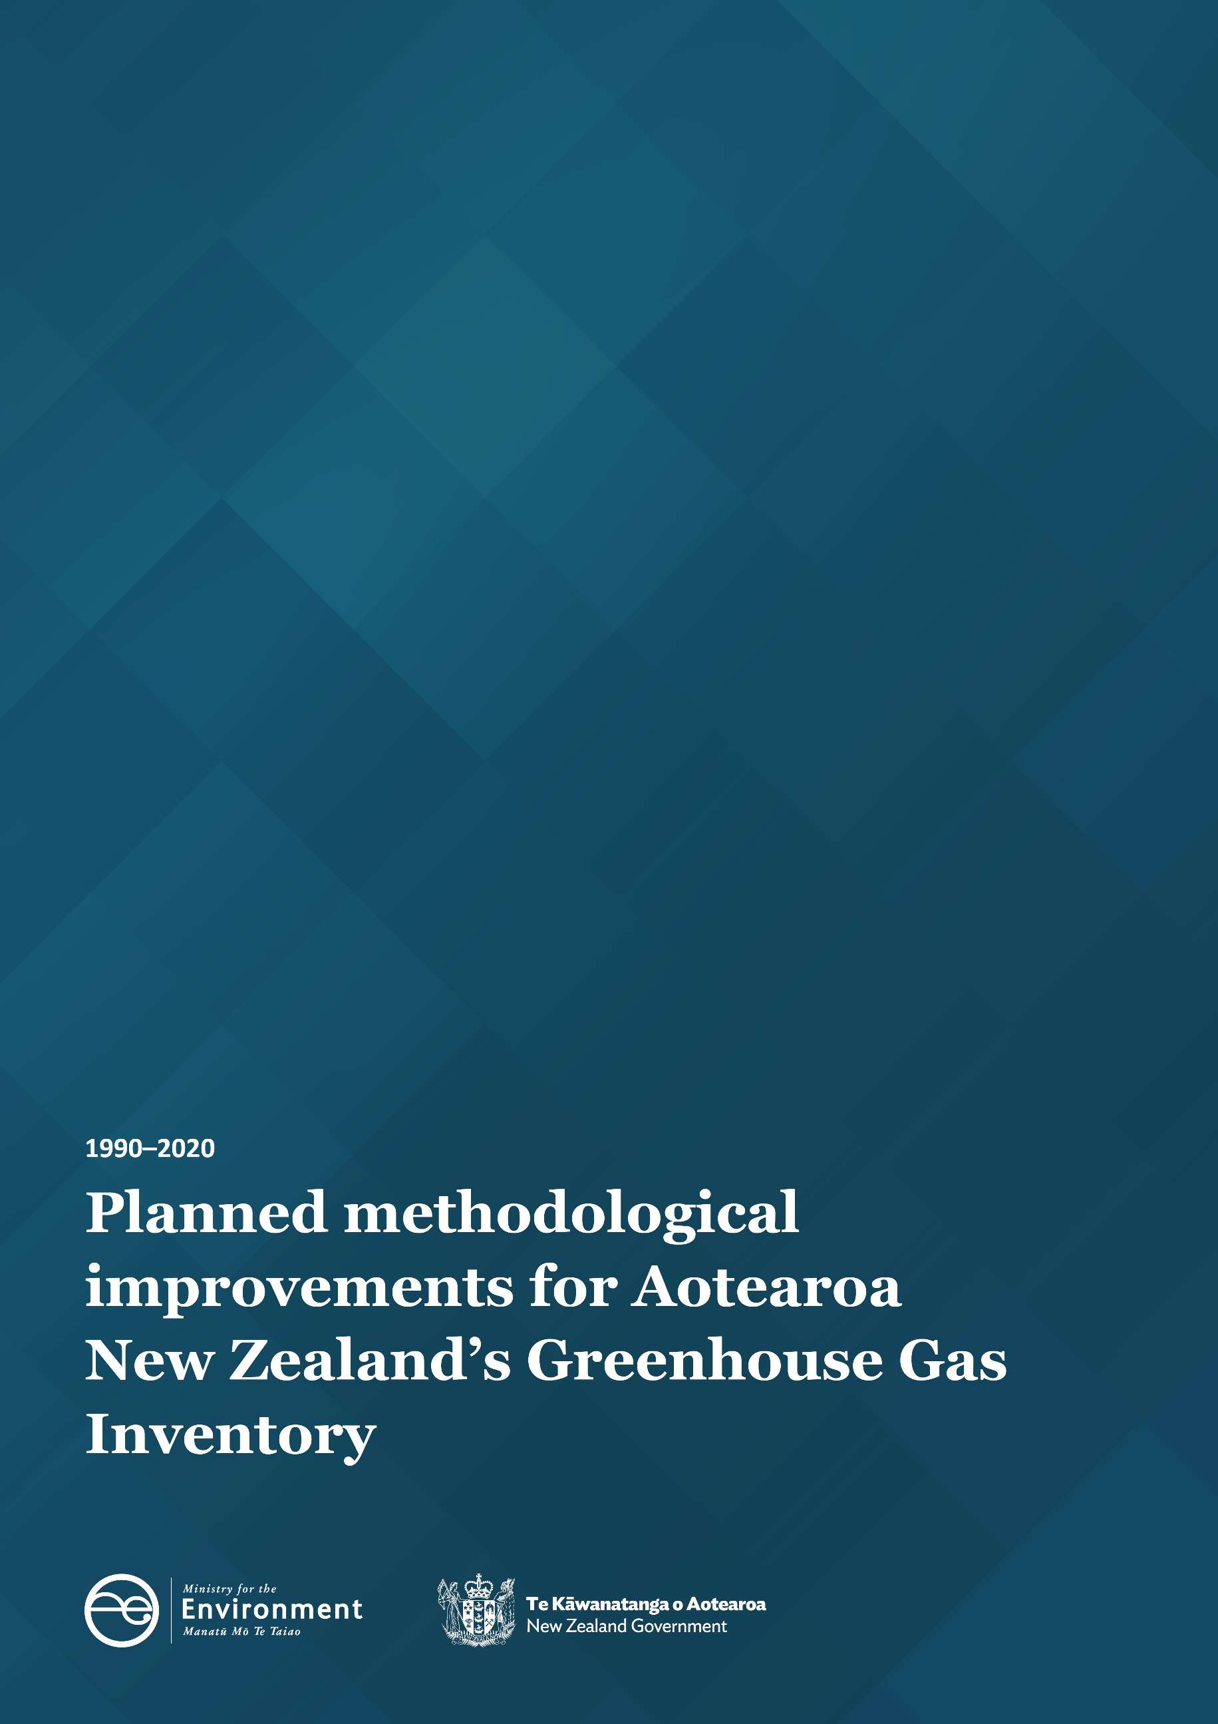
Planned Methodological Improvements for Aotearoa New Zealand’s Greenhouse Gas Inventory 1990-2020

Disclaimer
The information in this publication is, according to the Ministry for the Environment’s best efforts, accurate at the time of publication. The Ministry will make every reasonable effort to keep it current and accurate. However, users of this publication are advised that:
- The information does not alter the laws of New Zealand, other official guidelines, or requirements.
- It does not constitute legal advice, and users should take specific advice from qualified professionals before taking any action based on information in this publication.
- The Ministry does not accept any responsibility or liability whatsoever whether in contract, tort, equity, or otherwise for any action taken as a result of reading, or reliance placed on this publication because of having read any part, or all, of the information in this publication or for any error, or inadequacy, deficiency, flaw in, or omission from the information in this publication.
- All references to websites, organisations or people not within the Ministry are for convenience only and should not be taken as endorsement of those websites or information contained in those websites nor of organisations or people referred to.

This document may be cited as: Ministry for the Environment. 2022. Planned methodological improvements for Aotearoa New Zealand’s Greenhouse Gas Inventory 1990–2020. Wellington: Ministry for the Environment.

Published in March 2022 by the
Ministry for the Environment
Manatū Mō Te Taiao
PO Box 10362, Wellington 6143, New Zealand
ISBN: 978-1-99-102510-4
Publication number: ME 1623
© Crown copyright New Zealand 2022
This document is available on the Ministry for the Environment website: environment.govt.nz.

Contents
Contents 3
Tables 4
Introduction 5
Impacts of Improvements 6
Overall impact on emissions 8
Summary of Improvements by Inventory Sector 9
Energy 9
Agriculture 9
Waste 11
Land Use, Land-Use Change and Forestry (LULUCF) 11

Tables
Table 1: Provisional effect of proposed methodological improvements 6
Table 2: Comparison of total agricultural emissions estimates before and after incorporation of proposed FracLEACH values for 1990 and 2019 10
Table 3: Comparison of total agricultural emissions estimates before and after incorporation of proposed lime purity values, 1990 and 2019 10

Introduction
Aotearoa New Zealand’s National Greenhouse Gas Inventory (the “Inventory”) is the official annual report of all anthropogenic (human induced) emissions of greenhouse gases in New Zealand. The next Inventory will be published on 12 April 2022 as part of New Zealand’s obligations under the United Nations Framework Convention on Climate Change (UNFCCC) and Kyoto Protocol.
Every year, methodological improvements are made to the way emissions are estimated. This follows the Intergovernmental Panel on Climate Change (IPCC)’s guidelines for the preparation and continuous improvement of national greenhouse gas inventories.
In anticipation of the next Inventory, this report sets out the methodological changes that have been made this year and their estimated impact on emissions. The aim of this publication is to provide greater transparency around the improvement process and the changes that can be expected in the next Inventory due to them. We present a summary of the improvements and their impacts on emissions by sector.
Reasons for methodological improvements include – but are not limited to – meeting UNFCCC reporting requirements, aligning with IPCC methodologies, or in response to factors such as internal or external reviews. The figures presented in this report are provisional and exclude Tokelau.
The impacts of each methodological improvement on the 2019 emissions totals and the 1990 baseline year are given in Table 1. Estimated emissions are expressed in kilotonnes of carbon dioxide equivalents (kt CO₂-e) and represent the change to the total emissions estimates made in relation to last year’s Inventory estimates.
Each Inventory submission includes revised estimates across the time series back to 1990. This practice ensures consistency, and that the data series reflects the current trends in New Zealand’s greenhouse gas emissions. Year-on-year comparisons can only be made within an annual submission. Trends cannot be compared between or among submissions because methods used to estimate greenhouse gas emissions are continually improving. This report, therefore, outlines the improvements that will be introduced to the next Inventory submission, covering the years 1990–2020.

Impacts of Improvements
Table 1 shows the impact of methodological improvements being introduced in the next Inventory.
Table 1: Provisional effect of proposed methodological improvements
Sector | Improvement | Reason for improvement | Change in emissions (kt CO₂-e) |  | Impact on gross emissions |  | Impact on net emissions
 |  |  | 1990 | 2019 | 1990 | 2019 | 1990 | 2019
Energy | Reporting emissions from fireworks | Improve completeness and comparability to other countries | 0.2 | 0.4 | ~0.0% | ~0.0% | ~0.0% | ~0.0%
Agriculture | Adoption of updated Frac_{LEACH} values for cropping and grazing systems | Apply the results of new research and modelling, and align with IPCC guidelines | 1.3 | 1.8 | ~0.0% | ~0.0% | ~0.0% | ~0.0%
 | Purity of agricultural lime assumption updated | Align with IPCC guidelines | -63.0 | -96.0 | -0.1% | -0.1% | -0.2% | -0.2%
Waste | Revised method for deriving activity data for non-municipal landfills | Improve transparency | -19.6 | -6.8 | ~0.0% | ~0.0% | ~0.0% | ~0.0%
Land Use, Land-Use Change and Forestry | Revised method to classify tall and regenerating pre-1990 natural forest | Increase accuracy of pre-1990 natural forest estimates | 973 | 973 | - | - | 2.4% | 1.8%
 | Revised method to report on annual net carbon stock change in tall pre-1990 natural forest |  | 282.4 | 282.4 | - | - | 0.7% | 0.5%
 | Updated post-1989 and pre-1990 planted forest yield tables and application methods | Increase accuracy of planted forest estimates | -115 | 1,460 | - | - | -0.3% | 2.7%
 | Enabled average harvest age to change through time and expanded range | Increase accuracy of harvest and deforestation age class profiles and activity data | 1,700 | 100 | - | - | 4.1% | 0.2%
 | Improved method to determine planted forest harvest area from 2017 onwards
 | Improved deforestation age class profile for planted forest estate
 | Applying a consistent average harvest age across the planted forest estate
 | Reporting N₂O emissions estimates from drained organic soils in Forest Land | Improve completeness and align with IPCC guidelines | 78.0 | 121.7 | - | - | 0.2% | 0.2%
 | Reporting indirect N₂O emissions estimates from runoff and leaching |  | 40.8 | 17.6 | - | - | 0.1% | ~0.0%
Impact on gross emissions |  |  | -81.1 | -100.6 | -0.1% | -0.1% | - | -
Impact on net emissions |  |  | 2,878.1 | 2,854.1 | - | - | 7.0% | 5.2%

Overall impact on emissions
In total, the changes made to the methods that will be introduced in the 1990–2020 Inventory will decrease gross emissions in 1990 by 81.1 kt CO₂e and 100.6 kt CO₂e in 2019. The changes made will increase net emissions in 1990 by 2,878.1 kt CO₂e and 2,854.1 kt CO₂e in 2019. This is not an indication of the revisions to the figures as a whole, as it does not include annual variations in New Zealand’s emitting activities, for example national fuel use or forest harvest rate.

Summary of Improvements by Inventory Sector

Energy

Emissions from fireworks
Emissions estimates from the combustion of solid fuels in fireworks will be included in the next Inventory for the first time. Fossil fuels in fireworks are combusted to provide energy for propulsion, light and sound. Black carbon, coal, asphaltum and gilsonite are among these fossil fuels.
Emissions factors for CO₂, CH₄ and N₂O (kg/t fireworks) have been sourced from Denmark’s National Inventory Report, and data on the gross weight of fireworks imported have been sourced from New Zealand’s official data agency (Stats NZ). The emissions estimates from fireworks are low, but importantly, their inclusion improves reporting completeness, and comparability to other countries.
Applying this improvement to historical emissions years, the sector notes the level of emissions will increase by 0.23 kt CO₂-e in 1990 and 0.42 kt CO₂-e in 2019.

Agriculture

Adoption of updated Frac_{LEACH} values for cropping and grazing systems
Frac_{LEACH} values determine the amount of nitrogen (N) that is lost through leaching and runoff when applied to soils, and enable indirect N₂0 emissions to be calculated. Previous estimates did not include organic matter and crop residues as nitrogen inputs, and a uniform value of 0.07 had been assumed across cropping and grazing systems. New Frac_{LEACH} values aligning with IPCC guidelines and modelling using OVERSEER software have been developed. We will now apply a Frac_{LEACH} value of 0.10 to cropping systems while retaining a Frac_{LEACH} value of 0.07 for grazing systems. While the research suggested a Frac_{LEACH} of 0.08 for grazing systems, further analysis of the underlying assumptions is required before it is adopted within the inventory.
Applying this improvement to historical emissions years, agricultural emissions will increase 1.3 kt CO₂-e in 1990 and 1.8 kt CO₂-e in 2019, or 0.38 per cent and 0.45 per cent respectively. The change in emission outputs (+0.5 kt CO₂-e) between 1990 and 2019 demonstrates the applied improvements are reasonably consistent when backdated.
Table 2: Comparison of total agricultural emissions estimates before and after incorporation of proposed FracLEACH values for 1990 and 2019
Improvement impact | 1990  (kt CO₂-e) | 2019  (kt CO₂-e) | Change in emission outputs between 1990 and 2019 (kt CO2-e) | Percentage change in emission outputs between 1990 and 2019
2021 (1990-2019) emissions estimate with current Frac_{LEACH} values | 33,840.3 | 39,617.7 | 5,777.4 | 17.07%
2021 (1990-2019) emissions estimate with proposed Frac_{LEACH} values | 33,841.6 | 39,619.5 | 5,777.9 | 17.07%
Difference in emission estimates | 1.3 | 1.8 | 0.5
Percentage difference in emission estimates | 0.38% | 0.45%

Updated assumption applied to purity of agricultural lime
Liming is used throughout Aotearoa New Zealand to neutralise soil acidity. When soils are too acidic, they impact the solubility and availability of nutrients and result in poorer pasture production.
Previously it was assumed that agricultural lime was comprised of 100% calcium carbonate (CaCO₃). Recent research findings have updated this assumption to better reflect the impurity of agricultural lime and additionally, moisture content, given that the method to estimate emissions is based on dry weight. A correction factor of 82 per cent is now being applied to the total tonnage of agricultural lime used on soils.
Applying this improvement across the entire time series results in a decrease in agricultural emissions of 63 kt CO₂-e in 1990 and 96 kt CO₂-e in 2019, or 0.19 per cent and 0.24 per cent respectively. The change in emission outputs (-33 kt CO₂-e) between 1990 and 2019 demonstrates the applied improvements are reasonably consistent over time.
Table 3: Comparison of total agricultural emissions estimates before and after incorporation of proposed lime purity values, 1990 and 2019
Improvement impact | 1990  (kt CO₂-e) | 2019  (kt CO₂-e) | Change in emission outputs between 1990 and 2019 (kt CO₂-e) | Percentage change in emission outputs between 1990 and 2019
2021 (1990-2019) emissions estimate with current lime purity values | 33,840.3 | 39,617.7 | 5,777.4 | 17.07%
2021 (1990-2019) emissions estimate with proposed lime purity values | 33,841.6 | 39,619.5 | 5,777.9 | 17.07%
Difference in emission estimates | 1.3 | 1.8 | 0.5
Percentage difference in emission estimates | 0.38% | 0.45%
Improvements to Frac_{LEACH} values for cropping systems and updated assumptions to the purity of agricultural lime will only have a minor impact on agricultural emissions. These improvements result in an overall decrease in emissions of less than 0.3 per cent based on 2019 data.

Waste

Minor revisions to activity data method for non-municipal landfills
Previously, activity data required for estimating emissions from non-municipal landfills for 1950–2015 were derived from research and have been extrapolated out from 2016 onwards. An internal review of the research used to derive the 1950–2015 time series found there was a lack of documentation to describe the relationship between the source data and the resultant activity data that have been used to calculate emissions from this source. It also found that the methods used to extrapolate beyond 2015 were not able to be justified.
A new method, developed to quantify the relationship used to generate activity data for the 1950–2015 period, is being applied to this year’s Inventory. Activity data for 2016 onwards is being kept constant at 2015 levels. This will increase accuracy and overall transparency of emissions estimates from non-municipal landfills.

Land Use, Land-Use Change and Forestry (LULUCF)

Increased accuracy of pre-1990 natural forest estimates
Tall and regenerating pre-1990 natural forest area is currently classified using land cover data based on the Land Cover Database (LCDB). Carbon stock change, however, has been estimated using a species composition approach to classify plots. This method created a mismatch in assigning carbon stock change per hectare to this forest area. To correct this, the LCDB (for the 2008 map year) will now be used to classify the forest area as either tall or regenerating, and estimate the carbon stock and stock change associated with these forest types. This change will decrease the estimated CO₂ removals from pre-1990 regenerating forest by just under 1,000 kt CO₂-e per year. The land cover approach also allows for an adjustment to be made for estimating the regenerating forest area, which is currently under-sampled.
Tall natural forests have previously been reported as being in steady state because the analysis of annual net stock change found the change was not statistically significant for these forests at the national scale. A recent expert review finding recommends that the losses should be reported along with associated uncertainty occurring in this forest class, regardless of the statistical significance. This forest type is currently estimated to be losing carbon at a rate of 0.01 tonnes of carbon per hectare per year. This equates to an increase of emissions nationally of just under 300 kt CO₂-e per year across the time series.

Increased accuracy of planted forest land estimates
The method applied to estimate emissions when grassland with woody biomass (GWB) is converted to post-1989 natural forest has been improved to reflect more accurately what occurs in practice for this land use conversion. A revised yield table will be introduced for these conversions. The change will not impact net CO₂ removals by the time the forest reaches age 30, but will impact the year the reported emissions and removals occur in.
Post-1989 and pre-1990 planted forest yield tables have been revised to include forest plot data collected up until 2020, along with updated uncertainties. A new method to apply different yield tables to different forest cohorts was introduced in the last submission. This method is being revised for this year’s submission, by applying two yield tables instead of three. This results in an increase in net removals reported through the time series from 1990–2017 (ranging from approximately 2 kt CO₂-e to 2000 kt CO₂-e). Then from 2018 onwards, net removals are reduced by approximately 700–1200 kt CO₂-e.

Increased accuracy of harvest and deforestation age class profiles and activity data
Methods to improve accuracy of harvest and deforestation activity data have been improved. These improvements include:
- accounting for the change in the average harvest age through time
- expanding the harvest age profile to range from age 15–45 (previously 20–40)
- applying the same harvest profile and average harvest age to both post-1989 and pre-1990 forest
- improving the calculation to determine the harvest area of post-1989 and pre-1990 planted forest from 2017 onwards
- improving the deforestation age profile for pre-1990 and post-1989 planted forest.

Inclusion of N₂O emissions for drained organic soils in Forest land
Currently, N₂O emissions for drained organic soils are reported for Cropland and Grassland in the Agriculture sector. The LULUCF sector will include N₂O emissions for drained organic soils in Forest land in this year’s Inventory for the first time. An IPCC default emission factor will be applied to country-specific activity data, where conversions to Forest land have taken place on organic soils.
Applying the Forest land improvement back through the time series, emissions from the LULUCF sector will increase 78 kt CO₂-e in 1990 and 121.7 kt CO₂-e in 2019.

Inclusion of indirect N₂O emissions for runoff and leaching
Indirect N₂O emissions from runoff and leaching have previously only been reported for Cropland remaining Cropland in the Agriculture sector. Emissions from leaching and runoff have been estimated for all other land use categories for inclusion in this year’s Inventory for the first time. These emissions are associated with the mineralisation of N, and loss of soil carbon in mineral and organic soils which have taken place due to land-use change or management practices.
Applying this improvement will increase LULUCF sector emissions by 40.8 kt CO₂-e in 1990 and 17.6 kt CO₂-e in 2019.

Tokelau’s greenhouse gas emissions have been included since the 1990–2017 Inventory.
~0.0% indicates where a value is non-zero but is less than 0.05% in magnitude; a positive number indicates an increase on last year’s emissions estimates; a negative number indicates a decrease; all figures have been rounded to one decimal place.
Totals may not sum due to rounding.
Totals may not sum due to rounding.
www.overseer.org.nz/

