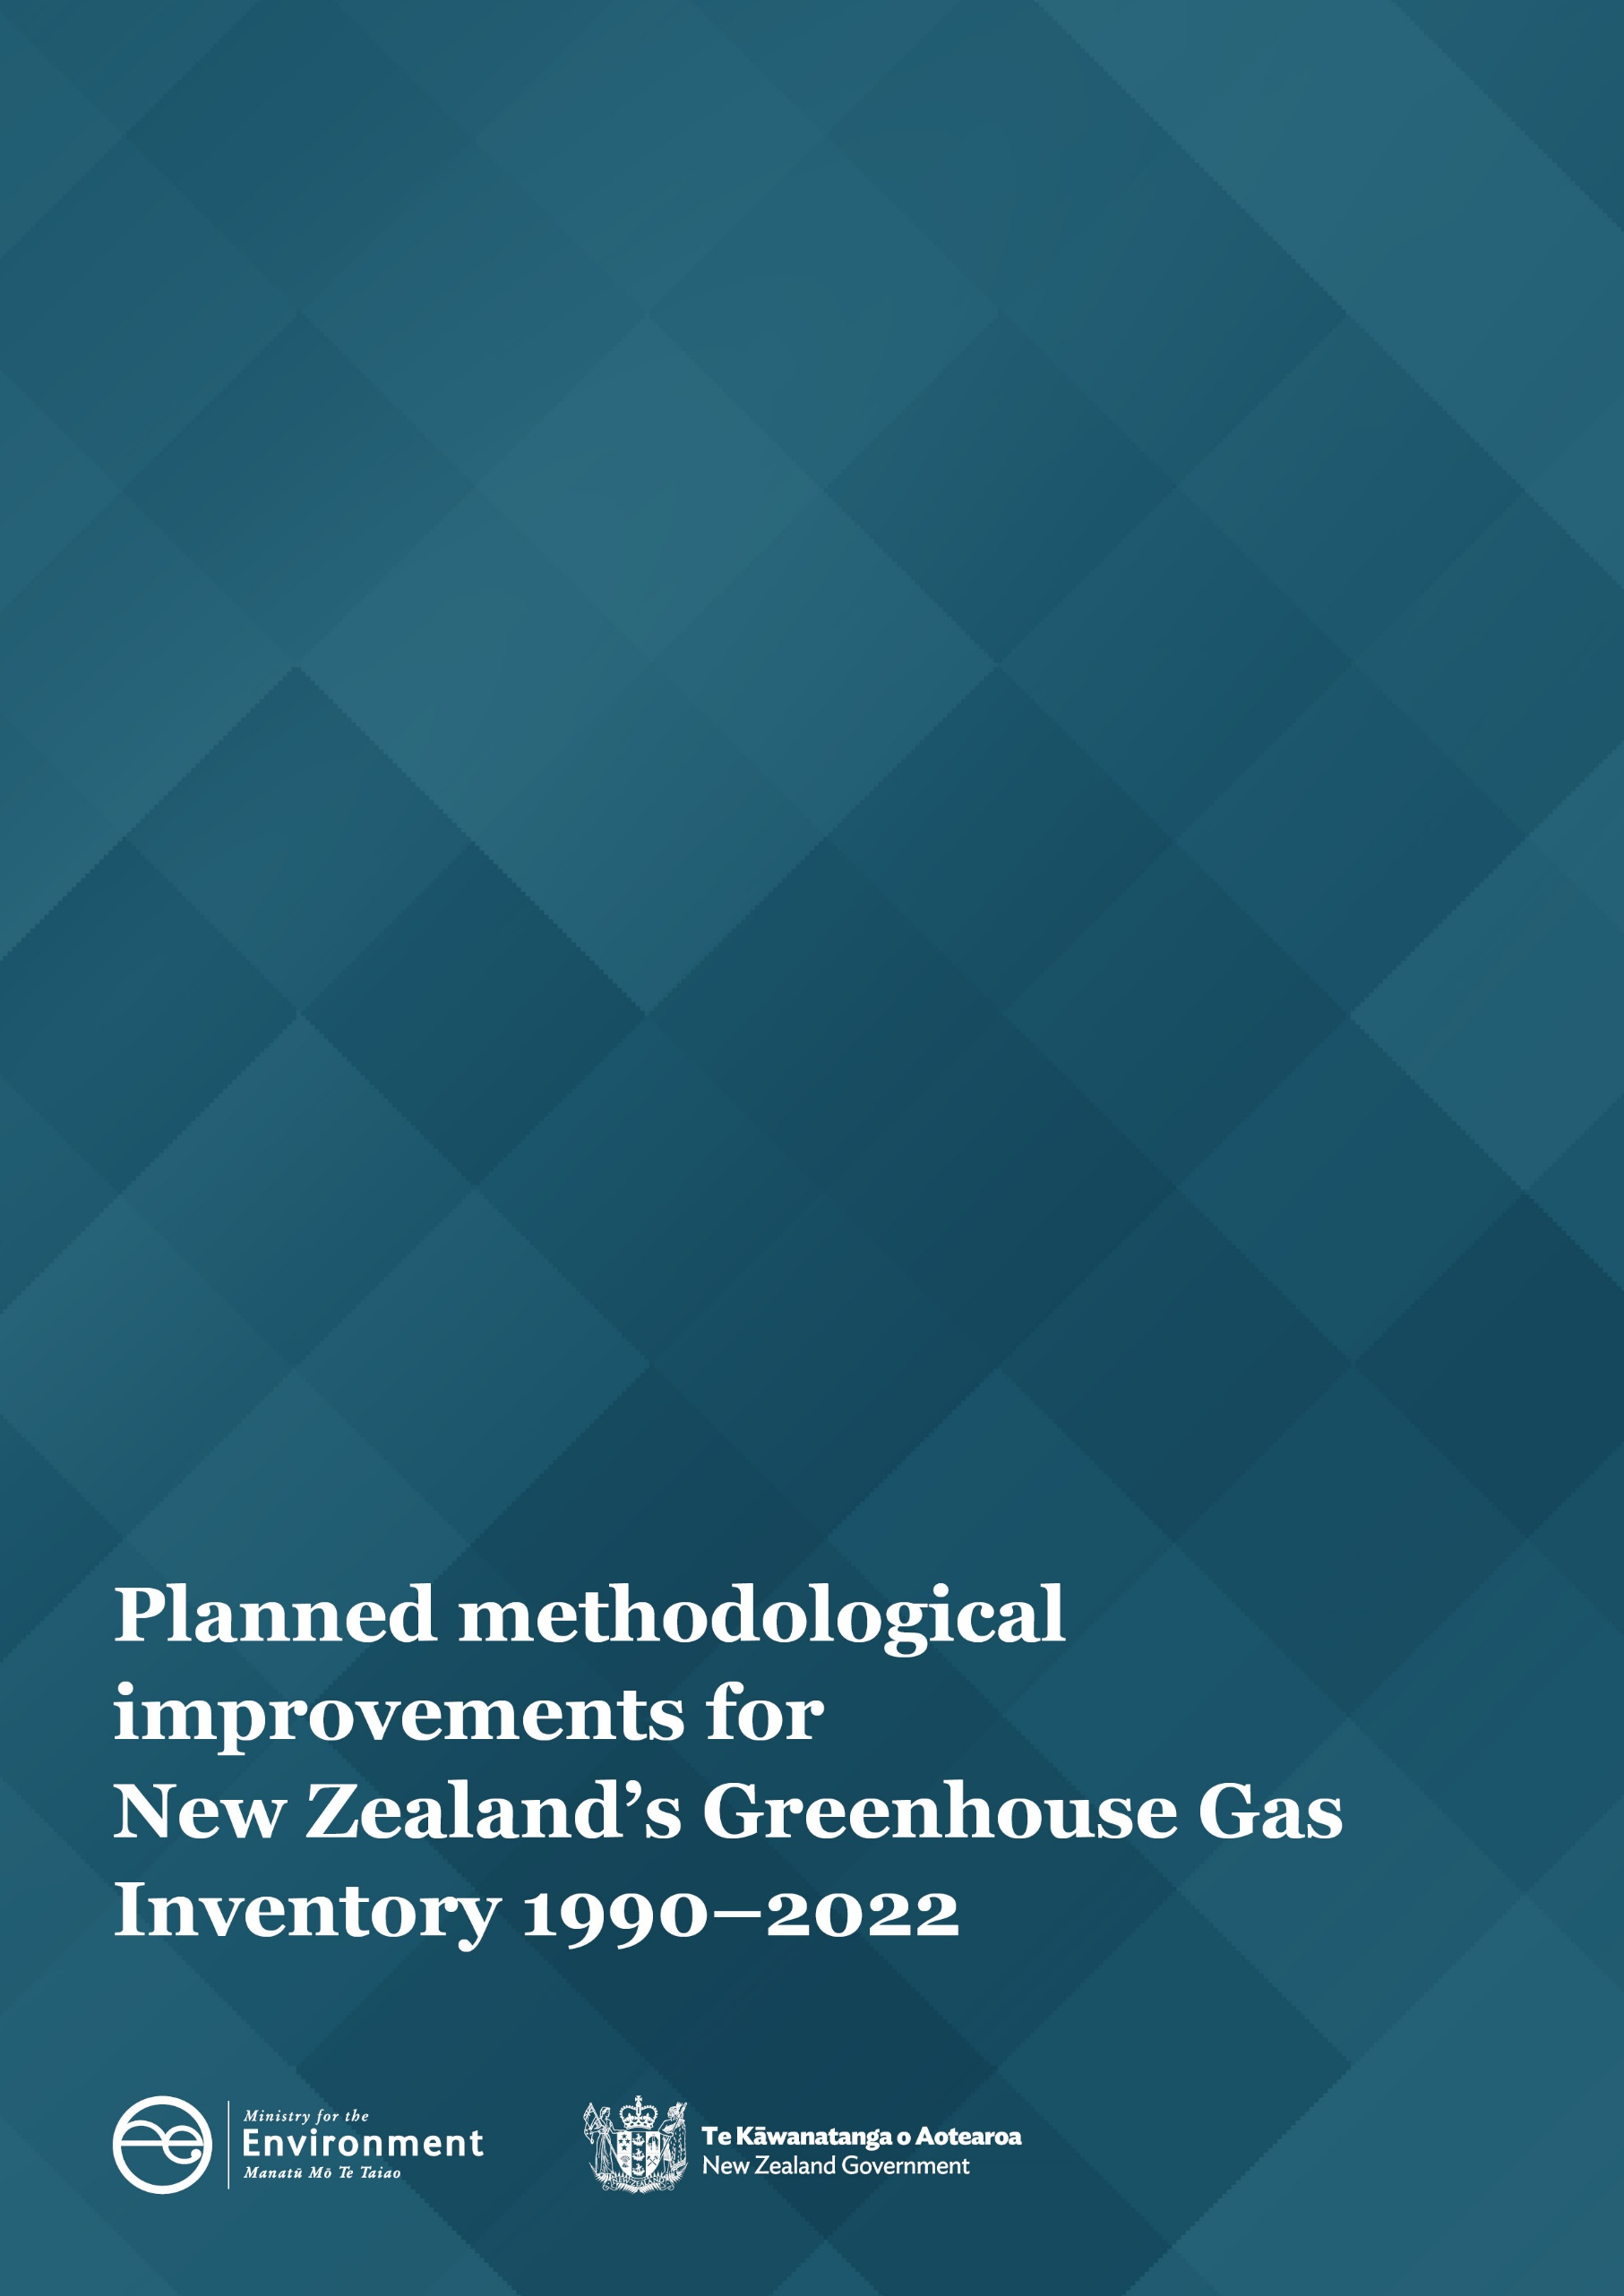

Disclaimer
The information in this publication is, according to the Ministry for the Environment’s best efforts, accurate at the time of publication. The Ministry will make every reasonable effort to keep it current and accurate. However, users of this publication are advised that:
- the information does not alter the laws of New Zealand, other official guidelines, or requirements
- it does not constitute legal advice, and users should take specific advice from qualified professionals before taking any action based on information in this publication
- the Ministry does not accept any responsibility or liability whatsoever whether in contract, tort, equity, or otherwise for any action taken as a result of reading, or reliance placed on this publication because of having read any part, or all, of the information in this publication or for any error, or inadequacy, deficiency, flaw in, or omission from the information in this publication
- all references to websites, organisations or people not within the Ministry are for convenience only and should not be taken as endorsement of those websites or information contained in those websites nor of organisations or people referred to.

This document may be cited as: Ministry for the Environment. 2024. Planned methodological improvements for New Zealand’s Greenhouse Gas Inventory 1990–2022. Wellington: Ministry for the Environment.

Published in February 2024 by the
Ministry for the Environment
Manatū Mō Te Taiao
PO Box 10362, Wellington 6143, New Zealand
environment.govt.nz
ISBN: 978-1-991140-07-4
Publication number: ME 1818
© Crown copyright New Zealand 2024
Contents
Introduction 3
Impacts of improvements 4
Overall impact on emissions 5
Summary of improvements by Inventory sector 6
Energy 6
Industrial Processes and Product Use 6
Agriculture 6
Waste 7
Land Use, Land-Use Change and Forestry 7

Introduction
New Zealand’s Greenhouse Gas Inventory (the “Inventory”) is the official annual report of all anthropogenic (human-induced) emissions of greenhouse gases in Aotearoa New Zealand. The next Inventory will be published on 18 April 2024 as part of New Zealand’s obligations under the Paris Agreement and United Nations Framework Convention on Climate Change (UNFCCC).
Every year, methodological improvements are made to the way emissions are estimated. This follows the Intergovernmental Panel on Climate Change’s (IPCC’s) guidelines for the preparation and continuous improvement of national greenhouse gas inventories.
In anticipation of the next Inventory, this report sets out the methodological changes that have been made this year and their estimated impact on emissions. The aim of this publication is to provide greater transparency around the improvement process and the changes that can be expected in the next Inventory due to them. We present a summary of the improvements and their impacts on emissions by sector.
Reasons for methodological improvements include – but are not limited to – meeting UNFCCC reporting requirements, aligning with IPCC methodologies, or a response to factors such as internal or external reviews. The figures presented in this report are provisional.
The impacts of each methodological improvement on the emissions totals for the most recently published year and the 1990 baseline year are given in the Impacts of improvements table. Estimated emissions are expressed in kilotonnes of carbon dioxide equivalents (kt CO₂-e) and represent the change to the total emissions estimates made in relation to last year’s Inventory estimates.
Each Inventory submission includes revised estimates across the time series back to 1990. This practice ensures consistency, and that the data series reflects the current trends in Aotearoa New Zealand’s greenhouse gas emissions. Year-on-year comparisons can only be made within an annual submission. Trends cannot be compared between or among submissions because methods used to estimate greenhouse gas emissions are continually improving.
Throughout this report, the impacts of the improvements are presented by applying 100-year time horizon global warming potential (GWP100) values from the IPCC Fifth Assessment Report: Climate Change 2013 (AR5) for both the previous and current submission to ensure a like-for-like comparison.
This report outlines the improvements that will be introduced to the next Inventory submission, covering the years 1990–2022.

Impacts of improvements
The below table shows the impact of methodological improvements being introduced in the next Inventory.
Sector | Improvement | Reason for improvement | Change in emissions  (kt CO₂-e) |  | Impact on gross emissions |  | Impact on net emissions
 |  |  | 1990 | 2021 | 1990 | 2021 | 1990 | 2021
Agriculture | Improvements to beef cattle population and liveweight estimates | To improve the accuracy of Inventory modelling estimates | 919.3 | 1,036.7 | 1.4% | 1.3% | 1.9% | 1.8%
 | Changing the assumed proportion of lambs held over to a second slaughter date | To utilise updated data to accurately reflect historical and current slaughter characteristics | -18.2 | 42.7 | ~-0.0% | 0.1% | ~-0.0% | 0.1%
Land Use, Land-Use Change and Forestry | Updated planted-forest yield tables | Incorporating new data to improve the overall accuracy of Inventory estimates | -330.8 | 383.2 | - | - | -0.7% | 0.7%
 | Modelling improvements for planted forests | To improve accuracy and time-series consistency between submissions | -3,898.8 | 216.9 | - | - | -8.2% | 0.4%
 | Mapping improvements for estimating deforestation | To improve the accuracy of deforestation activity data and Inventory estimates | 38.4 | 374.9 | - | - | 0.1% | 0.6%
 | Modelling process improvements within the Calculation and Reporting Application | To accommodate new mapping data and improve the overall accuracy and consistency of Inventory estimates | -22.5 | 86.6 | - | - | ~-0.0% | 0.1%
 | Updated Harvested Wood Products model | To reduce uncertainty of modelling estimates and improve overall accuracy | 43.2 | 167.8 | - | - | 0.1% | 0.3%
 | New land-use map | To improve accuracy of activity data | 46.7 | 54.1 | - | - | 0.1% | 0.1%
Notes: ~-0.0% indicates where a value is non-zero but less than 0.05% in magnitude. A positive number indicates an increase on last year’s emissions estimates. A negative number indicates a decrease on last year’s emissions estimates. All figures have been rounded to one decimal place.

Overall impact on emissions
In total, the changes made to the methods that will be introduced in the 1990–2022 Inventory will increase gross emissions in 1990 by approximately 1.3 per cent (901 kt CO₂-e) and 1.4 per cent (1,079 kt CO₂-e) in 2021. The changes made will decrease net emissions in 1990 by approximately 6.8 per cent (3,223 kt CO₂-e) and increase net emissions by 4.0 per cent (2,363 kt CO₂-e) in 2021.
This is not an indication of the revisions to the Inventory estimates as a whole, as it does not include changes to historical activity data or other data updates. In addition, these impacts also do not include the change in Global Warming Potentials (GWPs) that will be applied to aggregated emissions estimates from this year forward. The change in GWPs is required to meet reporting obligations under the UNFCCC and Paris Agreement (as further explained below).

Change in Global Warming Potentials
So that emissions of different greenhouse gases can be reported on a consistent basis, Aotearoa New Zealand’s estimated emissions of each non-carbon-dioxide greenhouse gas (methane, nitrous oxide, fluorinated gases) are expressed in terms of their carbon dioxide equivalent (CO₂-e), based on estimates of the different GWPs of each gas. The GWP for each gas is defined as its warming influence in relation to that of carbon dioxide over a particular time period.
In last year’s Inventory, aggregated emissions estimates were based on the 100-year time horizon GWP (GWP100) from the IPCC Fourth Assessment Report: Climate Change 2007 (AR4). Under the Paris Agreement and the UNFCCC, aggregated estimates are now required to be presented by applying the GWP100 values from AR5. From this year onwards, therefore, aggregated emissions estimates are based on the AR5 GWP100 values.
As non-carbon-dioxide emissions are a significant contributor to our national gross emissions total, this will increase the national total by around 4 to 5 per cent each year. This change will have the largest relative impact on the emission totals for the agriculture and waste sectors.

Summary of improvements by Inventory sector

Energy
No methodological changes are planned for the Energy sector in the 2024 Inventory submission.

Industrial Processes and Product Use
No methodological changes are planned for the Industrial Processes and Product Use sector in the 2024 Inventory submission.

Agriculture
Improvements to beef cattle population and liveweight estimates
The Agriculture Inventory Model (AIM) uses population modelling to calculate annual beef cattle emissions. The AIM applies several assumptions to determine the numbers of cattle present each month, such as assuming beef cattle are slaughtered at two years of age. Statistics on animal carcass weights are collected and used by the Ministry for Primary Industries (MPI) to derive liveweights. Research commissioned by MPI estimated that the current model underestimates lifetime greenhouse gas emissions from beef cattle by about 10 per cent.
Several improvements have been introduced to the AIM to increase the accuracy of beef cattle population and liveweight estimates. These include changing the national calving date and the slaughter dates of all classes. Key changes to the beef population model that impact all classes were:
- calculating an average population to use as the representative population for each month, rather than the value on the first of the month
- distributing the beef population reported in the Agricultural Production Survey differently to account for the new classes.
Applying this modelling improvement will result in increases of approximately 919.3 kt CO₂-e in 1990 and 1,036.7 kt CO₂-e in 2021, a difference of approximately 2.6 per cent of agricultural sector estimates in both years. This increase occurs because the new modelling assumes (more accurately) that beef animals are living for longer.

Changing the assumed proportion of lambs held over to a second slaughter date
The AIM uses livestock slaughter data provided by meat processors to estimate liveweights of lambs at slaughter that are characterised by two slaughter dates each year. Research commissioned by MPI identified that the proportion of lambs held over to a second slaughter date has historically increased from 16 per cent (the current model) to approximately 22 per cent since 2010. The model has been updated to reflect the new research findings, by increasing the proportion of lambs held over to the second slaughter date from 14 to 22 per cent over the period 1990–2010 on a linear trajectory, followed by a constant 22 per cent thereafter.
Applying this improvement will result in a reduction in emissions of 18.2 kt CO₂-e in 1990 and an increase in emissions of 42.7 kt CO₂-e in 2021, or by -0.05 per cent and 0.11 per cent of agriculture sector estimates respectively.

Waste
No methodological changes are planned for the Waste sector in the 2024 Inventory submission.

Land Use, Land-Use Change and Forestry

Updated planted-forest yield tables
The planted-forest yield tables present nationally representative estimates of carbon stocks by forest age and are used to calculate emissions and removals from pre-1990 and post-1989 planted forests. These yield tables are periodically updated to integrate the latest analyses of data collected through the continuous national forest plot Inventory programmes.
The post-1989 and pre-1990 planted-forest yield tables used to generate planted-forest estimates in the 2024 Inventory submission have been updated by integrating data from the 2021 and 2022 planted-forest plot-measurement field seasons. The incorporation of these updates into the yield tables improves the overall accuracy of the Land Use, Land-Use Change and Forestry (LULUCF) Inventory estimates across the full reporting time series.
The impact of applying this methodological improvement on emissions estimates is variable across the time series. Total LULUCF emissions through the 1990s are reduced and from 2001 onwards are increased. The impact of the change in total emissions peaks in 2019 with a 6 per cent increase in emissions (975 kt CO₂-e) compared to the previous submission. This is driven by reduced estimated growth rates in mid-age pre-1990 planted-forest stands.
Applying this methodological improvement will result in a significant emissions reduction of approximately 330.8 kt CO₂-e in 1990 and an emissions increase of 383.2 kt CO₂-e in 2021.

Modelling improvements for planted forests
Several improvements have been introduced to the modelling of the harvesting in the planted-forest estate. The modelling improvements are grouped by highest to lowest impact on emissions estimates as follows:
- The harvest area profile across the 1980–1989 period has been constrained. Previously, due to model limitations, when a new year was added to the time series, the 1985–1989 harvest-area profile was forced to increase, changing the 1990 emissions estimate significantly from the previous submission. By constraining the harvesting across the 1980–1989 period, the model better reflects reality, and the emissions estimate for 1990 is stabilised between submissions.
- The methods have been revised to:
  - calculate the harvest age profile; and
  - calculate the new planting time series between 1962–1989.
- automate the process for determining harvest area and stand age on organic soils, making it easier to run the models to years beyond the current one.
Collectively, these modelling improvements for planted forests significantly improve the accuracy and consistency of the LULUCF Inventory estimates.
Applying these modelling improvements will result in a significant emissions reduction of approximately 3,898.8 kt CO2-e in 1990 and an emissions increase of 216.9 kt CO2-e in 2021.

Mapping improvements for estimating deforestation
Multispectral satellite imagery is used to identify and map afforestation and deforestation across Aotearoa, to quantify the greenhouse gas emissions and removals associated with these changes. All deforestation is now mapped up to 2020 and subsequent years are estimated using a trend-extrapolation approach.
The extrapolation method has been modified to tie the pre-1990 planted-forest deforestation estimates to the trend presented in the Afforestation and Deforestation Intentions Survey 2022 (Manley, 2023). This methodological change does not impact the total area of estimated deforestation but provides a more accurate method to allocate it between the pre-1990 and post-1989 planted-forest classes.
Applying this modelling improvement will result in emissions increases of approximately 38.4 kt CO₂-e in 1990 and 374.9 kt CO₂-e in 2021.

Modelling process improvements within the Calculation and Reporting Application
The Calculation and Reporting Application (CRA) is the modelling software used to process LULUCF data. The addition of a new land-use map for 2020 has required several modifications. The ingestion and transformation of the mapping data through interpolation and extrapolation models within the CRA has been improved to accommodate the new time series by:
- improving the interpolation model, including a new validation test which uncovered several issues that have now been addressed
- expanding the number of land-use change models to cover all possible combinations of land-use change occurring over time
- changing the way deforestation was treated and calculated within the multiple land-use change pathway from a ‘straight-line’ interpolation to the same approach as the standard pathway (i.e. using historical deforestation intention surveys).
Collectively, these improvements significantly improve the accuracy and consistency of the LULUCF Inventory estimates to align with the 2006 IPCC Guidelines for National Greenhouse Gas Inventories.
Applying these modelling improvements will result in an emissions decrease of approximately 22.5 kt CO₂-e in 1990 and an emissions increase of 86.6 kt CO₂-e in 2021.

Updated Harvested Wood Products model
An updated Harvested Wood Products (HWP) model has been developed for the 2024 Inventory submission which incorporates New Zealand-specific weighted half-life values for HWPs produced and consumed in both the domestic and export markets. The model was also extended to allow half-lives to be set up for HWPs by end-use category and enable projections to 2080.
Applying this modelling improvement will result in an emissions increase of approximately 43.2 kt CO₂-e in 1990 and 167.8 kt CO₂-e in 2021.

New land-use map
A new land-use map (LUM 2020) has been developed for the 2024 Inventory submission. This includes wall-to-wall mapping of land-use change up until 31 December 2020. The following methodological improvements have been introduced to LUM 2020:
  - revised methods applied to the mapping of mature planted forest throughout the LUM 2020 time series from 1990, based on independent mapping, using deep-learning techniques
  - revised methods applied to the mapping of Annual cropland and Grassland, based on time-series analysis of the frequency of cultivation visible in satellite imagery.
The cumulative impact of incorporating the new LUM will result in emissions increases of 46.7 kt CO₂-e in 1990 and 54.1 kt CO₂-e in 2021.

Afforestation and Deforestation Intentions Survey 2022. Wellington: Ministry for Primary Industries https://www.mpi.govt.nz/dmsdocument/57130-Afforestation-and-Deforestation-Intentions-Survey-2022 (1 August 2023).

