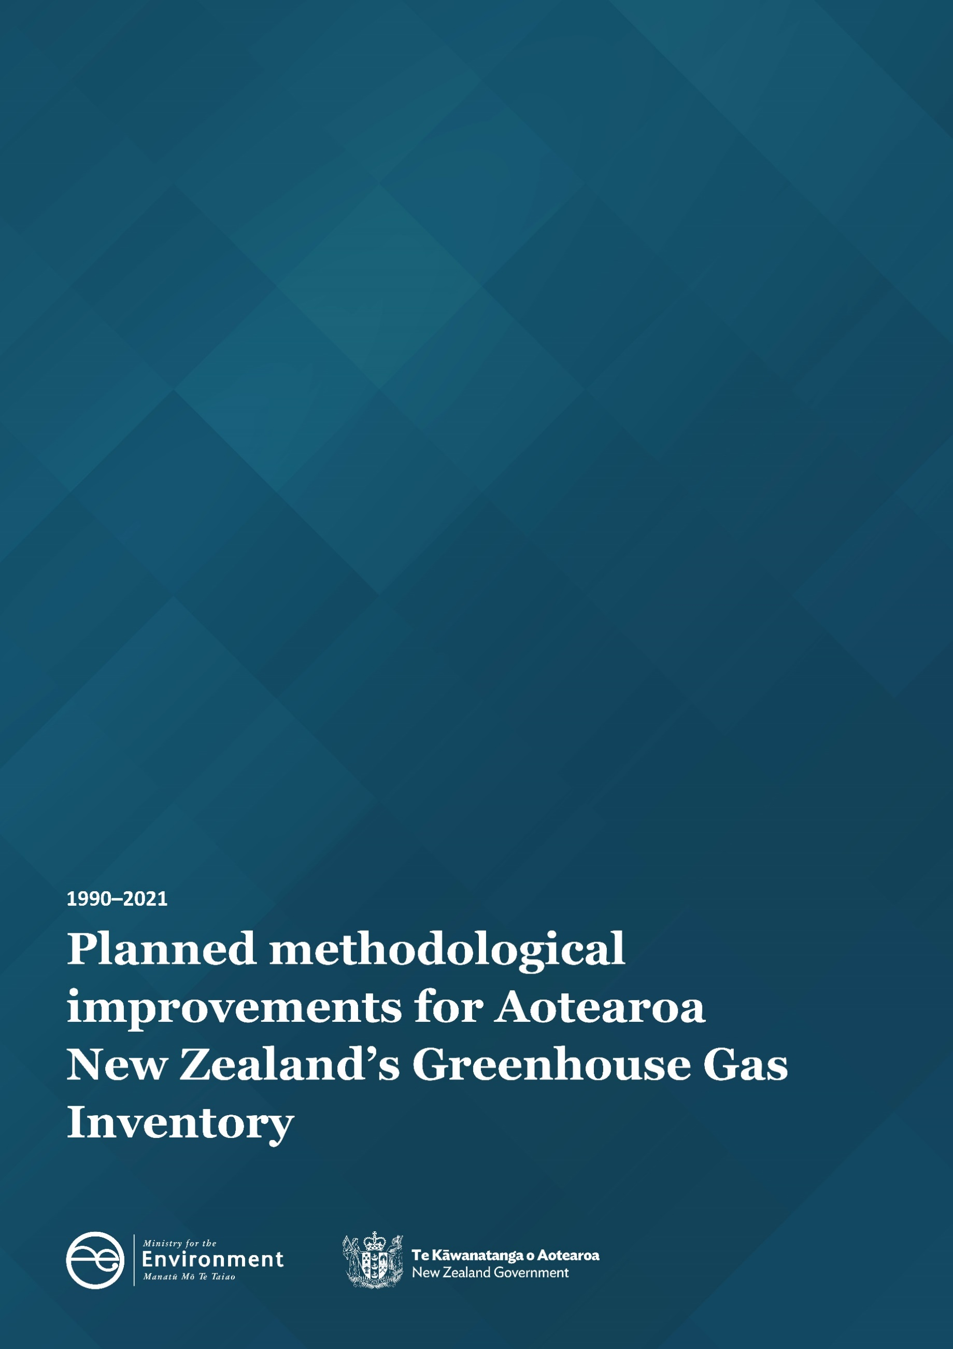

Disclaimer
The information in this publication is, according to the Ministry for the Environment’s best efforts, accurate at the time of publication. The Ministry will make every reasonable effort to keep it current and accurate. However, users of this publication are advised that:
- the information does not alter the laws of New Zealand, other official guidelines, or requirements
- it does not constitute legal advice, and users should take specific advice from qualified professionals before taking any action based on information in this publication
- the Ministry does not accept any responsibility or liability whatsoever whether in contract, tort, equity, or otherwise for any action taken as a result of reading, or reliance placed on this publication because of having read any part, or all, of the information in this publication or for any error, or inadequacy, deficiency, flaw in, or omission from the information in this publication
- all references to websites, organisations or people not within the Ministry are for convenience only and should not be taken as endorsement of those websites or information contained in those websites nor of organisations or people referred to.

This document may be cited as: Ministry for the Environment. 2023. Planned methodological improvements for Aotearoa New Zealand’s Greenhouse Gas Inventory 1990–2021. Wellington: Ministry for the Environment.

Published in February 2023 by the
Ministry for the Environment
Manatū Mō Te Taiao
PO Box 10362, Wellington 6143, New Zealand
environment.govt.nz
ISBN: 978-1-991077-31-8
Publication number: ME 1743
© Crown copyright New Zealand 2023

Contents
Introduction 4
Impacts of improvements 5
Overall impact on emissions 7
Summary of improvements by inventory sector 8
Energy 8
Industrial Processes and Product Use 9
Agriculture 9
Waste 10
Land Use, Land-Use Change and Forestry 11

Introduction
Aotearoa New Zealand’s National Greenhouse Gas Inventory (the “inventory”) is the official annual report of all anthropogenic (human induced) emissions of greenhouse gases in Aotearoa. The next inventory will be published on 13 April 2023 as part of Aotearoa New Zealand’s obligations under the United Nations Framework Convention on Climate Change (UNFCCC) and Kyoto Protocol.
Every year, methodological improvements are made to the way emissions are estimated. This follows the Intergovernmental Panel on Climate Change’s (IPCC’s) guidelines for the preparation and continuous improvement of national greenhouse gas inventories.
In anticipation of the next inventory, this report sets out the methodological changes that have been made this year and their estimated impact on emissions. The aim of this publication is to provide greater transparency around the improvement process and the changes that can be expected in the next inventory due to them. We present a summary of the improvements and their impacts on emissions by sector.
Reasons for methodological improvements include – but are not limited to – meeting UNFCCC reporting requirements, aligning with IPCC methodologies, or in response to factors such as internal or external reviews. The figures presented in this report are provisional.
The impacts of each methodological improvement on the emissions totals for the most recently published year and the 1990 baseline year are given in the impacts of improvements table. Estimated emissions are expressed in kilotonnes of carbon dioxide equivalents (kt CO₂-e) and represent the change to the total emissions estimates made in relation to last year’s inventory estimates.
Each inventory submission includes revised estimates across the time series back to 1990. This practice ensures consistency, and that the data series reflects the current trends in Aotearoa New Zealand’s greenhouse gas emissions. Year-on-year comparisons can only be made within an annual submission. Trends cannot be compared between or among submissions because methods used to estimate greenhouse gas emissions are continually improving.
This report outlines the improvements that will be introduced to the next inventory submission, covering the years 1990–2021.

Impacts of improvements
The below table shows the impact of methodological improvements being introduced in the next inventory.
Sector | Improvement | Reason for improvement | Change in emissions  (kt CO₂-e) |  | Impact on gross emissions |  | Impact on net emissions
 |  |  | 1990 | 2020 | 1990 | 2020 | 1990 | 2020
Energy | Begin reporting estimated emissions from the combustion of used tyres | To improve accuracy, completeness and comparability of inventory estimates | NA | NA | NA | NA | NA | NA
 | Revise estimated fugitive emissions from natural gas distribution networks | To improve accuracy and transparency of inventory estimates | 0.0 | -147.6 | 0.0% | -0.2% | 0.0% | -0.3%
Industrial Processes and Product Use | Hydrofluorocarbon stock model revision | To improve accuracy of inventory estimates | 0.0 | -35.5 | 0.0% | -~0.0% | 0.0% | -0.1%
Agriculture | Adoption of updated FracLEACH values for cropping and grazing systems | To be consistent with new research and modelling improvements, and to align with the 2006 IPCC Guidelines | 55.0 | 73.1 | 0.1% | 0.1% | 0.1% | 0.1%
 | Inclusion of non-pasture feed activities in the Agriculture Inventory Model (AIM) for dairy cattle, sheep, and beef operations | To capture emissions impacts of the inclusion of non-pasture feed use in Aotearoa New Zealand’s inventory estimates | -360.8 | -769.1 | -0.6% | -1.0% | -0.8% | -1.4%
 | Incorporate improved activity data for within-year dairy cattle population fluctuations | To more accurately estimate dairy cattle population emissions in inventory estimates | -231.5 | -488.1 | -0.4% | -0.6% | -0.5% | -0.9%
Land Use, Land-Use Change and Forestry | Improved modelling methods for estimating planted forest harvest and deforestation area | To improve accuracy of activity data and inventory estimates | -987 | -106 | NA | NA | -2.2% | -0.2%
 | Introduction of country-specific values for above and below ground biomass carbon stocks in vegetated wetlands | To improve completeness and accuracy of inventory estimates | -39 | -16 | NA | NA | -0.1% | -~0.0%
 | Changes to the method for estimating deforestation area in recent years | T improve accuracy of inventory estimates | -20 | -209 | NA | NA | -~0.0% | -0.4%
Notes: ~0.0% indicates where a value is non-zero but less than 0.05% in magnitude. A positive number indicates an increase on last year’s emissions estimates. A negative number indicates a decrease on last year’s emissions estimates. All figures have been rounded to one decimal place.

Overall impact on emissions
In total, the changes made to the methods that will be introduced in the 1990–2021 inventory will decrease gross emissions in 1990 by approximately 500 kt CO₂-e and 1,400 kt CO₂-e in 2020. The changes made will decrease net emissions in 1990 by approximately 1,600 kt CO₂-e and 1,700 kt CO₂-e in 2020.
This is not an indication of the revisions to the figures as a whole, as it does not include annual variations in Aotearoa New Zealand’s emitting activities, such as national fuel use or forest harvest rate.

Summary of improvements by inventory sector

Energy

Emissions from used tyres
Use of this non-standard fuel has not previously been reported in the inventory. In 2021, Golden Bay Cement started using used tyres as fuel in its cement kilns, which reduces the burning of coal.
We now require an appropriate fossil carbon emission factor to estimate the CO₂ emissions. A country/plant-specific emission factor has not yet been established and the 2006 IPCC Guidelines do not provide a default emission factor for used tyres. Based on a scan of all other national inventories, a CO₂ emission factor of 1,668 kg CO₂/t will be applied. For CH₄ and N₂O emissions, default IPCC emission factors for stationary combustion of industrial wastes in the Manufacturing Industries and Construction reporting category will be applied. The emissions estimates from used tyres are low, but their inclusion improves reporting accuracy, completeness, and comparability with other countries’ inventory estimates.
This improvement will not be applied to historical emissions years because this activity only began in 2021. Impacts to emissions estimations will begin from the 2021 inventory year onwards.

Revised estimated fugitive emissions from natural gas distribution networks
Historically, an assumed constant leakage rate of 1.75 per cent from total natural gas in distribution networks has been applied to estimate this source of emissions. Recent engagement with industry experts has revealed that the current estimate of the leakage rate from the modernised distribution pipelines in Aotearoa averaged 0.35 per cent over the period 2017 to 2021. Emissions estimates from 2017 onwards will adopt the new industry leakage estimates, while the 1990 estimate will be based on the previously assumed leakage rate of 1.75 per cent. The leakage rate for the intervening years will be interpolated.
This takes into consideration information supplied by industry experts surrounding the timing of the replacement of cast iron pipes and the monitoring of improvements. Early years would have seen larger reductions as older and leakier pipes were replaced first, followed by diminishing returns in later years.
The incorporation of this improvement will improve accuracy and transparency. The 2006 IPCC Guidelines state it is good practice to change methodology when the previously used method is insufficient to reflect mitigation activities in a transparent manner. Adopting this change will also preserve time series consistency and maintain credibility and comparability with other countries that have already migrated to higher tier methods to estimate fugitive leakage from natural gas systems.
Applying this improvement to recent emissions years will decrease emissions by 147.6 kt CO₂-e (-5.9 kt CH₄, -0.7 kt CO₂) in 2020, with no changes made to 1990 estimations.

Industrial Processes and Product Use

Hydrofluorocarbons (HFCs) stock modelling revision
This improvement updates the two models that are used to estimate the inventory emissions of HFCs when they are used as refrigerants in various sectors of the economy.
Currently, the ‘commercial refrigeration’ stock model covers all refrigeration equipment in industrial and commercial applications including retail, farming, food processing, and storage, while ‘supermarket refrigeration’ is represented by a separate stock model.
Recent research provides a more accurate picture of equipment retirement and the reuse of HFCs. The supermarket refrigeration stock model incorporates linear retirement assumptions whereby the turnover is assumed to be consistent over time. Research has identified that this is no longer a reasonable approach. Operators are managing equipment retirement as part of a strategy to progressively substitute reused refrigerants and HFCs with lower global warming potentials, and transition to substitute refrigerants.
The supermarket refrigeration stock model has been revised to factor in the differing retirement practices for supermarkets adopting these new approaches. The impacts can now be reflected more accurately in emissions estimates.
HFC emissions from the cool-store and industrial refrigeration sector will continue to be modelled separately through the commercial refrigeration stock model, as the quantities of refrigerant used and HFC management practices are less accurately known. Across all sectors, the models now distinguish and separately calculate the recovery of refrigerants for destruction and for reuse.
In addition to this, a reassessment and subsequent recalculation of emissions from HFCs that are imported in bulk and in equipment such as heat pumps has been carried out. The imports of these items have increased rapidly in recent years and this needs to be factored into inventory estimates.
Applying this methodological improvement has no impact on 1990 estimates and will result in a decrease in emissions of approximately 35.5 kt CO₂-e in 2020.

Agriculture

Adoption of updated Frac_{LEACH} values for grazing systems and synthetic nitrogen fertiliser
Frac_{LEACH} values determine the proportion of nitrogen (N) that is lost through leaching and runoff when it is applied to agricultural soils and are used for calculating indirect N₂O emissions.
In Aotearoa New Zealand’s 1990–2020 greenhouse gas inventory, Frac_{LEACH} values were disaggregated into two values: 0.10 for cropping systems and 0.07 for grazing systems. Research undertaken to improve the value for grazing systems determined that the Frac_{LEACH} value be revised to 0.08. At their 2022 meeting, the Agriculture Inventory Advisory Panel also recommended that the leaching value for nitrogen fertiliser application be calculated using a weighted average. This is an addition to the other two Frac_{LEACH} values and is dependent on the ratio of N fertiliser applied to grazing and cropping systems. This was calculated as 0.082 using 2020 data from Statistics New Zealand which gave an approximate 90:10 ratio of fertiliser applied to grazing and cropping systems. These findings will be backdated to apply across the entire time series to ensure consistency.
Applying this improvement to historical emissions years results in agricultural emissions increasing by 55.0 kt CO₂-e in 1990 and 73.1 kt CO₂-e in 2020, or by 0.17 per cent and 0.19 per cent respectively.

Inclusion of non-pasture feed in the Agricultural Inventory Model for dairy, sheep, and beef
The Agriculture Inventory Model (AIM) requires feed quality data to calculate CH₄ and N₂O emissions from the Tier 2 livestock categories (cattle, sheep and deer). For inventory purposes, the three key components of feed quality are metabolisable energy (ME), nitrogen content (N%) and digestibility (DMD).
The current AIM assumes that these livestock are 100 per cent pasture feed, and therefore excludes other feed types. While this is not an accurate reflection of the changing agricultural practices occurring in Aotearoa, insufficient national level data on other feed types has limited the ability to change the methodology accordingly and has been the subject of extensive research. Robust data has been obtained to reflect non-pasture feed use in the pasture quality values used in the inventory. Non-pasture feed is included in the AIM by changing the values for ME, N% and DMD from pasture values to weighted averages based on the total diet of dairy cattle, beef cattle, and sheep. This methodology does not account for changes to the amount of methane produced per unit of feed consumed.
Applying this improvement to current emissions estimates will result in a significant reduction of 360.8 kt CO₂-e in 1990 and 769.1 kt CO₂-e in 2020, making up 2 per cent of total agricultural greenhouse gas emissions in 2020. These emissions reductions will occur across the Enteric fermentation, Manure management and Agricultural soils reporting categories within the Agricultural sector, impacting both CH₄ and N₂O.

Improving estimates of within-year dairy cattle population change
The AIM uses population modelling to calculate annual dairy cattle emissions and applies several assumptions to determine the numbers of cattle present by month, which is split by age and sex.
Recent research has recommended several changes to these assumptions in relation to calving date, calf population from birth, historical live cattle export numbers, death rates, and distribution of annual cull deaths for mature cows. Given the inter-annual variability of feed quality and production, which directly influences emissions, more accurate estimates of monthly population fluctuations will improve the accuracy of emissions estimates. The liveweight calculations for dairy cattle have been updated to reflect the changes to the population estimates.
Applying this improvement to emissions estimates will result in a decrease of approximately 231.5 kt CO₂-e in 1990 and 488.1 kt CO₂-e in 2020 (1.3 per cent of total agricultural emissions). These emissions affect dairy emissions within the Enteric fermentation, Manure management and Agricultural soils reporting categories, and impact both CH₄ and N₂O.

Waste
No methodological changes are planned for the Waste sector in the 2023 inventory submission.

Land Use, Land-Use Change and Forestry

Improved modelling methods for estimating planted forest harvest and deforestation area
Consistent methods will be applied to modelling the area of planted forest harvest and deforestation activities. Specific improvements to enable this include:
- changing the way harvest of pre-1990 planted forests is treated to address a minor discrepancy in the age-class profile that has historically existed in the models
- changing the process for deriving the area of organic soils subject to pre-1990 planted forest harvesting to ensure model reliability in the future
- changing the methods for maintaining the age-class profiles for post-1989 planted forests to ensure that there is enough area available to harvest each year and to better incorporate mapped harvest data
- allowing the average harvest age to change through time (using a moving average from successive National Exotic Forest Description releases from 1995–2020)
- apportioning the harvest areas of pre-1990 and post-1989 planted forests based on mapped area in 2017 and 2018.
Applying these methodological improvements will result in a decrease in emissions of approximately 987 kt CO₂-e in 1990, and 106 kt CO₂-e in 2020.

Introduction of emission factors for above-ground and below-ground biomass carbon stocks in vegetated wetlands
Previously, net emissions for the carbon stock and carbon stock change of vegetated wetlands have not been estimated. A literature review was carried out in response to the UNFCCC expert review process, which recommended that Aotearoa improve its methodology to report emissions from the biomass lost when land has been converted from wetlands to another land use.
Country-specific values derived from the literature review for above-ground and below-ground biomass carbon stocks in vegetated wetlands will replace previously applied IPCC Tier 1 default methods.
Above-ground biomass carbon stocks are estimated at 20.22 tC ha⁻¹ (11.07–29.38, 95 per cent CI) and below-ground as 7.40 tC ha⁻¹ (1.85–12.9, nominal error range).
The default 20-year transition applied to other land-use changes is also applied to the conversion into and out of the vegetated wetland class.
The introduction of this improvement will result in a decrease in emissions of approximately 39 kt CO₂-e in 1990 and 16 kt CO₂-e in 2020.

Improved methods for estimating deforestation area in recent years
Previously, where mapped data have not been available, the estimated area of planted forest deforestation has been based on survey results published by the Ministry for Primary Industries (eg, Afforestation and Deforestation Intentions Survey 2021). A comparison of survey results with subsequently mapped areas showed that the survey results usually under-estimated total planted forest deforestation (except in 2014 and 2019 where there was reasonable agreement between estimated and mapped areas). Trend extrapolation has therefore been selected as the most appropriate method for estimating the area of planted forest deforestation for the years since 2019, that being the last available year deforestation was mapped.
Deforestation areas for 2020 and 2021 have been extrapolated from the mapped data by:
- extrapolating the downward trend for both total deforestation and pre-1990 planted forest deforestation
- estimating all natural forest deforestation classes as the average of the last three mapped years (2017–19)
- assigning the remaining area of deforestation to the post-1989 planted forest class.
Applying this improvement will result in a reduction in emissions of 20 kt CO₂-e in 1990 and 209 kt CO₂-e in 2020.

