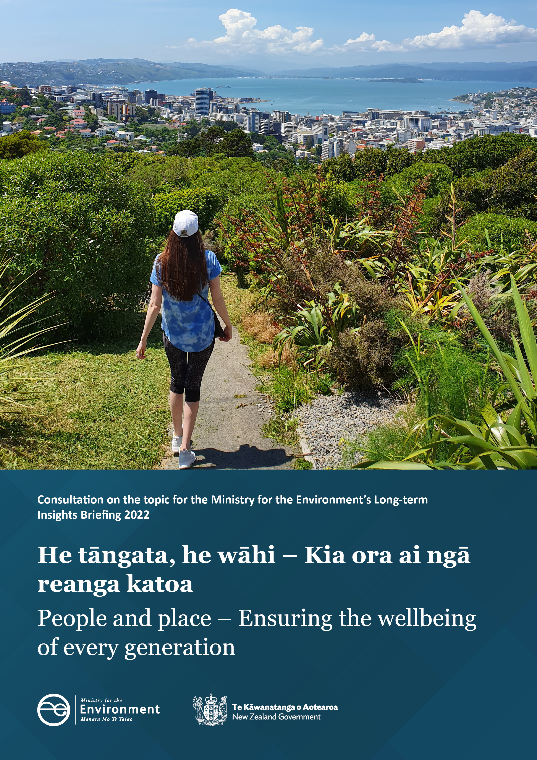

Disclaimer
The information in this publication is, according to the Ministry for the Environment’s (‘Ministry’) best efforts, accurate at the time of publication. The Ministry will make every reasonable effort to keep it current and accurate. However, users of this publication are advised that:

- the information does not alter the laws of New Zealand, other official guidelines, or requirements
- it does not constitute legal advice, and users should take specific advice from qualified professionals before taking any action based on information in this publication
- the Ministry does not accept any responsibility or liability whatsoever whether in contract, tort, equity, or otherwise for any action taken as a result of reading, or reliance placed on this publication because of having read any part, or all, of the information in this publication or for any error, or inadequacy, deficiency, flaw in, or omission from the information in this publication
- all references to websites, organisations or people not within the Ministry are for convenience only and should not be taken as endorsement of those websites or information contained in those websites nor of organisations or people referred to.

This document may be cited as: Ministry for the Environment. 2022. People and place: Ensuring the wellbeing of every generation: Consultation on the topic for the Ministry for the Environment’s Long-term Insights Briefing 2022. Wellington: Ministry for the Environment.

Published in May 2022 by the
Ministry for the Environment
Manatū Mō Te Taiao
PO Box 10362, Wellington 6143, New Zealand
ISBN: 978-1-99-003382-7
Publication number: ME 1596
© Crown copyright New Zealand 2022
This document is available on the Ministry for the Environment website: www.mfe.govt.nz

Contents
Introduction 4
What is a long-term insights briefing? 4
Focus – People and place 4
This consultation 4
People and place 5
People’s connections to the land 5
Changes and legacies 5
What matters to you? 7
Section 1 – Connections to place 7
The importance of land in your everyday life today 7
The importance of land for the wellbeing of tomorrow’s generations 7
Section 2 – The places you use and value 9
Understanding place through case studies 9
Section 3 – Your role 10
What is holding people back? 10
What could make a difference? 10
Have your say 11
How to provide feedback 11
Next steps 11
More information 11
Publishing and releasing submissions 11

Introduction

What is a long-term insights briefing?
Under the Public Service Act 2020, government departments are required to produce Long-term Insights Briefings every three years. The purpose is to enhance public debate on long-term issues and contribute to future decision-making. This requires all of us to think about, anticipate and act with the future interests of New Zealanders front and centre.
Read more about futures thinking and long-term insights briefings.
See a list of other agencies’ public consultations on long-term insights briefings.

Focus – People and place
The Ministry’s long-term insights briefing (‘Briefing’) will build on evidence gathered in the Aotearoa New Zealand national environmental reporting series about the present state of the environment, but then cast its gaze to what could be ahead of us. What future path(s) can be created collectively? The Briefing will put a deliberate focus on people, so as to understand the drivers and behaviours behind people’s decisions that impact on nature, people’s aspirations for nature into the future, as well as options to secure that future.
‘People and place: Ensuring the wellbeing of every generation’ is a topic that speaks to the Ministry’s strategic vision: He taiao tōnui mō ngā reanga katoa – a flourishing environment for every generation.
Land is an intergenerational taonga (treasure) that connects every part of te taiao (the environment). How land is cared for – via, for example, stewardship and kaitiakitanga – has a bearing on many interactions across lakes, rivers, oceans, air, climate and native species. The health of the land and people’s wellbeing go hand in hand, so the land must be well looked after to ensure people’s wellbeing. While emphasis in this Briefing is being placed on caring for the land (versus a broader, whole-of-environment insights approach), interactions with the wider environment will naturally be drawn.

This consultation
This consultation is your opportunity to share with the Ministry what focus is of most value and interest to you when considering people and place – to tell us about your aspirations for the future of the land (looking 30 years out and beyond) and share ideas for what New Zealanders need to do to get there.
Following this consultation, the Ministry will release a summary of submissions and prepare a draft Briefing. The Ministry will then seek your feedback via a second round of consultation. The final Briefing will be presented to Parliament by the Minister for the Environment.

People and place

People’s connections to the land
People’s collective wellbeing is intrinsically linked to te taiao. A healthy whenua (land) is fundamental to all aspects of people’s wellbeing: material, physical, mental, spiritual, cultural and social. Land provides places and spaces to live, work, play and socialise. Land generates benefits and material goods, including food, shelter and energy. It provides non-material benefits, in the form of spaces for recreation, spiritual connection and inspiration. Ensuring everyone has access to greenspaces – in urban as well as in rural areas – is important to people’s physical and mental health; it is equally important that land is cared for in return.
Our Land 2021 describes some of the connections between people and place in Aotearoa New Zealand.
Land is central to our identity as people of Aotearoa New Zealand – it is our tūrangawaewae, our place to stand. This country’s unique landscapes connect us culturally and emotionally to the whenua (land) we call home.
The natural environment is also part of our national identity. As tangata whenua – people of the land – Māori have a distinct and special connection to land. In te ao Māori, the health of animals, humans and the environment are intimately connected, and connections go far beyond appreciating the material goods that land provides. If the environment is not healthy, every dimension of whānau wellbeing suffers. Te taiao provides resources to feed (mahinga kai), shelter and heal whānau, opportunities to learn, and connections for people to Papatūānuku (mother nature).

Changes and legacies
Every generation leaves its mark on the land. While people benefit from land, they are also changing it in ways that will create both opportunities and challenges for future generations. There are many drivers for the changes being made to the land (see figure 1 below).
The basics of life – where we choose to live and the food we choose to eat – have an influence on the demand for land and how it is used in Aotearoa New Zealand. Our growing population will continue to drive this demand in the future.³
Decisions about how people use and manage land start before we step foot on the soil. Everyone plays a role, through choices about what we eat, buy and sell, and where we live. The decisions being made today will influence the wellbeing of future generations.
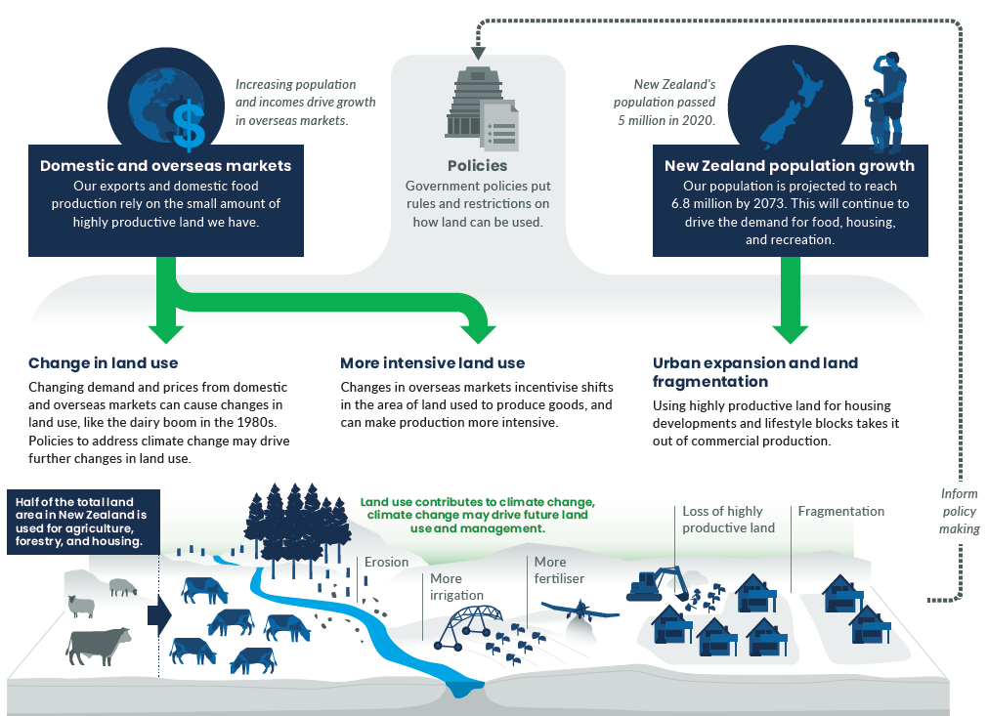
Figure 1: Driving forces that influence the changes being made to land.
From Our Land 2021, Chapter 2.

What matters to you?
This consultation is an opportunity for you to share what focus – when considering people and place – is of most value and interest to you. It is an opportunity for the Ministry to hear about your aspirations for the future of the land (looking 30 years out and beyond) and to share ideas for what New Zealanders need to do to get there.

Section 1 – Connections to place

The importance of land in your everyday life today
A healthy whenua (land) is fundamental to every aspect of our wellbeing: physical, mental, cultural, spiritual, social and material. The Ministry would like to know how land supports your wellbeing.
Q1. How important, or not, is the land in supporting the following aspects of your wellbeing?
- My physical wellbeing (for example, being outdoors for physical exercise or sports)
- My mental wellbeing (for example, as a place to recharge or relax)
- My cultural wellbeing (for example, retaining links to ancestors or traditional practices)
- My spiritual wellbeing (for example, meditation or worshipping in nature)
- My social wellbeing (for example, going for a walk with others, picnicking)
- My material wellbeing (for example, relying on the land to generate income or grow food for my family)
SCALE:
- Not at all important
- Not very important
- Fairly important
- Very important
- Extremely important
- Prefer not to say

The importance of land for the wellbeing of tomorrow’s generations
Land is an intergenerational taonga. The state of land in Aotearoa New Zealand is a legacy of the way it was used, managed and cared for by previous generations. Likewise, the decisions made today about how land is cared for will affect future generations.
Q2. What do you think is the most important change that today’s generations of New Zealanders should make to how we care for the land, as stewards for the environment?
Q2B. What should be the legacy of today’s generations?
Q3. How important, or not, is it to you that the Briefing explores the following land uses and activities, when considering the wellbeing of tomorrow’s generations?
- To provide spaces to live (for example, land for housing and communities)
- To support work and livelihoods (for example, farming, nature-based tourism, forestry, energy and resource production)
- To grow and gather food and resources for personal use (for example, hunting, foraging, gardening)
- To foster cultural value and a sense of belonging (for example, places of tradition and connection to ancestors, tapu land, historic sites)
- To nurture spiritual connection to places (for example, preserving holy or sacred sites and natural landscapes that generate a sense of awe and wonder)
- To conserve and protect land, biodiversity and species (for example, national parks)
- To provide spaces for play, relaxation and recreation (for example, bush tracks, swimmable beaches, mountain climbing)
- Other (if you consider a land use, activity or connection to place that is not covered above to be very or extremely important, please let us know)
Scale:
- Not at all important
- Not very important
- Fairly important
- Very important
- Extremely important
- Prefer not to say

Section 2 – The places you use and value

Understanding place through case studies
The Ministry would like to explore place-based case studies in its Briefing, to better understand the opportunities and challenges communities experience that guide how they relate to, and therefore care for, the land.
Q4. How interested, or not, would you be in knowing more about the following types of case studies?
- Access to forests and mountains for biking, walking and exploring
- Forest and bush available to support native plant and bird species
- Greenspaces, such as parks and community gardens, within towns and cities
- Housing developments and subdivisions
- Wetlands, along with the plants and birds they support
- Local food production, to support households and communities
- Household waste and the journey to landfill
Scale:
- Not at all interested
- Not very interested
- Fairly interested
- Very interested
- Extremely interested
- Prefer not to say

Q5. Are there any other case studies, not listed in Q4, that you would find it valuable for the Ministry to look at?

Section 3 – Your role

What is holding people back?
While people may seek to reduce their impact on the environment, this can be difficult for many reasons. The Ministry wants to understand the barriers and challenges you face in making environmentally sustainable choices.
Q6. How much do you agree or disagree with the following statements?
- Information: I don’t have the right or clear information about what I can do to reduce my environmental impact.
- Cost: The cost of more sustainable products and services is too high (for example, organic fruit and vegetables versus conventional foods).
- Availability: More environmentally sustainable products and services are not readily available where I live or where I go to buy what I need.
- Technology: Technology and infrastructure to support environmentally sustainable choices are not good enough (for example, public transport or electric-vehicle charging options do not meet my needs).
- Quality: Sustainable or environmentally friendly products and alternatives are not as good as standard products.
- Time: I don’t have time to be able to focus on the environment.
Scale:
- Strongly agree
- Slightly agree
- Neither agree nor disagree
- Slightly disagree
- Strongly disagree
- Prefer not to say
Q7. Which barrier or set of barriers do you think is most important to address to encourage uptake of environmentally sustainable choices?

What could make a difference?
We would like to hear your ideas about what could make a positive difference to how you draw wellbeing from the land. This information will help inform what the Ministry could look at as part of the Briefing.
Q8. What is likely to inspire you and enable you to reach your aspirations for how the land is cared for?
Q9. Are there any final comments you would like to share before completing your submission?

Have your say
The Ministry welcomes your submission on this consultation document. The questions in this document are a guide only and all comments are welcome. You do not have to answer all questions.
This consultation starts on 5 May and ends on 20 May 2022.

How to provide feedback
You can make a submission through Citizen Space, our online consultation hub: https://consult.environment.govt.nz/insights/long-term-insights-briefing-land
Submissions close at 11.59pm, 20 May 2022.

Next steps
The feedback received from this consultation will help the Ministry refine what it looks at within the proposed topic for the Briefing.
During the development of the Briefing, the Ministry intends to undertake targeted engagement with individuals and/or groups that have an in-depth interest in the topic. If you would like to hear more about this and/or be further involved in the development of this Briefing, please contact us using the details below. Once a draft Briefing is prepared, the Ministry will again seek feedback from the public.
After that second round of consultation is taken into consideration, the final Briefing will be presented to Parliament. This is expected to happen in the latter half of 2022. The Minister for the Environment will submit the Briefing to Parliament’s Environment Committee for consideration and debate.

More information
Please direct any queries to:
Email: insights@mfe.govt.nz
Post: Long-term Insights Briefing, Ministry for the Environment, PO Box 10362,
Wellington 6143

Publishing and releasing submissions
All or part of any written submission (including names of submitters) may be published on the Ministry for the Environment’s website, www.environment.govt.nz. Unless you clearly specify otherwise in your submission, the Ministry will consider that you have consented to website posting of both your submission and your name.
Contents of submissions may be released to the public under the Official Information Act 1982 following requests to the Ministry for the Environment (including via email). Please advise if you have any objection to the release of any information contained in a submission and, in particular, which part(s) you consider should be withheld, together with the reason(s) for withholding the information. We will take into account all such objections when responding to requests for copies of, and information on, submissions to this document under the Official Information Act 1982.
The Privacy Act 2020 applies certain principles about the collection, use and disclosure of information about individuals by various agencies, including the Ministry for the Environment. It governs access by individuals to information about themselves held by agencies.

Ausseil AG, Collins A, Greenhalgh S, Booth P, Samaringhe O. 2021. Environmental Stewardship and Wellbeing. Prepared for the Ministry for the Environment by Manaaki Whenua – Landcare Research. https://www.landcareresearch.co.nz/uploads/public/Publications/Working-papers-and-reports/LC3901_TechnicalReport.pdf
Intergovernmental Science-Policy Platform on Biodiversity and Ecosystem Services. 2019. The Global Assessment Report on Biodiversity and Ecosystem Services: Summary for Policymakers. https://ipbes.net/global-assessment
Ministry for the Environment and Stats NZ. 2021. New Zealand’s Environmental Reporting Series: Our Land 2021. https://environment.govt.nz/publications/our-land-2021/

