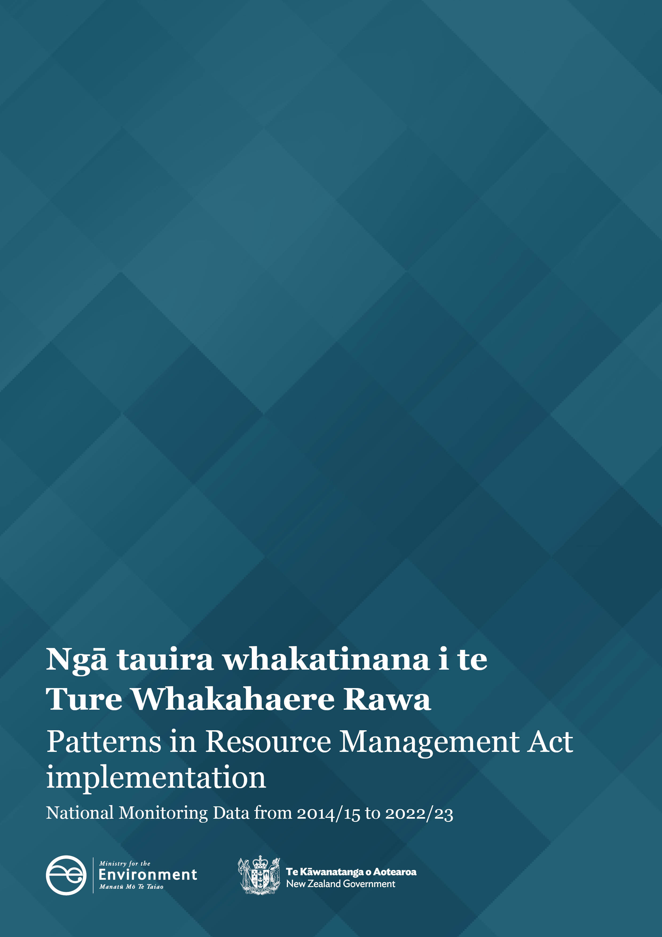
Disclaimer
The information in this publication is, according to the Ministry for the Environment’s best efforts, accurate at the time of publication. However, users of this publication are advised that:
- The information does not alter the laws of New Zealand, other official guidelines, or requirements.
- It does not constitute legal advice, and users should take specific advice from qualified professionals before taking any action based on information in this publication.
- The Ministry does not accept any responsibility or liability whatsoever whether in contract, tort, equity, or otherwise for any action taken as a result of reading, or reliance placed on this publication because of having read any part, or all, of the information in this publication or for any error, or inadequacy, deficiency, flaw in, or omission from the information in this publication.
- All references to websites, organisations or people not within the Ministry are for convenience only and should not be taken as endorsement of those websites or information contained in those websites nor of organisations or people referred to.
Copyright
© Crown copyright New Zealand 2024. Unless otherwise stated, this copyright work is licensed for re-use under a Creative Commons Attribution 4.0 International licence. In essence, you are free to copy, distribute and adapt the work, as long as you attribute the work to the New Zealand Government and abide by the other licence terms. To view a copy of this licence, visit Creative Commons Attribution 4.0 International licence.
If you publish, distribute, or otherwise disseminate this work (or any part of it) to the public without adapting it the following attribution statement should be used: Source: Ministry for the Environment and data providers and licensed by the Ministry for the Environment for re-use under the Creative Commons Attribution 4.0 International licence. If you adapt this work in any way, or include it in a collection and publish, distribute, or otherwise disseminate that adaptation or collection to the public, the following attribution statement should be used: This work uses material sourced from the Ministry for the Environment and data providers, which is licensed by the Ministry for the Environment for re-use under the Creative Commons Attribution 4.0 International licence.
Where practicable, please hyperlink the name of the Ministry for the Environment to the Ministry for the Environment web page that contains, or links to, the source data.

Acknowledgements
We would like to acknowledge the contribution of local authorities who collect and provide the data for the National Monitoring System that informs this report.
This document may be cited as: Ministry for the Environment. 2024. Patterns in Resource Management Act Implementation – National Monitoring System data from 2014/15 to 2022/23. Wellington: Ministry for the Environment.
Published in June 2024 by the
Ministry for the Environment
Manatū Mō Te Taiao
PO Box 10362, Wellington 6143, New Zealand
ISBN: 978-1-991140-23-4
Publication number: ME 1833
© Crown copyright New Zealand 2024
This document is available on the Ministry for the Environment website: environment.govt.nz

Contents
About this National Monitoring System data report 5
Patterns in RMA implementation 6
Resource consent data patterns 6
The number of new resource consents granted has decreased 6
Three councils continued to process the highest number of new resource consent applications 7
Fewer councils processed new resource consents on time since 2018/19 9
Councils approved most new resource consent applications 10
Number and type of declined new resource consent applications 11
The number of notified resource consents remained low 11
Councils used section 37 more and section 92 less in 2022/23 14
Median processing times of consent types increased 14
Plan-making processes 17
Councils improved the timeliness of completing their plan change processes 17
Iwi and hapū participation within the resource management system 18
There was variation in how councils budgeted for iwi and hapū participation in consenting and plan-making 18
The number of new iwi management plans remains low 19
Compliance, and enforcement 19
Enforcement action taken by councils continues to show variation 20
Staffing levels on resource management work varied 20

Figures
Figure 1: Number of new consents granted by year and type 6
Figure 2: Number of new consents granted in 2022/23 by council 7
Figure 2a: Councils that processed fewer than 1,000 new consents by area 8
Figure 3: Percentage of new consents processed within statutory timeframes 9
Figure 4: Percentage of new consents processed within statutory timeframes by area 10
Figure 5: Percentage of new consents that were granted 10
Figure 6: Percentage of new consents that were declined by type and year 11
Figure 7: Percentage of consent applications that were notified 12
Figure 8: Percentage of new consent applications that were notified in 2022/23 by council area 13
Figure 9: Percentage of consents that used at least one section 37 or section 92 14
Figure 10: Median processing time of new consents by year and type 15
Figure 11: Median processing time of new consents in 2022/23 by council 16
Figure 12: Median processing time to complete a plan-making process once notified 17
Figure 13: Percentage of councils that provided budget to iwi and hapū to participate in plan-making or resource consenting 18
Figure 14: Number of new iwi management plans endorsed by iwi authorities and lodged with councils 19
Figure 15: Number of enforcement actions (infringement notices, abatement notices and enforcement order applications) taken by councils by council type 20
Figure 16: Number of full-time equivalents working on resource management at councils by subject area 21
Figure 17: Number of full-time equivalents working on resource management at councils 21

About this National Monitoring System data report
This report is written to inform central and local government of patterns in Resource Management Act 1991 (RMA) implementation, which reflects the roles councils play in everyday decision-making under the RMA. Every year, the Ministry asks each council to provide data on how they have implemented the RMA for the previous year 1 July – 30 June. A national data set is then created by the Ministry using all councils’ data for the purposes of this report. This report has been publicly released to make it accessible to the wider resource management community.
This report is organised by topic and highlights patterns in how councils have implemented the RMA over the past eight years, as recorded by the National Monitoring System (NMS). The data collected by the NMS will continue to inform the Ministry’s understanding of how the current resource management system has been working and will help inform future changes to the resource management system.
In some sections of this report, the data are broken down to reflect the types of councils where differences have occurred in RMA implementation.
Unless otherwise noted:
- all consenting facts and figures relate to a council’s decision to grant or decline new resource consent applications within 1 July – 30 June 2022/23
- the report excludes data from new resource consent applications that were incomplete, withdrawn or returned
- the term ‘processed’ refers to new resource consents that were granted or declined
- the term ‘plan-making’ refers to policy statements or plans, changes or variations that were started, continued or completed by councils within the 2022/23 financial year.
Key patterns from 2022/23
- There was a decrease in the number of new resource consents processed by councils.
- Most councils processed fewer than 1,000 new resource consents.
- Councils continued to grant over 99 per cent of all new applications.
- Councils increased the use of section 92 (Further information requests) and decreased the use of section 37 (Power of waiver and extension of time limits)
- The proportion of new resource consents being notified remained below 2.5 per cent.
- The median processing time for new resource consents increased from 46 working days to 57 working days.
- Councils employed their highest number of full-time equivalent staff for resource management.

Patterns in RMA implementation

Resource consent data patterns
Under the RMA, certain activities require a resource consent. A resource consent is permission from a council for an activity that might affect the environment and that is not allowed ‘as of right’ by the district, regional or unitary plan, or a national environmental standard. A resource consent is also required for some types of subdivision activities.
There are different categories of resource consents depending on the rules in a district, regional or unitary plan, or a national environmental standard: coastal permits, combined land-use and subdivision consents, discharge permits, land-use consents, subdivision consents, and water permits.

The number of new resource consents granted has decreased
Figure 1 outlines the number and type of new resource consents granted by councils since 2014/15.
In 2022/23, 36,134 new resource consents were granted. This is a decrease from 39,773 in the 2021/22 reporting year. Land-use consents dropped 11 per cent from the previous year and were at their lowest level since the 2014/15 reporting year. Fewer subdivision consents were granted in 2022/23, compared with the previous year.
Figure 1: Number of new consents granted by year and type
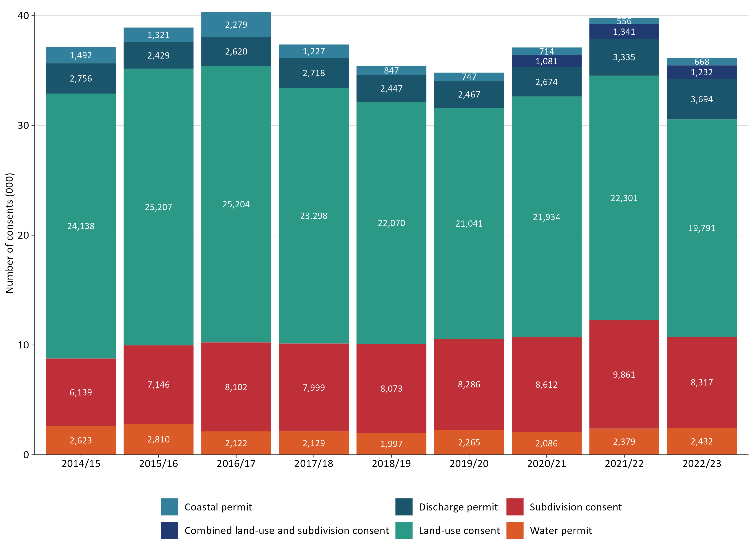

Three councils continued to process the highest number of new resource consent applications
Of all the councils across New Zealand, 77 of the 78 processed fewer than 2,500 new resource consents in 2022/23. This is consistent with the 2021/22 findings. Auckland Council processed more than 10,500 new resource consents in 2022/23.
Of those councils that processed fewer than 2,500 new resource consents, Christchurch City Council processed the second-highest number for the fourth year in a row. Marlborough District Council processed the third-highest number for the third year in a row. Figure 2 shows the number of new resource consents granted by each council in 2022/23.
Figure 2: Number of new consents granted in 2022/23 by council
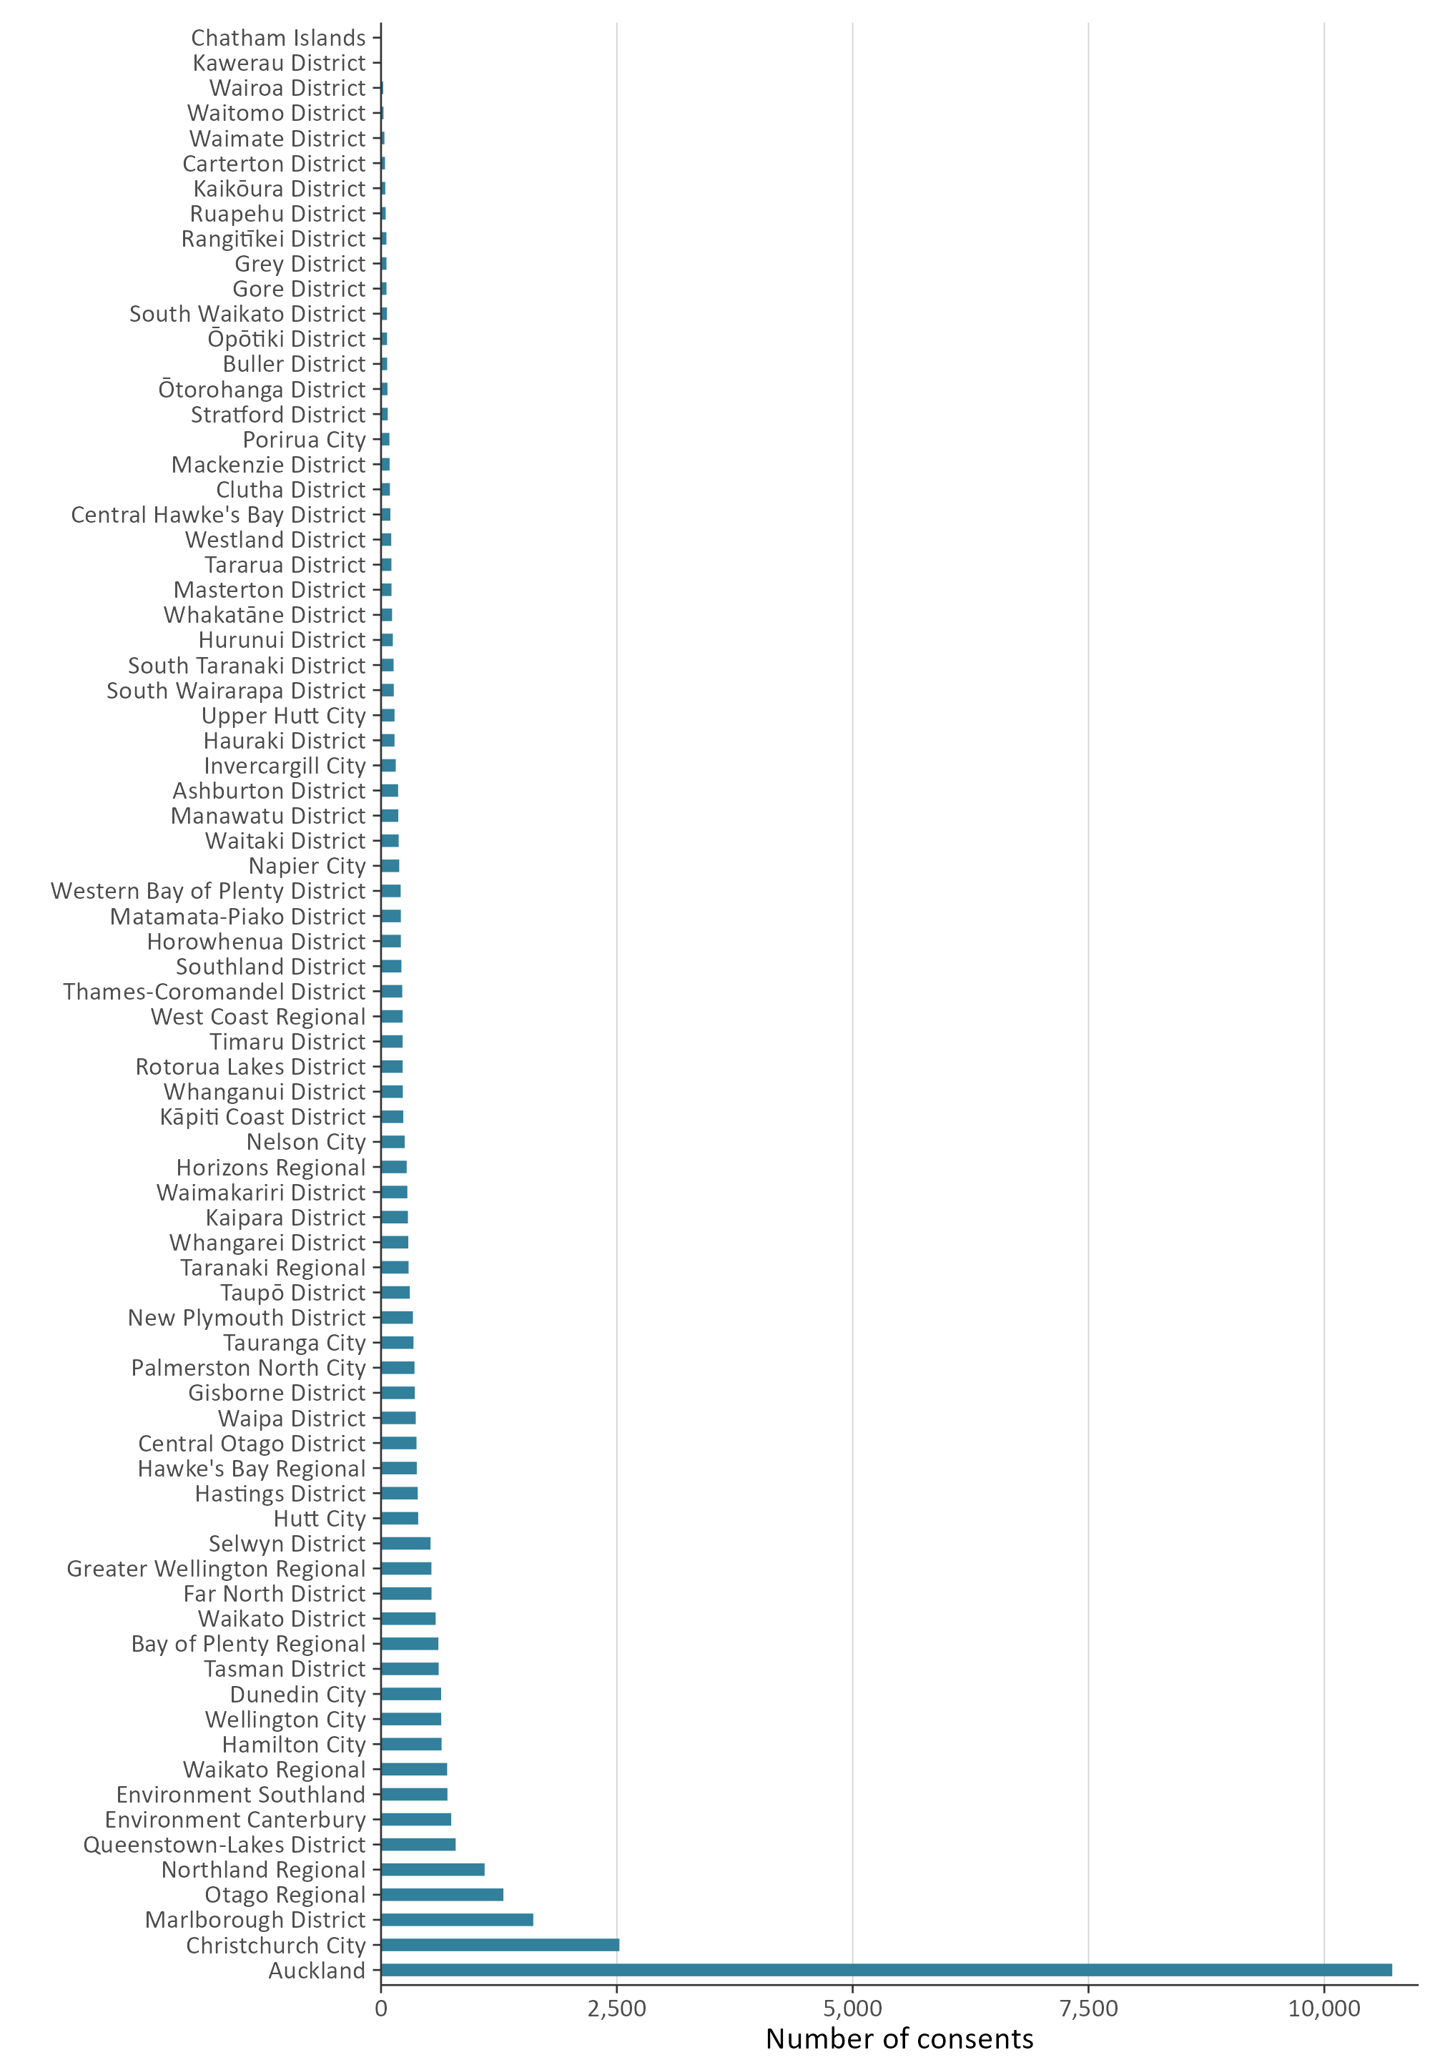

Figure 2a shows those councils that processed fewer than 1,000 new resource consents in the 2022/23 year, which represents just under 94 per cent of all councils that provided data. This is consistent with the 2021/22 reporting year.
Figure 2a: Councils that processed fewer than 1,000 new consents by area
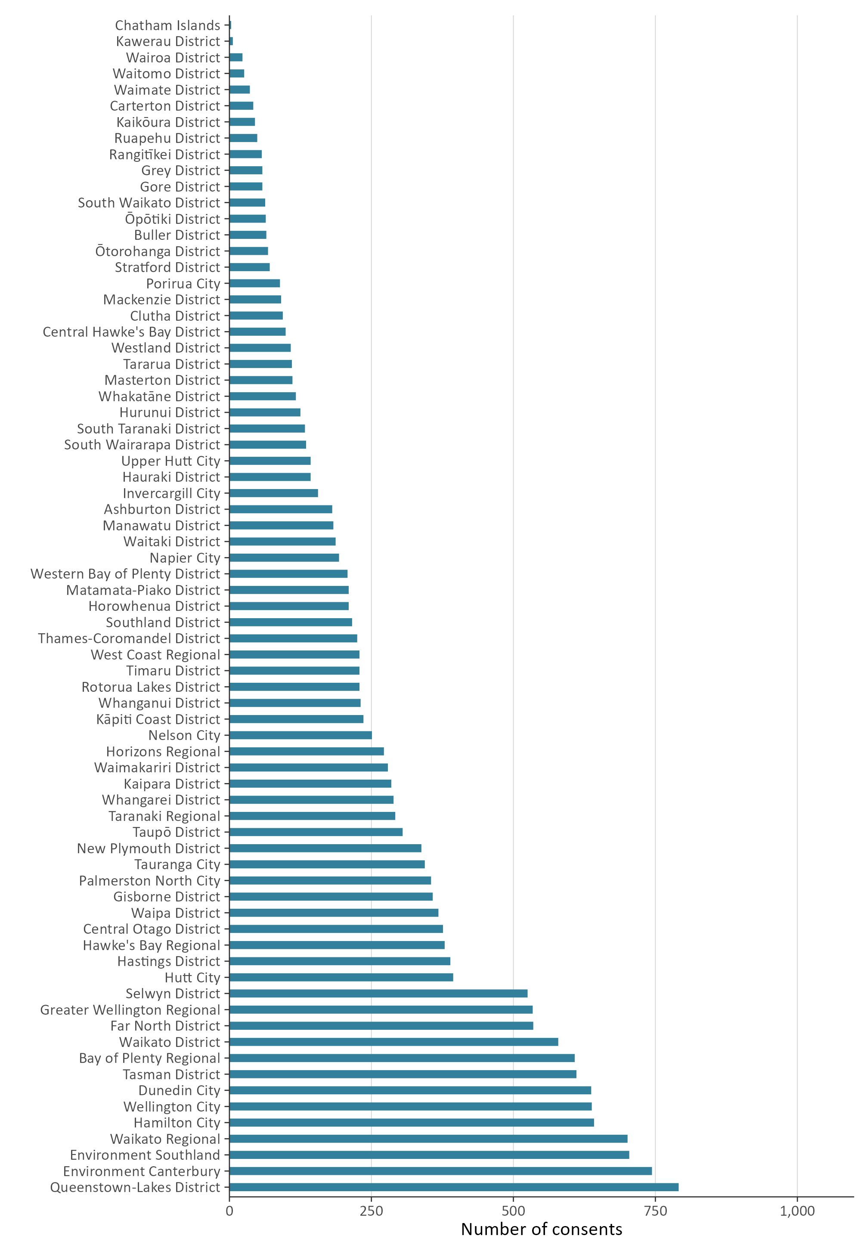

Fewer councils processed new resource consents on time since 2018/19
Councils have a responsibility under the RMA to process resource consent applications within a set amount of time. For example, the statutory time limit for a non-notified consent is 20 working days.
When a council cannot meet its statutory requirements for processing a resource consent, and special circumstances do not apply, the council must give the applicant a discount on administrative charges. This requirement, which was introduced under the Resource Management (Discount on Administrative Charges Regulations 2010), provides a financial incentive for all local councils to meet the RMA’s statutory timeframes.
Figure 3 shows new resource consents processed within statutory timeframes. Over the course of 2022/23, 76.3 per cent of new resource consents were processed within the statutory time limits set out in the RMA. This is a 4.2 per cent reduction from the previous year and the lowest level of compliance with statutory timeframes.
Figure 3 and figure 4 (overleaf) show the percentage of new resource consents processed within statutory timeframes in the 2022/23 financial year.
Figure 3: Percentage of new consents processed within statutory timeframes
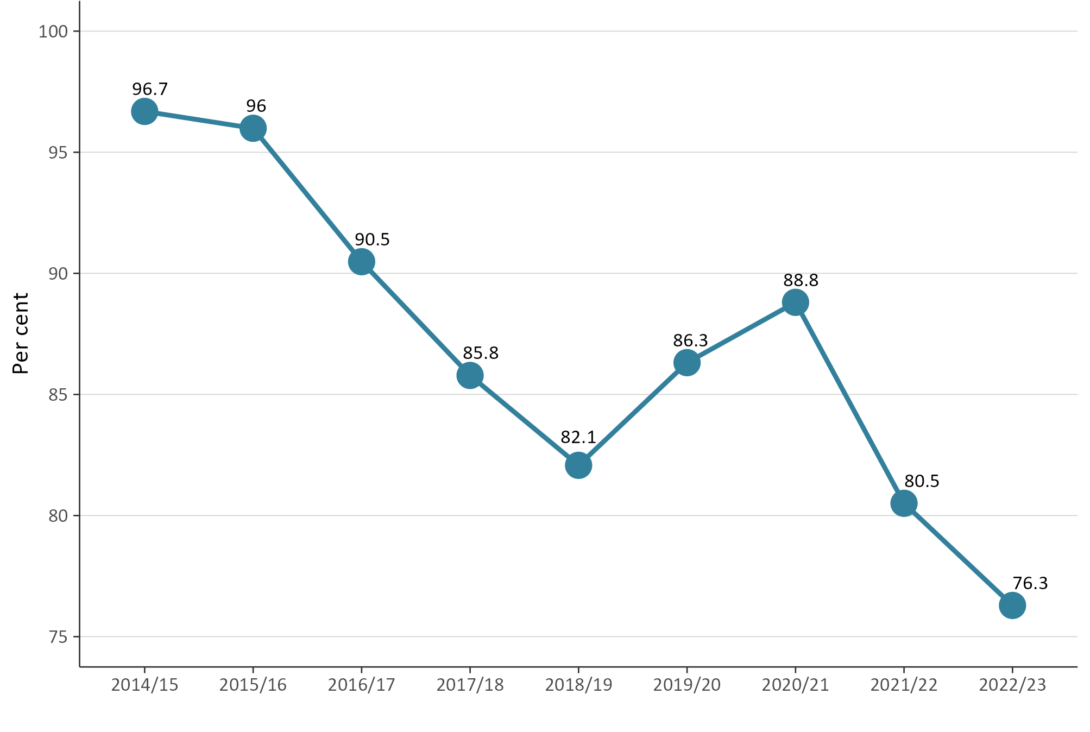
The data in figure 3 is influenced by the volume of new resource consents processed by Auckland Council. However, as shown in figure 4, there is a general downward pattern on the number of new resource consents processed within the statutory time-limits across all councils. While Auckland Council experienced a 2 per cent decrease in compliance with statutory time limits, other areas experienced a 6 per cent decrease, compared with the previous year.
Figure 4: Percentage of new consents processed within statutory timeframes by area
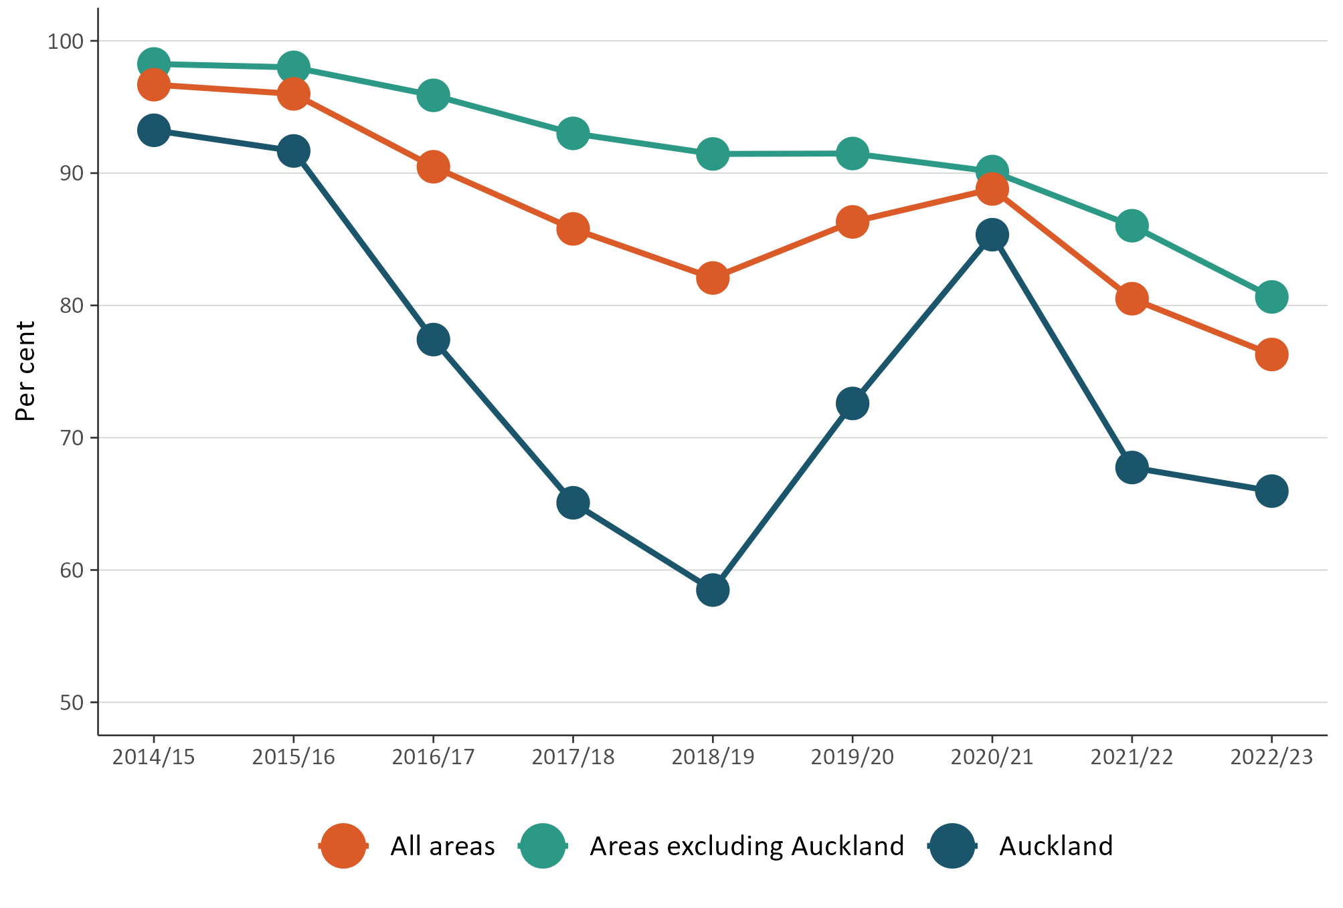

Councils approved most new resource consent applications
Figure 5 shows the number of approved new resource consent applications. More than 99 per cent of all new resource consents are granted each year.
Figure 5: Percentage of new consents that were granted
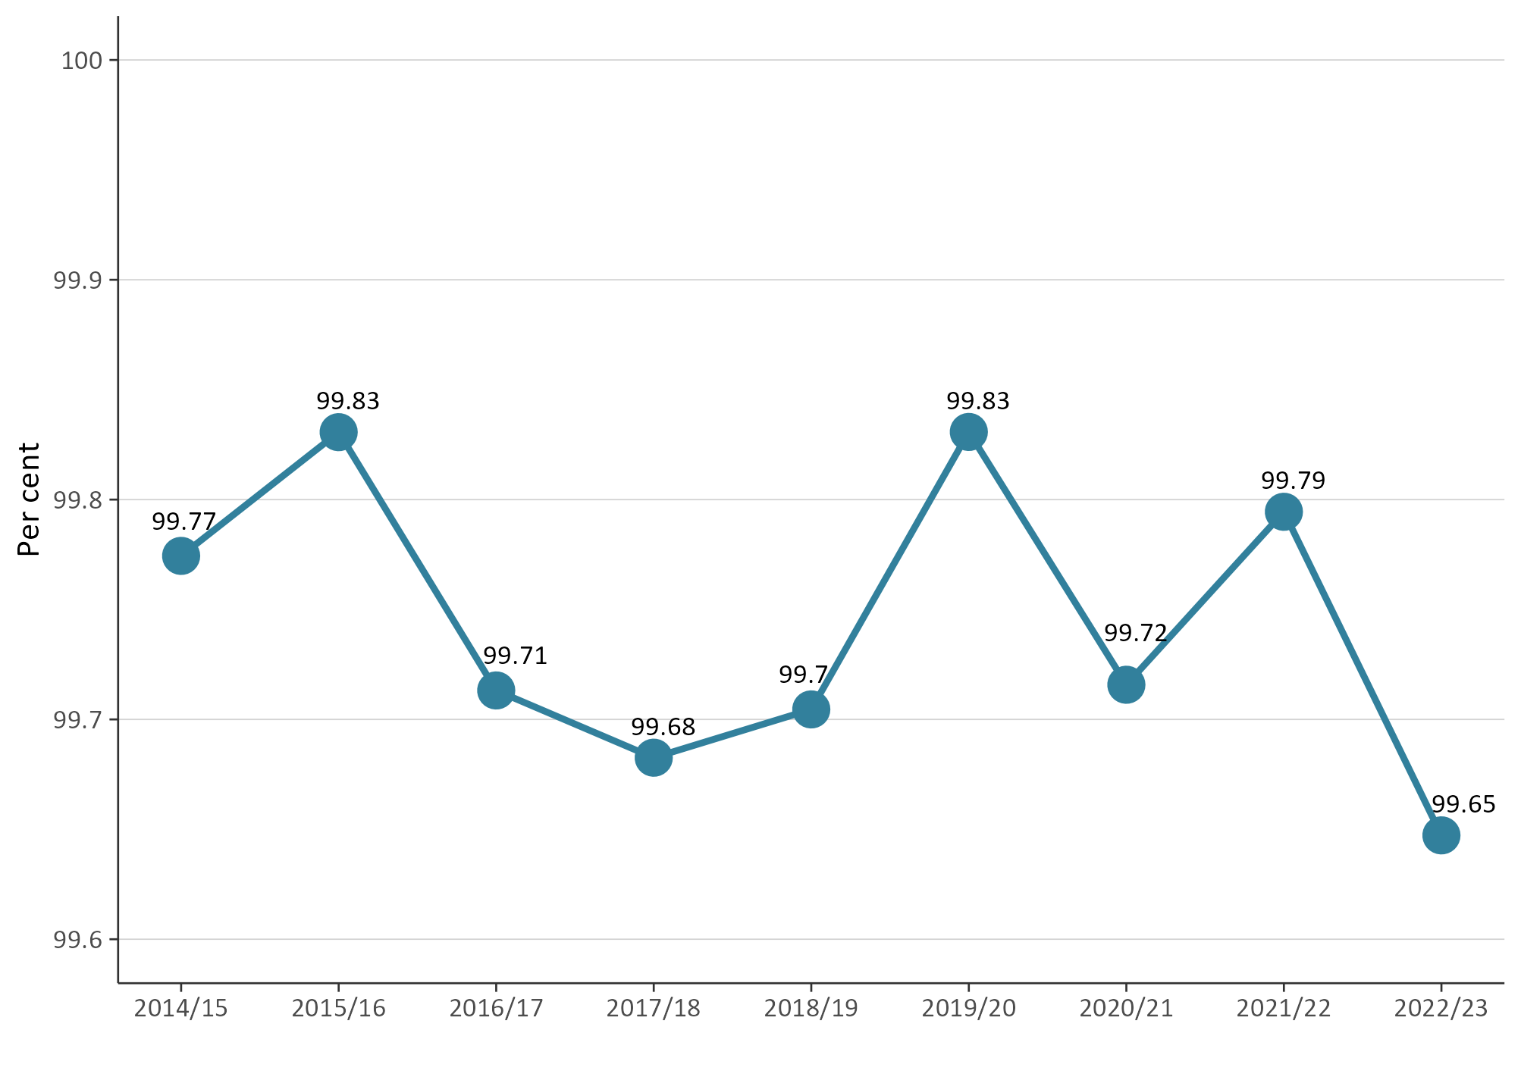

Number and type of declined new resource consent applications
NMS data since 2014/15 has provided the types of resource consents that have been declined by councils. Overall, the figures have generally remained stable and low across years and by type, with minor fluctuations.
Figure 6 shows declined new resource consents by type. It shows that more subdivision consents, water permits, land-use consents, and new combined land-use and subdivision consents were declined, compared with the previous year. However, fewer coastal permits and discharge permits were declined in 2022/23.
Figure 6: Percentage of new consents that were declined by type and year
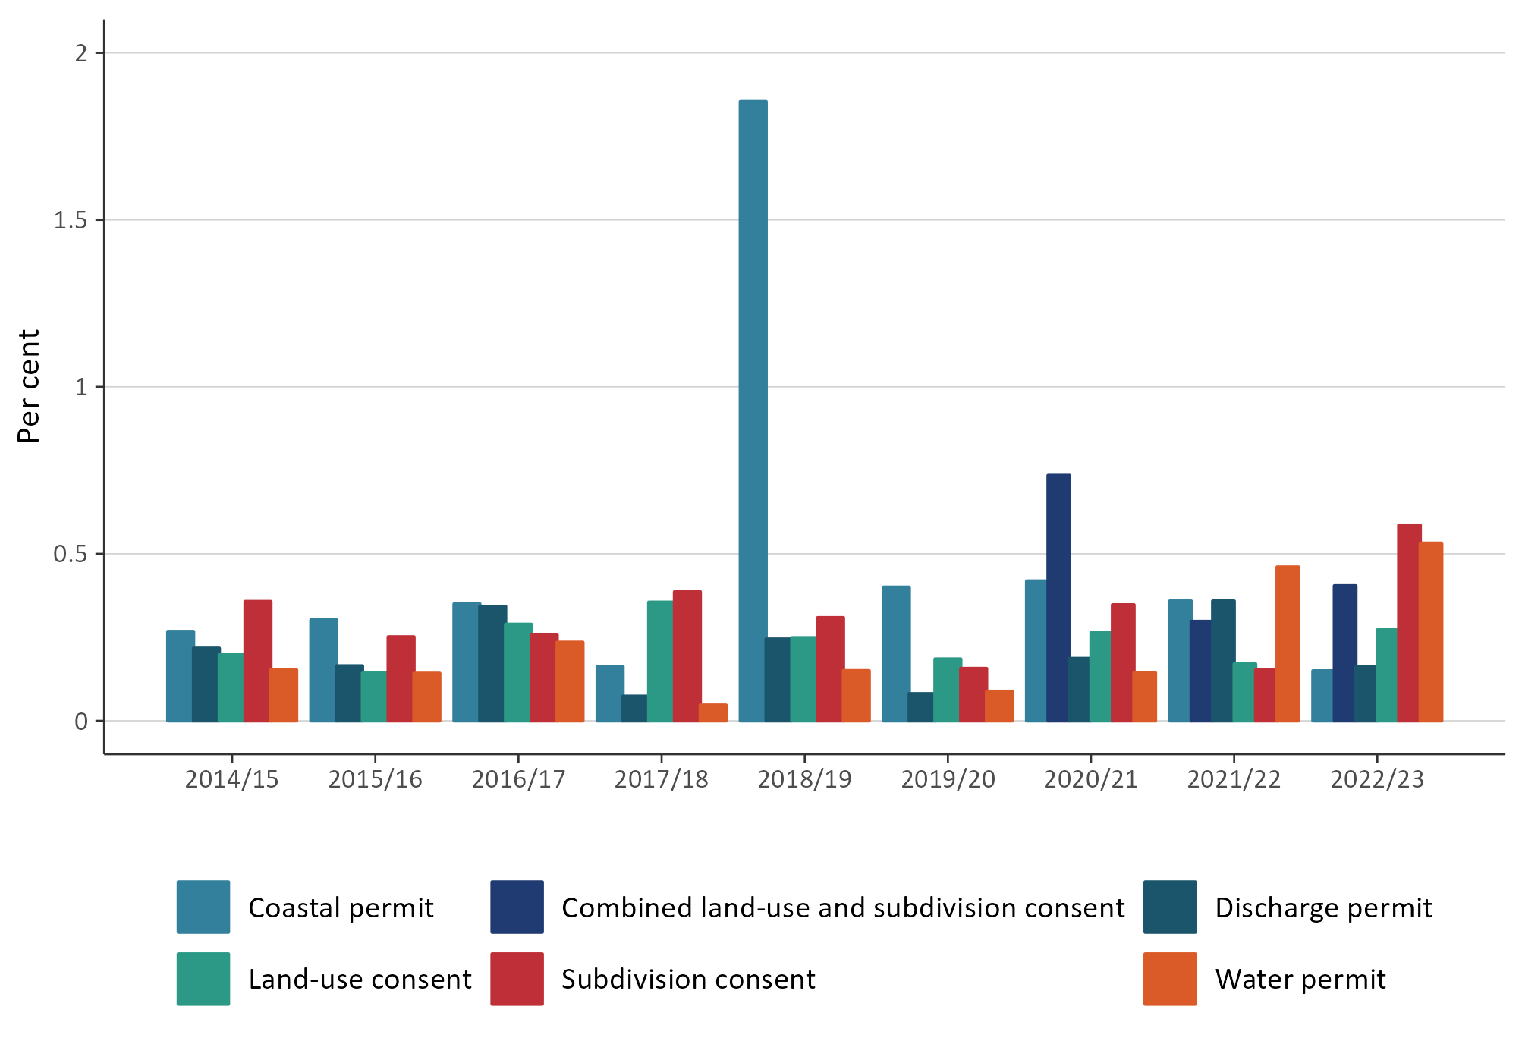

The number of notified resource consents remained low
When processing a new resource consent application, a council may determine its effects and require it to be publicly notified. The proportion of notified resource consents has historically remained low; over any year it has been under 4 per cent (of all new resource consent applications). Therefore, most new resource consent applications are processed on a non-notified basis.
In 2022/23, the proportion of new notified resource consent applications remained below 2.5 per cent and for a second year in a row (see figure 7 overleaf), although there was an increase from 2.13% to 2.36%.
Figure 7: Percentage of consent applications that were notified
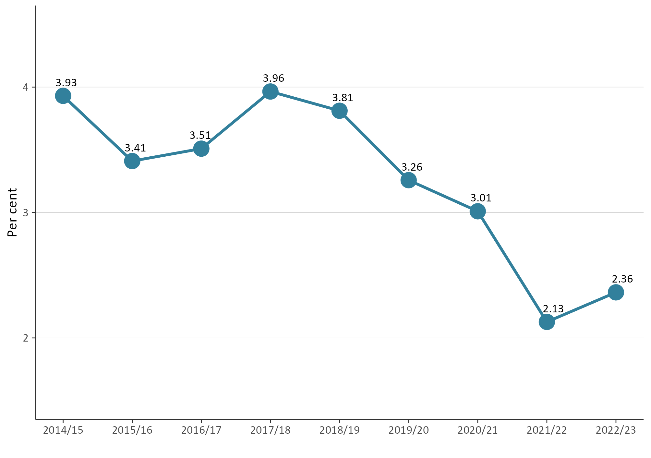

Figure 8 (overleaf) shows the percentage of resource consent applications notified by council area. In 2022/23, Buller District Council had notified the highest proportion of consent applications (24 per cent), followed by Hawke’s Bay Regional Council (over 15 per cent). Contrastingly, in 2021/22, Marlborough District Council notified the highest percentage of consents at just over 15 per cent, compared with just under 15 per cent for 2022/23. Whereas, Buller District Council had notified the second highest percentage of consents at just over 15 per cent in 2021/22.
In 2022/23, 24 councils notified less than 1 per cent of resource consent applications and 15 councils notified 5 per cent or greater.
Figure 8: Percentage of new consent applications that were notified in 2022/23 by council area
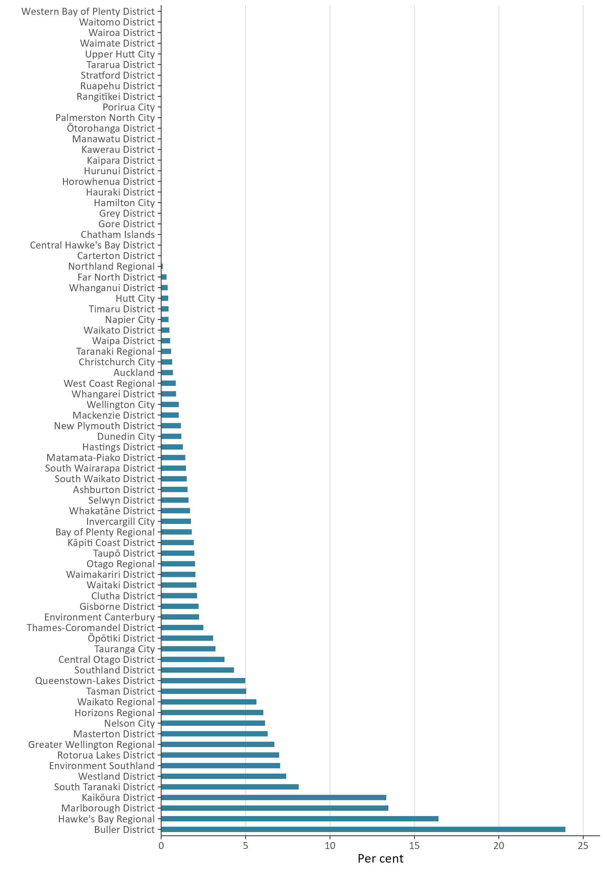

Councils used section 37 more and section 92 less in 2022/23
Section 37 allows a council additional working days where certain circumstances are met during the processing of a resource consent. Where used, section 37 allows a council to double the statutory timeframes or to waive a failure to comply with the statutory timeframes. In using section 37, a council must take into account the interests of who may be directly affected by the waiver, the interests of the community in making a decision on a consent, and a council’s overall duty to avoid unreasonable delay.
Section 92 of the RMA allows a council to ask for more information from a resource consent applicant before making a decision on the application. The processing clock is paused while the applicant responds to the council’s request. Generally, a council seeks additional information to better understand a proposed consenting activity and any effects it may have on the environment. When a council is processing a consent, both section 37 and section 92 can be used one or more times on the same application where certain circumstances occur.
Figure 9 shows that use of section 37 by all councils had a 1.9 per cent decrease in 2022/23. Figure 9 also shows that use of section 92 by all councils saw a 3.6 per cent increase in 2022/23.
Figure 9: Percentage of consents that used at least one section 37 or section 92
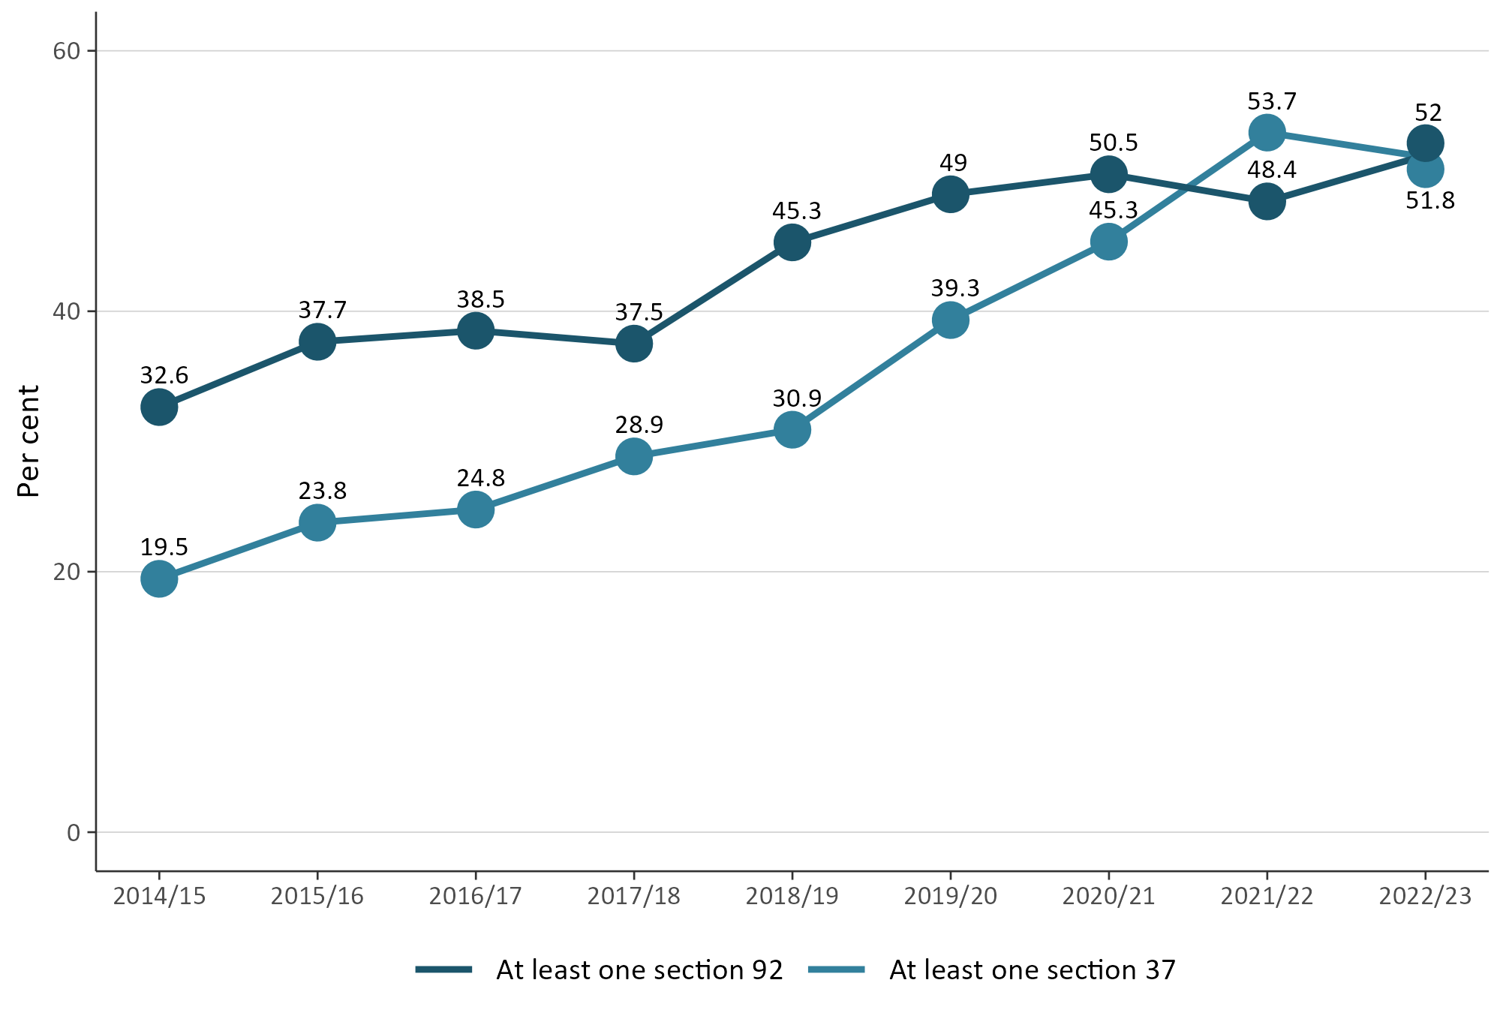

Median processing times of consent types increased
Figure 10 (overleaf) contains a breakdown of types of new resource consents and the median length of time (days) that councils took to process them in 2022/23. The data includes processing time to grant or decline a new resource consent.
The 2022/23 data shows that subdivision consents took longer to process at a median timeframe of 72 days, compared with 68 days in 2021/22. Figure 10 also shows that water permits took longer to process at a median timeframe of 74 days, compared with 54 days in 2021/22. Discharge permits took a median timeframe of 68.5 days, compared with 50 days in 2021/22.
Reporting on combined land-use and subdivision consents was introduced in2020/21. Data shows it has taken longer, year-on-year, for councils to process these types of consents. Figure 10 shows that, for 2022/23, it took councils a median timeframe of 55 days to process these types of consents.
Figure 10: Median processing time of new consents by year and type
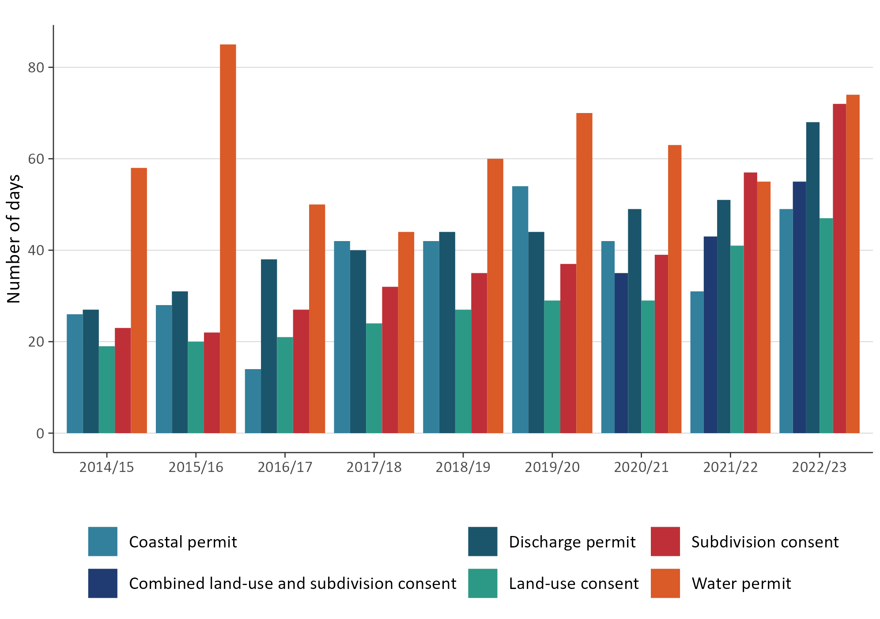
Figure 11 shows that the median timeframe it took councils to process new resource consents was 57 days compared with 46 days in 2021/22. The 2022/23 data shows that Taranaki Regional Council had the highest number of median days (over 150). Whereas, the highest number of median days to process new resource consents in 2021/22 was 80 days, which was held by Hutt City Council.
Figure 11: Median processing time of new consents in 2022/23 by council
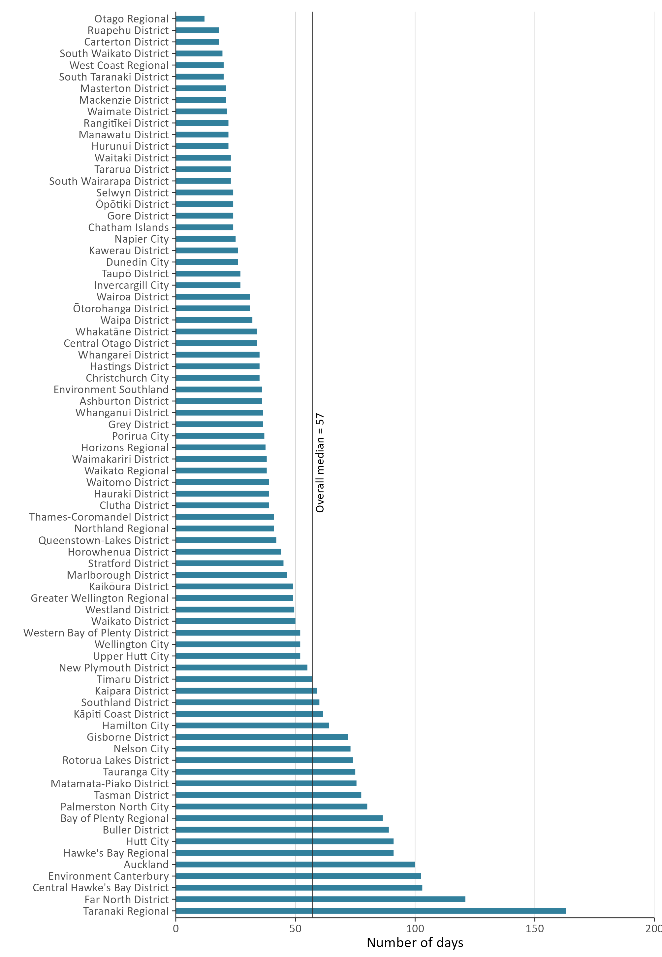

Plan-making processes
Councils prepare regional policy statements and regional, district and unitary plans under Part 5, subpart 3 of the RMA. A regional, district or unitary plan provides a list of activities requiring a resource consent and may also include a list of ‘permitted activities’.
Councils must review their policy statements and plans, or any plan provisions, at least every 10 years. Plan changes can be initiated by councils or can be requested by private individuals or entities. These are known as plan-making processes and occur under Schedule 1 of the RMA.

Councils improved the timeliness of completing their plan change processes
Under Schedule 1, Clause 5 of the RMA, all local authorities are required to meet a two-year timeframe, from notification, to make decisions on proposed plans or plan changes.
Figure 12 shows that, since 2014/15, a downward trend has occurred in median plan-change timeframes, indicating that councils have continued to improve the median time taken to progress a plan-making process. As the most recent illustration of continual improvement shows, it took councils just under one year (0.99 median years) to complete a plan-change process in 2022/23, compared with just over one year (1.08 median years) in 2021/22.
Figure 12: Median processing time to complete a plan-making process once notified
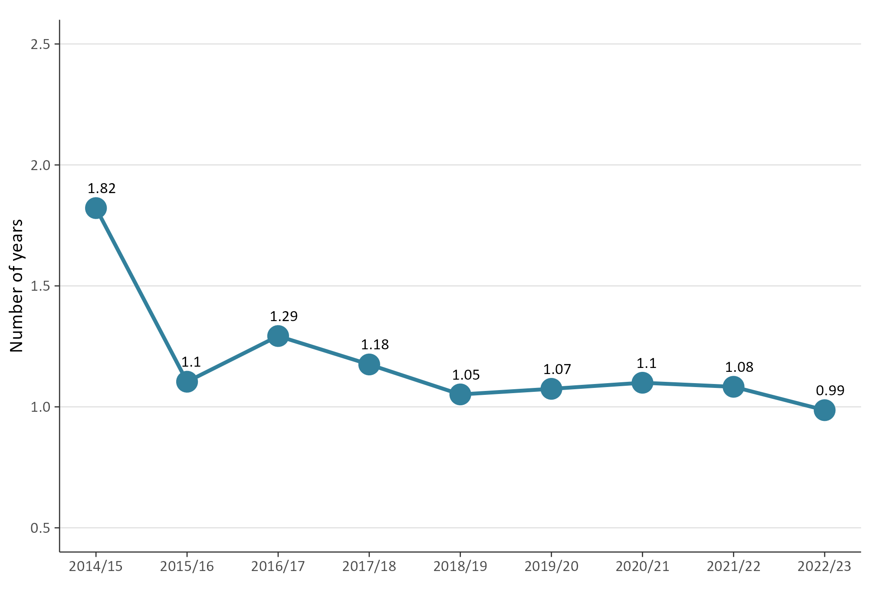

Iwi and hapū participation within the resource management system
The RMA sets out different ways to enable iwi and hapū participation in resource management processes. Councils also have provisions in place for specific tangata whenua participation in resource management processes.
Provisions may come in the form of budgetary commitments from councils to support iwi and hapū along with other forms of contribution such as access to databases or memoranda of understanding.

There was variation in how councils budgeted for iwi and hapū participation in consenting and plan-making
Figure 13 shows the percentage of councils providing budget for iwi and hapū to participate in plan-making and resource consenting processes. Since 2014/15, there has been a general downward pattern for both, from 62 per cent to 44 per cent for plan-making, and from 43 per cent to 26 per cent for resource consenting.
The 2022/23 data shows a downward pattern on providing budget to iwi and hapū to participate in resource consenting processes. However, the data indicates that there is a 3.2 per cent rise in the percentage of councils that provided budget to iwi and hapū in the plan-making process, compared with the previous year.
Figure 13: Percentage of councils that provided budget to iwi and hapū to participate in plan-making or resource consenting
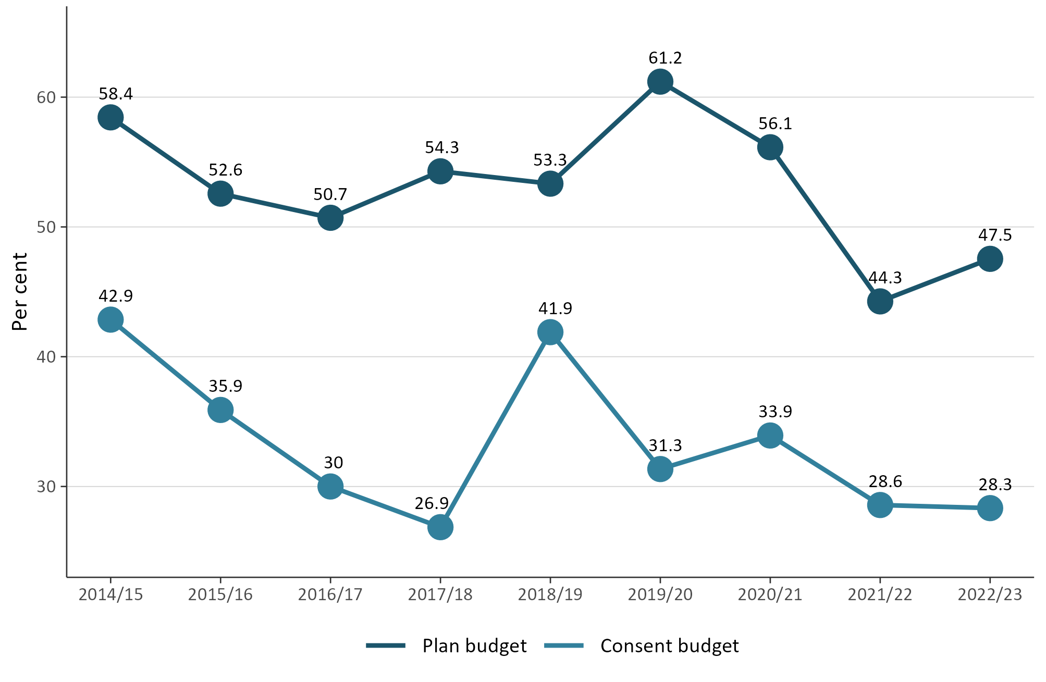

The number of new iwi management plans remains low
Iwi management plans describe resource management issues of importance to tangata whenua and can also be used to express values relating to specific areas, natural resources or taonga. Iwi management plans can also provide guidance for interactions between councils and iwi and hapū, as well as direction on decision-making and information requests. An iwi management plan can help improve understanding of specific values and interests for tangata whenua.
Figure 14 shows that, in 2022/23, the number of new iwi management plans endorsed by iwi authorities and lodged with councils remained low.
Figure 14: Number of new iwi management plans endorsed by iwi authorities and lodged with councils
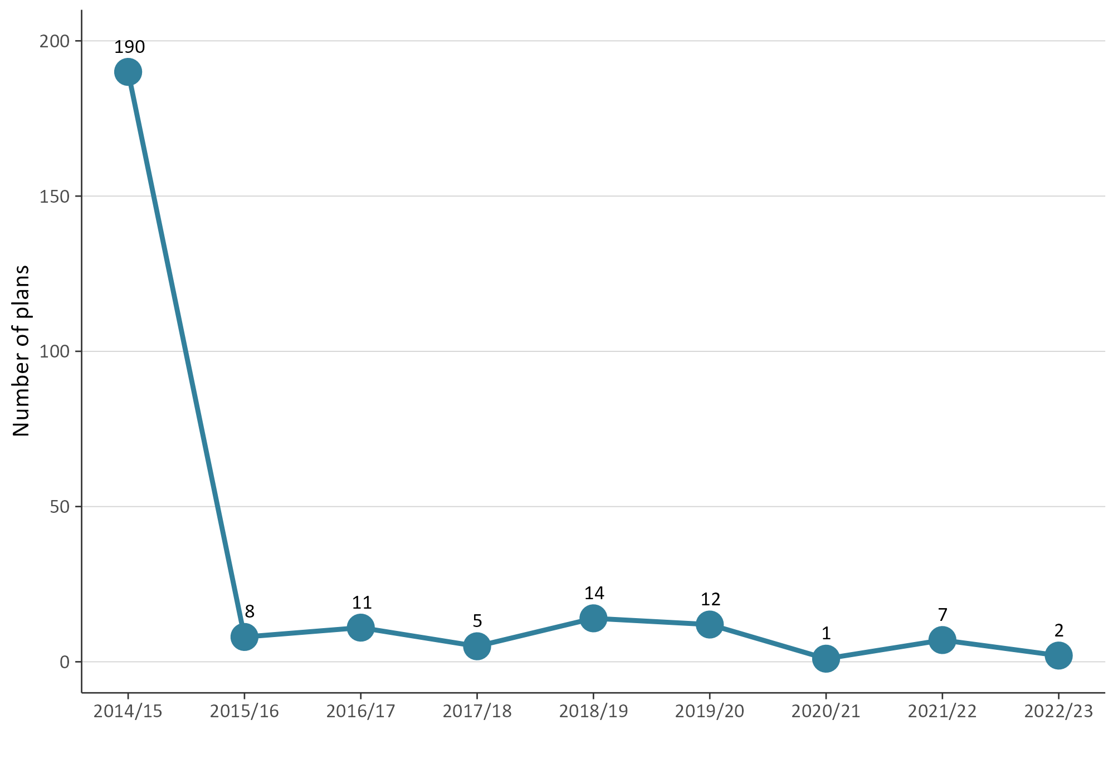
Note: Iwi management plans lodged with more than one council are counted separately.

Compliance, and enforcement
Under the RMA, all councils have a responsibility to monitor a range of matters as part of their compliance, and enforcement duties. Such functions enable all councils to:
- ensure the efficiency, effectiveness and enforcement of policy statements and plans
- monitor and enforce the exercising of resource consents and resource management plans
- ensure people and companies are delivering the environmental outcomes supported by councils.
Compliance, and enforcement is an important part of councils fulfilling their statutory functions to show that their objectives, policies and methods are meeting the purpose of the RMA. The amount of active compliance, and enforcement work varies between councils, depending on the number of consents they have and the local environmental context.
Councils can use different types of enforcement tools under the RMA, from issuing abatement notices or seeking an enforcement order, through to issuing an infringement notice or taking a prosecution.

Enforcement action taken by councils continues to show variation
Figure 15 shows that enforcement actions taken by councils have varied since 2014/15. The 2022/23 data showed that regional councils increased their enforcement actions, compared to 2021/22. By contrast, territorial authorities and unitary authorities showed a decrease, compared with the previous year.
Figure 15: Number of enforcement actions (infringement notices, abatement notices and enforcement order applications) taken by councils by council type
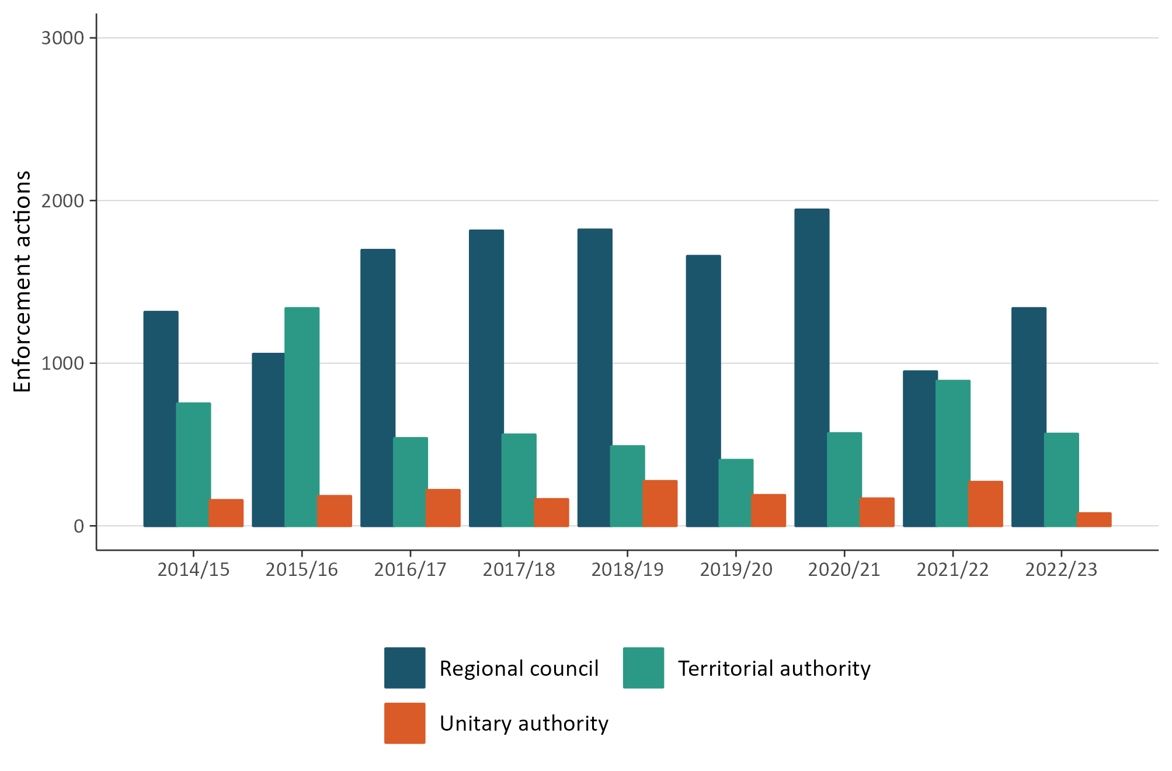
Note: The above excludes data that has not been reported to the Ministry or reconciled by councils.

Staffing levels on resource management work varied
Full-time equivalents measure the number of employees working in the different areas of consenting, plan preparation processes (planning) and compliance and enforcement at councils. Since 2014/15, consenting staff numbers have remained higher than full-time equivalents measured in planning and CME.
Figure 16 (overleaf) shows an increase occurred in the number of consenting staff during 2022/23, up to 1,250 full-time equivalents, compared with the previous year.
In 2022/23, the data also showed that the number of full-time equivalents for planning staff decreased, compared with the previous year. Full-time equivalents for compliance, and enforcement staff also showed a decrease, compared with the previous year.
Figure 16: Number of full-time equivalents working on resource management at councils by subject area
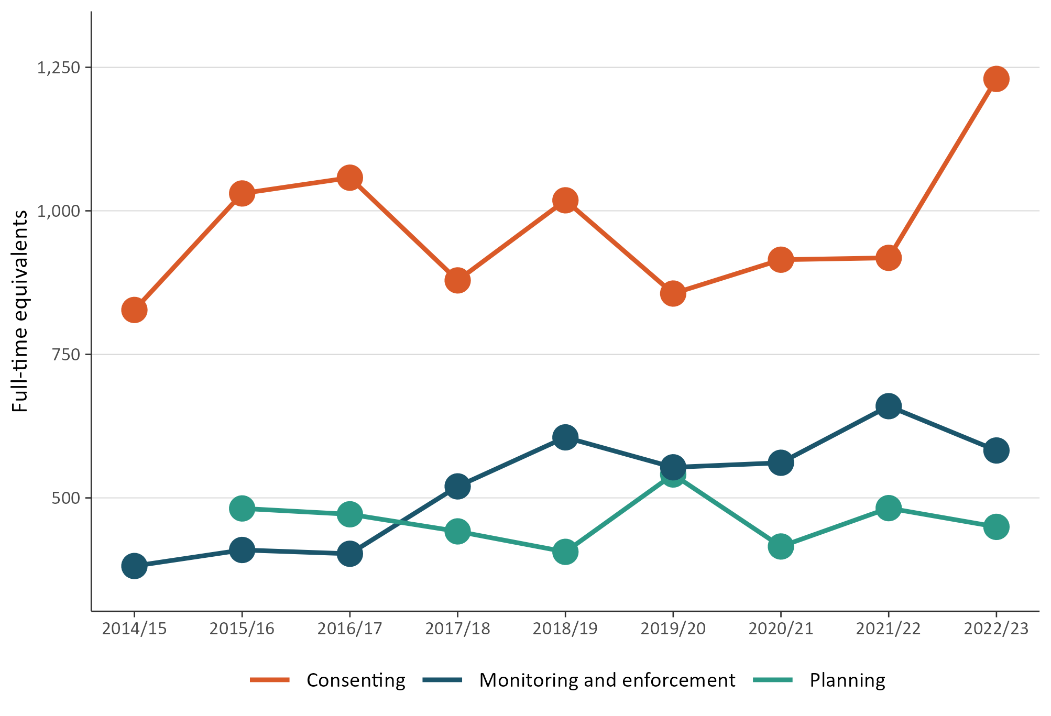
Figure 17 shows councils employed their highest number of full-time equivalents in resource management (the data combined compliance, and enforcement, and planning policy staff) in 2022/23. The 2022/23 data also illustrates upward growth has occurred since 2020/21.
Figure 17: Number of full-time equivalents working on resource management at councils
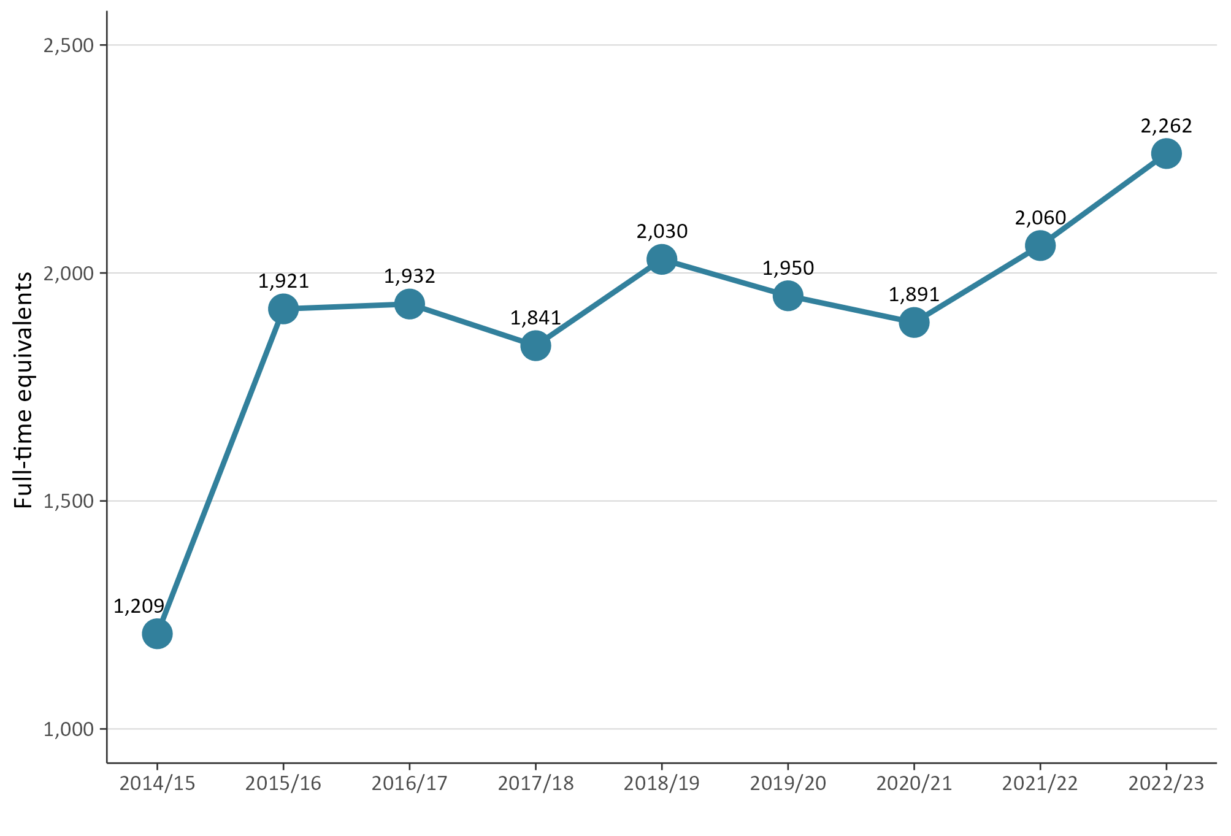
Note: Full-time equivalents data records the number of staff employed and do not include vacancies.

The RMA uses the term ‘local authorities’. In this report, we have used ‘councils’ to refer to all local authorities, that is, district and city councils, regional councils and unitary authorities.

