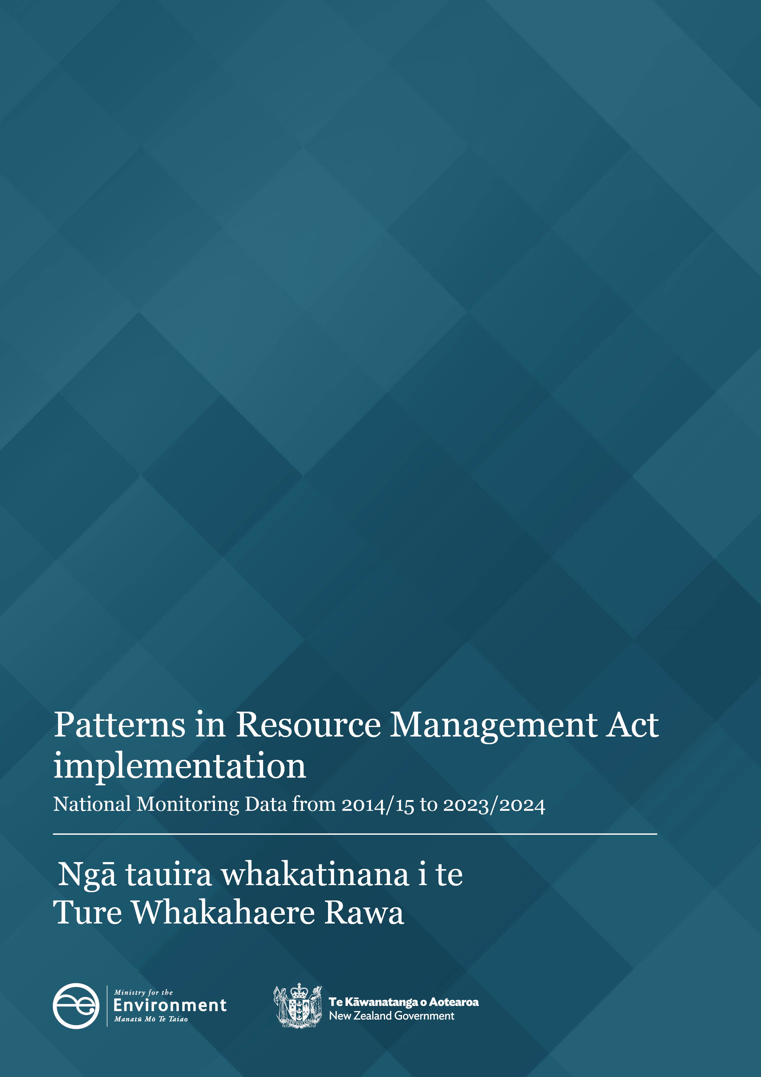

**Disclaimer**

The information in this publication is, according to the Ministry for the Environment’s best efforts, accurate at the time of publication. However, users of this publication are advised that:

* The information does not alter the laws of New Zealand, other official guidelines, or requirements.
* It does not constitute legal advice, and users should take specific advice from qualified professionals before taking any action based on information in this publication.
* The Ministry does not accept any responsibility or liability whatsoever whether in contract, tort, equity, or otherwise for any action taken as a result of reading, or reliance placed on this publication because of having read any part, or all, of the information in this publication or for any error, or inadequacy, deficiency, flaw in, or omission from the information in this publication.
* All references to websites, organisations or people not within the Ministry are for convenience only and should not be taken as endorsement of those websites or information contained in those websites nor of organisations or people referred to.

**Copyright**

© Crown copyright New Zealand 2025. Unless otherwise stated, this copyright work is licensed for re‑use under a Creative Commons Attribution 4.0 International licence. In essence, you are free to copy, distribute and adapt the work, as long as you attribute the work to the New Zealand Government and abide by the other licence terms. To view a copy of this licence, visit Creative Commons Attribution 4.0 International licence.

If you publish, distribute, or otherwise disseminate this work (or any part of it) to the public without adapting it the following attribution statement should be used: Source: Ministry for the Environment and data providers and licensed by the Ministry for the Environment for re-use under the Creative Commons Attribution 4.0 International licence. If you adapt this work in any way, or include it in a collection and publish, distribute, or otherwise disseminate that adaptation or collection to the public, the following attribution statement should be used: This work uses material sourced from the Ministry for the Environment and data providers, which is licensed by the Ministry for the Environment for re-use under the Creative Commons Attribution 4.0 International licence.

Where practicable, please hyperlink the name of the Ministry for the Environment to the Ministry for the Environment web page that contains, or links to, the source data.

**Acknowledgements**

We would like to acknowledge the contribution of local authorities who collect and provide the data for the National Monitoring System that informs this report.

This document may be cited as: Ministry for the Environment. 2025*. Patterns in Resource Management Act Implementation – National Monitoring System data from 2014/15 to 2023/24.* Wellington: Ministry for the Environment.

Published in May 2025 by the  
Ministry for the Environment   
Manatū Mō Te Taiao  
PO Box 10362, Wellington 6143, New Zealand

ISBN: 978-1-991140-85-2 (online)

Publication number: ME 1894

© Crown copyright New Zealand 2025

This document is available on the Ministry for the Environment website: [environment.govt.nz](http://www.environment.govt.nz)

# Contents

About this National Monitoring System data report 5

Patterns in RMA implementation 6

Resource consent data patterns 6

Number of new resource consents granted has decreased 6

Three councils continued to process the highest number of new resource consent applications 7

Higher percentage of new resource consents processed on time since 2021/22 9

Councils approved most new resource consent applications 10

Number and type of declined new resource consent applications 11

Number of notified resource consents remained low 12

Councils used Section 37 less and Section 92 more in 2023/24 14

Median statutory processing times of consent types decreased 15

Plan-making processes 20

Councils improved the timeliness of completing their plan change processes 20

Iwi and hapū participation within the resource management system 21

Council budgets for iwi and hapū participation in consenting and plan-making 21

Number of new iwi management plans increased 22

Compliance and enforcement 23

Enforcement action taken by councils continues to show variation 23

Staffing levels on resource management work varied 24

# Figures

Figure 1: Number of new (Section 88) consents granted by year and type 6

Figure 2: Number of new (Section 88) consents granted in 2023/24 by council 8

Figure 2a: Number of new (Section 88) consents granted in 2023/24 by council (less than, 1,000) 8

Figure 3: Percentage of new (Section 88) consents granted or declined that were processed within statutory timeframes 9

Figure 4: Percentage of new (Section 88) consents granted or declined that were processed within statutory timeframes across all council 10

Figure 5: Percentage of new (Section 88) consents that were granted 10

Figure 6: Percentage of new (Section 88) consents that were declined by type and year 11

Figure 7: Percentage of new (Section 88) consent applications that were notified 12

Figure 8: Percentage of new (Section 88) consent applications that were notified in 2023/24 by council 13

Figure 9: Percentage of new (Section 88) consents granted or declined that used at least one Section 37 or Section 92 14

Figure 10: Median statutory days lapsed for processing time of new (Section 88) consents granted or declined/refused by year and type 15

Figure 11: Median statutory days lapsed by new (Section 88) consents granted or declined/refused in 2023/24 by council 16

Figure 11a: Statutory days lapsed by new (Section 88) consents granted or declined/refused in 2023/24 by council 17

Figure 11c: Statutory days lapsed by new (Section 88) consents granted or declined/refused with less than 20 days in 2023/24 by council 19

Figure 12: Median processing time to complete a plan change once notified for reported plan changes 20

Figure 13: Percentage of councils that provided budget to iwi and hapū to participate in either the development of resource management plans or processing of resource consents 21

Figure 14: Number of new iwi management plans endorsed by iwi authorities and lodged with councils 22

Figure 15: Number of enforcement actions (infringement notices, abatement notices and enforcement order applications) taken by councils by council type 23

Figure 16: Number of full-time equivalents working on resource management at councils by subject area 24

Figure 17: Number of full-time equivalents staff working in resource management at councils 25

# About this National Monitoring System data report

This report is written to inform central and local government of patterns in Resource Management Act 1991 (RMA) implementation, which reflects the roles councils[1] play in everyday decision-making under the RMA. Every year, the Ministry asks each council to provide data on how they have implemented the RMA for the previous year 1 July 2023–30 June 2024. A national data set is then created by the Ministry using all councils’ data for the purposes of this report. This report has been publicly released to make it accessible to the wider resource management community.

This report is organised by topic and highlights patterns in how councils have implemented the RMA over the past eight years, as recorded by the National Monitoring System (NMS). The data collected by the NMS will continue to inform the Ministry’s understanding of how the current resource management system has been working and will help inform future changes to the resource management system.

In some sections of this report, the data are broken down to reflect the types of councils where differences have occurred in RMA implementation.

Unless otherwise noted:

* all consenting facts and figures relate to a council’s decision to grant or decline new resource consent applications within 1 July 2023 − 30 June 2024
* the report excludes data from new resource consent applications that were incomplete, withdrawn or returned
* the term ‘processed’ refers to new resource consents that were granted or declined
* the term ‘plan-making’ refers to policy statements or plans, changes or variations that were started, continued or completed by councils within the 2023/24 financial year.

|  |
| --- |
| Key patterns from 2023/24   * There was a decrease in the number of new resource consents processed by councils. * Most councils processed less than 1,000 new resource consents. * Councils continued to grant over 94 per cent of all new applications. * Councils increased the use of Section 92 (Further information requests) and decreased the use of Section 37 (Power of waiver and extension of time limits). * The proportion of new resource consents being notified was slightly above 2.5 per cent. * The median statutory processing time for new resource consents decreased. * Councils employed their highest number of full-time equivalent staff for resource management. |

# Patterns in RMA implementation

## Resource consent data patterns

Under the RMA, certain activities require a resource consent. A resource consent is permission from a council for an activity that might affect the environment and that is not allowed ‘as of right’ by the district, regional or unitary plan, or a national environmental standard. A resource consent is also required for some types of subdivision activities.

There are different categories of resource consents depending on the rules in a district, regional or unitary plan, or a national environmental standard: coastal permits, combined land-use and subdivision consents, discharge permits, land-use consents, subdivision consents and water permits.

### Number of new resource consents granted has decreased

Figure 1 outlines the number and type of new resource consents granted by councils since 2014/15.

In 2023/24, 30,578 new resource consents were granted. This is a decrease from 36,134 in the 2022/23 reporting year. Land-use consents dropped 13 per cent from the previous year and were at their lowest level since the 2014/15 reporting year. Fewer subdivision consents were granted in 2023/24, compared with the previous year.

**Figure** **1: Number of new (Section 88) consents granted by year and type**

### Three councils continued to process the highest number of new resource consent applications

Of all the councils across New Zealand, 77 of the 78 processed fewer than 2,500 new resource consents in 2023/24. This is consistent with the 2022/23 findings. Auckland Council processed more than 7,500 new resource consents in 2023/24.

All other councils processed less than 2,500 new resource consents. Christchurch City Council processed the second-highest number for the fifth year in a row. Marlborough District Council processed the third-highest number for the fourth year in a row. Auckland Council continues to process the highest number of consents in 2023/24. Figure 2 shows the number of new resource consents granted by each council in 2023/24.

**Figure 2: Number of new (Section 88) consents granted in 2023/24 by council**

Figure 2a shows those councils that processed less than 1,000 new resource consents in the 2023/24 year, which represents just under 96 per cent of all councils that provided data. This is similar to processed application numbers from the 2021/22 reporting year.

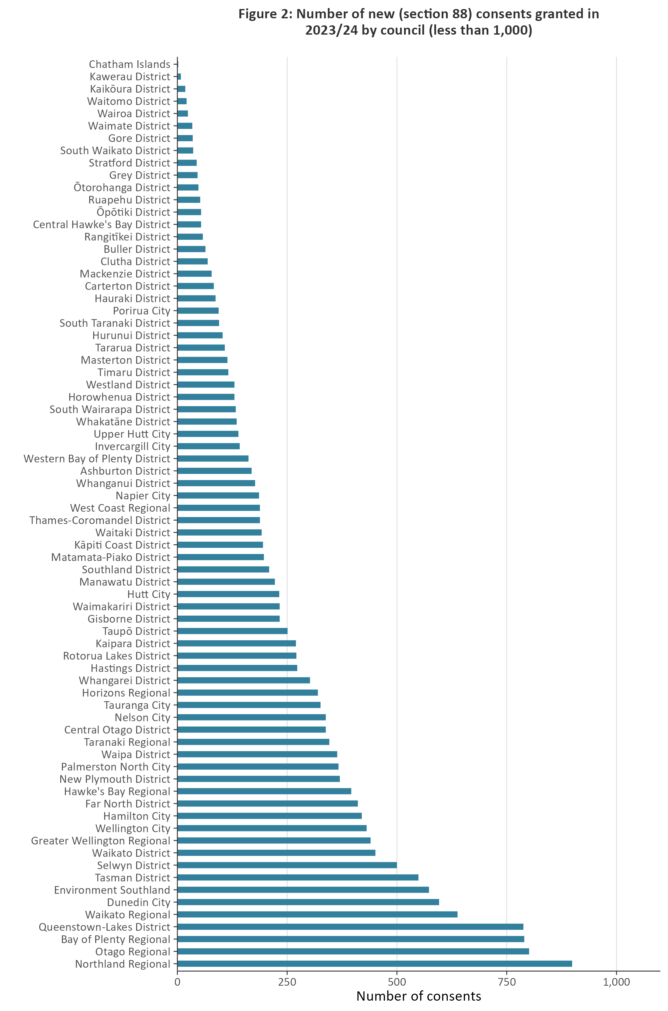Figure 2a: Number of new (Section 88) consents granted in 2023/24 by council (less than, 1,000)

### Higher percentage of new resource consents processed on time since 2021/22

Councils have a responsibility under the RMA to process resource consent applications within a set amount of time. For example, the statutory time limit for a non-notified consent is 20 working days.

When a council cannot meet its statutory requirements for processing a resource consent, and special circumstances do not apply, the council must give the applicant a discount on administrative charges. This requirement, which was introduced under the Resource Management (Discount on Administrative Charges) Regulations 2010, provides a financial incentive for all local councils to meet the RMA’s statutory timeframes.

Figure 3 and figure 4 (overleaf) show the percentage of new resource consents processed within statutory timeframes in the 2023/24 financial year. Figure 3 shows that over the course of 2023/24, 82 per cent of new resource consents were processed within the statutory time limits set out in the RMA. This is a 5.7 per cent increase from the previous year.

Figure 3: Percentage of new (Section 88) consents granted or declined that were processed within statutory timeframes

The data in figure 3 is influenced by the volume of new resource consents processed by Auckland Council. However, as shown in figure 4, there is an upward pattern in the number of new resource consents processed within the statutory time limits across all councils from the 2022/23 reporting year. Although Auckland Council experienced a 17 per cent increase in compliance with statutory time limits, all other areas experienced a 6 per cent increase, compared with the previous year.

Figure 4: Percentage of new (Section 88) consents granted or declined that were processed within statutory timeframes across all council

### Councils approved most new resource consent applications

Figure 5 shows the number of approved new resource consent applications. More than 94.73 per cent of all new resource consents are granted each year.

Figure 5: Percentage of new (Section 88) consents that were granted

### Number and type of declined new resource consent applications

NMS data since 2014/15 has provided the types of resource consents that have been declined by councils. Overall, the figures have generally remained stable and low across years and by type, with minor fluctuations.

Figure 6 shows declined new resource consents by type. It shows that more combined land-use and subdivision consent and land-use consents declined, compared with the previous year. However, fewer coastal permits and water permits were declined in 2023/24.

Figure 6: Percentage of new (Section 88) consents that were declined by type and year

### Number of notified resource consents remained low

When processing a new resource consent application, a council may determine its effects and require it to be publicly notified. The proportion of notified resource consents has historically remained low; over any year it has been under 4 per cent (of all new resource consent applications). Therefore, most new resource consent applications are processed on a non-notified basis.

Figure 7 shows that, in 2023/24, the proportion of new notified resource consent applications was slightly above 2.5 per cent, representing an increase from 2.36 per cent to 2.52 per cent.

Figure 7: Percentage of new (Section 88) consent applications that were notified

Figure 8 (overleaf) shows the percentage of resource consent applications notified by council area. In 2023/24, Buller District Council notified the highest proportion of consent applications (nearly 20 per cent), followed by Bay of Plenty Regional Council (just over 15 per cent). Buller District Council also notified the highest percentage of consents in 2022/23.

In 2023/24, 35 councils notified less than 1 per cent of resource consent applications and 8 councils notified 5 per cent or greater.

Figure 8: Percentage of new (Section 88) consent applications that were notified in 2023/24 by council

### Councils used Section 37 less and Section 92 more in 2023/24

Section 37 allows a council additional working days where certain circumstances are met during the processing of a resource consent. Where used, Section 37 allows a council to double the statutory timeframes or to waive a failure to comply with the statutory timeframes. In using Section 37, a council must take into account the interests of who may be directly affected by the waiver, the interests of the community in making a decision on a consent, and a council’s overall duty to avoid unreasonable delay.

Section 92 of the RMA allows a council to ask for more information from a resource consent applicant before making a decision on the application. The *processing clock* is paused while the applicant responds to the council’s request. Generally, a council seeks additional information to better understand a proposed consenting activity and any effects it may have on the environment. When a council is processing a consent, both Section 37 and Section 92 can be used one or more times on the same application where certain circumstances occur.

Figure 9 shows that use of Section 37 by all councils had a 2.8 per cent decrease in 2023/24. Figure 9 also shows that use of Section 92 by all councils saw a 1.6 per cent increase in 2023/24.

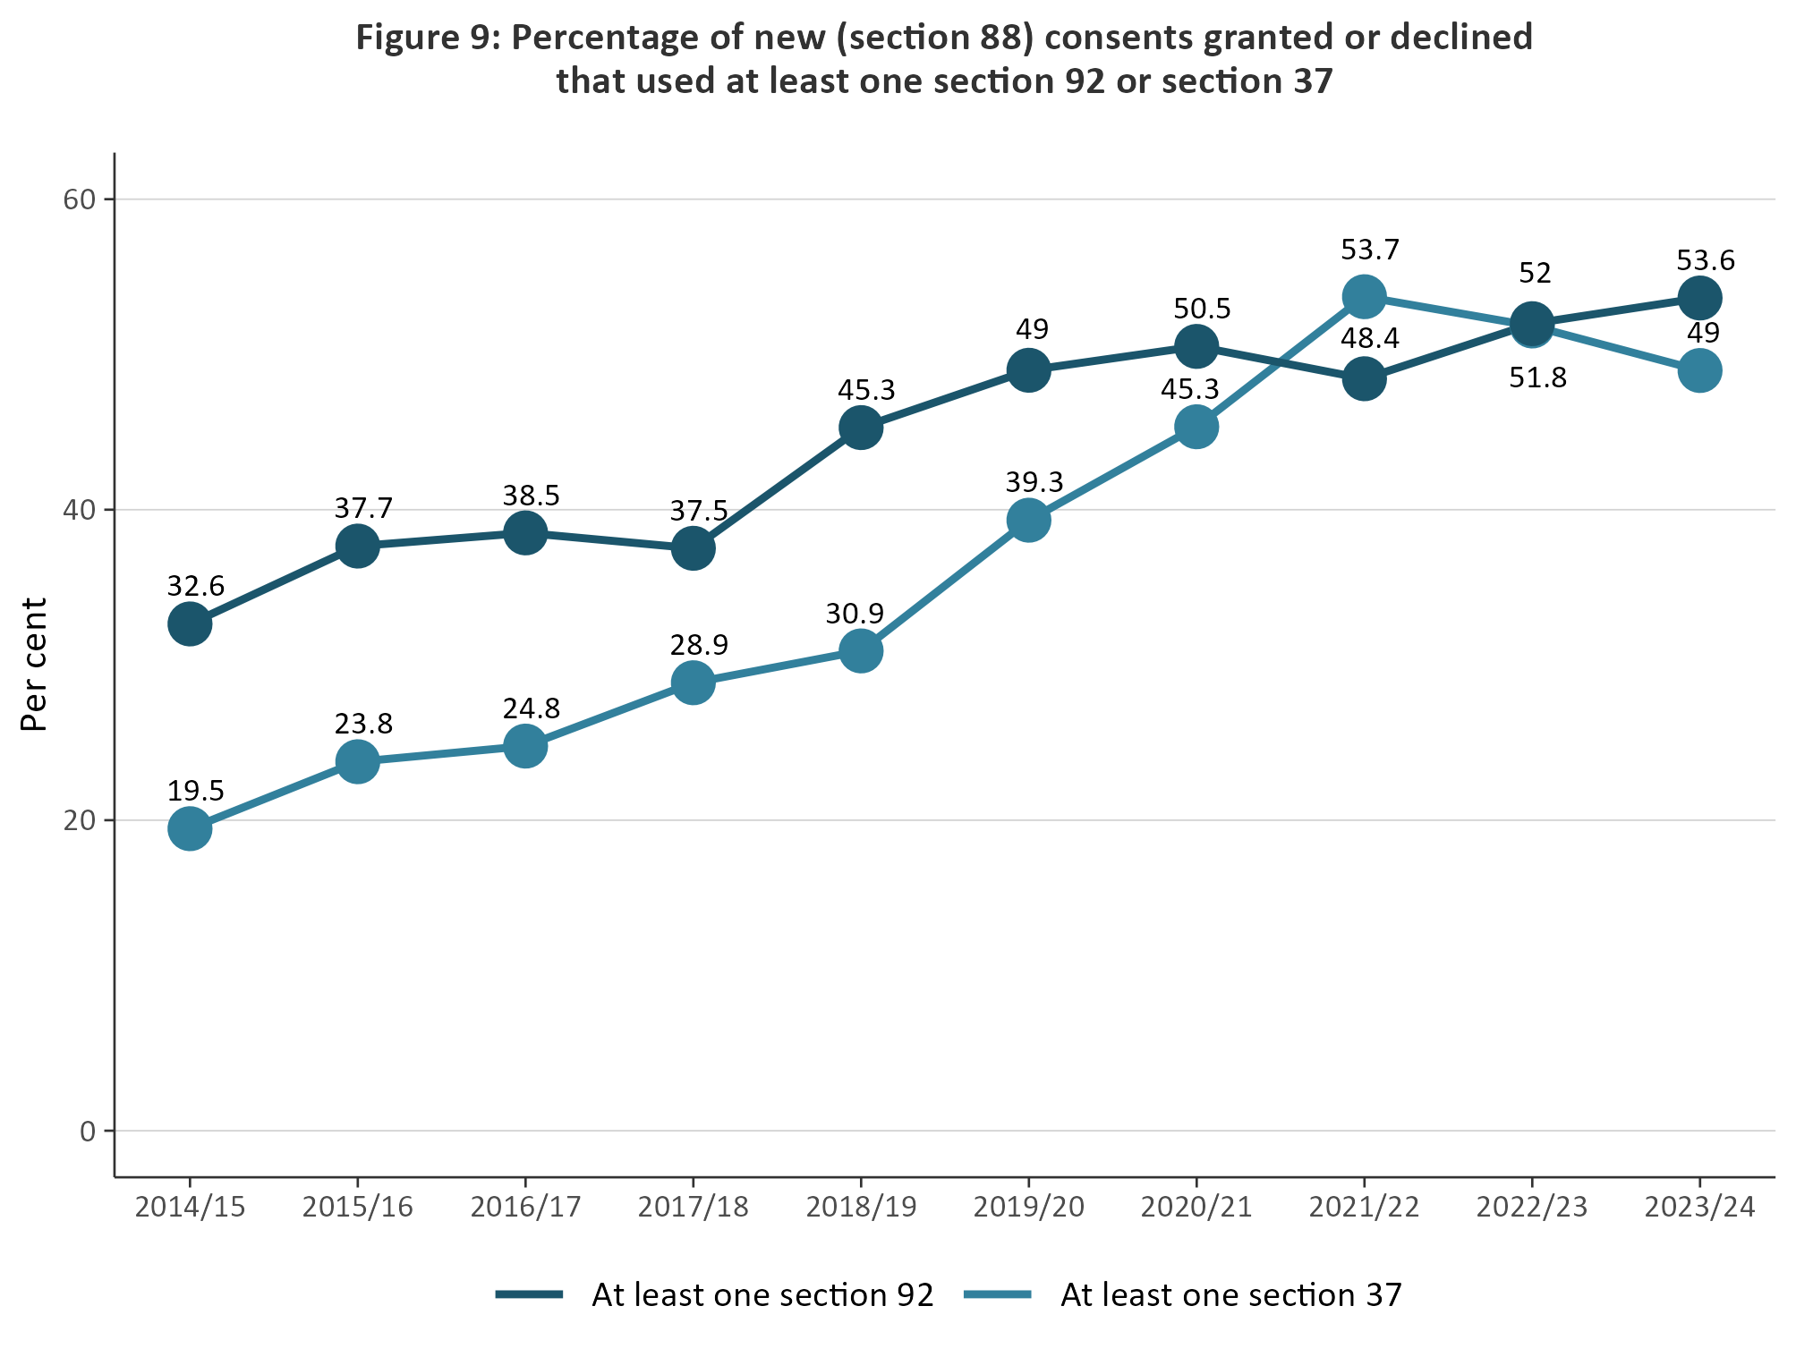Figure 9: Percentage of new (Section 88) consents granted or declined that used at least one Section 37 or Section 92

### Median statutory processing times of consent types decreased

Figure 10 contains a breakdown of types of new resource consents and the median statutory length of time (days) that councils took to process them in 2023/24. The data includes processing time to grant or decline a new resource consent.

The 2023/24 data shows that consent processes nationwide had a median statutory day-processing time of 20 days. Figure 10 also shows that a higher proportion of subdivision consents were processed within 20 days, compared with the 2022/23 timeframe. Coastal permit, land-use consent and water permit consents took a median statutory timeframe of 19 days, compared with 20 days in 2022/23.

Reporting on combined land-use and subdivision consents was introduced in 2020/21. Figure 10 shows that, for 2023/24, the median statutory timeframe decreased to process these types of consents.

Figure 10: Median statutory days lapsed for processing time of new (Section 88) consents granted or declined/refused by year and type

Figure 11 shows the median number of statutory days councils took to process new resource consents. The 2023/24 data shows that some councils’ median processing times exceed 50 statutory days. Figures 11a, 11b and 11c show the median statutory days lapsed along with the spread of statutory days lapsed for consents processed by councils in 2023/24.

Figure 11: Median statutory days lapsed by new (Section 88) consents granted or declined/refused in 2023/24 by council

Figure 11a: Statutory days lapsed by new (Section 88) consents granted or declined/refused in 2023/24 by council

Note: *n* is the number of consents granted or declined/refused

**Figure 11b: Statutory days lapsed by new (Section 88) consents granted or declined/refused with median greater or equal to 20 days in 2023/24 by council**

Note*: n* is the number of consents granted or declined/refused

Figure 11c: Statutory days lapsed by new (Section 88) consents granted or declined/refused with less than 20 days in 2023/24 by council

Note*: n* is the number of consents granted or declined/refused

## Plan-making processes

Councils prepare regional policy statements and regional, district and unitary plans under Part 5, Subpart 3 and Schedule 1, Part 5 of the RMA. A regional, district or unitary plan provides a list of activities requiring a resource consent and may also include a list of ‘permitted activities’.

Councils must review their policy statements and plans, or any plan provisions, at least every 10 years. Plan changes can be initiated by councils or can be requested by private individuals or entities. Plan changes and other plan-making processes occur under Schedule 1 of the RMA.

### Councils improved the timeliness of completing their plan change processes

Under Schedule 1, Clause 5 of the RMA, all local authorities are required to meet a two-year timeframe, from notification, to make decisions on proposed plans or plan changes.

Figure 12 shows that, since 2014/15, a downward trend has occurred in median plan-change timeframes, indicating that councils have continued to improve the median time taken to progress a plan-making process. As the most recent illustration of continual improvement shows, it took councils just under one year (0.96 median years) to complete a plan-change process in 2023/24, compared with just over one year (0.99 median years) in 2022/23.

Figure 12: Median processing time to complete a plan change once notified for reported plan changes

## Iwi and hapū participation within the resource management system

The RMA sets out different ways to enable iwi and hapū participation in resource management processes. Councils also have provisions in place for specific tangata whenua participation in resource management processes.

Provisions may come in the form of budgetary commitments from councils to support iwi and hapū along with other forms of contribution such as access to databases or memoranda of understanding.

### Council budgets **for** iwi and hapū participation in consenting and plan-making

Figure 13 shows the percentage of councils providing a budget for iwi and hapū to participate in plan-making and resource consent processes. Since 2014/15, there has been a general downward pattern for both, from 61.2 per cent (2019/2020) to 38.1 per cent (2023/2024) for plan-making, and from 42.9 per cent to 29.2 per cent for resource consenting.

The 2023/24 data show a downward pattern in providing budget to iwi and hapū to participate in resource consenting processes. The data shows a 9.4 per cent decrease in the percentage of councils that provided budget to iwi and hapū in the plan-making process, compared with the previous year.

Figure 13: Percentage of councils that provided budget to iwi and hapū to participate in either the development of resource management plans or processing of resource consents

### Number of new iwi management plans increased

Iwi management plans describe resource management issues of importance to tangata whenua and can also be used to express values relating to specific areas, natural resources or taonga. Iwi management plans can also provide guidance for interactions between councils and iwi and hapū, as well as direction on decision-making and information requests. They can also help improve understanding of specific values and interests for tangata whenua.

Figure 14 shows that, in 2023/24, the number of new iwi management plans endorsed by iwi authorities and lodged with councils has increased.

Figure 14: Number of new iwi management plans endorsed by iwi authorities and lodged with councils

Note: Iwi management plans lodged with more than one council are counted separately.

Note: 2014/15 was the first year of the NMS in its current form with many historical management plans received.

## Compliance and enforcement

Under the RMA, all councils have a responsibility to monitor a range of matters as part of their compliance and enforcement duties. Such functions enable all councils to:

* ensure the efficiency, effectiveness and enforcement of policy statements and plans
* monitor and enforce the exercising of resource consents and resource management plans
* ensure people and companies are delivering the environmental outcomes supported by councils.

Compliance and enforcement are an important part of councils fulfilling their statutory functions to show that their objectives, policies and methods are meeting the purpose of the RMA. The amount of active compliance and enforcement work varies between councils, depending on the number of consents they have and the local environmental context.

Councils can use different types of enforcement tools under the RMA, from issuing abatement notices or seeking an enforcement order, through to issuing an infringement notice or making a prosecution.

### Enforcement action taken by councils continues to show variation

Figure 15 shows that enforcement actions taken by councils have varied since 2014/15. The 2023/24 data showed that Auckland Council, regional councils, territorial authorities and unitary authorities increased their enforcement actions, compared with 2022/23.

Figure 15: Number of enforcement actions (infringement notices, abatement notices and enforcement order applications) taken by councils by council type

**Note:** The above excludes data that has not been reported to the Ministry or reconciled by councils.

### Staffing levels on resource management work varied

Full-time equivalents measure the number of employees working in the different areas of consenting, plan preparation processes (planning), and compliance and enforcement at councils. Since 2014/15, consenting staff numbers have remained higher than full-time equivalents measured in the planning, compliance and enforcement areas.

Figure 16 shows a decrease in the number of consenting staff during 2023/24 (1,192 full-time equivalents) compared with the previous year.

In 2023/24, there is an increase in both the number of planning staff and the number of monitoring and enforcement staff compared with the previous year.

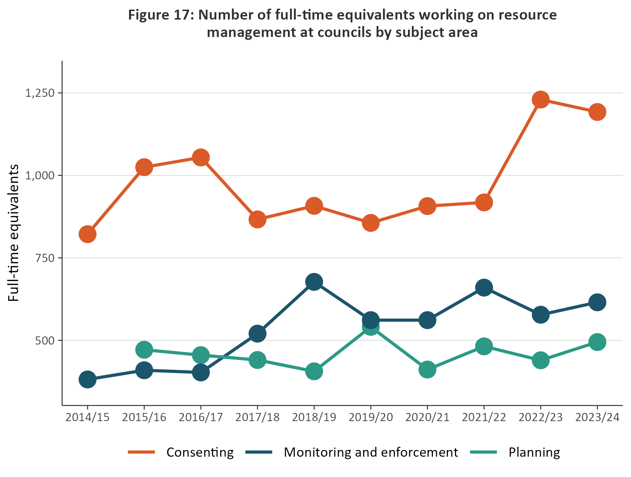Figure 16: Number of full-time equivalents working on resource management at councils by subject area

Figure 17 (overleaf) shows councils employed their highest number of full-time equivalents in resource management (the data combined consenting, compliance, enforcement, and planning policy staff) in 2023/24.

The 2023/24 data illustrates upward growth in comparison to the 2022/23 data.

Figure 17: Number of full-time equivalents staff working in resource management at councils

**Note:** Full-time equivalents data records the number of staff employed and does not include vacancies.

1. The RMA uses the term ‘local authorities’. In this report, we have used ‘councils’ to refer to all local authorities, that is, district and city councils, regional councils and unitary authorities.