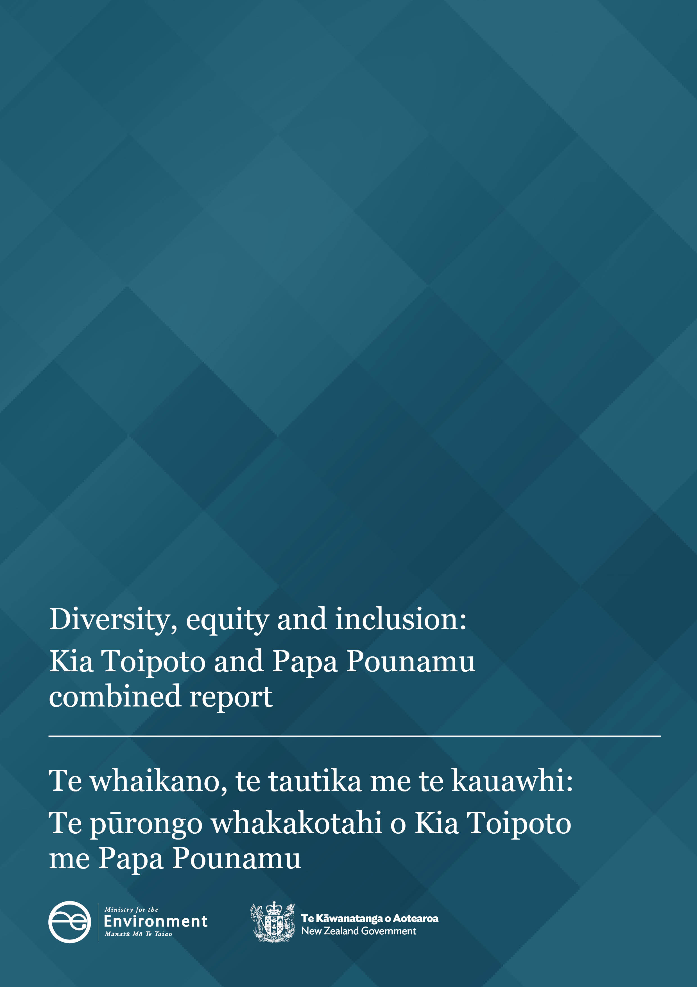

Disclaimer
The information in this publication is, according to the Ministry for the Environment’s best efforts, accurate at the time of publication. The Ministry will make every reasonable effort to keep it current and accurate. However, users of this publication are advised that:
- the information does not alter the laws of New Zealand, other official guidelines, or requirements
- it does not constitute legal advice, and users should take specific advice from qualified professionals before taking any action based on information in this publication
- the Ministry does not accept any responsibility or liability whatsoever whether in contract, tort, equity, or otherwise for any action taken as a result of reading, or reliance placed on this publication because of having read any part, or all, of the information in this publication or for any error, or inadequacy, deficiency, flaw in, or omission from the information in this publication
- all references to websites, organisations or people not within the Ministry are for convenience only and should not be taken as endorsement of those websites or information contained in those websites nor of organisations or people referred to.

This document may be cited as: Ministry for the Environment. 2025. Diversity, equity and inclusion: Kia Toipoto and Papa Pounamu combined report. Wellington: Ministry for the Environment.

Published in January 2025 by the
Ministry for the Environment
Manatū mō te Taiao
PO Box 10362, Wellington 6143, New Zealand
environment.govt.nz
ISBN: 978-1-991140-63-0 (online)
Publication number: ME 1871
© Crown copyright New Zealand 2025

Contents
Introduction 5
Our vision 5
Our commitment 5
Our people 5
Our approach 5
Key initiatives 6
Data 8
Representation 8
Pay gaps 8
The numbers 9
Kia Toipoto – Public Service Pay Gaps Action Plan 2021–24 progress and plan 12
Papa Pounamu Public Service work programme progress and plan 15
Planning for 2025–27 17

Table
Table 1: Ministry for the Environment workforce and leadership representation by gender and ethnicity as at 30 June 2024 9
Table 2: Ministry for the Environment Kia Toipoto progress as at 30 June 2024 12
Table 3: Ministry for the Environment Papa Pounamu progress as at 30 June 2024 15

Figures
Figure 1: Ministry for the Environment overall gender pay gap 10
Figure 2: Average Ministry for the Environment salaries by gender and ethnicity 11
Figure 3: Ethnic pay gaps compared to the public sector average 11

Introduction

Our vision
This Ministry for the Environment’s vision is to provide an inclusive and equitable work environment, one that lifts our organisational capability and performance to deliver better outcomes for all New Zealanders and allow a diverse workforce to flourish.
We have four broad organisational goals we strive to achieve:
- Embed organisational practices that make the most of our diverse talents. Our policies, practices and processes are fair, free from discrimination, and enable us to attract and retain a more diverse workforce.
- Harness diversity of thinking. We’re skilled at seeking out and incorporating diverse perspectives, and managing the healthy and robust discussion that can come with this. This enables us to develop innovative solutions and take people with us.
- Create an inclusive culture. All our people feel valued for their perspectives and as people, and can bring their whole selves to work. We have strong cultural capability, particularly in te ao Māori. We support and enable our employee-led networks to thrive.
- Demonstrate inclusive leadership. Our leaders are skilled at working with diverse teams, managing conflict, and creating an inclusive culture that surfaces and builds on diverse thinking to create better outcomes.

Our commitment
The Ministry is committed to delivering on our diversity, equity and inclusion (DEI) goals. We invest in diversity and inclusion, and for the past five years have been working to Tui Raumata, our Diversity, Equity and Inclusion Strategy. We are proud of the progress we’ve made since this strategy was put in place. Following our operating model review and organisational changes, we will shortly commence the process of reviewing and redeveloping a DEI strategy for the coming three years.

Our people
As at 30 June 2024, the Ministry had a total of 938.9 full time equivalents (FTEs). 58 per cent of our workforce is based in Te Whanganui-a-Tara – Wellington, 10 per cent in Tāmaki Makaurau – Auckland, 12 per cent in Ōtautahi – Christchurch, with the remaining 20% based remotely across the motu. Working flexibly-by-default has been a key policy that has allowed the Ministry to access a diverse range of talent from across the country.

Our approach
Tui Raumata, our Diversity, Equity and Inclusion Strategy, represents the tapestry of the Ministry, woven from the threads of our kaimahi, who collectively bring a diverse array of backgrounds, perspectives and worldviews. The strategy references the whakataukī: “Nā tō rourou, nā taku rourou ka ora ai te iwi – With your food basket and with mine, the people will thrive.”
Over the last 18 months, the Ministry has undergone significant change, including an operating model review and organisational reset, and changes to our size and structure. A key principle of the change process was ensuring all decisions follow a kaimahi-centric approach. That meant designing a process that was respectful and transparent, and that showed manaakitanga (care for others) and arohatanga (compassion and empathy) to all our people. Tui Raumata has played an important role in the change process, ensuring that people remain at the centre of leaders’ decisions.
The Ministry’s Papa Pounamu and Kia Toipoto action plan have been updated to reflect the Ministry’s progress and broad goals for diversity, equity and inclusion, and for closing pay gaps in the context of our reset environment, which are outlined in this document.

Key initiatives
In 2023, the Ministry embarked on an operating model redesign process. This work provided the Ministry with a clear pathway forward that led to significant change process at the start of 2024. A key principle to the change process was to deliver a kaimahi-centric approach. As such, the Ministry implemented key initiatives that ensured we put our people first throughout the change process.
- Implementing recruitment controls at the commencement of the operating model redesign process. Targeted financial savings expected to be delivered over the next three years required the Ministry to put in place controls on recruitment. The decision to do this ensured the Ministry could enter the change process with the aim to retain as many of our kaimahi as possible. Restricting external recruitment encouraged leaders to prioritise work, as well as utilise the existing workforce – including permanent and fixed term employees.
- Engaging with and seeking feedback from all stakeholders. Throughout the operating model redesign and organisational reset process, we regularly engaged with key stakeholder groups including:
- the PSA
- our employee-led networks
- our whole employee base via an email address where kaimahi were invited to “Have your say”.
These touchpoints allowed our kaimahi and their representatives to provide feedback during the consultation period, to ask questions and make suggestions, and to access guidance at various stages of the process.
- At the commencement of the selection process, where kaimahi were applying for roles in our reset structure, all leaders and kaimahi were supported in the following ways:
- Interview applicants were invited to bring along a support person to their interviews.
- Interview pātai (questions) were provided to all interviewees. This gave kaimahi the best opportunity to prepare before attending interviews.
- We reflected on the whakataukī: “Kaore te kumara e kōrero mō tōna ake reka - The kumara does not speak of its own sweetness.” The Ministry supported Māori and Pasifika staff with training on effective ways they can promote themselves, their personal brand, and provided tips and techniques for putting their best foot forward.
- CV, cover letter and interview workshops were provided to staff. Personalised one-on-one review of staff CVs were offered at staff request.
- Refresher workshops in unconscious bias were delivered for all people leaders and managers to attend. The workshop focused on supporting leaders to have stronger awareness of the biases they may have, and provided effective tools that would ensure the fairest evaluation of staff during the reset process.
- Workshops on the selection process, including CV and interview support, were offered through the neurodiversity network and provided on request.
While the major focus for the last 18 months has been delivering on the operating model review and organisational reset process, the Ministry has made progress in several other areas.
- Te Ao Hurihuri, our te ao Māori capability strategy. This strategy leverages the Whāinga Amorangi capability framework. The Ministry’s aim is to bring Te Tiriti o Waitangi and te ao Māori into the workplace every day. Achievements have included:
- Continued rollout and delivery of Tōnui to all kaimahi. This is the Ministry’s baseline capability workshop for all staff, to increase their knowledge and understanding of New Zealand’s history, te ao Māori, Te Tiriti, discrimination and cultural safety.
- Incorporation of Rongoā Māori into the Ministry’s Employee Assistance Programme (EAP) provision. Rongoā is a holistic and cultural healing practice that incorporates deep, personal connections with the natural environment. It was introduced to EAP following consistent feedback received in our Tō Reo (employee engagement) survey that a more culturally-aligned service was needed for our kaimahi Māori. The service is accessed confidentially in the same way counselling services are accessed through our EAP provider.
- Te reo Māori and te ao Māori resources and learning. These are available through our intranet, Te Taiao. Karakia for starting and closing meetings is encouraged, and staff are supported with resources to help with pronunciation. The Ministry performs pōwhiri and mihi whakatau for manuhiri and guests, and, prior to the change process, ran quarterly mihi whakatau for new kaimahi. This will be reinstated as the Ministry moves out of our reset.
- Recruitment. We have continued to enhance our recruitment practices, including using gender-neutral language, advertising jobs titles in both te reo Māori and English, and a flexible-by-default location, and advertising all roles with transparent salary ranges. In addition, we promote the use of diverse interview panels and the provision of interview questions to candidates prior to interview.
For any roles that are externally advertised, all adverts contain the following statement: “We embrace diversity and inclusion and are committed to equal opportunities. What’s important to us is ‘he rau kotahi tangata’ – embracing our multiple talents – by harnessing our diversity and being inclusive. We actively encourage applications from all backgrounds.”
- Flexible work. Our sector-leading ‘flexible-by-default’ way of working has embedded and normalised flexible working at the Ministry; it has helped to increase our diversity as an organisation by allowing us to tap into candidate pools anywhere across Aotearoa, and reduce barriers to entry for those who have care or community responsibilities. Our trust-based system is modelled by leaders and highly valued by our workforce. It allows people outside of the urban centres to access opportunities to work at the Ministry while maintaining connections to whenua, whānau and community.
- Regular ‘deep dive’ reporting into our diversity and inclusion landscape, including pay gaps. Sharing this information with our leaders has helped to build awareness of our current state and reinforced our focus on building a workplace free from bias and discrimination
- Continued progress against Tui Raumata, our Diversity, Equity and Inclusion Strategy, and Tangata Ora, our People Strategy. This includes participating in external accreditation processes to ensure continuous improvements to our practices and systems, strengthening support for employee-led networks, delivery of cultural capability uplift for leaders and teams, and building the foundations of a career-development framework.

Data

Representation
As at 30 June 2024, the Ministry had a total of 938.9 FTEs, having reduced from 1068 FTEs at the peak of our growth in November 2023. The reduction in our kaimahi numbers is largely due to the operating model change and organisational reset process, which commenced with voluntary redundancies and strong recruitment controls. FTE reduction has continued through the change process, with the new organisation structure being effective from 1 November 2024.
As at 30 June 2024, females made up 67 per cent of the Ministry’s workforce, 32 per cent were male and 1 per cent were ‘another gender/prefer not to say’. These numbers have held consistently over the past 12 months and throughout the change process. In Tier 2 and Tier 3 leadership (deputy secretaries and general managers), females were strongly represented at 58 per cent, with males making up the remaining 42 per cent. As with the overall workforce statistics, these numbers have been consistent across the last 12 months.
In terms of ethnicity, Europeans are the highest represented in both overall workforce and in Tier 2 and Tier 3 leadership roles, at 73 per cent and 68 per cent respectively.

Pay gaps
The Ministry’s overall gender pay gap has held its position over the past two financial years at 8.8 per cent. In part, this is due to the recruitment controls that have been in place for the past year. There has been very little external recruitment activity and minimal internal movement.
The Ministry’s gender pay gap continues to be largely driven by a higher proportion of females than males in lower paid roles at the Ministry. The Ministry has good female leadership representation at all levels and this is a likely advantage when it comes to attracting a strong female talent pool to entry-level roles. The higher representation of females at the entry level (Support, Advisor and Analyst roles) is a result of this strong female talent pool that we attract.
Continuing to build our development frameworks, including identifying future-critical skills that the Ministry will need to achieve its organisational goals. The process of mapping both core capabilities and career pathways will help to ensure we are supporting female employees in entry-level roles to grow and progress their careers.
The Ministry has made good progress in increasing Māori representation across all levels, and this is reflected in our Māori pay gap data. This shows that, at an overall level, Māori are paid slightly more on average than Europeans.
The Ministry’s overall ethnic pay gap has reduced year-on-year for the last five years, and the European pay gap is smaller than the public-service average. This means that, overall, the gap between European and non-European ethnicities combined is smaller than for the public sector overall.
For Pasifika Peoples and Middle Eastern, Latin American and African (MELAA) employees, it should be noted that the data is volatile due to low numbers in these groupings.
Similarly, in the case of the Asian pay gap, a lack of representation at leadership drives a larger pay gap, though the Ministry’s mid- and senior-level bands have reasonably healthy Asian representation.
In addition to improving the diversity of our workforce across all levels through hiring, the Ministry is focused on supporting the career development of an ethnically diverse talent pool internally, alongside building cultural capability and inclusive leadership to support a more diverse team. Actions towards these goals are outlined at a high level in this report, and in detail in Tui Raumata, our Diversity, Equity and Inclusion Strategy.

The numbers
This section provides an overview of the key workforce data relating to our gender and ethnic pay gaps, including the pay gaps themselves, and how different genders and ethnicities are distributed across our workforce.
All data is as at 30 June 2024.
Table 1: Ministry for the Environment workforce and leadership representation by gender and ethnicity as at 30 June 2024
 | Overall workforce representation | All managers, including senior leaders | Senior leaders,  Tier 2 and Tier 3
Gender
Female | 67% | 67% | 58%
Male | 32% | 33% | 42%
Another gender/Prefer not to say | 1% | 0% | 0%
Ethnicity
European | 73% | 79% | 68%
Māori | 13% | 14% | 20%
Asian | 7% | 3% | 4%
Pacific Peoples | 2% | 1% | 0%
Middle Eastern, Latin American and African (MELAA) | 2% | 1% | 0%
Other Ethnicity | 1% | 1% | 2%
Not Declared | 4% | 2% | 6%
Notes:
Ethnicity disclosure: 96.3 per cent of all staff, 94 per cent of senior leaders. Employees can declare up to three ethnicities, therefore the total can equal more than 100 per cent. Representation percentages are rounded to the nearest whole number. MELAA: This is included as an ethnicity category to meet our reporting obligations, however, we recognise that this grouping together of diverse ethnicities is not in line with how many of our employees would choose to identify themselves.
Figure 1: Ministry for the Environment overall gender pay gap
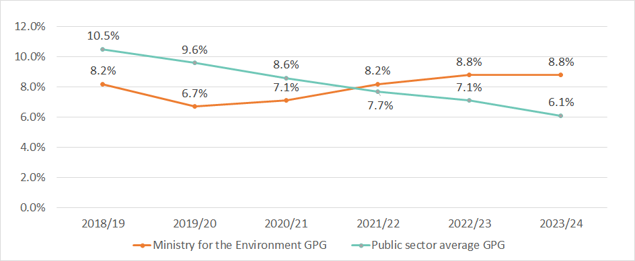
Note: Gender pay gap (GPG) is measured by calculating the difference between the average salary of male and female employees. The GPG figure includes permanent, fixed-term and staff on secondment outside the Ministry.

Figure 2: Average Ministry for the Environment salaries by gender and ethnicity
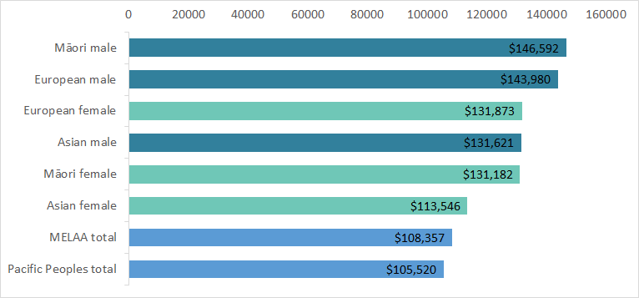
Note: Pacific Peoples and MELAA have not been split out by gender due to low numbers compromising confidentiality (2 per cent share of workforce per group).

Figure 3: Ethnic pay gaps compared to the public sector average
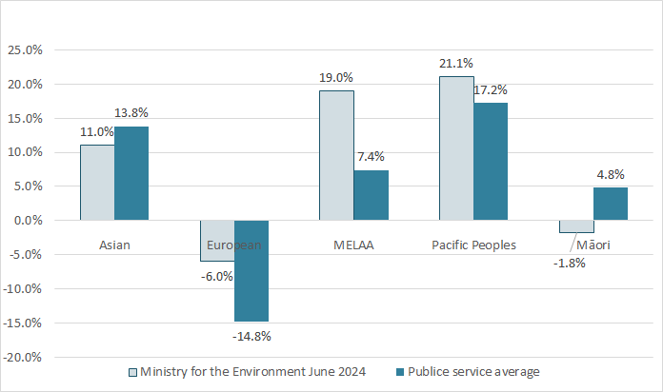
Note: Ethnic pay gaps (EPG) are measured by calculating the difference between the average salary of European and non-European employees. The EPG is calculated using all ethnicities that an employee has declared (for example, if they have declared both Māori and European, they will contribute to the average for both ethnicities). The EPG figure includes permanent, fixed-term and staff on secondment outside the Ministry. For Pacific Peoples’ and MELAA figures it should be noted that figures are based on low employee numbers, and therefore are subject to significant fluctuations based on individual movements.

Kia Toipoto – Public Service Pay Gaps Action Plan 2021–24 progress and plan
This section outlines the Ministry’s progress against our existing Gender and ethnic pay gaps action plan. Due to the significant demands of the organisational change process which spanned the reporting period, and the change to our structure which took effect on 1 November 2024, we have been limited in our ability to consult with our people on our Gender and ethnic pay gaps action plan, as is our normal practice.
As we move out of change, the Ministry will reset the focus onto Tui Raumata, our Diversity, Equity and Inclusion Strategy, in the second half of the financial year. This will involve engagement and consultation with our people, particularly our employee-led networks and the PSA, and the setting of targets, actions and deliverables to address pay gaps and identified priorities to improve diversity, equity and inclusion.
Table 2: Ministry for the Environment Kia Toipoto progress as at 30 June 2024
Focus area | Current state | Outcomes
Te pono – Transparency | We have published a pay gaps action plan for the last three years. We included ethnicity for the first time in the 2021/22 plan.  Policy, guidelines and remuneration bands are published on our intranet, remuneration bands are published in the collective agreement and all advertised roles have transparent salary ranges. | Our employees and prospective employees have access to fully transparent pay-band information and visibility of pay gaps that exist, along with information about what the organisation is doing to reduce these.  Our employees feel more empowered to discuss their pay with their managers, and understand where they sit within bands and the reasons for remuneration decisions.  Our Tō Reo (employee-engagement survey) measures related to remuneration and reward transparency improve.
Ngā hua tōkeke mō te utu – Equitable pay outcomes | All advertised roles include transparent salary ranges (with starting salary influenced by negotiation and internal relativities).  We designed a starting-salary calculator, with the intention of reducing bias at point of entry – this required further work to ensure it is properly benchmarked.  We inserted a step in our recruitment process for hiring managers to discuss internal relativities at point of salary negotiation with business partners/advisors.  We have regular six-monthly reporting across bands and business groups, reviewed annually in line with remuneration review.  Pay equity processes are followed when a claim is made, as outlined by Te Kawa Mataaho Public Service Commission. | Pay gaps within bands will reduce (below four per cent tolerance by June 2024).  Hiring managers will be supported to make remuneration decisions that are not influenced by bias.  Identified within-band pay gaps are picked up through ongoing analysis and remedial actions recommended where appropriate.
Te whai kanohi ngā taumata katoa – Leadership and representation | We have set targets via Tui Raumata, our Diversity, Equity and Inclusion Strategy, which we are assessing progress against and reporting to leadership on every six months.  We have implemented a six-monthly cycle to monitor progress against targets. | Reduced ethnic and gender pay gaps, due to the reduction of occupational segregation.  Strong female representation in leadership (Tiers 1 and 4) is maintained.  Better representation of ethnicities across leadership is built.  A clear method of identifying and supporting future leaders from diverse ethnic backgrounds to fulfil their leadership potential exists.
Te whakawhanaketanga i te aramahi – Effective career and leadership development | We have launched leadership expectations, which begin to set common standards for individual contributors, leaders and senior leaders.  We have included a diversity lens on our selection panel for Aspiring Leaders and New People Leaders programmes.  We have commenced design and implementation of a strategic workforce planning approach that gives us clarity around the key skills, capabilities and roles the Ministry will need into the future, thereby informing career pathways.  We support participation in the Te Puni Kōkiri Māori Emerging Leaders Programme.  We continue to run a Ministry summer internship programme and are involved in partnership programmes through iwi and via the Ministry of Business, Innovation and Employment Tupu Tai programme, which enables us to access a diverse early career talent pool. | Data and insights relating to development, talent and career allow us to understand whether bias is at play in our career-development landscape.  The leadership cohort is significantly more diverse.  Improvements made to our Tō Reo measures relating to career and development across different ethnic populations.
Te whakakore i te katoa o ngā momo whakatoihara, haukume anō hoki – Eliminating all forms of bias | Recruitment process improvements:  - Unconscious-bias module promoted to hiring managers  - ethnic and gender-balanced panels  - ensuring hiring managers are aware of diversity landscape prior to hiring  - diversifying sourcing channels (including specialist job boards, social media)  - ensuring interview questions are circulated in advance.  Regular reporting and updates to leadership against Tui Raumata targets, Tō Reo results.  Completion of organisation-wide roll out of Tōnui, inclusive leadership and Mana Aki – intercultural capability programme is made available. | We will increase our organisational capability in te ao Māori and Te Tiriti obligations from ‘unfamiliar’ to ‘comfortable’ (based on Whāinga Amorangi organisational cultural capability framework).  The recruitment process delivers a significant increase in diversity of new hires.  Employee-experience gaps measured in Tō reo close.  The Ministry maps the employee lifecycle and identifies and addresses areas where bias may exist.
Te taunoa o te mahi pīngore – Flexible work by default | Roles are recruited with flexible location unless there is a specific requirement for in-person engagement, such as local stakeholder engagement or support.  The Ministry has published guidelines around flexible ways of working, including guidance for leaders and guidance for managing wellbeing in a flexible working environment. | Access to flexible-by-default ways of working are available to all, in line with true requirements of roles.  We have a clear view of the impact of different types of flexible working on career progression and development and are thus able to solve for any equity issues that exist.  Our flexible-by-default policy continues to allow us access to a more diverse talent pool, and we have clear and effective support in place for developing early-in-career professionals to ensure no disadvantage to remote kaimahi.

Papa Pounamu Public Service work programme progress and plan
This section outlines the Ministry’s progress against our existing diversity and inclusion work programme and action plan.
As we move out of change, the Ministry will reset the focus onto Tui Raumata, our Diversity, Equity and Inclusion Strategy, in the second half of the financial year. This will involve engagement and consultation with our people, particularly our employee-led networks and the PSA, and the setting of targets, actions and deliverables to address pay gaps and identified priorities to improve diversity, equity and inclusion.
Table 3: Ministry for the Environment Papa Pounamu progress as at 30 June 2024
Focus area | Current state | Outcomes
Te Urupare i te Mariu| Addressing bias | Leaders attended unconscious-bias training during the change process.  Tōnui is our introductory-level programme on Te Tiriti o Waitangi and its place in our work, policy and practices at the Ministry. Tōnui was designed in accordance with Whāinga Amorangi in lifting our Māori–Crown relations capability. A segment in Tōnui explores structural discrimination and a case study is provided. The aim of the segment is to provide an awareness and a perspective of the attributes of structural discrimination and bias, and provide examples of that in context. More importantly, participants are invited to evaluate what they’ve learned and demonstrate that awareness by formulating their own individual or collective responses to structural discrimination in their work and their place of work; identifying more proactive ways of being more responsive to structural or racial discrimination and bias in real-time contexts. | Including contractors, fixed-term and permanent staff (as well as staff who have left) we had a total of 869 of 1177 staff complete the Tōnui programme. Tōnui will continue to be delivered in 2024 and 2025.
Te āheinga ā-ahurea | Cultural competence | Tōnui, our all-employee cultural competency programme, has been the mainstay of our Māori–Crown relations focus, with a specific goal of enabling the Ministry to consistently meet its obligations under Te Tiriti o Waitangi, to contribute to our society, to be a good partner and to address inequality and promote development. At a foundational level, Tōnui offers an insight into the whakapapa of Māori–Crown relations, the Māori worldview, the impact of Te Tiriti o Waitangi and significant legislation on Māori–Crown relations, and what this all means for our people in their work as public servants. Based on what they learn, participants are invited to consider how they might contribute to the improvement of Māori–Crown relations in our roles and work. Additionally, a programme of learning that covers a period of three months is offered as an extension on our one-day wānanga.  Te Ao Hurihuri – Embracing Te Ao Māori at Manutū Mō Te Taiao is our strategy to build the capability needed to be a good Treaty Partner. It focuses on 6 pou:  - Whānau Ora – Unifying our people  - Wai Ora – Creating safe environments  - Mauri Ora – Building a resilient structure  - Kaitiaki Ora – Accessing knowledge  - Hau Ora – Checking our progress  - Mana Ora – Standing together | Including contractors, fixed-term and permanent staff (as well as staff who have left) we had a total of 869 of 1177 staff complete the Tōnui programme. Tōnui will continue to be delivered in 2024 and 2025.
Ngā tūhononga e kōkiritia ana e ngā kaimahi | Employee-led networks | Employee-led network (ELN) has an intranet page and in included in our induction book  We have a sector-leading resourcing model for ELN leadership, ensuring our ELN leaders are supported consistently and appropriately, and their contribution is recognised. | Two-way flow of information and support from ELNs.  Sustainability of ELNs improved by ensuring support is given and contribution is recognised.
Hautūtanga Ngākau Tuwhera | Inclusive leadership | People leaders attend unconscious-bias training prior to the commencement of the selection process. | Leaders support each other during the change process and ensure they are making good, sound decisions.
Te whakawhanaungatanga | Building relationships | “Ask me anything” – leader-led drop-in sessions. Multiple sessions set up during the change process for staff to come together and ask questions of leaders. | Kaimahi to stay engaged and connected with each other and their leaders.

Planning for 2025–27
As we move from our organisational reset programme back into ‘business as usual’, we will be prioritising several work programmes that will impact on our organisation from a diversity, equity and inclusion, and pay gaps perspective. These are:
- Reestablishing Tui Raumata, our Diversity, Equity and Inclusion Strategy for 2025–27. The lifecycle of this strategy drew to a close at the end of 2024, and given the context of organisational reset, we have been limited in our ability to ask our kaimahi groups to input into redesign. This project will be a key deliverable for the second half of the 2024/25 financial year. Analysing and planning for reduction of pay gaps (based on real-time data rather than at 1 July 2024, before our organisational change took place) will occur as part of this project and the resulting work programme will be shared with our kaimahi.
- Introducing a Growth and Performance Framework to support performance and career development. As a key deliverable of our organisation’s Renew programme of work, we are in the early stages of designing a Growth and Performance Framework that will support our people with clarity around the Ministry’s goals and priorities, measures of success, and ensure that all kaimahi have regular opportunities to discuss their performance and development with their people leaders. All people leaders will be supported with training to ensure they have clear expectations of how they are expected to support our people effectively within this framework.
- Resetting our culture. We have commenced work on redefining our organisational culture and values to ensure that this aligns with our goals, is clear to our people, and supports the diverse and inclusive organisation we aspire to be. It’s important to us that we build an environment where all our kaimahi can thrive, and as such we will see this woven through our culture work programme.
- Continuing to build momentum on cultural capability. Tōnui, our baseline cultural capability programme has been rolled out to all kaimahi, consisting of an in-person workshop and series of self-paced modules. We are currently in the process of designing and building Tōnui 2.0, which is an extension programme designed for roles across the business where there is a higher degree of capability required to perform successfully. This programme is based on Whāinga Amorangi and aims to support kaimahi to reach the ‘Capable’ level of the framework.
- Reviewing pay-gap controls within our recruitment process. Work currently underway on our recruitment process includes the review of delegations for remuneration decisions as point-of-hire, and will seek to ensure that good visibility of pay-gap impacts of proposed remuneration offers is built in.

