

Te Tahua Pūtea mō te Kirihou Auaha

Plastics Innovation Fund

Expression of interest guide for applicants

**Disclaimer**

The information in this publication is, according to the Ministry for the Environment’s best efforts, accurate at the time of publication. However, we advise users of this publication that:

* the information provided has no official status and so does not alter the laws of New Zealand, or other official guidelines or requirements
* this guide does not constitute legal advice, and users should take specific advice from qualified professionals before taking any action as a result of information obtained from this publication
* the Ministry for the Environment does not accept any responsibility or liability whatsoever whether in contract, tort, equity or otherwise for any action taken as a result of reading, or reliance placed on this publication because of having read any part, or all, of the information in this publication or for any error, or inadequacy, deficiency, flaw in or omission from the information provided in this publication
* all references to websites, organisations or people not within the Ministry for the Environment are provided for convenience only and should not be taken as endorsement of those websites or information contained in those websites nor of organisations or people referred to.

This document may be cited as: Ministry for the Environment. 2023. *Te Tahua Pūtea mō te Kirihou Auaha Plastics Innovation Fund: Expression of interest guide for applicants*. Wellington: Ministry for the Environment.

First published in October 2022. Updated version published in December 2023.

Published by the  
Ministry for the Environment   
Manatū mō te Taiao  
PO Box 10362, Wellington 6143, New Zealand

environment.govt.nz

ISBN: 978-1-99-102588-3  
Publication number: ME 1695

© Crown copyright New Zealand 2023

# Contents

About this guide 4

Purpose 4

Intended audience 4

How to use this guide 4

PART 1: Eligibility criteria 5

Is your project eligible for funding? 5

What we won’t fund 7

PART 2: Expression of interest 8

Expression of interest and assessment criteria 8

PART 3: How to apply 15

Completing your online expression of interest 15

Appendix 1: Definition and examples of project objectives 17

Appendix 2: Benefits 19

# About this guide

## Purpose

This document is a guide to applying to the Plastics Innovation Fund (PIF) for a plastic waste minimisation project.

It outlines the funding process, how to check your project’s eligibility, and the expression of interest process. Once you know your project is eligible, please read the guide to ensure your project meets the assessment criteria.

We will give further information to successful applicants who are invited to progress from expression of interest through to the application process.

## Intended audience

This guide is for anyone interested in seeking funding for a plastics waste minimisation project from the Plastics Innovation Fund.

## How to use this guide

Use this guide together with:

* Fund Management System (FMS) [Client Portal Guide for Applicant Organisations](https://enquire-content-catalog-mfeprod.s3.ap-southeast-2.amazonaws.com/MFEFMS/document/f4a5e655-6606-4f06-854d-b26d9d2d6609.pdf), and
* the five strategic outcomes outlined on the [Te Tahua Pūtea mō te Kirihou Auaha Plastics Innovation Fund](https://environment.govt.nz/what-you-can-do/funding/plastics-innovation-fund/) website.

We suggest you read these before you start preparing your expression of interest.

Tēnā koutou, tēnā koutou, tēnā koutou katoa.

# **PART 1: Eligibility criteria**

## Is your project eligible for funding?

The first step is to check if your project meets the criteria set by the Minister for the Environment.

Only projects that promote or achieve plastic waste minimisation are eligible for funding.

The eligibility criteria are set out on the [New Zealand Gazette website](https://gazette.govt.nz/notice/id/2021-go4172?stageDraft).

Please note that meeting the criteria alone does not guarantee your project will be funded.

If your project doesn’t meet the criteria, other government funding options may be available – see the [Ministry for the Environment’s website](https://environment.govt.nz/what-you-can-do/funding/) or [business.govt.nz](https://www.business.govt.nz/how-to-grow/getting-government-grants/grants-and-help-for-your-new-business/).

**Important:** Expressions of interest will be assessed by the Ministry for the Environment (the Ministry). Projects that do not meet the criteria or are incomplete are likely to be declined.

|  |
| --- |
| Eligibility criteria  To view the criteria, see the [New Zealand Gazette website](https://gazette.govt.nz/notice/id/2021-go4172?stageDraft).  Projects must include those that:   * aim to reimagine how we make, use, recycle or dispose of plastics, to provide more sustainable alternative options * may involve innovation across the plastics lifecycle: rethink/redesign, reduce, reuse/repurpose, recycle, recover, treat and dispose * may innovate across a range of approaches, including mātauranga Māori, engineering, economics, the social and biophysical sciences * may involve international collaboration to find or adopt international solutions to reduce harm to our environment from plastics.   **If you answer NO to any of the questions below, your request for funding is unlikely to be successful.**   1. **Legal entity**   The applicant must be a legal entity and not an individual.  **Q1 – Is your expression of interest being submitted on behalf of an NZ domiciled legal entity? Yes/No**   1. **Primary objective**   The fund’s main aim is to promote or achieve plastics waste minimisation, as required under the Waste Minimisation Act (WMA) 2008, in order to protect the environment from harm.  **Q2 – Does your project promote or achieve plastic waste minimisation? Yes/No** |
| 1. **Eligible activities – beyond business as usual**  * Funding is based on the ‘additionality’ of a project – it is not for the running costs of existing, ‘business as usual’ activities or replacing existing initiatives similar to the proposed project. Funding can be for operational or capital expenditure necessary for a project to succeed. * Projects must promote or bring in new activity by the applicant, or involve a significant expansion in the scope or coverage of existing activities. * Projects that adopt, scale up or increase the uptake of existing technologies and innovation, developed in New Zealand or overseas are also eligible.   Can you answer ‘yes’ to at least one of the following? If you answer ‘no’ to all three, your project is unlikely to be eligible.  **Q3 – Does your project:**   * promote or introduce a new activity? * involve a significant expansion in scope or coverage of existing activities? * adopt, scale up or increase the uptake of existing technologies and innovation, developed in New Zealand or overseas?  1. **Timeframe**   Projects should be for a defined timeframe of up to four years, after which the initiative will have met the objectives and, where appropriate, will become self-funding.  **Q4 – Is your project for a set time limit of up to four years? Yes/No**   1. **Is this the most appropriate fund for your project?**   For projects where there is alternative, more suitable, government funding, you should apply for this before applying to the Plastics Innovation Fund. For more information, see the list of other funding options on the [Ministry’s website](https://environment.govt.nz/what-you-can-do/funding/) or [business.govt.nz](https://www.business.govt.nz/how-to-grow/getting-government-grants/grants-and-help-for-your-new-business/).  **Q5 – Is the Plastics Innovation Fund the most suitable government funding source for your project? Yes/No**   1. **Co-funding**   Applicants should secure funding from other sources – known as co-funding. This can include a financial contribution from the applicant. Co-funding is defined as direct financial support and, in general, it is expected that any typical commercial project is co-funded by at least 50 per cent. We will consider favourably projects that contribute more than 50 per cent of the total cost. There may be flexibility for community, iwi and Māori-led projects on a case-by-case basis, depending on:   * the level of public benefit * the project being additional to business as usual. * reasonable costs.   **Q6 – Is funding contributed from other sources (including the applicant)? Yes/No**   1. **Minimum funding limits**   The minimum grant available for feasibility or scoping studies is NZ$20,000. The minimum grant for other project types is NZ$50,000.  **Q7 – Does your project meet the relevant minimum funding limit? Yes/No** |

## Examples of what we won’t fund

The PIF does not cover the areas listed below. If you are unsure whether your project fits these criteria, please contact the fund at [PlasticsIF@mfe.govt.nz](mailto:PlasticsIF@mfe.govt.nz).

|  |  |
| --- | --- |
| Area | What funding does not cover |
| Environment | * General environmental education projects (as opposed to education about waste minimisation). * Projects that focus on waste disposal or treating waste for disposal or cleanups. * Projects that create net carbon emissions. |
| Research | * Academic costs or research to support the attainment of a qualification. * Duplication of demonstration projects or pilot studies. * Monitoring or data collection that does not result in waste minimisation. |
| Other funding sources, including government agencies | * Projects that are clearly the responsibility of other funding sources (eg, government agencies). This includes projects with outputs to be used specifically to develop government policy. * Statutory duties of local government (legally required council activities such as local government planning, developing Waste Management and Minimisation Plans, resource consent approval or monitoring functions). |
| Retrospective costs | * Retrospective or backdated costs (ie, incurred before a funding deed is signed). |
| Normal operating costs | * Normal, ongoing operating costs for meeting an organisation’s ‘normal’ responsibilities. * Subsidised products and services. |
| Other | * Purchase of land. * Attendance at conferences. * Alcohol, entertainment, gifts or social expenses. * Costs associated with supporting a political party or movement, running a political campaign, or lobbying against the New Zealand Government. * Contingency or unforeseen costs. |

# **PART 2: Expression of interest**

## Expression of interest and assessment criteria

If your project meets the eligibility criteria (part 1), please use this part of the guide to consider the assessment criteria in detail before completing your expression of interest.

Write your expression of interest in a concise, accurate and clear manner to show how your project will meet all assessment criteria.

Consideration of eligible expressions of interest will include evaluation against the assessment criteria and the Minister’s priorities for the PIF in the following paragraphs. Funding decisions will also take into account further due diligence, assessment moderation and input from an advisory panel of experts.

### 1. Applicant details and project summary

#### Describe your project or proposal and select the most suitable category

##### What you provide

* A concise summary of your project.
* The most suitable category, using drop-down lists.

##### What we consider

We don’t assess your description and categorisation. This is background information that will establish your project and approach. However, geographical spread may indicate the scale or impact of a project, and may be considered overall.

### 2. Funding summary

#### Costs, co-funding and funding request explanation

##### What you provide

Outline the total project costs, the funding you need, and the amount that co-investors will contribute. For commercially oriented applications, the Ministry will contribute a maximum of 40 per cent of the total project cost. That means applicants and potential co-funders must contribute at least 60 per cent of the total cost. The Ministry may seek higher or lower levels of co-funding on a case-by-case basis. Generally, proposals with high levels of applicant co-funding are more likely to be supported by the PIF.

In-kind contributions such as voluntary hours and donated services cannot be considered as co-funding.

There may be flexibility in the co-funding requirement for community, iwi and hapū projects on a case-by-case basis, depending on the level of public benefit and contribution to outcomes, and based on reasonable costs and whether the project is additional to normal business.

Explain why the project requires a grant, and the implications if the application fails. The PIF will not fund projects that would still deliver the same outcomes at the same pace, without the funding. The funding is for generating public benefits that would not otherwise occur.

##### What we consider

* How you justify the funding amount against the total cost of the project.
* Whether costs are reasonable and within our scope (see What we won’t fund, part 1).

### 3. Project details

#### Problem/opportunity and solution

##### What you provide

In more detail, outline the problem (or opportunity) that your project seeks to address, and describe the proposed solution.

Describe all elements of the solution, including the level of innovation, and the likelihood that it will address the problem. The help text in the ‘expression of interest’ form suggests elements you can describe.

##### What we consider

* How well you identify the problem or opportunity.
* How well your solution addresses these.
* How innovative the solution is.

#### Research and feasibility

##### What you provide

Describe any relevant business case, research, prototyping or feasibility studies. If you have engaged with any stakeholders with an interest in the product or service, please attach relevant correspondence, as evidence of market research.

#### Project objectives

##### What you provide

Describe the key activities of your project, and the deliverables it will create. These will form the basis for a milestone schedule (‘what will happen and when’) if you are invited to submit a full application.

##### What we consider

We are seeking between two and four objectives as part of your expression of interest. Project objectives as a statement must be specific, measurable, achievable, realistic and timely (SMART). See the definition and some examples of SMART objectives in appendix 1.

### 4. Benefits

Questions 1 to 8 are an opportunity to describe the most important elements of your project – their alignment to the fund’s objectives, and other benefits. This section will be the focus of the assessment of your expression of interest. You will be asked specific questions about your project. Please read the guidance in the ‘expression of interest’ form. Where possible, address these, as we will assess all these aspects. The table below lists examples of how you can answer each of the benefits questions in the form.

| Benefits | Examples/ help text |
| --- | --- |
| Question 1: How will your project minimise plastics and by how much? | The PIF aims to boost New Zealand’s minimisation of plastic waste.  **Example 1**  The project will replace expanded polystyrene (EPS) packaging with a sustainable alternative. Based on engagement with the interested industry partners, if the product is successfully commercialised, it has the potential to replace [X] tonnes of EPS packaging in New Zealand each year, which is currently being sent to landfills.  **Example 2**  The project will establish a plant that will process [X] tonnes of coloured plastics per year. The output will be used as an alternative to virgin plastic. The identified feedstock sourced from [Y] is currently being downcycled onshore or shipped offshore for processing. |
| Question 2: How will your project support the reduction of plastic imports? | The PIF invests in projects that prevent more plastic imports from overseas.  **Example**  We expect that during project implementation alone the import of [X] virgin materials will decrease by 100 tonnes. Within two years of project completion, our reliance on imported virgin materials would have been reduced by 80 per cent from the 2022 baseline, with a corresponding increase in the domestic supply of recycled product. |
| Question 3: How will your project impact greenhouse gas emissions and protect the environment from harm?  If you intend to calculate emissions, we encourage you to use this guide: Measuring and reporting greenhouse gas emissions: [Guide for organisations | Ministry for the Environment](https://environment.govt.nz/guides/measuring-and-reporting-greenhouse-gas-emissions-guide-for-organisations/) | The PIF aims to accelerate New Zealand’s transition towards a low emissions economy. Please be aware if the project requests over NZ$1 million in funding, we will require a more detailed emissions assessment at the application phase.  **Example**  The new recycling infrastructure will help reduce emissions in the long run, despite generating upfront emissions during the establishment phase. The operation will reach the breakeven point from Year 2, when it will start mitigating emissions by avoiding freighting and preventing fossil fuel extraction to develop raw plastic material. The site will use renewable energy and electric vehicles where possible to minimise operating emissions. Within two years of project completion, [X] tonnes of CO2 will be reduced per year. |
| Question 4: How will your project involve te ao Māori and/or create better outcomes for tangata whenua?  For a definition of a Māori business, see appendix 2 | The PIF supports projects that encourage Māori participation and the use of te ao Māori principles.  **Example 1**  As a Māori organisation, we are kaitiaki for the environment in our rohe. Our project integrates our local mātauranga and will connect with and empower whānau, local iwi, and the community to increase awareness about reducing plastic waste and the benefits of recycling. Being able to put our beliefs into practice will enhance our community’s mana.  **Example 2**  Our project will work closely with local iwi and hapū to evaluate and co-design a solution to process food and green waste in the rohe. This will support us to identify and develop a solution that maximises diversion from landfill and reduces emissions in a way that embraces te ao Māori and mātauranga Māori principles. It will also provide Māori with the chance to input, invest, and/or operate the resulting facility at a mutually suitable level. |
| Question 5: How will your project support circular solutions?  For diagrams of the circular economy and waste hierarchy, see appendix 2 | A circular economy is where we keep resources in use for as long as possible. Please indicate which part of the waste hierarchy your project will impact the most, and the end-of-life solution for your products.  **Example 1**  The proposed product will replace the expanded polystyrene packaging. Therefore, it sits higher up the waste hierarchy by eliminating plastic waste from the source. The new product is made of recyclable cardboard and can be accepted by the council kerbside collections at the end of its life.  **Example 2**  This project is a fully circular solution – it encourages reuse to replace single-use plastic products with reusable alternatives. At the end of the product’s life after 50 or 60 uses, the manufacturer will make it into new products to close the loop. The project will act as a voluntary product stewardship scheme by taking responsibility for managing the product’s end-of-life. |
| Question 6: How will your project lift the behaviour of people and businesses up the waste hierarchy towards more sustainable behaviour?  For a diagram of the waste hierarchy, see appendix 2 | It is essential to facilitate the change in attitudes and behaviours of individuals and organisations, to achieve plastic waste minimisation goals.  **Example 1**  The campaign element of the project will encourage people and businesses to reuse products, which will reduce the need for raw plastic material at the source.  **Example 2**  The project will establish a network of regional plastic processing plants addressing logistical challenges to divert plastics in remote areas. This will accelerate the change from how we currently manage plastic waste in these areas. |
| Question 7: Beyond business as usual (additionality) | PIF funding is only eligible for projects that adopt new initiatives or scale up significantly. We assess projects on their level of expansion and additionality. Please be aware that any projects requesting over NZ$1 million may be required to be submit a business case study at the application phase. Applicants will receive further guidance on developing the business case.  **Example 1**  Setting up the plastic recycling plant is additional to the daily operation, which focuses on [X] manufacturing. The goal is to launch a voluntary product stewardship scheme for [Y] and take responsibility for the product’s life cycle and waste management through this new recycling scheme.  **Example 2**  This is an expansion project due to the purchase of new capital equipment. The new infrastructure will increase our current operational efficiency by 200 per cent, and divert an additional 200 tonnes of soft plastics from landfills. |
| Question 8: Are there any other benefits of this project that you have not covered in your earlier answers? | The PIF invests in projects that maximise the return on investment. This includes additional environmental, social or cultural benefits that may not be covered above.  **Example 1**  The project will yield economic benefits for the local community by employing six full-time staff to work on the objectives and activities. We expect to recruit a few more roles from the project after its completion, and that they will provide permanent employment to the local community. This will increase the number of people working in waste minimisation in this region.  **Example 2**  The capital assets purchased through this R&D project will be made available to the industry to further test and refine their product formula. Any findings will be shared with the industry players who expressed interest and promoted the project on their social media and website.  **Example 3**  The project will generate long-lasting cultural benefits, which will continue and gradually increase after the funding is used. |

### 5. Experience and capability

#### Your ability to deliver

Your ability to deliver signals the potential for your project to succeed and have an impact.

##### What you provide

Summarise your organisation’s history and relevant experience in relation to your project.

Outline the resources, experience, governance and skills your organisation/partnering organisation will bring, or who you plan to engage, to ensure it succeeds.

### 6. Estimated budget

#### High-level expenses over the life of the project

##### What you provide

Draw up an indicative project budget by key expense type, exclusive of GST. These figures should represent the full cost of the project, not just the amount of funding you are requesting. If your proposal is invited to move to the application stage, we will require a more detailed budget.

Please make this information as accurate and realistic as possible. It is unlikely that the amount of funding requested may be adjusted at the application stage. The total cost estimate for your project should align with the funding summary.

##### What we consider

We will consider whether the planned budget demonstrates reasonable and realistic costs against your objectives. See part 1 of this guide for costs that are ineligible for funding.

### 7. Checklist and declaration

#### Finalising your expression of interest

You must complete all the tick boxes on the checklist of your application.

A person with the organisation’s signing authority must complete the declaration (eg, the chief executive officer or equivalent delegated authority). This person may differ from the primary contact person for the application.

### 8. What happens next?

#### Our assessment

##### Assess and score (four to six weeks)*

We will assess the expression of interest against the criteria described above, and score those that qualify using the [assessment tool](https://environment.govt.nz/assets/publications/Waste/Waste-investment-funds-Scoring-guide-for-assessing-applications.pdf). The assessment tool is one part of the application assessment and not the sole determination of success. We will notify those who do not qualify and will not progress to the application assessment stage. Investment managers from the Ministry may contact applicants prior to the assessment to provide further information or to clarify aspects of the expression of interest.

#### Next steps

##### Regular draw of the most competitive expressions of interest (monthly)*

As we assess and score, the projects will move into a holding phase – the expression of interest pool. The Ministry will periodically invite the most competitive expressions of interest from the pool to progress to the application phase. The number of projects invited to apply will vary based on their type, size and complexity. The projects that are not invited will remain in the pool until the following draw or the end of the round.

##### Application phase (six weeks)

After progressing through the draw, applicants will have six weeks to complete a more in-depth application form. This is similar to the expression of interest form, and will automatically include the information already received. Applicants must provide more detail and supporting documentation, to expand on the initial claims. It is crucial that these details align with the expression of interest, and that any claims are not diluted or varied.

Projects requesting over NZ$1 million may be required to submit a detailed emissions assessment and a business case at the application phase.

We will provide additional guidance for those who are invited to apply.

##### Assess and recommend (four to six weeks) *

The Ministry will assess applications in detail and make a recommendation to the Minister (or delegate). Applications will be assessed using the scoring tool, but the resultant scores are not determinative, and the assessment may involve seeking advice from subject matter and Ministry policy experts, as well as additional due diligence. Additionally, the Ministry will seek advice from an independent waste investment panel that will strategically assess the complexity and risk of the applications.

##### Plan, contract (three months)

Once approved to proceed, a project plan template is provided alongside a deed. Together these outline the detailed deliverables and form the contract itself. This establishes the project details. When agreed, all parties sign, and funding is paid out as the project reaches each milestone. Your Ministry investment manager assigned at the application stage will guide you through the contracting process. Depending on the complexity of your project, this will take about three months from the approval of funding.

##### Progress reports (duration of the project and beyond)

During the term of the project, you must report regularly on progress and incidents (including after delivery) to the Ministry, to mitigate risk.

# **PART 3: How to apply**

## Completing your online expression of interest

To submit your expression of interest, you must be a registered user of the Ministry’s online Funds Management System (FMS) Client Portal. To register for FMS, you will first need a RealMe account.

* If you already have a RealMe login, go to <https://fms-cp.mfe-enquire.cloud/login>. Enter your RealMe username and password, and log in.
* If you do not have a RealMe account, you will need to create one. Select Login, then select Create a RealMe login.
* If you are unsure at any stage of the RealMe process, go to <https://www.realme.govt.nz/help/>

You can find more information about how to register as an FMS user via RealMe in our [Client Portal Guide for Applicant Organisations](https://enquire-content-catalog-mfeprod.s3.ap-southeast-2.amazonaws.com/MFEFMS/document/f4a5e655-6606-4f06-854d-b26d9d2d6609.pdf).

After you submit your expression of interest form, you will receive an email. For your reference, there will be a copy of the form in your Client Portal. Your application will now progress through the review and assessment process.

### Official Information Act 1982

Information presented to the Minister for the Environment or the Ministry for the Environment is subject to disclosure under the Official Information Act 1982 (OIA). Certain information may be withheld in accordance with the grounds for withholding information under the OIA. For more information on the OIA, [see the parliament website](https://www.ombudsman.parliament.nz/what-ombudsman-can-help/requests-official-information).

Information held by the Minister or Ministry may have to be released under the OIA in response to a request from a member of the public (or any other body). If you wish to provide sensitive information to the Minister or Ministry that you do not want released, we recommend you consult with the Ministry as to whether the information is necessary for the application, and whether there may be grounds in the OIA for withholding the information. For instance, if releasing the information would disclose a trade secret or be likely to unreasonably prejudice the commercial position of the person who supplied or who is the subject of the information, there may be grounds to withhold the information. If we receive an OIA request relating to your application, the Ministry will endeavour to contact you to discuss it and the implications of releasing your information.

The grounds for withholding information must always be balanced against consideration of public interest that may justify release. Although the Ministry does not give any guarantees as to whether information can be withheld under the OIA, it may be helpful to discuss OIA issues with the Ministry in advance, if information provided with an application is sensitive.

### Privacy Act 1993

The Ministry for the Environment (8 Willis Street, Wellington Central) may collect, use, hold or disclose personal information for the purpose of assessing eligibility and suitability for Waste Minimisation Fund funding. Individuals have the right in accordance with the Privacy Act 1993 to request access to and correction of their personal information. While the provision of personal information is not mandatory, failure to provide requested information could lead to a delay in considering the application or a decline of the same.

##### Contact

Phone: 0800 499 700

Email: PlasticsInnovationFund@mfe.govt.nz [plasticsif@mfe.govt.nz](mailto:plasticsif@mfe.govt.nz)

Web: [environment.govt.nz](https://environment.govt.nz/what-you-can-do/funding/plastics-innovation-fund/)

# Appendix 1: Definition and examples of project objectives

### SMART objectives

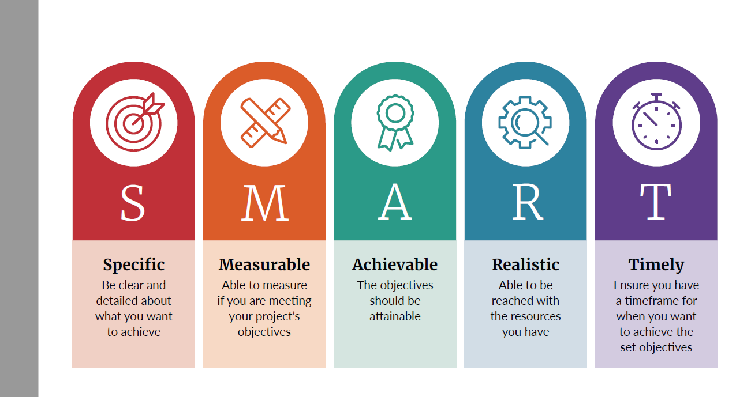

### Examples of SMART objectives

The examples below are a guide to structuring your objectives using SMART principles.

| Area of project | Example |
| --- | --- |
| Research and development | Draft specific hypotheses for [investigation/research/development] and prepare a plan of how you will test these for Milestone 1. |
| Research and development | Resolve specific unknowns (or scientific uncertainty) in relation to the project and seek scientific/specialist instruction to resolve these within a set timeframe. |
| Research and development | Design a solution or blueprint, to define the scale of the technological solution and outlay required for maximum efficiency, within a set timeframe. |
| Research and development | Produce a minimum viable product or solution or optimise a product/service for a specific outcome, within a set timeframe. |
| Research and development | Test the durability/viability/impact (or similar) of a product or solution, to verify the overall effectiveness of a project, within a set timeframe. |
| Community/Education | Increase local community recycling in [location] by diverting at least [quantity] of [plastic type] by the end of the project. |
| Community/Education | Develop and deliver a [recycling] programme [virtually or in person] to at least [quantity] households in [location/community] by the end of the project. |
| Community/Education | Draw up a communication strategy to engage with [stakeholder group] and promote [new process/plant/ programme] by the end of the project. |
| Community/Education | Design a learning programme to raise awareness of [waste type] waste minimisation practices among communities in [region/s] and hold at least [quantity] workshops by the end of the project. |
| Feasibility | Pilot a [new technology/process/programme] in [location] to process/divert/collect at least [quantity] of [plastic type] by the end of the project. |
| Feasibility | Research and scope the viability of [new process, plastic challenge, or opportunity] to process/produce [plastic type] by completing a business case and feasibility report by Milestone 1. |
| Infrastructure | Expand existing facilities at [location] by installing/commissioning [equipment/plant] to increase processing capacity from [baseline] to [new capacity] by the end of the project. |
| Infrastructure | Set up a new [site/plant/facility] to increase the sorting/processing capacity [plastic stream] and become operational by the end of the project. |
| Infrastructure | Divert at least [plastic type and quantity] tonnes per annum from landfill by the end of the project. |
| Infrastructure | Scope local and international equipment specification to process at least [quantity] tonnes per year of [plastic type] and provide a business case by Milestone 1. |
| Services | Expand existing [service/programme] and set up [new branch/operations] in [location] to divert [plastic type] by Milestone 3. |

# Appendix 2: Benefits

**To clarify concepts in** **PART 2** **below are a definition of Māori businesses and diagrams of the circular economy and waste hierarchy.**

### Māori business

Māori-owned businesses are defined as enterprises with:

* Partnerships: at least 50 per cent of each class of partnership interest is owned by Māori individuals and such ownership must be reflected in the partnership agreement; or
* Corporations/companies: Māori individual(s) own at least 50 per cent of each class of ordinary voting shares issued and at least 50 per cent of each class of all other shares issued; or
* Trusts: at least 50 per cent of owner(s) of securities or assets held in trust are Māori individual(s); or
* Sole proprietorship/trader: 100 per cent ownership by a Māori person.

Māori are defined as people with Māori whakapapa and who identify as Māori.

Adapted from [Amotai | Supplier diversity Aotearoa](https://amotai.nz/support) October 2021

### The circular economy

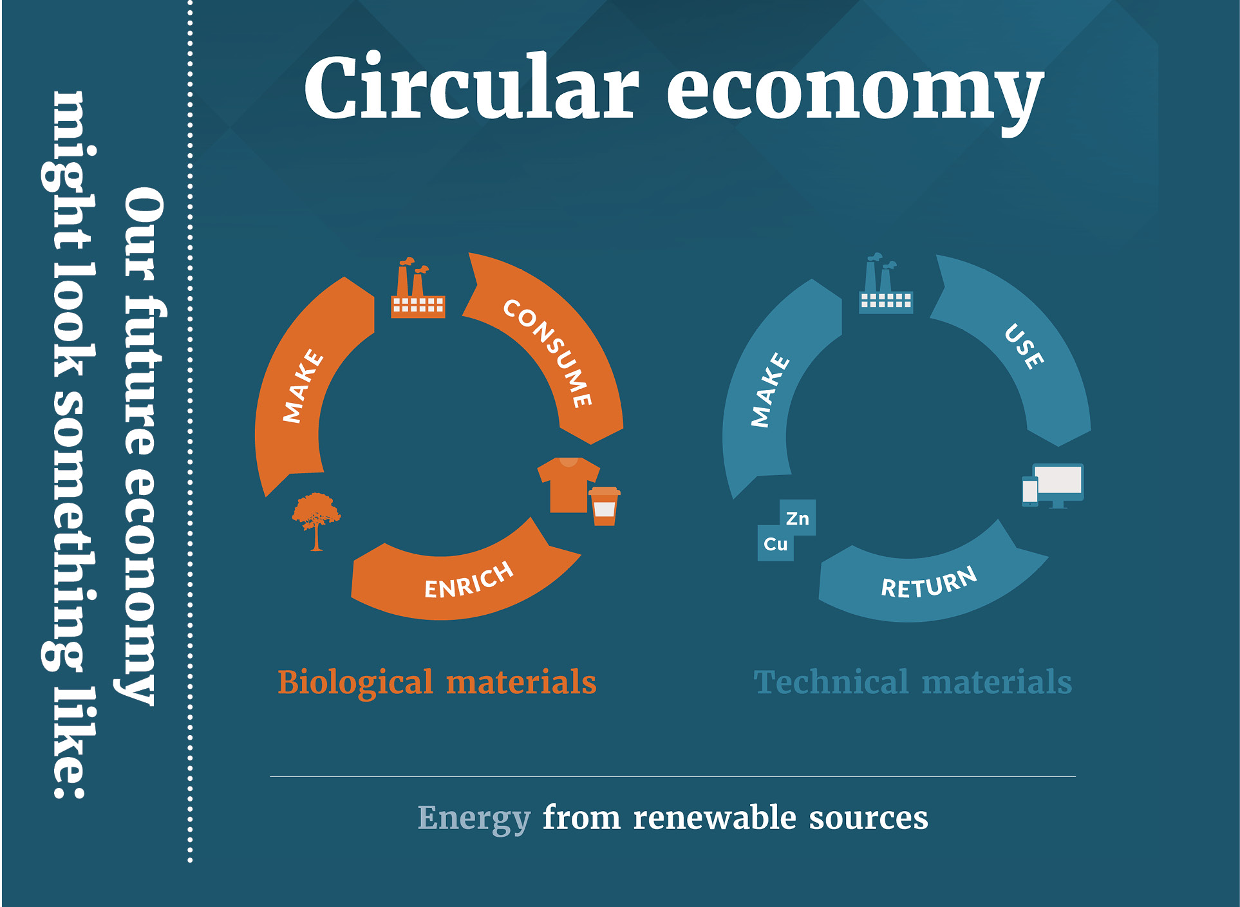

### The waste hierarchy

