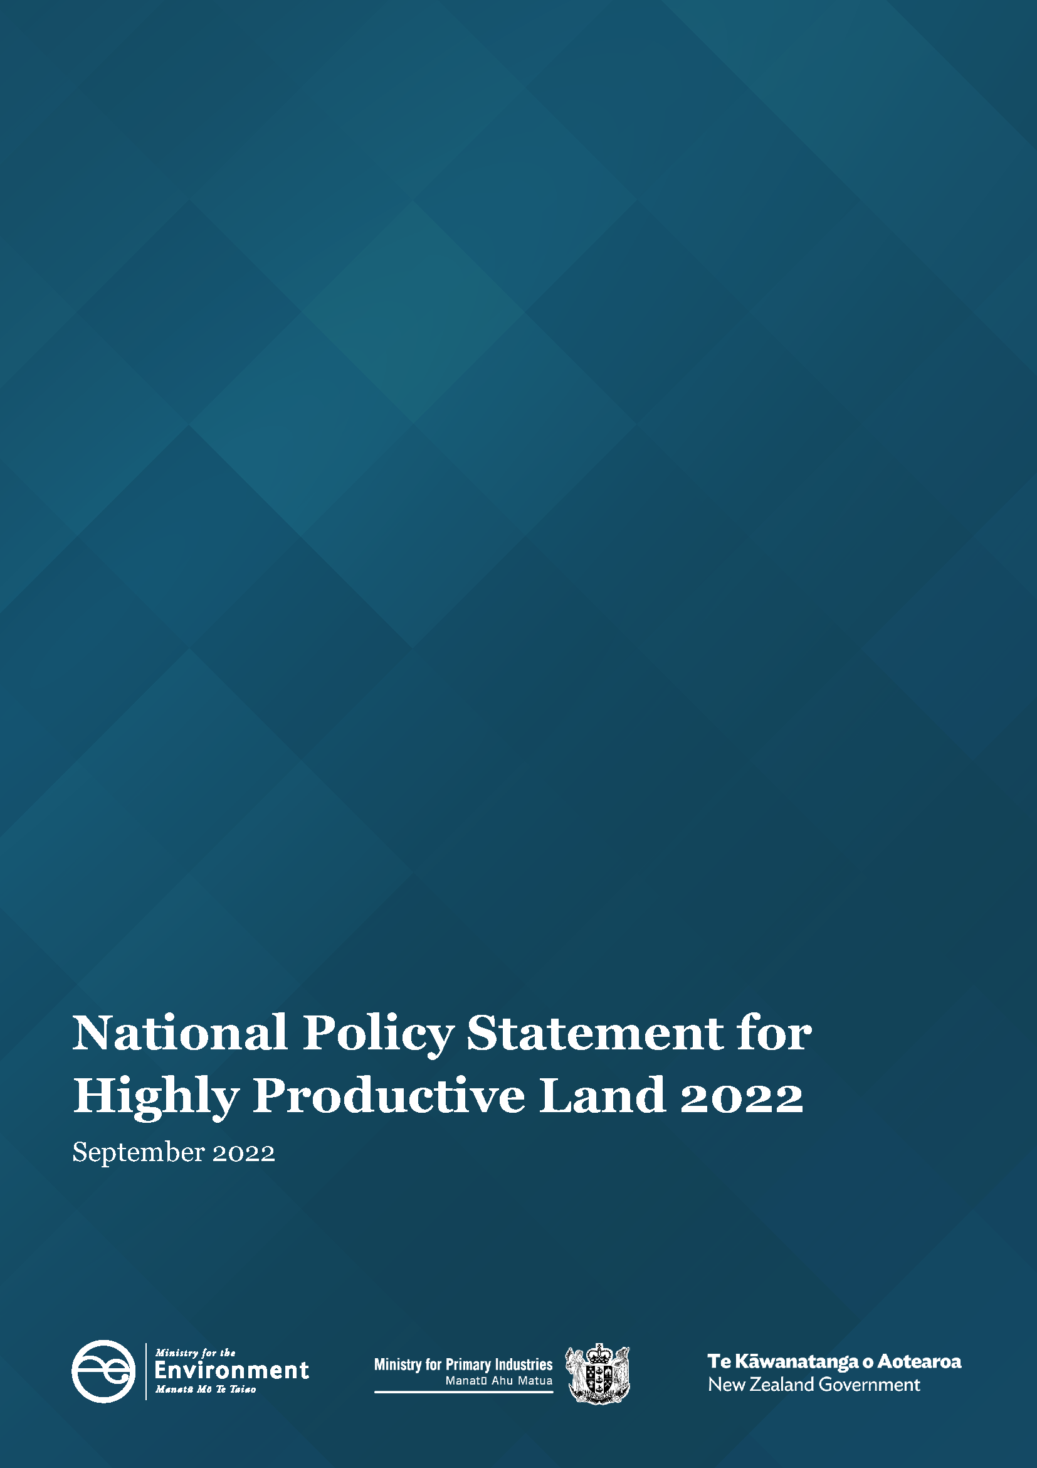

Authority
This National Policy Statement was approved by the Governor-General under section 52(2) of the Resource Management Act 1991 on 12 September 2022, and is published by the Minister for the Environment under section 52(3) of that Act.

Contents
Part 1: Preliminary provisions 4
1.1 Title 4
1.2 Commencement 4
1.3 Interpretation 4
1.4 Incorporation by reference 6
Part 2: Objective and Policies 7
2.1 Objective 7
2.2 Policies 7
Part 3: Implementation 8
3.1 Outline of Part 8
3.2 Integrated management 8
3.3 Tangata whenua involvement 8
3.4 Mapping highly productive land 8
3.5 Identifying highly productive land in regional policy statements and district plans 9
3.6 Restricting urban rezoning of highly productive land 10
3.7 Avoiding rezoning of highly productive land for rural lifestyle 11
3.8 Avoiding subdivision of highly productive land 11
3.9 Protecting highly productive land from inappropriate use and development 12
3.10 Exemption for highly productive land subject to permanent or long-term constraints 13
3.11 Continuation of existing activities 14
3.12 Supporting appropriate productive use of highly productive land 14
3.13 Managing reverse sensitivity and cumulative effects 14
Part 4: Timing 16
4.1 When this National Policy Statement takes effect 16

- Preliminary provisions
  - Title
- This is the National Policy Statement for Highly Productive Land 2022.
  - Commencement
- This National Policy Statement comes into force on 17 October 2022.
- See Part 4 for timeframes for giving effect to this National Policy Statement.
  - Interpretation
- In this National Policy Statement:
Act means the Resource Management Act 1991
commencement date means the date on which this National Policy Statement comes into force, as identified in clause 1.2(1)
highly productive land means land that has been mapped in accordance with clause 3.4 and is included in an operative regional policy statement as required by clause 3.5 (but see clause 3.5(7) for what is treated as highly productive land before the maps are included in an operative regional policy statement and clause 3.5(6) for when land is rezoned and therefore ceases to be highly productive land)
identified for future urban development means:
        - identified in a published Future Development Strategy as land suitable for commencing urban development over the next 10 years; or
        - identified:
          - in a strategic planning document as an area suitable for commencing urban development over the next 10 years; and
          - at a level of detail that makes the boundaries of the area identifiable in practice
land-based primary production means production, from agricultural, pastoral, horticultural, or forestry activities, that is reliant on the soil resource of the land
lifeline utility has the meaning in section 4 of the Civil Defence Emergency Management Act 2002
LUC 1, 2, or 3 land means land identified as Land Use Capability Class 1, 2, or 3, as mapped by the New Zealand Land Resource Inventory or by any more detailed mapping that uses the Land Use Capability classification
productive capacity, in relation to land, means the ability of the land to support land-based primary production over the long term, based on an assessment of:
        - physical characteristics (such as soil type, properties, and versatility); and
        - legal constraints (such as consent notices, local authority covenants, and easements); and
        - the size and shape of existing and proposed land parcels
specified infrastructure means any of the following:
        - infrastructure that delivers a service operated by a lifeline utility:
        - infrastructure that is recognised as regionally or nationally significant in a National Policy Statement, New Zealand Coastal Policy Statement, regional policy statement or regional plan:
        - any public flood control, flood protection, or drainage works carried out:
          - by or on behalf of a local authority, including works carried out for the purposes set out in section 133 of the Soil Conservation and Rivers Control Act 1941; or
          - for the purpose of drainage, by drainage districts under the Land Drainage Act 1908
specified Māori land means land that is any of the following:
        - Māori customary land or Māori freehold land (as defined in Te Ture Whenua Māori Act 1993):
        - land vested in the Māori Trustee that—
          - is constituted as a Māori reserve by or under the Māori Reserved Land Act 1955; and
          - remains subject to that Act:
        - land set apart as a Māori reservation under Part 17 of Te Ture Whenua Māori Act 1993 or its predecessor, the Māori Affairs Act 1953:
        - land that forms part of a natural feature that has been declared under an Act to be a legal entity or person (including Te Urewera land within the meaning of section 7 of the Te Urewera Act 2014):
        - the maunga listed in section 10 of the Ngā Mana Whenua o Tāmaki Makaurau Collective Redress Act 2014:
        - land held by or on behalf of an iwi or hapū if the land was transferred from the Crown, a Crown body, or a local authority with the intention of returning the land to the holders of the mana whenua over the land
strategic planning document means any non-statutory growth plan or strategy adopted by local authority resolution
supporting activities, in relation to highly productive land, means those activities reasonably necessary to support land-based primary production on that land (such as on-site processing and packing, equipment storage, and animal housing)
urban rezoning means changing from a general rural or rural production zone to an urban zone
urban, as a description of a zone, means any of the following zones:
        - low density residential, general residential, medium density residential, large lot residential, and high density residential:
        - settlement, neighbourhood centre, local centre, town centre, metropolitan centre, and city centre:
        - commercial, large format retail, and mixed use:
        - light industrial, heavy industrial, and general industrial:
        - any special purpose zone, other than a Māori Purpose zone:
        - any open space zone, other than a Natural Open Space zone:
        - sport and active recreation.
- Terms defined in the Act and used in this National Policy Statement have the meanings in the Act, unless otherwise specified.
- Terms defined in the National Policy Statement on Urban Development 2020 and used in this National Policy Statement have the meanings in the National Policy Statement on Urban Development 2020, unless otherwise specified.
- A reference in this National Policy Statement to a zone is:
        - a reference to a zone as described in Standard 8 (Zone Framework Standard) of the National Planning Standards; or
        - for local authorities that have not yet implemented the Zone Framework Standard of the National Planning Standards, a reference to the nearest equivalent zone.
  - Incorporation by reference
- Clause 2(1) of Schedule 1AA of the Act does not apply to any material incorporated by reference in this National Policy Statement.

- Objective and Policies
  - Objective
Objective: Highly productive land is protected for use in land-based primary production, both now and for future generations.
  - Policies
Policy 1: Highly productive land is recognised as a resource with finite characteristics and long-term values for land-based primary production.
Policy 2: The identification and management of highly productive land is undertaken in an integrated way that considers the interactions with freshwater management and urban development.
Policy 3: Highly productive land is mapped and included in regional policy statements and district plans.
Policy 4: The use of highly productive land for land-based primary production is prioritised and supported.
Policy 5: The urban rezoning of highly productive land is avoided, except as provided in this National Policy Statement.
Policy 6: The rezoning and development of highly productive land as rural lifestyle is avoided, except as provided in this National Policy Statement.
Policy 7: The subdivision of highly productive land is avoided, except as provided in this National Policy Statement.
Policy 8: Highly productive land is protected from inappropriate use and development.
Policy 9: Reverse sensitivity effects are managed so as not to constrain land-based primary production activities on highly productive land.

- Implementation
  - Outline of Part
- This Part sets out a non-exhaustive list of things that local authorities must do to give effect to the objective and policies of this National Policy Statement, but nothing in this Part limits the general obligation under the Act to give effect to that objective and those policies.
  - Integrated management
- Regional councils and territorial authorities must identify highly productive land, and manage the effects of subdivision, use, and development of highly productive land, in an integrated way, which means:
        - considering how land-based primary production, including supporting activities, interact with freshwater management at a catchment level; and
        - providing co-ordinated management and control of the subdivision, use, and development on highly productive land across administrative boundaries within and between regions; and
        - taking a long-term, strategic approach to protecting and managing highly productive land for future generations.
  - Tangata whenua involvement
- In giving effect to this National Policy Statement through regional policy statements, regional plans, and district plans, every local authority must actively involve tangata whenua (to the extent they wish to be involved).
- The active involvement must include consultation with tangata whenua that is:
        - early, meaningful and, as far as practicable, in accordance with tikanga Māori; and
        - undertaken at the appropriate levels of whānau, hapū, and iwi decision-making structures, recognising that:
          - some delegates will have to represent the interests and perspectives of more than one group; and
          - some committees are not always fully representative of every iwi and hapū in the region; and
          - each constituent group will continue to be entitled to make submissions on notified plans and retain all other rights to be heard and have standing for appeals.
  - Mapping highly productive land
- Every regional council must map as highly productive land any land in its region that:
        - is in a general rural zone or rural production zone; and
        - is predominantly LUC 1, 2, or 3 land; and
        - forms a large and geographically cohesive area.
- However, despite anything else in this clause, land that, at the commencement date, is identified for future urban development must not be mapped as highly productive land.
- Regional councils may map land that is in a general rural zone or a rural production zone, but is not LUC 1, 2, or 3 land, as highly productive land if the land is, or has the potential to be (based on current uses of similar land in the region), highly productive for land-based primary production in that region, having regard to the soil type, physical characteristics of the land and soil, and climate of the area.
- Regional councils must undertake the mapping required by this clause:
        - in collaboration with relevant territorial authorities; and
        - in consultation with tangata whenua, as required by clause 3.3; and
        - at a level of detail that identifies individual parcels of land or, where appropriate for larger sites, parts of parcels of land.
- For the purpose of identifying land referred to in subclause (1):
        - mapping based on the New Zealand Land Resource Inventory is conclusive of LUC status, unless a regional council accepts any more detailed mapping that uses the Land Use Capability classification in the New Zealand Land Resource Inventory; and
        - where possible, the boundaries of large and geographically cohesive areas must be identified by reference to natural boundaries (such as the margins of waterbodies), or legal or non-natural boundaries (such as roads, property boundaries, and fence-lines); and
        - small, discrete areas of land that are not LUC 1, 2, or 3 land, but are within a large and geographically cohesive area of LUC 1, 2, or 3 land, may be included; and
        - small, discrete areas of LUC 1, 2, or 3 land need not be included if they are separated from any large and geographically cohesive area of LUC 1, 2, or 3 land.
  - Identifying highly productive land in regional policy statements and district plans
- As soon as practicable, and no later than 3 years after the commencement date, every regional council must, using a process in Schedule 1 of the Act, notify in a proposed regional policy statement, by way of maps, all the land in its region that is required by clause 3.4 to be mapped as highly productive land.
- The identification of highly productive land in a regional policy statement may be sequenced over the 3 years following the commencement date.
- As soon as practicable, and not later than 6 months, after a regional policy statement that includes maps of highly productive land becomes operative, each relevant territorial authority must identify the highly productive land in its district, and must do so using maps that are exactly equivalent to those in the relevant regional policy statement.
- The inclusion of the maps of highly productive land in district plans is an amendment subject to section 55(2) of the Act (which means the territorial authority must make the amendment without using a process in Schedule 1 of the Act).
- All maps of highly productive land in proposed regional policy statements, regional policy statements, and district plans must be updated at the next appropriate plan review to reflect relevant changes to zoning, land use capability classification, or any other matter affecting the classification of land as highly productive land.
- If highly productive land is the subject of an approved plan change to rezone the land so that it is no longer general rural or rural production zone, the land ceases to be highly productive land from the date the plan change becomes operative, even if the change is not yet included in maps in an operative regional policy statement.
- Until a regional policy statement containing maps of highly productive land in the region is operative, each relevant territorial authority and consent authority must apply this National Policy Statement as if references to highly productive land were references to land that, at the commencement date:
        - is
          - zoned general rural or rural production; and
          - LUC 1, 2, or 3 land; but
        - is not:
          - identified for future urban development; or
          - subject to a Council initiated, or an adopted, notified plan change to rezone it from general rural or rural production to urban or rural lifestyle.
  - Restricting urban rezoning of highly productive land
- Tier 1 and 2 territorial authorities may allow urban rezoning of highly productive land only if:
        - the urban rezoning is required to provide sufficient development capacity to meet demand for housing or business land to give effect to the National Policy Statement on Urban Development 2020; and
        - there are no other reasonably practicable and feasible options for providing at least sufficient development capacity within the same locality and market while achieving a well-functioning urban environment; and
        - the environmental, social, cultural and economic benefits of rezoning outweigh the long-term environmental, social, cultural and economic costs associated with the loss of highly productive land for land-based primary production, taking into account both tangible and intangible values.
- In order to meet the requirements of subclause (1)(b), the territorial authority must consider a range of reasonably practicable options for providing the required development capacity, including:
        - greater intensification in existing urban areas; and
        - rezoning of land that is not highly productive land as urban; and
        - rezoning different highly productive land that has a relatively lower productive capacity.
- In subclause (1)(b), development capacity is within the same locality and market if it:
        - is in or close to a location where a demand for additional development capacity has been identified through a Housing and Business Assessment (or some equivalent document) in accordance with the National Policy Statement on Urban Development 2020; and
        - is for a market for the types of dwelling or business land that is in demand (as determined by a Housing and Business Assessment in accordance with the National Policy Statement on Urban Development 2020).
- Territorial authorities that are not Tier 1 or 2 may allow urban rezoning of highly productive land only if:
        - the urban zoning is required to provide sufficient development capacity to meet expected demand for housing or business land in the district; and
        - there are no other reasonably practicable and feasible options for providing the required development capacity; and
        - the environmental, social, cultural and economic benefits of rezoning outweigh the environmental, social, cultural and economic costs associated with the loss of highly productive land for land-based primary production, taking into account both tangible and intangible values.
- Territorial authorities must take measures to ensure that the spatial extent of any urban zone covering highly productive land is the minimum necessary to provide the required development capacity while achieving a well-functioning urban environment.
  - Avoiding rezoning of highly productive land for rural lifestyle
- Territorial authorities must avoid rezoning of highly productive land as rural lifestyle, except as provided in clause 3.10.
  - Avoiding subdivision of highly productive land
- Territorial authorities must avoid the subdivision of highly productive land unless one of the following applies to the subdivision, and the measures in subclause (2) are applied:
        - the applicant demonstrates that the proposed lots will retain the overall productive capacity of the subject land over the long term:
        - the subdivision is on specified Māori land:
        - the subdivision is for specified infrastructure, or for defence facilities operated by the New Zealand Defence Force to meet its obligations under the Defence Act 1990, and there is a functional or operational need for the subdivision.
- Territorial authorities must take measures to ensure that any subdivision of highly productive land:
        - avoids if possible, or otherwise mitigates, any potential cumulative loss of the availability and productive capacity of highly productive land in their district; and
        - avoids if possible, or otherwise mitigates, any actual or potential reverse sensitivity effects on surrounding land-based primary production activities.
- In subclause (1), subdivision includes partitioning orders made under Te Ture Whenua Māori Act 1993.
- Territorial authorities must include objectives, policies, and rules in their district plans to give effect to this clause.
  - Protecting highly productive land from inappropriate use and development
- Territorial authorities must avoid the inappropriate use or development of highly productive land that is not land-based primary production.
- A use or development of highly productive land is inappropriate except where at least one of the following applies to the use or development, and the measures in subclause (3) are applied:
        - it provides for supporting activities on the land:
        - it addresses a high risk to public health and safety:
        - it is, or is for a purpose associated with, a matter of national importance under section 6 of the Act:
        - it is on specified Māori land:
        - it is for the purpose of protecting, maintaining, restoring, or enhancing indigenous biodiversity:
        - it provides for the retirement of land from land-based primary production for the purpose of improving water quality:
        - it is a small-scale or temporary land-use activity that has no impact on the productive capacity of the land:
        - it is for an activity by a requiring authority in relation to a designation or notice of requirement under the Act:
        - it provides for public access:
        - it is associated with one of the following, and there is a functional or operational need for the use or development to be on the highly productive land:
          - the maintenance, operation, upgrade, or expansion of specified infrastructure:
          - the maintenance, operation, upgrade, or expansion of defence facilities operated by the New Zealand Defence Force to meet its obligations under the Defence Act 1990:
          - mineral extraction that provides significant national public benefit that could not otherwise be achieved using resources within New Zealand:
          - aggregate extraction that provides significant national or regional public benefit that could not otherwise be achieved using resources within New Zealand.
- Territorial authorities must take measures to ensure that any use or development on highly productive land:
        - minimises or mitigates any actual loss or potential cumulative loss of the availability and productive capacity of highly productive land in their district; and
        - avoids if possible, or otherwise mitigates, any actual or potential reverse sensitivity effects on land-based primary production activities from the use or development.
- Territorial authorities must include objectives, policies, and rules in their district plans to give effect to this clause.
  - Exemption for highly productive land subject to permanent or long-term constraints
- Territorial authorities may only allow highly productive land to be subdivided, used, or developed for activities not otherwise enabled under clauses 3.7, 3.8, or 3.9 if satisfied that:
        - there are permanent or long-term constraints on the land that mean the use of the highly productive land for land-based primary production is not able to be economically viable for at least 30 years; and
        - the subdivision, use, or development:
          - avoids any significant loss (either individually or cumulatively) of productive capacity of highly productive land in the district; and
          - avoids the fragmentation of large and geographically cohesive areas of highly productive land; and
          - avoids if possible, or otherwise mitigates, any potential reverse sensitivity effects on surrounding land-based primary production from the subdivision, use, or development; and
        - the environmental, social, cultural and economic benefits of the subdivision, use, or development outweigh the long-term environmental, social, cultural and economic costs associated with the loss of highly productive land for land-based primary production, taking into account both tangible and intangible values.
- In order to satisfy a territorial authority as required by subclause (1)(a), an applicant must demonstrate that the permanent or long-term constraints on economic viability cannot be addressed through any reasonably practicable options that would retain the productive capacity of the highly productive land, by evaluating options such as (without limitation):
        - alternate forms of land-based primary production:
        - improved land-management strategies:
        - alternative production strategies:
        - water efficiency or storage methods:
        - reallocation or transfer of water and nutrient allocations:
        - boundary adjustments (including amalgamations):
        - lease arrangements.
- Any evaluation under subclause (2) of reasonably practicable options:
        - must not take into account the potential economic benefit of using the highly productive land for purposes other than land-based primary production; and
        - must consider the impact that the loss of the highly productive land would have on the landholding in which the highly productive land occurs; and
        - must consider the future productive potential of land-based primary production on the highly productive land, not limited by its past or present uses.
- The size of a landholding in which the highly productive land occurs is not of itself a determinant of a permanent or long-term constraint.
- In this clause:
landholding has the meaning in the Resource Management (National Environmental Standards for Freshwater) Regulations 2020
long-term constraint means a constraint that is likely to last for at least 30 years.
  - Continuation of existing activities
- Territorial authorities must include objectives, policies, and rules in their district plans to:
        - enable the maintenance, operation, or upgrade of any existing activities on highly productive land; and
        - ensure that any loss of highly productive land from those activities is minimised.
- In this clause, existing activity means an activity that, at the commencement date:
        - is a consented activity, designated activity, or an activity covered by a notice of requirement; or
        - has an existing use of land or activity protected or allowed by section 10 or section 20A of the Act.
  - Supporting appropriate productive use of highly productive land
- Territorial authorities must include objectives, policies, and rules in their district plans that:
        - prioritise the use of highly productive land for land-based primary production over other uses; and
        - encourage opportunities that maintain or increase the productive capacity of highly productive land, but only where those opportunities are not inconsistent with:
          - any matter of national importance under section 6 of the Act; or
          - any environmental outcomes identified in accordance with the National Policy Statement for Freshwater Management 2020.
  - Managing reverse sensitivity and cumulative effects
- Territorial authorities must include objectives, policies, and rules in their district plans that:
        - identify typical activities and effects associated with land-based primary production on highly productive land that should be anticipated and tolerated in a productive rural environment; and
        - require the avoidance if possible, or otherwise the mitigation, of any potential reverse sensitivity effects from urban rezoning or rural lifestyle development that could affect land-based primary production on highly productive land (where mitigation might involve, for instance, the use of setbacks and buffers); and
        - require consideration of the cumulative effects of any subdivision, use, or development on the availability and productive capacity of highly productive land in their district.
- Timing
  - When this National Policy Statement takes effect
- Every local authority must give effect to this National Policy Statement on and from the commencement date (noting that, until an operative regional policy statement contains the maps of highly productive land required by clause 3.5(1), highly productive land in the region must be taken to have the meaning in clause 3.5(7)).
- Every territorial authority must notify changes to objectives, policies, and rules in its district plan to give effect to this National Policy Statement (using a process in Schedule 1 of the Act) as soon as practicable, but no later than 2 years after maps of highly productive land in the relevant regional policy statement become operative.

